A study on HRM Practices at Diamond Life Insurance Company LTD

Fariha Hassan

This report is submitted to the school of Business and Economics, United International University as a partial requirement for the degree fulfillment of Bachelor of Business Administration

A Study on HRM Practices at Diamond Life Insurance Company LTD

Submitted to
Nasrin Akter
Assistant Professor
School of Business & Economics (SOBE)

Submitted by
Fariha Hassan
111 193 118
Human Resource Management


School of business And Economies
August 4 ,2025

Letter of Transmittal
October 4, 2025
Nasrin Akter
Assistant Professor,
School of business And Economics (SOBE)
United International University, United city,
Madani Aven, Dhaka 1212
Subject: Internship report on Diamond Life Insurance company
Sir,
This internship report, my intension is to highlight the HRM activities of Diamond life insurance company in an elaborative manner. This report will contain data regarding the exercise of HRM skills, knowledge, employee satisfaction, performance appraisal, improvement. This report has been prepared by the achieved knowledge from Diamond life insurance company. This report is based on authentic data and experience. There can be some unintended error. I am thankful for your consideration.
Sincerely

Fariha Hassan
111 193 118
Certification of Similarity Index

Declaration of Student
I am a student of Bachelor of Business Administration at United International University. I have done my major in Human Resource Management.
The announcements are,
*The report A study on HRM practice in Diamond life insurance company is totally based on authentic experience.
*This report has been created by using the knowledge that I achieved by working with the company.
* The report was instructed by Nasrin Akter Assistant Professor school of business and economics.
* The reason to create the report is to carry out the condition of the Bachelor of Business Administration Degree.

Fariha Hassan
111 193 118
Bachelor Of Business Administration
United International University

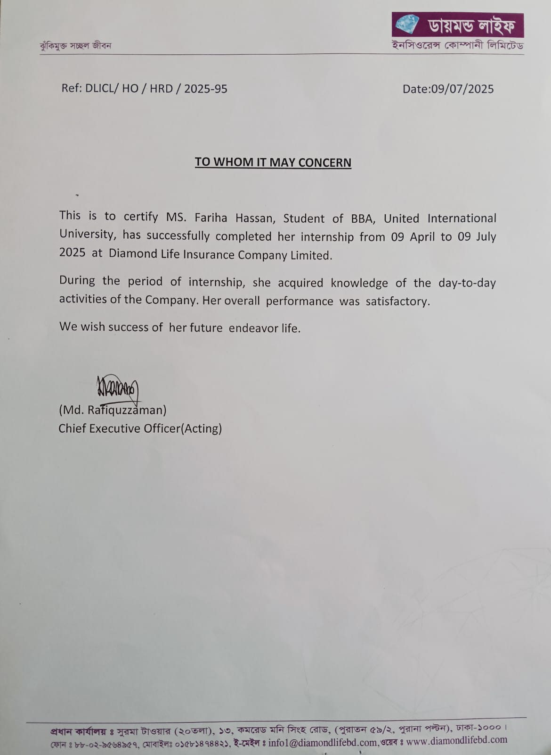
Acknowledgment
It is my greatest pleasure to present this report. This report has involvement of many people and their amazing contribution. There is an amazing contribution of my supervisor Nasrin Akter Assistant Professor of school of business and Economics, United International University. Because of her amazing guidance and strong involvement this report could be presented.
Not only that I would like to that the Diamond life insurance company for giving me the opportunity to be a part of their company. Their support helped me to achieve practical knowledge and experience. A special thanks to the Chief Executive Officer Md. Rafiquzzaman for giving me the opportunity to be a part of Diamond Life Insurance Company.
I tried my best to present this report in an appropriate manner. But still there can be some unintentional error. I would be really thankful if these errors can be taken under consideration

Executive Summery

This report is carrying the practical knowledge of internship at Diamond life Insurance company. This report is prepared to carry out the requirement of the university to complete the Bachelor of Business degree. This report is mainly focusing on the Human Resource Practice of Diamond Life Insurance Company. There is a discussion on the Human Recourse practice and rules and regulation of the company. Not only that my personal experience of working there is also explained in this report. This report is carrying the main object of preparing the report. Not only that it is also contains information about the company, their services, growth and all. Furthermore my personal experience on working as an intern is also added in this report. And the other relevant activities are attached in the report. There were some lacking also that the company needs to overcome. This internship gave me the opportunity to experience the corporate life and the skills, knowledge.

Key word- HR practices, Diamond life insurance company, Experiences, Employee satisfaction, motivation.

Table of Content
Executive Summary………………………………………………………………..……..…vi Chapter1:Introduction 1.1BackgroundoftheReport……………………………………………………….……..…….2 1.2RationaloftheReport…………………………………………………………….…..………2 1.3ObjectiveofTheReport………………………………………………………….……….…..3
1.4 Scope of the Report……………………………………………….……………3
1.5 Methodology of the Report…………………………………………………….………….3
1.6 Limitation of the report……………………………………………………………………4
Chapter2:CompanyandIndustryProfile 2.1companyanalysis………………………………………………………………….………6 2.1.1OverviewandHistory……………………………………………………………………6 2.1.2TrendandGrowth…………………………………………………………………………6 2.1.3Product/Service/Custom Mix……………………………………………………………7 2.14companyoperations/Activity………………………………………………………………9 2.1.5SwotAnalysis……………………………………………………………………………10 2.2IndustryAnalysis………………………………………………………………………….…11 2.2.1SpecificationofIndustry……………………………………………………………….…..11 2.2.2Size,TrendandMaturityoftheindustry……………………………………………………11 2.2.3IndustrySWOTAnalysis…………………………………………………………………12
Chapter3: Internship Experience
3.1Position&Responsibility…………………………………………………………….……14 3.2TrainingandDevelopment…………………………………………………………………14 3.3ContributionstoOrganization/Operations…………………………………………………15 3.4Evaluation………………………………………………………………………………...15 3.5skillApplied………………………………………………………………………………..15
Chapter4: Analysis of the work
4.1AnalysisofTheWork……………………………………………………………….…….17
Chapter 5: Conclusion and Key Facts
5.1Findings…………………………………………………………………………………20
5.2 Recommendations……………………………………………………………………..20
5.3Conclusion…………………………………………………………………………………21 Reference………………………………………………………………………………………..22

Chapter- 1
Introduction
Introduction
Background of the Report
This report is a vital part of BBA program in United International University. I got the opportunity to complete my internship at Diamond Life Insurance Company. By working there, I gained knowledge and on the basis of that I prepared the report. I was a part of Human Resource division. I was strongly involved with the Human Resource activities in that company.
I was a part of Human Resource Planning. My activities were involved with planning. It is very important to develop a proper plan. It helps to predict the future. Not only that it also ensured there is accurate type of employee for the working environment.
As Diamond life insurance company is a service provider it needed strong human power. And it is also important to ensure a proper use of that human power. The tasks are distributed among the employees according to their skills and knowledge.

Rationale of The Report
This report is essential part of BBA program. On the basis of internship knowledge and experience the report is created. This is carrying data about Diamond life Insurance company. Diamond Life Insurance company is based on service so it requires skilled employees.
As it is an insurance company it has come confidential information. Not all the employees have access to the information. As I was joined as intern I had to follow some rules and regulation and could not get access to all types of information. So there can be lack of some information.
This report presents information about the experience of the internship. It contains primary and secondary both type data. All the experience are presented in this report. It contains detail information about how HR practices are implemented.

Objective of The Report
Internship is a compulsory course of United International University. After completing the internship a report must be submitted to the university. The report is prepared under the supervision of Assistant professor Nasrin Akter. This report is carrying an elaborative data and information about the working experience with Diamond life insurance company. It has the detail elaboration of HR practice in Diamond Life Insurance company. There are two types of objectives.

Broad Objective
The long term objective is to fulfil the major demand of the BBA program. Not only that it with develop my skills and make me feel more confident. It also helps to build a strong networking system.

Specific Objective
It helped to improve my soft skills. It helped to gain idea about my internship roles. It also helped to evaluate my skills.

Scope of the Report
I got the opportunity to be a part of Diamond Life Insurance company. I work closely with the company as a result I gathered various kind of knowledge. I achieved knowledge regarding the practice of HRM specifically HRP. This report is prepared on the basis of present conditions and policies of the organization. Which can help to analysis the present situation of the organization and improve the future. It helps to find out the lacking and develop it with new opportunities.

Methodology of the Report
This report is based on Human Recourse Practice at the Diamond Life Insurance Company. This report is descriptive type of report. So this report carries descriptive idea about the practice of Human Recourse Management. This report is created by using both type of data, primary and secondary.
Primary: The data that I have collected directly throughout my internship. I have collected knowledge by working with supervisor, team members, and seniors and so on. Not only that I was a part of that company as a result I got the opportunity to work there and observe others.
Secondary: The secondary data has been collected from internet, official website of Diamond Life Insurance company. Not Only that there were some reports, Human recourse management data that are used in this report.

Limitations of the Report
Diamond Life Insurance company provides financial support to its customers. There are some rules and policies. There are some confidential data that is not accessible to all. That has brought a limitation to this report. Secondly the report is totally based on HRM practice in Diamond Life insurance company so there can be lack of other data.

Chapter- 2
Company and Industry Profile

Company and Industry Profile
Data of Diamond Life Insurance Company
Name | Diamond Life Insurance Company
Category | Public Limited Company
Industry Type | Service Industry
Establishment | 2014, operated June 2014
Main Brunch | Middle Badda, Tropical Molla tower
Founder | MD. Shaque Ali Khan Panna

History of Diamond Life Insurance Company
Diamond Life Insurance company is a company that provides financial service to the customer. Its main intension is to ensure that the customer is financially protected. It was registered in 2014. After six month of registration it started its activities in the same year of June. Its head office is located at middle badda. It has a capital of 1000 million and that is authorized by the company.
This insurance company is founded by MD. Ishaque Ali Khan Panna and the vice chairman named Riad Mahmud.
This insurance company main intention is to provide affordable insurance policies to the people of our country. This insurance company in created by various investors.

Trend And Growth
Diamond Life Insurance company started it journey in 2014. During 2019 its market share was 0.5%. There has been noticed a negative cashflow during 2021. In 2024 there was a growth noticed and that was by 9.16%.
Because of the unstable economical condition there was a drop in the financial statement of the company. There has been an announcement of an audit in order to identify the problems.

Service Mix
Service
This company is a combination of various type of life insurance.
Savings type of policy.
Protection policy for the customers.
Product that adjusts with the need.

Price
It provides eye catching return to the people who invest on the premiums In order to access the wide range of investors their center of attraction is on bargain cost premium.
Place
There are brunches of diamond life insurance company in order to provide service all over the country. The employees are also well trained to provide service to the customers.
Promotion
It is very important to build up a trustworthy relation with the customers. So its main intention is to build awareness among all.
Physical Evidence
There are many brunches all over the country to provide service to the investors and the customers. Even there are some digital service system.
People
All the employees of the company are well trained. Insurance companies requires well trained employees in order to maintain a strong communication with the investors.
Process
The overall activities are done in a very transparent way. And the employees are accountable for all the queries.

Customer Mix
Demographic Segment
Young And people who are unmarried always search for policies that are accessible to then and mostly interested in flexible way of communication such as online platforms.
The people with family mostly wants security and wants reliable service.
High net worth people demand for customized and premier level of service.
Socio Economic Segment
People investments depend on their earnings.
Behavioral Segment
Not all the customers have same attitude to word the company. Different people have different behavior to word the company.
Geographic Segment
There are different brunches in different areas to provide service to the customers. According to the geography customer behavior also changes.

Company Activity
Life Insurance
Diamond Life Insurance company provides life insurance policies to the customers and provides securities to the investors lives.
Customer Focused Service
Diamond life insurance company provides service according to the requirements of the customers.
Field Management
There are some skilled employees who are engaged to manage the activities regarding the customers and their need.
Fund Collection and New Investments
Diamond Life Insurance company collect funds from the investors and use then in different new investments.
Job Opportunity
Diamond Life Insurance company create job opportunity for the employees and helps them to lead a good life.
Group Insurance Agreement with Business
Diamond Life Insurance company involves with corporates in order to increase the area of making profit.

SWOT Analysis
Strength
It provides service according to the economical demand which helps to develop market relevance.
Diamond life Insurance company is committed to provide a good service and keep transparency about their work.
It is trying its best to reach out the target customers in different part of the country.
Weakness
People have lack of trust on insurance company and this has a bad impact on the company. There is a lack of skilled employees. As a result it effect the company.

Opportunity
There is great scope to increase the penetration of insurance by doing proper marketing. Diamond life insurance company is trying their best to reach the rural areas. There other companies are still unable to.
Mobile marketing can bring new opportunities for the insurance company. It can open a wide area of profit for the company.
Threat
The competitors are the risk for the company. They can bring challenges for the company. The political situation in our country is challenge for the insurance company. Unstable economical condition can bring challenges to the company.

Industry Analysis
Specification of the Industry
Diamond Life Insurance company belongs to Service industry. This company provides safety of the customers against specific amount of premium. This company provides safety security to the customers. Diamond Life Insurance Company presents affordable life insurance policy. It provides service according to the requirement of the customer. It uses various strategies to attract the policy holders. It creates job opportunities for the people. It keeps transparency with its policy holders.

Size, Trend and Maturity of the Industry
Diamond Life industry falls under the category of Service industry. The size of the industry is to that big. The market share of the company is also not that big. The amount of revenue is also small.
Diamond Lide Insurance Company is recognize as a small scale company. There is still scope of maturity. Maturity can be brought by providing trust worthy service, building good relation with the customers.

Service Industry SWOT Analysis
Strength
Service industry requires high number of employees in order to provide service. As the service is directly serve to the customer it builds a strong relation with the customer Provides service according to the customer service.
Weakness
The service is based employee qualification and skills.
Employee turnover can affect the quality of service.
Can not be served in multiple way or medium.

Opportunity
The demand can increase by providing the customer service according to the customer needs.
Online platform can create a great opportunity.
Threats
Unstable political condition can influence the customer in less investment. The competitor can be a threat in service industry.

Chapter- 3
Internship Experience

Internship Experience
I got an amazing opportunity to complete my internship at Diamond Life Insurance Company. It was program of three months. I work there as a Human Recourse Inten. I learned their basic activities regarding HRM. It was a way of achieving knowledge through working in a organizational environment.
I got the opportunity to implement the bookish knowledge in real life working environment.
I did some mistake in my work but the manager make us understand. Diamond Life Insurance Company provided my very healthy working environment.
My first experience to work in an organization was full of amazing experiences.

Position, Duty, Responsibility
I was working with that company as an HR intern. I learned various HR activities there. And I got the opportunity to get real life organizational experiences.
I had some duties and responsibilities.
- Applying HR Strategies.
- Involve in selecting the CV of the new employees, screening, creating timetable for conducting interview.
- Evaluating the monthly performance of the employees.
- Maintaining organizations internal rules and regulation.
- Maintaining Good relationship with the employees and among the employees.
- Use to prepare report on assigned works.

Training and Development
As insurance company falls under the category of service industry, it requires training for the employees. Insurance companies requires well trained employees. Well trained employees are capable of convincing the customers for investing in the insurance policies.

Training and Development
As insurance company falls under the category of service industry, it requires training for the employees. Insurance companies required well trained employees. Well trained employees are capable of convincing the customers for investing in the insurance policies.
Contribution to Organization
I got the opportunity to join as an intern at Diamond Life Insurance Company. I gained experience and knowledge about the organizational activities. I was involve in CV screening process , preparing timing for interview, dealing internal affairs , preparing report, replying to mails of the candidate and so on.
Evaluation
At diamond Life Insurance Company I had some responsibilities and I had to perform them. Those activities were assigned by the manager and the manager use to evaluate them and give feedback of the activities.
Skills Applied
This internship program brought me the opportunity to learn the skills and knowledge those I learned about in my courses. I was not skilled employee but I was loyal to my work honest with my activities and punctual at my workplace.

Chapter-4
Analysis of the Work

Analysis of the Work

I was engaged in various HR activities of Diamond Life Insurance company. I gathered knowledge working there with the employees and my supervisor. I was always involved as a part of decision making regarding the HR activities.

HR Strategies
I was engaged with the activities that are taken by the manager to motivate the employees such as marking their activities and deciding employee of the month according to their work.
Involve in CV selection for Interview
I was involved in the process of selecting the CV for interview. The CV of the students and the candidate. The student who had CGPA above 2.80 can have a chance to be selected for their interview. I was also a part of interview panel who applied for job. Candidate were selected according to their skills.
Evaluation of Monthly Activities
The employee performances are evaluated in various process such as the employees who are involve in marketing their activities are evaluated according to their collection of number of clients.
Rules and Regulation
Sometimes the registers are checked by the HR manager to make sure that the employees are on time or not.
Good Relationships Among the employees
The HR manager engages the employee in group task so that the employees have a strong and positive relationship.

Preparing Reports
I was supposed to prepare reports and present it to the manager of the organization.
These activities were a part of HR internship in Diamond life Insurance Company. All over combination of these activities makes the organizational activities more Affective.

Chapter-5
Recommendation and Conclusion

Findings
Diamond Life Insurance Company is well known for its amazing policy. It offers affordable Life Insurance policy. It has a huge and powerful human support system as a result it has access in different part of the country.
Sometimes It’s quite tough for Diamond Life insurance Company to provide the benefits on the proper time. As a result employee sometime employees are not mentally satisfied and that effects their organizational performance. In such condition employee don’t gets support from the HR managers and that makes the working environment unhealthy.

Recommendation
There were some lacking in the organizational activities. As a result there are some indiscipline in the organization. There should be a proper evaluation process. The evaluation should be done following some strategy and the feedback should begiven to the employees. It is important to maintain a employee engagement at the organization.
More Training opportunities should be created. There should be reword system to motivate the employees. New strategy should be followed in order to develop business ideas. The employees should get their benefits on proper time according to their performance. There should a strong HR supportive system that works also on behalf of the employees. If these conditions kept maintained there will be a healthy environment in the organization.
Conclusion
Human Resource department is one of the most vital department in the organization. The most Important decisions are taken by the HR managers. HR managers brings coordination among the organization and the employees. HR managers works for the betterment of the organization not only that they also work for the employee satisfaction.
Diamond Life Insurance Company is one of the most popular insurance company. It is known for its amazing service to the customers. I got the opportunity to complete my internship in this organization and got the experience of working with an amazing team. It helped me to achieve all my bookish knowledge in a practical way.

Reference
https://m.facebook.com/100067016243439/about/
https://diamondlifebd.com/page/board-of-directors
https://diamondlifebd.com/page/senior-management
https://www.diamondlifebd.com/page/field-management
httpshttps://www.facebook.com/p/Diamond-Life-Insurance-company-Limited- 100067016243439/://www.diamondlifebd.com/

