“A Study on Aarong SCPD and its Role in Enhancing Artisan Retention and Productivity.”



Lubna Akter Lota

This report is submitted to the school of Business and Economics, United International University as a partial requirement for the degree fulfillment of Bachelor of Business Administration

“A Study on Aarong SCPD and its Role in Enhancing Artisan Retention and Productivity.”

Submitted to:
Name: Ms. Ishrat Sultana
Designation: Assistant Professor
School of Business & Economics (SoBE)
Major: Human Resource Management

Submitted By:
Name: Lubna Akter Lota
Id: 111201157
Major: Human Resource Management
Registration Trimester: Summer 2024


School of Business and Economics
United international University

Date of submission: 29th July, 2025

Letter of Transmittal

28th July, 2025
Ms. Ishrat Sultana
Assistant Professor
School Of Business and Economics (SoBE)
United International University
Subject: Submission of Internship Report

Dear Madam,
I am pleased to submit my internship report that was assigned to me as an academic requirement of BBA Program at United International University. The topic of my report is “A Study on Aarong SCPD and its Role in Enhancing Artisan Retention and Productivity.”
During my three-month internship with Aarong’s Social Compliance and Producer Development (SCPD) department, I gained valuable hands-on experience and insights into the department’s efforts to promote artisan welfare, enhance retention, and boost productivity. I have endeavored to craft this report with accuracy and depth to reflect my learnings.

I am deeply thankful for your invaluable guidance and the unwavering support of the SCPD team throughout my internship journey.

Thank You.

Yours Sincerely,
Lubna Akter Lota
Id: 111201157

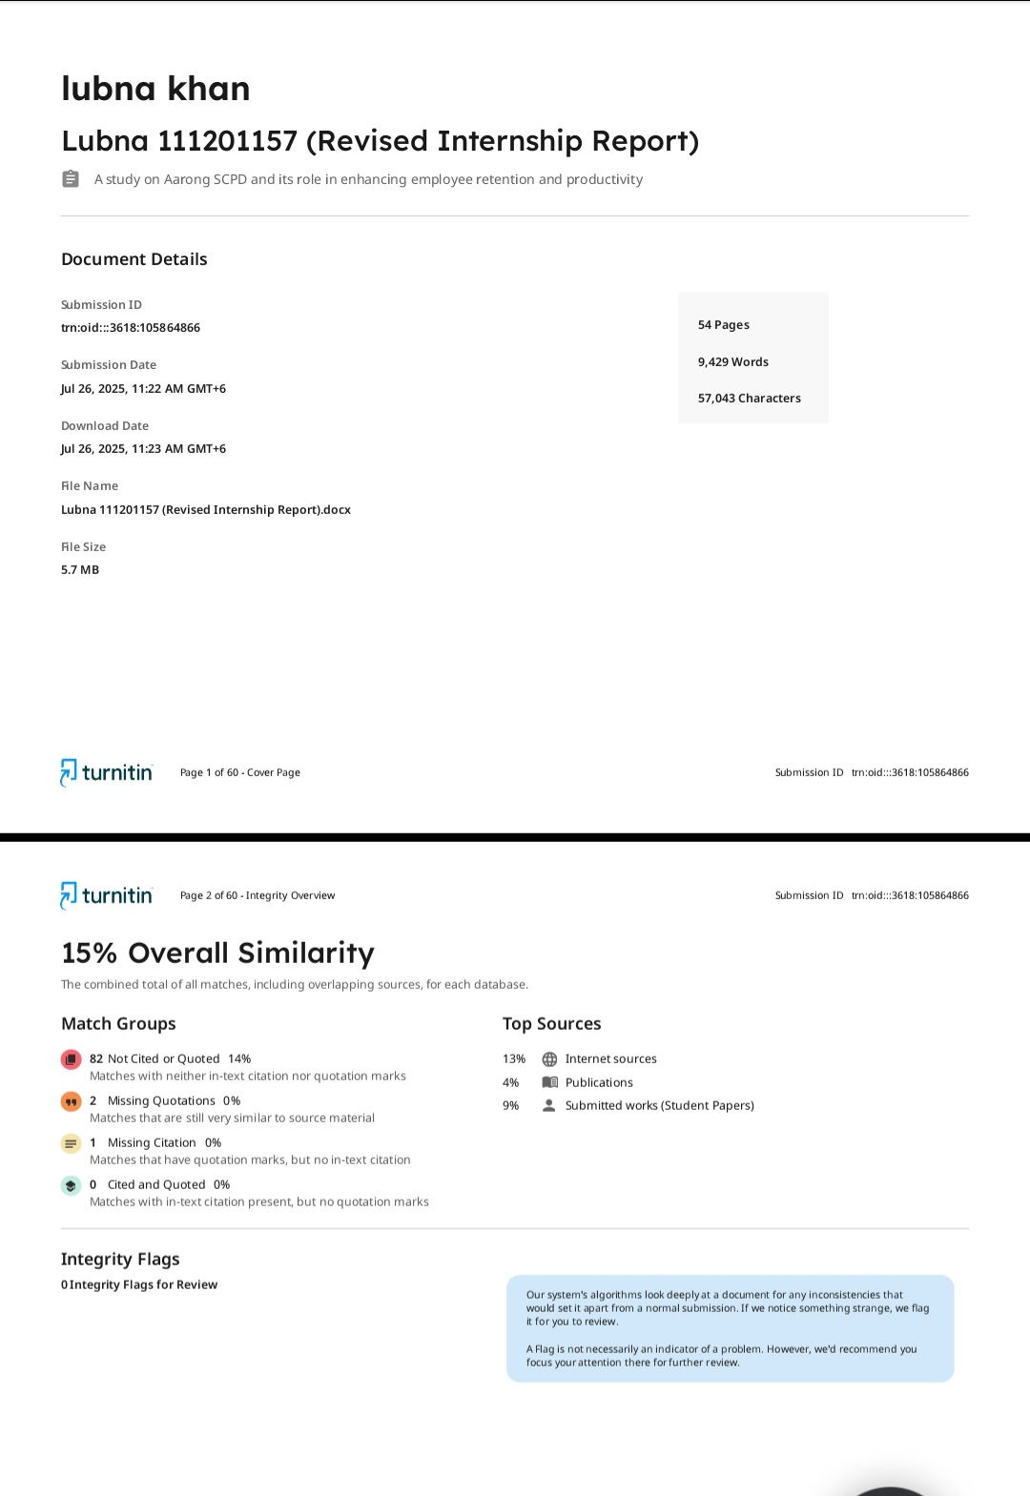
Clarification Of Similarity Index

Declaration of the Student

I hereby declare that the internship report titled “A Study on Aarong SCPD and its Role in Enhancing Artisan Retention and Productivity” has been prepared by me as a partial requirement for the completion of the Bachelor of Business Administration (BBA) program at United International University.
This report is the result of my own work, except where reference has been made to other sources, which have been duly acknowledged. The report has not been submitted, either in whole or in part, to any other institution or for any other degree or qualification.
I affirm that the report is based on the practical experiences and observations gained during my internship at Aarong’s Social Compliance and Producer Development (SCPD) department and complies with the academic integrity standards set by the university.

Name: Lubna Akter Lota
ID: 111 201 157
Program: BBA in HRM
United International University
Date: 28th July, 2025

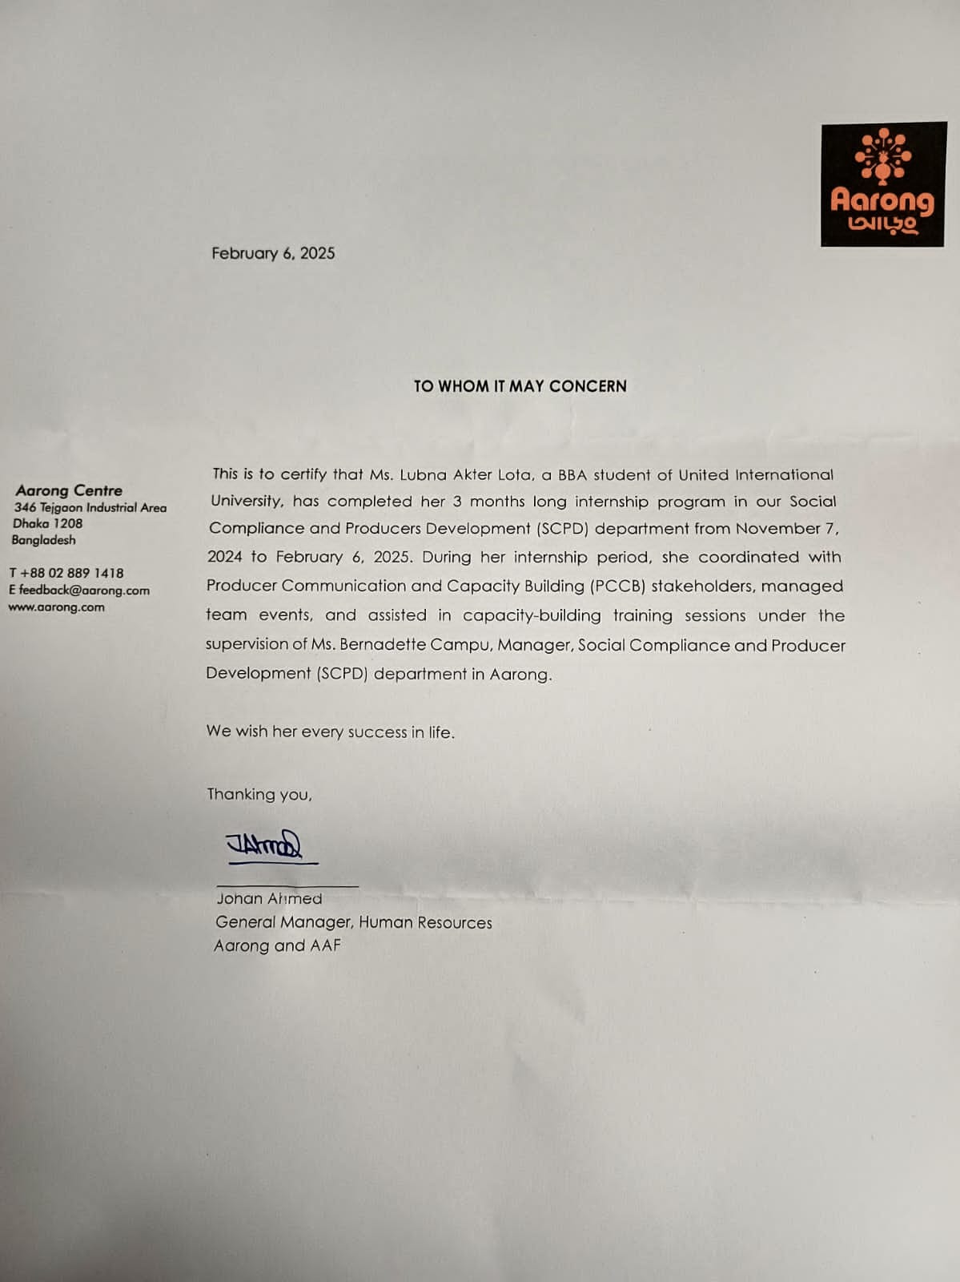
Corporate Evidence

Acknowledgement

At the outset, I express my sincere gratitude to Almighty Allah for giving me the strength, patience, and determination to complete my internship and prepare this report successfully.
I am deeply indebted to my academic supervisor, Ms. Ishrat Sultana, Assistant Professor, School of Business and Economics, United International University, for her continuous guidance, constructive feedback, and valuable advice throughout the entire process. Her support played a vital role in shaping this report with the required academic standard.
My heartfelt appreciation goes to Ms. Bernadette Campu, Manager, SCPD, Aarong, for granting me the opportunity to work as an intern and gain practical exposure in the Social Compliance and Producer Development department. I am equally grateful to Mr. Kenny David Rema, Deputy Manager, SCPD, and the entire SCPD team for their constant cooperation, warm behavior, and for providing me with the necessary resources and real-life insights that enriched my learning experience.
Finally, I would like to thank my family and friends for their encouragement and moral support throughout this journey. I am also grateful to United International University for setting the guidelines and providing the academic platform to complete this report.
Although I have made every effort to ensure accuracy and quality, I acknowledge that there may be unintentional mistakes, for which I seek your kind consideration.

Executive Summary

As one the largest leading fairtrade organizations in Bangladesh, Aarong plays a crucial role in empowering producers and rural artisans by providing sustainable livelihoods, fair wages, training, and social benefits with the support of one of the world’s largest NGOs ‘BRAC’.
In becoming a successful organization, loyal producers and artisans play a great role. Their unbelievable contribution and loyalty have helped Aarong maintain its product quality from the beginning to now and remain one of the market leaders in the Bangladesh retail industry. The Social Compliance and Producer Development (SCPD) department is consistently working as a Human Resource team for 700 hundred producers and 1500 artisans to make things happen. So, this report aims to understand SCPD’s role and initiatives in contributing long-term engagement and efficiency of its producers and artisans.
The report is based on qualitative research, including interviews with SCPD employees and artisans as well as secondary data from company reports, website, and academic literature, and my observation of the three-month internship journey.
So far the Department of Social Compliance and Producer Development is made up of many units and I have tried to work with all units. All of them have equal contributions in retaining Aarong’s treasure like artisans. The findings of the report illustrate Aarong’s fair trade policies, skills development training, and welfare programs. However, challenges such as market competition, limited technological adoption, and artisans’ financial struggles still exist. To further strengthen artisans’ retention, recommendations include expanding training programs, performance-based incentives and leveraging digital solutions for better efficiencies.
By providing long-term support and ethical working conditions, Aarong SCPD not only sustains the livelihoods of thousands of artisans but also preserves Bangladesh’s rich heritage and craftsmanship. This study highlights the importance of investing in artisans as a strategic approach to building a sustainable and socially responsible business.

Table Of Content

Letter of Transmittal 3
Clarification Of Similarity Index 4
Declaration of the Student 5
Corporate Evidence 6
Acknowledgement 7
Executive Summary 8
Table Of Content 9
List Of Figures 12
List of Acronyms & Abbreviations 13
Chapter 1: Introduction of The Report 14
1.1. Background of the Study: 14
1.2. Purpose of the study: 14
1.3. Objective of the Study: 15
1.4. Methodology of the study 15
1.5. Sources Of Data: 16
1.6. Scope of the study: 16
1.7. Limitations of the study: 16
Chapter 2: Literature Review 18
2.1 Introduction 18
2.2 Overview of HRM Functions 18
2.2.1 Recruitment and Selection: 18
2.2.2 Training and development: 19
2.2.3 Compensation and Benefits: 19
2.2.4 Employee Engagement and Motivation 19
2.2.5 Workplace Safety and Compliance 19
2.3 Importance of HRM in Employee Retention and Productivity 20
2.4 Theoretical Perspectives of HRM and Artisan Retention 20
2.4.1 Maslow’s Hierarchy of Needs 20
2.4.2 Herzberg’s Two-Factor Theory 21
Chapter 3: Organization Overview 23
3.1. Organization Profile 23
3.2. Relation between Aarong and AAF: 24
3.3. Core Values of Aarong 26
3.4. Product: 26
3.5 Target Customers of Aarong: 28
Chapter 4: Overview of SCPD Operations at Aarong 29
4.1 Introduction of Social Compliance & Producer Development: 29
4.2 Objectives of SCPD: 29
4.3 Operation Section of SCPD Department: 29
4.4 Organizational Chart of SCPD: 30
4.5 Operation of SCPD: 31
4.6 Activities of each units: 31
4.7 Social Compliance policies: 34
Chapter 5: HR Functions of Aarong & Their Role in SCPD 37
5.1 HR Role for SCPD employees 37
Aarong fosters a positive and inclusive workplace culture where diversity, integrity, and accountability are deeply valued. In SCPD, employees work in close contact with rural communities and artisans, requiring high levels of empathy, patience, and ethical behavior. 40
5.2 HR Role for Artisans 41
Chapter 6: Description of My Responsibility in Aarong SCPD 43
Chapter 7: Analysis of data and findings 45
9.1 Target Groups: 45
9.2 Data Collection Method: 45
9.3 Analysis of Artisan Responses 45
9.4 Analysis of Employee Responses 48
9.5 Comparative Summary of Finding 52
Chapter 8: Recommendations & Conclusion 53
Recommendations 53
Conclusion 55
Chapter 9: Bibliography/ Reference 56
Chapter 10: Appendix 58
Interview Questions 58

List Of Figures
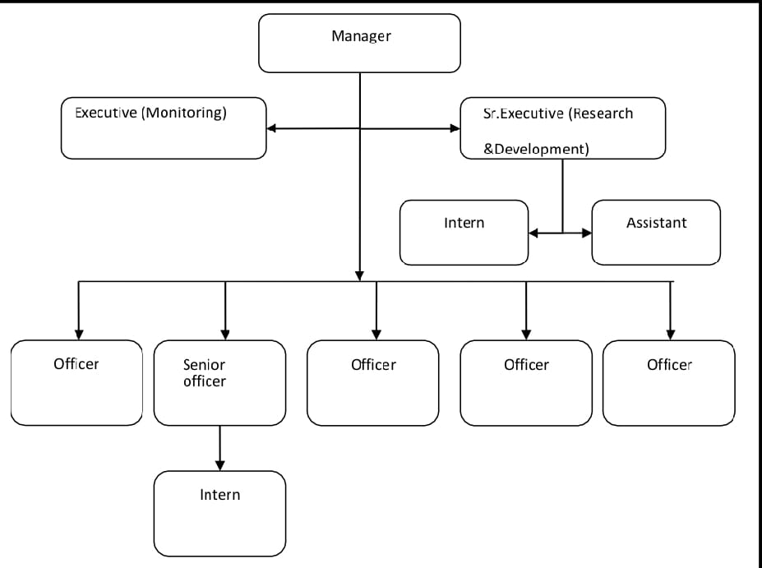
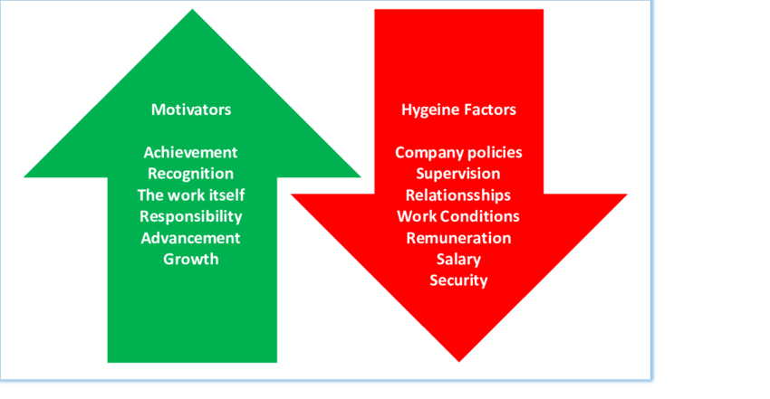
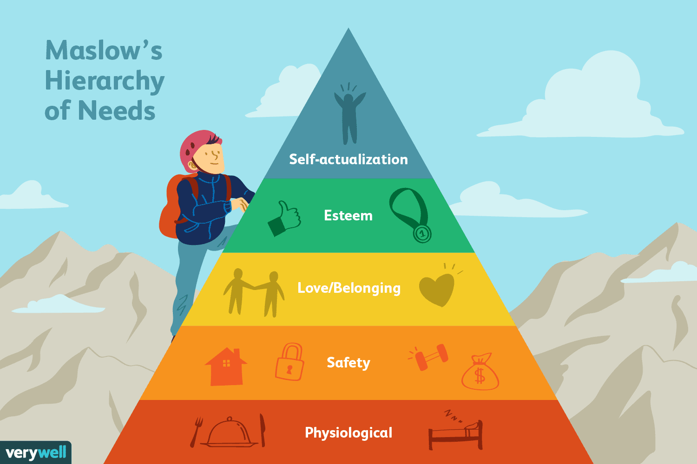

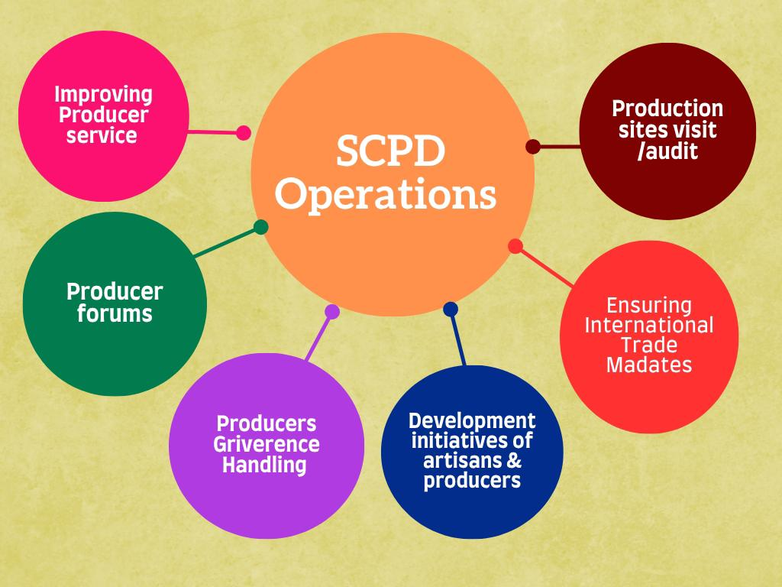

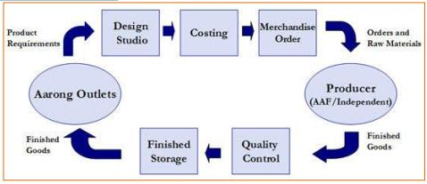

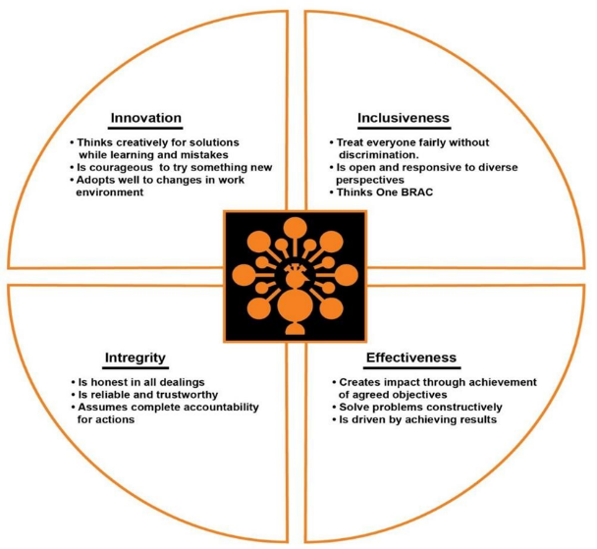

List of Acronyms & Abbreviations

Acronym | Full Form
AAF | Ayesha Abed Foundation
Aarong | Brand Name (Meaning 'Village Fair' in Bengali)
BBA | Bachelor of Business Administration
HR | Human Resources
HRM | Human Resource Management
HSS | Health Support Services
KPI | Key Performance Indicator
NGO | Non-Governmental Organization
PACE | Personal Advancement and Career Enhancement
PCCB | Producer Capacity and Capability Building
SCPD | Social Compliance and Producer Development
UIU | United International University

Chapter 1: Introduction of The Report

1.1. Background of the Study:

The handicraft sector is an important part of Bangladesh’s economy, employing thousands of artisans, particularly in rural communities. Many artisans, however, suffer from great obstacles in being able to succeed in this beautiful vocation. Low wages, lack of job security, and limited access to the market continue to limit these skilled people from making a living. This has led to artisans switching jobs at higher rates, and fewer people wanting to preserve traditional craftsmanship.

To overcome these challenges, the largest fair-trade organization in Bangladesh, Aarong has developed its Social Compliance & Producer Development (SCPD) department. With a strong focus on ethical working conditions and fair wages, this initiative is the driving force behind changing the way artisans work.

This study illustrates how Aarong’s SCPD contributes to Artisan retention and increasing productivity, identifying the key factors that influence their long-term engagement.

1.2. Purpose of the study:

The primary purpose of this study is to analyze how Aarong SCPD’s HRM practices and social compliance initiatives impact artisan retention and productivity. This report aims to evaluate the effectiveness of SCPD’s strategies in ensuring Artisans remain motivated, financially secure, and productive in their creative work.

1.3. Objective of the Study:
The specific objectives of the report are:
- To analyze the role of SCPD in Producers and Artisan Retention to understand the strategies Aarong implements to ensure Artisan continues working with them for the long term.
- To evaluate the functions of HRM on Artisan productivity for examining how training programs, compensation and engagement initiatives contribute to artisans’ efficiency and quality work.
- To identify the key challenges producers and artisans face in financial, social and professional aspects which affect their retention and productivity.
- To investigate the producers' and artisans development training, social benefits and compliance which are introduced to support producers and artisans.
- To provide recommendations for improving artisans’ retention and productivity that Aarong can adopt to further betterment of producers and artisans.

1.4. Methodology of the study
This study follows a qualitative research approach with in-depth analysis of artisans’ retention and productivity. The methodology involves the following steps:
- Research Design: Exploratory, qualitative study focusing on real-life experiences of artisans and SCPD employees.

- Data Collection Techniques:
- Interviews: Conducted with artisans and employees from SCPD units such as PCCB, HSS, and Social Audit teams and HR team to gather in-depth insights.
- Observation: Observed the working environment and artisan engagement activities during the internship period.

- Data Analysis: Responses were grouped into themes such as recruitment, training, retention, and challenges for comparative analysis between artisans and SCPD and HR staff.
This structured approach ensures a deeper understanding of both perspectives employees and artisans while linking practical findings with HRM theories.

1.5. Sources Of Data:

- Primary Data:
- Face-to-face interviews with 30 artisans and 12 employees (SCPD and HR) of Aarong.
- Informal discussions during field visits to AAF centers and artisan clusters.

- Secondary data
- Aarong’s internal reports, HR policy documents, and SCPD compliance manuals.
- Academic literature including journals, books, and articles related to fair trade, artisan retention, and HR practices.

1.6. Scope of the study:

Though Aarong operates in multiple sectors including retail, marketing, supply chain, merchandising and so on, this study only focuses on Aarong’s SCPD department. The research only examines the HRM functions and social compliance and producer development strategies related to artisan retention and productivity.

1.7. Limitations of the study:
Although this study aims to provide useful insights, there are some limitations which need to be acknowledged:
- Limited access to internal HR data due to confidential policies.
- Time constraints which limited the number of artisan and producer interviews. Also, three months of internship is not enough to conduct the research broadly to gain more reliable data.
- Reliance on qualitative data due to less opportunity to collect quantitative data.
- Less accuracy of the results as artisans and employees might not feel comfortable sharing negative feedback.

Chapter 2: Literature Review

2.1 Introduction
Human Resource Management plays a crucial role in employee retention, productivity and overall organization success. But when it comes to labor-based industries where artisans and producers are dependent on fair wages and skill development, HRM functions become more critical. To understand the role of HRM in this type of industry and its impact on artisan retention and productivity research findings are given below along with relevant theories from textbooks and online journal articles.

2.2 Overview of HRM Functions
Human Resource Management (HRM) plays a critical role in enhancing employee productivity, motivation, and retention across industries. In the context of handicraft-based organizations like Aarong, HRM goes beyond conventional practices and touches on the livelihood, empowerment, and well-being of artisans. The sustainability of such enterprises heavily relies on effective HR strategies tailored to the unique needs of rural producers and artisans. This chapter explores the core HRM functions and relevant theoretical frameworks that help understand how HR practices contribute to artisan retention and productivity.

2.2.1 Recruitment and Selection:
Recruitment and selection refer to the process of attracting, screening, and choosing individuals who fit the organizational needs. A strong recruitment system ensures the right artisans are identified based on skill, experience, and potential.
According to Dessler (2020), “A well-structured recruitment process helps organizations build a strong and committed workforce.”
In artisan-based models, like Aarong, selection also considers craftsmanship, geographical accessibility, and training adaptability.
Fair and transparent recruitment increases trust, reduces exploitation, and encourages long-term association.

2.2.2 Training and development:
Training and development involve equipping employees with knowledge and skills necessary for their roles and future growth. For artisans, training is a continuous need due to evolving design trends, market expectations, and quality standards.
Noe et al. (2019) emphasized that “effective training programs lead to higher job satisfaction, improved performance, and long-term engagement.”
In artisan-based industries, skill-based training such as PACE (Personal Advancement and Career Enhancement) is crucial.
Continuous learning increases productivity and confidence, directly impacting retention

2.2.3 Compensation and Benefits:
Compensation is one of the strongest tools for motivating and retaining employees. It includes both direct financial rewards and indirect benefits like healthcare, housing, or education support.
Milkovich et al. (2017) highlight that “competitive compensation leads to higher satisfaction and lower turnover.”
For artisans, especially from vulnerable backgrounds, fair trade wages, timely payments, and healthcare schemes improve livelihood security and reduce attrition.

2.2.4 Employee Engagement and Motivation
Employee engagement refers to the emotional commitment an employee has toward their organization. Motivated employees are more likely to remain productive and loyal.
According to Kahn (1990), engagement is influenced by social support, meaningful work, and fair treatment.
Aarong SCPD uses initiatives such as recognition programs, newsletters, and feedback systems to keep artisans engaged.
Engaged artisans feel valued and thus contribute with more dedication and creativity.

2.2.5 Workplace Safety and Compliance
Ensuring workplace safety is a legal and ethical obligation of any organization. Compliance ensures that working conditions are humane, dignified, and transparent.
Robbins & Judge (2019) noted that “organizations with strong compliance and ethical policies retain employees better.”
In rural artisan communities, access to clean water, first aid, safe machinery, and harassment-free environments directly affect artisan satisfaction and commitment.

2.3 Importance of HRM in Employee Retention and Productivity
HRM maintains a vital position because it ensures both the retention of employees along their maximum productivity. Multiple research has demonstrated that human resource management practices directly affect employee retention:
- Employee Retention: According to a study by Cascio (2015), organizations that invest in training, fair wages, and career development have lower employee turnover.
- Job Satisfaction and Productivity: A research article by Pleffer (2018) found that companies with structured HR policies and employee-friendly work environments experience higher employee satisfaction and productivity.
- Fair Wages and Retention: According to a World Fair Trade Organization (WFTO) report (2021), artisans working under ethical trade policies have longer job tenures and better income stability than unregulated workplaces.

2.4 Theoretical Perspectives of HRM and Artisan Retention
To understand artisan motivation and retention, we must consider key psychological and behavioral theories.

2.4.1 Maslow’s Hierarchy of Needs
Maslow (1943) proposed that individuals are motivated by five levels of needs: physiological, safety, love/belonging, esteem, and self-actualization.
Aarong SCPD meets physiological and safety needs through fair wages and health coverage.
Belongingness and esteem are nurtured through engagement programs and recognition.
Skill development programs help artisans reach self-actualization by realizing their creative potential.

Figure1: Maslow’s Hierarchy of Needs, Source: https://www.verywellmind.com/

2.4.2 Herzberg’s Two-Factor Theory
Herzberg (1959) stated that motivation and hygiene factors influence job satisfaction. For artisans:
- Hygiene factors: Fair wages and safe working conditions prevent dissatisfaction.
- Motivators: Recognition, and skill development enhance job satisfaction and productivity.
Aarong SCPD addresses both:
- Hygiene: Clean, safe workshops, timely payments.
- Motivators: Training, performance recognition, artisan forums.

Figure2: Herzberg’s Two-Factor Theory

From the theories and literature discussed above, it is evident that a strong HRM framework centered on ethical recruitment, development, engagement, and fair compensation is essential for artisan retention and productivity. Aarong SCPD’s practices align with global HRM best practices and can be evaluated based on these frameworks to measure effectiveness and areas of improvement.

Chapter 3: Organization Overview

3.1. Organization Profile

BRAC was founded by Sir Fazle Hasan as a small-scale relief and rehabilitation project in Abed at Shallah Upazillah in the district of Sunamganj to aid returning war refugees following the Bangladesh Liberation War of 1971. It was first known as the Bangladesh Rural Advancement Committee (1972) and later named as Building Resources across Communities (2000).

Aarong, a handicraft marketing outlet, was established by BRAC to create jobs for low-income women. Education, agriculture and food, disaster relief, the environment and climate change, gender justice and diversity, health, nutrition, and population, human rights and legal aid services, integrated development, microfinance, social enterprise, socially responsible investments, addressing extreme poverty, water, sanitation, and hygiene, and other support programs are among BRAC's other programs.

In remembrance of the late Mrs. Ayesha Abed, Sir Fazle Hasan Abed's wife and coworker, the Ayesha Abed Foundation (AAF) was founded in 1982. The foundation serves as a production hub for Aarong and includes 12 Main Production Centres, including Manikgonj, Gorpara, Jessore, Jhenaidah, Pabna, Kushtia, Nilphamari, Baniachong, Rajbari, Kurigram, Sherpur, and Jamalpur, in addition to more than 658 sub-centers. Each main production centre contains 15–90 sub-centers, with 10–80 female craftsmen per sub-center. Each sub-center is overseen by a single person.

As one of Bangladesh's largest fashion retail chains under Aarong, one of the biggest fashion retail chains in Bangladesh and a subsidiary of one of the biggest non-governmental organizations in the world, supported rural craftsmen by investing in their handicrafts for a number of years. In the process, independent producers came into being, and thousands of craftsmen from areas outside of BRAC's service area were given the chance to earn a living. 85% of the more than 65,000 craftspeople it employs are female (BRAC-Aarong, 2015). In addition to leading BRAC's 16 social businesses, such as Aarong, BRAC Dairy, and BRAC Seed and Agro Enterprise, Tamara Hasan Abed is the senior director of BRAC businesses.
Aarong has created a special place in the market by connecting skilled artisans with new opportunities, offering hope and support to crafters. One of its big goals is to protect traditional crafts, which is a key part of its social mission. To keep this mission on track, Aarong set a strategic plan for 2017-2018 to figure out which artisan skills are fading and how to improve them.

Right now, Aarong runs 15 stores across Bangladesh, in places like Gulshan, Dhanmondi, Uttara, Moghbazar, Mirpur, Jamuna Future Park, Wari, Narayanganj, Sholoshahar, Halishahar, Khulna, Comilla, Noakhali and Sylhet. It also exports its products to countries like Japan, Nepal, and India in Asia; the UK, Italy, Netherlands, Spain, France, and Sweden in Europe; Canada and the USA in North America; and Australia and New Zealand in Oceania. Aarong once had a franchise called “Craft & Culture” in London, but it was later shut down.

3.2. Relation between Aarong and AAF:

The twelve subcenters, where the artisans work in various departments (hand embroidery, erri, weaving, washing, tailoring, value addition, metal, furniture, pottery, etc.), are overseen by the Ayesha Abed Foundation. The artists' creations are sent to Aarong's headquarters for quality assurance. Products that have been approved by QC are then sent to the Aarong outlet. The monthly wages of craftsmen, a 12% markup with cash costs for manufacturers, and a set health benefit fund are all funded by the income, which also goes to Aarong. The excess is used by BRAC for its development programs, which include Wash (sanitization), Alo (education), and Apon (child care).

Figure 3: Relation between Aarong, AAF and BRAC, Source: Brac University Studies

Vision of Aarong: A world free from all forms of exploitation and discrimination where everyone has the opportunity to realize their potential.

Mission of Aarong: To empower people of communities in situation of poverty, literacy, disease and social injustice. Their interventions aim to achieve large scale positive changes through economic and social program that enables men and women to realize the potential.

3.3. Core Values of Aarong
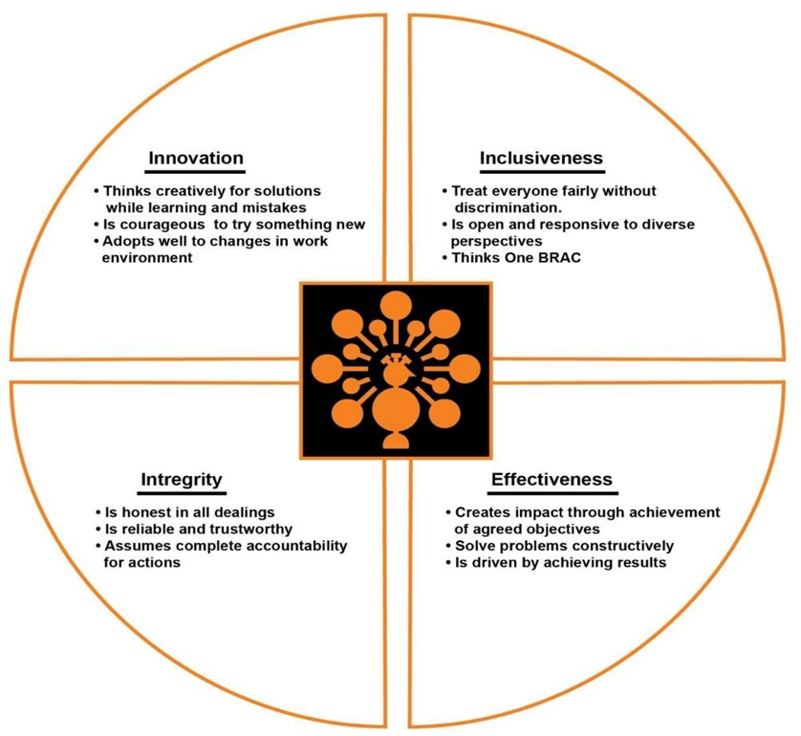
Figure4: Core values of Aarong, Source: Brac net

3.4. Product:
Aarong is well-known for promoting traditional Bangladeshi craftsmanship and ensuring fair trade practices for artisans. They support the livelihoods and existence of thousands of rural handicraft producers and artisans. These talented artisans create a diverse range of products for both local and international consumers. They are known for high-quality textiles, handicrafts and lifestyle products. With the help of a team of designers and more than 3,000 weavers nationwide, Aarong creates clothing for men, women, and children. The brand also has a jewelry department where skilled jewelers create sophisticated pieces that combine traditional and modern styles using gold, silver, and precious stones like diamonds. Other accessories, like bags and sandals, are made using materials like leather, jute, and bamboo. Aarong also offers pottery, vases, and sculptures made from wood, bamboo, brass, and clay. They also have dairy products which are quite well-known in the market and also produce natural beauty and wellness products which are yet to be established in the market. Here is a list of Aarong’s products:
Apparel
Their apparel line comprises of various categories products for men, women and kids of different ages and they feature both traditional and contemporary designs, crafted from high-quality fabrics like cotton, & silk.
- Men: The men’s section products varies from Punjabi to Shirt, Shawls, Kurta, Fatua etc.
- Women: The women’s section contains Saree, Kameez, Scarfs, Kurti, Three piece, Tops, Pants etc.
- Kids: Children garments section is almost the same as men and women just the products are of children’s sizes.
Handicrafts
Aarong offers a wide collection of handmade crafts created by the talented artisans. These crafts are often used as home decoration.
- Home décor: Showpieces, wall hangings, Tableware, Vase, Candles etc.
- Living: Furniture, Pillow, Cushion etc.
Accessories
- Jewelry
- Bags
- Wallets
- Purses
- Shawls

Beauty and wellness
- Organic Soaps
- Essential Oils
- Skincare Products
- Body Wash
- Face Wash

Dairy
Aarong is also making their way in the dairy market and has made a good progress. Some of the products are:
- Pasteurized milk
- Flavored drinks
- Ghee
- Yogurt

3.5 Target Customers of Aarong:
All social classes in our society are unable to afford Aarong's items due to their relatively high cost. Thus, the following are Aarong's target customers:
• The middle and upper socioeconomic strata
• International tourists and business travelers;
• Bangladeshis residing overseas.

Chapter 4: Overview of SCPD Operations at Aarong

4.1 Introduction of Social Compliance & Producer Development:
The Department of Social Compliance and Producer Development (SCPD) at Aarong serves as a crucial mechanism for upholding Aarong’s commitment to ethical production, fair trade practices, and artisan welfare. Established in 2009, this department ensures that both in-house and partner production operations follow labor laws, fair wages, compliance regulations, and sustainable practices. SCPD plays a vital role in supporting rural artisans and independent producers across Bangladesh through training, social audits, development initiatives, and grievance handling mechanisms.

4.2 Objectives of SCPD:
The core objectives of the SCPD department are:
- To ensure ethical and compliant production environments.
- To safeguard the rights and well-being of artisans and producers.
- To monitor and enhance production capacity and compliance standards.
- To foster a fair and supportive working relationship between Aarong and its independent producers or AAF units.

4.3 Operation Section of SCPD Department:
SCPD operates through multiple sub-units, each performing distinct yet interconnected functions. These include:
• Social Audit Unit – Evaluates compliance with labour laws, workplace safety, health standards, and environmental regulations.
• Producer Development Unit – Offers training, orientation, and capacity-building programs for producers and artisans.
• Field Operations – Coordinates health, safety, and support services for artisans under the Health Security Scheme (HSS).
• Research & Design Unit – Collects data, monitors performance, and develops strategies for continuous improvement.

4.4 Organizational Chart of SCPD:
The department is structured hierarchically with a Director overseeing all units, supported by Senior Executives, Executives, Officers, Assistants, and Interns. Each position has specific responsibilities such as audits, training facilitation, grievance tracking, or compliance documentation. Interdepartmental collaboration ensures smooth workflow across all production hubs.

Figure 5: Organizational chart of SCPD

4.5 Operation of SCPD:
Figure 6: Operation of SCPD

SCPD operates through multiple sub-units, each performing distinct yet interconnected functions. These include:

1. Social Audit Unit – Evaluates compliance with labor laws, workplace safety, health standards, and environmental regulations.
2. Producer Compliance & Capacity Building (PCCB) – Offers training, orientation, and capacity-building programs for producers and artisans.
3. Health Security Scheme (HSS) Coordinates health, safety, and support services for artisans.

4.6 Activities of each units:

PCCB (Producer Compliance & Capacity Building)

- Capacity Building: Aarong provides comprehensive training programs for its producers to enhance product quality and sustain its operating cycle. Since Aarong emphasizes reliability and customer satisfaction, it follows a zero-tolerance policy regarding any compromise on quality. For these purposes, the company performs several training programs and conducts Focus Group Discussions (FGDs) in a bid to improve production constantly and meet customers' needs.

- Training Evaluation: After conducting training programs, we assess their effectiveness by gathering feedback from producers. This evaluation helps manufacturers identify their mistakes and understand areas for improvement. By receiving timely feedback, they can quickly address concerns and enhance their skills, ensuring continuous development and better production quality.

- Producer Compliance: Grievance Handling: Producers raise a lot of social and development matters, which the SCPD responds to cautiously. Even if the issue is a social issue, SCPD takes responsibility for addressing matters that impact production and sustainability. The department keeps track of these issues in weekly sessions, consulting in consultation with experts to identify and study the cause. Committed to the services of their producers, SCPD creates thoughtful and effective solutions, choosing their principles and mandate to provide the best possible outcome.

- Producer Forum: The Producer Forum is a non-training initiative by SCPD designed to foster a positive relationship between Aarong and its producers. This platform allows producers to attend meetings and directly communicate their needs and complex concerns to the board in an organized manner. For managers, it serves as an additional channel to address supplier-related issues. Producers from various categories, as designated by the SCPD office, participate in these meetings. During these consultations, representatives from different agencies listen to suppliers, provide suggestions, and help structure solutions while addressing various challenges.

Social Audit
The SCPD carries out social audits to check if Aarong’s suppliers are following environmental laws. These audits review whether suppliers meet the required rules on health, safety, security, social and environmental standards, as well as management, finance, and organizational practices. Audit officers look at guidelines, laws, and policies to make sure they are correct and applicable. They collect information by visiting the sites, checking documents, and interviewing employees. After that, they compare this information with the necessary permits and regulations to see how well the suppliers follow the law.
Social Audit According to Labor Law:
Under the Child Labour Law of 14 years, it is permissible for employers to hire workers above the age of 14, but from the viewpoint of some, it is hardly realistic to expect this age group to complete voluntary school training. Aarong encourages part-time employment for children over 14, allowing them to go to school and work. The positive effect of such an initiative might come not only for the individual but also for society in promoting education and economic security.
Survey research investigates the fundamentals of good working conditions: safe drinking water, first aid kits, hygienic restrooms, fire extinguishers. These provide for healthy, safe working conditions. A healthy workforce, in turn, implies healthy families, thus helping society at large.
Fair wages, reasonable hours of work, and necessary labor protection are central to maintaining social justice. Comparison of the employees' salary with both industry standards and the minimum wage mandated by the state is made during regular analysis. It also mentions hours worked for comparisons and compliance. By additionally closely examining the worker's dependence on the top management and his knowledge about his rights, it aims to guarantee that discrimination is not practiced by the management in question.
The social audit of Aarong actively guards against discrimination at the workplace on the basis of race, social background, ethnicity, class, sexual orientation, political belief, marital status, or other factors. This is in line with Aarong acting responsibly as a social enterprise to work towards building an inclusive society.

HSS (Health Security Scheme)
The Health Security Scheme (HSS) is funded through monthly contributions from both the Ayesha Abed Foundation (AAF) and AAF artisans with the contributions being made to the Health Security Fund (HSF). Under this scheme, artisans and their registered family members are eligible for financial support when they visit empaneled medical facilities or designated medical units for treatment. The primary mission of HSS is to assist artisans with the expense of catastrophic health conditions so that they can receive medical attention they require without financial hardship.

4.7 Social Compliance policies:

Aarong strictly follows several Social Compliance Policies, which are monitored by the SCPD team to ensure proper implementation. These policies play a vital role in Aarong’s operations.

Environmental Policy
Aarong is committed to building a sustainable environment and following all environmental regulations and laws. For this, Aarong has an environmental policy that builds a balanced and green environment inside and outside the organization. The policy also has a proposed green development plan, which is based on sustainability and environmentally friendly practices in all its operations.

Penalty Policy
One of the important tasks of SCPD is to create a disciplinary policy. This policy will include the penalty rates for different types of manufacturing faults made by Aarong production centers and individual manufacturers. It will also mention penalties for late delivery. Currently, there is no written policy for this. Penalties are decided by the department head on a case-by-case basis. As a result, suppliers and production centers do not clearly know the exact fault limits they need to maintain during production.

Wage Reasoning Policy
The contract on wage deduction must clearly set out the basis on which wage deductions can be made, in accordance with national guidelines. It will serve as a reference in making it possible to establish that any deduction is permissible and justified as fair. For the maintenance of corporate and social justice, a salutary wage deduction must solidify the corporate attitude that sends a diplomatic response allowing the fair treatment of all employees without double standards in all circumstances.

Social Audit Policy
Analysis has been defined as an examination of an organization on its revenues and transactions, accounting books, taxation documents, and records of some payments and credits aimed at checking the accuracy and fairness of its financial statements and non-financial disclosures. In conducting the study, research was undertaken at a variety of units, with both independent producers and Ayesha Abed Foundation (AAF) factories visited. Information was gleaned from key aspects of health and safety, remuneration issues, the working environment, issues of child and forced labor, and individual hours and overtime practices.

Living Wage
Operating as a humanitarian enterprise, Aarong is committed to working to address the basic needs of its workers. The factory has as its highest goal the establishment of a living wage for its employees, fair remuneration that would encourage them to meet their most pressing expenses. To this end, Aarong entrusts the services of an outside consultant to assess appropriate living wages. The overall intention of the process by which wages were calculated was in such a way as to measure the basic necessities of the workers from a long-term sustainability perspective for generations. Under the guidance of an external consultancy group MCG, I was instructed to collect all necessary data and evaluate worker living allowance payment practices within their scope of the fair and sustainable wage.
Suppliers are not allowed to market their output to outsiders. Any finished product that does not meet with the approval of Aarong is stamped substandard, and is either relegated to the discounted category or sold out during the annual sale. Any strict penalties are designed to motivate the manufacturers toward the maintenance of quality; if for some reason a particular product fails to meet the quality standards, the producers will have to simply discard it. Accordingly, while Aarong does follow a systematic penalty regulation, it generally accepts unsatisfactory products under special conditions to support producers.

Wage Deduction Policy
Laws governing wage deduction should, therefore, regulate the procedures and instances of wage deductions, ensuring compliance with national labor laws. They should provide the framework and basis for honoring wage deductions and safeguards against unfair labor practices. An effective reduction approach is vital for establishing company-based and societal equity, thus catering to all the workers involved in an equitable manner under prevailing conditions.

Chapter 5: HR Functions of Aarong & Their Role in SCPD

Human Resource Management (HRM) at Aarong serves as a critical backbone for both its internal workforce and its external network of artisans. The HR department not only supports the staffing, development, and evaluation of Aarong’s organizational employees, particularly in the Social Compliance and Producer Development (SCPD) department, but also collaborates closely with SCPD to enhance artisan retention and productivity. This chapter discusses how Aarong’s HRM practices apply to both employee management and artisan development, with emphasis on recruitment, training, compensation, and retention strategies.

HR Role for SCPD employees

- Human Resource Planning:
Human Resource Planning (HRP) in Aarong ensures that the SCPD department has the right number of skilled employees to manage compliance, artisan development, and field operations. The HR team collaborates with SCPD management to forecast staffing needs based on seasonal demand, expansion of artisan networks, and compliance requirements. This proactive approach helps prevent shortages of field officers during peak production periods and ensures timely recruitment and deployment of resources.
Key Practices:

- Analyzing workload and future project requirements for artisan training and monitoring.
- Identifying skill gaps and planning internal transfers or new hires accordingly.
- Aligning workforce planning with Aarong’s long-term compliance and sustainability goals.

- Recruitment and Selection
Aarong’s recruitment strategy follows a formal, transparent, and merit-based approach. The HR department is responsible for identifying workforce needs, advertising job openings, conducting initial screenings, and arranging interviews in collaboration with the respective departments. For the SCPD unit, candidates are selected based on both technical expertise and alignment with Aarong’s ethical values. Preferred qualifications include backgrounds in human resources, development studies, social compliance, public health, or community engagement.
The selection process typically involves multiple stages, such as:
- CV screening to shortlist potential candidates.
- Written assessments (if applicable) to evaluate analytical skills.
- Panel interviews to assess communication, problem-solving, and field readiness.
- Final evaluation based on reference checks and alignment with BRAC-Aarong’s values.
Positions in SCPD often require candidates who are field-oriented, culturally sensitive, and empathetic toward artisans’ needs. Hiring decisions are guided not only by competence but also by a candidate’s capacity to uphold social justice and ethical business conduct.

- Orientation And Onboarding
Once hired, new employees, particularly those joining SCPD undergo a structured orientation program. This onboarding process includes:
- Introduction to BRAC and Aarong’s mission, values, and operations.
- Overview of SCPD’s functions, field responsibilities, and artisan-related programs.
- Detailed explanation of Aarong’s code of conduct, ethical practices, and labor standards.
- Field visit opportunities to observe artisan workshops and production centers.
Such orientation helps new employees understand the organizational culture, expected behaviors, and their roles in achieving social impact through compliance and development work.

- Training And Development
Aarong places a strong emphasis on continuous learning and capacity building. For SCPD employees, specialized training modules are offered that focus on:
- Labor law and legal compliance.
- Social auditing standards and reporting procedures.
- Grievance redresser mechanisms and conflict resolution.
- Artisan communication and counseling techniques.
- Health and safety regulations under the Health Security Scheme (HSS).
- Producer capacity building frameworks like PACE.
Training is both in-house and external, often involving collaboration with NGOs, legal consultants, or development trainers. Refresher training, workshops, and learning sessions are regularly arranged to enhance employee capabilities and adapt to emerging compliance requirements.

- Performance Management
Aarong applies a structured performance management system across all departments, including SCPD. Performance is evaluated periodically through formal reviews that consider both quantitative and qualitative outcomes. For SCPD employees, evaluation metrics may include:
- Number and quality of audits conducted.
- Timely resolution of grievances.
- Efficiency in organizing training programs.
- Communication and relationship-building with producers.
- Contribution to policy development or reporting.
The feedback system includes self-assessment, peer reviews, and supervisor evaluations. Constructive feedback is provided to encourage professional development and address performance gaps.

- Compensation and Benefits
Aarong offers competitive and equitable compensation packages in the accordance with internal salary grading and market standards. Employees in the SCPD department receive:
- Monthly salary and allowances.
- Festival bonuses and performance-based incentives (if applicable).
- Travel and field visit reimbursement.
- Access to health insurance and emergency medical support.
- Opportunities for career advancement through internal promotions or job rotations.
As a social enterprise, Aarong ensures that compensation reflects both employee value and financial sustainability.
- Employee Engagement and Working Culture

Aarong fosters a positive and inclusive workplace culture where diversity, integrity, and accountability are deeply valued. In SCPD, employees work in close contact with rural communities and artisans, requiring high levels of empathy, patience, and ethical behavior.
Regular team meetings, cross-departmental coordination, newsletters, and celebration of achievements are part of SCPD’s engagement practices. The department also encourages employee participation in producer forums, awareness campaigns, and community development initiatives.

- Performance Apprisal
Performance appraisal in SCPD is structured to evaluate employees based on both quantitative and qualitative indicators. Aarong follows a performance review system that includes self-assessment, supervisor evaluation, and sometimes 360-degree feedback. For SCPD employees, key performance indicators (KPIs) include:
- Timely completion of social audits and compliance checks.
- Quality and impact of artisan training sessions (e.g., PACE programs).
- Efficiency in grievance resolution and field-level reporting.
- Contribution to artisan retention and satisfaction.
Performance reviews are usually conducted annually, and outstanding performers are considered for promotions, salary increments, and recognition awards. The appraisal process also identifies training needs for skill enhancement and career development.

- Workplace Safety and Compliance
SCPD employees, especially those conducting fieldwork, are trained in workplace safety protocols. Employees are encouraged to follow safety standards during travel, field visits, and artisan interactions. Aarong’s HR team ensures that all compliance officers and trainers are aware of their responsibilities regarding both their own safety and that of the producers and artisans they serve. In addition to regular HR functions, Aarong conducts fire safety training every six months, and designated members on each floor receive specialized training to handle emergency fire outbreaks. Furthermore, all newly appointed employees undergo training on workplace safeguards to foster a safe, respectful, and harmonious work environment.

  - HR Role for Artisans

Although artisans are not formal employees of Aarong, the organization treats them as vital stakeholders in its ethical supply chain. Aarong’s Human Resource practices, in collaboration with the SCPD department, extend beyond internal staff management and encompass the welfare, development, and retention of over 65,000 artisans across Bangladesh. The HR department works closely with SCPD to ensure a fair, supportive, and growth-oriented environment for artisans.

- Recruitment and Onboarding
Aarong recruits artisans through the Ayesha Abed Foundation (AAF) and independent producer groups. The HR and SCPD teams collaborate with local communities and NGOs to identify skilled individuals, particularly women. After selection, artisans receive orientation on workplace rules, safety practices, fair wage policies, and grievance mechanisms.

- Training and Skill Development
The HR team supports SCPD in organizing continuous training programs such as PACE (Personal Advancement and Career Enhancement), which includes skill building, communication, financial literacy, and leadership development. These trainings enhance artisans’ productivity, efficiency, and confidence.

- Performance Monitoring and Support
While artisans are not evaluated through formal performance appraisals, HR helps establish informal systems to track attendance, quality of work, and production efficiency. High-performing artisans receive more work orders and are sometimes promoted to supervisory roles.
- Compensation and Welfare
HR ensures that artisans are paid fairly through transparent systems such as bank or mobile transfers. In addition to competitive wages, artisans receive bonuses during festivals and access to the Health Security Scheme (HSS) for medical support. The HR team also oversees wage structures aligned with fair trade and living wage principles.

- Engagement and Retention
To retain artisans long-term, Aarong promotes a culture of respect, inclusivity, and recognition. HR supports initiatives such as artisan forums, grievance redresser channels, and relationship-building activities to strengthen artisans’ emotional connection with the organization. Many artisans remain with Aarong for over a decade due to the sense of dignity, financial security, and development they experience.

Chapter 6: Description of My Responsibility in Aarong SCPD

During my internship in Aarong’s Social Compliance and Producer Development (SCPD) department, I had the opportunity to work closely with PCCB (Producer Capacity and Compliance Building), which plays a crucial role in ensuring the development, compliance, and well-being of Aarong’s artisans and producers. My responsibilities within PCCB were diverse, ranging from organizing training programs to managing grievances and assisting in day-to-day operations.

One of my key contributions was actively organizing PACE (Personal Advancement & Career Enhancement) training programs for artisans. PACE is designed to enhance artisans’ technical skills, financial literacy, communication, and leadership abilities, ultimately helping them improve their productivity and self-sufficiency. My role involved coordinating training sessions, managing logistics, and ensuring that artisans had access to the necessary resources for effective learning. By facilitating these programs, I helped artisans develop their skills and gain confidence, which directly contributes to both productivity growth and job satisfaction.

Another critical aspect of my role was grievance management. Artisans and producers often face
Challenges related to workplace concerns, payment issues, health and safety, or interpersonal conflicts. I was responsible for documenting grievances, assisting in resolving conflicts, and ensuring that artisans’ voices were heard. This process not only helped maintain a positive work environment but also strengthened the trust between Aarong and its artisans, ultimately contributing to retention and engagement.

Additionally, I assisted in various day-to-day activities within PCCB, such as monitoring compliance standards, ensuring that producers adhered to Aarong’s ethical guidelines, and supporting field visits to artisan workshops. My involvement in these activities allowed me to gain a comprehensive understanding of compliance frameworks, artisan challenges, and the importance of capacity-building initiatives in sustaining ethical production.

Overall, my experience in SCPD and PCCB provided me with valuable insights into how social compliance and producer development contribute to a sustainable and fair artisan ecosystem. It reinforced my understanding of HR compliance, grievance resolution, and training management, which are essential for fostering long-term artisan retention and productivity.

Chapter 7: Analysis of data and findings

This chapter presents the analysis of primary data collected through interviews with two distinct groups: artisans and SCPD employees. The interviews conducted with artisans, and SCPD staff provide profound understanding of the ways in which Aarong’s SCPD program affects artisan productivity, retention, and company expansion. Following a thorough examination of the replies received, this part presents important themes and insights along with practical conclusions

Target Groups:

Group 1: Artisans – 30 artisans participated in the interviews. They represent both Ayesha Abed Foundation (AAF) centers and independent producer groups.
Group 2: Employees – 12 employees participated in the interviews, including field officers, trainers, senior officers from SCPD, and HR department staff.

  - Data Collection Method:
Semi-structured interviews and field visits were conducted to gather insights from both groups. A separate set of questionnaires was used for each group to ensure context-specific responses.

Analysis of Artisan Responses

- Recruitment and Selection Process
Most artisans shared that they were introduced to Aarong through community leaders or existing artisans. They did not undergo formal written tests or interviews but were selected based on their existing skills, willingness to learn, and recommendations from local coordinators.
“A lady from the village told me about the job. I showed her my embroidery work, and the next week I was called to join a center.” –Lima, Artisan Interviewee, Manikgonj.

- Training and Development
All interviewed artisans confirmed that they received orientation training before starting production work. Many participated in PACE training sessions and technical workshops.
“I learned how to do proper finishing, maintain hygiene, and communicate with team members. I even started saving after financial training.” – Mahmuda Smrity, Artisan, Manikganj.

- Fair Wages and Financial Support:
Most of the artisans said they were happy with their pay and working conditions at Aarong. The Aarong SCPD’s prompt payments and financial stability greatly aid in the retention of artisans. Producers and artisans get special benefits for children’s education and medical expenses. Nonetheless, craftsmen said that pay raises would improve their work satisfaction even more, especially if they were in pace with inflation.
“I received funding for my daughter’s university tuition through Producers Wellbeing, which enabled her to pursue higher education at a reputable university.”–Most. Happy, Producer, Aarong.

- Artisan Engagement & Communication:
SCPD employees emphasized the importance of artisan engagement through recognition programs, feedback mechanisms, and regular communication. Both artisans and producers noted that feeling valued and recognized for their work made a significant impact on artisan motivation and productivity.

- Retention Experience and Motivation
A majority have been with Aarong for over 5 years, citing reasons such as job security, timely payment, respect, and access to health services (HSS). Artisans expressed emotional connection to Aarong and appreciated opportunities to grow within the centers.
“This is not just a job, it has become part of my life. They listen to us and help when we are in trouble.” – Kanij Fatema, Artisan, AAF, Kushtia.

- Artisan Retention Strategy
Most artisans expressed that they remain with Aarong for many years because of timely payments, respectful treatment, and continuous work opportunities. Health benefits (HSS), education support, and skill development programs strengthen their trust in Aarong. However, they suggested additional incentives like regular wage increases and festive bonuses to enhance retention further.
“I have worked with Aarong for over 10 years because I know they care for us and pay on time. If we had a little more bonus, it would be even better.” – Roksana, Artisan, AAF.

- Challenges and Areas for Improvement:
Although Aarong’s SCPD program has improved retention and productivity to a considerable extent, a number of issues still exist. These difficulties include managing peak workloads, adjusting for seasonal variations in demand and guaranteeing regular wage increases that keep pace with inflation.
“Sometimes, we don’t get enough work & sometimes we go through heavy workload that becomes hard to finish within deadline. When we don’t get enough order our artisans become demotivated to work with us as their salary depends on the orders”–Hosne Ara, Artisan & Producer, Aarong.

Key Findings (Artisan Group):
- Recruitment is informal but inclusive & easier for Artisans which also motivates new artisans to work with Aarong.
- Training is practical and impactful. It creates an effective & harmonious working environment for Artisans which increases their productivity.
- Some artisans noted that rising living costs impacted their financial security, while others found their income competitive with other sectors. Benefits like children’s education and Medical support enhanced their ability to provide for their families and meet daily needs.
- Recognized artisans were more committed and productive, but some wanted more frequent check-ins and one-on-one SCPD interactions to feel connected and empowered.
- Long-term retention is driven by emotional satisfaction, income stability, and benefits. Specially, regular medical support of artisans given by HSS has added extra values.
- Retention is driven by emotional satisfaction, fair wages, and extra benefits such as medical care and education support. Artisans suggested more structured rewards for long-term service.
- Seasonal swings in orders hit artisans and manufacturers hard, with craftspeople really struggling to make ends meet during quiet times. Some manufacturers think bigger sales networks and ramping up production could smooth out the busy seasons.

Analysis of Employee Responses

- Artisan Recruitment Approach
SCPD staff explained that recruitment is largely community-driven. Field officers maintain networks in villages and identify potential artisans during routine visits or through NGO partners. The focus is on skill, attitude, and willingness to work in a structured setting.
“We don’t take exams. We observe, talk, and assess their work in person.” –Most. Saima, Field Executive, SCPD

- Training and Artisan Development
According to employees, SCPD organizes PACE sessions quarterly. New artisans go through orientation on wage policies, safety rules, grievance reporting, and quality standards.
“Our job is not just training. We also monitor their progress and act as a bridge between them and management.” – Namia Jafor, SCPD Trainer

- Artisan Retention Strategies
Employees believe that retention is possible because Aarong builds trust and provides predictable income and support.
“Even in hard times, they stay because we treat them like family. When someone faces a family crisis, we often help beyond duty.” – Farhin Alam, Senior Officer, SCPD.

- Communication and Grievance Handling
SCPD employees play a vital role in addressing artisan grievances and maintaining two-way communication. Most centers have a grievance box or regular meetings where artisans can share problems confidentially. Field officers ensure complaints are documented and resolved promptly.
“We listen to every complaint, even if it sounds small. Sometimes, just listening makes a difference which helps to sort out biggest problems” – Kenny David, Deputy Manager, SCPD.

- Emotional Bonding and Relationship Building
Employees shared that creating emotional bonds with artisans helps increase trust and job satisfaction. Visiting artisans during personal crises, celebrating special days (like International Women’s Day), and engaging in informal conversations contribute to long-term loyalty.
“If an artisan’s child is sick, we often check in. That care makes them feel they matter to us.” – Tanusree Saha, Field Supervisor, SCPD.

- Artisan Retention Strategy
SCPD employees reported that retention is a core priority for Aarong, achieved through emotional bonding, consistent work orders, welfare schemes, and PACE training for personal development. They also said retention depends on maintaining artisans’ trust and addressing grievances promptly.
“We try to keep artisans engaged by giving them steady work and listening to their problems. If we lose trust, we lose them.” – Kenny David, Deputy Manager, SCPD.
The HR department also supports SCPD in designing welfare schemes, monitoring artisan satisfaction, and creating policies that ensure fair wages and safe work environments. HR also collaborates with SCPD to develop recognition programs and provide personal development opportunities that encourage long-term artisan engagement.
We design the policies, but SCPD brings them to life in the field. Their direct engagement with artisans helps us ensure fair wages, safe working conditions, and timely support.” – Sharif Rahat, Senior Officer, HR, Aarong.

- Challenges Faced in Field Operations
Employees mentioned several challenges they face in the field, including:
- Artisan absenteeism during harvest/festival seasons
- Difficulty reaching remote areas
- Miscommunication due to low literacy
- Resistance from family members (especially in conservative villages)
“Sometimes a talented woman isn’t allowed to work by her family. We try to convince them about the benefits.” – Tanjila Sarkar, SCPD Field Officer
Key Findings:
- Recruitment is informal but community-driven. Field officers identify artisans through local networks based on skills, attitude, and availability, ensuring inclusivity and practicality.
- SCPD emphasizes both technical and behavioral development through orientation and PACE programs. Employees also provide ongoing support and mentorship during artisans’ work lifecycle.
- Retention is achieved through emotional connection, reliable income, and social benefits. Artisans feel valued, especially during personal crises, which strengthens loyalty to Aarong.
- Open communication systems like grievance boxes and regular check-ins help artisans express concerns safely. Timely responses from SCPD enhance trust and workplace harmony.
- Personal interaction beyond work like celebrating events or checking on artisan families helps build strong emotional bonds and contributes to high job satisfaction and retention.
- SCPD employees also believe retention strategies like regular communication, skill development, and financial stability are crucial to keeping artisans loyal.
- Employees if SCPD often face cultural and logistical barriers, including illiteracy, seasonal absenteeism, and family resistance. Overcoming these challenges requires sensitivity and persistent community engagement.

Comparative Summary of Finding
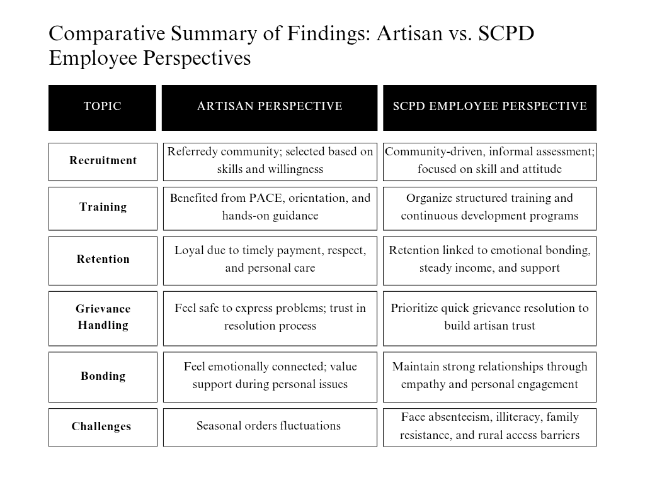

Figure 7: Comparative Summary of Findings

Chapter 8: Recommendations & Conclusion

Recommendations

Based on the data analysis and observations during the internship period, following recommendations are proposed to enhance artisan's retention and overall HR practices in Aarong's SCPD department.

- Standardize Artisan Recruitment Guidelines:
Although the current artisan recruitment process is effective at the grassroots level, its informality can lead to inconsistencies across regions. Developing a standardized recruitment framework including a basic checklist for evaluating artisan skills, attitude, and socio-economic conditions will ensure fairness, transparency, and consistency. It will also help new field staff follow clear procedures and minimize bias or personal judgment.

- Expand and Localize Training Modules
Artisan training programs like PACE and skill-based technical workshops have proven successful, but their frequency and content can be further customized based on local needs. Training should be more regular, and adapted to the specific craft type (e.g., embroidery, weaving, block printing), education level, and region. Additionally, more advanced training for experienced artisans could help them grow into roles such as trainers or production coordinators.

- Maintain Work Orders and Seasonal Modifications:
SCPD should put in place a forecasting system to anticipate demand trends and issue more reliable work orders in order to tackle the problem of seasonal swings. This will guarantee that during off-peak seasons, manufacturers and craftspeople won’t experience financial volatility. Furthermore, diversifying markets or developing seasonal product lines can support consistent output all year round.

- Encourage Career Progression Within Artisan Roles
To retain skilled artisans, SCPD can introduce defined growth paths. Experienced artisans can be trained and promoted to roles like lead artisan, peer mentor, trainer, or production coordinator. This will give them purpose beyond repetitive production work and reduce burnout or dropout over time.

- Implement Bonuses and Annual Wage Adjustments:
Concerns over the growing cost of living have been voiced by manufacturers and artisans. SCPD ought to think about introducing yearly pay raises that take inflation into consideration. Bonuses for achieving productivity goals or particular recognition for craftspeople who create novel or inventive items would help encourage employees to keep improving their job in addition to increasing retention.

- Boost individualized feedback and communication:
Clear and open communication is important to producers and artisans. The frequency of individualized feedback meetings, when manufacturers and craftspeople may voice problems, get guidance, and recommend enhancements, should be increased by SCPD. By creating more interactive avenues for feedback, like monthly check-ins or an online inquiry platform, craftsmen will be more engaged and inspired to increase their output.

Conclusion

The study highlights the critical role of Aarong’s Social Compliance and Producer Development (SCPD) department in promoting artisan retention through ethical HR practices, structured training programs, and welfare initiatives. Aarong’s people-centered approach emphasizing respect, timely payment, skill development, and social support has successfully created a sustainable engagement model for artisans, particularly women in rural areas. This approach has not only improved artisans’ productivity but also contributed to their socio-economic empowerment.

The findings of this report clearly indicate that Aarong’s artisan retention success lies in its empathetic and people-centered approach. The SCPD department, through its field teams, not only performs HR functions like recruitment, training, and monitoring but also goes far beyond by offering emotional support, building trust, and advocating for artisans’ welfare. Artisans, in return, demonstrate strong loyalty and emotional attachment to the organization.

However, the analysis also revealed areas that can be improved. The lack of formal documentation, inconsistent training coverage, and operational challenges in remote areas limit the scalability and efficiency of SCPD’s impact. By adopting the recommended changes like digitizing processes, formalizing policies, and expanding recognition and empowerment programs Aarong can further enhance its mission of sustainable and inclusive development.

Overall, Aarong’s SCPD model demonstrates how social compliance and HR strategies can intersect to create an inclusive and sustainable business ecosystem. Continued investment in structured policies, digital systems, and community engagement will enable Aarong to strengthen its leadership position as a socially responsible enterprise committed to artisan welfare and ethical trade.

Chapter 9: Bibliography/ Reference

Books & Journals:
- Armstrong, M. (2014). Armstrong's handbook of human resource management practice (13th ed.). Kogan Page.
- Aguinis, H. (2019). Performance management (4th ed.). Pearson.
- Blau, P. M. (1964). Exchange and power in social life. John Wiley & Sons.
- Cascio, W. F. (2015). Managing human resources (11th ed.). McGraw-Hill.
- Dessler, G. (2020). Human resource management (16th ed.). Pearson.
- Herzberg, F. (1959). The motivation to work. John Wiley & Sons.
- Kahn, W. A. (1990). Psychological conditions of personal engagement and disengagement at work. Academy of Management Journal, 33(4), 692–724. https://doi.org/10.5465/256287
- Maslow, A. H. (1943). A theory of human motivation. Psychological Review, 50(4), 370–396. https://doi.org/10.1037/h0054346
- Milkovich, G. T., Newman, J. M., & Gerhart, B. (2017). Compensation (13th ed.). McGraw-Hill.
- Noe, R. A., Hollenbeck, J. R., Gerhart, B., & Wright, P. M. (2019). Fundamentals of human resource management (7th ed.). McGraw-Hill.
- Pfeffer, J. (2018). Dying for a paycheck: How modern management harms employee health and company performance—and what we can do about it. Harper Business.
- Robbins, S. P., & Judge, T. A. (2019). Organizational behavior (18th ed.). Pearson.

Online & Industry Reports:
- World Fair Trade Organization (WFTO). (2021). The impact of fair trade on artisan retention and sustainability. Retrieved from https://wfto.com
- International Labour Organization (ILO). (2020). The role of ethical employment practices in sustaining the handicraft sector. Retrieved from https://ilo.org
- Aarong. (2023). SCPD social compliance & producer development report. (Internal documentation)

Chapter 10: Appendix

Interview Questions

For Artisans:
- Recruitment and Selection Process:
- How did you start working for Aarong as an artisan?
- What has kept you here, and how long have you been employed here?
- Have you ever considered leaving? If yes, what kept you here?

- Fair Wages and Financial Support:
- Are you satisfied with your pay at Aarong?
- Do you think the wages are fair and adequate for the work you do?
- How does your income from Aarong compare to other places you've worked?

- Training and Development:
- Has Aarong SCPD provided you with any training to help you advance your abilities?
- In what ways has this training improved your performance at work?
- To get better at what you do, is there a particular talent you'd like to learn more about?

- Artisan Engagement & Communication:
- Have you ever faced problems at work? Were they solved?
- Do you feel as a valued member of Aarong?

- Retention Experience and Motivation:
- What benefits have you received apart from wages?
- How long have you been with Aarong? Why have you stayed this long?
- Do you feel respected and supported?

- Retention Strategy :
- What makes you continue working with Aarong for so many years?
- What benefits or facilities do you value most in your work?
- Have you ever thought about leaving Aarong? If yes, what factors made you consider it?

- Challenges and Areas for Improvement:
- What difficulties do you encounter most frequently as an artisan?
- How can SCPD further assist artists like you?
- What adjustments might enhance Aarong's ability to retain artisans?

For Employees (SCPD team):

- Artisan Recruitment Approach
- How do you usually identify potential artisans in the community or village areas?
- What are the key factors you consider when selecting an artisan (e.g., skills, attitude, and availability)?
- Do you collaborate with any NGOs, community leaders, or producer groups during the recruitment process?

- Training and Artisan Development
- What types of training programs are offered to newly recruited and existing artisans?
- How do you assess the effectiveness of the training, both technically and behaviorally?
- In your experience, how do artisans respond to orientation sessions like PACE or health and safety modules?

- Artisan Retention Strategies
- In your opinion, what factors contribute most to long-term artisan retention in Aarong?
- How does SCPD support artisans during personal or financial difficulties to maintain their engagement?
- Are there any formal incentives or benefits provided to artisans who have been with the organization for many years?

- Communication and Grievance Handling

- What mechanisms are in place for artisans to report grievances or share their concerns?
- How do you ensure confidentiality and fairness while resolving those issues?
- Can you share an example of how resolving a grievance helped improve artisan motivation or trust?

- Emotional Bonding and Relationship Building
- How do you maintain emotional connections or personal rapport with the artisans you oversee?
- What impact do small gestures (e.g., visiting sick artisans, celebrating events) have on their morale and performance?
- Have you noticed any difference in loyalty or motivation between artisans who feel emotionally supported and those who don’t?

- Retention Strategy
- What policies does Aarong have to support artisan retention?
- How does HR collaborate with SCPD to improve artisan engagement and satisfaction?
- Are there any future plans to enhance retention programs for artisans?

- Challenges Faced in Field Operations
- What are the most common challenges you face while managing artisan centers in rural areas?
- How do you deal with artisan absenteeism during seasonal or festival periods?
- What strategies do you use to overcome social or family resistance against women’s participation in artisan work?

