Brand Marketing of Akij Food and Beverage Ltd

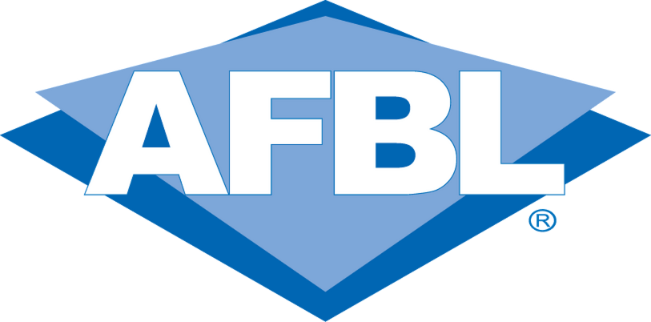
  - Prepared by Ishtiaque Moinul Islam

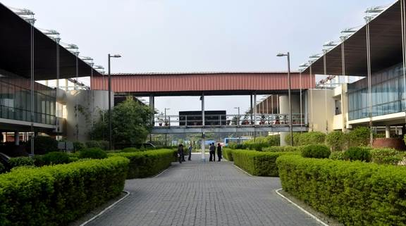
  - Internship Report on
Brings Quality in Life


Internship Report
On
Brand Marketing of Akij Food and Beverage Ltd


Submitted to

Dr. Seyama Sultana Ph.D.
Assistant Professor, School of Business
United International University

Submitted by
Ishtiaque Moinul Islam
ID# 111 151 215
School of Business
United International University
Trimester: Summer 2018

Date of Submission:

16th September, 2018

16th September, 2018

Dr. SEYAMA SULTANA, Ph.D.
Assistant Professor
School of Business
United International University, United City, Madani Avenue, Satarkul, Badda, Dhaka 1212

Subject: Request for Acceptance of the Internship Report on “Brand Marketing of Akij Food and Beverage Ltd”.

Madam,
I have the pleasure to submit my internship report on Akij Food and Beverage Ltd. In conformity with your given instruction, I have prepared a fair and informative report on Brand Marketing of Akij Food and Beverage Ltd.

I tried my level best to apply the theoretical concepts in real life working situation. I have thoroughly enjoyed while preparing this report as a partial requirement of the internship program. I will be very much obliged to provide you with further information in case if you need any clarification and queries,

Regards,
Ishtiaque Moinul Islam
ID: 111 151 215

Declaration Statement

I hereby declare that all the information about the mentioned organization, Akij Food and Beverage Ltd, is true and valid. They were added with utmost honesty and integrity. I also declare that this report is free from plagiarism. Any statements from outside sources have been appropriately acknowledged throughout the report.

In addition all the observations, findings, recommendations, analysis, and designs incorporated in the report are formed from my own personal views, and opinions. I apology for if there are any kind of mistakes made with no intentions.

________________________
Ishtiaque Moinul Islam
ID: 111 151 215

Acknowledgement
I would like to take this opportunity to thank everyone who has helped me complete this report.
My special regards go to Dr. Seyama Sultana (Ph.D.), Assistant Professor of School of Business, United International University; for guiding me throughout completion of this report. Her continuous support and monitoring during the project has helped me tremendously to accomplish this task. I am extremely humbled to have received the opportunity to work on this topic and it has helped me gain a practical knowledge of the corporate workplace and has helped me in attaining practical knowledge.
I would also like to thank Mr. Hindol Roy, Head of Marketing of Akij Food and Beverage Ltd (AFBL), Mrs. Tuhin Sultana, Brand Manager of AFBL, Aziz Abdul Aziz Assistant Brand Manager, Mr. Redwan Noor Ullah, Senior Executive, Brand Marketing, Rezaul Karim, Senior Executive, Brand Marketing, Motiur Rahman Senior Executive, Brand and all the employees of Brand Department who took out their time from their busy schedule to guide and provided vital information for this report.
Lastly, but most importantly I would like to thank my family members especially my sister who always supported me not only this report but throughout my education.
I obviously enjoyed working on this report and have gained invaluable knowledge in the internship program, and hope that the report will be appreciated.

Executive Summary:
Akij Group is one of the largest conglomerates of Bangladesh Industry and continuously diversifying its business activities. Akij Food and Beverage Ltd, is a concern of Akij Group established in year 2006 by founder Late Mr. Sheik Akij Uddin. I had the golden opportunity to work for three months in this big organization. This report is based on the Brand Marketing of Akij Food and Beverage Ltd. This report shows the brand activity, branding campaign, advertisement campaigns of brand department and also the glimpse of activities of other departments as well. The first part of this report shows the detailed overview of company Akij Food and Beverage Ltd, company’s glorious history, its products and services, its hierarchy of management, company’s mission visions and morale. The second part shows the job responsibility I was assigned to in the brand department while working for last 3 months and my personal observations. The third part is about my findings and analysis from my personal observation. The final part is the conclusion and my recommendation; I have tried to provide some recommendations out of my personal view which might be helpful in this report. Although this report is not a 100% perfect but still the information included are added with integration and well informative.

Table of Contents
Chapter 1: Introduction: …….………..…………………………………….………………………………………….…………......1
Introduction: 1
Theoretical Background: 2
Marketing and Branding: The difference 2
What is brand? 3
Are Brand and Product same? 3
Why brand is so important? 3
Objective of the report: 5
Scope of the Study: 5
Limitation of the study: 5
Chapter 2: Overview of the company: ………………………………………………………………………………..……………7
Industry Overview: 7
Overview of the company: 8
History: 9
Mission Statement: 9
Vision of AFBL: 9
Goal: 10
Core Values of AFBL: 10
Organizational Structure of Akij Group: 10
Hierarchy of the Organization 11
Product and Services: 12
Service Offering: 14
Figure: Service Blueprint of Aladdin 15
Chapter 3 : Job Responsibility and Observation: ………………………………………………………………………...…16
Job Responsibilities and duties: 16
Observation: 19
Chapter 4 : Analysis and Findings: ………………………………………………………………………………………..………..22
Findings: 22
Chapter 5: Conclusion and Recommendation: ……………………………………………………………………………….25
Conclusion: 25
Recommendation: 26
References: 28
APPENDIX: 29

Chapter 1: Introduction

Introduction:

This report is about the organization Akij Food and Beverage Ltd (AFBL), which is a sister, concern of Akij Group. This report solely focuses on the brand marketing and brand department of AFBL. This report is based on the three months of Internship period of mine where I was assigned in the real working environment. The purpose of this report is to show the real process of branding and marketing strategy of AFBL. To do the Internship program under this organization was a requirement for my BBA program. This Internship program was designed in such a way that as a trainee a student can experience the real life working environment in a reputed company. While working in the company a student can implement his theoretical knowledge which he gathered for last four years in his university’s learning period and compare this knowledge to the practical ground. This helps him to find out the similarities and the differences between his theoretical knowledge and practical work. Learning and working is definitely a fun job especially when a student knows what he is doing and he is able to apply his learning in his work. The head office of Akij Group is located at Akij House 198, Bir Uttam Mir Showkat Road Gulshan Link Road Tejgaon Dhaka. This is where the main office of AFBL is situated and all the work of AFBL is directed from here. AFBL is a business unit of Akij Group and its business is production of food and beverage as commodities item for the mass consumer. The details of AFBL are described in the company overview chapter.

Theoretical Background:
Before we start at first we need to be clear of on what theoretical background this internship report really falls. As this report emphasizes on the Brand marketing of AFBL, we need to first understand the basic theoretical knowledge of Brand. We need to know what is brand and why it is important to both consumers and the business firm.

Marketing and Branding: The difference
Where Marketing ends Branding begins
There is a common misconception of mixing up branding with marketing. Branding goes deeper than the marketing activity.
Marketing is vast and wide sector. Marketing is the tool marketer utilizes to promote their brand. As the product and services change continually marketing tactics will also change and evolve. Marketing will be directly targeted towards specific target and segmentation as well as supporting your values and identity of your brand.
Branding is not same as marketing. This is because Branding is the core of marketing strategy. Your marketing strategy might change and evolve due to industry and cultural change but branding will remain the same. Even before marketing methods, tactics, tools strategy you need to clearly define your brand first. This is because your brand is the foundation on which consumers’ loyalty will be build up as they will be coming back to your brand. For example if we think about fast food chain KFC, it is the brand value of KFC for which customers coming back even generation after generation. If you modify your brand for market growth or expansion of market, but your brands core values and principle will remain same. Branding is not only the reflection of your desired consumer’s personality but it is the sum of commitment to its quality, customers, society, convenience, communication and forever satisfying consumers’ needs and wants.
As competition as become vigorous and fierce, while rival companies are offering similar products that can be used as substitute or even exact products. It is the brand that can save you from this competition and success can be far more everlasting.

What is brand?
We can say that a brand is name, sign, symbol or design or all of these combinations only to distinguish the goods or service of one business and differentiate them from those of the competitor’s company. This definition is derived from the definition by American Marketing Association (AMA). The concept of branding was there for centuries and used to differentiate the goods of one maker from another. The word brand came from the Old Norse word brandr which means “to burn”. This is because in the past the owners of cattle used to mark their animals with hot burning sign to identify them. In short whenever a new name or logo or symbol is created for a new product or service, this becomes a brand. In present time the managers refer brand as more than that. In modern days a brand is something which has created a certain amount of awareness, status, goodwill, reputation and distinction in the consumer’s mind and marketplace. In one word a brand is the reflection of consumer’s personality.

Are Brand and Product same?
So are the brand and product same thing? Although its might seem similar but there is a huge space between their meaning. A product can be anything in the market that satisfy our need or want by means of acquisition, usage or consumption. So a product is a tangible thing or a physical, for example a bat, or automobile, food and drink, or even a service like banking, departmental store etc. On the other hand a Brand is more than a product. Unlike product brand is way ahead than just satisfying need. It holds the product’s unique performance, intangible and emotional and symbolic things related to the product. For example a branded product can be Sony television, Ferrari automobiles, or celebrity person like Brad Pit, Mark Zuckerberg etc.

Why brand is so important?
Obviously the question can rise up why brand matters? What makes it so valuable to the marketers? Brand plays a vital role for two different parties. Consumer and the firms

Consumers: and serves an important function to the consumers. Brand helps consumer to identify the source of producer of the particular product. Because of branding and marketing consumer can figure out which brand can fulfill their desired needs and wants and which does not. Thus this simplifies a consumer’s decision making process before a purchase. If a consumer what to buy something he or she doesn’t need to waste time engaging in lot of research for a product decision. So economical way it also reduces the consumer’s search cost.

Firms:
Brand also serves number of important functions to its firms. A brand gives a firm its product identification which simplifies product handling. It also helps to keep track of inventory and accounting records. Most importantly a brand provides a firm a legal protection for special characteristics of its product. For this it can be protected via registered trademarks, manufacturing by patents and packaging by copyrights. A brand creates distinct identity to a product and this makes the investment of the firm safer. As brand provides a certain level of satisfaction to its buyers this create a brand loyalty among the buyer. This brand loyalty ensures a security for the firm and makes it difficult for a new firm to enter the market.

Objective of the report:
- Broad objective:
The main objective of this report is to apply my theoretical knowledge of marketing and gain the working experience of AFBL by learning how AFBL brand department works and apply various promotion strategies.

- Specific Objectives:
  - To understand how the functions of Brand department of AFBL is done.
  - To relate the theoretical knowledge of branding with the real life brand promotion campaigns done by the brand department of AFBL
  - To find out the advertisement campaigns of AFBL
  - To find out what is the secret way of branding that makes the AFBL brand so popular in the market.
  - To understand the various brand activity done by the brand department of AFBL

Scope of the Study:
This report mainly covers the activity and operations of Brand Department of AFBL. The scope is mainly from the gathered information and experience of my observation under the supervision of the current employees of Brand Department of AFBL, a unit of Akij Group.

Limitation of the study:
Due to limitation of time and scope it was not possible to write a perfect flawless report. This is because 3 months are not sufficient enough to study the vast marketing activity of such a large company. Although I have tried my level best to provide the required information as much as possible with the help of the employees, but still there are some limitation I have faced to complete this report during my internship period are given as followed:
- Three months or 90 days are not sufficient time to completely study the vast marketing activity of this organization.
- Sources of collecting data were very few.
- Interns are prohibited to obtain the confidential official documents and information because of confidentiality.
- The insufficient access to information has interrupted the scope of study and analysis required to complete this report.
- Employees of AFBL remain busy on their duties most of the time so they cannot give time for consultation.
- Every organization has its own confidential information those are kept secret and not revealed to outsiders. So confidentiality of information is another barrier of conducting this study.
- Employees do not hand over the confidential information.
- Sometimes too much rush for work and assigned duties refrain me from gathering data.
- Information collection of the competitors and market was also difficult.
- Published information was not up to date.
- The official website of the company does not have enough information needed and not well designed.

However apart from all these constraints this report still have some information that will help us to study more about Akij Food and Beverage Ltd.

Chapter 2: Overview of the Company

Industry Overview:
The food industry is vast. In recent times, this food industry under FMCG in Bangladesh has been growing tremendously. As usual the demand for any food products is always there in the market. But as the population on Bangladesh has grown rapidly the consumption and demand of packaged food is huge. The diversity of innovative food products has evolved all over the market as more and more companies have entered this industry. In past the industry scenario was not like this. With the huge potentials of capturing market share in this industry competition has raised among the existing companies as well as threat of new entrance is also there. The current food industry is dominated by Pran-Rfl Group. With most of the variety of products are produced by the Pran-Rfl from bakery food to juices and beverage items their versatility of products range has helped them to dominate this market. They are the one of the licensee of world famous soft drink brand Coca-Cola after Abdul Momen Group. Another Famous international brand Pepsi’s licensee is Transcom Group. Talking about soft drinks Akij food and Beverage ltd is also in the competition with their brand Mojo and Clemon. As the consumers’ lifestyles have developed in our country people are more into ready-made packaged food. The demand for bakery products is huge. Here Pran-Rfl is leading this sector with their brand “All-Time”. Other companies are serving this bakery sector, they are the old Nabisco, FU-Wang, Haque Bakery, Danish and the new Square Food and Beverage, Dan Cake company etc. But on bakery item Akij Food and Beverage Ltd is on behind. In energy drink market the Globe Soft drinks & AST beverage Ltd has their very popular brand “Royal Tiger”. But now Akij Food and beverage is hugely popular in market of energy drinks with their brand Speed is one of the top brand in the market. Not only that for Pran’s juice brand “Frooto”, Akij Food and Beverage ltd had also given a tough competition with their brand juice brand “Frutika”. But there is a new entrance of a food company in the market, brought by the Meghna Group of Industry. Although this is an old company but new brands in the food market like “Gear” energy drinks, “Soul up” and “Fresh” mineral water and “Fresh Mejanda” there is potential competition in this industry. For Dairy products there are market leader “Milk Vita’ following “Pran Dairy”, “Aarong Dairy” and AFBL’s “Farm Fresh”.
The food industry of Bangladesh is enormous and talking about it will not end. Here the few companies related to Akij food and beverage ltd was mentioned only.

Overview of the company:
Akij Group of industries is one of the biggest conglomerates in industries of Bangladesh. Besides being one of the oldest industries it is still continuing its business operations successfully. The 50 years old company consistently established its confidence over the year. It has twenty four big concerns. This includes tobacco, plastic, textiles, food & beverage, cement, matches, printing and packaging, ceramics, pharmaceuticals, consumer products etc. More than fifty thousand people are employed here and cared as family member in this company. Akij Group is one of the country’s highest Tax payer contributing 2 percent of national budget and development of the country. The Akij Group is proud for its top quality and excellent service by providing value to its customers at the same time never stopped from the aim of making profits. Akij Food and Beverage Ltd also known as AFBL is one of the business unit of Akij Group which is worth 70 million dollar. In the year 2006 Akij Food and Beverage Ltd started its journey as result of visionary concept of Late Mr. Sheikh Akij Uddin. The main business of AFBL is manufacturing wide range of snacks and beverage for both domestic and foreign markets like South East Asia, Easter Asia, Middle East and Africa. AFBL mainly produce snacks and beverage items like fruit Juice, dairy products- pasteurized milk and butter, chips, carbonated beverages like soft drinks, energy drinks, fruit bar, drinking water. The factory is located at 50km outside capital the Dhaka Krishnapara, Dhamrai, covering above 100,000 square meter area. AFBL was built with the most modern European technology for processing and packaging which includes the only Aseptic Filing line in the entire country as well as subcontinent. Machineries and packaging are done by world famous brands like Tetra Pack, SIG, Crones, providing the best quality for its consumers. The capacity is at the ground breaking rate of 1900 BPH with annual sales volume of around US $ 5 million to US $10 million and export percentage of 21% to 30 %. With the food industry becoming more competitive AFBL has won the utmost satisfaction of the customers by producing best quality products and substantially became a threat for both local and foreign brands in the country within a very short period of time.

History:
The Akij group was founded by Late Mr. Sheikh Akij Uddin half a century back in the 1950s who was the Founder, Entrepreneur, a Visionary and Lifetime Chairman of this company. Because of poverty Akij Uddin could not attend any formal education. It all started from a simple way of Jute trading which was known as the golden fiber of Bangladesh back in the late 1940s before the tobacco business. In his childhood Sheikh Akij Uddin left his home at age of 13 to Calcutta carrying only TK 16 with him. By selling oranges near Hawra Bridge he gathered little savings and with that he bought a mobile grocery cart and started selling for 6 paisa. Later in 1952 at Bejerdanga Rail Station he opened a tobacco shop and started selling tobaccos that later turned into one of the biggest tobacco company of Bangladesh. After several turn of events later in 1950s in the town of Navaron Bangladesh, the biggest tobacco factory was built. This started with a single brand of cigarette which is famously known as AKIJ BIRI. Soon this brand became well known product across the country and abroad as well. Later in the 1970s the Government decided to disinvest and hand over the tobacco industries to private sector. With the success of the brand Akij Biri, the Akij Group formed The United Dhaka Tobacco Co Industries. After that Akij Group started booming to its peak by diversifying its business in variety of product line. In very recent time United Dhaka Tobacco Co was sold to Japan Tobacco for US $ 1.5 billion deal which is one of the nation’s largest acquisition transactions by a foreign company.

Mission Statement:
To deliver quality food and beverage to the market thus bring quality to the life of the consumers by fulfilling their needs.

Vision of AFBL:
According to Visionary Entrepreneur Late Mr Sheikh Akij Uddin, he quoted “We will not only manufacture and provide high quality products in the market for consumers but also for our family’s usage as well; and thus not to let our family to consume foreign products”. So this was his vision regarding AFBL that is to be the number one pioneer brand in food and beverage industry in terms of quality, excellence, marketing creativity, honesty and proper service to the consumers by means of commitment and effort from our employees of AFBL.

Goal:
To gain profitability by means of acquiring the market share and create strong brand position in consumers’ mind.

Core Values of AFBL:
- Innovation and Transformation
- Teamwork and Cooperation
- Integrity and Righteousness
- Customer Focus
- Trust and Respect

Organizational Structure of Akij Group:
Each business unit of Akij Group has its own directors. The directors are the successors or children of founder Late Mr. Sheikh Akij Uddin. Akij Group has a bureaucratic working environment where the decision making process is very much centralized from Top level Directors. The hierarchy is shown graphically on next page.

Hierarchy of the Organization

Product and Services:

Product Line | Brand | Size (SKUs)
Cola | MOJO (Mojo Diet, Mojo Zero Cal) | 150ml can, 250ml pet and can, 500ml pet, 1litre pet, 2litre pet
Cloudy Lemon | Lemu | 150ml can, 250ml pet and can, 500ml pet, 1litre pet, 2litre pet
Orange Drink | Twing | 250 ml Pet
Clear Lemon | Clemon  Clear Up | 150ml can, 250ml pet and can, 500ml pet, 1 liter pet, 2 liter pet
Energy Drink | Speed,  Houston,  Hero (Discontinued) | 250ml pet and can  250ml Can  250 ml pet
Spicy Drinks | Aafi Jeera Pani  Clemon Masala | 250 ml Pet  250 ml Pet
Mineral Water | Spa, Rivera, Aafi | 500ml pet, 1 liter pet, 2.15 liter pet, 5 Liter pet
Juice | Frutika (Mango, Red Grape, Apple, Orange, Pineapple. Guava, )  Aafi (Mango drink; Ziraa Pani) | 125ml Tetra Pack; 250ml pet, 250 ml & 500 ml tetra pack and pet, 1 liter pet
Dairy | Farm Fresh UHT milk  Farm Fresh UHT milk ( Mango flavored, Chocolate flavored)  Farm Fresh Pasteurized Milk  Farm Fresh Ghee  Farm Fresh Butter  Farm Fresh Powdered Milk  Farm Fresh Yoghurt (Sweetened, sour, low fat) | 200ml and 500 ml tetra pack  200 ml  0.5 Liter, 1 Liter  200gm, 450gm, 900gm  200gm  100gm, 500gm
Malt Beverage | Wild Brew | 250ml can
Snacks | Cheese Puffs, O’ Potato (Vegetables Masala, Magic Masala)  Aafi Chanachur | 15/30gm Foil pack
Fruit Bar | Aafi Mango Bar | 15 gm

Service Offering:

“Call Aladdin” - Home delivery Service:
Call Aladdin is the home delivery service brand of Akij Food and Beverage Ltd. By delivering the service of all products as well as daily commodities of Akij food and Beverage Ltd, the main goal is to reach the pinnacle as a top brand of the country. The service standard operating procedures are following:
- Customer can place order of the product through the call center by dialing hotline no 16609 or toll free no 08000016609 or via Facebook or through website of Akij Food and Beverage Ltd.
- The lowest order value is 1000 Taka
- Even if there is one or two product out of stock for a single order and ordered value is less than 1000 Taka, in that case order will be also delivered.
- Customer will enjoy 10% discount from the retail price of the product.
- Except Friday, all the days are open for receiving order.
- The product will be delivered within 12 working hours after an order is placed. In case of buyer’s urgency to avoid cancellation of that order instant product delivery will be taken.
- In case of unavailability of company’s own transport, order will be delivered by hired transportation services. For that, CNG, Uber, Pathao Car, Pickup Van can be hired.
- On buyer’s demand, product can also be delivered from open carton. (From AFBL Panthopath Depot)
- Initially instant cash payment is being taken from the buyer after delivering the product. But later P.O.S mobile banking and other online facilities will be provided.
- Cash deposited from sales will be followed up regularly by accounts and finance department.
- At first Product will be delivered within Dhaka Metro Area (Uttara, Bashundhara, Badda, Khilgaon, Jatrabari, Puran Dhaka, Mohammadpur, Zigatola)

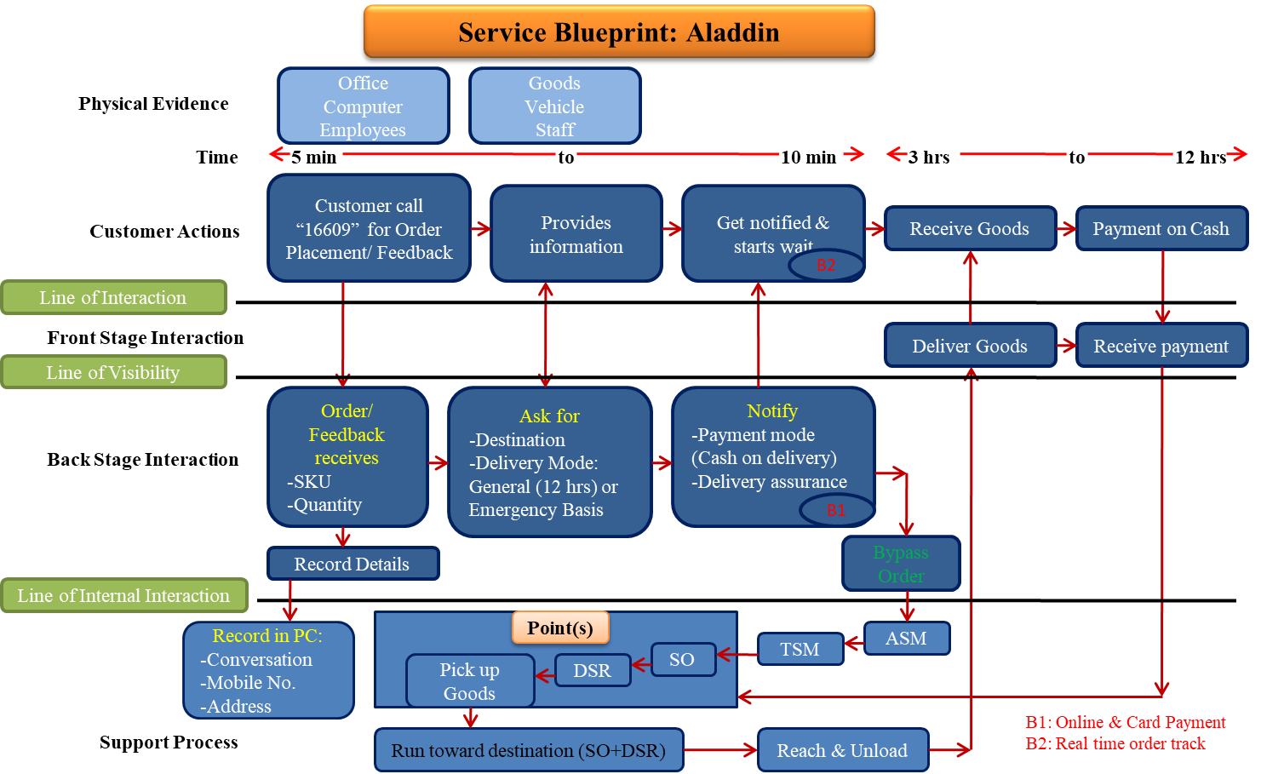

Figure: Service Blueprint of Aladdin

Chapter 3: Job Responsibility and Observation:

Job Responsibilities and duties:
I had this opportunity to work in Akij Food and Beverage Ltd. The department in which I was assigned was Brand Department and I had this golden opportunity to witness their marketing activities. I worked there for three consecutive months as Intern as it was part of this educational program. During this period I had to go through various types of tasks and duties.
On the first day of my joining I was introduced to the Marketing Head of AFBL Mr. Hindol Roy. He assured me full assistance in case of any problems. I was assigned under Brand Manager Mrs. Tuhin Sultana and under supervision of a Senior Executive of the Brand Department name Redwan Noor Ullah. The brands he looks after are ‘Frutika’ and ‘Sip It’. The brand department performs the marketing activities which are executed by the respected Senior Executives for each Brand. Each Senior Executives look after each brands. For example ‘Aafi’ and ‘Farm Fresh’s, ‘Speed’, ‘Spa’ and ‘Houston’, ‘Mojo’ and ‘Twing’, ‘Clemson’s branding are done by each senior executives. As an Intern I had the opportunity to work almost with every brand executives. Not only in the Brand Department but I also had the chance to work with Design, Media, Digital and Research Department even a bit of HR as well. But most of my work was with the brand ‘Frutika’ as I was assigned there for.
Initially being a newcomer in this organization every work seemed to be new and difficult for me. Later as days passed, by support of my supervisor and other fellow employees and executives I quickly learned their style of work. Getting used to the environment and work increased self-morale and boosted my motivation. Without AFBL employees it would not have been possible.
Not to mention that the AFBL’s core marketing lies especially on the Brand Department. In my last three months of Internship I did few of the jobs related to the branding and marketing of AFBL’s brands.
Some of the jobs related to branding which I had done are given below:
- Photo copying, Scanning, Printing of Important Documents

- Emailing

- Taking important signatures from authorities

- Checking Sales Report (Volume Wise) Frutika Brand

- Calling ASM for monthly sales updates

- Checking Sales Report (Speed, Spa, Houston, Wild Brew) and making yearly sales growth database on excel sheet

- Sales Monitoring by calling ASM

- Gift allocation area wise and distribution (mobile scratch Card) for Brand (Farm Fresh)

- Attending event during Ramadan of grand finale of “Frutika Islamic Genius” and monitoring the whole event

- Invitation Card Design Proof reading, Making Invitation list, Preparing Packaging Cards in envelope

- Proof Reading Frutika Final packaging info

- Translate Arabic

- Facebook Page feedback monitoring for Frutika

- Study foreign market products and their Facebook marketing

- Tasting factory sample products

- Proof Reading of important documents before sending for approval

- Booking meeting room

- Attending Meeting with the Ad agencies ( pitching and briefing)

- Attended the event Notre Dame science Fair (sponsored by Frutika and Cheese Puffs)

- Cross checking master budget for whole event Frutika Islamic Genius

- Checking Bills for Branding (TVC, RDC, POP up, Doggy ) by Ad Agencies

- Contacting Ad agencies and fixing meeting

- Making documents for Gift Items' Budget Approval (Distributors)

- Calling ASM/RSM for confirmation of receiving the gift items

- Checking market for price and availability gift items (Mobile) for the distributors

- Attended meeting and signed up for market visit of Clemson’s Eid Campaign ( market visit was later cancelled)

- Making excel database of the potential customers contacts for further digital marketing (mobile, Email)

For Research Department:

- Checking research questionnaires and creating tabulation on database

- Stapling the questionnaires (1000)

- Delivering the sample products for research (FGD)

For Media Department:

- Buying past newspapers for official work

Observation:
While working in the Brand department of AFBL I came to know many things. All the works and experiences were new to me. From that point, many things came into my observation.
- Working Environment
AFBL always tries to maintain nice clean working environment, health & safety procedure which is certified internationally.

- Limited Workforce:
AFBL is run by limited workforce. This cause extra work pressure and stress on the existing employees. All the departments including brand need more workforce.

- Whole new environment for the Interns. As there is no training session for the interns they face difficulties initially.

- Director possesses the sole authority.
For any business decision whether it is for marketing or any other department the approval of director is required. Only after director’s approval department can start their respected functioning.

- Brand marketing is done by ATL (above the line), BTL (below the line) activities and TTL (through the line). ATL activity includes the mass marketing like TVC, RDC, and Print Advertising on newspaper, magazines. BTL activities include sponsorship of events, outdoor activities like billboard, store marketing, sales program like giving gifts for distributors, secondary customer, etc. TTL activities includes digital marketing, online marketing that is Facebook, Instagram marketing.

- Product development and ideas are taken from re known foreign products which is good and innovative of our country’s economic market.

- The Brand Department combined with the Media and Digital department work along. All the three departments are responsible for building brand positioning and brand equity in the market.

- Each Brand Executives are designated to one or more brands. The core decisions are taken by the Head of Marketing of AFBL and the Assistant General Manager along with a Brand manager. Senior Executives performs all the branding and marketing campaign for their respected brands. Most of the branding campaign includes, Sponsorship event, Sales promotion, Gift items distribution, Branding for T shirt, Mug, Advertisement of TV RADIO and NEWSPAPER and many more.

- For each of the campaign particular budget is requested, and send for approval to the managers and director.

- Most of the work is outsourced to the Ad Agencies. Most renowned ad agencies work with AFBL. They are, Grey, Mediacom, Adcom, Bitopi, and Asiatic.

- Fiscal Year of this company starts from July and ends in next year June. The forecasted sales, target, yearly budget, business development planning, branding objectives all starts at the beginning of the Fiscal year.

- Before any campaign the planning is done with the director, head of marketing, assistant general manager and the brand manager. Senior executive executes the plan, creates budget, and outsource the work to the Ad agencies, Event department, outdoor department and media department.

- The Managers brief about the campaign to the several number of Ad agencies in meeting room. Ad agencies compete with each other by delivering the best sample. This is called pitching. Pitching is also done in meeting room. The best pitch if goes with the budget is bought by the company.

- Media Department is solely responsible for media buying, in newspaper magazines, TV channel. Radio channel

- The digital department is solely performs the Facebook Instagram and other online promotion campaigns.

- The Event Department is located at Panthopath office. For any kind of events sponsored by AFBL, the event department successfully executes the program. The events are run by experienced employees of the event team. The decoration, signboard, flyers, backdrop, display board, standing board, gate, billboard, and other outdoor materials are made and transported to the event by the Outdoor department. Printing materials are made by the Akij Printing and Packaging business unit of the Akij Group.

- The Design Department. AFBL has internal design department. The Design department creates the design for all kind of promotions, like design, logos for any events. Also for any brand promotion for Printing, Billboard, Newspaper magazines Ad, etc.

- AFBL has their internal Research Department solely for the research purpose. Research work includes questionnaire survey, interviews, qualitative and quantitative research. The FGD and other qualitative research work are outsourced.

- All the official internal communication of AFBL and Akij Group is done through email and IP phone. Akij Group itself has vast system of network server connections all throughout the office. An IT department run by IT experts is responsible for all the maintenance of this network and securities. Each of the employees has their own laptop computer connected to server and IP phones. This makes their way work even more efficient and faster.
- The Sales Department totally monitors sales activities. It is administered by several Senior Sales Admins.

- The sales distribution force is divided into 27 Area nationwide.
DHAKA-1 | DHAKA-2 | DHAKA-3 | DHAKA-4 | GAZIPUR
NARSINDHI | ZINZIRA | NARAYANGANJ | MYMENSING | TANGAIL
Chittagong-1 | Chittagong-2 | Chittagong-3 | SYLHET | MOULOBIVABAZAR
COMILLA | CHADPUR | KHULNA | KUSHTIA | BARISAL
FARIDPUR | BOGRA | RAJSHAHI | RANGPUR | JESSORE
NOAKHALI | DINAJPUR

Chapter 4: Analysis and Findings

Findings:
Throughout my internship period in AFBL, based on my work (brand ‘Frutika’) and totally from my personal observation I have found the following findings:

- As the Brand mission statement says about brining quality to life. I’ve personally found that AFBL provides best quality products for its consumers compared to other brands.
- In juice Industry ‘Frutika’ is the so far best tasted and pure fruit juice produced by modern machineries with only aseptic filtration process. For other brands AFBL tries to maintain its best quality.
- The brand ‘Speed’ is the star product of AFBL. It is the most demanded and widely sold product nation wise. Speed has the most market share among other AFBL products and no 1 market position currently in energy drink industry. The other brands Frutika and Mojo are still among the favorites in the market.
- The Brand ‘Frutika’ once became very popular at the time of its launching. Frutika took big position in consumer’s mind as well as the market share. Because of its bold promotions, and its integrity it took its place in consumer’s heart. But AFBL has been facing its problem of shortage of supply recently. The supply of ‘Frutika’ is not sufficient but the market still has huge demand for this juice brand. Because of its taste quality and brand value consumer still demand this product. The distributors want more distribution of this product. But lack of supply they are unable to fulfill customers demand and reach their target sales.
- To increase sales several sales promotion incentives are taken by the brand department. Slab Card Program is such program designed to boost the sales. In this program gift items are given to the dealers and distributors each month. For each no of case of Frutika or other drinks purchase dealer will receive a certain gift. Gift items vary from plastic chair, umbrella, bowl, to mobile phone, television, microwave oven, blender etc.
- Despite of so many promotions, the production level cannot meet the market demand. Distributors are unable to fulfill customers’ demands and reach their target sales, and company is losing potential buyers and huge amount of sales volume. When I was assigned to monitor Frutika’s monthly sales, the Sales officers complained that the supply of Frutika is very short. Company need to increase the supply and include more programs. Moreover the competitors were offering better sales program to the storekeepers so overall once AFBL’s top brand Frutika is falling behind.
- Not only the brand Frutika but this goes for other brands also except Speed and Mojo. Other brands like Houston, Farm fresh, Lemu, Twing are also found less in the market because of short supply.
- As mentioned earlier about the brand value of Frutika, it was once earned a place in consumers’ heart and it still does. Now AFBL authority has decided to once again bring back this favorite brand again to the consumers’ reach in a new way. The Brand marketing department has decided to re-launch a new marketing campaign for Frutika. This time with new slogan, and new promotions which would be still bold and aggressive like before. If we see the past advertisement of Frutika then it will be much clear. For that Brand department is going to redesign Frutika’s packaging with transparent bottle and much thinner label so that the inside juice can be seen through. The Brand Slogan has new version that is 2.0 versions they call which is similar to previous slogan but more updated. For confidentiality it is not mentioned in this report. But as usual the creative ideas for advertisement for this campaign are pitched by the ad agency. Later the best ideas for promotion of Frutika’s new campaign will be chosen by the AFBL authority under the approval of the director. All of this is to be done only to promote the purity or the purest brand identity of Frutika to the consumers.
- Not to mention that each of the executives are designated for one or more brands. For example the Brand Aafi and Farm fresh are designated for a senior executive. Same goes for the brand Frutika and Sip It, Spa and Houston. So for a single person instead of looking after particular brand sometimes it might become a bit trouble to handle so many brands. Thus concentration of handling this work divides and efficiency reduces.
- The Digital department unlike other departments is designated to only two executives. This cannot be denied how important online activity especially Facebook has become in this time. Because this provides a two way communication between the business and the consumer, and there is a way of getting feedback also. Most of the people’s daily activity time has now engaged into Facebook. So this is a huge window for marketing opportunity. Such an important department which plays a vital role is still run by only two employees only in coalition with brand department.

- In the brand department there are lots of written works required to do for brand campaign. These can be promotional writings, article for magazines, notices and brochures for the distributors and sales forces, advertisement briefing, writings on poster design and all other necessary internal documentation, etc. For all these documentation most of the time proof reading is required. These works are mostly assigned to the temporary interns.

Chapter 5: Conclusion and Recommendation:

Conclusion:
In conclusion, Akij Food and Beverage Ltd (AFBL) already established its name and reputation in the food and beverage industry with their quality products and services. The sales are increasing and customers are more satisfied with their product quality and affordable price. The organization is up to date in terms of modern technology, environment protection, corporate social responsibilities, production, marketing, customer satisfaction and services. Without any doubt Akij Food and Beverage Ltd is at its peak and one of the leading companies in food industry. Not only that, AFBL maintains and follows all the Bangladesh Government’s rules and regulations.
In my time at AFBL I have seen the most talented, experienced hardworking team members and at the same time friendly and dynamic too. The entire organization works together is like family members. I have enjoyed my time over here with the support of the AFBL team and my supervisors. I will end by stating that being part of such huge and old organization enabled me to gain lots of practical knowledge which in return will support me for my future work.

Recommendation:
From my personal observation and experience after spending three months in AFBL I came up to the following recommendations. The explanations I came up to are based on my personal opinions. Hopefully these will be helpful to the AFBL’s Brand department team for smooth functioning of their operations.

- The brand official of Frutika needs to be more careful about its new highly aggressive marketing campaign tactics targeting competitors. As this practice can be very sensitive issue in the juice industry. This method can might even backfire itself to Frutika’s own brand image.

- Brand department need to hire a full time proof reader to cross check all the written works. This will avoid the possibility of silly mistakes due to ignorance.

- In the Digital department more full time employees are needed to be hired who are expert in handling Facebook pages, Instagram and YouTube channels. The online market place is booming rapidly so the more number of workforces in digital department will flourish AFBLs online marketing.

- Research department is quite small to conduct a huge research throughout the entire country. More full time research employees are needed to be hired permanently. This will strengthen the research team and make research work more fast and effective.

- Increase Frutika’s and all other brands’ production and supply. Products must be available in the market. So product availability must be increased in order to avoid customer dissatisfaction and losing brand loyalty of the customers.

- Inspection of factory machineries for fast production is must for efficient production.

- Take more initiatives to satisfy the distributors that can help to reach target sales. This can be including more attractive sales promotion programs not only to the distributors but also the consumers that can be more attractive and beneficial to all of them.

- Sales force is a big part of AFBL marketing team. For better result in the market these employees should be given proper support and inspiration as much as possible.

- Training is required for all the department employees, which is done quite less. More and more training sessions for respective department need to be taken.

- Current brand activity campaign is not sufficient enough for sustaining long term brand equity in market. More branding and marketing strategy need to develop in order to survive this fierce competition in the market.

- Competitors are keen as they closely monitor AFBL’s marketing activity. These competitors like Pran Rfl, Meghna Group, Square food and beverage and others can be a huge threat to AFBL’s marketing. AFBL need to be more careful of these competitors.

- More executives are needed to be hired in brand department. Each executive has to be assigned for each particular brand. In this way a work load will be distributed and efficiency in the work as they will be able to concentrate more on their respected brand.

Bibliography:

References:

Kevin, Lane, Keller, (2013), Strategic Brand Management. 4th ed. Pearson Education Inc., Global Edition.

Landor, (2010), Essentials Branding from the Big Book of Marketing, the McGraw Hill Companies

John Burnett, (2008). Core Concepts of Marketing, New Ed, a Global Text.

All the Information about Akij Food and Beverage Ltd. [online], [cited in August 2017]. Available from Internet: https://www.akij.net/about-us/

All Information about products and services of Akij Food and Beverage Ltd. [online], [cited in August 2017]. Available from Internet: https://www.akij.net/akij-food/about-us/#

All Information about Standard of Procedure of Akij Food and Beverage Ltd. [online], [cited in August 2017]. Available from Internet: http://afbl.akij.net/Index.aspx

All the Theoretical information about Akij Food and Beverage Ltd. [online], [cited in August 2017].
Available from Internet: http://afbl.akij.net/Index.aspx

All the Theoretical information about Products of Akij Food and Beverage Ltd. [online], [cited in August 2017]. Available from Internet: http://www.akij.net

Information of Products of AFBL. [Online], [cited in 2018]. Available from Internet. https://www.gulfood.com/exhibitors/akij-food--beverage-ltd

All the Information of Mission, Vision, Values of Akij Food and Beverage Ltd. [online], [cited in February 2018]. Available from Internet: https://video.akij.net/watch/vision-mission-values-afbl_nT2LwceVLnzFlhn.html

Theoretical Information of Brand Marketing. [Blog], [online], [cited in 2018]. Available from the Internet: https://neilpatel.com/blog/where-branding-begins/

Theoretical Information of Brand marketing, [online], [cited in 2018]. Available from the Internet: https://www.outbrain.com/help/advertisers/branding-vs-marketing/

Photos of Products of AFBL, [Official Facebook page of Call Aladdin] [online], [cited in May 2018]. Available from Internet https://www.facebook.com/pg/aladdin16609/photos/?tab=album&album_id=178156882812023

APPENDIX:

Figure1 : Images of Products of AFBL:

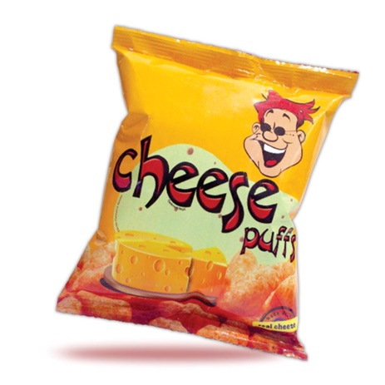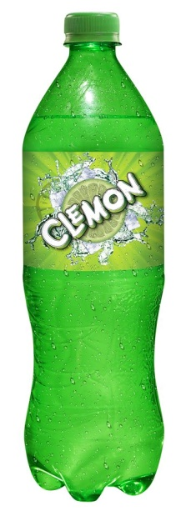 ––––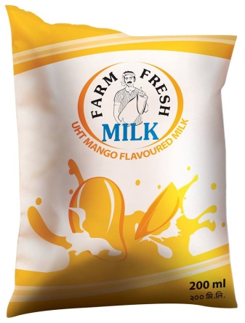
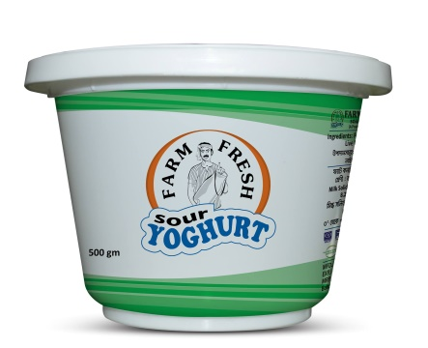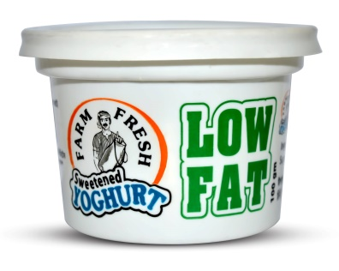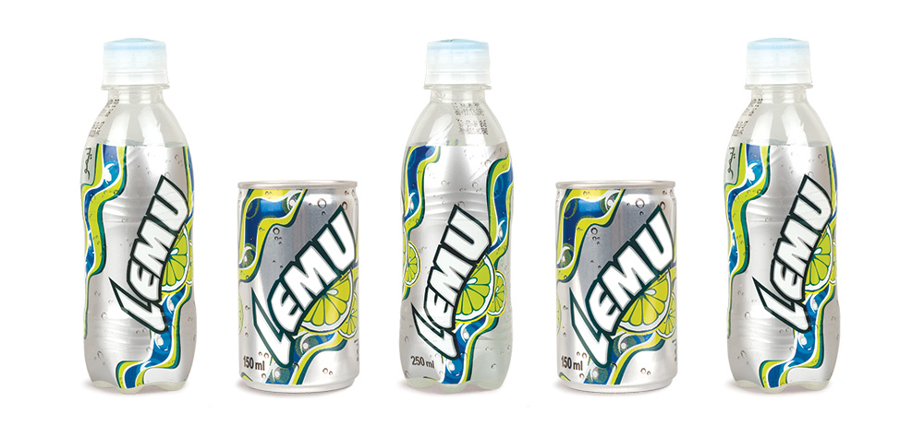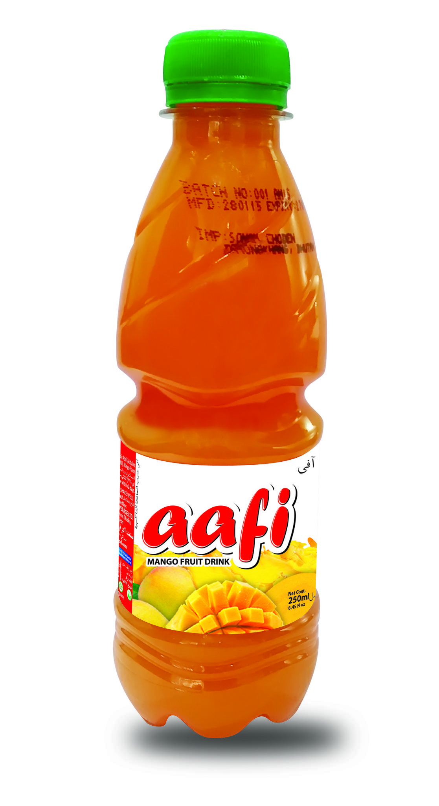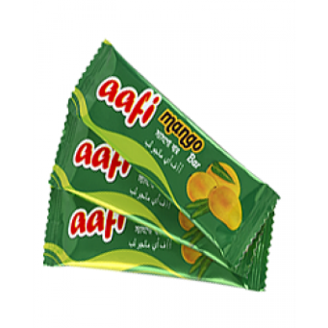
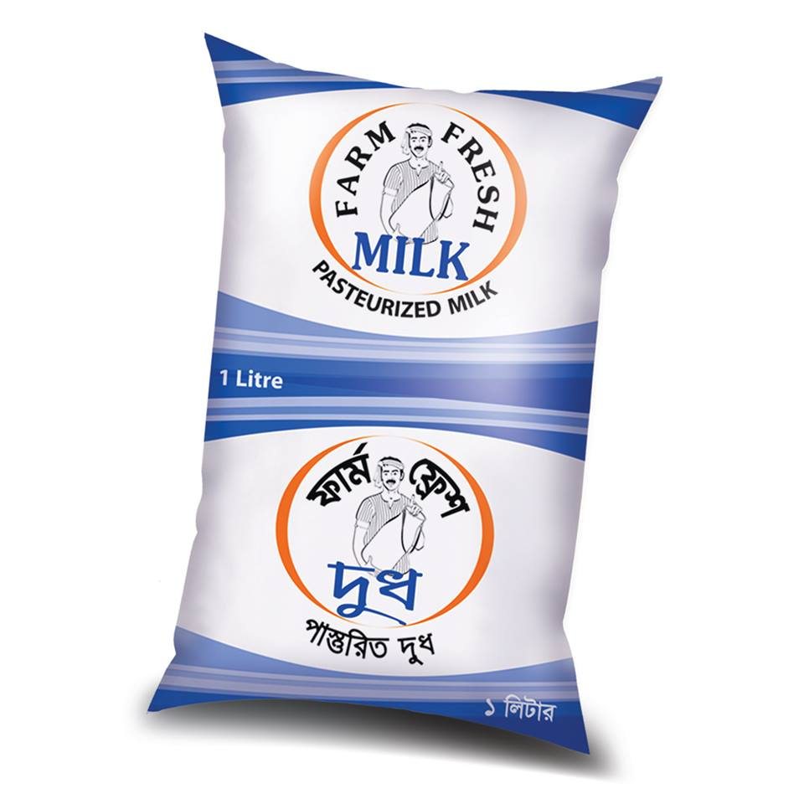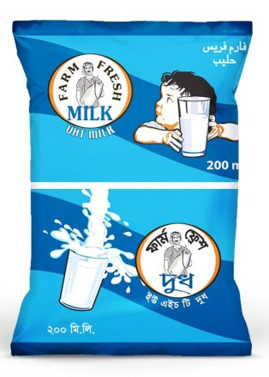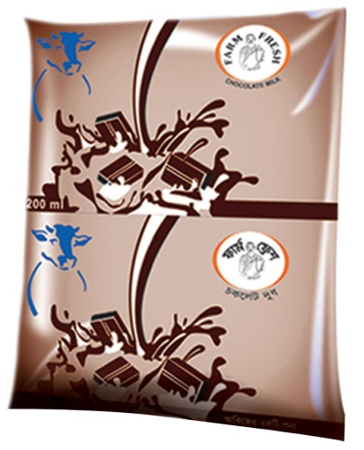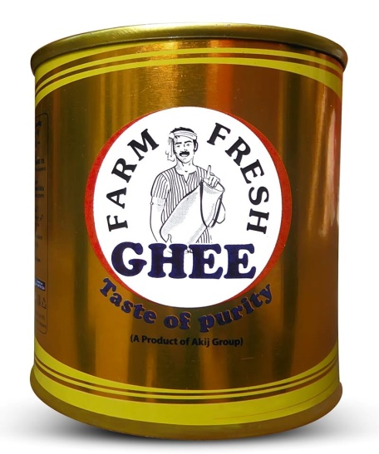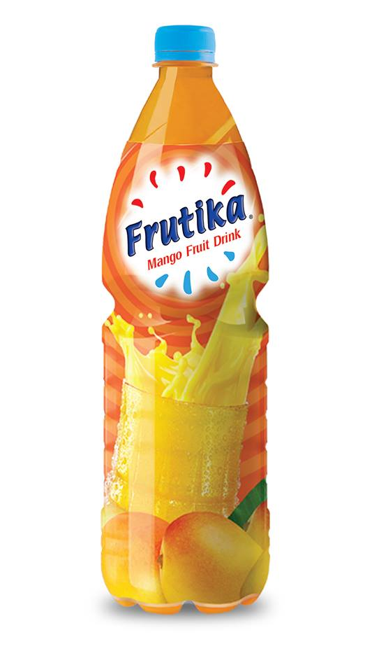
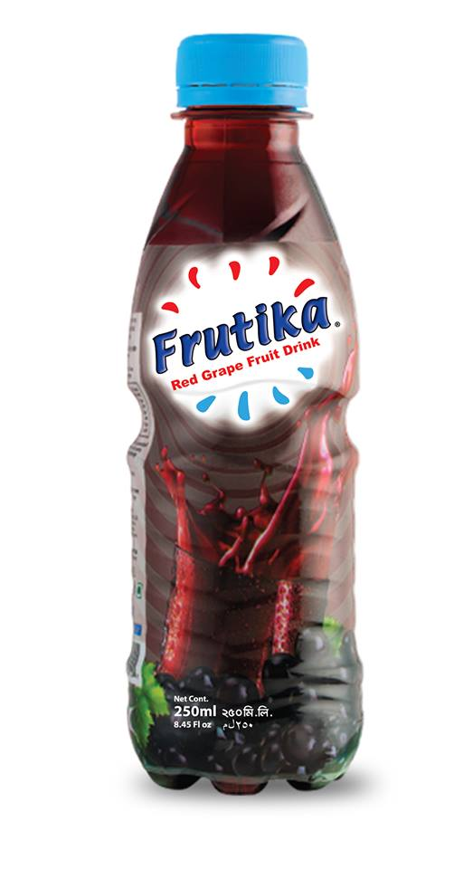
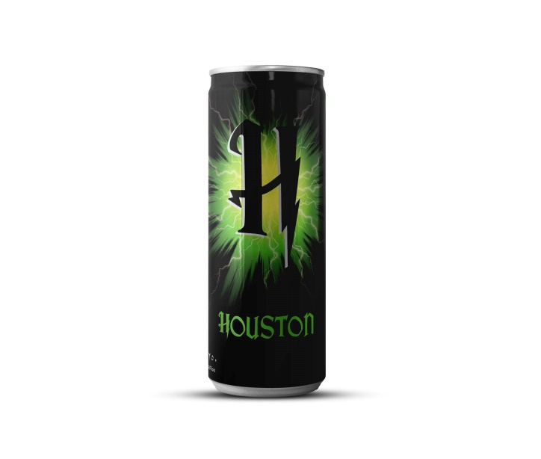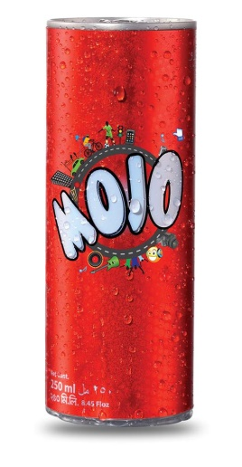

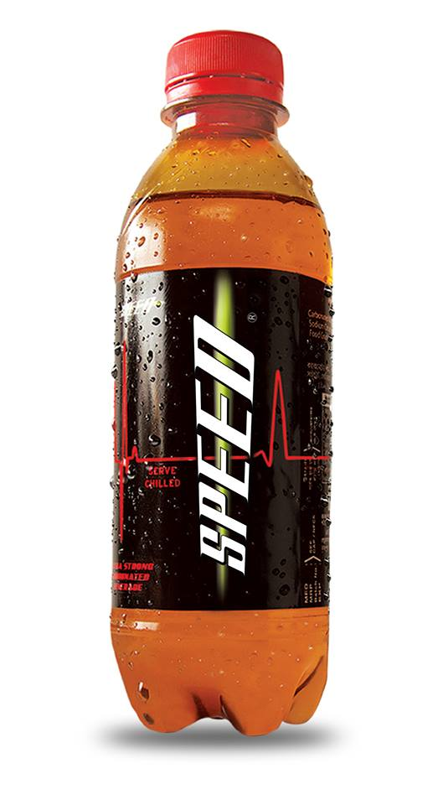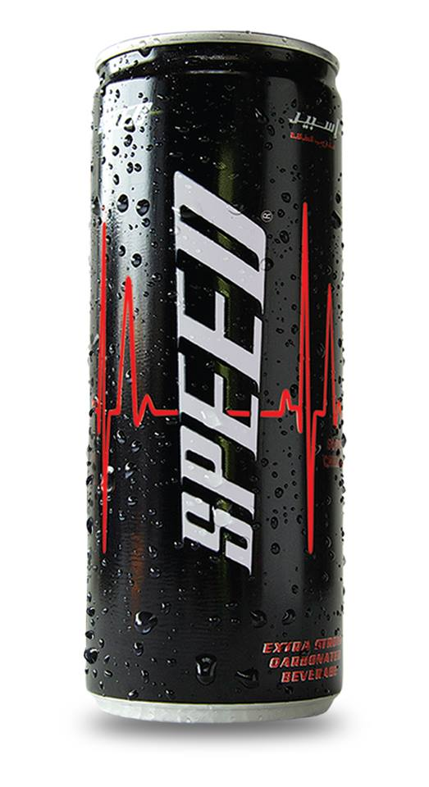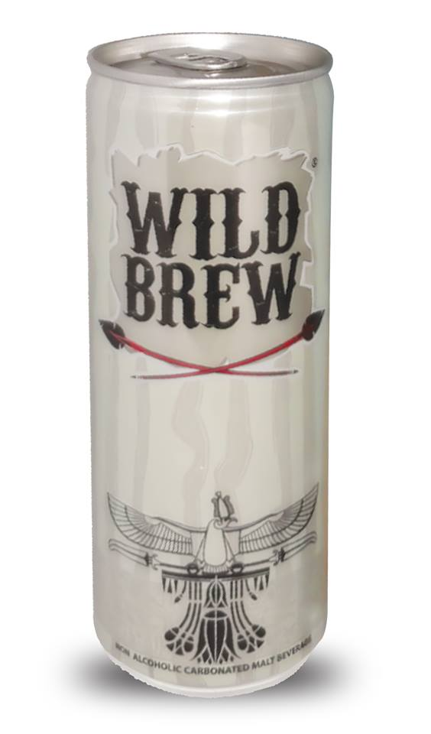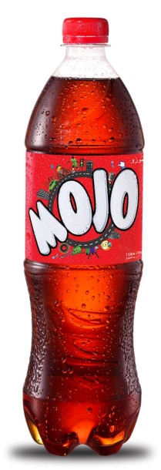

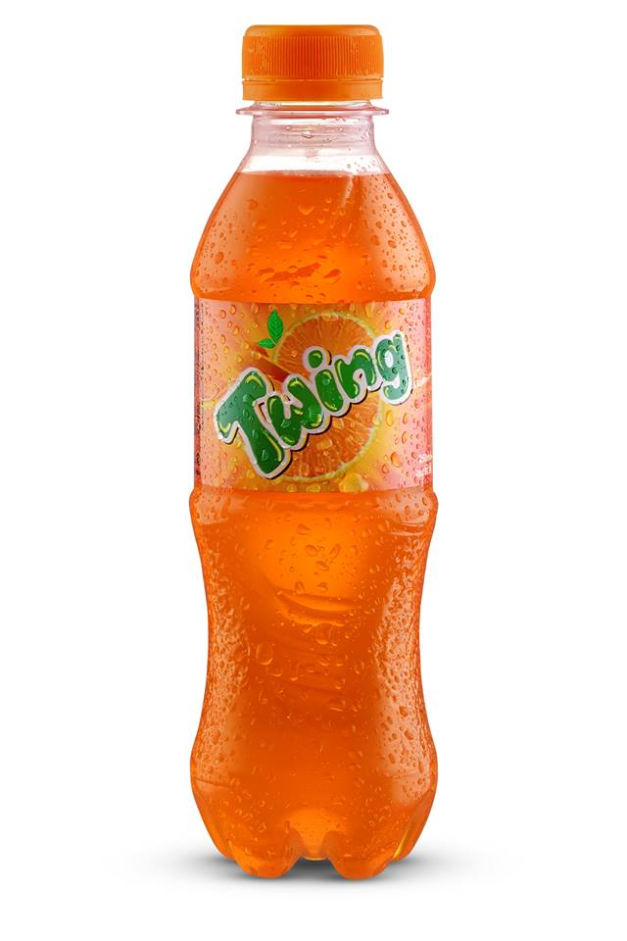
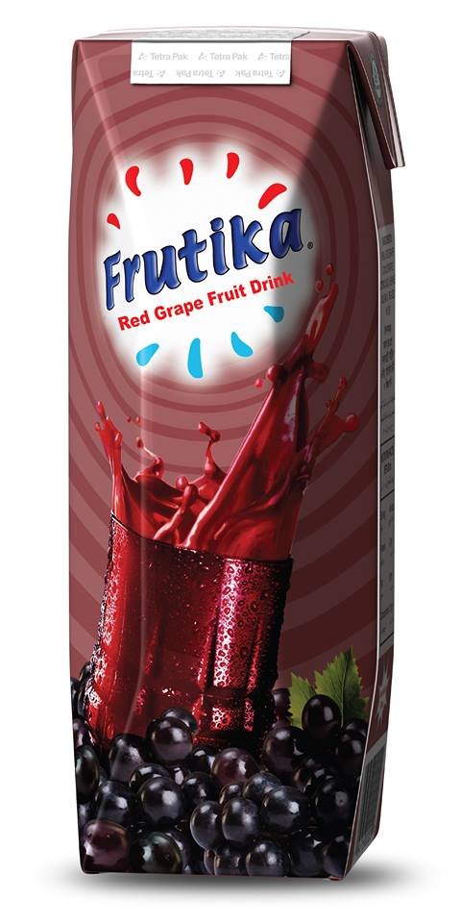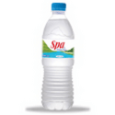

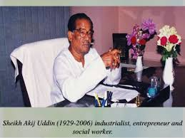
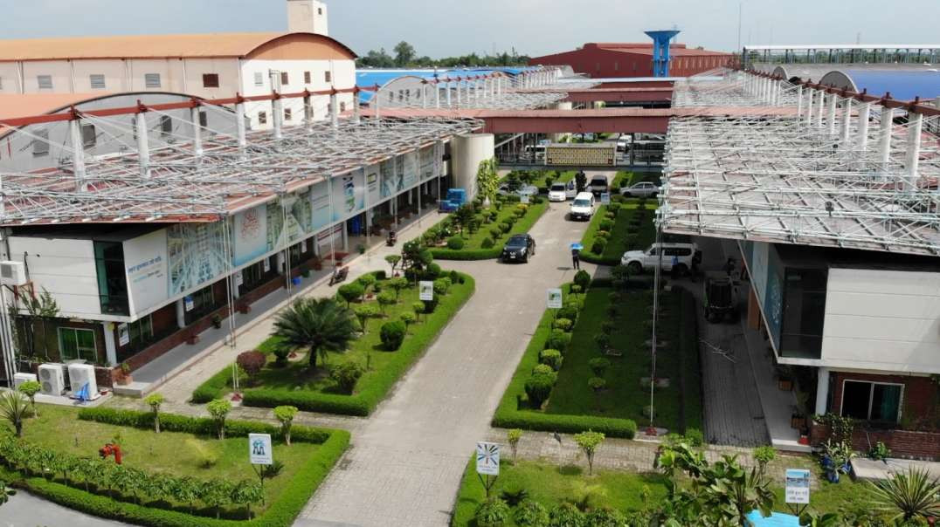
Figure 3: Factory of AFBL at Kirshnapara, Dhamrai
Figure 2: Founder Entrepreneur of Akij Group Late Mr. Sheikh Akij Uddin (1929-2006)
Figure 4: Slab Card Program of brand Frutika
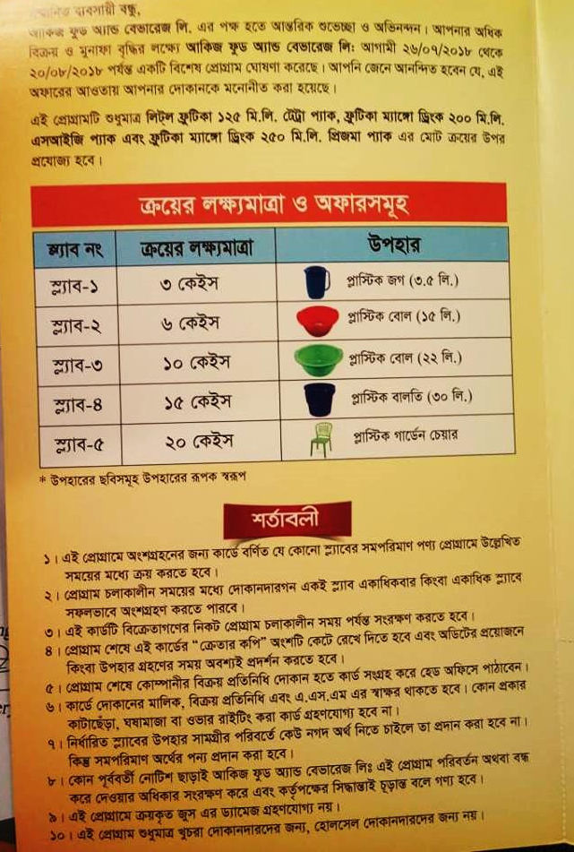

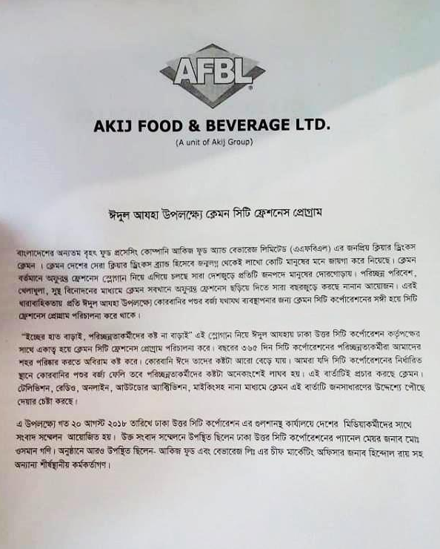
Figure 5: Clemon City freshness program news.

