Internship Report
On
Managing the Risks Associated with Providing Financial Services:
A Case Study on IDLC Finance Limited


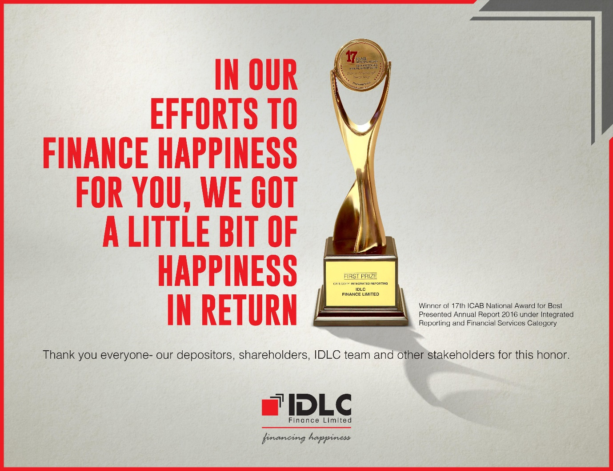

Internship Report
On
Managing the Risks Associated with Providing Financial Services:
A Case Study on IDLC Finance Limited

Submitted By:
Farah Rahman
ID: 111 132 042
School of Business and Economics
United International University

Submitted To:
Muhammad Hasan Al-Mamun
Assistant Professor,
School of Business and Economics (SOBE)
United International University

Date of submission: 18th December 2018

Acknowledgement

At first, I love to show my gratitude to the Almighty Allah to give me the strength to complete all the parts carefully of the Internship process, to thank my honorable internship supervisor from United International University, Muhammad Hasan Al-Mamun, Assistant Professor, for giving me such a chance to complete my Internship Report on "Managing Risks Associated with Providing Financial Services: A Case Study on IDLC Finance Limited ". Without his kind direction, the completion of this report could be so tough for me. I would like to place my appreciation to the HR of IDLC Finance Limited to empower me to finish my internship in their reputed institution.
Exceptionally, My gratitude goes to Mr. Md Abu Musa, AGM of Legal division of IDLC Finance Limited, and Mr. Md Mohammad Ali, Senior officer of legal Division, IDLC Finance Limited, for helping me in all time of the internship. Their noteworthy help for my internship gave me the motivation to complete a superior report.
During my planning of the internship work, I got helps from various people (respondents from IDLC Finance Limited) and companions who share their thoughts, time and concerns to clarify each of the side of the report. I need to pass on my heartiest appreciation to them for their important responses.
Thank you all.
Letter of Transmittal

To,
Muhammad Hasan Al-Mamun
Assistant Professor,
School of business and economics (SOBE)
United International University
Subject: Submission of Internship Report on “Managing the Risks Associated with Providing Financial Services: A Case Study on IDLC Finance Limited”.
Dear Sir,
It’s my pleasure to submit you my internship report on “Managing the Risks Associated with Providing Financial Services: A Case Study on IDLC Finance Limited” which is a pre-requisite of my BBA Program in United International University.

I have been working in IDLC Finance Limited for last 3 months as an intern and learn a lot how Non-Banking financial Institution (NBFI) like IDLC manages their legal issues, mostly the management of Credit risks associated with providing financial services. This practical experience helped me a lot to generate a clear vision to prepare my internship report.

Following all the guidelines, you had provided me, I had collected a lot of Learning materials, data, information, and last 2 years annual report. With all this data and information and all the knowledge I have gained during my BBA program and the guidelines and supervision you had provided me, I have finally prepared my internship report.

I want to add that I am highly thankful to you for all the efforts, supervision and guidelines you had given to me during my internship report.

I therefore, pray and hope that you would be kind enough to accept my internship report and oblige thereby.

Sincerely yours,
Farah Rahman
ID: 111 132 042
School Of Business and Economics (SoBE)
United International University.
Executive Summary
The non-bank financial institutions (NBFIs) comprise a quickly developing section of the financial system in Bangladesh. The NBFIs have been contributing toward expanding both the quality and amount of financial services and in this manner relieving the failures of existing financial intermediation to meet the developing needs of various sorts of investment in the nation.
Today all NBFIs are assuming an essential job in the development of the country's economy with the best of their capacity. During the time of world recession, NBFIs in Bangladesh act in a stringent way with the goal that their financial systems, and in addition the economy, don't crumble. 29 NBFIs are presently adding to the development of the national economy. IDLC Finance Ltd as a main and pioneer NBFI began their task in 1986 and still, they are overwhelming the NBFI part and additionally adding to the flourish of economic development. Their achievement in this industry has enlivened others to put their capital beneficially.
As the real business of all NBFIs is giving lease offices to the business alongside different kinds of loan to individual and associations, in this manner, the risk is related with every single product they are putting forth. To limit this risk each establishment has its own risk management approaches. Various actions are taken to minimize risks related to their investments.
This Internship report explains the several duties performed by me in legal team under Customer Relationship Management (CRM) Department of IDLC Finance Limited, after that an overview of IDLC Finance along with the management of the legal issues such as risk management related to financial services in IDLC finance Limited in Bangladesh. In such a manner, IDLC Finance Limited has been taken as the example of NBFI, its services, legal issues, several risk management such as credit risk management, is also taken into consideration.
Key Words: Risk Management, Non-Banking Financial Services

Table of Contents

Chapter 1: Introduction
1.1 Topic in Hand 8
1.2 Distinctive Part of my Job performance 9
1. Vetting 9
2. Had prepared legal costing databases 9
a) NI ACT 10
b) ARA ACT 10
c) AREA ACT 10
3. Had prepared litigation accounts 10
4. Updated case status 10
5. Had prepared the professional lawyers bill 11
6. Managed the withdrawals and submitting case carefully 11
7. Filling case statement 11
8. Preparing legal documents 11
9. Issuance of the statement 11
10. Scanned required records of various case documents 12
1.3 Context of the Study 13
Chapter 2: Organizational Information of IDLC
2.1 Background of IDLC Finance Limited 17
2.2 About IDLC Finance Limited 17
2.3 The vision of IDLC Finance Ltd 19
2.4 The mission of IDLC Finance Ltd 19
2.5 Targets of IDLC Finance Ltd 19
2.6 Core Qualities: 19
2.7 Business Review of IDLC Finance Ltd. 20
I. SME 20
II. Buyer 20
III. Corporate 21
IV. Capital Markets 21
2.9 IDLC Finance Limited: Organogram 23
2.10 Current Shareholdings of IDLC Finance Limited 23
Objectives of the report 26
1. General objective 26
2. Specific objectives 26
Chapter 3: Methodology
Methodology of the Study 27
A. Essential Primary Information 27
B. Secondary Information 27
Chapter 4: Findings of the report
4.1 Management of Legal Issues of IDLC……………………………………………………………………………….29
4.2 Kinds of Risks that might be occur in IDLC 30
4.3 Risk Management strategies 31
4.4 Principles of Risk Management and Controls of IDLC 31
4.5 Credit Risk Management 32
4.6 Credit Risk Management Structure 32
4.7 Credit Policy of IDLC 33
4.8 Tools & Techniques for the Management of Risk 34
a. Grading Model (GM) 34
b. CRG Model for SME 35
c. EDD (Environmental Due Diligence) Agenda and ESMS 35
d. Credit Limit (single person and Sector-Wise) 36
e. Collateral 36
f. Risk Transfer 36
4.9 Other risks 36
1. Market risk 36
2. Liquidity and Funding Risk 37
3. Legal Risk 37
I. Business risk 37
II. Regulatory risk 37
4. Compliance Risk 37
5. Operational Risk 37
6. Technology Risk Management 38
7. Environmental and Social Risk 38
8. Reputation Risk 38
Chapter 5
Limitations of the Study 41
Chapter 6:
Recommendation 43
Conclusion 44
References

Chapter 1
Introduction of the report

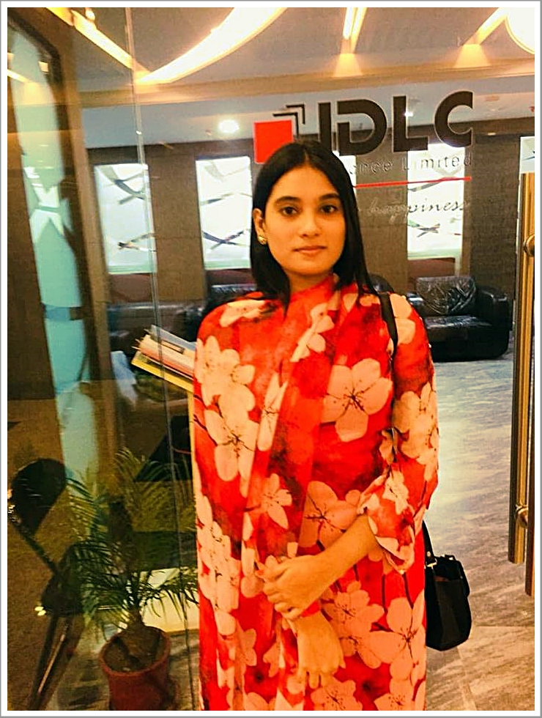

1.1 Topic in Hand
During my internship period at IDLC Fincance Limited, I worked as an intern in the Legal team which is under Customer Relationship Department (CRM). I have learned to handle a lot of legal issues by working in IDLC. I was qualified for doing all sorts of supporting activities of Legal team there. Here I would like to share some basic and distinctive work experience from my internship period.
The Basic Duties that I have learned and performed as an intern in legal team at IDLC Finance Ltd.
The Primary work responsibilities as an intern in the legal team were;
- Communicate with clients.
- registered debit and credit cards information
- Filling lease and loan files with appropriate data.
- Checkbook requisition.
- Checking client’s credit-worthiness.
- Learned the importance of maintaining the relationship with clients.
- Handling phone calls.
- Assisted clients to fill the loan form rightly.
- Filling memo's, checkbooks.
- Issuance of Statement.
- Scanned required records of various documents and sent it to the office or branch

1.2 Distinctive Part of my Job performance
Internship involvement with IDLC was extremely a decent learning and opening in the corporate business world for me. It was a procedure of learning by doing. I was working in the Legal team as an intern and performed some distinctive job duties throughout the entire period. All of my colleagues and seniors of mine was so helpful to teach and show me how to perform these responsibilities well. All of these duties that I have listed as distinctive, are mentioning below:
- Vetting: vetting is the client's mortgage schedule. Their legal documents enquirers by the sub- register office and based on their enquirer or inspection report this vetting report is concluded. Here mortgagers property details, such as property which is classified in 2 categories.
- Land,
- Flat .
If one client has 2 or more than 2 property to mortgage then there would be more scheduling. Such as
  - Schedule 1,
  - Schedule 2.
After vetting each file, it is processed for the authorization.
- Had prepared legal costing databases: During the internship period, I had to prepare the legal costing Databases. There are 3 acts of Legal Costing Databases. They are:
  - NI ACT
  - ARA ACT
  - C)ARAE ACT
Under this acts, the cases of against our clients are filled.
    - NI ACT ( Negotiable Instrument - 138 ): Most often these cases are the cases of the bouncing check. A bounced check is slang for a check that can't be prepared as the account holder has not sufficient funds (NSF). Banks return these checks, and often called worthless pieces of paper, as opposed to respecting them, and banks charge the check authors NSF expenses.

    - ARA ACT: When customers don’t paying money in the time period, these act takes place.

    - AREA ACT: In this act, the cases are basically judgment or decreed by the court against the clients or the company. Its basically a combination of three acts. they are:
- ARAE ACT (Artho Jari Mamla),
- 7 (1) act
- 33(1) act .
All the legal cases are filled under this 3 acts & cases are filled all together in each clients name, and finally, the total amount is calculated.
- Had prepared litigation accounts: I had to prepare litigation accounts. This account is for the company records of clients cases, cases under which act, cases previous status, previous case filling & appearing date in court, plaintiffs, law firms name, current case status & date. All are recorded here. In this terms, SUITS number or case number is the main thing. Each suit number has a unique code But account number could be the same for the clients/ lawyers firm name.

- Updated case status: I had to update the case statuses. The case status which is recorded is upgrading by the next steps of each date of hearing of high court.

- Had prepared the professional lawyers bill: During the internship period, a particular task for me was to prepare the professional lawyers bill. The lawyers who are the vendor of IDLC. Their bills are made according to their reason for the cost. For example appearance in court.
- If it is CR case - it would be 600;
- If it is ARA case, it would be taka 700,
- If it is ARAE it would be taka 1000,
- If any case is withdrawn under CR act it would cost of taka 2500,
- Miscellaneous & others cost of taka 1500.
In any of the above situation, there could be many hearing days. & each day I had to prepare the bill for IDLC.
- Managed the withdrawals and submitting case carefully: The cases records of withdrawals & submitting are very important to keep each document separately & to create separate folders on system & also important to check if there are any double entry.

- Filling case statement: Case statement is provided by the court & the statement is recorded to the system.

- Preparing legal documents: Documents are like an asset to the company, it’s mandatory for all the mortgages. I had to make legal documents for the clients of IDLC & make sure to save all the necessary information about their mortgages and policies are included with specific terms & dates.

- Issuance of the statement: I had to issue whatever statement is provided by the high court, IDLC also prepare a copy of the high court statement & also sent it to the clients officially.

- Scanned required records of various case documents: scanned records & sent it to vendor office & also IDLC branch Offices.

All of the duties enriched my knowledge with these various practical experiences and I feel this knowledge will be an asset for me in my future. It’s a pleasure for me to get the opportunity to work such a reputed NBFI in Bangladesh.

1.3 Context of the Study
The Non-banking financial organization has provided an extraordinary help for most ventures and business to earn loan for their smooth exchange and to enhance and grow their business. As indicated by Koranteng (2016) that numerous ventures, business, and individuals select such organizations to take the loan and another type of fund from this Non-Banking Financial institutions. Often, Banks don't enable much to get the loan and their methodology might be troublesome regularly to acquire the loan or any sort of fund. In this way, it turns into the best choice to raise capital for firms during their troublesome financial times. Besides, Maxwell (2016) included that non-banking financial organizations these days turn into a source of capital for some organizations. The achievement and change of firms prompt better economy of a nation, all in all. Along these lines, quick and hasty finance is required to keep the task of the firms smooth.
Whatever, it is additionally essential for them to identify the Legal Issues Such as risk of that credit zone and to operate them proficiently and adequately to decrease the risk. It is actually the way, they can maintain a steady and better economy. Frank (2016) also said that the administration of risk additionally may know as the essence of legitimate financial administration. At the point when loans are under process, things should be seen that are the connection between credit risk and other risk related to the business. If it is figured out legitimately and they endorse the loan as needs be then it can assume in diminishing default risk. As default risk represents a major issue for financial sector recently and it can hamper economic development. For the most part, there is a high plausibility of default risk in long-term loans thus legitimate examine can reduce the risk a few. Thus, Government forces significance to credit risk administration and has a few rules with respect to credit risk administration (Ntiamoah, 2016). Plus, each non-banking financial establishment has their very own strategies to handle with credit risk. Fundamentally, in credit risk administration, there are 4 stages to pursue: Risk distinguishing, risk evaluation, risk screen and risk relief. These all are done when endorsing the loan aside from loan risk observing. Risk observing is done after authorize. To manage credit risk governing body favor the credit risk approaches and procedure, survey them intermittently or every year to quantify its viability to diminish the credit risk. They additionally assume a job in deciding credit cutoff and make the strategy for credit risk administration. They also characterize by and large risk resistance in connection to credit risk. Then again, the higher administration is responsible for actualizing the strategies, technique, and system endorsed by the top managerial staff. They here and there create arrangements for risk distinguish, screen, estimation, and control. Such approaches and methods enable find out credit risk and limit the risk. Bangladesh government has rules and endorsed wide strategies in regards to managing credit risk and all will undoubtedly pursue. When setting as far as possible financial investigator contemplates the customer's profile for the loan he needs to think about the quality of the borrower, motivation behind the credit, economic condition, and risk hunger. After completely fulfilling foundation data a financial investigator endorses the loan. Further, an investigator should screen every now and again its customer and its business to recoup the loan. As a major aspect of that, he frequently goes to customer visit and evaluates technique and attempts to distinguish any sort of weakening in the credit. He takes part in this screen procedure to recognize the current financial position of the customer, how the customer is utilizing endorsed credit lines without any end in sight (Bangladesh Bank, 2016).
"The impact of Risk Administration activities on Non-Bank Financial Organization of inspected Ghanaian credit associations was analyzed. Results demonstrate that Credit Risk administration has noteworthy positive relationship to the NBFI execution of the tested credit association which infers that for each expansion in NBFI execution through years came about because of an expansion of 5.35% of credit investigation, 1.14% in credit policy and choice, 7.79% in loan policy, 8.06% in observing, and 6.07% in loan misfortunes (default and collapses). There is additionally a positive connection amongst NBFI and credit risk administration when it was investigated autonomously while it gave a positive relationship when broke down together with other execution pointers. Loan policy likewise has a positive critical association with NBFI execution. So also, credit investigation and credit policy and choice additionally apply negative impacts on NBFI execution demonstrating that the use and not proprietorship has the impact on NBFI execution. In a similar vein, loan misfortunes (default and disappointments) likewise have a positive connection with profit for NBFI. This outcome infers that the expansion in loan misfortunes likewise prompts an expansion consequently on NBFI execution" (Koranteng, Honest, Maxwell, Ntiamoah, 2016).
All in all, there is a solid measurable and positive effect on the NBFI execution of business sectors on the off chance that it puts resources into credit risk administration. With the reason for building up the execution of Non-Bank Financial Establishment (NBFI), the administration ought to create an effective administration of credit risk administration.

Chapter 2

Organizational Information of
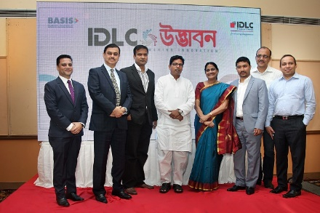
IDLC Finance Ltd

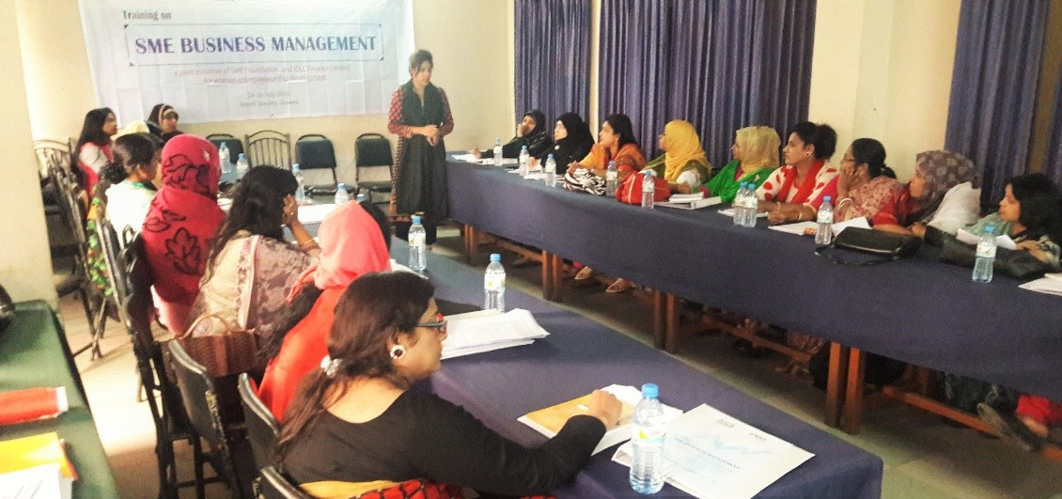

2.1 Background of IDLC Finance Limited
IDLC Finance Limited, the primary leasing organization of Bangladesh, was built up in 1985. Its introduction to the world was really a community exertion between a few neighborhood and multinational financial institutions e.g. Global Finance Partnership (IFC), German Venture and Development Organization (DEG), Kookmin Bank, Korea Development Financing Enterprise, The Aga Khan Reserve for Economic Development, The City Bank Limited, IPDC of Bangladesh Limited, Sadharan Bima Company. With the development of this organization, the underlying outside shareholding of 49% was bit by bit being pulled back. The nearby supporters were taking the shareholding places of the organization lastly in 2009, there was no shareholding that comes from outside of Bangladesh of the organization.

2.2 About IDLC Finance Limited
IDLC Finance Limited began its adventure, in 1985, as the main renting organization of the nation with multinational cooperation and the lead sponsorship of the Global Finance Enterprise (IFC) of the World Bank Gathering. Specialized help was given by the Korean Development Leasing Partnership (KDLC), the biggest leasing organization of the Republic of South Korea.

IDLC which has now risen as Bangladesh's driving multi-products financial institution, has among its outside investors, universal development offices, for example, Aga Khan Reserve for Economic Development (AKFED) and German Venture and Development Organization (DEG) other than the IFC. The other outside supporters including Kookmin Bank of the Republic of Korea notwithstanding IDLC and every one of these institutions together hold 47.3%% of the organization's offers.

Five Bangladeshi financial institutions-The City Bank Ltd, Sadharan Bima Corporation, Commercial Bank Ltd, Eskayef Bangladesh Ltd, Reliance insurance Ltd, and the overall population hold the staying 52.7%. IDLC is the recorded individual from Dhaka Stock exchange.
The interesting institutional shareholding structure involving for the most part of financial institutions causes the organization to continually create through sharing of understanding and expert methodology at the most elevated policy-production level.

IDLC offers a diverse exhibit of financial services and answers for institutional and singular customers to meet their differing and remarkable prerequisites. The item contributions incorporate Lease Finance, Term Finance, land Finance, Here and now Finance, Corporate Finance, Vendor Keeping money, term deposit Plans, Debentures, and Corporate Warning Services.

The vision of IDLC Finance Limited is to end up the best performing and most imaginative financial arrangements supplier in the nation. To accomplishing this vision and objective it is essential to taking due consideration of the majority of our constituents, especially the investors, clients and workforces.

The corporate theory is release their capacities with legitimate responsibility for activities and results and visually impaired themselves to the most elevated moral gauges.

2.3 The vision of IDLC Finance Ltd
IDLC Finance Ltd will be the best financial brand in Bangladesh.

2.4 The mission of IDLC Finance Ltd
We will center on quality growth, predominant client encounter and supportable business practices.

2.5 Targets of IDLC Finance Ltd
- Grow and build up ability.
- Fully use the new core managing a banking platform.
- Optimize distribution point.
- Grow and broaden financing sources
- Grow deals and service capacities in the Shopper Division
- Aggressively enhance the SME portfolio.
- Focus on top-level customers in the Corporate section.
- Consolidate capital market activities and upgrade abilities.
- Embrace universally acknowledged corporate administration and adaptable business work activities.

2.6 Core Qualities:
- Honesty and Integrity
- Clients interest
- Trust and honor
- Eco-accommodating
- Simplicity
- Equal Opportunity
- Passion

2.7 Business Review of IDLC Finance Ltd.
The organization achieves its various business through its four parts
- SME,
- Buyer,
- Corporate,
- Capital Markets.

I. SME
This division is devoted to giving expert loaning to little and medium-sized organizations over an expansive scope of enterprises including steel, cement, light building materials, plastics, and materials, among others, topographically spread crosswise over Bangladesh. This division gives a wide scope of services e.g. term advances, working capital credits, and rent financing to fulfill broadened client necessities. Also, this division redoes their services if important. The division likewise underpins and empowers ladies business enterprise by giving them advances at alluring pledges.
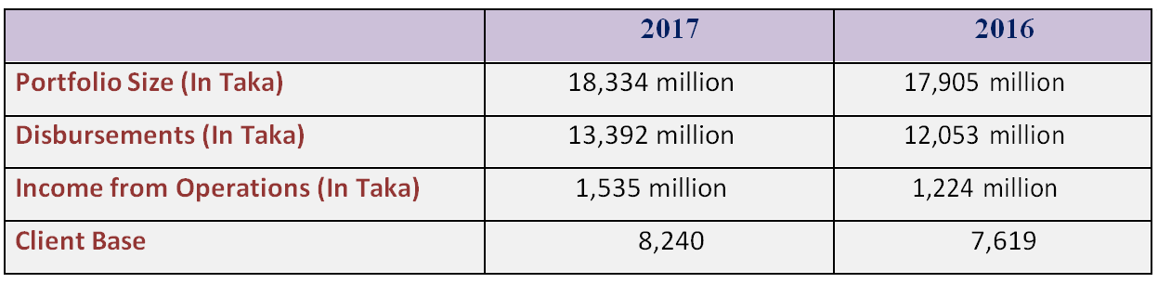

II. Buyer
The Buyer division is engaged in offering retail financial services. Its financial products include Home Loan, Auto Loan, and a little part of Individual Loan and Loans against Stores. This division is presently getting a charge out of the most noteworthy market offers and growth rates inside the Home Loan industry of Bangladesh. This arm of the organization is likewise effectively occupied with activating stores through various retail investment funds products with shifting financing costs and developments.
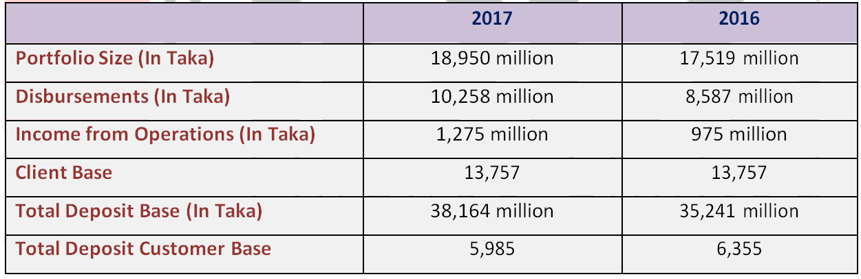

III. Corporate
The vital capacity of the Corporate Division is to give quality service to financial institutions the nation over in financial issues. Among its differentiated exhibit of services rent financing, term loans and financing choices for capital use and so forth are mentionable. Notwithstanding these this division of the organization additionally offers Organized Finance (SF) arrangements which incorporate corporate security issuance and obligation syndication.
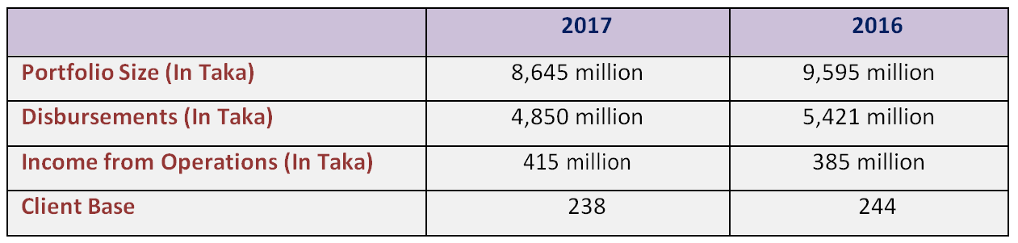

IV. Capital Markets
IDLC Finance Ltd. achieves its capital market tasks through two of its completely claimed backups – IDLC Securities Ltd. also, IDLC investment Ltd. These two backups give a wide range of exchanging services to their clients. Their strong exchanging offices empower them to offer best execution experience to their expansive and enhanced customer base. Endorsing, essential issuance and shipper banking are its other significant services. The division has as of late started Optional Portfolio Management services. They are giving careful consideration to develop this portfolio, particularly with their Buyer Division through between divisional synergistic chances.
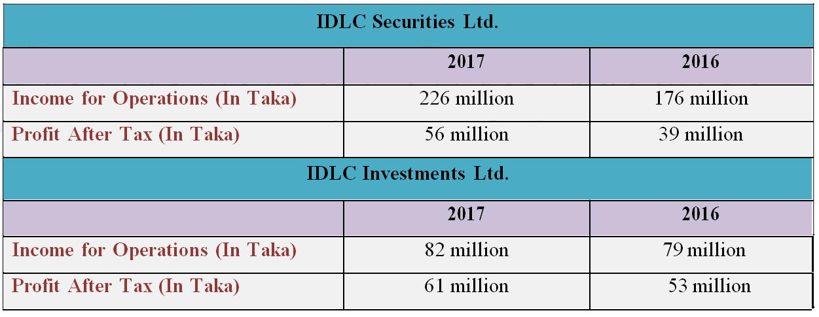
Income from above operation in the year 2017

2.9 IDLC Finance Limited: Organogram

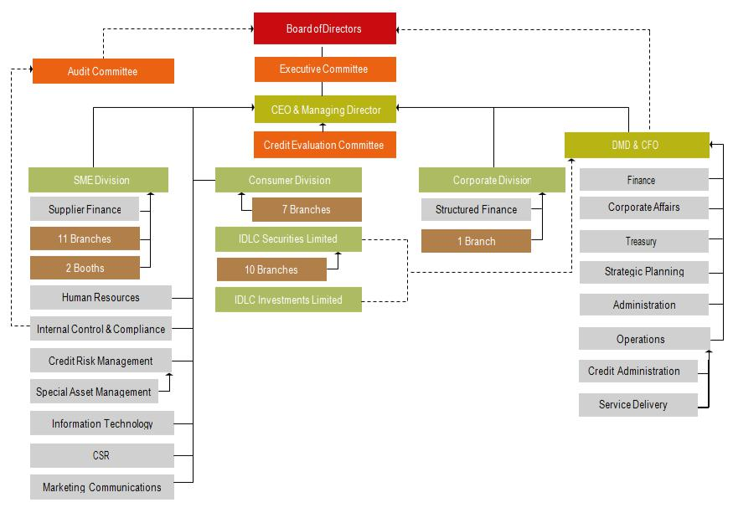
2.10 Current Shareholdings of IDLC Finance Limited

Chapter 3
Objectives and Methodology

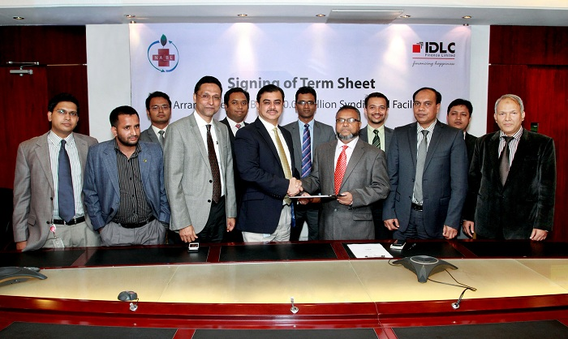
Objectives of the report
Objectives means goals. I have two broad objectives for preparing this internship report. The objectives are discussing below:
- General objective: It’s a requirement of my BBA program at United International University that I must have to work in an organization to relate my educational experience with the practical experience for 3 months. After working in the organization, I have to submit this internship report to complete my BBA under-graduation degree.
- Specific objectives: Apart from the general objectives, I also have some more Important and specific objectives to prepare this Internship Report on ‘Managing the Legal Issues Associated with Providing Financial Services: A Case Study on IDLC Finance Limited’. These objectives are listed below:
- At first, the objective of this report is to show my practical experiences earned from IDLC Finance Limited by working 3 months long.
- To give a broad idea about What IDLC Finance is, what kinds of services they provide, what is the Shareholding Structure of IDLC Finance etc.
- To provide the real work experience that’s relates to my Internship Topic.
- To express the working environment, rules and regulations related with IDLC Finance Legal Issues such as risk management associated with financial services.
- To Focus on Credit Risk Management (CRM) as it is the main legal issues for any banking or non-banking financial institutions.
- To share an overall view of the practices and operations of Credit Risk Management of IDLC Finance Limited.

Methodology of the Study
Methodology is the systematic, theoretical analysis of the methods applied to a field of study. It comprises the theoretical analysis of the body of methods and principles associated with a branch of knowledge. This report is finished by the utilization this two sources of information.
  - Essential primary information
  - Secondary information that I gather during my internship period.

A. Essential Primary Information:
- My own work understandings.
- Conversation with the particular authorities
- IDLC Back Limited annual report 2016 and 2017

B. Secondary Information:
- IDLC Website pages'
- Bangladesh Bank Site
- Financing Ministry of Bangladesh Site.
- Bangladesh Department of statistics Site
- Other Financial institution Sites such as Lankabd.com

Chapter 4
Findings of the Study
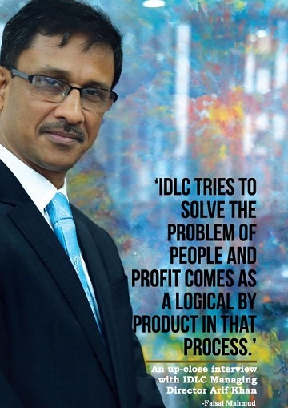

4.1 Management of Legal Issues of IDLC
At IDLC, the way to deal with risk is grounded on the solid practices of Corporate Administration that are expected to fortify IDLC's enterprise risk administration system and furthermore the situation of the Organization, to adjust to the changing administrative condition in a compelling and productive way. The administration of risk management begins with our Board, which assumes an essential job in auditing and affirming risk administration strategies and practices. The organization's administration structure gives the convention and duties to basic leadership on risk administration issues and guarantees their satisfactory execution. IDLC's risk administration abilities are entwined around a solid administration structure and data framework, a viable risk-rating framework, and hearty arrangements. The essential goal of risk administration is to secure the Organization's financial quality and notoriety and guarantee proficient capital sending to help business activities and upgrade investor profitability. Notwithstanding grasping the prescribed procedures of the business for evaluating, distinguishing and estimating risk, IDLC considers Rules for Overseeing Center Risks of Financial Organizations issued by the Bangladesh Bank vide FID circular no. 10 dated September 18, 2005, and Coordinated Risk Administration Rules for Financial Establishments issued by Bangladesh Bank on 2016. Solid interdepartmental correspondence interface on risk factors and a culture of joint effort in basic leadership among the income creating units, free control, and bolster capacities, advisory groups and the senior administration help the association in the successful administration of authoritative risk. Viable risk administration combined with the reception of BASEL-II recommendations advantage IDLC by expanding capitalization and streamlining expenses to risk and subsidizing.

4.2 Kinds of Risks that might be occur in IDLC
At IDLC, 'risk' is the uncertainty of making a misfortune for the organization and also for its partners. Such misfortune isn't really quantifiable. A bad behavior does not really make a good impact on hierarchical reputation and financial value. Now and again a mistake influences the financials of more than the time of the event. In this way, risks are assorted in term of its impact. Risks are additionally enhanced in term of their source. A misfortune may happen because of the poor choice of a borrower. A loss may be caused by the nonappearance of strict guidelines. In this way, IDLC risks making enhanced losses for itself or for its partners during its everyday activities.
The Risks of IDLC are giving below:
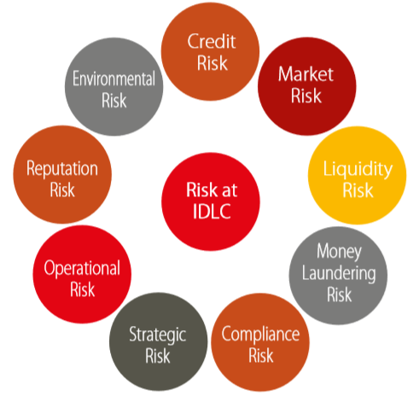

4.3 Risk Management strategies
Integrate Risk principles with IDLC’s values

IDLC Risk Management Strategies
Building of screening system for early warning of Risk
Maintaining these values
With actions
Periodic Analysis of the management program

Implementations of strategies to mitigate Risks

Performing Risk Analysis

4.4 Principles of Risk Management and Controls of IDLC
The five columns that help of IDLC's way to deal with accomplishing a fitting harmony among risk and return incorporate the accompanying:
1. Ensuring IDLC's financial quality by controlling risk exposures and dodging potential risk fixation at the level of individual exposures, at particular portfolio levels and at a total far-reaching level overall risk composes.
2. Securing our reputation through a sound risk culture portrayed by an all-encompassing and incorporated perspective of risk, execution, and compensate and by guaranteeing careful consistency with our models and standards, especially our Set of principles.
3. Allover administration accountability whereby business administration, instead of risk control, claim all risks expected all through the firm and are in charge of the persistent and dynamic administration of all exposures to guarantee the correct harmony among risk and return.
4. Autonomous control capacities which screen the viability of the business' risk administration abilities and furthermore manage risk-taking activities.

4.5 Credit Risk Management
CRM is amongst the most vital issues for a Financial Institution as credit risk isn't just connected with direct accounting misfortune yet additionally with economic exposures incorporating opportunity costs, exchange expenses and costs related with a non‐performing resource. At IDLC, the fundamental objective of Credit Risk Administration is to augment our benefit over long run keeping up credit risk presentation inside the worthy level. To meet this objective CRM colleagues plan to accomplish four goals:
  - Quality Credit Development
  - Minimized Loan Provisioning
  - Minimized TAT [ Turn-around-time/Pivot Time]
  - Compliance with legal Administrative and Inner Policy

4.6 Credit Risk Management Structure
At IDLC, credit risk mgt is a consistent procedure dependent on a structure to increase most extreme benefit at the expense of least credit risk presentation.

Risk Measurement
Risk Identification
Credit Risk Management Process
Risk Mitigation
Risk Monitoring

4.7 Credit Policy of IDLC
At IDLC, approaches of Credit Risk are intermittently changed. IDLC's credit policy is by and large assessed each year. IDLC's credit policy has been last surveyed in December 2017. The last survey was done in 2016. Product Program Rules (PPG) for various products are broke down each year to fuse the adjustment in market variable and gaining from gathering history. Such intermittent alteration of arrangements enables IDLC to adapt to the current market circumstance and changes in the business. A month to month meeting is held between the Credit Risk Administration (CRM), Uncommon Resources Administration (SAM) and the accumulation group, featuring learnings from exceptional customers. This enables IDLC to plan better arrangements to enhance its advantages, fills in as a compelling screening framework and gives early admonitions to IDLC about a customer/industry.

4.8 Tools & Techniques for the Management of Risk
IDLC Legal Department uses various useful models as tools to recognize and mitigate and control Risks. These tools and techniques are discussing here briefly.
- Grading Model (GM)
- CRG Model for SME
- EDD (Environmental Due Diligence) Checklist & ESMS
- Credit Limit
- Collateral
- Risk Transfer

Grading Model (GM)
IDLC has possess inward Risk Grading Model to encourage educated basic leadership. In December 2016, IRG (IDLC Risk Grading) Model for Corporate and medium enterprise customers has been affirmed by the board which has supplanted our current RGM model from January 2017. The point of refreshing our current model was to fuse a wide range of risk in a more definite way and incorporate the Office risk: risk related with the structures of various offices as prescribed by "Coordinated Risk Management Rules for Financial Establishments" issued by Bangladesh Bank on 2016. IRG model rates each credit proposition dependent on customer's financials, by and large industry and business viewpoint, customer's general installment history, customer's gathering standing, management nature of the customer and office structure of a specific proposition. This model is an essential piece of the credit basic leadership process.

CRG Model for SME
IDLC considers the uniqueness of risk components of various customer sections and creates risk management procedures as needs be. For SME, an alternate Credit Risk Grading model created in relationship with IFC is utilized to recognize and measure credit risk. This model sets a score for every customer dependent on their financial execution, non-financial angles like proprietorship structure, and industrial facility area and conduct perspectives like reimbursement track record. Diverse CRG score needs unique survey like customer visit, customer meet and so on. Consequently, this model guarantees quality endorsement at all conceivable time.

EDD (Environmental Due Diligence) Agenda and ESMS
In accordance with the Environmental Risk Management (ERM) Rules for Banks and Financial Establishments in Bangladesh issued by the Bangladesh Bank in January 2011, ERM Rules have been fused in IDLC's credit policy and has been affirmed by the Board. According to these rules, customers are classified in Green, Orange-An, Orange-B and Red classifications dependent on their sector. General EDD agenda and ten sector particular EDD agendas were improved the situation customers to distinguish and measure environmental and social risk. In any case, we have joined more exhaustive ESMS instrument endorsed by the board in our environmental risk management process a year ago which covers 22 sectors particular environmental and social risk recognizable proof incorporating those ten sectors in EDD agenda. In light of the ESMS, Environmental Risk Rating (EnvRR) can either be low, moderate or high. If there should be an occurrence of high EnvRR for any proposition, the endorsement is taken from equipped endorsement expert. In this way, environmental and social risks are effectively considered alongside the general credit risks while evaluating a planned borrower. Notwithstanding national laws and directions, IDLC has additionally deliberately received the standards of the UN Worldwide Minimized (UNGC).

Credit Limit (single person and Sector-Wise)
IDLC has an arrangement of Board-endorsed prudential limits to address fixation risk in a specific customer, a gathering or a sector. On the off chance that any credit proposition makes fixation in both of these three surpass the prudential limit, that proposition should be affirmed by senior management or official panel or board.

Collateral
It is a special security as a benefit or outsider commitment that serves to moderate inalienable risks of credit misfortune due to the introduction by either substituting the borrower default risk or enhancing recuperations in case of a default.

Risk Transfer
IDLC holds ensures, letters of credit (LC) and comparable instruments from outsiders, which empower it to guarantee the settlement in case of default with respect to the counter-party. Underwriter counter-parties incorporate banks, parent organizations, investors and related counter-parties.
4.9 Other risks with whom the legal department has to deal are discussing below briefly:

Market risk
Market risk is the risk of misfortune emerging from changes in market factors, for example, financing costs, security costs, value record levels, exchange rates, product costs, and general credit spreads. For simplicity of management and with regards to administrative prerequisites, market risk in IDLC is additionally classified into loan cost risk and value risk.

Liquidity and Funding Risk
Liquidity risk is the risk of being not able meet our installment commitments on development, due to the liquidity emergency. Risk of misfortune caused by the inability to get assets from the market at a satisfactory cost to support genuine or proposed duties is perceived as funding risk.

Legal Risk
Illegal tax avoidance and Fear based oppressor Financing Risk Tax evasion and psychological oppressor financing risk is an unavoidable risk of working together as a financial establishment. For IDLC, illegal tax avoidance and fear monger financing risk take two wide measurements.
- Business risk - the risk that IDLC might be utilized for illegal tax avoidance or fear based oppressor financing
- Regulatory risk - the risk that IDLC neglects to meet administrative commitments under pertinent Illegal tax avoidance Anticipation and Hostile to Fear mongering enactment.

Compliance Risk
Compliance risk can be characterized as the current or planned risk of legal endorse and material financial misfortune IDLC may endure because of its inability to follow laws, its very own controls, set of accepted rules, and measures of the best practice and from the likelihood of off base translation of viable laws or directions.

Operational Risk
Operational risk is the risk of misfortune emerging from insufficient inward procedures, individuals and frameworks or from outside occasions. Operational misfortune occasions may cause coordinate financial misfortunes or may show themselves in a roundabout way as income sworn off. They may likewise harm our reputation, causing long haul financial ramifications. Operational risk is an inescapable outcome of being good to go and overseeing it is a center component of our business activities.

Technology Risk Management
With the end goal to deal with the risk of IT failure, our ICT task is concentrated through a Information Center (IC) with a continuous Catastrophe Recuperation Site (CRS). Besides, the branches and corners of IDLC are associated with DC and DRS through fiber optic with excess availability up to tertiary level, which additionally guarantees network consistently.
To guard against information break risk, we have put get to controls at 3 layers, decisively - system, application and database level access controls. Other than giving staggered insurance against dangers our risk management structure gives us a critical lead time should any endeavors at breaking our information by an outsider be made.

Environmental and Social Risk
Environmental and Social Risk alludes to the risk The earth and Society look from our activities.

Reputation Risk
Reputation risk might be characterized as the risk of misfortune emerging from harms to an association's reputation. Reputation risk issues may prompt various unfortunate results:
- Reduction of income;
- Expanded working cost;
- Capital or administrative expenses;
- Disintegration/pulverization of investor profitability

Chapter 5
Limitations of the Study

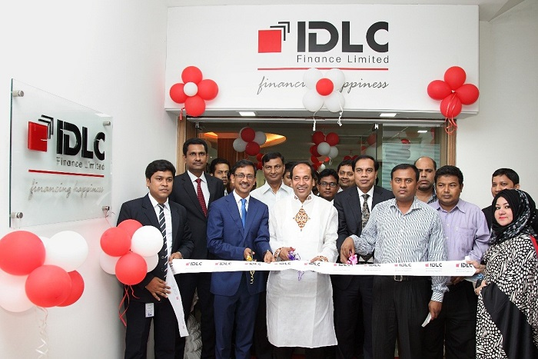
Limitations of the Study
During my Internship period, I was ready to learn a lot of things, yet at the same time, it was insufficient. There are a few limitations that I can't overlook. The fundamental limitations were:
- At 1st day of my internship, the manager and my supervisor of IDLC Finance Ltd made it very clear to me that I will be helping the branch by carrying out supporting activities, there will be a very small number of chances to get involved in the core activities in the department.

- The time range was not sufficiently adequate to take in every one of the activities of IDLC appropriately. Along these limited time, it was extremely hard to complete the entire study.

- Information accessibility was restricted. Official archives on the detail activities of some departments were not accessible.

- To maintain banking confidentiality, private data, which could enlighten this report, couldn't be shared.

- In Working days, the work pressure was so high, I couldn't manage enough time for gathering information for my internship report.

- IDLC Finance Limited is highly preservationist about their data, gathering essential information was hard for me. So I need to get ready the vast majority of the part of my report in light of the secondary report.

Chapter 6
Recommendations and Conclusion

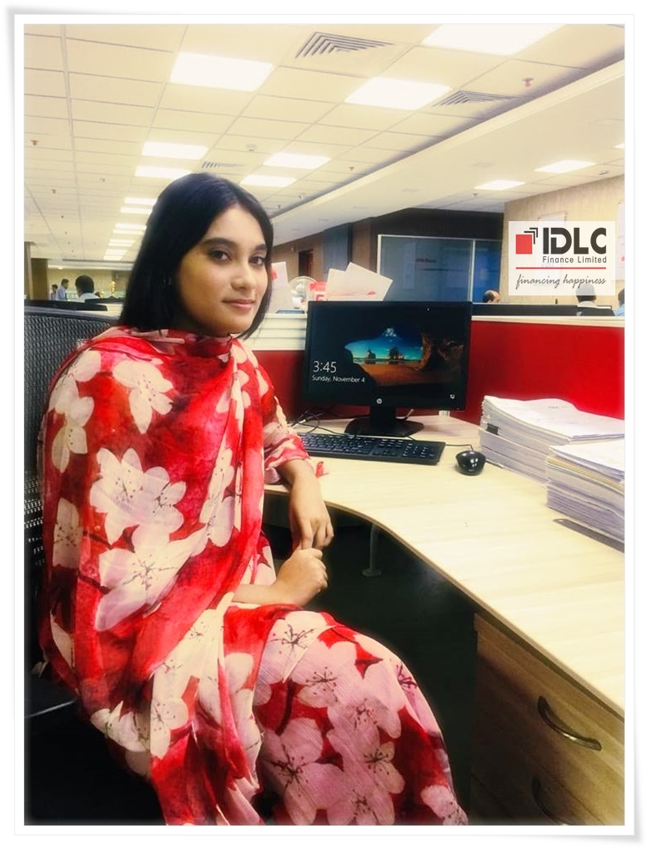

Recommendations

Here are some recommendations because I have worked here as an intern for last three months and I think some improvement can help the legal team of IDLC to manage the legal issues and various risks.
- Management needs to have fair for choosing a person responsible for performance evaluation. The HR manager should not have any personal relationship with the candidates.
- IDLC need to protect all the legal papers inside a safe box. So that any unusual occurrence can be handled immediately.
- While giving loan, they need to be more careful so that no one cannot deliver wrong and artificial papers.
- Various skill development program should be performed for customer relationship department.
- The legal team should concentrate not only to the overdue customers of three months but also they need to focus on the loan defaulter of 9 months.
- There should be some arrangements of discussion session with the borrowers to let them know all the legal issues and risk management criteria of IDLC Finance Limited.

Conclusion

IDLC Finance Limited is holding an important part of the monetary improvement of Bangladesh. IDLC Finance Limited is working superbly in by providing a lot of services. IDLC finance is worth place for Finance, Accounting and HRM graduates to do their intern. By doing the internship in the Legal Team one will get the chance to comprehend hr and finance related work. The report additionally gave profundity investigation of the jobs and duties, critical commitments, learning results and difficulties looked of different risk and legal issues during the 3 month' of internship period and how in the coming years, this experience would design my future objectives.
My internship was extremely significant for me and I would not have any desire to do it some other way. In any case, if I need to re-try this internship for any reasons, I would re-do this internship in a similar department and ideally under a similar mentor however with more aspiration and devotion. At first, I figured I would be made to do humble work or regarded as an insignificant care staff, however all through my internship, I understood what an imperative and noteworthy job I've needed to play. With every one of these learnings and experience, I would have the capacity to make a proactive methodology towards my work and request more difficulties and obligations dissimilar to before when I held up to be called and requested that by my boss do something. I would request that my Department Head give me the chance to apply the information I got from more elevated amount courses much more, so my ideas get clearer and I would give some attention on discussing even with individuals of different departments.

References

- IDLC Finance Limited. (n.d.). About Us: IDLC Finace Limited. Retrieved December 2017, from idlc.com: http://idlc.com/
- Sharmin, B. (2012). Analysis of collection procedure of Retail Loan. Dhaka: BRAC University. https://thefinancialexpress.com.bd/ https://www.bb.org.bd/econdata/index.php
http://quotes.wsj.com/BD/XDHA/IDLC
- https://www.ceicdata.com/en/indicator/bangladesh/non- performing-loans-ratio IDLC Finance Limited, Annual Report-2017. http://www.investopedia.com/terms/g/grossmargin.asp
- The Global Economy. (n.d.). Retrieved December 2016, fromwww.theglobaleconomy.com: http://www.theglobaleconomy.com/Bangladesh/Nonperforming_loans

