An analysis of the customer service operations at the City Bank

Mirza Abid

This intern report is submitted to the School of Business & Economics, United International University, as per the requirement for completing the Bachelor of Business Administration Degree.
An analysis of the customer service operations at the Cit
An analysis of the customer service operations at the City Bank

Submitted By
Mirza Abid
ID: 111173085
School of Business & Economics
United International University

Supervised By
Kawsar Ahmmed, Ph.D.
Professor
School of Business & Economics
United International University

Date of Submission: 24.02.2022

Letter of Transmittal

24 February, 2023

Dr. Kawsar Ahmmed
Professor
School of Business & Economics
United International University
Dhaka1- 1212

Subject: Submission of internship report on “An analysis of the customer service operations at the City Bank”

Dear Sir,
I am writing to submit my internship report, which I completed at The City Bank LTD during my internship period from 8-6-2022 to 7-09-2022. During my time at the bank, I was able to gain hands-on experience in various areas of banking operations, including customer service, loan processing, and financial analysis.

This report provides a comprehensive overview of my activities, learning, and achievements during the internship. I have highlighted the skills and knowledge that I acquired, as well as the challenges I faced and how I overcame them. The report also includes recommendations for improving the bank's operations and services, based on my observations and experience. I would like to express my gratitude to The City Bank LTD for giving me this opportunity to undertake this internship and for providing me with the support and guidance needed to complete it successfully. I would also like to extend my appreciation to my internship supervisor (Branch) MR. Zaki Uddin, who provided me with valuable insights and guidance throughout the internship.

I hope that this report will be of value to The City Bank LTD and will demonstrate my commitment to professional development and my eagerness to contribute to the financial industry.

Thank you for considering my report. I look forward to your feedback and comments.

Sincerely yours,

Mirza Abid

Acknowledgement

I would like to express my heartfelt gratitude to all those who have contributed to the successful completion of my internship report. This report would not have been possible without the support and guidance of many individuals.
First and foremost, I would also like to extend my gratitude to my internship supervisor, Dr. Ahmmed Kawsar Sir, for providing me with guidance and support throughout the internship. His feedback and suggestions were extremely valuable and helped me to improve my report.
I would like to express my sincere thanks to The City Bank for providing me with the opportunity to undertake this internship. I am grateful for the hands-on experience I gained in various areas of banking operations, which has helped me to gain a deeper understanding of the financial industry.
I would like to thank all the employees of The City Bank for their support and cooperation during my internship. I appreciate the time and effort they took to explain various banking procedures and provide me with practical examples.
Finally, I would like to acknowledge the support of my family and friends, who encouraged me throughout the internship and helped me to stay motivated.
Thank you all once again for your support and guidance.
Sincerely,
Mirza Abid.

Declaration:

Mirza Abid
Address : Chunkutia , Purbopara (Mirza Bari)
Keraniganj, Dhaka – 1310.
Email Address: mirzaabid898@gmail.com
Bank Name : The City Bank LTD.
Address : Islampur Road Branch , Dhaka -1100
Dear Sir,
During my time at The City Bank, I had the opportunity to work closely with various departments and gain hands-on experience in the operations and processes of a leading financial institution. The internship provided me with valuable insights into the challenges and opportunities facing the banking industry and helped me develop a deeper understanding of the financial sector.
I have put in a great deal of effort and hard work in the preparation of this report and I believe that it accurately reflects my learning and experiences during the period of internship at The City Bank . I have included all the relevant information and data, and have taken utmost care to ensure that the content is accurate and reliable.
I certify that this report is original and has not been submitted for academic credit elsewhere. Thank you for considering my internship report.
Sincerely,
Mirza Abid.

Executive Summary

This report presents the findings and recommendations from an internship at The City Bank in the customer service department. The purpose of this internship was to gain hands-on experience in the banking industry, with a focus on customer service.
During the internship, I had the opportunity to observe and participate in various customer service activities, including account opening, loan processing, and complaint-resolution. I also gained experience in using banking software and tools, as well as in following established policies and procedures.
Observations showed that the City Bank provides high-quality customer service and has a strong commitment to meeting the needs of its customers. However, I also identified some areas for improvement, such as the need for better training for customer service representatives and the implementation of more efficient complaint resolution processes.
In conclusion, this internship has provided me with valuable insights into the banking industry and the importance of customer service in the financial sector. I have developed a deeper understanding of the challenges faced by customer service representatives and the steps that can be taken to improve the customer experience.
Based on the observations and experience, I recommend that The City Bank should invest in training and development for customer service representatives, streamline complaint resolution processes, and use technology to enhance the customer experience. I believe that these actions will contribute to the long-term success of The City Bank and enhance its reputation as a provider of high-quality customer service.

Keywords: operations, customer service, training and development, complaint resolution, City Bank
Table of Contents
Letter of Transmittal 2
Acknowledgement 3
Declaration: 4
Executive Summary 5
Chapter-1 8
Introduction 8
Objectives of the Report: 9
Research Methodology: 10
Limitations of the Report: 11
Chapter-2 12
Industry and Company Analysis 12
Specification of the Banking Industry in Bangladesh 13
Size , Trend and maturity of The Industry: 14
Technological Factors 16
MFS 16
Agent Banking: 17
Internet Banking: 18
CRM : 19
E- KYC : 20
Political, Legal and Regulatory Factors 22
Political Factor: 22
Regulatory Factor 23
Industry Rivalry 25
• Rivalry Among Existing Competitors 26
Threats of new entrants: 26
Bargaining power of Buyers: 27
Bargaining power of Suppliers: 27
Threats of Substitute Products: 27
Summary of the Challenges and Opportunities 28
Challenges: 28
Opportunities: 29
Overview and history 30
History: 30
Company Overview : 31
Profile : 32
Mission, Vision And Values: 34
Customer Mix 35
Ordinary Customer: 35
VIP Customer: 35
Product and Service Mix 36
Deposits ( Current , Savings , Fixed ) 36
City Alo Savings Account 36
City Islam Account 37
City Gem Account 37
Citytouch (Digital Banking) 37
Statement Facility 38
Dollar Endorsement service 38
Loan Service (Auto Loan, Second Hand Car Loan, Personal Loan, Home Loan, City Bike Loan, Student Loan , Secured facilities) 38
Cards (Master card Platinum Debit Card, Mastercard Regular BDT Dabit Card, Credit card Customer Service Portal , Cards FAQ , American Express card 38
Wholesale Banking 39
Remittance Services 39
SWOT analysis: 40
Strengths: 41
Weakness: 43
Opportunities: 44
Threats: 45
Strategies to Meet the Challenges and Opportunities 46
Chapter – 3 48
Literature Review 48
Features of Services: 49
Service Quality 50
Importance of Service Quality: 50
5CS of Service Quality Requirements : 51
5Cs In Banking Sector : 52
Chapter – 4 53
Job Description 53
Job Responsibilities: 54
Daily Operations 54
Assisting Supervisor and Coworkers 55
Customer Service 55
Process Improvement : 55
Interactions with the supervisor and coworker 56
Chapter – 5 57
Methodology, Analysis, and Discussion 57
Methods: 58
Analysis and Discussion: 59
Relationship Manager: 59
Cash Area: 61
Teller Service: 62
Customer Service: 63
Recommendation: 66
Conclusion: 67
References : 68

Introduction:

Chapter-1

Introduction
This report provides a comprehensive overview of the internship experience at The City Bank. The internship period was a valuable opportunity to gain practical exposure to the workings of the banking industry. I was fortunate to be placed in the customer service department, where I was able to observe and participate in various day-to-day activities. The three-month internship period from June to September provided hands-on experience in various aspects of banking such as loan processing, customer service, and risk management. Through this internship, I have gained a deeper understanding of the challenges and opportunities in the banking industry. In this report will discuss the key learning outcomes, tasks and responsibilities assigned, and the overall impact of the internship on my personal and professional development.

Objectives of the Report:
The objectives of my banking internship report include gaining practical exposure to the banking industry, developing skills such as customer service and problem-solving, understanding the operations and procedures of a bank, evaluating personal and professional growth, and contributing to knowledge and understanding of the industry. This report aims to provide an overview of the internship experience and discuss the key learning outcomes and impact on my development.
- To provide an overview of the internship experience at the bank and the tasks and responsibilities assigned to me.
- To gain practical exposure to the banking industry and understand the various operations and procedures of a bank.
- To learn about the challenges and opportunities in the banking industry and the role of technology in shaping its future.
- To develop and enhance skills such as customer service, communication, problem-solving, and time management.
- To understand the role of various departments within a bank and the interdependence between them.
- To observe and understand the regulations and policies governing the banking industry.
- To understand the impact of macroeconomic factors on the banking industry and its operations.
- To gain a deeper understanding of the financial products and services offered by the bank.
- To evaluate the personal and professional growth achieved through the internship and identify areas for future improvement.

Research Methodology:
Based on both qualitative and quantitative data this report is prepared. The maximum portions of qualitative data are collected from The City Bank website, personal observation and journals. Secondly the quantitative data are collected from websites, survey and also from journals.
All the data collected to accomplish this report can be classified into two categories:
- Primary sources.
- Secondary Sources.
Primary Data Sources:
- Personal observations and experiences during the internship.
- Interviews with supervisors, co-workers, and customers.
- Documentation and records provided by the bank, such as training materials, operational procedures, and financial reports.
- Feedback and evaluations from supervisors and co-workers.
Secondary Data Sources:
- Published reports and studies on the banking industry.
- Online resources, such as articles, news, and websites related to the banking industry.
- Government and regulatory agencies, such as the central bank, for information on policies and regulations.

Limitations of the Report:
- Time Constraints: The short duration of the internship may not allow for a comprehensive understanding of the banking industry and its operations.
- Limited Access to Information: There may be restrictions on access to confidential and sensitive information within the bank, which can limit the depth and breadth of the report.
- Limited Representation: The internship experience is limited to a single bank and may not reflect the experiences or practices of other banks or the banking industry as a whole.
Despite these limitations, a well-structured and comprehensive internship report can provide valuable insights and practical experience for myself and contribute to the understanding of the banking industry.

Chapter-2

Industry and Company Analysis

Specification of the Banking Industry in Bangladesh

Bangladesh is one of the developing countries in South Asia and its banking industry has seen significant growth and expansion in recent years. There are more than 50 commercial banks operating in Bangladesh including both state-owned and private banks. The banking sector in Bangladesh is regulated by the central bank of the country, Bangladesh Bank, which is responsible for formulating and implementing monetary policies, licensing and supervising banks and non-bank financial institutions, and ensuring stability in the financial system.
The banking industry in Bangladesh is divided into three main segments - conventional banking, Islamic banking, and microfinance. Conventional banking offers traditional banking services such as deposits, loans, foreign exchange, and trade financing. Islamic banking, on the other hand, follows the principles of Islamic finance and prohibits interest-based transactions. Microfinance institutions provide small loans and other financial services to low-income individuals and micro-enterprises.
A bank is a financial entity that is permitted to accept deposits and provide loans. Banks are classified into three types: retail, commercial, and investment. Banks are governed by the national government or central bank in the majority of nations. If we go back to the history then we will see that the bank was invented right after the “Bartar trade policy”. In the era of bartar trade policy, people exchange goods to buy other products. After that Gold and silver coin was used for buying products. Generally bank was invented to give safety of people’s money and make profit by recycling that money. In general, the term "bank" refers only to financial institutions that deal with cash. When we hear the word "bank," we typically think of a financial entity that manages money. The full state of affairs of a rural company is continuously detected by evaluating the banking division's predicament. The general formula of the bank is to collect money from the customers for a certain time and to distribute the money to the loan seekers by including a particular interest. This interest is considered as the revenue of the bank . The bank authority pays a certain interest to the depositors and the rest of the interest is counted as a profit of the band. So in general, we can say that bank is an organization and the product of this organization is money. The banking division is critical to any country's economic operations and development. Central banks, commercial banks, savings banks, investment banks, industrial banks, and cooperative banks are all types of banks. However, in the past, we used the word "Bank" without qualification or constraint, and it referred to commercial banks. Commercial banks are the first to assist in a rural economy like ours.
The banking industry in Bangladesh has seen significant growth in recent years and has made significant contributions to the country's economic development. The sector has also undergone modernization and digitalization, with a significant increase in the use of technology such as mobile banking, internet banking, and ATMs. This has made banking services more accessible and convenient for the people of Bangladesh.
In terms of performance, the banking industry in Bangladesh has generally been stable and profitable. However, there have been some challenges in recent years, including rising non-performing loans and increased competition from non-bank financial institutions. To address these challenges, Bangladesh Bank has taken various measures, including implementing stricter regulations, improving corporate governance and risk management practices, and encouraging greater collaboration among banks.
Overall, the banking industry in Bangladesh has come a long way in recent years and has shown significant potential for further growth and expansion. However, there is still room for improvement, particularly in terms of financial inclusion, which remains a challenge in the country. The government and the central bank have taken various steps to address this issue, including promoting the growth of microfinance institutions and increasing access to banking services in rural areas.
In conclusion, the banking industry in Bangladesh has shown significant growth and potential for further development. With a focus on modernization and digitalization, the sector is poised to make a greater contribution to the country's economic development in the years to come.

Size , Trend and maturity of The Industry:

It is obvious that Bangladesh is a developing country. The government of Bangladesh encouraged the banking sectors from the last three decades. By this, the banking industry has become a dramatic developing sector now. The banking industry in Bangladesh achieves this success by a great market orientation. Firstly they divided the whole economy in two sectors one is urban economy and another one is rural economy. A country can lead by a strong economic position only when both of the sectors are efficiently strong. That is why the banking industry started the path of expansion on that time in the rural areas because they believe that urban economy is facilitated by the rural economy from a continuous resource transfer system. For this policy, it becomes very helpful for the rural people because they can invest in harvesting and more agricultural sectors and exports their product to urban markets. .Commercial banks dominate the economic sector and macroeconomic oversight in our country, with the remainder of the commercial banks' performance and investment divisions trailing close behind. Experts believe that non-public banks should be allowed to provide positive incentives to the development process in order to benefit themselves. This is why, for the first time, non-public sector banks were allowed to establish in the 1980s. City Bank LTD. is one among them. They started with a lot of branches throughout the whole Bangladesh and later those were extended.
In order to maintain public confidence in the banking system, seven state-owned banks and three private sector banks that were operating capital deficits by the middle of 2018 required state funding for recapitalization or bailouts. However, these bailouts pose a moral hazard issue and are likely to encourage banks to carry on acting in this way. Additionally, the government must refrain from directing financing to particular industries or ends that are better served by budgetary provisions. The fact that many banks are experiencing capital deficiency shows that the current regulatory capital standards to ensure banks stay financially viable have not produced the anticipated results. That begs the question of whether such specifications are appropriate for the task.
There are currently 62 banks operating across the country. Also there are nine state-owned entities (including five special banks), among them 38 private commercial banks, and nine commercial banks left. Despite the fact that Bangladesh's banking industry is undergoing fundamental reform, it is nonetheless suffering from chronic deterioration. The most major disadvantage of Bangladesh's banking sectors is the danger of loan default. Numerous efforts have been established in Bangladesh to prevent loan default.
If we talk about the trend of the banking industry then we have to focus on a point that the economy of a country is dominated by the banking industry and this process starts with collecting the money from people and re-invest those money in various sectors. The money was invested by the people who borrowed them from the bank on the other hand the bank also provide corporate loan, SME loan and in other financial activities of the institution.

Technological Factors

Innovation is the blessings of human being and All the bank of Bangladesh is also touched by this blessing. The banking system was conducted through manual banking system at past. It means all the data are collected and stored in a manual procedure. But now data is collected not only in manually but also in a digital process. The bank authority keep both softcopy and hardcopy of each documents for ensuring the safety of the data. We know the banking sector was one of the first in the financial services sector to embrace fast globalization, and it is greatly benefited from technological advancement. The introduction of the first automated bookkeeping equipment at banks in the 1950s marked the beginning of the banking industry's technological revolution. This was long before other sectors of the economy adopted technology. According to reports, the first Automated Teller Machine (ATM) with just a cash dispenser debuted in the USA in 1968. Over the past few decades, automation in banking has grown commonplace as banks soon learned that a large portion of their labor-intensive information-handling procedures could be automated with the use of computers.
In the past 15 years, the introduction of digital innovation has drastically changed Bangladesh's financial industry, bringing millions of people within the umbrella of banking services that have even reached the village level. Since clients can now complete their transactions from the convenience of their homes, the revolution has made it simpler for them to obtain those service. Additionally, village-level banking was made possible by agent banking, quicker depositing cash recycling machines (CRMs) are being introduced by banking, and online banking is making it easier for users to make a withdrawal, deposit money, and transferring money.

MFS
The word MFS depicts Mobile Financing Services. By the innovation of this technology banking industry had changed significantly on that time. Moreover, these tis the only technology which brings the banking services to the remote area. As it is tough to establish a bank in the remote area so this was the only way to bring the banking services on the village area in a full swing. By the blessing of this technology the rural economy also developed by the enrichment of the business areas. The only requirement for this is a mobile device; by the mobile device the account holder can directly operate his account throughout his device. Nowadays, over 18 Core account holder conduct 2 core transaction by the help of MFS. The Duch Bangla bank first introduce the Mobile banking system in 2011 and the name of theirs system is “DBBl Mobile” which is rebranded in “Rocket” later.


Agent Banking:

In 2012 Bangladesh bank at first introduce the agent banking system in Bangladesh. The mission is to provide safe banking services to the customers and spread the safe banking to the people. Banking is a sensitive takes in nature . Generally most of the people in the rural areas are illiterate and the don’t know how to operate the mobile banking only on the other hand it is tough to established a branch at a remote area . That is why the agent banking system was introduced where the account holder can easily and safely make their transaction .
Typically, agent banking is employed to provide fundamental banking services such cash deposits, cash withdrawals, and remittance receipts. In addition, banks are now disbursing loans via their brokers. In June 2022, there were 1.6 crore agent banking accounts countrywide, an increase of nearly 31% over the same month the previous year. However, compared to the same month the previous year, there has been a 54% increase in the number of accounts in June 2021.Records from the Bangladesh Bank show that as of June 2022, 79.80 lakh men had established agent banking services, an increase of almost 20% from the previous years.
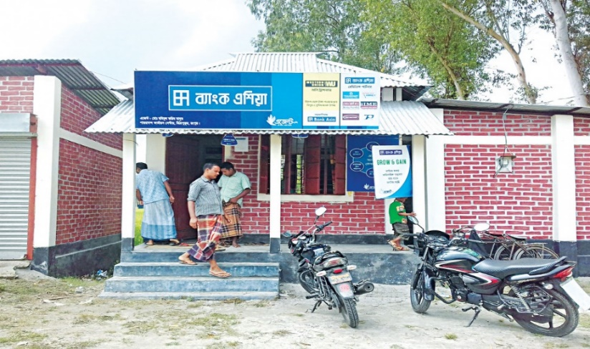

Internet Banking:

The banking industry has got an immense gather of customer through the innovation of Internet banking. It is usually popular for it’s features and the easiness of using . It also saves time money and energy because by using this the customer can pay their mobile phone bill, utility bill, tuition fees which the previously need to pay by bank. So the benefit is the don’t need to go to the bank , stand in a que and wait for a long to pay those bills. The customer satisfaction is the first thing to sustain in a competitive market and by the innovation of this technology it is perfectly ensured by the banking industry. In Bangladesh, online banking transactions more than doubled in the most recent fiscal year as a huge number of participants, particularly the new generation, began that used the platform for monetary operations.

Digital banking has grown rapidly as a result of the Covid-19 pandemic in mid 2020, which compelled people to use technology for pleasure, work, and communication.
---*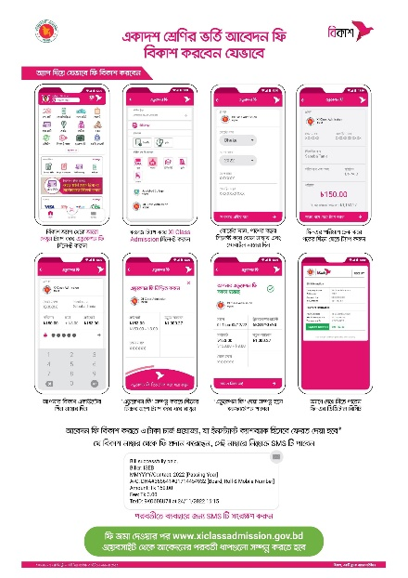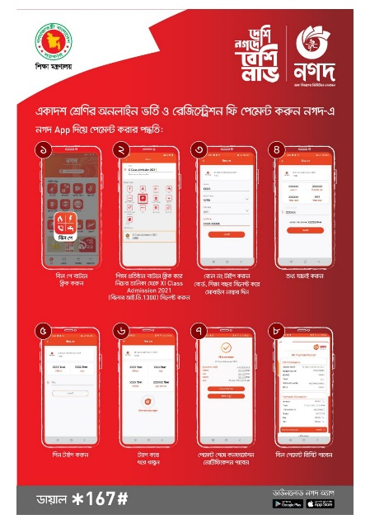

CRM :

Customer relationship management, or CRM, is a system used to manage and maintain customer relationships. Throughout the whole service lifecycle, CRM technology aids businesses in developing and strengthening relationships with their customers.Banks may eliminate the need for human labor by using a CRM to collect cash, counting the banknotes, validate them, and transfer the amount to accounts in actual. By closing all gaps, a CRM enables the bank to help each customer every step of the way—from opening a bank account to transactions, loans, and more. This enables banks to respect customers' appearance and promptly and easily meet their financial needs. Functional, statistical, and collaboration CRM systems are the three different categories. The three software programs that are most frequently used and preferred in Bangladeshi banks are Adobe, Oracle, and Microsoft.


E- KYC :

To individuals, opening an account without going to a bank has traditionally been a difficult process. The digital Know Your Customer (e-KYC) was implemented by the Bangladesh Financial Intelligence Unit in January 2020, allowing customers to access their bank accounts in about five minutes as opposed to the two to four days it had usually needs. The process is currently reducing the cost associated with KYC by up to 80%. Verifying a customer's identification is the process of "knowing your customer” .The goal of its KYC regulations is to prevent bad actors from using banks for their money-laundering schemes. Money laundering has become a great issue in this digital era . for example , A man who has a business of gold , sends money to a person who has a business of cutting ship. Here , the transaction is suspicious and the bank authority will get alerted by the E-KYC system because the details of both customers are uploaded and there should not be any relationships between a gold businessman and a ship cutting businessman .

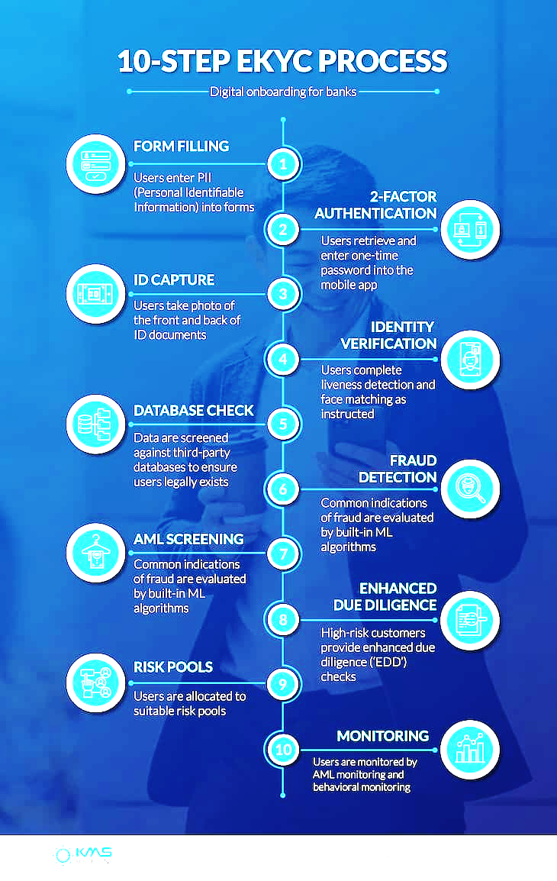

Political, Legal and Regulatory Factors

Political Factor:

The political factor means the government interference in the activities of the banks . Usually the central bank conducted the process but sometime the government need to do this for ensuring the smooth monetary flow in the economy. It can be clearly observed that sometimes the government increase the interest rate and decrease the interest rate on deposits . The purpose to do this is to ensure the smooth money flow . for example , if the government need money for a mega project then the government give instruction to the central bank to increase the interest rate on public deposit. Consequently the people become more interested in savings . on the other hand when the government can realize the money lacking in the economy then the simply deduct the interest rate because of the smooth monetary flow in the economy . One thing should be described , the central bank can also fill the deficiency of money by issuing new notes in the economy but if they do it , then the inflation rate will be increased because the overall resource will remain same in the boundary. Political Stability is also a considerable factor for the banking industry. Because only the government can ensure the business friendly environment in a country .If there is positive environment for business then the economic stability will become strong , if not then the opposite will be happen. Recently the government impose high taxes in deposits , The ratios are different for the particular amount of money. For example ,

Deposit Amount | Government tax
0 – 3,00,000 | 300 TK
3,00,000 – 9,00,000 | 600 TK
10,00,000 or more | 1500 TK

Now the question Comes in mind that “Is FDR a taxable sector for the Government ?”
The answer is yes , FDR is fully taxable because it is considered as an income from the other sources of individual. This tax is imposed by the governed according to the tax act 1961. The interest of the FDR is also considered as an income and it is added in the individual’s annual income according to this act.

Money is like the blood of the economy . A perfect blood circulation is mandatory for a body, like this a clear monetary flow is mandatory for a healthy economy.

Regulatory Factor

Regulators of Financial System In Bangladesh
Financial institutions must comply with regulations set by a national bank regulator in order to achieve the regulator's goals. The degree of risk exposure for a particular banking system is frequently strongly correlated with these standards. Keeping capital requirements levels is the key prerequisite for financial regulation. Since it was founded on December 16, 1971, Bangladesh Bank has served as the nation's central bank. A nine-member Board of Trustees, led by the Governor, who also serves as the institution's CEO, has been given broad supervision and control of Bangladesh Bank's operations. There are 45 divisions and 10 branch locations at Bangladesh Bank.
According to Section 7A of the BB Order from 1972, BB's primary responsibilities are given below:
- developing and carrying out monetary and fiscal policy,
- developing and carrying out effective interventions in the foreign exchange market,
- advising the government on how money supply interacts with fiscal and exchange rate regulation, on the effects of different policy measures on the economy,
- suggesting federal legislation it deems necessary or proper to achieve its goals and carry out the necessary its operations;
- holding and manage the official foreign reserves of Bangladesh.

The primary goals of Bangladesh Bank's financial regulation are:

- sustainability including both external and internal markets
- Balanced expansion and development
- greater remuneration
- effective and economical utilization assets
- Savings / investment technological support.

Reserve Management Policy:
Reserves assist the money market in providing liquidity to the domestic financial markets, the banking industry, and perhaps even export; this is particularly important when there is a large dollarization of bank deposits and other domestic obligations. To reduce the risk brought on by extensive volatility in the exchange values of major currencies and very erratic activity in borrowing costs on the international money market, Bangladesh Bank keeps the country's reserves of foreign currency in a variety of banknotes. Bangladesh Bank has agreements in place for accounts with many Financial Institutions. The money that builds up in all these deposits is invested in Treasury bills, equity securities, and other sovereign bonds in the corresponding currencies. Additionally, it invests in high overall company, institutional, and governmental bonds as well as relatively brief savings with numerous reputable lenders. The practical aspects of investments are handled by a different Bangladesh Bank department, and the one that follows investment guidelines established by the organization's Advisory Board, which would be presided by a Deputy Governor.

Regulations of micro finance Institution:
Bangladesh bank Have passed the "Microcredit Regulatory Authority Act, 2006" , as entered into force on , 2006 August , in order to place Non-Governmental Microfinance Institutions (NGO-MFIs) under a regulatory framework. To ensure the accountability of the microcredit activities of the Non-governmental in the nation, the government instituted the Microcredit Regulatory Authority (MRA) under this Act. A Commission has the authority and duty to carry out the aforementioned act and provide a comprehensive policy structure for the nation's venture capital industry.
The goal of MRA is to support the long-term development of this industry while ensuring the openness and responsibility of Voluntary organization’s formal financial initiatives. MRA has established the following objectives that it wants to accomplish in in order to achieve its purpose:
- to develop and put into place regulations that would enable MFIs have accessible capital markets and excellent control.
- to perform in-depth analysis of crucial micro - credit difficulties and offer the government recommendations that are consistent with the national goal for eradicating poverty.
- To give NGO-MFIs exposure and connect them with the higher profit economy in order to support efficient energy use and effective management.
- to support the state in creating a diverse capital market for the nation's economy.
- To determine the top priorities in the microfinance industry for regulatory policies and document management in order to fulfill the moral obligation of the Microcredit Regulatory Authority.

Industry Rivalry

The Porter’s five forces model , A very excellent theory of analyzing a business and it’s current position. This theory is not only applicable for analyzing the own business but also for knowing the position of the competitors. By this theory a company can easily find his strength , weakness and develop those weak point by the rivalry among existed competitors is generally existed in some elements and they are threats of new entrants, bargaining power of buyers, bargaining power of suppliers and threats of substitutes products or goods . Moreover , there also exists some sophisticated factor at each sector which should be taken into consideration. Each business in an industry should have to follow the Porter’s five forces model to successfully conduct their business . without this any business could not stand in the field of competition. Like all other business industry the banking industry in Bangladesh also follow this technique to cope up with competition. They accomplish it just by providing lower lending, higher rates, capital markets, and greater advantages versus banking competitors. Financial competition is frequently a battle to discover which branch can provide the finest and earliest solutions, however this has resulted in reduced ROA for financial companies (Return on Assets).
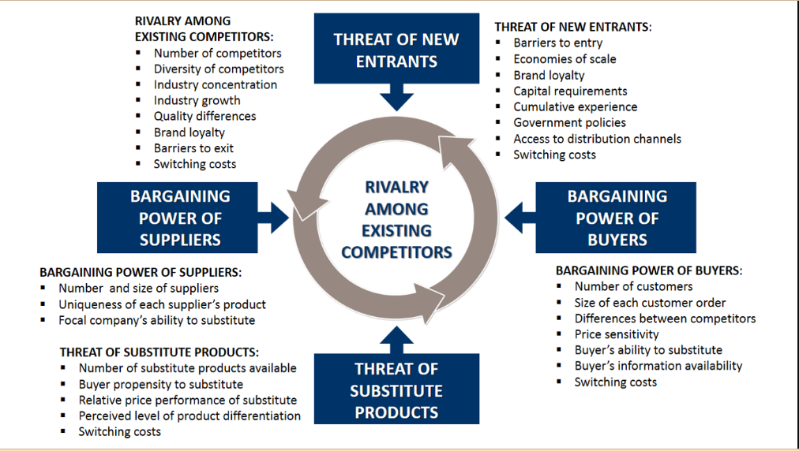

- Rivalry Among Existing Competitors :
If we talk about the rivalry among existing competitors then we must have to consider several factors which are very essential and vital. The following question should be asked here ;
- How many rival exist?
- Who are the biggest rivals?
- How does your quality compare to that of the competitor?
- What is the distinction between you and your rivals?
- What will it cost if your customers decide to switch to your rivals?
Generally banking industry is a very competitive industry. Bank competitive rivalry in Bangladesh has risen dramatically. The financial sector is up against 60 companies . The sector's 59 banks' competitiveness, combined with an aggressive pricing war, had resulted in a reduction in the amount of loyal consumers, putting the financial services market very aggressive. Customers' transactions costs are very low; they may simply change with one institution to some other, and there is minimal loyalty. There is some distinction for both rivals' offerings. Inside the sector, customer engagement is still developing. Bankers are already focused on unique and distinct services and products propositions in order to be successful.. It is not a easy task to gather money from the people and reinvest those money to various sector. So there is huge competition in this industry. All the basic standards are same in all banks and the activities are also same because those standards and activities are applied to banks bay the central banks . But the main point to get the fast mover advantage is to provide the service as faster as possible . So if a bank provide service to a customer easily and smoothly it will become a great advantage for that institution . But the safety issue should be maintained. Secondly Banks sometimes offer higher interest rate om deposits and offer lower rate on loan than others but It cause lower ROA(Return on investment) . To prevent this kind of problem the bank follow a strategy which is merging with other banks.

Threats of new entrants:
In recent years, a number of brand-new financial institutions have already established and created a competitive market, those new banks will compound competitiveness in the coming years. As a result, the threat posed by newcomers is relatively strong in this industry.

Bargaining power of Buyers:
Financial borrowers are commonly recognized as buyers, and therefore impose strong power of bargaining . Those who impose pressure on businesses to reduce prices while improving customer experience, lower interest rates. Consumers are more strong throughout this sector in order to pressurize banks. Financial institutions are frequently subject to selling loans and advances in order to protect their own interests.

Bargaining power of Suppliers:
Money is the main product for all the banks and banks get those money from the individuals who deposits to their institution. Without central bank the other banks cannot issue notes in the financial market . So the only supplier in the market is people who deposits money to the bank. Mortgage property and loan from other banks are also a source of product (Money) for the bank but those are not usually happen. The bargaining power of suppliers is comparatively high in the industry because There are a huge amount of banks in the markets and the other thing is people become more aware in financial activities for example they become more interested in investing money in business or other startup . So it becomes a difficulty for the bankers but still now people are depositing money into their account for the safety of their money. The middle class businessman think just the opposite because they want to invest the money to business to extend their business they just want to maintain a current account which I have observed during my internship period .

Threats of Substitute Products:
Almost all of the banking company's most serious substitute challenges come not exclusively from competing institutions, as well as from other nonbanking financial companies. Moreover the there are a lot of substitutes of banking services. For example NGO, Multipurpose companies ,online banks ,credit unions , Peer to peer lending etc. If we talk about the multi-purpose companies they do the same things as banks with less difficulty. Bank need some legal documents if somebody wants to take loan from them and sometimes it becomes a matter of hassle for the customer . And if we talk about the peer to peer lending system, the interest rate is lower than the traditional banking system in here and there is no middleman in here so the task become so easy than the bank while taking loan for the betterment of the individual. Challenges from replacement items are high, reducing prospects for development.

Summary of the Challenges and Opportunities

Challenges:
The banking sector in Bangladesh faces a lot of challenges but there is opportunities too. If we talk about the challenges then some considerable factors should be focused like IT knowledge, cyber security and NPL(Non-performing loan). The IT sector of bank should be more improved to prevent casual cyber-attack from hackers. According to a research 52 percent of all banks are now facing the high risk of a cyber-attacks . The real situation is all the privet banks are 100% equipped with IT instruments and systems but the state owned banks are not fully equipped with this innovation. But the positive thing is they are embracing it gradually . Improvement in IT sector is very much helpful for the effective communication , storing data ,making online transaction , Documentation, back up data and ensuring the safety of all data.
Another great challenge is to prevent the ratio of money laundering . Money laundering is a serious criminal activities and according to the research 12-15 billion USD is smuggled every year from our country. Almost every bank appoint several BAMELCO (Bank Anti Money Laundering And Compliance Officer to track the money laundering type of transaction. For example , I observed a case during my internship that a businessman of gold should not send money to a businessman of cutting ship. Because there is no direct relationship between this two people and it is abnormal too. Another example I have noticed The AI system of banking easily detect those transaction if somebody cross the limit of amount in transaction. By this several types of process bank authority are trying to stop this offence.

Loan Defaulting is also a great challenge for the banking industry because this is the main income source of a bank. NPLs constitute one of the most serious issues which can endanger a bank's financial safety and soundness. As per Bangladesh Bank records, the total amount of hazardous loans climbed by 11.23 percent to 993.7 billion BDT at the end of the first quarter of 2019.For this kinds of activities the Nonperforming loans now make up 11.45 percent of overall liabilities, up from 10.41 percent in June of previous year. Bangladesh bank has arranged several training program for the bankers to stand against this immoral act. A total of six government banks are the worst hit by default loans costing Tk 480.80 billion only until September 2018, up 12.20 percent from the previous three months.

Opportunities:
Differentiated competitive strategy , Highly diversified financial products ,Advanced technology and develop human resource are the main element of opportunities for the banking industries in Bangladesh.

If we talk about the human resource , the corporate world nowadays become more competitive day by day and they are also developing themselves as well because the can feel that without personal development they cannot sustain in the job market So the always need to be updated about what happed in the market and become trained for the worst situation. So therefore we can say that there is no lack of skilled human resource in Bangladesh job market.
Secondly, If we look at the advantage of differentiation strategy, A differentiated strategy is a strategy developed by organizations to provide consumers with doing something distinctive, diverse, and separate from what their opponents may provide in the industry. The primary objective of applying a market development strategy is to gain an advantage in the market.

Technological diversity is also a great opportunity for the banking industries in Bangladesh . A very large proportion of people have mobile phone in their hand and almost a significant majority of people have computer , tablet , laptop and other smart device . In these difficult times, the utility of technology in keeping connected, self-employed, and having healthcare coverage has been highlighted. Technology is essential for higher security, good interaction, better defined, schooling, and, final but just not last, entertainment.. So as we can see it is become very easy for the bank to communicate with the customer over this smart technologies and the customer also feel enthusiastic to operate their own account activity through it . So we can say that there is a rapid change in the technological sector of bank and in future it will be more updated and more efficient for the people.

Last but not the least is “Economic Enrichment”. Bangladesh is a developing country all the vital economical sector in our country is growing up day by day and the SME sector is running very well. Ther entrepreneurs are become more engaged and interested in using the banking services. For example , sending money through the bank, doing RTGS, making LC etc.

Analysis of the City Bank

Overview and history

History:
In typically, the word "banking" denotes for only banking institutions that deal with currency. Whenever people hear the term "banking," people tend to imagine of a financial entity that manages money. The full state of affairs of a rural company is continuously detected by evaluating the banking division's predicament.
The City Bank is the first privet bank which is established in 1983 by the courage of 12 brave people . The set up their business idea with their great courage and with a lots of uncertainty. By using their skill productively they became successful to establish the bank as a first commercial bank in Bangladesh. The pioneers are:

- Mr. Monowar Ali,
- Mr. Ibrahim Mia (Late).
- Mr. Abdul Hadi (Late),
- Mr. M.A. Hashem (Late),
- MD Foyzul Bashar
- Mr. Anwar Hossain(Late),
- Mr. Abdul Barik Choudhury (Late),
- Mr. Deen Mohammad(Late),
- Mr. A.B.M. Feroz,
- Mr. Md. Ali Hossain,
- Mr. Azizul Haque Chowdhury (Late),
- Mr. N.A. Chowdhury (Late)

The financial division is critical to any nation's economic development and functioning. Central banks, commercial banks, savings banks, investment banks, corporate banks, and credit unions are all types of banks.
Privet Banks are governed by the national government or central bank in the majority of nations. If we go back to the history then we will see that the bank was invented right after the “Bartar trade policy”. In the era of bartar trade policy , people exchange goods to buy other products. After that Gold and silver coin was used for buying products . Generally bank was invented to give safety of people’s money and make profit by recycling those money . In general, the term "bank" refers only to financial institutions that deal with cash. When we hear the word "bank," we typically think of a financial entity that manages money. The full state of affairs of a rural company is continuously detected by evaluating the banking division's predicament. The general formula of the bank is to collect money from the customers for a certain time and to distribute the money to the loan seekers by including a particular interest . This interest is considered as the revenue of the bank . The bank authority pay a certain interest to the depositors and the rest of the interest is counted as a profit of the band. So in general , we can say that bank is an organization and the product of this organization is money. The banking division is critical to any country's economic operations and development.

Company Overview :

The City Bank LTD is a renowned privet commercial bank in Bangladesh . It is the first commercial bank in this country which is successfully operate their activities till now. The picture in below is collected from their official website . If we look at the picture , we will see throughout the country they have established 132 branches , secondly they gave appointed more than four thousands people as employees and another important thing is they have a big customer base . The authority of this bank also focus on the online banking also . that’s why they set up more than four hundreds ATM booth throughout the country. Also they have seven priority centers , 2 VIP airport lounges , which is very essential for corporate banking and providing service to VIP people.
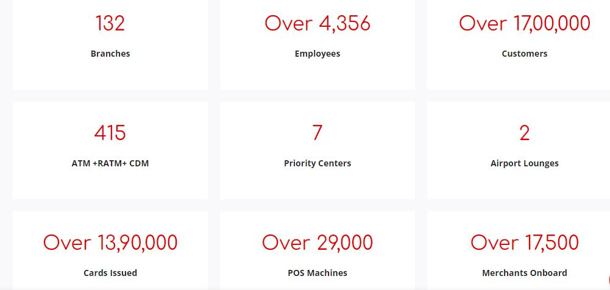
The City Bank is committed to building a better society by analyzing the scope of the problem and functioning and contributing in fields such as energy, nutrition, crisis response, athletics, and government initiatives. The long process truly represent our care for those participating in critical Activities in our monetary concentration. The City Bank ,by contrast , had also built asset regulations in with its everyday activities. The unskilled finance group is charged with mundane policy and product development, as well as management of the company's minimal investment operations. The company has a robust staff of highly trained and knowledgeable employees, along with an economical governing board that plays a dominant role in policy formulation and implementation.

Profile :

Name of the bank | The City Bank LTD
Status | Public Limited Copany
Date Of Incorporation | 28 March 1983
Registered office | Head Office. City Bank Center. 136, Gulshan Avenue, Gulshan-2. Dhaka-1212, Bangladesh
Company Registered Number | BD0102CTBNK5
Services | Retail Banking  Corporate Banking  SME Banking  Islamic Banking  Locker Rental
Service Hours | Sunday: 10:00 am – 4:00 pm  Monday: 10:00 am – 4:00 pm  Tuesday: 10:00 am – 4:00 pm  Wednesday: 10:00 am – 4:00 pm  Thursday: 10:00 am – 4:00 pm  Friday: Closed  Saturday: Closed
Swift Code | CIBLDBBH
Bangladesh Bank License Number | C 79186/09
Telephone | +880 2 8813483, 8814375, 8813126
Email | info@thecitybank.com
Web Page | www.thecitybank.com
Chairman | Aziz Al Kaiser
Managing Director | Mashrur Arefin
Number Of Branches | 132
Number Of ATM | 415
Number OF Card Issued | 1390000
Airport VIP Lounges | 2
Company Logo | 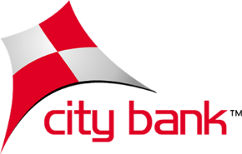

Mission, Vision And Values:
The City Bank LTD is a regulated bank which entered service on 1983, under the Company Law of 1994, also with purpose of playing a major role in the state's economic growth. Committed to delivering banking services to the destination on time of customers around the state. People trusted this organization practically quickly once it was launched. The company has already been able to establish itself as a towards and competitive commercial organization in the country throughout that time. From tiny merchants to huge traders and enterprises, comprising largest business and overseas investors, this is now generally acknowledged by the banking industry for contemporary and original ideas and financial solutions.

- Mission:
- Offer wide array of products and services that differentiate and excite all customer segments.
- Be the "Employer of choice" by offering an environment where people excel and leaders are created.
- Continuously challenge processes and platforms to enhance effectiveness and efficiency.
- Promote innovation and automation with a view to guaranteeing and enhancing excellence in service.
- Ensure respect for community, good governance and compliance in everything we do.
- Vision:
- The Financial Supermarket with a Winning Culture Offering Enjoyable Experiences.

- Values:
- Result Driven.
- Accountable & Transparent.
- Courageous & Respectful.
- Engaged & Inspired.
- Focused on Customer Delight.

Customer Mix
There are several types of customer in The City bank. All the customer are considered to this institution as an honorable one. The officer of this bank always try to provide the optimum quality of service . The customer service and complaints management cell always put an eye on each officer of all branches. They strictly handle all the complains from the customer and provide guidelines to the employee to provide better service. We can classified all the customer in three categories.

Ordinary Customer:

This kind of customer takes basic service from the bank , For example loan service , cash deposit, opening account , paying utility bill and so on . Maximum amount of customer are belongs to individual account . Students , Housewife, Employee, Small & Medium businessman , labor, freelancer these kind of people are usually considered as the ordinary customer . Normally they take service from the customer service desk and in the cask area and if needed they also consult with the loan officer and from the LC officer for importing & exporting.

VIP Customer:

The City Bank also provide service for the VIP customer . The bank generate a large proportion of their profit from this customer base . For example , The corporate banking customer , City Gem customer, 5 star clubs hotels etc can be categorized as a VIP Customer. At the end of the year 2021 The City Bank earns 400 cores as a profit. The maximum ratio of this amount of profit comes from corporate banking . Usually when the corporate company need loan for a project then they takes loan from several commercial banks because the amount is too big. Beximco ,Square, Meghna group , Abul Khayer group , Jamuna Group etc are regarded as a corporate customer . If we talk about the another VIP customer which is City Gem customer , they need to deposit minimum 40 laks taka inntially while opening a gem account. They got the VIP service , they don’t need to stand on que to take service and if need the officer of the bank visit their places .

Product and Service Mix

The City Bank offers a variety of services, including internet banking, Q-cash ATM services, several types of opening a bank account, agricultural and manufacturing loaning, SMS banking, transfer payments, BACH service, RTGS, and more.

School banking, utility bill collecting, locker services, elder allowance, and so on. The following are brief descriptions of key services:
Product and service offered by the City Bank for personal banking

Deposits ( Current , Savings , Fixed )
Cash can be considered like the blood of the bank and this blood is collected by the service of deposits . Current accounts are maintained by the businessman they do not get any interest from their deposited amount as they can withdraw money from their account at any time . Savings Deposits are the kind of deposits of the savings account . This account can be maintained by any person but there is transaction limit as per the occupation of the account holder. Lastly People who want to keep a fixed amount of money for a certain period of time open a FDR and deposit money in the account with the interest rate of 6.25% Currently.
Deposit services include financial products, current accounts, fixed deposits, short term cash and dual currency accounts. All commercial banks provide both savings and current accounts. Fixed deposit accounts are naturally directed towards the elderly's idle funds. In exchange, The City Bank offers attractive interest rates to account customers. A fixed deposit account is a sort of short-term account. People who desire to keep our funds for a long time.
Interest rates are higher than those offered by savings accounts but lower than those offered by fixed deposits for a smaller amount of time.

City Alo Savings Account
City Alo Savings account is a specialized bank account which launched by The City Bank particularly for the women entrepreneurs . Now a days the women entrepreneurs are playing a great role in our economic sector . Moreover they are doing well sometimes than the men. The women entrepreneurs in our country start their business for example start up like Fashion house, Catering Service and Counselling , Handy Craft making etc. With a redesigned banking experience, their purpose is to empower women by providing financial aid and support to help customer build their business or help improve their individual requirements.

City Islam Account
City Bank's Islamic Banking journey launched in 2003 and on that time they also opened their first Islamic Banking branch. The indigenous' daily financial demands are guided by their dedication to Islamic doctrine and Shariah laws. This ever-increasing demand for a modern Shariah - based financial services system has led to the launch of City Manarah as City Islamic - a Comply with shariah Islamic Banking service to meet day-to-day banking needs through some kind of diverse range of Shariah - based Private and Corporate And investment products and services.
The authority integrate extensive Shariah consultation knowledge from in an established Shariah Committee with the specialized Islamic Banking employees to provide a pleasurable Shariah-compliant banking experience for all valued customers.

City Gem Account
This account is launched by The City bank only for the VIP customers. Here they basically differentiated a different segment from the general segment of customers . All the activities are same a s the general customer segment but the servicer here are presented with a VIP treatment. For example The City Gem customer do not need to stand on a queue for chequebook withdrawals , sometimes if need the customer relationship officer visit to their place to give them service as per their expectation. Some conditions are required to be a Gem customer ,one of the vital requirements is , The customer must need to keep a certain amount of money to his account and the amount is 40 laks taka .

Citytouch (Digital Banking)
Digital Banking is the new extension of banking service in our country. To get the sustainable competitive advantage in market The City bank also launched Citytouch recently . By using the citytouch a customer can operate his account from his mobile for example they can check their balance , Issue pay order , send money to BKASH , pay utility bill, open DPS and FDR, issue debit/credit card , Change the pin of card, receive money from another account . As we can see a lot of activities can be done with this Citytouch . It can be a a great alternate of other digital banking method like Bkash , Nagad and UPay

Statement Facility
A financial statement is a record from the financial institutions that indicates all transactions on someone account for a specified time period, generally a month. Your bank statement's activity contains data including executed withdrawals and payments, someone per day balances, and any revenue earned. The City Bank LTD provides also provide statements to their valuable customers for any time period . After opening the account the first two statements are provided freely by the bank after that they charged 110 tk for per statements .

Dollar Endorsement service
The City bank provide the dollar endorsement device to the customer for their welfare. The customer can expend those dollar by the American express card in other countries . It is a great privilege to the customer and also a matter of pleasure , because before this they need to carry cash dollar by exchanging from the money exchange firms . So it is clear that now it becomes much easier for the customer .

Loan Service (Auto Loan, Second Hand Car Loan, Personal Loan, Home Loan, City Bike Loan, Student Loan , Secured facilities)
The City Bank mostly invests or lends in the Commercial Sector such as business like startup For example Data Farm, Health care Service, farming, dairy farms and other kinds of personal loan for business, at the lowest possible interest rate. However, it also lends to manufacturing businesses such as clothing, mails, and factories. The City Bank also provided a personal loan, a credit card loan, live stocks, Home loan ,Car loan and continuing loan as per the policy of their institution.

Cards (Master card Platinum Debit Card, Mastercard Regular BDT Dabit Card, Credit card Customer Service Portal , Cards FAQ , American Express card )
The City Bank LTD have a variety of card service for their honorable customer. Most of the people are now appreciating the digital banking system . It is found by a research that people are now feel more safe in carrying cards instead of cash . An young businessman gave his opinion he keep less amount of money as cash than the card because he didn’t feel the need of using cash instead of cards . This is happened , cause in most of the place for example in a shop or outlets the card payment service are active and it is much easier and safe than receiving cash. The City Bank have Master card Platinum Debit Card, Mastercard Regular BDT Dabit Card, Credit card Customer Service Portal , Cards FAQ , American Express card for the customer . Customers can choose cards as per their need and they also give offer through their cards . For example recently they give offer of 1% cashbackon citymax card . Among all this cards the American Express Card is the most effective for dual currency payment.

Wholesale Banking (Working Capital Finance , Trade finance , Short/Mid term Finance, project Finance, Structured Finance , Supply Chain Finance , Cash management )
Wholesale banking services are those sold to large clients such as other banks, financial companies, government agencies, huge enterprises, and property developers. It is the contrary of traditional banks, which deals to individuals and small businesses. Interest rates are higher than those offered by savings accounts but lower than those offered by fixed deposits for a brief period of time.

Remittance Services
'City Remit' is an electronic fund transfer program that would permit migrant earners in Malaysian to transfer money to Bangladesh, India, Bhutan, Pakistan, Australia, the Philippines, Sri Lanka, and Vietnam .Workers' or migrant remittances occur when migrants return home a portion of their salaries in the form of dollars or products to aid their families. They had already grown quickly in recent years and are now the primary source of overseas earnings for several emerging markets. They also give remittance service through money exchange ,Union pay to transfer money from all over the world .
City Bank's remittance service offers fast, secure, and convenient methods for individuals to send and receive money globally. The bank provides various options for remittances such as online transfers, wire transfers, and money transfer services through partnerships with leading providers. City Bank also offers competitive exchange rates and low fees, making it a cost-effective solution for those looking to transfer funds. The bank's dedicated remittance team provides personalized support and assistance to ensure smooth transactions. With its advanced security measures and a commitment to customer satisfaction, City Bank's remittance service is a trusted choice for individuals and businesses.

SWOT analysis:

The SWOT analysis approach is used to discover and analyze an internal strengths, weaknesses, opportunities, and threats. The phrase SWOT is made up of these components. The major purpose of SWOT analysis is to raise consciousness about the variables that influence business decisions or the development of a strategic plan. To sustain in the competitive market generating strategic plan is a must need for the company and it can be possible only by evaluating the SWOT (Strength, Weakness, Opportunities and threats). In here I would like to discuss the true fact of these elements about The City Bank and this topic will be presented based on my personal experience during my internship and also from the collected information from Internet.
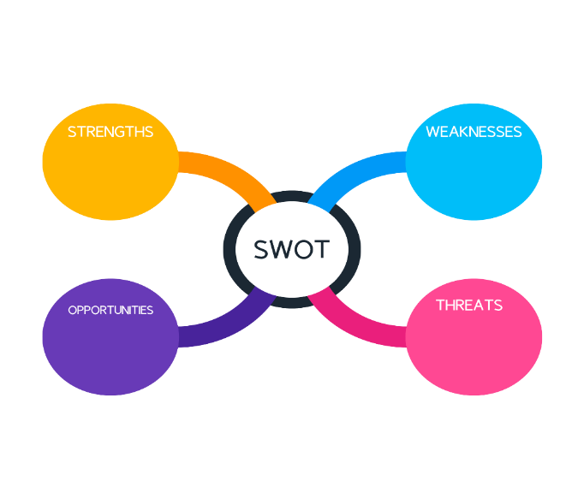
SWOT analysis is a strategic planning tool used to evaluate the Strengths, Weaknesses, Opportunities, and Threats (SWOT) of a business or organization. In the banking industry, SWOT analysis can be used to assess the current state of a bank and identify areas for improvement. By understanding the bank's strengths, such as a strong customer base or a robust network of branches, a bank can leverage these assets to grow and expand its business. On the other hand, the bank's weaknesses, such as a high level of debt or a limited product offering, can be addressed to improve overall performance. Opportunities, such as expanding into new markets or investing in technology, can be pursued to drive growth. Threats, such as economic downturns or increased competition, can be mitigated by developing contingency plans.

Strengths:

  - AMEX
It is great milestone of The city Bank in the extension of their service . This type of card requires maintain a good credit balance in the account . the availability of this card is so high and it is very easy to use . The City Bank LTD provide AMEX cards in Platinum , Gold and Silver variable.

  - Online Banking :
Secondly online banking is also a good strength for this bank. “Citytouch” can be a great example for it though they have other online services. It can be accessed at anytime from anywhere . It saves a lot of time for the customer. The major benefit is the faster transaction by this in lower cost. So we can say that it is a great competitive advantage for the economics of scale.

  - Service Quality
The Service quality of the city Bank is also very good. They always try to make their customer delighted and conduct survey on customer satisfaction. The higher authority take immediate action if they get a tiny complain from the customer . That’s why they become successful to maintain the quality of their service.

  - Brand Value
This bank have a high brand value in the market . Since 1983 they are providing service to the customer . Since that time till now they do not nave any bad record . So they get a good loyal customer base and those customer will not make transaction through other bank if they get more privileges from the bank. The main thing is this brand reputation is achieved through the service quality .

  - Updated Equipment.
The bank authority always try to embrace thye updated technology and equip them in their service bay. For example , CCTV camera, Cash Counting machine , MICR Check machine , Computer, Finacle software, ATM machine etc. By the installation of updated technology the service area get more productive .

  - Agent Banking
It is also a great positive factor for them because at a very remote area the banking service could not be served like a way the serve in the urban area . That’s why they extend they service through agent banking in the remote area . The basic services like deposit , opening account, transfer money can be provided by this bank.

  - Chain Of Command :
The chain of command is very strong in this bank . The subordinates employee can report only their immediate senior for any issue. If need only then they can report to the higher authority.

  - Customer Satisfaction
The result of customer satisfaction is very positive according to the research . Customer review is 4 out of 5 and it can be found from the website “Glass Door”.

  - Modern ATM
The City bank authority import modern ATM machine for the customer to meet the need of them . In total they have 415 ATM machine . ATM machine is basically used for withdrawing money by punching the card . It is a very easy process for any kind of customer but the main thing is security . Sometimes the ordinary ATM machine can be hacked by the hacker . But the modern ATM Machine is more secured and that’s why the customer feel safe to use it.

  - Best Corporate Culture
All the employees of the bank are practicing a best corporate culture since they are established . The output of a good corporate culture is the best service quality. The main advantage is that the employee always become motivated ,so they can provide their best output for customer satisfaction.

Weakness:
  - Workforce Limitation
Right now The City Bank have more than four thousands of employee all over the country . But this amount of employee still not adequate for serving the large amount of customer. It becomes quite challenging for the employee to provide the standard service to the customer . During the worktime some bottleneck process generated only for the lack of workforce.

  - Long duration of loan procedure
Loan processes may be time-consuming due to the extensive complexity of The City Bank's loan application process. Furthermore, the small branch has extremely strict restrictions that may impair the customer's thought process. Furthermore, city banks do not make loans to anyone without sufficient proof.

  - Lack of strategic plan
There is no well-defined and articulated purpose statement or strategic plan at The City Bank. As a result, financial institutions have yet to develop a long-term strategy for determining if they wish to emphasize on retailing by becoming commercial banks. A complete new strategy with the potential to be accomplished should always be prepared as immediately in order to effectively prepare for what is ahead in future.

  - Career Growth Lack
Several occupations at the local bank offer no chances for progression or professional development. As a consequence, the people who execute these professions lack intrinsic motivation. Some of the bank's many flaws is that a large proportion of its employees are dissatisfied with their jobs. When it comes to promotions, the local bank must concentrate its efforts on that specific segment of the market. Companies also had no alternative but to participate in relentless marketing efforts.

  - Time Consumption in Service
Professionals in customer service expend a large amount of time to resolving client issues, which is resulting in a substantial decrease in contact volume. There are times when the resources required to execute a task are insufficient in comparison to what could be demanded. Customers who directly approach any of its venues must wait for a prolonged period of time while getting services.

Opportunities:

  - Brand Value Opportunity
To decrease this same fundamental monetary uncertainties with doing business, The City Bank financial risk management diversification must be broadened. For illustration, the senior management may consider launching a merchants money transfer or developing further into rental and financial sectors. Each of these are options that should be looked at to get the advantage of this brand value in future.

  - Growth Of Population
The population in our country is increasing day by day . More population means more customers also a point should be noticed that the business sector is becoming more popular gradually . Due to the nation's population explosion, which is becoming more accustomed to using consumer finance on a regular basis, there is a chance of finding a job in retail banking. Furthermore, the large proportion of our nation's population are regarded as middle-class. This population requires a diverse selection of retail lending products, each with its own distinct selling factor. As a consequence, the marketplace for a wide range of industry credit facilities is reasonably large and competitive.. So it could be great opportunity to do well in future.

  - Serving Better Service
It is possible for Banks to offer customers additional trimming and up-to-date services and offerings if they so desire. There are numerous ways to invest money, including: City Bank Limited could also bring unique advantage in a variety of fields of study and research, such as corporate banking.

  - Variability of products
The entire quantity of private banks engaged in the market has increased noticeably during the previous several years. If city banks wish to preserve a long-term advantage in this environment of intense competition, they must diversify their product offerings to consumers. They may compete with both domestic and foreign banks because they offer Machines as a component of their service offering. They can give clients who want to buy from them the possibility to pay with credit and debit cards, either both forms of cards.

  - Good Strategies
The City Bank may find new chances for expansion across surrounding different regions by creating strategic collaborations with key enterprises in the specific market. Furthermore, whereas regional enterprises provide their great experience in the sector, The City Bank, as a worldwide player, can provide its better understand of globalization procedures.

  - Growth Of online Banking
This Bank will eventually be able to give premium features to its consumers in the Community Banks sector because of the increasing use of internet banking services as well as transaction solutions of many of its clients. Consumers of this financial Institution will also be enabled to utilize these digital programs.

Threats:

  - Duration of Launching New Product:
The time required for bringing a new item onto the market is shrinking, trying to make the banking industry increasingly competitive. As a reason, businesses like Banking Industry have already been subjected to greater competition demand. As it provides a large number of clients, The Bank is unable to reply promptly to the requirements of the specialized businesses that are the primary focus of disruption. Furthermore, these marketplaces are distinguished by such a considerable level of expertise.

  - Loan Defaulting
To maintain the other's financial position in the market, it is critical to reduce the likelihood of the borrower to repay on one of the loan agreements. This is required to maintain one's market presence. The possibility of default brings the company ever closer to bankruptcy. As a result, the city bank must maintain a high degree of understanding in this area in order to take preventive measures which might, at the minimum least, considerably reduce the impact of the situation.

Strategies to Meet the Challenges and Opportunities

IT knowledge, cyber security and NPL(Non-performing loan) are the most challenging activities for The City Bank. In these sectors knowledge and strategies should be developed to gain the sustainable competitive advantage . However , the bank authorities make the training programmer mandatory for all employees. . All the service holder have to join in the training of their relevant sectors . For example the cash department employee will take the training according to the cash related activities. Moreover , they also develop a training program to develop the IT skill of their employee. In this program the bank hire specialist and teach them how to use all the digital equipment and software according to the requirement. For example , Properly doing MICR of a cheque, putting the right entry in the software and usage of different software etc.
Secondly , another considerable factor that is cyber security is also a great headache for the City Bank . Serious incident can take place for the lacking of cyber security in this industry. In this era , thieves have become digitally skilled .Now they donot need to make a long plan to make a tunnel to the volt to loot all the money . They just simply hack the server of the bank and transfer all the money to their account . To prevent this kind of situation The city Bank authority follow the cyber security guideline provided by Bangladesh Bank. Some IT specialist are appointed for this task in fact the bank authority create a separate department to ensure the cyber security. The specialist makes a guideline for the employees and all the employees follow them strictly. For example , The employees are not allowed to insert their personal pen drive into the official computer , Branch manager donot install Wi-Fi in the same broadband line they use in their official computer , Mail related to security guideline always sent by the authority for reminder etc.

NPL (Non Performing Loan) is the biggest problem in the banking sector not only that NPL is a national threat also . Because of this a country economy can loose its normal pace. As a result of NPL a bank loose profit and also it hampers the banking system drastically.
To prevent these kinds of unexpected situations The City Bank authority folly several process.
- Following Bangladesh Bank guideline.
Bangladesh bank provides a guideline of loan for all banks . All the banks in Bangladesh must need to follow the instructions specifically. Those instruction might be updated if needed and it will be issued by Bangladesh Bank.

- Collecting the details of the Customer .
The City Bank Ltd collect all the data while they provide loan to the customer . Moreover, they have also a specialized team to inspect all the document of the customer. After having all the necessary documents the bank officer send those to the head office , then the Loan inspection team carefully justify those documents and if they get that get the positive result only then they will recommend the authority to issued the loan.

- Keeping Eye.
The officer will also continue their inspection while the loan period is running. For example the bank officer can talk over the phone or directly visit to the customer and ask the customer about his current business condition. All the banks do not follow this method, However they are realizing now to apply this technique.

- Counselling Support.
The City Bank LTD also provide counselling support to the honorable clients . Sometimes an unexpected situations might occurred . They why they figure out the solution and provide the adequate support by counselling.

Chapter – 3

Literature Review

Features of Services:
Service features refer to the tangible and intangible elements that make up the overall experience of a service. They include aspects such as the design and layout of the service environment, the physical appearance and demeanor of the service providers, the quality of the service delivery, and the overall convenience and accessibility of the service.
Other key features of service include reliability, responsiveness, competence, and communication. Reliability refers to the ability of the service to consistently meet or exceed customer expectations. Responsiveness refers to the willingness and ability of the service provider to meet customer needs promptly and effectively. Competence refers to the skill and knowledge of the service provider, and communication refers to the quality of the interactions between the customer and the service provider.
Service features are the elements that make up the overall experience of a service, including tangible and intangible elements. The following are the key features of service:
- Reliability: The ability of the service to consistently meet or exceed customer expectations in terms of quality, accuracy, and timeliness.
- Responsiveness: The willingness and ability of the service provider to promptly and effectively meet customer needs, whether it be through prompt attention, helpful information or quick resolution of problems.
- Competence: The knowledge, skills, and experience of the service provider, which impact the quality of the service delivery.
- Communication: The quality of the interactions between the customer and the service provider, including the effectiveness of verbal and nonverbal communication, clarity of information provided, and ease of understanding.
- Accessibility: The ease of accessing the service, including factors such as location, hours of operation, and availability of online or mobile services.
- Convenience: The overall ease of use of the service, including factors such as the simplicity of the process, the availability of self-service options, and the absence of hassle or inconvenience.
- Physical appearance: The physical appearance of the service environment, including factors such as the design and layout, the cleanliness and maintenance of the premises, and the appearance and demeanor of the service providers.
The combination of these service features creates the overall impression of the service, and it is essential for service providers to understand and deliver these features to ensure customer satisfaction. By paying attention to the features of service, service providers can create a positive customer experience, build customer loyalty, and ultimately grow their business.

Service Quality
Service quality in general banking in Bangladesh is an important aspect that affects customer satisfaction and loyalty. The banking sector in Bangladesh has seen significant growth in the last decade, with many new players entering the market and providing various services to customers. However, the quality of service provided by banks is still a matter of concern for many customers.
The banking industry in Bangladesh operates in a highly competitive environment. Customers have become more demanding, and as a result, banks need to provide high-quality services to meet their expectations. The quality of service provided by banks can be measured in terms of several factors, including speed, accuracy, reliability, accessibility, and security.
When I join in The City Bank Islampur branch . I do my regular duty as an intern as well as I also conducted a survey as I was instructed by the authority. On the survey there were several question for a customer and those are applicable for all kinds of customer. On my survey I collected my data from those customer who took service from different department. There are four classification in my survey from where the customer took service usually:

Importance of Service Quality:

Service quality is a critical factor in the banking sector, as it directly affects customer satisfaction, loyalty, and retention. The banking industry is a highly competitive market, and providing high-quality service can give a bank a competitive advantage over others. Service quality can be defined as the degree to which a bank's services meet the expectations of its customers. It encompasses a wide range of factors, including the professionalism and competence of employees, the reliability and accuracy of services, the timeliness of responses, and the overall convenience of the services offered.
A high level of service quality can result in improved customer satisfaction, which can lead to increased loyalty and repeat business. Satisfied customers are more likely to recommend a bank's services to others, which can help to attract new customers and increase market share. Additionally, satisfied customers are less likely to switch to another bank, which can reduce the cost of acquiring new customers.
In today's digital age, service quality is becoming even more important as customers have a wide range of options available to them. With the increasing use of technology, customers expect seamless and convenient services, and banks that can provide this will be well-positioned to compete. Additionally, as customer expectations continue to evolve, it is essential for banks to regularly evaluate and improve their service quality to ensure that they meet the changing needs of their customers.
In conclusion, service quality is a crucial aspect of the banking sector, and banks that can consistently provide high-quality service will be better positioned to succeed in a highly competitive market. Providing high-quality service can help to improve customer satisfaction, loyalty, and retention, while also reducing the cost of acquiring new customers.

5CS of Service Quality Requirements :

The standard of service quality can be evaluated in terms of the 5 Cs: competence, courtesy, credibility, communication, and consistency.
- Competence refers to the level of expertise and skill that employees have in providing the service. Customers expect that the employees they interact with are knowledgeable and capable of delivering the service they need in a timely and efficient manner.
- Courtesy refers to the manner in which employees interact with customers. This includes being friendly, polite, and respectful, and ensuring that customers feel valued and appreciated.
- Credibility refers to the trustworthiness of the service provider. Customers expect that the service they receive is reliable, accurate, and consistent with what was promised.
- Communication refers to the way in which information is conveyed to customers. Effective communication involves listening to customer needs and concerns, providing clear and concise information, and ensuring that customers understand what is being communicated.
- Consistency refers to the reliability and predictability of the service provided. Customers expect that the level of service they receive is consistent across different interactions and channels.
Overall, the standard of service quality is critical to the success of any business. By focusing on the 5 Cs, companies can ensure that they are providing a high level of service that meets the needs and expectations of their customers.

5Cs In Banking Sector :

In the banking sector, the standard of service quality can be evaluated in terms of the 5 Cs: competence, courtesy, credibility, communication, and consistency.
- Competence is critical in the banking sector, where customers require assistance with complex financial transactions. Bank employees need to be highly skilled, knowledgeable, and able to provide timely and accurate information to customers.
- Courtesy is also essential in the banking sector, where customers need to feel valued and appreciated. Employees should be friendly, polite, and professional, and should take the time to understand and address customer needs and concerns.
- Credibility is particularly important in the banking sector, where customers entrust their money and financial information to the bank. Customers need to feel confident that their money is safe, and that the bank is trustworthy and reliable.
- Communication is vital in the banking sector, where customers require clear and concise information about their accounts, transactions, and other financial matters. Employees should be able to communicate effectively with customers, using plain language and avoiding jargon or technical terms.
- Consistency is also essential in the banking sector, where customers expect a high level of service quality across all channels and interactions. Customers should receive the same level of service quality whether they visit a branch, call the customer service center, or use the bank's online or mobile banking platforms.
Overall, the standard of service quality is critical to the success of the banking sector. By focusing on the 5 Cs, The City Bank can ensure that they are providing a high level of service quality that meets the needs and expectations of their customers, which ultimately leads to customer loyalty and increased business success and it will be effective to gain the sustainable competitive advantage in the market.

Chapter – 4

Job Description

Job Description:

Job Responsibilities:
Altogether, my internship at The City Bank LTD was quite beneficial. As a result of my internship, I am delighted to be working for The City Bank LTD. The fundamental corporate culture of this organization is incredibly adaptive. I performed for an investigator who is doing the task of general banking.
My officer assigned me simple responsibilities as an intern, such as filling out forms, collecting signatures, organizing files, and providing clients with RTGS forms. While doing my internship at The City Bank Limited, Islampur Road Branch, I was involved with various responsibilities over the period. A short description of my responsibilities in this bank are given below:

Daily Operations
The daily operations of an intern in a bank may vary depending on the department they are working in and the specific responsibilities assigned to them. However, some common tasks that an intern in a bank may be responsible for include:
- Customer service: As an intern I always assist customers with their banking needs, such as opening accounts, answering questions about bank products and services, and resolving customer issues.
- Data entry and record keeping: I was also responsible for entering data into the bank's computer systems and maintaining accurate records of customer transactions and account information.
- Market research: Sometimes I need to conduct market research to stay updated on industry trends and gather information to help the bank develop new products and services.
- Administrative tasks: I was also responsible for various administrative tasks, such as scheduling appointments, answering phone calls, and managing incoming and outgoing mail.
- Assisting with loans and mortgages: I did some task in the loan and mortgage process, helping customers with loan applications, processing loan documents, and performing credit checks.
- Attending meetings: I also attended meetings and took notes to keep track of important discussions and decisions made by bank management.
These are just some of the tasks that I did as an intern in the city bank. By doing these specific responsibilities I had learned a lot and I think it will be helpful for my future career.

Assisting Supervisor and Coworkers
- Helped the Assistance Officers and customers to open their desire new accounts like Savings, Current, and Short Notice Deposit etc. by filling up their forms.
- Accessed, edited, stored, shared and printed necessary customer documents from the Dhaka Bank server and NID verification server for the Senior Executive Officer.
- Assisted the Assistance officer to serve the walk-in-clients.
- Helped the SEO by entering different service request in the online service portal.

Customer Service

- Helped the client by supplying basic information;
- influenced the customer in writing cheques and deposit slips;
- advised the client in checking out their Account Opening Forms
- supported the costumers in writing down various demand letters to the supervisor such as Account Disbursement, Information Changes, Interest Withdrawal, and so on.
- Assisted clients by describing the many aspects and process of the amortization plan to them. Educated consumers on the impacts of rate changes, term changes, amount changes, and so on.
- Told the customer about their balance for check encashment
- supply cheque books and debit/credit cards

Process Improvement :
- Created a database including the names of various documents that are kept in separate folders in the branch in order to conveniently identify the papers.
- I set up an Excel spreadsheet for both the issued cheques so that I can quickly determine whether or not a customer's check book is ready for delivery simply typing in his or her name or account number.
- I drafted a document in which I created many Registration form samples for giving service swiftly.

Interactions with the supervisor and coworker

Mr. Zaki Uddin was my internship program's official supervisor. He is the manager and Operations Manager of the City Bank Ltd., Islampur Branch. He's a very pleasant and diligent individual. Occasionally, in the course of his work, he would inquire what I was learning and if I needed any assistance.
I primarily reported to the officer in charge of the Customer Service Department. Rebeka Sultana (AVP & CSM) is the most senior member of this division, and she is also a really pleasant person. She was the very first woman in the branch with whom I got incorporated by the branch manager. Then she allocated me to Md. Imran Hossain, the Customer Service Officer.
Then Md.Imran Hossain provided me a brief overview of the bank's operations so that I could learn the duties of a distinct department.
Rebeka Sultana was a very caring individual , she did not assign me too many responsibilities during the initial week and instead urged me to become acquainted with the workplace. She trusted me with my duties and often complimented my good job to keep me motivated. We'd start talking whenever we had a few free time, and she was always pleasant to me. I mostly had to collaborate with him and assist him in serving people. From him, I acquired numerous tips and techniques for succeeding in the corporate world.
I've also collaborated with Md, Ziaour Rahman (Assistant Customer Service Officer), and Tarek Hossain (Assistant Customer Service Officer), but Mr. Tarek was soon moved to a different branch. As a result, I was given the opportunity to operate at the desk and present necessary info customers directly. All of the employees were quite pleasant. They assisted me greatly in acquiring new skills and also provided me with the essential information and guidance to accurately assess the front desk duty.
Iftekhar Ahmed, the Branch Operations Manager, is also a really pleasant individual. He also could stop by on a continuous basis to discuss and look things up about how my internship was doing. Officers from other departments were equally courteous to me. Although I did not want to be an internship, they always treated me as a colleague or never made me wish I was new at the office.

Chapter – 5

Methodology, Analysis, and Discussion

Methods:
Data collection is an essential aspect of a banking internship report, as it helps to provide me a solid foundation for the analysis and interpretation of the findings. There are several methods of data collection, each with its advantages and limitations. The following are some commonly used data collection methods in a banking internship report:
- Surveys: At the period of my internship I’ve collected some quantitative data via Surveys. It is a common method of data collection in a banking internship report, as they allow the researcher to gather information from a large number of participants in a relatively short amount of time. Surveys can be administered through various methods, including online, mail, telephone, or face-to-face.
- Observation: Secondly I also gather data by observation. it is a method of data collection in which the researcher observes the behavior of participants in a natural setting, without interfering with the situation. Observation is useful for gathering data on customer behavior and service delivery in a bank.
- Documentation Review: Thirdly I’ve also followed a vital step and that is Documentation. We all know the procedure of this but we need to know the best process of reviewing document. Documentation review involves the examination of existing records, reports, and other written materials to gather data. This method is useful for collecting data on processes, policies, and procedures within a bank.
The choice of data collection method will depend on several factors, including the research question, the resources available, and the target population. The researcher should carefully consider these factors and choose the method that best meets the needs of the study.

Analysis and Discussion:

When conducting a customer experience survey, it is essential to identify the key areas of the banking experience that you want to assess. This may include the ease of opening an account, the quality of customer service, the accessibility of digital services, and more. Once you have identified these areas, you can develop a set of survey questions that are tailored to your specific needs.
It is also important to ensure that the survey questions are clear and concise, and that they can be easily understood by all respondents. Using a mix of closed-ended and open-ended questions can help provide a comprehensive understanding of the customer experience.
Once the survey questions have been developed, it is important to determine the best method for collecting responses. This may include online surveys, in-person interviews, phone surveys, or a combination of these methods.
Finally, it is crucial to analyze the survey data carefully and use the insights gained to drive improvements in the bank's services and processes. Customer feedback is a valuable tool for improving the overall customer experience, and the bank's commitment to using this feedback to make meaningful changes will help ensure that customers are satisfied with the services provided.
When I join in The City Bank Islampur branch . I do my regular duty as an intern as well as I also conducted a survey as I was instructed by the authority. On the survey there were several question for a customer and those are applicable for all kinds of customer. On my survey I collected my data from those customer who took service from different department. There are four classification in my survey from where the customer took service usually:

Relationship Manager:
A Relationship Manager (RM) in a bank is responsible for managing the relationships between the bank and its clients. RMs play a crucial role in building and maintaining strong relationships with customers, increasing the bank's revenue, and ensuring customer satisfaction.
The primary duty of a Relationship Manager is to acquire new clients and expand the bank's customer base. This requires a thorough understanding of the bank's products and services, as well as the ability to assess the needs of potential customers and offer them solutions that meet their requirements. RMs must also be skilled in identifying opportunities to cross-sell and up-sell bank products to existing customers, thereby increasing revenue and customer retention.
Once a customer is on boarded, the RM becomes their primary point of contact with the bank. The RM is responsible for addressing any questions or concerns the customer may have, as well as providing guidance and advice on financial matters. RMs must be knowledgeable about the banking industry and financial products, so they can help customers make informed decisions.

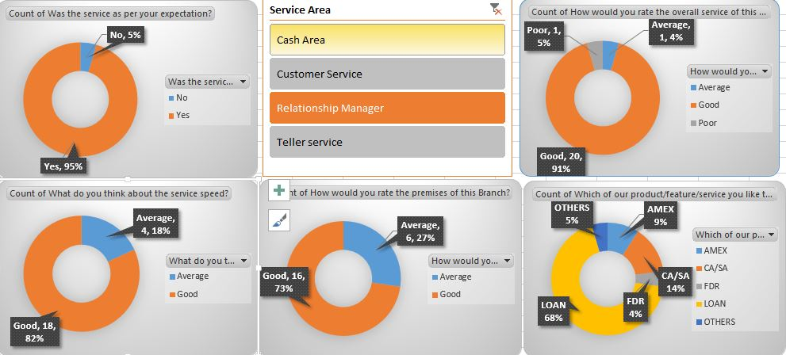
Data ratios of Islampur Road Branch

Lastly, RMs are responsible for maintaining accurate records of customer interactions and account information. This information is used to track customer needs, identify opportunities for growth, and improve customer service. RMs must be organized and detail-oriented to ensure that all customer information is accurate and up-to-date.
In summary, a Relationship Manager's duty in a bank is to acquire new clients, maintain existing relationships, and increase revenue while minimizing risk. The job requires a combination of sales skills, financial knowledge, risk management expertise, and customer service skills.

Cash Area:

The cash area in a bank is a critical service area where customers can perform various transactions related to cash deposits, withdrawals, currency exchange, and other related services. Here is a summary of the primary services offered by the cash area in a bank:
- Cash deposits: Customers can deposit cash into their accounts by filling out a deposit slip and providing it along with the cash to the bank teller. The teller will verify the amount and process the deposit.
- Cash withdrawals: Customers can withdraw cash from their accounts by filling out a withdrawal slip and presenting it to the teller. The teller will verify the account balance and process the withdrawal.
- Currency exchange: Customers can exchange foreign currency for their local currency or vice versa. The teller will provide the current exchange rate and process the transaction accordingly.
- Cashier's checks and money orders: Customers can purchase cashier's checks and money orders for a fee. These instruments are widely accepted as a secure form of payment and are often used for large transactions.
- Account inquiries: Customers can inquire about their account balances, transaction history, and other related information at the cash area.
- Cash handling services: The cash area also provides cash handling services for businesses, such as preparing cash floats for cash registers, processing deposits, and providing change.
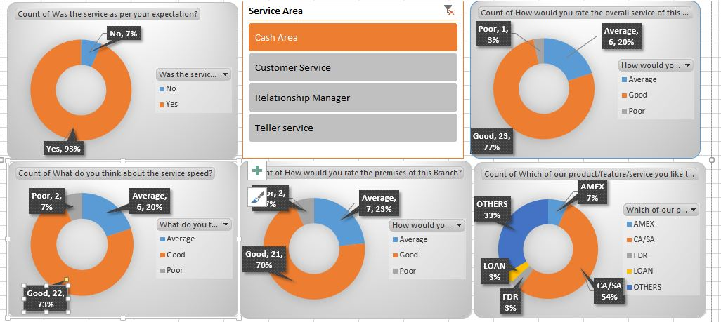
Data ratios of Islampur Road Branch

Overall, the cash area in a bank is an essential service area that helps customers perform various transactions related to cash. The tellers in the cash area must be knowledgeable, efficient, and accurate in processing transactions to provide excellent customer service.

Teller Service:
The City Bank's teller service is a critical component of its banking operations, providing customers with a variety of financial services. The bank's tellers are highly trained and knowledgeable, offering personalized service to meet each customer's unique needs. They process transactions quickly and accurately, including deposits, withdrawals, and transfers. Additionally, City Bank tellers provide valuable information about the bank's products and services, including loans, credit cards, and investment options. The bank also places a strong emphasis on customer service, with tellers going above and beyond to ensure that customers feel valued and satisfied with their banking experience. Overall, The City Bank's teller service is an integral part of its commitment to delivering excellent financial services to its customers.
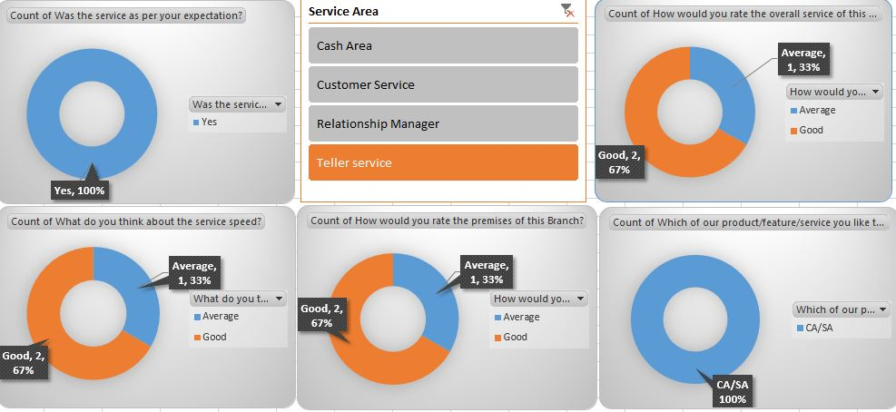
Data ratios of Islampur Road Branch

Customer Service:
The City Bank is committed to providing exceptional customer service to its clients, and its customer service area plays a vital role in achieving this objective. The customer service area of The City Bank offers various services, including account management, information assistance, dispute resolution, and more. The highly skilled and knowledgeable customer service representatives strive to provide personalized support to each customer, ensuring that all their needs are met.
One of the primary functions of The City Bank's customer service area is to assist customers with account management tasks. This includes opening new accounts, updating personal information, and answering any questions customers may have about their accounts. The customer service area also offers assistance with online banking, mobile banking, and other digital services, making it easy for customers to manage their finances on-the-go.
Another essential aspect of The City Bank's customer service area is dispute resolution. The bank recognizes that customers may experience issues with their accounts or transactions, and the customer service representatives are dedicated to resolving these issues promptly and efficiently. Whether it is a billing error or a fraudulent transaction, the customer service area is equipped to handle a wide range of disputes and find a satisfactory resolution for the customer.

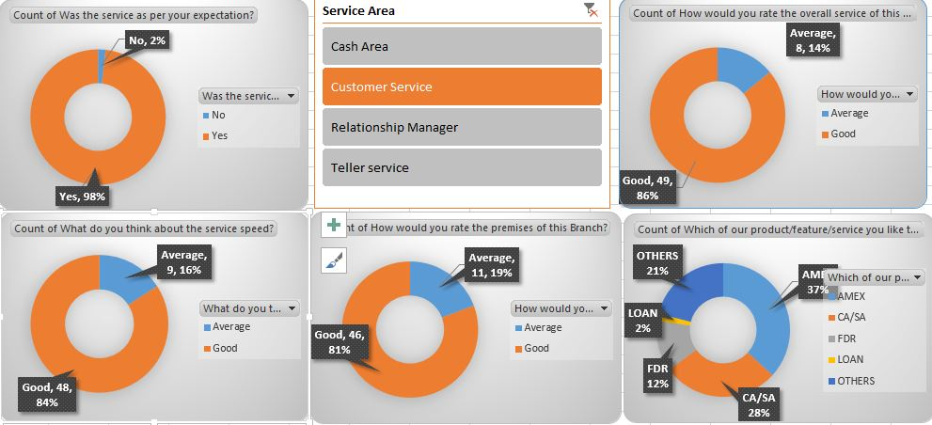
Data ratios of Islampur Road Branch

Overall, The City Bank's customer service area is an integral part of its commitment to providing excellent financial services to its customers. The bank's dedicated and knowledgeable customer service representatives are available to assist customers with all their banking needs, ensuring that each customer receives the highest level of support and service.
A good customer service experience in The City Bank would involve a customer being greeted by a friendly and knowledgeable representative who promptly attends to their needs. The representative would listen attentively to the customer's queries and provide clear and accurate information. They would also offer relevant banking products and services that meet the customer's financial requirements. The representative would handle the customer's transactions efficiently and in a timely manner, ensuring that the customer leaves the bank satisfied with their experience. Additionally, the representative would follow up with the customer after their visit to ensure that all their needs were met and to see if there is anything else the bank can do for them. Overall, a good customer service experience in The City Bank is one where the customer feels valued and their needs are effectively addressed.
Speed of service is one of the critical factors that affects customer satisfaction. Customers expect their transactions to be processed quickly and efficiently. However, many banks in Bangladesh still face challenges in providing fast service due to a lack of proper infrastructure and outdated technology. Banks need to invest in modern technology and improve their processes to provide fast and efficient service to customers.
Accuracy is another critical aspect of service quality in the banking sector. Customers expect their transactions to be processed correctly, and errors can cause significant inconvenience and frustration. Banks need to ensure that their staff is well trained and equipped with the necessary tools to provide accurate service. They also need to have proper internal controls in place to prevent errors and ensure accuracy.
Reliability is an essential aspect of service quality in the banking sector. Customers expect their transactions to be processed promptly and efficiently. However, many banks in Bangladesh still face challenges in providing reliable service due to a lack of proper infrastructure and outdated technology. Banks need to invest in modern technology and improve their processes to provide reliable service to customers.
Accessibility is also an important aspect of service quality in the banking sector. Customers expect to be able to access their accounts and perform transactions from anywhere, at any time. Many banks in Bangladesh are now offering online and mobile banking services to provide customers with convenient and accessible banking services. However, many banks still face challenges in providing reliable and secure online services. Banks need to invest in technology and security measures to provide safe and accessible services to customers.
Security is a crucial aspect of service quality in the banking sector. Customers expect their financial information and transactions to be protected from fraud and other security threats. Banks need to invest in technology and security measures to provide safe and secure services to customers. They also need to educate customers about the importance of protecting their financial information and the steps they can take to ensure their security.
In conclusion, service quality in general banking in Bangladesh is an important aspect that affects customer satisfaction and loyalty. Banks need to invest in technology, infrastructure, and human resources to provide high-quality services to customers. They also need to educate customers about the importance of protecting their financial information and the steps they can take to ensure their security. The banking industry in Bangladesh has a significant role to play in the economic development of the country, and providing high-quality services to customers is crucial for the success and growth of the sector.

Recommendation:

Based on the findings and analysis of this internship report, the following recommendations are proposed to further enhance the operations of The City Bank :
- Invest in digital transformation initiatives: Firstly , The City Bank should focus on implementing advanced technology solutions to automate routine tasks and improve the customer experience. This can include online banking services, mobile applications, and catboats to provide 24/7 assistance.
- Enhance risk management practices: Secondly , The City Bank should continue to strengthen its risk management practices to ensure the security of its assets and the financial stability of the institution. This can include regular risk assessments, the implementation of robust fraud detection systems, and ongoing training for employees.
- Focus on customer satisfaction: Thirdly , The City Bank should prioritize customer satisfaction and implement measures to continually improve the quality of its services. This can include regular customer feedback surveys, training programs for employees to enhance their customer service skills, and the implementation of a customer complaints resolution system.
- Expand product offerings: The City Bank should consider expanding its product offerings to better meet the needs of its customers. This can include offering more loan options, investment products, and insurance services.
- Foster a positive company culture: The City Bank should cultivate a positive company culture that encourages employee engagement and satisfaction. This can include promoting a healthy work-life balance, providing opportunities for professional development, and recognizing employee contributions.
- Collaborate with other financial institutions: Lastly , The City Bank should explore opportunities for collaboration with other financial institutions to increase its reach and enhance its services. This can include partnerships for joint product offerings, shared technology solutions, and cross-selling opportunities.
Overall, these recommendations aim to improve The City Bank’s operations, enhance its competitiveness, and ensure the satisfaction of its customers.

Conclusion:

In conclusion, the internship at The City Bank provided valuable insights into the operations of a financial institution and allowed for the development of practical skills in the banking industry. Through the various tasks and projects assigned, I was able to gain a deeper understanding of the key functions of a bank, including customer service, risk management, and product development.
The internship also provided me an opportunity to observe the impact of technology on the banking sector and the importance of digital transformation initiatives in enhancing the customer experience and improving the efficiency of operations.
Overall, the internship was a rewarding and enriching experience that has enhanced my knowledge and understanding of the banking industry. I am grateful for the opportunity to work with a team of dedicated professionals and learn from their expertise.
This report serves as a testament to the valuable experience gained during the internship and the lessons learned that will be valuable in my future endeavors. I look forward to applying the knowledge and skills acquired during my time at the bank in future opportunities and continuing to learn and grow in the banking industry.

References :
- https://www.thedailystar.net/business/news/how-innovations-are-transforming-banking-bangladesh-3127411?fbclid=IwAR0JtYzO_6GK5EKXAgJ_qkLsgyic0jCaljw-Pr41biSQwPjRLkHKTxTVhmw
- https://www.thedailystar.net/business/economy/banks/news/agent-banking-transactions-see-robust-growth-2185646?fbclid=IwAR1qgSGh9QHohDl8C8OYCR7yXJbEPtHYC6Ly3LRlk-Fej_-zmE9tZilZQg4
- https://onlineaccountopen.in/learning-center/opened-a-digital-bank-account-know-the-difference-between-full-kyc-and-e-kyc/?fbclid=IwAR07Crip_6Xoze_OJ-VREQQcPyGNQL5NkpG0lpcNvazi_pbJgkVhBZmJpIo
- https://www.bb.org.bd/en/index.php/financialactivity/regulator?fbclid=IwAR1dfIm1xcpPPyBQpmmzRUbY9lZFMnAtJKz36uXM1O4y7n44ZidL4orU7X8
- https://www.tbsnews.net/economy/budget/source-tax-bank-deposit-interests-companies-doubles-436318
- https://www.business-to-you.com/porters-five-forces/?fbclid=IwAR3zaiWCr3daMj_SR5z1hPZuG1ryyGRa3V5d8yWVnYWIXEhtQVfJD41tbSU
- https://sites.google.com/site/bankingindustryandtheinternet/home/5-forces?fbclid=IwAR0JtYzO_6GK5EKXAgJ_qkLsgyic0jCaljw-Pr41biSQwPjRLkHKTxTVhmw
- https://www.moneycrashers.com/best-alternatives-traditional-banking/?fbclid=IwAR2hKfXg-5-Q2_uloq_ufzAc0zoMUf4-GQZh-R1STYdDQFD2ggQ8VXS8GJ4
- https://www.thecitybank.com/our-history?fbclid=IwAR1qgSGh9QHohDl8C8OYCR7yXJbEPtHYC6Ly3LRlk-Fej_-zmE9tZilZQg4
- https://www.zooinfotech.com/city-bank-limited/?fbclid=IwAR07Crip_6Xoze_OJ-VREQQcPyGNQL5NkpG0lpcNvazi_pbJgkVhBZmJpIo

