ELECTRONIC BIDDING

By

Shihab Kabir
ID-011132072
Roksana Akter
ID-011132099
Md. Rafat Al Mehdi
ID-011132086
Md. Reza-e-Rabbi
ID-011122019

Submitted to
Department of Computer Science and Engineering in partial fulfillment of the requirements of the degree of Bachelor of Science in Computer Science and Engineering



Department of Computer Science and Engineering
United International University (UIU)
Dhaka, Bangladesh
July 2018

Statement of Originality

This is to certify that the work presented in this project entitled E-bidding System is the outcome of the investigation carried out by us under the supervision of Mr. Suman Ahmmed, Asst. Professor, Department of Computer Science and Engineering, United International University, Dhaka. It is also declared that neither this project nor any part thereof has been submitted or is being currently submitted anywhere else for the award of any degree or diploma.

-----------------------------------
(Supervisor)
Mr. Suman Ahmmed
Asst. Professor
Director,CDIP
Department of Computer Science and Engineering
United International University

---------------------- ---------------------- ---------------------- ----------------------
Rafat al Mehdi Reza-e-rabbe Shihab kabir Rokshana akter

ABSTRACT

E-commerce is getting popularized day by day around the world and eventually in our country. A person sitting on his chair in front of a computer can access all the facilities of the Internet to buy or sell the products. From that intuition we wanted to build such an e-commerce that will not work in a traditional way rather in a competitive and selling oriented way where products will be sold out in terms of bidding and where seller may get some extra advantage rather than the traditional commerce. This is a fully dynamic system which can be easily operated by the users.

TABLE OF CONTENTS

Statement of Originality................................................................................................................2
Abstract ..........................................................................................................................................3
CHAPTER 1 ..................................................................................................................................6
Introduction....................................................................................................................................6
1.1 Problem Definition.......................................................................................................6
1.2 Motivation ....................................................................................................................6
1.3 Objective.......................................................................................................................6
CHAPTER 2 ..................................................................................................................................7
Requirement Analysis…………………………………………………………………………....7
2.1 Background Studies.....................................................................................................7
2.1.1 Shopgoodwill.com ........................................................................................7
2.1.2 Listia.com .....................................................................................................8
2.1.3 The -saleroom.com.......................................................................................8
2.1.4 Propertyroom.com……...............................................................................9
2.1.5 Bdbidd.com……..........................................................................................10
2.1.6 E-Bidding.com….........................................................................................11
2.2 Major Stakeholders…………………………………………………………..…….11
2.3 Functional Requirement...........................................................................................13
2.4 Benchmark systems VS Our Proposed System.......................................................14
CHAPTER 3 ................................................................................................................................15
System Design Development …………......................................................................................15
3.1 Context Diagram........................................................................................................15
3.2 Data Flow Diagram……………................................................................................16
3.2.1 Level 1 Diagram .........................................................................................16
3.2.2 Level 2 Diagram………………………………..........................................17
3.3 Activity Diagram……………………………………………………………………18
3.4 Use case………...........................................................................................................19
3.4.1 Use case for main module...........................................................................19
3.4.2 Use case for buyer module………………………………………….........20
3.4.3 Use case for seller module…………………………..................................21
3.5 Entity Relationship Diagram……............................................................................22
3.6 Sequence diagram…..………………………………………………………………23
CHAPTER 4 ................................................................................................................................24
Implementation Environment ....................................................................................................24
4.1 Framework.................................................................................................................24
4.2 Language….................................................................................................................24
4.3 Database……………………………………………………………………………..24
4.4 Tools…………………………………………………………………………………24
4.5 Version Control System……………………………………………………………24
4.6 System Module User Interfaces……………………………………………………25
Chapter 5………………………………………………………………………………………..32
Conclusion………………………………………………………………………………32
5.1 Summary…………………………………………………………………………….32
5.2 Future Work………………………………………………………………………...32
REFERENCES.............................................................................................................................33

LIST OF FIGURES
Figure 2.1: Benchmark system vs. our proposed system ……………………………………14
Figure 3.1: Context Diagram ………………………….……………………………………....15
Figure 3.2.1: DFD level………………........................................................................................16
Figure 3.2.2: DFD level 2…...………….……………………………………………………….17
Figure 3.3: Activity Diagram ……………………………………………………………...…. 18
Figure 3.4.1: Use case for main module ...…………………………………………………….19
Figure 3.4.2: Use case for buyer module ……………………………………………………...20
Figure 3.4.3: Use case for seller module ……………….……………………………………...21
Figure 3.5: Entity Relationship Diagram …………….…….………………………………....22
Figure 3.6: Sequence diagram …..………….…………………………………………………23
Figure 4.6: Home Page ………………….….………………………………………………….25
Figure 4.7: Login ……………………………………………………………………………….26
Figure 4.8: Register …………………………………………………………………………….26
Figure 4.9: Seller profile ……………………………………………………………………….27
Figure 4.10: Product post……………………………………………………………………...28
Figure 4.11: Posted product by seller ……...…………………………………………………28
Figure 4.12: Pending product of seller………………………………………………………..29
Figure 4.13: Buyer Profile ………………………………………………………………….....29
Figure 4.14: Posted product ………..........................................................................................30
Figure 4.15: Bidded product ………………………………………………………………….30
Figure 4.16: Admin homepage ………………………………….…………………………….31
Figure 4.17: Add Category …………………………………………………………………....31

CHAPTER 1

Introduction

1.1 Problem Definition

Now-a-days online auction plays an important role in shopping era.
By representing the views of its seller and customer to building an engaged and supportive shopping community appropriate to a world class marketplace.

Reasons: sellers play an important role in an auction site. Today in Bangladesh we don’t have an auction site .for getting a digital life we all know that digital market is so popular, that helps customers and sellers bring together for such an innovative shopping.

We made this web-site which will assemble every seller and customer who really love to shopping through bidding process.

1.2 Motivation

Our website is for online bidding. Who wants to get new adventure or a little spice in shopping, he will go for it.
In our country we don’t have a single online auction site, internationally now this is so popular, most of the site has a boundary about users and also very high rate which we can’t afford. So we think why not we make something for Bangladesh actually for us .So that our digital shopping place get a new place like bidding.

1.3 Objective

Using this website sellers who are not satisfied with the sell or selling price get benefitted. Also maintaining customer relation so that customer can buy things from here.

Chapter 2

Requirement Analysis

2.1 Background Studies

We conduct benchmark studies across a wide range of products which is already established in the website. We will show these wide range of web applications key features and limitations.

2.1.1 Shopgoodwill.com

Shopgoodwill.com is the first Internet auction site created, owned and operated by a nonprofit organization. It was created and is operated by Goodwill of Orange County (Santa Ana, CA). Participating Goodwill's from across the country offer for auction on the site a wide array of art, antiques and collectibles as well as new and nearly new items pulled from their vast inventories of donated goods.
Goodwill's global presence extends to five continents, with 179 full member organizations in 15 countries. In addition, there are 14 affiliate members in 13 countries. Through its services, Goodwill's network helps people overcome barriers to employment and become independent, tax-paying members of their communities.

Key Features:
This site has many useful features and information. Some of the key features are as follows -
- Product information
- Advanced search
- Categories
- Can share product on social media
- Price
- Bid increment
- Customer account details
- Saved searches
- Shipping details
Limitations:
- Do not have any kinds of rating system.
- Do not have any social media login option.
- Previously removed items/orders re-appearing in Open Orders.
- Maximum bid amount showing as Item Price on item combining page during checkout.

2.1.2 Listia.com

Since 2009, Listia has provided the best online marketplace for millions of people to save money, get rewarded, and earn free stuff by giving away things they no longer use.Here customer can trade things he don't need any more for stuff he want. It's all free with no money involved.

Key Features:
This site has many useful features and information. Some of the key features are as follows -
- Product information
- Categories
- Can share product on social media
- Price (in INK)
- Can sign up with Facebook
- Shipping detail
- Search
Limitations:
- Do not have any kinds of rating system.
- Do not have specific search options for product class, Indications brand name of companies.
- Products filter is not possible with manufacturer name.

2.1.3 The-saleroom.com

Thesaleroom.com is Europe’s leading portal for fine art and antiques auctions. Visitors to the site can search and browse catalogues and place bids over the internet in real time, with live audio and video feeds communicating the auction room atmosphere. In 2015, thesaleroom.com hosted 5,100 live and timed auctions, partnered with over 500 auction houses and sold 634,000 lots online. The website continues to innovate and offer new features and in 2015, introduced a responsive mobile-friendly design. It also introduced advanced categorization and search filters, making it easier and quicker for bidders to find what they need on the website.

Key Features:
This site has many useful features and information. Some of the key features are as follows -
- Live video chat
- Product information
- Alarm for specific product
- Categories
- Price
- Shipping detail
- Search
Limitations:
- Do not have specific search options for product class, Indications brand name of companies.
- Do not have any social media login option.
- Do not have any kinds of rating system.
- Products filter is not possible with manufacturer name.

2.1.4 Propertyroom.com

By statute, law enforcement agencies must auction seized, found, and unclaimed personal property at public auction. This was usually done in the parking lot of the local police station. But back in 1999 a former police detective said “Why can’t we do this online?” And PropertyRoom.com was born.
Thus created a solution for law enforcement agencies nationwide. Here all those seized, stolen, abandoned and surplus goods out of their Property Room, open up their public auctions nationwide and send back proceeds to the local communities. That’s also where they got their name – the Property & Evidence Room is where all these goods are stored at their local law enforcement agencies. We just shortened it to just PropertyRoom.com.

Key Features:
This site has many useful features and information. Some of the key features are as follows -
- Product information
- Categories in detail
- Price
- Shipping detail
- Search
- Limitations:
- Do not have any social media login option.
- No advanced search
- User from United Kingdom, Canada and Mexico can only buy from this web site.
- Don’t have rating or review system.

2.1.5 BDBiDD.com

FIRST AUCTION SITE OF BANGLADESH, a revolutionary new way to shop online and get the things that you really want at prices you like! Either you buy it or Bid It! We bring you new shopping ideas every day on big brand mobiles & electronics, designer fashion accessories, cosmetics, jewelry, toys, home wares and much, much more.
Key Features:
- Product information
- Price

Limitations:
- No search option
- No category
- No detail about shipping
- Do not have any social media login or signup option.
- Do not have enough information about auction.

2.1.6 Our proposed System E-Bidding
E-Bidding is the electronic bidding system in Bangladesh. It is the most comprehensive, advanced and up-to-date information source available.
Key Features-
- All product information
- Price
- Categories
- Edit post product
- Change bidding price
- Award the buyer before end time.

2.2 Major Stakeholders:

- Seller
- Buyer
- Admin
Stakeholders Features:
- Seller Features:

- Manage their own Account
- Post products in different categories
- Set bid end time
- Watch items they are interested
- View Items by thumbnail
- Place auto or straight bids
- Place items on a product list
- Edit posted product
- Change the bidding price
- See the pending products
- Delete product from account
- See number of bidders
- See max bidding amount
- Award to buyer via email.

- Buyer Features:

- Manage their own Account
- View Items by thumbnail
- Edit the bidding price
- Bid in incremental way
- See max bidding amount
- See the total counted bid
- See the own bidding history

- Admin Features:

- Manage own Account
- Approve the pending product
- Delete the unwanted product
- See all the post
- Edit the bidding price
- Add different categories
- See the categories
- Delete the categories
- View the auction history

2.3 Functional Requirements
We studied some benchmark products (Section: 2.1) and identify some very interesting and useful feature which can be very important for user. We also find some flaws and limitation which can be fixable. So finally, we met our project features which contains some important features from our benchmark studies and try to overcome the limitations of them. Our projects key features are described below-
- Check Product
- Approve Product
- Update product
- Update Bid
- Notify
- Delete User
- All products and their classification can be found in here. Each product can be classified into one or more product classes.

2.4 Benchmark systems VS Our Proposed E-bidding System

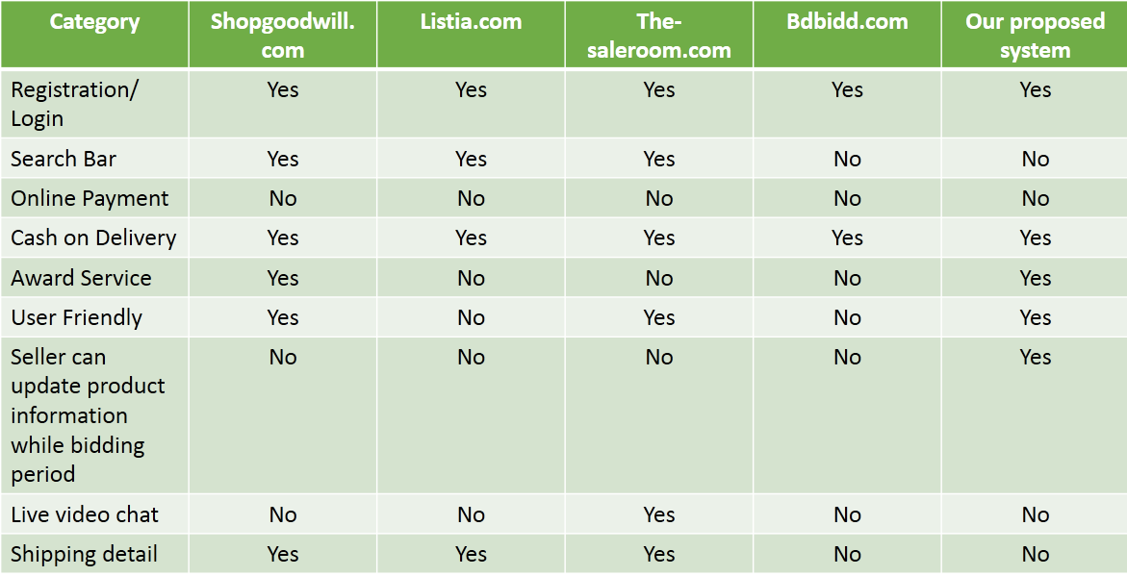
Figure 2.1: Benchmark system vs. our proposed system

CHAPTER 3
System Design
In this chapter we will discuss about system study. We will figure out the different diagram like context diagram, dataflow diagram, activity diagram, sequence diagram and many more for the implementation of our system.

3.1 Context diagram
A system context diagram (SCD) in engineering is a diagram that defines the boundary between the system, or part of a system, and its environment, showing the entities that interact with it.
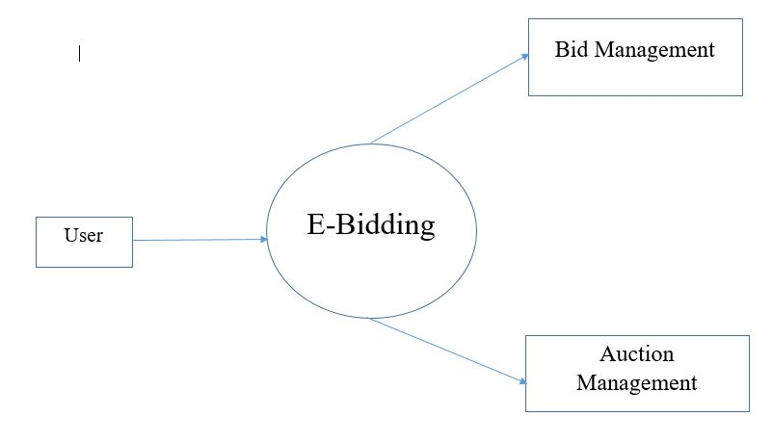
Fig 3.1: context diagram for e-bidding

  - Data Flow Diagram

3.2.1 Level 1 Diagram:

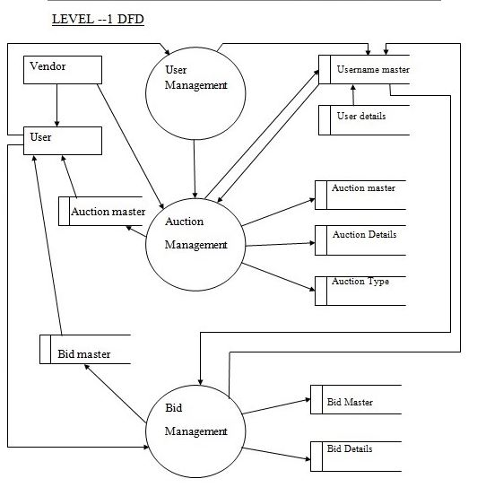
Fig 3.2.1: DFD level 1 for e-bidding

3.2.2 Level 2 Diagram

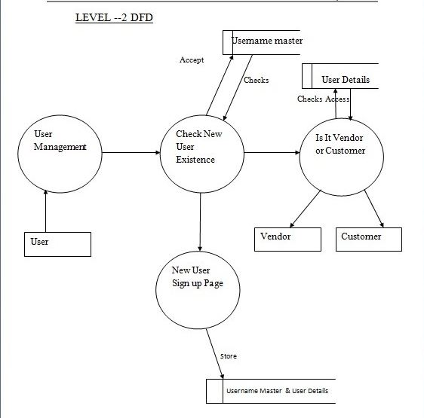

Fig 3.2.2: DFD level 2 for e-bidding

3.3 Activity Diagram
In this figure we are showing our system’s activity diagram. This diagram is basically
A flowchart to represent the flow form one activity to another activity. The activity can be
Described as an operation of the system.
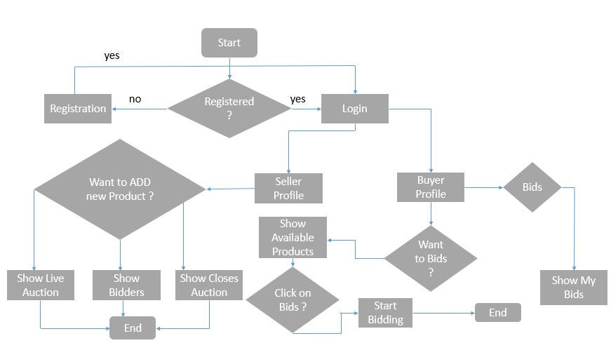

Fig 3.3: Activity Diagram for e-bidding

3.4 Use case:
A use case is a bridge between requirements and systems design and aids in the understanding of functional requirements. A use case utilizes a persona element, which can be created using the use case all modules. Here we are showing and describe our system use case module by module. All use case module are as follows,
3.4.1 Use case for main module
In this use case we are showing our system’s main module. This use case caries a brief idea about our system main module.
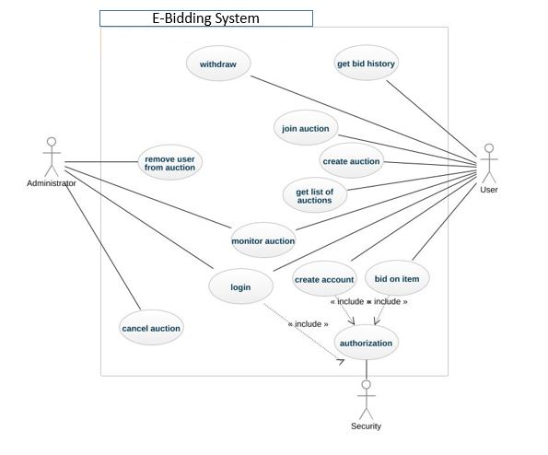Figure 3.4.1: Use case for main module

3.4.2 Use case for buyer module

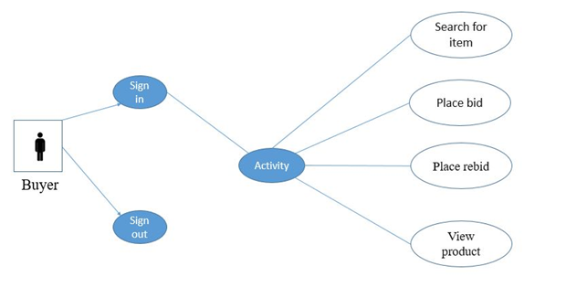
Figure 3.4.2: Use case for buyer module

3.4.3 Use case for seller module
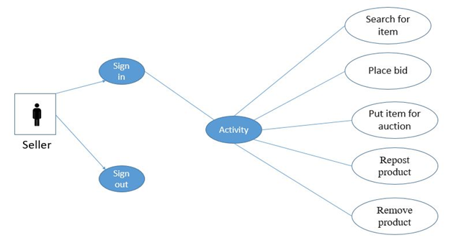
Figure 3.4.3: Use case for seller module

3.5 Entity Relationship Diagram (ERD)
In this figure we are showing our system entity relationship diagram. This diagram represent our system basic database entity and its relation between them. With this ERD anyone can easily understand how our system works in database label.
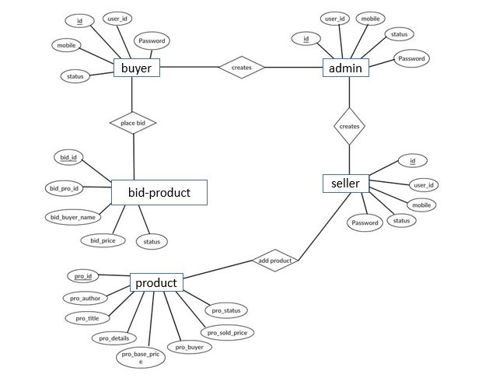
Fig 3.5: Entity Relationship Diagram (ERD)

3.6 Sequence diagram:
A sequence diagram is an interaction diagram that shows how objects operate with one
Another and in what order. It is a construct of a message sequence chart. A sequence
Diagram shows object interactions arranged in time sequence.

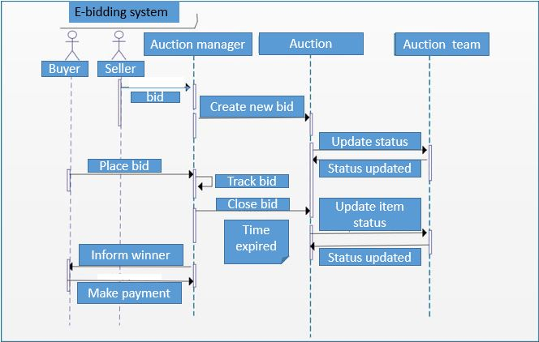
Fig 3.6: Sequence diagram for e-bidding

CHAPTER 4
Implementation Environment
For our system environment we have selected LA ravel framework as a development platform. This framework helps developers build applications that adhere to the model view controller pattern. This framework has added functionality like Html Helpers, validators that work unobtrusively, attribute based model validation, pluggable components and dependency injection, which in turn improved testability and much more.

4.1 Framework
- Laravel 5.6
- Bootstrap 3.4

4.2 Language
- php
- HTML, CSS
- Javascript, JQuery, AJAX

4.3 Database
- MySQL

4.4 Tools
- Team viewer
- BitBucket

4.5 Version Control System
- GIT

4.6 System Module User Interfaces
This is our system’s home page. Initially users can find lots of activity options using Alumni Directory option. User can also find popular job circular which was posted in this website and can see student projects in here which is one of the basic recommendation system of our system. User can easily interact with our system. This application’s user interface is so simple but attractive and easier to understand.

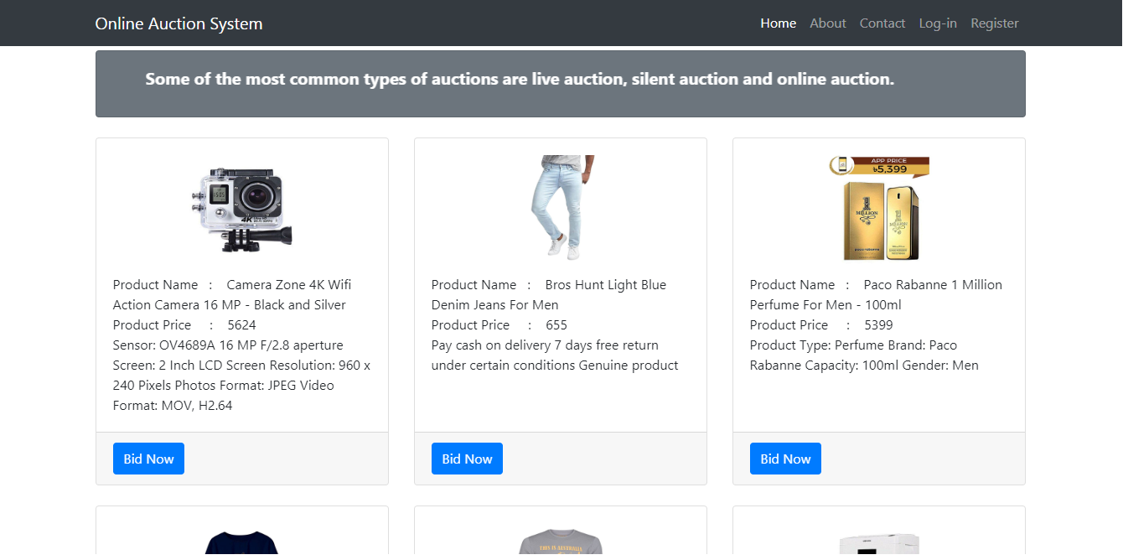
Fig 4.6: Home page

User needs to login as seller or buyer to bid or post product for seller.

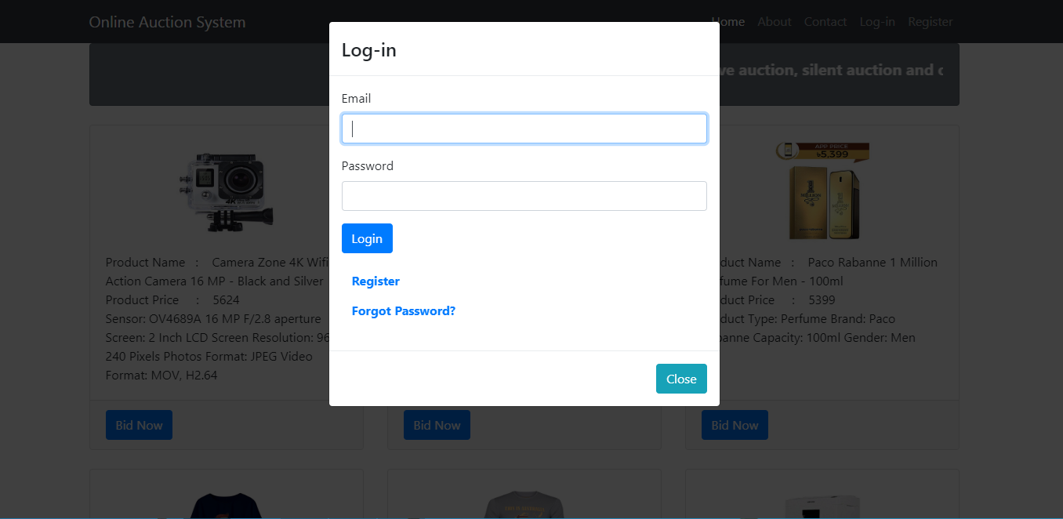
Fig 4.7: Login

Before login user needs to register by filling up the following information.

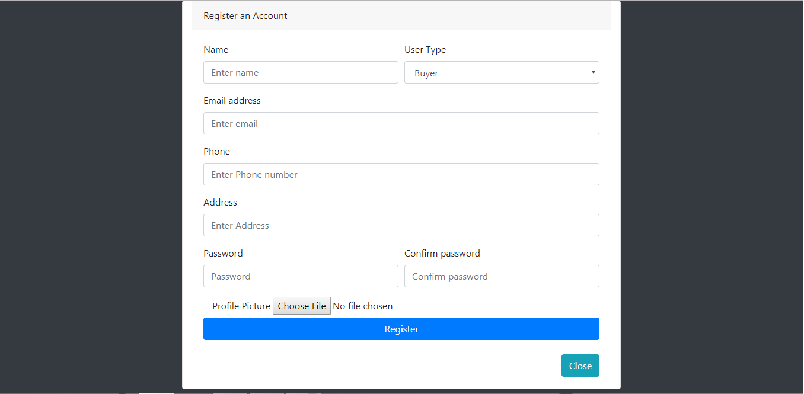
Fig 4.8: Register

Seller profile from here user can go to post product, posted product and pending product.

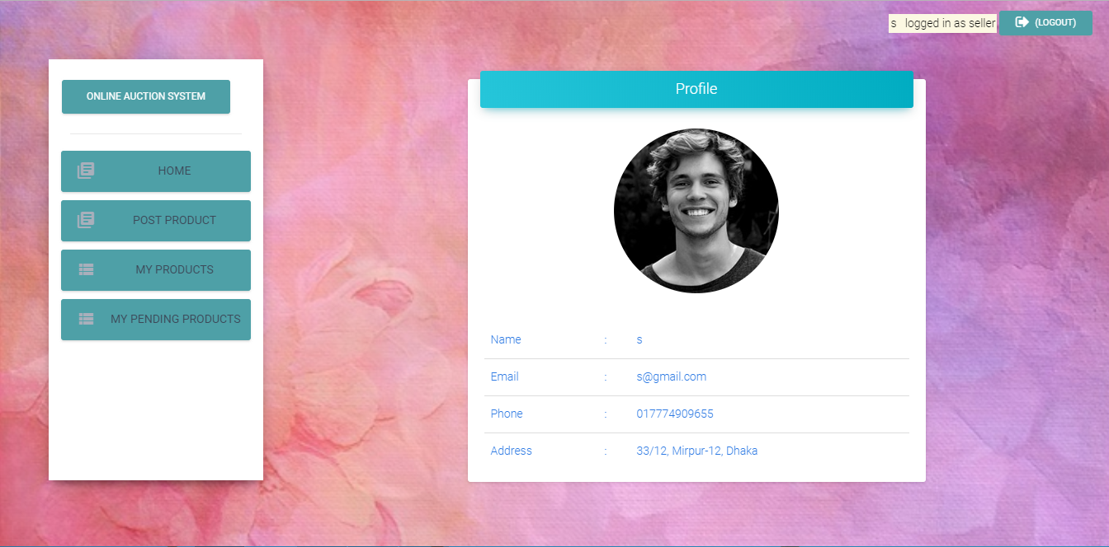
Fig 4.9: Seller profile

From here seller can post product by providing required information.

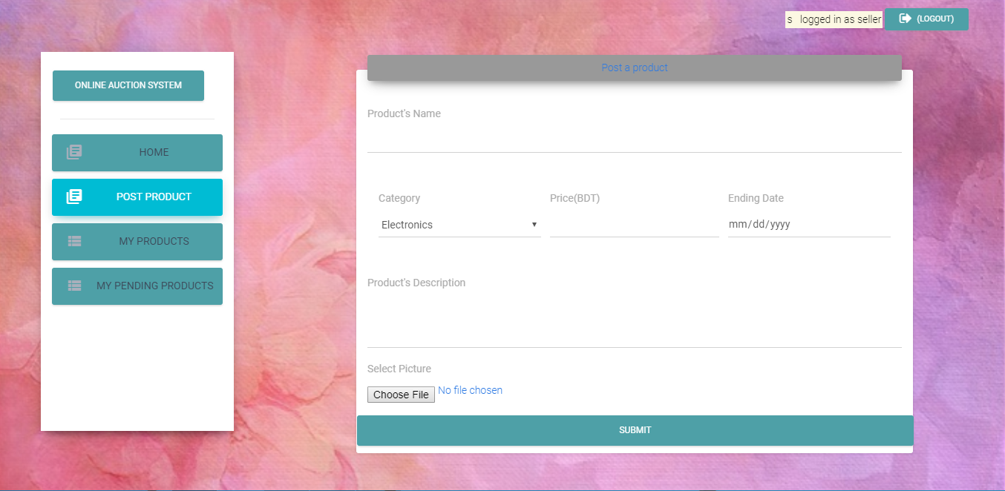
Fig 4.10: Product post

From here seller can view posted product, update posted product, delete posted product.

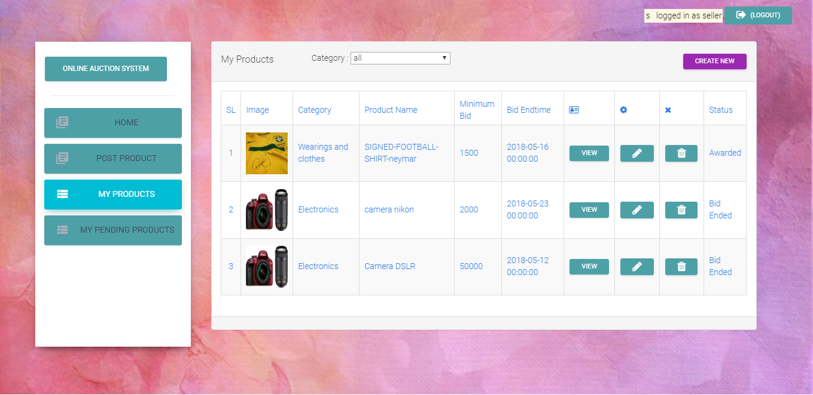
Fig 4.11: All posted product by seller

From here seller can view pending post waits for approval of admin.

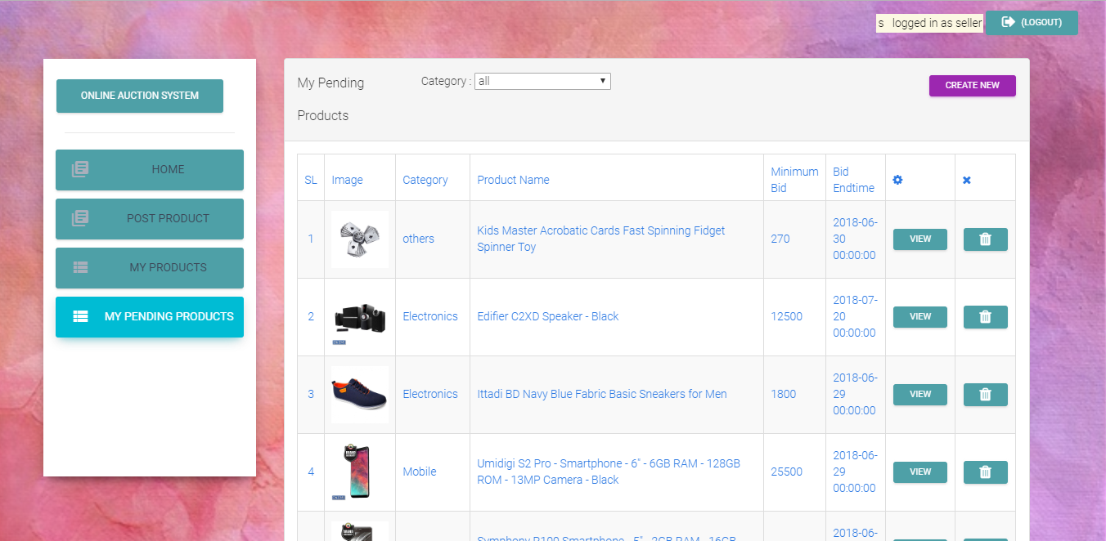

Fig 4.12: All pending product of seller

Buyer profile here buyer can view all product, bid product.

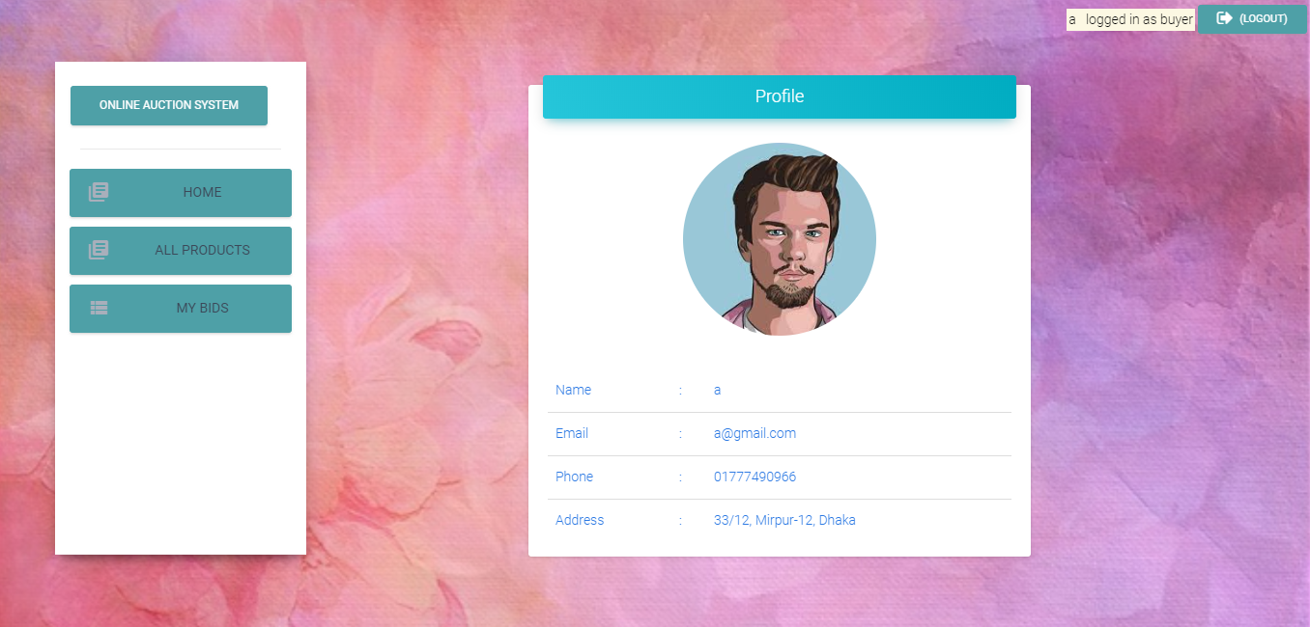
Fig 4.13: Buyer profile

Here buyer can view all product and their details.

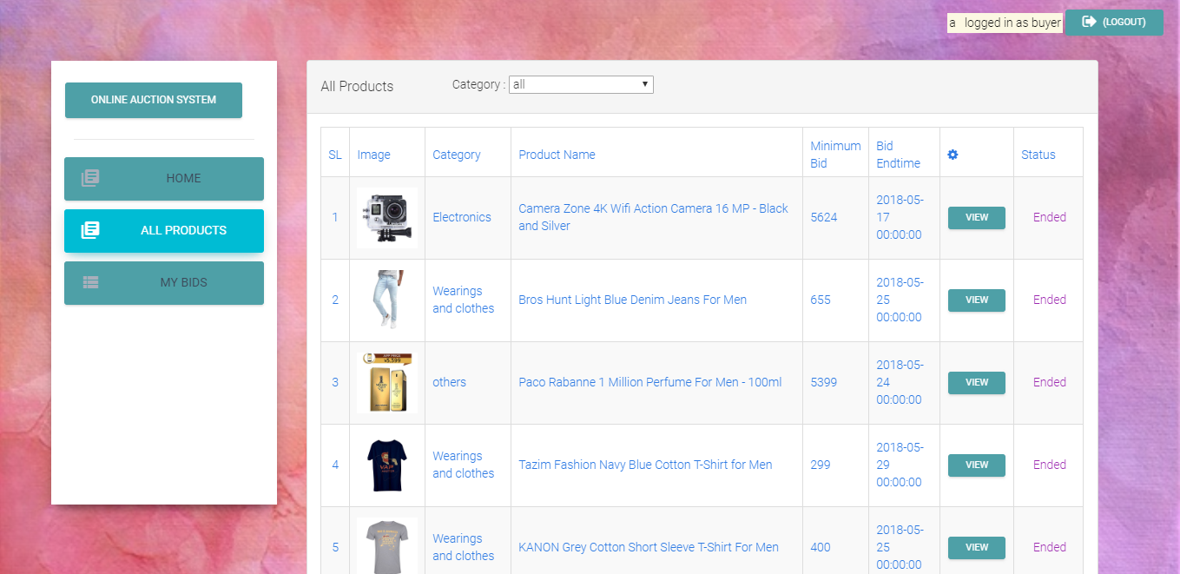
Fig 4.14: All posted product

Here buyer can see own bidding product

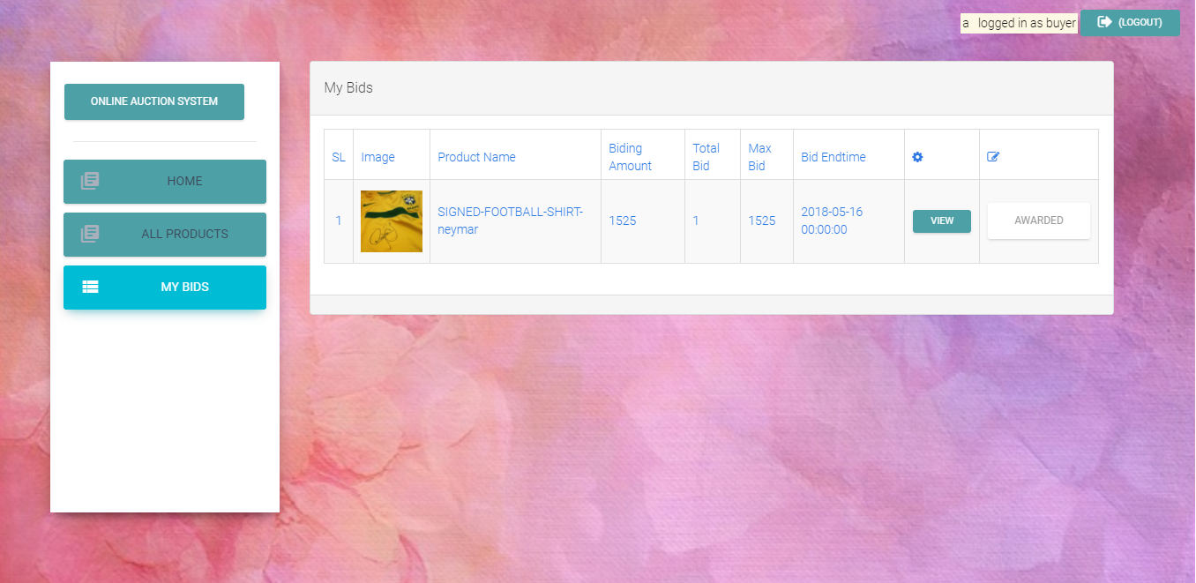
Fig 4.15: All bidding product

Admin profile here admin can go to pending post, all post, add category, see category.

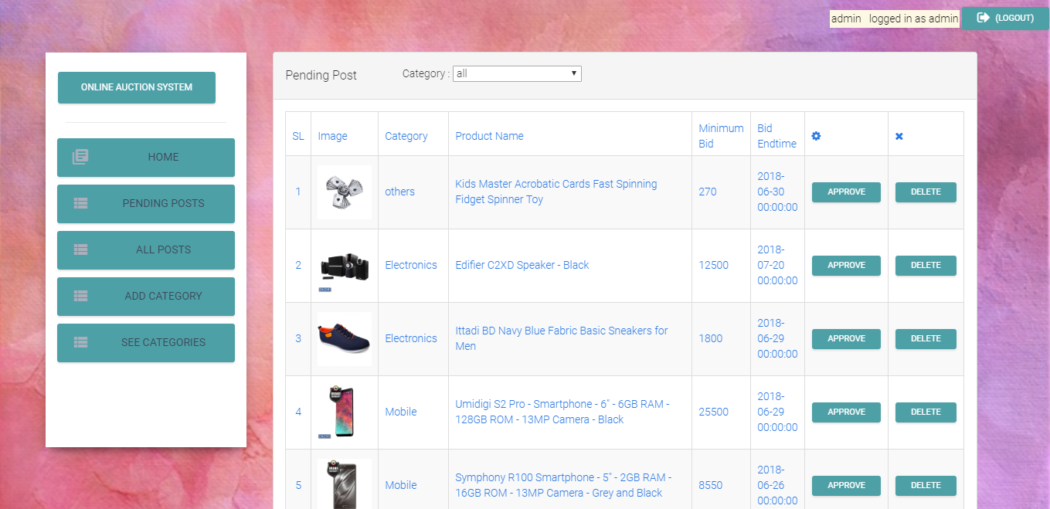
Fig 4.16: Admin’s Home page

Here admin can add category.

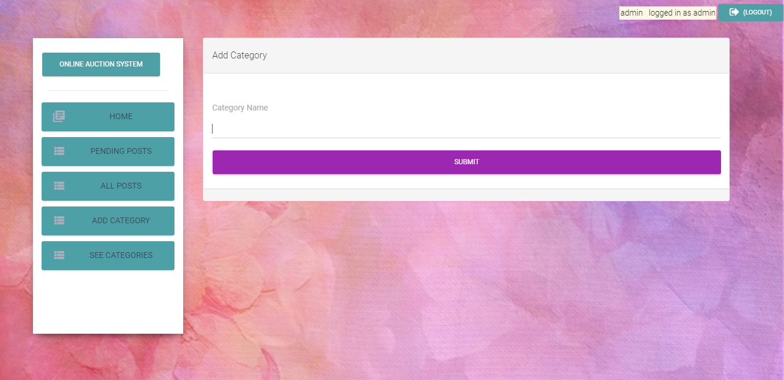
Fig 4.17: Add category

Chapter 5

Conclusion

5.1 Summary

As we can see that e-commerce is getting popularized day by day around the world and eventually our country. Now a days people find more relax. They don’t want to go to market due to many obstacles. Rather they want to buy their products from ecommerce. Hence, it is pretty obvious that there might be a hope for ecommerce. For sure it will be more popularized within upcoming years. From this point of view, there is great opportunity for e-bidding. As it’s totally new with respect to our market place. It can be a great start up for our country. Besides seller will get some extra benefits by using site. In a traditional way sellers always don’t get their desired price as there always comes a negotiation in a traditional ecommerce .From this aspect seller may get some extra benefits as products are sold in e-bidding in terms of bidding. So For our system if a product is sold then seller will obviously get his desired price.

5.2 Future Work:
The future plan of this project is to improved design; implementation and documentation in such a way that anyone can use this project for better perform. I will develop the site more dynamically and the database work as well. There are some limitations in my project. In future I will add the following module for better improvement of the project:
- Account authentication.
- Mobile application of the existing sites.
- Electronic payment policy
- Multiple payment policy
- More secure
- More user friendly
- Real time notification

REFERENCES

- Shopgoodwill.com [Online]
- Listia.com [Online]
- The-saleroom.com [Online]
- Propertyroom.com [Online]
- Bdbidd.com [Online]

