Internship Report on
Recruitment and Selection procedure of EcoFab Limited 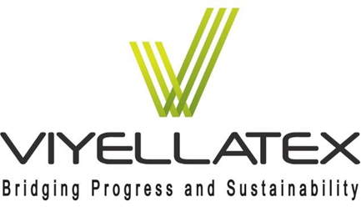
EcoFab Limited.


Submitted by:
Md. Mofazzal Hossain Nibir
ID: 111 192 095

United International University



United International University
School of Business and Economics
Internship Report on
Recruitment and Selection procedure of EcoFab Limited
Submitted to:
Ishrat Sultana
Assistant Professor, SOBE
United International University
Submitted by:
Md. Mofazzal Hossain Nibir
ID: 111 192 095

Date of Submission:
1st December 2024

Acknowledgement
I am truly thankful for all those who have supported me in developing these ideas and assisting me in completing this report on “Recruitment and selection procedure of EcoFab Limited”. I want to thank my supervisor Ishrat Sultana, Assistant Professor, SOBE, UIU for guiding me and assisting me through my internship period. I am thankful for her guidance, support, and help which encouraged me to complete this internship report under her supervision. I would not be able to complete this report properly without her support and guidance.
I also want to express my gratitude to the entire “EcoFab Limited” HR & Compliance team as well as Afsana Anjuli (Executive, HR & Compliance), M A Razzak (HR Officer), Subarna Bashori (Welfare Officer) for all of their direction, information and assistance during my internship period.
Finally, I would like to appreciate all of those who advised me and showed me then accurate direction towards developing my knowledge and learning skills and to complete my internship report.

Letter of Transmittal
1st December 2024
Ishrat Sultana
Assistant Professor
School of Business & Economics
United International University
Subject: Submission of the report on “Recruitment and Selection procedure of EcoFab Limited”
Dear Ma’am,
I was allowed to work with EcoFab Limited as an intern in the human resources and compliance department. In this report, I have tried my best to represent my learning essentials and experiences during the internship time. My learning outcome has a major impact on the report.
Therefore, I request the internship report for your kind review and consideration. I would be very thankful if you could please assess my attempt with your helpful opinion. I will happily answer any questions you may have about this report.
Sincerely
Md Mofazzal Hossain NIbir
ID: 111 192 095
Department: BBA
Major: HRM

Executive Summary
HR is a very critical department for any business but for the RMG factory it is tough to manage many people EcoFab Limited realized that dedicated and talented people are essential for business and retaining them can give sustainability in the long and also it will ultimately lead to good quality products which will increase the brand value. This internship report is focused on the recruitment and selection procedure of EcoFab Limited.
Effective recruitment and selection is an important part of any business and in the RMG sector, it is very much essential because in one factory minimum of 1000 to 1200 people work under the same roof also every department needs to have talented and dedicated people so the company can run its operation smoothly. EcoFab Limited has around 1600 manpower to run the factory. EcoFab is a green factory. They are committed to ensuring minimum damage to the environment and also focus on a low-cost strategy also they want to give a healthy and friendly environment to their employees. For a low-cost strategy, they do not want to spend money on recruitment and training processes so they always want to recruit experienced and hardworking employees. The company focuses on retaining the employees that’s why they try to get the best talented and experienced people. The current procedure is effective but time-consuming so for good operation they need to have automation for recruitment and selection procedures. The improvement of detailed training and better HR planning leads to gain the skilled and experienced manpower and follow retention strategies.

Table of Contents
Acknowledgement ii
Letter of Transmittal iii
Executive Summary iv
Chapter-01 1
Introductions 1
1.1 Background of the report 1
1.2 Objective of the Report 1
1.3 Methodology 2
1.4 Source of data 2
1.5 Scope of Report 2
1.6 Limitations 3
Chapter-02 4
Literature Review 4
2.1 HRM Functions 4
2.2 Importance of HRM 5
2.3 HR policies for business development 6
Chapter-03 8
Company Overview 8
3.0 Company profile 8
3.1 Vision 9
3.2 Mission 9
3.3 Quality of the product 10
3.3.1 Buyer 10
3.4 Green Initiatives 11
Chapter-04 13
HRM Functions of Eco-Fab Limited 13
4.1 HRM function followed by ECOFAB Limited 13
4.2 HR planning of ECOFAB Limited 14
4.3 Policy Implementation 17
4.4 HR Activity 18
4.4.1 Daily maintenance 18
4.5 Factory Organogram 19
Chapter-05 21
Analysis of data & Findings 21
5.1 Recruitment process 21
5.1.1 Skills Required: 22
5.1.2 Documentation process: 23
5.1.3 Medical Test: 23
5.1.4 Biometric checking: 24
5.1.5 Capacity Study: 24
5.2 Selection Process 25
5.2.1 Medical Test 26
5.3 Introduction of New recruits 26
5.4 Contribution of HR department 26
5.5 Human Resource Department 27
Chapter-06 29
Current Situation Challenges (During student Movement) 29
6.1 Positive Impacts 29
6.2 Negative Impacts 30
6.3 Challenges for HR 30
6.4 Changes for COVID-19 31
6.4.1 Positive Impacts 33
6.4.2 Negative Impacts 33
Chapter-07 34
Recommendation 34
Conclusion 36
Chapter-08 37
Bibliography 37
Chapter-09 39
Appendix 39
Pictures of Important Documents 39

Table of Figures
Figure 1 Human Resource Functions 5
Figure 2 Eco-Fab Limited Factory 8
Figure 3 Buyers LOGO 11
Figure 4 Organogram of the factory 20
Figure 5 Job Description 39
Figure 6 Policy Implement 40
Figure 7 Policy Implement Team Members 40
Figure 8 Capacity Study 41
Figure 9 Internal Audit Policy 41
Figure 10 Training Policy 42
Figure 11 Hiring Policy 42

Chapter-01

Introductions

1.1 Background of the report
To graduate with a United International University's Bachelor of Business Administration (BBA), students must fulfill a three-credit internship requirement. In addition to academic learning, we must prepare a report related to professional inheritance based on the knowledge we gained during the three-month internship.
The most important element in every organization is its workforce. The organization must first choose suitable candidates if they wish to run. In this competitive marketplace, every large organization wants to have a strong workforce. A company can achieve more success with an effective workforce. Companies must go through a few recruitment procedures to get a strong workforce. Selecting appropriate candidates must probably be done carefully. In this case, implementing new employees is both a very challenging procedure and an important part of the company's success. Everybody will be unique from each other. They must be taken to the real field, where all procedures will be carried out, after being recruited. Candidates must present a strong, open personality and move forward in an environment of challenges.
In this report, I tried to describe my knowledge and learning from the Human Resources & compliance department at EcoFab Limited about their recruitment and selection process and policies. This report is titled “Recruitment and selection procedure of EcoFab Limited.”.

1.2 Objective of the Report
This report is prepared for describing the recruitment procedure of the EcoFab Limited and identifying the HR policies and operations provided by the organization and analysing the key factors of recruitment process and also their planning and strategies followed by the organization. Here I tried to focus on the policies of the company for employee recruitment also by discussing with the current staffs and workers to find out and understand there strategy for recruiting and retain the talented employees. My main objective is below
- Selection of Staffs and workers
- Experience and qualification of the candidates
- Which teams are involved in the recruitment process
- Who are responsible for the recruitment process
- Selection process of the qualified candidates
- Sources and methods of recruiting

1.3 Methodology
In this report I tried to gather information about the recruitment and selection procedure of the organization through discussing with the HR & Compliance team members which includes Executives, HR officer, Welfare officer, Fire Officer, and other IT and engineering persons. The information I gathered for preparing the report is fully authentic. All information is accumulated through making conversations with them and also checking the files of the organization where companies’ policies are written. Basically this organization focuses on various methods for recruitment process of staffs such as internal hiring and must be experienced candidates also they have two more unit for same business so they hire required employees from those units by using transfer method but they use different methods for recruiting the workers, those are external recruitment but must be experienced candidates.

1.4 Source of data
For preparing this internship report information has been collected from various sources and all of the information is collected from authentic sources. I gathered information from two sources which are given below,
- Primary Source: Primary data collections includes discussion made with the HR & Compliance team members and close observation of their works and daily duties then attending the interview and exams of the candidates then making conversation with the recruit teams and gather their workings system or procedure they follow for recruitment.
- Secondary Source: Secondary data collection includes company’s website, documents, employee files, policy files, academic books, online journals and articles.

1.5 Scope of Report
This report presents the experience and learning I gained during my internship at EcoFab Limited. For a better understanding of the reader, additionally, the brief history and policies and company overview of EcoFab Limited are given. In this report, I tried to give the details of the HR team’s duties and responsibilities, their goal and objectives, and their way of operation. The culture of the factory their way of conducting operations and some details of the equipment they used have been discussed. This information is gathered from real-life experience and the help of the HR team. The main section of the report is the recruitment and selection process of EcoFab Limited, which includes their HR activities.

1.6 Limitations
It was challenging to gather appropriate information for preparing the intern report as the organization is strict to maintain their privacy for confidential information. Some of the challenges are given below.
- Most of the employees were busy with their tight schedule so it was not possible to take their interview for gathering more information.
- Authority was strict to give their all information about the system due to some security issues.
- As the recruitment process task is sequential, one individual duty is dependent on other for complete the task so very difficult for merging the information.

Chapter-02

Literature Review
Human Resources management refers to the policies, practices, and systems that influence employee behavior, attitudes, and performance. Human resources practices play a key role in attracting motivating rewarding and retaining talented employees. Human Resource Management (HRM) is the term used to describe formal systems devised for the management of people within an organization. The responsibilities of a human resource manager fall into three major areas: staffing, employee compensation and benefits, and defining or designing work (Edward L. Gubman observed in the Journal of Business Strategy).
The main focus of Human resources is to develop an effective workforce, retain talented and high performers also align the workforce with the business to achieve its goal. HRM will work as a business partner to ensure that the whole organization is moving forward to achieve its ultimate goals and sustain itself in the long run. A study research implies that, to develop a sustainable work environment the relationship between human resources & other functional departments plays a channel and the integration of diversity makes it more innovative. (The central role of human resource management in the search for sustainable organizations, 11 Dec 2008)

2.1 HRM Functions
By effectively managing an organization's most valuable asset—its people—human resource management (HRM) contributes significantly to its success. The primary duties of HRM can be divided into multiple fundamental domains:
- Recruitment and Selection
- Training and development
- Performance Management
- Compensation and benefits
- Employee relations
- Strategic HR planning
These functions are important for the organization to utilize its workforce effectively as well as it will put impact for the sustainable workforce.
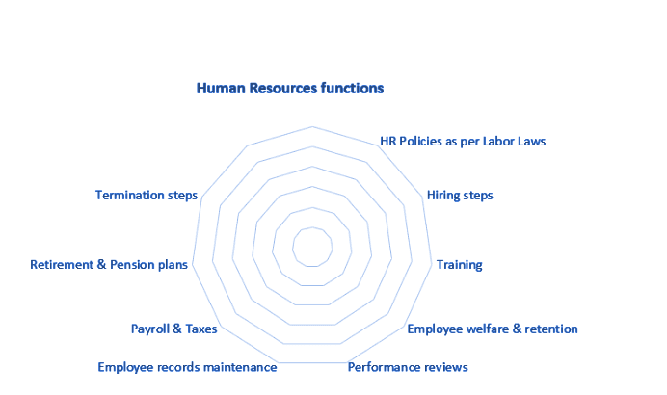
Figure 1 Human Resource Functions

The duties mentioned above are dynamic and will vary depending on the size of a corporation and its work sector, funds available, and workforce size. Nevertheless, an HR team’s role is essential for the success of any business (From online article, Anita Kalra, March 13, 2024).
These are the functions for Human Resource Management an organization considers.

2.2 Importance of HRM
HRM ensures profitability and growth through effective workforce management and the utilization of all organizational resources. For an organization to succeed and last, human resources management, or HRM, is essential. It guarantees that the business brings in support and keeps the best talent, putting employees into alignment with strategic business objectives through appropriate recruitment processes, training, performance reviews, and opportunities for career development. Effective HRM encourages employee motivation, engagement, and productivity.
In addition, HRM promotes a pleasant work environment by maintaining ethical standards, diversity, and equality. HR contributes to a peaceful workplace by managing employee relations and solving conflicts. HRM also makes sure that labour laws and regulations are followed, which reduces the possibility of legal problems and protects the company's reputation. It has focused on how effective HRM practices can lead to improvements in employee productivity in Bangladesh's RMG sector. It has been identified as well-organized.
HR activities strategic recruitment, training, performance appraisal, and motivation are highly instrumental in improving workforce efficiency. Furthermore, HR initiatives directly contribute to employee satisfaction and retention, thereby ensuring the sustainability of organisational performance. The study has pointed out that linking HR policies with business objectives certainly enables a firm to keep its competitive edge and enhances overall operational performance.
The potential growth and prospects in Bangladesh's RMG sectors are huge. For using these opportunities, it should focus on the proper implementation of HR policies to emphasise quality performance. In recent knowledge-based economic conditions, human resources are the most crucial resource, as organisational effectiveness and efficiency are largely dependent on the utilisation capacity of this resource, especially in the case of the ready-made garment industries of Bangladesh. Yet the reality for RMG organizations is that their people remain undervalued, undertrained, and underutilized. Due to improper HR practices, the labor unrest rate at RMG is high, and the employee productivity rate is lower than that of its competitors. Because RMG is the rising sector for further investment, nowadays much concern is needed for its improvement to sustain garment companies' growth and sustain in the long run. In Bangladesh's RMG industry, human resource management needs a lot more attention. Since human resources are the main source of industrial growth and long-term competitive advantage in business, research has shown that HR practices in this area have received little attention. These practices should be measured and examined in the context of Bangladesh's RMG sector quality performance improvement.

2.3 HR policies for business development
In this 21st century, change is occurring due to new technology and dramatic fashion trends. It is essential to meet up with upcoming trends and be comfortable using new technology for effective results. Here HR plays a vital role because HR is responsible for maintaining the workforce. HR should track down previous and upcoming trends and analyze those to predict new things and shift the workforce effectively. In this changing and dynamic economic era, HR should be prepared for any type of worst-case scenario and can maintain any situation because the whole workforce depends on HR.
Strategic HRM is a way to maintain those. Here the HR team will plan their activities and also other departments’ activities based on the organisation's objectives and planning implications, and follow-up planning is the responsibility of the HR team. In the long run, it can be a sustainable competitive advantage for the organization. Strategic human resource management can be a key to success for the RMG industry in Bangladesh because the whole industry is based on cheap labour costs, and the labour is maintained by the HR department.
The development of HR requires some tasks that should be addressed, such as educating the employees to provide proper training, work engagement, motivation, etc. These are the tasks that should be done to get an effective workforce and drive the way to achieve the organisation's goal and objective. HR planning and policy will be based on or will be linked with that goal so that the whole organisation can run towards achieving that goal.

Chapter-03

Company Overview

3.0 Company profile
COMPANY NAME: Ecofab Limited
ESTABLISHED :2016
ADDRESS :228/1, Zogitola, BRRI, GAZIPUR-1701,
PHONE :880-2-9291913-7, 9813001-10(HO)
FAX :880-2-9291841 (Fax)
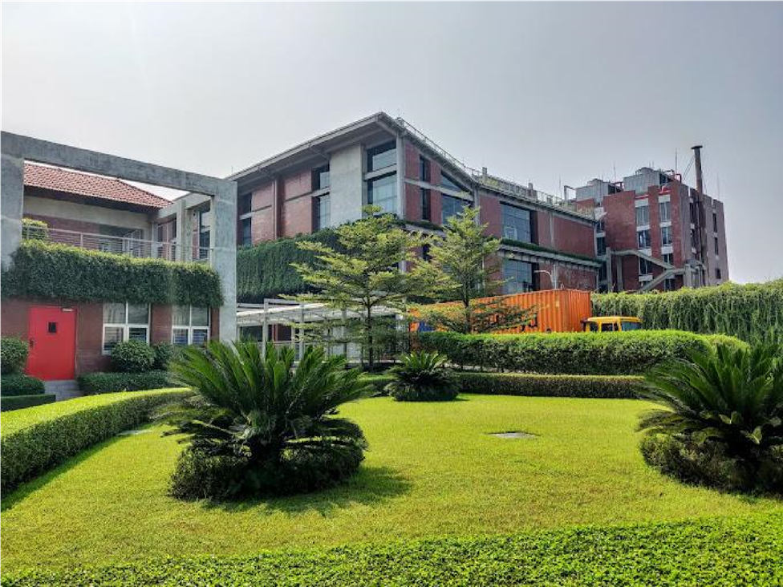
Figure 2 Eco-Fab Limited Factory
Eco-fab is another unique venture of the Viyellatex Group, which started in 2016. This LEED Gold Certified, environmentally friendly building is an extension of the group's woven business.
Eco-Fab has been built on the concept of a luxury resort where its craftsmen would work and enjoy spending time simultaneously. The green landscaping embedded in the architecture, along with the use of natural light and the air being recycled continuously, creates a serene environment of creativity and encourages optimum efficiency.
Inter-fab Shirt Manufacturing Limited (ISML). Just like Eco-Couture, the inspiration and vision of Eco-fab focus on the workplace environment of its artists. Eco-fab has been built on the concept of a luxury resort where its craftsmen would work and enjoy spending time simultaneously. The green landscaping embedded in the architecture, along with the use of natural light and the air being recycled continuously, creates a serene environment of creativity and encourages optimum efficiency.
The company itself is entirely family-owned and employs over 300 management staff and over 15,000 workers. With a vertically integrated setup, the incorporation of advanced technology, and a proficient management team, Viyellatex is emerging strongly as one of the most respected organizations in the country. Looking ahead, Viyellatex is focusing more on the front end of the chain: the end customer. It has further diversified, expanding its presence to include other ventures such as tea production, agriculture, engineering, power generation, and educational services.

3.1 Vision
To Achieve the best possible quality standards by developing the best methods and practices and recognized by all buyers for product quality and “To be the most regarded company”.

3.2 Mission
We strive to provide quality services on time, based on best practices, to the satisfaction of our partners and stakeholders. We foster a friendly working environment through open communication and mutual respect. We encourage initiative, innovation, and teamwork. Workers' welfare and rights are our premier focus. We are committed to a cleaner and greener environment. We are driven by our responsibility to the society as a corporate body. Other missions are given below. A standard of excellence in every aspect of our business.
- To ensure ethical and responsible conduct in all our operations.
- To respect the rights of all individuals.
- To respect the environment.
- To respect the legal and ethical rights of our employees.
- To be an equal opportunities employer and not tolerate discrimination in hiring and employment practices.
- To stringently enforce and uphold the child labor act and actively discourage such practices with others.
- To ensure a zero-tolerance policy towards physical or verbal harassment or abuse towards any worker or employee.
- To ban the use any forced or involuntary labor whether they are prisoners or bonded, indentured or otherwise.
- To provide a comprehensive and free healthcare to all employees and workers.
- To provide crèche facilities for children of workers up to 3 years of age. Food is the children free of cost and facilities are provided for nursing mothers.
- To provide free access to education for the children of illiterate workers.
- To comply with all applicable wages and working hours' law and regulations, including those relating to minimum wages, overtime, maximum hours and other elements of compensation and provision legally mandated benefits.
- To ensure the payment of two-yearly festival bonuses to all workers and staffs.

3.3 Quality of the product
Eco-fab Ltd. puts great emphasis on achieving the best possible quality standards by developing the best methods and practices and being recognized by all buyers for product quality. Part of the quality system check method is designed by KSA Technopak. 200% checks with random quality audits. The incentive scheme is linked to the quality of merchandise produced in the factory. Documented quality standards and measurement procedures. Quality is strictly measured at all stages of production with a team of:
-Inline inspector.
-Inline Auditors.
-End Line inspector.
-Quality Auditors.
-Section Quality Supervisors.
-Section Supervisors.

3.3.1 Buyer
Eco-Fab Limited has some fixed buyers who gave them continuous order based on their quality maintained sample products. These buyers has some requirements which the company need to follow and maintain for getting the production orders. The requirements are such as maintaining proper workplace safety and security, equal treatment for all, give opportunity to disabled people and maintain diversity, child care facility in the factory for those mothers who have recent born child and also a child care giver for looking after those child.
Eco-fab limited major buyers are
- HUGO BOSS
- M&S
- OLYMP

Figure 3 Buyers LOGO

3.4 Green Initiatives
Protecting the environment from the harmful by-products of operations encouraged the sustainability team to start a number of initiatives that not only save resources for the country but also is cost effective. The main focus is to incorporate the 3 R’s – Reduce, Reuse and Recycle into all initiatives. Some of the initiatives include:
Re-using treated water: treated waste-water from the ETP is re-used for daily toilet flushing of 9000 workers in the premises, saving almost 100 million liters of underground water per year.
Harvesting rain-water: The 250,000 sq. ft. roof top rain water harvesting system is used for fabric dyeing, washing and other purposes, saving approximately 28 million liters of underground water every year.
Reusing utility water: Water used daily by the management staff in the wash basin is re-used for gardening around the main premises. This initiative saves about 500 liters of water per day.
Recovering heat: Exhaust from the 5 MW gas generator is re-used for cooling purposes, saving substantial energy and reducing carbon emissions at the same time. Similarly, exhaust from the 3.2 MW gas generator is re-used for steam generation purposes.
Recycling organic waste: 30 tons of organic compost fertilizer is produced monthly. Leftovers from lunch of employees along with kitchen waste from the surrounding area, cotton dust from the spinning mill, cow dung, water hyacinth and other natural ingredients are used to make the fertilizer. Tests done by the Department of Environment (DOE) of Bangladesh have revealed that the fertilizer is very potent, but till date it has only been used at the tea estate.

Chapter-04

HRM Functions of Eco-Fab Limited
Some HR functions are followed by the organization. First of all, they do acquisition, development, motivation, and maintenance. Under these four functions, they try to ensure the whole HRM process in the factory. In these functions, some components are used to complete the task of HRM.
The HR & compliance department of ECOFAB Limited ensures many tasks and works in the factory. They are connected with all the activities from raw materials to finished products. The HR team also ensures compliance matters, such as monitoring the whole factory, maintaining a register for activities completed for compliance, ensuring safety measures, and creating awareness among the workers about safety and security, maternity facilities, and workplace harassment. They put extra care into these things because the majority of the workers are female, so they need to ensure proper safety for them in the factory area. Compliance management is HRM's responsibility to make sure the company follows labor laws, regulations, and policies. HR managers are in charge of keeping proper records for the company, keeping an eye on compliance, and taking care of compliance-related concerns.

4.1 HRM function followed by ECOFAB Limited
- HR planning: ECOFAB used demand and supply procedures to predict the manpower needed for production. The production gives the requisition for the needed workers, and then the HR manager or HR executive examines the total turnover rate and total cost for the new hiring. Then they set several positions that need to be filled to reach the production target. So that there are no shortages or surpluses of manpower.
- Job Analysis: Job Description: In the JD, the total responsibility of a worker of staff is given clearly, such as the responsibility of a supervisor and compliance responsibility and maintaining discipline in the factory, and those need to be followed strictly. Mainly all duties and responsibilities are given in JD.
- Recruitment and Selection: This is done based on the requisition give from the production team. HR department measures those and calculate these with annual budget. If the requirements are met the budget then the process of recruitments starts.
- Employee Introduction: After completing the recruitment and selection process now the employees are arranged in the dining hall for the introduction session with all employees and giving them brief idea about organization rules and regulations.
- Management & Career Development: There are specific planning for the career development of the workers and staffs. If they successfully passed the probation period with proper performance then they will assigned for permanent employment. Also workers have the opportunity for get promotion such as junior swing operator to Swing operator. For this promotion workers need to maintain proper performance and fulfil the production target.
- Motivation: There are some benefits that are given for keeping up the motivation of the employees. Such as giving rewards and recognition for the work done and also extra payment for that.
- Maintenance: Safety and health, employee relations, and record maintenance is the main part of maintenance. Here HR executives are responsible for controlling these issues and also keeping follow up the registers. There is extra fire safety department under HR.

4.2 HR planning of ECOFAB Limited
The RMG sector is a significant industry for Bangladesh. It helps with economic boosting and also has a great impact on the national GDP. Here many international buyers give their orders to the company, and the factory team makes the finished goods and exports them to many countries in the world. Through this industry, Bangladesh can export and earn huge amounts of revenue. This sector is the highest contributor to the national economy. To maintain the quality of the products, ensure the buyer's requirements, and deliver the best output, the organisation needs proper HR planning and strategy for the long term and, in some cases, the short term, but the ultimate objective is to maintain the reputation of the organisation and keep moving forward to get a sustainable stage for the organisation.
ECOFAB Limited's HR planning starts with demand and supply forecasting. It depends on the production orders and the capacity of the factory. If there is a high rate of production orders from buyers, then obviously the HR team will need more employees to complete the task by the deadline. And sometimes, due to low-order company layoffs, some employees are laid off to reduce costs. Secondly, maintaining compliance with international standards is essential, as buyers from different countries have specific requirements that must be met to secure production orders. Then employee retention and engagement with work. Preparing a model so that the company can ensure high retention. Here this company is focusing on compensation benefits and giving promotions. This planning and procedure will be made by the high authority of the organisation, which is the managing director and COO (chief operating officer).
There will be a meeting held in the first year, and the whole year's plans will be discussed, and a budget will be decided for spending the whole cost. The head of HR will get instruction from the authority on how to maintain these expenditures at a minimum level and ensure all buyer's requirements are also met to maintain the production team by supplying enough manpower. There are challenges in HR planning. Given below
- Turnover rates: in this industry company need to retain the experienced workers and staffs for getting high effectiveness. So maintain low turnover rate is a challenge for the HR department
- Health and safety: Within the low budget is difficult to maintain the proper safety measurements but the HR team need to ensure proper safety in the workplace and also met the buyer requirements.
- Cultural issues: there is huge number of employees working under one roof. There will be many people from different religion and from different areas so maintaining equality between them is a challenge for HR team.
The following describes the reporting chain for those given tasks as well as the hierarchy of authority within the Human Resources team.
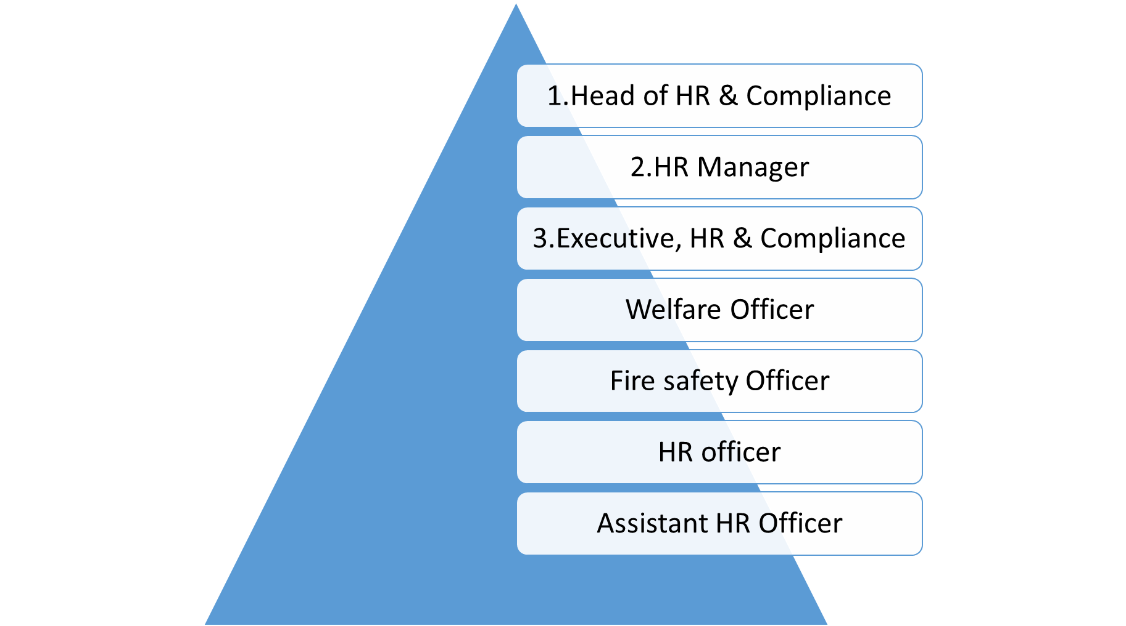

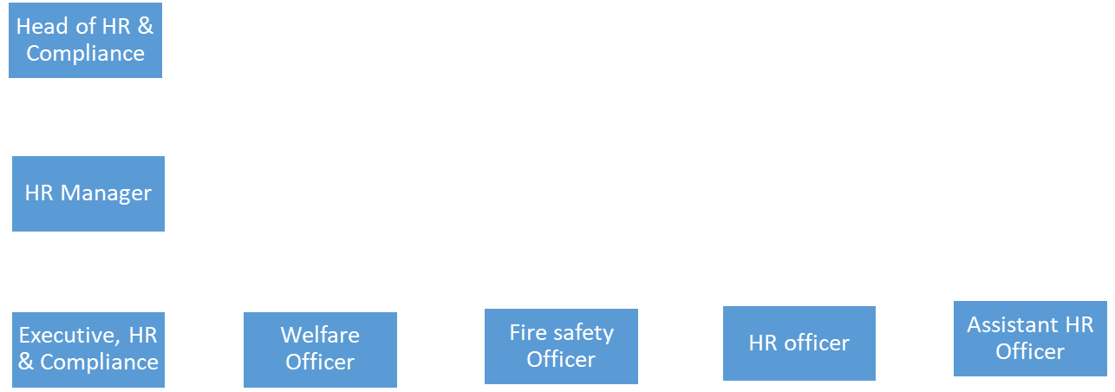

The daily activities are monitored by executives who will report to the HR manager, and other officers will report to the executive, and every officer has to maintain a register of their activities. These are persons who will be responsible for the HR activities. The HR team needs to focus on a lot of things, such as maintaining international standards, building sustainable strategies to achieve the organization's long-term goals, and building effective, skilled manpower for industrial growth.

4.3 Policy Implementation
There is a team with combined members of the different departments; they work to implement any new policy for the factory. They have the power to instruct the departments and the employees to create awareness and do such things for policy implementation, and they have the responsibility to ensure workplace safety and policy-related issues. If anything is not done properly, then these team members will be responsible for that.
Manager Engineering
Safety Committee
Manager
Inventory
GM Production
DGM
HR & Admin

Assistant Manager (EM)
PM Production
Manager
Inventory Control Officer

Line Supervisor
Assistant Manager
Electrician

Sr. Executive

Welfare Officer

4.4 HR Activity
HR activity of the garments factory is different from the other organization. The activities are given below
- Manpower planning.
- Management and data entry of the employees.
- Maintain employee personal files and updating.
- Maintain attendance record and register for absent.
- Handle employee resignation, Exit interview, clearance, closing files and final settlement as required.
- Handle legal affairs and compliance.
- Performance appraisal.
- Employee counselling.
- Arrange training programs.
- Coordinated recruitment, selection and interview session.
- New employee orientation.
These are the activities of the HR team members.

4.4.1 Daily maintenance
Every machine is taken maintenance daily by the operators during production. When a production is started by the operator after handing over from previous shift operator, he takes a routine maintenance on the machine. He cleans the machine, assures fabric is fed to the machine properly, cleans the roller & motor etc. All around of the machine are kept neat and clean as if there is no dirt/spot in the fabric.
HR officer and line supervisors monitor these maintenance and ensure that every worker is following the process of cleaning the machine.
For keeping record of the daily maintenance HR team follows daily 5S Report. 5S is for,
- Sort.
- Set in order.
- Shine.
- Standardized.
- Sustain.
Every HR officer takes pictures of every violation of the maintenance rules, and they make a 5S report on a daily basis. They give a score based on the situation of the violation. The aisle mark of the factory should always be clear; if there is any obstacle in the aisle mark, then it will be a violation of the rule, and it will be mentioned in the 5S report by the HR officer and submitted to the higher authority such as GM and MD.
So that they can call the responsible person for the rules violation and take proper steps to maintain the rules of the maintenance.

4.5 Factory Organogram
Chairman
↓
Vice Chairman
↓
COO
↓
Senior General Manager
↓
Deputy General Manager
↓
Senior Manager
↓
Deputy Manager
↓
Assistant Manager
↓
Senior Executive
↓
Executive
↓
Junior Executive
Figure 4 Organogram of the factory

Chapter-05

Analysis of data & Findings

5.1 Recruitment process
As one of Bangladesh's well-known equipped-made garment (RMG) gamers, ECOFAB Limited employs a recruitment device suitable for employer and organization goals. Besides, ECOFAB is a green manufacturing unit that prioritizes fee financial savings, significant and meeting the specifications of global clients. The RMG sector of Bangladesh has been imparting strategies such as ECOFAB-constrained ways. The organization is based on professionals; documentation, verification procedures, and practice-oriented activities are used to maintain high and environmentally friendly personnel. This technique looks suitable for the enterprise as it supports improving functioning conditions, assessing worldwide tendencies, and remaining competitive in the world market.
ECOFAB Limited has a unique hiring procedure. The production team first identifies the number of employees needed for specific roles, such as swing operators and iron men, as well as support positions like supervisors and quality inspectors. Based on the required production targets and the factory's operational capabilities, the production team submits a labor requisition to the HR department for the necessary workers and staff to meet these goals. This requisition is primarily based totally on the following:
- Current production orders
- Factory equipment capability
- Projected output objectives
Afterward, the HR Executive will evaluate this requisition against the as soon as a one-year charge variety (if hiring is possible).The popularity has become on experienced people. ECOFAB Limited mainly desires professional personnel, which is a strategic choice for minimize training charges and also It would help if you made sure without delay productivity and maintain brilliant requirements to comply with global clients.
EcoFab Limited is a green factory that follows a low-cost strategy, so they try to reduce costs as much as possible. They try to find suitable candidates for the required position based on their experience, and they usually follow the internal hiring process so that they can reduce the cost of new hiring and give training to them. That's why they primarily concentrate on internal hiring and promote existing employees, believing that this approach will boost employee motivation and engagement with their work. They have a total of 4 factory units, and they try to get suitable candidates from these factories and give them transfers. Following these strategies is currently giving them the desired outputs from the recruitments.
However, that is fashionable within the Bangladesh RMG region, where the abundance of skilled workers lets businesses fill positions rapidly, dispensing with large training packages.

5.1.1 Skills Required:
ECOFAB Limited strictly follow that all the candidates should be experienced in job related field such for workers
- Swing operator:
- Collar joint.
- Cuff joint.
- Pocket joint.
- Sleeve attach
- Iron man:
- Proper iron for the garments.
- How to iron the materials.
- Finishing:
- Packaging finished goods.
- Final product presentation.
- Cutting man:
- Cutting the garments using patterns.
- Skills for using the cutting machine.
- Reducing cost of the equipment.
For staffs like supervisors and quality inspectors recruitment there are different set of skills required for the position. For Supervisors and Quality inspectors,
- Swing Line Targets:
- Continuous monitoring of the operators for reaching hourly targets of the garments
- Ensure compliance and safety measures.
- Managing gaps for the absent operators.
- Work under pressure for reaching the production target.
- Maintaining Quality:
- Ensure that output garments have proper quality.
- Minimum rejected garments.
- Ability to get the best productivity from the operators.
- Ensure Compliances of the factory:
- Knowledge about factory safety measures.
- Give instructions to the operators for use the swing machine properly.
These skill necessities are critical as international customers such as Hugo Boss, M&S, and OLYMP are among ECOFAB's most critical customers.

5.1.2 Documentation process:
If candidates have these skills then he/she will be able to apply for the job. Depending on this the candidates will be chosen for different floors as per the production team requisition. Workers need have some documents with for entering the factory gate. This are given below
- National Identity card of the candidate or Photocopy of NID
- Chairman certificate
- NID card of the candidate’s nominee
- Passport and stamp size picture (4 copy each )
- Medical certificate of blood group
- Pervious organization ID card (If have any)
These are the documents candidates need to have with them.
After checking all these documents by a HR officer, He/she will give the candidates interview card and let them go for the further process.

5.1.3 Medical Test:
After completing the documentation process the candidates will sent to medical for the checking the physical ability for the job and also verify age of the candidates. ECOFAB Limited strictly follow that there will be no child labor the factory. So the organization strictly follows the rules and regulations of the factory as well as the labour law of Bangladesh. That’s why they conduct medical tests to ensure no child labor and no laborers who cannot bear the pressure of the work and don’t have the physical ability to ensure proper work of time.
The medical takes a look at ECOFAB Limited serves twin functions:
- Physical Ability Assessment:
- Their top and weight measurements.
- It assesses the capability to work eight–hour shifts.
- Age Verification:
- Rare dental and chest examinations
- It ensures compliance with labour law of Bangladesh.
A certified MBBS clinical officer and a nurse conduct this process and maintain records. After successfully completing the medical test the candidates will be sent for the further process.

5.1.4 Biometric checking:
Here candidates will be checked through biometric process and it will be checked by BGMEA software named EBIMS (Employee Biometric Identity Management System). Using this software they check the candidates employment history in the garments industry and also NID checking. This EBIMS helps the HR team to find suitable candidates for the required positions. HR teams want to hire people who are dedicated and hard-working and also honest towards the work because in the RMG sector, people from various places come to work, so there is the possibility of having conflicts between the workers and staff. If any candidates have this type of previous record, then with the help of the EBIMS, HR can easily identify those and select the most suitable one for the position. This organization tries to avoid the risk of layoffs as much as possible, and the organization is highly focused on retaining the existing employees.
There are some things that are followed by the recruitment team that if any candidates have any violation record in previous employment history, if have any then the candidate will be rejected from here and also team check the reason for leaving the previous job.

5.1.5 Capacity Study:
In this stage, candidates will be sent to the production floor and given field tasks for one or two hours, and the task will be provided based on their skills. An industrial engineer officer on each floor will monitor them during the test period and prepare a capacity study report based on their performance. Here the production of the candidates will be compared to the average production of the current workers. This test will be held for 1 or 2 hours. Candidates will be sent to the HR department with their capacity study report for further processing.
This capacity study is important for the HR team to identify a suitable candidate because it gives a clear image and report of the candidate's skills and ability and how much he/she can contribute to the organization, and it also helps the HR team to select the best candidate based on the capacity report.
The capability test should remain important to meeting the moderate productivity degrees required for the RMG industry to compete in the global RMG marketplace.

5.2 Selection Process
Based on the capacity study report, the executive of HR & Compliance will start negotiations with selected candidates. Candidates will be selected as whoever reached the nearest production rate compared with average production for one hour. Passed candidates will get a call for the interview and negotiation process. Salary will be set based on their capacity, but in some cases, it can be considered for experienced employees. In the interview session, normal questions for workers such as swing operators. Questions are given below,
- How can he/she can increase their performance?
- Share previous organization experience?
- Expected salary And finally
- Negotiation.
But for the staff position such supervisor or IN-Charge position there will be two test. One is written test and a verbal test. Written test have 50 marks 10 question 5 marks each question. Questions are related to their job field such as,
- How to maintain line discipline?
- How to reach production target?
- If more than 3 workers is absent in a same day than how to manage production?
- How use the manpower to get the best output with minimum errors?
These are the questions for the staff recruitment, and if the candidates get 35 marks out of 50 marks, then he or she will pass the test and can move forward for the verbal test with an industrial engineer who will test his or her communication skills, managing skills, convincing skills, and negotiation skills to judge how he or she can get the output from the workers. If the IE accepts the candidate, then he or she will be selected for the position, and further formalities will be done by the HR officer.
Selected candidates will be sent to the HR officer to give their needed documents and apply for the ID card, service book, and gate pass for a limited period and collect uniforms for duty. Within 2 working days, these things will be provided to the new recruiters, and then they can continue work.

5.2.1 Medical Test
Another medical test is required for the selected candidates to know about their medical status and blood group it will be recorded for the emergency need.

5.3 Introduction of New recruits
There will be a session for new recruiters. Sr. HR Officer will host the session. This session is for recruits to know about the company and its people. The Sr. HR officer will give them all the documents that they had applied for and collect the documents that they had missed. In this session, they try to give an overview of the company and its policy rules and regulations, also giving knowledge about the working environment and giving a short brief about the grievance mechanism and how one individual can file any complaints.
There will be some trainings for the new recruiters. Listed below
- New Workers orientation Training.
- PPE (Personal Protection Equipment) Training.
- Health & Safety Training.
- Rights & Benefits Training.
- Abuse & harassment Training.
ECOFAB Limited is very much aware of managing and conducting a good and effective orientation program so that the new recruiters can learn about the company and its mission and objective and also learn about their safety and benefits so they can give their best performance at the working time. Eco-fab Limited nurtures its employees, and they believe that a good orientation is the first step to nurturing an employee and retaining those employees for a sustainable advantage.

5.4 Contribution of HR department
ECOFAB Limited's HR team is comprised of talented and dedicated employees. They try to give their best efforts to complete their responsibilities and also support the other departments so they run smoothly. They are focused on helping the organization to reach its goal. Monitoring the workforce continuously to drive the workforce effectively. Providing the company with experienced, motivated, and dedicated workers and staff. Increase employee motivation through counseling. Maintain communication with employees and help other departments function.
The HR team plays a vital role in the factory and contributes to many operations. They set strategies for the factory and set planning and budgeting of the yearly costing to manage every operation within the budget and maintain proper compliance measures. The HR team is recognized as a key factor in the factory because they contribute their knowledge and skills to every operation in the factory. In this RMG factory, the HR activities cannot be ignored. Proper HRM practices can ensure high productivity, a clean image, and a brand reputation. It is essential because HRM practices ensure good compliance. As RMG sectors in Bangladesh contribute to getting foreign currency by dealing with international buyers and meeting their requirements for being in a competitive position, proper HRM practices are essential. It ensures a sustainable competitive advantage in the marketplace, and following the various HRM factors and using instruments to address those can have an impact on the whole organization's sustainability. Meeting the international buyer’s requirements can also bring sustainability to the business because the buyers will be satisfied and can give more production orders to the factory, which will ultimately increase the overall business.

5.5 Human Resource Department
Recruitment and selection is one of the most important HR practices of any organization. It is a critical process that includes selecting the right people for the right place at the right time, and then the organisation can get the best performance from one individual. Finding the right talent for the right place can make a difference in the organization. That’s why EcoFab Limited HR team is consistently looking for the right people and putting them in the right role at the right time by giving promotions or internal hiring or transfers from another unit of the factory.
The main impact of the human resources department reflects on employee productivity and budget allocations. HR department handles every issue within the factory. A well-dedicated and talented team of members is combined to contribute their knowledge and skills for better performance of the whole factory. This HR team includes the IT executive, Industrial Engineers, Fire & safety officer, Payroll Executive. These members are the part of the HR team with the factory. Basically EcoFab limited includes these persons in the HR team for getting the best understanding of the other departments. The HR department directly handles the recruitment and selection procedure, compensation and benefits, maintains compliance with the laws, performance management for the employees, and maintains records for that, then conducts training and other activities for employee engagement. These are the things that are followed by the EcoFab Limited HR team, which directly impact the whole organization's performance and reputation. If the compliance is not done properly, then the international buyers will not give their orders to the factory because international standard compliance is one of the requirements of the buyers. So it is a critical duty for the HR team to maintain proper compliance and safety measures in the factory. Human Resource team members are concerned with maintaining the compliance of HR activities with the requirements of different internal and external parties like the government, buyers, trade unions, suppliers, and so on. The HR team needs to maintain complaints as per the requirement. HR officers are the responsible ones for maintain the discipline of the factory and maintain the compliance with proper safety measures.

Chapter-06

Current Situation Challenges (During student Movement)
RMG sector in Bangladesh faced a lot of difficulties during the student movement period. All the highways and city road were blocked by the students as a result vehicles cannot reached to destination on time. First of all we know that RMG industry is an export based industry, here finished goods are send to abroad on fixed time. That is buyer requirement and also it creates good reputation in the industry. There is strict instructions from the buyer is that there should be no delayed for product shipment but for student movements many organization faced delayed shipment and also faced challenges for production.
ECOFAB Limited faced a lot of challenges during that period. There shipment date was near month September and because of the protest all roads was blocked the fabrics was not reaching to the factory for production. It was a huge challenge for the company also for the internet shut down the authority cannot maintain communication with buyers. At that buyers are also concern about the production because they are not getting any updates about the production. There was a huge chaos in that period. Because of the delay the costing of the product was increasing and that was a huge loss for the company. They had to give overtime duty to the workers so that they can reach the target and recover the damage for the delay and for that the company had to give extra payment which increases the total costing of the product.

6.1 Positive Impacts
This student movement has some positive impacts on the industry, but it is very low. I tried to mention some impacts here. First of all, every RMG organisation is now aware of the uncertain circumstances. Now they try to prepare a backup plan for this kind of situation. Also, buyers are aware of the Bangladesh current situation, so merchandisers are trying to convince them to buy some extra time for the shipment, which also increases the accountability towards buyers. Workers and labourers got benefits from this movement even though they were also part of this movement in the country. We know Bangladesh is popular worldwide because of the cheap labour cost, but the actual garment workers face difficulties maintaining their families on such a short amount of salary. So after the government changed, the interim government took action to increase the minimum salaries of the workers.

6.2 Negative Impacts
Every business should run smoothly, but because of the student movement, many businesses got stuck. This was harmful to the national economy as well as to the business market in Bangladesh. The RGM sector faced a lot of difficulties because of the student movement. It causes delayed shipment of the products and also a lost communication with the international buyers. EcoFab Limited Buyers are well known in the marketplace, so there is a lot of competition in the market for getting their orders because they order in huge quantities and give high prices, but of course, the factory needs to meet their requirements with international standards. Because of the student movement, there were so many obstacles to running the business smoothly. The buyers faced uncertainty in doing business in the Bangladesh market, which had a huge negative impact on the country as well as on EcoFab Limited.
ECOFAB Limited faced problems because of the movement. Workers went on strike, and the whole factory was shut down. It causes late production and loss of time as well. So the company had to give OVER TIME payment to reach the production target, and ultimately it increased the cost of the product, which was huge for the company.

6.3 Challenges for HR
The Bangladesh RMG sector is widely known for its low labour costs in the world, so it is a big issue for the HR team to maintain proper compliance as per the buyer’s requirements and also put focus on health and safety measures. The HR team needs to ensure the proper work environment within the factory because already workers are facing restless working hours, and the HR team needs to take proper steps to ensure the health and safety of the workers. During the protest period, workers faced a lot of dissatisfaction due to their low wage rate, and they also tried to conduct protests against the low wage rate. Ultimately it will cause the shutdown of the factory, so that’s why the HR team had to take proper steps so that the EcoFab limited workers are fully satisfied with their wages and have proper compliance measures.
HR team faced some challenges to maintain this situation. Workers were scared to do work under this type of situation and there was risk of life. Many innocent people died in the streets so HR team continuously tracking the activities of the workers and giving them instruction what to do in this situation and calling them for taking updates about their lives. They also encouraged the workers to do extra duty to reach the production target so that there will be no delayed for shipment. One of the main challenges for the HR team is maintaining compliance with the country's labor laws. The government was giving shutdown orders during the protest time, so the whole process of maintaining the law of the country was a huge task. HR teams have to ensure and maintain proper workplace safety and a comfortable place for everyone. To overcome these challenges, the HR team encourages continuous communication between the HR officer and other people who are working in the factory, and they are keeping up with the following news trends for the situation knowledge.
The HR team at the factory works hard to make sure that every employee has a safe and satisfying place to work. In their rules and regulations, they work to protect the respect of every worker and develop an environment of equity and equality. They also provide attractive benefits like competitive wages and excellent medical care. To guarantee that the company's goals are fulfilled and that everyone has a happy and secure workplace, the HR team communicates closely with every department.

6.4 Changes for COVID-19
COVID-19 has changed a lot of things in the world. This pandemic made people aware of health and safety issues. Many countries have to go for total shutdown for many months. Every work had to be off for unlimited days, which was a huge concern for business people. COVID had a major impact on the whole RMG sector because other industries, like corporate offices, made changes and utilized the power of the internet. They offered a work-from-home policy for their employees, and they could easily operate the business by that, but in the RMG sector, it was impossible. Every garment has to be prepared with the help of human touch. So there was no way to work from home. Only the merchandisers of the factory can do their work from home, but the production team has to work physically in the factory, which was so risky during the pandemic.
As ordered by the government, the Bangladesh Garment Manufacturers and Exporter Association (BGMEA) shut down their operations. Additionally, the increasing worldwide lockdown put on by COVID-19 complicated garment transportation processes, and even though online sales may have increased, supply chains failed to keep up with demand due to modifications in shipment possibilities. As a result, almost 10 million working people including RMG employees left Dhaka, the capital of Bangladesh, where most of the garment factories are located, to return to their hometowns because they couldn't survive there without employment. Unfortunately, the emergency measures against COVID-19, like keeping a minimum safe social distance from other people, were not followed on the return trip. There have been reports of large crowds on trains, buses, and ferries without personal protection, which presents a significant danger to disease transmission.
A lot of things changed after the opening of the factory, such as health safety measures. Now the factory is so much concerned about the health and safety of the workers. They have taken some steps to maintain this health safety. Maintaining proper distance from one another was a huge challenge in the factory because around 1500-1600 people worked under the same roof, so they introduced a roster basis duty for the workers to reduce the number of people at the same time and maintain the proper distance from one another for safety. Washing hands and wearing a mask was mandatory to get inside the factory, and there was also a bacteria cleaning gate at the factory entrances so that every person who was going inside the factory was free from the coronavirus.
The COVID-19 pandemic has impacted the costs of our everyday lives and pushed lockdowns in several nations. Besides the pandemic's effects on the economy and health, introducing restrictions could have a major effect on how families work. Family members may have mental health issues as a result of the lockdown, primarily those who have preschool-aged and school-aged children.
There was some extra activity for the HR officer for monitoring the health safety measures.
- Giving proper instructions for health safety such as providing them training for knowing the health precautions and what to do for health safety.
- Giving extra facility such as flexible work timing for the workers and maintain the records of the timings.
- Providing face masks, hand gloves and PPE for every worker and it was done daily.
- Marking the safe distance in the whole factory so that worker can maintain safe distance from one another.
- Monitoring continuously that every worker is following the safety measures.
Some policy had been changed for the COVID situation, which was an advantage for the employees of EcoFab Limited. It enabled the employees to work on a flexible schedule and also maintain a balance between work life and personal life.

6.4.1 Positive Impacts
There was a huge change after the opening of the factory. The factory rules and policies have to change and be reconsidered for the betterment of the employees for their morale and motivation, as well the health and safety. They offered flexible timing for work and made double shift timing to reduce the number of people. The HR team faced some difficulties, but ultimately it helped them to think broadly and creatively. It made them understand that the HR team should be prepared for any uncertain situations and operate the business. The HR team felt the importance of adapting to the new changes according to uncertain situations. That’s why they offered flexible timing for the workers and a double shift system; also, they paid extra attention to safety measures, such as maintaining proper distance and cleaning the workplace and machines properly.

6.4.2 Negative Impacts
A huge number of international orders were canceled due to the pandemic situation, which was a loss for EcoFab Limited. EcoFab Limited follows a low-cost strategy for providing the best quality within the minimum budget, but because of the COVID situation and cancellation of orders, they faced a huge loss in that period. To overcome this loss, they have fired a lot of workers to reduce the cost of salary and balance the loss of the factory. Because of this decision, a huge number of people were unemployed.

Chapter-07

Recommendation
ECOFAB Limited is a green factory of Viyellatex Group. They are committed to provide best quality garments as per the buyer’s requirement and timely shipment of the goods. As a green factory they focused more on low cost strategy so that they can give the best quality products at minimum cost. They maintained their commitment that’s why they in a good position in the RMG sector in Bangladesh.
Although there was some gaps in the recruitment and selection procedure. There are some area where I think they should put more focus to improve and fill the gaps to get best outcome from the man power. According to my findings and analysis there are some recommendation given below
- Creating recruitment process less time consuming:
According to my analysis and findings during the internship period, I found that the process of recruitment is manual and traditional, and all the records are done by hand, which is time-consuming and also a risk for errors. So they should use automation software, such as HRIS software and other related tools, to do the process easily and effectively in less time.
- Adapt New Technologies:
According to the findings, I realized that every worker and staff member has been working here for more than 3-4 years, and they are experienced and also used to the regular jobs, so there is an obstacle to taking the new changes and adapting to new technologies for effective workings. The company should focus on this area to gain a sustainable position in the market. They arrange more training to educate and give knowledge about the new software and tools used to work effectively within a short time.
- Company Policies:
The policies should be more flexible and based on employee well-being. The policy is applied to all the departments within the factory, so it should be prepared to get an outcome from the employees. There should be more flexible timing and other benefits arrangements for the employees so that they can feel motivated toward work.
- Increase Ratio of Female recruiting:
High recruitment of females can increase diversity in the workplace. Female workers are more productive than male workers, and they are cheaper than male workers. It is essential to maintain workplace safety for women; especially if there is training for abuse and harassment, it should be more effective so that there will be a zero percentage of abuse issues. This can be done by properly monitoring and training the existing employees about the consequences of harassment and abuse. Another thing that can be done for easy recruitment is setting targets for female recruits, and it will lead to low costs, but we have to ensure a proper work environment for the female workers.
- Effective channel for advertising :
Currently, the factory is hiring from internal sources and searching for candidates from outside the factory. Expected candidates wait in front of the factory gate, and the HR officer selects the potential candidates from there. This is a very poor way of getting the best people for the role, so the authority should use other channels, such as giving advertisements in the newspaper, then online advertisements, and also application forms for the candidates so that they can easily apply online. It will help the HR team to identify the qualified candidate for the role.
So, these are the recommendations and suggestions that have been considered from the analysis and findings of EcoFab Limited. EcoFab Limited may consider these recommendations to implement for further betterment in the overall recruitment process.

Conclusion
EcoFab Limited is always committed to providing the best quality products on time. They have a reputation in the RMG industry because of their good quality products and well-maintained compliance management, which attracts international buyers. EcoFab Limited is a green factory of the Viyellatex Group. This factory is focused on low-cost strategies, which also include low budgets in the recruitment and training of recruits. That’s why they put more attention on finding better, more talented, dedicated, and experienced employees and take beneficial initiatives to retain those people.
The HR & Compliance department handles the recruitment and selection of new employees. They handle all the files of the employees and update them continuously. The HR team found that good, dedicated, hard-working, and talented people can bring a competitive advantage in the market, and also it will lead the organization to achieve its goal. So HR is dedicated to providing their knowledge and ability for getting the best people for the company.

Chapter-08

Bibliography
Akter, N. P. (n.d.). Akter, N. Prospects and Challenges of Green Human Resource Management in RMG Sector of Bangladesh.
Alam, M. N.-m.-1. (n.d.). Alam, M. N., Azim, M. T., & Alias, R. B. (2017). Social compliance in ready-made garment industry in Bangladesh: Challenges for HR personnel. Journal of Applied Environmental and Biological Sciences, 7(10), 8-18.
Ali, M. H. (n.d.). Ali, M. H., & Barishal, B. (2022). Impact of HRM Practices on Employee Productivity: A Study on the RMG Sector in Bangladesh. International Journal of Scientific Research and Modern Technology, 1(2).
Ali, M. H. (n.d.). Ali, M. H., & Barishal, B. (2022). Impact of HRM Practices on Employee Productivity: A Study on the RMG Sector in Bangladesh. International Journal of Scientific Research and Modern Technology, 1(2).
Dessler, G. (2020-2021). Human Resouce Management. In G. Dessler, Human Resouce Management (Fifteenth ed.). Pearson Education Lmited.
Haque, M. A.-1. (n.d.). Haque, M. A., & Nishat, S. S. (2022). The impact of HRM digitalization on employee performance in the RMG industry of Bangladesh. European Journal of Business and Management Research, 7(4), 192-198.
Huda, K. N.-O.-1. (n.d.). Huda, K. N., Karim, R., Ahmed, F., & Olu-Olu, O. (2007). Practices of strategic human resource development in the RMG sector of Bangladesh: An Empirical Study. International Business Management, 1(1), 7-11.
Judge, S. P. (2017-2018). Organizational Behavior. In S. P. Judge, Organizational Behavior (Seventeenth ed.). England.
Kabir, H. M.-1.-5. (n.d.). Kabir, H., Maple, M., & Usher, K. (2021). The impact of COVID-19 on Bangladeshi readymade garment (RMG) workers. Journal of Public Health, 43(1), 47-52.
Kabir, H. M.-1.-5. (n.d.). Kabir, H., Maple, M., & Usher, K. (2021). The impact of COVID-19 on Bangladeshi readymade garment (RMG) workers. Journal of Public Health, 43(1), 47-52.
Kalra, A. (2024, March 13). Human Resources Functions. Retrieved from https://www.pitchlabs.org/library/operations/human-resources/human-resources-functions
Khan, M. R.-3. (n.d.). Khan, M. R., & Roy, S. K. (2023). Do primary HR functions model work in emerging economies? Sustainable compact perspective for Bangladeshi RMG industry. Review of International Business and Strategy, 33(2), 328-341.
Khan, R. M. (n.d.). Khan, R. M. M. R., & Arman, S. M. Role of Human Resources in Building a Sustainable Business: A Study on Ready Made Garments (RMG) Organizations in Bangladesh.
Lynch, R. (n.d.). Strategic Management. In R. Lynch, Strategic Management (Seventh Edition ed.). Pearson Education Limited.
Mello, J. A. (2023-2024). Strategic Human Resouce Management. In J. A. Mello, Strategic Human Resouce Management (Fourth ed.). US: Cengage Learning.
Noe, R. A. (2022-2023). Employee traning and development. In R. A. Noe, Employee traning and development (Eight ed.). Mc Graw Hill Education.
Rashid, F. T.-m. (n.d.). Rashid, F., Taib, C. A., Zien Yusoff, R., Ahmad, M., & Hj, A. (2019). An analysis of quality human resource management (HRM) practices in Bangladesh ready-made garments sector. Journal of Economics and Business, 2(4).
RTOC. (2023, O. 3.-p.-b.-a.-r.-2. (n.d.). Retrieved from RTOC. (2023, October 30). How protests in Bangladesh ahttps://www.linkedin.com/pulse/how-protests-bangladesh-affecting-rmg-2rtoc/
Shimanta, M. L.-1. (n.d.). Shimanta, M. L. R., Gope, H., & Sumaiya, I. J. (2020). Readymade garments sector and COVID-19 in Bangladesh.
swailes, B. s. (n.d.). Organizatinal Change. In B. s. swailes, Organizatinal Change (Sixth ed.). Pearson Education Limited.

Chapter-09

Appendix

Pictures of Important Documents
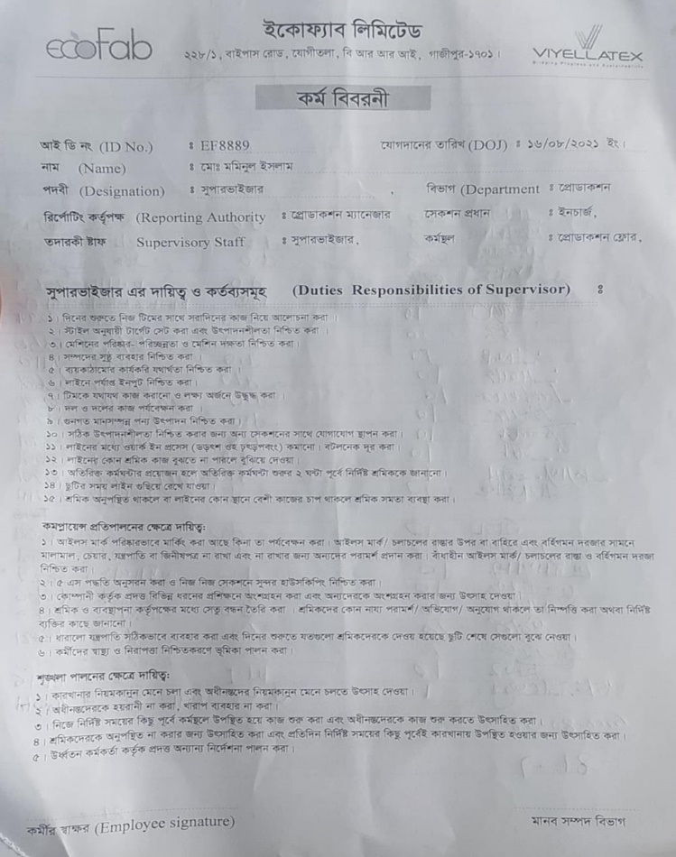
Figure 5 Job Description
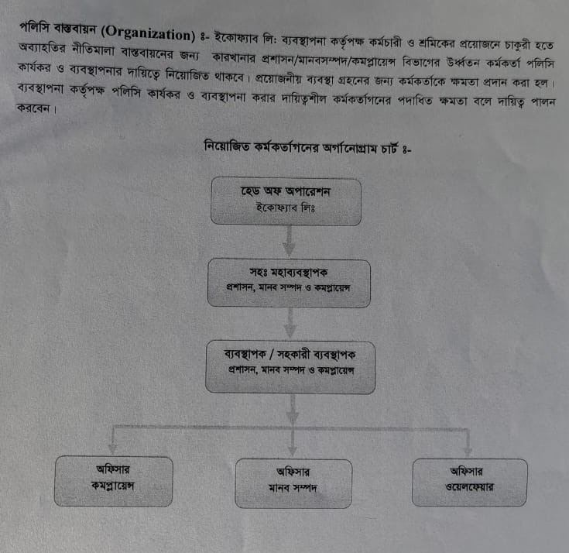
Figure 6 Policy Implement
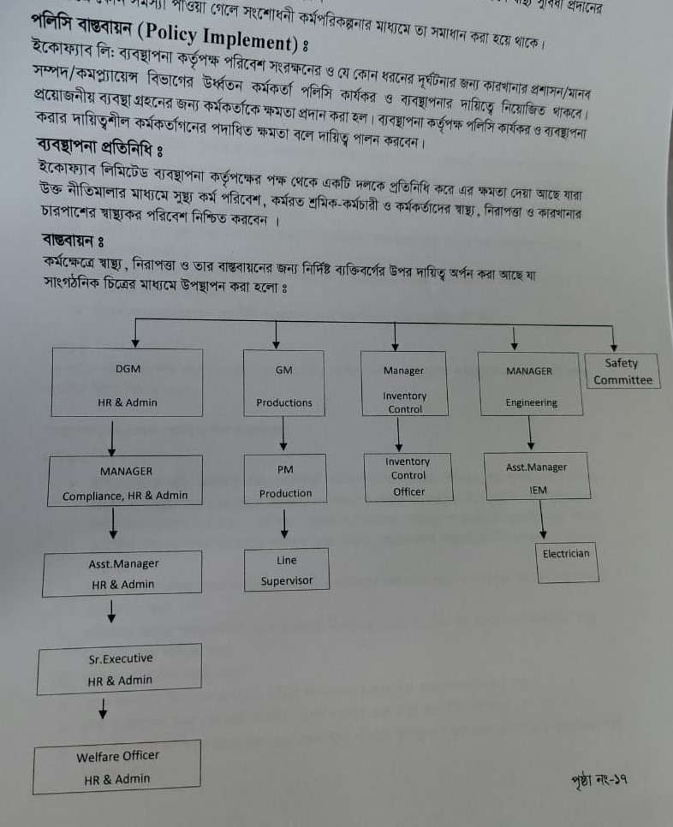
Figure 7 Policy Implement Team Members
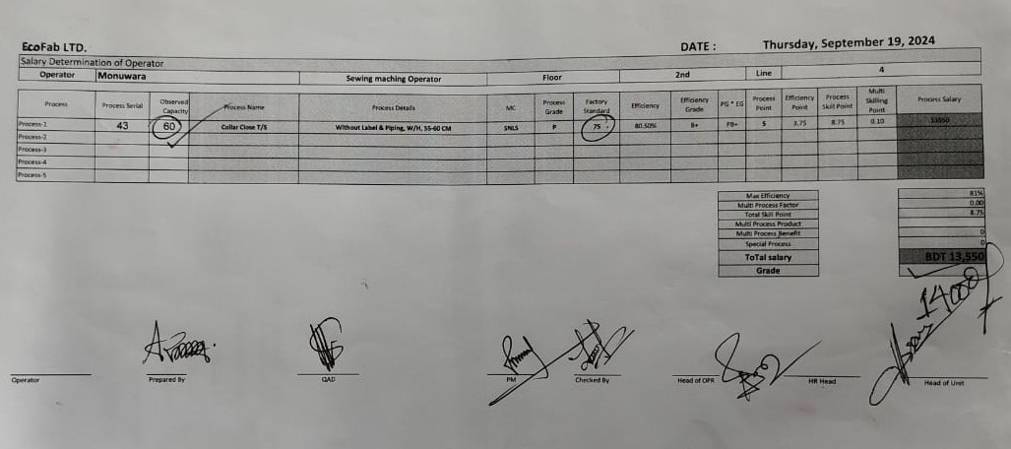
Figure 8 Capacity Study
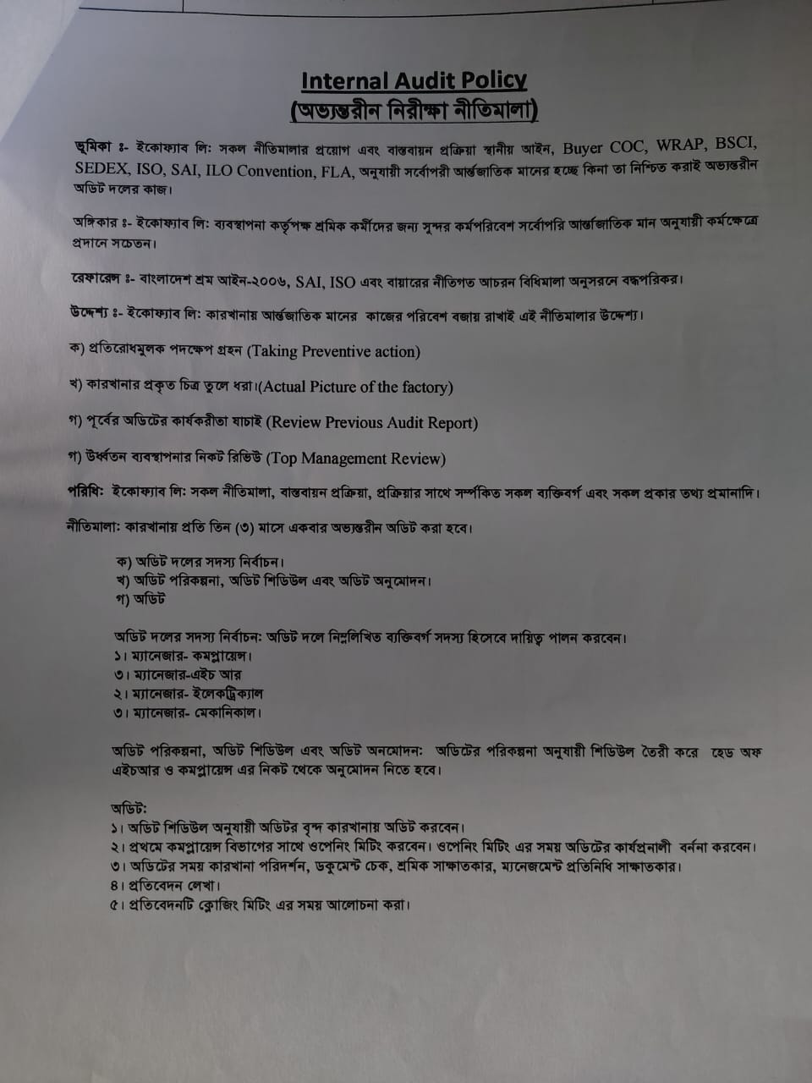
Figure 9 Internal Audit Policy
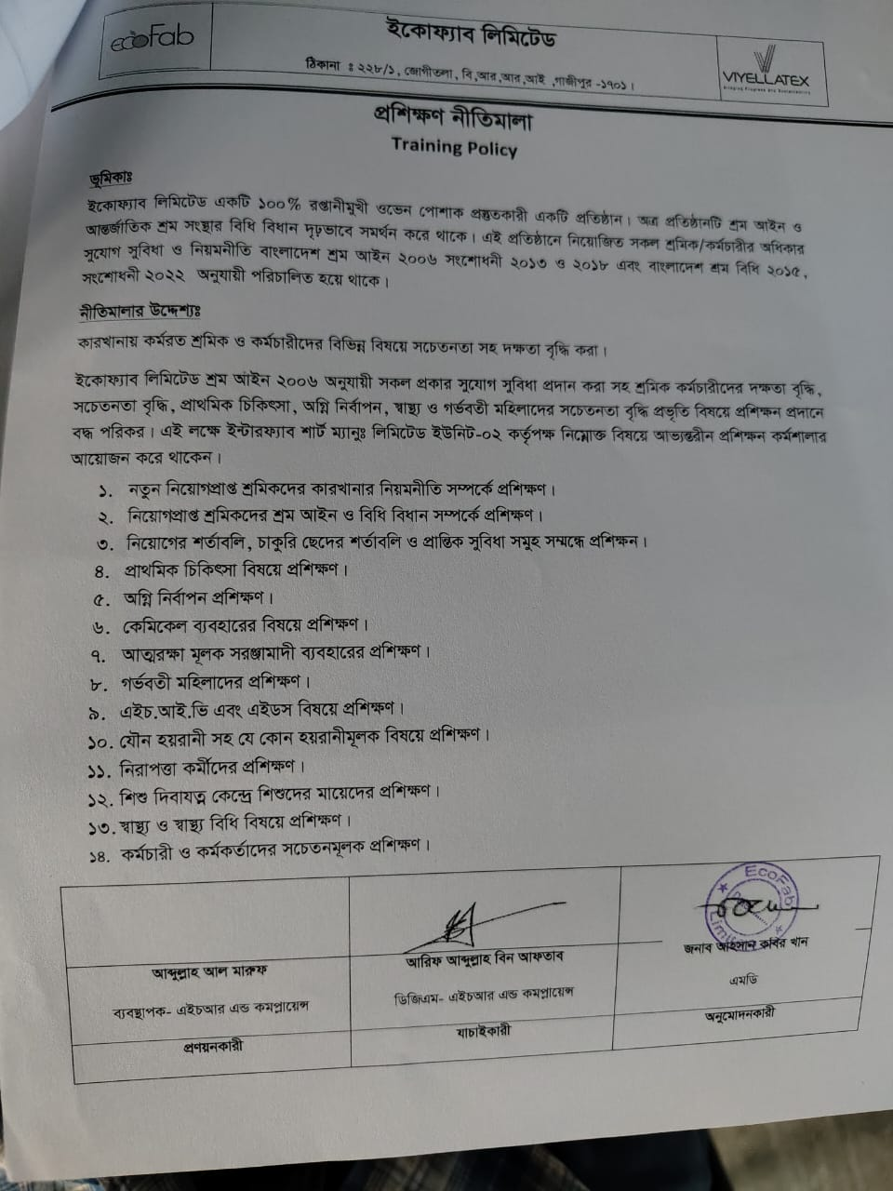
Figure 10 Training Policy
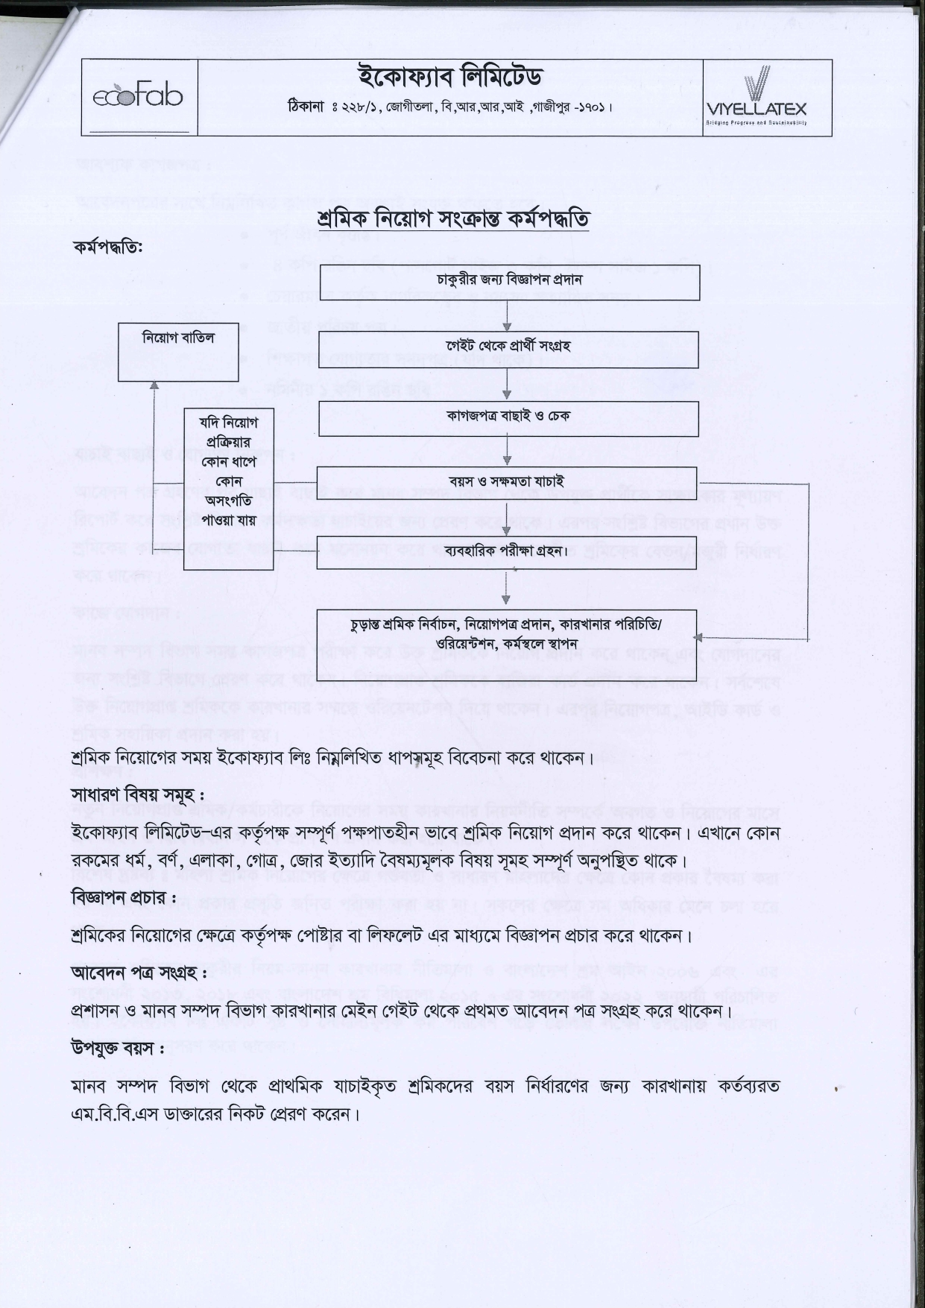
Figure 11 Hiring Policy

