

Internship report
On
NRB Global Bank Limited.

A brief study on the Ratio Analysis and Credit procedures of
NRB Global Bank limited.

Submitted to:
Dr.James Bakul Sarkar
Associate Professor,
School of Business and Economics.
United International University.
Submitted by:
Fariha Mojumder
ID# 114 143 008
Course code# AIS 4441
Department of BBA in AIS
Date of submission: 05-01-2019
Letter of Transmittal

05.01.2019
Dr.James Bakul Sarkar.
Associate professor
School of Business & Economics.
United International University

Honorable sir,
I feel immense pleasure to present you my internship report on ‘a brief study on the Ratio Analysis and Credit procedures of NRB Global Bank limited’. I have found this report to truly challenging in many aspects. Writing this report itself was truly comprehensive learning experience. While preparing this report I have followed the instructions of my respective faculty Dr.James Bakul Sarkar.
The report has been conducted based on the experience that I have gathered during my internship period. I have tried my best to complete the report appropriately as much as possible according to the guidelines. Any type of constructive criticism is highly appreciated and I would like to answer any sort of questions regarding this report.

Fariha Mojumder
ID: 114 143 008
BBA in AIS
United International University.

Acknowledgment
First of all I would like to thank the almighty Allah, whose invisible guidance helped me to complete this report. As three months period is very short time for gathering all the knowledge about banking activities but the short experience that I have gathered as an internee in NRB Global bank limited, Dhanmondi Branch will be listed as my life time asset. I took the opportunity to broaden my knowledge about this sector.
I am highly thankful to my supervisor, Dr.James Bakul Sarkar, Associate professor of department of BBA in united international university. He has provided me his valuable suggestions in every aspect while preparing this report. His participation and helping activities have inspired me to prepare this report successfully.
I would like to thank all of the employees of NRB Global Bank Limited, Dhanmondi Branch. All of them were very helpful. Their friendly and supportive activities have never let me feel that I am only a student of internee in that bank. They have treated us as their own NRB Global family. Besides I have special appreciations to the following persons:
- MD.Shamsul Islam, Deputy Managing Director.
- Mr.Kazi Anwarul Azam, Senior Assistant Vice President & Branch Manager.
- A.K.M. Kayum, Senior Principal Officer & Manager Operations.
- Nipa Kashem, GB In-Charge.
- Mortaja Parvez,Cash-In-Charge.
- Md.Ekramul Islam Fahim, Assistant Officer.
Finally I would like to appreciate my parents and other family members and also remember my friends whose cooperation and suggestions has helped me in preparing a quality report.

Executive summary
The basis of the report is ‘a brief study on the Ratio Analysis and Credit procedures of NRB Global Bank limited’. It is prepared from my personal experience that I have gathered within this internship period. According to me collection of deposits is the main task as well as challenge for a Bank. This is the way in which banks are generating their revenues. All the employees are so dedicated to their works. They have created a wonderful protocol to maintain a good relationship with their customers. Because of their good services every month they are getting large amount of deposits. NRB Global Bank Limited believes that about 80% to 90% money should be reinvested in to the loan sanctioned.
For reinvesting NRB Global Bank requires analyzing the different financial ratios to evaluate their growth in the industry. This ratio helps them to evaluate theme selves as well as helps to take necessary policies for the betterment of the whole Bank. On the other hand investors get relieve seeing the ratios is a graph.
At the very first two months I worked in the General Banking Division (GB) .Here I learned how to open an account, the different types of services provided in the General Banking Division. I also learned how to provide a quick service to the customer, how to handle an arrogant customer, how to take care of complaints, how to write pay order and how to register inwards and outwards.
For last one month I have been working in the Credit Division of NRB Global Bank Limited. Here I have learned to fill up LC Registers, Loan forms and obtained a detailed view about the loan procedures.
The major challenge for the bank is to survive in a highly competitive market. It should know the strategies to develop a strong and effective credit department.NRB Global Bank is doing a wonderful job in the industry. It is maintaining its assets and liabilities in an efficient way. And as a result it is gaining continuous success. Its target is to catch a sustainable market in a disciplined way.
Table of Contents
CHAPTER – 01 10
Introduction of the report 10
1.1 Introduction: 10
1.2 Origin of the report: 10
1.3.1 Broad objective: 11
1.3.2 Specific objective: 11
1.3.3Scope of the report: 11
1.4 Methodology 12
1.5.1 Primary data: 12
1.5.2 Secondary data: 12
1.5.3 Limitations: 12
CHAPTER – 02 15
Overview of NRB Global Bank 15
2.1 Company profile: 15
2.2 Vision of NRB Global Bank: 16
2.3 Mission of NRB Global Bank: 16
2.4 Goal of NRB Global Bank: 16
2.5 Company organ gram of NRB Global Bank: 17
2.6 Profile of NRB Global Bank: 18
2.7 Branch lists of NRB Global Bank Ltd: 19
2.7.1 Expansion of branch network in year 2017-2018: 20
2. 8 Lists of ATM booths In Bangladesh: 21
2.8.1 Expansion of ATM network in year 2017-2018: 22
2.9 SWOT analysis of NRB Global Bank: 23
2.9.1 Strength of NRB Global Bank Ltd: 23
2.9.2 Weakness of NRB Global Bank Ltd: 24
2.9.3 Opportunities of NRB Global Bank Ltd: 24
2.9.4 Threats of NRB Global Bank Ltd: 24
2.10 Products of NRB Global Bank: 25
2.10.1 Retail banking products: 25
2.10.2 Foreign Trade Products: 26
2.10.3 Other service products: 26
2.10.4 Loan products: 26
2.11 NGB Global Products Brochures: 27
CHAPTER -03 29
Ratio Analysis of NRB Global Bank 29
3.1 Return on Equity: 29
3.2 Return on Asset: 30
3.3 Return on deposit: 31
3.4 Fixed Asset Ratio : 32
3.5 Net Asset Turnover: 33
3.6 CASH RATIO: 34
3.7 Loans to deposit Ratio: 35
3.8 Loans to total Asset : 36
3.9 Equity to Asset Ratio: 37
3.10 Equity to Net Loans: 38
Chapter-04 40
Credit Procedures 40
Loan products in Details: 40
4.1 SME Banking: 40
4.1.1 NRB Uddom: 40
4.1.2 NRB Kishan (Agri-Loan) : 41
4.1.3 NRB Proshar (Linkage Finance) 41
4.1.4 NRB Nondini ( Loan for women entrepreneurs) 41
4.2 NRB Health Support Loan : 41
4.3 NRB Home Loan: 42
4.4 NRB Travel Loan : 42
4.5 NRB Utshaho Loan : 42
4.6 NRB Student Education Loan: 42
4.7 NRB Sohoyota Loan: 43
4.8NRB Migrant Loan: 43
4.9 General Procedures related to credit: 43
4.9.1 Check list for credit procedure done by NRB Global Bank Limited: 44
4.9.2 Application for the loan proposal: 45
4.9.3 Selection of the borrower: 46
4.9.4 Preliminary screening for the loan proposal: 46
4.9.5 CIB Information: 47
4.9.6 Security Analysis: 47
4.9.7 Site Visit: 47
4.9.8 Documentation: 48
4.9.9 Disbursement: 48
4.10 Accounting Treatment of disbursing a loan by the branch of NRB Global Bank Limited: 49
4.11 How analysis of Credit Risks done by NRB Global Bank Limited? : 50
4.11 How management of Credit Risks done by NRB Global Bank Limited: 52
Chapter-05 54
Concluding Parts 54
5.1 Findings 54
5.1 Recommendations: 55
5.2 Conclusion: 56
References: 57
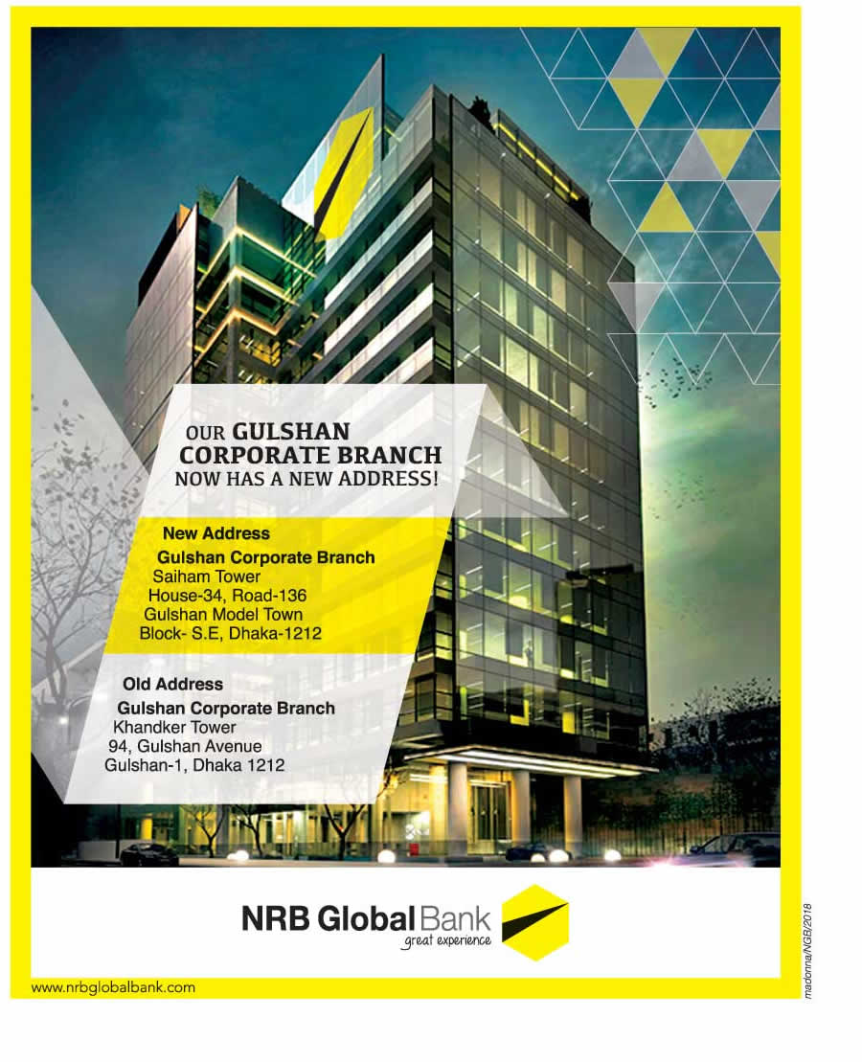

Chapter – 01
Introduction of the report

CHAPTER – 01

Introduction of the report

1.1 Introduction:

This is an era of modern technology so the connection between countries should be stronger. Central bank of Bangladesh that is - Bangladesh Bank approved 9 fourth generation banks. Among them, 3 banks have the funding of non-resident Bangladeshi (NRB) people.
NRB Global Bank Limited is one of those three banks to materialize the dream of people having the goal to keep Bangladesh well connected with other advanced nations. It is the brainchild of 25 (twenty five) well reputed visionary Non-Resident Bangladeshi (NRB) people residing in different countries of the world. It has been approved by the regulatory bodies in 2012 to operate business in banking of Bangladesh.
After hard labor of three years and complying with all the regulations it has finally got the approval on July 25, 2013 from the regulatory body to run the banking business in Bangladesh.
Head office of this bank has inaugurated September 09, 2013. Its head office was situated at Khandker Tower, 94 Gulshan Avenue, which is a great example of post modern structure and one of the finest buildings in Bangladesh. Even, this bank has opened its first branch at the same premise on October 23, 2013. Thereafter, Bank re-located its Head Office and Gulshan Corporate Branch to Saiham Tower on May 6, 2018. (Nrbglobalbank.com, 2018)

1.2 Origin of the report:
This report is generated after completing three months of internship period conducted at NRB Global Bank, Dhanmondi,Dhaka. This branch is situated at Dhanmondi -27 road. I was honored to do my internship after completing 120 credits of BBA course from United International University. During an internship period a student has to understand the depth of work in his/her belonging organization. The report is the final output of three months of skill gathered, suggested by the Human Resource Department ( HR DEPT) of NRB Global Bank.

1.3.1 Broad objective:
The broad objective is to know the organizational structure, to know how to work under pressure and to get familiar with the work environment. This is a mandatory course contains 3 credits and it’s a must to complete the graduation.

1.3.2 Specific objective:
- To analyze and understand the overall activities of a bank
- To evaluate the current techniques of NRB Global bank
- To study the operational proficiency.
- To compare the theoretical and practical knowledge.
- To prepare SWOT analysis for NRB Global bank.
- To examine bank’s policy
- Know how to minimize general banking risks.
- To reveal some findings on the given report.

1.3.3Scope of the report:
Banking sector holds a significant position in any country’s economic feasibility. It shapes the fiscal market of a country. NRB Global bank is playing an excellent job in this regard. This bank has started earning profit from its very beginning.
Banking sector is a large area which cannot be truly understood within a short time. Every bank has different products, schemes. Different departments of bank play different roles. This report contains the information mainly based on the activities of NRB Global bank, Dhanmondi branch. It contains mostly the general banking activities of the bank. The preparation of the report implies a great opportunity to gather knowledge about the bank. The report has been made based on the experiences gathered during my internship period. It was a great opportunity for me to understand the overall activities of the branch and to practically execute them. I have developed my knowledge mainly in the general banking side, gathered short knowledge about the processing of cheque and how to make a input for transactions. I was also enlightened with a short knowledge about credit department of NRB Global bank, Dhanmondi branch.

1.4 Methodology
This part of the report shows how I have gathered data to complete this report. The methodology of the report is very different from the conventional report. Here I have mainly used my observations. I have also used different data sources to beautify the report.

1.5.1 Primary data:
- I had several discussions with the officials about NRB Global bank.
- Informal interviews
- Individual conversations with the employees.
- Direct involvement in different departments.

1.5.2 Secondary data:
- Took help from the Annual Report ( 2017 & 2018)
- Brochures, manuals and several publications.
- Browsed website of Bangladesh Bank
- Browsed website of NRB Global Bank.
- Different circular published by the head office.
- Different paper cutting about this bank.

1.5.3 Limitations:
To provide recent information and to make the report read worthy use of different sources was important. In spite of giving full effort I could not managed to gather all the required information during the study. So, the report is not free from any kind of deficiencies. Some limitations are given below:
- Less accessibility in preceding and latest data.
- Like other organizations, much information was confidential. I could not manage them.
- Concerned personnel did not have enough time for me due to rush banking
- There was some technical error like data interpretation, transmission.
- Understanding the tasks was bit difficult for me.
- Most of time, I had to use previous data due to unavailability of current ones.
- Time limitations of intern period.
- At the beginning it was difficult for me to cope up with the environment.
- Working in a practical scenario is far different from the academicals environment.
- Non paid intern schemes have demoralized me for several times.

Chapter-02
Overview of NRB Global Bank Limited (NRBG)

CHAPTER – 02

Overview of NRB Global Bank

2.1 Company profile:
The economy of Bangladesh was developing since 90’s. So the modern era has to be well matched with the changing nature of transaction. 25 extremely brilliant people took the initiative to build a non conventional bank. For them, it was a competence and challenges to provide the best services among people. NRB Global is one of the fourth generation banks among the approved nine banks. This bank was approved by regulatory on 25th July, 2013 to run their business activities.
The chairman of the bank is Mr. Nizam Chowdhury. He is the founding chairman of the bank. He has 26 years of experience and reputations in this field and other directors are also certified and well equipped in this sector. All of them are very enthusiastic and very much dedicating in fulfilling the company’s mission and vision. The main target of the bank is not only to serve people but also to serve the non banking people all over the country. Their vision is to make banking easier for all sorts of people and to provide world class service to them.
As a fully licensed bank, NRB Global bank is well managed by skilled person. It always focuses on developing and building a strong customer relationship. It targets to identify customer needs. As the banking situations undergo different changes, it always adjust itself with the changing circumstances.
Bank is a financial institute. The economy is mainly dependent on these financial institutions. NRB Global bank has been grown so fast and made its own position in the industry. It has made a remarkable slot in industry.
NRB Global bank is one of the 9 banks permitted recently and recognized as 3rd generation bank. It has no bad loan history.NRB Global bank is designed to serve all category in the country, ranging from low class to middle class people. The business does not serve only the entrepreneurs but also serve the socio-economic sectors.

2.2 Vision of NRB Global Bank:
To become exceptional brand in the financial sector by offering service excellence and creating value for everybody encompassing customers, shareholders, partners, society and economy through transparency, technology, innovation & integrity.

2.3 Mission of NRB Global Bank:
- Building confidence among the NRBs for investments.
- Upholding transparency.
- To provide fast and accurate service.
- To operate efficiently to ensure growth and sustainability.
- To make a constant relationship with the professionals.
- To create a dignified working atmosphere for employees.

2.4 Goal of NRB Global Bank:
Aims at providing ‘great experience’ of banking to abroad and home.

2.5 Company organ gram of NRB Global Bank:
Managing director

Deputy managing director

Head of international department
Head of SME
Head of Branch
Head of Administration
Head of retail banking
Head of R&D

Head of Information Technology
Head of Finance &Accounts
Head of Credit
Head of HR
Head of credit risk management

Figure 01: company structure of NRB Global Bank Ltd.

2.6 Profile of NRB Global Bank:
Particulars | Date | Year
Getting NOC from Bangladesh Bank | 19th July | 2013
Consent from BSEC for raising Paid up Capital | 7th July | 2013
Date of Incorporation from RJSC | 21st July | 2013
Date of Commencement of Business | 21st July | 2013
License from Bangladesh Bank for Head Office | 25th July | 2013
Listed as a Schedule Bank | 29th July | 2013
Opening of Head Office | 9th September | 2013
License from Bangladesh Bank for Gulshan Corporate Branch | 10th October | 2013
Operation of Gulshan Corporate Branch | 23rd October | 2013

Table 01: Milestones of NRB Global Bank Limited.

2.7 Branch lists of NRB Global Bank Ltd:

Name of the branch: | District
- Gulshan Corporate Branch | Dhaka
- Motijheel Branch | Dhaka
- Naya Paltan Branch | Dhaka
- Mawa Branch | Munshigonj
- Ulokhola Branch | Gazipur
- Agrabad Corporate Branch | Chottogram
- Panchgachia Bazaar Branch | Feni
- Gunabati Branch | Cumilla
- Dohazari Branch | Feni
- Patherhat Branch | Noakhali
- Uttara Branch | Dhaka
- Dhanmondi Branch | Dhaka
- Cox's Bazar Link Road Branch | Cox Bazar
- Anwara Branch | Borishal
- Nasirabad Branch | Feni
- Jubilee Road Branch | Dhaka

Table 02: Branch list of NRB Global Bank Limited.

2.7.1 Expansion of branch network in year 2017-2018:
Particulars | Districts
Boalkhali Chowdhury Hat Branch | Chottogram
Ishapur Branch | Chottogram
Alankar Mor Branch | Chottogram
Gazipura Branch | Gazipur
Mawna Branch | Gazipur
Mirpur Branch | Dhaka
Madhabdi Branch | Narshingdi
Barabkunda Branch | Chottagram
Kalatia Branch | Dhaka
Rajshahi Branch | Rajshahi
Chandina Branch | Cumilla
Barishal Branch | Barishal

Table 03: Newly expanded Branch lists.
Barishal Branch was launched at 6th December 2018. so it is the newest wing of NRB Global Bank LTD. ‘Daily Sun’ reported this news .

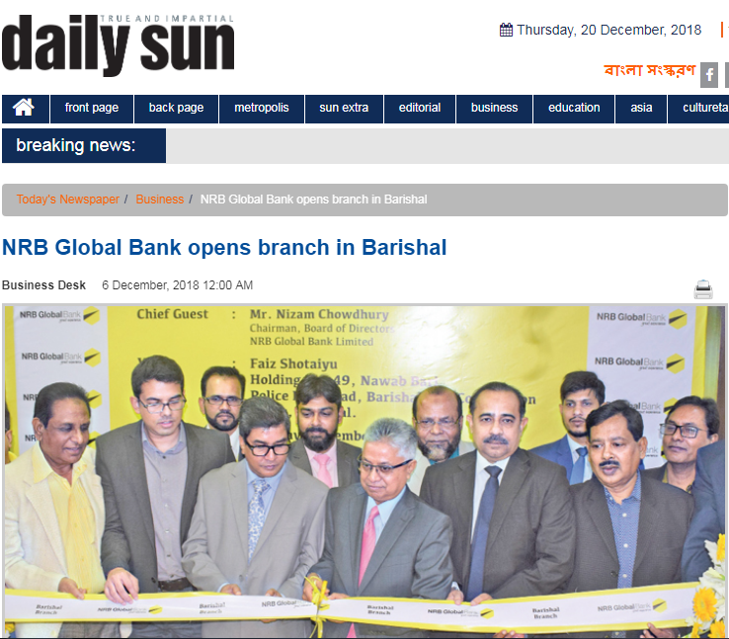
Figure 02:News about launching new branch.

2. 8 Lists of ATM booths In Bangladesh:
- Bogra Branch
- Agrabad Corporate Branch
- AnwaraBranch
- Chamol Branch
- Boalkhali branch
- Dohazari branch
- Rowshanat branch
- Khatungonj branch
- Adhunagar branch
- Nasirabad branch
- Alankar mor branch
- Patherhat branch
- Gunabati branch
- Link road branch
- Long beach hotel
- Bonani branch
- Dhanmondi branch
- Bangla motor branch
- Gulshan corporate branch
- Tajmahal road
- Motijhil branch
- Naya paltan branch
- Bashundhora city
- Panthapath branch
- Jamuna Future Park (Level 1)
- Jamuna future park (level 5)
- East Rampura
- Rampura
- Basabo
- Ashulia
- Uttora branch

Table 04: List of ATM booths of NRB Global Bank.

2.8.1 Expansion of ATM network in year 2017-2018:
ATM Booths inaugurated in 2017 |  | Districts | Opening Dates
Boalkhali Chowdhury Hat Branch | Chattogram |  | May 4,2017
Alangkar Mor Branch | Chattogram |  | June 8,2017
Chambol Branch | Chatoogram |  | July 11,2017
Madhubdi Branch | Norshingdi |  | December 18, 2017
Mirpur Branch | Dhaka |  | December 19,2017
Gazipura Branch ATM | Gazipur |  | December 19,2017

Table 05: Expansion of ATM booth

2.9 SWOT analysis of NRB Global Bank:
SWOT analysis plays a vital role in evaluating the company’s strategic situations. So, it’s a must for a company to identify the four basic components- Strength, Weakness, opportunity and Threat.
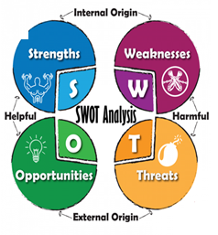
Figure 03 : SWOT Analysis of NRB Global Bank Limited.

2.9.1 Strength of NRB Global Bank Ltd:
It is an internal factor of a company it focus on the own strength of the company. The strength of NRBGL is:
- Professional management team
- Strong distribution channel.
- Satisfactory IT sector and infrastructure.
- Adequate capital base.
- Installation of highly sophisticated and automated system that enables the bank to communicate on real time basis.
- Relationship with existing clients is very strong.
- Good corporate culture.
- Good understanding between employees.

2.9.2 Weakness of NRB Global Bank Ltd:
- Dependency on high cost bearing deposits.
- Manual vouchers.
- Higher service charge than other national banks.
- Higher interest rate in customer loan scheme.

2.9.3 Opportunities of NRB Global Bank Ltd:
- Bangladesh Government has provided her full support to the banking sectors to build up a sound economy of Bangladesh.
- Credit facilities of NRB Global Bank have attracted the business men widely.
- It provides attractive compensation packages to its employees and motivate them.
- It has good distribution of authority.
- Flexible credit schemes.
- Introduction of online banking.

2.9.4 Threats of NRB Global Bank Ltd:
- Too many private banks in the industry.
- Gap in supply of foreign currency.
- Conventional banks can easily cope up with existing products.
- Better developed card division of other banks.

2.10 Products of NRB Global Bank:
Detail lists of products that are served by NRB Global Bank Limited are given below. These services required different criteria to avail them.

2.10.1 Retail banking products:
Name : | Focus at :
NGB deposit | Allows customers to save from monthly income.
NGB Double benefit | Helps to get double money at maturity.
Fixed deposit | Higher interest rate on long term savings.
Professional loans | Professional loan is provided for self-employed persons.
Monthly Benefit | Helps to get extra benefit on each month deposits.
Senior citizen benefit | Helps them to carry out day to day banking activities.
NRBG Pre-paid Card
NRBG Debit Card.
NGB executives | Designed especially for salaried executives.
NGB Salary Account | Employees can credit their per month salary in it.
NGB festivals | For festival purpose
NGB fresher | For students
NGB Juniors | For year 3 to 18.
NGB marriage | For marriage purpose.
NGB Queen | Interest bearing account only for women.
NGB Perfect | Allows individual to maintain its savings and transactions simultaneously.
NGB Travelers. | Travel purpose loan.

Table 06: Retail Banking Products.

2.10.2 Foreign Trade Products:
- Letter of Credit (L/C)
- Back to Back Letter of Credit ( BTB L/C)
- Foreign Demand Draft ( FDD)
- IDLC (Inland Brick to Brick Local L/C)
- IDBP ( Inland Document Bill Purchase)
- Remittance Products.
- Pay Order (PO)
- Demand Draft (DD)

Table 07: Foreign Trade Products

2.10.3 Other service products:
- Corporate Banking
- Tele Banking
- SMS Banking
- ATM Banking

Table 08: Other services offered.

2.10.4 Loan products:
- Personal loan
- Car loan
- House loan
- Education loan
- Project financing
- Agriculture loan
- Consumer loan
- Leasing loan
- SME
- House Building
- Import Loan
- Export Loan
- Travel Loan
- Marriage Loan
- Executive Loan
- Festival Loan

Table 09: Other services offered.

2.11 NGB Global Products Brochures:
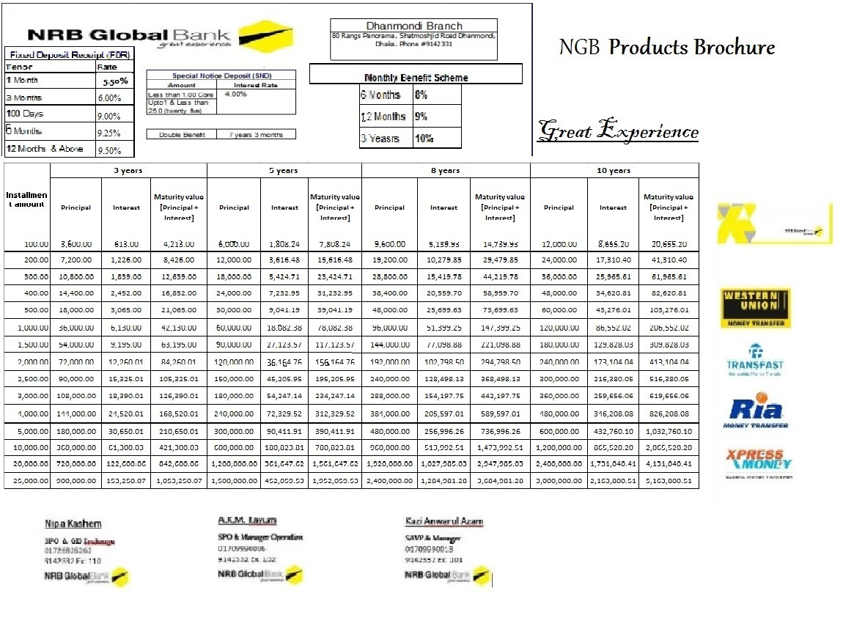
Figure 04: NRGB brochures

Chapter 03
Ratio Analysis OF NRB Global Bank Limited
For
The Year 2017, 2016 and 2015.

CHAPTER -03

Ratio Analysis of NRB Global Bank

3.1 Return on Equity:
Return on equity shows the amount of net income returned as a percentage of shareholder’s equity. ROE evaluates the profitability a company or organization can generate by using shareholder’s invested money.
ROE = (Net Profit/Equity) * 100

Figure 5: Return on equity diagram
Particulars : | Year
 | 2017 | 2016 | 2015
Net Profit | 556840206 | 423011157 | 18971822
Equity | 5003315807 | 4616455565 | 4210616031
ROE : | 11% | 9.16% | 0.45%

Table 10: Calculation of Return on Equity.

3.2 Return on Asset:
It’s indicates a company’s profitability. Return on Asset is calculated by dividing a company’s net income by its total assets of a fiscal year. It is also known as profitability or productivity ratio. It is an important measuring tool as it evaluates company’s performance against predetermined ones.
ROA = (Net Profit/Asset) * 100

Figure 6: Return on asset diagram
Particulars : | Year
 | 2017 | 2016 | 2015
Net Profit | 556840206 | 423011157 | 18971822
Total Asset | 79132597005 | 492667523168 | 31430029968
ROA : | 0.70% | 0.09% | 0.06%

Table 11: Calculation of Return on Asset.

3.3 Return on deposit:
Return on deposit (ROD) evaluates a corporation's profitability by identifying that how much profit a company generates with the money savers have kept in the bank.
ROD = (Net profit /Total Deposit)*100

Figure 7: Return on deposit diagram

Particulars : | Year
 | 2017 | 2016 | 2015
Net Profit | 556840206 | 423011157 | 18971822
Total deposits | 5191640343 | 3268784490 | 1868887512
ROD : | 0.11% | 0.12% | 0.010%

Table 12: Return on deposit calculation.

3.4 Fixed Asset Ratio :
The fixed-asset turnover ratio measures a company's ability to generate net sales from fixed-asset investments. A higher ratio indicates better management and utilization.
Fixed Asset Ratio = (Revenue/Total Fixed Assets)*100

Figure 8: Fixed Asset Ratio diagram

Particulars : | Year
 | 2017 | 2016 | 2015
Revenues | 3168101465 | 2135125456 | 1248248098
Total Fixed Assets | 59328382619 | 34958285464 | 20846130626
Fixed Asset Ratio | 5.34% | 6.11% | 5.9%

Table 13: Fixed Asset Ratio calculation.

3.5 Net Asset Turnover:
The net asset turnover ratio evaluates the ability of management to use the net assets of the company to generate sales revenue. A good company may try to minimize the use of equipment while utilization of them. As much as the net asset ratio is higher it indicates the positive signs that company is generating high profit with little investment.
Net asset Ratio = (Revenue/Total Asset) *100

Figure 9: Net Asset Ratio diagram
Particulars : | Year
 | 2017 | 2016 | 2015
Revenues | 3168101465 | 2135125456 | 1248248098
Total Assets | 79132597005 | 49266752168 | 31430029968
Net Asset Ratio | 4% | 4.33% | 3.97%

Table 14: Net Asset Ratio calculation.

3.6 CASH RATIO:
This ratio compares company’s total cash and cash equivalents in terms of total liabilities. It is also known as company’s liquidity ratio. It indicated how fast company can repay the loans.
Cash Ratio = (cash in hand/total deposits)*100

Figure 10: Cash Ratio diagram

Particulars : | Year
 | 2017 | 2016 | 2015
Cash in hands | 379997885 | 315266932 | 209627510
Total deposits | 5191640343 | 3268784490 | 1868887512
Cash Ratio | 7.32% | 9.64% | 11.21%

Table 15: Cash Ratio Calculation.

3.7 Loans to deposit Ratio:
This ratio is used to know the liquidity of a bank. It is calculated by dividing the total loans by total deposits. If the ratio is high it indicated that the bank is in risk that it may not be able to peruse any unforeseen scenario if the ratio is two low it indicates that the bank may not be able to earn as it should earned. Whether the bank can open a new branch or not depends on this ratio. This ratio is often used by the policy maker while conducting different financial policies for the overall bank.
Loans to deposit ratio: (loans/deposits)*100

Figure 11: Loans to deposit Ratio diagram

Particulars : | Year
 | 2017 | 2016 | 2015
Loans | 59328382619 | 34958285464 | 20846130626
Deposits | 5191640343 | 3268784490 | 1868887512
Loans to deposit Ratios: | 11.42% | 10.69% | 11.15%

Table 16: Loans to deposit Ratio calculation.

3.8 Loans to total Asset :
It evaluates the outstanding loans as a percentage of total assets. Higher ratio is negative for a bank as it indicates that the bank is loaned up and the liquidity is lower. Higher risk reflects that the bank may become defaulter by high rate.

Loans to Total Asset ratio = (Loans/Total Asset)

Figure 12: Loans to total Asset Ratio diagram
Particulars : | Year
 | 2017 | 2016 | 2015
Loans | 59328382619 | 34958285464 | 20846130626
Total assets | 79132597005 | 49266752168 | 31430029968
Loans to total Asset Ratio | 75% | 70% | 66%

Table 17: Loans to total Asset Ratio calculation.

3.9 Equity to Asset Ratio:
Company’s financial leverage are calculates by using liquidity ratio. It indicates the method of finncing.and suggests way to meet financial obligations. It measures the risk of the company in terms of both equity financing and debt financing.
Equity to Asset Ratio evaluates the proportion that is used to finance with equity. It shows the amount of how much a shareholder would receive in the time of liquidation.
Equity to asset ratio = (total equity/total Asset)*100

Figure 13: Equity to total Asset Ratio diagram
Particulars : | Year
 | 2017 | 2016 | 2015
Total Equity | 5003315807 | 4616455565 | 4210616031
Total assets | 79132597005 | 49266752168 | 31430029968
Equity to Asset Ratio | 6.32% | 9.38% | 13.39%

Table 17: Equity to total Asset Ratio calculation.

3.10 Equity to Net Loans:
This ratio forms both finance and debt of a company and calculates the financial leverage by calculating the proportion of used finance and debt to run the company.
Equity to net loans = (total equity/total loans)

Figure 14: Equity to Net Loans Ratio diagram
Particulars : | Year
 | 2017 | 2016 | 2015
Total Equity | 5003315807 | 4616455565 | 4210616031
Net Loan | 2848296905 | 757085065 | 48807071
Equity to Net Loan Ratio | 1.75% | 6.09% | 8.63%

Table 17: Equity to Net Loan Ratio calculation.

Chapter 04
Credit Procedures
Of
NRB Global Bank Limited.

Chapter-04

Credit Procedures

Loan products in Details:
NRB Global Bank Limited offers different loan schemes for different category of people. And the interest rate is very much relevant as per current banking era. NRB Global Bank Limited believes that every deserving business or initiative should be financed with loans. The different loan products are given below:

4.1 SME Banking:
SME stands for Small-Medium-Enterprises. SME finance is a funding which is provided to the newly small and medium enterprises/businesses. It represents a major function of business finance or capital market. It is the depending factor of a enterprise’s costing and capital pricing.
NRB Global Bank provides this SME loan in different categories like-
- NGB Uddom.
- NGB Kishan ( Agri-Loan).
- NGB Proshar (Linkage Finance).
- NGB Nondini (Loan for Women Entrepreneurs).

4.1.1 NRB Uddom:
Particulars OF NGB Uddom are given below:
Target group: Small Enterprise.
Purpose: any legal business purpose for small enterprises.
Loan Limit: Minimum BDT 2, 00,000 Maximum 10, 00,000 Taka.
Tenure: 12 months to 36 months.
Interest Rate: 15%

4.1.2 NRB Kishan (Agri-Loan) :
Particulars OF NGB Kishan are given below:
Loan Limit: Minimum 10,000 Maximum 1, 50,000 Taka.
Period: 6 months to 12 months.
Interest Rate: 11%

4.1.3 NRB Proshar (Linkage Finance)
Particulars OF NGB Proshar are given below:
Sectors that get priority: Agricultural sectors, processing and industry sectors,Trade and communications sectors, social sectors.
Loan Limit: Minimum 50 lac Maximum 20 crore.
Period: 12 months to 60 months.
Rate of Interest: 11%

4.1.4 NRB Nondini ( Loan for women entrepreneurs)
This loan has designed to provide facility the women entrepreneurs. Its eligibility are to be a Bangladeshi and applier must be of 18+ age. Particulars OF NGB Nondini are given below:
Loan Limit: Minimum 1, 00,000 BDT Maximum 10, 00,000 BDT.
Tenure: 12 months to 36 months.
Rate of interest: 10%

4.2 NRB Health Support Loan :
It’s a term loan facility given to individual people of resident of Bangladesh who is in need pf medical support. Particulars of NGB Health Support Loan are given below:
Limit Amount: Minimum BDT 1, 00,000 Maximum BDT 3, 00,000.
Tenure: 6 to 12 months.
Rate of Interest: 14%

4.3 NRB Home Loan:
This loan is designed for non-resident Bangladeshi engaged in business with valid income source in abroad. The particulars of NGB Home Loan are given below:
Limit Amount: Minimum BDT 3, 00,000 Maximum BDT 100 00,000.
Tenure: 5-7 years
Rate of Interest: 13%

4.4 NRB Travel Loan :
This loan’s targeted group of people is any credit worthy individuals such as salaried person, self-employed and businessman. Its purpose is to serve them with travel expenses. The particulars are given below:
Limit Amount: Minimum BDT 1, 00,000 Maximum BDT 5,00,000 .
Tenure: 12 to 24 months.
Rate of Interest: 15%

4.5 NRB Utshaho Loan :
Migrates returned home within last three years and planning to run a business in running level also have vocational training in that particular field might be eligible for this loan. The particulars are given below:
Limit Amount: Minimum BDT 1, 00,001 Maximum BDT 1,00,00,000 .
Tenure: Upto 60 months.
Rate of Interest: 14%

4.6 NRB Student Education Loan:
It is designed to leverage the cost burden of NRB’S child, only at Bangladesh. Particulars associated with it are given below:
Limit Amount: Minimum BDT 50,000 Maximum BDT 5,00,000.
Tenure: 12 to 36 months.
Rate of Interest: 14%

4.7 NRB Sohoyota Loan:
Migrates returned home within last five years and planning to run a business in running level or start up and also have vocational training in that particular field might be eligible for this loan. The particulars are given below:
Limit Amount: Minimum BDT 3, 00,000 Maximum BDT 10,00,000 ( security based) .
Tenure: 12 to 36 months.
Rate of Interest: 14%

4.8NRB Migrant Loan:
It is a loan facility for individual for who is willing to go to abroad as job or wage . but this will be applicable only after getting visa. Related particulars are given below:
Limit Amount: Upto 3,00,000 BDT.
Tenure: 12 to 36 months.
Rate of Interest: 14%

4.9 General Procedures related to credit:
Loan granting is one of the major factors of a Bank. The strength of a bank depends on amount of loan provided and deposited money. There should be a balance between them. Traditionally bank follows the criteria before proceeding for any loan scheme:
- Liquidity
- Safety
- Profitability.
While conducting for a loan NRB Global Bank Limited judge the following factors of the loan applier.
- Character of the applier.
- Capacity of the applier.
- Capital of the applier.
- Condition of the applier.
- Collateral of the applier.

4.9.1 Check list for credit procedure done by NRB Global Bank Limited:
The whole procedure follows nine different steps. They are-

Figure 15: Loan Procedures

4.9.2 Application for the loan proposal:
At first the willing individual will right an application to the Head of Branch, Dhanmondi, NRB Global Bank Limited. And should submit a copy of that application to the Head of Credit Department. After proper study the branch will notify the applicant within 3 working days. The application may be any of them – decline or acceptable for processing further.

The following documents should be presented for further processing.
For Retail Loan check lists | For Corporate Loan and SME Checklists
National ID photocopy. | Approach for required credit limit
3 copies of photographs. | CIB undertaking form filled up
Visiting card. | Board resolutions.
Up to date bank statements. | Company profile.
Trade license. | Group profile.
TIIN Certificate. | Photocopy of updated trade license.
Nominee photograph. | Photocopy of certificate of incorporation.
Salary certificate. | Photocopy of TIIN certificate.
Office ID photocopies. | 2 passport size copy photographs.
Utility bill photocopy. | Personal net worth of the owner.
Self declaration. | Approval letter from all concerned bodies.
Evidence of other income documents. | Financial statements
2 guarantors NID card’s photocopies. | List of machineries.
Guarantor’s utility bill’s copies. | List of buyers and sellers.

Table 18: Document lists for loan.

4.9.3 Selection of the borrower:
Depending factors for selection process are identifying the customer’s repayment ability, his or her source of income, validity of that source, net worth and information from the CIB.
The bank must identify the key drivers and the risks associated with the business. There is also an age limit (minimum 25 age and maximum 60 age) .This age limit should be considered.

4.9.4 Preliminary screening for the loan proposal:
The management of credit department gathers all necessary documents and after that evaluates those papers. The following documents are mandatory:

- Formal application for financing
- Business plan
- Personal guarantee
- Appraisal of asset to be financed
- Personal financial statement
- Business financial statement
- Purchase agreement
- Cash flow projection
TIN certificate
- Bank solvency certificate
- Vat certificate
- Export license (applicable for export oriented business)
- Market reputation

4.9.5 CIB Information:
It is not possible for a bank to know every detail about the customer. But it is a must to know the whole background of the customer before sanctioning a loan. Here Bangladesh Bank plays a vital role. It reserves all the information of a customer.
For an example, suppose Mr.Rahim has taken loan from AB Bank and also applied for another loan from NRB Global Bank Limited .Now NRB Global Bank Limited will fill the CIB Form and send it to the Bangladesh Bank. Bangladesh Bank will justify all the gathered documents and send a detail information list of Mr.Rahim to the NRB Global Bank Limited.
Mr.Rahim will need a CIB report only if he is applying for a loan exceeding 5, 00,000 BDT. NRB Global Bank Limited updates CIB report of its all existing and new customers and send a copy to the Bangladesh Bank.

4.9.6 Security Analysis:
There should be a security analysis while granting for a loan. It represents the commitment of the borrower. Security check protects the bank from any risk associated with the loan and also ensures the interest of the bank. Different modes of security analysis are given below:
- Lien: Lien is the type of mood where customers use their own property or asset against the loan.
- Pledge: here Bank is the bailey and the customer is bailer. Bank will give loan against customer’s important product.
- Mortgage: Here bank will provide loan in against of customer’s land, building and properties. It is the most common types of mood

4.9.7 Site Visit:
Borrower’s land, property or buildings are monitored and visited by the bank management. After the site visit the bank decides the condition of the product or land and its sustainability. Bank also judges the market price and the inventory stocks. If it is mortgaged, bank tries to evaluate the land’s price in the market. Then the Branch credit team sends a detailed site visit report to the Head Office duly signed with the operation manager of that branch for further evaluation.

4.9.8 Documentation:
The process of obtaining relevant document of a client can be known as documentation process. Before approving any loan, a bank has to check client’s capital, character of that customer, capacity and the relevant collateral. The bank should obtain all necessary documents which are being gathered from the customer to protect against willful defaults. When a loan is given against any property of the client, the client must transfer his or her legal and binding charge to the bank.

4.9.9 Disbursement:
The last step of sanctioning a loan is ‘Disbursement’. The processing is done when every document collected are okay. The steps of disbursement are given below:

Figure 16: Disbursement procedure done by NRB Global Bank Limited.

At disbursement time the following vouchers are made along with duly signed pay order slip. The PO slip is signed by the second officer and the branch manager.

4.10 Accounting Treatment of disbursing a loan by the branch of NRB Global Bank Limited:

Loan Account ……………………….. Dr.
Pay Account or Savings Account……Cr.
Apart from that sanctioned loan amount the client has to insure some additional charges like stamp fee (Taka 10 per stamp), risk fund charge. Journal for these costs are also given below:
Current Account or Savings Account ………Dr.
Risk Fund………………………………………..Cr.
Service charge …………………………….Cr.

4.11 How analysis of Credit Risks done by NRB Global Bank Limited? :
Credit risk analysis focus at the lending and borrowing facilities of both the bank and the borrower. It tries to ensure both sides’ benefit. Risk rating is the evaluation process of identifying the default risks of particular loans. Here a predetermined confidence level is used. It estimates the probable loss that would bank face even if the borrower defaults. While analyzing NRB Global Bank Limited uses 5 different risk measurements.

Figure17: Risk analysis tools.
- Financial Risk:
Here bank analysis client’s suppliers and buyers position, their frequency. It also evaluates the turnover ratio. The much the turnover ratio it is that much bad for a customer.
- Business Risk:
Client’s current business condition is one of the vital concerns for the borrowing bank. Here bank tries to assess the riskiness of lending the money depending on the business current situations
- Security Risk:
Banks always tries to be in safe side while providing a loan to particular client. So they efficiently check out the collateral against whom the loan is going to be sanctioned. They also assess the value of that collateral to ensure that they can get their money back by selling that collateral in case of defaults.
- Management Risk:
Management risks deal with client’s social value. Client’s social value and their business reputation are being judged at this step. Bank wants to know the efficiency level of the client while running a business.
- Relationship Risk:
Exporter and importer are the main factors for any business. So it is important for the bank to understand the relationship of the importer and the exporter with the client the much the stronger the relation it is more beneficial for the bank, as stronger relation indicates a less risky situation.

Loans provided in year 2017 59328382619
Loans provided in year 2016 34958285464
Loans provided in year 2016 20846130626

Figure 17: Increased loan sanctioning over the year.

4.11 How management of Credit Risks done by NRB Global Bank Limited:
Default loan results because of different reasons such as economical, political, unrest situations of industry etc. Sometimes the borrower intentionally avoids the repayment of loan. When a loan holder fails to deposit its payment, bank takes the following steps to secure its own interest:
- A soft reminder should be made by the bank officer after 3 working days of installment date and will ask the borrower to pay back the monthly installment immediately.
- If the phone call does not work, an official letter from NRB Global Bank should be given to the borrower.
- If the above steps fail to alert the borrower, the bank will make a visit to the loan holder’s organization and will provide 2 days extra to repay.
- If all the above steps go wrong the bank will file a lawsuit against the client and takeover the mortgaged property.
But if borrowers come to the bank and discuss in detail that if there is any problem in his or her running business and ask for more days, the branch would send a request copy to the Head Office. After discussing all the issues Head Office would provide extra 3 months period for repayment. If the loan holder fails to provide payment, then his or her mortgaged properly will be listed as bank’s property. Bank can even sale that property than.

Chapter 05
Concluding Parts

Chapter-05

Concluding Parts

5.1 Findings
While conducting my 3 month long internship period at NRB Global Bank Limited, Dhanmondi Branch I have found the following things. I believe the Dhanmondi Branch’s activity is representing the whole bank’s organization.
Findings are enlisted below:
- There is a strong bonding between the employees. All the employees are so much dedicated and enthusiastic.
- Shortage of workforce in General Banking Department.
- Everyone is bound to work under work pressure and before deadline the forced work should be completed.
- NRB Global Bank limited provides facilities their customers in many ways.
- There is a proper delegation of authority so that the employees can develop their skills.
- Regular visiting for marketing increases the work pressure for other employees as there is already shortage.
- The information is still preserved manually. But Bangladesh Bank has regulations to use all the information in a computerized way.
- The monthly targeted amount is so high that sometimes become a pressure for the employees.
- As NRB Global Bank Limited is a new bank, people often misunderstand it with NRB Commercial Bank.

5.1 Recommendations:
As I am only an intern student under graduation program of mine, it is my courage to suggest such a good bank. As per my own experience some suggestions for development is given below:

- Regular research
NRB Global Bank can run a survey within the organization for in each 3 months to justify whether the employees are happy or not. It can run this survey with help of a simple questionnaire.
- More ATM booths are needed:
Sufficient ATM booth may increase the satisfaction level of the customers. Outside Dhaka should get more focus as NRB Global Bank is trying to attract more customers all over the country.
- Faster customer service:
Comparing with other banks, NRB Global Bank Limited should also focus on their online services. New technologies should be introduced between customers as well as employees.
- Customers feedback :
Customers should get the highest priority from the bank personnel. Bank should encourage customers to give more feedback about the services.
- New employees should be hired:
I have noticed that sometimes work pressure is so high that employees face difficulties to handle all the customers. Here bank can hire new employees and distribute the work pressure between them.
- Advertisement:
Bank should focus on more advertisement strategies. For this TVC can be made.
- Intern Remuneration:
Bank should provide a minimum remuneration to the internee to motivate them in the new work place.

5.2 Conclusion:
NRB Global Bank is almost a new bank. In spite of it, it has proved itself as one of the best banks in the country. Mr.Nizam Chowdhury has leaded the bank efficiently with his competent skills. This bank has became a strong competent not only for the commercial banks but also for the public banks. It is contributing to the positive growth of the economy. It invests a large amount in the import and export sectors as it has well efficient foreign exchange facilities.
It has made strong relation with their customers and also with many reputed organizations in the country with their trustworthy and helpful services. It has potential to help the agriculture sector. On the other hand it has different schemes for women also. It is participating itself and also helping others to participate in the industry.
In my intern period I have been thought to work under pressure. I am now able to face the corporate world with more efficiency. I am very much lucky to work with one of the best companies of the country. It has broadens my knowledge. NRB Global Bank Limited will attempt to look forward for a greater future with their hardworking and good strategies.

References:

- at Barishal, B. (2018). NRB Global Bank opens branch in Barishal | daily sun. Retrieved from https://www.daily-sun.com/printversion/details/355150/201
- Aurni, M. (2015). Credit Management. Retrieved from http://123.49.46.157/bitstream/handle/10361/4220/10204055.pdf?sequence=1
- Bank limited., N. (2015). NRB Global Bank ATM Booths in Bangladesh. Retrieved from https://www.banksbd.org/ngbl/atms
- Bank Limited., N. (2016). Why NRB Global Bank? - Google Search. Retrieved from https://www.google.com/search?q=Why+NRB+Global+Bank%3F&source=lnms&sa=X&ved=0ahUKEwih07j6zdTfAhWYfysKHciEBOoQ_AUICSgA&biw=1366&bih=608&dpr=1
5) Bank, N. (2019). Internship Report on Credit Management of Banks - Assignment Point. Retrieved from http://www.assignmentpoint.com/business/finance/internship-report-on-credit-management-of-banks.html
6) Global, N. (2015). NRB Global Bank Dhanmondi Branch Location Dhaka. Retrieved from https://www.banksbd.org/ngbl/dhanmondi-branch-3711.html
7) Islam, T. (2017). Internship Report on Financial Performance Analysis of NRB Global Bank | Corporate Social Responsibility | Banks. Retrieved from https://www.scribd.com/document/354388774/Internship-Report-on-Financial-Performance-Analysis-of-NRB-Global-Bank
8) Palit, R. (2012). Internship Report on Credit Management Published by Rahul | Banks | Loans. Retrieved from https://www.scribd.com/document/145094321/Internship-Report-on-Credit-Management-Published-by-Rahul
9) Pedia, W. (2019). what is sme banking - Google Search. Retrieved from https://www.google.com/search?q=what+is+sme+banking&oq=what+is+SME+Banking&aqs=chrome.0.0l6.7454j0j8&sourceid=chrome&ie=UTF-8
10) Report, I. (2014). Intern Report. Retrieved from http://dspace.bracu.ac.bd/xmlui/bitstream/handle/10361/8504/13104059_BBS.pdf?sequence=3&isAllowed=y
11) university, B. (2014). report. Retrieved from http://dspace.bracu.ac.bd/bitstream/handle/10361/4169/BBA%2010204096%20.pdf?sequence=1

