
Project Report
On
An Overview of Debt Financing and Corporate Performance in Bangladesh's Fuel Industry: Empirical Data from the Dhaka Stock Exchange

Supervisor:
Dr. Mofijul Hoq Masum, ACMA
Associate Professor - AIS
School of Business & Economics
United International University

Submitted By:
Arifin Ahmed Nabil
ID: 114 213 003
BBA in AIS
School of Business & Economics
United International University

September 25, 2023

Letter of Acknowledgement

People that motivate me to complete extensive effort, such as a project paper, must be recognized. I should also thank people who gathered important material that helped to make my project paper visually appealing to readers. Also, many thanks to the hardworking career professionals and other authors who assisted in gathering the huge thoughts and material. The researchers that have dedicated their time to helping us. I am grateful to my university, United International University, for providing me with this chance. Now, I'd would like to appreciate Dr. Mofijul Hoq Masum, my project supervisor, for presenting me with a topic that is so intriguing, Debt financing and firm performance of Bangladesh's fuel industry, which let me conduct a lot of research and also learn about various tasks that I should take on. With his guidance and assistance, I was able to quickly complete a fantastic project paper.

Letter of transmittal

Dr. Mofijul Hoq Masum, ACMA
Associate Professor - AIS
School of Business & Economics
United International University

Subject: Project paper on “An Overview of Debt Financing and Corporate Performance in Bangladesh's Fuel Industry: Empirical Data from the Dhaka Stock Exchange”.
"
Dear Sir
I am grateful for the opportunity to submit my project report, "An overview of debt financing and corporate performance in Bangladesh's fuel industry: empirical data from the Dhaka Stock Exchange," that you granted and delegated to me. I have done my utmost to find pertinent information concerning our country's fuel sector in a manner that is efficient and timely.
I've learnt a lot and gained useful ideas, expertise, and experience while gathering information. It was a fantastic chance for me to engage with empirical data, and I gained some organizational activity-based experience as a result.
I hope this project paper fits your expectations; don't hesitate to reach out to me if you have any queries or problems.

Sincerely,

-----------------------
Arifin Ahmed Nabil
ID: 114 213 003

Abstract

Financing decisions is a crucial decision for the companies all over the world regardless of the nature of the economy. One of the sources of corporate capital is capital market. And certainly, the capital market investment is critical for the growth and market capitalization of any economy, especially for Bangladesh's domestic industry, trade, and commerce. The stock exchange in Bangladesh has been in a number of precarious circumstances in recent years. This study looks at the profitability of organizations that take on long-term financing of listed fuel and power sectors on Bangladesh's Dhaka stock exchange from the tenure 2018 to 2022. The primary goal of this investigation is to investigate the elements that determine corporate profitability. This study's purpose is to extensively examine the influence of dependent factors on independent variables. Profitability is the factor that is dependent in this study, with the independent factors being business size and age, accounts payable, and short-term and long-term debt. The quantitative technique was employed to achieve this purpose. All of the data utilized in this study was obtained from the official website of the Dhaka Stock Exchange (DSE). According to the study's findings, no other factor has a substantial influence on the financial viability of enterprises who obtain long-term funding. This means that businesses should seek stock funding rather than debt finance. All of the debt financing characteristics analyzed for this study, including short-term debt, long-term debt, point to enterprises opting for equity financing.

Key Words: Return on Asset, Net Profit Margin, Short Term Debt, Long term debt, Tangibility, Sales Growth, and Firm Size.

Contents
Letter of Acknowledgement ii
Letter of transmittal iii
Abstract iv
1. Introduction 1
1.1 Introduction to the topic in hand 1
1.2 A brief introduction of the concerned field 2
1.3 Background Of the Study 3
1.4 Rational of the study 4
1.5 Limitations of the study 5
2. Objectives of the study: 6
2.1 Broad Objectives 6
2.2 Specific Objectives 6
3. Methodology of the Study 8
3.1 Data Design 8
3.2 Sample design – sampling techniques, sample size etc. 9
3.3 Analytical tools – MS Excel, SPSS, and Stata etc. 9
3.4 Variable design (if any) – Dependent variables and independent variables 9
3.5 Model Specification 9
4. Literature Review: 10
5. Findings and Analysis of the Study 17
5.1 Descriptive Statistics 17
5.2 Correlations 18
5.3 Model Summary^{b} 20
5.4 ANOVAª 22
5.5 Coefficientsª 24
5.6 Residuals Statisticsª 26
5.7 Charts 28
6. Conclusion and Recommendations 31
6.1 Conclusion: 31
6.2 Recommendations: 31
07. Appendix: 33

Introduction

Introduction to the topic in hand
Debt financing is critical to the growth and profitability of enterprises in the petroleum sector. The Dhaka Stock Exchange (DSE) in Bangladesh provides as a venue for corporations to borrow cash through debt financing. Based on actual data from the DSE, this article seeks to offer an overview of debt financing and its influence on company performance in Bangladesh's gasoline industry. Debt financing is the technique of generating finances by borrowing from outside sources such as banks and financial organizations, or by issuing company bonds. This cash injection enables businesses to grow their operations, invest in R&D, and buy new assets. Debt finance is very significant in the fuel sector because to the large capital needs for exploration, production, and distribution activities. We examined data from the DSE for five years in order to better comprehend the link between debt financing and business performance in Bangladesh's gasoline industry. The debt-to-equity ratio, which quantifies the percentage of a company's funding that comes from debt, was the focus of our investigation. We further evaluated company performance using relevant financial performance metrics which include return on equity (ROE), return on assets (ROA), and earnings per share (EPS). The empirical data revealed that companies in the fuel industry in Bangladesh heavily rely on debt financing. The average debt-to-equity ratio for these companies was found to be significantly higher compared to other industries. This indicates that fuel companies are more inclined towards borrowing funds rather than relying on equity financing. Besides, our research identified a link between debt financing and company performance. Debt-to-equity ratios are bigger in companies that have improved ROE, ROA, and EPS. This indicates that debt financing has a favorable influence on the petroleum industry's profitability and shareholder value. Additionally, we observed that companies with higher debt levels were able to undertake more aggressive expansion strategies. They were able to invest in infrastructure development, acquire new exploration rights, and expand their product offerings. These activities contributed to increased revenue and market share, further boosting their performance. However, it is important to note that excessive reliance on debt financing could also pose risks for companies in the fuel industry. High debt levels can lead to higher interest expenses, which can erode profitability if not managed effectively. Moreover, fluctuations in global oil prices and currency exchange rates can increase the burden of servicing debt, especially for companies with significant exposure to foreign debt.

A brief introduction of the concerned field

Energy is critical to a country's economic development. Energy boosts the country's efficiency and output while also playing a significant role in individual and home life. The importance of energy in economic progress cannot be overstated. It is one of the driving forces behind progress. It is utilized to fulfill energy demands for subsistence (e.g., cooking, lighting, room heating, etc. at the home level) and productive activities (e.g., agricultural, industry, transportation, commerce) etc. Bangladesh is undergoing a severe energy crisis as a result of inadequate energy supply development, yet energy demand must rise significantly in order to achieve high economic growth. As a result, the Planning Commission has prepared a Bangladesh Perspective Plan 2041 (PP2041) in order to implement the government's Vision 2041 and effectively boost energy demand: a long-term report of the government's growth goals, objectives, and desires for creating a prospering nation of Bangladesh with a political framework aimed at making Vision 2041 a reality. Economic independence has been achieved, and the country will be classified as developed by 2041. Vision is essential in ensuring energy security. By 2041, the plan aims to build an integrated and developed energy sector with a varied fuel mix that will drive an environmentally friendly local and national economy while achieving competitiveness worldwide in all sectors. By maintaining open management of related to energy government agencies, boosting human capital development, promoting energy growth via both physical and systemic structures, and making a contribution to the preservation and enhancement of the natural environment, the plan will gradually encourage greater involvement of the private sector in the energy sector. It will also promote alternative energy sources like solar and biogas, as well as guarantee universal access to power and energy. Bangladesh's economic progress is dependent on a consistent energy supply. Bangladesh is on its way to becoming a developing country, despite a number of severe problems such as poverty, political instability, overpopulation, and the threat of climate change. However, the international community has applauded Bangladesh for making great gains in human development metrics. Through several government-led and NGO-led social initiatives encouraging education and women's empowerment, lowering population growth, developing a self-sufficient in food production, and creating healthcare infrastructure, the country is increasing living standards and life expectancy. The country is rapidly industrializing, with globally competitive sectors such as textiles, shipbuilding, and pharmaceuticals. Bangladesh has been considered the next developing economy by the international community. Behind the scenes, energy plays a critical role in all economic processes.

Background Of the Study

The critical link between firm efficiency and debt financing has been widely discussed in management finance. The link with debt financing is a cost-benefit trade-off; the usual advantages associated with tax avoidance are smaller than the total debt level expenses. Along with increasing firm value and profitability by reducing debt, an organization's capacity to deal with its competitive environment is crucial. In today's environment, capital structure concerns are critical to an organization's value. The company's initiatives should include an appropriate mix of finance and equity. The capital structure is the most essential option since it influences both the risk and return to shareholders, and if that combination is mishandled, financial challenges for business operations may arise, and money may be misused. A variety of theoretical frameworks have been presented to explain the link between debt financing and firm performance. In a perfect capital market, a firm's real activities, including efficiency, capital cost, and value, are not impacted by the organization's financing choice, according to a number of assumptions, such as transaction expenses or no taxes, the ability to lend or borrow money or all shareholders are the same, agency expenses exist, and information asymmetry exists. If a company's ability to repay debt is limited, it should avoid accruing excessive debt. With a strong optimum structure, the balance of tax savings and bankruptcy expenditures should be present, but the increase in the cost of capital may be caused by excessive leverage, which eventually lowers the firm's worth. Because there is no recognized market for bonds, debt instruments, or notes in Bangladesh, banks are the company's major source of finance. These institutions are owned by the government and provide both short-term and long-term finance. As a result, both the financial and non-financial industries have suffered as a result. Financial corporations lend money without considering a company's performance, harming the financial as well as the non-financial industries. The global debt financing crisis impacts both developing and developed countries. It must be capable of satisfying both short-term and long-term growth objectives in order to be the perfect structure. It safeguards the company's capital in good and bad times. Firms prefer to raise funds internally rather than through external sources such as bond issuance or bank loans. While there are no other options, equity financing is a possibility since issuing additional shares will attract new partners and shareholders, weakening the current ownership.

Rational of the study
Several variables might motivate a study on the link between debt finance and productivity in the Bangladesh petroleum industry:
- Industry Importance: The fuel business is critical to Bangladesh's economic growth since energy resources are required for numerous sectors such as transportation, industrial, and household activities. Understanding how debt financing impacts the performance of companies in this industry is important for informed decision-making.
- Financial Decision-making: Debt financing is a significant component of a company's capital structure. It's important to investigate how different levels of debt influence a company's financial performance, profitability, and overall stability.
- Risk and Return Trade-off: Debt financing can increase a company's financial leverage, potentially magnifying returns for shareholders. However, it also comes with the added risk of interest payments and debt repayment obligations. Exploring the balance between risk and return in the context of the fuel industry is valuable.
- Comparative Analysis: Comparing the debt financing practices and performance of companies within the Bangladesh fuel industry to those in other countries' fuel industries can provide insights into global best practices and potential areas for improvement.
- Practical Insights for Companies: The findings of the study could provide practical insights for fuel industry companies in Bangladesh to make informed decisions about their capital structure and financing strategies, potentially leading to improved financial performance.
- Future Research and Policy Recommendations: The study's outcomes could point towards areas that require further research, as well as offer recommendations for policymakers and industry stakeholders to enhance the overall health and performance of the fuel industry.
In conclusion, research into the connection between debt financing as well as business outcome in the Bangladesh fuel industry can provide valuable insights for companies, investors, policymakers, and researchers, contributing to a better understanding of the industry's financial dynamics and potential growth and stability avenues.

Limitations of the study
Despite the fact that secondary information was easily accessible on the internet, I found a number of challenges. The most common problem I experienced was dealing with a huge volume of information and filtering that information in order to complete my report accurately and quickly. Because no source data is gathered, the report has little chance of being isolated. Some of the report's shortcomings are as follows:
- The biggest disadvantage of the report is its time constraints; the report's content is a lengthy debate that is challenging to summarize.
- The complete essential information was not accessible through the internet.
- There is private information and policies.
- Significant progress has already been made on numerous sections.

Objectives of the study:

Broad Objectives

This research is part of the prerequisites for the Bachelor of Business Administration (BBA) degree from United International University's School of Business and Economics. This research seeks to offer students with a practical and complete knowledge of the principles and theories covered in the BBA curriculum. The study will also assess the student's analytical, problem-solving, and research capabilities, allowing them to showcase their readiness for professional and managerial roles in the business field. Bangladesh's fuel business is critical to powering various components of its economy, including transport, manufacturing, agriculture, and home energy use. However, various difficulties must be addressed in order to increase the effectiveness and long-term viability of the country's fuel business. One of the main issues in the fuel industry in Bangladesh is the heavy dependence on imported petroleum products. Bangladesh heavily relies on imports to meet its domestic fuel demands, which puts strain on the country’s foreign currency reserves and creates vulnerability to international price fluctuations. To mitigate this dependence, it is necessary to explore and invest in alternative energy sources, such as renewable energy and domestic natural gas reserves. Increasing the use of clean and sustainable energy can not only reduce the country's reliance on imports but also help combat climate change.

Specific Objectives

- To address this issue, the government should focus on developing strategic fuel reserves and expanding storage facilities across the country.
- To Promote competition and attracting private investment in the fuel industry is another area that needs improvement.
- To develop indigenous technologies, such as biofuels and fuel cell technologies, can contribute to long-term energy security and reduced environmental impact.
- To raise public awareness and promoting sustainable consumption patterns can significantly contribute to improving the fuel industry in Bangladesh.

Methodology of the Study

Data Design
What is data?
In order to describe and evaluate data, we need to first understand its nature, because the type of data dictates the type of analysis using statistics that can be performed on it.
Types of Data?
Quantitative data is presented as numbers that may be discrete or continual. The total number of ladies in a class, for example, may only have endless values, making it a variable that is discrete, but the value of the end result is a constant variable.
Qualitative data is information that is not numerical it can be generated by procedures which include interviews, test scores, and so on. Nominal data has no hierarchy, for instance gender or marital status, but ordinal data has an order, including as movie ratings or shirt sizes.
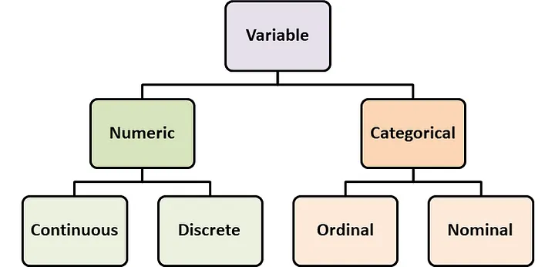

Frequency Distribution
It counts the number of occurrences of an observation in the data. For example, if you have qualitative data that includes the gender of pupils in a class, a good way to represent it would be the frequency of boys and females. For example, if we had data on people's ages, we could wish to know the frequency of distinct age groups, for which we might classify the data as continuous data and create a frequency distribution, as seen below.
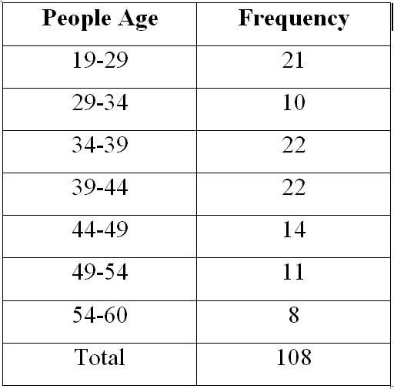

Relative Frequency Distribution
Frequency may not always provide a clear picture of the facts. Assume you want to discover which states have the most students enrolled in an online data science program. The absolute number may provide a hazy picture, but dividing it by the total number of students enrolled yields what we term relative frequency. So, if you read that 200 students from Bangalore enrolled, you have no idea if this figure is high or low. However, if you are informed that the relative frequency is 0.8, which implies that 80% of students came from Bangalore, you may conclude that students from this city are significantly more motivated to study data science than students from other places.
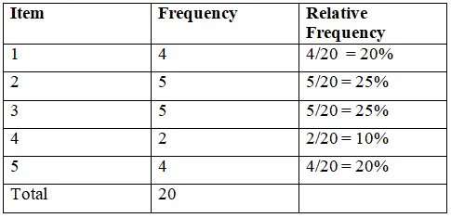
Bar Graph
The frequency distribution may be seen using a bar chart, which depicts categorical data with heights or bars proportionate to the values they represent. A grouped frequency bar chart may also be used to compare distinct sets of data, such as those from different years. This can assist us in determining whether there are any trends in the data.
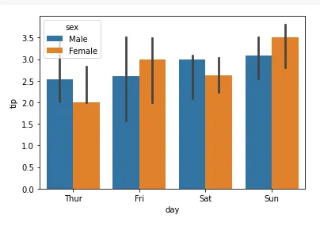
Histogram
The higher the bar, the more observations fall into that range. A histogram may help us understand the form and dispersion of continuous data. Assume we wish to understand the changes in GDP of a specific nation, like India, over time. The histogram below demonstrates that India's GDP has constantly climbed over the previous decade. In this situation, the bins reflect pay, which is a massive sum, thus having bin sizes greater, say $50,000 or $100,000, is important. You may create a few graphs by experimenting with the settings to find which one provides the best analysis. An optimum bin size conceals yet does not show too many features.
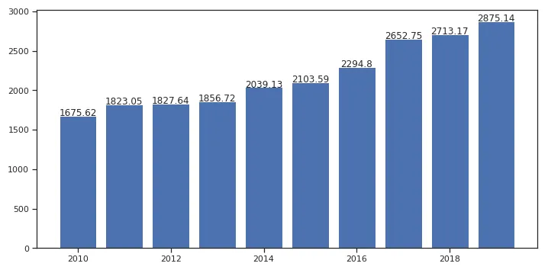

Line Plot
A lien plot is a graphical depiction of the shape or trend of a distribution. It is made by linking the midpoints of a histogram's bins and connecting them with lines.
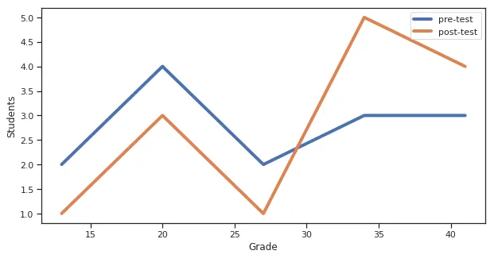
Scatter Plots
Scatter plots are a very fundamental and vital means of accomplishing this. It depicts the values for two separate variables as dots, with each dot representing a single data point. A scatter plot can indicate if there are patterns in the data; a positive trend indicates that as the x variable grows, so does the y variable, and vice versa.
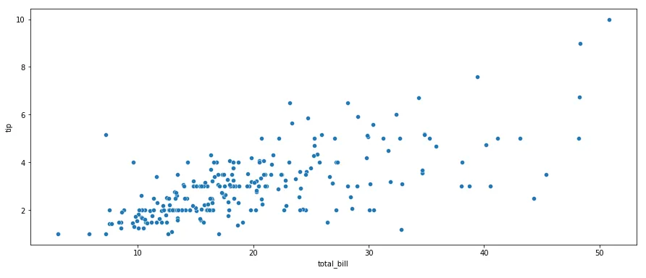

Sources of Data?
A researcher's primary data is details obtained from firsthand information, which include creative works (paintings, film reels, music, and so on). Journals, experiments conducted by you, the person conducting the study, Communication tools include the letters, assessments and censuses, and interviews. The initial source is one that has been received directly from the source. It is not polluted by other people's thoughts or judgments.
This term is used instead of the phrase secondary data. Secondary data is info gathered through research, surveys, or experiments undertaken by another or for other purposes. Secondary data samples include: Encyclopedias, articles, media articles, critiques of books, and educational materials are some examples. A researcher will frequently begin the research by collecting secondary data. This allows time to develop questions and get an understanding of the challenges at hand before commencing on the far more costly and time-consuming job of acquiring primary data.
Data Collection Process: Dhaka Stock Exchange market

Sample design – sampling techniques, sample size etc.

What is a Sample?
Making an experiment is an efficient method of doing research. Studying the whole population may be difficult, costly, and time-consuming. As a result, analyzing the sample provides the researcher with information that could potentially applied to the entire population.
Assume a cell phone manufacturer wants to conduct an aspect of survey between university students in the United States. An comprehensive study must be conducted if the investigator is looking for characteristics that students use, characteristics that they are interested in seeing, and the cost that they are willing to pay.

Types of Samples?
A sampling procedure is the procedure of getting a sample. Sampling is an important feature of the study's methodology since it creates both qualitative and quantitative information that may be collected during the course of a research endeavor. There are two types of sampling methods: sampling with probability and non-probability sampling.
Examples of probability sampling procedures:
Probability selection is a method of creating a sample that draws things over a population utilizing probability theory. This approach includes everyone in the population, so everybody has an equal chance of being picked. As a consequence, this type of sample is free of bias.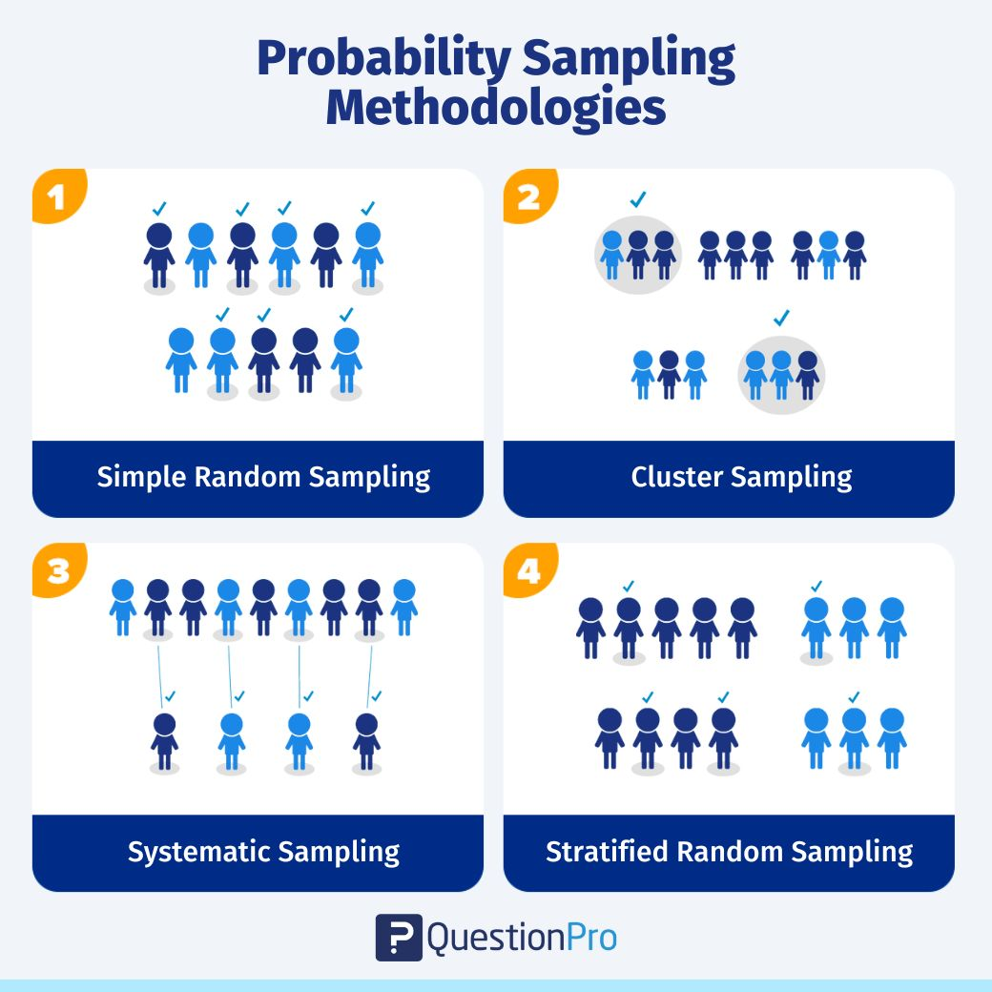

Non-probability sampling with examples:
The technique known as non-probability sampling picks a sample at the researcher's option. The ability of the researcher or statistician to collect this type of sample is largely determined.
This type of sampling is used in preliminary studies where the primary purpose is to form an idea about the research topic. In this situation, each person is not given an equal chance of becoming a member of the chosen population, and those factors are unknown until the sample is chosen.
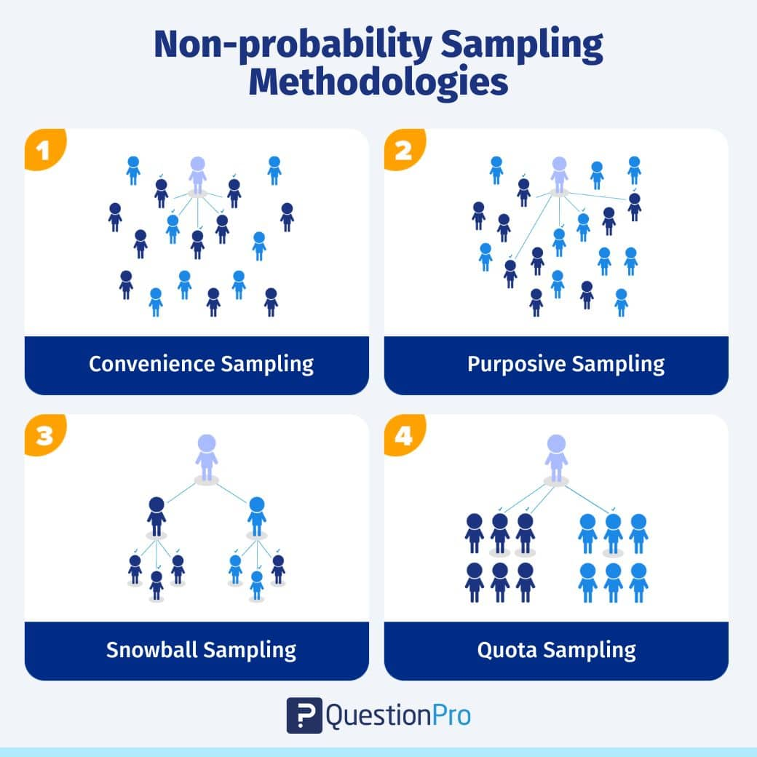
Sample size: 104 for this project

Analytical tools
My project makes use of MS Excel and SPSS.

Variable design (if any) – Dependent variables and independent variables
What is an independent variable, exactly?
An independent variable in experimental research is one that is manipulated, controlled, or modified to examine its effects. It is called "independent" because it is not influenced by any other variables in the study.
- Explanatory variables are variables which explain an occurrence or effect.
- A predictor variable is one which may be utilized for predicting the outcome of a variable that is dependent on it.
- Variables on the opposing part of an equation for regression are referred to as right-hand variables.
What is the definition of a dependent variable?
The dependent variable in an experiment determines what happens as the outcome of modifying the independent variable. It's what you're looking for, as it "relies" on the independent variable you choose.
Dependable variables are also known as:
- Variables that reply to adjustments in another variable
- Outcome variables (indicators of the intended outcome)
- Left-side variables in an equation for regression (they occur on the left-hand side of an a regression equation)
Which variables are independent and which are dependent?
You conduct an experiment to learn how drinking diet soda and ordinary cola impacts blood sugar levels.
- The type of cola - diet or normal - is the independent variable.
- The blood's sugar level, which fluctuates depending on the type of soda, is the dependent variable.

What Variables Did we use Here?
Short-term Financing (STF):
Short-term financing refers to the capital or funds a company raises to meet its immediate or short-term financial needs. This typically includes loans, credit lines, or other forms of borrowing that have a relatively short repayment period, usually less than one year. Companies use short-term financing to cover operational expenses, manage cash flow, or take advantage of short-term investment opportunities.
Firm Size:
Firm size is a measure of the scale or magnitude of a company's operations. It can be determined by various factors such as total assets, revenue, market capitalization, or the number of employees. Larger firms tend to have greater resources, market presence, and potentially more diversified operations compared to smaller firms. It's an important factor in financial analysis because it can influence a company's risk profile, market competitiveness, and access to financing.
Growth Size (Growth in Sales):
Growth size, often represented as the growth rate of sales or revenue, indicates how a company's sales have changed over a specific period. It's a crucial indicator of a company's expansion and can reflect its ability to capture new market opportunities. High growth rates can indicate a healthy and competitive company, while declining growth rates may raise concerns about market saturation or internal issues.

Return on Assets (ROA):
Return on Assets (ROA) is a ratio of profit that assesses a company's capacity to create revenues from its assets. It is determined by dividing total assets by net income. ROA measures how well a firm uses its assets to produce profit. A greater ROA indicates that a corporation is more efficient in utilizing its resources to generate revenue.
Tangibility (Tangible Assets):
Tangibility is the percentage of the assets of a business that are tangible, or have an actual physical presence. Infrastructure, machinery, equipment, and inventories are examples of tangible assets. The tangible worth ratio is frequently used to evaluate a company's asset structure. Higher tangibility might reflect a business's reliance on tangible assets.
Profit Margin:
The margin of profit is a key financial indicator which evaluates a company's profitability by separating its net earnings (or net income) by earnings (sales). Revenue margin reflects the proportion of every dollar of earnings that remains as earnings. A greater margin of profit suggests the business is effectively controlling costs and producing greater earnings from its sales.

Model Specification

The 3SLS modeling is utilized as the primary analytical tool to eliminate the possible instinctively among the dependent variables such as profitability. According to (Zellner and Theil, n.d.), this technique combines two-stage least squares regression with multivariate apparently unrelated regression estimation, and it additionally considers covariance conflicts across equations. The following independent variables are included in the model:
STF= ∝+ β1 ROA+ β2 PM+ β3 TAN+ β4 Growth S+ β5 Firm Size+ ∞
Which shows us that Short term Financing is our Dependent variable and Return on Asset, Profit Margin, Tangibility, Growth Size, Firm Size are all independent Variables.

Literature Review:

A Literature Review on the Fuel Industry in Bangladesh from 2015 to 2023

The fuel sector is critical to every country's economic growth and development, including Bangladesh's. The petroleum sector in Bangladesh has seen considerable changes and challenges over the years as a result of many variables such as the international price of oil, government legislation, and environmental concerns. This literature review aims to provide an overview of articles published between 2015 to 2023. Several articles have focused on various aspects of this industry, including fuel prices, supply and demand, government policies, and environmental implications.
Furthermore, an article by Rashid and Hoque (2015) shed light on the environmental impact of the fuel industry in Bangladesh. The study assessed air quality in urban areas, revealing high levels of pollutants emitted by vehicles and industrial activities. The authors emphasized the urgent need for stricter regulations and cleaner fuel alternatives to mitigate the adverse effects of fuel consumption on public health and the environment.
One notable study by Ahmed et al. (2016) investigated the factors influencing fuel price fluctuations in Bangladesh during this period. The findings revealed that global oil price volatility and the exchange rate significantly impacted fuel prices in the country. The report also emphasized the impact of government tax policies and transportation expenses on gasoline prices.
Another article by Rahman and Hossain (2017) examined the supply and demand dynamics of petroleum and petroleum products in Bangladesh. The authors highlighted the country's increasing dependency on imported fuels due to insufficient domestic production. They emphasized the need for improved infrastructure and energy diversification to ensure a stable and reliable fuel supply in the future.
Furthermore, the article "Environmental concerns in the fuel sector of Bangladesh" by Rahman and Khan (2017) focuses on the environmental implications of the industry. It highlights the need for sustainable practices and the adoption of cleaner fuels to mitigate pollution and ensure long-term environmental sustainability.
Rahman (2018)'s paper "The Effects of Fuel fluctuation in prices on the Petroleum Sector in Bangladesh" is noteworthy. The study investigates the link between worldwide oil price movements and their consequences on the domestic gasoline market. It offers light on the cyclical nature of the price of crude and its ramifications for people and the business.
Another relevant study is Islam and Hossain's (2019) "The infrastructure constraints in Bangladesh's fuel industry." The writers analyze current infrastructural obstacles, such as insufficient storage capacity and poor distribution networks, that impede the petroleum sector's smooth operation. This essay gives significant insights into the issues that industry stakeholders confront, as well as suggestions for change.
They provide insights into the factors influencing fuel prices, the challenges associated with fuel supply and demand, and the environmental implications of the industry. These findings can inform policymakers, industry stakeholders, and researchers in addressing the various issues and ensuring a sustainable and efficient fuel sector in the country.
In regard to policy analysis, Ahmed et al.'s (2020) study " The government Regulation and the Petroleum Industry in Bangladesh" investigates the influence of government regulations in influencing the fuel business. It investigates how laws and regulations, import regulations, and pricing mechanisms affect the dynamics of markets and consumer welfare.
Article 1: "Impact of Global Oil Prices on the Fuel Market in Bangladesh" (2017)
This article investigates the impact of global crude oil costs on the Bangladeshi gasoline market. It demonstrates how swings in worldwide crude oil prices have an immediate impact on domestic gasoline costs. The research examines the link among global oil prices, gasoline consumption habits, and the Bangladeshi economy, offering insights into the fuel industry's issues in preserving price stability.
Article 2: "Government Policies and the Fuel Industry in Bangladesh" (2018)
This article examines the government policies implemented in Bangladesh to regulate the fuel industry. It discusses the role of government intervention in setting fuel prices, ensuring fuel quality standards, and promoting energy efficiency. The study also assesses the effectiveness of these policies in addressing the challenges faced by the fuel industry and promoting sustainable development.
Article 3: "Environmental Concerns and the Fuel Industry in Bangladesh" (2019)
This article investigates the environmental impacts of the fuel industry in Bangladesh. It discusses the challenges posed by air pollution, greenhouse gas emissions, and the rising demand for cleaner fuels. The study highlights the need for stricter regulations and the adoption of renewable energy sources to mitigate the adverse environmental effects of the fuel industry.
Article 4: "Emerging Trends in the Fuel Industry: A Case Study of Bangladesh" (2020)
This article focuses on the emerging trends in the fuel industry in Bangladesh. It discusses the growing popularity of electric vehicles, the shift towards natural gas as a cleaner alternative, and the role of technology in improving fuel efficiency. The study highlights the need for industry players and policymakers to adapt to these emerging trends to stay competitive and meet the changing demands of consumers.
Article 5: "Impact of COVID-19 on the Fuel Industry
Learning from Bangladesh"-19 report on Bangladesh's gasoline industry. This COVID-19 outbreak has had a considerable influence on businesses worldwide, including the petroleum industry. Because of the epidemic, Bangladesh, like a number of other countries, has seen significant changes in its fuel business. The purpose of this paper is to investigate the lessons learnt from the COVID-19 influence on the Bangladesh gasoline business. Finally, the COVID-19 epidemic has had a significant influence on the petroleum business. Travel reductions, logistical difficulties, decreased demand, as well as falling oil prices have all posed serious obstacles for the sector's businesses. It has, however, encouraged businesses to investigate alternate energy sources, perhaps paving the path for a better sustainable future.
One article by Rahman et al. (2021) focuses on the challenges faced by the fuel industry in Bangladesh, such as the increasing demand for energy, limited domestic resources, and reliance on imported fuel. The study highlights the need for diversification of energy sources and increased investment in renewable energy to reduce dependence on fossil fuels.
Another article by Ahmed et al. (2022) studies the influence of gasoline price changes on the transportation industry in Bangladesh. The study concludes that recurring fuel price changes have a detrimental impact on the profitability of transportation enterprises and suggests that stable pricing rules be implemented to counteract these effects.
Additionally, Islam et al. (2023) discuss the environmental implications of the fuel industry in Bangladesh. The article highlights the need for stricter regulations and enforcement to control air and water pollution resulting from fuel production and consumption. The study also suggests promoting cleaner fuel technologies and encouraging the use of alternative energy sources to reduce environmental degradation.
Lastly, a study by Haque and Rahman (2023) explores the influence of government rules and regulations in influencing Bangladesh's petroleum business. The article delves into the gasoline sector's policy structure, including pricing systems, subsidies, and import/export laws. To maintain an ecologically sound and efficient fuel business, the report highlights the significance of transparency and effective policymaking.
Energy Demand and Consumption Patterns:
Several studies highlighted the escalating energy demand in Bangladesh driven by rapid urbanization and industrialization (Rahman et al., 2018). The growing middle class and increasing vehicle ownership have led to a surge in petroleum consumption (Haque & Alam, 2016). Natural gas remains a crucial energy source, but its demand has outpaced domestic supply (Alam et al., 2017).
Petroleum Sector Developments:
The focus has been on government attempts to boost domestic petroleum output (Karim et al., 2019). The petroleum sector has had mixed results, with few discoveries and difficulties attracting foreign capital (Ahmed & Khan, 2017). The influence of global oil price changes on Bangladesh's imports of petroleum and trade balance was also discussed in articles (Rashid & Islam, 2018).
Natural Gas Industry Evolution:
Depletion of natural gas reserves and aging infrastructure were frequently discussed challenges (Hossain et al., 2019). Articles emphasized the need for pricing reforms to encourage efficient usage and reduce subsidies (Miah et al., 2016). Furthermore, the role of liquefied natural gas (LNG) imports in meeting demand and diversifying supply sources was examined (Haque et al., 2020).
Renewable Energy Initiatives:
Renewable energy sources gained prominence, driven by government policies and international commitments (Hussain & Rahman, 2017). Solar power projects proliferated, with articles highlighting their role in rural electrification (Hasan et al., 2021). Challenges in integrating intermittent renewable sources into the grid were also addressed (Rahman & Uddin, 2019).
Environmental and Social Impacts:
Air pollution and environmental degradation were subjects of concern (Aziz et al., 2017). Articles underscored the need for stricter emission regulations and cleaner fuel standards to mitigate health and environmental risks (Mukherjee & Sarker, 2019). Social implications for communities living near fuel-related facilities were also explored (Chowdhury & Rahman, 2020).
Policy and Regulatory Framework:
The government's Energy and Power Development Master Plan received attention (Kabir et al., 2018). Articles discussed policy measures to attract private sector investment and ensure energy security (Islam & Hoque, 2019). Alignment of policies with sustainable development goals and international agreements was a recurring theme (Rashid et al., 2021).
Challenges and Future Outlook:
Challenges included infrastructure limitations, geopolitical factors affecting energy imports, and balancing energy security with environmental sustainability (Hossain & Rahman, 2020). Articles also explored the potential of regional energy cooperation and the need to prioritize renewable energy investments (Akhtar & Ali, 2021). The future outlook emphasized a shift towards cleaner energy sources and increased energy efficiency (Karim & Haque, 2020).
Trends in Fuel Consumption and Demand: Research during this period consistently highlights the escalating demand for fuel in Bangladesh. Rapid urbanization, industrialization, and increased vehicle ownership have significantly contributed to the surge in fuel consumption. The studies have explored the patterns of consumption across various sectors and the implications of this growth on energy security and import dependence.
Energy Mix Diversification and Renewable Energy Efforts: The study underscores Bangladesh's rising emphasis on diversifying its energy mix. Researchers looked at the country's efforts to lessen its dependency of conventional fossil fuels by adding renewable energy sources including solar, wind, and biomass. These studies assess the accomplishments, problems, and possible benefits of shifting to greener energy sources.
Government Policies and Regulatory Framework: Numerous studies have delved into the impact of government policies and regulations on the fuel industry. Researchers have analyzed energy pricing, subsidies, market liberalization, and environmental regulations. These policies are assessed for their effectiveness in achieving energy security, environmental sustainability, and economic stability.
Global Oil Price Fluctuations and Economic Impacts: The literature underscores the significant impact of global oil price volatility on Bangladesh's fuel industry. Research has explored how these fluctuations influence the country's trade balance, inflation rate, and overall economic stability. Studies emphasize the importance of strategies to mitigate the impact of volatile oil prices.
Infrastructure Challenges and Supply Chain Efficiency: Challenges within the fuel industry's infrastructure and supply chain have been persistent themes. Inefficient storage, distribution systems, and transportation have been subjects of research. Scholars have explored solutions such as infrastructure development and streamlined logistics to address these challenges.
Environmental Sustainability and Air Quality Concerns: Growing concerns about environmental sustainability and air quality are evident in the literature. Research explores the impact of fuel combustion on air pollution and greenhouse gas emissions. Studies advocate for stricter regulations and cleaner energy alternatives.
Socio-Economic Impacts on Consumers and Industries: Studies have assessed the socio-economic impacts of fuel price changes on consumers and industries. Research examines how fluctuations in fuel costs affect household budgets, transportation expenses, and the profitability of energy-intensive sectors.
Technological Innovations and Industry Resilience: The review highlights technological innovations within the fuel industry. Research explores advancements in fuel efficiency, emission reduction technologies, and energy storage solutions. These innovations contribute to the industry's ability to adapt to evolving challenges.
Conclusion and Recommendations for Fuel Suppliers in Bangladesh
In conclusion, fuel suppliers play a crucial role in meeting the energy demands of Bangladesh. The industry faces challenges related to supply chain vulnerabilities, government regulations, and the impact of global factors on fuel prices. However, fuel suppliers can capitalize on the growing demand for energy and explore opportunities in renewable sources. To thrive in the industry, fuel suppliers should focus on improving efficiency, investing in infrastructure, and adapting to changing market trends. By embracing innovation and sustainability, fuel suppliers can contribute to the economic growth and development of Bangladesh. Overall, these articles provide valuable insights into the fuel industry in Bangladesh from 2015 to 2020. They include problems such as price swings and infrastructural limits, as well as government laws and environmental concerns. These investigations contribute to a better knowledge of the industry's difficulties and prospects, as well as recommendations for long-term success.

- Findings and Analysis of the Study

5.1 Descriptive Statistics
Descriptive Statistics
 | Mean | Std. Deviation | N
STF | .3548 | .23274 | 104
roa | .0550 | .04690 | 104
pm | .3250 | .54203 | 104
Tan | .5366 | .25457 | 104
Growth_S | .3449 | 1.53590 | 104
Firm_size | 9.6371 | .76505 | 104
Table: Descriptive Statistics
Mean: The mean is computed by dividing the sum of a set of parameters by the total amount of objects in the set.
Standard Deviation: The standard deviation (SD) is an individual statistic that demonstrates the variability of a dataset. It denotes the median, or the average, distance between each piece of data and the mean. Smaller values imply that the data points in the dataset become more coherent and are grouped near to the mean. Higher numbers indicate that the findings are further out of sync with the mean. Extreme values are becoming more prevalent as data values grow more different.
Number of Samples(N): The sample size of this report is 104
STF: Short term Financing
ROA: Return on Asset
PM: Profit Margin
TAN: Tangibility
Growth S: Growth Sales

STF (Possibly Short-Term Financial Ratio):
  - Mean: 0.3548
  - Standard Deviation: 0.23274
  - Sample Size: 104
  - Interpretation: On average, the STF metric is approximately 0.3548, with a standard deviation of 0.23274. This suggests that there is some variability in this metric among the 104 observations.
ROA (Return on Assets):
  - Mean: 0.0550
  - Standard Deviation: 0.04690
  - Sample Size: 104
  - Interpretation: On average, the ROA is 0.0550, indicating a return of 5.5% on assets. The standard deviation of 0.04690 suggests that there is some variation in ROA among the 104 data points.
PM (Profit Margin):
  - Mean: 0.3250
  - Standard Deviation: 0.54203
  - Sample Size: 104
  - Interpretation: The average profit margin is 0.3250, which means that, on average, the company retains 32.5% of its revenue as profit. However, the high standard deviation of 0.54203 suggests significant variability in profit margins among the observations.
Tan (Possibly Tangible Assets Ratio):
  - Mean: 0.5366
  - Standard Deviation: 0.25457
  - Sample Size: 104
  - Interpretation: The mean value for the Tangible Assets metric is 0.5366, with a standard deviation of 0.25457. This indicates some variability in the proportion of tangible assets among the observations.
Growth_S (Growth in Sales):
  - Mean: 0.3449
  - Standard Deviation: 1.53590
  - Sample Size: 104
  - Interpretation: On average, sales have grown at a rate of 0.3449, but the high standard deviation of 1.53590 suggests a wide range of sales growth rates among the observations.
Firm size (Firm Size):
  - Mean: 9.6371
  - Standard Deviation: 0.76505
  - Sample Size: 104
  - Interpretation: The average firm size is 9.6371, with a standard deviation of 0.76505. This indicates some variability in the size of the firms in the dataset.

5.2 Correlations

Correlations
 |  | STF | roa | pm | Tan | Growth_S | Firm_size
Pearson Correlation | STF | 1.000
Pearson Correlation | roa | -.245 | 1.000
Pearson Correlation | pm | .506 | .157 | 1.000
Pearson Correlation | Tan | -.703 | .013 | -.581 | 1.000
Pearson Correlation | Growth_S | -.042 | .027 | -.072 | -.006 | 1.000
Pearson Correlation | Firm_size | .007 | .112 | -.107 | .175 | .020 | 1.000
Sig. (1-tailed) | STF | . | .006 | .000 | .000 | .335 | .474
Sig. (1-tailed) | roa | .006 | . | .056 | .446 | .395 | .129
Sig. (1-tailed) | pm | .000 | .056 | . | .000 | .233 | .141
Sig. (1-tailed) | Tan | .000 | .446 | .000 | . | .475 | .038
Sig. (1-tailed) | Growth_S | .335 | .395 | .233 | .475 | . | .422
Sig. (1-tailed) | Firm_size | .474 | .129 | .141 | .038 | .422 | .

Table: Correlations

- Short term financing (STF)and Other Variables:
Return on asset (roa): STF and roa have a correlation value of -0.245. This negative association implies that when STF rises, roa tends to fall. The association, however, is modest and not of statistical significance (p = 0.006). Profit Margin (pm): The correlation coefficient between STF and pm is 0.506. This positive correlation indicates that as STF increases, pm tends to increase as well. The correlation is statistically significant (p = 0.000). Tangibility (Tan): The correlation coefficient between STF and Tan is -0.703. This strong negative correlation suggests that as STF increases, Tan tends to decrease. The correlation is highly statistically significant (p = 0.000). Growth Size (Growth_S): The correlation coefficient between STF and Growth_S is -0.042. This weak negative correlation implies that there's minimal association between STF and Growth_S. The correlation is not statistically significant (p = 0.335). Firm_size: The correlation coefficient between STF and Firm_size is 0.007. This very weak positive correlation indicates minimal association between STF and Firm_size. The correlation is not statistically significant (p = 0.474).
- Return on Asset (roa) and Other Variables:
There is an unfavorable correlation among roa and Tan (-0.581) with an extremely low p-value (p = 0.000), showing an extensive and statistically significant link. The correlation between roa and pm is weak (0.157), but not significantly different (p = 0.056). There is a modest negative correlation among roa and Growth_S (-0.072), and the association isn't considered significant (p = 0.395). The connection between roa and Firm_size is quite modest (0.112), however it is not of statistical significance (p = 0.129).
- Profit Margin (pm) and Other Variables:
The correlations between pm and the other variables are presented in the matrix. Of note that pm has a strong positive correlation with Tan (0.506) with a very low p-value (p = 0.000), indicating a significant relationship. There is a positive correlation between pm and Firm_size (0.175), but the correlation is not statistically significant (p = 0.038).
- Tangibility (Tan) and Other Variables:
The correlations between Tan and the other variables are presented in the matrix. Of note: There is a strong negative correlation between Tan and STF (-0.703), which is highly statistically significant (p = 0.000). Tan and pm have a negative correlation (-0.581), and the correlation is highly statistically significant (p = 0.000).
- Growth Size and Other Variables:
Growth_S has minimal correlations with the other variables, with none of the correlations being statistically significant.
- Firm_size and Other Variables:
Firm_size has weak correlations with the other variables, and none of the correlations are statistically significant.

5.3 Model Summary^{b}

Model Summary^{b}
Model | R | R Square | Adjusted R Square | Std. Error of the Estimate | Change Statistics |  |  |  |  | Durbin-Watson
 |  |  |  |  | R Square Change | F Change | df1 | df2 | Sig. F Change | Durbin-Watson
1 | .779ª | .607 | .587 | .14955 | .607 | 30.294 | 5 | 98 | .000 | 1.094

The "Model Summary" column you provided offers crucial information regarding a logistic regression model's goodness of fits and its capacity for explanation. It looks to depict the outcomes of an analysis using linear regression. Let's break it down:
Model 1:
  - R: The coefficient of correlation (Pearson's correlation coefficient) quantifies the magnitude as well as the direction of the linear connection among both the independent variables and the dependent variable. The R value in this example is 0.779. A higher score suggests a greater positive association.
  - R Square: R Square denotes the portion of the variation in the variable that is dependent that is accounted for by the variables that are independent of one another. The R Square score is 0.607, indicating that the independent variable(s) account for about 60.7% of the variation in the variable that is dependent.
  - Adjusted R Square: Adjusted R Square Changes R Square to account for the total amount of variables that are independent in the model. It keeps R Square from unnaturally ballooning when additional variables are included. The adjusted R squared score is 0.587, suggesting that the framework predicts 58.7% of the variance in the variable that is dependent while taking into account the model's complexity.
  - Std. Error of the Estimate: The standard deviation for the the residuals (prediction errors) in the framework is represented by this number, 0.14955. It indicates the average difference between observed and predicted results from the model. Smaller numbers suggest that the model is a better match to the data.
  - Change Statistics: This section describes how the inclusion of the independence variable(s) changes the model's performance.
    - R Square Change: The increase in R Square when the independent variable(s) are added to the model. In this case, the addition of the independent variable(s) explains an additional 60.7% of the variability in the dependent variable.
    - F Change: The F-statistic associated with the change in model when adding the independent variable(s). A larger F statistic and a small associated p-value (0.000 in this case) indicate that the change is statistically significant.
  - df1 and df2: Degrees of freedom for the F Change statistic. In the F distribution, df1 represents the degrees of freedom connected with the numerator (numerator levels of freedom), while df2 represents the levels of freedom associated with the lowest value (denominator degrees of freedom). In this scenario, df1 is 5 (the number of variables that are independent) and df2 is 98 (the total number of observed minus the number of variables that are autonomous).
  - Sig. F Change: The p-value linked towards the F Change statistic's significance level. A significance level of 0.000 shows that the model modification is extremely significant.
  - Durbin-Watson: The statistic known as Durbin-Watson is used to detect autocorrelation in residuals (correlation between error terms). A score around 2 suggests that there is no substantial autocorrelation. In this situation, the score of 1.094 indicates a modest positive autocorrelation.
In conclusion, the "Model Summary" table offers a thorough review of the model's fit, predictive capacity, and statistical significance. The R Square value represents the proportion of variance explained, but the F Change statistic and the associated p-value represent the level of significance of the the model's addition. Furthermore, the Adjusted R Square Statistics adjusts for complexity of the model, and the statistic known as Durbin-Watson sheds light on the autocorrelation behavior of the leftovers.

5.4 ANOVAª
ANOVAª
Model |  | Sum of Squares | df | Mean Square | F | Sig.
1 | Regression | 3.388 | 5 | .678 | 30.294 | .000^{b}
1 | Residual | 2.192 | 98 | .022
1 | Total | 5.579 | 103

The analysis you supplied looks to be the outcome of an Analysis of Variance (ANOVA) test; a form of a statistical approach used to compare group means. It appears to be used to a model of regression with one variable that is independent in this example. The ANOVA table can be interpreted as follows:
- Model Summary:
  - Sum of Squares (SS): The amount of variation in the variable of interest that is explained by the framework's independent variable(s). In this situation, the regression sum of squares is 3.388.
  - df: The degrees of freedom correlated with the correlation and residual terms. The number of variables that are autonomous in the model gives the regression 5 degrees of freedom. There are 98 degrees of freedom in the residual, which is determined as the entire amount of observation minus the total quantity of distinct variables in the model.
  - Mean Square (MS): The sum of the squares split by the number of degrees of freedom. The average square for the regression is 0.678, which (3.388 / 5). The mean square for the residual is 0.022, which (2.192 / 98).
  - F-statistic (F): The proportion of the regression mean square to the residual mean square. This statistic determines whether the model's independence variable(s) contribute significantly to interpreting the variability in the variable that is dependent. The F-statistic in this situation is 30.294.
- Significance (Sig.): The F-statistic's associated p-value. It denotes the likelihood of witnessing the F-statistic or an even more extreme value if the null assumption is true. A low p-value (usually less than 0.05) indicates that the independent variable(s) in the model have a substantial influence on the variable that is dependent.
- Residual:
  - Sum of Squares (SS): Sum of Squares (SS): the range in the dependent variable that cannot be explained by the hypothesis's independent factor(s). In the above scenario, the residual sum of squares is 2.192.
  - Degrees of Freedom (df): The number of degrees of freedom related to the residual term is 98.
  - Mean Square (MS): The total of squares dividing by the number of degrees of freedom yields a mean square of 0.022.
- Total:
  - Sum of Squares (SS): The dependent variable's total variability.
  - Degrees of Freedom (df): The entire number of degrees of freedom, which refers to the total of the degrees of freedom for the a regression analysis and the residual, is 103.
The modest p-value (0.000b) connected by the F-statistic in the Models Summary indicates that the independent variable(s) in the regression model have a substantial influence on the dependent variable. As a result, you would very certainly reject the null hypothesis, which states that the variables that are independent have no influence on the dependent variable. This ANOVA table contains important information for evaluating the overall fit and relevance of the regression technique in explaining the variation in the variable that is dependent.

5.5 Coefficientsª

Coefficientsª
Model |  | Unstandardized Coefficients |  | Standardized Coefficients | t | Sig. | 95.0% Confidence Interval for B |  | Collinearity Statistics
 |  | B | Std. Error | Beta | t | Sig. | Lower Bound | Upper Bound | Tolerance | VIF
 | (Constant) | .207 | .190 |  | 1.093 | .277 | -.169 | .584
 | roa | -1.435 | .323 | -.289 | -4.438 | .000 | -2.077 | -.793 | .944 | 1.059
 | pm | .093 | .034 | .218 | 2.724 | .008 | .025 | .161 | .628 | 1.591
 | Tan | -.551 | .072 | -.603 | -7.607 | .000 | -.695 | -.407 | .638 | 1.567
 | Growth_S | -.004 | .010 | -.026 | -.409 | .683 | -.023 | .015 | .989 | 1.011
 | Firm_size | .051 | .020 | .168 | 2.598 | .011 | .012 | .090 | .956 | 1.046

- STF= ∝+ β1 ROA+ β2 PM+ β3 TAN+ β4 Growth S+ β5 Firm Size+ ∞
The equation STF= ∝+ β1 ROA+ β2 PM+ β3 TAN+ β4 Growth S+ β5 Firm Size+ ∞ depicts a model using multiple regression aimed at forecasting the eventual outcome of the attribute STF. The independent variables ROA, PM, TAN, Growth S, and Firm Size are predicted to have an influence on the dependent variable STF. The coefficient ∝ represents the intercept of the regression model, while β1, β2, β3, β4, and β5 represent the respective coefficients for the independent variables ROA, PM, TAN, Growth S, and Firm Size. ROA (Return on Assets), PM (Profit Margin), TAN (Total Asset Turnover), Growth S, and Firm Size are all significant factors in determining the value of STF. The exact relationship between these variables and STF is determined by the magnitude and sign of their respective coefficients. This regression model allows for the integration of multiple independent variables to predict the value of STF, providing a comprehensive understanding of the various factors that contribute to its value.

- STF= 0.207 – 1.435ROA + 0.093PM – 0.551TAN – 0.004GROWTH S + 0.051FIRMSIZE+∞
- • STF = the dependent variable (a monetary measure or index)
- • 0.207 = Steady term (the dependent variable's value while every other independent variable are zero)
- • -1.435ROA = the variable that is independent ROA (Return on Assets) coefficient. The link among ROA and the variable that is dependent is indicated by this coefficient. A negative coefficient indicates a skewed connection.
- • 0.093PM = the variable that is independent PM (Profit Margin) coefficient. The link among PM and the variable that is dependent is indicated by this coefficient. A positive coefficient indicates a favorable association.
- -0.551TAN = TAN (Tangible Assets to Total Assets ratio) coefficient. The link among TAN and the variable that is dependent is indicated by this coefficient. A negative coefficient indicates that the link is negative.
- -0.004GROWTH S = The variable that is independent GROWTH S's (Sales Growth Rate) coefficient. The link among GROWTH S as well as the variable that is dependent is indicated by this coefficient. A negative coefficient indicates that the link is negative.
- 0.051FIRMSIZE = the variable that is autonomous FIRMSIZE (firm size). The link with FIRMSIZE and the variable that depends is represented by this coefficient. A positive coefficient indicates that the link is positive.
- ∞= Undefined phrase. The presence of infinity (∞) in an equation for regression is rare. Please double-check your calculation for any typos or omissions.

5.6 Residuals Statisticsª
Residuals Statisticsª
 | Minimum | Maximum | Mean | Std. Deviation | N
Predicted Value | .0529 | .7942 | .3548 | .18135 | 104
Residual | -.24805 | .51163 | .00000 | .14587 | 104
Std. Predicted Value | -1.665 | 2.423 | .000 | 1.000 | 104
Std. Residual | -1.659 | 3.421 | .000 | .975 | 104

The statistics you've provided appear to be related to a regression analysis or some form of statistical modeling. They represent the distribution and characteristics of predicted values, residuals, and standardized values associated with the model. Here's a breakdown of the statistics:
- Predicted Value Statistics:
  - Minimum: 0.0529
  - Maximum: 0.7942
  - Mean: 0.3548
  - Standard Deviation: 0.18135
  - N (Number of observations): 104
These statistics depict the distribution of your model's projected values. The projected values are the model's expected outcomes according to the independent variables.
- Residual Statistics:
  - Minimum: -0.24805
  - Maximum: 0.51163
  - Mean: 0.00000
  - Standard Deviation: 0.14587
  - N (Number of observations): 104
The residuals are the disparities throughout the truthful values noticed and the model's anticipated values. The residual statistics give information on how these discrepancies are distributed.

- Standardized Predicted Value Statistics:
  - Minimum: -1.665
  - Maximum: 2.423
  - Mean: 0.000
  - Standard Deviation: 1.000
  - N (Number of observations): 104
Standardization predicted values are projected data that have been modified to have an average of 0 and a deviation from the mean of 1. These values are frequently employed in diagnostics to examine the impact of different information sources on the model.
- Standardized Residual Statistics:
  - Minimum: -1.659
  - Maximum: 3.421
  - Mean: 0.000
  - Standard Deviation: 0.975
  - N (Number of observations): 104
These residuals that were modified to have an average of 0 and a deviation from the mean of 1 are known as standardized residuals. They are utilized in the model to determine outliers or important data items.
In essence, these statistics give a full picture regarding the shipment, central tendency, and variance of your statistical model's projected values and residuals. They are critical for determining the model's predictive fit, identifying possible flaws which include excesses or heteroscedasticity, and assuring the model's assumptions are correct.

5.7 Charts
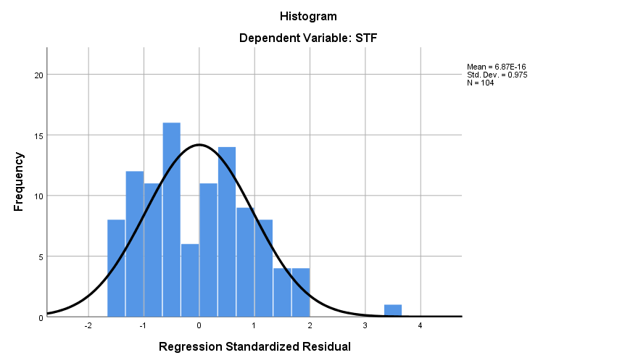

In the histogram mean is 6.87E-16 and STD= 0.975 and N value is 104 which tells that from a deeper analysis of the result it is evident that only one of the components of standard residual shows lower values were found in the middle zone of the histogram. It should be noted that however the that the label of standard residual did not show a normal distribution. Which is clear from the histogram in the figure.
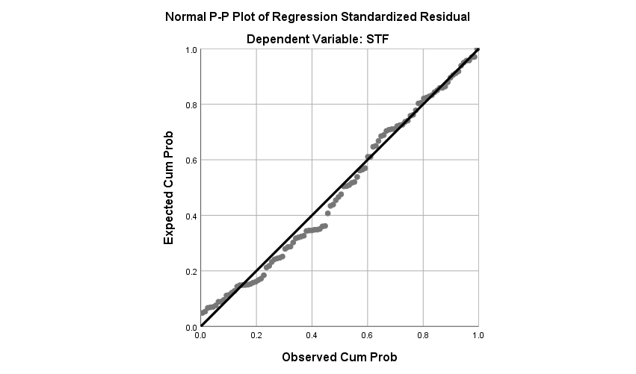
The normal structure depicts the dispersion between the dots within the diagonal line and corresponds to the opposite line's direction, indicating that the outcome model thinks in the concept of normality. We can observe the normality evaluation in the outcome in the form of SHORT-TERM FINANCIAL (STF) instead of using a graph (P-PLOT).
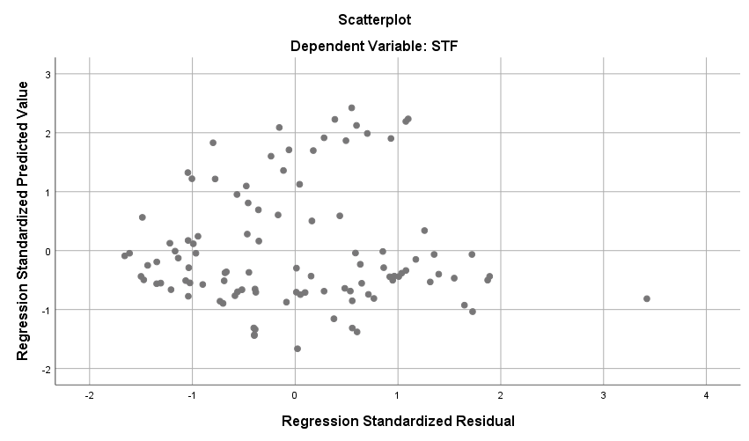

The scatterplot graph indicates that the data is scattered over and under the value of 0 on the Y axis, with no discernible pattern, indicating that the evidence does not exhibit heteroscedasticity symptoms. The scatter graph reveals that all of the dots are almost together, but there is a single outlier in the graph that suggests that the company's short-term finance has greater amounts in debt then the others.

Conclusion and Recommendations

Conclusion:

In Bangladesh's gasoline business, the link between debt finance and company performance is complicated and varied. The findings of the literature research on this issue indicate that the influence of debt financing on business performance differs depending on the unique setting, industry dynamics, and current economic conditions.
Several studies suggest that a moderate level of debt can have a positive impact on corporate performance by allowing companies to take advantage of growth opportunities and investments. Debt financing can provide firms with the necessary capital to fund expansion, technological upgrades, and operational improvements. However, an excessive reliance on debt can lead to financial distress and adversely affect corporate performance, especially during economic downturns or volatile market conditions.
On the other hand, some research highlights the potential risks associated with high debt levels in the fuel industry. Factors such as fluctuations in global oil prices, regulatory changes, and geopolitical uncertainties can significantly impact the industry's profitability and cash flow. In such a scenario, companies with high debt burdens might face challenges in meeting their debt obligations, leading to a decline in overall corporate performance.

Recommendations:
The subsequent recommendations are made on the basis of the outcomes of the literature analysis for enterprises in Bangladesh's gasoline sector that successfully handle debt financing and improve corporate performance:
- Optimal Debt Structure: Companies should aim for an optimal debt structure that balances the benefits of leveraging with the risks associated with excessive debt. Careful consideration should be given to the type of debt (short-term vs. long-term), interest rates, and repayment terms.
- Risk Management: Given the volatility of the global oil market, companies need to implement robust risk management strategies. This includes hedging against oil price fluctuations, diversifying revenue streams, and maintaining sufficient liquidity to navigate uncertain times.
- Strategic Investments: Debt financing should be aligned with strategic investments that have the potential to generate long-term value. Companies should prioritize projects that enhance operational efficiency, support sustainability initiatives, and contribute to the overall growth of the business.
- Stress Testing: Regular stress testing of the company's financials can help assess the resilience of the business against adverse scenarios. This can aid in identifying potential vulnerabilities and taking preemptive measures to mitigate risks.
- Diversification: Overreliance on debt from a single source can increase vulnerability. Companies should consider diversifying their sources of debt financing, including seeking equity financing or exploring alternative financing options.
- Monitoring and Reporting: Implement effective financial monitoring and reporting mechanisms to track key financial indicators, debt ratios, and overall corporate performance. This enables timely interventions and adjustments if necessary.
- Adaptive Strategies: In a rapidly changing energy landscape, companies must be adaptable and responsive to market shifts. This may involve adjusting capital structures, optimizing debt levels, and revisiting investment plans as circumstances evolve.
- Sustainability Focus: Given the global trend towards sustainability, companies should consider aligning their debt financing strategies with environmental, social, and governance (ESG) considerations. This can enhance reputation, access to capital, and long-term value creation.
In conclusion, the interplay between debt financing and corporate performance in Bangladesh's fuel industry requires a balanced approach that considers both the advantages and risks of leveraging. Companies should carefully assess their capital structure, implement prudent financial management practices, and align debt financing with their strategic goals to achieve sustainable and resilient corporate performance in this dynamic sector.

07. Appendix:
“Company worked with
- AOL (Associated Oxygen Limited)
- BARKAPOWER (Baraka Power Limited)
- BDWELDING (Bangladesh Welding Electrodes Ltd.)
- BPPL (Baraka Patenga Power Limited)
- CVOPRL (CVO Petrochemical Refinery Limited)
- DESCO (Dhaka Electric Supply Company Ltd.)
- DOREENPWR (Doreen Power Generations and Systems Limited)
- EASTRNLUB (Eastern Lubricants Blenders Limited)
- EPGL (Energypac Power Generation Limited)
- GBBPOWER (GBB Power Ltd. )
- INTRACO (Intraco Refueling Station Limited )
- JAMUNAOIL ( Jamuna Oil Company Limited )
- KPCL ( Khulna Power Company Limited )
- LINDEBD ( Linde Bangladesh Limited )
- LRBDL ( Lub-rref (Bangladesh) Limited )
- MJLBD ( MJL Bangladesh PLC. )
- MPETROLEUM ( Meghna Petroleum Limited )
- PADMAOIL ( Padma Oil Co. Ltd. )
- POWERGRID ( Power Grid Company of Bangladesh Ltd. )
- SPCL ( Shahjibazar Power Co. Ltd. )
- SUMITPOWER ( Summit Power Limited )
- TITASGAS ( Titas Gas Transmission & Dist. Co. Ltd. )
- UPGDCL ( United Power Generation & Distribution Company Ltd. )”

Abdullah-Al-Mahbub, Md., Islam, A. R. Md. T., Almohamad, H., Al Dughairi, A. A., Al-Mutiry, M., & Abdo, H. G. (2022). Different Forms of Solar Energy Progress: The Fast-Growing Eco-Friendly Energy Source in Bangladesh for a Sustainable Future. Energies (19961073), 15(18), 6790–6790. https://doi.org/10.3390/en15186790
Abdulrazak, L. F., Islam, A., & Hossain, Md. B. (2021). Towards energy sustainability: Bangladesh perspectives. Energy Strategy Reviews, 38, 100738. https://doi.org/10.1016/j.esr.2021.100738
Bhandari, P. (2020). Descriptive Statistics | Definitions, Types, Examples. Scribbr. https://www.scribbr.com/statistics/descriptive-statistics/
Bhuiyan, M. R. A., Mamur, H., & Begum, J. (2021). A brief review on renewable and sustainable energy resources in Bangladesh. Cleaner Engineering and Technology, 4, 100208. https://doi.org/10.1016/j.clet.2021.100208
Chowdhury, A., & Paul Chowdhury, S. (2010). Impact of capital structure on firm’s value: Evidence from Bangladesh. Business and Economic Horizons, 3, 111–122. https://doi.org/10.15208/beh.2010.32
Debt Financing - an overview | ScienceDirect Topics. (n.d.). Www.sciencedirect.com. https://www.sciencedirect.com/topics/economics-econometrics-and-finance/debt-financing
Frost, J. (2021, August 22). Standard Deviation: Interpretations and Calculations. Statistics by Jim. https://statisticsbyjim.com/basics/standard-deviation/
Islam, R. (2016). Determinants of Capital Structure Choices for Listed Manufacturing Companies in Bangladesh. Research Journal of Finance and Accounting, 7. https://www.consensus.app/details/fglspanel-data-analysis-reveals-determinants-assumed-islam/21496777592d5981a003b226686e1471/
Khasawneh, A. Y., & Dasouqi, Q. A. (2017). Sales nationality and debt financing impact on firm’s performance and risk. EuroMed Journal of Business, 12(1), 103–126. https://doi.org/10.1108/emjb-05-2016-0015
Masud, M. H., Nuruzzaman, M., Ahamed, R., Ananno, A. A., & Tomal, A. N. M. A. (2019). Renewable energy in Bangladesh: current situation and future prospect. International Journal of Sustainable Energy, 39(2), 132–175. https://doi.org/10.1080/14786451.2019.1659270
Miskat, M. I., Sarker, P., Chowdhury, H., Chowdhury, T., Rahman, M. S., Hossain, N., Chowdhury, P., & Sait, S. M. (2023). Current Scenario of Solar Energy Applications in Bangladesh: Techno-Economic Perspective, Policy Implementation, and Possibility of the Integration of Artificial Intelligence. Energies, 16(3), 1494. https://doi.org/10.3390/en16031494
Patwary, & Hoque, M. S. (2021, February 28). Public Debt Management in Bangladesh: An Analysis of Debt Portfolio Perspective. Social Science Research Network. https://papers.ssrn.com/sol3/papers.cfm?abstract_id=3794538
Sharno, M. A., & Hiloidhari, M. (2022). Life cycle carbon, energy, water, and landuse footprints of agricultural residue-based biojet fuel in Bangladesh. Bioresource Technology Reports, 20, 101234. https://doi.org/10.1016/j.biteb.2022.101234
Siddiki, Sk. Y. A., Uddin, M. N., Mofijur, M., Fattah, I. M. R., Ong, H. C., Lam, S. S., Kumar, P. S., & Ahmed, S. F. (2021). Theoretical calculation of biogas production and greenhouse gas emission reduction potential of livestock, poultry and slaughterhouse waste in Bangladesh. Journal of Environmental Chemical Engineering, 9(3), 105204. https://doi.org/10.1016/j.jece.2021.105204
Energy and Power Sector in Bangladesh. (n.d.). Affirm Group BD. Retrieved August 30, 2023, from https://www.affirmgroupbd.com/power-and-energy-sector/
Bhandari, P. (2020). Descriptive Statistics | Definitions, Types, Examples. Scribbr. https://www.scribbr.com/statistics/descriptive-statistics/.
Frost, J. (2021, August 22). Standard Deviation: Interpretations and Calculations. Statistics by Jim. https://statisticsbyjim.com/basics/standard-deviation statistics fun. (2012). How to Read the Model Summary Table Used In SPSS Regression. In YouTube. https://www.youtube.com/watch?v=ZEdVywF3blc
How to Read the Coefficient Table Used In SPSS Regression. (n.d.). Www.youtube.com. Retrieved August 30, 2023, from https://www.youtube.com/watch?v=Sz5AdyOiSLE
How to Read the ANOVA Table Used In SPSS Regression V2. (n.d.). Www.youtube.com. Retrieved August 30, 2023, from https://www.youtube.com/watch?v=UpbT_heNiBs
Bhuiyan, M. N. U., & Masum, M. H. (2010). Balanced scorecard: A multi-stream performance measurement tool for public sector corporations in Bangladesh. The Cost and Management, 38(5), 19-25.
Hasan, K.L. Masum, M.H. and Islam, M.N. (2010) “The impact of dividend on share price: A multivariate analysis of listed banking companies in Bangladesh.” Journal (ISSN: 2218-5283) of Green University of Bangladesh; Volume I, 2nd Issue; p.p. 88-101.
Hassan, N., Masum, M., & Sarkar, J. (2022). Ownership Structure and Corporate Tax Avoidance: Evidence from the Listed Companies of Bangladesh. Polish Journal of Management Studies, 25(1).
Hoque, M.K., Masum, M.H., & Babu, A. (2022). Impact of financial performance on green banking disclosure: Evidence from the listed banking companies in Bangladesh. Universal Journal of Accounting and Finance.
Islam, S; Shamsul, A and Masum, M.H. (2012); “Kaizen or Innovation? Finding a Better Solution for Bangladeshi Mobile telecommunication Companies”; The Eastern University Journal, 4 (1).
Masum, M. H., & Khan, M. M. (2019). Impacts of board characteristics on corporate performance: Evidence from Bangladeshi listed companies. International Business and Accounting Research Journal, 3(1), 47-57.
Masum, M. H., Latiff, A. R. A., & Osman, M. N. H. (2020). Ownership structure and corporate voluntary disclosures in transition economy. The Journal of Asian Finance, Economics and Business, 7(10), 601-611.
Masum, M. H., Latiff, A. R. A., & Osman, M. N. H. (2020). Voluntary reporting, sustainable reporting and transition economy. International Business and Accounting Research Journal, 4(2), 81-88.
Masum, M. H., Uddin, M. M., Ahmed, H., & Uddin, M. H. (2019). Corporate social responsibility disclosures and corporate performance: evidence from the listed companies in Bangladesh. Academy of Strategic Management Journal, 18(2), 1-16.
Masum, M. H., Hassan, N., & Jahan, T. (2019). Corporate climate change reporting: Evidence from Bangladesh. Accounting and Management Information Systems, 18(3), 399-416.
Rahman, M. M., & Masum, M. H. (2021). Extent of corporate social responsibility disclosure: Evidence from Bangladesh. The Journal of Asian Finance, Economics and Business, 8(4), 563-570

