

Internship Report on Human Resource Division
of BRAC Bank LTD.

Submitted To:
Dr. Khandoker Mahmudur Rahman
Professor
School of Business & Economics
United International University

Submitted By:
Name: Tonima Nasrin Riya
Major: Marketing
ID: 111 191 089

Date of Submission:
04.01.2024

United International University

LETTER OF TRANSMITTAL

04 January, 2024
Prof. Dr. Khandoker Mahmudur Rahman
Professor
School of Business & Economics
United International University

Subject: Submission of Internship Report.
Sir,

Presenting my internship report, "Internship Report on Human Resource Department of BRAC Bank Limited," is a pleasure for me. Under your careful supervision, I completed my internship at BRAC Bank Limited's head office located at Anik Tower, 220/B, Tejgaon Gulshan Link Road, Tejgaon, Dhaka-1208.

I am sure that the information and expertise that I have received while producing the report will be very valuable to me in my future as a professional, and I hope you are going to assess my report keeping in mind the limitations and flaws of the study. I would be very appreciative if you could accept this try.

Best regards,
Tonima Nasrin Riya
ID: 111 191 089

ACKNOWLEDGMENT

I would first like to express my gratitude to Almighty Allah for enabling me to finish the internship and produce a report on it. My BBA internship report would not have been possible without the help and participation of many individuals, particularly those who contributed to it and took the time to provide their insightful advice and recommendations for how to make the report better. I find it challenging to express my gratitude to everyone who has helped with this paper. There are certain individuals who deserve particular recognition.

I would like to express my profound appreciation to my academic supervisor, Prof. Dr. Khandoker Mahmudur Rahman, who is a professor at United International University's UIU Business School. This study would not have been as successful without his gracious leadership and appropriate instruction.

I would like to thank the HR Management Division of BRAC Bank Limited's Ms. Kakoli Rashid (Associate Manager) and Md. Enamul Hoque, (Officer) for their help and guidance.

Table of Contents

Executive Summary v
Chapter 01 1
Introduction 1
1.1. Source of the Report: 1
1.2. Background of the Report: 1
1.3. Scope of the Study 1
Chapter 02 2
Objective of the study 2
2.1. Primary Objective 2
2.2. Secondary Objective 2
Chapter 03 3
Methodology of the Report 3
3.1. Primary Data 3
3.2 Secondary Data 3
3.3. Processing of the data: 3
3.4. Interpretation and analysis of the data: 4
3.5. Limitations of the Report: 4
Chapter 04 5
Organizational Overview 5
4.1. Organizational Mission: 5
4.2. Organizational Vision: 6
4.3. Values: 6
4.4. Achievements: 7
4.5. Board Directors: 7
4.6. Organogram: 8
4.7. Divisions of BRAC Bank Ltd: 8
4.8. Products and Services: 9
4.9. Partners: 9
4.10. Strategic Focus 10
Chapter 05 11
Human Resource Division of BRAC Bank 11
5.1. People Management, BRAC Bank Ltd.: 12
5.2. Types of employees: 13
5.3. Various Functions of HR divisions: 13
5.4. Wings of Human Resource Division: 14
5.5. Recruitment 15
5.6. Compensations and Rewards: 17
5.7. Promotion Pattern: 20
Chapter 06 20
My Internship Experience 20
6.1. Job Responsibilities: 21
Chapter: 07 21
Literature Review on SWOT Analysis 21
7.1. Introduction to SWOT Analysis 21
7.2. Historical Development of SWOT Analysis 21
7.3 Components of SWOT Analysis 21
7.4. Purpose and Benefits of SWOT Analysis 22
7.5. Criticisms and Limitations of SWOT Analysis 22
7.6. Application of SWOT Analysis in the Banking Sector 22
Chapter 08 23
SWOT Analysis 23
8.1. Strength 23
8.2 Weakness: 25
8.3. Opportunities: 26
8.4. Threats: 27
8.5. Some critical issues: 27
Chapter 09 28
Recommendation and Conclusion 28
9.1. Recommendation: 28
9.2. Conclusion: 28
References 29

Executive Summary

In Bangladesh, BRAC Bank Limited operates as a designated commercial bank. The Banking Corporations Act, 1991 allowed for its establishment in Bangladesh, and on May 20, the year 1999, the Companies Act, 1994, allowed for its incorporation as a private company with limited liability. It began operations on July 4, 2001, with the goal of becoming the industry leader by offering various forms of assistance to individuals and corporate clients in order to serve small and medium-sized business owners throughout Bangladesh. BRAC Bank concentrates on exploring uncharted market segments for small and medium-sized businesses. BRAC Bank Limited, one of Bangladesh's newest and fastest-growing banks, is an essential financial intermediary that connects the government's economic policies to the rest of the economy.

The Human Resources Division of BRAC Bank Limited is made up of the departments of Learning and Development, Recruitment, Compensation & Benefits, Human Capital, and HR Operations. The division also maintains an adaptable human resources management strategy. A team of dynamic HR Relationship Managers connects HR support with business needs. This report's specific goals are to gain a practical understanding of HR procedures, principles, and their nature; to comprehend BRAC Bank Limited's HR operations; to learn about employee satisfaction and dissatisfaction levels; to discover the activities and implications of the Human Resources (HR) division to the organization; and to analyze HR strategy, job assessment, employee recruitment, training, performance evaluation, reimbursement and pay plan, benefits, and services.

The first chapter covers some fundamental details, such as the history and source of the report. The major and secondary goals of the study are covered in Chapter 2. The third chapter covers the study's methodology, including its secondary and primary data, the number of samples, the sampling procedure, data collection method, data analysis approach, and limitations. Section Four It also explains the principles of banking and the distinctions between BRAC Bank and conventional banks. Comprehensive details about Bangladesh's BRAC Bank, including their history and current state of affairs.

Chapter 01

Introduction

Source of the Report:

The report was written following an internship that lasted three months at BRAC Bank Limited. The effective completion of the Bachelor of Business Administration (BBA) program at United International University's School of Business and Economics (SOBE) depends on the development and submission of the report.

Background of the Report:

Bangladesh's scheduled commercial bank is called BRAC Bank Limited. The Financial Companies Act, 1991 allowed for its establishment in Bangladesh, and on May 20, 1999, the Companies Act, 1994, allowed for its incorporation as a private limited company. In Bangladesh, BRAC Bank will stand out from other companies. Offering a wide range of banking services is the Bank's main goal.
Although Bangladesh has a large number of banks, I prefer BRAC Bank since it is among the country's top private banks. Offering a wide range of banking services is the Bank's main goal. The objective of the bank is to finance large-scale manufacturing and consumption, hence promoting Bangladesh's development. By delivering effective, amiable, and cutting-edge completely automated internet service on an income-generating basis and striving to deliver commercial banking services to clients' doors across the nation, BRAC Bank hopes to establish itself as the industry leader in Bangladesh. This company won the trust of its clients right away after its founding. The company has been profitable in establishing itself as the nation's forward-thinking and vibrant banking company in this brief period of time. Today, the business world, from small business owners to large retailers and conglomerates, including prestigious international investors, highly praises it for its cutting-edge concepts and financial solutions. As a result, in this brief period of time, it has established a distinctive brand for itself and developed important innovations to support the nation's banking industry.

Scope of the Study

Any firm needs its human resources to be in good shape, especially for expansion and growth. Naturally, the human resources department is the center of any firm since they handle all of the crucial tasks. An organization can quickly learn about its employees' conditions—that is, their level of contentment, unhappiness, history, and so forth—by consulting the human resources department. This report will provide a comprehensive overview of BRAC Bank Limited's human resources department. What kinds of perks do they provide to their staff members? Why is BRAC Bank's employee turnover so high? What objectives are behind creating the training program?

Chapter 02

Objective of the study

2.1. Primary Objective

The main thing I need to do in order to get my BBA is finish the internship report. Three out of 123 credits were awarded for the report. Writing reports for my internship gave me the chance to apply the knowledge I gained throughout my BBA.

2.2. Secondary Objective

- Getting a hands-on understanding and firsthand insight into the general HR process, roles, values and essence.
- To provide a synopsis of the business of BRAC Bank Limited.
- to comprehend BRAC Bank Limited's HR operations.
- To ascertain the degree of employee satisfaction and dissatisfaction.
- Identify the functions and implications of the human resources department inside the company.
- Examining the HR organizing, job analysis, hiring and selection procedures, performance reviews, training, pay scales, benefits, and services.

Chapter 03

Methodology of the Report

The report is made more comprehensive and educational by utilizing both primary and secondary data.

3.1. Primary Data

Primary data is collected through:

- Throughout the whole internment period, observation
- Details provided by my supervisor
- Interactions with internal staff members
- Both closed- and open-ended questions

3.2 Secondary Data

Secondary data is collected through:

- Perusing through websites
- Similar description as well as guide.
- Various publications and publications about the financial services sector.

3.3. Processing of the data:

Throughout the study, data gathered from secondary sources was manually processed using both a qualitative technique generally and a quantitative approach specifically applied to certain situations.

3.4. Interpretation and analysis of the data:

The processed data formed the basis for the qualitative approach, which was utilized for data analysis and interpretation.

3.5. Limitations of the Report:
Every job includes some restrictions. Therefore, the study must have certain limitations as well. These are listed in the following order:
- Inadequate information availability has limited the study's breadth of analysis, which is one of its key limitations.
- Many of the issues could not be covered in the current study due to time constraints.
- Every corporation keeps certain things private and not shares them with others. For the purpose of maintaining corporate confidentiality, they withheld a lot of information while they were gathering it.

Chapter 04

Organizational Overview

In November 2015, BRAC Bank Limited relaunched its operations with fresh leadership and staff fervor. Process simplification, hiring of bright individuals, greater employee perks, and employee training have all contributed to a colossal increase in business growth and improved client services. With the launch of Corporate Branches, the bank redesigned its branch banking strategy to offer large corporate clients customized services. In addition, the bank has expanded its big-ticket commercial loans outside of Dhaka and Chittagong by concentrating on middle-class and rising company clients. Additionally, the bank has opened ten locations nationwide. With a network that includes 229 remittance distribution locations, 81 CDMs, 181 Branches, ATMs, and 448 SME Unit Offices, the bank is well-positioned for future expansion. With its extensive network and diverse subsidiary activities, such as bKash, BRAC Bank has established the necessary framework to become the nation's top bank in terms of service quality, ethical behavior, compliance, and transparency, among other areas. The bank established the momentum for company expansion in 2016 in order to accelerate its progress. Being the greatest bank is simply the start of the trip.

Originally founded in the capacity of an organization for advancement, BRAC's mission was to enable the impoverished to transform their own lives in order to reduce poverty. Since its founding in 1972, Bangladesh has emerged as a leader in identifying and addressing the diverse the actualities regarding impoverishment, with BRAC Bank standing as country’s one of a significant operational commercial venture with a clear mission. On July 4, 2001, BRAC Bank was established in order to serve the vast majority of unbanked individuals who were not served by commercial banks. The bank's primary goal was to support small and medium-sized businesses (SME). In accordance with Bangladesh Bank's guidelines, as a scheduled commercial bank, BRAC Bank provides all banking services. BRAC Bank is among the fastest-growing banks in the nation. In barely 13 years of existence, the bank has amassed more than 1.2 million customers, establishing itself as Bangladesh's largest SME financier. It is currently expanding into other banking sectors, including retail, corporate, SME, and probashi.

4.1. Organizational Mission:

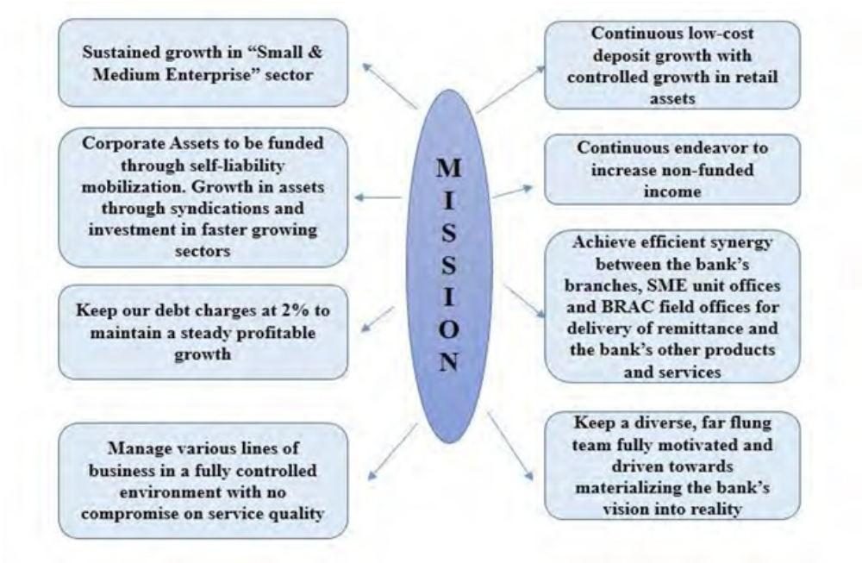

4.2. Organizational Vision:
Creating a financially sound, socially conscious organization that is centered on markets and businesses with room to grow, in order to support BRAC and other stakeholders in their efforts to create a Bangladesh that is enlightened, healthy, democratic, and devoid of poverty.

4.3. Values:
Our owner, BRAC, is the source of our strength. This means that while carrying out our duties, we shall adhere to and be led by the following values:
- We appreciate being a part of the BRAC community.
- Establishing a transparent, truthful, and supportive atmosphere.
- Maintain an intense concentration on your customers and cultivate partnerships built on honesty, excellence in assistance, then reciprocity.
- Aim toward sustainable development and revenue.
- Collaborate as a unit to fulfill company owner's needs as best we can.
- Unwavering on seeking out company innovations that is significant
- Recognize and appreciate individuals, therefore based judgments upon worth
- Recognition and rewards should be based on accomplishment.
- Being lawful, dependable, as well as accountable in whatever that we accomplish

4.4. Achievements:

    - Fastest growing bank in the country for the last two Years
    - Leader in SME financing through 300 offices
    - Biggest suit of personal banking &amp; SME products
    - Large ATMs (Automated Teller Machine) &amp; POS (Point of Sales) network

4.5. Board Directors:
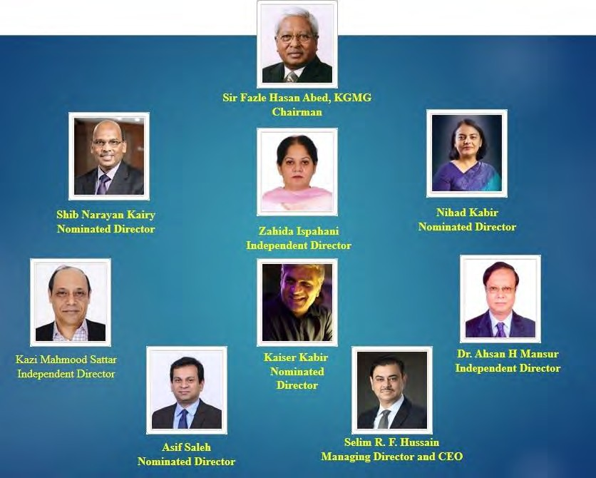

4.6. Organogram:
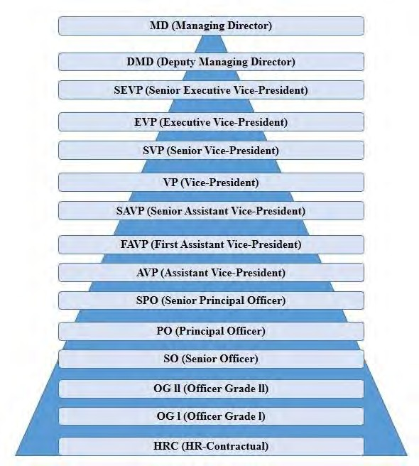

4.7. Divisions of BRAC Bank Ltd:

SME Banking | Retail Banking
Corporate Banking | Probashi Banking
Cash Management & Custodial Services | Human Resources

Finance | Credit Risk Management
Operations | Company Secretariat
Regulatory & Internal Control | Operational Risk Management
Treasury & Financial Institutions | Information Technology
Research & Development | Corporate Affairs

4.8. Products and Services:

The bank offers a broad range of products to meet the needs of customers from all social classes. Apart from typical offerings for the assets and the liabilities faces, the banking institution provides customized loan services to its clients.
- Funding for consumers
- Finance for Leases
- Micro Mortgage
- Funding for events
- Home mortgage.
- Funding for short-term as well as long-term loans.

4.9. Partners:

EPL Stock Brokerage Limited

BRAC EPL Stock Brokerage Limited is one of the leading stock brokers in the country. The two stock markets in the country, the Dhaka Stock Exchange, or DSE, and the Stock Exchange of Chittagong (CSE), both accept memberships from BRAC EPL Stock Brokerage Limited.

SAAJAN Exchange Limited:
BRAC Saajan Exchange Limited mainly provides remittance services to the large Bangladeshi communities living in the UK. In addition to providing remittance services, the Company offers investment services to the NRBs through its parent company, BRAC Bank.
Bkash:
A BRAC Bank subsidiary, bKash Limited, seeks to ensure that Bangladeshis have access to a greater array of financial products and services, including mobile money transfer capabilities. By providing dependable, practical, and competitively priced services, its main objective is to enable more economic opportunity for the low-income people of the country.

4.10. Strategic Focus

For BRAC Bank, the upcoming years will be quite important. Two major technology investment projects, ERP and Core Banking Upgrade, will be launched this year. That will be crucial for maintaining their company's momentum, cutting down on turnaround time, and enhancing customer support. With the implementation of the new branch banking model, all branches will serve as distribution hubs for corporate, retail, and SME banking solutions. In order to attract business from the Developing Industrial Services and Smaller and Middle-Sized Industry, which make use of their branch network. They want to persist with the current restructure aimed at streamlining the procedures, decreasing reducing turnaround time and enhancing client support. They will keep making investments in technology and human development.

Chapter 05

Human Resource Division of BRAC Bank

BRAC Bank Limited, one of Bangladesh's newest and fastest-growing banks, is an essential financial intermediary that connects the government's economic policies to the rest of the country's economy. By increasing aggregate demand and output and so generating wealth for the economy, the bank continuously benefits the people and the nation's economy. to continue being resilient while conducting profitable, growth-oriented, and socially conscious business in Bangladesh's highly competitive banking sector. The management committee and the human resources department of BRAC Bank Limited collaborate closely to achieve strategic advancements. BRAC Bank has one of the biggest human resources departments in the sector. In comparison to other commercial financial institutions, BRAC Bank employs a significantly larger workforce, which results in a larger management team. The HR department is a crucial component of the organization's assistance, as is already well known given that BRAC Bank is divided into two main divisions: business and support. Additionally, BRAC Bank is able to effectively handle a big number of staff centrally thanks to the well-organized support.
The Human Resource Division of BRAC Bank Limited, being a Bangladeshi bank and catering to the banking needs of Bangladeshis, maintains an adaptive human capital management strategy. The division is composed of the following departments: Learning and Development, Recruitment, Rewards & Benefits, Human Capital Department, and HR Administration Departments. A team of dynamic HR relation managers connects HR support with business needs.
According to BRAC Bank, the organization's greatest significant asset is its workforce. The HR Section of the BRAC Bank Limited pays careful attention to the significance of hiring a diverse workforce and selects employees of the highest quality through a rigorous hiring process that is based on the needs of the organization and the specifications of the position. The Bank actively pursues hiring the "best fit" in accordance with business needs and its core principles with proper recruiting planning, using successful evaluation methodology, ensuring efficient process, and building and maintaining a strong employer brand. This is because hiring the "right" people is what fosters learning, developing, growing, and striving organizations. All employees of the Bank have equal access to opportunities for professional growth and competitive compensation packages. In order to bolster the bank's continued expansion and the management team's dedication to bringing the bank to every customer's doorstep, the HR division has hired 4847 permanent staff members, 1139 external employees, and 2136 contract employees in a range of grades. In the process, the HR division has conducted approximately 14,000 in-depth interviews with job seekers.
BRAC Bank places a high value on its workers and works hard to create effective HR practices because they genuinely feel that people are the most important asset for success. The bank places a high priority on providing training to improve the abilities and skills of its workers, and to that end, they have appropriate training plans and timetables. For instance, BRAC Bank offers each employee thirty hours of training on average every year. BRAC Bank Limited offers computer-based training (CBT) via the BBL internet through an e-learning portal. Products and services, departmental and divisional overviews, laws and regulations, and a few soft skills are among the e-learning modules. BRAC Bank Limited's Human Resources department acknowledges the critical role that e-Learning plays in offering training and refreshers to its extensive nationwide workforce of employees. Each year, all regular Bank employees are obliged to participate in the online education exam and finish predetermined e-learning modules that are announced at the start of the year. The Human Resources division plans to use e-learning to step up its training efforts.
The bank adopts planned development activities to guarantee that managers and leaders will be needed in the future, in addition to training staff members to improve their skills and talents for a better grasp of job responsibilities. Through several in-depth internal as well as external training programs, the Human Resources division hopes to concentrate on skill growth and leadership development for the bank's staff. The HR division made sure that employees were aware of and participated in the celebration of local and international auspicious days by organizing a variety of promotions and events. Celebrities from a variety of fields were invited to participate in the celebrations of "Bengali New Year" and "Women's Day" as part of an employee engagement initiative. The celebrities graciously spoke on a range of topics, including work-life balance, gender equity, and women's empowerment through employment.

5.1. People Management, BRAC Bank Ltd.:

The "People" have been BRAC Bank's primary success factor in achieving success quickly. Therefore, the Bank's management places a high priority on finding, developing, and keeping exceptional workers. The Bank's human resources strategy is committed to meeting workers' interests and career aspirations, and it does so continuously. The bank sees its workers as its most significant asset since they are unique individuals with the potential to produce excellent results when creatively and thoughtfully guided. In keeping with the Bank's goal of expansion, the leadership team of the institution carefully chooses prospective future leaders from within its staff and goes above and above to develop them. BRAC Bank, Ltd. is a preferred employer in the labor market for a variety of reasons. Hardworking and talented personnel with the appropriate setoff intellect enjoy faster career growth at BRAC Bank Limited, a sophisticated and rapidly expanding bank. Along with the Bank's many notable CSR initiatives, a sizeable amount of its earnings go toward realizing its founder, Chairman, and Chairperson Sir Fazle Hasan Abed's vision of an enlightened, poverty-free Bangladesh, which he closely followed through on from the start. The Bank's management promotes an equitable, supportive, morally grounded, and ethical workplace environment. The Bank's staff members take pleasure in contributing to its continued growth and success.

5.2. Types of employees:

Contractual Employees: Contractual workers are engaged for a set amount of time, such as six months. In addition to their pay, they receive a desirable performance bonus in the event that they meet the organization's goals. HR temporary contracts are intended for those categories whose job descriptions require them to work directly under the authority of the bank, with bank management overseeing their performance.

Full time/Regular Employees: Employers set a minimum number of hours that full-time workers must put in. An official definition of permanent employment does not exist. They may be paid on an hourly basis or as salaried workers, in which case their monthly income is predetermined. Employees in the full-time group begin their employment as probationary for either six months or a year, depending on the type of work. In addition to their base pay, ordinary employees are eligible for bonuses, incentives, and other benefits. Additionally, these workers benefit from additional amenities that BRAC Bank Limited offers to its staff members.

Employees from outsource: The act of assigning specific job functions to an organization or an individual rather than having an internal department or employee perform them.There is no entitlement to any service agreement for other contractual employees. They'll be hired by means of outsourcing companies. Any request for support staff from an outsourcing company must go through HR and be approved by the division head. HR will transmit the Outsource Agency's request for staffing. Recruitment of Outsourced Staff is contingent upon the departments' budgeted need for personnel. The salaries of the outsourced staff are set, and they do not receive any further compensation.

Interns: In order to promote and facilitate the development of human resources in the financial sector, the Bank may choose to provide internship opportunities to individuals or academic institutions. On the department head's advice, the MD&CE will decide whether to enter such an arrangement. With the Head of HR's advice, the HRD will draft the proposal for such an engagement with a person or organization before submitting it to the CEO and MD for review. A combined remuneration of Tk. 10,000 will be given to those hired as interns each month.

MTO: BRAC Bank Limited's highly skilled Management Trainee Officer students. Although the MTOs are regular employees, they must spend a year learning as students at BRAC Bank. If they successfully finish their learning time within a year, they will be promoted immediately from the MTO to senior officer status.

5.3. Various Functions of HR divisions:

An effective human resources department may give a company structure and the capacity to handle commercial demands by effectively managing its most precious asset, its workforce. Small firms without an in-house human resources department can nevertheless manage their workforces and achieve the same degree of efficiency by joining an experienced employer group or outsourcing HR operations. With the assistance of personnel, BRAC Bank Limited has a fully operational Human Resources Division (HRD). BRAC Bank Limited's HRD carries out the following duties:

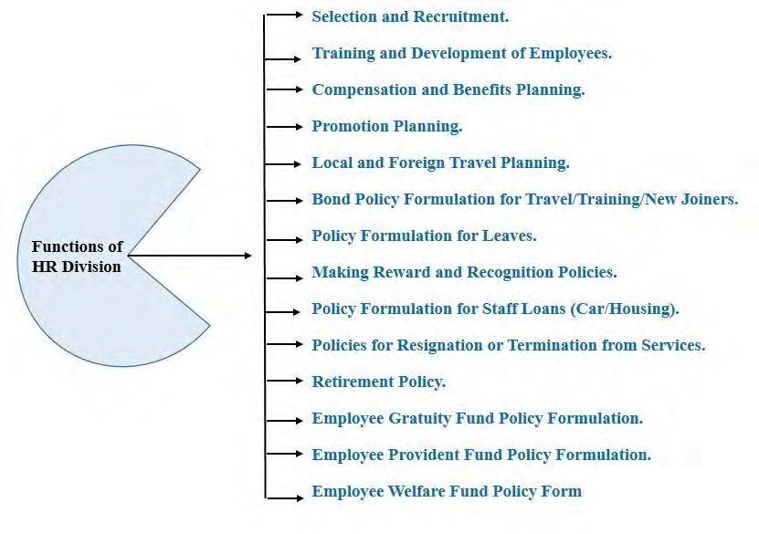

5.4. Wings of Human Resource Division:

There are presently 5 distinct wings within the Human Resources Department. These are the following:

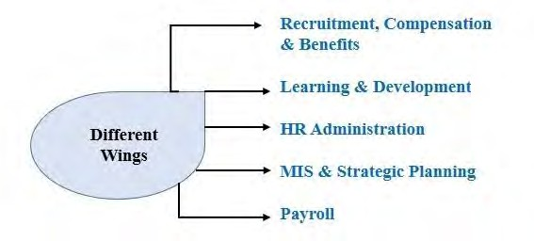

5.5. Recruitment

Any organization that primarily depends on its staff to carry out its goal and eventually realize its vision must prioritize recruitment. Therefore, a crucial component of managing human resources is the proper selection of applicants for employment, which is handled by BRAC Bank Limited's human resource division.

The recruiting team is in charge of gathering:

Resume

Job Applications

Internship Applications and etc.

The hiring managers gather and file these paper copies in addition to routinely updating and maintaining computer databases. The recruiting officer's job is to arrange potential applicants' resumes so that they can be located and shortlisted in a timely manner when hiring is needed. The main notion behind the recruitment division's duties is that following the shortlisting of CVs, the shortlisted candidates are contacted (typically over the phone) to schedule interviews. Letters are sent out to the candidates' mailing address when there are many candidates. These follow the schedule for interviews that was established prior to getting in touch with the candidates. Before contacting the short-listed applicants, the departments that submitted the demand for the needed manpower communicate with each other to set up an interview or examination time. Along with the HR Head, the corresponding Department Heads and cross-departmental heads join the interview board. The Interview Score Sheet is obtained by the recruitment division following the interview and is printed and given to the interview board prior to the commencement of the interviews. The final candidates chosen for each role are listed using the completed Interview Score Sheets. The Recruitment Division asks the candidates who are ultimately chosen to pick up their appointment letters from the HRD, as indicated by the Score Sheets. After being welcomed, the new hires complete the necessary paperwork (bond signing, PIN number assignment, etc.) and are given a joining date for their departments. Written examinations are only scheduled when required, typically in situations when there are many applicants. In order to schedule orientation or first training sessions for recently hired staff members on time, recruitment officials must coordinate with learning and organization development officers prior to the recruitment process being fully completed. This is commonly done since initial training or introduction is often required for the positions that are being filled.

Additionally, BRAC Bank offers a wide range of internship opportunities to students nationwide. One of a recruitment officer's duties is to inquire about available internship opportunities and communicate with other departments. Every time an internship opportunity arises in their particular stations, departments and branches also get in touch with the recruitment team. The recruitment officer can choose an intern by matching the student's subject of study with the available department. When applying for a position that is open, BRAC Bank HRD offers preference to interns who have successfully finished an internship within any department or location of the bank.

The following are the steps that make up a recruitment process:

A correctly completed Staff-Requisition Form is turned in by the manager or head of the relevant department.

If the Manpower Budget fails to endorse the Request for the year, the Managing Director must sign and approve a Non-Budgeted Requisition that outlines a legitimate basis for the hiring.

The next step is to identify the type of recruiting so that the CVs' source may be determined. An external job watch with the post's details must be distributed via Lotus Mail to every employee of the bank for a full-time or regular position. For a position given through mail, external resumes are also welcomed; however, in these situations, the relevant department will favor internal candidates because certain positions call for current, seasoned bank workers. For instance, an HR Contract employee who has worked satisfactorily in the Unsecured Content Center for the last two years is typically preferred for a Regular role that is open in the Unsecured Value Center.

In order to apply for an internal job watch, current regular workers must meet the following requirements:

a) have worked in their present department for a full year following confirmation; and

b) have completed one year of continuous service.

c) Minimum performance rating of "P" (for Proficient) is required.

d) must have finished the eight required online courses.

Two years of continuous employment in the present department is a requirement for HR contracts.

The recruitment wing reviews the archive of resumes submitted for any open positions, and for significant hirings, we publish announcements in newspapers. Typically, in "The Daily Star" and "Prothom Alo."

The Recruitment Wing reviews all the resumes as a first screening step and forwards them to the relevant departments that submitted requisitions for a final short listing on the day an Internally Job Monitor closes or a Paper Advertisement reaches its deadline for CV submission. After deciding on a time for the interview and location, the applicants that were ultimately chosen are then called for an interview or, in the event of big recruitments, such as CROs for SME Banking, provided interview cards.

Policy for the Recruitments:

The Managing Director will appoint all regular staff members.

The Head of the Human Resource Division will appoint all HR contract and outsourced contract personnel.

The interview board will consist of the HRD Head, the Head of the Supporting Department, and the Head of the Department for that position.

Employees are only eligible to apply for internal job postings if they have worked for BRAC Bank for more than two years. Their reporting supervisor must also recommend the candidate's application.

If the newly hired employee has fewer than a decade of work experience, they will have a one-year probationary period; if they have more than three years of work experience, they will have a six-month probationary period.

5.6. Compensations and Rewards:

The Bank is dedicated to implementing a compensation strategy that is equitable, competitive, and adaptable. The Board will periodically review and update this policy based on recommendations from the Managing Director and Management Committee. The Board has the last say over adoption of this policy. The bank's compensation policy will apply to all employees who work for the bank on a permanent basis.
Salary information is kept private between the management and the affected personnel. These job grades' wage ranges are periodically reviewed. HR Outsourcing and temporary employees are not allocated a job grade. Every month, the contracts receive a single, combined payment; no further benefits are applicable aside from commission determined by job requirements.
Basic Pay:
The Board sets Basic Salary Range (BSRs) based on the Managing Director's recommendation and in accordance with the job grades. At least once in two to three years, the Board evaluates the BSR.
Rent allowance:
Employees may receive House Rent Allowance at the rates and under the guidelines that the Competent Authority may from time to time specify.
Medical allowance:
Medical Payments may be paid based on job grades and under any circumstances that may occasionally be stipulated by the Competent Authority.
Festival Bonus:
Every year, two bonuses are awarded to all confirmed and regular employees. Two bonus periods are offered to employees of different religions: one during Eid-Ul-Fitr and another in Eid-Ul-Azha exclusively to Muslims. The Payment, Pay & Benefits division also oversees a performance bonus program. But the MANCOM always makes the final assessment decision.
In addition to the aforementioned benefits, the bank maintains an employee security and welfare fund, a provident fund structure, a gratuity system, and a group hospitalization insurance policy. Regular and verified workers are eligible to apply for auto and house building loans. Only regular or confirmed personnel are eligible for allowances, whereas those in grades higher than Senior Principal Officer (SPO) are only eligible for car allowances.
Performance Bonus:
The Supervisory Board of Directors may designate a specific portion of the pre-tax earnings as a performance bonus, depending on the Bank's profitability. Performance Matters will be the source of the contribution measurement. Performance matters for this purpose must be made based on the periodically modified management-established criteria. The distribution mechanism will be at the discretion of management, and the performance bonus amount will be 3% of net profit after taxes. Employees who receive a mediocre or unacceptable rating will not be eligible for a bonus. After completing a grading process, the MANCOM will decide on the Final Evaluation for the bank as a whole in order to ensure that an agreement is established.
Leave Fare assistance:
For all Bank permanent workers who have worked for the company for at least a year, leave fare support is a one-time benefit. As per the policy of Bangladesh Bank, all permanent employees are required to take 15 days of mandated leave in one go. LFA would be provided throughout this leave period to encourage everyone to take the leave. In its 92nd Meeting, the Board adopted the LFA. In order to guarantee that its workers take their full 15 days of obligatory vacation at one time, BRAC Bank offers vacation Fare Assistance. This will undoubtedly improve worker satisfaction and increase competitiveness with other organizations in the sector.
Telephone policy:
All facilities allow mobile phone sets (T&T coming in, outgoing, and Smu connection) for employees ranked AVP and higher. Below AVP bank employees are asked to purchase a post-paid mobile phone on their own dime in accordance with departmental requirements. They are also assigned a cap based on the extent of their work capability. Prior to filing for payment disbursement, all others—aside from SME—must have their monthly bill authorized by the departmental or divisional head. Other people can use a bank's mobile services as long as they get prior authorization from the appropriate authority.
Security Fund:
The fund's goal is to give a predefined financial benefit to a normal employee's dependent, heir, or nominee nominated by the bank in the event of their death or permanent disability. All Regular Confirmed workers are qualified to receive this perk. Only The Bank's Contribution will be used to establish the account for this benefit. Every year, the Bank will deduct Taka 5.00/Thousand from each eligible employee's last basic wage. (The board's consent is required before changing the contribution rate.) To administer the fund, the Bank keeps a liability account open.
Provident Fund:
10% of each regular confirmed employee's basic pay must be contributed to the BRAC Bank workers' provident fund by the employer, BRAC Bank Limited. Upon retirement or departure from their position, every member of the fund receives a retirement benefit based on the terms set forth in the fund. This game began to function on January 1st, 2003.
The fund's management, investment, and control are within the purview of a board of trustees. The Chief Operating Officer, also known as the COO, has the authority to nominate new board trustees and to remove any incumbent. The term of office for each trustee is three years.
Contribution:
Each member makes a monthly contribution, as specified by the rules, which the bank deducts at the point of payment. The monthly contribution is equal to ten percent of the base wage. The employee's contribution is matched by BRAC Bank Limited, which pays each member 10% of their base income each month. Interest related to the income from fund investments is credited to each member's account every six months. The amount provided by the bank and the amount provided by the members are credited to each member's account separately in a unique ledger maintained by the trustees at the bank's main office in Dhaka.
Payment:
Subject to the duration of their participation in the contributing provident fund, the employee has the right to collect the employer's contribution and the accrued interest at the time of departure or retirement. The employee will not be qualified to receive each of the aforementioned contributions if they have been an employee or a period of time equivalent to one year. The additional contributions can only be obtained by him/her during the membership period. The member is eligible for 50% of the employer's contribution and accrued interest if their membership has lasted for three years or less. The member is entitled to 100% of the cumulative interest and employer's contribution if their membership has lasted more than three years. Should a member be removed from the group for carelessness or incapacity, they are entitled to collect their own contribution plus any interest that has accumulated at the predetermined interest rate. On the other hand, the bank's contribution can be forfeited and divided among the participants based on their respective balances. The same holds true if a worker is let go from a bank for dishonesty or fraud. To be sure, the trustees alone will determine whether or not the reason for the forced retirement or dismissal is important enough for these objectives.

5.7. Promotion Pattern:

A continual process, promotion is meant to reward employees for their superior performance and to push them to do even better. There are two kinds of promotions offered by BRAC Bank:

Regular Promotion:
Regular promotions are granted based on an employee's consistent performance. When an employee's supervisor and department head determine that they are a valuable asset to the bank and should be promoted, they obtain an evaluation form from Hr and suggest the person for advancement. The Deputy Manager of BRAC Bank, Ltd. receives this assessment form from the HRD head with his permission signature, and she forwards it to the Managing President of BRAC Banking Limited for approval before the Managing Director signs it. The employee shall be promoted and get a pay increase in accordance with the comments and remarks on the appraisal form.

Chapter 06

My Internship Experience

I had a 12-week internship with BRAC Bank Limited as part of my internship requirements. Working with BRAC Bank Limited, one of Bangladesh's fastest-growing banks, was an amazing opportunity. I've had the opportunity to study and develop at BRAC Bank in addition to my regular work duties, which will help me in my future professional endeavors. I have complete freedom to work in the BRAC Bank HRD. The HR Recruitment wing has provided me with complete assistance throughout my internship program in the Human Resource Division. I've added value to BRAC Bank HRD, which is covered below:

6.1. Job Responsibilities:
- Called the candidates to inform them about the interview schedule, date and venue.
- Prepared brief profiles for the candidates.
- Conducted interview sessions efficiently, ensuring a smooth process through clear communication.
- Effectively addressed candidate queries about interviews and onboarding.
- Assessed candidates for their joining formalities.
- Prepared personal files for the employees.
- ensured all necessary paperwork is in place for new hires.
- Efficiently executed onboarding sessions for 150 candidates during my internship, showcasing adept organizational and leadership skills in facilitating successful integration into the company culture.

Chapter: 07

Literature Review on SWOT Analysis

7.1. Introduction to SWOT Analysis

The strategic management method known as SWOT analysis, which refers to Strengths, Weaknesses, Opportunities, and Threats, offers a thorough framework for assessing the internal and external elements impacting an organization's performance.(GÜREL, 2017). This analytical technique is frequently used in company strategic planning to acquire understanding of an entity's present situation or potential future states. (STRATEGIC PLANNING AND SWOT ANALYSIS, n.d.)

7.2. Historical Development of SWOT Analysis

Originating in the 1960s, SWOT analysis has developed into an essential part of strategic management. Albert Humphrey first presented the idea while working on a project at Stanford University's Research Institute(Puyt et al., 2023). The framework has been improved and tailored throughout time to fit different organizational settings and industries, and it is now a crucial component of decision-making procedures all around the world.(Puyt et al., 2023)

7.3 Components of SWOT Analysis

An organized method for evaluating the internal and external environments of an organization is provided by the following four elements of SWOT analysis:
- Strengths (S): Internal characteristics and assets that provide a business with a competitive edge. A strong brand, effective procedures, a knowledgeable staff, or cutting-edge technology are a few examples. (Rahman, 2016) (GÜREL, 2017),
- Weaknesses (W): Internal elements that make it more difficult for an organization to accomplish its goals. These could include inadequate management, out-of-date technology, or scarce financial resources. (Benzaghta et al., 2021; GÜREL, 2017)
- Opportunities (O): Outside elements that the organization may be able to take advantage of. These can be modifications in customer behavior, emerging markets, or technical breakthroughs. (Benzaghta et al., 2021)
- Threats (T): External elements that could endanger the company. These could include shifts in regulations, fierce competition, or economic downturns.

7.4. Purpose and Benefits of SWOT Analysis

SWOT analysis is essential to strategic management for a number of reasons:
- Strategic Planning: By balancing internal resources with external prospects, SWOT analysis assists firms in determining the most important areas for strategic concentration.
- Risk management: Organizations can proactively create plans to reduce risks and overcome obstacles by assessing possible threats. (Benzaghta et al., 2021)
- Resource Allocation: Allocating resources effectively and maximizing capabilities is made possible for businesses by having a clear understanding of their strengths and weaknesses.
- Making Decisions: Based on a thorough evaluation of their internal and external environments, companies can make well-informed decisions by utilizing the organized framework that SWOT analysis offers.

7.5. Criticisms and Limitations of SWOT Analysis

The analysis of SWOT is a useful tool, but it has drawbacks and restrictions as well. Critics contend that it may fail to sufficiently take into account dynamic and quickly changing circumstances and that it can simplify difficult strategic concerns. Furthermore, biases in the gathering and processing of data may affect how accurate SWOT analyses are.(Benzaghta et al., 2021; GÜREL, 2017)

7.6. Application of SWOT Analysis in the Banking Sector

Due to its extreme dynamism and sensitivity to changes in the economy, the banking industry can greatly profit from SWOT analysis. With the help of this technology, financial institutions may better understand their competitive advantages, fix operational inefficiencies, and take advantage of new market opportunities. (Business Using SWOT, n.d.)

Chapter 08

SWOT Analysis

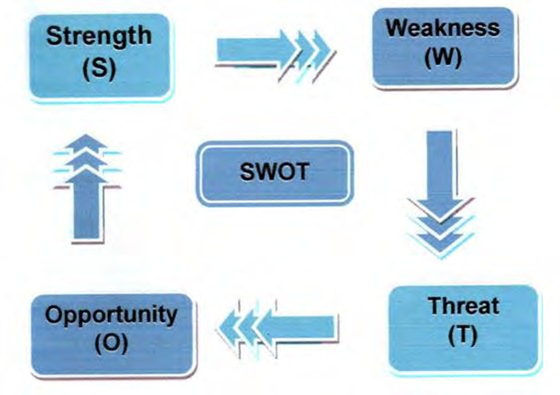
A strategic planning process generally begins with or includes a SWOT analysis. Because it helps an entity see chances for success that were previously unarticulated or to highlight hazards before they become unduly burdensome, the framework is regarded as a valuable support for decision-making. An entity, whether it be a company, a person, or a bank, should employ a SWOT analysis to help it understand where it stands both now and in the future in the marketplace or in relation to a specific objective. Put differently, upon identification of the SWOT variables, decision-makers ought to possess enhanced capacity to determine the viability of a project, initiative, or product and the necessary conditions for its triumph. Consequently, the analysis's goal is to assist an organization in allocating its resources according to the level of competition in which it works.
8.1. Strength:
BRAC Bank Ltd. is the best bank in Bangladesh, based on the CAMEL ranking. The bank's liquidity, management, asset quality, earnings, and capital sufficiency all go into this assessment. Bangladesh Bank releases the ranking after keeping an eye on these factors. The bank's greatest strength is its current position at the top. This is the rationale behind the bank's reliance on all of its corporate and household clients. Other strengths are-
- The Bank holds a good reputation within the industry. At the 23rd ICAB National Awards 2023, BRAC Bank outperformed all other commercial banks in the country in terms of integrated reporting. BRAC Bank received the Gold Award in the area of integrated reporting for its contributions to sustainability initiatives, influence on society, and generation of value for customers, shareholders, and stakeholders.
Additionally, BRAC Bank received second place in the ICAB Best Published Annual Reports 2022 for Private Commercial Banks under the Best Presented Annual Reports category.

- Perfect policies are in place at BRAC Bank Limited to uphold and manage their workforce. Since BRAC Bank employs a huge workforce, which is extremely difficult for any organization to manage, the bank is doing a great job of managing this enormous workforce. Customers of the BRAC Banking Software Token can read about BRAC Bank Limited's privacy policy, which is devoted to protecting client privacy. The information gathered, shared, and safeguarded via the app for mobile banking is covered by the policy. By downloading the program, users affirmatively consent to the terms listed and accept security protocols. Voluntary disclosures, transactional information, and device-related data are among the types of information gathered. The bank uses this information to handle applications, improve security, and meet regulatory obligations. For as long as the relevant mobile application function is used, user-provided data is kept. Although the bank uses security steps to safeguard data, it makes clear that no electronic technique is 100% secure. Location tracking helps with security protocols, and data can be processed and forwarded to Bangladesh. The policy offers contact information for questions and highlights how important it is to protect children's privacy. Changes to the policy are posted on the application and take effect immediately after. Users are advised to evaluate them. (CODE OF CONDUCT, n.d.)

- A well-kept database of resumes. Every CV is kept on a monthly basis, making it simple to locate the CVs when needed. During my internship period, I have organized various CV for various positions. For Example, they maintain files for the resume of Head of Audit in separate files according to the years, months and dates.

- Improved employee motivation through internal hiring opportunities. They have hired their interns in various permanent positions. In 2022, they hired Papri Biswas, an intern in an officer position after completing the internship program.

- Training opportunities are offered to all employees, regardless of their level. Training is given to every employee to help them perform better. They have a separate department for employee training name Learning and Development. This team handle the part where they make sure every new or existing employee get their required training through proper trainers.

- Effectively collaborated with other BRAC Bank departments. Each and every department has improved understanding and excellent communication with one another. Consequently, they produce useful results. During my internship, I have seen various teams and departments working together while solving an issue. During the salary period I have seen the HRM and Finance team work and communicate to get better outcome.

8.2 Weakness:

There are some weaknesses:

- The wage structure needs to be adjusted because the pay is not commensurate with the amount of work. Numerous factors lend credence to the claim that BRAC Bank PLC's compensation structure has to be adjusted. According to industry norms, if a bank's salary is much less than average for similar tasks in the banking business, there may be a mismatch between pay and workload. Employee opinions on job portals and employee feedback platforms, in addition to internal surveys, can offer insightful information on individual viewpoints on pay in relation to work volume. For example, while working inside the recruitment team I saw Relationship Executive employees showing their dissatisfaction regarding their wages. Excessive employee turnover within the bank could indicate discontent with the current salary structure, particularly when contrasted with industry comparisons. It is imperative to do a comparative analysis inside BRAC Bank, with a particular focus on any potential differences in remuneration for comparable tasks.

- Superior level references are also accepted, as their resumes are always considered first when hiring, regardless of whether the applicant is underqualified for the available position. BRAC Bank is required to maintain rigorous requirements in its hiring practices as a preeminent financial organization, stressing the value of reliable references in assuring the caliber and dependability of new workers. Employment advertisements and prerequisites could reveal the financial institution's emphasis on references from higher-ups, and any remarks made in public by BRAC Bank officials or leadership about the value of these recommendations could serve as oblique proof of the claim. It is important to contact the bank's HR and recruitment department in order to acquire the most up-to-date and correct information. They can offer valuable insights into the hiring process, including the consideration of references at a higher level. Testimonials and experiences from employees may also reveal whether superior-level referrals are important to the banks.

- A company such as BRAC Bank Limited does not have enough control over its human resource situation to use it optimally. There are not enough refreshments in relation to the workload. Employees who are under too much work pressure occasionally become depressed about their jobs. The team that I worked with had 8 members and one of them is going to leave the job in upcoming month. She holds the position of Associate Manager. So, the workload of team became intense and the other people are currently responsible for the duties of associate manager.

- Controlling and maintaining a large number of employees is challenging due to a shortage of manpower. During my internship, I have witnessed various mess while recruiting a large number of candidates. I, alone had to work for around 60 people at a time which was quite challenging.

- The transportation facility ought to be provided at no cost. For junior level officers, BRAC Banks' 2500 taka per person transport cost is very expensive. Most of the employees showed their dissatisfaction regarding that.

8.3. Opportunities:

- As was previously mentioned, BRAC Bank Limited is a well-known bank in Bangladesh. This Bank is trusted by importers and exporters alike. BRAC Bank Limited employs roughly 8,000 people. This bank's enormous workforce contributes to its increased productivity by generating a variety of ideas and plans. The Human Resource Division is constantly coming up with new ideas for how to engage its staff members in a way that will inspire them and make them more valuable assets for BRAC Bank Limited. There aren't many Bangladeshi organizations that have this kind of opportunity.

- By 2025, BRAC Bank Limited hopes to have doubled its commercial stake in the nation's banking sector by leveraging its two core competencies, digital transformation and corporate governance. The objective was established in January 2022, as part of a four-year development strategy, at a time when the nation's top private commercial financial institution had already attained a 2.2% market share.

- The bank wants to reach this lofty goal at a moment when the instability of the global economic fronts has continued to put pressure on the economy. Mr. Hussain said that the bank achieved a 24 per cent increase in deposits in 2022, but the industrial average was only 7 per cent. He also mentioned that the bank had a 28 per cent rise in lending, which was more than the 13 per cent industrial average.

- According to Mr. Hussain, CEO of BRAC Bank, there are elements that contribute to the inflated bad loans, and he described the expanding NPL (non-performing loans) as the biggest concern facing the banking industry. Although new courts must be added in order to enhance the legal system and the laws already in place, not enough money has been invested in this area in recent years

8.4. Threats:

- BRAC Bank Limited employs a sizable workforce. Thus, with so many employees, it is challenging to uphold the HR policies. At BRAC Bank Limited, managing HR policy for a large staff presents typical issues found in large enterprises. During my internship I was a part of the internal communication of HRM and I observed that the magnitude and intricacy of a heterogeneous labor population may provide challenges to the uniform application and enforcement of human resource regulations in different positions and settings. It becomes difficult to ensure good policy communication, particularly in a changing financial environment, which could result in misunderstandings. Much resources are needed for policy changes communication, extensive training, and compliance monitoring for a huge workforce. Organizations frequently invest in HR IT solutions and set up routine audit procedures to address these issues.

8.5. Some critical issues:

- When hiring, BRAC Bank does not rely heavily on paper advertisements. They only use platforms lie BD Jobs. They will place an advertisement in the newspaper only after hiring Management Trainee Officers and higher-ranking staff members, such as the CEO. More paper ads should be distributed so that more people are aware of it.
- Inadequate personnel in relation to the entire bank staff. Due to a shortage of personnel, there is a lot of unfinished business in the HR administration and pay roll departments. Therefore, they should hire enough employees to meet the needs of all HR wings. They occasionally leave a ton of work unfinished. The work will not remain unfinished if they regularly review the documents.
- The current HR software has to be updated and changed. The software that they use is called Taleo. Many functions should be updated regarding candidate and employee information should be updated to get smoother recruitment process.

Chapter 09

Recommendation and Conclusion

9.1. Recommendation:

The bank’s human resources division is doing well. However, a few things ought to be mentioned. Based on the updated SWOT analysis, I would like to suggest a few changes to the factors.
- Junior officers should be provided transportation facilities.
- Make the employee's wage structure appealing.
- It is recommended that they augment the HRD staff in the recruitment wing.
- Managerial control needs to be executed flawlessly.
- Make sure the individual receives appropriate training, with a focus on motivation.
- Improved support for MIS is necessary to ensure seamless operation.
- There isn't a designated location where interns can work. It should be enhanced that interns don't have to wander around looking for a spot to work; instead, they should be assigned a fixed location where they can work properly.
- It is imperative that BRAC Bank implement appropriate succession planning in order to advance eligible employees to higher positions and serve as a source of motivation.
- Plan extracurricular events that will provide employees with incentive and lower their turnover rate.
- Rules, policies, or guidelines that are given to recruitment officials for CVs that are rejected following an interview need to be implemented.
- When they require employment, they should use newspaper advertisements.
- It is imperative that BRAC Bank prioritize quality over amount when hiring new employees.

9.2. Conclusion:
BRAC Bank Limited's human resources department is robust, helpful to its staff, and effectively coordinates with other departments to accomplish the organization's objectives. It is not the total number of employees in a company. It is the culmination of all of their skills, knowledge, aptitudes, and creative abilities in addition to their values, attitudes, and optimistic outlook. The last nine years have seen a growth in BBL's corporate culture, giving employees several chances to assume responsibility and initiative. The difficulty lies in upholding a corporate culture that is as dedicated to business as BBL's objective. Globally, organizations are evolving and becoming better at a rapid pace. The assessment procedure, which includes a variety of assignments, controls this quality. The bank sees its workers as its most significant asset since they are unique individuals with the potential to produce excellent results when creatively and thoughtfully guided. In keeping with the Bank's goal of expansion, the leadership team of the Bank actively seeks for among its workforce future leaders and goes above and above in their development.

References

- Benzaghta, M. A., Elwalda, A., Mousa, M., Erkan, I., & Rahman, M. (2021). SWOT analysis applications: An integrative literature review. Journal of Global Business Insights, 6(1), 55–73. https://doi.org/10.5038/2640-6489.6.1.1148
- Business using SWOT. (n.d.).
- GÜREL, E. (2017). SWOT ANALYSIS: A THEORETICAL REVIEW. Journal of International Social Research, 10(51), 994–1006. https://doi.org/10.17719/jisr.2017.1832
- Puyt, R. W., Lie, F. B., & Wilderom, C. P. M. (2023). The origins of SWOT analysis. Long Range Planning, 56(3). https://doi.org/10.1016/j.lrp.2023.102304
- Rahman, K. M. (2016). Strategic Planning and Marketing Models. In Strategic Marketing Management in Asia. Emerald Group Publishing Limited. https://doi.org/10.1108/978-1-78635-746-520161003
- BRAC Bank Limited 2016, Annual Report (Online), Available from:
https://www.bracbank.com/financialstatement/Annual%20Report%202016.pdf
    - BRAC Bank website, Available from:
https://www.bracbank.com/
    - HR Operations of BRAC Bank Limited. Available from: http://www.assignmentpoint.com/business/human-resource-management/hr- operation-of-brac-bank-limited.html
    - General Information of BBL. Available from: https://en.wikipedia.org/wiki/BRAC_Bank_Limited
    - David A. Decenzo & Stephen P. Robbins “Human resources management” 7th edition, Available from: file:///C:/Users/Mypc/Downloads/Fundamental%20of%20Human%20Resource%20M anagement%20 (1).pdf
    - Gary Dessler “Human resources management, 10th edition, Available from: https://evergreenvmw.files.wordpress.com/2015/03/gary-dessler-human-resource- management-nicebrothers-blogspot-com.pdf
- Recruitment Policy & Procedures, Colette Kelleher, March 2014, Available from: http://www.fedvol.ie/_fileupload/Quality%20&%20Standards/Policies%20for%20We bsite/Recruitment%20Policy%20&%20Procedures.pdf

