

INTERNSHIP REPORT
On
Advertising Agency




Internship Report
On
Saturday Digital & Advertising

Supervised By
Dr. Seyama Sultana
Assistant Professor
School of Business and Economics (SOBE)
United International University

Prepared By
Mahmudul Hasan Reza
ID -111 142 196
School of Business and Economics (SOBE)
United International University

Date of Submission
3rd May 2019

Letter of transmittal

3rd May 2019
Dr. Seyama Sultana
Assistant Professor
School of Business and Economics (SOBE)
United International University
United City, Madani Avenue, Badda, Dhaka 1212

Subject: Submission of Internship Report

Dear Ma’am,
This is an amazing privilege for me to exhibit my temporary job report titled “Internshipat Advertising Agency” authorized under your supervision. As you definitely realize I am right now working for "Saturday Digital & Advertising" one of the main promoting organization of bangladesh I recently finished some hit TVC for Shohoz named “Matha Nosto Food Fest” and for “Pran” named “Pran Gura Moshla Rannay Valobasha er Chowa”.
I have been an indispensable piece of the ventures and observed it to understand the production and how the agency co-operates with the whole process of making an advertisement.
I attempted to put my best exertion for the readiness of this report contingent upon my experience. I am incredibly grateful to you for your keen help and supervision. However in the Report that any issue emerges; it will be my pleasure to answer any elucidation and proposal in regards to this report.
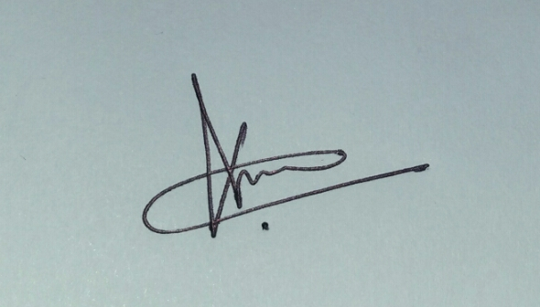Sincerely Yours,

……………………………
Mahmudul Hasan Reza
ID:111 142 196
United International University
Executive Summary

This report accentuation on the job contacts an Intern. I have gathered it in the Customer Administrations branch of Saturday computerized and Promoting from February 5, 2019 until April 30, 2019. In this report, basically I have incorporated my experience at Saturday Digital & Advertising especially production line management, campaign management, research and development works etc. Also I had administer details about my job involvement at Saturday Digital & Advertising with all-inclusive job details. Where I needed to work with numerous nearby brands and worldwide brands and an examination on the demonstration of customer administration. Begun its adventure on December 17, 2014 in Bangladesh, Saturday Computerized and Publicizing has dependably been saving quality administration. In this report, I have incorporated a rundown of their customers and brands they are overseeing. Additionally, I talked about crusades and generation that I needed to oversee where some inventive customer administration done by Saturday Advanced and Publicizing. Where I followed-up by my area of expertise's manager under innovative and customer administration division. I likewise consider about the report on the obligation of creation line the board. The report dispassionate is to find out the goal of client service route over the prevailing marketing from the buyer point of view to find out how marketing route is helping current marketing system for client. This report will disseminate legitimate data for the advertisers. In Bangladesh there is an organization customer remove, on the off chance that we can be chopped down it, and then the two gatherings may carry out the responsibility in all respects serenely. Once more, most offices and corporate are not pondering advanced advertising enthusiastically till now. More commitment required in advanced media which may give a greater perceptibility of the brands and which is create increasingly awesome the publicizing and advertising weight.

Table of Contents
Chapter-01 1
(Introduction) 1
Introduction 2
Background of the Study 2
Rational 3
Chapter-02 4
(Literature Review) 4
Industry Overview: 5
Company Overview: 7
Chapter-03 10
(Job Responsibility) 10
Team Work 11
Brainstorming 11
Chapter-04 13
(Activity of Organization) 13
Saturday work with some happy clients: 14
TV/Web Commercials: 15
Print Media Ads: 16
Social Media Contents 17
Website Designs 18
Social Media Apps 18
Brand identity 19
Chapter-04 21
(Conclusion and Recommendation) 21
Conclusion 22
Recommendation 23
References 24

Chapter-01

(Introduction)

Introduction

Promoting is one of the basic components in logo and business boss interchanges which offer records which may furthermore also help take an outstanding purchasing choice through the customers. As a matter of fact, functional fellowship is the last produced using promoting and publicizing which can likewise offer business administration’s or items to the point gathering. A showcasing company makes designs and deals with all components of a customer's promoting and publicizing. Advertising groups can consciousness on unique regions, including interactive advertising, or they may be a complete-provider corporation that creates advertising materials like INTERNET websites, on line and social campaigns, brochures, catalogs, direct mail, print classified ads, radio and TV advertisements, earnings letters, and more.
Lately, publicizing and showcasing venture in Bangladesh is advancing a ton. Among the top promoting and showcasing offices in Bangladesh, Saturday Advanced and Publicizing has accurately found its call doing wonderful works for the promoting undertaking in Bangladesh. The creating advanced promoting name for in Bangladesh made Saturday Computerized and Publicizing centering more at the computerized media. In this record, the data and things from Saturday Advertisements is utilized to perceive the jobs of computerized promoting and showcasing and publicizing over conventional publicizing and advertising.

Background of the Study

The file, titled INTERNSHIP REPORT On Advertising Agency A context on Saturday Digital & Advertising has been qualified to achieve the partial obligation of my Internship of BBA Program of UIU Business School, supervised by, “Dr. Seyama Sultana” Assistant Professor of School of Business and Economics (SOBE) at United International University. I have been hook up all kind of services and works of “Saturday Digital & Advertising” which is perceiving and seasoned there on 05th February, 2019 until 30th April, 2019 and I have prepared this file in connection with my empower role.

Rational

The wellsprings of the data are gathered from various branch of Saturday Computerized and Promoting and other association of this industry, different archives which is distributed on sites. For gathering the data I am attempting my best and buckle down. Be that as it may, it was hard to gather data without commonsense work on various branch of the Advertisement office. Every single industry has a few restrictions; on the off chance that they can recoup it, at that point they will get more achievement. Presently I am discussing a few issues. These are as per the following:
These days in Bangladesh Advertising Offices assume an extraordinary job to make the style of promoting current and one of a kind; you may locate countless offices in Dhaka, which are every day worked. In any case, it's inadmissible that there is no network of them. Every one of them are proceeding with their very own standards and guidelines. They don't have any base. When they face any issue, comprehend it by their own specific manner. Notwithstanding the role that we do the most inventive things in advancing, are continually misinterpreted. To run this industry easily, offices ought to have a network.
But some huge office by far most of the organizations is not formally sorted out. They have carried out their responsibility adhoc premise and not kept up corporate information recording process. In this industry by far most of the work accompanies short due date. Organizations are confronting troubles to finish the activity to satisfy the customer's desire inside due date because of absence of ability and well game plan. Organizations ought to send master individuals and ensure their essential course of action constantly.

Chapter-02

(Literature Review)

Industry Overview and Company Overview

Industry Overview:

In the Bangladesh market just as present day advertise it is extremely noteworthy to stop among every single accessible contender destroy of the business and item or administration anyone gives. Most of the cases there is dependably a differentiating for a customary purchaser. That is the reason the area or overall association is they by and large have an extraordinary time to accomplish their hankering objective. In this difficult and aggressive market it isn't constantly feasible for the organizations to make their item or administration so unique or make them so captivating to the eyes of customers.
The publicizing business of the world organizes the answer for the issue. As a skilled organization approach to have the natural influence of its customers business. A perfect organization fills in as an accomplice of every one of its customers and progresses in the direction of the headway of their organizations together.
There is some mainstream Promoting organization at Publicizing office Industry in Bangladesh.
- Saturday Ads
- Spellbound Communication Ltd.
- Asiatic Experiential Marketing
- Mindtree Advertising
- Macomm
- Market Express Limited
- AdPeople Worldwide
- Mattra
- We are X
- Step Media Ltd
- We Host Dhaka
- Gray Advertising
- Pink Creative Ltd.
From entirely unexpected organization reason for read here some of the job:
Correspondence arrangement supplier:
Essential job of office is to create correspondence goals for its customers, correspondence goals incorporates all styles of medium with that the customers wants to talk with its customers. As a correspondence provider partner degree organization moreover gives the supporting administration besides.

Understanding the customer frame of mind:
An office furthermore encourages its customer to know the purchaser higher. It conjointly gets a handle on customer the purchaser the patron} conduct and furthermore the buyer needs inside the customers point of view. A promoting organization cooperates with investigation offices.

Vital accomplice:
An association in addition goes about as a key assistant of its customers. While building an all out the client and thusly the workplace capacities as key accessories to make a higher and continuously sensible brand to insist future achievement for its customers. For the achievement of the business they're constantly dedicated to deliver the best vital endeavor toothier customers or customer.

With an each changing world and in a dynamic area like promoting, a publicizing organization assumes different jobs to guarantee the achievement of customers. The organization business is in essence, if the customers succeed the office will succeed it with naturally. On the contrary hand if the customers fall in any set up taken by organizations it moreover produce the clarification to fall the customer or customer.

Company Overview:

Saturday Advancing is a full organization publicizing association for Standard and Modernized media with Promoting Strategies, Creative Correspondence Musings and age support. They started their voyage from seventeenth December 2014. They board an engaged trade that urges them to figure a better contract of increasingly strong to stay on prime of the brain and pattern in like manner. They work personally with their clients to draw out the colossal idea and change this idea into practical exhibiting endeavors through their imaginative considerations. They tackle the contemplations and considerations, structure them using right displaying systems for their expected intrigue gathering to get in to their top of mind through ATL, BTL and Progressed or by using all media.




What we do:
Marketing & Advertising
ATLcampaigns, Outdoorand Radio, BTLcampaigns,
Direct mail campaignsetc.


Digital Services
Content marketingstrategy, Contentmanagement& production,Social media campaigns, Websites & Apps develop,Viral
Videos etc.


Brand Design
Creative design concepts for
Brands,
Brand positioning,
Brand and product identities,
Sales and marketing collateraletc.

Theoretical Framework

Saturday Digital & Advertising has different departments for maintaining the operation. The complete organization hierarchy or Framework is illustrated below-

Saturday Advanced and Publicizing keeps up a rich culture among the specialists. They have a neighborly situation among the specialists. Likewise, the working environment is top class as everyone is co-usable to each other. Representatives are allowed to set their own one of a kind destinations for ventures and achieve them. These things show that Saturday Computerized and Promoting keeps up an uncommonly rich, inviting society in their corporate life.

Chapter-03

(Job Responsibility)

Job Responsibility at a glance
Client-servicing
Our Chief Mahbub Alam Mahi says, "We offer, or the consequences will be severe", so making the customer captivated was one of the targets of my activity. As a colleague of the Customer administrations office, one of the center obligations was to guaranteeing the customers' satisfaction through checkup their undertakings. The underlying brief about our customers' necessities were given to us after whom I needed to re-brief the imaginative office about the plans, content, battle and so forth. Here was the crucial test to make the action done in time with essentials. Our intra and between departmental associations helped a lot to vanquish the test.

Team Work
At Saturday, workers are into groups. So cooperation is actually quite huge which needs great working relationship. Intra-relationship just as between relationship is extremely significant in an association which is pleasantly stream here. While making great association with different groups, it was another test for me. Be that as it may, I made great relationship individuals inside our area of expertise and different offices inside a brief timeframe which I accept is the consequence of my correspondence aptitude.

Brainstorming
As a promoting office at Saturday our most significant undertaking here was to do conceptualizing to create remarkable 'out of the container' thoughts for various brands and battles. Our dearest customer 'Pran', need to a TVC contain forever bread and we needed to discover a best content for the TVC. Customer chose our substance and I feel pleased for it since that was my idea which is designated "All Time Bread Nasta er Astha". Here we needed to discover diverse ways deliberately to dispatch the idea.
Everyday Activities
As an Assistant, there was some time or another today undertakings in customer administration division, innovative office and in particular creation line the board. Between departmental follow up of advancing exertion, cutting-edge endeavors, checking the endeavors, etc are most groundbreaking among the ordinary errands.

Production Management and Execution
I was truly favored to do a portion of the extraordinary creation the board and execution of that generation. A portion of the representations of the crusades and generation that I completely oversaw are given beneath.
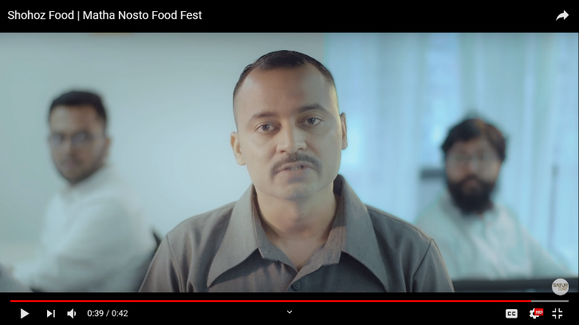

Client: Pran Spice
Campaign: RannayValobashaerChowa
Media: Video Commercial
YouTube Link:
https://www.youtube.com/watch?v=a_5rdxdZ454

Client: Cats Eye
Campaign: Tamim Iqbal EID Special Photo Shoot
Media: Social Media
Client: Shohoz Food
Campaign: MathaNosto Food Fest
Media: Video Commercial
YouTube Link: https://www.youtube.com/watch?v=JgWP9LudxhM

Chapter-04

(Activity of Organization)

Activity of Organization

Saturday Advertising is an absolutely administration and inventive advertising arrangement office for conventional and advanced and internet based life. They make inventive substance, thoughts, showcasing and marking techniques and generation support. Saturday began its voyage on December 17, 2014 to live in an aggressive industry which urges them to work a lot harder to remain over the psyche and pattern also. As of now working with more than 20+ nearby and worldwide customers. A portion of the movement of the association is given beneath

Saturday work with some happy clients:


















Some recent job we have already done for our valuable clients

TV/Web Commercials:

Client: Pran-RFL
Campaign: Mr. Noodles Ready Bite Launch
Media: Video Commercial
YouTube Link: https://www.youtube.com/watch?v=UC8ok_kBs3k


Client: NOKIA
Campaign: Nokia-Rangpur Riders
Media: Video Commercial
YouTube Link: https://www.youtube.com/watch?v=o6cRwMDm6cc

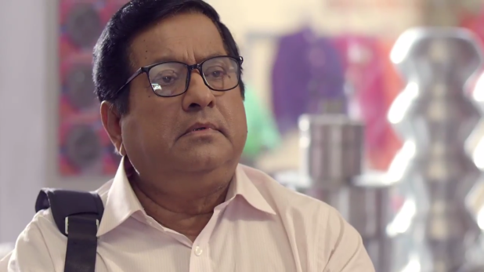
Client: Pran-RFL Group
Campaign: RFL Drinking Mug
Media: Video Commercial
YouTube Link: https://www.youtube.com/watch?v=jxPSja1a9jI


Client: Pran-RFL Group
Campaign: Canton Soup Launch
Media: Video Commercial
YouTube Link: https://www.youtube.com/watch?v=0eOTYvM5ELQ



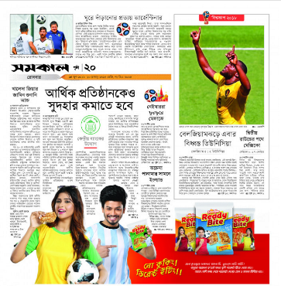


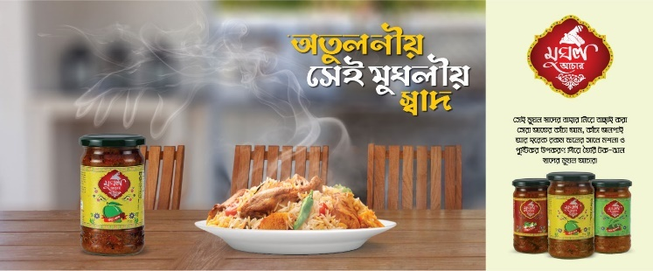

Print Media Ads:


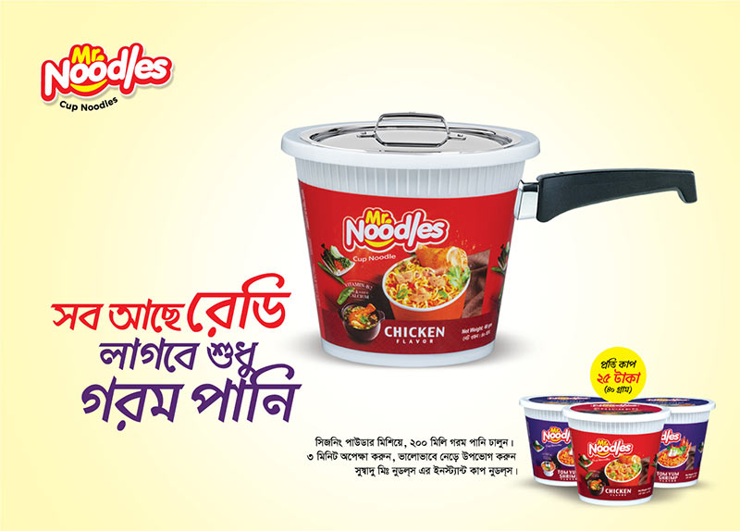
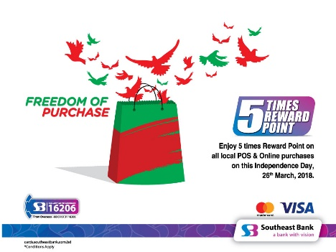
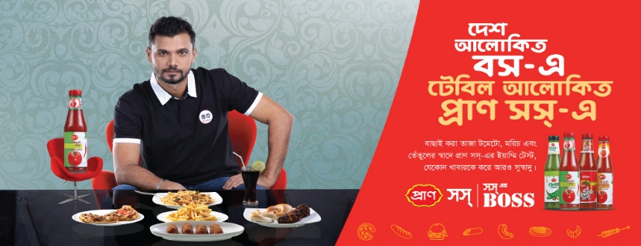

Social Media Contents:
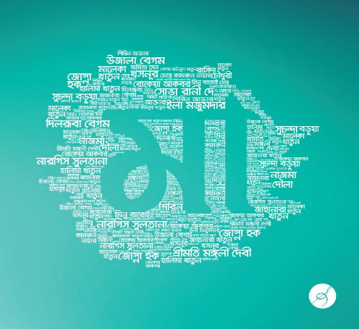
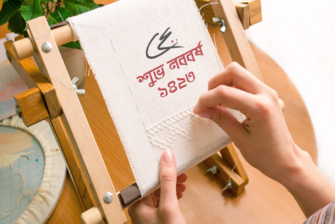



Sites, application advancement, viral recordings, advancements, generation, online life and battles are a piece of Computerized Administration works and campaigns are part of Digital Service works. Content marketing strategies and content management is our Digital service works.
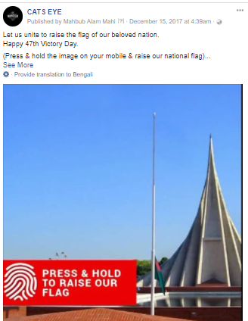
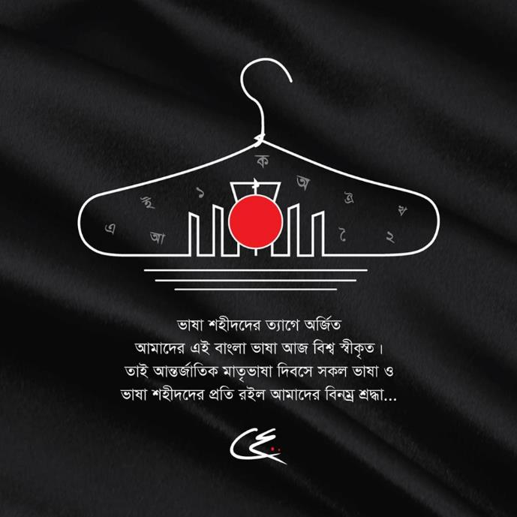


Website Designs
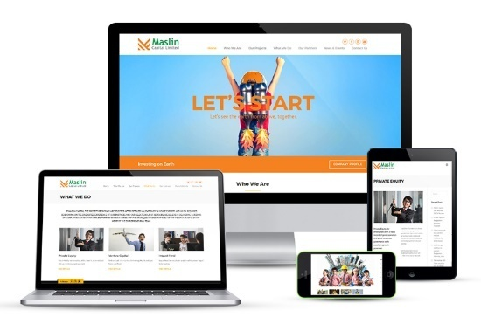
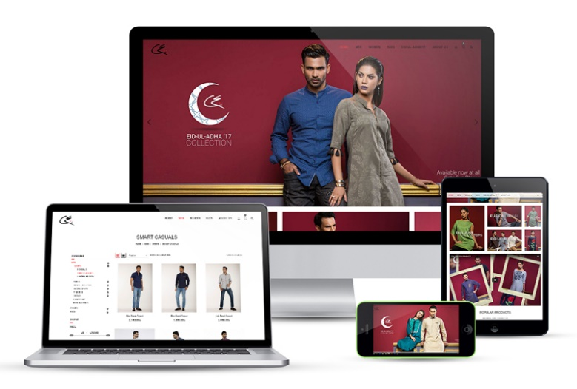
We are ensured and resolved to make our clients both corporate, brand and electronic business locales. Making responsive locales with webpage upkeep and quality web organization consolidates UI/UX structure.
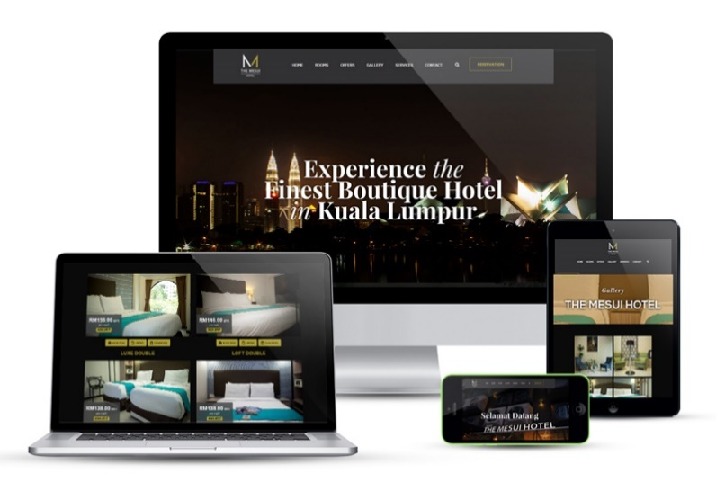

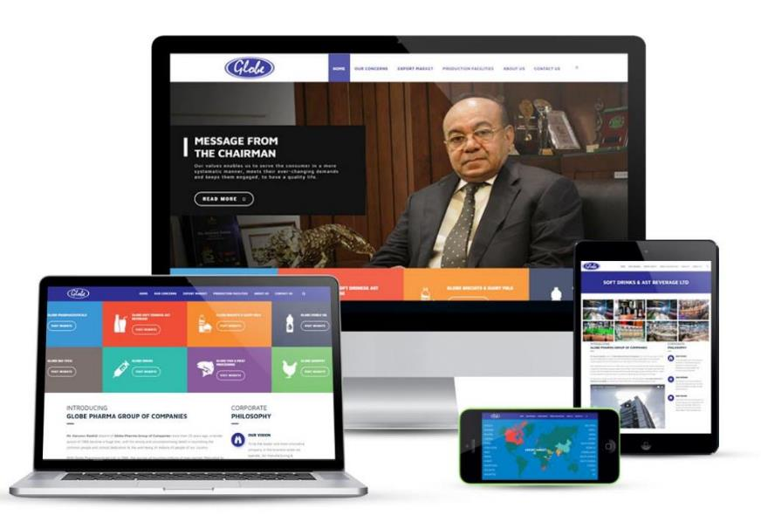

Social Media Apps
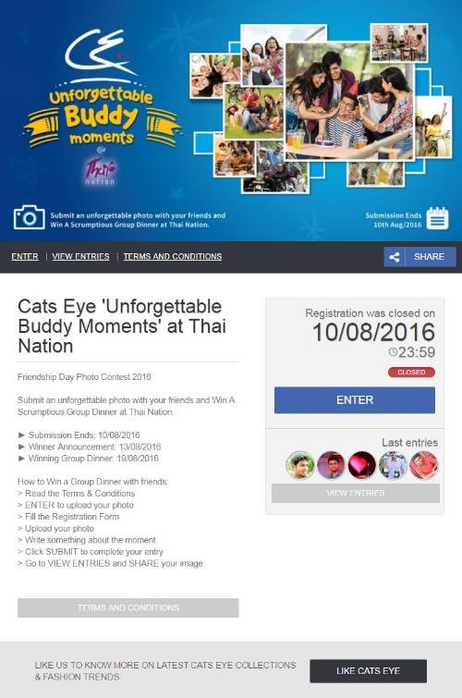


Brand identity
Brands will draw attention by their plan and that we do. To achieve the business objective and business possibilities, we create solid, enduring and obviously separated brand stages. The whole association's basic stay focuses serves by the brand stage and it guarantees the brand encounters are reliable crosswise over touch focuses, administrations and feasible arrangements.

Brand Logo Design


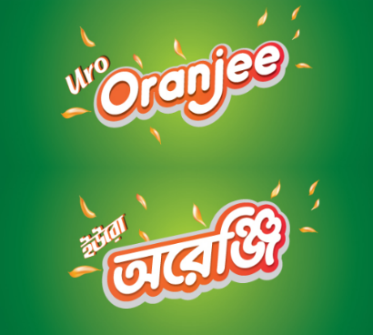


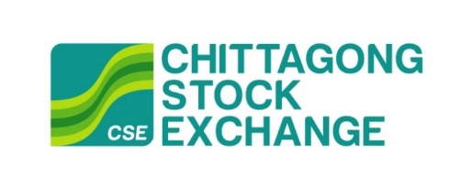

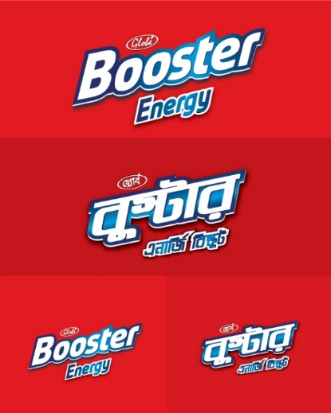



Packaging Designs












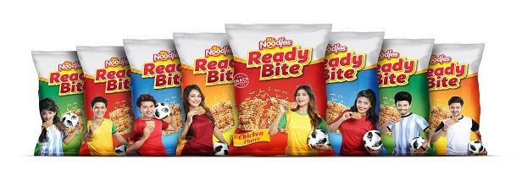

Chapter-04

(Conclusion and Recommendation)

Conclusion
Working in a promoting office like Saturday advertisements was one I had always wanted when I was an under-graduate dimension understudy. I am very glad to the point that, I could finish the last period of my undergrad life working in such a publicizing office. As a youthful blood like me working with difficulties and the innovative personalities unquestionably that was an incredible encounter for me. The workplace and individuals I have an inclination that it is my family. We used to have a ton of fun, work of late with high consolation since we sensed that, we are working for the customer as well as for our country and our kin. Each correspondence tallies. 360 degree correspondence is finished by Saturday, however 3 months connections isn't sufficient for an individual to get familiar with each one of those, in any case, the associations made there are a lifetime asset who are still with me adjusting such countless was an extraordinary experience working with such a critical number of close-by and widespread brands which reasons that, it has been a staggering knowledge for me. Resulting to bantering with Mr. Mehraz Raja who is the Head Working Officer and after our own inquires about and perception to all divisions, we came to know how well Saturday Computerized and Publicizing is doing. Great distributed relationship, enduring behavior a not too bad work environment, Saturday Computerized and Promoting has everything. Their customer administration and imaginative office methodologies and practices are first class. There is no error in the action commitment. Everyone knows their doled out activity and perform it perfectly and help one another. They have totally zero flexibility against defilement. The present brands achievement and reach locally as well as universally relies upon Advanced showcasing correspondence.

Recommendation
Although we can say that the agency is well planned but still we can recommend for their better future. Some points are given below:
- It should fabricate a solid connection with the new age. Like, it ought not be for the general population of explicit age, rather it should make a solid connection with the general population of new age.
- It should drive more development and experimentation in both substance and organizations. For instance, it can attempt and test the new advancements like 360 degree recordings, increased reality just as computer generated reality. Additionally, it can likewise attempt computerized reasoning for the new models of innovativeness. It should create a multi-platform touch point for a stable brand experience. It can also offer different purchasing options like online and offline both options, so that people can feel more comfortable.
- Agency ought to accomplish something that can make the female urged to work at advanced promoting and Publicizing, which may build the quantity of female client base in Bangladesh.
- Digital advertising correspondence isn't so exorbitant than some other media yet content administration in advanced promoting correspondence is actually quite significant. So advertisers should give more accentuate on substance the board and incorporate that with customary media and put successfully both in advanced and ordinary media.

In this way, if the suggestions can be actualized the office will go for an exceptionally brilliant future ahead.

References
Advertising, S. D. (2019, 4 2). EXPERTISE. Retrieved from Saturday Digita & Advertising : http://www.saturdaybd.com/skills/
Advertising, S. D. (2019, 4 5). OUR HAPPY CLIENTS. Retrieved from Saturday Digital & Advertising: http://www.saturdaybd.com/clients/
Advertising, S. D. (2019, 4 5). Saturday Digital & Advertising. Retrieved from Saturday Digital & Advertising: http://www.saturdaybd.com/
Advertising, S. D. (2019, 4 3). WORKS. Retrieved from Saturday Digital & Advertising: http://www.saturdaybd.com/works/
Digital, S. (2019, 4 1). Youtube. Retrieved from Saturday Digital: https://www.youtube.com/channel/UCeUh16Z4xqJ1bKswn2nq6pw
Eye, C. (2019, 4 2). Home. Retrieved from Cats Eye: https://catseye.com.bd/

