BTL Marketing for bKash Limited:
Focusing on Dhaka International Trade Fair 2024

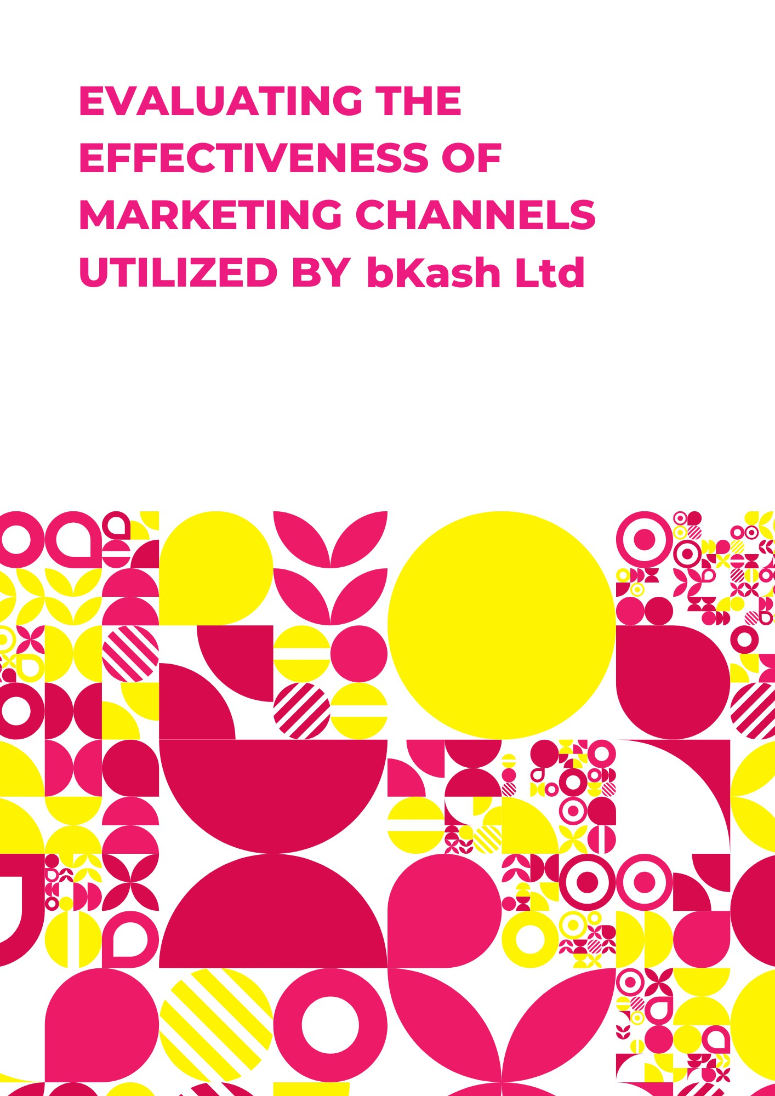
Md. Rayhan Hasan

This report is submitted to the School of Business and Economics, United International University as a partial requirement for the degree fulfillment of the Bachelor of Business Administration

BTL Marketing for bKash Limited:
Focusing on Dhaka International Trade Fair 2024

Submitted to:
Dr. Md. Shariful Alam
Professor
School of Business & Economics, UIU

Submitted by:
Md. Rayhan Hasan
Id: 111 201 064
BBA (Marketing), SoBE, UIU
Trimester: 13


United international university
School of Business and Economics

Date of submission: April 27, 2024

Letter of Transmittal
To
Dr. Md. Shariful Alam
Professor, School of Business and Economics
United International University
Subject: Submission of Internship Report Titled “BTL Marketing for bKash Limited: Focusing on Dhaka International Trade Fair 2024”
Dear Sir,
With great pleasure, I would humbly like to present my internship experience as a bKash’s Marketing Intern at Dhaka International Trade Fair 2024 as a part of the requirement for the completion of the Bachelor of Business Administration program at United International University. This report is a culmination of my experience from the eight-week mandatory organizational attachment as well as the learnings I received from this prestigious business school.
This report was compiled under the supervision of Dr. Md. Shariful Alam, who took the time to advise me and provide guidelines whenever necessary to achieve my goal. It has been my priority to complete this report with due diligence. I hope that it meets the requirements for completing the internship program. Under no circumstances will this report be reproduced and shared with any third party in any shape or form.
Thank you for your time and consideration.
Sincerely,
Md. Rayhan Hasan
ID: 111 201 064
BBA (Marketing), SoBE
United International University

Declaration of the Student
I, Md. Rayhan Hasan, declare that I have prepared the internship report on “BTL Marketing for bKash Limited Focusing on Dhaka International Trade Fair 2024”. All information used in this report is collected and analyzed prior to use in the study. All the information provided in the study is valid and relevant. Also, no information is copied or shared directly in the report without sharing the proper reference.
Md. Rayhan Hasan
ID: 111 201 064
Major: Marketing
BBA Program
School of Business and Economics
United International University

Acknowledgment
I would like to express my gratitude sincerely to Dr. Md. Shariful Alam, my faculty advisor, for allowing me to complete this report under his wise supervision. Without his timely direction and guidance, completing this report would have been impossible to even imagine.
Likewise, I am also grateful to the BTL Media team of bKash Limited’s Media and Operations department of the Marketing Division. I extend my heartfelt thanks to my organizational supervisor, Mr. Jafar Iqbal, General Manager of the Media and Operations Department, Marketing Division, for allowing me to be a part of his team and giving me the space to grow and understand the fast-paced corporate dynamics. I would also like to express my gratitude to Mr. Sultan Mahmud, Manager, of the Media and Operations Department, Marketing Division, and Mr. Hiroq Dev Roy, Assistant Manager, of the Media and Operations Department, Marketing Division, for providing me with extensive knowledge and timely feedback for my work that further motivated me to accomplish my tasks. Without their guidance and patience, it would have been impossible for me to complete this mammoth task on my own.

Executive Summary
This report mirrors the internship experience at bKash Ltd during the Dhaka International Trade Fair 2024, mostly focusing on BTL activation, brand promotion, and agency management.
Key recommendations for improving departmental operations are to broaden the team, and proactive strategy development. These actions aim to improve efficiency and nurture growth within the competitive MFS industry in Bangladesh.
The internship delivered a cherished understanding of big event and activation management, team leading, horizontal and vertical coordination, and the underlying forces of the MFS industry. It emphasized the significance of effective synchronization, tactical planning, and flexibility in achieving organizational goals and enhancing brand existence in consumer’s minds.
In conclusion, the internship at bKash was a satisfying experience that developed my interpersonal and professional skills and extended my knowledge and understanding of the fintech industry.

Table of Contents for Internship
Table of Contents
Letter of Transmittal 4
Declaration of the Student 5
Acknowledgment 6
Executive Summary 7
Table of Contents for Internship 8
List of Figures 11
List of Abbreviation 11
CHAPTER I: INTRODUCTION 12
1.1 Background of the Report 12
1.2 Objectives of the Report 12
1.3 Motivation of the Report 12
1.4 Scope and Limitations of the Report 13
1.5 Definition of Key Terms 13
CHAPTER II: COMPANY PREVIEW 14
Company Analysis 14
2.1 Overview and History 14
2.2 Trend and Growth 15
2.3 Culture and Values 15
2.4 Organizational Structure 17
2.5 Customer Mix 23
2.6 Product/Service Mix 24
2.7 Operations 25
2.8 Key Strategies 26
2.9 SWOT Analysis 28
CHAPTER III: INDUSTRY PREVIEW 30
Industry Analysis 30
3.1 Specification of the Industry 30
3.2 Size, Trend, and Maturity of the Industry 30
3.3 External Economic Factors 33
3.4 Technological Factors 33
3.5 Barriers to Entry 33
3.6 Supplier Power 33
3.7 Buyer Power 33
3.8 Threat of Substitutes 34
3.9 Industry Rivalry 34
CHAPTER IV: INTERNSHIP EXPERIENCE 35
About Dhaka International Trade Fair 2024 35
4.1 Position, Duties, and Responsibilities 36
4.2 Training 40
4.3 Contribution to Departmental Functions 40
4.4 Evaluation 41
4.5 Skills Applied 41
4.6 New Skills Developed 43
4.7 Application of Academic Knowledge 44
CHAPTER V: CONCLUSIONS AND KEY FACTS 45
5.1 Recommendations for Improving Departmental Operations 45
5.2 Key Understanding 45
5.3 Conclusion 45
References 46

List of Figures
Figure 1 Logo of bKash 14
Figure 2 Investors 14
Figure 3 Organizational Structure 17
Figure 4 SWOT Analysis of bKash 28
Figure 5 Number of MFS from 2019 to 2024 31
Figure 6 Agent Networks from 2019 to 2024 31
Figure 7 Registered clients from 2019 to 2024 32
Figure 8 Active Accounts from 2019 to 2024 32
Figure 9 Crowd in DITF 2024 35
Figure 10 Brand Promoters 36
Figure 11 bKash Coupon offer at DITF 37
Figure 12 POSM at DITF 37
Figure 13 Sitting zone of bKash at DITF 2024 38
Figure 14 Amar Ekushey Boi Mela activation by Bkash 39

List of Abbreviation
BP: Brand Promoter
DITF: Dhaka International Trade Fair
MFS: Mobile Financial Service
POSM: Point of Sale Marketing
BTL: Below the line

CHAPTER I: INTRODUCTION

Background of the Report
The report is about my internship experience at bKash Ltd. in the Media & Ops Department of Marketing Division throughout the Dhaka International Trade Fair 2024. The fair was a key platform for bKash to strengthen its brand presence, engage with customers, and onboard merchants. As a marketing intern, I played an essential role in various aspects of the bKash's involvement, leading and supervising brand promoters, managing agencies, and ensuring the best brand presence.

Objectives of the Report
- To provide a comprehensive summary of bKash's involvement in the DITF 2024.
- To detail the roles and responsibilities undertaken by the intern in facilitating brand promotion, agency management, and merchant onboarding.
- To evaluate the effectiveness of strategies deployed by bKash in enhancing brand visibility and customer engagement during the event.
- To analyze the challenges encountered and lessons learned during the internship period.
- To propose some recommendations for future developments in bKash's participation in comparable events.

Motivation of the Report
The motivation behind this report is the desire to document and reflect upon my internship understanding, knowledge, and experience at bKash Ltd throughout a massive event like the DITF 2024. By summarizing my roles, everyday tasks, challenges, and contributions, this report assists as a testament to my professional growth and learning journey during the internship.

Scope and Limitations of the Report
The scope of this report includes the internship experience specifically about bKash's participation in the DITF 2024. This dives into the knowledge gained, roles and responsibilities undertaken by the intern, tasks performed challenges come across, and lessons learned. Nevertheless, it may not cover everything about bKash's operations or deliver a comprehensive study of bKash's overall performance.

Definition of Key Terms
- Brand Promoters: Individuals who are hired and responsible for promoting and making awareness about a brand and its product or services amongst visitors at the DITF 2024.
- Merchant Onboarding: The process of enlisting new merchants onto the bKash platform, enabling them to accept bKash payments from customers during and beyond the trade fair.
- Agency Management: The procedure of managing and overseeing the activities of external agencies appointed by a company to assist in several sectors of activation management and promotion.

CHAPTER II: COMPANY PREVIEW

Company Analysis

Overview and History

bKash Limited is a mobile financial service provider in Bangladesh that was founded in 2010 as a subsidiary of BRAC Bank. The company aims to promote financial inclusion in the country by providing mobile financial services to the unbanked and underbanked population. bKash operates as a digital wallet platform that allows customers to store, send, and receive money using their mobile phones. bKash is a joint venture of BRAC Bank, US-based Money in Motion LLC, International Finance Corporation of the World Bank Group, Bill and Melinda Gates Foundation, Ant Group, and SoftBank Vision Fund, which operates under the regulation of Bangladesh Bank.
Figure 1 Logo of bKash
Figure 2 Investors

bKash has a vast network of agents across the country who offer cash-in and cash-out services to customers. The company has over 330,000 agents in Bangladesh and more than 800,000 merchants on its platforms, making it the largest mobile financial service provider in the country. In addition to cash-in and cash-out services, bKash offers a range of financial services, including bill payments, anytime top-ups, merchant payments, and fund transfers.

Trend and Growth
bKash's journey exemplifies strategic growth, innovation, and adaptation. Initially offering basic services such as P2P money transfers, bKash has evolved into a comprehensive financial services platform that includes bill payments, mobile top-ups, and savings and loan products. This evolution has been underpinned by a deep understanding of user needs and a commitment to leveraging technology to address those needs efficiently. The company has received several awards for its innovative mobile financial services. In 2019, bKash won the Best Mobile Payments Solution award at the GSMA Global Mobile Awards (GSMA, 2019). The company was also recognized as the Best Financial Institution in Bangladesh by Euromoney magazine in 2019 (Euromoney, 2019).
bKash is Bangladesh’s best and most loved brand for the 5th consecutive year through a consumer survey conducted by Bangladesh Brand Forum (BBF). After its successful performance from 2019 to 2022, bKash, the country's leading Mobile Financial Services (MFS) provider, maintains its status as the top brand among the top 15 brands in the nation. Furthermore, bKash has once again been honored as the 'Most Loved Brand' in the Mobile Financial Services (MFS) category, marking its 7th consecutive win.
By 2023, bKash has demonstrated remarkable growth, with a reported profit of Tk88 crore in the first nine months, a sign of its increasing revenue and successful business model adaptation. The company's strategic focus on interest earnings and efficient service delivery contributed to this financial success.

Culture and Values
- One of the best things that bKash has because of which it won the #1 Employer of Choice award for 5 uninterrupted years is its culture. Due to this culture, bKash is believed as an organization that is collaborative and very friendly.

- Unlike traditional Bangladeshi businesses where seniors are referred to as “Sir” or “Ma’am”, bKash follows a practice where seniors are referred to as “Bhaiya” or “Apu”. Furthermore, everyone in bKash is very approachable, open open-minded and is always prepared to help everyone in need. This makes collaboration the go-to approach when they plan on tackling any kind of obstacle. Whether it means coming to a solution by working together or taking second opinions from colleagues, employees at bKash never shy away from taking help.

- Accountability and ownership are also prominent in the culture of bKash, as they have faith in the saying “Never leave a stone unturned”. Once an employee starts working on a project or task, he/she makes sure to be thorough in a way such that every single critical factor and variable is measured and there’s no room for compromise. Furthermore, the people of bKash are continuously in quest of innovative ways to improve themselves and grow as an organization. This growth mindset is prevalent throughout all the divisions in bKash which is the reason behind they are still able to sustain their spot as the market leader for so numerous years.

- All these aspects are deep-rooted within the working style and culture of bKash due to the values set by the top-level management. These values which define bKash are:

- Customer Centric: At bKash, the #1 priority is its users. bKash is dedicated to understanding and appreciating the needs of its customers, providing them with dependable, reasonable, and suitable solutions. bKash operates with the customer at the forefront of its approach.

- Innovative: Innovation is one of the core things in bKash's culture. bKash inspires fresh ideas and drives changes to improve its service to its customers. bKash is devoted to trialing with customer-centric solutions and endlessly improving through creativity and curiosity.

- Collaborative: Collaboration is a central value at bKash. The company nurtures a humble and unified environment in all its dealings. bKash has faith in sharing resources and co-creating to achieve shared results, fostering openness, transparency, and hope.

- Agile: bKash functions with agility to meet client needs and expectations punctually. The company is adept at learning fast and adapting to the changing market. Employees at bKash are empowered to take actions necessary to fulfill the company's purpose.

- Ethical: Ethical behavior is at the core of all values at bKash. The company confirms fairness and constancy in all its dealings. Honesty is upheld in every aspect of bKash's processes, with a promise to never compromise on its values. bKash strictly obeys its Code of Conduct and all the laws relevant to it.

Organizational Structure
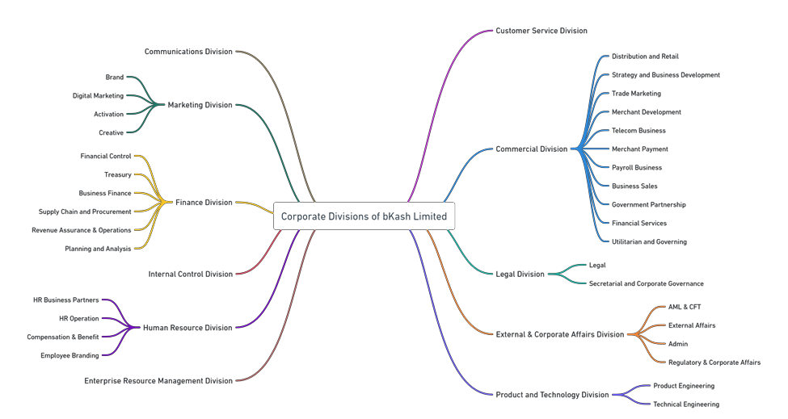
Figure 3 Organizational Structure

Finance & Accounts
The Department of Finance & Accounts division ensures that bKash’s operations are supported by effective financial management and controls. It manages to make monetary and investment choices, create monetary statements, keep track of the general ledger, pay bills and customers' invoices, manage payroll, and handle taxes.
There are six departments under the Finance & Accounts division which are:
- Financial Control
- Management Reporting & Planning
- Revenue Assurance
- Supply Chain & Procurement
- Business Finance
- Treasury

Human Resources (HR)
The HR division cooperates with key stakeholders to ensure that bKash leverages expert HR knowledge. They examine the situation and determine the most effective HR involvements and actions. Additionally, the division prioritizes the efficiency and culture of bKash. The team employs its understanding to predict possible shifts in culture and workforce and utilizes organizational conduct principles to align the organization's culture and strategies.
The four departments under the HR division are:
- HR Operations
- Commercial & Corporate Functions
- Organization Development & Employer Branding
- Compensations & Benefits

External and Corporate Affairs (ECAD)
This division's primary responsibility is to promote communication and collaboration with external stakeholders like law enforcement agencies and regulatory bodies. Furthermore, the department initiates networks with diverse business entities. Additionally, this division is tasked with preserving and enhancing the company's status and image and formulating proactive communication strategies to generate revenue that aligns with the company's objectives.
There are five departments under the ECAD division:
- Anti-Money Laundering & Combating the Financing of Terrorism (AML & CFT)
- Regulatory & Corporate Affairs (R & CA)
- Administration
- External Affairs
- Infrastructure and Project Management

Communications
The Communications Division attempts to enhance the brand, promote products or services bKash has, and attract new customers. Moreover, the division oversees social media, public relations, client events, and advertising. They aim to ensure all-in-one internal communication within the organization, as effective communication among employees, investors, and management is crucial. This division is accountable for nurturing promising relationships with the general public and media, as well as maintaining a positive brand image. Moreover, the communication division focuses on driving community engagement.
The two departments under this division are:
- Digital Assets & Communications
- Corporate Communications

Marketing
The Marketing division is responsible for the representation and awareness of the brand of bKash. It is also accountable for generating and managing all branding-related materials. The division diligently engages with possible clients, current customers, investors, and the public, while also fostering a favorable image for the organization. Moreover, this team is tasked with formulating brand tactics, enhancing brand awareness and sales, and reaching the brand's target audience.
Within this division, there are four departments in operation:
- Digital Marketing
- Media & Operation
- Brand
- Creative
Commercial
The Commercial Division is the largest in bKash, therefore, it has an extensive range of responsibilities. The division is responsible for founding and sustaining positive relationships with potential investors and the government, as well as supervising the company's financial and administrative activities. These duties include billing, revenue collection, procurement, expenditure management, and control. Moreover, they generate management and financial reports for both internal and external stakeholders. Also, the division manages support operations, including regional operations and inventory control.
The Commercial Division has a total of 10 departments:
- Commercial Operations
- Strategy & Business Development
- Merchant Development
- Merchant Payments
- Telecom Business
- Payroll Business
- Business Sales
- Government Partnership
- Financial Service
- Utility, Bill, and Education Payment
Product & Technology
The Product & Technology Division bears the accountability of defining the product's vision and strategy, as well as managing a multi-layered team comprising technicians, developers, and engineers to bring forth a superior product to the market. This division constructs the product roadmap, encompassing features, requirements, and the business case. Collaborating closely with the technical team, they work on the design and development journey to ensure a successful product outcome. Moreover, they continuously evaluate customer preferences and anticipate future needs. This division is divided into two wings, Product Engineering and Technical Engineering.
The departments under this division are:
- Product Engineering
- Merchant Products
- Payables & Identity Management
- Financial Products
- App & Essential Services
- Technical Engineering
- System Engineering
- Software Research and Engineering
- Service Operations
- Data Science & Engineering
- Solution Architecture & Planning
- Project & Partner Management
- IT Governance

Customer Service
The Customer Support Department takes the responsibility of talking to clients and grasping their worries. The customer support team knows a lot about the product or service, which helps them give quick answers to customers. If the customer's issue is too tricky for customer support, they'll send it to the right internal teams and often check in with them for progress updates.
- There are six departments under this division which are:
- Customer Center
- Customer Care
- Digital Service & e-KYC management
- Call Center
- Service Quality & Complaint management
- Competence & Process management

Internal Control & Audit
The Internal Control & Audit Division aims to set up effective procedures for organizational operations and sharply monitor and inspect that all processes are supported, and if any breach is found, to identify it and report it to management for correction and ongoing improvement.

Legal, Secretariat & Corporate Governance
This division handles all the law-related aspects and provides legal services to bKash. It consists of a team of lawyers who specialize in different areas like employment and commercial law. The primary duty of this division is to work in the company's favor rather than for individual directors or shareholders. To improve operations, the legal team works together with the other departments at bKash. There are two departments under this division, which are:
- Legal
- Secretariat & Corporate Governance

Enterprise & Risk Management
The Enterprise & Risk Management division examines and regulates risk factors of every decision and process to ensure bKash can predict any future threats or opportunities to achieve its objectives through its resources. Since bKash is a financial institution, it is highly scrutinized by external stakeholders. Thus, this department ensures that bKash is aware of all the potential risks that it might face so that it can maintain trust amongst its stakeholders.

Customer Mix
bKash's customer mix typically includes a diverse range of individuals, from urban to rural areas, spanning various socio-economic backgrounds. Customers may include:
  - Urban professionals: People working in towns who use bKash for convenient and safe monetary transactions, including bill payments, purchase spending, and transfers.
  - Rural residents: Individuals living in country areas who rely on bKash for monetary inclusion, accessing banking services, sending and making payments, receiving money, and without needing to travel long distances.
  - Small business owners: small business owners and entrepreneurs who use bKash for paying bills of suppliers, getting payments from clients, and managing their business funds.
  - Migrant workers: Individuals working abroad who use bKash to send money to their families back home, leveraging the platform's efficiency and affordability for international remittances.
  - Unbanked and underbanked individuals: Those who lack access to traditional banking services or have limited banking options, turning to bKash for their financial needs, including savings, payments, and transfers.
Overall, bKash serves as a vital financial service provider catering to a broad spectrum of customers, offering convenience, accessibility, and reliability in their financial transactions.

Product/Service Mix
bKash, as a mobile financial service offers a diverse product and service mix to provide the monetary needs of its consumers. Here is an overview:
- Mobile Financial Services (MFS): The Company’s key offering is its mobile financial services, letting users do various financial transactions straight from their mobile phones. This includes transferring money to friends and family, paying bills, and making payments at both online and offline merchants.
- Wallet Services: The bKash wallet assists as the fundamental heart for all financial activities. Users can store money securely in their wallets, which can be retrieved anytime, and anyplace for trades or transactions.
- Remittance Services: bKash eases global and national remittances, allowing customers to send money to their loved ones in other regions of the country or receive money from abroad. This facility plays a vital role in easing financial presence and supporting migrant workers.
- Merchant Payments: bKash lets consumers to make payments at an extensive range of merchants, including retailers, restaurants, utility providers, and online shops. This service promotes cashless transactions and enhances convenience for both customers and businesses.
- Bank Integration: bKash has integrated with numerous banks, letting users transfer money between their bKash wallets and bank accounts flawlessly. This addition improves interoperability and expands the reach of financial services to a larger audience.
- Bill Payments: Users can pay utility bills, such as electricity, water, gas, and internet bills, directly through the bKash platform. This feature eliminates the hassle of standing in long queues and ensures timely payments.
- Savings and Investments: bKash offers savings and investment products, allowing users to save money, earn interest, and invest in various financial instruments directly through the platform. This helps users manage their finances more effectively and achieve their financial goals.
Overall, bKash's product and service mix is designed to provide users with convenient, accessible, and secure financial solutions that cater to their diverse needs and preferences.

Operations
bKash operates through a healthy and well-organized system that ensures the smooth delivery of its mobile financial services. Here's an overview of its operations:

- Technology Infrastructure: bKash depends on advanced technology infrastructure to control its operations. This includes secure servers, mobile applications, and backend systems that enable users to access their accounts, conduct transactions, and perform various financial activities.
- Agent Network: bKash has established a massive network of agents across city and country areas throughout Bangladesh. These agents, often local businesses or individuals, provide physical access points where customers can deposit or withdraw cash, open accounts, and access other bKash services.
- Customer Support: To assist users with any inquiries or issues, bKash operates a customer support center staffed with trained representatives. Customers can reach out for assistance via phone, email, or in-person at designated service centers.
- Regulatory Compliance: bKash operates in compliance with regulations set forth by the central bank and other relevant authorities. This includes adherence to Know Your Customer (KYC) guidelines, anti-money laundering (AML) measures, and other regulatory requirements to ensure the security and integrity of its financial services.
- Security Measures: Security is vital in bKash's operations. The platform employs encryption protocols, multi-factor authentication, and other security measures to safeguard users' personal and financial information, as well as to prevent unauthorized access and fraudulent activities.
- Partnerships: bKash collaborates with various stakeholders, including banks, telecommunications companies, government agencies, and merchants, to expand its reach and enhance its service offerings. These partnerships enable bKash to integrate with existing infrastructure, leverage complementary services, and deliver greater value to its customers.
- Continuous Improvement: bKash is committed to continuous improvement and innovation in its operations. The company invests in research and development to enhance its technology platform, expand its service portfolio, and address evolving customer needs and market trends.

Overall, bKash's operations are characterized by efficiency, reliability, and a customer-centric approach, enabling it to maintain its position as a leading mobile financial services provider in Bangladesh.

Key Strategies
bKash's approach to building digital products can be characterized by several key strategies:
User-Centric Design: Understanding and addressing the specific financial needs of Bangladeshis, particularly those with limited access to traditional banking services. Through comprehensive user research, bKash designs its digital products to be intuitive and accessible, ensuring inclusivity across diverse demographics and socioeconomic backgrounds.
Innovative Services: Introducing services like the digital nano loan and savings schemes through the app, which have significantly impacted users' lives by providing them with access to financial services previously beyond their reach. By continuously exploring new avenues for financial empowerment, bKash remains at the forefront of innovation in the mobile financial services sector, catalyzing positive socioeconomic change.
Scalable Technology Infrastructure: Building a robust technology platform that can handle millions of transactions daily, ensuring reliability and security for its users. With a focus on scalability and resilience, bKash invests in cutting-edge technology solutions that enable seamless transaction processing and safeguard user data, fostering trust and confidence in its services.
Strategic Partnerships: Collaborating with banks, international finance corporations, and other stakeholders to expand service offerings and improve the user experience. Through strategic alliances, bKash taps into additional resources and expertise, enriching its service ecosystem and enhancing value propositions for users and partners alike.
Continuous Improvement: Leveraging data and user feedback to continually refine and expand services, ensuring they remain relevant and valuable to users. By adopting a culture of continuous learning and adaptation, bKash iteratively enhances its products and processes, staying agile in a dynamic market landscape and driving sustained customer satisfaction and loyalty.

SWOT Analysis
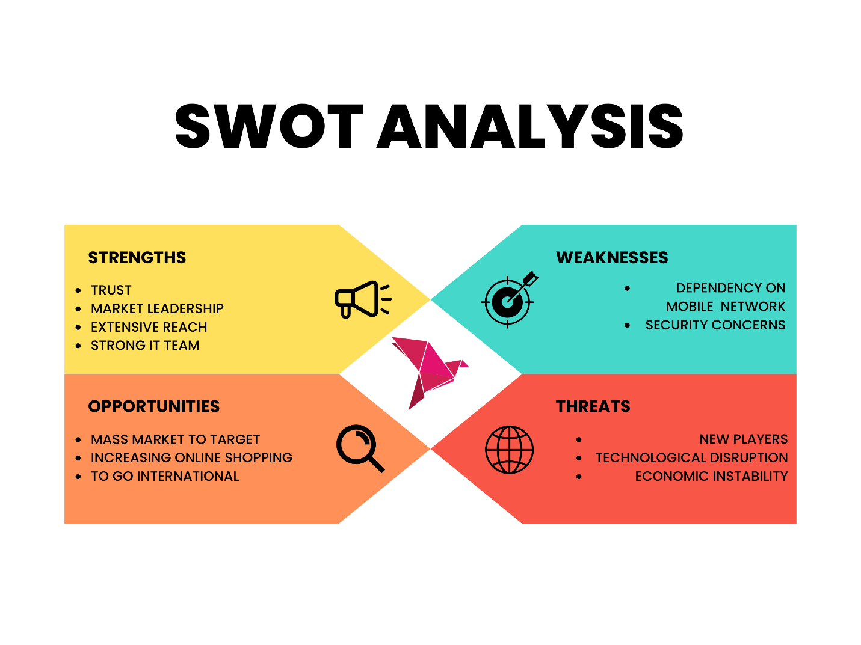
Figure 4 SWOT Analysis of bKash
Strengths
- Trust: Since bKash is under the wing of BRAC Bank, people across the country have trust on the organization.
- Market Leader: bKash is the leading MFS provider in our country, enjoying a large market share and well-known recognition.
- Extensive Reach: With a vast network of agents and merchants, bKash has established a strong presence even in rural areas, enabling financial inclusion.
- Strong IT team: bKash is backed up with the best technological support which allow them to serve their customer in the shortest possible time.

Weaknesses
- Dependency on Mobile Network: The dependence on mobile network coverage for transactions poses a challenge in areas with poor connectivity, limiting accessibility.
- Security Concerns: Even though efforts to increase security measures, concerns about fraud and cybersecurity threats continue, possibly discouraging user trust.
Opportunities
- Mass Market to Target: The target market of bKash Limited is those people who are generally ignored by the big financial service providers and their offerings. As Bangladesh is a nation with a large populace of this segmentation, bKash has a good chance of seizing a vast market share.
- Increasing trend of online shopping: Online shopping is gaining popularity in Bangladesh so if the company can offer a transaction system for online shopping, it could be a way of earning big profits.
- Go international: As the company has joint ventures with large international companies, so bKash could offer international transaction services more extensively.
Threats
- New Players: There are some other Banks in Bangladesh who have come up with new MFSs in the market with new offers and facilities, if the bKash can’t take the essential steps to shield the competition, then they will have a threat of losing market share.
- Technological Disruption: Rapid progressions in technology and shifting user preferences may render bKash's existing infrastructure and services obsolete deprived of the frequent invention.
- Economic Instability: Economic slumps, currency instabilities, and political instability in Bangladesh could harmfully impact customer spending and confidence, affecting bKash's transaction volumes and income.

CHAPTER III: INDUSTRY PREVIEW

Industry Analysis

Specification of the Industry
bKash operates in the MFS industry in Bangladesh. bKash is the leading provider of digital monetary services, it enables peer-to-peer fund transfers, merchant payments, mobile recharges, bill payments, and other monetary transactions over its phone app platform.

Size, Trend, and Maturity of the Industry
Mobile Financial Services (MFS) are now the embodiment of financial technology that is expanding at the fastest rate anywhere in the world, notably in Bangladesh. The MFS plays a crucial part in easing the process of conducting financial transactions for individuals of all social groups and professions, offering services like Cash In, Cash Out, Bill Payment, Mobile Recharge, Merchant Payment, etc.

Mobile financial services were introduced in 2011 by three private banks in Bangladesh, namely Dutch Bangla Bank Limited (DBBL), BRAC Bank Limited, and Trust Bank Limited (Latifee & Tamanna, 2022). At the moment, Bangladesh is home to 61 banks that are spread throughout 10,467 locations (Bangladesh Bank, 2023). While MFS usage has significantly increased compared to the expectation at its inception, the usage is still mostly restricted to cash in/out transactions, peer-to-peer transactions, online purchases, and some bill payments. There are 13 authorized MFS providers; nevertheless, bKash and Nagad are the most dominant players in the industry, with the biggest market share.

  - Rocket - Dutch Bangla Bank Ltd
  - bKash - Brac Bank Ltd
  - MYCash - Mercantile Bank Ltd
  - mCash - Islami Bank Bangladesh Limited
  - Trust Axiata Pay - TAP Trust Bank Limited
  - FirstCash - First Security Islami Bank Ltd.
  - Upay - United Commercial bank Limited
  - Ok Wallet - One bank Limited 9
  - SureCash - Rupali bank limited 10
  - TeleCash - Southeast Bank Limited
  - Islamic Wallet - Al-Arafah Islami Bank Limited
  - Meghna Pay - Meghna Bank Ltd
  - Nagad - Bangladesh Post Office
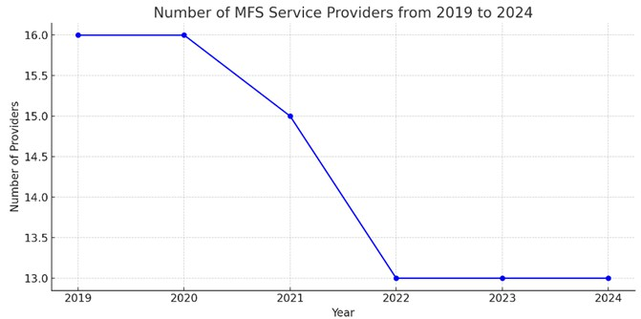
Figure 5 Number of MFS from 2019 to 2024
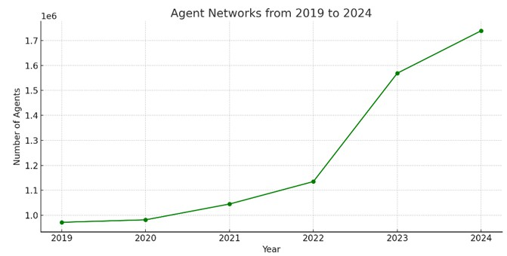
Figure 6 Agent Networks from 2019 to 2024
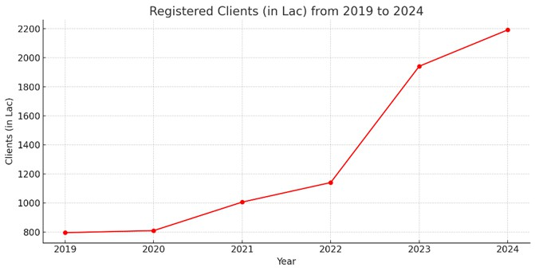
Figure 7 Registered clients from 2019 to 2024
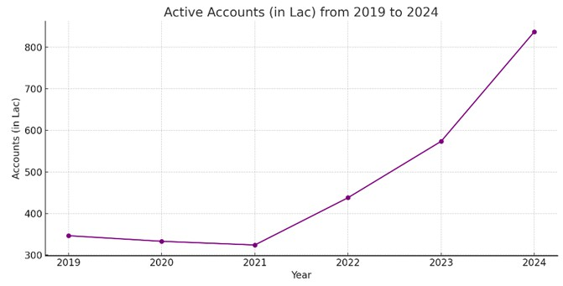
Figure 8 Active Accounts from 2019 to 2024
According to Bangladesh Bank (2024), some recent trends in the overall MFS industry are:
• Stability and Consolidation among Banking Institutions
• Expansion of Agent Networks
• Growth in Registered Clients
• Growth in Active Account number

External Economic Factors
External economic factors can be the county’s growth of GDP, rates of inflation, and flows of remittance that can vitally influence the MFS industry. Strong GDP growth and increased income and spending, tend to drive higher adoption of digital financial services. Equally, financial slumps or fluctuations may disturb user spending and trust in MFSs.

Technological Factors
The most important thing for bKash’s success is its technological improvements. Aspects such as mobile penetration, the infrastructure of the internet, cybersecurity, and progressions in digital payment technologies affect the acceptance and evolution of MFSs. Nonstop innovation and advancement in tools are vital for bKash to continue to be competitive and meet the expectations of users.

Barriers to Entry
There is quite a barrier to entry in the industry as a massive investment is needed to start an MFS. Another thing is that the switching cost is high as well. When someone gets habited or used to using a service in daily life, the person is less likely to switch to another MFS unless there is any super attractive offering or the current MFS is not providing a good service.

Supplier Power
The MFS industry has moderate supplier power. bKash depends on IT vendors, telecom companies, and banking organizations to support its operations. And there are various providers in the market. Nonetheless, the excellence of associations and being partner with key providers can impact on bKash's attractiveness and capability to renovate.

Buyer Power
In the Mobile Financial Service industry buyer power is comparatively high. The availability of other payment methods offered by other organizations makes it easy for customers to switch. Customers have the flexibility to get financial services from many MFS providers based on features such as cash-out fees, handiness, facility quality, and availability. Hence, bKash must always improve its offerings and user experience to maintain its market share and attract new users.

Threat of Substitutes
The main threats can be cash-carrying by individuals, traditional banking, or other payment methods. Even though MFS seems to be the most convenient way of sending and receiving money and doing other transactions, there is always a threat of substitutes.

Industry Rivalry
There is intense rivalry in this industry of mobile financial service providers. bKash faces opposition from other MFSs. Yet, the loyalty among the customers of bKash and its quality of service always helped the company to keep its head held high. The reasons behind its competitive edge in the MFS industry are differentiation by facility invention, consumer experience, and tactical partnerships.

CHAPTER IV: INTERNSHIP EXPERIENCE

About Dhaka International Trade Fair 2024
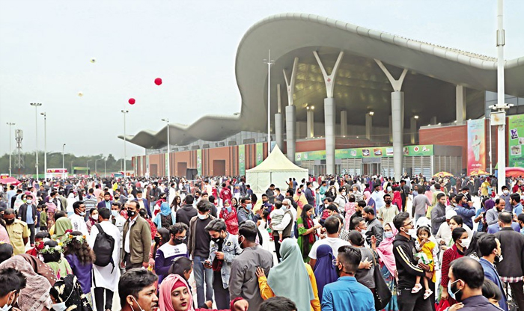
The Dhaka International Trade Fair (DITF) held from January 21 to February 20 featured 351 stalls showcasing a wide range of products. Products worth 400 crores were sold throughout the event, with export orders amounting to 392 crores as reported by Dhaka Tribune. According to Jugantor, the event attracted an average audience of 5,000 visitors per day. On holidays, the attendance flowed significantly to an average of 140,000 visitors, according to DITF authority through Bangla Tribune. The highest footfall was detected on weekends, recording between 200,000 to 250,000 visitors, as reported by EPB.
Figure 9 Crowd in DITF 2024

Position, Duties, and Responsibilities
Position: Intern at bKash Ltd. in the Media & Ops Department of Marketing Division
Duties and Responsibilities:
- Dhaka International Trade Fair 2024
- Supervising a big squad of 70 brand promoters, ensuring their operative distribution and devotion to promotional plans and strategies for bKash ltd. used to meet with all the BPs in the morning sharp at 10 am every day to communicate proper distribution, positions and daily targets.
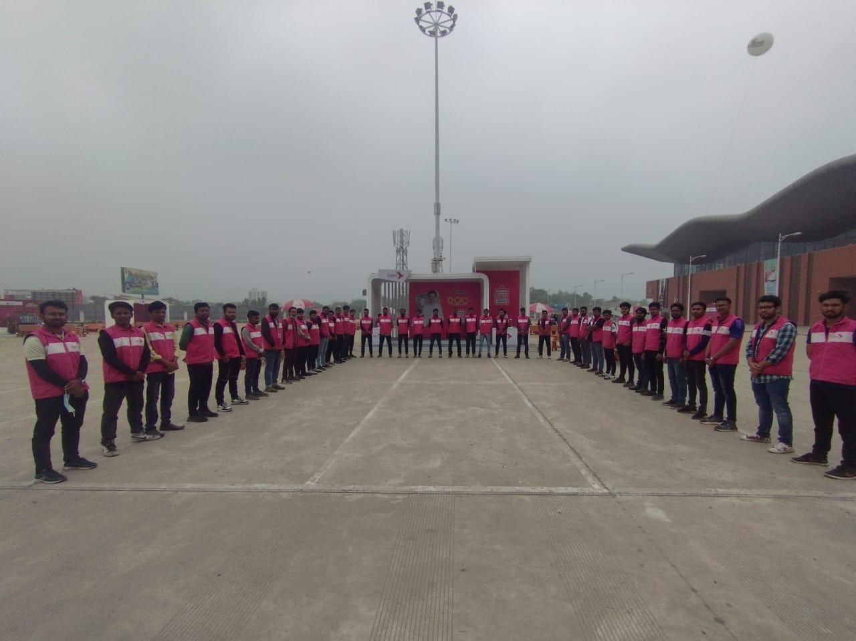
Figure 10 Brand Promoters

- Keeping track of daily targets was one of the key things that mattered the most. Used to communicate to assign targets and motivate the BPs so that we get maximum output and ensuing right messages are being delivered

- Overseeing and handling agency, coordinating with external allies to perform promotional activities and logistical support. Used to communicate what we needed in the activation and how it can align with the goals and objectives of the organization.

- Confirming constant brand presence in such places where visitors are most likely to notice during the activation venue. For example, ads are playing on right time, POSM are neat and clean, and placed in the right place.
Figure 11 bKash Coupon offer at DITF

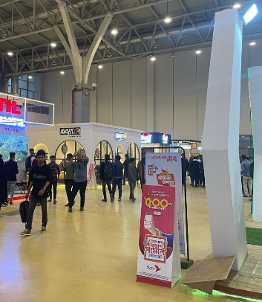
- Coordinating engagement booths and bKash zone was also another significant responsibility that I had to take care of. We had 8 engagement booths where we were offering different things for customer engagement and offering a sitting zone for the customers to rest for a while after a tiring tour of the fair. I used to make sure that all the booths were activated and operating smoothly and ensure the sitting zone was okay, clean, and nice so that people felt comfortable.
Figure 12 POSM at DITF

- Assisting the commercial team in onboarding new merchants, customer service team so in to maintain a smooth customer service flow, and agents of bKash in overall mobile financial service through bKash.

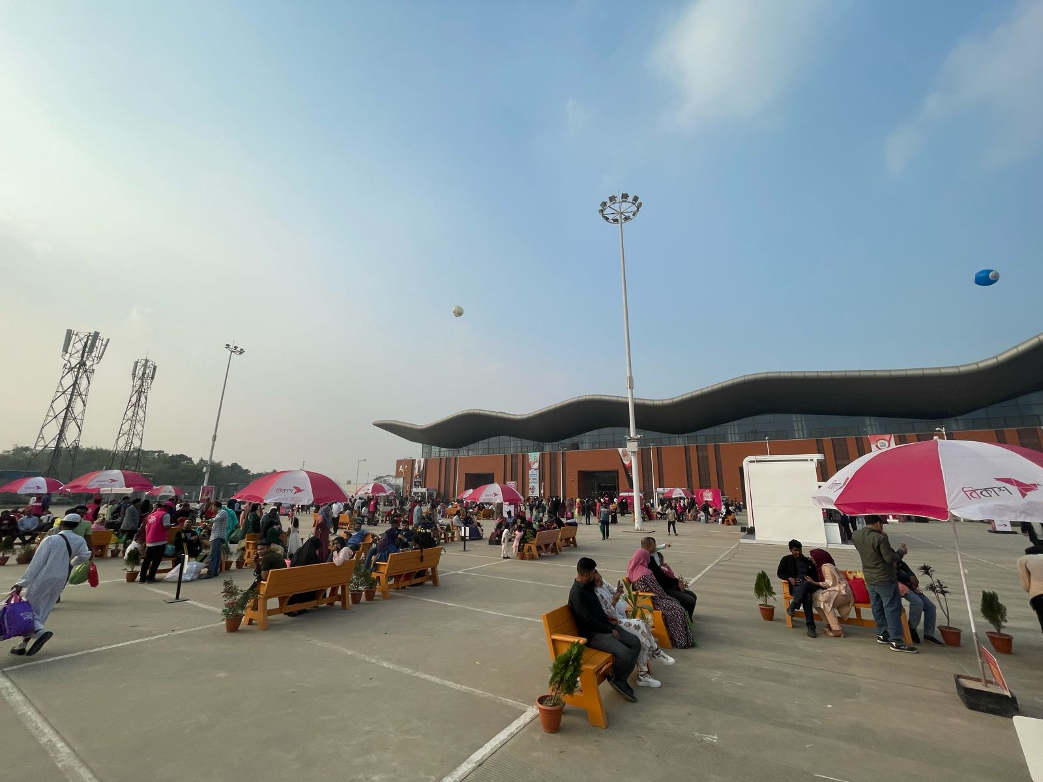
Figure 13 Sitting zone of bKash at DITF 2024
- Amar Ekushey Boi Mela 2024
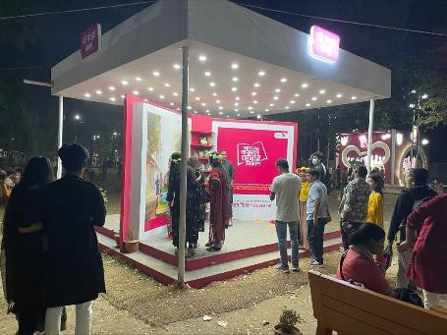
For this event, I had to do detailed operational work which involved working till the closing hours of the event at 9 PM. My regular day working in the Boi Mela usually starts off with walking around the entire venue to check whether the BPs are effectively engaging with customers. Then, I would work on taking attendance for each BP and check whether their targets align with the objective set by bKash. This involved one-by-one talking to each BP and motivating them to reach the set target. At the end of the day, I would tell the vendors of the event to make a report on the daily activities which I forwarded to the manager in charge of the event. Additionally, I also had to ensure that the branding elements and POSM were placed properly. This involved walking around the venue and closely observing every stall for POSM and places where brandings are present according to our specifications. I also had to ensure that all the branding elements were neat and tidy. During the event, there were some branding elements in progress yet to be executed. For these elements, I had to coordinate between vendors and our brand team to ensure all the designs were approved and went to production on a timely basis.
Figure 14 Amar Ekushey Boi Mela activation by bKash

- Beacon at East West University 2024
BEACON is a campus activation event targeting university students in Bangladesh. This event involved gaming competitions, quiz shows, and engagement through a booth that was designed to attract a huge crowd in front of it. My role was to observe and take notes on all the improvement areas as it was our first time doing such an event. I also assisted my seniors in various operations-related activities. The employer branding team of the HR division was also present during this event. Thus, my work here involved collaborating with the Employer branding team and vendors in order to assist my supervisor conduct this event.

Training
During the internship period, I received effective training on:
- Corporate communication and etiquette: Here I learned the right way of formally communicating with internal and external individuals of an organization. I helped me boost up my confidence in communication and improve my formal negotiation skills.
- Induction to FinTech: Here I learned the basics about how a fintech company actually operates its operations. I learned about the core departments a fintech needs, and also the technologies and the team behind the success.
On top of that, I learned bKash's products, services, and brand messaging to effectively communicate with customers and promote brand awareness. I understand big event management and coordination, including logistical planning, coordination with agencies, communicating requirements to vendors, and crisis management strategies.

Contribution to Departmental Functions
My input to the departmental function was many-sided:
- I played a vital role in ensuring the perfect engagement booths set ups and booth activation.
- Ensured agency understand bKash’s requirements and assist accordingly.
- Enhancing brand visibility and customer engagement in every corner of the DITF2024.
- Managing agency coordination and overseeing BPs, I assisted enhance resource utilization and make the best use of the impact of promotional efforts.
- Assisting different teams, for example, the Customer Service team in serving a smooth service, and the commercial team in merchant onboarding eased the development of bKash's merchant network, contributing to bKash's growth, market presence, and sustainability.
- Solving daily challenges and handling crisis moments.
- Developing and doing several surveys on customers’ insights.
- Communicating and motivating top merchants to push sales.

Evaluation
Overall, my performance throughout the internship was positively evaluated based on:
- The fruitful execution of given tasks and responsibilities, including overseeing BPs, managing agency, and ensuring brand presence.
- Proven ability to adapt to dynamic and challenging environments, successfully problem-solving, ability to handle crisis moments and making decisions under pressure.
- Contribution in bKash’s customer engagement and brand presence at the DITF 2024.

Skills Applied
During my internship at bKash Limited, where I oversaw all activities at the Dhaka International Trade Fair (DITF) 2024, I developed diverse skills that are invaluable to my professional growth.

Leadership: As the leader of a team of 70 brand promoters, I honed my leadership skills by setting clear objectives, providing direction, and motivating team members to perform at their best. I learned to lead by example, fostering a sense of accountability and teamwork among the team members.
Team Management: Managing such a large team requires effective coordination of schedules, allocation of tasks, and resolution of conflicts. I developed the ability to understand each team member's strengths and weaknesses, assigning roles accordingly to optimize productivity. Additionally, I prioritized creating a positive work environment where team members felt valued and supported.
Collaboration: Working alongside agencies and the commercial team demanded strong collaboration and communication skills. I learned to effectively communicate ideas, listen to feedback, and negotiate with stakeholders to ensure the alignment of strategies and goals. Building strong working relationships was essential for the successful execution of plans and achieving desired outcomes.
Sales Strategy: Supporting the commercial team in driving sales involved a deep understanding of market dynamics and customer behavior. I gained experience in conducting market research, identifying target demographics, and devising tailored sales strategies to attract customers and boost revenue. This included analyzing sales data to identify trends and opportunities for improvement
Problem-Solving: Throughout the event, I encountered various challenges and unexpected issues that required quick thinking and problem-solving skills to address. Whether it was resolving logistical issues, handling customer complaints, or adapting to changes in the environment, I learned to approach problems analytically, identify viable solutions, and implement them efficiently to ensure the smooth operation of activities.
Time Management: With multiple tasks and responsibilities to juggle, effective time management was crucial for meeting deadlines and ensuring that all activities were executed efficiently. I learned to prioritize tasks based on urgency and importance, delegate responsibilities where necessary, and effectively allocate resources to maximize productivity and achieve objectives.

Report Generation: As part of my responsibilities, I was tasked with generating various reports related to the performance of bKash's activities at DITF 2024. This involved collecting data on metrics such as foot traffic, customer engagement, and sales figures, and compiling them into comprehensive reports for internal review and analysis.

Data Collection and Analysis: I gained experience in collecting and analyzing data from multiple sources, including sales transactions, customer feedback, and promotional activities. This involved using analytical tools and software to interpret data trends, identify patterns, and derive actionable insights to inform decision-making processes.

Overall, my internship experience at DITF 2024 provided me with a comprehensive skill set in leadership, team management, collaboration, sales, marketing, problem-solving, and time management, all of which are essential for success in various professional roles within the marketing and business sectors.

New Skills Developed
Monitoring Performance: Throughout the event, I closely monitored the performance of bKash's activities, including the effectiveness of promotional campaigns, the impact on sales revenue, and the level of customer engagement. This involved real-time tracking of key performance indicators (KPIs) and identifying areas for improvement or adjustment based on ongoing observations.
Trade Marketing: Participating in trade marketing activities provided insights into promoting bKash's products and services in a trade show environment. I was involved in every aspect, from planning the booth setup and designing promotional materials to engaging with visitors and delivering compelling presentations. This hands-on experience helped me understand the importance of creating a strong brand presence and effectively communicating key messages to potential customers.
Collaboration: Working alongside agencies and the commercial team demanded strong collaboration and communication skills. I learned to effectively communicate ideas, listen to feedback, and negotiate with stakeholders to ensure the alignment of strategies and goals. Building strong working relationships was essential for the successful execution of plans and achieving desired outcomes.

Application of Academic Knowledge
My academic knowledge in marketing, management, supply chain, and business operations were useful in numerous parts of the internship, including:
- Developing and applying promotional plans to improve bKash’s visibility and customer engagement.
- Utilizing project managing principles to manage logistics, accumulate resources, and confirm the fruitful and effective implementation of promotional activities.
- Put on academic concepts in marketing and business development to contribute well to bKash's purposes throughout the DITF 2024.
- Applying service marketing concepts to put customers in the first place and present bKash as a customer-centric organization.
- Utilizing business analytics and computer applications in business knowledge to develop reports on BP’s performance reports based on daily targets.
- Applying business communication lessons in effectively communicating with different stakeholders of bKash ltd.

CHAPTER V: CONCLUSIONS AND KEY FACTS

Recommendations for Improving Departmental Operations
Broader Team: Expand the team to embrace diverse skill sets and expertise, facilitating a more holistic approach to handling promotional activities, agency coordination, and managing multiple activations and events at a time.
Proactive Strategies: Cultivate proactive strategies and contingency plans to anticipate possible challenges, mitigate risks, and take advantage of emerging opportunities, ensuring agility and flexibility in responding to dynamic market conditions

Key Understanding
The internship experience at bKash Ltd throughout the DITF 2024 provided treasured visions into the complications and dynamics of handling promotional activities, agency relationships, brand promoter management, and coordination with different internal teams within a fast-paced environment. It highlighted the significance of effective coordination, tactical planning, and flexibility in achieving organizational goals and increasing positive brand presence.

Conclusion
The internship at bKash Ltd offered a practical opportunity to contribute to the company's involvement in a significant event like the Dhaka International Trade Fair 2024. Through managing agency relationships, overseeing brand promoters, and assisting in teams of different verticals, I gained practical knowledge, capabilities, experiences, and an understanding of the multi-layered characteristics of event management and brand promotion.
Moreover, the internship not only developed my professional skill set but also gave depth to my understanding of the complex dynamics involved in executing successful promotional campaigns and fostering business growth in the mobile financial services sector.

References
  - https://www.youtube.com/watch?v=ZVetfE8qI08
  - https://businesspostbd.com/economy/ditf-secures-tk400cr-sales-3562m-export-orders
  - https://www.tbsnews.net/economy/dhaka-intl-trade-fair-fetches-over-30m-worth-export-orders-796066
  - https://www.bssnews.net/business/174657
  - https://www.bb.org.bd/en/index.php/financialactivity/mfsdata

