Internship Report
On
“General Banking Activities and Investment Modes & Mechanisms of Islami Bank Bangladesh Limited”

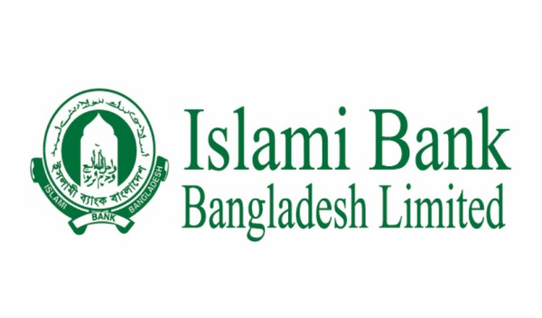

This report is submitted to the school of Business and Economics, United International University as a partial requirement for the degree fulfillment of Bachelor of Business Administration
Title of the report
“General Banking Activities and Investment Modes & Mechanisms of Islami Bank Bangladesh Limited”

Submitted to:
Name: Dr. Md. Qamruzzaman
Designation: Associate Professor
School of Business and economics
Major: Finance

Submitted by:
Rabeya Sultana Prity
ID: 111 171 278
Major: Finance
Trimester: Spring 2021

School of Business and Economics

United international university
Date of Submission: 05th July 2021

Letter of transmittal
5th July, 2021
MD. Qamruzzaman
Associate Professor
School of Business and Economics
United International University
Subject: Submission of Internship Report.
Dear respected Sir,
It’s my great pleasure to submit the internship report on “General Banking Activities and Investment Modes & Mechanisms of Islami Bank Bangladesh Limited” as per our Bachelor in Business Administration (BBA) program requirement. I have completed this report as part of my internship program. I have been placed in Munshiganj Branch of Islami Bank Bangladesh Limited (IBBL). I have written this report based on my practical observations from general banking section, credit section, foreign exchange section, credit card section and Investment section.
I believe that the knowledge and experience I have gathered during my internship period will definitely help me in my future professional life. I also believe this genuine and honest analysis will help you to have a positive viewpoint upon me.
I hope that this paper will live up to your expectation & hope this report will meet the standards of your judgments and you will appreciate my efforts.
Sincerely yours,
Rabeya Sultana Prity
ID : 111 171 278
Bachelor of Business Administration.
United International University.

Certification of similarity index

This is to certify that the Internship Report on “General Banking Activities and Investment Modes & Mechanisms of Islami Bank Bangladesh Limited” This report is done by Rabeya Sultana Prity, as a partial fulfillment of the requirement of Bachelor of Business Administration (BBA) degree from work carried out successfully.
Student ID- 111 171 278
Signature of the Student ......Rabeya Sultana.......................
Signature of Supervisor ………………………
MD. Qamruzzaman
Associate Professor
Faculty of Finance
BBA Program
UIU Business School
United International University

Declaration of the Student

I am Rabeya Sultana Prity hereby declare that the internship report entitled “General Banking Activities and Investment Modes & Mechanisms of Islami Bank Bangladesh Limited”, is entirely prepared by me after two months of my internship in an Islami Bank Bangladesh Limited, in Munshiganj Branch. ".
I am acknowledging and claiming that the task is original in my internship program was completed by me. It is an unique experience of mine that has never been used for a certificate, articles, or evaluation before, and it has never been published for an education achievements or bachelor's degree to any other institution or company degree.

………………………
Rabeya Sultana Prity
ID : 111 171 278 (BBA Program)
United International University

Acknowledgement

Firstly, I would want to express my gratitude to Almighty Allah for allowing me to complete my internship report successfully. I have tried my best to present both hands on experience and study in this paper. I'd want to show my heartfelt gratitude to my respected and honorable supervisor Md. Qamruzzaman Ph. D, Faculty of Finance, BBA Program, United International University.
I am also thankful to head of HR division of Islami Bank Bangladesh Limited, for allowing me to work in Munshiganj branch. I'd want to express my gratitude to Abdul Bakhi, Senior Principle Officer (SPO) of the general banking sector, for overseeing work and providing myself to with crucial data that helped me prepare a successful assessment. I am also grateful to Md. Amir Hossain, VP & Manager of Islami bank, Munshiganj Branch and I would also like to thank also Md. Ruhul Amin Sharif First Assistant VP of Islami Bank Munshiganj Branch to help me and give me proper instruction and guideline while working in general Banking activities.
Moreover I am very thank full to all the officers specially Saddam Hossen junior offier in foreign remittance and stuffs of Islami Bank Bangladesh Limited, Munshiganj Branch, who supported me throughout my internship program. The report would not be possible without their support and helps.

Abstract/ Executive summary
This internship report is prepared as a representation of the BBA program of United International University. This report is on “General Banking Activities and Investment Modes & Mechanisms of Islami Bank Bangladesh Limited”. This report desire to assist the reader in detailed understanding the General Banking activities and provides basic knowledge about Sources of fund and Principles of Collecting Deposits”of IBBL.
Account opening, invoice paying, and cash clearance are all part of general banking. It builds Banker client relationships, collects bills for customers, and honors cheques written on this branch through these divisions. These services are provided by the General Banking section in a more timely and efficient manner. The very first chapter Purpose of the research, source of the research, rationale, Effectiveness, purpose of the investigation, limitations of the study, statistical treatment, and so on are all included in the report's establishment. The report's second component focuses on an analysis of Islami Bank Bangladesh Limited. Overview, goal, objectives, tactics, SWOT Analysis, Islami Bank Limited strategic planning, and many more. The third section focused on departments of Munshiganj branch at Islami Bank Ltd. Third chapter of the report focused on general banking section and my activities on general banking sector. Besides, here I discuss the investment modes and mechanism of IBBL at general banking department. The connection among a financial institution and a client is known as traditional banking, as well as the bank generates revenue by collecting interest on loan assets and utilizing the money it receives to make payments to depository institutions of resources. On the other hand, the relationship between an Islamic bank and its customer takes on a various form because Islamic Banking considers the payment or receipt of interest “Riba” as an act of sin. So, their deposit terms are also different than other conventional banks. Islami Bank Bangladesh Limited mobilizes deposits through different types of accounts as like 1. Al-wadeah Accounts and 2. Mudaraba Accounts. There are two types of Al-wadeah accounts and various mudaraba accounts which is operating by IBBL. Besides, IBBL has established a number of income-generating operations for thousands of people in both rich and poor. Finally is conclusions of internship work in the report.

Table of contents for Internship
Table of Contents
Letter of transmittal ii
Certification of similarity index iii
Declaration of the Student iv
Acknowledgement v
Abstract/ Executive summary vi
Table of contents for Internship vii
List of Abbreviation ix
CHAPTER I: INTRODUCTION 1
1. Introduction: 1
1.1 Background of the Report 1
1.2 Objectives of the Report 2
1.1.1 Primary Objective: 2
1.1.2 Secondary Objective: 2
1.3 Motivation of the Report 2
1.4 Scope and limitations of the Report 3
1.5 Definition of Key terms 4
CHAPTER II: COMPANY PREVIEW 5
2.1 Company Analysis 5
2.1.1 Overview and history 6
2.1.2 Trend and growth 8
2.1.3 Customer Mix 16
2.1.4 Product/service mix 16
2.1.5 Operations 25
2.1.6 SWOT analysis 26
2.2 Industry analysis 29
2.2.1 Specification of the industry 29
2.2.2 Size, trend, and maturity of the industry 33
2.2.3 External economic factors 33
2.2.4 Technological factors 34
2.2.5 Barriers to entry 35
2.2.6 Supplier Power: 35
2.2.7 Buyer Power: 36
2.2.8 Threat to substitutes: 36
2.2.9 Industry Rivalry: 36
CHAPTER III: INTERNSHIP EXPERIECNE 37
3.1 Position, duties, and responsibilities 37
3.2 Training 43
3.3 Contribution to departmental functions 46
3.4 Evaluation 51
3.5 Skills applied 52
3.6 New Skills developed: 52
3.7 Application of academic knowledge 53
CHAPTER IV: CONCLUSIONS AND KEY FACTS 55
5.1 Recommendations for improving departmental operations 55
5.2 Key Understanding: 56
5.3 Conclusion: 56
REFFERENCE 57
Appendix 58

List of Abbreviation
IBBL | Islami Bank Bangladesh Limited
IBTRA | Islami Bank Training and Research Academy
GB | General Banking
ADC | Alternative Delivey Channel
CDD | Customer Due Diligence
EDD | Enhence Due Diligence
MSA | Mudaraba Savings Account
AWCA | Al-Wadeah Current Account
DPS | Deposit Pension Scheme
HPSM | Higher Purchase under Shirkatul Melk
BEFTN | Bangladesh Electronic Funds Transfer Network
RTGS | Real Time Gross settlement
BACH | Bangladesh Automated Clearing House
KYC | Know Your Customer
RDS | Rural Development Scheme
UPDS | Urban Poor Development Scheme
FATF | Financial Action Task Force
ML | Money Laundering
CRR | Cash Reserve Ratio
SLR | Statutory Reserve Ratio
CTR | Cash Transection Report
STR | Suspicious Transection Report
UCIC | Unique Customer Identification Code

CHAPTER I: INTRODUCTION

1. Introduction:
Islami Bank Bangladesh Limited is the first Shariah based Islami Bank in Bangladesh, in fact considered to be first in South-East Asia. Islamic Economics is that part of Islamic regulations which deals with economic, social and moral behaviour of human being in case of production, distribution and consumption of goods and services”. a monetary sector regulated by Islamic Finance and founded on the rules of Law, often known as Islamic laws. According to OIC - An Islamic bank as “a financial institution whose statutes, rules and procedures expressly state its commitment to the principles of Islamic Shariah and to the banning of the receipt and payment of interest on any of its operations.”

Background of the Report
It is a fantastic opportunity for any understudy to come up with some outstanding ideas for the practical field. It's also a stimulating experience to prepare an internship position report, which helps students develop the scholarly abilities as a successful graduate. As a Bachelor of Business Administration (BBA) student, students must do an internship at any organization to fulfill the criteria of the Internship Program. The primary goal of this course is to teach students how to use their theoretical knowledge in the workplace. That will enhance the knowledge of students and assist in understanding the connection between theoretical and actual work.
Since I am a Finance student I have tried to highlight the “General Banking Activities and Investment Modes & Mechanisms of Islami Bank Bangladesh Limited”. I have chosen a bank named “Islami Bank Bangladesh Ltd”. In the study period, basically students gain theoretical knowledge. Students should have real-world experience in the primary area of study on the career choice that interests them before entering the corporate sector. I selected this bank since a bank performs all of the operations required to keep the economic growth cycle running.
IBBL (Islami Bank Bangladesh Limited) is regarded as Southeast Asia's only usury-clear bank. It was organized as a Publicly Listed Financial services act of 1913 on March 13, 1983. The bank began operations on March 30,1983 and Formal Inauguration:12 August 1983.

Objectives of the Report
Main objective of the report is to discuss about the ““General Banking Activities and Investment Modes & Mechanisms of Islami Bank Bangladesh Limited”(IBBL).
    - Primary Objective:

The primary goals of this report are to learn about Islami Bank Bangladesh Limited workplace and to meet the requirement of BBA conceptual knowledge gained from courses in a certain field's BBA degree.
    - Secondary Objective:
- To identify the features and functions of Islami Bank Bangladesh Limited.
- To decide entire general activities of Islami Bank Bangladesh Limited.
- To check the extents of additional improvement of general banking framework.
- To evaluate the impact of these activities helping to improve the society.
- To fulfill the requirements for obtaining a BBA degree.
- Connecting academic understanding to practical application.
- Understanding the banking environment and the role of banks in economic development.

Motivation of the Report
The primary goal of this report is to give a visual representation of my internship experiences. I got a huge amount of theoretical information during my undergraduate degree, and internship is the final step in my undergraduate BBA program. The report will also be very helpful to the top management in their efforts to improve customer loyalty. Furthermore, it may be a fantastic opportunity for me to learn useful information about the financial field. As a result, this research is extremely important to both myself and the bank. Essentially, an internship program provides students with pragmatic expectations and exposure to various work situations.
Working in the Munshiganj Branch of Islami Bank Bangladesh Ltd. allowed me to finish my internship course. I worked in practically every department of that bank. I've worked in a variety of banking areas, including account opening sector, credit Department, foreign remittance, cash management and investment sector. In this paper, I have wanted to present IBBL general banking and sources of fund in an Islami Bank Bangladesh Limited and Principles of Collecting Deposits.

Scope and limitations of the Report
Since I was doing 15 days online class through Zoom for this pandemic situation which was operated by Islami Bank Training and Research Academy( IBTRA). Then IBTRA sent us to our branch for 45 days practical session and I choose Munshiganj branch. As my internship programs consistency is only for two months. This is a fairly little time to get the necessary experiences and knowledge. Despite my best efforts to prepare the report with care and dedication, there are some limitations to my work. Those following limitations are given below:
- For the purpose of the bank’s confidentiality, they did not reveal much information while gathering data when I was asking the employee.
- They did not share much information with me since I was not a regular employee and they also did not train me properly because I was not a permanent employee.
- Though the officiers of the bank tried to assist, sometimes their working pressure couldn't give me with the right support when I required. That’s why they didn't give enough time because they were on a tight timeline.
- Clients are also busy and not always cooperative and they are reluctant to comment on the bank found within the premises, which created problems throughout the survey.
- Lastly, it was extremely difficult and challenging for me to collect knowledge, experiences, and represent them on my report in such a short period of time.

Definition of Key terms
- Riba:
The term riba refers to an overabundance, increase, or accretion. Riba is the term for any sum beyond the mortgage in a lease agreement.
- Mudaraba:
““Mudaraba is a profit-sharing collaboration in which one party gives finance and another company contributes capabilities and knowledge and manpower. The provider of capital is called “Shahib-al-Mal” or ”Rabb-ul-Mal (owner of the fund) while the provider of skill and labour is called “Mudarib” (Organizer/Manager).
- Bai-Salam:

Bai-Salam is an agreement among a Producer and the Consumer whereby the Consumer buys specific goods and services to the Purchaser in detail under Shariah Principles at a fixed period payments made on contractual terms, as well as the goods and services are despatched as indicated in volume, performance, and amount at a specific date in a prescribed manner in a particular area.

CHAPTER II: COMPANY PREVIEW

Company Analysis
Islami Bank Bangladesh Ltd. is the largest private sector bank in Bangladesh. Even very few private investors are capable of competing against IBBL. The banking system that exclusively offers items that are acceptable with sharia, or Islamic law. So, Islamic banking is simply conducting financial transactions in today's banking environment using Islamic Shariah and Islamic Economics principles.
Vision:
- Our mandate is to improve sociocultural wealth and sustainable goods among low-level income people, particularly in rural regions.
- The ambition is to influence continued for excellent capital structure and then to be recognized as a largest Islamic Bank in terms of credibility and productivity.
- To enhance personal income in the form of deposits, specifically in initiatives that are significantly more useful in determining job.

Mission:
▪ Introducing a government benefits financial sector in order to build Islamic Financial system. To guarantee that all socioeconomic operations are conducted in an equitable and instead just manner. To use a range of marketing activities, achieve unequal sharing and long-term progress in the region's economic development and lowest affluent regions. To reduction in compressive strength people's revenue generation and income growth, rural communities.
Objectives of Islamic Bank:
The primary purpose of Islamic banking institutions is to encourage, grow, and strengthen the application of Islamic precepts to industrial prosperity. The following are the aims of an Islamic bank when considered part of its role in the economy:

- To provide modern financial services in accordance with Islamic Shariah.
- Contribute to economic development and prosperity while adhering to Islamic justice values.
- Optimal use of limited financial resources and
- To aid in the allocation of money in a more equitable manner.

Overview and history
Islami Bank Bangladesh Limited, established on 13th March,1983, Business commenced on 30th March in 1983 and formal inauguration on 12th August,1983. Islami Bank Bangladesh Limited is a joint venture public limited company engaged in commercial banking based on Islamic Shari'ah with 63.09 percent foreign shareholding and the largest branch network among private sector banks in Bangladesh (total 373 Branches, 171 Sub-Branches, and 2284 Agent Outlets).
Year | History of Islami Bank in Bangladesh
In 1974 | As a Member of IDB, Bangladesh undertakes for researching of banking activities to conform to Islamic Shariah.
In 1978 | Bangladesh participated in the Islamic Foreign Ministers’ Conference held in Dakar, Senegal in 1978 and responded to the recommendation to establish Islamic Banks.
In 1980 | Bangladesh Bank made study on the operations of Islamic Banks abroad.
In 1981 | During the 3rd OIC Summit in Makkah and Taef, says former of Bangladeshi suggested that Muslim nations establish an independent central bank.
In 1982 | IDB expressed interest in joining a strategic partnership Islamic bank in Bangladesh.
In 1977-1982 | Seminars, Symposium and Workshops on Islamic Banking were arranged by different Organizations.
In 1983 | With the first Islamic financial institution in Asian Countries, IBBL was established.

The Board of Directors of Islami Bank Bangladesh Limited is comprised of both foreign and local directors. The Board of Directors has designated an Executive Committee with formulating policies and making crucial and strategic decisions.
Financial Information: [ As on: 31 December 2019]
 | BDT(TK)
Authorized Capital | 20,000.00 million
Paid-up Capital | 16,099.91 million
Equity | 79,079.70 million
Reserve of Fund | 40,941.78 million
Investment (including Investment in Shares) | 953,150.85 million
Deposits | 946,291.53 million
Import | 399,884 million
Export | 234,443 million
Remittance | 305,514 million

The Institute for NRB has awarded IBBL with the "Golden Money transfer Prize 2019" for earning the greatest contribution in 2019. IBBL received “Bangladesh Bank Remittance Award 2019 & 2018 for mobilizing highest remittance.

Trend and growth

Analyzed the deposit trend of the bank and advised the management to exert best eort for mobilizing the deposit in order to support the business growth of the bank.
Confidence of Crore Depositors: Total number of Depositors of IBBL stood at 13,843,053 as on 31.12 2020. Account opening performance of IBBL in last 05 years is as under given below:

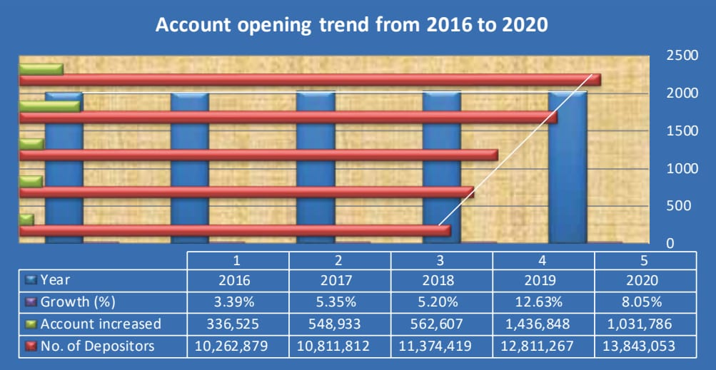
Fresh Investment: Tk. 136,274million Growth: 15.16%
Fresh Deposit: Tk 233,259 million Growth: 24.65%

Total deposits of the Bank in 2020 rose to Tk. 1,179,476 million from Tk. 946,217 million in 2020 showing an overall increase of 24.65% and the management have achieved 115% of Board target. Deposit Achievement is shown in the Graph
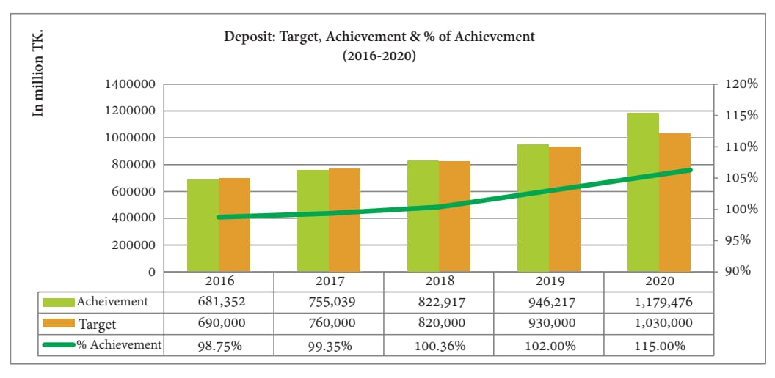
Total General Investments of the bank as on 31st December 2020 stood at Tk. 1,035,287 million as against Tk.899,013 million on 31st December 2019 despite COVID-19 pandemic challenge on the banking sector since the beginning of the year. The investments increased by Tk.136,274 million recording 15.16% growth in 2020 over the previous year. The trend is shown in the following graph below:
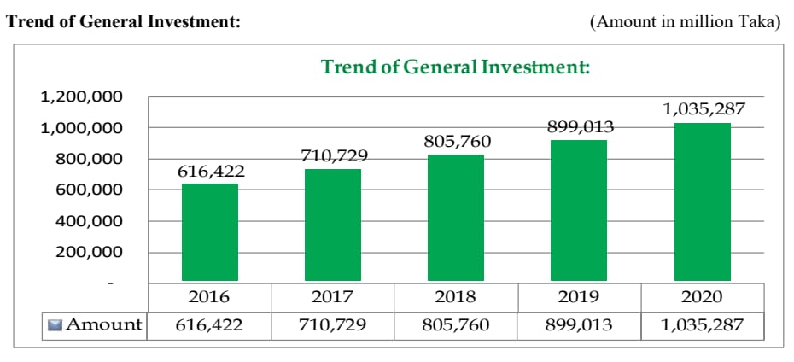

Now we can see the Growth of General Investment:
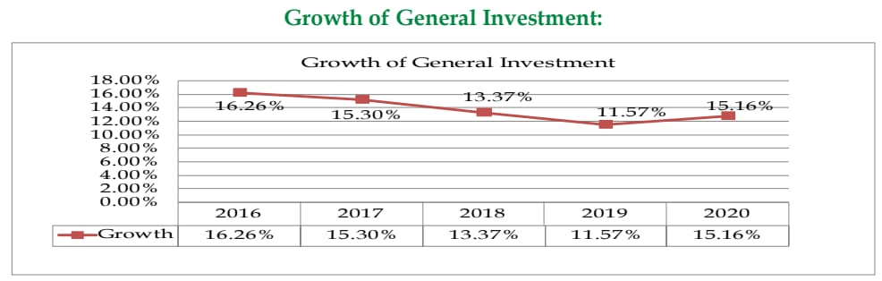
Here in 2020 the growth of General Investment is 15.16% which is higher than previous year 2019 which was 11.57% that is very low for pandemic situation COVID 19. But here in 2017 the growth of General Investment was high which is 15.30% comparatively previous year.
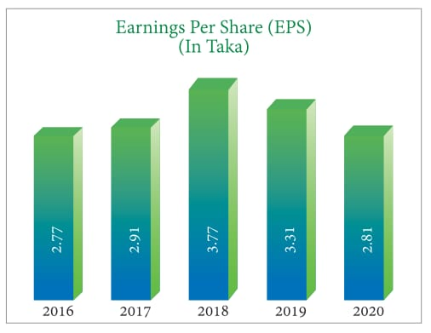
EPS ratio shows measure of a company's profitability. In 2018 EPS is 3.77% which is high. We all understand that an essential to economic growth (EPS) indicates that an organization is more attractive. But in 2020 EPS is 2.81 which is low and it shows the company performance is not valuable.
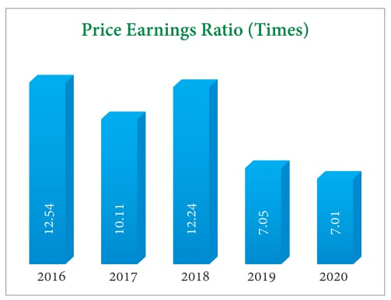

The Price per earning proportion for 2019 is 7.05 percent, indicating that shareholders are prepared to pay a greater net profit margin currently resulting from economic expansion predictions. However, the P/E ratio for 2020 is 7.01 percent, which becomes reduced, and a low Price per earning ratio can imply that a firm is presently profitable or that it is running very well in compared to actual patterns.
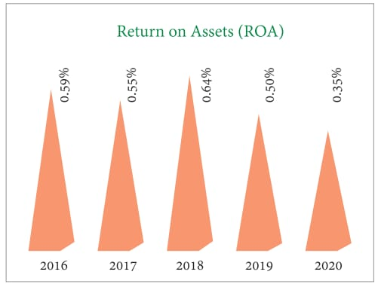

Islami Bank is investing more on assets but not getting adequate return because ROA is decreasing over the years. In 2020 ROA was 0.35% which was low but in 2018 ROA was 0.64% which was high.

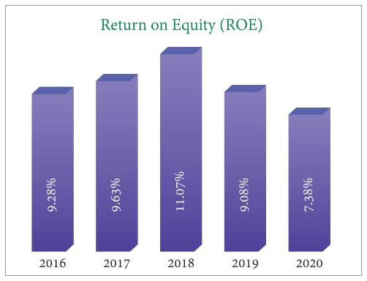

Here above the graph, in 2018 ROE was 11.07% that means 11.07% return we are generating for our owners against they equity investment they can get 11.07% return which was very good. But in 2020 ROE was 7.38% which is low and that is not okay. We are supposed to increase our ROE higher level 11.07%.
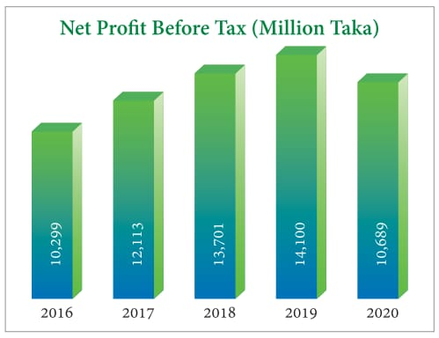

Here above the graph, we can see that, the net profit before tax increasing and decreasing as well. In 2019 it was the high which was 14,100 Million Taka. On the other hand, for COVID 19 in 2020 it was 10,689 million taka which is low.

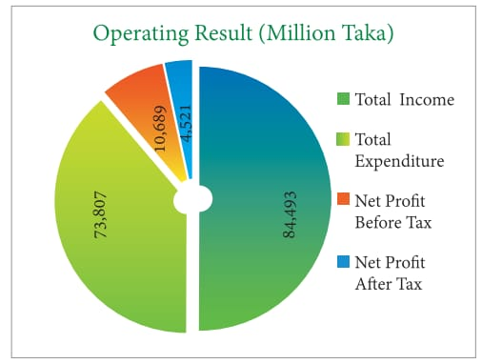

Here in this graph we can see that in the operating result Total income is 84493 Million Taka. It shows how much the organization earns from its operation. Therefore, Total expenditure is 73,807 million Taka.
Last 5 years import performance (2016-2020) is shown in the chart that is given below:
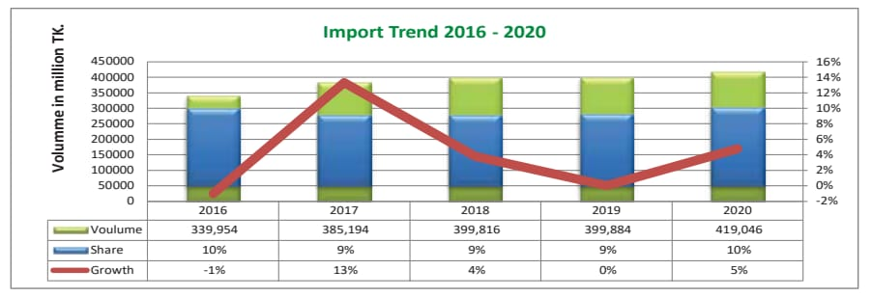

Import business rose to Tk.419, 046.00 million in 2020 from Tk.399, 884 million in 2019 with a growth of 4.79%.

Last 5 years export performance (2016-2020) is shown in the chart that is given below:
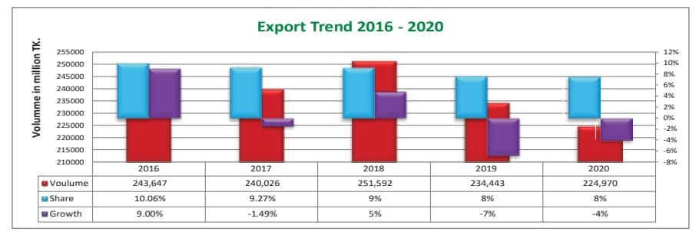

Export business decreased to Tk. 224,970.00 million in 2020 from Tk. 234,443 million in 2019. The market share of IBBL in export business stood at 8.00%.
Last 5 years remittance performance (2016-2020) in the chart that is given below:
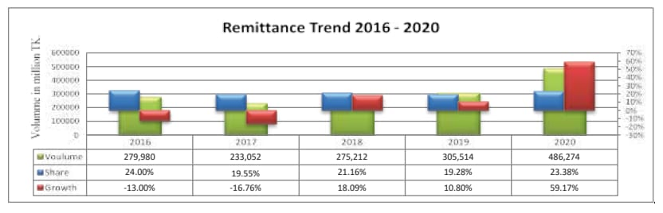

Remittances are regarded as one of the most significant indicators of our country's economy. Because of its importance to the economy, the IBBL has given the highest priority to remittance collection through transactions. As like to previous years, we are being 1st in remittance collection by routing almost one-fourth of the remittance through our bank with 25% market share. Our inward remittance volume sharply rose to Tk. 486,274.00 million in 2020 from Tk. 305,514 million in 2019 with a growth of 59.17%.

Organizational Structure:
Organizational Structure

Executive President (EP)

Shariah
Supervisor

Deputy Executive President (DEP)

Executive Vice President (EVP)

Senior Vice President (SVP)

Vice President (VP)

Branch

Assistant Vice President (AVP)

Senior Principal Officer (SPO)

Investment

Principal Officer (PO)

Senior Officer (SO)

General Banking

Officer

Probationary Officer

Assistant Officer Grade - I

Assistant Officer Grade - II

Assistant Officer Grade - III

Customer Mix
Islami Bank Bangladesh Limited is one of the most recognizable banks in Bangladesh. It stands out because of its authoritative and trustworthy background, competence, and quantifiable proficiency. The corporate branch of IBBL Bank stands out for the way it collaborates, manages customers, and maintains a diverse portfolio. IBBL focuses investment in the nation's economic thrust sectors, as the government declares from time to time. The bank has a substantial interest in the industrial sector, contributing for 54.36% of its total assets. IBBL's CSR projects have made a substantial contribution to improving the socioeconomic status of Bangladesh's rural population. IBBL is appreciated by the Central bank for its highest contribution in CSR activities among all Banks in Bangladesh.

Product/service mix
Islami Bank Bangladesh limited offers a wide variety of products and services on various fields. Islami banks provides excellent services as well as a number of attractive schemes for their customers which is very beneficial for customers. There are different types of products and services in Islami Bank Bangladesh Ltd. That are benefitable for clients:
1. Deposit Schemes:
- Al-Wadeeah Current Account (AWCA):
Wadeeah – Literally it means deposit. It is a contractual arrangement wherein the individual holds its goods to some other person for security. The phrase Al-Wadiah refers to a monetary deposit that allows someone to obtain the earnings in the bank. Any liabilities suffered as a result of this loan transaction are not the depositor's responsibility. As a result, there is no chance of loss. The company received funds from investors on the understanding that they be returned on requested. Customers can withdraw and deposit several time within the banking hours. All costs, nearly twice and annually, shall been implemented according to the banks' circulars from occasionally.

There are two basic types of wadeeah:
  - Wadeeah amanah refers to property is deposited on the basis of trust (guarantee safe custody).
  - Wadeeah salam Part of customer denotes to secure or guaranteed funds.
Mudarabah Savings Account (MSA):
“Mudaraba is a profit-sharing collaboration in which one participant contributes finance as well as the other contributes talent and effort. The Account is conducted as per Mudarabah Principle of Shariah. The Mudarib functions as both a manager and a representative for the company. In Islamic Banking, the depositor is the “Shahib-al-Mal” and the Bank is the “Mudarib”. The bank has been given permission to deploy Mudaraba additional money at the liability of the issuer "Shahib-al-Mal."
IBBL receives deposits in Mudaraba accounts, which the bank invests directly instead of through a third party in commercial initiatives. Any profit generated by these investments is divided among Mudaraba depositors according to a specified rate, with the bank keeping the remainder as profit. If no earnings are made, the depositors receive nothing else in return for their money. Furthermore, if a loss occurs, Mudaraba depositors are responsible for a specified percentage of the losses in accordance to their savings.
- Mudaraba Term Deposit Account (MTDR):
Interest-based banks receive different kinds of Term Deposits from the depositors. The deposits are generally for 3 months, 6 months, 9 months, one year, 2 years, or 3 years, and the bank pays a stated interest rate on each of these deposits, which varies depending on the term. In general, the bank pays a higher rate of interest the longer the term of the deposit and lower rates for shorter time periods. In addition, a higher rate of interest is generally paid on term deposits than on saving deposits. Depositors are not generally allowed to withdraw money from a term deposit until the term matures. Premature withdrawal may result in penalties in excess of the interest earned, resulting in a negative return. Once a time deposit matures, the depositor may wish to reinvest for a new term.
- Mudaraba Special Notice Account (MSNA):
❖ Mudarabah Special Notice Account operates on the basis of Mudarabah principle of Shariah.
❖ Again with authorization of the Department Administrator, people particularly worried can deposit money. Tk.25,000/- has been set as the money borrowed and payment.
❖ If the chequing accounts falls under Tk.25,000/- at any time mostly during relevant full year, no income will be given. Income will be permitted at a transitional value in June and December, according to modification with the bank's fulfill the demands, which will be issued. Income and expenses will be monitored on a regular level based on market accounts.
❖ All payments, partially and annually, shall be implemented in accordance with the banks' circulars from period to period.

- Mudaraba Hajj Savings Account (MHSA):
❖ On a basis of real grounds, a depositor's Mudaraba Hajj Savings Account could be switched through one bank to that same.
❖ Because funds can always be taken away from the Mudaraba Hajj Bank Account, neither checkbook is granted.
❖ There will also be Twelve repayments yearly, Sixty installments in five years, then 300 installments in twenty-five years.

Year-wise monthly instalments of persons intend to perform Hajj in 2015
Term/ Year | Monthly installment (Tk.) | Estimated expenditure related Hajj (Tk.)
25 | 1700 | 15,80,000
20 | 2210 | 12,80,000
15 | 2930 | 10,05,000
10 | 4200 | 7,55,000
05 | 7250 | 5,30,000
01 | 29600 | 3,70,000

Fig: Year-wise monthly instalments of persons intend to perform Hajj in 2015.
- Mudaraba Special Savings (Pension) Account (MSSA):
When an Islamic bank receives a Mudaraba deposit for investment in some specific business, sector, or project, the deposit is called a "Special Mudaraba Deposit". In this case, an Islamic bank, while receiving deposits, comes to an agreement with the depositors that the money to be received will be invested in some specific business such as the fertilizer or salt business; or in some specific sector like the industrial sector, textile sector, export-import sector; or in some specific investment sector. In Special Mudaraba depositors will share only in the profit and loss of those particular businesses, sectors or projects for which they have deposited their money. They are not impacted by profits or losses from the other operations or projects in the general Mudaraba accounts.
- Mudaraba Savings Bond (MSB):
Relation is an Islamic finance industry certification that indicates a percentage of the profits in a collection of qualifying actual or potential resources in Islamic Financing. That is not a promissory note in the sense of traditional currencies. The Bank will sell certified to clients after they are issued, and indeed the revenues are used to buy the property, giving shareholders full possession of the property. The shareholders are again eligible to a percentage of the investment's earnings. Academic systems, organizations, unions, and several other non-trading and non-profit cultural and social entities may acquire Mudaraba Savings Accounts in their own ownership or in partnership firm. Supervisors will be able to acquire Securities together a person if the child's gender is specified.
- Mudaraba Muhor Savings Account (MMSA):
This is a monetary and within right granted to the wife by her spouse as component of the contractual agreement, and this must be paid in order to properly register this deal. This Arrangement is being introduced by Islamic bank in order to maximize the potential for another Aqeedah to be established. Any understanding spouse can create an account in his personal bank account for regular payment of Tk. 500/-, & Tk. 5,000/- just for 5 to 10 years.
- Mudaraba Foreign Currency Deposit Account (MFCD):
At the User's account choice, it would be created united State Dollars or even other appropriate currency.
❖ Types of the Account will be “Mudaraba Foreign Currency Deposit A/C.”
❖ Usual Mudaraba Savings A/C cheque Book may be used for withdrawal.
❖ FC A/c may be opened with any A/D Branches of the Bank.
❖ Profit is distributed twice in a year (June and December) at the provisional rate, which is adjusted based on annual profit/loss of the Bank.
❖ The other conditions of Mudaraba principle stated in the Islamic Shariah will also be applicable in this contract.
The investment Modes and Mechanism:

2. Investment Modes:
'SHARE' Modes
'BAI' Modes

‘IJARA’ Modes

Hire Purchase Under Shirkatul Melk (HPSM)
Mudaraba
Bai-Murabaha
Bai-Istijrar
Bai-Muajjal
Musharaka
Bai Salam
Istisnaa
Bai-As-Sarf

Bai Murabaha: The term Bai Murabaha has been derived from the Arabic word- ‘Bai’ & ‘Ribhun’ ‘Bai’ means- ‘Purchase & Sale’ and ‘Ribhun’ Means- ‘Profit’. Characteristics of this profit is- ‘Agreed upon profit’. The Murabaha can be denoted as “Sale With Profit”. ‘Bai Murabaha’ means- ‘Sale of goods on agreed upon profit’.
Bai Muajjal: The term Bai Muajjal has been derived from the Arabic word- ‘Bai’ & ‘Ajal’ ‘Bai’ means- ‘Purchase & Sale’ and ‘Ajal’ Means- ‘Fixed and Defined period’. ‘Bai Muajjal’ means- ‘Sale of goods for Fixed and Defined period’ or ‘Deferred Sale’.
Bai-Salam: A Bai-Salam agreement is a document with both a Producer and the Consumer wherein the Business operates specified things carefully.
Bai- Istisna: A agreement in between producer or salesperson and a client wherein the supplier offers particular things following manufacturing these, as permitted by Shariah Principles.

Sectors of Bai Murabaha Investment:
1. Commercial / Trading: (MTR, Murabaha Pledge)
2. Industrial: (Working Capital)
3. Agriculture : (RDS)
4. Import : (MIB, MPI, MFCI)
Ijarah/rent based modes:
Ijara Mechanism: It entails acquiring and then passing to the benefit the ability using the tools and materials with a certain duration of time and charging money, while the Financial institution maintains possession of the property.
HIRE PURCHASE UNDER SHIRKATUL MELK (HPSM)
Shirkatul Melk's Hire Purchase agreement is a unique sort of deal that will have changed over the years.
Through Hire Purchase under Shirkatul Melk, the banker as well as the customer all provide capital in a full or partial percentage again for acquisition of a property such as property, construction, equipment, transportation, and so on. Buy the property with the alternative investments, own it collectively, split the profits as agreed, but absorb the losses in accordance with individual shares. The customer partnership is contracted out the whole sharing or proportion of the business's property for such a specified payment each unit of measure for a specified timeframe.
Finally, the company purchases and distributes possession about its start sharing to the customer in exchange for full repayment set for such a proportion, whether progressively or in one large amount, throughout the hiring stage. There are 3 parts :
(1) Purchasing under one jointly owned agreement, (2) Recruit and (3) Selling and property transference to another partnership Hiring manager.

3. Investment Scheme:
- House Hold Investment Scheme:
- Goal: For strengthen the capacity of livings of a predefined team by providing individuals with investing opportunities to buy home goods.
- Target Group: Permanent Officials of Govt. / Semi-Govt. / Autonomous Body / Corporations / Banks & FIs / Defense Forces / Madrasa / School / College / University Teachers / Businessmen / House owners of Metropolitan & other District Head Quarters / Professionals (Doctors / Engineers / Lawyers etc.)
- Mode of Investment: Bai-Muajjal / HPSM (item wise).
- Period of Investment: Maximum 3-years
- Rate of Return: Here 16.00 percent decided by the Bank on a particular scenario basis.
- Amount of Investment: For All Metropolitan Cities Tk.0.30 million For Districts & Municipalities Tk.0.20 million Others Tk.0.10 million
- Bank’s Participation: 30% or as per Guideline of Bangladesh Bank
- Security: HDS Goods + PG + Spouse / Guardian Guarantee + Employer Certificate / Marking lien on MSS / MTDR (if applicable).
- Investment Scheme for Doctors (ISD):
To assist jobless trained professionals doctors in becoming self-employed.
- Target Group: Doctors (MBBS), Dentist (BDS),Homeopath,Unani, Ayurbed Doctors
- Mode of Investment: Bai-Muajjal/ HPSM
- Period of Investment: Maximum 5-years
- Percentage of Interest: 14.00 percent or a rate decided by the Bank on a scenario basis.
- Amount of Investment: For All Metropolitan Cities : Tk.1.50 million For Districts: Tk.1.00 million For Thana / Municipalities: Tk.0.70 million
- Bank's Participation: 90% (for new doctors) & 80% (for specialized doctors).
- How to Submit: To implement, go to your closest Islami Bank Bangladesh Ltd branch and pick up an offer letter.
There are others interesting investment schemes are given below:
- Transport Investment Scheme (TIS)
- Car Investment Scheme (CIS)
- Small Business Investment Scheme (SBIS)
- Micro Industries Investment Scheme (MIIS)
- Agricultural Implement Investment Scheme (AIIS)
- Real Estate Investment Program (REIP)
- Real Estate Investment (Commercial & Working Capital)
- Agricultural Investment of IBBL
- NRB (Non-Resident Bangladeshi) Entrepreneurs Investment Scheme (NEIS)
- Women Entrepreneurs Investment Scheme (WEIS)
4. Rural Development Scheme:
Strategy to International Cooperation:
The Agreement's goal is to provide not only Small Business opportunities to stakeholders, but also a variety of equipment and provision of other financial products as component of a Structure Plan Concept and Sustainability Reporting. Sector-wise Investment of RDS:
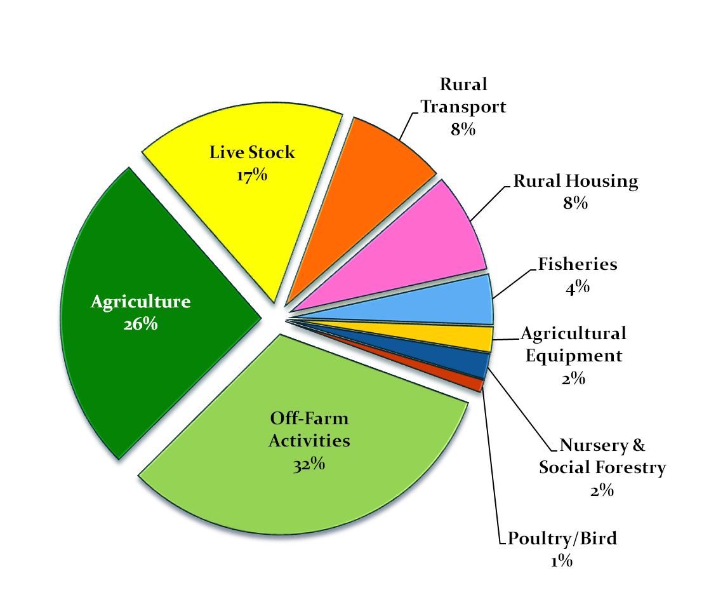
- Client Selection : RDS have given emphasis to make such a large majority of clients’ productive by providing income generating activities, but widows and divorces are ignored. Since, microfinance is more well-fare concern than profit earning, therefore, priority may be given to select more widows and divorcees.
- Touching Ultra-poor : To be the RDS client having minimum 50 decimals of land is the precondition. So, for clients selection, emphasise should be given to the poor and ultra-poor clients. Mechanism can be developed in this regard.
- Control Fund Diversion : Although RDS clients are supposed to invest money to income generating activities but study shows that a significant percentages of clients have diverted their investment to unproductive sector.
- Small Investment Size: Investment size was inadequate to pursue income generating activities properly; study results also supported their opinion. So, size of investment should be increased based on the nature of income generating activities.
- Small Gestation Period : Gestation period is also too small. Repayment of investment should start after getting return from the investment.
5. Foreign Exchange Business Services
6. Special Services
❖ Locker Services
❖ ATM/CRM Service

Operations
Islami Bank Bangladesh Limited basically operates General Banking, Investment and Foreign Exchange Operations. The Islamic banking system does not pay interest to the bank. In this situation, IBBL obtains its complete deposit from client investments on a profit-sharing basis and distributes it to the actual entrepreneurs on a profit-sharing basis. As a result, it is evident that in conventional banking systems, depositors are paid a predetermined proportion of interest regardless of revenue received. IBBL depositors are never deprived of any extra money generated by the bank at the end of the year. This banks operates successfully because of it’s efficient senior management, dedicated employees, loyal customers, interest free banking system which is very important. Therefore bank serve better Customer Service and diversification in Products.
The organizational Information is given below:
Chairman, Board of Director | Prof. Md. Nazmul Hassan, Ph. D
Managing Director & CEO | Mohammed Monirul Moula
Company Secretary | J. Q. M. Habibullah FCS
Number of Zones | 17
Number of Branches | 552
Number of AD Branches | 59
Number of ATM/CRM Booth | 1131
Number of Shareholders | 33,686
Number of Manpower | 11,381
Number of Sub-Branches | 171
Agent Outlets | 2284

SWOT analysis
SWOT means companies Strength, Weakness, and Opportunity & Threats. Here we will see lslami Bank’s SWOT analysis to understand its current situation.

Strength:
- Skilled and dedicated employees: One of the vital strength Islami bank have their skilled and dedicated employees. Human resources and financial capital are valued more highly by them.They are so self-motivated and dedicated towards their work.
- Communication: Communication is an art which is very important and Islami bank maintain perfectly with their clients. Banks employer are ensure that clients are satisfied and observing that banking is conducted in a welfare-oriented manner.
- High quality and Good variety of products: They have some high quality products with so many different features which is attractive to the clients. They have a good variety of products in their product mix which help the clients to choose the particular product according to their needs.

- Very high Reputation: As the country's lone bank, Islami Bank Bangladesh Limited is among the world's top 1000 banks. To rise to the top of the banking industry as a healthier and more productive bank, with stable ratings based on the number of high-quality assets, which is essential to any business since it acts as goodwill.
- Well-disciplined and friendly working environment: Another important strength of them is they have a well disciplined and friendly environment. IBBL can recruit efficient and knowledgeable work force for which the employees get energy to work and never gets bored.
- Experienced management team: They have a experienced management team which I think is most important for any organization to conduct its activities nicely.
- Team Work: IBBL has maintain good team work relationship among its branches and employees. Customers can access banking services at any time and in any location.
- Time Management: IBBL is very good at managing their time and providing exceptional and ensure the efficiency to their consumers.
- Technology: The introduction of e-banking will expand the scope of IBBL.

Weakness:

- Weak ATM facility: Islami Bank Ltd might also enhance the number of ATM it has because its customer base is growing. IBBL must need to be upgraded their machine on a regular basis otherwise it will defective soon.
- In comparison to other banks, the credit facility approval process is excessively lengthy.
- In some locations, employees are unmotivated and IBBL does not have a strong marketing strategy.

Opportunity:

- Welfare oriented banking: RDS initiatives have been fully dedicated to create economic, social & environmental development and well being of the distressed people especially in rural areas.
- IBBL has the capability to provide more inventive and ripping client service.
- In a remote location, multiple branches can be available.
- Because it provides a high level of job satisfaction, IBBL can hire experienced, efficient, and knowledgeable employees.

Threats:
- The global trend of banking sector mergers and acquisitions is producing problems.
- The frequent devaluation of the taka and fluctuations in the foreign exchange rate are producing problems.
- By selling identical products, rival companies can gain a large share of the market.
- Treat of new entrants: Several of these new banks are entering the scene, and each has its own set of services. As a result, the possibility of new competitors, posing a fresh challenge, cannot be ruled out; nevertheless, despite the strong market image and branding, new competitors are far less likely to have an influence on the Banks' operations.

Industry analysis

Islami Bank Bangladesh Limited, established on 13th March,1983, Business commenced on 30th March in 1983 and formal inauguration on 12th August,1983.

Founder & Sponsors:

- 19 Bangladeshi national, 4 Bangladeshi institutions,

- Middle East and European 11 banks and financial institutions, notably the IDB

- Two eminent personalities of the KSA

Specification of the industry
Islami Bank Bangladesh Ltd. (IBBL) is trying to enhance the community's best interests by adhering to Islamic Shariah principles Al - Quran and Sunnah. Both Islam and Bangladesh bank prohibited extravagant lifestyle. As a result, when it comes to consumer investment, IBBL discourages a luxury lifestyle and always attempts to donate money to people who truly need it like rural area people. As a result, it minimizes the widespread use of costly things while also improving society's lifestyle by serving the needy people. IBBL promotes its culture of adventure through the three fundamental pillars of People, Product, and Processes in order to provide the required solution. IBBL's unique recruitment approach ensures a broad human resource base that can serve a wide range of stakeholders. Client requirements aid in the development of the needed product, which is then used to create the process.
Islami Bank Bangladesh Ltd. is a pioneer in Bangladesh's welfare activities. It is equally important to develop the country's rural areas. The Bank's Investment Policy is unique in that it invests on a profit-loss sharing basis in conformity with Islamic Shariah beliefs and principles.The Bank's Investment Policy places a greater emphasis on achieving social goals and objectives, such as creating employment opportunities, than on making a profit. Government policy in Muslim nations should promote the transformation of existing banking systems to Islamic banking, especially given the pro-efficiency aspects of Islamic banking and its good economic benefits.

Differences between Islamic Banking and Conventional Banking
During my internship Here I had practical understanding about the Differences between Islamic Banking and Conventional Banking:
SL | Conventional Banking | Islamic Banking
01 | Traditional banks' operations and operating modes are founded on man-made concepts. | The functions and modes of operation of Islamic banks are dependent on Islamic Shariah principles.
02 | A set rate of interest is guaranteed to the investors. | On the other hand, it encourages risk sharing between the capital supplier (investor) and the fund user (entrepreneur).
03 | Its goal is to maximize profit with no constraints. | It also seeks to maximize profit while adhering to Shariah guidelines.
04 | It has no dealings with zakat and pays no zakat. | The collection and distribution of zakat has become one of the service-oriented responsibilities of Islamic banking. It is obligated to pay zakat.
05 | The primary role of traditional banks is to lend money and receive it with interest. | Islamic banks' primary role is to participate in partnership business.
06 | Frequently, the bank's own interests take precedence. It makes no attempt to assure equity-based growth. | The public interest is given fair consideration. Its ultimate goal is to ensure that development is based on equity.
07 | Because the money from the advances is fixed, building competence in project appraisal and evaluation is low on the priority list. | Islamic banks give more attention to project appraisal and evaluations since they share profit and loss.
08 | A traditional bank's relationship with its customers is that of creditor and debtor. | The Islamic bank's relationship with its customers is that of partners, investors, and traders.

Historical Background of IBBL:
Government Initiative
- Signing of IDB Charter 1974
- Establishment of IDB 1975
- Senegal, OIC Foreign Ministers’ Conference 1978
- Mohammad Mohsin’s letter 1979 (Ambassador in UAE)
- Islamabad, OIC Foreign Ministers’ Conference 1980
- Makkah, Taif ,OIC Summit 1981
- Ministry of Finance letter to Central Bank , Apr 1981
- Government’s Decision to allow private sector banks ,Nov 1981
Central Bank Initiative
- Sending of research representatives abroad 1980
- Bangladesh Bank Governor inaugurates seminar 1980
- Report of the research representative 1981
- Central Bank Governor attends conference in Khartoum 1981*
- day seminar at BIBM 1981
- 17th Bankers’ meeting at Bangladesh Bank 1981
- Central Bank participates in international seminar 1981
- Decision of 24th Bankers’ meeting at Bangladesh bank.
- Policy Activities towards Green Environment:
- Bangladesh Bank issued Green Banking Policy Guideline for Banks in 2012.
- Green Banking Policy Guidelines for Financial Institutions (FIs) and Banks Scheduled in 2013 were also released in 2013. All banks and financial institutions were placed under the structured reporting system as a result of these rules.
- By eliminating both Green Banking and CSR divisions, the Bangladesh Bank directed all banks and financial institutions to form a Sustainable Finance Unit and a Sustainable Finance Committee.
- In 2011, the Bangladesh Bank issued Environmental Risk Management (ERM) Guidelines for Banks and Financial Institutions, which began its policy intervention on environmentally friendly banking practices.
There are some Banks which are now following Islamic shariah concept that are given below:
1. Islami Bank Bangladesh Limited – 1983
2. Al Baraka Bank (now ICB Islamic Bank) - 1987
3. Al-Arafah Islami Bank Ltd - 1995
4. Social Islami Bank Ltd - 1995
5. Shahjalal Islami Bank Ltd - 2001
6. Exim Bank Ltd. (Converted) - 2004
7. First Security Islami Bank Ltd (Converted) - 2009
8. Union Bank Ltd - 2013.
9. Global Islami Bank Ltd. – ( Converted to Islami in 2021)
10.Standard Bank Ltd. – (Converted to Islami in 2021)
11.Bank Al-Falah Ltd. (Foreign Bank)

Size, trend, and maturity of the industry
Islamic banking is getting more and more popular and size around the world. This industry offering is being used on a larger scale now than before. In Bangladesh, the experience is similar. Bangladesh's asset, financing, and deposit portfolios all increased dramatically. Bangladesh was able to sustain a greater year-on-year growth rate than Malaysia in 2016. Bangladesh's industry growth in 2016 was higher than that of Indonesia, Kuwait, and Saudi Arabia (Islamic Financial Services Board, 2017). The Islamic banking industry now accounts for more than 20% of the financial assets in Bangladesh.
Corporate Investment Division: This sector invests in a wide range of businesses and sectors for a significant number of corporate clients across Bangladesh. The average investment size in this segment is greater than Taka 1,000 million.
SME Investment Division: IBBL is the country’s largest SME (Small and Midium-size enterprise) investment Bank. SME deals with investment size of Tk. 50 million to Tk. 150 million.
In Bangladesh, a fairly large portion of the population remains underprivileged. Islamic finance has made a significant contribution to poverty reduction. By cooperating with microfinance institutions and non-governmental organizations, this industry has even more potential to improve the lives of those at the bottom of the hierarchy. Islamic banks in the country have a big opportunity to enhance even more to the growth of infrastructure development projects by syndicating funds to the government. Bangladesh's demand for financing for infrastructure development would continue to rise now that it has been upgraded to a lower-middle-income countries category.

External economic factors
Despite the fact that we have developed an operating model based on our prior experience, the following are some of the most important external elements that impact our business:
- The prevailing interest/profit rate system, which is primarily regulated by policy rates set by the Bangladesh Bank on a regular basis.
- Economic and consumer demand are impacted by political changes.
- A slowdown in the economy as a result of COVID -19's post-impact, as measured by GDP, which might lead to a reversal in corporate and other companies' deposit and investment plans.
- A overall drop in the country's risk-taking appetite, affecting its entrepreneurial skills.

Technological factors
The CBS (Core Banking Solution), which was created in-house, offers a structured transaction distribution centre for all branches. For ATM interconnection, the Bank is also connected to the national payment switch and other shared switch operators. Customers can use the Online Banking services for services such as fund transfers and utility payments. To give banking services to the unbanked people, the Mobile Banking Financial Service has been developed.
1) To verify that the technology infrastructure of IBBL accounts meets all Islamic Banking criteria and and to obtain significant industrial qualifications.
2) To enhance investment in technology that are aligned with the company's strategic goal, particularly in terms of E-channels of distribution, by using global banking best practices.
3) Aims at providing shared organizational services to satisfy long-term outstanding and departmental service excellence strategic goals.
4) To implement a green banking interaction and operational framework.
5) To improve the way ICT services deliver projects and services to customers and workers by developing effective procedures, techniques, and structures.
6) IBBL develops different new financial technologies based services like Cellfin, Fintech etc. to ensure smooth and reliable services to customers.

Barriers to entry
- Changes in the national political, economy, and financial conditions, changes in the government's modifications and regulate policies, and regulatory issues, securities and financial markets behavior, including changing market liquidity and variability, and the global economic downturn, which has resulted in a significant drop in global trade volumes.Global unrest in Middle-east countries affecting flow of remittances and trade;
- Fiscal, monetary, and trade policy are all changing;
- Natural catastrophes and political disturbances;
- Changes in lifestyle and economic activities due to COVID-19
- Consumer behavior, commodity prices and technology are all changing.
- Changes in -nancial and capital market;
- Changes in interest rates and foreign exchange rates on a national and international scale.

2.2.6 Supplier Power:

To reduce the risk of new entrants, IBBL should develop more strong brand name image. Though IBBL already have name and fame in the world. Customers are more likely to engage with relevant objects if they have a positive brand image. If a variety of high-quality products are available in direct competition with one business, that business may find itself with little or no market power. It should also be simple for them to go from one company to another.
Suppliers have significant power in the IB (Investment banking) sector. The Shariah board, is a vital strength of IB suppliers. Although there are fewer available Shariah expert results, they charge higher prices for services because the Business operation is more complicated and impossible without the development and authorization of Shariah researchers' products. Similarly, there is a scarcity of qualified personnel and professionals, who are asking higher fees for their services.

2.2.7 Buyer Power:

Customers' vulnerability Clients often have a lot of clout inside the calculation because major businesses are notoriously pricing competitive. Personalized management and also client relationships are used to fix the challenges. The institution is also concentrating on customers who need financing for mid - sized businesses in order to eventually lessen its reliance on major business customers.

2.2.8 Threat to substitutes:

In terms of substitute products, the banking industry faces a low threat. However, alternative items pose a significant challenge in several categories. Frequent scientific research on unique and modern product lines solves the problem. Islamic bank is indeed promoting the nation's relatively low individuals to access smaller lending organizations. Little financial institutions, on the other hand, have a greater impact on the environment than Banking sector. To summarize, the risk of replacements in Bangladesh's financial sector for financial services is low.

2.2.9 Industry Rivalry:

The current state of Investment Banking (IB) is extremely competitive, and it is becoming more because over time. Here is strong competition between Conventional and islamic banking. Regardless of the fact that remote areas have a strong market for Islamic financial institutions, businesses are not concentrating on serving these populations. As a consequence, Commercial finance have a consumer base in Bangladesh's rural regions. Both conventional and Islamic banks conduct business in Bangladesh. Many traditional banks, both domestic and international, are opening new Islamic banking units, resulting in strong competition.
As a result of the increased rivalry, Islamic banks' professionals and skilled workers have various employment opportunities. To clarify, in the Commercial banks, the distributor's influence is considerable, and the legal framework keeps substantial influence from over institutions since this banks cannot start transactions also without islamic law committee's authorizat

CHAPTER III: INTERNSHIP EXPERIECNE

Position, duties, and responsibilities
I completed my internship at the Munshiganj branch of Islami Bank Bangladesh Ltd. My internship program duration was of total 60 days, which was decided by Islami Bank Training and Research Academy (IBTRA). I did my internship at the Munshiganj branch of Islami Bank Bangladesh Ltd. Because of the COVID-19 disease outbreak, the first 15 days of my IBTRA course were conceptual, and I gained knowledge such as investment moods and methods, availability of finance in an Islamic bank and fundamentals of balance transfer, the differentiation between earnings and involvement, Muslim Shariah, and the variation among an Islamic financial institution and a co-operative bank. After that, I moved to the Munshiganj Division for 45 days of actual skills, wherever I acquired regarding Islamic financial institutions and the banking industry. I was hired as a customer representative in almost every department of the Munshiganj branch, but I primarily worked in the General Banking section. But I was learned many things from investment sector which is completely separate sector of IBBL.
While working in general banking and as an internship, I was required to work in a variety of positions and perform a variety of functions. Firstly I worked in the account opening department in general banking. Besides, under GB section without investment all are including.
Account Opening:
The account opening department's function is to assist consumers with relevant information and create new accounts based with their requirements. Every customer transaction statement has been kept secure by the department. In Islami Bank customers can create various types of accounts. The basic account of Islami bank practice more which Mudaraba Savings account and Al-wadeeah current account. In this account opening section I basically opened major two types of accounts most of the time. They are given below:

Al-wadeeah current account Practices in IBBL
Islamic bank benefits from the Al-wadeeah current account because the bank can utilize or make investments with the permission of the consumers not agreeing to spend some interest upon this transaction. In the instance of Al-Wadeeah,” I noticed that authorisation from of the company's financial administrator was required in order to use whatever same for a operations between other funds. The required Initial deposit Tk.1000/ and maintenance of minimum balance.
Mudaraba Practices in IBBL
Opening more than one Mudaraba Savings account in the name of the same person is typically not permitted. A minimum initial deposit of Tk.500/- is required to open a Mudarabah Savings Account, which also serves as the minimum amount for profit/loss sharing. Income could be released after providing 7 days' notification up to 25% of the minimum payment or Tk.50,000/-, however is much less, or according the company's standards for period to period. All charges, half-yearly and yearly, will be collected in accordance with the Bank's circular from time to time. Profit and loss will be determined on a monthly product basis in this case. There are some attractive types of Mudaraba account in IBBL that are given below:
- Mudaraba Term Deposit Account (MTDR):
- Mudaraba Special Notice Account (MSNA):
- Mudaraba Hajj Savings Account (MHSA)
- Mudaraba Special Savings (Pension) Account (MSSA)
- Mudaraba Savings Bond (MSB)
- Mudaraba Monthly Profit Deposit Account (MMPDA)
- Mudaraba Muhor Savings Account (MMSA)
- Mudaraba Waqf Cash Deposit Account (MWCDA)
- Mudaraba NRB Savings Bond (MNSB) Account
- Mudaraba Foreign Currency Deposit Account (MFCD)
- Students Mudaraba Savings Account (SMSA)
- Mudaraba Farmers Savings Account (MFSA
To obtain all required account opening documents in accordance with regulations. To collect relevant papers for Non-Account Holders while completing transactions. Shell Bank will not be doing business with IBBL. Furthermore, IBBL will not provide services for creating fake identities. IBBL will manage corporate banking relationships with a number of banks and follow the proper procedures for doing so, such as performing CDD, EDD, and KYC recertification, negative news screening, and so on.
Foreign Currency accounts may be opened by 4 (four) ways:
1) Private Foreign Currency Account (PFC)
2) Non-resident Foreign Currency Deposit account (NFCD)
3) Resident Foreign Currency Deposit Account (RFCD)
4) Exporter’s FC A/C
Required Documents: (i) Complete account opening form (ii) 02 copies passport size photographs of account holder duly attested by introducer (iii) 1 copy photograph of nominee duly attested by the accountholder (iv) Identification proof like National ID Card/Passport/Chairman or employer certificate. (v) Minimum deposit US $1,000/- (vi) Introducer signature.
Mudaraba NRB Savings Bond (MNSB) Account:
Objectives the system's goal is to give NRBs a special incentive that will save their tricky money abroad. Minimum deposit Tk.25000/-. Through the financing of Mudaraba funds, the bank allocates a least of 65 percent of its capital gains to Mudaraba customer accounts based on probability of occurrence. Loss will be borne by Mudaraba account holder. No cheque book will be issued in operating Special Scheme, Bond and Term account..
Providing Benefits to Clients: On the first day of my enrollment career, my main task and responsibility was to assist customers and then provide relevant information when they had a problem or had a question. When dealing with problems with entering a record, I needed to assist the client with kinds of activities like which documents were actually needed, which Mudaraba savings account was much more eligible for them in terms of deposit and maturity level, etc. I was check an electronic payment of clients and checking their account balance whom has face such problem. Then some clients want to change their email- address I helped them give them form to change the email. Then some clients was updating the pictures, and the telephone number I update all these information.
Providing deposit slip & Cheque Book:
As I was work in Munshiganj branch here some of rural people comes they didn’t know how to fill up a slip and cheque. That’s why I helped them to fill up their deposits slips and giving the slip whom want new deposit slips.
Besides I helped customers whom request to me to write their cheque book properly and some of them couldn’t write the amount in check. I needed to hand over a cheque book to the client when they went to claim personality. I required to double-check the client's name, photo, and signed before taking their signatures and authorization sign, as well as the cheque book page numbers and other cheques book-related information. The client was further given the cheque book, which is then verified or authorized.
Cash Department:
It is the most significant department of the bank because the cash department interacts directly with consumers from the counter. The cash department's principal function is to receive deposits and pay on depositor payments. So, the cash department is primarily responsible for the following tasks:

• Receipt for cash • You must make payments.
The cash department's other major responsibilities include calculating transaction volume and vault reserves. Following the analysis, the total must be recorded in the vault register book.
- Procedures of Cash Receive
In these department when cash receive I saw that the title number, account number, and sum in figure and words on the deposit slip of credit voucher will be checked by the cash receiving officer. While getting the money, the receiving officer writes the amount of the currency on the backside of the voucher and records it in the cash processing book under the sequential serial number. He will sign his name with a certificate of authenticity on both the desk ticket and the deposit slip/voucher, then hand it over to the officer in charge of the cash department for signature. It will be double-checked and signed by a specially authorized officer once more. At the closing of the bank, the receiving officer totals the amount entered in the cash receiving book.
- Procedures of Cash Payment
When I was work as a cashier I checked the instrument to see if the A/C name is correct. If the A/C number is right then the amount printed in words and numbers. Then I checked the documents again and signed by the officer in charge. The following information about document is entered into the computer are given below:
Additional will be required in the unfortunate case. The officer keeps paid instruments. Lastly t his section is also responsible for making payments against different debit vouchers for the branch's numerous additional charges.
Credit Department:
The bank's credit section is another interesting area. Because that is where the bank makes the majority of its money. The bank provides the customer with numerous options for borrowing money. If a customer mortgages a valued asset, they may be eligible for a loan, which they must repay in installments at a certain interest rate established by the bank. However, I was unable to work in this portion because I had spent the majority of my time in the GB section. However, I am familiar with the loan-giving process, and I occasionally assist officers in scanning their relevant documents, which I subsequently save in a specific file on their behalf. However, I was unable to work here on a regular schedule.
Here I learn how Managing Director & CEO Business support Department Money Laundering & Terrorist Financing Prevention Division:
Program Oversight Department
1.Monitoring and implementation Desk 2.Policy & Procedure Development Desk 3.Training Desk
Investigation Department
1.Transaction monitoring desk 2.Counterfeit currency Reporting Desk 3.Cash Transaction Reporting desk 4.Suspicious activity Reporting Desk 5.Suspicious
Transaction Reporting desk
1.Customer Identification And verification desk 2.Screening Desk 3. Customer Acceptance Desk 4.Enhanced Due Diligence Desk 5.KYC remediation Desk 6.CB on Boarding.

Training

Also at Islami Bank Training and Research Center, I received 15 days of training and research on Islami financial services and the duties of Islami Bank when I first joined the office. IBTRA All of the interns were required to give an exam based on what we had studied through the internship process.
Based on the current working order issued by IBTRA, I spent 45 days out of 60 days in this branch. Amongst those branches, it might be one of the largest. All of the personnel were quite helpful to me. I was assigned to many General Banking & Investment departments. I am also grateful to Md. Amir Hossain, VP & Manager of Islami bank, Munshiganj Branch and I would also like to thank also Md. Ruhul Amin Sharif First Assistant VP of Islami Bank Munshiganj Branch to help me and give me proper instruction and guideline while working in general Banking activities. During two months internship I learned a lot regarding IBBL and the incentive monetary system, and I gained a years of knowledge.
My first duties was opening account in GB section. In this portion, I've worked there for 7 days. One of the crowded portions of this branch is something like this. First of all and importantly, I have learned about several types of accounts, such as MSA savings accounts, MSSA pension or DPS accounts, AWCA current accounts, and student accounts SMSA, as well as the requirements for opening an account. This is because information is required whenever a new customer visits the banking sector to create an account.
In bank I was creating more than 50 accounts different types of account I have created. Specially customers are encourage to open MSA account which is Mudaraba Savings account. Here a large number of consumers enter and attempt to gather data for account opening and further details about the bank's goods and services.
Most of the accounts demands same types of information. But there is a difference between Current account and Savings accounts. If a customer want to create Savings deposits account then he must submit following documents.
Document for Mudaraba Savings Account (MSA) for account opening:
a) Photo Identification Document: NID, Passport, Driving License, Job id, others.
b) One latest passport-size photos with the Introducer's signature. There is only one photo of the nominee. However, in the current account, the Introducer has confirmed two most recent passport-size pictures. one attested photographs of Nominee.
c) Address Verification Documents: Copy of Utility Bill, Electricity/Gas/Telephone bill.
d) If possible, a photocopy of the passport, or a client's certificate, an official's or manager's identification card, or a statement of introduction from an individual appropriate to the bank.
e) TIN Certificate, if applicable.
Document for Al-wadeah Current account (AWCA)
For Current account no individual can create any current only business organization can create current account. For current account business organization must submit following documents:
Required Initial deposit Tk.1000/ and maintenance of minimum balance and all documents are remain same as above I already mentioned. Bangladesh Bank requires clients to update their account details. KYC is required by the bank. The importance of a client cannot be emphasized.
- Steps of Clients’ identity process:
a) Data capture and generation
b) Identity verification
c) Sanction and other screening
d) Account opening
e) Customer profiling
f) Customer risk grading
Collection, Verification and Authentication customers’ Information:
Customer details (name, contact, address, etc)
Others information as deemed necessary to complete customer KYC.

Photograph

Collection, Verification and Authentication customers’ Information
Customer ID image (both side)

Transaction pattern etc; and

Customer signature (where necessary

Customer risk review process (once in 5 years)

Clearing Section: After finishing the task, go to the clearing section. In this section, I worked for a total of five days. Receiving many checks from clients was the major concern. For clearance, I additionally applied a cover front and rear sides of the check. My job entailed double-checking banking information, payment details identities, and the legitimacy of sums stated in percentages and characters on payments, as well as looking for in the quantity or period. These cheques were sent to our clearing officer after confirmation. He was in charge of entering data into the computer and accomplishing additional operations. Here I wasn't in charge of entering data into the computer or finishing other tasks. I also learned concerning inbound and outbound approval, frequent and large checks, and terms such OBC and CPS Home. BEFTN EFT & RTGS , BACPS Inward & Outward.
Online Banking Section:
I proceeded to the online banking section after working in the clearing section. I've been working in this section for three days. Internet Banking, SMS Banking, ATM Baking, Mobile Banking, and more services are available through the internet banking section. My priority is making sure that people came to the online banking section for mobile banking services, and I assisted them by giving them with the details they required. I assisted clients by filling out applications for cell-fin, Khidmah credit card, Debit card, M-cash, I-Banking, ATM Banking, SMS Banking, and Mobile Banking, among other services. I also participated actively in immediately receiving their cards and verifying the availability of their cards.
Help Desk Section:
I've spent two days on this assistance section. Here I have learned how to answer several questions in a single attempt, how to provide bank statements to customers, how to write numerous type of cheques, and how to fill out a form for clearing a check from another bank. Every day, a large number of consumers come in to learn more about the products, services, and foreign currency offered by this branch. Clients visit to get their bank statements, update their addresses, verify documents, switch their accounts from one branch to another branch, or close their accounts. I provided details regarding the event. There are many ways to check the bank account balance I helped customers who had face problem to check their Ibbl account:
- In Cell phone's message option Type IBB BAL 1234 then send to 26969 for Mini Account Statement.
- Clients would like to know their account balances in person or over the phone, thus they come to this branch.
- Customer can check their account through Islami bank Varified facebook Page in messenger by following proper instructions.
- Using Whatsapp clients can also check their account balance.
days’ notice, address change, sign change, account transfer in this section.

Contribution to departmental functions
General Banking:
I worked in the banking industry in a host of applications. I open a Savings account and a student account while intern in Munshiganj branch. I collect huge deposit it almost 25 Lac Taka. As well as clients I was encourage my friends and family members too by describing the benefits that IBBL give their clients all the time through Islamic Shariah. On the basis of deposit money I was rewarded from IBTRA. I've filled out a variety of forms and vouchers. There are two different types of forms. One is for Savings Deposits, the other is for Current Deposits. In savings deposits accounts which is MSA account,
- I fill up accounts number which was automatically generated by server name electronic Integrated Banking System (eIBS). I filled up customer information in the bank copy.
- I also attach customer photo there. I filled up both debit voucher and credit voucher on behalf of VIP customers.
In current deposits accounts which is AWCA account, already I discussed it before.
- Complete account opening form
- Minimum deposit Tk.1000/-
Mudaraba Special Notice Deposit (MSND) Required Documents:
(i) Complete account opening form. (ii) 02 photocopies of the profile owner's travel documents pictures, officially verified by the independent observer. (iii) 1 copy of the candidate's picture, confirmed by the issuer. (iv) Identification proof like National ID Card/Passport/Chairman certificate. (v) Minimum deposit Tk.25000/- (vi) Introducer signature.
Instruments Issuing( TT, PO, DD) Section: After working opening account section. For the past five days, I have been working in the instrument issuing area. I learned how to write debit vouchers while in this section. Telegraphic Transfer (TT), Pay Order (PO), and Demand Draft (DD) are some of the instruments available. I prepared a debit voucher in case a telegraphic transfer order arrived. I type a computerized transaction into a credit coupon whenever it appears at the department, open that the client, address verification, TT percentage, and periods are all printed correctly mostly on TT Vouchers. As a result, I double-check the signatures of two officers before sending this voucher to the computer department. PO & DD I double-checked the mission statement, I verified the official logo, drawers location, time, and amount of revenue, including the names of officers among this section.
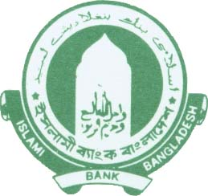 Islami Bank Bangladesh Limited
…………. Branch.
DEMAND PROMISSORY NOTE
Tk. ______ Date ………
I/We promise to pay on demand to Islami Bank Bangladesh Limited or order, the sum of Tk. ………………………….. …………….……..……………… for value received and profit/rent & other charges, if any, from this date and compensation, if any imposed by the Bank.
Revenue Stamp

Account closing Procedure:
I was shutting DPS, MTDR, MSA, and issuing checks as part of the account closing procedure. The process of closing a savings account issuing cheques through authorization and cheque entry system.
Foreign Remittance Section:
Last but not least, I visited the foreign remittance division, where I spent 4 days. First, I learned about different types of money transfer methods, as well as country codes and PINs. My primary task was to guarantee that the papers were carefully written by the customer and also that the branch seal was applied to the papers. On this section, it was my duties to guarantee that the clients confidential numbers were properly filled out, as well as to double-check the details on their National Identity Cards (NID). The original NID and a photocopy of the NID are required for clients to receive money remitted from abroad. IBBL offers a variety of remittance services, including Merchantrade-14, national Exc Co-9, Western Union-10, MoneyGram-8, and others. Clients came to a foreign remittance department for export and import business, such as opening LCs (Letters of Credit), making payments to foreign countries, and so on. Thus, withdrawing money is a simple process that the bank offers as well as being a significant function.
Export Services:
Service Principles | Scope of applications | Basis
Wakalah | Advising Letter of Credit Transferring Letter of Credit Remittances.  Remittance Collection of Cheques, Drafts, Traveller Cheques, Endorsement of Foreign Currency, Opening Student File Collection of export proceeds | Fee basis
Kafalah | Adding Confirmation | Commission basis

Cash department:
- In the cash department, I communicate with customer and enquiries to verify the checks and deposit slips information that were filed for cash withdrawals.
- In addition, I signed money that was returned to the Bangladesh bank for refund.
- I computed deposits number of clients and entered them into a ledger.
- I calculated the amounts that depositors had submitted.
- I have learned how to identify false money note which is very important.
Investment Section:
In this section, I worked for a total of ten days. Due to its innovative investing method, IBBL has become one of Bangladesh's most profitable banking institutions in recent years. I had the opportunity to learn about Islamic investment procedures. What are the many forms of investment, why do consumers choose this banking institution for investment, how does the bank select its clients for investment, and what documentation and journal are required to complete the operation are all things I learnt on the field.
Writing deeds, notifying clients with outstanding debts, etc. Client information is gathered from the records. IBBL's investment modes, How to prepare a deed, a pay order, a voucher, IBBL investment sections, and the UPDS distribution procedure.

Investment Processing of IBBL:
In general, a bank takes specific procedures to offer its suggested investment to a client, but the process requires detailed research. Because banks invest depositors'
money rather than their own. If the bank fails to meet the demands of its depositors, it will be forced to close. As a result, each bank should place a high priority on investment proposals. However, Islami Bank Bangladesh Limited (IBBL) determines its investment strategy after successfully completing the following critical processes, which are listed below:
Selection of Client

Application Stage
Appraisal Stage

Sanctioning Stage

Document Ation Stage

Disbursement Stage

Monitoring & Recovery stage

Figure: Investment Processing Steps of IBBL.

Evaluation
During my internship program at lslami Bank, I encountered both favorable and negative situations. The personnel are quite polite and helpful, which is a positive circumstance to me. While working as a regular employee at the bank, I worked properly the majority of the time, but I did make a few mistakes. I focused entirely on my work, and it was well received by everyone. I had some nice feedback on it and it continues to motivate me, independently of whether I have done anything wrong. The manager of the Munshiganj branch planned to shift me to the invetment sector after a set period of time, however due to a lack of time, this was not possible. When I'm not at work, however, I go to the invetment area to learn more about differnt kinds of investment sheme. They assist me whenever I have an issue and teach me how to solve challenges. The issue I have is that they were unable to educate me anything due to their own work demands. When they have free time, they give it their all. I was unable to gain access to every department of the bank because to the Covid-19 problem. The GB -in-charge officer is always willing to answer any questions I have about the process. And they always respect my desire to learn more about the job. In any event, I can claim to have worked in practically every division. They value my performance because I worked there as if I were a regular employee and helped them complete their mission quickly. In this way, the formal evaluations I received were all inspiring.

Skills applied
My work at Islami bank as an intern was specific. Because banks deal with a variety of challenges, I was always available to assist them. I've mostly acted as a representative in the previous. I can express everything they told me because I understood their instructions quickly. But I found it not easy to communicate with different people because I am an introvert. I was eligible to apply there while operating in the online banking department because I have knowledge about the internet section. Beside I can learn about Money laundering It has three steps: 1. Placement Stage 2. Layering Stage and 3. Integration Stage.
My Laptop skills are the one that I have used a lot. I used to work with Microsoft Word and Microsoft Excel, and I had to create a lot of official documents, such as verifying the NID copy, activating the cheque, requisitioning the cheque, and so on. As I am a quick learner, and I can state that this is another important skill of mine for which I have never had any difficulties learning something new, and my work has always been well received. I observe their activity for a period of time, and then I have the capacity to handle consumers without the assistance of authorities.
  - New Skills developed:
Throughout my internship, I developed many of the relevant knowledge that have proven to be quite valuable and necessary. It was a fantastic opportunity to learn some essential banking, finance, and operational activities that will benefit me in the future. I could acquire how to prepare official documents in the proper manner and maintain records of them. This helped me in understanding the significance of Islami Bank Bangladesh Limited documentation system. Internships, in my opinion, are the best way to overcome our fear.
My manager at IBBL Bank was quite helpful, and as a result, I was able to develop a wide range of new skills. The most important thing I've done is start a conversation with new people and high ranking officials. I was always afraid of handling new people, carrying on in a corporate manner, and expressing interest in trying anything different. There, I had to supervise new people and speak with them without fear. I had the opportunity to address my flaws in a way that will improve my leadership performance in future. So, I have learned many things from this branch.
- I've developed a strong understanding of electronic Integrated Banking Software (eIBS) which is very important for working in IBBL, Computerized Transfers, and Investment, all of which will benefit me in my career advancement.
- I've also noticed that payment of expenditure claims is performed in a structured way. Earnings allocation, capital appreciation collecting, foreign remittance management, and spot cash payment are some of the most beneficial assignments I've worked on during my internship program, and they've helped me learn a lot about various elements of these fields.
- I've learnt organizational skills that will help me advance in my work.
- I've also learnt how to keep good relationships with clients, which will support me advance in my job in future.

Application of academic knowledge
Academic knowledge is a distinctive type of information that differs from other types of knowledge, specifically knowledge or opinions based simply on individual perspective. While working in the General Banking Department, I put my academic expertise to use. I used my academic skills to analyze the investment moods and mechanism and they way of principle of collecting deposit in IBBL.
Internship is a term that accurately connects office world with academic life. Academic information about an apprentice is extremely useful during the internship time. So here's how I put the academic information to use:
Fundamental components of academic knowledge are
- transparency,
- codification,
- reproduction, and
- communicability.
Transparency refers to the ability to investigate and verify the source of information that I was doing in GB section. Codification refers to the ability to reliably convey knowledge in certain form (words, symbols, video) that allows anyone except the creator to understand it. Knowledge can be duplicated or copied several times. Finally, knowledge must be presented in a way that allows it to be shared and disputed by someone else.
General Banking Section: This section of any bank is its most important component. Customers can have any information related with them verified by banks. While doing savings account and Pension account at the front desk area, I used my academic knowledge. It is necessary to compute loan charges for a specific individual at a specific rate for a specific time period. In IBBL for Special Savings account which is DPS account. I needed to figure out how much the loan fee would be based on the amount they were opening the FDR using. That refers to the interest they will get and the amount they will receive when the FDR matures. If there would have been in the case of DPS, I required to use a similar approach. As a result, I used these items in the GB Section.

CHAPTER IV: CONCLUSIONS AND KEY FACTS

Recommendations for improving departmental operations

Despite Islami Bank Bangladesh Ltd. (IBBL) is doing very well, it still has to enhance in several other key areas, as mentioned below:
- The number of personnel at the Munshiganj Branch should be accelerated. IBBL wants to employ qualified employees who can help the bank move significantly. IBBL should engage in a variety of promotional activities.
- This is the age of professional banking. Every banking sector is making effective use of technology advancements. As a result, in attempt to continue up with the trends, IBBL must employ such current technology.
- IBBL invests the most in the Small and medium enterprises(SME) sector, with the Economic growth having the highest. To increase their profits, they need diversify their investments into other areas such as transportation, agriculture, and real estate.
- IBBL will promote its investment plans more appealing in efforts to gain greater investment projects.
- Because the proportion of category investments has increased over the year, the bank should focus greater attention to it.
- A credit card that is called Khidma card and a Visa card should be available from the bank.
- IBBL is deserving of special consideration in the establishment of Islamic principles banks as profit-loss-sharing income institutions.
- Because the negative and deterioration sector accounts for the majority of the bank's total segmented investments, the bank needs employ a suitable and restrictive financial regulation and carefully watch the client to return the money.
- In the framework of Bangladesh's current economical situation, the IBBL should explore utilizing rural opportunities because from a productivity and income perspectives.
- IBBL should upgrade the eIBS software to produce it more accessible.

  - Key Understanding:

I need to be more assured in my job, and I'm always afraid of bringing up problems I've had with one of the Islami Bank Limited employees, because I want to be a banker when I finish my studies, and I've chosen a bank to conduct my internship in Islami bank. To cope with my knowledge as a banker, I need to encourage myself. I noticed that the atmosphere is calm and welcoming. When I'm in another situation where my productivity is consistently affected, I feel concerned. As a result, I would encourage myself to become more confident in the future and to work on this tendency in order to better my efficiency.
  - Conclusion:
Islamic banks have maintained a strong growth rate, as seen by their growing largest market share of resources, funding, and savings in the overall banking sector. IBBL's investment philosophy is to embrace the concept of financing for the advantage of customers, in accordance also with commandments and concepts of Sharia Law. The bank's investment policy does not have profit as its sole motivation or goal; instead, it focuses on achieving greater benefit and developing job possibilities.
Once finishing the fieldwork, I returned to IBTRA following my practical learning experience at Munshiganj Branch was completed. IBTRA has requested that a document be submitted. IBTRA requires me to show myself because my practical knowledge at the Munshiganj Branch. Then I received a payment determined on my Organisation's achievement, and IBTRA issued me an apprenticeship qualification.

REFFERENCE

Annual Report of 2020

- Jannat, Mehedi. “A REPORT on FINANCIAL ANALYSIS of AL-ARAFAH ISLAMI BANK LIMITED (AIBL).” Dir.iub.edu.bd, 21 Nov. 2011, Accessed 5 May 2020.
From Websites and Journal:
- Jahan, Md Ashraf. “A Study of Customer Satisfaction on Online Banking & ATM Services, Islami Bank Bangladesh Limited.” Dspace.bracu.ac.bd, 2018. Accessed 1 July 2020.
- Hassan, Kabir, and Mervyn Lewis. Handbook of Islamic Banking. Google Books, Edward Elgar Publishing, 1 Jan. 2009, Operational Techniques of Islamic Bank “About IBBL: Concept & Ideology.” Www.islamibankbd.com, operational techniques of Islamic bank.php.
- Belal, Ataur Rahman, et al. “Ethical and annual Reporting in Islami Bank Bangladesh Limited” Journal of Business Ethics, vol. 129, no. 4, 29 Mar. 2014, pp. 769–784, Accessed 30 Aug. 2019.
- “Internship Report on BBA Program of IBBL - Assignment Point.” www.assignmentpoint.com/business/economics/internship-report-on-bba-program-of-ibbl.html. Accessed 11 Nov. 2020.
- Sakib, Md. “Investment Mechanism of Islami Bank Bangladesh Limited.” Dspace.uiu.ac.bd, 22 Oct. 2018, Accessed 1 July 2020.

Appendix

Internship Certificate from IBTRA:
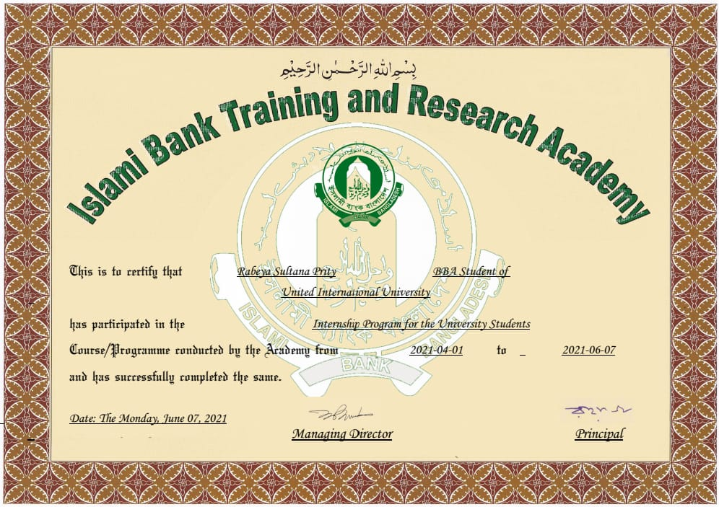
IBBL Cheque:
