Synergizing Organizational Culture and
Training & development Programs:
The case of Ziska pharmaceuticals Ltd.

Md. Shafiul Alam
ID: 111 222 076
Human Resource Management
School of Business and Economics
United International University

This report is submitted to the school of Business and Economics, United International University as a partial requirement for the degree fulfillment of Bachelor of Business Administration
Internship Report
On
Synergizing Organizational Culture and
Training & development Programs:
The case of Ziska pharmaceuticals Ltd.

Submitted to:
Ms. Nasrin Akter
Assistant Professor
School of Business & Economics
United International University

Submitted by:
Md. Shafiul Alam
ID: 111 222 076
Major: Human Resource Management


School of Business and Economics
United International University

Date of submission: 28th July, 2025

Letter of Transmittal
28th July, 2025
Ms. Nasrin Akter
Assistant Professor and Internship Supervisor
School of Business and Economics
United International University
Subject: Report on “Enhancing Employee Performance and Satisfaction at Ziska pharmaceuticals Ltd.”
Respected Ma’am,
Here is the internship report titled "Synergizing Organizational Culture and Training & Development Programs: Enhancing Employee Performance and Satisfaction at Ziska Pharmaceuticals Ltd." This research explores the dynamic relationship between Ziska Pharmaceuticals Ltd.'s organizational culture and its training and development programs, evaluating their joint impact on employee performance and satisfaction. While working on the report, I have tried to follow each and every guideline that you have advised me. Additionally, preparing this paper has been a valuable part of my skill development journey. I kindly request your understanding regarding any limitations it may contain.
Thank you for providing the invaluable guidance and support throughout this research endeavor. Further information or clarification can be provided upon request.
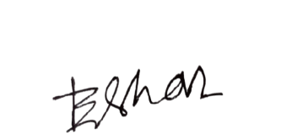
Sincerely,

Md. Shafiul Alam - (111 222 076)
Human Resource Management
School of Business and Economics
United International University

Certification of Similarity Index

This is to certify that Md. Shafiul Alam, a student of BBA, ID - 111 222 076, under School of Business, United International University (UIU) has completed the internship report titled "Synergizing Organizational Culture and Training & Development Programs: Enhancing Employee Performance and Satisfaction at Ziska Pharmaceuticals Ltd." as a part of requirement for obtaining BBA degree. I have gone through the report and found in to be a well written report. He has completed the report by himself successfully under my supervision.

I wish him every success in his future endeavor.

Supervisor,

Ms. Nasrin Akter
Assistant Professor
School of Business & Economics
United International University

Declaration of the Student

I am Md. Shafiul Alam, student of School of Business and Economic (Human Resource Management) of United International University, Bangladesh, do hereby declare that the internship Report on "Synergizing Organizational Culture and Training & Development Programs: Enhancing Employee Performance and Satisfaction at Ziska Pharmaceuticals Ltd." is an original work and has not been previously submitted for any degree, diploma, title, or recognition.

Md. Shafiul Alam
ID No: 111 222 076
School of Business and Economics,
United International University.

Corporate Evidence
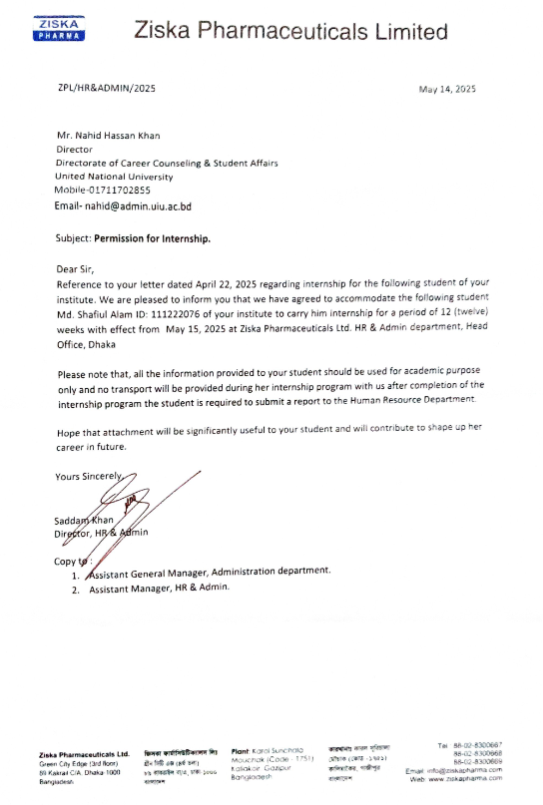

Acknowledgement

First and foremost, I would like to express my heartfelt gratitude to the Almighty Allah for granting me the strength and ability to successfully complete this internship report.
I am sincerely thankful to Ms. Nasrin Akhter, Assistant Professor of the BBA Program at United International University, for her invaluable supervision, insightful feedback, and continuous encouragement throughout the preparation of this report. Her guidance was instrumental in shaping both the structure and content of this study. I would also like to extend my appreciation to all my respected faculty members at UIU for their constant support during my academic journey.
My special thanks go to Md. Mostafa Zaman, Senior Executive of HR Administration at Ziska Pharmaceuticals Ltd., for providing me with the opportunity to work with his team and gain practical experience in a real-world corporate setting.
Lastly, I would like to express my sincere appreciation to all the employees and the management team of Ziska Pharmaceuticals Ltd. for their support and collaboration throughout my internship journey, making this experience both enriching and rewarding.

Executive Summary

This report, titled "Synergizing Organizational Culture and Training & Development Programs: Enhancing Employee Performance and Satisfaction at Ziska Pharmaceuticals Ltd.," this research examines the complex relationship between organizational culture and human resource development initiatives at Ziska Pharmaceuticals Ltd., a leading player in Bangladesh's pharmaceutical industry. Understanding how these elements influence employee outcomes is critical in today's human capital-driven business landscape. Employing a qualitative methodology based on an internship project, company profile analysis, and employee survey interpretations, key findings reveal Ziska's strong, positive, and employee-centric culture, characterized by high collaboration, innovation, supportive learning, shared values, ethical leadership, and effective morale-boosting recognition. Concurrently, its T&D programs are well-managed, frequent, skill-focused, and directly linked to career growth, with employees consistently applying learned knowledge. This profound internal synergy, where the collaborative culture facilitates T&D and T&D reinforces core values, demonstrably enhances employee performance and satisfaction. However, a critical strategic challenge emerges as these robust internal strengths have not yet translated into a dominant external competitive advantage, with Ziska facing intense market pressures, low customer loyalty, and an obscure brand image. Consequently, the report recommends strategically leveraging Ziska's internal cultural and T&D strengths to address these external challenges, enhance brand visibility, and achieve sustained market leadership and long-term organizational success through improved customer engagement and targeted market penetration.

Table of Contents
Letter of Transmittal I
Certification of Similarity Index II
Declaration of the Student III
Corporate Evidence IV
Acknowledgement V
Executive Summary VI
List of Acronyms & Abbreviations X
CHAPTER 1: INTRODUCTION 1
1.1 Background of the Report 1
1.2 Objectives of the Report 2
Broad Objective 2
Specific Objectives 2
1.3 Rationale of the Report 4
1.4 Methodology of the Report 5
1.5 Scope and Limitations of the Report 6
Scope to the study 6
Limitation to the study 6
CHAPTER 2: COMPANY AND INDUSTRY PROFILE 7
2.1 Company Analysis 7
2.1.1 Overview and History 7
2.1.2 Mission, Vision, and Value Statements 7
2.1.3 Trend and Growth 8
2.1.4 Product / Service mix 9
2.1.5 Company Operations / Activity 10
2.1.6 SWOT Analysis 11
Strengths 11
Weaknesses 12
Opportunities 12
Threats 13
2.1.7 Structure of the Organization 13
CHAPTER 3: INTERNSHIP EXPERIENCE 15
3.1 Position, Duties, and Responsibilities 15
3.2 Training & Development 16
3.3 Contribution to Organization 17
3.4 Evaluation 18
3.5 Skills Applied 19
CHAPTER 4: ANALYSIS AND FINDINGS 21
Analysis (Organizational Culture) 21
4.1 Perceived Collaboration within Organizational Culture 21
4.2 Emphasis on Innovation as a Core Value 22
4.3 Alignment of Training Programs with Cultural Values 22
4.4 Collaborative and Supportive Learning Environment 23
4.5 Positive Impact of Organizational Culture on Employee Satisfaction 24
4.6 Shared Values as a Sign of Strong Organizational Culture 25
4.7 Cultural Events Boosting Employee Engagement 25
4.8 Encouragement for Suggesting Improvements 26
4.9 Leadership's Supportive Role in Reinforcing Organizational Culture 27
4.10 Organizational Culture Supporting Continuous Learning 27
4.11 Employees' Sense of Belonging 28
4.12 Prioritization of Diversity and Inclusion 29
4.13 Constructive Conflict Resolution through Open Communication 30
4.14 Effectiveness of Employee Recognition Programs in Boosting Morale 30
4.15 Culture Encouraging Risk-Taking and Creativity 31
Analysis (Training and Development Programs) 32
4.16 Frequency of Training Programs 32
4.17 Effectiveness of the HR Department in Managing Training and Development 32
4.18 Primary Goal of Training: Skill Development vs. Compliance 33
4.19 Measurement of Training Effectiveness through Feedback 34
4.20 Employee Motivation for Training for Career Growth 34
4.21 Regular Coverage of Teamwork and Communication in Training 35
4.22 Perceived Effectiveness of On-the-Job Training 36
4.23 Direct Improvement of Employee Performance by Training 36
4.24 Application of Training Knowledge in Daily Work 37
4.25 Well-Established Leadership Development Programs 38
4.26 Training Content Tailored to Different Experience Levels 38
4.27 Receipt of Clear Pre- and Post-Training Resources 39
4.28 Technology Enhancing Training Accessibility 40
4.29 Interactive and Engaging Training Sessions 40
4.30 External Trainers/Experts Brought in When Needed 41
4.31 Ideas and Opinions Valued by Management 42
Findings 43
CHAPTER V: CONCLUSIONS AND KEY FACTS 44
5.1 Recommendations 44
5.2 Conclusion 45
Reference 47
Appendix-A: 48

List of Acronyms & Abbreviations

Acronym/Abbreviation | Full Form
T&D | Training & Development
cGMP | current Good Manufacturing Practice
HRIS | Human Resources Information System
MPO | Medical Promotion Officer
RM | Regional Manager
AM | Area Manager
DGDA | Directorate General of Drug Administration
API | Active Pharmaceutical Ingredient
TRIPS | Trade Related Aspects of Intellectual Property Rights
WTO | World Trade Organization
PPE | Personal Protective Equipment
LOTO | Lock-Out/Tag-Out
MoC | Management of Change

CHAPTER 1: INTRODUCTION

The modern business landscape is defined by rapid change, fierce competition, and a growing dependence on human capital as a key driver of sustainable advantage. Organizations that strategically invest in their workforce through effective human resource practices are better equipped to adapt, innovate, and succeed. Among these practices, organizational culture and training & development (T&D) programs play a crucial role in shaping employee behavior, enhancing capabilities, and driving organizational performance. While culture reflects shared values and norms that shape the internal environment, T&D directly strengthens employee skills and knowledge. When aligned, these elements can create a powerful synergy, where a supportive culture enhances the effectiveness of T&D, and robust T&D reinforces the culture; leading to improved employee performance and satisfaction.
This report explores this dynamic within Ziska Pharmaceuticals Ltd., a key player in Bangladesh’s highly competitive and innovation-driven pharmaceutical sector. Given the industry's complexity and demand for continuous improvement, Ziska’s approach to human capital development is particularly relevant. Drawing from an internship experience, this research applies theoretical concepts in a real-world context to examine how Ziska leverages organizational culture and T&D initiatives to boost employee outcomes and strengthen its strategic position.

Background of the Report

Internships are crucial for business students, offering direct insight into organizational behavior, cultural norms, and individual practices. This hands-on experience is crucial for refining professional skills, deepening knowledge, and preparing individuals for successful careers in the corporate world.
During my internship at Ziska Pharmaceuticals Ltd., I had the valuable opportunity to work under the Human Resources department, which provided firsthand exposure to corporate policies, organizational practices, and employee behavior. This experience allowed me to closely observe how company guidelines are implemented across different functions. I actively participated in tasks assigned by my supervisors and collaborated with the HR team, gaining practical insight into corporate operations. Additionally, I conducted surveys on organizational culture and employee performance of Ziska Pharmaceuticals Ltd. While maintaining full compliance with all procedures was sometimes challenging, the organization consistently demonstrated strong efforts to uphold its policies and values in practice.

Objectives of the Report

Broad Objective
To comprehensively analyze the synergistic relationship between organizational culture and training & development (T&D) programs at Ziska Pharmaceuticals Ltd., with the goal of evaluating their combined impact on employee performance and satisfaction; ultimately contributing to the company’s long-term competitive advantage in the dynamic pharmaceutical industry.

Specific Objectives
To achieve this overarching goal, the report focuses on the following specific objectives:
- Describe Organizational Culture
  - Identify core values, norms, and behavioral patterns within Ziska Pharmaceuticals Ltd.
  - Examine how the culture shapes the internal environment and employee interactions.

- Evaluate T&D Programs
  - Assess the structure, effectiveness, and strategic alignment of current T&D initiatives.
  - Analyze their relevance to both individual development and organizational goals.
- Explore Cultural–T&D Synergy
  - Investigate how organizational culture and T&D programs interact and reinforce each other.
  - Examine how this synergy fosters continuous learning and professional growth.
- Measure Impact on Performance
  - Determine the influence of culture - T&D integration on employee productivity, efficiency, and output quality.
- Assess Impact on Satisfaction
  - Explore how this synergy affects employee morale, engagement, retention, and overall job satisfaction.
- Recommend Improvements
  - Provide practical, evidence-based suggestions to optimize the culture - T&D interaction.
  - Ensure alignment with Ziska’s strategic objectives and operational realities.

Rationale of the Report

This study holds significant relevance from both academic and practical perspectives. Academically, it contributes to the existing body of knowledge in organizational behavior and human resource management by providing an empirical examination of the interplay between organizational culture and training & development within a specific industry context; the pharmaceutical sector in Bangladesh. While the individual impacts of culture and T&D are well-documented, their synergistic effects, particularly in a developing market, offer a nuanced understanding of human capital dynamics.
From a practical standpoint, this research provides Ziska Pharmaceuticals Ltd. with data-driven insights into its internal dynamics. The company's SWOT analysis reveals notable internal weaknesses, such as "lower customer loyalty," "no market share," "lack of brand image," and "obscure marketing activities," alongside significant external threats like "large number of competitors" and "inflation risk". Despite these challenges, employee perceptions suggest a strong internal culture and effective T&D programs. This study aims to illuminate how Ziska's internal strengths in culture and T&D can be strategically leveraged to mitigate its identified weaknesses and navigate external pressures. Understanding this internal alignment is crucial for Ziska to enhance its competitive posture and achieve sustainable growth in a highly contested market.
Furthermore, the findings of this report can offer valuable lessons and potential best practices for other organizations within the competitive pharmaceutical sector in Bangladesh. It demonstrates how robust internal human resource strategies can foster resilience and create a distinctive advantage, even when faced with intense market rivalry. Finally, the report reflects the practical learning gained during the internship, bridging theoretical knowledge with real-world application and providing a comprehensive understanding of human resource functions within a corporate setting.

Methodology of the Report

The methodology of this report is structured around a quantitative analysis framework to evaluate employee satisfaction and the impact of training and development programs at Ziska Pharmaceuticals Ltd. I created a detailed survey to gather information about various parts of employee satisfaction, the work environment, and how well training programs are seen by employees. This survey was given to all employees across different departments and levels, making sure we heard from a wide range of people.
The survey questions were all "closed-ended," meaning they had specific answer choices. This helped me collect information that could be easily counted and analyzed. I made sure the survey allowed people to answer honestly. After collecting all the answers, I carefully put the information together. Then, I used statistical methods to look for patterns, connections, and important findings related to employee satisfaction and the impact of training and development.
My main goal was to measure how well Ziska's training and development efforts lead to employee satisfaction. I also wanted to find specific areas where these important HR functions could be improved. To make sure my findings were accurate, I compared them with what's considered standard or "best practice" in the industry. This careful method gave me solid, data-backed reasons for the conclusions and suggestions in this report.

Scope and Limitations of the Report

Scope to the study
This research paper has been developed based on extensive engagement with both the academic supervisor and the host organization during my internship at Ziska Pharmaceuticals Ltd. in Bangladesh. The study focuses exclusively on Ziska’s organizational setting, particularly its organizational culture and training & development (T&D) programs. The core aim is to examine how these elements influence employee performance and satisfaction.
The analysis draws upon multiple sources of insight gathered throughout the internship period, including a strategic management report on the company, observations from HR-related tasks, a questionnaire-based survey conducted among Ziska employees, and interpretations of the collected responses.

Limitation to the study
In time of making this report I have these types of limitation:
- Due to time constrains I couldn’t able to collect sufficient data.
- Lack of sources to verify of information that I get.
- The research based on survey data provided during the internship; no primary data collection or direct interviews were conducted by the researcher.
- Employee performance and satisfaction assessments are based on self-reported perceptions from the questionnaire, limiting the ability to establish objective or causal conclusions.
- The findings are specific to Ziska Pharmaceuticals Ltd. and may not be applicable to other organizations.
- Reported document has some confidential fact so difficult to collect that information.

CHAPTER 2: COMPANY AND INDUSTRY PROFILE

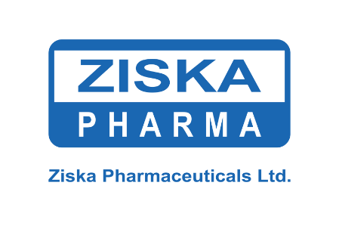

Company Analysis

Overview and History
Ziska Pharmaceuticals Ltd. is recognized as one of the leading pharmaceutical companies in Bangladesh, having commenced its journey in 1989, following its establishment in 1986. The company is deeply committed to producing medicine strictly under current Good Manufacturing Practice (cGMP) compliance, ensuring high standards of quality and safety in its pharmaceutical products. Ziska extends its services to its valued customers through a robust and healthy network spanning across Bangladesh.

Mission, Vision, and Value Statements
Ziska's strategic direction is articulated through its vision and mission statements, which have evolved over time. The original vision aimed "To be a credible pioneer in changing the practice of medicine." This was supported by an original mission to be "A voyager in healthcare," steadfastly improving the quality of life, creating innovative medicines nationally and internationally, and continuously improving technology, products, and services by applying creativity.
The company's guiding principles, which serve as its core values, include:
- Trust: Establishing relationships with all stakeholders based on strong mutual trust and respect.
- Quality: Providing the best products with uncompromised quality.
- Ethics: Honoring high ethical standards in all endeavors.
- Environment: Respecting nature and striving to protect and improve the global environment.
A significant development in Ziska's strategic outlook is reflected in its revised vision and mission. The revised vision is "to be a global leader of medicine sector bringing innovation and great integration to its consumer." Correspondingly, the revised mission emphasizes "providing a responsible promising healthcare solution... by building an ethical, obligated trust worthy relationship with our loyal customers through creating innovative medicines," coupled with a belief in "continuous research for discovering new medicine with transparency". This explicit inclusion of "innovation" and "global leadership" in the revised strategic statements is a critical indicator of the company's deliberate efforts to shape its future identity and, by extension, its internal culture. This strategic intent aligns directly with employee perceptions, as later analysis of survey data indicates that "Innovation is the most emphasized core value at Ziska". This alignment suggests a successful translation of top-level strategic direction into tangible cultural values perceived by the workforce.

Trend and Growth
Ziska Pharmaceuticals has historically demonstrated a strategic focus on product development, which has enabled it to achieve a "first mover advantage" in the market for certain products. Notable examples include Dementa (Memantine Hydrochloride) for Alzheimer's disease, MM Kit (Mifepristone & Misoprostol combination) for safe medical termination of pregnancy, and Peuli (Ulipristal Acetate 30mg) as an emergency contraceptive pill. This prioritization of developing new products has been a key aspect of its marketing strategy, contributing to its profitability and stable profit margin. The company also maintains a "large distribution channel," which has facilitated its market reach and profitability, indicating an application of a forward integration strategy.
However, a closer examination of the company's performance reveals a nuanced picture. While Ziska has achieved initial success with its first-to-market products, the "Findings" section of the strategic report indicates that the company "could not keep up first mover advantage continuously". This suggests that the initial competitive edge gained from innovation was often fleeting, as rival firms quickly produced similar products, leading Ziska to lose its initial advantage, as observed with Soluperea and Minoxidil. Furthermore, despite its claims of a strong distribution channel, interviews with retailers suggest that Ziska has "very few products and not very popular". This presents a significant contradiction between Ziska's stated strategic success and its actual market perception and sustained competitive performance. This discrepancy highlights that while internal efforts, such as research and development and product innovation, may be robust, they are not consistently translating into sustained external market leadership or strong brand recognition. This gap between internal capability and external market impact represents a critical area for strategic review and will be important in formulating recommendations.

Product / Service mix
Ziska Pharmaceuticals Ltd. is primarily focused on developing innovative medicines, serving both the domestic market in Bangladesh and expanding toward international presence. The company has established itself as a pioneer by introducing the highest number of first-ever pharmaceutical products in Bangladesh, including specialized items such as Dementa, Methylprednisolone injection, Monoxide, Methoxsoler, Adepolane, Benzyl peroxide gel, Melatrin cream, MM Kit, and Dixieland.
Ziska places strategic emphasis on women’s health, as reflected in its advertising and product portfolio. This suggests a deliberate diversification focus strategy, targeting a niche segment within the pharmaceutical market. This approach is closely aligned with the company’s internal culture, which values innovation, risk-taking, and creativity, qualities essential for developing and marketing specialized products.
The company ensures wide accessibility to its offerings through a robust distribution network across key districts including Dhaka, Barisal, Lakshmipur, Dinajpur, and Bogra.
Ziska’s product range spans various therapeutic categories, such as antibiotics, anti-ulcerants, NSAIDs, vitamins and minerals, anti-diabetics, and cardiovascular drugs. Prominent brands include Zimax, Ziscom, Zithrin, Ziskacef, Ziscor, Zisvit, and Zismin. Additionally, the company produces specialized treatments such as Dementa for Alzheimer’s disease, MM Kit for medical termination of pregnancy, and Peuli, an emergency contraceptive pill; highlighting its commitment to addressing specific and critical healthcare needs.

Company Operations / Activity
Ziska Pharmaceuticals Ltd. places strong emphasis on operational excellence and technological advancement, particularly within its manufacturing facilities. These are built in accordance with the latest cGMP (Current Good Manufacturing Practice) guidelines recommended by WHO, TGA, and MCA, ensuring strict adherence to international quality and safety standards. Each production block is equipped with state of the art, cGMP - compliant equipment, reflecting substantial investment in advanced technology.
The production process follows a unidirectional flow of personnel and materials from dispensing to packing designed to optimize efficiency and minimize contamination. Additionally, the use of purified water and Water for Injection (WFI) via an online looping system highlights Ziska’s commitment to maintaining the highest levels of quality control.
Beyond manufacturing, the company maintains a strong distribution network across Bangladesh, ensuring the timely and compliant delivery of medicines directly to customers.
A key pillar of Ziska’s operations is its continuous research and development (R&D) focused on new molecule development. This effort is led by a dedicated team of pharmacists, supported by a computerized R&D system. The company's heavy investment in R&D reflects its deep-rooted cultural values of innovation and quality, as clearly stated in its mission and vision and consistently recognized by its employees.
Ziska also operates state-of-the-art laboratory facilities for rigorous testing of raw materials, in-process materials, and finished products, reinforcing its commitment to regulatory compliance and product integrity. Its robust supply chain management ensures efficient nationwide distribution, further underscoring the strong alignment between its cultural values and day-to-day operations. This coherence between strategic intent and operational execution is a defining strength of the organization.

SWOT Analysis
A comprehensive SWOT analysis of Ziska Pharmaceuticals Ltd. reveals a complex interplay of internal capabilities and strategic challenges, as well as external opportunities and threats.
This analysis provides a critical framework for understanding the company's strategic position in the Bangladeshi pharmaceutical market.

Strengths
Ziska Pharmaceuticals Ltd. possesses several significant internal strengths that contribute to its competitive advantage:
- Strategic Location and Facilities: Its factory is strategically located near Dhaka, boasting extensive and segregated manufacturing facilities for specialized products, such as penicillin and cephalosporins.
- Innovation Leadership: The company holds a "Pioneer ship" status for introducing the "highest number of new products" in Bangladesh for the first time, showcasing its robust innovation capabilities.
- Quality Assurance: Manufacturing facilities adhere to the "latest recommendations of cGMP of WHO, TGA and MCA," ensuring high-quality production standards.
- Operational Scale and Reach: Ziska benefits from a "Larger manufacturing Factory than many other companies" and a "Strong Distribution Network all over Bangladesh."
- Value Proposition: It provides "Quality Medicine at a competitive Price," supported by "Efficient and qualified technical manpower at minimum cost."
- Continuous R&D: The company is committed to "Continuous research and development on new molecule development," backed by a dedicated team.

Weaknesses
Despite its strengths, Ziska faces notable internal weaknesses that may hinder its growth:
- Organizational Structure: The company structure is perceived as "Less Organized."
- Technological Gap: There is an "Absence of Advanced Technology" for innovative medicine development, a significant disadvantage in a rapidly evolving industry.
- Market Perception: Ziska suffers from "Lower Customer Loyalty" and a "Lack of Brand Image," especially when compared to major competitors like Square and Beximco.
- Financial Market Presence: It has "No Market Share" in the stock market, indicating a lack of public incorporation.
- Supply Chain Vulnerability: "Dependency on Imported Raw Materials" poses a critical supply chain risk.
- Export Underinvestment: There is "Low Investment in Export of Products" despite potential international opportunities.
- Operational Deficiencies: The company exhibits "Obscure Marketing Activities" and a "Lack of Modern Drug Testing Laboratory."

Opportunities
The external environment presents several promising opportunities for Ziska:
- Market Expansion: Potential exists for "Gaining market Share" through new innovative products and the establishment of "New Product Units" driven by continuous R&D.
- Financial and R&D Support: Opportunities for "Financing Back up from Financial Institutions" and "R & D activities... with external support" (from foreign agencies and government) can facilitate expansion and technological advancement.
- Talent Pool Growth: An increasing number of "Students of Pharmacy department" ensures "Sufficient Manpower" for sustained industry growth.
- Government Support: "Intensive Government Support" for advanced manufacturing bases provides a favorable policy environment.

Threats
Ziska operates under several external threats that could impact its stability and growth:
- Economic Volatility: "Inflation Risk" due to increasing raw material prices and "Currency Risk" pose financial vulnerabilities.
- Intense Competition: A "Large Number of Competitors" creates an intensely rivalrous market.
- R&D Effectiveness Barriers: "R & D efforts can become less effective" due to a lack of enabling regulatory requirements and high dependency on imported Active Pharmaceutical Ingredients (APIs).
- Innovation Implementation Gap: A critical threat is "Less number of innovations" being implemented, potentially hindering future growth.
- Trade and Regulatory Hurdles: "Tariffs and International Trade Restrictions" (e.g., TRIPS agreement) can impact operations.
- Rising Costs: "Increasing Interest Rate" on loans can elevate production costs.
- New Market Entrants: The "Threats of New Entrants" (e.g., low-cost producers like China) could further erode Ziska's differentiation capacity.

Structure of the Organization
Ziska Pharmaceuticals Ltd. operates under a functional hierarchical structure, designed to support efficiency, innovation, and regulatory compliance. At the top is the Board of Directors, comprising the Chairman, Vice Chairman, Managing Director (MD), and Advisors, who provide strategic oversight and governance.
The Managing Director oversees the organization’s overall operations and leads the Executive Leadership Team, which includes the Chief Operating Officer (COO), Chief Financial Officer (CFO), Chief Marketing Officer (CMO), Head of R&D, and Director of HR.
Under the COO, key operational areas such as Manufacturing, Quality Assurance, Supply Chain, and Plant Operations are managed. Manufacturing adheres to cGMP standards, while QA ensures product safety and regulatory compliance. The Supply Chain Department manages procurement, warehousing, and distribution nationwide.
The R&D Department, led by a dedicated team of pharmacists and supported by digital systems, drives product innovation and collaborates with Regulatory Affairs for compliance.
Sales and marketing activities fall under the CMO, including Regional Sales Managers, Product Managers, and Medical Promotion Officers (MPOs). This team is responsible for market strategy, brand promotion, and stakeholder engagement.
The Finance Department, under the CFO, manages financial planning, auditing, and compliance. The HR Department oversees recruitment, employee development, performance management, and policy implementation, ensuring alignment with organizational culture and goals.
Supporting functions include IT & Digital Services for infrastructure and ERP systems, and the Legal & Compliance Team to ensure regulatory and ethical adherence.
Employees are broadly classified into:
- Management Staff: Executives and department heads.
- Non-Management Staff: Mid-level officers and administrative personnel.
- Workers: Factory and operational support staff.
This structured model supports Ziska’s mission of operational excellence, innovation, and strong internal alignment across all departments.

CHAPTER 3: INTERNSHIP EXPERIENCE

Position, Duties, and Responsibilities
During my internship at Ziska Pharmaceuticals Ltd., I served as a Human Resources Intern, a role that provided me with hands-on experience across multiple areas of human resource management. My responsibilities were diverse and directly supported the HR department’s operations, contributing to the organization’s overall efficiency.
Key responsibilities included:
• Candidate Communication & Resume Screening: I acted as the primary point of contact for job seekers through email, phone, and professional networking platforms. I reviewed resumes using a keyword-based screening method to match candidates with job requirements, ensuring an unbiased and efficient selection process.
• Interview Coordination & Onboarding: I managed the logistics of interviews by sending invitations, coordinating with hiring managers and panel members, and ensuring all arrangements were in place. I also supported the onboarding process by preparing necessary documentation, facilitating orientation sessions, and organizing work tools for new hires.
• Employee Records & HR Database Management: I maintained and regularly updated employee records, including personal information, promotion history, leave details, and training activities. I managed entries in the HR Information System (HRIS), conducted data audits, ensured data privacy compliance, and generated various HR reports.
• Appointment Letter & Document Handling: I drafted and customized appointment letters to fit specific roles, verified legal compliance, managed the approval process, and ensured timely delivery. I also maintained well-structured personnel filing system and followed proper document retention practices.
• EIS & Excel Data Management: I entered and updated employee data in the Employee Information System (EIS) and utilized advanced Excel features such as pivot tables and conditional formatting - for tracking recruitment activities, training participation, and preparing HR reports.
• Expense Verification for Field Staff: I reviewed and verified monthly expense claims submitted by Medical Promotion Officers (MPOs), Regional Managers (RMs), and Area Managers (AMs), ensuring all documentation met company policy standards and identifying any discrepancies.
• Training Support & Certification: I coordinated logistics for training sessions, monitored attendance, issued certificates upon program completion, and updated HR records to reflect employees' new qualifications.
• Administrative & Project Support: I handled a variety of routine HR administrative tasks and provided support for broader projects such as policy updates, HR system improvements, and employee engagement initiatives.

Training & Development
During my internship at Ziska Pharmaceuticals Ltd., I had the opportunity to gain direct exposure to the company's training and development (T&D) initiatives, which provided me with a practical, ground-level understanding of their operational execution. My role involved significant participation in Training Coordination and Certification Management, where I was responsible for coordinating various logistical aspects of training sessions. This included booking suitable venues, arranging necessary equipment, and ensuring the timely distribution of training materials.
I managed participant registrations and closely tracked attendance across different training programs. Additionally, I was involved in the administrative tasks of preparing and issuing certificates to employees upon successful completion of the programs, followed by updating HR records to reflect their newly acquired qualifications.
These hands-on experiences allowed me to observe how Ziska’s HR department structures and delivers its T&D programs. I noted that the company offers a diverse range of training opportunities, likely including both general skill-building and targeted leadership development. My observations aligned with employee perceptions; captured in survey data - that training is frequent, well-managed, and supported with clear pre- and post-training resources. This firsthand involvement deepened my appreciation for how T&D policies are practically applied to foster continuous learning and employee growth within the organization.

Contribution to Organization
My internship at Ziska Pharmaceuticals Ltd. allowed me to make meaningful contributions to the HR department and, by extension, to the organization’s overall operations. My efforts directly supported critical HR functions that influence organizational culture and training & development, ultimately enhancing operational efficiency and employee well-being.
Specific contributions included:
- Talent Acquisition Efficiency: I optimized the recruitment process through effective candidate communication and rigorous resume screening. This helped filter out unqualified applicants early, saving time and resources for both the HR team and hiring managers.
- Employee Integration: By facilitating a smooth onboarding experience for new hires, I supported their faster acclimatization to Ziska’s work culture. This improved early productivity, job satisfaction, and long-term retention.
- Data Integrity & Compliance: I ensured the accuracy and consistency of employee records and maintained the HR database with attention to detail. This was critical for payroll accuracy, benefits administration, and meeting compliance requirements.
- HR Service Delivery: I supported the preparation of appointment letters and helped organize HR documentation systematically. These tasks contributed to legal compliance and transparency within HR operations.
- Operational Efficiency: I utilized the Human Resources Information System (HRIS) and Microsoft Excel to manage employee data efficiently. This improved reporting accuracy and supported data-driven HR strategies aligned with organizational goals.
- Fiscal Accountability: I played a role in verifying monthly expense reports from field personnel, helping to identify inconsistencies and ensuring adherence to company policy. This safeguarded financial resources and promoted fiscal responsibility.
- Employee Development Support: I assisted in coordinating training sessions, managing attendance, and issuing certificates to participants. This directly contributed to the company's ongoing commitment to employee development and a culture of continuous learning.
These experiences not only developed my practical HR skills but also demonstrated how my work supported key functions essential to fostering a strong organizational culture and driving effective training and development at Ziska Pharmaceuticals Ltd.

Evaluation
My internship experience at Ziska Pharmaceuticals Ltd. was an invaluable opportunity for both practical learning and professional growth. The immersive nature of the role enabled me to directly apply the theoretical knowledge I had gained during my academic studies to real-world human resource challenges within a dynamic pharmaceutical company.
Through self-reflection, I recognize significant personal development in understanding the complexities of HR practices; particularly in areas such as talent acquisition, employee data management, and training coordination. My exposure to Ziska’s internal operations gave me a deeper appreciation for how organizational culture is shaped and how training and development programs are implemented in practice, far beyond textbook definitions. Observing daily interactions and the HR department’s emphasis on collaboration and innovation helped me better connect theoretical concepts of organizational behavior to actual workplace dynamics.
While the overall experience was highly positive, I did face challenges - especially in managing large-scale data and coordinating logistics for a diverse group of employees. However, these obstacles became key learning moments that strengthened my adaptability, problem-solving abilities, and attention to detail. I also realized the critical role that effective communication and teamwork play in meeting departmental goals.
Overall, the internship at Ziska Pharmaceuticals Ltd. was a transformative experience. It helped me bridge the gap between academic learning and professional practice and gave me a deeper understanding of the vital role human resources plays in driving organizational success.

Skills Applied
During my internship at Ziska Pharmaceuticals Ltd., I consistently applied and further developed a diverse set of professional and interpersonal skills. These skills were essential in effectively performing my responsibilities and making meaningful contributions to the HR department’s operations.
- Communication Skills: I maintained clear and professional communication with prospective candidates, internal colleagues, and management through email, telephone, and professional networking platforms. These interactions helped me build confidence and refine my communication abilities.
- Organizational and Logistical Skills: I was responsible for coordinating complex interview schedules, facilitating smooth onboarding processes, and managing the logistical aspects of training sessions—including booking venues and distributing materials. These tasks enhanced my ability to plan, prioritize, and execute activities efficiently.
- Analytical Skills: I conducted detailed resume screenings to identify qualified candidates, validated employee data, and utilized Excel to analyze and interpret HR metrics. These analytical tasks helped me develop a data-driven mindset and sharpen my attention to key insights.
- Attention to Detail: Accuracy was critical in maintaining employee records, drafting and reviewing appointment letters, and verifying expense reports. I ensured all documentation met quality standards and organizational guidelines.
- Technical Proficiency: I regularly used HR software, particularly the Employee Information System (EIS), to input and update employee data. Additionally, I leveraged Microsoft Excel for data management and reporting tasks, becoming more proficient with functions like pivot tables and conditional formatting.
- Teamwork and Interpersonal Skills: Collaborating with the HR team and other departments was a key part of my role. I also supported new hires during onboarding, which strengthened my ability to work well with others and contribute to a cooperative work environment.
- Problem-Solving: I addressed various challenges, such as managing overlapping interview schedules or identifying discrepancies in expense reports. In these situations, I took initiative to find solutions or escalate issues appropriately for resolution.
Applying these skills throughout the internship allowed me to perform my duties effectively and support the smooth operation of HR functions. This experience significantly contributed to my personal and professional development.

CHAPTER 4: ANALYSIS AND FINDINGS

I have analyzed in detail of the survey findings about Ziska Pharmaceuticals Ltd.'s organizational culture, its core values, the alignment of training and development programs, and their perceived impact on employee satisfaction and engagement. The data, collected through a comprehensive questionnaire administered to the employees, provides critical insights into the prevailing cultural dynamics within the organization.

Analysis (Organizational Culture)

Perceived Collaboration within Organizational Culture
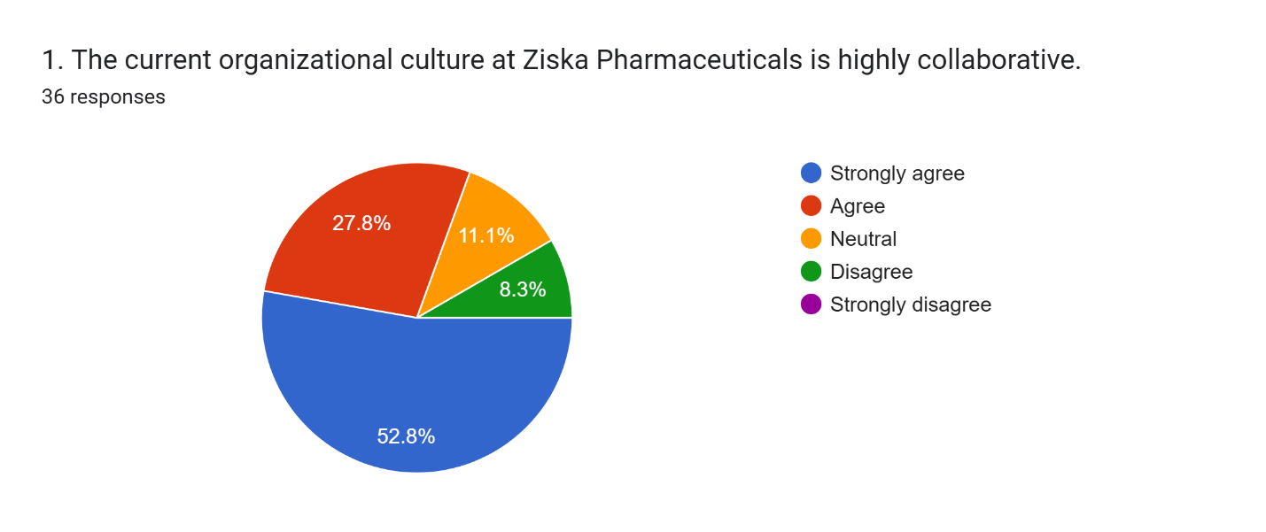
The results indicate a strong positive perception among employees, with a substantial majority (52.8% strongly agreeing and 27.8% agreeing, totaling 80.6%) perceiving Ziska's culture as highly collaborative. This finding suggests that the organizational environment effectively fosters teamwork, open communication, and interdepartmental synergy, which are foundational elements for effective operations and complex problem-solving in a highly regulated and intricate industry like pharmaceuticals. The minimal 11.1% of neutral responses and 8.3% of disagreement indicate that while collaboration is a dominant and celebrated trait, there may be isolated instances or specific contexts within the organization where collaborative practices could be further optimized, or where individual preferences for autonomy might slightly diverge from the collective norm.

Emphasis on Innovation as a Core Value
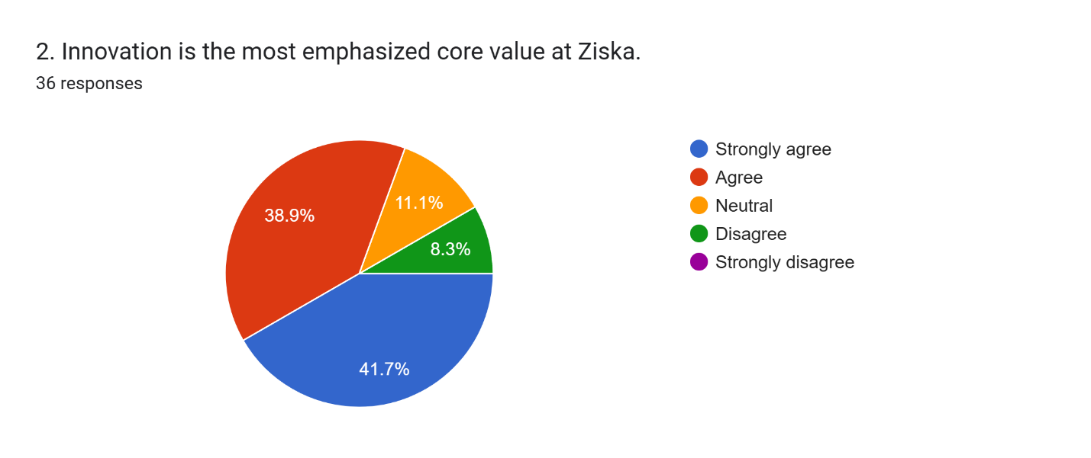
The responses reveal a clear and compelling consensus, with 41.7% strongly agreeing and 38.9% agreeing, culminating in an overwhelming 80.6% of respondents affirming innovation as a highly emphasized core value. This strong alignment is particularly critical and advantageous given the dynamic and research-intensive nature of the pharmaceutical sector, where continuous innovation in product development, manufacturing processes, and therapeutic approaches is paramount for competitive advantage and market leadership. The data robustly suggests that Ziska successfully cultivates an innovation-driven mindset and a forward-thinking ethos among its workforce, with only a small minority (11.1% neutral and 8.3% disagreeing) indicating any reservations regarding this emphasis.

Alignment of Training Programs with Cultural Values
The survey results demonstrate a significant perceived alignment, as 44.4% strongly agreed and 33.3% agreed, leading to a combined 77.7% of employees believing that Ziska's training programs are well-integrated with and reinforce its cultural values.

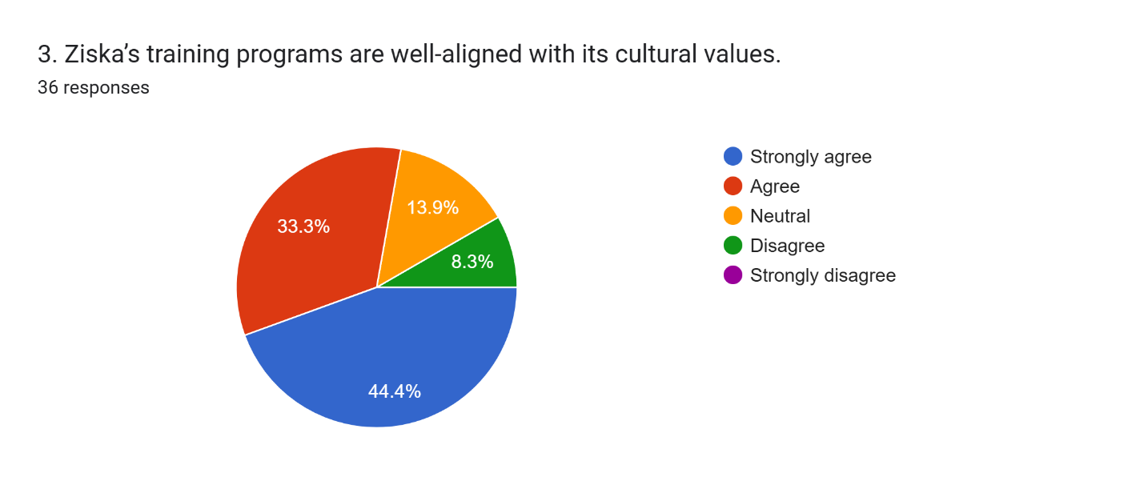
This indicates a cohesive human resource development strategy that transcends mere skill enhancement, actively working to inculcate and reinforce the company's core principles and norms through its learning initiatives. Such strong alignment is vital for ensuring that employee development efforts contribute directly to the desired organizational culture, fostering a workforce that is not only competent but also culturally attuned. The relatively small percentage (13.9% neutral and 8.3% disagreed) of non-affirmative responses suggests a high degree of strategic integration in this area.

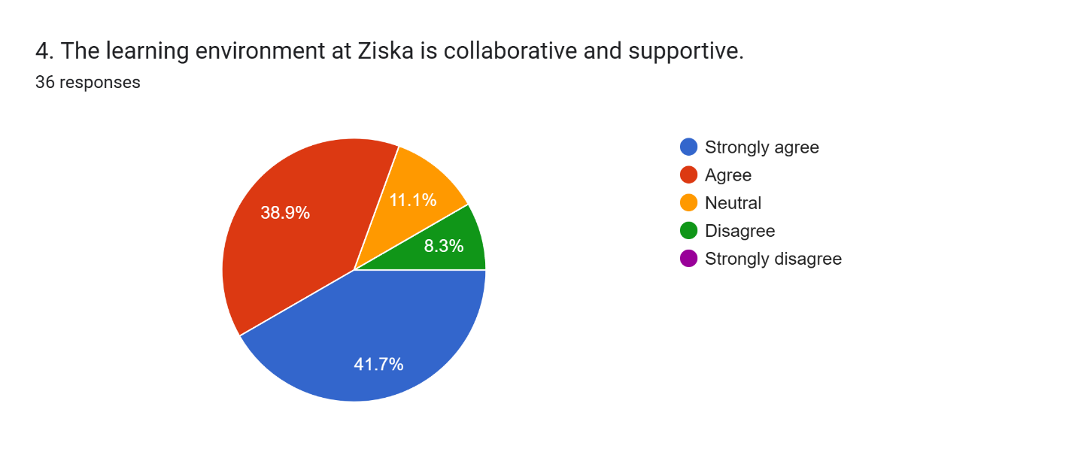
Collaborative and Supportive Learning Environment
The findings closely mirror the positive perception of overall organizational collaboration, with 41.7% strongly agreeing and 38.9% agreeing, totaling an impressive 80.6% of employees who perceive the learning environment at Ziska as highly collaborative and supportive. This is a critical enabler for effective training and development, as it suggests that employees feel psychologically safe and encouraged to share knowledge, seek assistance from peers and mentors, and actively engage in collective learning processes. This environment is essential for continuous improvement and the rapid dissemination of scientific and operational advancements within a research-driven field. Neutral responses accounted for 11.1%, and a small 8.3% disagreed, indicating a generally pervasive positive learning climate.

Positive Impact of Organizational Culture on Employee Satisfaction
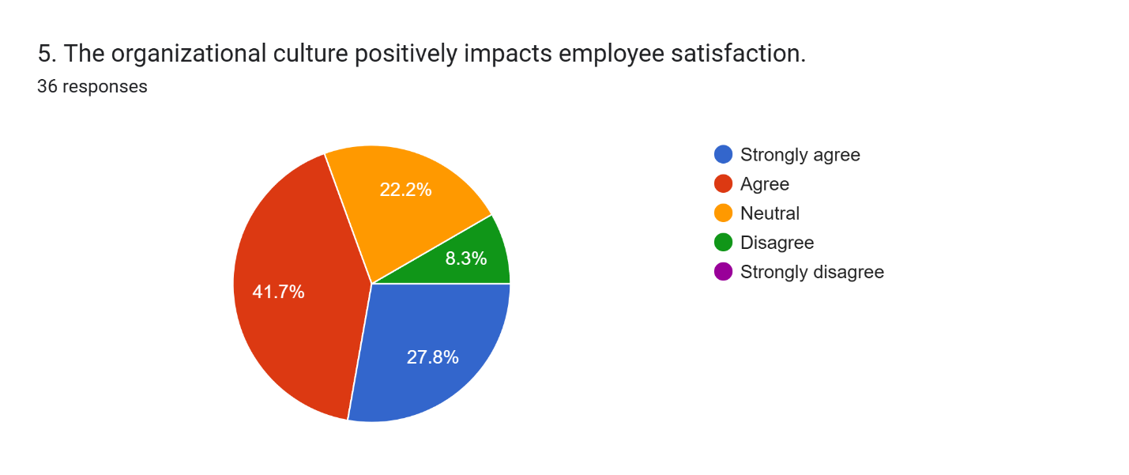
The responses indicate a generally positive perception, though with some discernible room for further enhancement. While 27.8% strongly agreed and 41.7% agreed that the organizational culture positively influences their satisfaction (totaling 69.5%), a notable 22.2% provided a neutral response. This suggests that while the culture is broadly perceived as beneficial, a significant segment of the workforce does not perceive a strong, direct, and consistently impactful positive influence on their personal satisfaction levels. This finding indicates a strategic opportunity for Ziska to further leverage its cultural strengths more explicitly and consistently to boost overall employee morale and well-being, translating cultural values into tangible satisfaction outcomes. Only 8.3% disagreed, pointing to a generally favorable, albeit not universally overwhelming, positive impact.

Shared Values as a Sign of Strong Organizational Culture
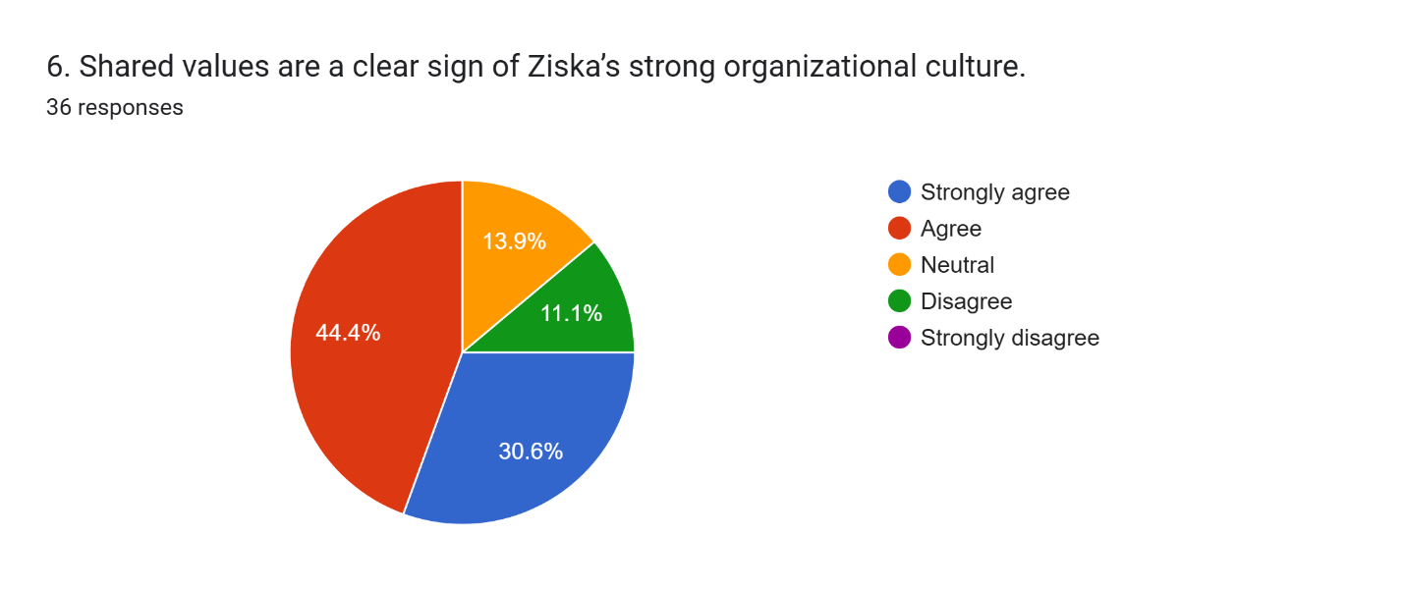
The results robustly confirm this perception among the majority. A substantial 75% of respondents (30.6% strongly agreed and 44.4% agreed) believe that shared values are an evident sign of Ziska's strong organizational culture. This highlights the successful inculcation of common principles, beliefs, and behavioral norms among employees, which is fundamental to fostering a cohesive, unified, and purpose-driven organizational identity. The relatively small proportion (13.9% neutral and 11.1% disagreed) of non-affirmative responses suggests that while shared values are largely ingrained, continuous reinforcement is beneficial to ensure complete alignment across all employee segments.

Cultural Events Boosting Employee Engagement
The findings unequivocally underscore their positive contribution. A significant 72.3% of employees (30.6% strongly agreed and 41.7% agreed) believe that cultural events contribute positively and meaningfully to employee engagement. This suggests that Ziska's initiatives in organizing such events are effective not only in providing social opportunities but also in fostering a deeper sense of community, belonging, and overall involvement among its workforce. These events likely serve as important mechanisms for cultural reinforcement and morale enhancement. A neutral stance was taken by 16.7% of respondents, and 11.1% disagreed, indicating that while effective, the impact might not be universally profound for all employees.
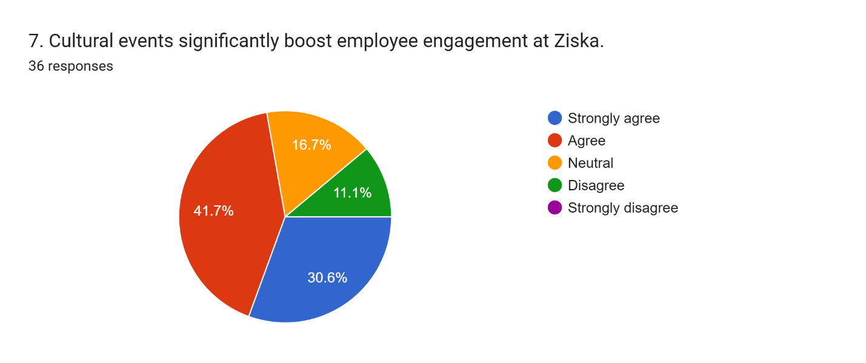

Encouragement for Suggesting Improvements
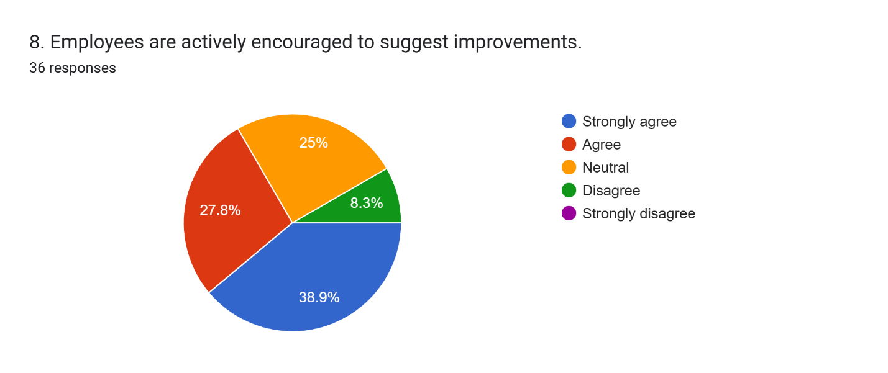The survey examined whether employees are actively encouraged to suggest improvements within the organization, a critical aspect of fostering an innovative and adaptive culture. The responses indicate a generally receptive environment, albeit with a notable degree of neutrality. A majority of 66.7% (38.9% strongly agreed and 27.8% agreed) feel encouraged to suggest improvements, indicating that Ziska promotes an environment where employee input and ideas are explicitly valued. However, the 25% neutral response rate suggests that while formal or informal channels for feedback and suggestions may exist, their effectiveness, visibility, or the perceived impact of submitted ideas might vary. This points to an opportunity for Ziska to further empower employees and ensure that their contributions to continuous improvement are consistently recognized and acted upon. Only 8.3% disagreed, suggesting that outright discouragement is rare.

Leadership's Supportive Role in Reinforcing Organizational Culture
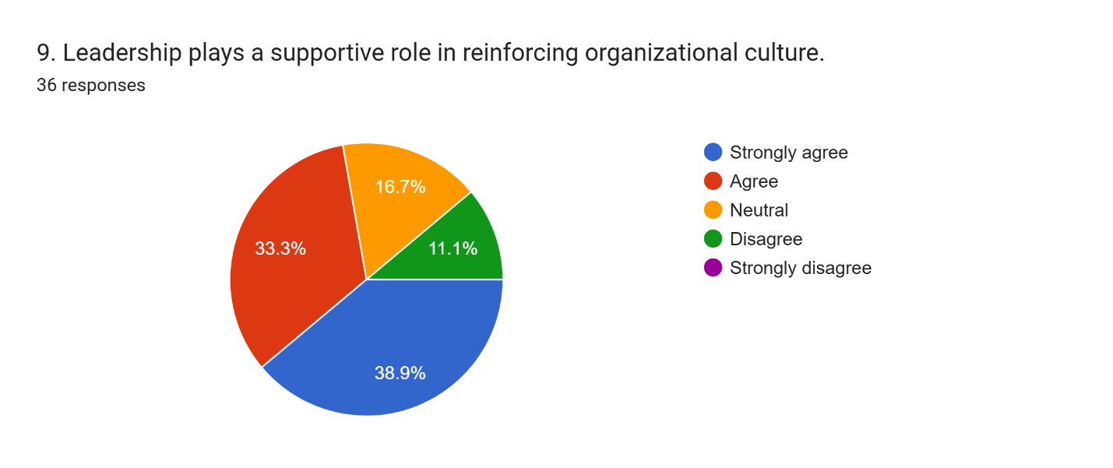
Finally, the survey assessed the role of leadership in reinforcing the organizational culture, recognizing that leadership behavior is a powerful determinant of cultural strength. The findings indicate a strong and pervasive supportive role, with a substantial 72.2% of employees (38.9% strongly agreed and 33.3% agreed) perceiving leadership as actively playing a supportive role in reinforcing the organizational culture. This is crucial for maintaining cultural consistency, ensuring that espoused values are consistently translated into daily practices, and modeling desired behaviors. Effective leadership support is a cornerstone for a robust, enduring, and positively evolving organizational culture. A smaller percentage (16.7%) remained neutral, and 11.1% disagreed, suggesting that while leadership's role is largely positive, there might be room for even more consistent and visible cultural championship across all leadership tiers.

Organizational Culture Supporting Continuous Learning
The survey investigated the extent to which Ziska's organizational culture supports continuous learning among its employees. The results indicate a strong and widespread positive perception. A combined 75% of employees (30.6% strongly agree and 44.4% agree) firmly believe that Ziska's culture strongly supports continuous learning.
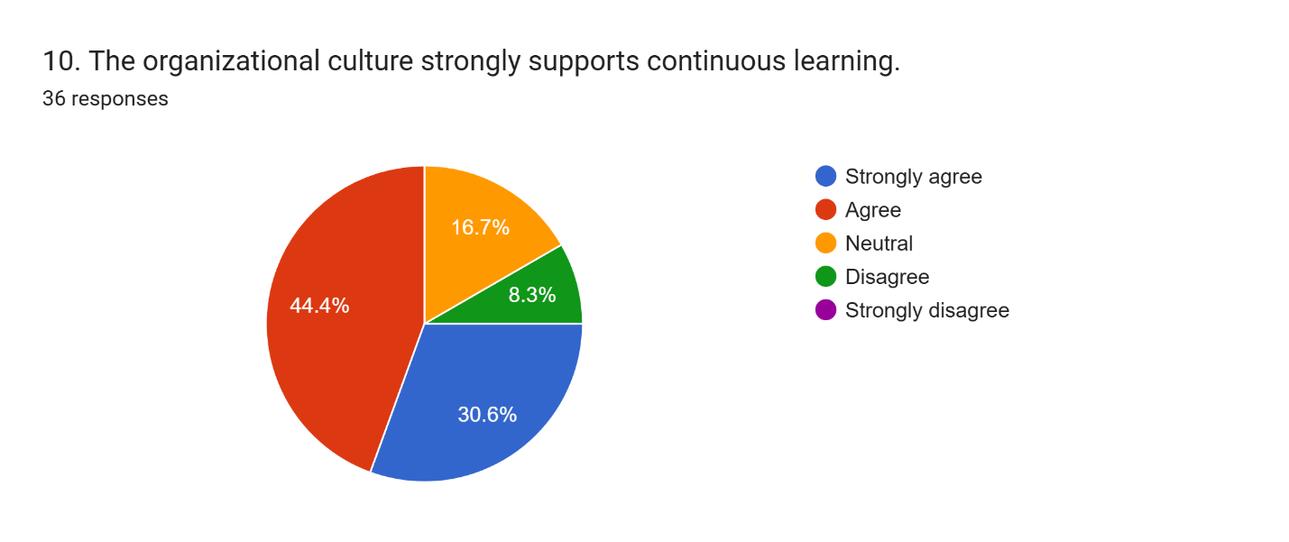This is an exceptionally critical asset in the pharmaceutical industry, which is characterized by rapid scientific advancements, evolving regulatory landscapes, and the constant need for new knowledge and specialized skills. The high agreement rate suggests that Ziska successfully fosters an environment where employees are not only encouraged but actively supported in their pursuit of ongoing professional development and knowledge acquisition, positioning the company well for future challenges.

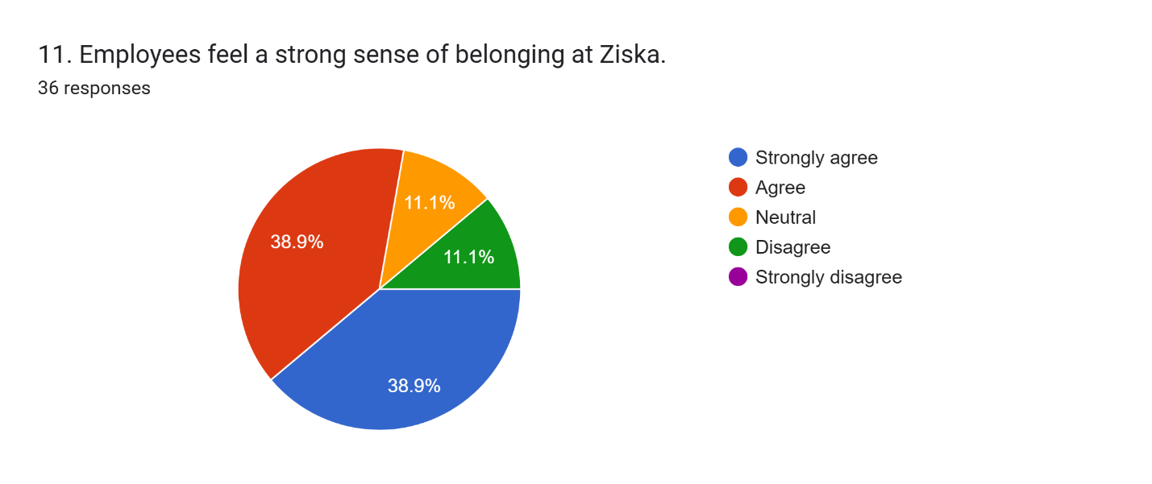
Employees' Sense of Belonging

The survey explored whether employees feel a strong sense of belonging at Ziska, a key indicator of psychological safety and inclusion. The findings reveal a predominantly positive and robust sentiment. A significant 77.8% of employees (38.9% strongly agree and 38.9% agree) report a strong sense of belonging within the organization. This indicates that Ziska successfully cultivates an inclusive and cohesive environment where employees feel genuinely connected to the organization and their colleagues. Such a strong sense of belonging is vital for enhancing employee retention, fostering greater engagement, and promoting a stable and supportive work environment.

Prioritization of Diversity and Inclusion
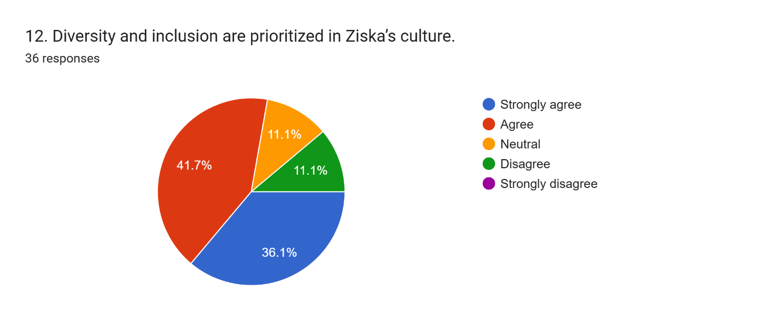
The survey assessed the prioritization of diversity and inclusion within Ziska's culture, an increasingly important aspect of modern organizational effectiveness and social responsibility. The responses show a generally positive perception, though with some discernible room for further improvement and universalization of these efforts. A combined 77.8% of employees (36.1% strongly agree and 41.7% agree) believe that diversity and inclusion are prioritized within the company. This suggests that Ziska is making commendable strides in creating a diverse and inclusive workplace where varied perspectives are valued. However, the presence of 11.1% neutral responses and 11.1% disagreement indicates that while progress is being made, there may be specific areas or demographic groups where these efforts could be strengthened to ensure all employees feel equally valued, represented, and included.

Constructive Conflict Resolution through Open Communication
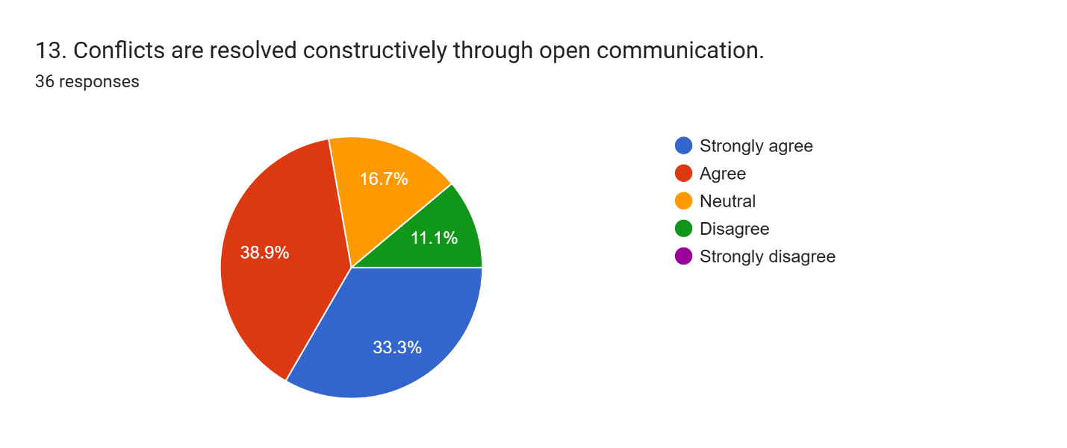The survey investigated the effectiveness of conflict resolution through open communication at Ziska, a crucial element for maintaining a healthy and productive work environment. The results are largely positive and encouraging. A substantial 72.2% of employees (33.3% strongly agree and 38.9% agree) perceive conflicts as being resolved constructively through open communication. This highlights a healthy and functional communication environment for addressing disagreements, fostering mutual understanding, and preventing issues from escalating. Such an approach is crucial for maintaining a harmonious and productive workplace, minimizing disruption, and preserving team cohesion.

Effectiveness of Employee Recognition Programs in Boosting Morale
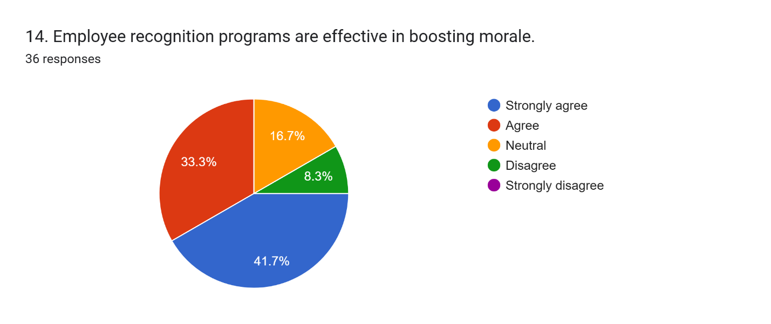
The survey assessed the effectiveness of employee recognition programs in boosting morale, acknowledging the importance of appreciation in driving engagement. The findings indicate a significant and positive impact. A combined 75% of employees (41.7% strongly agree and 33.3% agree) firmly believe that employee recognition programs are effective in positively impacting morale. This suggests that Ziska's efforts to acknowledge and reward employee contributions are largely successful in positively influencing employee spirits, motivation, and overall job satisfaction. Effective recognition programs are vital for reinforcing desired behaviors and fostering a culture of appreciation.

Culture Encouraging Risk-Taking and Creativity
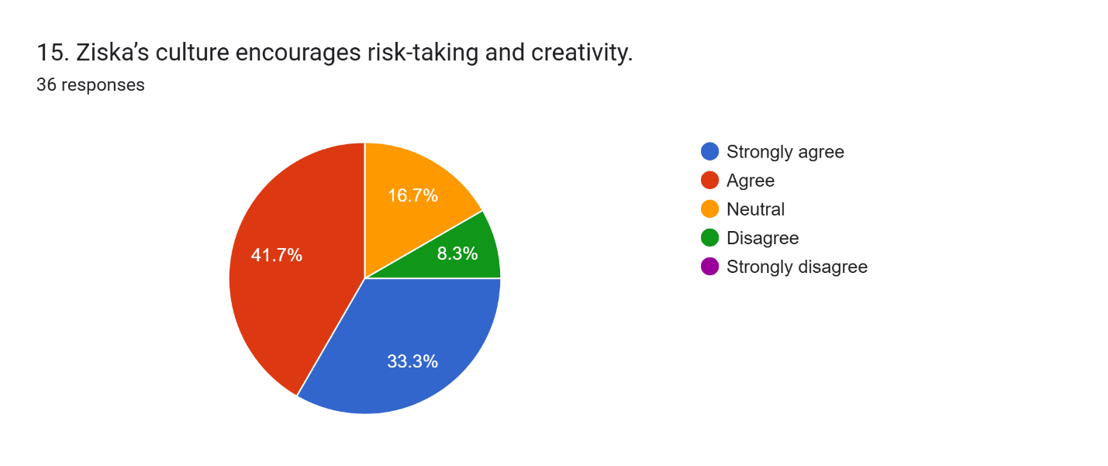The survey explored whether Ziska's culture encourages risk-taking and creativity, attributes essential for innovation and adaptability. The responses show a generally supportive and forward-thinking environment. A significant 75% of employees (33.3% strongly agree and 41.7% agree) perceive Ziska's culture as actively encouraging risk-taking and creativity. This is particularly important for an innovation-driven industry like pharmaceuticals, as it fosters an environment where new ideas are welcomed, experimentation is supported, and employees feel empowered to explore novel solutions without undue fear of failure. This cultural trait can drive competitive differentiation.

Analysis (Training and Development Programs)

Frequency of Training Programs
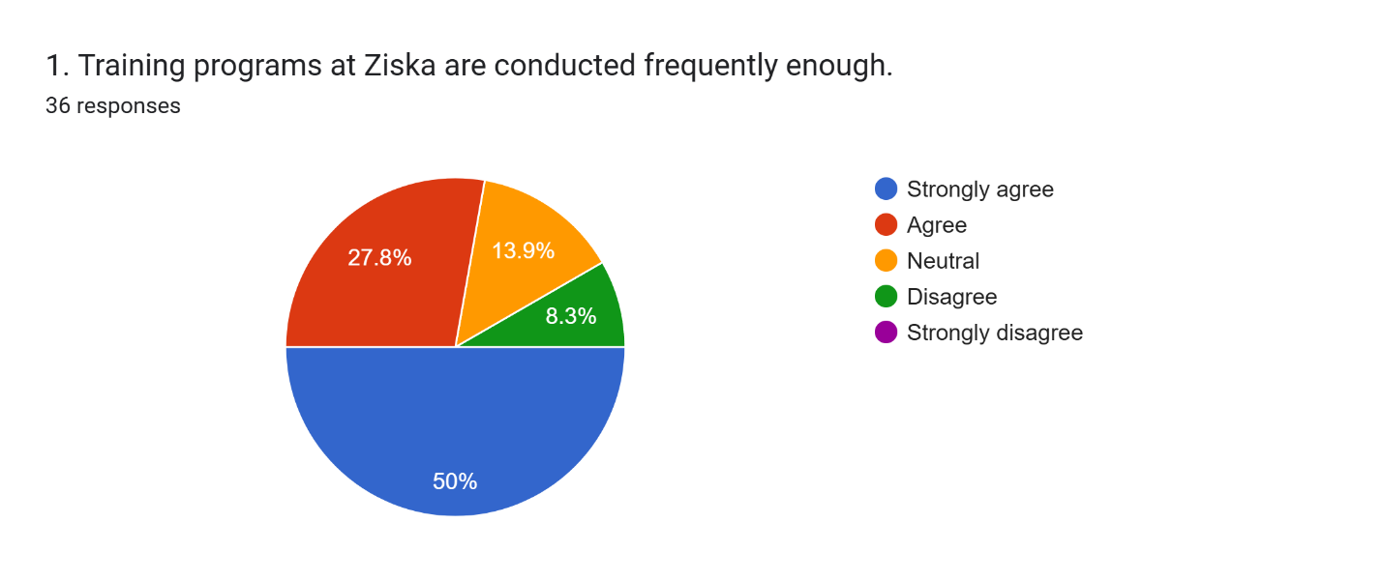The results indicate a strong and pervasive positive perception among employees regarding the regularity and timeliness of T&D initiatives. A substantial majority of employees, specifically 50% strongly agreeing and an additional 27.8% agreeing, collectively totaling 77.8%, perceive that training programs are conducted with sufficient frequency. This robust consensus suggests that Ziska maintains a consistent and responsive schedule for its T&D offerings, which is fundamentally crucial for continuous skill enhancement, knowledge updates, and staying abreast of industry advancements in a dynamic and highly competitive pharmaceutical sector. The relatively small percentage of neutral responses (13.9%) and outright disagreement (8.3%) indicates that while the overall frequency is largely satisfactory, there might be specific departments, specialized roles, or individual learning preferences where employees desire slightly more frequent interventions, or where the perceived need for particular types of training varies, warranting a nuanced approach to scheduling.

Effectiveness of the HR Department in Managing Training and Development
The responses reflect a generally strong and positive assessment of HR's pivotal role in this critical function. A combined 75% of employees (41.7% strongly agreeing and 33.3% agreeing) firmly believe that the HR Department effectively manages T&D.
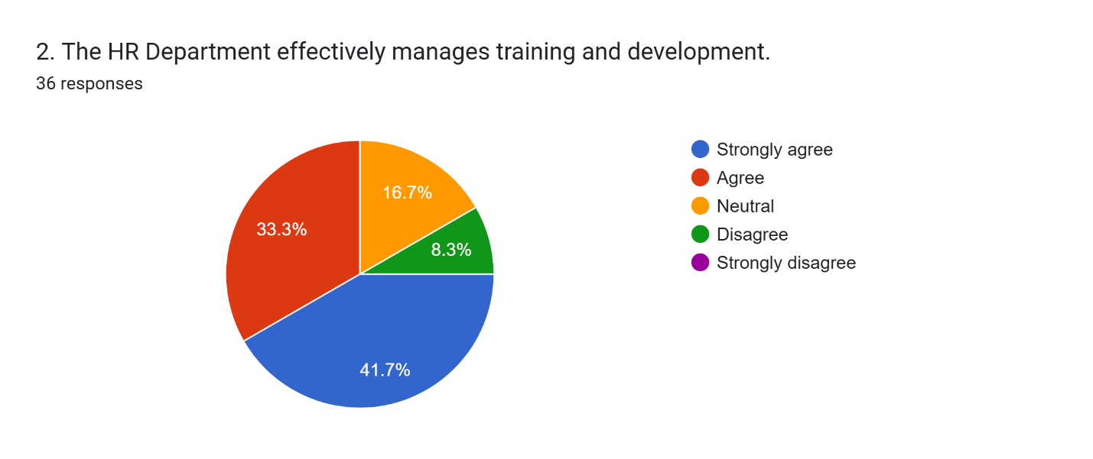
This high level of agreement indicates that HR is largely successful in the strategic planning, meticulous organization, and efficient delivery of training programs, thereby ensuring their smooth execution, accessibility to all relevant employees, and alignment with organizational objectives. The presence of a 16.7% neutral response suggests that while HR's efforts are widely appreciated and effective, there might be opportunities to further enhance transparency in T&D planning, improve communication regarding available programs, or increase responsiveness to individual training requests to achieve even broader and more consistent employee satisfaction with HR's T&D management.

Primary Goal of Training: Skill Development vs. Compliance
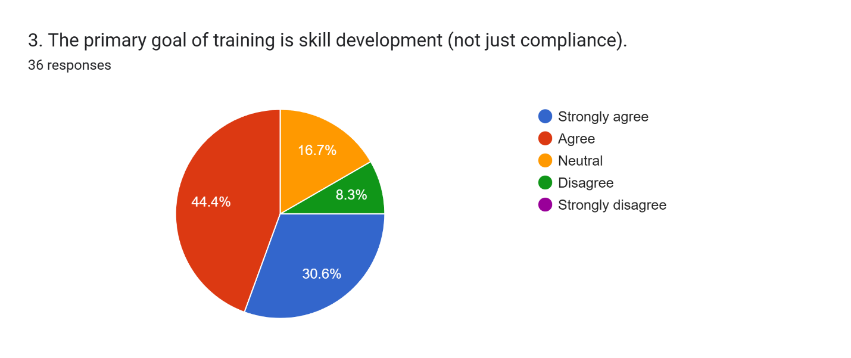The survey explored employees' perception of the fundamental goal of training at Ziska, specifically whether its primary focus is on comprehensive skill development rather than merely fulfilling mandatory compliance requirements. The findings indicate a clear and strong emphasis on skill development, which is indicative of a progressive T&D philosophy. A significant 75% of employees (30.6% strongly agreeing and 44.4% agreeing) perceive that the primary objective of training at Ziska is indeed skill development. This is a critical indicator of a forward-thinking and value-adding T&D strategy, as it suggests that Ziska actively invests in enhancing and broadening employee capabilities for long-term professional growth, improved performance, and career progression, rather than simply meeting regulatory or procedural obligations.

Measurement of Training Effectiveness through Feedback
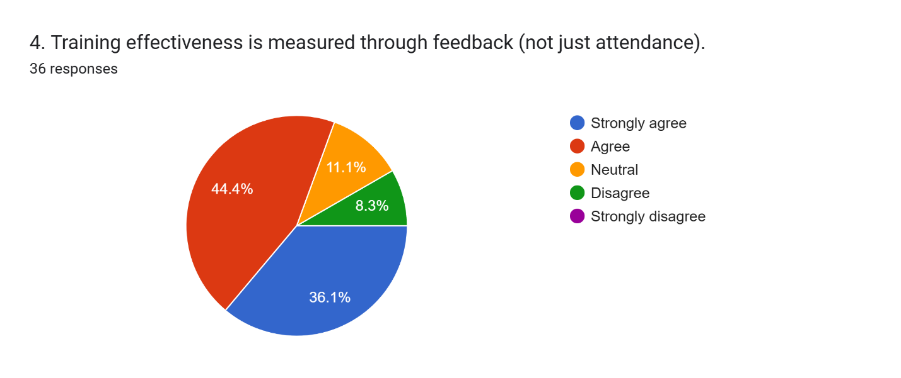The responses indicate a highly positive trend towards a more sophisticated and employee-centric approach to evaluation. An impressive 80.5% of employees (36.1% strongly agreeing and 44.4% agreeing) believe that training effectiveness is indeed measured through feedback. This robust finding suggests that Ziska employs a more advanced and insightful approach to evaluating its T&D programs, actively moving beyond simplistic attendance metrics. By gathering qualitative and quantitative insights directly from participants regarding learning outcomes, practical applicability, and overall program quality, Ziska can ensure continuous improvement of training content, delivery methodologies, and overall relevance to employee needs and organizational goals. This feedback-driven approach is essential for optimizing T&D investments.

Employee Motivation for Training for Career Growth
The findings reveal a strong intrinsic motivation for professional advancement among the workforce. A substantial 75% of employees (36.1% strongly agreeing and 38.9% agreeing) are motivated to attend training primarily for career growth. This indicates a strong and healthy alignment between individual aspirations for progression and the organizational T&D offerings.
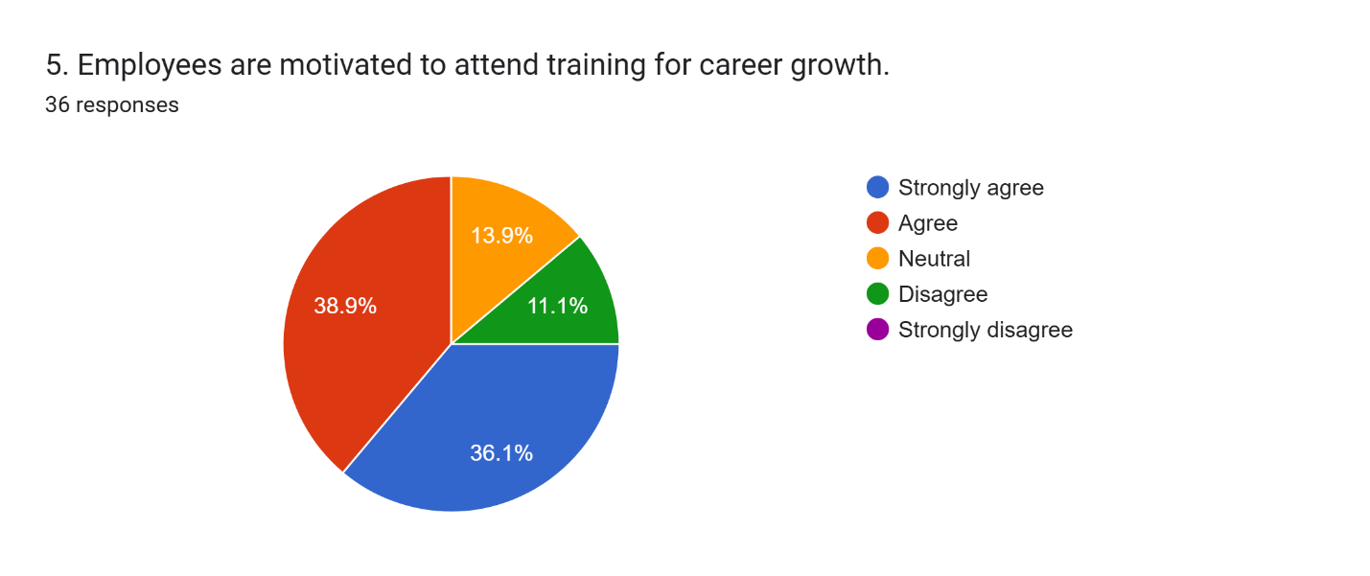Employees clearly perceive training as a valuable and tangible pathway to enhanced career opportunities and advancement within Ziska, which is fundamentally crucial for fostering a proactive growth mindset, boosting employee engagement, and effectively retaining high-potential talent within the organization.

Regular Coverage of Teamwork and Communication in Training
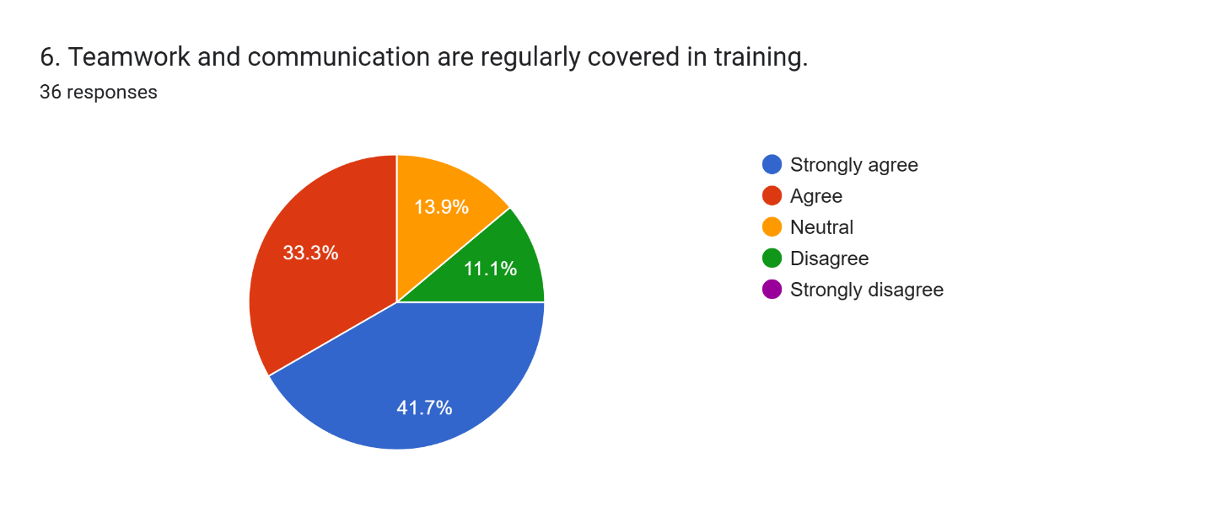The responses indicate a significant and consistent focus on these essential soft skills. A combined 75% of employees (41.7% strongly agreeing and 33.3% agreeing) confirm that teamwork and communication are indeed regularly covered in training initiatives. This highlights Ziska's strategic recognition of these interpersonal competencies as critical enablers for effective collaboration, efficient project execution, and overall organizational performance, especially in a complex, multi-disciplinary environment. Prioritizing these areas in T&D reinforces the collaborative and communicative culture that was identified as a strength in previous analyses of Ziska's organizational environment.

Perceived Effectiveness of On-the-Job Training
The survey assessed whether on-the-job training (OJT) is perceived by employees as the most effective training method utilized at Ziska. The findings strongly suggest that OJT is highly valued and considered impactful. A significant 77.8% of employees (36.1% strongly agreeing and 41.7% agreeing) perceive OJT as the most effective training methodology. This robust endorsement indicates that practical, hands-on learning directly within the work environment, coupled with real-time application and mentorship, is highly valued and contributes significantly to immediate skill acquisition and practical application at Ziska.
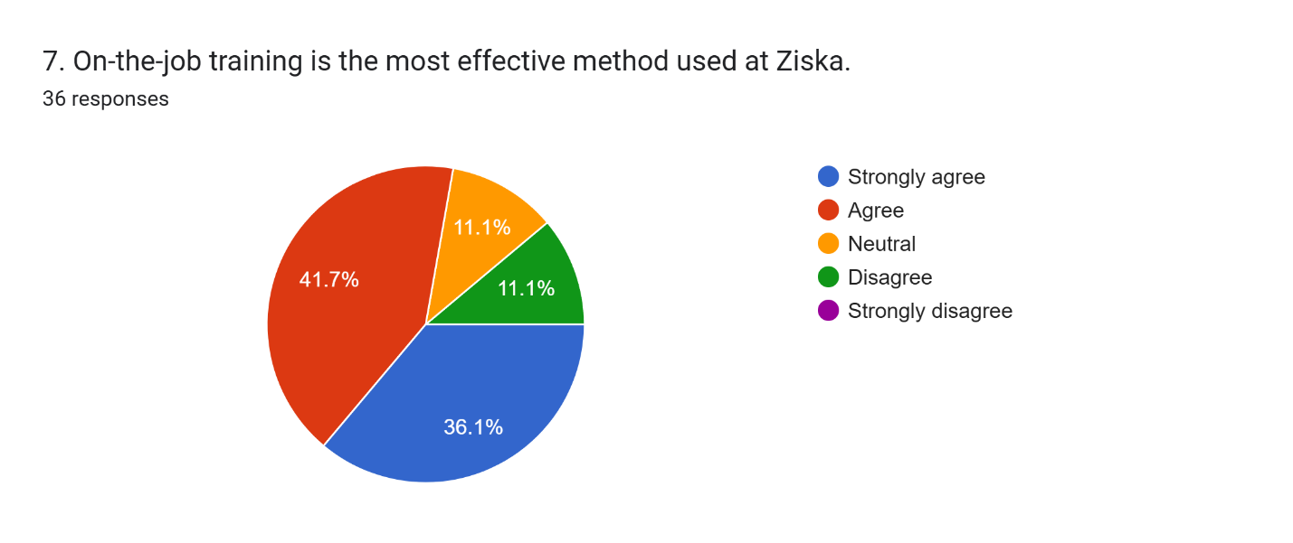

Direct Improvement of Employee Performance by Training
The results indicate a strong and unequivocal perceived positive impact of T&D on individual effectiveness. A substantial 75% of employees (47.2% strongly agreeing and 27.8% agreeing) firmly believe that training directly improves their performance. This is a crucial and validating finding, as it directly supports the return on investment in T&D programs from the most critical perspective – that of the employee. It strongly suggests that training at Ziska is highly relevant, practical, and directly applicable to job responsibilities, leading to discernible and measurable improvements in individual effectiveness, productivity, and quality of work.
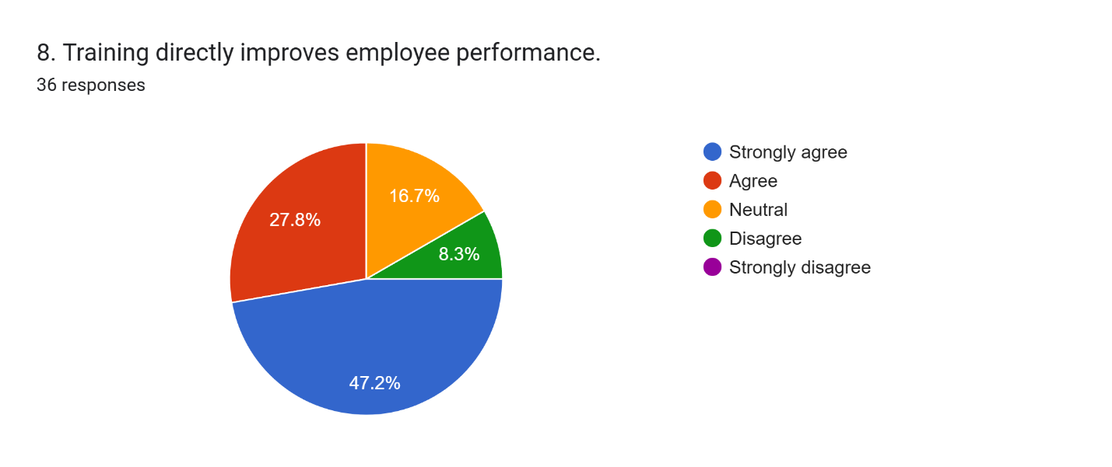

Application of Training Knowledge in Daily Work
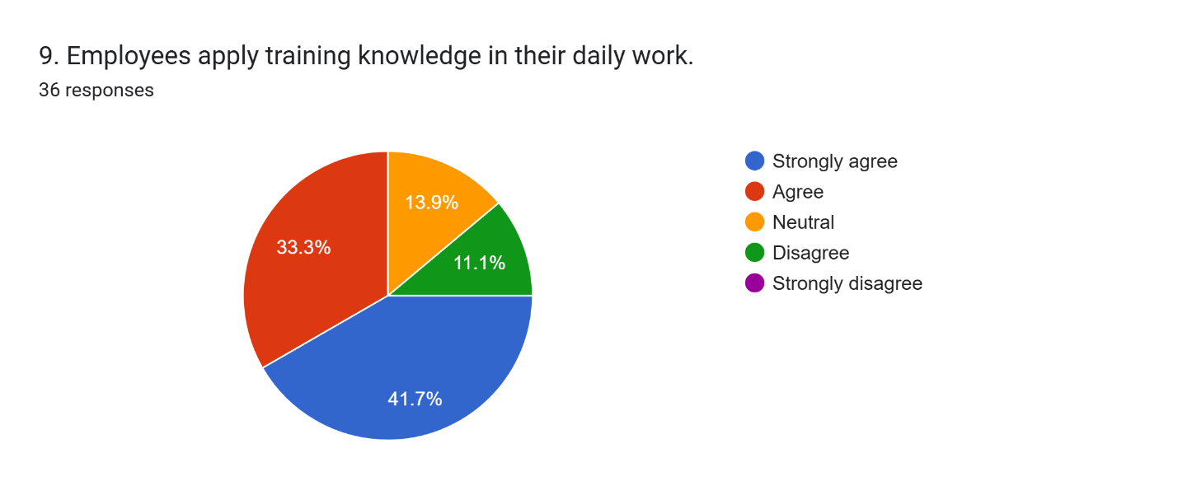
The responses demonstrate a high degree of successful knowledge transfer and practical integration. A significant 75% of employees (41.7% strongly agreeing and 33.3% agreeing) report regularly applying training knowledge in their daily work. This indicates effective knowledge retention and a successful transfer of learned skills and information from formal or informal training sessions to practical job execution. This high rate of application is fundamentally essential for maximizing the benefits and strategic value of T&D investments, driving continuous operational improvement, and ensuring that learning translates into tangible organizational outcomes.

Well-Established Leadership Development Programs
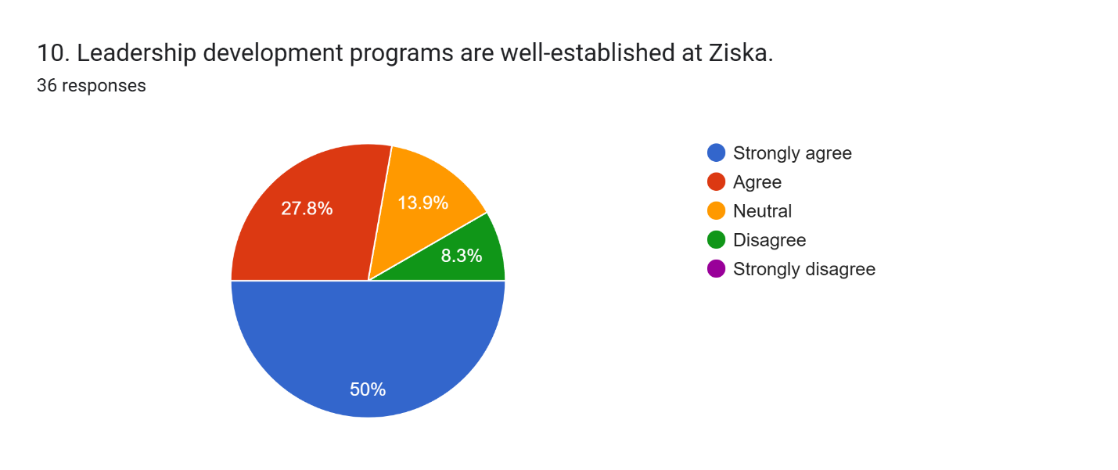The findings indicate a strong and widespread positive perception regarding the maturity and impact of these initiatives. An impressive 77.8% of employees (50% strongly agreeing and 27.8% agreeing) believe that leadership development programs are well-established at Ziska. This robust endorsement suggests that Ziska has made significant and strategic investments in structured initiatives designed to cultivate and enhance leadership capabilities across various levels within its workforce. Such programs are vital for effective succession planning, fostering a strong and capable management pipeline, and ensuring future organizational effectiveness and adaptability. The high agreement rate underscores the perceived maturity, strategic importance, and effectiveness of these critical leadership development programs.

Training Content Tailored to Different Experience Levels
The results indicate a strong positive perception regarding the customization of training.
A substantial 80.5% of employees (44.4% strongly agreeing and 36.1% agreeing) believe that training content is effectively tailored to various experience levels. This is a crucial strength, as it ensures that training remains relevant and impactful for all employees, regardless of their tenure or seniority. Customization enhances the effectiveness of learning and development by addressing specific needs and skill gaps across the organizational hierarchy, with only 11.1% neutral and 8.3% disagreeing.
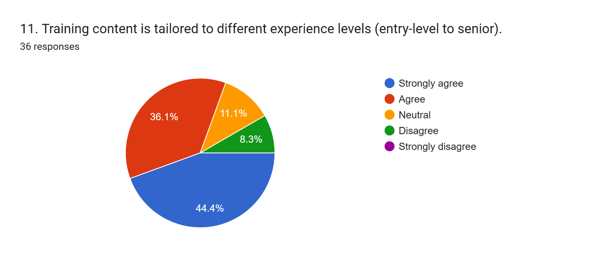

Receipt of Clear Pre- and Post-Training Resources
The findings indicate a positive, but not universally strong, provision of such resources. A combined 75% of employees (41.7% strongly agreeing and 33.3% agreeing) report receiving clear pre- and post-training resources. This suggests that Ziska generally provides support materials that aid in the preparation and reinforcement of learning. However, the 16.7% neutral response rate indicates an opportunity to further standardize and enhance the provision of these resources, ensuring all employees consistently benefit from comprehensive pre-learning preparation and post-training reinforcement to maximize knowledge retention and application, with only 8.3% disagreeing.
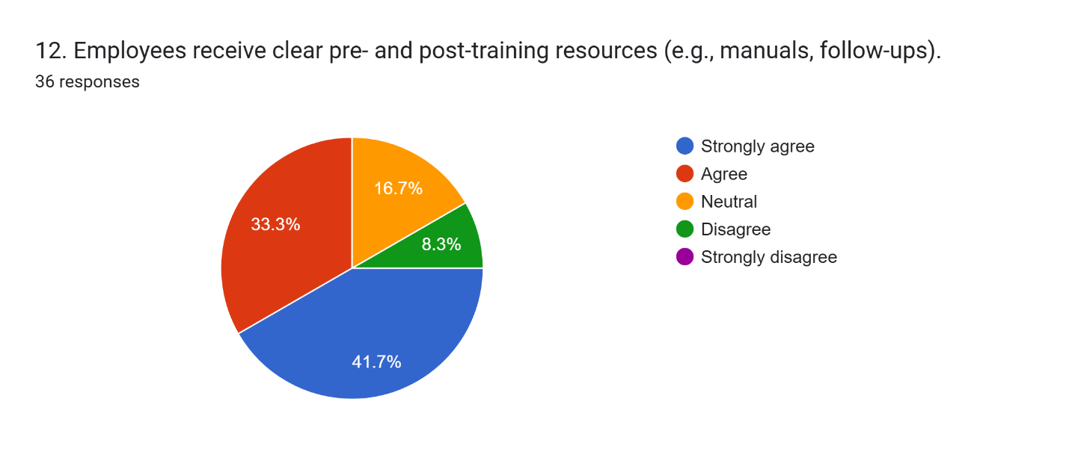

Technology Enhancing Training Accessibility
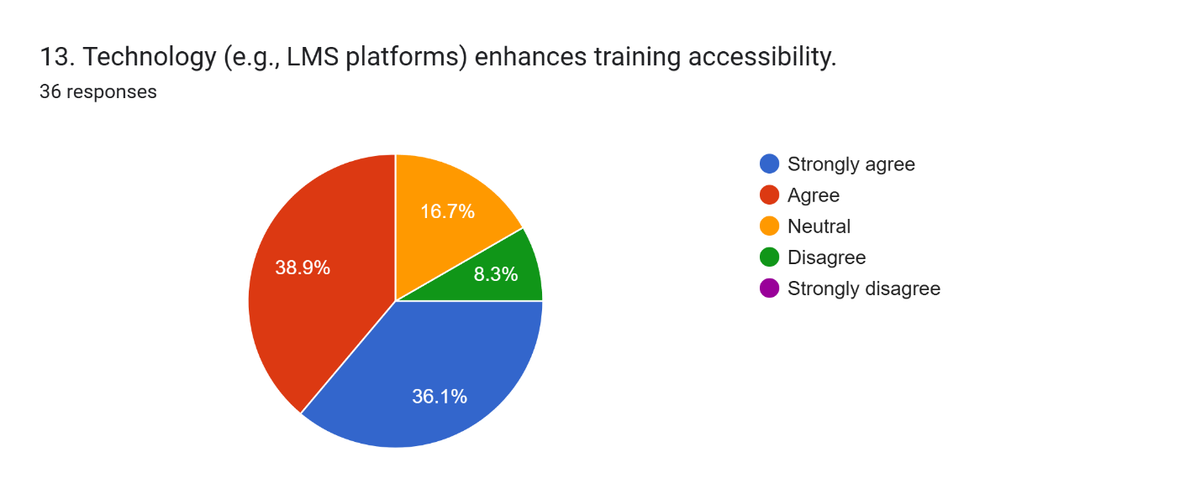The survey assessed whether technology, such as Learning Management System (LMS) platforms, enhances training accessibility. The results indicate a generally positive view of technology's role. A significant 75% of employees (36.1% strongly agreeing and 38.9% agreeing) believe that technology enhances training accessibility. This is a vital aspect of modern T&D, allowing for flexible and scalable learning opportunities. The positive perception suggests that Ziska effectively leverages digital tools to make training more convenient and available to its workforce, with 16.7% neutral and 8.3% disagreeing.

Interactive and Engaging Training Sessions
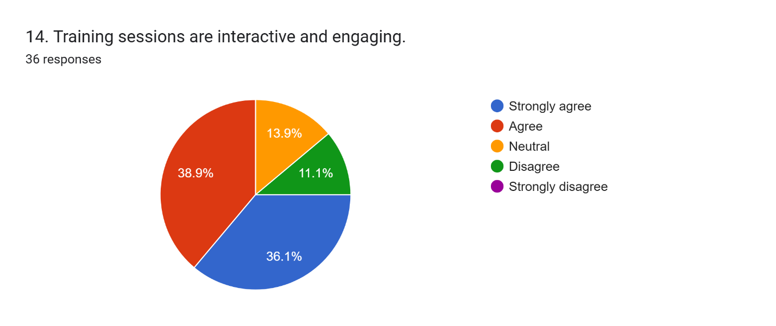
The findings indicate a generally positive, but with room for more dynamic delivery. A combined 75% of employees (36.1% strongly agreeing and 38.9% agreeing) find training sessions to be interactive and engaging. This is crucial for effective adult learning, as active participation and engaging content enhance retention and application. While largely successful, the 13.9% neutral and 11.1% disagreement suggest that some sessions might benefit from further incorporation of interactive methodologies to ensure universal engagement.

External Trainers/Experts Brought in When Needed
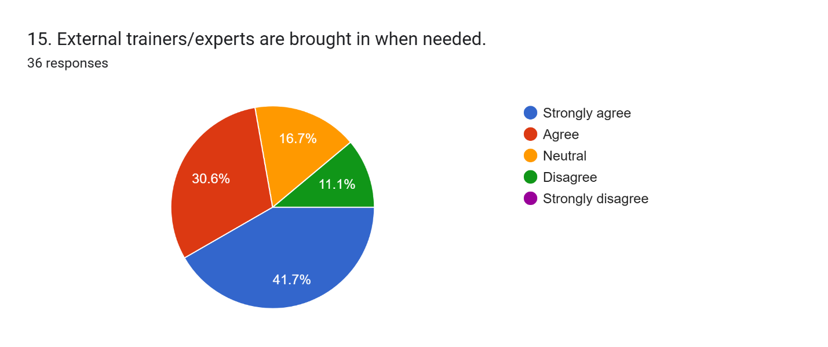The findings indicate a positive approach to leveraging external expertise. A combined 72.3% of employees (41.7% strongly agreeing and 30.6% agreeing) believe that external trainers or experts are brought in when necessary. This demonstrates Ziska's commitment to providing specialized knowledge and diverse perspectives that may not be available internally, enriching the learning experience and ensuring access to cutting-edge industry insights, with 16.7% neutral and 11.1% disagreeing.

Ideas and Opinions Valued by Management
The results indicate a strong positive perception of management's receptiveness. A significant 66.7% of employees feel that their ideas and opinions are valued by management. This highlights a culture of open communication and respect for employee input, which is crucial for fostering innovation, engagement, and a sense of ownership.
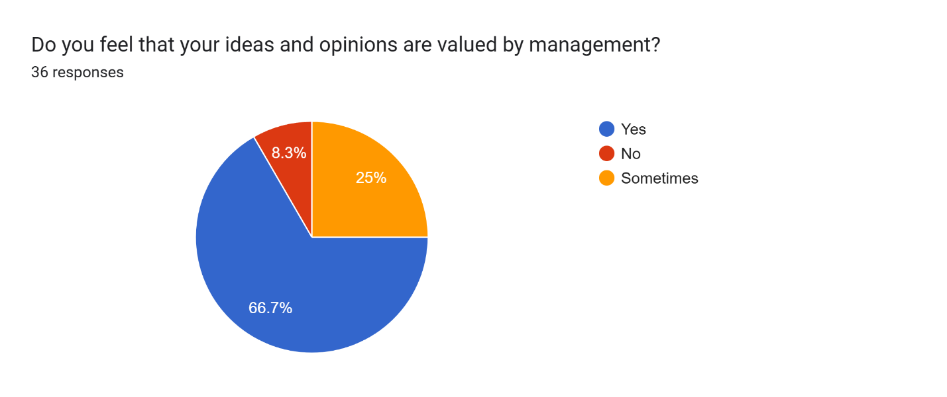However, the 25% who respond "Sometimes" and 8.3% who respond "No" suggest that while valuing employee input is a strength, there is room to ensure this is consistently felt across all teams and departments, making the process more universal and predictable.

Findings
- Ziska fosters a supportive work environment where teamwork, diversity, and inclusion are prioritized; creating a strong foundation for effective training and employee engagement.
- The organization promotes creativity and calculated risk-taking, aligning well with dynamic, skills-focused training programs that encourage continuous improvement.
- Leaders model ethical behavior and clearly communicate company values, which reinforces a culture of accountability and strengthens the integrity of T&D initiatives.
- T&D programs are frequent, well-managed, and focused on holistic development; demonstrating Ziska’s commitment to long-term employee growth and organizational resilience.
- Employees report directly applying learned skills in daily tasks, indicating strong integration between training content and job performance.
- The presence of structured leadership training supports succession planning and strengthens the cultural value of internal growth and mentorship.
- Active involvement of managers and the use of technology enhance accessibility and relevance of training, fostering a culture of learning across all employee levels.
- While most feel heard, further effort is needed to ensure all employees; especially remote or hybrid staff, feel empowered to contribute ideas and access development opportunities.
- Strong cultural values such as adaptability, transparency, and collaboration are embedded into training content, amplifying its relevance and impact.
- Ziska could further optimize cultural alignment by conducting targeted needs assessments, expanding inclusive feedback mechanisms, and ensuring universal access to tailored training initiatives.

CHAPTER V: CONCLUSIONS AND KEY FACTS

Recommendations
Based on the findings in Chapter 4, several targeted recommendations have been developed to help Ziska Pharmaceuticals Ltd. strengthen its organizational culture and future-readiness. In today’s competitive pharmaceutical industry, aligning employee experience with strategic goals is essential for long-term success.
Ziska has already demonstrated a strong commitment to collaboration, innovation, and continuous development. The proposed initiatives aim to build on these strengths; enhancing leadership capacity, promoting upskilling, fostering cross-generational learning, and deepening cultural integration across all levels of the organization.
By implementing these forward-thinking strategies, Ziska Pharmaceuticals Ltd. can further position itself as a progressive, employee-centric organization that nurtures growth, adaptability, and excellence across its workforce.
- Expand scenario-based and values-driven leadership development programs to build a future-ready management team capable of navigating complex challenges.
- Launch a company-wide digital upskilling initiative to equip employees with emerging tech competencies relevant to the evolving pharmaceutical landscape.
- Establish mentorship pairings between senior and junior employees to encourage mutual learning, strengthen collaboration, and preserve institutional knowledge.
- Introduce flexible training models combining formal instruction with experiential learning, empowering employees to take ownership of their development.
- Implement a wellness curriculum addressing physical, mental, financial, and social health to reinforce employee engagement and organizational care.
- Strengthen internal mobility programs with transparent progression frameworks, helping employees visualize and pursue long-term growth within the organization.
- Utilize advanced HR analytics to anticipate future skill gaps, enabling proactive talent development and strategic workforce planning.
- Design immersive onboarding experiences that embed company values from day one, fostering cultural alignment and early engagement.
- Deploy peer recognition platforms and real-time feedback systems to boost morale, strengthen culture, and maintain continuous employee insight.
- Develop a company-wide knowledge management system that captures expertise and best practices to ensure organizational learning continuity.

Conclusion
This internship to Ziska Pharmaceuticals Ltd. reveals a profound synergy between its robust organizational culture and effective training and development (T&D) programs. Ziska's culture is highly collaborative, innovative, and supportive, fostering a strong sense of belonging, encouraging feedback, and boosting morale. Leadership consistently models ethical behavior, reinforcing this positive framework. Concurrently, Ziska's T&D initiatives are well-managed, frequent, and strategically focused on skill development, with employees motivated by career growth and consistently applying learned knowledge.
This potent internal synergy enhances employee performance and satisfaction, as the collaborative culture facilitates T&D, and T&D, in turn, strengthens core cultural values. However, despite these formidable internal strengths, Ziska faces significant external competitive pressures, including intense rivalry, low customer loyalty, and an obscure brand image. This indicates that while internal human capital is thriving, it has not yet fully translated into a dominant external competitive advantage.
Ziska Pharmaceuticals Ltd.'s internal human capital strategies are remarkably effective in fostering employee well-being, enhancing capabilities, and promoting a vibrant organizational culture. To fully capitalize on these internal strengths and achieve sustained competitive advantage, the report strongly advocates for a strategic imperative: Ziska must proactively leverage its internal cultural and T&D strengths to directly address its identified external market challenges. This involves enhancing brand visibility, strategically improving customer engagement, and pursuing targeted market penetration initiatives. The ultimate success of Ziska Pharmaceuticals Ltd. in the long-term hinges not only on its continued investment in its people but also on its ability to strategically align these internal human capital triumphs with its external market positioning to secure tangible leadership and enduring organizational success.

Reference

- Noor, A. (2018, April). AN ANALYTICAL STRATEGIC MANAGEMENT REPORT ON ZISKA PHARMA. ResearchGate. Retrieved July 23, 2025, from https://www.researchgate.net/publication/326558576_AN_ANALYTICAL_STRATEGIC_MANAGEMENT_REPORT_ON_ZISKA_PHARMA
- Ziska Pharmaceuticals Ltd. (n.d.). Official Website. Retrieved July 23, 2025, from https://www.ziskapharma.com/
- LinkedIn. (n.d.). Ziska Pharmaceuticals Limited. Retrieved July 23, 2025, from https://www.linkedin.com/company/ziska-pharmaceuticals-limited/
- MedEx. (n.d.). Ziska Pharmaceuticals Ltd. | Company overview and top brands. Retrieved July 23, 2025, from https://medex.com.bd/companies/79/ziska-pharmaceuticals-ltd

Appendix-A:

Organizational Culture Questions:
1. The current organizational culture at Ziska Pharmaceuticals is highly collaborative.
- Strongly Agree
- Agree
- Neutral
- Disagree
- Strongly Disagree
2. Innovation is the most emphasized core value at Ziska.
- Strongly Agree
- Agree
- Neutral
- Disagree
- Strongly Disagree
3. Ziska’s training programs are well-aligned with its cultural values.
- Strongly Agree
- Agree
- Neutral
- Disagree
- Strongly Disagree

4. The learning environment at Ziska is collaborative and supportive.
- Strongly Agree
- Agree
- Neutral
- Disagree
- Strongly Disagree
5. The organizational culture positively impacts employee satisfaction.
- Strongly Agree
- Agree
- Neutral
- Disagree
- Strongly Disagree
6. Shared values are a clear sign of Ziska’s strong organizational culture.
- Strongly Agree
- Agree
- Neutral
- Disagree
- Strongly Disagree
7. Cultural events significantly boost employee engagement at Ziska.
- Strongly Agree
- Agree
- Neutral
- Disagree
- Strongly Disagree

8. Employees are actively encouraged to suggest improvements.
- Strongly Agree
- Agree
- Neutral
- Disagree
- Strongly Disagree
9. Leadership plays a supportive role in reinforcing organizational culture.
- Strongly Agree
- Agree
- Neutral
- Disagree
- Strongly Disagree
10. The organizational culture strongly supports continuous learning.
- Strongly Agree
- Agree
- Neutral
- Disagree
- Strongly Disagree
11. Employees feel a strong sense of belonging at Ziska.
- Strongly Agree
- Agree
- Neutral
- Disagree
- Strongly Disagree

12. Diversity and inclusion are prioritized in Ziska’s culture.
- Strongly Agree
- Agree
- Neutral
- Disagree
- Strongly Disagree
13. Conflicts are resolved constructively through open communication.
- Strongly Agree
- Agree
- Neutral
- Disagree
- Strongly Disagree
14. Employee recognition programs are effective in boosting morale.
- Strongly Agree
- Agree
- Neutral
- Disagree
- Strongly Disagree
15. Ziska’s culture encourages risk-taking and creativity.
- Strongly Agree
- Agree
- Neutral
- Disagree
- Strongly Disagree

Training & Development Questions:
1. Training programs at Ziska are conducted frequently enough.
- Strongly Agree
- Agree
- Neutral
- Disagree
- Strongly Disagree
2. The HR Department effectively manages training and development.
- Strongly Agree
- Agree
- Neutral
- Disagree
- Strongly Disagree
3. The primary goal of training is skill development (not just compliance).
- Strongly Agree
- Agree
- Neutral
- Disagree
- Strongly Disagree
4. Training effectiveness is measured through feedback (not just attendance).
- Strongly Agree
- Agree
- Neutral
- Disagree
- Strongly Disagree
5. Employees are motivated to attend training for career growth.
- Strongly Agree
- Agree
- Neutral
- Disagree
- Strongly Disagree
6. Teamwork and communication are regularly covered in training.
- Strongly Agree
- Agree
- Neutral
- Disagree
- Strongly Disagree
7. On-the-job training is the most effective method used at Ziska.
- Strongly Agree
- Agree
- Neutral
- Disagree
- Strongly Disagree
8. Training directly improves employee performance.
- Strongly Agree
- Agree
- Neutral
- Disagree
- Strongly Disagree

9. Employees apply training knowledge in their daily work.
- Strongly Agree
- Agree
- Neutral
- Disagree
- Strongly Disagree
10. Leadership development programs are well-established at Ziska.
- Strongly Agree
- Agree
- Neutral
- Disagree
- Strongly Disagree
11. Training content is tailored to different experience levels (entry-level to senior).
- Strongly Agree
- Agree
- Neutral
- Disagree
- Strongly Disagree
12. Employees receive clear pre- and post-training resources (e.g., manuals, follow-ups).
- Strongly Agree
- Agree
- Neutral
- Disagree
- Strongly Disagree

13. Technology (e.g., LMS platforms) enhances training accessibility.
- Strongly Agree
- Agree
- Neutral
- Disagree
- Strongly Disagree
14. Training sessions are interactive and engaging.
- Strongly Agree
- Agree
- Neutral
- Disagree
- Strongly Disagree
17. External trainers/experts are brought in when needed.
- Strongly Agree
- Agree
- Neutral
- Disagree
- Strongly Disagree
18. Do you feel that your ideas and opinions are valued by management?
- Yes
- No
- Sometimes

