Project Report
On
Financial Statement Analysis
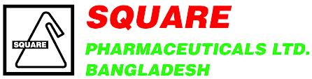
Report on Financial Statement Analysis
Of
Square Pharmaceuticals Limited

Prepared for
Mosabbir Uddin Ahmad
Assistant Professor
School of Business & Economics
United International University (UIU)
Prepared by
Fatema Tuj Jahura
ID – 111 131 119
School of Business & Economics
United International University (UIU)

Date of submission: 21st May, 2018


Letter of Transmittal
To,
Mosabbir Uddin Ahmad
Assistant Professor
School of Business & Economics
United International University

Subject: Submission of the Project Report
Dear Sir,
I would like to submit my project report on Financial Statement Analysis of the Square Pharmaceuticals Limited; it has been prepared as an obligation for the end of the BBA Program of United International University. While working on this report, I have endeavored to follow the instructions that you have advised. It has been an edifying experience to work on this project.
Moreover, I want to thank you for the facilitation you have provided me. If you need any further information while evaluating the project report, I would furnish you the same with profound pleasure.
Hence, I would be obliged if you go through my report and give your assessment to my work considering my abridgement.

Sincerely,
Fatema Tuj Jahura
ID No: 111131119

Acknowledgement
At first, I would like to articulate my gratefulness to the Almighty for giving me the potency and opportunity to complete the report within the scheduled time successfully.

I would like to be grateful to the project supervisor Mosabbir Uddin Ahmad who has helped me in every step of my report. Without his support and encouragement this report and business plan would not possible such an endeavor to enhance my practical knowledge about the real situation.

Declaration
I am Fatema Tuj Jahura, student of School of Business and Economics (Finance) of United International University, Bangladesh, do hereby declare that the project report on “Financial Statement Analysis” is an innovative work and hasn’t been previously submitted for any degree, diploma, title, or recognition.

________________
Fatema Tuj Jahura
ID No: 111 131 119
School of Business and Economics
United International University

Table of Contents
1.1. Introduction 2
1.2. Origin of report: 2
1.3. Objective of report: 2
1.3.1. General objective: 3
1.3.2. Specific objective: 3
1.4. Scope of the report: 3
1.5. Methodology 3
1.6. Limitations: 4
2.1. Company Overview 6
2.2. History 6
2.2.1. Mission & Vision 7
2.2.2. Core Values 7
3.1. Methods of Analysis: 10
3.2. Liquidity Ratio 10
3.2.1. Current Ratio: 10
3.2.2. Working Capital: 11
3.2.3. Cash Conversion Cycle: 11
3.3. Asset Management/Efficiency Ratio: 12
3.3.1. Inventory Turnover: 12
3.3.2. Total Asset Turnover Ratio: 13
Days sales outstanding: 14
Graphical Presentation: 14
3.4. Debt Management period: 14
3.4.1. Debt Ratio: 14
3.4.2. Times Interest Earned Ratio: 15
3.5. Profitability Ratio: 16
3.5.1. Net Profit Margin: 16
3.5.2. Gross Margin: 16
3.5.3. Operating Margin: 17
3.5.4. ROE: 18
3.5.5. ROA: 18
3.6. Fair Value Measurement 20
3.6.1. The Dividend Discount Model 20
3.6.2. Model to Equity 21
4.1. Key Findings: 23
4.2. Conclusion 24
4.3. Appendix 25
4.4. References 29

Executive Summary
This report is a pre-requisite of completion of the BBA Program. In this phase of my education I have received the practical knowledge related with the education I got. Additionally I have achieved commendable knowledge about the corporate finance industry.
I am going to cover up the policies that Square Pharmaceuticals Ltd basically follows to run their business and going to analyze their financial statement and evaluate the performance.
The report starts with an introduction part. In that part the objectives, scopes, methodology and limitations of the report have been discussed. After that, I have added a company overview. Here in the overview part, history, mission and vision of the company are briefly discussed also it contains a graphical presentation of Square Pharma from beginning till today.
In the third part I have done the financial statement analysis which is the major part of this report. This part starts with the liquidity ratio where I have added current ratio, working capital ratio and cash conversion cycle. After that, asset management/efficiency ratio has been added. In this part, inventory turnover, total asset turnover and days sales outstanding ratios are done. In debt management part, debt ratio and times interest earned ratio is calculated. Finally in the ratio analysis part, comes the profitability ratio. Here, net profit margin, gross profit margin and operating margin are shown. Every result of the ratio analysis is followed by an interpretation of how that is representing the company’s financial status also each has a graphical representation as well. Ratio analysis part is followed by the calculation of return on equity and return on asset.
After the ratio analysis part, fair value measurement is calculated in two ways. The dividend discount method, in this traditional method the current value of the stock is estimated on the basis of the spread between projected dividend growth and the discount rate. The second method which is used for fair value measurement is the model of equity. The model aims to calculate the intrinsic value of the shareholders equity of the firm.
The next chapter contains the key findings from the statement analysis, recommendations and conclusion. The report ends with an appendix and the references added to it.

Chapter-1

Introduction

Introduction
What we learn from books is accomplished only when we are able to imply our learning in practical fields. To cope with the changing modern business world we have to be capable of hatching own findings by exercising the knowledge we have accumulated.

This is the era of globalization. We can speculate the rapid change in economy of developing and under developed countries all over the world. This deportment has caused in boost of disposable income for a large fragment of population.

Square Pharmaceuticals Limited (Square Pharma) is currently the market leader of pharmaceuticals industry providing reasonable medicines capturing the largest market share.

Square Pharmaceuticals ltd. the flagship company of Square group has been holding the strong leadership in the pharmaceuticals industry and now has become a high performance global player by exporting drugs to 36 countries. they produce more than 500 products including herbal, nutraceuticals, agrovet and pesticides.

Origin of report:
This report is prepared to complete the partial obligation of my Bachelors of Business Administration (BBA) program of United International University. From this report I will be able to know real life situations of Square Pharmaceuticals Limited. While preparing this report, I had a great prospect to have an in depth knowledge of all the financial position through different analyzing tools and methods.

Objective of report:
This study has been conducted as fractional completion of requirement of the Bachelor in Business Administration (BBA) under Financial Statement Analysis of Square Pharmaceuticals Limited, the objectives of the study are:
The major purpose is to analyze the financial performance of Square Pharmaceuticals Limited in accordance with the knowledge acquired through the course “Financial Statement Analysis”. The subsidiary objective is to acquire knowledge about how to evaluate banking or financial organization’s in respect of its financial data through different financial analyzing techniques.

General objective:
The prime purpose of the report is to analyze the financial statement of square Pharmaceuticals Ltd.

Specific objective:
- To calculate the financial ratios and identify the areas of concern.
- To understand the implications in analyzing business activities and financial statements.
- To identify and assess the present financial performance of Square Pharmaceuticals Ltd.
- To identify the findings and raise possible recommendations for improving the performance of Square Pharmaceuticals Limited.

Scope of the report:
The scope of the report is limited at drawing descriptive and analytical rather than critical presentation of Square Pharmaceuticals Limited. Square Pharma is one of the most successful pharmaceuticals company in Bangladesh. The report covers the organizational structure; functions and the performance of the company have mainly worked in the common performance so our report covers all the activities of financial performance.

Methodology
There are many ways or techniques to evaluate a firm’s financial performance. Such as, Balance Sheet Analysis, Cash Flow Analysis, Ratio Analysis, Trend Analysis, and so on. However, for doing the analysis of performance analysis of Square Pharmaceuticals Ltd I have chosen the ratio analysis and calculate the fair value of market share of the company.

Limitations:
It is not possible to prepare a report on a topic without any limitations. So regarding this report, the limitations are:
- Hard to calculate the ratios in limited time period.
- Hard to calculate the faire value of the market share.
- Unable to do a direct contact with any employee of the company.
.

Chapter-2

Company Overview

Company Overview
Square Pharmaceuticals Limited is capturing the largest market share of pharmaceutical products and ingredients in Bangladesh. Square Pharma is the largest pharmaceutical company in Bangladesh and has been in the 1st position among all national and multinational companies since 1985.

History
Square Pharma started their journey in 1958 based in Dhaka, Bangladesh. In 1991 they were converted as a public company and in 1995 they were listed in Dhaka Stock exchange. Square Pharma has always looked beyond the horizon and decided to expand their range of services globally. They pioneered exporting medicine from 1987. They export pharmaceutical products including antibiotics and other drugs and the present export market covers 36 countries. At a glance the journey of Square Pharmaceuticals would look like the following:-

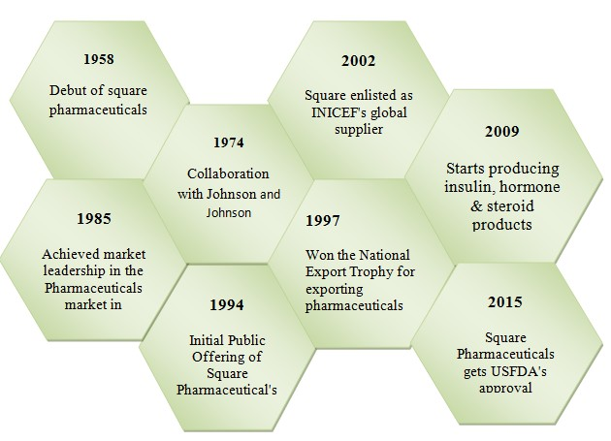

Mission & Vision
Square Pharmaceuticals Ltd creates values through the following vision and mission: [Table -1]

Square Pharmaceuticals Limited

Mission | Their mission is to produce and provide quality & innovative healthcare relief for people, maintain stringently ethical standard in business operation also ensuring benefit to the shareholders, stakeholders and the society at large.
Vision | They view business as a means to the material and social wellbeing of the investors, employees and the society at large, leading to accretion of wealth through financial and moral gains as a part of the process of the human civilization.

Core Values

Square Pharmaceuticals Ltd following some core values which are defines who they are. These are guiding them to acquire decisions and help recognize our individual and corporate aspiration. There are the following core values: [Table-2]

Square Pharma’s Core Values
Commitment to quality | They adopt industry best practices in all our operations to make sure highest quality standards products.
Satisfaction | They are committed to satisfying the needs of their customers, both internal and external.
People | SQUARE recognizes that progressive labor policies are good business practices, They follow laws and encourage work environment that welcomes diversity and also follow non-discrimination & fair treatment policy both in the recruitment & selection process and performance.
Accountability | Transparency & business ethics is the core value of SQUARE and it is strictly followed at every step of the business processes. Every business in SQUARE is modeled in a way that enables the management to ensure highest degree of both financial and behavioral accountability.
CSR | They scale-up CSR activities to consider the interests of our external & internal stakeholders like customers, employees, vendors, shareholders, society, government etc. and ecological & ethical considerations in all aspects of operations for safety and environment.

Chapter-3

Financial Statement Analysis

Methods of Analysis:
Common methods of Square Pharmaceuticals Ltd. is financial statement analysis consist of essential analysis, horizontal and vertical analysis and the use of financial ratios. Historical information joint with a series of assumptions and adjustments to the financial information used to project future performance.

Liquidity Ratio

Current Ratio:

Year | 31-Mar-13 | 31-Mar-14 | 31-Mar-15 | 31-Mar-16 | 31-Mar-17
Current Ratio | 3.68 | 7.02 | 8.49 | 9.74 | 11.75

Graphical Presentation:
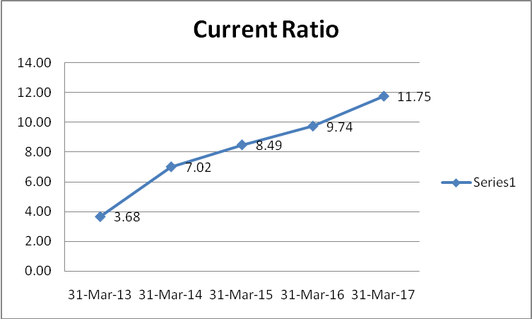

Interpretation: From the graph we can say that Square Pharmaceuticals Ltd. has a sharp rise in the current ratio over the period. From 2013 to 2017 the current ratio has increased by 8.07%. So we can conclude that they are in a very good position to fulfill their short term obligations.

Working Capital:

Year | 31-Mar-13 | 31-Mar-14 | 31-Mar-15 | 31-Mar-16 | 31-Mar-17
Working Capital | BDT 5,061,286,963 | BDT 6,431,454,959 | BDT 8,586,039,110 | BDT 15,312,191,759 | BDT 21,202,658,899

Graphical Presentation:
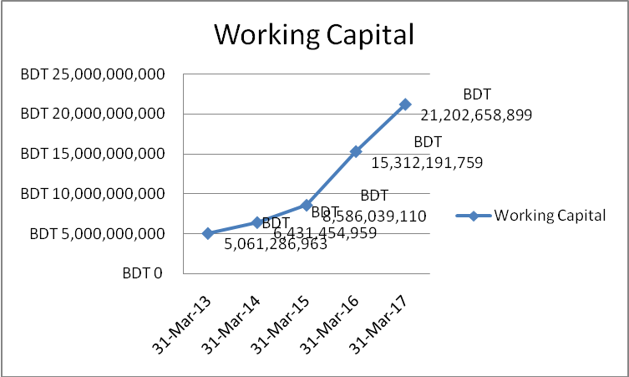

Interpretation: A company having higher net working capital has higher flexibility to spend on growing the business. From the result of working capital ratio we witness a dramatic rise from 2013 to 2017. In 2017 they hold the highest ratio from its past five years which indicates they can expand their business using the capital, and it also indicates effective capital utilization.

Cash Conversion Cycle:
Year | 31-Mar-13 | 31-Mar-14 | 31-Mar-15 | 31-Mar-16 | 31-Mar-17
Cash Conversion Cycle | 117 | 109 | 96 | 98 | 94

Graphical Presentation:
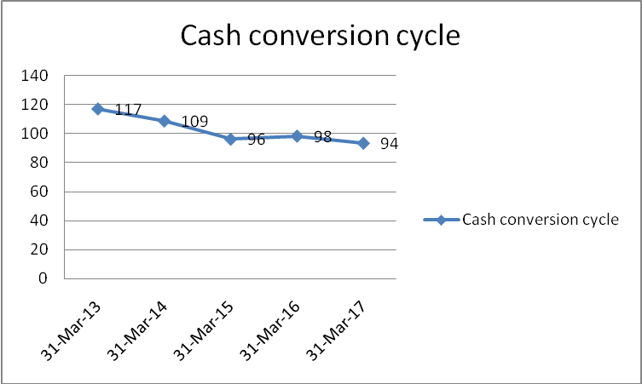
Interpretation: Cash conversion cycle refers the time a company takes to convert its resource inputs into cash. It measures how efficiently a company is running its working capital. We can see that the cash conversion period is declining every year. This can happen for slowing down the account payables. And the fall in CCC means they take less time now to convert their resources into cash in recent years which is a good indication. In 2017 they took only 94 days and in the worst situation, 2013 it was 117 days.

Asset Management/Efficiency Ratio:

Inventory Turnover:
Year | 31-Mar-13 | 31-Mar-14 | 31-Mar-15 | 31-Mar-16 | 31-Mar-17
Inventory Turnover | 3.66 | 3.88 | 4.29 | 4.27 | 4.60

Graphical Presentation:
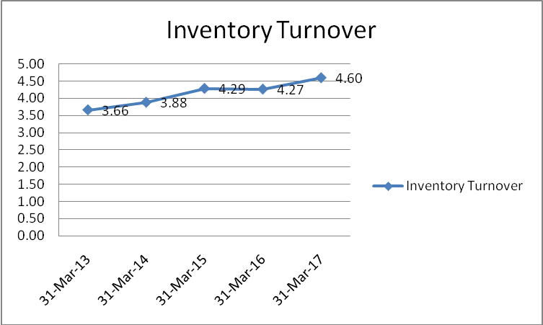

Interpretation: Inventory Turnover Ratio deals with how efficiently inventory is managed by comparing the cost of goods sold with average inventory for a period. Over the last 5 years Inventory turnover ratio has been increasing. Starting from 3.66 in 2013 the highest inventory turnover was recorded as 4.60 in 2017. From the income statement we see that the cost of goods sold over last 5 years has increased, and despite of having a steady inventory for the period we can conclude that increase in cogs has driven inventory turnover upwards.

Total Asset Turnover Ratio:
Year | 31-Mar-13 | 31-Mar-14 | 31-Mar-15 | 31-Mar-16 | 31-Mar-17
Total Asset Turnover Ratio | 73% | 75% | 76% | 75% | 70%

Graphical Presentation:
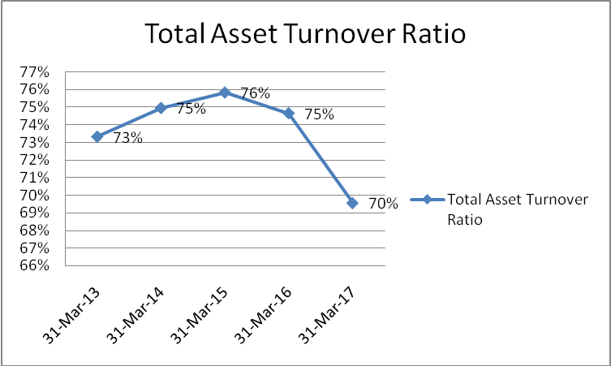
Interpretation: In case of total asset turnover ratio the higher ratio is more preferable. As it measures how a firm uses its assets to generate sales. From 2013 to 2015 Square Pharama had a steady rise but from after 2015 the ratio continues to fall. As the assets have increased that has caused the fall in the total asset turnover ratio. Hence their total asset turnover ratio is not bad as it stands at 70% in 2017 means they have quite effectively generates the sales.

3.3.3. Days sales outstanding:
Year | 31-Mar-13 | 31-Mar-14 | 31-Mar-15 | 31-Mar-16 | 31-Mar-17
Days sales outstanding | 17 | 15 | 11 | 13 | 14

Graphical Presentation:
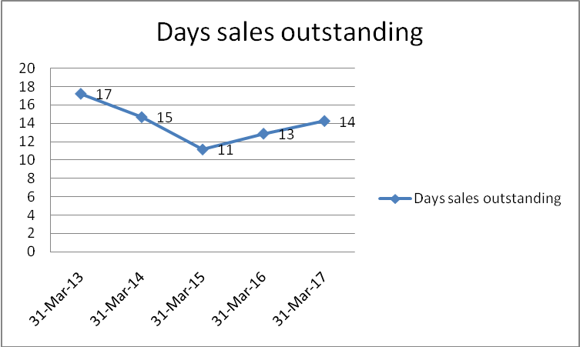
Interpretation: Square Pharma has a fluctuating trend of days sales outstanding. The account receivables had the same trend which has affected the DSO. It declined from 17 days to 11 days from 2013 to 2015. Again it was raised to 14 days in 2017. It indicates they take now more days to collect the cash from the customers. As seen in the cash conversion cycle increasing DSO could have caused CCC to rise but the increasing accounts payable managed to keep CCC downwards.

Debt Management period:

Debt Ratio:
Year | 31-Mar-13 | 31-Mar-14 | 31-Mar-15 | 31-Mar-16 | 31-Mar-17
Debt ratio | 18% | 14% | 12% | 8% | 7%

Graphical Presentation:
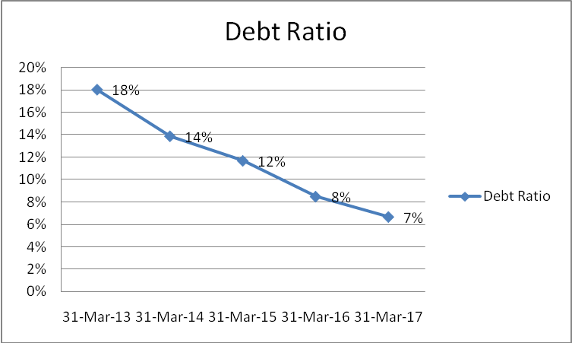
Interpretation: Debt ratio measures the financial leverage of Square Pharma. It had a declining trend over the time period as the liability has decreased and the assets have increased over time. In 2013 the debt ratio was 18% and within 5years it came to 7% decreasing by 11%. So it can be interpreted that the portion of Square Pharma’s asset which is financed by debt has decreased in a significant amount which has been continued every year.

Times Interest Earned Ratio:
Year | 31-Mar-13 | 31-Mar-14 | 31-Mar-15 | 31-Mar-16 | 31-Mar-17
Times Interest Earned Ratio | 4.48 | 4.35 | 4.62 | 4.95 | 4.64

Graphical Presentation:
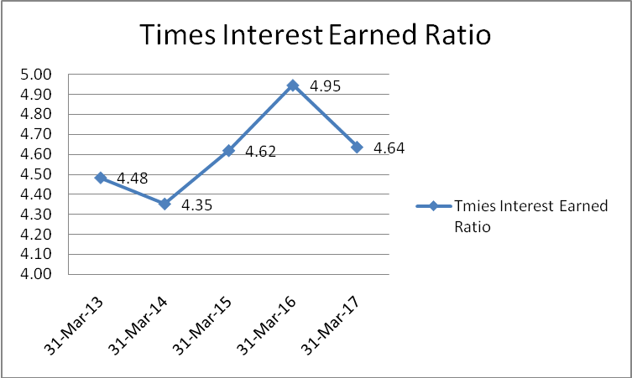
Interpretation: Times interest earned ratio measures a firm’s ability to honor its debt. The record shows that Square Pharma though had a fluctuating trend but it was never less than 2.5. So, it means that the firm is in a good position and has less risk for investors and creditors in terms of solvency.

Profitability Ratio:

Net Profit Margin:
Year | 31-Mar-13 | 31-Mar-14 | 31-Mar-15 | 31-Mar-16 | 31-Mar-17
Net Profit Margin | 20% | 22% | 22% | 28% | 30%

Graphical Presentation:
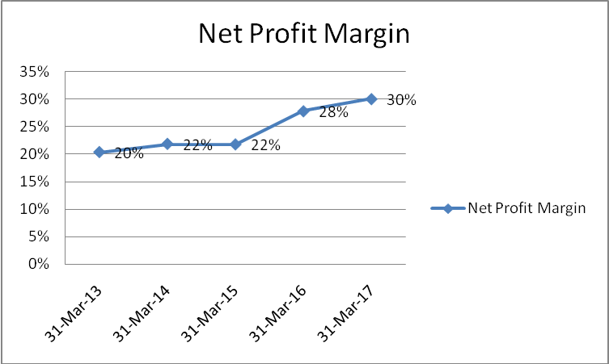
Interpretation: Net Profit Margin Ratio of Square Pharma has a significant increase over the period. The significant amount of increase in total revenue is the possible reason for increase in net profit margin. Within 5 years it has increased by 10%. That means the portion of revenue which is translated into profit had increased. And the rise of the growth was continuous throughout the taken period.

Gross Margin:
Year | 31-Mar-13 | 31-Mar-14 | 31-Mar-15 | 31-Mar-16 | 31-Mar-17
Gross Margin | 44% | 44% | 44% | 48% | 50%

Graphical Presentation:
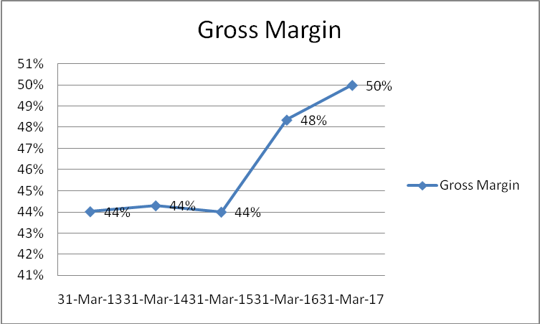
Interpretation: Gross margin ratio is a profitability ratio that measures what portion of the revenue is converted into gross profit. From 2013 to 2015 the gross margin ratio of Square Pharma was stable but after that it had gone upwards. In 2017 it was in the peak and that shows that they had 50% gross margin ratio for the year.

Operating Margin:
Year | 31-Mar-13 | 31-Mar-14 | 31-Mar-15 | 31-Mar-16 | 31-Mar-17
Operating Margin | 26% | 26% | 27% | 33% | 35%

Graphical Presentation:
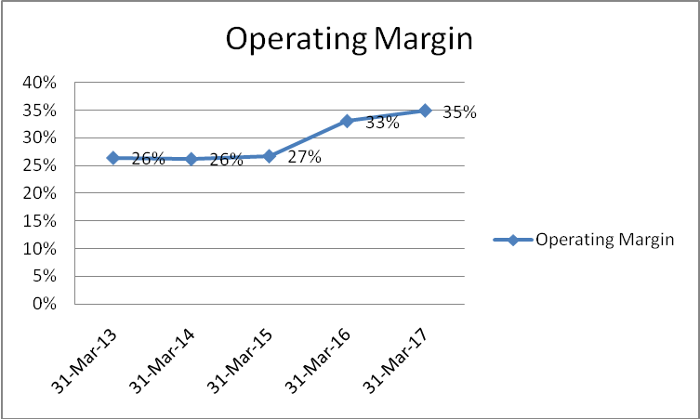
Interpretation: as the revenue of Square Pharma was steady till 2015, the operating margin behaves the same. But after 2015 the revenue has sharp rise, so does the operating Profit Margin. Th Ratio has increased from 26% to 35% within 2014 to 2017. Overall we can say that Square Pharma has a quite healthy operating margin ratio.

ROE:
Year | 31-Mar-13 | 31-Mar-14 | 31-Mar-15 | 31-Mar-16 | 31-Mar-17
ROE | 19% | 18% | 19% | 23% | 22%

Graphical Presentation:
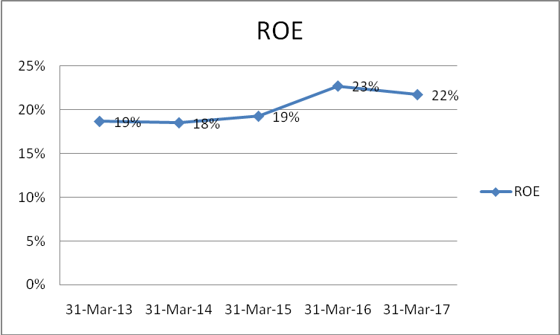
Interpretation: While calculating the ROE, we measure the firm’s performance from investor’s point of view. Square Pharma has a upward going ROE reflecting the rise of net income through the period. Though, the changes are not very big but still they have a good ROE. For 5 years the ROE was increased from 19% to 22%.

ROA:
Year | 31-Mar-13 | 31-Mar-14 | 31-Mar-15 | 31-Mar-16 | 31-Mar-17
ROA | 16% | 16% | 21% | 21% | 16%

Graphical Presentation:
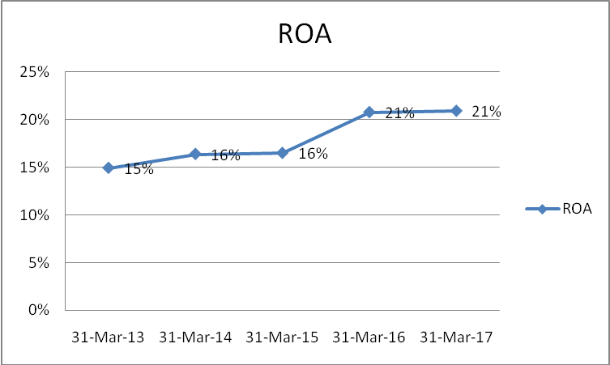
Interpretation: ROA tells us the profit that was generated against the invested capital. And ROA for Square Pharma goes same as its ROE. It’s slightly increasing every year. But for 2016 and 2017 it stood still at 21%. But still Square Pharma has a quite good ROA.

Fair Value Measurement

The Dividend Discount Model

Dividend Discount Model |  | Amounts are in Taka and in FULL AMOUNTS…
Item |  | 31/Dec/12 | 31/Dec/13 | 31/Dec/14 | 30/Jun/16 | 30/Jun/17
Cash Flow of Operation |  | 981,187,836 | 2,162,717,207 | 3,892,185,634 | 8,522,555,131 | 15,768,683,854
Cash Investment |  | 686,985,768 | 844,360,472 | 879,249,484 | 1,071,735,442 | 1,938,209,078
Free Cash Flow |  | 294,202,068 | 1,318,356,735 | 3,012,936,150 | 7,450,819,689 | 13,830,474,776
Discount Rate (1.09) |  | 1.09 | 1.1881 | 1.2950 | 1.4116 | 1.5386
Present Value of free Cash Flow |  | 269,910,154 | 1,109,634,488 | 2,326,539,522 | 5,278,348,511 | 8,988,859,644
Total Present value to 2017 | 17,973,292,319
Continuing Value (CV) |  |  |  |  |  | 363,049,962,870
Present Value of CV | 235,957,565,664
Enterprise Value | 253,930,857,982
Book Value of net debt | 12,278,005,956
Value of Equity | 49,040,374,351
Shares Outstanding | 685,945,200
Value Per Share | 71.49

Model to Equity

Model to Equity |  | Amounts are in Taka and in FULL AMOUNTS…
Item |  | 31/Dec/12 | 31/Dec/13 | 31/Dec/14 | 30/Jun/16 | 30/Jun/17
EPS |  | 8.74 | 10.26 | 10.8 | 13.41 | 15.51
Dividend |  | 51743548.67 | 86900977.26 | 131028327.2 | 310949487.2 | 384214840.7
DPS |  | 1.01 | 0.88 | 1.05 | 1.46 | 1.16
BPS | 68.03 | 60.43 | 45.99 | 49.48 | 51.58 | 56.84
ROCE |  | 7.92 | 8.21 | 7.86 | 8 | 10.32
RE(9% Charge) |  | 2.62 | 4.82 | 6.66 | 8.96 | 10.87
Discount Rate(1.09^t) |  | 1.090 | 1.188 | 1.295 | 1.412 | 1.539
Present Value of RE |  | 2.401 | 4.058 | 5.143 | 6.345 | 7.063
Present Value of RE to 2017 | 25.0111686
Value per share | 93

Chapter-4

Findings, Conclusion & Recommendations

Key Findings:
The study, Financial Statement Analysis and Performance Evaluation of Square Pharmaceuticals Limited, reveals the following majors findings:
- Square Pharmaceuticals Limited has an increasing current ratio. Which indicate that they are capable to meet their short term obligations with their current asset.
- Square Pharma’s current assets are greater than their Current liabilities. It indicates Square Pharma has great position to maintain their liquidity.
- Cash conversion cycle has decreased every year and was highly efficient in 2017. It took only 94 days to convert their asset into cash in that year which was the lowest amount of days in previous years.
- Square Pharma has an highly efficient inventory management.
- Square Pharma has effectively used it’s asset to generate sales over the years. From the latest year we see that he total asset turnover ratio was 70%.
- After 2015, the days sales outstanding has increased for Square Pharma. Meaning that they now need more time to collect the cash.
- Net profit margin of Square Pharma has increased by 10%. That means the portion of the revenue that has been translated into profit has been increased.
- They have maintained a good gross margin throughout the years. For 2017 the gross margin was 50%.
- Ability of Square Pharmaceuticals Limited to generate profits from its shareholders investment has increased over the time. Which make the company more attractive to the shareholders and prospective investors.
- Square Pharmaceuticals Limited has superior earnings per share which has increased sharply over the period. That means the company is more cost-effective and the company has more profits to give out to its shareholders comparing to other company.

Conclusion
Square Pharmaceuticals is a topnotch pharmaceutical company which had started their journey in 1955. It had been possible to lead the pharmaceuticals industry from 1985 and till now because of their wise business decision taken on right time. The study conducted here concentrated on the financial performance evaluation of Square Pharmaceuticals. And throughout the report we can see the reflection of their wise business tactics that has made them sustain in the leading position of Bangladesh Pharmaceutical industry for so long. One of the major benefits can be identified as having the most diversified product line to capture the largest market share. Moreover, they are the largest medicine exporter as well, exporting medicine to 36 countries. Square pharmaceutical alone comprise the one sixth portion of the total pharmaceutical industry in Bangladesh. That brings us to prognosticate that they are the player for long run and very much able to ensure their position in the top for upcoming years.

Appendix
Square Pharmaceuticals Ltd.
Statement of Financial Position
 | Amounts are in Taka and in FULL AMOUNTS…
 | 31/Mar/13 | 31/Mar/14 | 31/Mar/15 | 31/Mar/16 | 31/Mar/17
Property, Plant and Equipment | BDT 9,908,013,592 | BDT 13,933,689,469 | BDT 18,009,200,507 | BDT 18,848,282,139 | BDT 19,323,568,164
Investment - Long Term | BDT 157,694,430 | BDT 147,694,430 | BDT 251,599,097 | BDT 555,873,893 | BDT 588,808,565
Investment in Shares | BDT 686,985,768 | BDT 844,360,472 | BDT 879,249,484 | BDT 1,071,735,442 | BDT 1,938,209,078
Capital Work-in-Progress | BDT 4,907,039,756 | BDT 3,256,802,171 | BDT 207,629,864
Investment | BDT 4,914,958,933 | BDT 5,364,154,708 | BDT 6,036,139,963 | BDT 6,764,511,325 | BDT 7,504,636,420
Operating Expenses | BDT 30,616,969
Deferred Tax Assets |  |  | BDT 75,167,249
Total non-current assets | BDT 20,605,309,448 | BDT 23,546,701,250 | BDT 25,458,986,164 | BDT 27,240,402,799 | BDT 29,355,222,227
Inventories | BDT 3,091,263,712 | BDT 2,737,085,779 | BDT 3,310,086,668 | BDT 3,694,711,088 | BDT 3,730,808,243
trade debtors | BDT 812,741,029 | BDT 766,634,978 | BDT 894,543,303 | BDT 1,335,829,914 | BDT 2,204,014,900
Advances, Deposits and Prepayments | BDT 952,411,276 | BDT 671,749,541 | BDT 750,169,066 | BDT 1,131,340,560 | BDT 1,450,936,735
Loans, Advances and Deposits | BDT 1,108,757,914 | BDT 1,161,185,776
Short Term Loan |  |  | BDT 885,185,428 | BDT 2,378,929,958 | BDT 21,386,290
Cash and Cash Equivalents | BDT 981,187,836 | BDT 2,162,717,207 | BDT 3,892,185,634 | BDT 8,522,555,131 | BDT 15,768,683,854
Total Current Asset | BDT 6,946,361,767 | BDT 7,499,373,281 | BDT 9,732,170,099 | BDT 17,063,366,651 | BDT 23,175,830,022
Total Aseet | BDT 27,551,671,215 | BDT 31,046,074,531 | BDT 35,191,156,263 | BDT 44,303,769,450 | BDT 52,531,052,249
Issued Share Capital | BDT 3,707,686,640 | BDT 4,819,992,630 | BDT 5,542,991,520 | BDT 6,235,865,460 | BDT 6,859,452,000
Share Premium | BDT 2,035,465,000 | BDT 2,035,465,000 | BDT 2,035,465,000 | BDT 2,035,465,000 | BDT 2,035,465,000
Genaral Reserve | BDT 105,878,200 | BDT 105,878,200 | BDT 105,878,200 | BDT 105,878,200 | BDT 105,878,200
Tax Holiday Reserve | BDT 406,231,702 | BDT 406,231,702 |  | BDT 324,011,067 | BDT 852,508,043
Non Controlling Interest | BDT 7,719,551 | BDT 9,369,803 | BDT (1,669,864) | BDT 2,098,295 | BDT 12,674,141
 | BDT 6,262,981,093 | BDT 7,376,937,335 | BDT 7,682,664,856 | BDT 8,703,318,022 | BDT 9,865,977,384
Retained Earnings | BDT 16,017,431,580 | BDT 18,922,758,840 | BDT 23,143,634,751 | BDT 31,587,049,056 | BDT 38,577,835,254
Fair Value gain or surplus | BDT 313,532,224 | BDT 449,255,557 | BDT 265,332,813 | BDT 266,786,579 | BDT 596,561,713
Total Proffered Equity | BDT 16,330,963,804 | BDT 19,372,014,397 | BDT 23,408,967,564 | BDT 31,853,835,635 | BDT 39,174,396,967
Total Equity | BDT 22,593,944,897 | BDT 26,748,951,732 | BDT 31,091,632,420 | BDT 40,557,153,657 | BDT 49,040,374,351
Deferred Tax Liability | BDT 575,991,702 | BDT 718,957,750 | BDT 891,357,959 | BDT 1,054,498,262 | BDT 1,129,233,846
Trade Creditors | BDT 7,034,724 | BDT 217,855,755 | BDT 254,773,030 | BDT 693,982,698 | BDT 843,937,277
Short Term Borrowings | BDT 1,302,048,378 | BDT 131,104,817 |  | BDT 2,693,932
Total Current Liabilities | BDT 1,885,074,804 | BDT 1,067,918,322 | BDT 1,146,130,989 | BDT 1,751,174,892 | BDT 1,973,171,123
Long Term Borrowings | BDT 1,106,327,183 | BDT 1,183,627,923 | BDT 659,147,818
Long Term Borrowings | BDT 540,421,336 | BDT 461,433,822 | BDT 257,154,669
Liabilities for expenses | BDT 173,261,777 | BDT 20,518,598 | BDT 43,002,246 | BDT 42,871,218 | BDT 27,576,542
Liabilities for Other Finance | BDT 1,252,641,218 | BDT 1,563,624,134 | BDT 1,994,088,121 | BDT 1,952,569,683 | BDT 1,489,930,233
Total non-current liabilities | BDT 3,072,651,514 | BDT 3,229,204,477 | BDT 2,953,392,854 | BDT 1,995,440,901 | BDT 1,517,506,775
Total liabilities | BDT 4,957,726,318 | BDT 4,297,122,799 | BDT 4,099,523,843 | BDT 3,746,615,793 | BDT 3,490,677,898
Total Equity and Liabilities | BDT 27,551,671,215 | BDT 31,046,074,531 | BDT 35,191,156,263 | BDT 44,303,769,450 | BDT 52,531,052,249

Square Pharmaceuticals Ltd.
Statement of Profit or Loss
 | Amounts are in Taka and in FULL AMOUNTS…
 | 31/Mar/13 | 31/Mar/14 | 31/Mar/15 | 31/Mar/16 | 31/Mar/17
Revenue | BDT 20,202,005,922 | BDT 23,268,413,217 | BDT 26,684,573,116 | BDT 33,073,760,572 | BDT 36,543,140,106
Total revenue | BDT 20,202,005,922 | BDT 23,268,413,217 | BDT 26,684,573,116 | BDT 33,073,760,572 | BDT 36,543,140,106
Cost of Goods Sold | BDT 11,308,857,708 | BDT 12,960,738,683 | BDT 14,942,870,155 | BDT 17,082,336,657 | BDT 18,274,858,914
Total cost of sales | BDT 11,308,857,708 | BDT 12,960,738,683 | BDT 14,942,870,155 | BDT 17,082,336,657 | BDT 18,274,858,914
Gross Profit | BDT 8,893,148,214 | BDT 10,307,674,534 | BDT 11,741,702,961 | BDT 15,991,423,915 | BDT 18,268,281,192
Other Income | BDT 377,846,808 | BDT 245,133,874 | BDT 293,730,506 | BDT 657,143,316 | BDT 1,093,575,634
Total Other Income | BDT 377,846,808 | BDT 245,133,874 | BDT 293,730,506 | BDT 657,143,316 | BDT 1,093,575,634
Administrative Expenses | BDT 738,507,999 | BDT 730,951,152 | BDT 775,638,213 | BDT 845,013,243 | BDT 915,210,284
Selling, Marketing and Distribution Expenses | BDT 2,955,935,819 | BDT 3,431,938,716 | BDT 3,757,838,863 | BDT 4,349,841,995 | BDT 5,056,851,926
Total | BDT 3,694,443,818 | BDT 4,162,889,868 | BDT 4,533,477,076 | BDT 5,194,855,238 | BDT 5,972,062,210
Contribution to WPPF | BDT 246,729,864 | BDT 300,438,842 | BDT 379,795,062 | BDT 545,162,482 | BDT 646,577,651
Total Operating Expense | BDT 246,729,864 | BDT 300,438,842 | BDT 379,795,062 | BDT 545,162,482 | BDT 646,577,651
Operating Profit | BDT 5,329,821,340 | BDT 6,089,479,698 | BDT 7,122,161,329 | BDT 10,908,549,511 | BDT 12,743,216,965
Financial Expenses | BDT 357,151,743 | BDT 177,131,396 | BDT 158,614,307 | BDT 5,299,871 | BDT 154,389
Total Finance Cost | BDT 357,151,743 | BDT 177,131,396 | BDT 158,614,307 | BDT 5,299,871 | BDT 154,389
Profit/(Loss) from Associate Undertakings | BDT 575,807,315 | BDT 695,624,299 | BDT 795,199,468 | BDT 916,314,929 | BDT 928,615,539
Profit Before Tax | BDT 5,548,476,912 | BDT 6,607,972,601 | BDT 7,758,746,490 | BDT 11,819,564,569 | BDT 13,671,678,115
Provision for income tax | BDT 1,237,851,545 | BDT 1,518,801,391 | BDT 1,679,877,193 | BDT 2,389,605,742 | BDT 2,949,150,787
Provision for Deferred Income Tax | BDT 96,820,479 | BDT 142,966,048 | BDT 172,400,209 | BDT 227,100,343 | BDT 74,735,584
Deferred Tax Assets |  |  | BDT 75,167,249
Profit After Tax | BDT 4,213,804,888 | BDT 4,946,205,162 | BDT 5,981,636,337 | BDT 9,202,858,484 | BDT 10,647,791,744
Fair value Gain/Loss | BDT (107,174,041) | BDT 135,723,333 | BDT (183,922,744) | BDT (3,169,514) | BDT 329,775,134
Total comprehensive income | BDT 4,106,630,847 | BDT 5,081,928,495 | BDT 5,797,713,593 | BDT 9,199,688,970 | BDT 10,977,566,878

References
https://www.squarepharma.com.bd/
https://www.squarepharma.com.bd/mission-vision.php
https://en.wikipedia.org/wiki/Square_Pharma
https://www.stockopedia.com/share-prices/Square-pharmaceuticals-LON:BXP/
Stephen H. Penman, “Financial Statement Analysis”
https://www.investopedia.com
http://www.squarepharma.com.bd/annual-reports.php
https://www.dsebd.org/
https://www.dsebd.org/displayCompany.php?name=SQURPHARMA
http://lankabd.com/dse/stock-market/SQURPHARMA/square-pharmaceuticals-limited/stock-price?stockId=150
http://www.pharmatips.in/Articles/Pharma-Companies/Top-Pharmaceutical-Companies-In-Bangladesh.aspx

