
Internship Report on
Training & Development Process of Standard Bank Limited

Submitted To
Ishrat Sultana
Assistant Professor
School of Business & Economics
United International University

Summited By:
Farhana Islam
Student ID: 111 142 180
United International University

Date of Submission:
18th June, 2023
Letter of Transmittal

To
Ishrat Sultana
Assistant Professor
School of Business & Economics
United International University

Subject: Submission of Internship Report on “Training & Development of Standard Bank Limited”

Dear Madam,
It gives me immense pleasure to submit the report, which was assigned to as particular fulfillment of the requirement for the degree of Bachelor of Business Administration (BBA) from United International University. I have tried my level best to fulfill the requirement of this report. I would like to mention here that I am extremely grateful to you for your valuable guidance, endless effort and constant attention as and when required.
I hope that you would be kind enough to evaluate my performance with respect to the depth and quality of this report. If you desire, I shall be glad to provide any clarification and explanation regarding this report.

Sincerely yours,

___________________
Farhana Islam
Student ID: 111 142 180
United International University

Student’s Declaration

I do hereby solemnly declare that the dissertation titled “Training & Development of Standard Bank Limited” has been prepared by me and has not been previously submitted to any other University/ College/ Organization for an academic qualification/ certificate/ diploma degree.

The work, submitted by me, is not copied from any established sources. It also does not breach any existing copyright law.

--------------------------------------
Farhana Islam
Student ID: 111 142 180
United International University

Certificate of Supervisor

This is to certify that the thesis entitled, “Training & Development of Standard Bank Limited” submitted to the Human Research Management, United International University, in partial fulfillment of the requirements for the degree of Bachelor of Business Administration in Human Research Management by Farhana Islam, Student ID: 111 142 180 under my supervision and guidance. No part of the thesis has been submitted for any other degree or diploma.

Acknowledgement

At first all my gratitude will go to almighty god for giving me the capability for completing this internship report. My special indebtedness is to honorable instructor of Ishrat Sultana, Assistant Professor, School of Business & Economics, United International University for guiding me in the process of knowledge and technique in carrying out study “Training & Development of Standard Bank Limited”. She always gave me important and crucial suggestions to make the paper as flawless as possible the authors of internship report,

I would like to thank authority for providing me the most relevant information depending on which I have prepared this internship report. My special thanks will also go for a large number of my colleagues who have made me comfortable with the new environment in a professional working place and contributed directly in this report with their help and encouragement.
Finally, I would like to express my gratitude to all my fellows for their friendly and cordial cooperation during my internship report in “Training & Development of Standard Bank Limited”.

Abstract

This report on "Training & Development of Standard Bank Limited" illustrates the general function of HR managers at a bank and how they carry out their responsibilities. A recognizable collection of tasks are carried out by human resource managers that have an impact and influence on the workforce. Training and development, human resource planning, job analysis, recruiting, selection, and placement are some of these tasks. The HR department engages with a wide range of constituents because it supports the organization. Human resources management involves providing practical managers with a thorough examination of key people management principles and procedures in a highly accessible and comprehendible format. The Chapter one details on the Background of the study, Objective of the, Methodology of the study, Scope of the study and Limitations of the study. Chapter Two one the Literature Review. Chapter Three are Company Profile of Standard Bank Limited. Chapter Four are the Training and Development Process Standard Bank Limited SBL. Chapter Five are discussions on the data analysis and Chapter six on the some recommendations and Conclusion.

Table of Contents
Title Page No.
Chapter 1 – Introduction 1
1.1 Background of the study 2
1.2 Objective of the study 2
1.3 Methodology of the study 2
1.4 Scope of the study 3
1.5 Limitations of the study 3

Chapter 2 – Literature review 4
2.1 General Concept of HRM 5
2.1.1 Training and Development 5
2.2 Objectives of HRM 5
2.3 Basic Principles of HRM 6
2.4 Approach of HRM 6
2.5 Standard Organ gram of HR Department in a large organization 6

Chapter 3- Company Profile of Standard Bank Limited (SBL) 8
3.1 Historical Background of Standard Bank Limited 9
3.2 Vision 9
3.3 Mission 9
3.4 Objectives of the Bank 9
3.5 Standard Bank Ltd (SBL) Highlights 2022 11
3.6 Global Economy 13
3.7 Five Years Finical Highlights Standard Bank Ltd 2018-2022 17
3.8 Graphical Presentation of Standard Bank Ltd 20218-2022 20

Chapter 4 Training and Development Process Standard Bank Limited SBL22
4.1 HR planning Practices in Standard Bank Ltd 23
4.2 Recruitment & Selection Standard Bank Ltd 23
4.3 Selection 24
4.4 Recruitment and Selection Practices of Standard Bank Ltd. 26
4.5 Socialization and Orientation 27
4.6 Training and Development 27
4.7 Training & Development Practices in the Standard Bank 28
4.8 Performance Appraisal 30
4.9 Performance Appraisal Practice in the Standard Bank 31

Chapter 5 Data Analysis 33
5.1 Data Analysis 34-49
5.2 Findings of the Study 50

Chapter- 6 Conclusion 51
6.1 Recommendations 52
6.2 Conclusion 53

Bibliography 54

Annexure 55-56

Chapter 1– Introduction

1.1 Background of the study
Without a question, the workplace is undergoing fast change. Therefore, HRM must be equipped to cope with the consequences of the evolving workplace as a component of a company. This requires them to comprehend the effects of globalization, technological advancements, workforce diversity, shifting skill demands, programs, contingent labor, and dispersed participation. We should consider how these modifications are impacting HRM objectives and procedures. Integrating human resource initiatives with strategic company goals is HRM's current problem. Organizations face intense global competition pressure on a constant basis. To tackle this issue, HR managers must discover strategies to create efficient programs. Utilizing human resources to their fullest potential will help HRM guarantee that initiatives and policies are cost-effective.

1.2 Objective of the study
- To get knowledgeable about training and development processes in the Standard Bank Ltd.
- To gain real experience in a HRM procedure in the Standard Bank Ltd.;
- To provide suggestions for improving Standard Bank Limited's current training and development processes.

1.3 Methodology of the study
Direct observation, in-person conversations with the appropriate bank executive, the examination of files, circulars, etc., and practical work are all part of the methodology. This report was created using solely primary data used. The following sources have been used to get the necessary information:
- bank's employee service log;
- bank's yearly report;
- many publications about banking operations;

1.4 Scope of the study
Only Standard Bank Limited's training, development, and human resource policies are included in this study. It focuses on an overview of the bank and compares its current banking operations to the conventional theoretical aspects of training and development. The research also looks at how bank workers feel about their growth and benefit policies.

1.5 Limitations of the study
Despite the bank staff' sincere help, I encountered several difficulties when putting the report together. The following are the main restrictions:
It was really difficult to learn about general HRM practices in the banking industry in just three months.
The bank's strategy of withholding some statistics and information for clear reasons, which may be highly helpful, is another drawback of this report.

Chapter 2– Literature review
2.1 General Concept of HRM
Designing formal systems inside an organization to guarantee the effective and efficient use of human potential to achieve organizational goals is what HRM is all about.
The term "human resource management" (HRM) refers to the principles, rules, and techniques used to manage people within a company. Managers recruit, select, train, and develop company members using HR management functions. HRM is the methodical design, development, and management of a web of interconnected activities that touch and include every employee in a business.
- HR planning & forecasting
- Job & work design
- Staffing / recruitment & selection
- Training & development
- Performance appraisal & review

2.1.1 Training and Development:
Training is the formal procedure which a company uses to facilitate employee’s learning so that their resultant behavior contributes to the attainment of the company’s goals and objectives. (Mc Gehee & Thayer, 1964).
According to the Michel Armstrong, “Training is systematic development of the knowledge, skills and attitudes required by an individual to perform adequately a given task or job”. (Source: A Handbook of Human Resource Management Practice, Kogan Page, 8th Ed., 2001)

2.2 Objectives of HRM
The objectives of HRM can be described as follows-
- To hire the right person for the job
- To remove unfair labor practices
- To maintain a high morale & better human relations inside the organization
- To maintain organizational peace
- To attract competent people and retain them in the organization

2.3 Basic Principles of HRM
- Treat people with respect and dignity;
- Treat people as adults;
- Deal with people as complete individuals;
- Treat all employees with justice;
- Provide people with opportunities for growth and development;
- Make people feel that they are most valuable asset for the organization;
- Rewards should be earned, not given;
- Not to underestimate the potentials of people;

2.4 Approach of HRM
Strategic approach
People are the strategic asset of an organization. People have core competency, the basis of competitive advantage.
Human resource approach
People are human beings with a lot of potentials and intellectual abilities.
Commodity approach
People are commodity. They are viewed as a cog of a machine.
Proactive approach
Anticipate challenge of problem before they arise. Preventive is better than curative.

2.5 Standard Organ gram of HR Department in a large organization
A crucial role in the planning and oversight of the human resources system will be played by the personnel director and his or her team in businesses big enough to have an HR or personnel department. HR system design and implementation assistance is more likely to come from larger businesses. When businesses employ around 100 people, a full-time expert typically emerges. The following diagram illustrates a typical HR department organization in a major corporation with several thousand employees:

Figure: 2.1 Structure of HR organization in Large Business
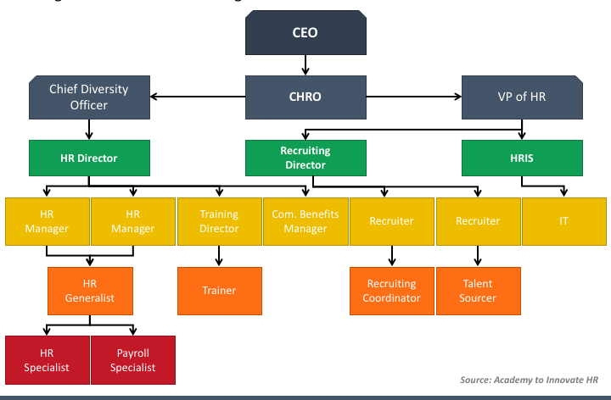
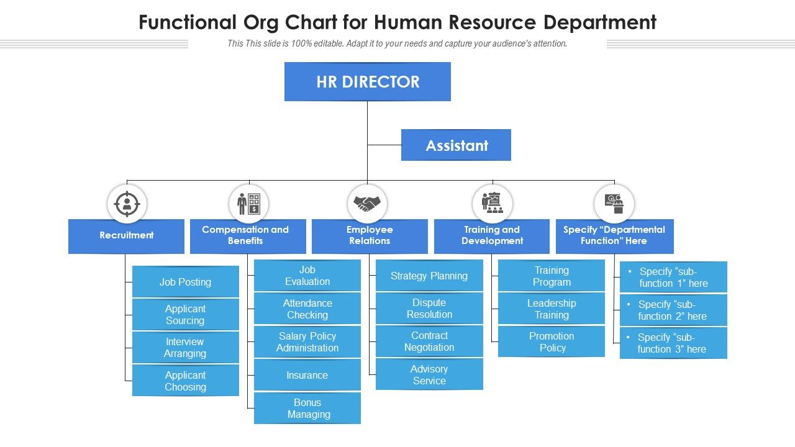
Sources: Human Resource Management

Chapter 3- Company Profile of Standard Bank Limited (SBL)

3.1 Historical Background of Standard Bank Limited
The Companies Act of 1994 was used to incorporate Standard Bank Limited (SBL) as a public limited company on May 11, 1999. On June 3, 1999, the Bank's commercial activities made sufficient progress. SBL has released a number of new credit and deposit program products. The same is true of corporate and retail banking, for example. Along with other banks, the Bank took part in fund syndication. Through all of these varied operations, SBL has influenced the market favorably.

3.2 Vision
To be a modern Bank having the object of building a sound national economy and to contribute significantly to the Public Exchequer.

3.3 Mission
To be the best private commercial bank in Bangladesh in terms of efficiency, capital adequacy, asset quality, sound management and profitability.

3.4 Objectives of the Bank
The Standard Bank Ltd.'s mission statement is to explore a new horizon of inventive contemporary banking, develop an automated and computerized environment that offers one-stop service, and become ready to confront the new challenges of the 21st century and globalization. One of the key goals of the Bank is to draw in new customers by offering high-quality goods and services.

Figure: 3.1 The Hierarchy (organ gram) of Management of the Bank
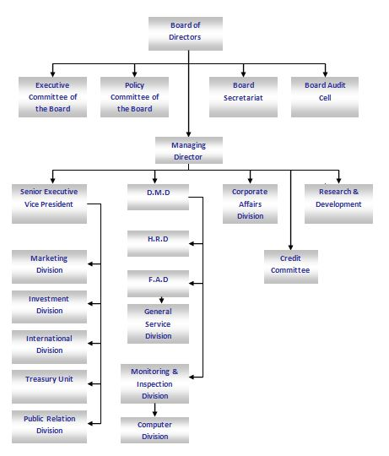
Sources: internet
About Management of the Bank –
The Management team of the Bank consists of highly motivated, well-educated and highly skilled and dynamic executives who have been contributing significantly in the bank's ongoing development and expansion. One of the top bankers who has distinguished expertise and excellent performance is managing director of the bank. He has 35 years of banking experience, and his coworkers and clients know him as an inventive, effective, and all-around banker.
3.5 Standard Bank Ltd (SBL) Highlights 2022
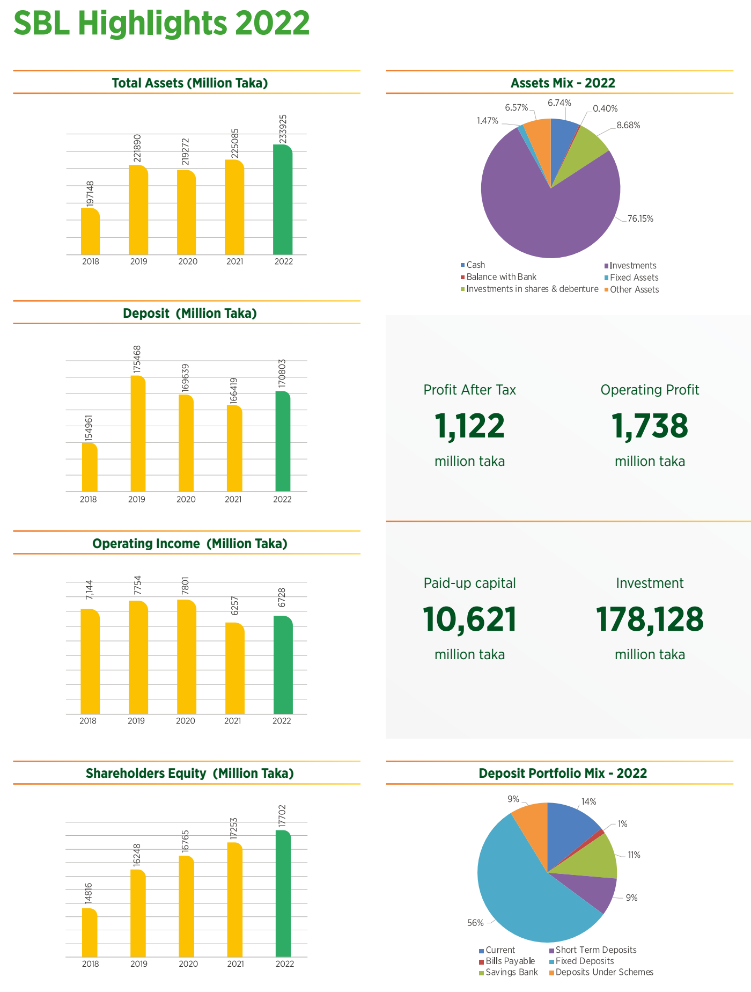
(Sources Anual Report SBL 2022)

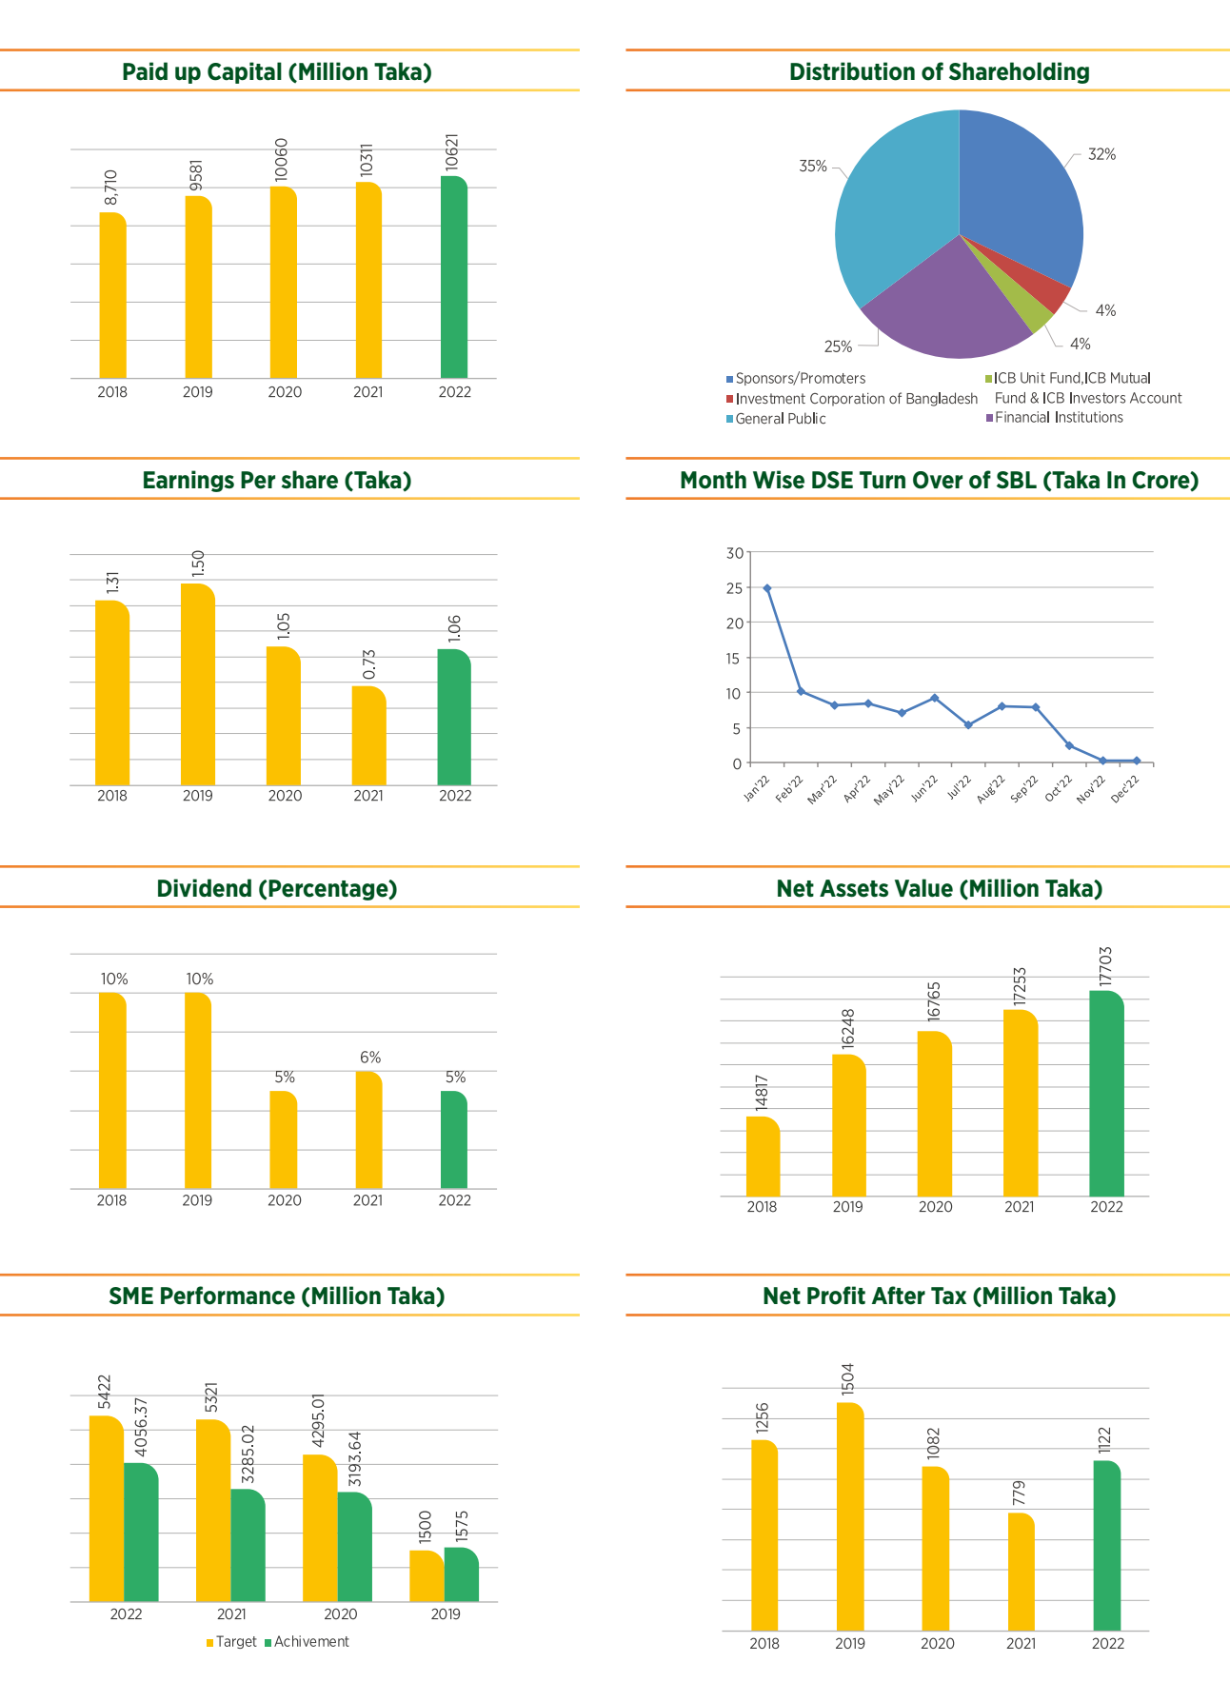
(Sources Anual Report SBL 2022)

3.6 Global Economy
Although the COVID-19 epidemic had left the world economy in a robust recovery, the conflict in Ukraine delayed the process. We are seeing an increase in global commodity prices and a slowdown in economic growth as a result of supply chain disruption brought on by conflict. International groups updated their predictions for inflation and economic development prospects.
Figure: 3.2 Global Growth under different scenarios
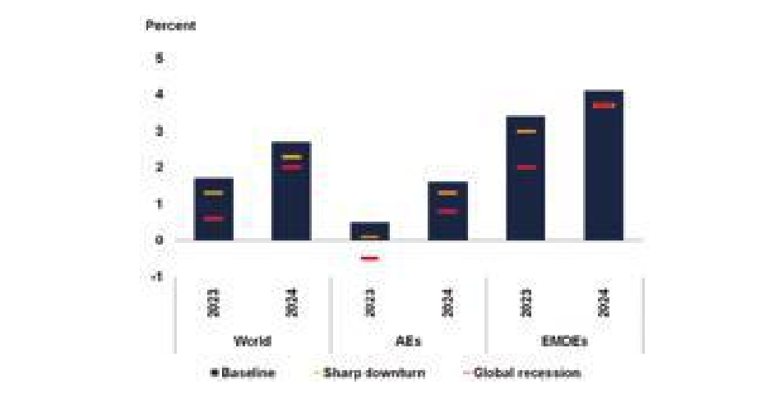The world economy expanded by 5.5 percent in 2021, the greatest growth rate since 1976, according to the United Nations (UN) book "World Economic Situation and Prospect 2022," following a contraction of 3.4 percent in 2020. In 2022 and 2023, respectively, the world economy is projected to increase by 4.0 percent and 3.5 percent.

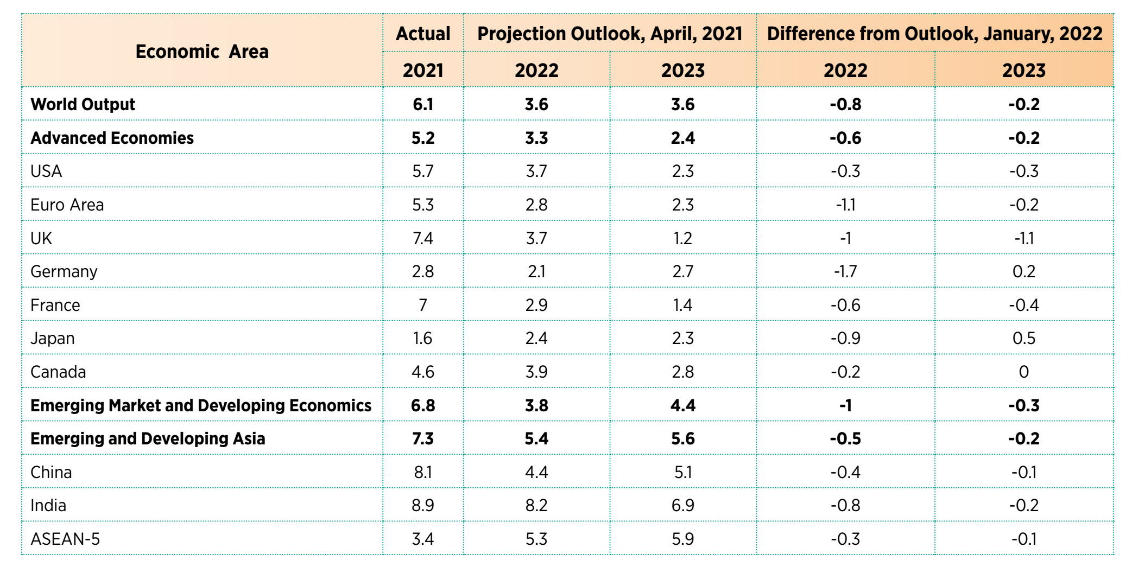
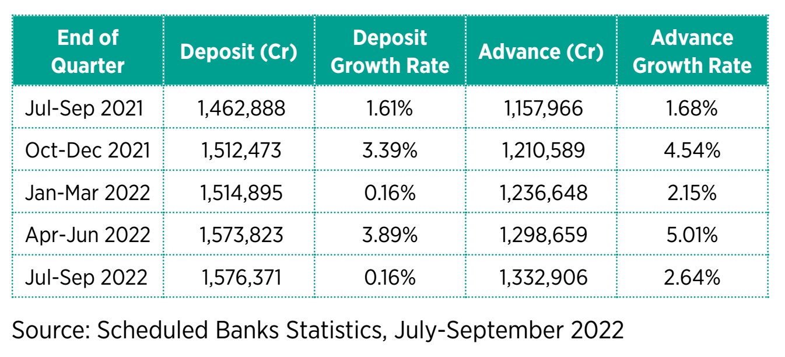
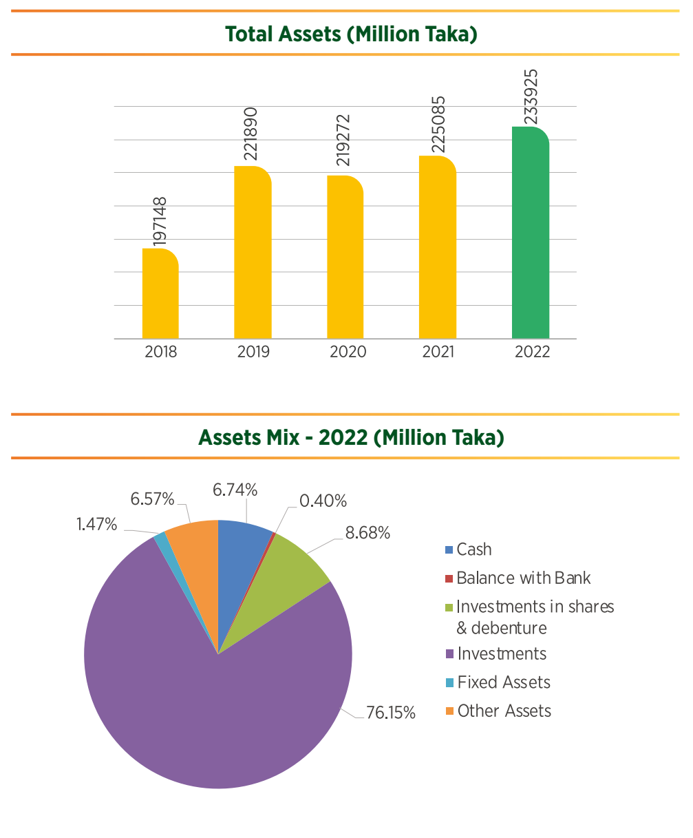
(Sources Anual Report SBL 2022)

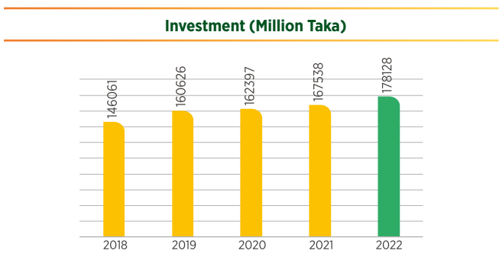
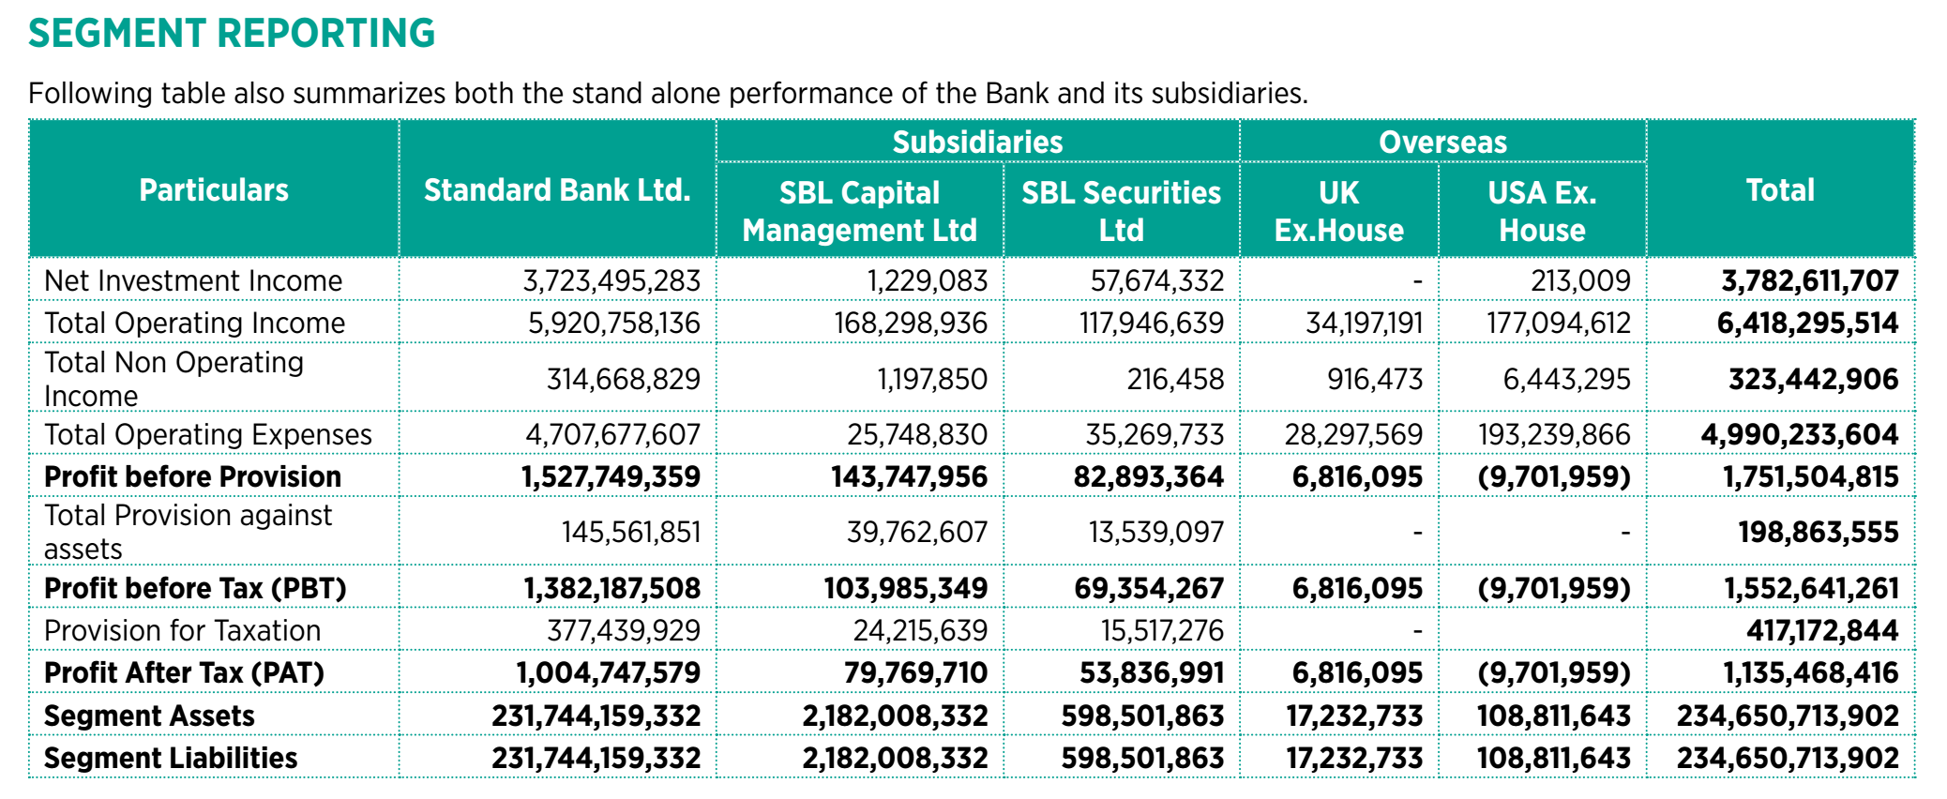
(Sources Anual Report SBL 2022)

3.7 Five Years Finical Highlights Standard Bank Ltd 2018-2022
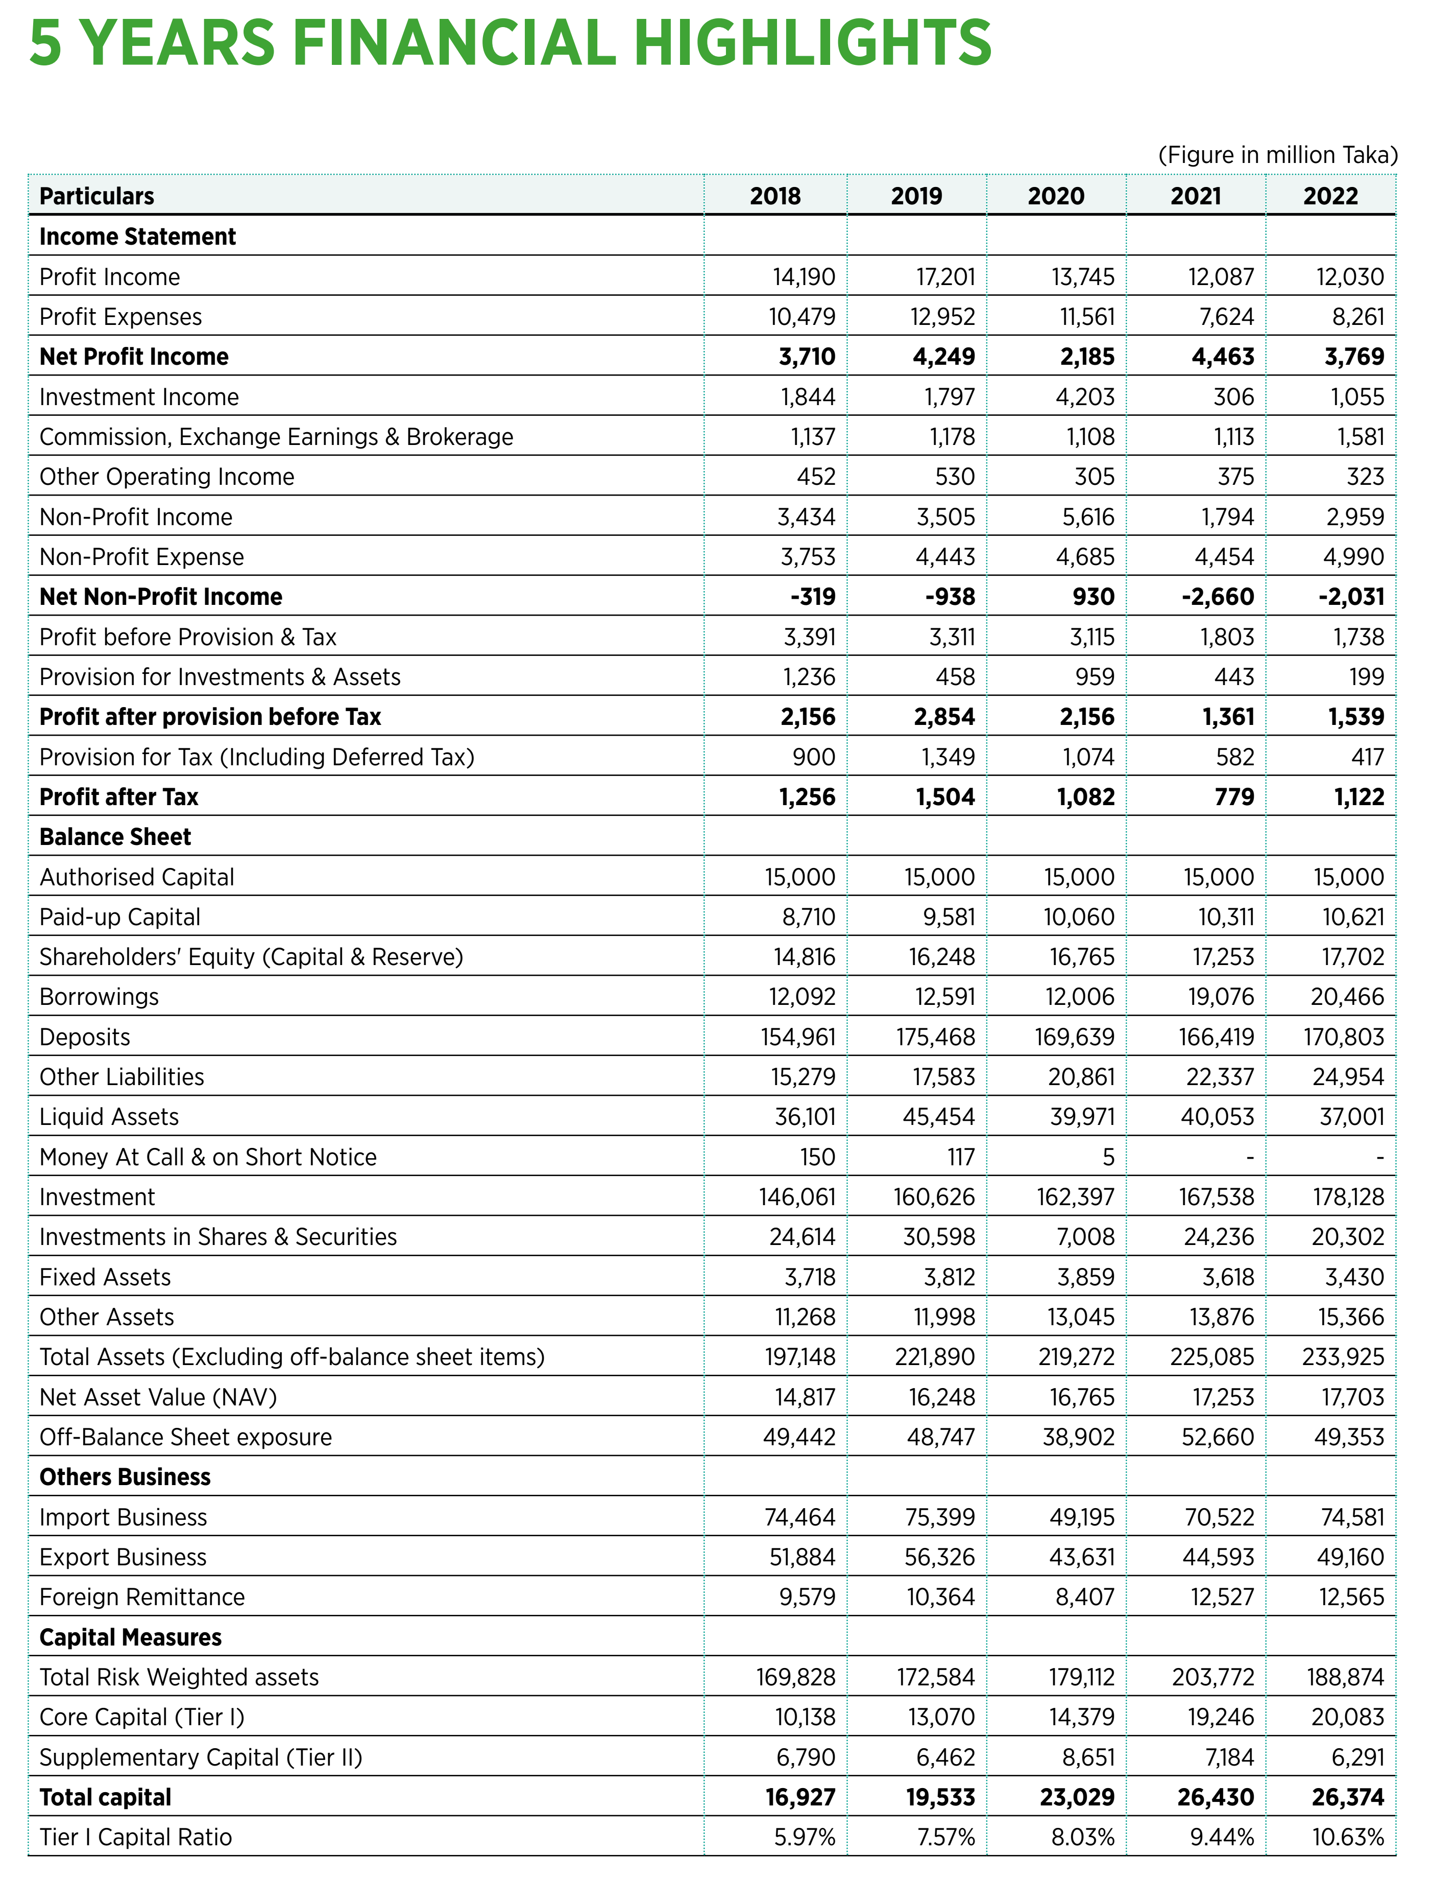
(Sources Anual Report SBL 2022)

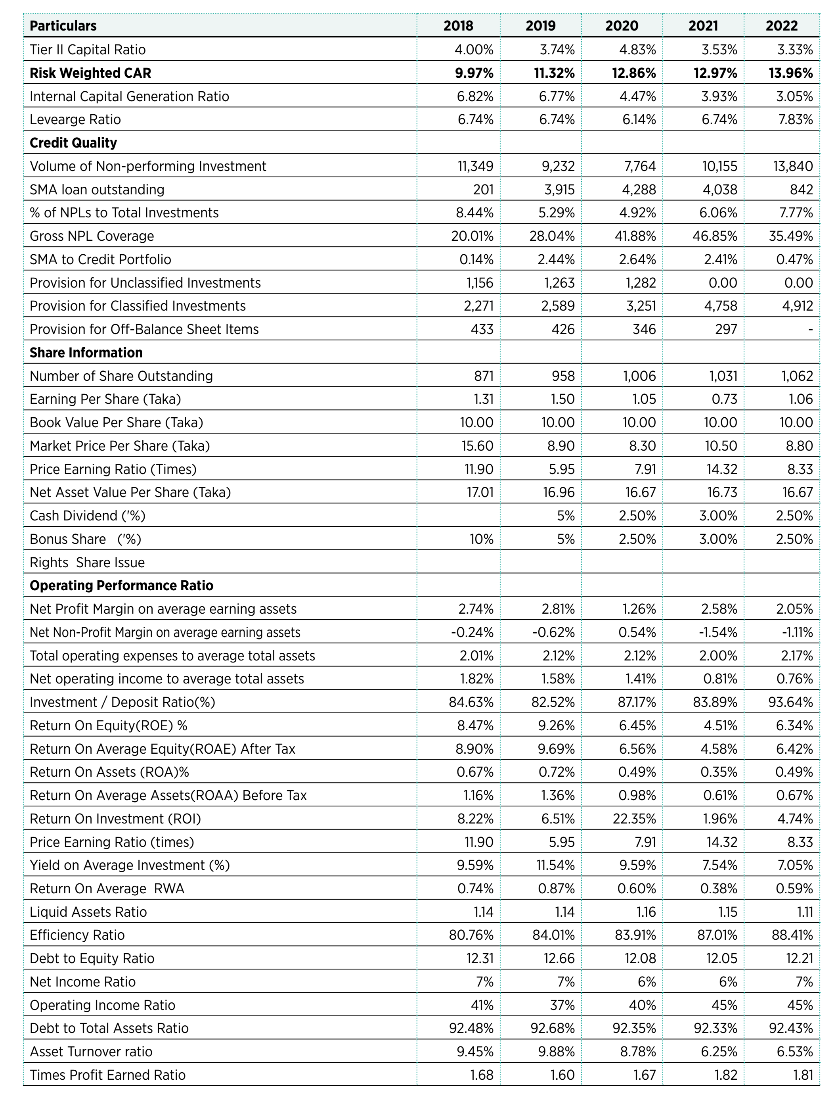
(Sources Anual Report SBL 2022)

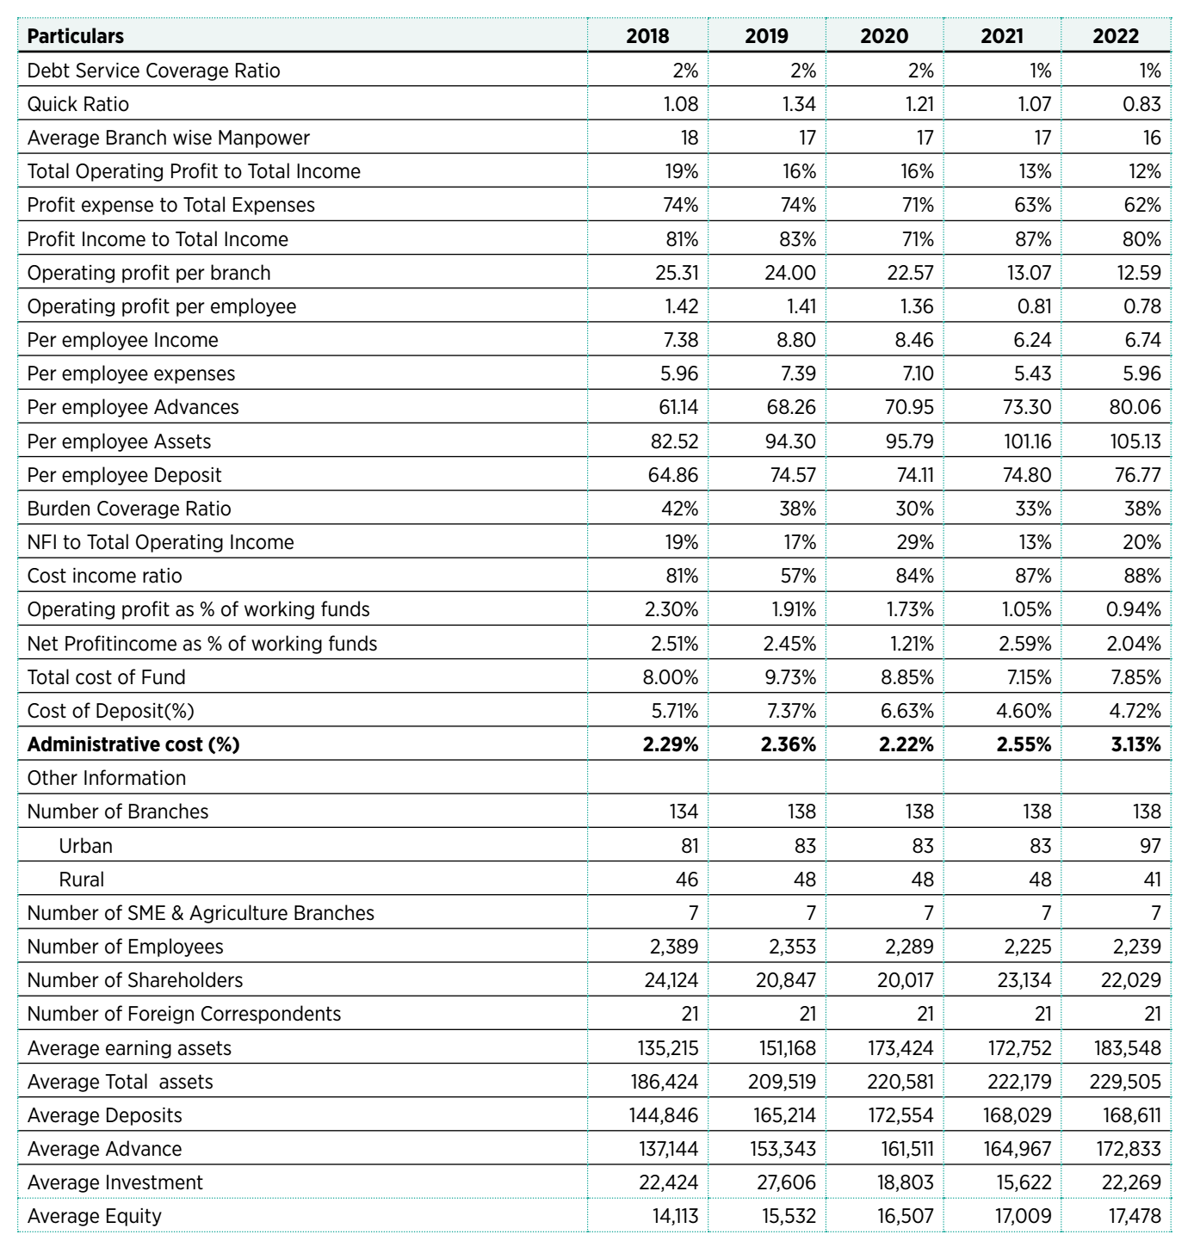
(Sources Anual Report SBL 2022)

3.8 Graphical Presentation of Standard Bank Ltd 20218-2022
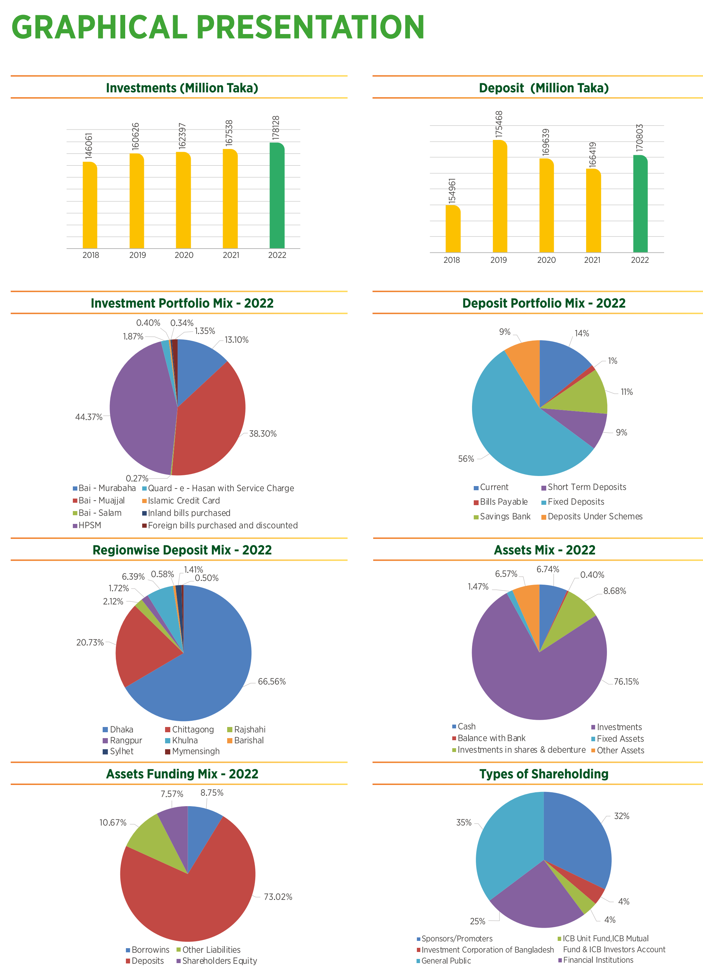
(Sources Anual Report SBL 2022)

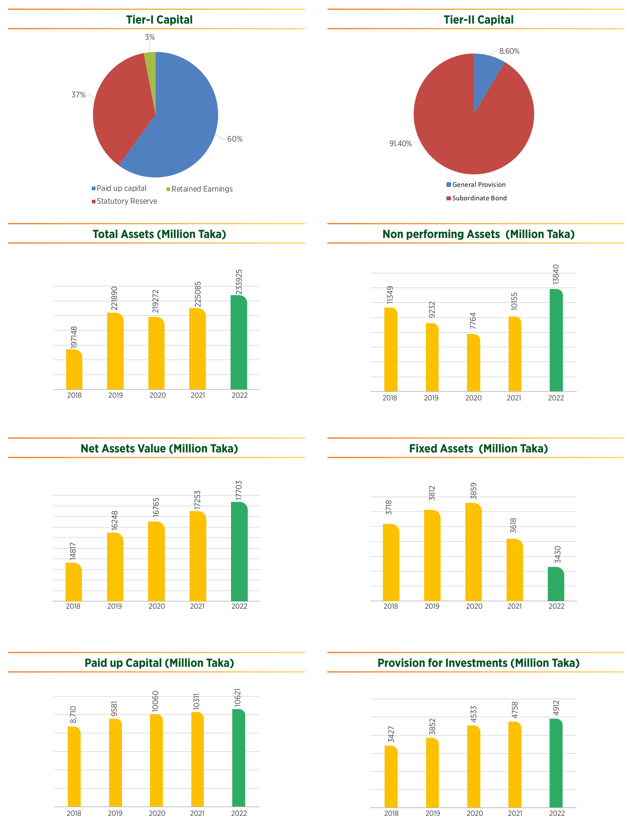
(Sources Anual Report SBL 2022)

Chapter 4- Training and Development Process of Standard Bank Limited

4.1 HR planning Practices in Standard Bank Ltd
The bank adheres to the majority of HR planning procedures, including integrating HR planning with business planning and evaluating internal HR capabilities. They use ratio analysis rather than trend analysis and scatter plots to predict future HR requirements.

Steps of HR planning
Human planning process begins with considering objectives and strategies.

<> Integrating HR planning with corporate planning is the first level of typical HR planning. All human resource planning is derived from business strategies in light of corporate strategies.
<> Forecasting or evaluating elements that influence the is the second stage of the HR planning process. Government impacts, economic, geographic, and competitive situations, technical considerations, labor diversity, management philosophies, and work patterns are some of the most important environmental elements. HR forecasting may currently be done using a variety of methods. Committee board, expert opinion, trend analysis, regression analysis, and correlation analysis are a few of the crucial ones.
<> The creation and examination of the internal inventory of HR skills comes next. HR planning calls for an assessment of present positions and personnel competencies as well as an inventory of organizational capabilities in order to assess internal strengths and shortcomings.

4.2 Recruitment & Selection Standard Bank Ltd
Concept of Recruiting & Selection
Finding possible applicants for current or future organizational openings is the process of recruiting. It entails looking for and finding qualified employment candidates. Finding eligible candidates and encouraging them to submit job applications is the process of recruitment. Selection, on the other hand, is the process of making a decision from those who do apply. The challenge of selecting the finest candidates for certain roles falls to the business after an efficient recruitment effort has produced a sufficient applicant pool.
One of the most important jobs every business must do is the hiring process—putting the right people in the right places at the right times. The company makes an effort to "Sell" itself to the more qualified applicants during the hiring process in order to persuade them that it is a great place to work. The typical hiring procedure for a big company is --
Vacant of new position occurs
Perform job analysis and plan recruitment effort
Generate potential applicant pool

Figure: The Recruiting and selection Process

Job Analysis
A comprehensive examination of the tasks involved in a job is known as a job analysis. It is a technological process used to specify a job's tasks, obligations, and accountabilities. In order to properly and precisely determine the needed activities, the knowledge and abilities required to do them, and the circumstances under which they must be completed, this analysis entails recognizing and describing what is happening on the job.
4.3 Selection
Selecting the best candidates for a position is the process of selection. The basic aim of selection is to find the ideal candidate for the position. A decision-making process is selection. The following steps are included in a well-designed selection process:
- Initial evaluation
- A written test, part two
- A thorough interview;
- A background check or examination, if necessary;
- A medical and physical examination; and
- An offer of a permanent position.

Figure: 3.3 Foundations of Selection
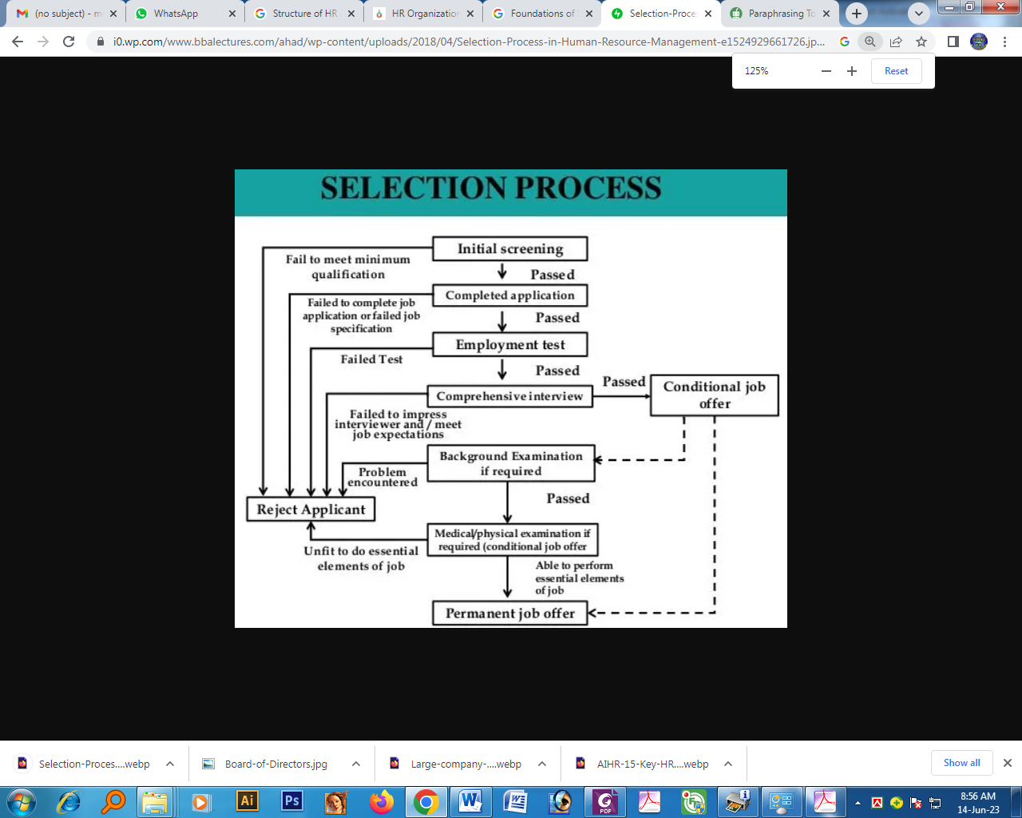

Source: Internet
(1) Initial Screening: After the hiring process is complete, HRM begins the selection process. The initial stage of the selection process is screening. The Human Resources department begins its initial screening after receiving applicants who responded. They are prepared to start an initial review of prospectively qualified applicants. After a successful hiring process, the HRM department is faced with a large pool of candidates.
Some of these replies can be removed
(2) The thorough interview: Those candidates who make it beyond the preliminary screening are subjected to the thorough interview exam, which includes questions about motivation, resilience under pressure, and "fitting in" with the bank. However, it must be work-related information.
(3) Background check: This stage of the hiring process involves looking into the candidates' backgrounds to see if they have potential to be workers. The purpose of the background investigation form is to identify if the candidates misrepresenting their educational or working history.
(4) Medical and physical examination: According to HRM, these tests show if a candidate is physically capable of performing the essential duties of the position. Before making an offer of employment, HRM requires candidates to have a medical clearance. According to HRM, a medical clearance is necessary to confirm that the candidate is physically capable of performing the essential job function.
(5) Job Offer: Those who successfully complete the previous steps are now thought to be qualified to get. Final employment offer is made by the HRM department. The manager of the department and branch where the opening is located really makes the hiring choice.

4.4 Recruitment and Selection Practices of Standard Bank Ltd.
Selection and recruitment are crucial components of SB's HR success. The HRD at SB adheres to a certain recruitment and selection process. The following
- After employees retire, get fired, or quit their jobs, vacant positions develop.
- Find the vacant job among the 40 branches.
- The board is then presented with a proposal to fill the vacant position.
- After receiving board approval, HRD publishes an advertisement in a national publication inviting applicants to apply for a vacant position.
- The application is then shortened from its entirety.
- After that, a test card will be issued.
- After the written test, give the people who passed the written test a new card for the interview.
- Applications are appointed for a one-year probationary period after passing the viva.
- They are appointed as permanent employees after a year.

Recruitment Objectives of the Bank:
i) To develop a joyful, deserving cadre of officers.
ii) To give the bank a human resources system that is effective and affordable.
iii) To prevent harmful trade union practices from entering the bank.

4.5 Socialization and Orientation
Socialization is a process of adaptation that happens when people try to understand the standards and values of occupational roles.
Employee orientation is a process used to provide new hires a general overview of the company. The focus of orientation programs is shifting away from a discussion of corporate policies and toward the mission of the organization and the employee's contribution to that objective.

4.6 Training and Development
Concept of Training & Development: Training is a planned organization effort to assist employees in acquiring information and skills necessary for their jobs in order to enhance performance. Giving new hires the fundamental skills they need to do their jobs is known as training. Training is viewed as a learning process that aims to make people more adaptable so they can perform better at work. The training department is now often referred to as HR development. More future-oriented. Therefore, development places greater emphasis on the individual's development.

Determining Training needs:
With a clearer knowledge of what training is, we can consider a more important issue for businesses. In other words, how does a company decide whether or not it needs training? We suggest that HRM can ascertain this by using the following procedure:
Figure: 3.4 Five steps of Training and Development process:
The training programs consist of five steps.
Need analysis
Instructional design
Validation
Implement the program
Evaluation

Sources: H R Management (David A Decenzo . 7th edition)
i) Needs assessment
The process of training begins with a needs analysis. It pinpoints the precise work performance capabilities required, evaluates the abilities of potential trainees, and creates quantifiable knowledge and performance targets based on any shortcomings.
ii) Instructional design
Individuals choose, gather, and create the training program content, including workbooks and activities, in the second part of instruction design.
iii) Validation
The third phase, known as validation, involves showing the training software to a small, representative audience in order to iron out any flaws.
(iv) Put the program into action
The program's actual implementation, which involves instructing the targeted employee group, is the fourth phase.
(v) Assessment
The management evaluates the programs' accomplishments or failures in the fifth stage.

4.7 Training & Development Practices in the Standard Bank
The Standard Bank has made the decision to train its staff and has determined their goals and training requirements; now the business must create an effective training program. On-the-job training and off-the-job training are the two categories in which firms apply the most common training and development techniques.
On-the-Job Training:
On-the-job training is one of the most popular training techniques. This technique's success can be ascribed to its. Employees receive instruction while they are really working, giving the impression that they are productive right away. It is experiential learning.
Of-the- classroom lectures, videos, and films.
i) In-class discussion lectures intended to teach Standard Bank employees specialized interpersonal, technical, or problem-solving abilities.
ii) Training through a simulation exercise where the task is actually done. Role-playing, case analysis, and group decision-making are a few examples of this.
iii) Computer-based instruction
Programming a computer to replicate some of the practical aspects of a profession in order to simulate the working environment.
iv) Vestibule Training
Training on real work tools is done in a simulated work environment, away from the actual task.
v) Pre-recorded lessons
Reducing the amount of information in a course and organizing it into logical steps includes interactive videodisks and computer training.
vi) Case study methodology
The case study approach gives a student a written account of an organizational issue. A conversation with other trainees follows the person's analysis of the case, diagnosis of the issue, and presentation of his conclusions and remedies.
vii) Off-campus seminars
Web-based and conventional management development seminars and conferences are provided by several businesses and academic institutions. For instance, FBCCI organizes several brief training sessions on various business-related topics.
Methods for Employee Development
An individual's skills can grow to some extent while working. There are two widely used on-the-job methods and two additional off-the-job techniques:
On-the-job
i) Assistant-to-positions: Employees with shown promise occasionally get the chance to work for an experienced and accomplished manager.
ii) Assignment to a committee
Assignments to committees can provide an employee the chance to participate in decision-making and look into certain organizational issues.
Off the job
i) Seminars and lecture courses
Formal classes and seminars dominated traditional teaching methods. These gave people the chance to sometimes learn new things and refine their analytical skills.
ii) Simulations
Any artificial setting makes an effort to closely resemble a genuine circumstance.

4.8 Performance Appraisal:
The formal, systematic evaluation of how well employees are doing their tasks in respect to defined criteria and the transmission of that evaluation to the employee constitutes performance appraisal.
- Strategic Importance of Performance Appraisal: Strategically organizations strive to do the following at all levels:

- Create positions and work processes to achieve corporate objectives
- Employ people who have the skills and motivation to work well.
- Train, inspire, and reward employees for their performance and productivity.
A strong performance evaluation system should quantify work qualities, be devoid of unrelated or confounding factors, and cover all crucial facets of the position. It must be trustworthy and free from rating mistakes. The evaluation method must be equitable for women, minorities, and other protected groups. Evaluation must also be useful.
The classification of a performance metric is either Objective or Subjective. Measures that are both objective and subjective may be combined. Subjective measurements can rate or rank individuals based on how they perform relative to the position's strict requirements.

4.9 Performance Appraisal Practice in the Standard Bank
Job evaluation's goal is to value the work rather than the employee. In order to create a fair compensation structure, job evaluation looks at how valuable one position is in comparison to another. Job evaluation is described as the process of analyzing and evaluating occupations in order to determine their relative worth with accuracy.
The four different sorts of mentors for job evaluation are as follows:
i) A system of rankings.
ii) A way of grading or classifying jobs.
iii) The point system.
iv) A system of factor comparison.
Step 1: Identify important factors. The main components, which are further divided into sub-factors, include skill, effort, responsibility, experience, and working conditions. For instance, accountability may be divided into three categories: other people's safety, equipment and supplies, helping trainees, and product quality.
Step 2: Identify important factors. The main components, which are further divided into sub-factors, include skill, effort, responsibility, experience, and working conditions. For instance, accountability may be divided into three categories: other people's safety, equipment and supplies, helping trainees, and product quality.
Step 3: Give points to the sub-factors. The job assessment committee gives each sub-factor the most points they deem appropriate. For instance, if helping trainees (50) is twice as essential as safety (100), safety receives the same number of points.
Step 4: Give points to the levels. Analysts distribute points across each row to indicate the significance of the various levels after allocating the maximum total points for each job element under level IV.

Table : A point system matrix
Critical factors | Minimum | Low | Moderate Level | High Level
1. Responsibility  a. Safety of others.  b. Equipment and material.  c. Assisting trainees.  d. Product quality | 25  20  5  20 | 50  40  20  40 | 75  60  35  60 | 100  80  50  80
Source: Internet
2. Skill  a. Experience  b. Education. | 45  25 | 90  50 | 735  75 | 100  80
3. Effort  a. Physical  b. Mental | 25  35 | 50  70
4. Working condition  a. Unpleasant conditions.  b. Hazards | 20 | 20 | 60 | 80
 | 20 | 40 | 60 | 80
 |  |  |  | 100

Compensation and Employee Benefits
Employees anticipate receiving payment after completing their tasks and receiving an evaluation. All sorts of salary or benefits that go to employees and result from their job are referred to as employee compensation. It consists mostly of two things: (i) direct monetary payments (such as wages, salaries, incentives, commissions, and bonuses); and (ii) indirect monetary advantages (such as paid time off and insurance from the company, childcare facilities).

Importance of Job Evaluation
A job's relative worth is to be ascertained through job appraisal. It contrasts different occupations according to their substance, which is often characterized in terms of remunerative elements including abilities, hard work, responsibility, and working circumstances.
Job Assessment Technique
There are four ways to evaluate a job such as 1. point factor, 2. factor comparison, 3. job ranking and 4. job classification.

Chapter 5- Data Analysis

5.1 Data Analysis
To know the opinion of employees toward the training and development programs of Standard Bank Limited, I have made a questionnaire. In order to achieve my report objective this questionnaire was interviewed among employees of Standard Bank Limited, Principal Branch. The questionnaires are analyzed below:
Question-1: How do you train you employees?
SL NO: | Particular | Respondents | Percentage
1 | Strongly Agree | 0 | 0%
2 | Agree | 5 | 50%
3 | Neutral | 3 | 30%
4 | Disagree | 2 | 20%
5 | Strongly Disagree | 0 | 0%
6 | Total | 10 | 100%

Interpretation: The graph shows that certain training staff agreed with the claim that the process of determining the training facility's needs was carried out correctly. According to the graph, this opinion was shared by 50% of train personnel, 30% of them were indifferent, and 20% of them disagreed.
Comment:
Here we can say that the train you employees process of SBL was properly followed to find out the train you employees.
Question-2: How many times you train your employees in year?
SL NO: | Particular | Respondents | Percentage
1 | Strongly Agree | 0 | 0%
2 | Agree | 5 | 50%
3 | Neutral | 3 | 30%
4 | Disagree | 2 | 20%
5 | Strongly Disagree | 0 | 0%
6 | Total | 10 | 100%

Interpretation: The graph shows that the assertion that the training need assessment method was correctly carried out to supply thee training facility was accepted by train your staff. The graph demonstrates that this viewpoint was shared by 50% of train your workers, 30% of them in agreement, 20% of them in disagreement..
Comment:
Here we can say that the many times you train your employees in year three/four of SBL was many times you train your employees in year properly followed to find out the many times you train your employees in year.

Question-3: Which of the following On-the-job training and development method SBL provides?
S.L | Particulars | Respondents | Percentage
1 | Job instruction training | 1 | 10%
2 | Job rotation | 8 | 80%
3 | Apprenticeship | 1 | 10%
4 | Total | 10 | 100%

Interpretation: From the graph, it is found that 80% of the employees said SBL provides Job Rotation most. 10% of employees said SBL provides job instruction training and 10% said apprenticeship training.
Comment:
Here we can reach at a statement that SBL provides job rotation most because it often enables them to gather various types of knowledge at different position.

Question-4: What is your training strategy?
SL NO: | Particular | Respondents | Percentage
1 | Strongly Agree | 5 | 50%
2 | Agree | 4 | 40%
3 | Neutral | 1 | 10%
4 | Disagree | 0 | 0%
5 | Strongly Disagree | 0 | 0%
6 | Total | 10 | 100%

Interpretation: With 50% strongly agreeing, 40% agreeing, and 10% having a neutral attitude, it is clear from the graph that the majority of the training strategy personnel agreed with the statement.
Comment:
Here we can understand that SBL considers training strategy as a part of organizational strategy.

Question-5: What is your training policy?
SL NO: | Particular | Respondents | Percentage
1 | Strongly Agree | 3 | 30%
2 | Agree | 7 | 70%
3 | Neutral | 0 | 0%
4 | Disagree | 0 | 0%
5 | Strongly Disagree | 0 | 0%
6 | Total | 10 | 100%

Interpretation: The graph shows that the majority of the employees adhered to SBL's training policies. In other words, 70% of employees agreed with this statement, and 30% of them strongly agreed.
Comment:
Here we can see that the training policy of SBL are employees friendly and help employees to achieve the organizational goal.

Question-6: Which method do you follow to train your employees and why?
S.L | Particulars | Respondents | Percentage
1 | Class room training | 0 | 0%
2 | Video presentation | 2 | 20%
3 | Conferences & Seminars | 8 | 80%
4 | Total | 10 | 100%

Interpretation: From the graph, it is found that 80% of the employees said SBL provides conferences & seminars and 20% of the employees said SBL provides video presentation, on the other hand, SBL does not provide class room lecture method as a training method because of the traditional forms of training are time consuming.
Comment:
The SBL method I do provides Conferences and Seminars method most.

Questionnaire of Employee:

1. Are you satisfied with your training?
Strongly Disagree | Disagree | No comment | Agree | Strongly Agree
8 | 20 | 18 | 4 | 0
16% | 40% | 36% | 8% | 0%
Table-: 5.1 satisfied with your training

Figure-5.1 satisfied with your training
From the above chart it is seen that among the total numbers of respondents 56% stands against (16% strongly disagree and 40% disagree) and 8% agreed with the given statement, whereas 36% didn’t comment anything for the given statement. From the respondents information it is clear that private banks has not enough resources to give the employee’s satisfied with your training in their work.

2. Does training help you increase your performance?
Strongly Disagree | Disagree | No comment | Agree | Strongly Agree
6 | 19 | 20 | 5 | 0
12% | 38% | 40% | 10% | 0%

Table-5.2 The organization has the training help you increase your performance

Figure-5.2 The organization has the competency to deal with training help you increase your performance

From the above chart it is seen that among the total numbers of respondents 50% stands against (12% strongly disagree and 38% disagree) and 10% stands with the given statement (0% strongly agree and 10% agree) that their organization has the competency to deal with the current market competition, whereas 40% didn’t comment anything for the given statement. From the respondents information it is clear that private banks has not enough competency to deal with training help you increase your performance.

3. It there any benefit of this training?
Highly Dissatisfy | Dissatisfy | No comment | Satisfy | Highly Satisfy
0 | 4 | 8 | 35 | 3
0% | 8% | 16% | 70% | 6%
Table- 5.3 benefit of this training

Figure-5.3 benefit of this training
From the above chart it is seen that among the total numbers of respondents 8% dissatisfied (0% highly dissatisfy and 8% dissatisfy) and 76% satisfied (6% highly satisfy and 70% satisfy) with the given statement, whereas 16% didn’t comment anything for the given statement. From the respondents information it is clear that private banks employees are quite satisfied on their relation’s with benefit of this training.

4. Do you get motivation through training?
Strongly Disagree | Disagree | No comment | Agree | Strongly Agree
0 | 0 | 0 | 39 | 11
0% | 0% | 0% | 78% | 22%
Table- 5.4 Organizational motivation through training

Figure- 5.4 Organizational motivation through training.
From the above chart it is seen that among the total numbers of respondents no one stands against (0% strongly disagree and 0% disagree) and 100% stands with the given statement (22% strongly agree and 78% agree) that their organization has a tendency of avoiding problems rather than facing it, whereas no one stands in neutral position. From the respondents information it is clear that private banks needs to motivation through training.

5. Does the organization provide you any inward, compensation or increment for the training?

Highly Dissatisfy | Dissatisfy | No comment | Satisfy | Highly Satisfy
0 | 0 | 4 | 39 | 7
0% | 0% | 8% | 78% | 14%
Table-5.5 organization provide you any inward, compensation or increment for the training

Figure-5.5 organization provide you any inward, compensation or increment for the training
From the above chart it is seen that among the total numbers of respondents nobody get dissatisfied and 92% satisfied (14% highly satisfy and 78% satisfy) with the given statement, whereas 8% didn’t comment anything for the given statement. From the respondents information it is clear that private banks provide you any inward, compensation or increment for the training.

6. Is it helpful to get promotion after training?
Highly Dissatisfy | Dissatisfy | No comment | Satisfy | Highly Satisfy
0 | 0 | 10 | 31 | 9
0% | 0% | 20% | 62% | 18%
Table-5.6 helpful to get promotion after training

Figure-5.6 helpful to get promotion after training
From the above chart it is seen that among the total numbers of respondents nobody get dissatisfied and 80% satisfied (18% highly satisfy and 62% satisfy) with the given statement, whereas 20% didn’t comment anything for the given statement. From the respondents information it is clear that private banks employees are helpful to get promotion after training.

7. How does training help you to develop your carrier?

Highly Dissatisfy | Dissatisfy | No comment | Satisfy | Highly Satisfy
0 | 0 | 4 | 33 | 13
0% | 0% | 8% | 66% | 26%
Table-5.7 training help you to develop your carrier

Figure-5.7 training help you to develop your carrier
From the above chart it is seen that among the total numbers of respondents nobody get dissatisfied and 92% satisfied (26% highly satisfy and 66% satisfy) with the given statement, whereas 8% didn’t comment anything for the given statement. From the respondents information it is clear that private banks employees training help you to develop your carrier.

8. What are the problems of training that you faced?
Strongly Disagree | Disagree | No comment | Agree | Strongly Agree
0 | 5 | 11 | 30 | 4
0% | 10% | 22% | 60% | 8%
Table- 5.8 problems of training that you faced

Figure-5.8 problems of training that you faced
From the above chart it is seen that among the total numbers of respondents 10% stands against (0% strongly disagree and 10% disagree) and no one stands with the given statement (8% strongly agree and 60% agree) that their organization has a tendency of avoiding problems rather than facing it, whereas 22% didn’t comment anything for the given statement. From the respondents information it is clear that private banks problems of training that you faced.

9. How much do you agree that your managers understand and accept your opinion?
Strongly Disagree | Disagree | No comment | Agree | Strongly Agree
10 | 22 | 12 | 4 | 2
20% | 44% | 24% | 8% | 4%
Table 5.9- Understanding and acceptance of employee’s opinion by managers.

Figure-5.9 Understanding and acceptance of employee’s opinion by managers.
From the above chart it is seen that among the total numbers of respondents 64% stands against (20% strongly disagree and 44% disagree) and 12% stands with the given statement (4% strongly agree and 8% agree) that the managers understand and accept employees opinion, whereas 24% didn’t comment anything for the given statement. From the respondents information it is clear that private banks managers most of the times following autocratic strategy.

10 Management spent enough time in resolving conflict.
Strongly Disagree | Disagree | No comment | Agree | Strongly Agree
4 | 10 | 26 | 7 | 3
8% | 20% | 52% | 14% | 6%
Table-5.10 Management spent enough time in resolving conflict.

Figure- 5.10 Management spent enough time in resolving conflict.
From the above chart it is seen that among the total numbers of respondents 28% stands against (8% strongly disagree and 20% disagree) and 20% stands with the given statement (6% strongly agree and 14% agree) that management spent enough time in resolving conflict, whereas 52% didn’t comment anything for the given statement. From the respondents information it is clear that private banks management has not enough focus in resolving conflict.

5.2 Findings of the Study:

- Hierarchy Issue Because of the workers' short tenures, The Standard Bank Limited hierarchy issue is viewed as a drawback. Thus, there is a potential that talented individuals will leave this bank for another.
- Number of Branches is Limited branches of Standard bank limited exist in Bangladesh, which is insufficient to adequately serve the whole market. Therefore, businesses need to open more branches if they wish to conduct a large company.
- Concern for the employee's training and education. Standard bank limited personnel often have advanced degrees; businesses must give these employees excellent training in science and cultural understanding and allow them to get practical experience.
- Standard bank limited maintain good quality of training environment.
- Standard bank limited always try to haired best trainer.
- Standard bank limited provide full salary in training time period.
- Standard bank limited provide proper training instrument of the entire employee
- They provide certificate after training
- They are using latest software for their customer services

Chapter 6- Conclusion

6.1 Recommendations
Different approaches to have supplied complementing themes that aid HR practitioners in maintaining the right perspective on HR roles and operations.

- A comprehensive HR plan is in place at Standard Bank. Their staffing ratio is enough for providing seamless and high-quality services to prospective consumers. Despite having a sound HR plan, the bank should use trend analysis to predict its future HR needs in order to maintain the same level of client service.
- The Standard Bank may outsource its hiring and choosing procedures. As a result, a third party may assume some of the hiring responsibilities. For instance, Standard Chartered Bank use outsourcing to find contract workers.
- The bank has to place greater emphasis on training programs connected to universities.
- Standard Bank's HR department needs to be cautious of rating errors. since it is aware of the procedure for employee performance reviews.
- Any individual performance's total quality is represented by a graphic rating scale. Therefore, it is crucial for the typical bank employee performance review. Otherwise, they do not evaluate an employee's overall quality.
- They ought to practice using a weighted checklist. Therefore, HR specialists or subject-matter experts on the work rate each conduct on a favorable or bad scale.

6.2 Conclusion
A first-growing, third-generation bank, The Standard Bank Ltd. is redefining the banking industry. The bank's management team is made up of energetic, highly competent, and well-educated professionals who have helped the bank advance and thrive throughout time. an examination of Standard Bank Ltd. I have made an effort to concentrate on the Standard Bank's hiring procedure, performance review procedure, and job design policy. I also tried to describe more HRM department of Standard Bank functions. Standard Bank HRM operates within contemporary policies. However, they have not yet attained greater levels of standardization for HRM practice. The administration of the HRM department is not as effective as the HRM practice of multinational corporations. While they adhere to conventional policy for various operations, they do not adhere to sound HRM procedures. The performance reviews conducted by The Standard Bank are usual; they are based on an assessment questionnaire and an interview. The technique is inappropriate given the scale of the company. Since the boss or immediate supervisor fills out these evaluation forms, the findings might be biased.

Bibliography

- Association of Business Executives: Human Resources Management, by RRC Business Training
- Bratton, J., & Gold, J. (2003). Human Resource Management . Palgrave McMillan.
- David, A., Decenzo. & Stephen, P. Robbins (2004-2005), “Human Resource Management” (7th edition), New York , John Wiley & Sons , Inc.
- Decenzo, David. A, Robbins, Stephen. P, “Human Resource Management-Seven Edition” John Wiley & Sons Ltd, Print and bound in India by Replika press Pvt. Ltd, 2002.
- Effective Training Systems, Strategies, and Practices (Fourth Edition) by-P.Nick Blanchard, James W.Thacker,V.Anand Ram
- Human Resource Management (Twelfth Edition) by-Gary Dessler
- Journal of Business and Technology, by Muhammad Shariat Ullah and B.M.razzak volume-1, Issue-1, January- June 2006” Problems and Prospects of Pharmaceutical Industry in Bangladesh”.
- Malhotra, N. K., & Dash, S. (2010). Marketing Research-An Applied Orientation. United States: Prentice Hall.
- Notes (collected during course classes)
- Patrick. (1992). psychology of training.
- Selden, S. C., Ingraham, P. W., & Jacobson, W. (2001). Human resource practices in state government: Findings from a national survey. Public Administration Review, 61(5); 598-607.
- Wilson. (2005). Human Resource Development: 2nd edition. London: Kogan Page.

Annexure
Questionnaire
Dear Respondent,
We are student of United International University, conducting a survey on “Training & Development of Standard Bank Limited”. Kindly noted that this is an academic study and the findings will remain confined within academic interests. No part of this study will be disclosed. Your kind cooperation will be highly appreciated.
[Please put a tick mark for the following questions. Thanks a lot for your co-operation.]

Section-1: General Information about Respondent:
- Name: ……………………………………………………………...............................

Gender:
a. Male b. Female.
- Age (In Years): ………………………………………

Education Level:

- HSC
- Graduate
- Post Graduate
- Others …………………..

Working Tenure:

- 2-5 years
- 5-10 years
- 10-15 years
- 15-20 years
- 20+ years

Manager:
- How do you train you employees?
- How many times you train your employees in year?
- Why do you train your employees?
- What is your training strategy/policy?
- Which method do you follow to train your employees and why?

Employee:
- Are you satisfied with your training?
- Does training help you increase your performance?
- It there any benefit of this training?
- Do you get motivation through training?
- Does the organization provide you any inward, compensation or increment for the training?
- Is it helpful to get promotion after training?
- How does training help you to developed your carrier?
- What are the problems of training that you faced (if any)?

