An Evaluation of Brand Activation Strategies of MediaQuest Bangladesh

Sabrina Sayda Purni

This internship report is submitted to School of Businesses & Economics, United International University as a partial requirement for the fulfillment of Bachelor of Business Administration Degree requirement

An Evaluation of Brand Activation Strategies of Media Quest Bangladesh

Submitted By
Sabrina Sayda Purni
ID: 111161120
School of Business and Economics
United International University

Supervised by
Kawsar Ahmmed
Professor
School of Business and Economics
United International University

Date of Submission
September 05, 2021


Letter of Transmittal

September 5, 2021

Kawsar Ahmed
Professor,
Department of School of Business and Economics
United International University
Subject: Submission of Internship Report
Dear Sir,
I am submitting my internship report on “An Evaluation of Brand Activation Strategies of MediaQuest Bangladesh” which is the part of the curriculum of BBA program.
I hope you found this internship report paper to be satisfactory, if you have any questions or concerns about these cases, it will be my pleasure to answer any questions you may have. I admire your full support and gracious cooperation.
I wish that you would be very pleased to accept my report and oblige thereby.
Sincerely,
Sabrina Sayda Purni
ID: 111 161 120
Program: BBA, Major in Marketing

___________________________

Declaration of the Student
I am Sabrina Sayda Purni, student of United International University of Bachelor of Business Administration, major in Marketing. I do hereby declare that the Project on “Brand Activation Strategies of MediaQuest Bangladesh” is real work and has not previously been submitted for a degree or accreditation.
I also hereby declare that this report work is solely done by me under my supervisor, Kawsar Ahmed, Professor of School of Business & Economics at United International University. This internship report is completed for the fulfillment of my undergrad degree, BBA Major in Marketing from United International University.
Sabrina Sayda Purni
ID- 11 161 120
School of Business and Economics
Program: BBA, Major in Marketing
United International University

Acknowledgment
An internship program is a highly significant and necessary way of gaining practical knowledge since a student's knowledge is not complete until he or she has acquired theoretical and practical information.
I can't take full credit for the study's completion. There were many persons that assisted me in completing my report on time by offering useful information, advice, and direction. But first and foremost, I want to thank Almighty God for providing me with the strength and calmness to complete the work on time.
Finally, I want to express my heartfelt gratitude to my honored Supervising instructor, Professor Kawsar Ahmed, Professor & Deputy Director of Marketing, School of Business & Economics, United International University, for his time, guidance, and advice in preparing my internship report.
I'd want to express my heartfelt appreciation to Md. Zillur Rahman, Associate General Manager, Client Relationship, MediaQuest Bangladesh who has provided me with a wealth of knowledge, appropriate information, and, most importantly, has collaborated with me to ensure the effective completion of this study.
I am grateful to Media Quest Bangladesh, its management, and especially the PR & Direct Marketing colleagues for their kind assistance in preparing this challenging research with vital facts and data.

Executive Summary

Brand Activation is marketing that both builds a brand’s image and drives a specific consumer action through one or more of six identifiable disciplines including Commerce marketing, experiential marketing, influencer marketing, content marketing, promotion marketing, and relationship marketing. All of these disciplines help bring a brand to life by connecting and interacting with the target consumer on a individual level. As such, Digital & traditional PR is an effective approach for improving brand’s online presence and visibility. Companies may talk directly to their target audience at any time of day or night, and static information can be converted into discussions.

This study aims at exploring the brand activation activities of MediaQuest in the Bangladeshi market. MediaQuest has started their journey from October, 2019 with the dream of becoming one of the top agencies in the country & their main goal is to provide the best service to achieve client satisfaction & meet client’s highest expectation in the field of brand building. MediaQuest has established their organization through a large team of experienced professionals from the public relation & advertising sectors. The main purpose of preparing this report is how Brand Activation is done and what are some essential techniques to perform brand activation in PR Agency of MediaQuest Bangladesh. For improving brand image, they generally do traditional PR, maintain relations with media & monitor it, developing content on online platforms, and advertising, organized events, activations & campaigns, digital marketing. All of these activities & strategies of brand activation as a PR agency of MediaQuest Bangladesh have been analyzed & discussed on this report.
And on the basis of analysis, some recommendations have been mentioned.

Keywords: Brand activation, relationship marketing, agency, MediaQuest, Bangladesh

Table of Contents

Executive Summary iv
CHAPTER 01 1
INTRODUCTION 1
1.1 Background of the Report 2
1.2 Origin of the Report 2
1.3 Objectives of the Report 2
1.4 Methodology of the Report 3
1.5 Scope & Limitation of the report 3
CHAPTER 02 5
Company Overview: MediaQuest Bangladesh 5
Company Analysis 6
2.1 Take a Look at MediaQuest Bangladesh 6
2.2 Mission, Vision & Objectives of MediaQuest Bangladesh 6
2.3 Core Values, Strengths & Competencies 7
2.4 MediaQuest Bangladesh at a Glance 8
2.5 Hierarchy of MediaQuest Bangladesh 9
2.6 Products & Services of MediaQuest Bangladesh 10
2.7 Clients of MediaQuest Bangladesh 14
2.8 Some Events by MediaQuest Bangladesh (2019-2021) 15
2.9 Revenue of MediaQuest Bangladesh 17
CHAPTER 03 18
Literature Review and Analysis 18
3.1 Brand Activation 19
3.1.1 Increase profits, sales & leads 20
3.1.3 Online Presence 21
3.1.4 Different uses of Social Media for Branding & PR 22
3.1.5 Works as a influencer in Social Media 22
3.1.6 To identify Brand Threats 23
3.1.7 To influencers journalist’s stories 23
3.1.8 To swiftly react to negative press 24
3.1.9 To make announcements 24
3.1.10 Events & Activation 24
CHAPTER 04 25
Internship Experience and Recommendation 25
4.1 Internship Program 26
4.1.1 Daily Routine 26
4.1.2 Use of Office Equipments 26
4.2 Description of the Job 26
4.2.1 Designing PR strategies 27
4.2.2 Assist PR Activities 27
4.3 Training 27
4.4 Recommendations 28
4.5 Conclusion 28
References 29

CHAPTER 01

INTRODUCTION

Background of the Report
If marketing is the soul of a business, then branding is the heart of marketing. Branding and marketing are critical for a business because they assist to demonstrate what the company does for its customers and, in a larger sense, for society. Any firm can't last long if it doesn't show off. Because we now have so many medium to present or highlight the brand, branding has become a highly essential problem. Branding is also crucial since without it, product loyalty will never improve. As previously said, Brand Activation played a big part throughout my time at the company, thus the main focus of this section is how Brand Activation is done and what are some essential techniques to perform brand activation in PR Agency of MediaQuest Bangladesh.

Origin of the Report
The internship report is a prerequisite for completing the Bachelor of Administration degree program. When selecting a topic for the report, my internship course instructor Kawsar Ahmed, Professor of United International University, enabled me to choose a field that I was interested in. Since I am doing my internship period in MediaQuest Bangladesh as a client relationship executive & also involved in many marketing activities, I selected the topic “Brand Activation strategies of MediaQuest Bangladesh” & sir also supported me to select this topic.

Objectives of the Report
Primary Objective:
The primary objective of the study is to get a clear understand the Marketing & Branding strategies & activities of a PR Agency. (A Perspective of MediaQuest Bangladesh)
Specific Objective
- To know about a PR agency’s activities
- To get a clear understand about their brand activation strategies
- To find out how PR activities change people perception about a company.
- To get a clear understanding how they maintain the relationship with their customers by events, using social media platforms, offline platforms.

Methodology of the Report
    - Sources of Information
Individual discussions with colleagues, senior staffs of MediaQuest Bangladesh, theoretical knowledge & various articles and other qualitative data collection methods have been be used for analyzing this study.
All of the information for this research & study was gathered from two different sources. They are as follows: -
- Primary Sources
- Secondary Sources
The following of basic overview of the data collection and analysis are used to prepare this report:
      - Primary Sources of Data
The following sources have been used for collecting the primary data, include:
- Interacting & discussions with colleagues, senior staffs of MediaQuest Bangladesh.
- Direct observing the current scenario of PR activities in MediaQuest Bangladesh.

    - Secondary Sources of Data
The following sources have been used for collecting the secondary data, include:
- Journals, Newspapers, Articles, annual reports which are related to PR & marketing activities.
- Official Website of MediaQuest Bangladesh & their Face book page.

Scope & Limitation of the report
I had pretty simple access to information regarding the operational and functional operations of the PR activities since I finished my internship there. As a result, I intended to focus my research on the company's present marketing, branding and PR activities & efforts for their Clients.
Although I was able to reach the main purpose of this study & report but faced some unavoidable problems & situations which are listed below:
- Due to the corona virus, it was unable to discuss and conduct a brief interview with staffs. Because most of the staffs are working from home.
- Information & data are confidential.

CHAPTER 02

Company Overview: MediaQuest Bangladesh

Company Analysis
This chapter highlights the overall background of the under study company, the overview of the Media Quest Bangladesh, their products & services, clients, competitors & market conditions.

Take a Look at MediaQuest Bangladesh


Founding Managing Partner Founding partner & Director

MediaQuest has established their organization through a large team of experienced professionals from the public relation & advertising sectors. They started their journey from October, 2019 with the dream of becoming one of the top agencies in the country & their main goal is to provide the best service to achieve client satisfaction & meet client’s highest expectation. They have specialized over the last years in providing 360 degree ideas, suggestions and solutions for –
- Public Relations
- Digital Marketing
- Proactive work & activation &
- Development & advertising of all corporate events.

Mission, Vision & Objectives of MediaQuest Bangladesh
Vision
We want to be well-recognized in the field of Public Relations, Event, Media Buying and Digital Marketing to serve private and public organizations as a solid and competent agency able to advise clients in the respective areas.

Mission
Is to help clients move products, sell services and grow brand through high- quality strategic communication programs.

Objective
To complete the mission and vision, MediaQuest Bangladesh as a PR & advertising agency their main objective is not only to gain profits but also to justify its earning through meet the highest clients’ expectations & providing client satisfaction. So their some objectives are -
- Working with their clients & increase their sales by building awareness about clients’ products & services & brand & consumer attention through media, events, digital marketing that means build relationship with publics or to educate them.
- Creating interest in customers about the clients’ products, services & brand
- Providing information to the clients about market conditions, competitors, and consumer’s demand.

Core Values, Strengths & Competencies
As a PR & Advertising agency, MediaQuest Bangladesh always tries to work with their clients to maintain public relationship through digital marketing, events & activation, newspaper advertisement & sustainable CSR activities. So they focus on audience behavior through ‘Smart approach’ which means Specific, measurable, attainable, and realistic & time bound. It can help to determine wants, thoughts & feelings of audience, when Media Quest exposes & delivers their messages to the audience.

Figure: Core Values of MediaQuest Bangladesh

Figure: Core Strengths & Competencies of Media Quest Bangladesh

MediaQuest Bangladesh at a Glance
Company Name | Media Quest
Country | Bangladesh
City | Dhaka
Found Year | 2019
Founding Managing Partner | Tariqul Sumon
Founding Partner & Director | Srabon Sagor
Corporate Head Office | H-142, R-4 , Mirupur DOHS, Dhaka 1212
Company Size | 20-50 employees
Brief | Public Relations & Advertising Agency
Web | https://mediaquest.com.bd/

Hierarchy of MediaQuest Bangladesh

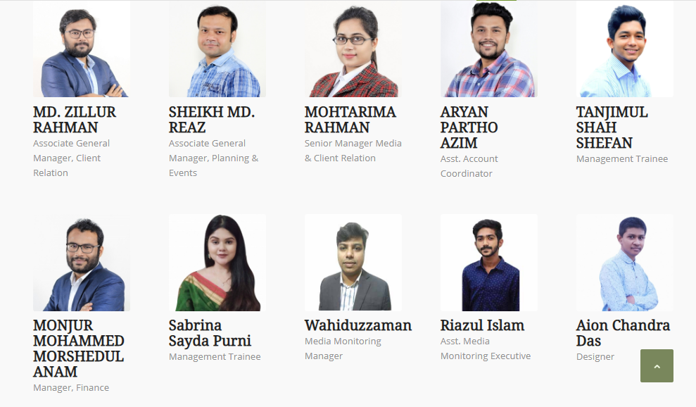
Team of Media Quest Bangladesh

Hierarchy of Media Quest Bangladesh

Figure: Hierarchy system of MediaQuest Bangladesh

Products & Services of MediaQuest Bangladesh
    - Public Relation
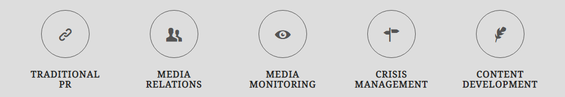
- Traditional PR: Public relation is about providing readers with information about a company through a sweet story and for that MediaQuest Bangladesh follows the methods of press releases, news story, conferences & media events.
- Media Relations: As a part of PR & according to clients’ needs, wants & expectations, MediaQuest Bangladesh design, create, execute & engage the connection between the media & their clients and provide the effective arrangements.
- Media Monitoring: Electronic, print & online media tracking, analysis & translation for news are provided by MediaQuest Bangladesh.
- Crisis Management: Unfortunately but true, now in a day many brands & organizations are going through crisis because of lack of market knowledge & that can be affect on their brand image, reputation, sales & growth. MediaQuest Bangladesh team with ground & planning level expert for public relations crisis management can provide the 180 degree services to contain & minimize on crisis management.
- Content Development: Media Quest Bangladesh believes “A better story brings better impact on the minds of the reader & with this statement, MediaQuest Bangladesh helps to their clients to create unique, sweet story which will be engaged the reader with main messages.

Figure: Products & Services of Public Relations sector in MediaQuest Bangladesh

    - Media Buying

- Newspaper Advertisement: MediaQuest Bangladesh offers competitive prices for newspaper, TV & radio advertising & strategic approach.
- Online Advertisement: They offer to create & design support for online advertisement with competitive pricing.

    - Events & Activation

Figure: Corporate Events of MediaQuest Bangladesh

Figure: Other Events & Activation

    - Digital Marketing
Internet & online platform is the easiest way for an organization or business to reach their targeted group, viewer or readers & MediaQuest Bangladesh helps to their clients to digitally presence needs by designing or creating-
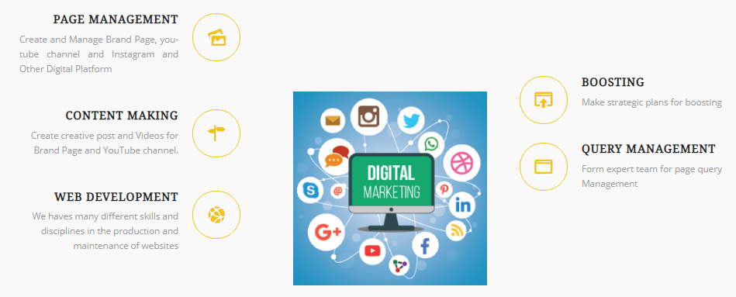

    - Development

Figure: Other Events & Activation
- Business Development: Brand development, production concept, Product selling concept, Marketing concept, Social Marketing concept.
- Sustainable CSR activates: With their long time experience on Events and Activation field, MediaQuest are able to help organizations with their CSR activities and social development programs.
- Special Training Program: Mental health and team building activities for employees.

Clients of MediaQuest Bangladesh





MediaQuest Bangladesh is started partner with Minister Hi Tech Park
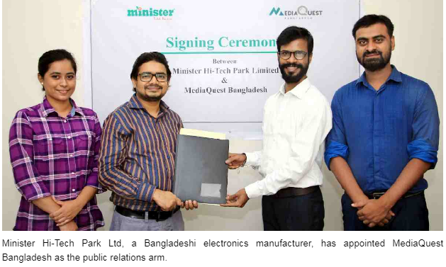

Some Events by MediaQuest Bangladesh (2019-2021)
- Bangabandhu Sheikh Mujib Dhaka Marathon 2021
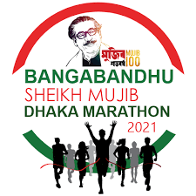
MediaQuest Bangladeshi was a part of this event management of the first ever Bangabandhu Sheikh Mujib Dhaka Marathon 2021.

- Synesis IT brings video conferencing platform
On the media platforms in October, 25, 2020, Media Quest Bangladesh covered the news of Synesis IT brings video conferencing platform
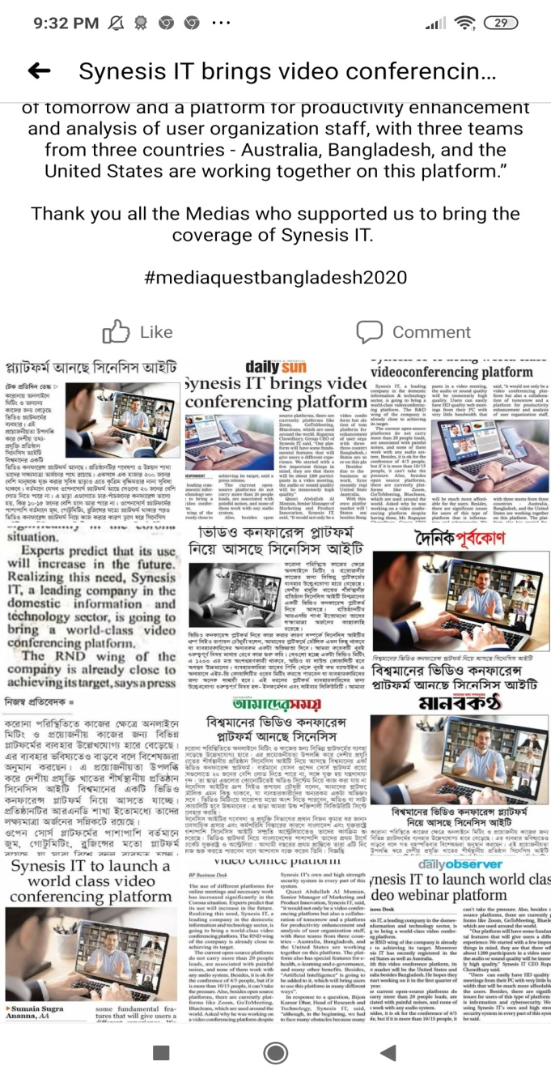

- UCB Investment Limited
MediaQuest Bangladesh covered the news of UCB investments limited, a subsidiary of united commercial Bank Limited, has been inaugurated at a five star hotel in the capital on Monday (Dec, 01, 2020).
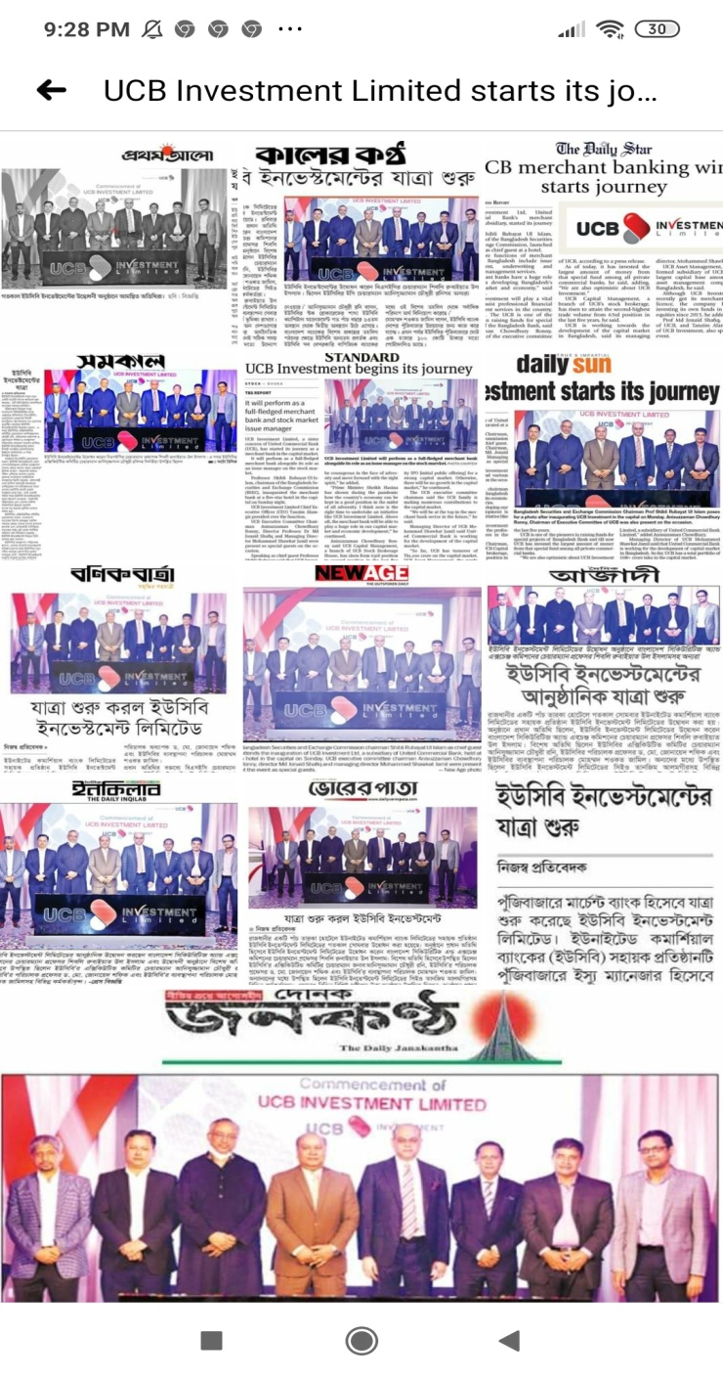

Revenue of MediaQuest Bangladesh
Revenue Data of Media Quest Bangladesh
(Jan 2020 - April 2020)

Account Code | Jan-20 | Feb-20 | Mar-20 | Apr-20
 | 28000 | 200000 | 0 | 0
 | 50000 | 45000 | 0 | 0
 |  | 43000 | 0 | 0
Total | 78,000 BDT | 108,000 BDT | 0 | 0
Revenue Data of Media Quest Bangladesh
(Jan 2020 - April 2020)

Account Code | May-20 | Jun-20 | Jul-20 | Aug-20
 | 5000 | 125000 | 125000 | 125000
 |  | 300000 | 200000 | 160000
 |  | 120000 | 120000
Total | 5,000 BDT | 545,000 BDT | 445,000 BDT | 285,000 BDT
Revenue Data of Media Quest Bangladesh
(Jan 2020 - April 2020)

Account Code | Sep-20 | Oct-20 | Nov-20 | Dec-20
 | 12000 | 125000 | 125000 | 125000
 | 95000 | 95000 | 95000 | 80000
 |  | 45000 | 15000
 |  | 300000
Total | 107,000 BDT | 565,000 BDT | 235,000 BDT | 205, 000 BDT

CHAPTER 03

Literature Review and Analysis

Brand Activation
Brand activation is a relatively new term in the marketing world that has become quite popular to the marketers over the past few years. Basically Brand Activation is a process of creating awareness for an organization to the specific target customers or audiences through various types of event campaigns.
Trust plays a huge role in any industry. Lack of trust could cause losing opportunities for sales for a brand. But when a company hires a PR agency, those experts can work for them to increase the credibility. Similarly, Media Quest Bangladesh as a Public Relation Firm, they do some activities and follow some strategies under the brand activation. These are

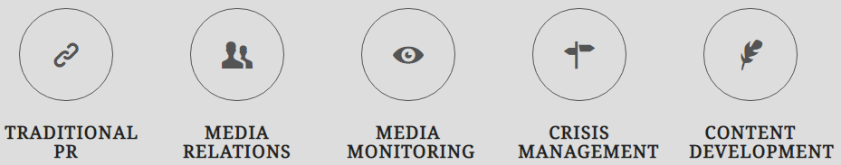

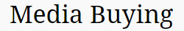




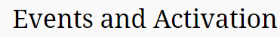


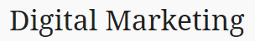

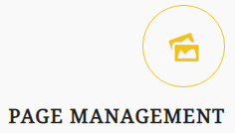
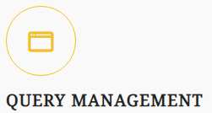

These activities & strategies under the brand activation are discussed below:

Increase profits, sales & leads
When a company's reputation is enhanced through various unique PR activities, it attracts new customers and leads them to the company's door. Customers and shoppers will find more ways to connect with a business through a press release, business stories, and, in this case, Media Quest Bangladesh agency, which is assisting companies in crafting the right message to create the best possible resonance for the targeted customers. And this whole process leads to a bigger profit.
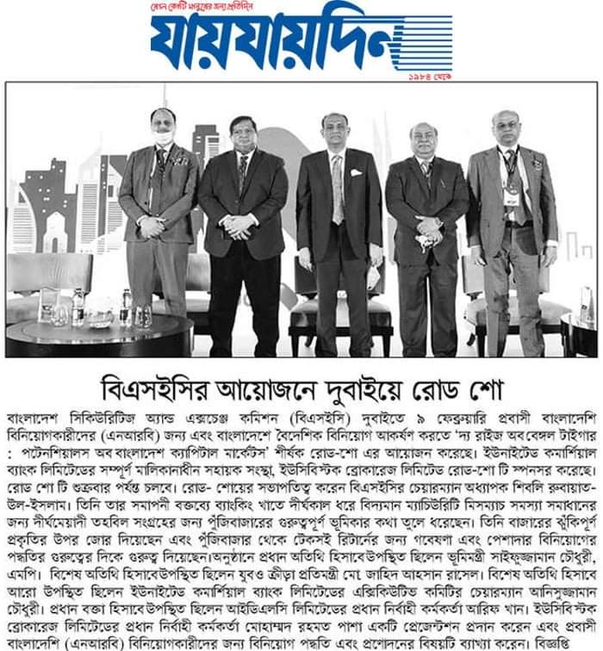
On February 14, 2021, Media Quest Bangladesh covered a report & published the report on their client (BSEC) in the newspaper in which in many cases it would play a role in building reputation, image & trust to the company’s targeted customers.

    - MediaQuest contributes in the changes the way people think about a company
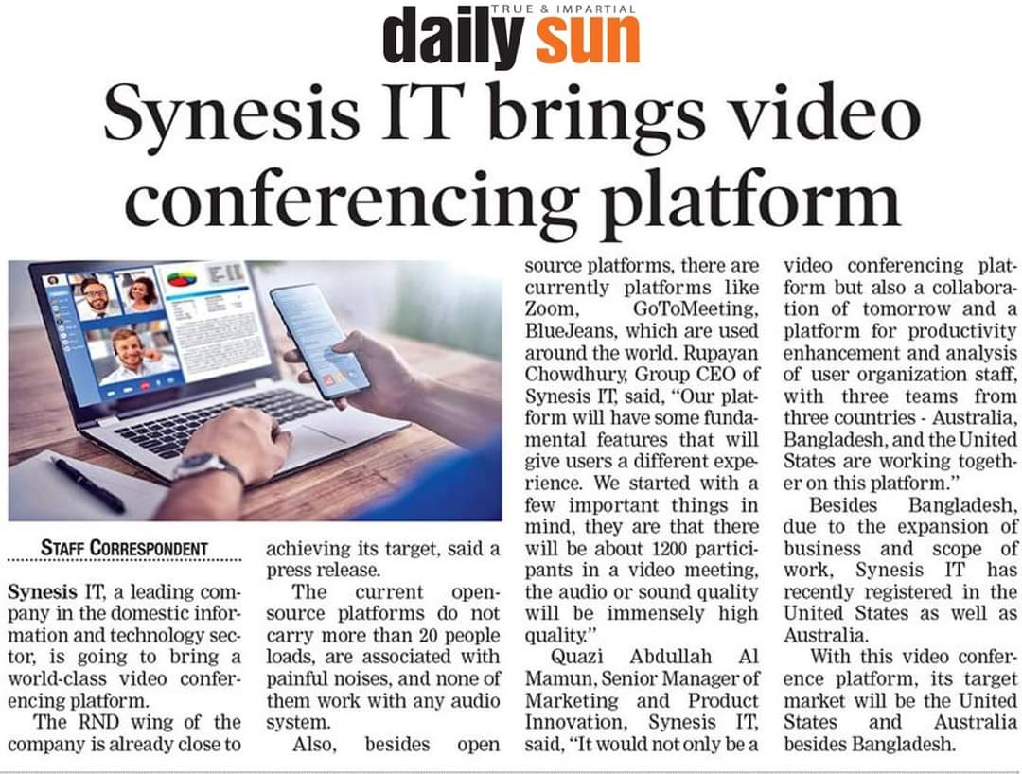
People can say anything or everything about a company, whether it is true or not, in today's world, which we can call a digital world, and there is very little a company can do about it. As a result, a company's reputation can be tarnished unfairly. But as a PR agency, Media Quest Bangladesh helps the business with a different PR campaign strategy to fix the problem and create a positive image for the business. Media Quest believes that “When you are talking about your own product people will not bother much but when we will talk for you, it will be more believable.

Online Presence
MediaQuest Bangladesh helps a business to connect with people in digital world. In Bangladesh this practice is yet to be performed. Media Quest Bangladesh, they are doing it in traditional way. They can really create a huge impact by using the digital world in the right way.
MediaQuest Bangladesh, they arranged many of shows, live adda in various platforms like Radio, TV, Face book Live & their selecting host try to give information about the upcoming events or their client’s products & services for PR marketing & bran activation.


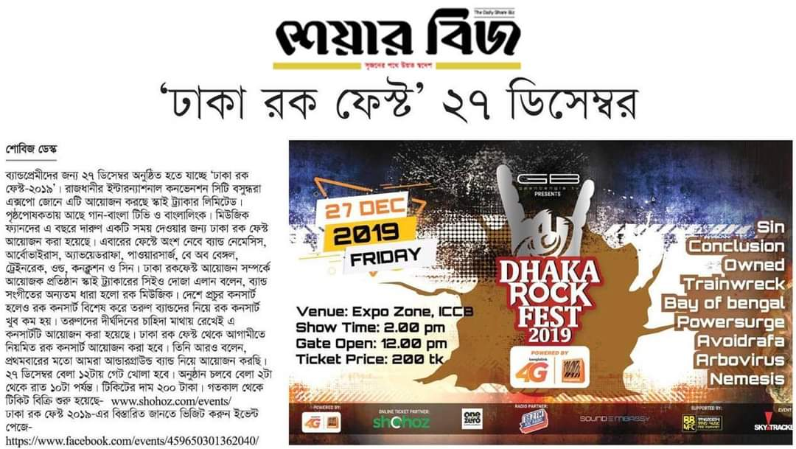
By this radio show, MediaQuest informed to the radio listeners the upcoming events & the sponsorship companies’ names, their brands, products & services.

Different uses of Social Media for Branding & PR
Social media can help PR professionals to meet their goals or help to manage reputation or any sort of crisis depending on the situation. Some of the most common ways PR professionals which Media Quest Bangladesh uses social media include:

Works as a influencer in Social Media
In the modern world, social media is the most popular and frequently used channel for communications. A statistic showed that, in 2018 social media is being used by more than billion people and the number is increasing every day. So, it is obvious that social media affect all spheres like marketing, digital marketing and especially PR. Influencers give brands a voice that can help a brand to increase its reputation and a brand could never use that on their own. Social media influencers have huge followers and a brand can use this to promote offerings and protect reputation.
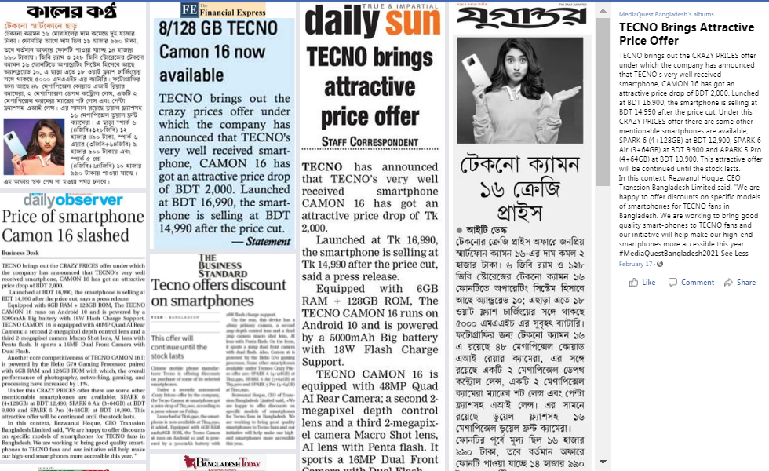
MediaQuest Bangladesh, they try to publish their client’s updating news in Prothom Alo online, Inqeelab, Manobjamin etc. And People are now getting news from social media and for verification they look for news portals. If they get the news from authentic social media source, they will not seek for any news portal in the future”. So, the fact is, now people are mainly search news in social media rather than traditional media. News spread faster in social media and there is no room for abandon this fact. In this case, Media Quest Bangladesh, they post the client’s updating news on their face book page which has been published in various newspapers and magazines.

To identify Brand Threats
Social media helps Media Quest Bangladesh to understand public opinion before it turns into a trending topic. Thus, they can proactively find and address online threats and possible solution to the crisis a brand may face for that.

To influencers journalist’s stories
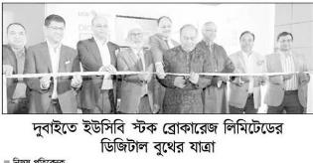
Whenever a trending topic arises in social media, the journalist often put their ear to it and often it seems that they took part in the discussion. In order to influence the journalist, Media Quest Bangladesh is trying to do something to create a different angle of the story so that the journalist will pick it and make some positive news.

To swiftly react to negative press
Nowadays, social media is the first place where people look for brands reaction to a negative claim. MediaQuest Bangladesh may use a company’s account to craft and publish a statement to tackle a crisis and, they can direct the public to another medium to collect more information. Social media is a huge platform for PR professionals that give immediate access to a large, attentive audience.

To make announcements

MediaQuest Bangladesh often uses social media to announce awards, product launch or any offerings or company updates. As social media users are huge in number, it is very easy to reach many audiences through it in very short time.
They are also using social media for public engagement like arranging quiz contest or announcing offerings. But the practice is very limited in Bangladesh.

Events & Activation
Events and activation are one of the major ways to get the masses involved with a campaign. MediaQuest team has an extensive rapport in the events and activation sector of the country. Exclusive Activation program all over Bangladesh including managing Brand promoters.

CHAPTER 04

Internship Experience and Recommendation

Internship Program
I had the opportunity to work at Media Quest Bangladesh as an intern for three (03) months from 01 September, 2020 to present to complete my all academic courses of Bachelors of Business Administration (BBA) degree. Since my major is Marketing, I joined at Media Quest Bangladesh as an Executive, Client Relationship department. I completely included in
- Designing PR strategies,
- Looking after client’s overall PR portfolio,
- Stakeholder management and media relationship,
- Designing government relationship strategies,
- Working with the content team to create press release, articles, and
- Monitoring team to prepare daily, weekly & monthly reports.
So, in the following, I'll talk about my internship experience with Media Quest Bangladesh and what I learned during my internship program.

Daily Routine
I've tried to maintain my regularity and obedience since the beginning of my internship. The primary goal of this internship was to gain practical experience, gather company information, become familiar with marketing activities, and gain a better understanding of the work environment. Due to the pandemic situation, my daily work began at 9.30 a.m. and ended at 5.30 p.m. at the office and occasionally from home.

Use of Office Equipments
At Media Quest Bangladesh, I was given permission to use all of the office's equipment. To complete my essential assignments, I was allowed to use a computer, the Internet, and some PR-related software such as Cision communication clouds and covered presses.

Description of the Job
As I have worked within the client relationship division, I completely included in managing the clients of UCB Bank, Minister Hi-Tech Park Ltd, Turaag Protex, and Techno Mobile & Merchant Bay for creating a professional positive relationship with our business & addressing client concerns as well as sells.

Designing PR strategies
One of my daily tasks was to create & identify strategies for our potential clients & their business to create brand awareness, lead generation, and trust with effective branding. So, here my tasks are designing strategies about communications between business & consumers, events, campaigns, social media & media relationship.

Assist PR Activities
I have learned and worked generally the PR tools and strategies from my 3-month internship program. In this period I have learned down to earth knowledge almost how to find out a relationship gap between our clients & their customers, implement the strategies for solving it through media relations, events, campaigns, articles & contents. During my internship, I do help them in numerous PR exercises. Such as:
- Effective Email marketing & trying to write a catchy subject line that they can’t ignore
- Assist in events & campaigns & playing a role as a host to catch-up with customers to strengthen relationships and gently upset.
- Post updating information about clients on social media for engaging the customers.

Training
- Create and implement creative marketing and public relations plans to increase brand awareness across multiple channels.
- During my Internship program, I gained an understanding of the field by planning, scheduling, budgeting, and communicating with customers, as well as observing all field work and public relations activities.
- If there any mistakes, how to overcome: I made mistakes during my working days, but my senior colleagues and upper management were extremely supportive, and he instructed me with care. But I made mistakes again at that point, so he gave me some feedback that helped me stay positive and learn how to deal with these situations.
- Management of Time Skills: During my internship, I am treated as if I were a full-time employee. My working hours were from 10:00 a.m. to 6:00 p.m. From here, I learned how to manage my time while working under duress and to complete my tasks on a daily basis.

Recommendations
In this chapter, on the basis of findings & analysis, need to some recommendations to Media Quest Bangladesh, PR & Marketing agency on their Brand activation strategies & activities.
Some recommendations are given below:
- They can communicate with the customers as public relationship activities by mobile-SMS marketing. Like they can deal with mobile operator to send the people who are using GP, Robi, Airtel about their clients’ products, companies, and services related content, messages, promotional activities.
- In my internship period I observed, they find the customers’ lead from someone’s references, word of mouth or direct marketing. Digitally they are less involving in online marketing such as YouTube marketing, face book video marketing. So considering this thing, like capture the PR market & building long term relationship with their target audiences & for doing brand activating activities, they should more focus on digital marketing.
- About PR & branding related activities, most of the staffs & employees are not get proper training, so Media Quest Bangladesh should be educated them by providing trainings.
- For the pandemic situation, since events & programs cannot be organized, Media Quest Bangladesh should organize online events, campaigns, programs for engaging their target audiences & promoting brand & creating awareness.

Conclusion
PR activities & advertising as the primary tool for building brands. In this internship report paper, I have attempted to provide an overview of Brand activation strategies & activities of Media Quest Bangladesh. Building Consumers’ positive perception, trust & confidence about a business, company, products & services because of the brand's image, this serves as a road map through PR activities. The true strength of a successful brand is that it fulfills the expectations of those who purchase it, or, to put it another way, it represents a promise maintained. They serve as a link between a vendor, a buyer, and a client. It pays off to build a strong brand. Media Quest Bangladesh as a PR & Marketing agency has a strong chance to create their brand and become the ultimate choice for customers, despite growing demand in the Bangladeshi markets.

References

Company Overview. (n.d.). Retrieved from Media Quest Bangladesh: https://mediaquest.com.bd/
Gendron, M. (2017). Public Relations to Brand Activation. Global Business and Organizational Excellence, 36(3):6-12.
How Can Digital PR Improve a Brand’s Presence? ( 2018, Sep 25). Retrieved from Digital Marketing Institute: https://digitalmarketinginstitute.com/blog/what-is-digital-pr
How To Create A Strong Brand Activation Campaign? (2020, February 29). Retrieved from Wootclub: https://wootclub.com/blog/how-to-create-a-strong-brand-activation-campaign/
PATEL, N. (n.d.). PR and Content Marketing. Retrieved from The All-In-One SEO Tool: https://neilpatel.com/blog/pr-and-content-marketing/
Public Relations Firm Marketing Plan. (n.d.). Retrieved from Mplans: https://www.mplans.com/public_relations_firm_marketing_plan/marketing_strategy_fc.php
SIMKI DUTTA, C. M. (2021, February 12). Social Media Content Strategy for PR Agencies. Retrieved from Prowly: https://prowly.com/magazine/social-media-content-strategy-for-pr/
Tables, S. (n.d.). PR Event Planning: 6 Ways to Get the Word Out. Retrieved from CVENT: https://www.socialtables.com/blog/event-planning/pr-event/
Tra, E. (2019, October 22). BRAND STRATEGY: HOW TO DEVELOP A BRAND ACTIVATION PLAN. Retrieved from KILLER VISUAL STRATEGY: https://killervisualstrategies.com/blog/brand-strategy-how-to-develop-a-brand-activation-plan.html

