

SCHOOL OF BUSINESS & ECONOMICS
United International University
A Thesis Report On
“Designing and Implementing a University Network Architecture using Cisco Packet Tracer”
A Thesis submitted
In partial fulfillment of the requirements for the degree of
Bachelor of Business Administration
In
Management Information Systems (MIS)

SUBMITTED BY
Murshid Kamiab Chowdhury
ID:111 162 050
Under the Supervision of:
Ahmed Imran Kabir
Lecturer, School of Business and Economics

Submission date: 13th April, 2023

Acknowledgment

I would like to express my heartfelt appreciation to my thesis supervisor, Ahmed Imran Kabir, an Adjunct Lecturer at School of Business and Economics at United International University, Bangladesh. I am grateful for his unwavering support and guidance throughout the completion of my research report, "Designing and Implementing a Campus Network Architecture using Cisco Packet Tracer." His expertise, insights, and motivation have been priceless during this journey.
His continuous support and encouragement have been the driving force behind the completion of this report. His dedication to helping me comprehend the subject matter and his timely feedback have been pivotal in shaping my ideas and enhancing my writing abilities.
Furthermore, I extend my gratitude to the faculty members of the School of Business and Economics for providing me with an intellectually stimulating environment that has nurtured my academic growth.
Finally, I extend my heartfelt thanks to my family and friends for their constant support and encouragement, without which this research project would not have been possible.

Contents
Acknowledgment 2
Contents 3
FIGURE LIST 5
TABLE LIST 6
Abstract 7
1.1 Introduction 8
1.2 Research Objective 8
1.3 LITERATURE REVIEW 9
1.4 Research Design 9
2 Configurations, implementations, topologies, and components 11
2.1 Local Area Network 11
2.2 Wide Area Network 11
2.3 Network Technologies 13
2.3.1 Bus Topology 13
2.3.2 Ring Topology 14
2.3.3 Mesh Topology 15
2.3.4 Star Topology 16
2.4 RIP (Routing Information Protocole) 17
2.5 Establishment of a Network Map and Regulations 18
2.5.1 Devices Used & Estimated Budget 18
2.5.2 Establishment of Network Map 19
2.5.3 Network Configuration 19
2.5.4 Network Rules 20
2.5.5 Network Flowchart: 22
3 SIMULATION & ANALYSIS 23
3.1 Step 1 23
3.2 Step 2 25
3.3 Step 3 30
3.4 Step 4 32
3.5 Step 5 34
3.6 Step 6 36
3.7 Step 7 37
3.8 Step 8 38
3.9 Step 9 43
3.10 Step 9 45
3.11 Step 10 46
3.12 Step 11 47
4 RESULT AND DISCUSSION 50
4.1 Scenarios Scope 50
4.1.1 Send packet (between two floors or on the same floor ) scenario : 50
4.1.2 Command Line Interface(CLI) Scenario: 52
4.1.3 University Website Scenario: 54
4.1.4 IP-Phone Scenario: 56
4.1.5 IoT Device (CCTV) Scenario: 58
4.2 Simulation images of the project: 60
Conclusion 63
Reference 65

FIGURE LIST
Figure 1. Local Area Network 11
Figure 2. Wide Area Network 12
Figure 3. Bus Topology 14
Figure 4. Ring Topology 15
Figure 5. Mesh Topology 16
Figure 6. Star Topology 17
Figure 7. Network Flowchart 22
Figure 8. Network Map (Devices) 23
Figure 9. Network Map (Devices) 24
Figure 10. Activation of DHCP (PC) 25
Figure 11. Activation of DHCP (Laptop) 26
Figure 12. Acttvation of DHCP (Smartphone) 27
Figure 13. Activation of DHCP (Home Gateway) 28
Figure 14. Activation of DHCP (Printer) 29
Figure 15. Physical between the Switch and the IP telephones 30
Figure 16. The setting of Switch for Ip Phone 31
Figure 17. The Setting of Router for IP phone 32
Figure 18. Connecting Switch with PC (Physical Connection) 32
Figure 19. Connecting Switch with Laptop (Physical Connection) 33
Figure 20. Connecting Switch with Home Gateway (Physical Connection) 33
Figure 21. Connecting Switch with Printer (Physical Connection) 34
Figure 22. Home Gateway Password Adjustment 34
Figure 23. Adjusting Wireless Password for Smart Phone 35
Figure 24. Wireless Connection of Home Gateway with SmartPhone 36
Figure 25. Activating IoT Device (door) DHCP 36
Figure 26. Wireless Connecting of Home Gateway with IoT Device(door) 37
Figure 27. Physical Connectivity of Switches with Main Switch and Last Switch with the Internet 37
Figure 28. Activation of HTTP Server 38
Figure 29. IP Adjustments of HTTP Server 39
Figure 30. About Us Page Content (HTTP Server) 40
Figure 31. Contact Page Content (HTTP Server) 41
Figure 32. Index Page Content (HTTP Server) 42
Figure 33. Connecting Switch with HTTP Server (Physical Connection) 42
Figure 34. Adjustment of DHCP Server IP 43
Figure 35. Ip Pool Creation Settings (DHCP Server) 44
Figure 36. Connecting Switch with DHCP Server (Physical Connection) 44
Figure 37. Adjustment of DNS Server Ip 45
Figure 38. Adjustment of DNS Server Name and Address 46
Figure 39. IoT Server IP Adjustment 47
Figure 40. Reset Router 48
Figure 41. RIP Routing 49
Figure 42. Send Packet (PC43 to Laptop15) 51
Figure 43. Send Packet (Laptop 7 to PC23) 51
Figure 44. Scenario of Command Line Interface(CLI) 52
Figure 45. Scenario of Command Line Interface(CLI) 53
Figure 46. Command Line Interface(CLI) 54
Figure 47. University Web Site 55
Figure 48. University Web Site (BBA Department) 56
Figure 49. Make Telephone Call 57
Figure 50. Make Telephone Call 57
Figure 51. Monitoring IoT Devices (CCTV) 58
Figure 52. Monitoring IoT Devices (CCTV) 59
Figure 53. Monitoring IoT Devices (CCTV) 59
Figure 54. Simulation image of the 1st floor 60
Figure 55. Simulation image of the 2nd floor 60
Figure 56. Simulation image of the 3rd floor 61
Figure 57. Simulation image of the 4th floor 61
Figure 58. Simulation image of the 5th floor 62
Figure 59. Simulation image of the 6th floor 62
Figure 60. Simulation image of the University Building 63

TABLE LIST

Table 1. Shows the price of devices used in the network 18

Abstract

In this project paper, I have demonstrated a computer-network design integrated into a university campus to make official works smooth and uninterpreted. The network in a university is typically defined as the part of the computing infrastructure that enables end users and devices deployed over a single geographic area access to network communication services and resources.
Firstly, I have implemented a computer network designed by Cisco Packet Tracer, allowing me to design the network system in-house. Cisco Packet Tracer is an advanced software developed by Cisco that enables the creation and simulation of virtual networks, specifically wireless networks, without the need for physical network hardware. Then, I have conceptualized the essential elements needed for creating a computer network. This section provides details on setting up the computer network, including different topologies, network technologies, architecture, and components of network cable systems. I have also integrated IoT (Internet of Things) service technology into the simulation tool, allowing students to simulate, build, and manage systems to gain a deeper understanding of IoT network concepts. The network architecture includes the implementation of Dynamic Host Configuration Protocol (DHCP) and Domain Name System (DNS) servers. Additionally, the network architecture incorporates other components such as web server, mail server, and more. Furthermore, I proceeded to define the layout and guidelines for the computer network architecture within an eight-story university building. Using Cisco Packet Tracer, I meticulously configured the network based on the required rules and topology, resulting in the establishment of a sophisticated computer network. The Cisco Packet Tracer tool proved invaluable in simulating and implementing the network structure, ensuring compliance with the desired network design and functionality. Finally, a series of eight scenarios were executed to validate the performance of the network within the university building. These scenarios encompassed packet transfer between floors via the command line interface (CLI) of network devices, successful deployment of website servers, inter-floor phone communication, and integration of security cameras for monitoring purposes. Through these simulations, the seamless operation of the network was confirmed, with all implemented functionalities working smoothly without any disruptions.

Introduction
It is not easy to imagine our daily lives without Internet access. The majority of individuals do not give it a second thought. Nevertheless, it does not occur by magic. It is driven by a computer network that enables the communication between devices, buildings, and the outside world. On a university campus, it is essential that all users can connect successfully and with minimal issues. The Cisco network design is ideal for a university campus network built to accommodate a building with multiple floors. In many cases, creating a network by physically connecting multiple computers with numerous cables and using graphical user interfaces is feasible. However, this approach can be space-consuming and require a significant amount of cables and interfaces. To address this, switches have been developed as a solution, allowing for communication and file sharing among multiple computers through a single interface. Computers are connected to Network Interface Cards (NICs) using connectors, while routers enable these computers to connect with other networks.
Nevertheless, university computer network architectures vary. The cost of building networks at universities varies considerably from institution to institution and from country to country. Using the Cisco packet tracer simulation technology, we can rapidly build a campus area network (CAN) without physically implementing the network equipment on campus, reducing the installation cost.
In addition, the report explains how to plan for the efficient and secure development of a campus network.

Research Objective
This network design's primary purpose is to offer a Local Area Network (LAN) that allows only authenticated users to access the network on a university campus, as well as configuration of network devices and evaluation of point-to-point connections using Cisco packet tracer.
The first challenge of this network's design was network troubleshooting; the second was quality and eliminating human labor in order to save energy consumption by configuring IOT services. The project has been integrated with a variety of tools and methods in order to introduce a network with an advanced level for the university network architecture. DHCP server, DNS server, HTTP server, IOT device implementation, and IOT server are the tools and techniques implemented in the university network architecture. These techniques are used for the student section, the account section, the exam controller section, and the management department. In addition, these techniques must offer enhanced levels for the campus network and a point-to-point connection that is seamless.
Nevertheless, this project design will assist the university in reducing costs associated with network architecture, and it will also facilitate effective network maintenance.

LITERATURE REVIEW
University networks have unique requirements due to their size and complexity, requiring a robust and secure network infrastructure to accommodate the needs of students, faculty, and staff. The use of Cisco packet tracer as a simulation technology can facilitate the efficient design and implementation of such networks, as it allows for the creation of a virtual network environment without physically implementing the network equipment on campus.
In a study by Alhaji et al. (2020), the authors proposed a network design for a Nigerian university using Cisco packet tracer. The design included a core switch, distribution switches, and access switches, along with a DHCP server, DNS server, and proxy server. The authors reported that the design was able to provide secure and reliable connectivity to the university's network, as well as efficient traffic management.
Similarly, another study by Anwar et al. (2018) utilized Cisco packet tracer to design and simulate a network for a university campus in Pakistan. The network design included routers, switches, and servers, as well as a wireless access point and a firewall. The authors reported that the design was able to provide high-speed connectivity, security, and easy management of the network.
A study by Han et al. (2017) explored the use of Cisco packet tracer in a project-based learning approach for network engineering education. The authors designed a network project that involved the creation of a virtual network for a university campus, incorporating VLANs, routing protocols, and security mechanisms. The study found that the use of project-based learning with Cisco packet tracer was an effective method for enhancing students' understanding of network engineering concepts.
In addition, a study by Dauda and Zakari (2020) proposed a network design for a university campus in Nigeria using Cisco packet tracer. The design included routers, switches, servers, and wireless access points, as well as a firewall and intrusion detection system. The authors reported that the design was able to provide a secure and reliable network environment for the university.
Overall, the use of Cisco packet tracer in designing and simulating university networks can offer several benefits, including cost savings, efficient network maintenance, and enhanced security and connectivity. These studies demonstrate the effectiveness of utilizing this simulation technology to design and implement network infrastructure for university campuses.

Research Design
The aim of this research is to design and implement a secure, efficient and cost-effective campus network architecture for a university using Cisco Packet Tracer. The network will be designed to provide a Local Area Network (LAN) that allows only authenticated users to access the network and communicate with other devices on the campus. The network design will be evaluated using Cisco Packet Tracer simulation technology.
Research Questions:
- What are the key components of a campus network architecture for a university?
- How can Cisco Packet Tracer be used to design and implement a secure and efficient campus network architecture?
- What are the challenges in designing and implementing a campus network architecture using Cisco Packet Tracer?
- How can the network design be evaluated and tested using Cisco Packet Tracer simulation technology?
- What are the benefits of using Cisco Packet Tracer for designing and implementing a campus network architecture?
Methodology:
The research will adopt a mixed-methods approach, comprising both quantitative and qualitative methods.
First, a literature review will be conducted to identify the key components and best practices for designing and implementing a campus network architecture using Cisco Packet Tracer.
Next, a case study approach will be adopted to design and implement a campus network architecture for a selected university. The case study will involve data collection through surveys, interviews, and observations to assess the effectiveness, efficiency, and security of the network design.
Finally, the network design will be evaluated and tested using Cisco Packet Tracer simulation technology. The simulation tests will assess the performance, reliability, and security of the network design.
The data collected from the case study will be analyzed using statistical analysis software. The statistical analysis will include descriptive and inferential statistics to analyze the quantitative data collected from the surveys. The qualitative data collected from interviews and observations will be analyzed using thematic analysis to identify the key themes and patterns that emerge.
The research aims to design and implement a secure, efficient and cost-effective campus network architecture using Cisco Packet Tracer. The research will provide insights into the key components and best practices for designing and implementing a campus network architecture using Cisco Packet Tracer, as well as the challenges and benefits of using this technology. The research findings will be valuable to universities and other organizations that are seeking to design and implement a secure and efficient campus network architecture.

Configurations, implementations, topologies, and components

Local Area Network
A Local Area Network (LAN) is a computer network that spans a small geographic area, typically within a building or a campus. It enables the sharing of data, information, and resources among connected devices, such as computers, servers, printers, and switches, within the defined area. LANs are commonly used in homes, offices, schools, and other settings to facilitate communication and collaboration among users, allowing them to access shared files, applications, and services. LANs are typically designed and managed locally, providing fast and efficient data transfer, high-speed connectivity, and localized control over network operations.
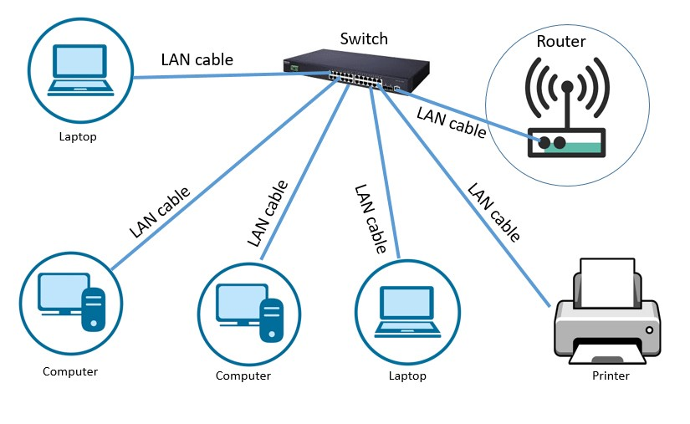
Figure 1. Local Area Network

Wide Area Network
Wide Area Networks (WANs) are expansive networks that connect multiple locations across large geographical areas, enabling seamless communication and data sharing between different sites. They offer advantages such as flexibility, scalability, and enhanced collaboration. WANs allow organizations to adapt their network to changing business needs, centralize network management, and facilitate real-time data sharing among teams in different locations. However, WANs also present challenges in terms of complexity, reliability, security, costs, and dependence on service providers.
One of the benefits of WANs is their flexibility, allowing organizations to scale their network up or down as needed and centralize network management, reducing redundant equipment and maintenance costs. Scalability is another advantage, as WANs can be easily expanded or contracted to accommodate changes in network requirements. Enhanced collaboration is also facilitated by WANs, as they enable real-time data sharing and other collaborative tools among teams in different locations, improving productivity and efficiency.
Despite these benefits, WANs also have drawbacks. They can be complex and challenging to set up and manage, requiring technical expertise and specialized knowledge. Reliability and latency concerns may arise due to the long distances data needs to traverse, potentially impacting network performance. Security risks, costs associated with hardware, software, maintenance, and dependence on service providers are also factors to consider. Organizations need to carefully weigh the pros and cons of implementing a WAN and plan accordingly to ensure successful deployment and operation.

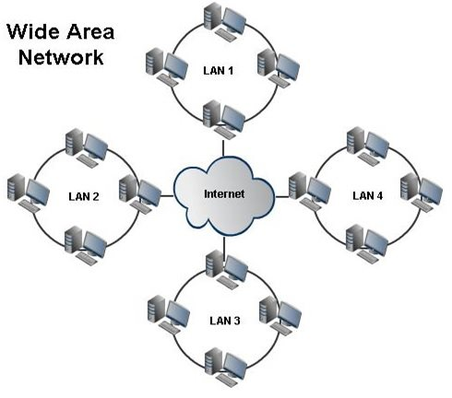
Figure 2. Wide Area Network

Network Technologies
Every computer network requires a framework that enables the exchange of data among different networks, typically through cables or wireless connections. While wireless setups are gaining popularity, wired configurations remain the more commonly used option for subdividing wide area networks with multiple local area networks. Before setting up the network, it is essential to determine its structure, and this is where network topologies come into play. Network topologies provide a visual representation of how networks and systems are organized and interconnected, establishing a general structure that dictates how data transmission will occur. Common types of topologies include star, ring, mesh, linear, and tree configurations. Topology can be understood in two ways:
- Physical topology: which refers to the visible structure of the network based on cable connections between computers.
- Logical topology: which describes how data is transmitted between computers on the network, regardless of the physical cable connections.

Bus Topology
Bus topology is a type of network topology where all devices are connected to a single communication line, known as a bus or backbone. The devices, such as computers or peripherals, are connected to the bus using taps or connectors. One of the main benefits of bus topology is its simplicity and cost-effectiveness. It is easy to set up and requires less cabling compared to other topologies, making it a cost-effective option for small to medium-sized networks. Additionally, bus topology allows for easy expansion as new devices can be added to the bus without disrupting the entire network.
However, bus topology also has some drawbacks. One of the main limitations is that if the main bus or backbone fails, the entire network can be affected. This can result in network downtime and disruption of communication among devices. Additionally, bus topology can suffer from performance degradation as more devices are added to the bus, leading to increased collision and contention for bandwidth. Another disadvantage is that bus topology does not provide inherent network security, as all devices on the bus can potentially access data transmitted across the network, making it vulnerable to unauthorized access.
In summary, bus topology is a simple and cost-effective network topology that is easy to set up and expand. However, it has limitations such as potential network failure, performance degradation, and lack of inherent security. Careful consideration should be given to the specific requirements and limitations of bus topology when choosing a network topology for a particular environment.

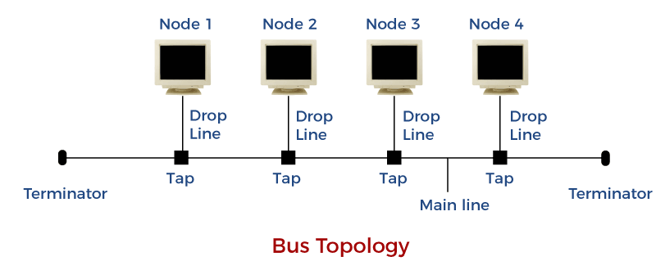
Figure 3. Bus Topology

Ring Topology
Ring topology is a type of network topology where devices are connected in a circular manner, forming a closed loop. There are two main types of ring topology: token ring and fiber distributed data interface (FDDI). In a token ring, devices transmit data sequentially using a token, which is a special packet that circulates around the ring. Only the device holding the token can transmit data, ensuring orderly and collision-free data transmission. FDDI, on the other hand, uses fiber optic cables to connect devices in a ring, allowing for higher bandwidth and longer distances compared to token ring.
One of the main benefits of ring topology is its reliability. In case one device or link fails, the network can still continue to function as data can flow in both directions, bypassing the failed device or link. This makes ring topology a suitable option for environments where network uptime is critical, such as in mission-critical applications or industries that require continuous data transmission. Additionally, ring topology can offer efficient data transmission as devices can transmit data without collisions or contention, resulting in better performance and less network congestion compared to other topologies.
However, ring topology also has some drawbacks. One of the main limitations is that if the main ring or backbone fails, the entire network can be affected, resulting in network downtime. This can be a significant drawback in environments where high network availability is essential. Moreover, adding or removing devices in a ring topology can be challenging as it requires disrupting the entire ring to insert or remove a device, which can be time-consuming and may cause network disruptions.
In summary, ring topology, including types such as token ring and FDDI, offers reliability and efficient data transmission, making it suitable for environments where network uptime is critical and data congestion needs to be minimized. However, it has limitations such as potential network failure and challenges in adding or removing devices. Careful consideration should be given to the specific requirements and limitations of ring topology when choosing a network topology for a particular environment.

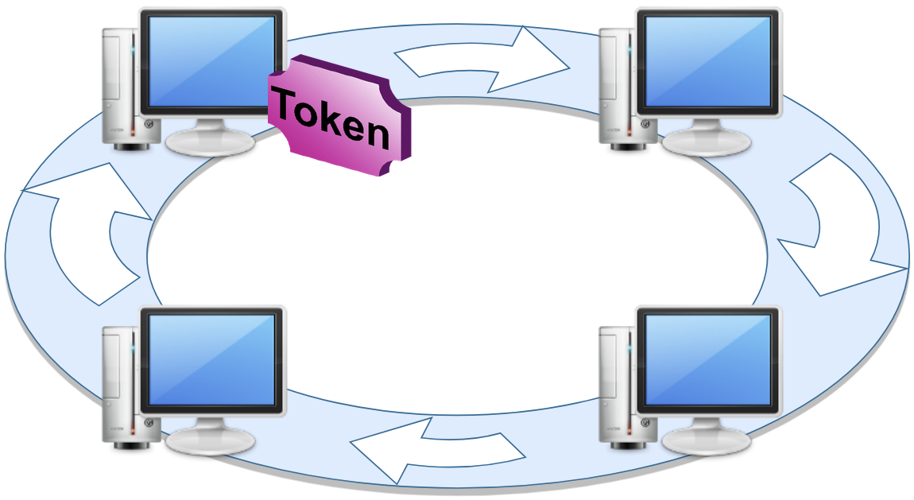
Figure 4. Ring Topology

Mesh Topology
Mesh topology is a type of network topology where each device is directly connected to every other device in the network, forming a redundant and fully interconnected network. There are two main types of mesh topology: full mesh and partial mesh. In a full mesh, every device is directly connected to every other device in the network, while in a partial mesh, only some devices have direct connections to all other devices. Mesh topology provides high redundancy and fault tolerance as multiple paths are available for data transmission, ensuring that if one link or device fails, data can still be routed through alternative paths.
One of the main benefits of mesh topology is its robustness and reliability. The multiple paths for data transmission make mesh topology highly resilient to failures, as data can automatically reroute through alternative paths. This makes it suitable for critical applications where network uptime is crucial, such as in mission-critical systems or environments with high data reliability requirements. Additionally, mesh topology offers high scalability as new devices can be added without disrupting the existing connections, providing flexibility for network expansion.
However, mesh topology also has some drawbacks. One of the main limitations is its high cost and complexity. The requirement of direct connections between every device in the network can result in a significant number of cables and ports, making it costly to implement and manage, especially in large-scale networks. Additionally, the complexity of managing and troubleshooting multiple paths and connections in a mesh topology can be challenging, requiring skilled network administrators and sophisticated network management tools.
In conclusion, mesh topology, including types such as full mesh and partial mesh, offers robustness, fault tolerance, and scalability, making it suitable for environments where high network reliability and flexibility are required. However, it also has drawbacks in terms of cost and complexity, and careful consideration should be given to the specific requirements and management capabilities when choosing mesh topology for a network deployment.

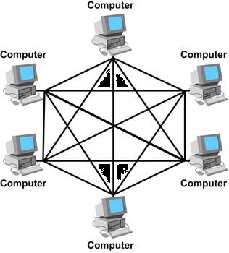
Figure 5. Mesh Topology

Star Topology
The star topology is a network configuration where all devices, such as servers, stations, and peripherals, are connected directly to a central connector, such as a hub or Switch. The central connector manages and controls all network functions, and data is transmitted through it to reach its destination. A repeater or signal amplifier also functions similarly in this topology.
The advantages of the star topology include the ease of adding a new station, simple fault detection and management, and flexibility in wiring methods. In case of a malfunction or new addition, the entire network is not affected.
However, this topology requires a high cable requirement and the entire network collapses if there is a problem in the central connector. It is also more expensive than the bus topology.
Twisted pair and fiber optic cables are commonly used, and the Ethernet and Local talk protocols are widely used in this topology. So, this topology will be used in this study.
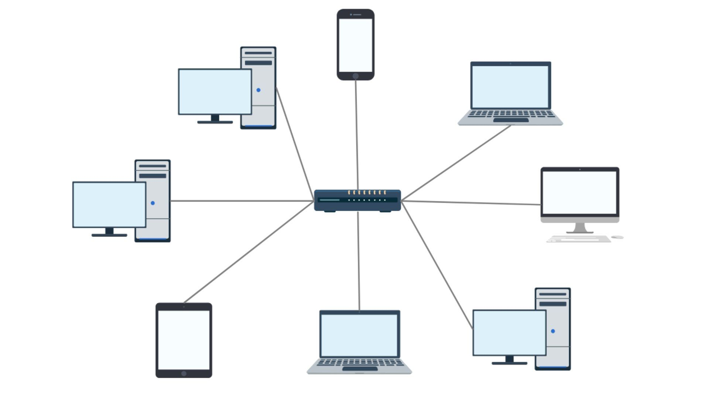
Figure 6. Star Topology

RIP (Routing Information Protocole)
Routing Information Protocol (RIP) is a dynamic routing protocol commonly used in computer networks to determine the most efficient route between source and destination networks, using hop count as the routing metric. It is commonly used in smaller to medium-sized networks and is supported by most network operating systems. To keep its neighboring routers updated about any changes in network topology, RIP routers dispatch routing updates at regular intervals. Each router then calculates the shortest route to each destination network based on the information it received from its neighbors. The scalability of RIP is limited to 15 hop counts, restricting its application in more extensive networks. RIP has two versions: version 1 and version 2. Version 1 lacks support for variable-length subnet masks (VLSM) and does not include network addresses and subnet masks in its routing updates. In contrast, version 2 supports VLSM and provides additional information about network addresses and subnet masks in its routing updates. Although RIP is easy to configure and implement, making it ideal for small networks or those that do not require high performance, its scalability limitations make it less suitable for larger and more complicated networks. RIP is a popular routing protocol that offers a straightforward and effective method for routing traffic in smaller to medium-sized networks.

Establishment of a Network Map and Regulations

Devices Used & Estimated Budget
The selection of appropriate equipment is crucial when designing a network as it determines the means of information transfer between nodes and devices, transmission speed, distance covered, interference protection, and cost. Two primary options are available, namely physical connections and wireless connections. To design a campus network, I have used the following devices: routers, switches, home gateways, personal computers, laptops, servers, printers, televisions, smartphones, air conditioners, fans, fire sprinklers, garage doors, home speakers, lawn sprinklers, motion detectors, smoke detectors, alarms, webcams, windows, cloud (internet), old cars, and among others. This network is designed to accommodate 4500 users. If more users connect to the network, it will be scalable. Four types of cables were utilized in this setup: Copper Cable, Coaxial Cable, Serial DTE Cable, and IOE custom cable.
The suggested design for the campus network architecture necessitates the inclusion of several components, including 2-3 Cisco routers, 66 switches, nine computer servers, six home gateways, seven racks, 70 boxes of twisted pair cable, 200 boxes of RJ45 connectors, and an estimated 6000 terminals. The table provided presents details such as the type of equipment, its quality, the number of devices needed, the price per device, the total cost for the specified quantity, and the overall total cost for all the required equipment. The prices referenced are obtained from websites such as Amazon and Daraz.

Equipment | Price per unit | Quantity | Total Amount
Generic PC, Laptops | 40,000 | 120 | 48,00,000
Cisco IP Phone 7960 | 9,089 | 16 | 1,45,424
1,000 ft bulk Cat5e Ethernet Cable /  Wire UTP Pull Box 1,000ft Cat-5e Style Grey ~ VIVO (CABLE-V001) | 7500 | 70 | 5,25,000
2950-24 switch | 18,000 | 66 | 11,88,000
Home Gateway- DLC100 | 6,000 | 6 | 36,000
100ft coax cable | 4,700 | 3 | 14,100
RJ-45- Cybertech Cat6, Cat5e crimp connectors pack of 100 | 1,000 | 200 | 2,00,000
Dell poweredge R340 Server | 1,70,000 | 7 | 11,90,000
22U Network Server Rack Cabinet | 32,500 | 7 | 2,27,500
2811 router | 60,000 | 3 | 1,80,000
 |  |  | Total
 |  |  | Taka 85,06,024
Table 1. Shows the price of devices used in the network

Establishment of Network Map
To establish connectivity among all devices within the given constraints, it is recommended to utilize switches and routers. Computers are connected to switches, which are then connected to the routers. The last switch in the network is connected to the edge switch, which serves as the hub for servers such as DHCP (Dynamic Host Configuration Protocol) and DNS (Domain Name System). The DHCP server is responsible for assigning IP addresses to devices within the network, while the DNS server is responsible for identifying and responding to website requests. Additionally, there is an HTTP server for hosting the campus website and an IoT (Internet of Things) server that enables remote access to smart devices, including cameras. The server room is located on the 6th floor of the university campus. Home Gateway is utilized for wireless connectivity across floors, while IP Phones facilitate communication between floors. Printers are also incorporated into the network for various purposes.
CCTV cameras are used to prevent security problems, and in case of a problem on the 1st floor, non-wired system should be checked, followed by a reset of the Switch and a configuration of the devices to connect to the network.
If there is an internet interruption, cables should be checked, and DHCP server's IP settings should be monitored. Manual IP addresses should also be checked for any overlaps. Additionally, any changes in Switch and Router settings should be noted. When a camera is broken, the cable and IP address should be checked, and the IoT server configuration should be verified.
The server room is located on the 6th floor to avoid any potential natural disasters or floods, and for better security.

Network Configuration
The most common Packet Tracer configuration for Cisco network devices includes a graphical user interface (GUI) with four important tabs: Physical, Config, Desktop, and Command Line Interface (CLI).
- The Physical tab is utilized in Packet Tracer to add or remove appropriate modules for each device.
- The Config tab is used for configuring various settings, including global settings, routing, V-Lan, and interface settings.
- The Desktop tab is used to select a suitable device for performing specific operations, such as a web browser, command prompt, or terminal.
- The CLI tab provides access to the command line interface of the physical device, allowing users to access different modes of the device using a terminal program connected via console cable or telnet using a crossover Ethernet cable.
- Packet Tracer provides the capability to save a device as a dedicated device with a customized set of modules, allowing users to define the device's configuration with specific modules.

Network Rules

- First Rule
The devices will be named according to the indications on the map.
- Second Rule
The configuration will be adjusted so that the computers and laptops in the network obtain their IP addresses from the DHCP server. No IPv6 identification will be assigned to the computers and laptops.
- Third Rule
The Switch on the particular floor will be connected to the IP phones situated on every floor via a physical connection. Additionally, the switches on each floor will feature a V-Lan configuration for IP phones, which will facilitate communication among them. The router will assign IP addresses to the IP phones.
- Forth Rule
The home gateway located on the first, second, fourth, fifth, and sixth floors will be secured using the WPA2-PSK encryption technique. Each floor's laptops, tablets, and smartphones are linked wirelessly to the floor's home gateway.
- Fifth Rule
The printers placed on every floor of the university campus will be connected to the Switch through physical connections, and their IP addresses will be configured to be obtained from the DHCP server.

- Sixth Rule
The IoT devices on every floor of the university campus will be connected to the home gateway through wireless connections, and their IP addresses will be configured to be obtained from the DHCP server.
- Seventh Rule
The connection between the computers and the Switch will be established through a physical connection on the respective floors.
- Eighth Rule
All the switches on the floors will be connected to the main switches and main Switch will be connected through a router. The last Switch will be directly connected to the external network (Internet).
- Ninth Rule
The HTTP Servers will be enabled, and adjustments will be made to the index.html file. The file structure of the HTTP Server will include index.html, contact.html, and aboutus.html. Once the appropriate modifications have been made, the server will be linked to the Switch located on the same floor.
- Tenth Rule
The DHCP Server will be turned on, and the required configurations will be made in the fields of Default Gateway, Start IP Address, and Subnet Mask.
- Eleventh Rule
DNS Servers will be activated. The domain name of the servers will be:
- edu.admission.uiu.ac.bd- 192.162.1.1
- edu.admin.uiu.ac.bd- 192.162.1.2
- edu.cse.uiu.ac.bd- 192.162.1.3
- edu.bba.uiu.ac.bd- 192.162.1.4
- edu.eee.uiu.ac.bd- 192.162.1.5
- edu.civil.uiu.ac.bd- 192.162.1.6
- iot.com- 192.162.1.7

- Twelveth Rule
The connectivity between devices within the same networks occurs directly through switch connections. Trunks, which are channels that enable connectivity between VLANs on a switch, are used to connect devices in parts of the network that have two or three switches. However, for connectivity between routers, network routing protocols such as RIP, which stands for Router Information Protocol, are needed. RIP is responsible for determining the best path for data transmission and preventing routing loops by limiting the number of paths from source to destination devices. Therefore, RIP was utilized to establish connectivity across the entire network, allowing end devices to send and receive information from different networks using the shortest and simplest path. Subsequently, the connectivity between end devices was verified.

Network Flowchart:
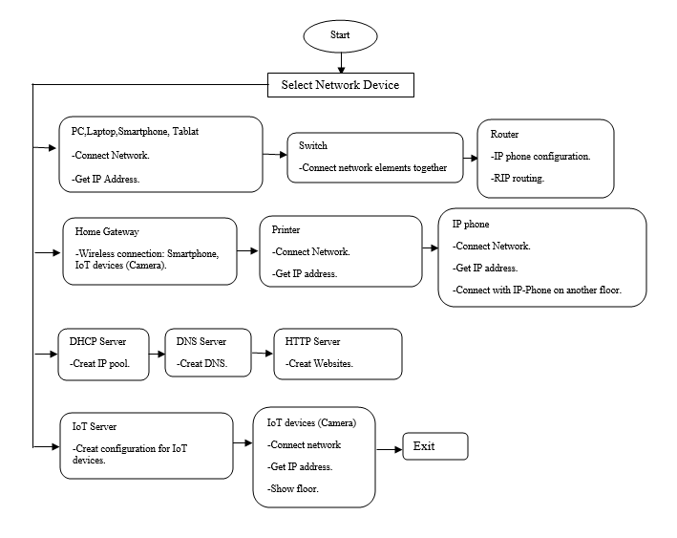
Figure 7. Network Flowchart

SIMULATION & ANALYSIS
This chapter provides a presentation of the simulation, which is divided into multiple steps based on the network map as outlined below:

Step 1
The devices were organized in accordance with the network map and assigned their respective names.

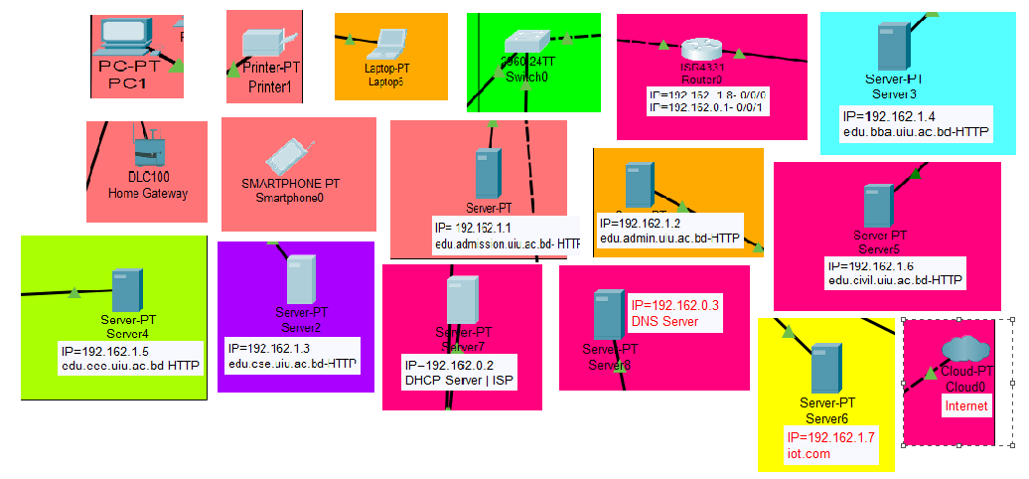
Figure 8. Network Map (Devices)

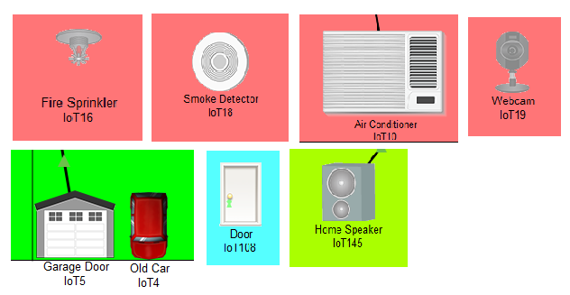
Figure 9. Network Map (Devices)

Step 2
Dynamic Host Configuration Protocol (DHCP) settings are configured to enable automatic IP assignment for computers, laptops, smartphones, home gateways, and printers.

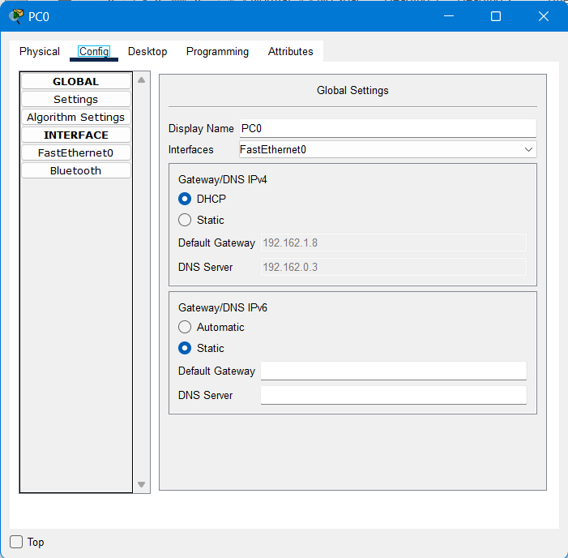
Figure 10. Activation of DHCP (PC)

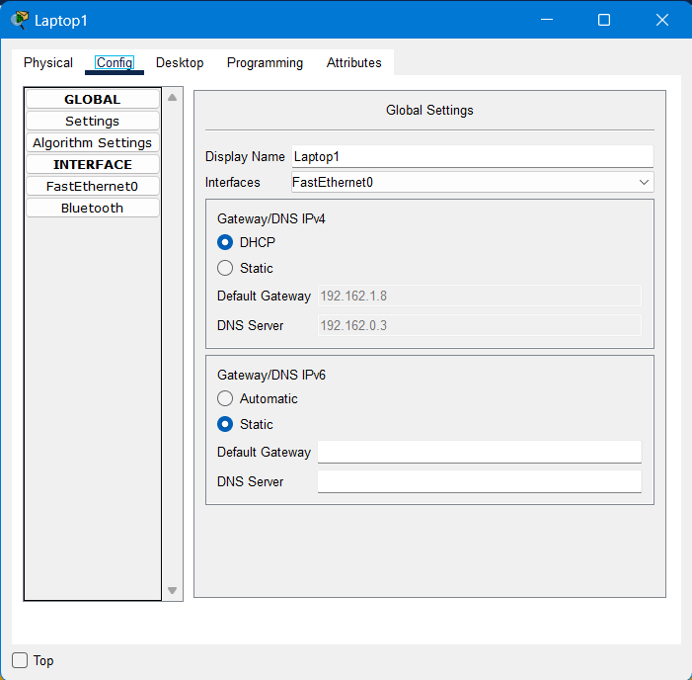
Figure 11. Activation of DHCP (Laptop)
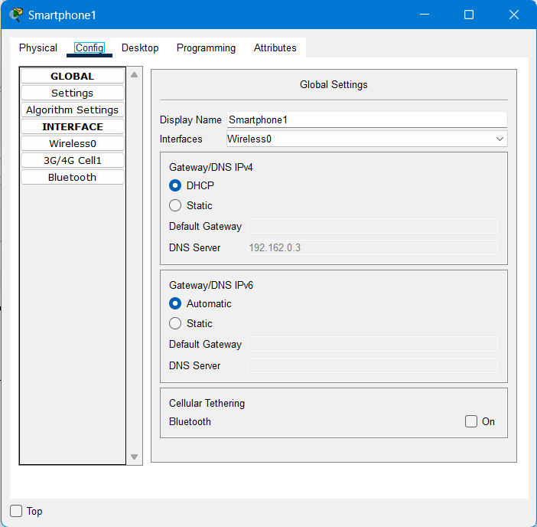
Figure 12. Acttvation of DHCP (Smartphone)
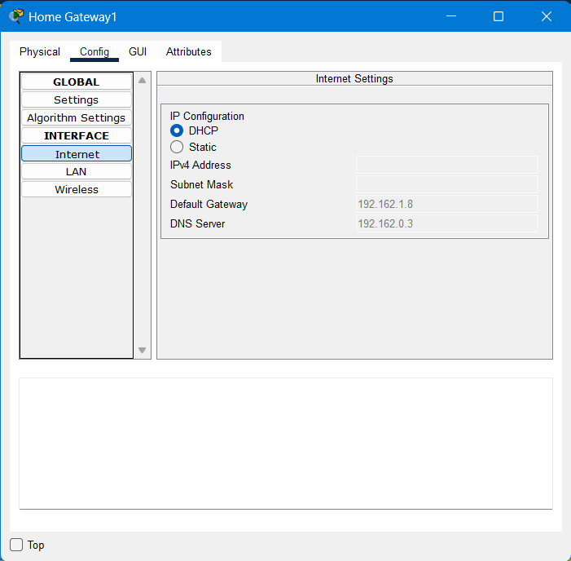
Figure 13. Activation of DHCP (Home Gateway)
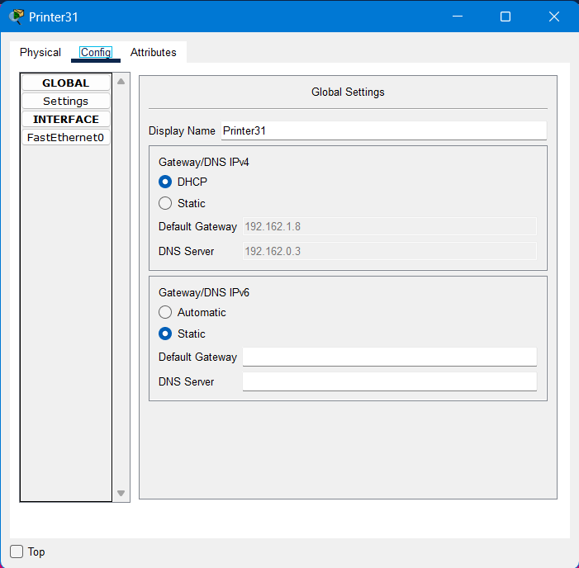
Figure 14. Activation of DHCP (Printer)

Step 3
The connection between the Switch and the IP telephones on each floor was established using the Copper Straight-Through cable type. Appropriate codes were configured on the Switch to enable communication with the IP phones. The router was used to assign IP addresses and phone numbers to the IP phones. For instance, the first IP phone was assigned the number 001, and the last IP phone was assigned the number 019.

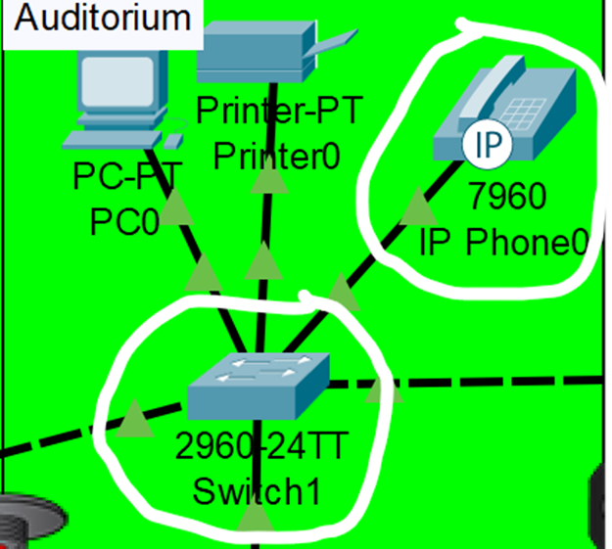
Figure 15. Physical between the Switch and the IP telephones

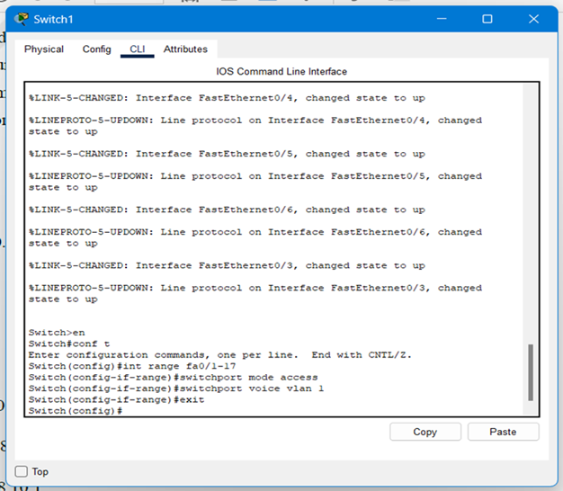
Figure 16. The setting of Switch for Ip Phone

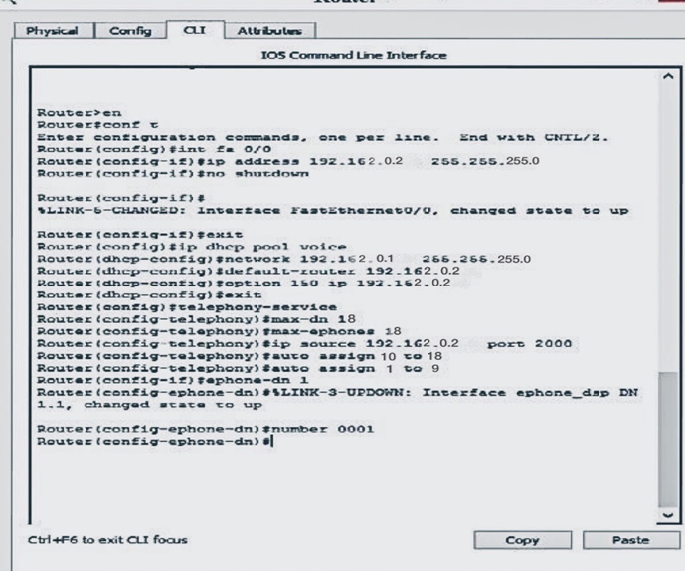
Figure 17. The Setting of Router for IP phone

Step 4
The computers, laptops, home gateways, and printers within the system are connected to the floor's switch using Copper Straight-Through cables.

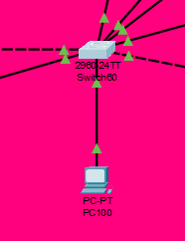
Figure 18. Connecting Switch with PC (Physical Connection)

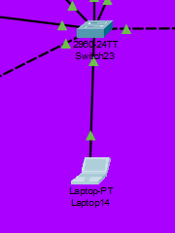
Figure 19. Connecting Switch with Laptop (Physical Connection)

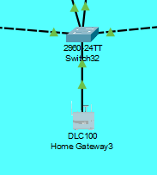
Figure 20. Connecting Switch with Home Gateway (Physical Connection)

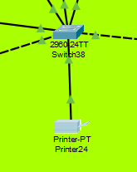
Figure 21. Connecting Switch with Printer (Physical Connection)

Step 5
The WPA2-PSK encryption method available on the Home Gateways on each floor is used to distinguish each password uniquely. The wireless settings were configured to connect the smartphone on a specific floor to the corresponding Home Gateway on that floor.

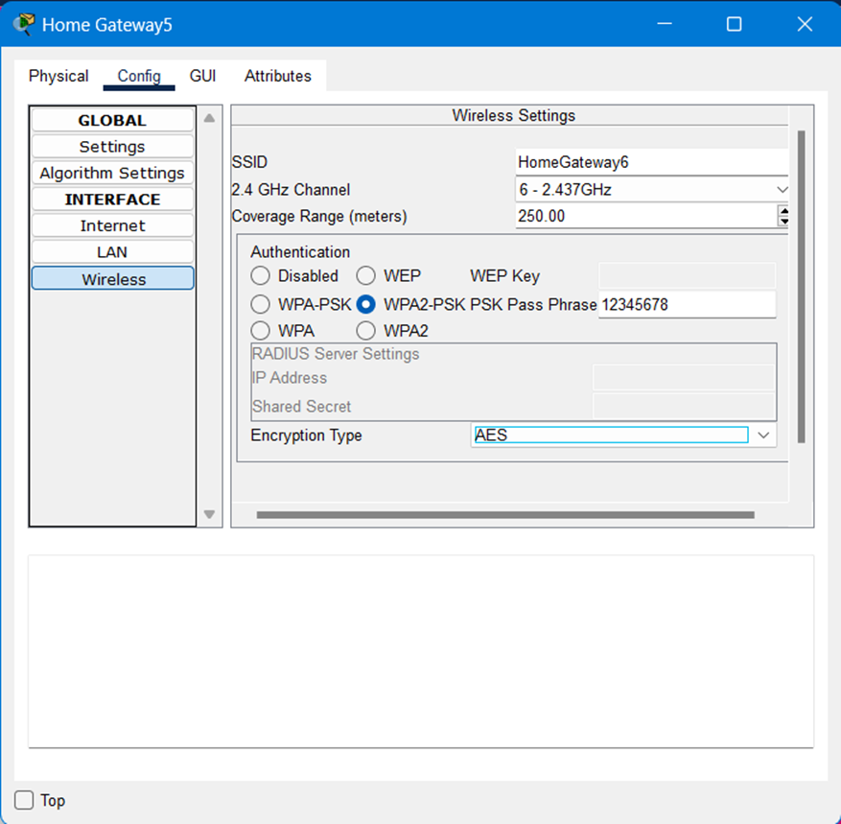
Figure 22. Home Gateway Password Adjustment

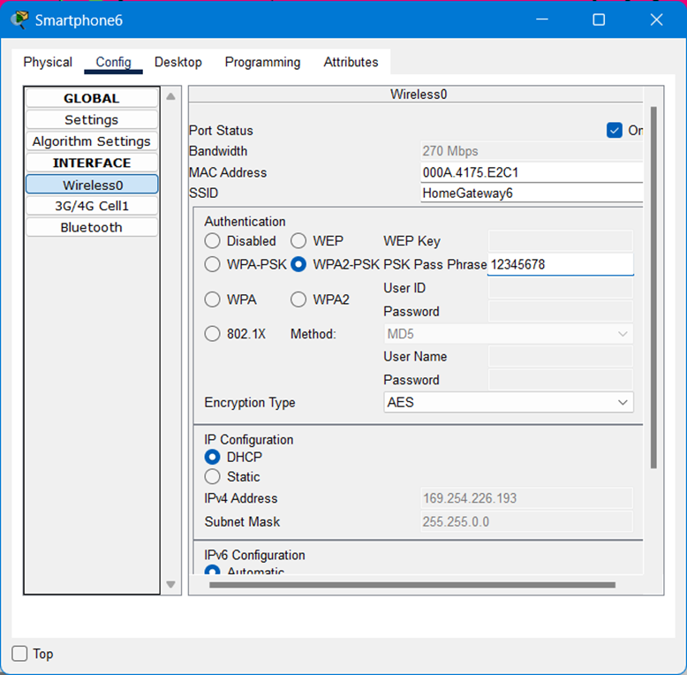
Figure 23. Adjusting Wireless Password for Smart Phone

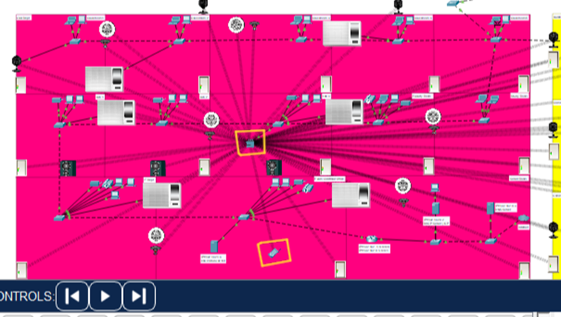
Figure 24. Wireless Connection of Home Gateway with SmartPhone

Step 6
The IoT devices on every floor of the university campus will be connected to the home gateway through wireless connections.

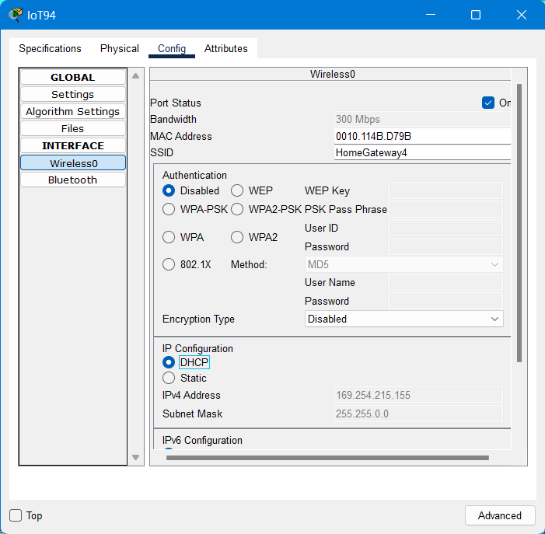
Figure 25. Activating IoT Device (door) DHCP
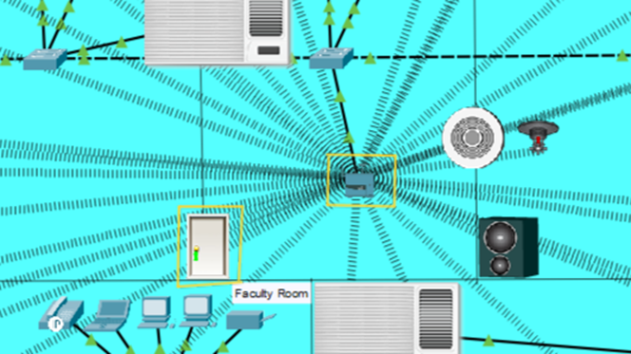
Figure 26. Wireless Connecting of Home Gateway with IoT Device(door)

Step 7
All the switches on the floors will be connected to the main switches and main Switch will be connected through a router. The last Switch will be directly connected to the external network (Internet).

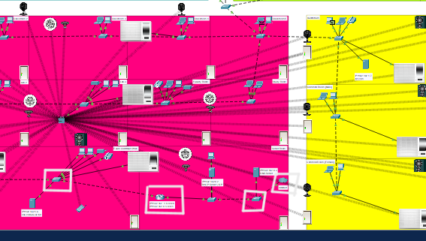
Figure 27. Physical Connectivity of Switches with Main Switch and Last Switch with the Internet

Step 8
The HTTP Servers were activated and necessary adjustments were made on the index.html file. The file structure of the HTTP Server includes index.html, contact.html, and aboutus.html. The IP addresses of the HTTP Servers were manually assigned as 192.162.1.1, 192.162.1.2, 192.162.1.3, 192.162.1.4, 192.162.1.5, and 192.162.1.6. Lastly, the HTTP Server was connected to the main Switch created for the regular network using Copper Straight-Through cable

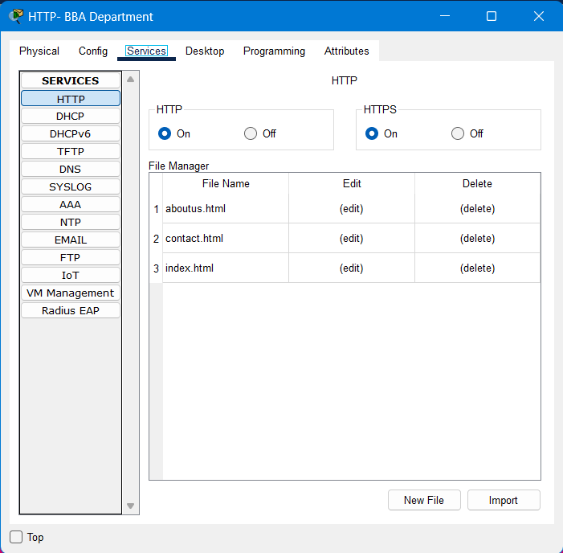
Figure 28. Activation of HTTP Server
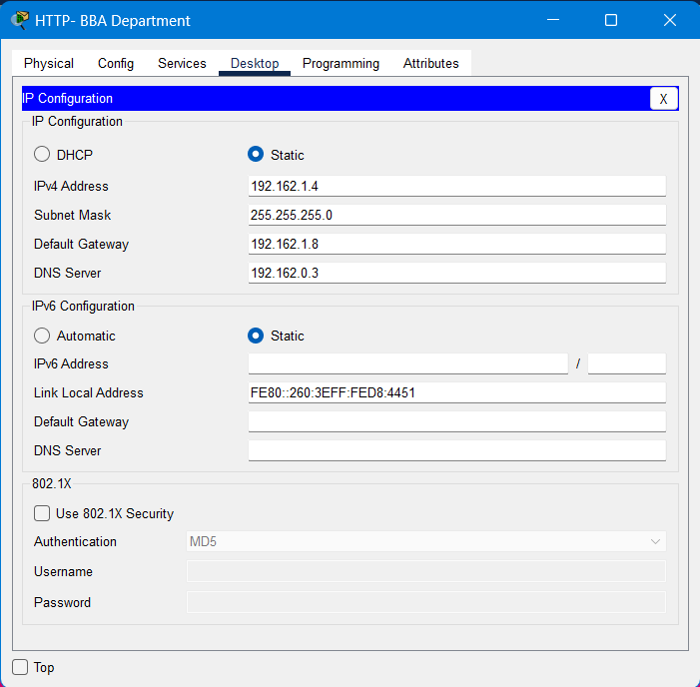
Figure 29. IP Adjustments of HTTP Server
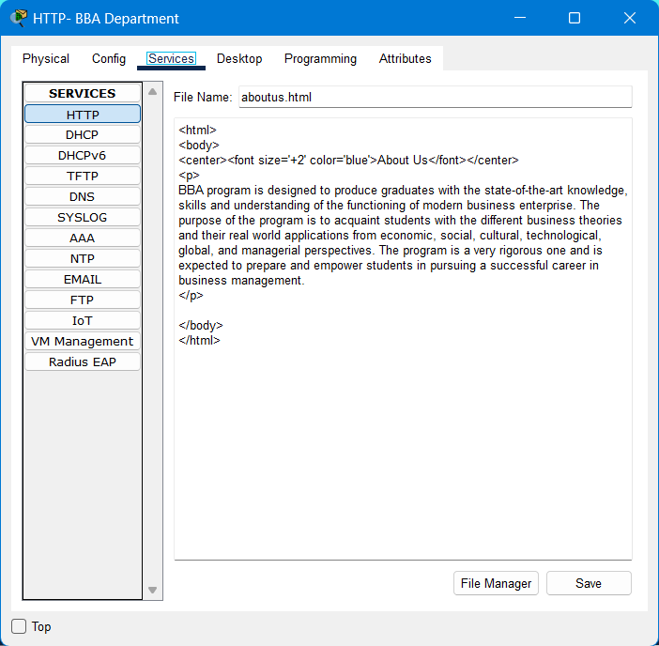
Figure 30. About Us Page Content (HTTP Server)

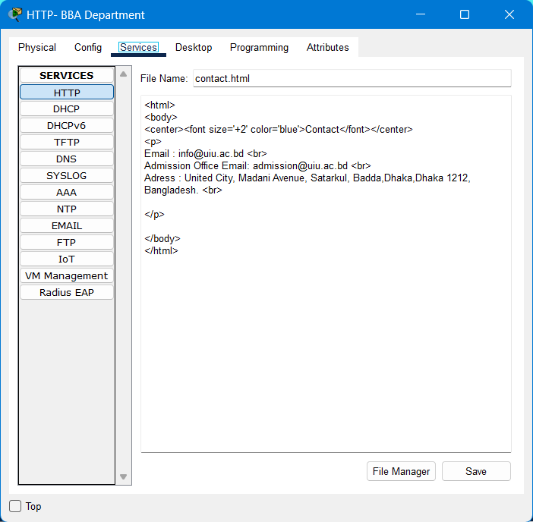
Figure 31. Contact Page Content (HTTP Server)

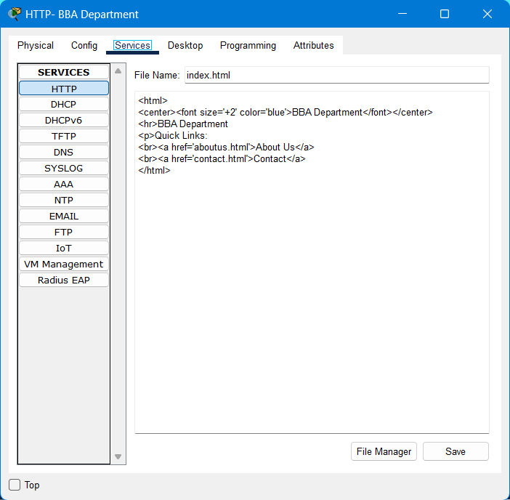
Figure 32. Index Page Content (HTTP Server)

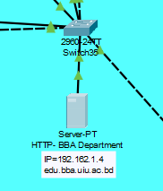
Figure 33. Connecting Switch with HTTP Server (Physical Connection)

Step 9
The DHCP Server is now active and the necessary settings have been made. The Default Gateway has been set to 192.162.0.1, the Start IP Address to 192.162.0.2, and the Subnet Mask to 255.255.255.0. The DNS Server is set to 192.162.0.3. Additionally, the DHCP IP number has been statically assigned as 192.168.0.1. Finally, the DHCP server has been physically connected to the Switch that was created for the network using a Copper Straight-Through cable type.

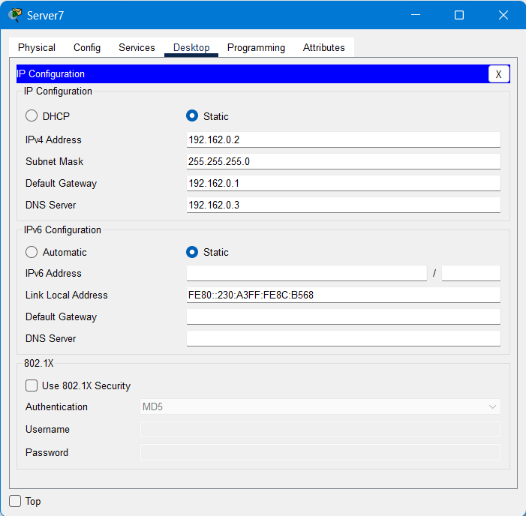
Figure 34. Adjustment of DHCP Server IP
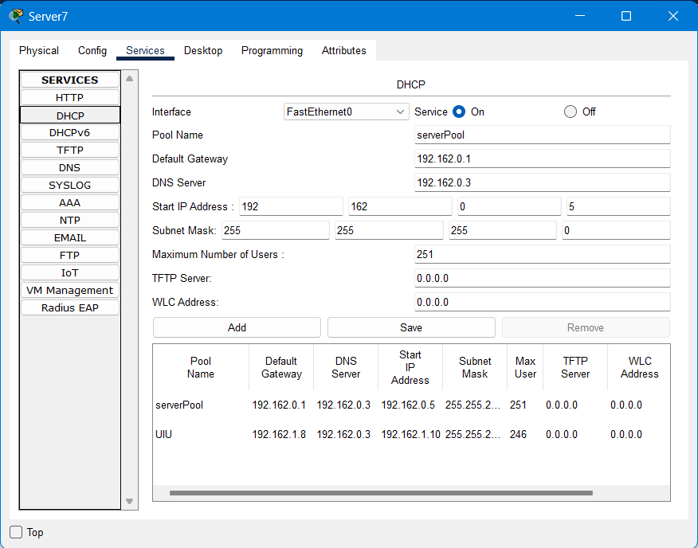
Figure 35. Ip Pool Creation Settings (DHCP Server)

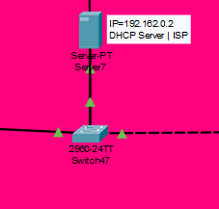
Figure 36. Connecting Switch with DHCP Server (Physical Connection)

Step 9
The DNS Server has been activated and the domain name and IP addresses of the http servers are provided as follows:
- edu.admission.uiu.ac.bd- 192.162.1.1
- edu.admin.uiu.ac.bd- 192.162.1.2
- edu.cse.uiu.ac.bd- 192.162.1.3
- edu.bba.uiu.ac.bd- 192.162.1.4
- edu.eee.uiu.ac.bd- 192.162.1.5
- edu.civil.uiu.ac.bd- 192.162.1.6
- iot.com- 192.162.1.7
The DNS server's IP address has been statically specified as 192.162.0.3.
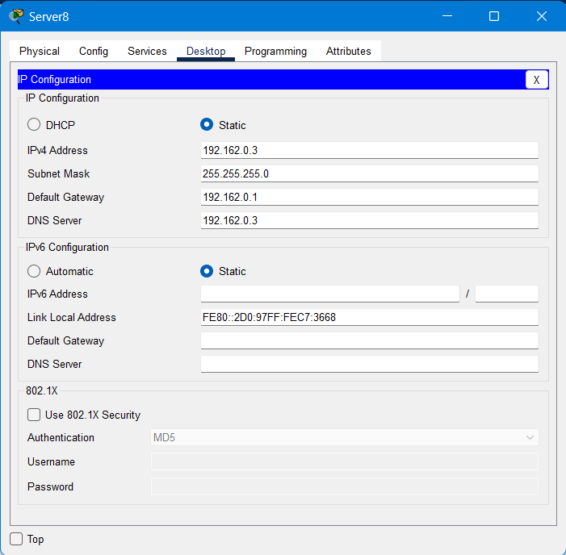
Figure 37. Adjustment of DNS Server Ip
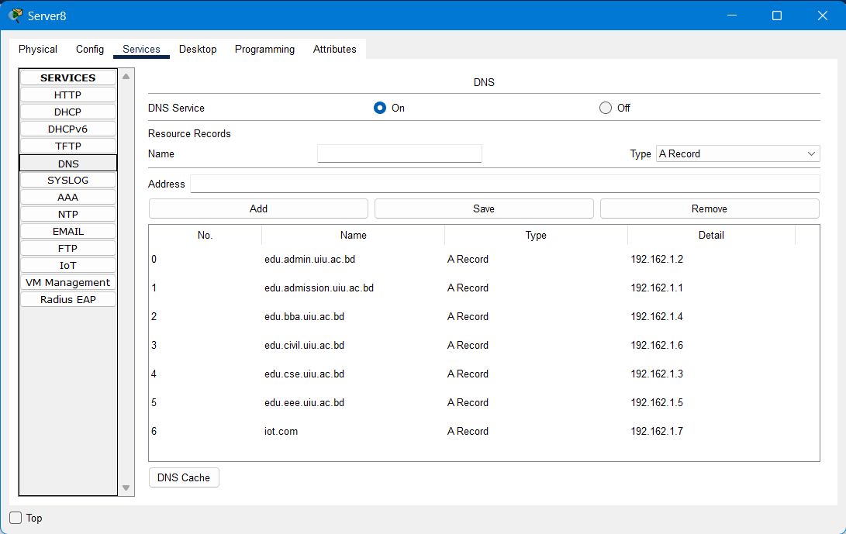
Figure 38. Adjustment of DNS Server Name and Address

Step 10
The IoT Server has been enabled with the Default Gateway set to 192.162.0.1, an IP Address assigned as 192.162.1.7, and a Subnet Mask configured as 255.255.255.0. Additionally, the DNS is specified as 192.168.10.3.

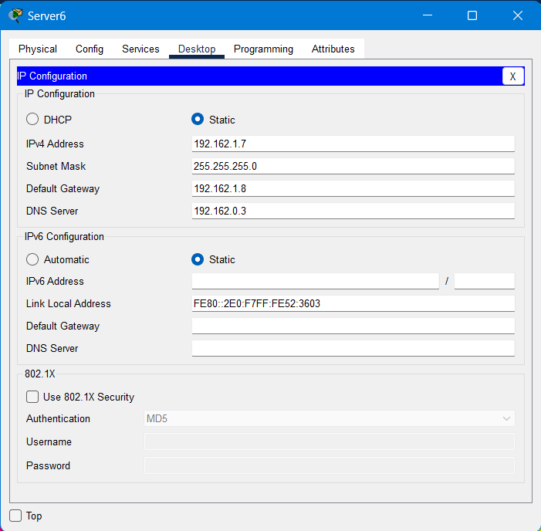
Figure 39. IoT Server IP Adjustment

Step 11
The router was configured with the necessary codes to split the network into two segments. Within the same network segments, direct connectivity is established due to switch connections between devices. For parts of the network that involve two or three switches, trunks were utilized to interconnect them. Trunks are channels that facilitate connectivity between VLANs associated with a switch. On the other hand, connectivity between routers requires network routing protocols, either static or dynamic, such as RIP (Router Information Protocol). RIP is responsible for determining the optimal path for data transmission and preventing routing loops by limiting the number of paths from source to destination devices. As such, RIP was implemented to interconnect the entire network, enabling end devices to send and receive information across different networks via the shortest and simplest path. Subsequently, the connectivity between end devices was verified.

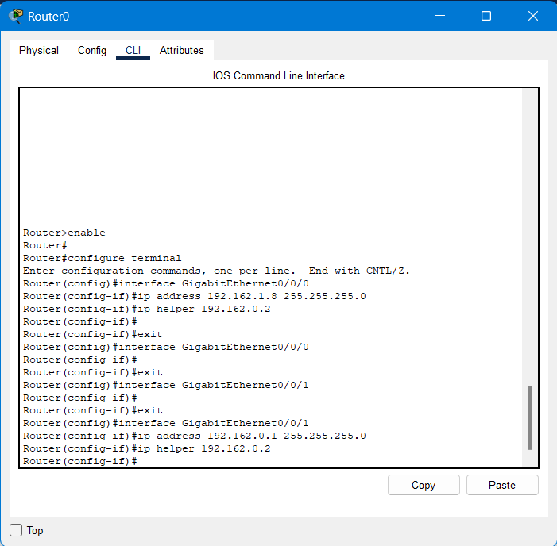
Figure 40. Reset Router

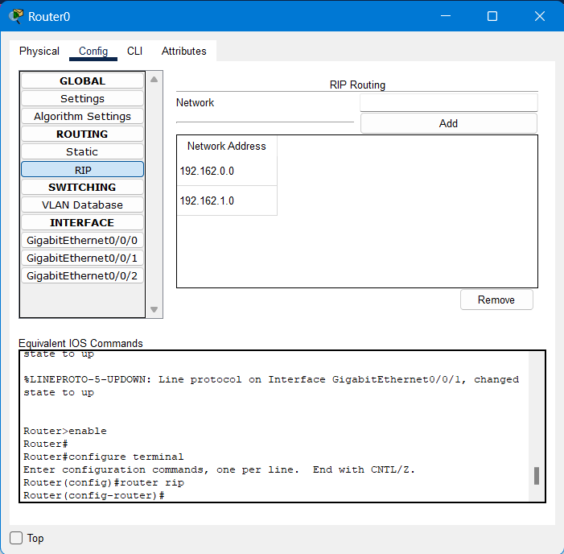
Figure 41. RIP Routing

RESULT AND DISCUSSION
This chapter divides into different sections. In this chapter, the simulation results are shown. The results have been produced by the Packet Tracer for the different scenarios.

Scenarios Scope
All of the network scenarios created using Packet Tracer were implemented to ensure the proper functioning of the network across the University campus. To achieve this, five different scenarios were executed. The first scenario involved transmitting packets between two floors or devices on the same floor. The second scenario required the use of the Command Line Interface (CLI) to ensure that all devices were connected to one another. The third scenario involved accessing the University websites and their respective pages. The fourth scenario was to test the telephone devices by making calls between phones located on different floors of the university. Lastly, the fifth scenario was aimed at monitoring the IoT devices, such as security cameras, using a smartphone to ensure that they were functioning properly. The surveillance cameras were installed throughout the university floors and were connected to the network to ensure that the security of the University campus was well maintained.

Send packet (between two floors or on the same floor ) scenario :
The first scenario involves sending a message from a computer on one floor to another computer on a different floor, while the second scenario involves sending a message from a computer to another computer on the same floor. The process of how the message is transmitted will be observed and recorded in steps. The steps are as follows:
- The packet is first sent to a switch.
- The Switch then forwards the packet to the core switch.
- The core switch redirects the packet to another switch if necessary.
- The final Switch then forwards the packet to the target device.
- Finally, the packet reaches its destination and is successfully delivered to the intended computer.
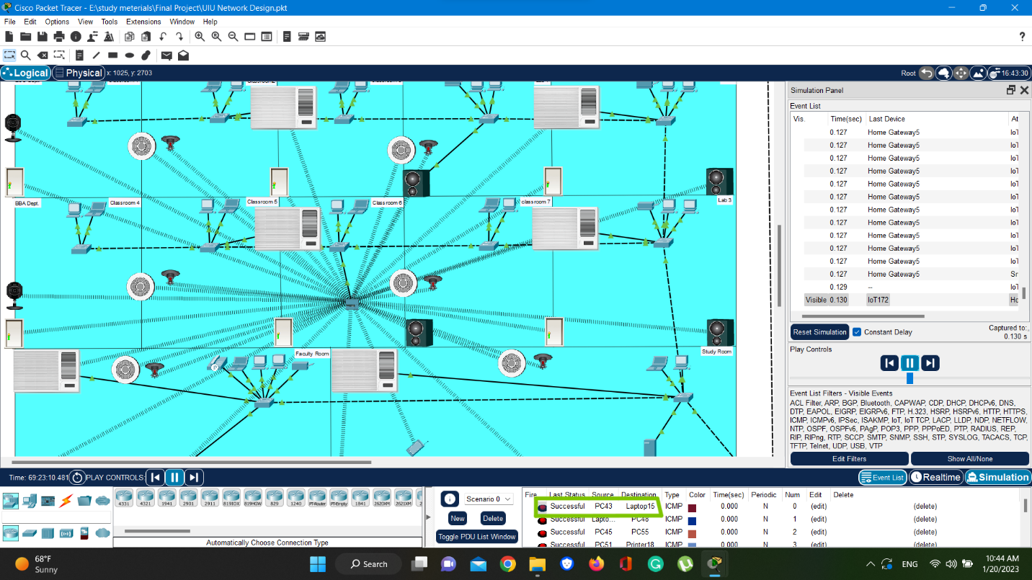
Figure 42. Send Packet (PC43 to Laptop15)

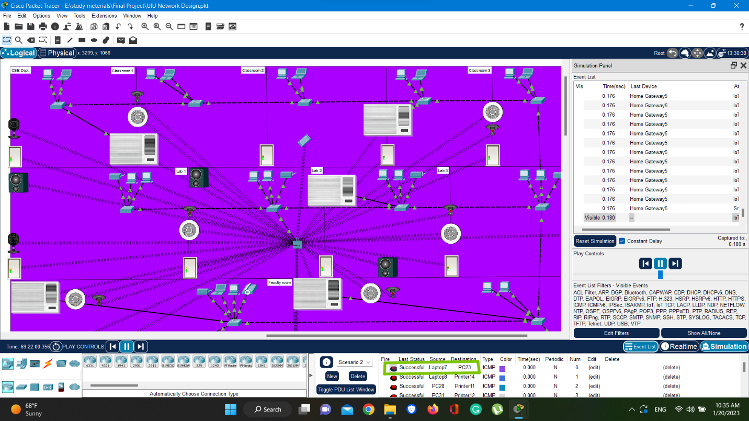
Figure 43. Send Packet (Laptop 7 to PC23)

Command Line Interface(CLI) Scenario:
This scenario involves using the command line interface (CLI) to verify connectivity between any two devices on the network. The steps are outlined as follows:
- The first step, access the interface of a computer device on any floor of the University campus and log in to the Command Prompt. After that, use the ping command to send a message between any two devices in the network and verify that the devices are able to connect to each other.

- Ping Command: The Ping Command is a useful tool used in the command line to send data over a network to another device, which then sends it back to the sender. This process helps to confirm that the device is connected to the network and provides additional information that is beneficial to information security professionals and network workers.

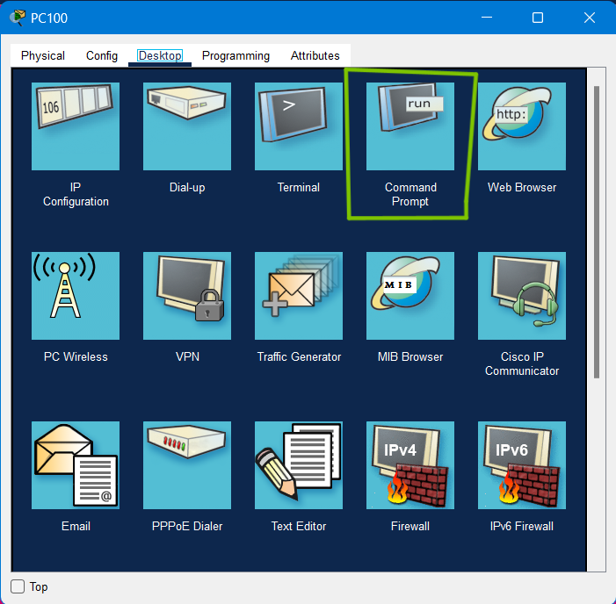
Figure 44. Scenario of Command Line Interface(CLI)

- The second step, involves specifying the IP address of the target device using the ping command, such as (192.162.1.160). After executing the ping command, the screen will display information such as the IP address to which the ping is sent in the first line, the packet size of 32 bytes in the second line, and the result of the four data packets sent in the form of one line per packet (as shown in the figure). Each line of the result indicates a reply received from the IP address (192.162.1.160), while the "Bytes=32" indicates the size of the packet sent in that attempt. The TTL (Time To Live) is also displayed, which represents the maximum time that a packet can be handled before being ignored. This information is useful for network workers and information security professionals.

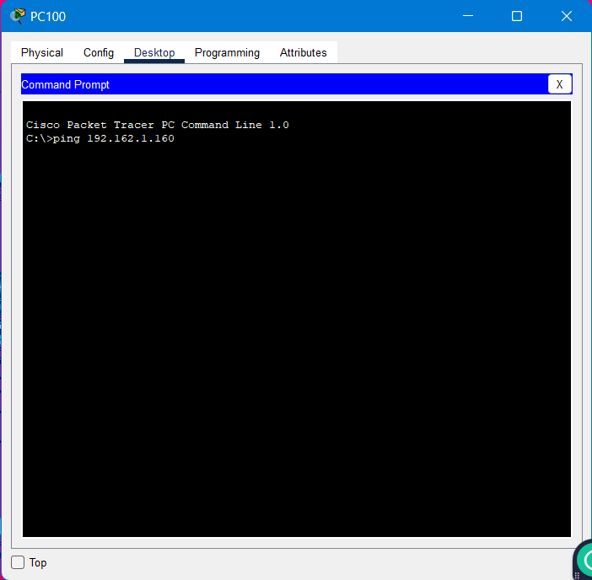
Figure 45. Scenario of Command Line Interface(CLI)
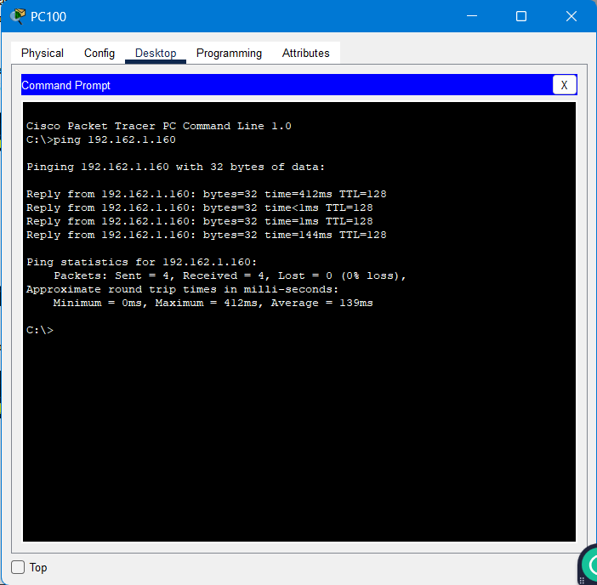
Figure 46. Command Line Interface(CLI)

University Website Scenario:
In this scenario, we will demonstrate the implementation of the University Websites for accessing their web pages as shown below:
- First step involves logging in to the BBA Department's website by accessing the interface of any network device connected to the network and clicking on the Web Browser button, as depicted in the figure.
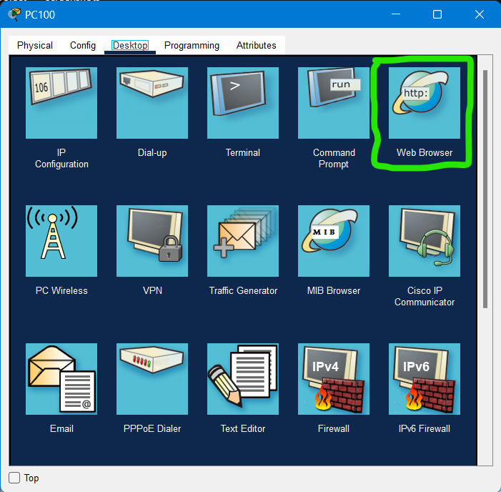
Figure 47. University Web Site

- The second step involves entering "http://192.162.1.4" (edu.bba.uiu.ac.bd) in the address line. This prompts the DNS server to resolve the IP address of hotel.com domain name. As the DNS server has the IP address of hotel.com, it directs the user to the location of the HTTP server associated with that IP address. Subsequently, the user will be presented with the web interface, as depicted in the figure, displaying the phrase "BBA Department" on the page.
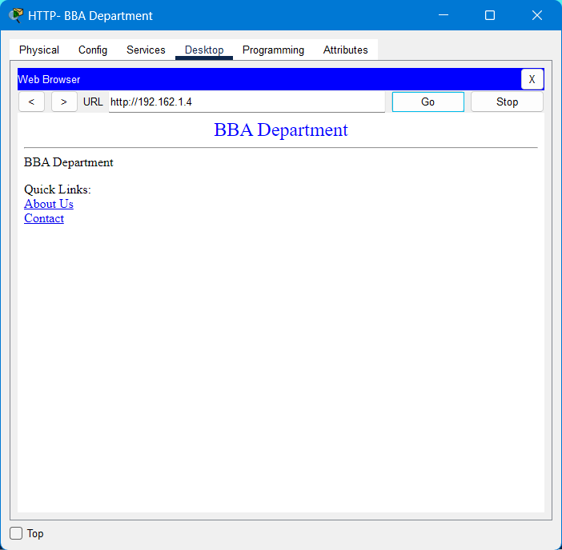
Figure 48. University Web Site (BBA Department)

IP-Phone Scenario:
In this scenario, we will see the utilization of an IP-Phone device to demonstrate that the network is also capable of supporting telephone devices by making a call between two phone devices located on different floors of the university building, specifically the Accounts & Finance department (First floor) and the Logistics department (Third floor). Initially, the user would access the interface of the phone located in the Accounts & Finance department (First floor). The user would then enter the phone number of the Logistics department phone (0006) into the phone. The user would then open the interface of the phone located in the Logistics department (Third floor) and answer the call by clicking on the phone.

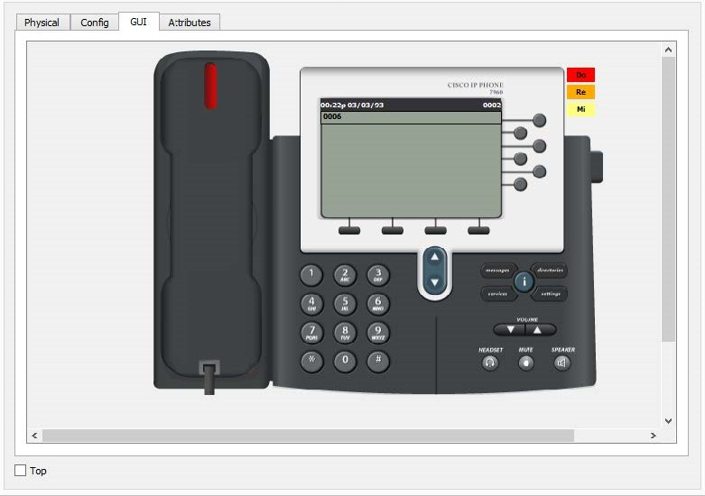
Figure 49. Make Telephone Call

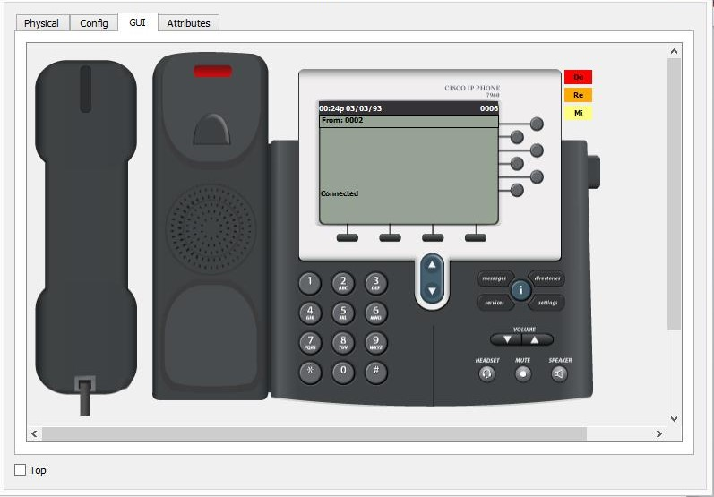
Figure 50. Make Telephone Call

IoT Device (CCTV) Scenario:
This scenario involved using a smartphone to monitor IoT devices, such as security cameras, to ensure their proper functioning throughout the university campus. The security cameras were connected to the network to maintain the safety of the campus. To monitor the cameras, follow these steps on a networked device:
- Open the web browser by accessing the interface of the networked device (as shown in the figure).
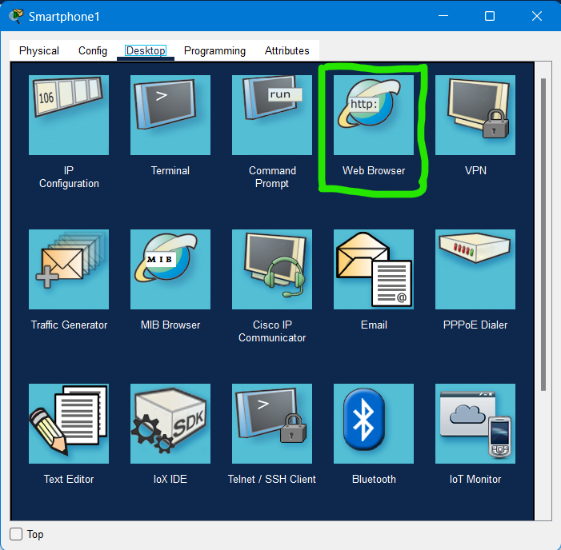
Figure 51. Monitoring IoT Devices (CCTV)

- Enter the IP address of the IoT server, 192.162.1.7 into the address line. Log in to the system by providing the specified username and password (as shown in the figure).

- Once logged in, select the floor that needs to be monitored (as shown in the figure).

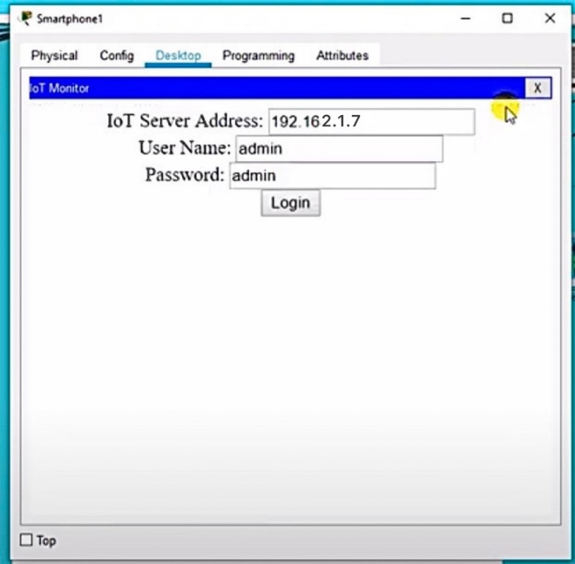
Figure 52. Monitoring IoT Devices (CCTV)

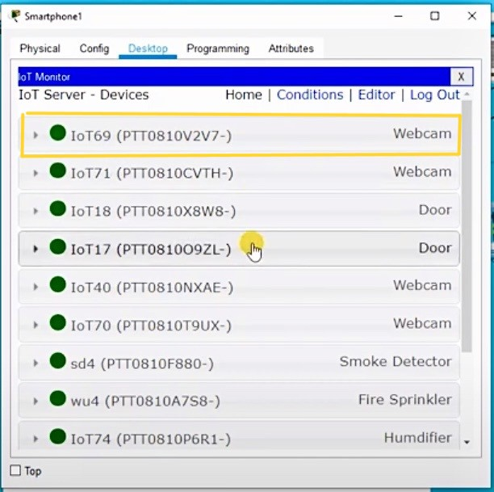
Figure 53. Monitoring IoT Devices (CCTV)

Simulation images of the project:

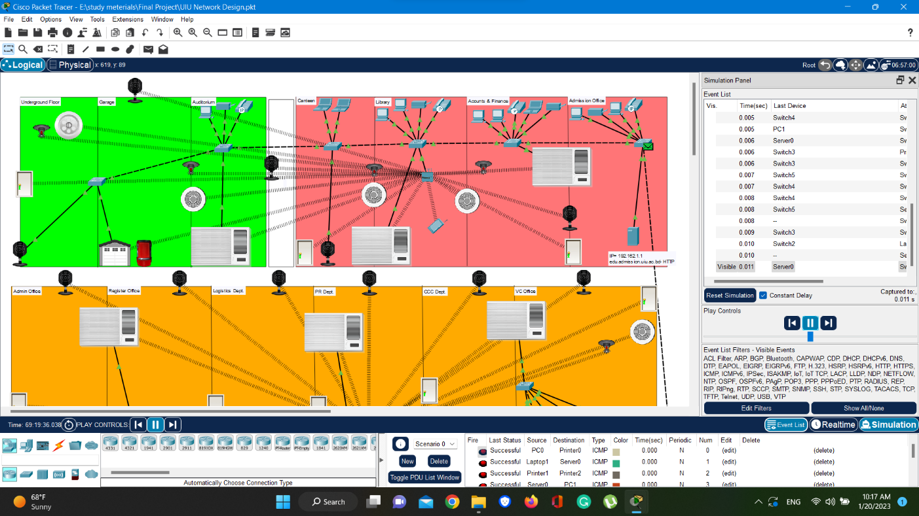
Figure 54. Simulation image of the 1st floor

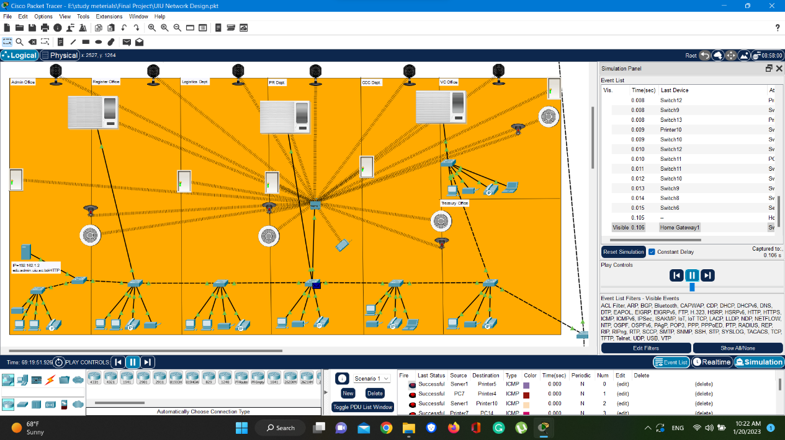
Figure 55. Simulation image of the 2nd floor
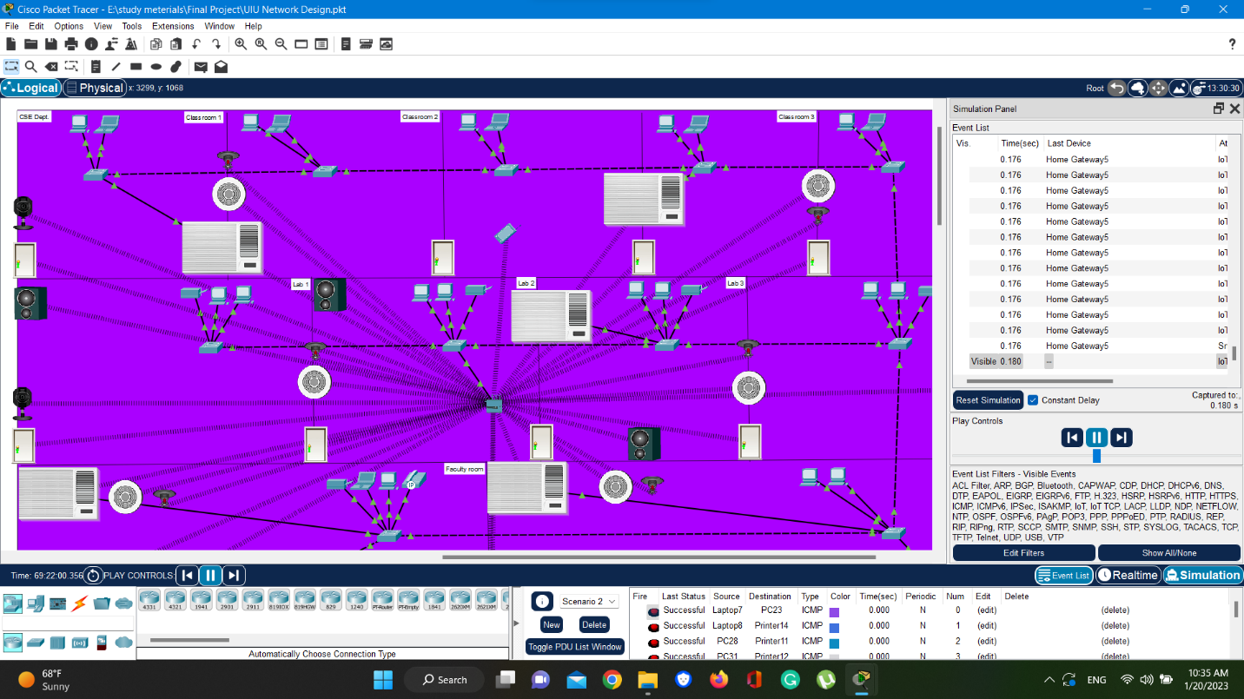
Figure 56. Simulation image of the 3rd floor

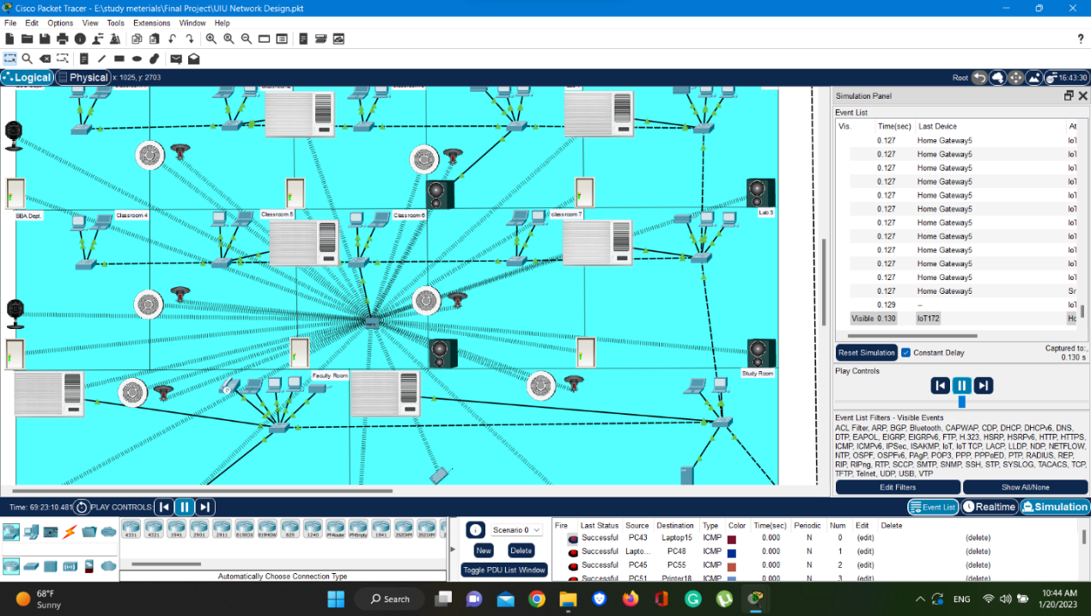
Figure 57. Simulation image of the 4th floor

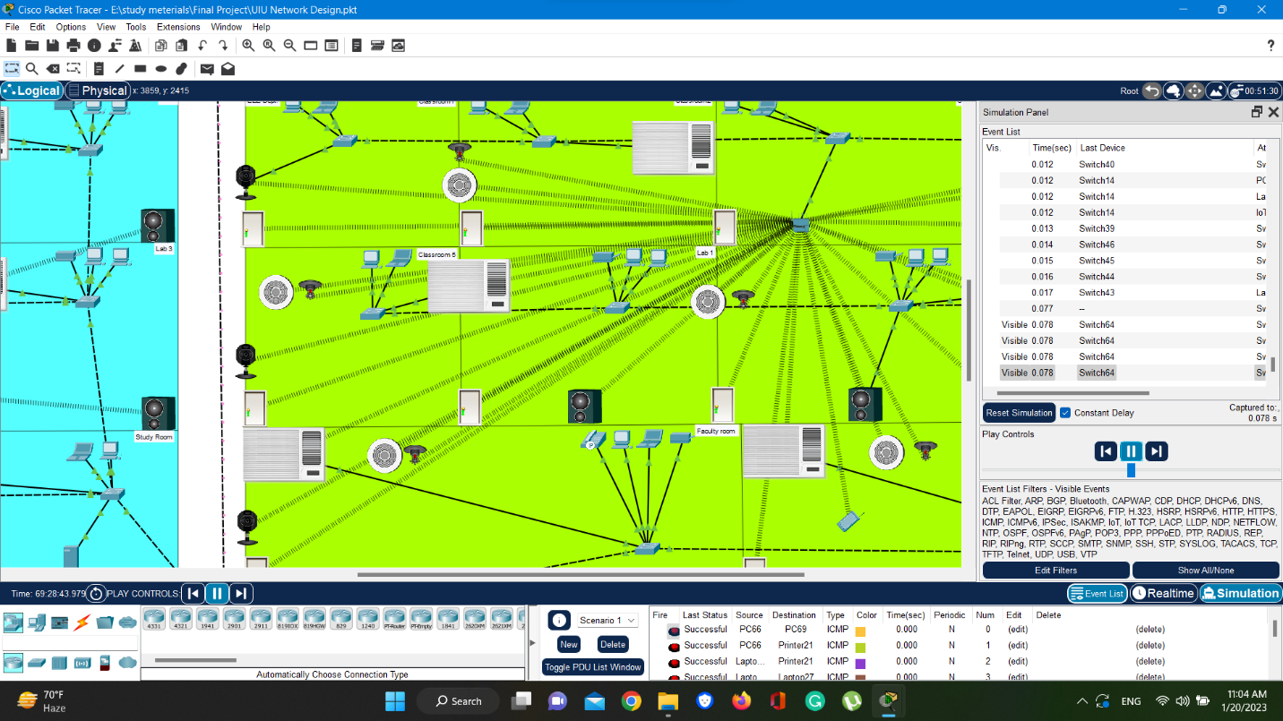
Figure 58. Simulation image of the 5th floor

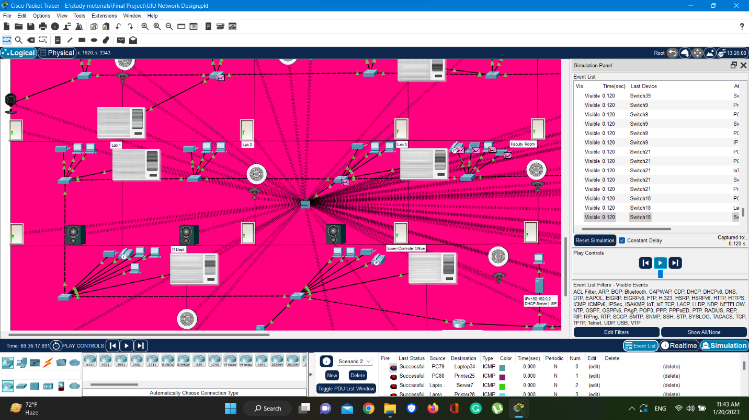
Figure 59. Simulation image of the 6th floor

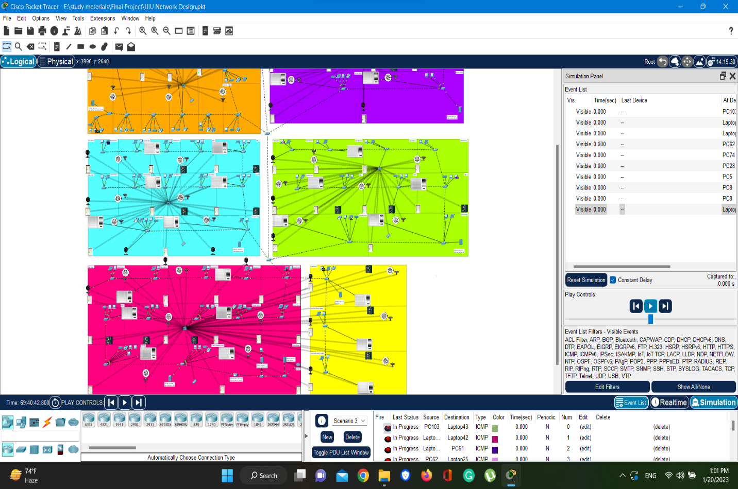
Figure 60. Simulation image of the University Building

The observation revealed that the network system was functioning smoothly. However, in case any issue arises, such as internet interruption or faulty cables, it is necessary to examine the DHCP, IP configurations, and other devices' IP addresses, switches, and routers.

Conclusion

Cisco Packet Tracer is a popular simulation tool used in computer network courses. It offers a user-friendly graphical interface and allows learners to build, configure, and troubleshoot networks in a virtual environment. The tool has two types of workspace, logical and physical, and operates in two modes, real-time and simulation. One of the main advantages of Packet Tracer is its low resource consumption, which results in lower costs compared to other network simulation software. Additionally, the simulation mode allows learners to understand data transmission and propagation across the network by capturing and explaining the contents of the packets from source to destination.
This study implemented Cisco Packet Tracer to design and implement a campus network architecture for an eight-story university building. The network map consisted of routers, switches, home gateways, personal computers, laptops, servers, printers, televisions, smartphones, air conditioners, fans, fire sprinklers, garage doors, home speakers, lawn sprinklers, motion detectors, smoke detectors, alarms, webcams, windows, cloud (internet), old cars, and other network devices.
The server room was located on the sixth floor, where the router, last Switch, DHCP server, and DNS server were placed. The DHCP server provided automatic IP distribution to networked devices, and the DNS server identified the DNS in the network and replied to the request for the website. The HTTP servers were responsible for the accommodation of the university websites. The IoT server provided remote access to smart devices, especially cameras, in this study.
Home Gateway was used for wireless connection in floors, and the Switch connected physically connected devices to enable communication. The IP Phone ensured communication between floors, and the printer was placed in the network for various purposes. The IoT server was utilized to connect users to IoT-enabled smart devices, especially cameras, which were used to prevent security problems.
After completing the necessary configurations and setting up the connections, advanced network simulation was established. The network system was operated without any problems, as proven by the five experimental scenarios that were implemented. These scenarios involved sending messages between computers on different floors, using the command line interface between any two devices in the network, testing the implementation of university HTTP websites, utilizing an IP-Phone device to demonstrate that the network supports telephone devices, and using a smartphone to monitor IoT devices, such as security cameras, throughout the campus.
Overall, this study demonstrated how to establish a topology using Cisco Packet Tracer, which can be used by anyone interested in learning how to establish a new topology by using the system via the internet or in the lab. The methodology used in this study can help learners establish their topology without wasting any equipment.

Reference

- Erol, A. (2020, January 5). https://iupress.istanbul.edu.tr/tr/journal/jspc/article/kultur-endustrisinden-dijital-kapitalizme. Sosyal Siyaset Konferansları Dergisi/Journal of Social Policy Conferences. https://doi.org/10.26650/jspc.2020.79.0051.
- COLLEGE CAMPUS NETWORK SCENARIO DESIGN & IMPLEMENTATION BY USING CISCO PACKET TRACER. (2023, March 16). International Research Journal of Modernization in Engineering Technology and Science. https://doi.org/10.56726/irjmets34445.
- Ahmed, A. H., & A. Al-Hamadani, M. N. (2021, July 1). Designing a secure campus network and simulating it using Cisco packet tracer. Indonesian Journal of Electrical Engineering and Computer Science, 23(1), 479. https://doi.org/10.11591/ijeecs.v23.i1.pp479-489.
- Design and Implementation of Smart Home using Cisco Packet Tracer Simulator 7.2. (2019, October 11). International Journal of Innovative Technology and Exploring Engineering, 8(11S), 107–111. https://doi.org/10.35940/ijitee.k1024.09811s19.
- Binti Zailani, & Binti Ismail. (2022, August). Effectiveness of using Cisco Packet Tracer as learning tools for Network Fundamentals course during the Covid-19 pandemic. ResearchGate. https://doi.org/10.6084/m9.figshare.22550071
- AlSarhan. (2016, December 19). Information Technology Capstone Research Project Report. In Computer Network Design for Universities in Developing Countries. Retrieved January 16, 2017, from https://scholar.valpo.edu/cgi/viewcontent.cgi?article=1002&context=itcrpr
- Phuloria, & Maske. (2020, May). Networking in University. In https://fayllar.org. Manipal University Jaipur . Retrieved July 2020, from https://fayllar.org/download/networking-in-university.doc
- YADAV . (2020, July). ENERPRISE NETWORK. In https://www.slideshare.net/. Dr. A.P.J. Abdul Kalam Technical University. https://www.slideshare.net/KulsumKhan13/final-report-on-enterprise-network
- Y. Kanojkar, R. Kapgate, S. Charde, B. Khadse, & N. Bhujade. (n.d.). Designing Advanced College Network using Cisco Packet Tracer. International Journal for Scientific Research & Development, 7(Issue 01 2019), 442–445. https://www.ijsrd.com/articles/IJSRDV7I10586.pdf
- THERA. (2020, June). INTERNET OF THINGS SIMULATION USING CISCO PACKET TRACER. In https://gcris.iyte.edu.tr. Graduate School of Engineering and Sciences of İzmir Institute of Technology. Retrieved April 10, 2023, from https://gcris.iyte.edu.tr/bitstream/11147/11000/1/10233220.pdf
- H. Ahmed, & N. A. Al-Hamadani. (2021, July). Designing a secure campus network and simulating it using Cisco packet tracer. Indonesian Journal of Electrical Engineering and Computer Science, Vol. 23(1), 479–489. https://doi.org/10.11591/ijeecs.v23.i1
- MOHAMMED ABDULKAREEM. (2018). IMPLEMENTATION OF CISCO PACKET TRACER IN ADVANCE COMPUTER NETWORK. In http://openaccess.altinbas.edu.tr. ISTANBUL ALTINBAS UNIVERSITY GRADUATE SCHOOL OF SCIENCE AND ENGINEERING. http://openaccess.altinbas.edu.tr/xmlui/bitstream/handle/20.500.12939/1694/Implementation%20of%20cisco%20packet%20tracer%20in%20advanced%20computer%20network%C2%A0%EF%BB%BF.pdf?sequence=1&isAllowed=y
- Cisco Networking Academy. (n.d.). Cisco. https://www.cisco.com/c/tr_tr/training-events/networking-academy.html
- Odom. (2004, April 21). Computer Networking first-step [1-58720-101-1]. Cisco Press. https://vulms.vu.edu.pk/Courses/CS206/Downloads/Cisco.Press.Computer.Networking.First.Step.Apr.2004.INTERNAL.pdf
- (2004). Implementation of the NetAcad program. In https://www.academia.edu. https://www.academia.edu/28413423/Implementation_of_standardized_educational_courses_at_the_Faculty_of_management_science_and_informatics_University_of_Zilina_Implementation_of_the_NetAcad_
- (2007). Network Analysis, Architecture, and Design (3rd Edition) [PDF]. Morgan Kaufmann Publishers is an imprint of Elsevier. https://books.google.com.bd/books?hl=en&lr=&id=iddGPgR48_MC&oi=fnd&pg=PP1&dq=J.+D.+McCabe,+Network+analysis,+architecture,+and+design:+Elsevier,%0D%0A2010.&ots=Y7yrS5BGZF&sig=kbscnzVsBuhkO3EkX1shgPLSFWE&redir_esc=y#v=onepage&q=J.%20D.%20McCabe%2C%20Network%20analysis%2C%20architecture%2C%20and%20design%3A%20Elsevier%2C%20%202010.&f=false
- Pioro, & Medhi. (2004, July 1). Routing, Flow, and Capacity Design in Communication and Computer Networks (1st edition) [EBook ISBN: 9780080516431]. https://www.elsevier.com/books/routing-flow-and-capacity-design-in-communication-and-computer-networks/pioro/978-0-12-557189-0
- Patterson, & L. Hennessy. (2009). Computer Organization and Design (Forth edition) [PDF]. Elsevier Inc. http://staff.ustc.edu.cn/~llxx/cod/reference_books/Computer%20Organization%20and%20Design%204th.pdf
- T. McMillan, Cisco networking essentials: John Wiley & Sons, 2015.
- D. Anfinson and K. Quamme, IT Essentials: PC Hardware and Software Companion Guide: Cisco Press, 2008.
- Dye, M., McDonald, R., & Rufi, A. (n.d.). Network Fundamentals, CCNA Exploration Companion Guide. Cisco Press.
- Tkach, R. W. (1993, July 1). Book Rvw: Fiber-Optic Communication Systems. By Govind P. Agrawal. Optical Engineering, 32(07), 1696. https://doi.org/10.1117/1.oe.32.7.bkrvw2
- Nadeem, F. A., & Sarkar, P. (2013, January 1). Implementing Cisco Ucs Solutions.
- KABIR, A. I., MITRA, S., AKTER, S., ISLAM, M. R., & DAS, S. S. (2022, March 30). Developing a Network Design for a Smart Airport Using Cisco Packet Tracer. Informatica Economica, 26(1/2022), 25–38. https://doi.org/10.24818/issn14531305/26.1.2022.03
- Noergaard, T. (2010, January 10). Embedded Systems Architecture: a Comprehensive Guide for Engineers and Programmers. Newnes.
- Lowe, D. (2004, January 20). Networking All-In-One Desk Reference for Dummies. For Dummies. https://doi.org/10.1604/9780764559075
- Abraham, A., Dutta, P., Mandal, J. K., Bhattacharya, A., & Dutta, S. (Eds.). (2019, January 18). Emerging Technologies in Data Mining and Information Security: Proceedings of IEMIS 2018, Volume 1 (Vol. 755). https://doi.org/10.1007/978-981-13-1951-8
- Dorathy, I., & Chandrasekaran, M. (2018, June 28). Simulation tools for mobile ad hoc networks: a survey. Journal of Applied Research and Technology, 16(5). https://doi.org/10.22201/icat.16656423.2018.16.5.739
- Makasiranondh, Woratat & Maj, Stanislaw & Veal, D.. (2010). Pedagogical evaluation of simulation tools usage in Network Technology Education. World Transactions on Engineering and Technology Education. 8. 321-326. https://www.researchgate.net/publication/288470760_Pedagogical_evaluation_of_simulation_tools_usage_in_Network_Technology_Education
- Chapter 3: Hardware. (n.d.). Chapter 3: Hardware. https://fcit.usf.edu/network/chap3/chap3.htm
- Hura, G. S. (2001, January 1). Data and Computer Communications: Networking and Internetworking. CRC Press.
- What is Networking (computer)? | Definition from TechTarget. (2018, June 1). Networking. https://www.techtarget.com/searchnetworking/definition/networking
- https://www.isi.edu/nsnam/ns/doc/node54.html. (n.d.). https://www.isi.edu/nsnam/ns/doc/node54.html
- Chapter 5: Topology. (n.d.). Chapter 5: Topology. https://fcit.usf.edu/network/chap5/chap5.htm
- Author, P. (n.d.). What is FDDI (Fiber Distributed Data Interface) ?http://turnpcon.blogspot.com/2016/03/explain-about-fddi.html
- Network Switches. (n.d.). Cisco. https://www.cisco.com/site/us/en/products/networking/switches/index.html

