Provision of Foreign Exchange Services:

A Study on United Commercial Bank Limited


United International University
Internship Report
On
Provision of Foreign Exchange Services:
A Study on United Commercial Bank Limited

Submitted to
Muhammad Hasan Al-Mamun
Assistant Professor
School of Business and Economics
United International University

Submitted by:

Nishat Jahan
ID: 111 151 375
BBA Program
School of Business and Economics

Submission Date: 23 September, 2019

Acknowledgement

Toward the start, I might want to offer my genuine thanks to Almighty, the most kind and helpful for enabling me to set up the report inside the scheduled time.

I likewise need to thank particularly to my internship supervisor Muhammad Hasan Al-Mamun, Assistant Professor, School of Business and Economics, United International University for her inspiring guidelines, important proposal, valuable analysis and steady help all through the work and in readiness of this report.

I additionally offer my warm thanks and heartfelt gratitude to the administration and authorities of United Commercial Bank Limited, Elephant Road Branch who have allowed me the chance to work with them and helped a ton by giving the data and empowering me to set up this report. I have gotten their liberal assistance and backing.

I might want to accept the open door to offer my wholehearted thanks to my kindred companions, precious ones who offered consolation, data, motivation and help over the span of building this report.

Letter of Transmittal

September 23, 2019

Muhammad Hasan Al-Mamun
Subject: Submission of internship report

Dear Sir,

With extraordinary joy I am presenting my Internship Report on "Provision of Foreign Exchange Services: A study on United Commercial Bank Limited" in view of my three months temporary position period. This report has been submitted as a significant necessity of BBA educational plan. The entry level position program has given me a chance of having an introduction to the workplace and hands on involvement in the General Banking Division, General Advance, Foreign Exchange Advance of an eminent private business bank, United Commercial Bank Ltd. I have observed the examination to be very intriguing, useful and quick.

I have attempted my level best to set up a successful and respectable report. I trust you will discover this report centrality of all the exertion I have placed in it.

I welcome your whole inquiry and invest wholeheartedly to answer them.

Yours truly,

…………………..
Nishat Jahan
ID- 111151375
United International University

Executive Summary

This internship report “Provision of Foreign Exchange Services of United Commercial Bank Limited” is really supported by the knowledge and skills gathered from the internship period at foreign exchange department United Commercial Bank Limited, Elephant Road Branch Dhaka. The objectives of this subject are to analyze the general banking services provided by this bank and also to evaluate the mechanism of providing foreign exchange services provided by United Commercial Bank limited. The report uses knowledge both from primary and secondary sources. To collect the primary data for this report I even have interacted with individuals and had face to face interaction with the senior bankers. Secondary data were acquired from the annual reports of the bank, and internet sites of the banks and relevant magazines, books.
The employees of United Commercial Bank Limited are serious regarding their works. They maintain a protocol to ascertain a good relationship with existing clients and new clients. This report focuses on foreign exchange services provided by the United Commercial Bank Limited and its overall procedure of trade. The United Commercial Bank Limited emerged as a commercial bank and launched its operation in mid-1983. The bank has 187 branches everywhere the country up to 2019.
The first one month I worked general Banking Division. In the second month, I worked in the foreign exchange department. I also learned different types of LC, LC opening, payments technique, Bank grantee register, LCF forms and gain a clear idea about the export and import method. The details of the mechanism of providing the foreign exchange services to the clients are reported in this report with due clarity.
Key Words: Commercial Bank, Foreign Exchange Services

Table of Contents

Chapter No. |  | Contents | Page No.
Chapter One |  | Introduction  - Topic in Hand  - Context of the study | 01-02  02  02
Chapter Two |  | Company Background and Industry Perspectives  2.1 Company Background  2.2 Industry Perspectives | 03-09  04-06  07-09
Chapter Three |  | Objective and Methodology of the Study  3.1 objectives of the Study  3.2 Methodology of the Study | 10-11  11  11
Chapter Four |  | Findings of the Study | 12-22
Chapter Five |  | Provision of Foreign Exchange Services:  A Study on United Commercial Bank Limited | 23- 41
Chapter Six |  | Foreign Exchange Performance | 42-46
 |  | Recommendations and Conclusion | 47-48
 | Reference |  | 49

CHAPTER: ONE

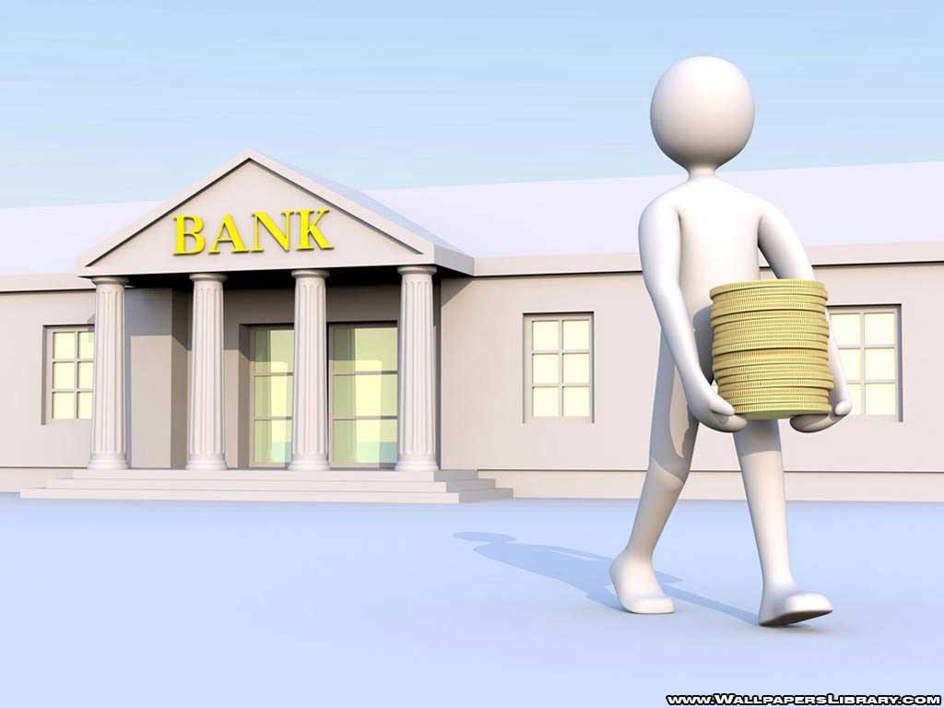
INTRODUCTION

  - Topic in Hand:

The real reason for this report is to understand the varied piece of the remote exchange trade of exchange Operation of the United Commercial Bank Limited. Numerous targets consider financial organization structure and survey the presence of out of doors exchange division. Here equally cross-check on completely different measures and rule of toll and import traditions and obtain information concerning the operate of the exchange Department. On account of cooperating domestically or all around, patrons and shippers have sure elementary objectives. Whereas acknowledgment with neighborhood mercantilism practices makes selecting some technique, mercantilism remote markets will have all the earmarks of being tangled and risky. Expanded geographic partition, obscure vernaculars, conventions, rules and trade practices could build us hesitant to enter the worldwide field. A pleasant understanding of the portion choices will facilitate their annihilation innumerable the difficulties usually skilled in overall exchange.

  - Context of the Study:
The fundamental target of the People’s Republic of Bangladesh government is to accomplish high money development as per gift monetary arrangement. To accomplish this goal, the money division assumes an essential job. Joined commercial bank full-service bank depository money institution bank banking concern banking company restricted is that the bank that is another contestant within the non-public financial scenario of the People’s Republic of Bangladesh. It likewise works in the People’s Republic of Bangladesh or quite a whereas as a nation one among the good bank. Joined banking companies strained leads to a large variety of business banking exercises. The middle administration or business involves Import/ Export account, assets fund, and company cash. Outside exchange activity is one among the foremost vital exercises o the bank. It allows company customers to assemble their organizations by giving cash connected and very important exhortation and things. The outside exchange contains Import and Export space and the foreign remission department contains inward and outward remittance. With its solid pledge to the money advancement of the state, the bank has formally created a selected imprint within the domain of personal space banking through tailored administrations, creative practices, dynamic methodology, and productive administrations, creative practices, dynamic methodology, and productive administration. The bank attending to assume the main job within the financial exercise of the state is immovably occupied with the advance o exchange, business, and business through an original credit strategy.

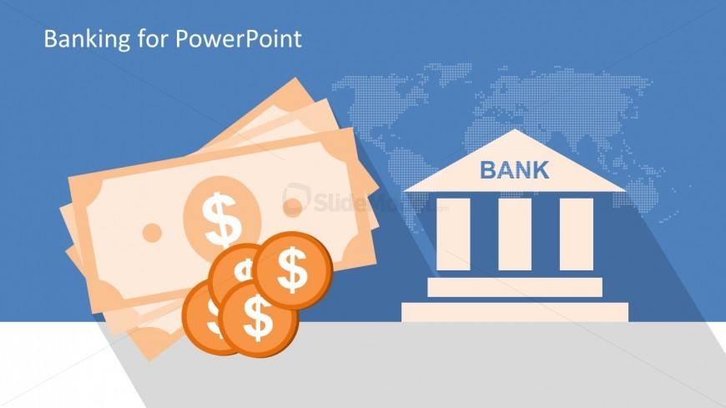
CHAPTER: TWO

Company Background and Industry Perspectives

  - Company Background:

- Company Profile:
With a robust duty of the financial and social improvement of People's Republic of Bangladesh, United Commercial Bank (UCB) started its voyage in mid-1983 and has since had the choice to line up and jointly of the best distinctive banks within the country. With associate large arrangement of 187 branches the Bank has with success created an indisputable engraving within the area of Personal Sector Banking through redid organization, innovative practices, dynamic system and capable Management.
The Bank has expanded its field in several and contrastive areas of banking like Retail Banking, SME Banking, company Banking, Off-shore Banking, and payment, etc. aside from varied store and advance consequences of Retail Banking, the Bank caters charge and credit to justifying up-and-comers that during this manner helps the final economy of the country through extended obtaining of outdoor exchange. alternative shopper things like UCB Cards are exhibiting vast accomplishment and improvement since its begin in 2006 and when a brief time remodeled into the pioneer in handy publicize with around 40000 card holders.
The Bank conjointly outfits its shoppers with each drawing nearer and dynamic settlement organizations. So the excludes notice a basic strategy to send cash through authentic channel.
With a solid guarantee to progress SME section, the Bank is equally assessing and looking at business credits, administering business finance risks, evaluating things and dealing for any improvement of SME. Its company cash connected organization contains essential business of supply advances to unendingly complicated problems, for example, proscribing obligations paid by abroad helpers, administering changes in outside exchange rates or figuring out the nuances of finance teams imperative for the advance of another workplace, plant or alternative workplace. Its explicit subject is all around knowledge in monetary fund examination with logical limit of finance large assignment together with RMG and institution improvement adventures.
The Bank, planning to settle for a primary activity within the monetary fund activities of the country, is ardently busy with the progression of trade, exchange and trade by inserting assets into framework enlargement and new advancement gathering to own position.

- Mission, Vision, Core Values:
Vision:
To be the Bank of 1st call through increasing Associate in Nursing incentive for our customers, investors, and employees and adding to the economy with social duties.
Mission:
To offer cash connected arrangements that build, administer and increment our customers' material resource whereas raising the non-public satisfaction within the networks we tend to serve.
Core Values:
- We tend to place our purchasers 1st
- We tend to stress on professional morals
- We tend to continue quality the least bit levels
- We tend to trust in being a capable company resident
- We tend to state what we trust in
- We tend to encourage interest the executives

- Organizational Hierarchy:

  - Industry Perspectives:
As a making nation, Bangladesh has created commendable upgrades as so much as monetary fund incorporation and body superintendence within the Banking section. Once the liberty, banking system in Bangladesh began its voyage with simply six nationalized business Banks, two States claimed explicit Banks and three Foreign Banks. Be that because it could, presently, fifty-nine engaged Banks in Bangladesh are controlled and directed by Bangladesh Bank. There are six State in hand industrial Banks (SOCBs), three specialized Banks, thirty-three standard personal industrial Banks; eight Islami Shariah primarily based personal industrial Banks and nine Foreign industrial Banks. Then again, there are presently five non-booked Banks in Bangladesh engineered up for a few distinctive and unequivocal destinations. Throughout the year 2018, Banking Sector showed a mixed execution as so much as liquidity. The currency market of the state is experiencing through some fast changes as a result of the reaction on the liquidity evaporate within the framework. Liquidity drag has been for the foremost half happened as a result of the broad personal space credit development (19.1% development in Nov 2017) pushing the overwhelming majority of the Banks' development store proportion (ADR) near/above eighty-fifth. Personal half-credit development was for the foremost part bolstered by borrowers' looking for modest store and Banks' probability to make profit. Bangladesh Bank schooled all of the Banks to bring down their ADR to 83 .5% from 85.0% for ancient Banks and 89.0% from 90.0% for shariah' primarily based Muslim Banks by June 30, 2018. With the top goal of supporting the pace of enthusiasm on store and disposition, Bangladesh Bank took some activities on commonplace premise. Additionally, Banks are inspired to confine the excellence among disposition and store rates or unfold with 4% apart from shopper credit. The weighted traditional disposition and store rates from Dec 2017 to December 2018 demonstrate that the 2 rates have marginally expanded bit by bit. The weighted traditional disposition pace of business Banks expanded to 9.42% toward the part of the cut-price from 9.26% of finish Dec 2017. Thus, the shop rate expanded to 5.26% in Dec 2018 from 4.91% in a very similar time of earlier year. The loan fee unfolds pointedly diminished to 4.16 toward the part of the arrangement from 4.35% from December 2017 base. Throughout the year 2018, the decision money rate has marginally in an upward pattern from 3.90% in January 2018 to 4.09% in December of that year. Banking system has distributed advances that were basically over its store activation. Complete stores in the banking system expanded to BDT 10,100 billion in December 2018 as against BDT 9,262 billion in December 2017 chatting with development of 9.05%. Then again, complete Bank's development expanded to BDT 9,605 billion of each 2018 from BDT 8,444 billion out of 2017 achievement 13.74% development.

The Banking half markers incontestable some worry in 2018 as gross non-performing credit (NPL) proportion crawled up to 10.30 percent toward the part of the cut-price from 9.3 percent at finish December 2017. Be that because it could, the proportion of web NPL within the Banking space keep unaltered at 2.2 percent throughout the same amount due incompletely to some healer in arrangement inclusion. Alien with non-public business Banks, UCB's NPL has attenuated from 7.38 percent to 6.79 percent in 2018.
- Risk and concerns for the Banking industry:
In spite of the very fact that the year 2018 was relied upon to be higher for banking system in East Pakistan, many vulnerabilities till now staying as pursues:
- The banking system may face an obstacle for maintaining AD quantitative relation within the new body purpose of confinement which can prompt shocking expense of store for the abstention of the recent store. During this means, yield on development could likewise be higher.
- Maintaining the continual soundness in political and financial exercises could be a check. Absence of agreement among ideological teams could whenever cause political unsettling, which can eventually influence the event of personal division together with the banking system.
- Growth of venture and business exercises might not investigate per focuses owing to the absence of activities permanently administration in government and body bodies' exercises. Banking system may not have adequate wise venture openings privately and open areas.
- The implementation of various super activities is the entire meantime. During this means, to urge along the consumption, the government could get finance from banking space that, somewhat, influence the liquidity state of affairs.
- Following a worldwide routine with regards to hazard the executives, East Pakistan Bank likewise in the amount of usage of Basle III for the Banks which can influence the capital sufficiency of the Banks. Banks ought to continue additional cushion capital of 2.50 percent by 2019 (every year additional requirement of 0.625 percent from 2016). This could expand strain to the banking system to stay up additional capital requirement in coming back years.

CHAPTER: THREE
Objectives and Methodology of the Study



  - Objectives of the Study:
The target of the report is separated into two segments. They are general and specific objectives.

General Objective:

To watch the exchange Operation of United Commercial Bank Limited concerns restricted and their services.

Specific Objective:
The main specific objectives are:
- To observe the Credit line arrangement.
- To observe the foreign reports of UCBL.
- To observe the post vital finance tasks.
- To investigation the extensions of the remote exchange Business of the UCBL.
- To differentiate the problems of finance.
- To inflict answers for the problems looked by UCBL in the exchange Department
  - Methodology of the Study:
There are two primary wellsprings of gathering info. They’re primary source and secondary source. The primary source of data contains gathering meetings, face to face meet etc. Secondary source of data means that gathering data through books, reports, diaries, etc. I used each primary and secondary info to end my report.

Primary data:.
- Directly look at the exercises of fare and import workplace.
- Face to face discussion with the individual Officer of the division.
- Face to face discussion with the purchasers.
- Relevant document study as given by the officers involved.

Secondary Data:
- Website of United Commercial Bank Limited
- Yearly report of United Commercial Bank Limited
- Periodicals revealed by Bangladesh Bank.
- Different sites.
- Completely different books, articles and then forthwith relation to exchange operation.

CHAPTER: FOUR

Findings of the Study


The UCBL is one of the apparent private business banks in Bangladesh; inside a brief time span it has been made an esteemed picture in the money related zone despite existing different foes. From the most punctual beginning stage to till now UCBL is unequivocally devoted to give a predominant quality help of the customer and without a moment's delay the master is giving a phenomenal office to the laborers. The Bank contains three departments at a time.

GENARAL BANKING DIVISION
- Account opening section:

In this segment, I have figured out how to open the record and top off the exchange profile of the client utilizing Bank Oracle programming. Additionally, I figured out how to top off the KYC (Know Your Customer) structure to anticipate illegal tax avoidance.

Savings Bank (SB) Account:

This is an interest bearing record and no one but people can open this sort of records. The code for SB record is 201. Clients can store or pull back cash from their SB account multiple times in a month. SB record is fundamental in the event that anybody needs to apply for a plastic in UCBL. There are two types of SB account:
- Savings with intrigue
- Non-Interest account
A specific measure of intrigue is given in the savings with intrigue account where no intrigue is given in the Non-intrigue investment account.
UCB Women's Savings:

To empower ladies' for reserve funds UCB offer this kind of investment funds. Women's saving account Interest is higher than normal savings account. Women’s savings account interest is 9.25% and Debit Card charge is free. There is no service charge in women's savings account.

UCB Youngster Savings:

Below 18 year old youngsters can open this kind of account. There is no administration charge in account and Debit Card is free. Cheque book won't accommodate this account.

UCB Staff Savings:

UCB staff saving is for UCB bank representatives. No administration run after is cut for this account. Just abundance obligation is chopped down once in a year.

Current Deposit (CD)Account:
It is famously known as Current Account. Any individual, association, firms are able to open this kind of record in its very own name. This is non-enthusiasm bearing record. The record holder can store or pull back money from their record at whatever point the individual needs. The code for CD account is 101.

Short Term Deposit (STD)Account:

This is opened and worked for present moment and for explicit reason like pay installment and so forth. It is additionally an enthusiasm bearing record and where pace of intrigue is for the most part beneath the investment funds rate. The code for STD accounts is132.

Fixed Deposit Receipt (FDR) Account:
People, Firms, Companies, and Associations may open this record. The store is taken for a particular fixed timeframe, for example, 3 months, 6months, 1-year and so forth. The code for FDR record is 402. There are additionally few plans UCBL is offering its clients. For example,
✓ UCB DPS Plus
✓ UCB Earning Plus
✓ UCB Multi-Millionaire

UCB DPS Plus:
In this arrangement, customers are required to store a particular proportion of money which they can pull back after 5 years including the advantage.
• Monthly portion starts from Tk. 500 to Tk.25,000
• Customers can acknowledge 90% of the store as credit
• Applicant ought to be in any occasion 18 years old

UCB Women DPS:

UCB Women DPS is a month to month reserve funds for empowering ladies for investment funds. Ladies DPS loan cost is higher than UCB DPS Plus. Under this plan, regularly scheduled payments are in different sizes and the plans for a time of a time of 2years, 3years, 5years, 7years and 10years.

UCB Earning Plus:
This is more versatile for the customers than the UCB DPS Plus if they have to pull back their money after a shorter period. The term of this arrangement would be 3 or 5 years. Customers can pull back money from their record after each 1 or 3 months close by the benefit.
- Minimum Tk. 50,000 and most extraordinary Tk. 50,00,000 is required to open
- Customers can acknowledge 90% of the store as credit
- Applicant should be in any occasion 18 years old
- Older Citizens (55 years above) will get 25% interest more

UCB Multi-Millionaire:
In this plan, the span would be 5 to 15 years with various size of regularly scheduled payment. At the point when the record will be developed, clients can get 10 Lac to 1 Core Taka relying upon which class they picked.
• Monthly portion would be Tk. 5,150 to Tk.60,000
• Customers can accept 90% of the store as credit
• Applicant ought to be at any rate 18 years of age
- Card section:
Card area is only a little part next to the record opening segment and is a piece of the client assistance in UCBL Elephant Road Branch.

- Clearing Section:

In the clearing department all instruments (Cheque, DD, and PO) etc. is sent for clearing operations in clearing house of Bangladesh Bank. For doing this type of operation they have to go through some steps:
- Outward

- Inward

In the clearing department received the cheque from customer, and then check it its forward or not with UV machine, then put received and authorized seal on it.
- Cash Section:
Cash section exhibits liquidity quality of a Bank. It is additionally delicate as it manages fluid cash. It is the most significant office that is adding to the winning of the financial terms of goodwill and consumer loyalty with their quality and brief administrations. Cash division of UCB Elephant Road Branch is very much prepared and brightened. There is likewise electronic tallying machine and PCs with online framework in this office. Balance of account can be seen with few moments. So money installment can be made in all respects speedily. Exchange including money is called money exchanges. The cheques/instrument/vouchers which are paid in real money over the counter are money exchanges. It has two sorts of administrations:
□ Cash Receipt
□ Cash Payment

Loan Products Department

- Credit Department:

I worked one week in this department. My work was to prepare record for competitors with the corresponding papers and help them to finish off it. I affixed stamp in a bit of the papers like as Demand Promissory Note and the couple of seals like as signature verifying seal. This structure isn’t exactly equivalent to venture account structure.

- Funded:

Secured over draft (SOD):

At the point when over draft is permitted against lien of FDR or other monetary instruments, it is named as Secured Over draft (SOD). Verified Over draft (SOD) office to the borrower perhaps permitted by and large in the accompanying ways:

•Overdraft against assurance
•Overdraft against FDR for the sake of obtain
•Overdraft against reserve funds declaration
•Overdraft again DPS

SOD (Export):

This sort of over draft is permitted to buying remote money to make installment against L/Cs where the exporter can't appear before the date of import installment.

Procedure of Sanctioning SOD:

- The gathering ought to have a present record with the branch.
- In instance of an ownership firm, exchange permit must be submitted and if there should arise an occurrence of a constrained organization, every one of the records required to open a current A/C ought to be submitted. The budget summaries of the concerned firm ought to likewise be submitted.
- The gathering will submit application to the concerned official in the endorsed structure.
- The official will set up a "Credit Appraisal", where he expounds on the business concern, subtleties of owners/executives of the worry, the board structure.

Cash Credit (CC):

Cash credit account resembles a current account with a limit up to which one can with draw from the bank. Cash credit is typically endorsed for a time of one year where a standard cutoff is authorizing against products to meet everyday costs of business.

Loan against Trust Receipt (LTR):

Is a supported office given to shipper to resign L/C related dispatching reports. Advance against a LTR got from the client is permitted when the reports covering an import shipment are given without installment. The client holds the merchandise or the deal continues in trust for the bank until the LTR is completely satisfied. Letter of Trust Receipt is kept as essential security, which makes the financier's lien on the products. LTR office is balanced from deal continue so Imported merchandise or money from possess wellsprings of the client inside the legitimacy. Legitimacy of the LTR A/C change from 30 to 180 days relies upon the nature and measure of things imported or according to Bangladesh Bank rules.

Term Loan:

This office is utilized to meet the use of common development and other in a structure improvement. Term Loan office is repayable by store in equivalent regularly scheduled payments.

Lease Finance:

UCB likewise give credit under rent consent to fund capital apparatus, gear and vehicle to the assembling and different specialty units. For this situation the rent holder is given the select ideal to utilize the rent hold resource for a concurred timeframe against installment of lease.

- NON FUNDED:

- SLC (LOCAL / FOREIGN):

SLC means locate LC. From this point forward getting transportation reports bank installment inside 5 working days.
- ULC (BACK TO BACK):

The fare letter of credit backs a second letter of credit which is utilized to pay a provider. At the point when the fare got a fare letter of acknowledge from the over as purchaser for fare of products, however the concerned exporter are not the genuine maker/maker of the exportable merchandise. He is required to gather the products/crude materials from the genuine maker/producer. In, for example, it the exporter requires this bank to open a letter of credit for the genuine maker against the fare letter of credit he has gotten. In this circumstance bank open a letter of credit for the genuine maker of the merchandise keeping the fare letter of credit as security. Since the letter of credit on the quality of and upheld by the fare letter of, the second letter of credit got back to back letter of credit. Bank may give pre-shipment credit offices up to 90% of fare request in blurring BTBLC. Anyway bank sere for the most part not for consecutive letter so credit as a methods for financing send out exchanges because of hazard they are presented to.

- Other Products:

- LOCKER SERVICE: UCBL Elephant Road Branch gives 3 kind of locker service Like little, medium and large. Little locker yearly charge expense is TK 3440, medium locker yearly charge is TK 4730, and large locker expense is 6500.
- CARD FACILITY: UCBL Provides charge card and MasterCard office to its clients. Charge card holder is 1, 50,000 and among them 70,000 to 80,000 card holders is effectively use it. UCBL gives 3 kinds of visa, for example, platinum, gold and great. Platinum card is for high esteem client and card utmost is TK 1,50,000 to TK 5,00,000 yearly charge expense TK 5,000 and platinum customer is 2,000 roughly. Gold card point of confinement is TK 50,000 to TK 1,45,000 yearly charge expense TK 3,000 and gold customer is 25,000 around. Great card farthest point is TK 20,000 to TK 45,000 yearly charge expense 1,500 and exemplary customer is 20,000 roughly.

- BANK GRANTEE:

A bank assurance is an unavoidable endeavor to an outsider by a bank for the benefit of his client to pay if the client neglects to meet the specific legally binding commitment. Banks get commission from issuing ensures. The individual who gives the assurance is known as the 'surety'. The individual in regard of whose default the certification is given is called 'the vital borrower' and the individual to whom the assurance is given is known as the 'leaser'. If there should be an occurrence of bank ensure, the bank is 'surety' and client is 'head account holder'. It is an unforeseen risk for example relies upon the occurrence of a specific occasion. Various kinds of assurance of United Commercial Bank Limited as expressed below:

Tender or bid bond guarantee: The bank issues offer bond ensure in the interest of the client supporting the recipient (outsider which has mentioned the offered) to present the delicate timetable by the client.

Performance or Earnest money Guarantee: If there should arise an occurrence of a presentation ensure the financier submits that it will pay a specific aggregate of cash if the bidder neglects to play out the legally binding activity. A presentation certification terminates on finishing of the conveyance or execution.

Repayment or advanced payment guarantee (APG): This sort of assurance is given against work request. Here we can refer to a model. Was a hazard for the legislature that the temporary workers probably won't do there development work even they were paid ahead of time. So the administration asked bank ensure from them. At that point the temporary workers submitted bank certification to the legislature. This kind of certification is called propelled installment Guarantee (APG). This sort of assurance is given against work request.

Counter Guarantee: Counter certification is issued against another bank's guarantee.

Security guarantee: This kind of assurance is given when security is required.

- Retail Loan:

Retail banking is the immediate execution of exchanges between a bank and its customers, rodent her than with companies or different banks. Administrations offered in educated reserve funds and value-based records, contracts, individual advances, platinum cards, and Visas. Retail advance is mean direct deal credit item to buyers. Bank contracts some non-lasting individuals who will straightforwardly contact with clients to sell the retail credit items. Some retail items are:

- House hold-Durable loan:

Consumer’s credit plan is one of the well-known territories of guarantee free fund of the bank. Individuals with constrained pay (least pay 10000to12000) can profit the credit office to purchase house hold products in obfuscating PC and different durables. Here pace of intrigue 18.5% and time of credit 4 years. Greatest credit point of confinement is 5lac.

- Auto loan:

Auto loan is a vehicles purchasing advance. UCBL permits under automobile credit plot for acquiring vehicle, jeep, station sway on, get van, secured van top a city up to 3000kg. Individuals who need to take this kind of advance the in month to month least pay should be Tk.20000 and representatives in come Tk.40000. Loan limits 20lac and time of advance 5years.

- Home loan:

To meet the developing need of lodging for individuals, UCBL has in traduced home advance plan. Such credit will be accessible for level buy or buy of new condos under development for self-living reason. Bank will take contract against home credit. Time of advance is inside 10 to 20 years and pace of intrigue 16.5%.

- Any purpose loan (personal loan scheme):

Personal advance plan has been acquainted with stretch out credit offices to satisfy the need sold and center pay bunch for any reason. Most extreme credit limits 10lac. Bank won't take any home loan against this advance. Time of credit is 4years and pace of intrigue is18.5%.

- Education loan:

For educational reason understudies can take advance most extreme 15lac. Here rate of intrigue is 18.5% and period is 4years.

Foreign Exchange Department

I work 3 weeks in foreign trade division. Here I about learned LC means letter of credit and LC is one sort of bank grantee that in the event that incase shipper can table to offer cash to the exported at that point bank itself offer cash to the exporter. Branch isn’t Ad(Authorized Dealer) so in the wake of finishing LC proposition they send it to Elephant Road Branch and this branch is Authorized Dealer branch. Promotion means approved Dealer. Banks need authorization from Bangladesh Bank to do outside trade exchange (open LC, Import and Export). Those bank have this consent, they are approved seller of Bangladesh Bank. In UCBL Elephant Road Branch my activity was look after LC registers. In this register I have to compose date, name of the LC opener with location, outside money sum, and pace of transformation, of bank, tank sum. When I come to know there is three kind of LC which are:
Sight LC:

It is one sort of money LC. At the point when bank will get delivery reports inside 5 working days bank will offer cash to the exporter from taking cash from the shipper.

Deferred LC:

At the point when Bank get transportation archives after explicit timeframe bank will offer cash to the exporter from taking cash from shipper.

Usance LC:

Here subsequent to accepting delivery records from exporter bank will pay cash to the exporter in the interest of Importer. At that point after explicit timeframe Importer will give the cash with enthusiasm for bank.

In cost implies International business terms acknowledged worldwide in task to expenses and obligations between the purchaser and the dealer. In Bangladeshi bank two kind of in cost terms is pursue, they are CFR (Cost and Freight) and CPT (Carriage Paid To). At the point when imports things dropped by transport, train or plane bank do CPT. at the point when products traveled via ocean at that point bank do CFR.



CHAPTER: FIVE
Provision of Foreign Exchange Services:
A Study on United Commercial Bank Limited

FOREIGN EXCHANGE
- Definition of Foreign Exchange:
Outside Exchange is a procedure which is changed over one national cash into another and moved cash starting with one nation then onto the next nation. As per Mr. H. E. Evitt. Remote Exchange is that segment of financial science which manages the methods and strategy by which appropriate to riches in a single nation's money are changed over into rights to riches as far as another nation's cash. It included the examination of the strategy by which the money of one nation is traded for that of another, the causes which leased such trade fundamental the structures which trade may take and the proportion or proportionate qualities at which such trades are affected. Outside trade is the pace of trade in the both nation's money.
- Foreign Trade and Foreign Exchange:
Global exchange alludes to exchange between the inhabitants of two distinct nations. Every nation capacities as a sovereign State with its arrangement of guidelines and cash. The distinction in the national of the exporter and the shipper shows certain impossible to miss issues in the direct of worldwide exchange and settlement of the exchanges emerging there from. Significant among such issues are:
(a) Different nations have distinctive financial units,
(b) Restrictions forced by nations on import and fare of merchandise,
(c) Restrictions forced by countries on installment from and into their nations,
(d) Differences in lawful practices in various nations.
Foreign exchange means foreign currency and includes:-
- All stores, credits and parities payable in any remote cash and any drafts, explorers checks, letters of credit and bills of trade, communicated or attracted Indian money yet payable in any outside money.

- Any instrument payable, at the alternative of the drawee or holder thereof or some other gathering thereto. Either in Indian cash or in remote money or incompletely in one and halfway in the other. Therefore, remote trade incorporates outside cash; balances kept abroad and instruments payable in remote money.

- Function of Foreign Exchange:
The Bank activities as a media for the arrangement of remote trade approach. Hence, the representative who is connected of the bank to outside trade, uncommonly remote business ought to know about these following capacities:-
I) Rate of trade.
ii) How the pace of trade works.
iii) Forward and spot rate.
iv) Methods of citing conversion scale.
v) Premium and rebate.
vi) Risk of Exchange rate.
vii) Causes of conversion scale.
viii) Exchange control.
ix) Convertibility.
x) Exchange position.
xi) Intervention cash.
xii) Foreign trade exchange.
xiii) Foreign trade exchanging.
xiv) Export and import letter of credit.
xv) Non-business letter of exchange.
xvi) Financing of outside exchange.
xvii) Nature and capacity of remote trade advertise.
xviii) Rules and Regulation utilized in outside exchange.
xix) Exchange Arithmetic.
- Area of Foreign Exchange:
Foreign exchange has three wings that are below
- Import
- Export
- Remittance

I started working in general banking division then work in internship from foreign trade department. Foreign trade is referred to as a business activity, which exceeds national boundaries. These trades may take place between individual parties or between governments. Trades among nations are a common phenomenon and normally benefit both the exporter and importer. In a worldwide situation, shippers and exporters are obscure to each other in the vast majority of the cases. That is the reason an exporter consistently looks for assurance for the installment of his/her sent out products. That is the point at which the bank ventures in and ensures the exporter the installment for the products in the interest of the merchant. This certification is known as the Letter of Credit. Therefore the agreement between the purchaser and the merchant is given a lawful shape by the bank through the Letter of Credit. The whole procedure of the Letter of credit has been appeared in Figure.
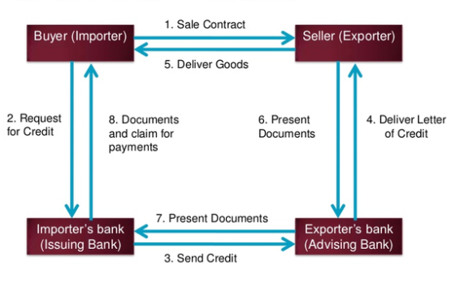

The foreign exchange department is considered one of the luxurious departments of the banking sector because it is the only department that deals with foreign clients and revenues at a massive scale. And this department is the busiest department of a bank. It this department everyone needs to do their work very carefully. If there is any wrong things happen it will create a big problem for the bank and employs. In this department, I was given tasks which were pending and it has to be done because the internal audit of the bank was supposed to arrive anytime and check whether they are operating properly and whether they are not sloppy in their assigned tasks. The following tasks were assigned to me when I worked in the trade finance or Foreign exchange department of UCBL:
- Making entries in Sight and Deferred L/C registers:
There is a register book, where I had to entry the L/C amount, LCAF number, Beneficiary bank name, correspondent name, margin, commission, tax, liability, country of origin, currency exchange rate, LC register number, date of expiry. I have to entry both sight and deferred L/C. And this entire task had done in import section.
- Making entries in Industrial and Commercial registers:
By looking at the LCAF number in the sight and deferred L/C register, I had to make entries of the L/C number and date of issue of a company’s L/C in the commercial register and industrial register.
- Filing the L/C Copies:
I was given the task of filing the L/C where I had to fill up the LCAF form, CF7 form, keep the copies of the L/C according to the Name of the Beneficiary, date of issue, amount of bill, time duration of the L/C, liability, issuing bank name, importer’s name and address.

- Collection and input the record of Credit Report:
I had to collect the credit report from the foreign group and kept theme in a file with a code and also input the company name and the code in a register book.
- Functions of Foreign Exchange Department:
Exports:
- Pre-shipment advance.
- Purchase of foreign bills.
- Negotiating of foreign bills.
- Export guarantees.
- Advising/confirming letters-letter of credit.
- Advance for deferred payments exports.
- Advance against bills for collection.
Imports:
- Opening of letter of credit (L/C)
- Advance bills.
- Bills for collection.
- Import loan and guarantees.
Remittances:
- Issue of DD, MT, TT etc.
- Payment of DD, MT, TT etc.
- Issue and enhancement of traveler’s cheques.
- Sale and enhancement of foreign currency notes.
- Non-resident accounts.
- The Most commonly used documents in Foreign Exchange:
- Documentary Letter of Credit.
- Bill of exchange.
- Bill of Lading.
- Commercial Invoice.
- Certificate of origin of goods.
- Inspection certificate.
- Packing List.
- Insurance policy.
- Pro-forma Invoice/ Indent.
- Master receipt.
- GSP certificate.
- Parties to a letter of credit (L/C): The parties to a letter of credit are:
- Importer/ Buyer
- Opening Bank/ Issuing Bank.
- Exporter/ Seller/ Beneficiary.
- Advising Bank/ Notifying Bank.
- Negotiating Bank.
- Confirming Bank.
- Paying/ Reimbursing Bank
1.Opening procedureof L/C in the UCBL import department there are:
a. Importer needs of document before opening L/C:
Open a Bank Account:
To import products and administrations the forthcoming shipper requires a financial balance, it might be current record or short term store account (STD). Obscure individual won't be permitted to open L/C. To open a ledger following archive need to submit: Valid Trade permit, Value included assessment (VAT), Tax distinguishing proof number (TIN), Import Registration Certificate (IRC), National ID card.
The above report is required for applying L/C to the bank
b. Bank will supply the following documents before opening of the L/C
I. LCAF structure.
ii. Application and Agreement structure.
iv. Charge archives for documentation.
The above papers must be finished appropriately marked and filled in by the gathering as indicated by the guidance of the broker.

c. Document submits to open L/C:
The customer will way to deal with open the L/C in Bank's endorsed structure, properly stepped and marked, alongside the accompanying paper and reports: Such as
i. Application for opening of the L/C
ii. Indent/Performa receipt.
iii. Insurance spread note with cash receipt.
iv. LCAF (letter of approval structure) properly filled in and marked.
v. Membership declaration structure Trade Association.
vi. Tax installment testament/affirmation.
vii. Charge records
viii. IRC, Trade permit Membership declaration and VAT enrollment testament in the event of new customer.
d. Bank Verify about the Importer:
Bank confirms or gathers data about the merchant in the accompanying manner
- Credit Report: Bank gathers credit report of the candidate (merchant) from Credit Information Bureau (CIB) of Bangladesh bank.
- Permissible item: The thing to be imported must be admissible and not restricted thing. In the event that the thing is from contingent rundown, the condition must satisfy to import the equivalent.
- Market Report: Bank will check the attractiveness of the thing and market cost of the merchandise. Now and then the shipper may misuse the Bank's cash through over invoicing.
- Sufficient Security or margin: Price of certain things vacillates as often as possible. If there should arise an occurrence of those things Bank will be increasingly mindful so as to take adequate money edge or other security.
- Business Establishment: Bank ought not to open a L/C for the benefit of a gliding specialist. The merchant must have business foundation; especially he should have business organize for promoting the thing to be imported.
- Permission from Ministry of Commerce: If the products to be imported under CIF (cost protection and cargo), at that point authorization structure service of business to be gotten.
- Creditability of the Client: with regards to all the above focuses, in the event that Bank winds up fulfilled in regards to the customer, at that point L/C might be opened for the customer. Prior to opening the L/C bank will issue and confirm a lot of LCAF for the sake of the merchant.
e. Requirement of Head office Approval:
The AD endless supply of same from the candidate, sent proposition to set out office toward endorsement to open L/C. at the point when head office give endorsement at that point AD branch can open L/C.
f. Sending Documents to Confirming Bank:
In the wake of getting the endorsement from the head office the AD branch open the L/C for candidate and send it to the affirming through SWIFT (society for overall interbank monetary media transmission). Approved Dealer will investigate the records and open the L/C for the exporter by changing over the Bangladesh Taka into outside cash at the current B.C selling pace of trade. Care must be taken with the goal that the farthest point of Bangladesh Taka isn't surpassed in any capacity. The outside cash estimation of the L/C must relate the comparable measure of Bangladesh Taka if LCA enlisted with Bangladesh Bank. On receipt of the delivery archives from the arranging bank, the L/C opening bank will cautiously examine the records with terms and states of the relative L/C. In the event that there is no inconsistency, the reports will be stopped. Lodgment of archives implies the passage of the points of interest of the reports in the Register and arrangement of vouchers by changing over the outside money sum into Bangladesh Taka as the conversion scale winning on that date. This sum is because of the merchant. The shipper will be approached to take conveyance archives by making installment of the bill sum barring the edge kept at the hour of opening L/C. Installment of bill sum and to take conveyance of archives by the shippers is known as Retirement of Import Bills. Subsequent to taking conveyance of reports from the L/C opening bank, the merchant will clear the merchandise which has just been arrived or due to touch base from the traditions specialist on accommodation of these records alongside the custom reason duplicate of LCA From.

- Documentary Letter Of Credit (Import/Export Documentation):
Documentary letter of credit is such sorts of business letter which a Bank issue for the benefit of outside dealer (exporter) as indicated by the heading of the (merchants) buyers. The archives appeared under are known as fare reports structure the merchant's side. These are: - The exporter presents the accompanying papers/records to the Negotiating bank:
- Bill of exchange / Draft.
- Bill of lading.
- Airway bill / Railway receipt.
- Commercial Invoice.
- Insurance policy.
- Certificate of Origin.
- Packing list.
- Weightiest& measurement list.

- Bill of Exchange: The bill of trade is that specific instrument through which installment is affected in economic agreements interior and global. The installment for the products is gotten by the dealer through the vehicle of a bill of trade drawn on the purchaser for the sum contingent upon the agreement. It is a debatable instrument. There are five fundamental gatherings associated with a bill of trade. They are:(a) Drawer (b) Drawee (c) Payee (d) Endorser (e) Endorsee.

- Bill of lading: A bill filling is an archive of title to products qualifying the holder for get the merchandise as recipient or endorsee and it is with the assistance of this record on receipt from the exporter that the shipper claims the merchandise from the conveying vessel at the port of goal.

- Airway bill / Railway receipt: When products to be moved are little in mass or requiring fast conveyance or those are transitory in nature on the arrangement is in the middle of the neighboring nations then method of vehicles other than transportation might be turned to far the carriage of the merchandise Airways bill/Railway receipt occur of Bill of filling relying upon the idea of the bearer.

- Commercial Invoice: It is the vender's bill for the product. It contains a depiction of merchandise, the cost per unit at a specific area, all out estimation of the products, pressing particulars, terms of offer, letter of credit, bill of filling number and so on. There is no standard structure for a business receipt. Every exporter plans his own business receipt structure. The receipt is made out by the dealer under his mark for the sake of the purchaser and must be submitted in a lot of at any rate 3 duplicates. Its primary intention is to check whether the suitable merchandise have been transported and furthermore that their unit value, all out worth, stamping on the bundle and so forth are steady with those given in different archives.

- Insurance Policy: In the worldwide exchange protection strategy is an unquestionable requirement to cover the danger of misfortune on relegations while they are on oceans, streets, aviation routes. The protection is the duty of the purchasers (proctor) under FAS, FOB and C&F contracts and of the dealer (distributor) under CIF contract. The approach must be of the sort as determined in the relative contract/credit. The approach would be at the estimation of CIF cost in addition to 10 10% to cover the costs and that is required to be acquired in a similar money as that of the credit and dated not later than the date of shipment with cases being payable at the goal. It must be appropriately stepped. Like a bill filling it must be debatable and be embraced where it is payable to arrange.

- Certificate of Origin: This is an authentication issued by a perceived specialist in trading nation.

2. Export Section:
Bangladesh sends out a huge amount of products and enterprises to remote family units. Making of riches in any nation relies upon the development of creation in the fare part in universal exchange. The majority of the exporters who fare through United Commercial Bank are readymade article of clothing exporters. They open fare Letters of Credit here to send out their products, which they open against the import Letters of Credit opened by their outside merchants.
- Export Policy:
Fare arrangements planned by the Ministry of Commerce, GOB give the general rule and impetuses for advancement of fares in Bangladesh. Fare arrangements likewise set out product astute yearly target. It has been chosen to detail these strategies to cover a five-year time frame to make them contemporaneous with the five-year plans and to give the approach system. The fare situated private divisions, through their delegate bodies and chambers, are counseled in the definition of fare arrangements and are likewise spoken to in the different fare advancement bodies set up by the administration. Notwithstanding, Exports structures Bangladesh are managed by the accompanying Acts, Guidelines and specialists:
• Bangladesh Bank by issuing rules and handouts in consistence with Foreign Exchange Regulation Act-1974 under the specialist given to it by the previously mentioned, Act. It controls physical and installment parts of fares.
• Ministry of Commerce by issuing Export Policy Order under the expert given to it by Export – Import Act, 1950; It traces the Government's fare advancement systems and sets out the bundle of impetuses to advance fares. It additionally gives the rundown of things, which are either restricted for fare or whose fare is liable to satisfaction of specific conditions.
o Controller of Export and Import
o Export Promotion Bureau
o National Board of Revenue (Regarding obligations and traditions issues)
o Ministry of Finance by giving Financial Assistance (like money motivating forces, obsession of lower loan fee of fare credit and so forth.)
- Export Mechanism:
The system of letter of credit under fare has been appeared in figure in the following page. The depiction of the system is expressed after the figure.

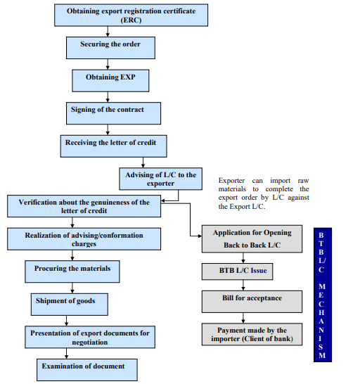

    - Obtaining export registration certificate (ERC):
No exporter is permitted to trade any item from Bangladesh except if he is enrolled with the Chief Controller of Imports and Exports (CCI and E) and holds a substantial Export Registration Certificate (ERC). In the wake of applying to the CCI&E in the recommended from alongside the essential papers, concerned workplaces of the Chief Controller of Imports and Exports issues ERC. When enlisted, exporters are to get the ERC reestablished each year. For enlistment the accompanying archives are required:
• Nationality and Assets Certificate;
• Memorandum and Article of Association and Certificate of Incorporation (in the event of Limited Company);
• Bank Certificate;
• Income Tax Certificate;
• Trade License and so on.
    - Securing the order:
In the wake of getting ERC, the exporter may continue to verify the fare request. He can do this by getting the purchasers legitimately through correspondence. In this reason, exporters can get help structure Liaison Officer of outside organizations, purchaser's neighborhood specialist, purchasing house, RPB, Bangladesh Mission Abroad, Chamber of Commerce and other Trade Associations like BGMEA, Chamber of Commerce of the Foreign Courtiers, Trade reasonable, looking through web/sites. In the wake of speaking with purchaser, exporter needs to get contracted for exportable item(s) structure Bangladesh managing product, amount, value, shipment, protection and imprints, investigations and discretion.
    - Obtaining EXP:
In the wake of having the enrollment, the exporter applies to the Bank with the exchange permit, ERC and the Certificate from the concerned Government Organization to get EXP. In the event that the bank is fulfilled, an EXP is issued to the exporter.
    - Signing of the contract:
In the wake of speaking with purchaser, the exporter needs to get contract for trading exportable things from Bangladesh specifying product, amount, value, shipment, protection and imprint, review, assertion and so on.
    - Receiving the letter of credit:
In the wake of getting contract available to be purchased, exporter ought to approach the purchaser for Letter of Credit unmistakably expressing terms and states of fare and installment. The fare is regularly, executed against letter of credit opened by purchasers. Once in a while, trades are made on CAD, DP, and DA on Consignment Sale premise without front of letter of credit. On receipt of Letter of Credit, it is checked altogether by prompting bank.

    - .Check about the validity of the letter of credit:
If there should be an occurrence of receipt of L/C other than structure the issuing bank, the educating bank must affirm the validity regarding the L/C .In every one of the cases, the bank must learn the genuineness of the Letter of Credit got before following up on that.
    - Advising of L/C to the exporter:
Having found out the validity of the Letter of Credit, the Advising bank makes the accompanying strides:
• The concerned part of the bank speaks with the recipient and advices him about the Letter of Credit got.
• The Branch enters full points of interest of the Letter of Credit in the Letter Credit Advising Register (Performance Register) designating separate sequential number for each Letter of Credit
• Particulars all things considered (assuming any) are additionally to be recorded in a similar Register before encouraging the equivalent to the recipient.
• If the L/C contains any solicitation by the opening bank, it must be followed under suggestion to the recipient; the endorsement of Head Office required for this.
• Any alteration to a Letter of Credit got structure Issuing Bank ought to be encouraged to the recipient immediately. Just solicitation of the Issuing bank for any correction ought to be acknowledged.
• A reasonable proviso ought to be joined at the base of the L/C expressing that the L/C is liable to the arrangement of UCPDC-ICC Publication No. 5000.
    - Realization of advising/conformation charges:
For instructing Letter with respect to Credit to the recipient, the branch records Letter of Credit prompting commission at the endorsed rate from the recipient. On the off chance that the recipient is the bank's customer the charge is charged to his check under guidance to him. In the event that the recipient isn't the bank's customer; the Letter of Credit is conveyed to him against money installment. Letter of Credit adjusting charges ought to be recouping either structure the recipient or the opening bank contingent upon the conditions of the Letter of Credit.
    - Procuring the materials:
Before the fare structures are stopped by the exporters with the traditions/postal experts, they ought to get every one of the duplicates supported by United Commercial Bank. Prior to shipment, exporter submits fare structure (EXP) with business receipt. At that point Bank official checks it appropriately, whenever fulfilled, guarantees the fare structure. Without it exporter can't make shipment. The client must proclaim all fares merchandise on the EXP issued by the approved sellers.
    - Shipment of goods:
After confirmation of EXP structures issued by the AD, the following stages for the exporter to make important courses of action for shipment of products.
    - Presentation of export documents for negotiation:
After shipment, exporter presents the accompanying reports to UCBL for Negotiation.
• Beneficiary's presentation about the shipment of products according to Letter of Credit/Contract Terms
• Bill of Exchange or Draft
• Bill of Lading
• Certificate of birthplace
• Consular Invoice
• Freight Certificates in the event of FOB contract
• G.S.P. declaration (whenever required)
• Inspection Certificate
• Insurance Policy/Certificate orchestrated to cover travel chance
• Invoice
• Packing List
• Photo – Sanitary Certificate.
• Quality (Control) Certificate
• Shipping Advice
    - Examination of document:
Banks manage records just, not with item. As the arranging bank is giving the incentive before repatriation of the fare continues it is prudent to investigate and look at every single archive with incredible consideration whether any error is seen in the records. The investors are to find out that the records are carefully according to the terms of Letter of Credit. Bank officials allotted for looking at the fare archives may utilize an agenda for their benefit. In the wake of inspecting the record; the bank sends them to the shipper's bank through DHL. Here the fare system is finished
- Back-to-back Letter of Credit:
There is another zone of fare. In readymade pieces of clothing division the exporter needs to import the crude materials for finishing the request. All things considered the exporter may look for financing office from the bank. In this circumstance the bank fund the exporter by opening consecutive L/C against the Export L/C. There are four sorts of Back-to-Back L/Cs. These are:
• Back to Back Local (Within Bangladesh)
• Back to Back EPZ
• Back to Back EDF
• Back to Back Foreign
d) Back-to-back L/C mechanism:
- Application for Opening Back to Back L/C:
From the start the exporter applies for opening BTB L/C against the Export L/C. He needs to compose an application to the Branch Manager expressing the measure of the L/C alongside a L/C structure and Pro-forma Invoice.
- BTB L/C Issue:
The approved official issues the L/C if the archive is OK and sends the L/C to the bank of the recipient.
- Bill sent by the recipient's bank for acknowledgment:
At the point when the exporter gets a L/C he sends his merchandise to the shipper and the bill for the fare sends to the shipper bank. On the off chance that there is no disparity in the record, at that point the opening bank gives acknowledgment and fixes the due date of installment as per the tenor.
- Payment made by the Importer:
At the point when the bill is expected, the bank pays it with the cash that the shipper gets from the fare. The returns are given to the exporter (merchant for BTB L/C). This is his benefit. The Back-to-Back L/C Mechanism is finished here.

3. Remittance section:
Our economy depends exceptionally on outside settlement. The individuals who are working abroad send cash through the assistance of bank. Joined Commercial Bank Ltd. pursues three different ways to gather remote settlement.
- Mechanism of remittance collection:
United Commercial Bank Ltd. pursues three different ways for gathering settlement. These are: trade houses with which bank has understanding, direct telephonic exchange and the trade house with which bank has no understanding.
- Exchange House with which UCBL has agreement:
Along these lines the settlement can desire anybody. He can be an A/C holder can be most certainly not. In the event that the beneficiary is an A/C holder the settlement straightforwardly kept to his record. On the off chance that he isn't an A/C holder then the technique is unique. The sender's bank will give a stick code that the sender needs to illuminate the collector. The beneficiary than tell the stick code, his name and other data to the approved official. The official will check and if everything is okay, the official will give the money to the beneficiary. Coming up next are the name of a portion of the Exchange Houses that UCBL has concurrence with:
•LARI Exchange Co.
•CITY INTL Exchange Co.
• Mustafa-Sultan Exchange Co.
• Western Union
• Ria Money Transfer.
- Telephonic Transfer:
The bank gives this administration just to its A/C holders. At the point when the settlements come it is straightforwardly stored to beneficiary's record.
- Exchange house having no agreement with UCBL:
This is another way that the bank pursues. This administration is likewise constrained to its A/C holders. On the off chance that a settlement is sent through a trade house having no concurrence with UCBL, it goes to the bank that has a concurrence with the trade house. Subsequent to getting the settlement, the bank issues a compensation request for UCBL. At that point UCBL gathers the money through clearing house and stores it to recipient's record.
This is the organization of outside trade business. In this procedure the outside trade division achieves its obligations.

- Submission of Return to Bangladesh Bank:
The Authorized Dealer (AD) must keep up satisfactory and legitimate records of all Foreign Exchange exchanges including exchange on non-occupant taka A/C. in their books and outfit such specifics in the endorsed type of Return to Bangladesh Bank. The reason for accommodation of come back to the Bangladesh Bank is to keep precise and legitimate records of all managing in remote trade exchange. Each and every exchange that Bank does must be accounted for on Bangladesh Bank Website. Other than that, there are yearly, quarterly, month to month, week after week proclamations which is submitted to Bangladesh Bank.

CHAPTER: SIX
FOREIGN EXCHANG
PERFORMANCE



Imports:
Import development expanded to 26.3% in 2018 up from 9.8 % development in 2017. Import installments expanded to USD 435.04 billion in 2018 from USD 344.58 billion in 2017. Solid import development energized by sustenance imports thanks to the flood-related climate stuns, capital hardware, and shift merchandise imports against higher fares development broadened exchange deficit. A lot of intensive exchange shortage, combined with up nonetheless humble settlement development, prompted a deficiency generally exploit of installments. By the market powers, ostensible conversion commonplace debased. Thus on prevent any difficult vacillations within the remote trade showcase, the People's Republic of Bangladesh Bank bolstered to sleek monumental changes. Despite ostensible swapping scale debased marginally, real powerful conversion commonplace valued somewhat due in the main to decrease in relative price of exchanging accomplices. Import installment for sustenance grains, milk and cream, flavors, beats, sugar, clinker, POL, plastic and elastic articles thence, crude cotton and iron, steel and alternative base metals ascended in 2018 contrasted with 2017 whereas those for oilseeds, manure, material and material articles thence, and staple fiber declined throughout an analogous amount.

Export:
Export development expanded to 11.5 % in 2018. Export remained at USD 267.18 billion in 2018 from 239.66 billion in 2017. In any case, trade development got from 0.1 % down in the last 50% of 2017 to 4.7 % upswing throughout the first portion of 2018. Items of covering fares are relied upon to profit by a lot of grounded development within the elementary fare goals and more distinguished item and market expansions, as well as into non-customary but larger market. Among the $64000 send things, synthetic, plastic, cowhide and leather things, cotton and cotton things, jute merchandise, home material, footwear and coming up with things encountered a better development in 2018 whereas solid nourishment, rural things, plain-woven articles of covering, oil bi-items, crude jute, and specific materials backed off in pace of fare execution as this stuff encountered a negative development.

Foreign Exchange Reserve:
Late years to a shortage from venture and sustenance connected an import has created falling weight on remote trade hold. To keep up a strategic distance from any monumental unpredictability given the remote trade market structure, Bangladesh Bank oversubscribed USD 1.1 billion to satisfy the increasing desire for outdoor profit the near advertise. Outside trade hold diminished by USD one.21 billion toward the part of the cut-price was 3.6 % de-development over the earlier year.

Remittances:
Remittance developed powerfully by 17.3% in 2018, behind declining within the past two years, the make a comeback supported by AN enlargement within the number of laborers traveling to a different country in the previous number of years, Bangladeshi monetary unit deterioration, and measures to cultivate money move through authority channels. throughout the money connected year 2018 (July 2017 to Gregorian calendar month 2018) influx of laborers' settlements stood BDT 1,232 billion (USD 14,982 million) contrasted with BDT 1,011 billion (USD 12,769 million) in the financial year 2017. Around seventeen % (USD 2,212 million) increment in 2018. Gross domestic product commitment from settlement has expanded to 5.49% in 2018 from 5.11% in 2017.

Remittance influx expanded essentially in 2018 from major conducive nations like UAE, KSA, USA, GB, and Qatar. From these Five Nations settlement expanded by USD 336 million, USD 324 million, USD 308 million, USD 298 million and USD 268 million severally that contributed 60 % of absolute settlement in 2018.

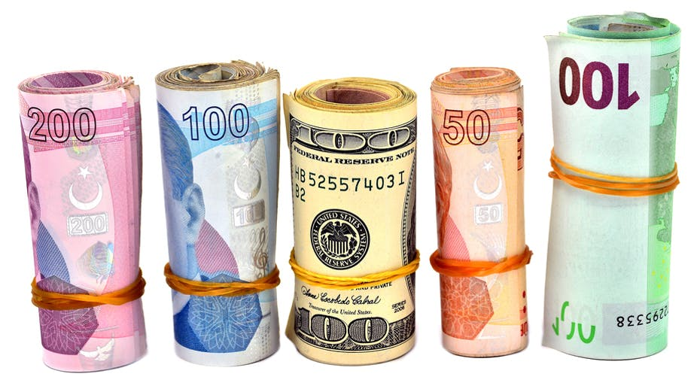

RECOMMENDATIONS & CONCLUSION

Recommendations:
Today’s business setting is extremely dynamic and every bank’s prime goal is to realize a profit through client satisfaction and economic contribution. UCBL is acting nice job in its foreign exchange performance however still there's a space for improvement. Three months internship at foreign exchange department isn't enough to counsel something about a huge organization like UCBL, however consistent with my observation; I created the subsequent suggestion which will improve the performance of foreign exchange department:
- Foreign exchange department ought to be processed for quicker and higher communication.
- Reducing bank charges like SWIFT charges, document handling charges or stamps charges for attracting a lot of customers.
- The bank could introduce some promotional program to extend export. If a bank provides a lot of stress to export parties they'll be influenced.
- The bank ought to follow the UCPDC (Uniform Customs and Practices for Documentary Credit) rules strictly to avoid the risks concerned in Foreign Trade Business.
- Performance measure programs are often introduced to live the performance of the officers concerned in the interchange method and if necessary providing them correct coaching.
- The situation of International Business is a kind of dynamic. Newer trends are going down from time to time. This could produce a tension between exporters-importers and also the bankers. Therefore UCBL should think about this issue and handle it rigorously.

Conclusion:
Banks as a financial organization mobilizes capital and alternative resources to boost the economic process of a country. From the terrible origination, UCBL is contributive to the socio-economic growth of Bangladesh. As a quickest growing bank, it's attempting its best in export, import and remission by giving customers satisfactory services than its competitors. Despite worldwide challenges, export and import are showing positive trends. Earnings during this sector are increasing day by day. Therefore as a developing country Bangladesh has a huge chance in market and Foreign exchange like continuously UCBL can make certain that things go swimmingly.

REFERENCES

- Books and Articles:

David W. Cravens & Nigel F. Piercy, (2017-2018),
Strategic Marketing, 10th Edition, McGraw-Hill International Edition

Bangladesh Foreign Exchange Rules and Guideline, (2017- 2018)

Global news and insight for corporate financial professionals
Foreign Exchange (August- 2018)
- Websites:

Information about United Commercial Bank Limited, [Online], [Cited in February 2019], Available from Internet: https://www.ucb.com.bd/index.php?page=know-ucb/ucb-profile
Information about United Commercial Bank Limited Annual Report, [Online], [Cited in December 2018], Available from Internet: https://www.ucb.com.bd/index.php?page=know-ucb/investor-relations/annual-report
Information about the Company History, [Online], [Cited on April 2019], Available from Internet: https://en.wikipedia.org/w/index.php?title=United_Commercial_Bank_Ltd&action=history

Theoretical Information of Bank Info Beta [Online]
Available from Internet: http://bankinfobd.com/banks/44/United_Commercial_Bank

Theoretical Information of Foreign Exchange, [Online], Available from Internet: http://www.pondiuni.edu.in/storage/dde/downloads/ibiv_forex.pdf

Theoretical Information of Bank Bangladesh foreign exchange guideline, [Online] [Cited on June 2018], Available from Internet:
https://www.bb.org.bd/aboutus/regulationguideline/foreignexchange/fegvol1.php

