Analyzing Service Quality of UIU transport and Canteen: An Application of SERVQUAL Method


Project paper on

Analyzing Service Quality of UIU Transport and Canteen: An Application of SERVQUAL Method

Submitted to
Dr. Md. Shariful Alam
Associate Professor
School of Business & Economics
United International University
Submitted by
M. A Hasan
ID: 111 133 023
BBA (Marketing)
School of Business & Economics
United International University

Date of Submission: October 31, 2018
Letter of Transmittal

October 31, 2018

Dr. Md. Shariful Alam Associate Professor
School of Business & Economics
United International University

Subject: Application for accepting the project report.

Respected Sir,
I, M. A Hasan, would like to inform you with the grace of Almighty Allah and your kind facilitation that I have completed the report as per your instruction to meet our course requirement.
I would like to show my gratitude to you for providing great opportunity to be familiar with the Service Marketing, also to be familiar with formal business report. My great effort has been administrated to make it as comprehensible also useful as I could. Despite my endless endeavor there might be some mistakes in some parts of our report just because we are neophytes in this arena. We fervently request you to look at the mistakes with a generous sight considering our circumstances. The report played a role of our pedant during the work and I learned the way of communication for business purpose, style of communication and most important thing I learned the formulation of a business report. Besides my academic knowledge, I learned the importance of thinking out of box, reasoning etc. I am very thankful to you for such kind of learning.
Therefore, I hope that you would be kind enough to accept my report and oblige thereby.
Yours sincerely
………………………….
M. A Hasan
111 133 023
BBA (Marketing)
Acknowledgment

At first, I want to give thanks to Allah to help me for preparing this project on “A Report based on the service quality of UIU transport service and UIU canteen Service”. I would like to express my respect and heartiest gratitude to my honorable instructor Md. Shariful Alam, Ph.D of United International University who delivered his instructions so clearly in order to make sure I understand every concept and able to apply in service analysis process sir had brief me about the report earlier to make sure I am well prepared for it. Without his supervision and guidance, the whole report would be impossible to achieve.
Besides I would like to thank every persons who helped me to accomplish my survey in the subject of UIU canteen. I also grateful for their cooperative attitude and dedicated efforts. All of them tried to share their constructive opinions and creative ideas in making of the report. Everyone or participant of survey contributed a lot in writing the question paper of survey completing the whole survey analysis. Their cooperation is deeply appreciated.
At last, I would like to convey my appreciation towards United International University campus authority and UIU canteen's employees who willingly help me to complete my survey process based on questionnaire.
I have gathered information through questionnaire survey, from various websites, which has shown into the reference section.

Table of content

Table of Contents
Introduction 1
Objective of the Report (UIU Canteen Services) 2
Methodology 2
Types of Resources 3
Process of Information collection: 4
Method of Data Collection 4
The five SERVQUAL dimensions 4
Implementation of Service Gaps Model in Khan Kitchen (UIU Canteen Services) 17
The Customer Gap: 17
The Provider Gap (Khan Kitchen) 19
Customer Expectations: 20
Major customer Expectations 21
ANALYSIS of UIU canteen Services 22
Interpretation (UIU Canteen Services) 25
Findings 26
Limitations 27
Recommendation 28
Conclusion 30

Executive Summary
For this report I have chosen to measure the quality of UIU transport and Canteen Service as this service is new after shifting our campus from Dhanmondi to Satarkul, Madani Avenue. This service has been provided to students for their safe journey and healthy food.
Service quality is a good measure for knowing about the performance of any service provider. This paper investigates the service quality expectations and perceptions of UIU transportation and canteen. This paper also examine the relationship between relative importance allocated by respondents to each of the five SERVQUAL dimensions as measured by the points allocated to that dimensions the ratings provided for the individual items of the dimension. In the SERVQUAL questionnaire there are 19 questions from five different dimensions. These are Tangibles, Reliability, Responsiveness, Assurance and Empathy. These questions measure the gap between customer expectations and perceptions. After conducting the survey I have calculated the average gap scores of these dimensions. Then it has been seen that the gap between the customers’ expectations and perceptions about the services are lower or below the average for the customers. Our investigation finds out that reliability, responsibility and assurance are relatively more important to the customers.

Introduction

Our report is basically based on “SERVQUAL Questionnaires”. “SERVQUAL” is a multi-dimensional analysis that helps to design and capture Customer’s expectations and perceptions of a service in a particular area. SERVQUAL along with the five dimensions that is understand to represent service quality. SERVQUAL is made on the basis of expectations and perceptions disconfirmation paradigm, which in general quotes means that service quality is perceived as the elaborative at consumers' pre-consumption or before buying expectations of quality are confirmed or disconfirmed by their actual perceptions of the service experience.
The questionnaire is made to be a face-to-face viva and needs a medium to maximum size of sample which is statistically reliable. In a sense, it is consumer related to sum up extension items for example the participant's demographics, major experience with the product or category and brand also behavioral intentions (intention to revisit/ repurchase, loyalty intentions and propensity to give word-of-mouth referrals).
SERVQUAL dimensions incudes tangibles, responsiveness, reliability, assurance and empathy dimension. I helps to get actual result from the questionnaire beads on their asking question. Through this dimensions surveyor can easily identified the gap between attendances expectations and perceptions are called dimensional gap. The dimensional gap helps to find out the actual problem along with the major areas.
Dimensional gap also helps to analyze, summarize the data which is collected by the surveyor and find out the result. Also helps to give the better solution to the authority.

Objective of the Report (UIU Canteen Services)
The objectives of the report are-
- To measure the service quality provided by UIU Transport & UIU canteens.
- To understand the lack of compatibility or similarity between the student expectations and perceptions about the services provided by UIU transport and UIU canteens.
- To monitor or keeping continuous record and track of Service performance.
- To assess gaps between customer expectations and perceptions.
- Searching the causes why the gap is created.
- To monitor changing customer expectations.
- To gauge the effectiveness of changes, so that Service recovery can be attempted.
- Analysis of those findings.
- To expect a better service from UIU Canteen.
- To expect a better quality food from UIU Canteen.

Methodology

SERVQUAL indicates Services and quality. Through this quotation we can create a questionnaire for survey. It is called as a blueprint survey. By using it we can collect, measure, summarize and analysis the data. My project report is in elaborate in nature and it involves studying or learning the perceptions and expectations of customers or students who buy food or service in order to measure or anticipate the service quality served by the service provider. The study helps to find out the major areas of development so that organization’s services to the customers can be developed in upcoming areas.

Types of Resources

A resource is an origin along with supply from which is a beneficial for producer. An objective or things becomes a resource with time and developing and maintenance of technology. Typically resources are materials, equipment, power, energy, goods, services, employees, staff, knowledge, data or other tangible or intangible assets that are transformed turned to produce or make benefit and in the process may be consumed or made unavailable. There are two types of data sources that was using to preparing questionnaire and answer:

1 .Preliminary Resources:
I have collected data from our existing UIU students. Collecting data from students is so easy. They are helpful. I can easily find them in the premises of UIU. They are too much familiar with this canteen.

2 .Secondary Resources:
- I have collected data from internet of khan kitchen's website.
- Analysis our strength, weakness, threat, opportunities, situation, demand, also gap between expectation and perceptions.
- Analysis our strength, weakness, threat, opportunities, market situation, market demand, gap between supply and demand & also financial condition.
- I have collected data from other canteen’s of UIU as well as Khan’s Kitchen

Method of Data Collection

The data was collected based on survey questionnaire. Firstly, I have made a questionnaire based on UIU canteen’s services that provided by the Khan’s kitchen to the students, teachers and staff of UIU. I have prepared my questionnaire on the basis of their service quality and I also tried to know the gaps between customer expectations and customer perceptions through this survey based on questionnaire. I made a questionnaire through Google sheet and sent it to my friends, known person and so on. They completed this sheet and I got a result from each person about the survey questionnaire.

Researching about the quality of the canteens in the university context is really a timely topic since there are lots of issues arise in the recent times. There were lots of media reporting about the conditions of the canteens but the updated situations are not reported. Here as our research we have selected such a realistic topic in order to evaluate the progress of the canteens in the university premises. To measure the service quality I have used here SERVQUAL model. The measurement of quality service using this SERVQUAL method contains questions about UIU canteens service policies from five specific aspects. For each of the aspects I have graded twice: first on the basis of customer expectations from an excellent Canteens and then from his/her perception of UIU canteens

The five SERVQUAL dimensions
- Tangibles- Appearance of physical facilities, equipment, personnel, and communication materials
- Reliability- Ability to perform the promised service dependably and accurately
- Responsiveness- Willingness to help customers and provide prompt service
- Assurance-Knowledge and courtesy of employees and their ability to convey trust and confidence
- Empathy- it means putting myself into the other shoes. Caring, individualized attention the firm provides its customers.

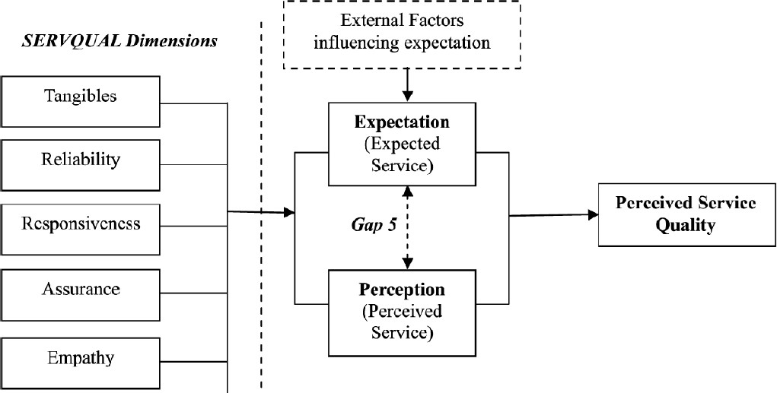

Service providers want to know what customers (internal or external) care about. Service quality is a good guess. Price, and to a minor degree product quality, also count. But for service providers, customers care most about service quality. Check the research. Statistically valid research. Of course, providers can always ask customers.
Here’s their importance to customers:
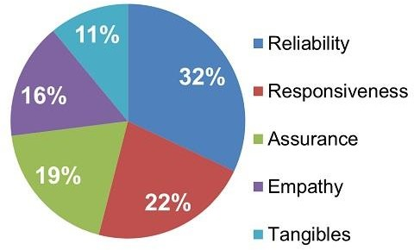

For this report purpose I have asked several question to UIU student about their perception and expectation from UIU Transportation Service. I tried to figure out how they think of this service and took their answer as a percentage form and prepare bar chart for analysis. In our prepared bar chart blue line is for “Expectation” and orange line is for “Perception”

SERVQUAL Survey & Analysis UIU Transport Services
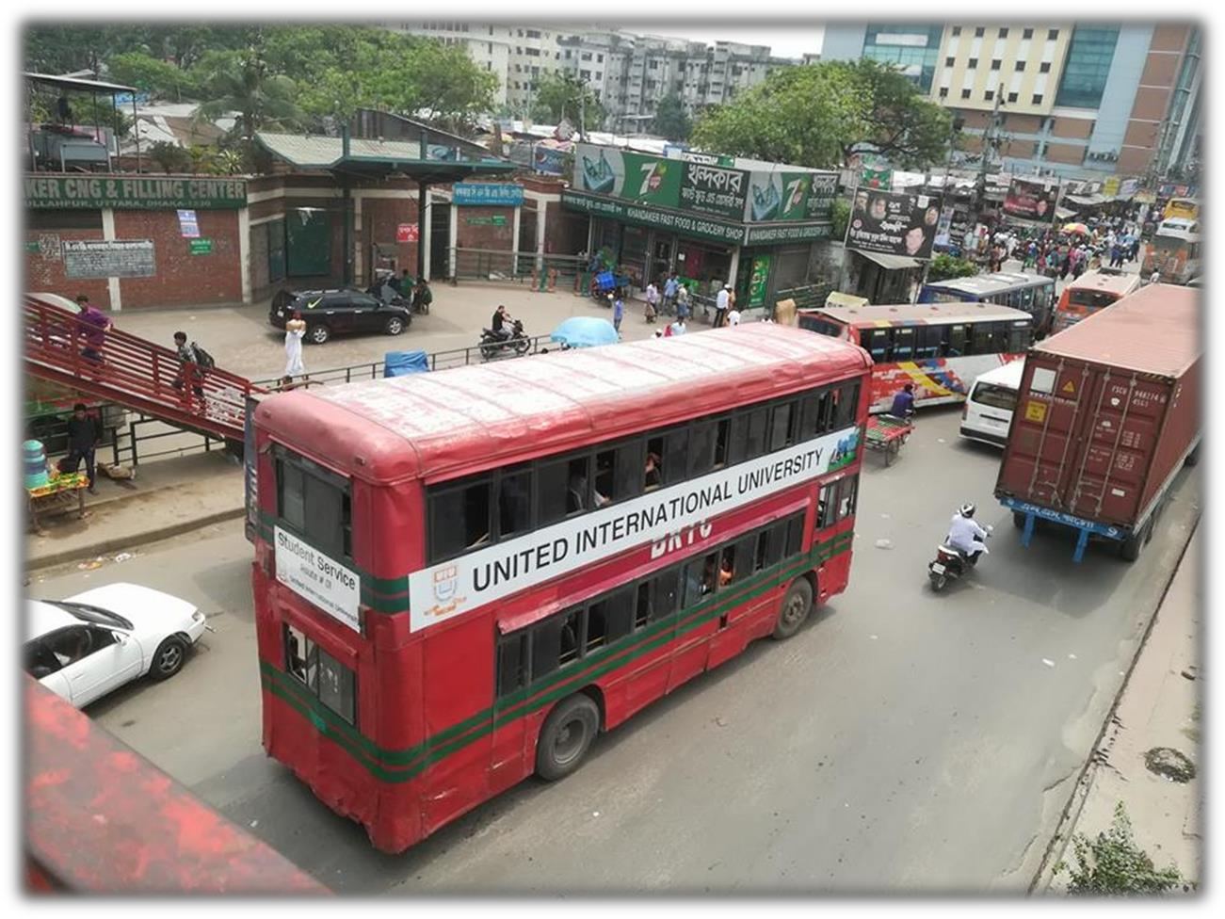
Here I will discuss about all of five dimensions of SERVQUAL along with the survey and analysis on the basis of UIU transport services. UIU transport services play a vital role for the students of UIU. Because the students need safety first along with the save of time. It also helpful because it certain the student’s class in time. this service is new after shifting our campus from Dhanmondi to Satarkul, Madani Avenue. So this service has been provided to students for their safe journey and healthy food. Now to the further report in every section we will going to describe how this service is working on five service dimensions based on SERVQUAL questions.


















Tangible Dimension
Series1 Series2
4
3
2
1
4
3.5
3
2.5
2
1.5
1
0.5
0
Tangible Dimension

All dimensions are important to customers, but some more than others. Service providers need to know which are which to avoid majoring in minors. At the same time they can’t focus on only one dimension and let the others suffer .SERVQUAL research showed dimensions’ importance to each other by asking customers to assign 100 points across all five dimensions.

Tangible means Having physical existence and/or form, or discernible through one or more senses. This section contains four questions.
Now in tangible dimension -
- The first question is whether the equipment’s of our transport service is modern looking or not. Now here we can see that student’s answers to this question are almost equal about perception and expectation. In open eyes it can be viewed that the difference or gap is not more than 0.02%. Student wants a bus service with modern looking equipment’s that’s why their expectation is high here. But UIU only give AC bus as shuttle service not for long route bus. For long route bus they use BRTC which doesn’t have any modern equipment.

- In second question, I asked whether the physical facilities of transport service are visually appealing or not. Here expectation is 2.97% and perception is 2.93% the gap is 0.04%. Now in this question’s answer expectation is a little bit high than perception. Every student expect an appealing transport vehicle, compare to other private universities.

- In third question I asked whether, employees of transport service are neat in their appearance. Here the expectation is very high more than 3.53% out of 4 and perception is 3.16%. The gap is 0.37%. So obviously students expect the employees related to this service are have to be well dressed up and neat in their appearance.

- In fourth question I asked whether the materials associated with the service are visually appealing. Here expectation is 3.27% and perception is 3.3. The gap is
-0.03. Here we can see that perception and expectation is almost same.

UIU provides BRTC bus for transportation, but the materials like fan, seat, and windows are not up to the mark. Here expectation is more.

Reliability Dimension





















Series1 Series2
5
4
3
2
1
3.7
3.6
3.5
3.4
3.3
3.2
3.1
3
2.9
2.8
Reliability Dimension

Customers want to count on their providers. They value that reliability. Don’t providers yearn to find out what customers value? This is it. It’s three times more important to be reliable than have shiny new equipment or flashy uniforms. This section contains 5 questions.
- In first question, I asked whether the transport service make a promise and do it on time. Here expectation is 3.38% out of 4 and perception is 3.14. The hap is 0.24.
UIU transport service promise students that the bus will start at sharp 7 A.M from Dhanmondi to Madani Avenue and students expect the service will occur on time because if the bus is late class will be missed.
- In second question, I asked when students has a problem UIU transport service show sincere interest to solve it. Here expectation is 3.13 and perception is 3.25. The gap is -0.12. Students may face any type of problem in journey, but as the attendance number is not more than one or 2, and they are not very much sincere to the students as lots of students travel in UIU’s Transport so students expectation is not so high here, because they do not get that service what perceive.

- In third question, I asked is UIU perform the Transport service right the first time. Here expectation is 3.51 and perception is 3.43, the gap is 0.08%. In this question most of the students agreed as it’s true that UIU for the first time start their transport service for students.
- In fourth question, I asked whether UIU provide the transport service at time they promise to do so. Here expectation is 3.57% and perception is 3.26%. The gap is 0.31.There is a noticeable gap between expectation and perception. UIU promises to give transport service when university moves to the permanent campus. Most students are expected this service but some were not sure about this. Now UIU fulfill its promise and provided the service as on that time they are promised to do so.
- In fifth question, I asked will UIU insist on error free record of transport service. Here expectation is 3.08 and perception is 3.13 the gap is -0.05. So in this question students are little bit of confused because UIU recently started their transport service. And till now they don’t make any error.


















Responsiveness Dimension
Series1 Series2
4
3
2
1
3.7
3.6
3.5
3.4
3.3
3.2
3.1
3
2.9
2.8
2.7
Responsiveness Dimension

Respond quickly, promptly, rapidly, immediately, instantly. This part contains 4 questions.
- In first question, I asked to the students that UIU tell students exactly when the service is performed. In this question student’s expectation is higher than perception. Here expectation is 3.1% and perception is 3.03%; the gap is 0.07%. UIU clearly tell students that the bus service will start from Dhanmondi Sharpe at 7 a.m. and leave the university premises at 4 p.m. but sometimes due to traffic jam students might get late for their class that’s why their perception is low.
- In second question, I asked will UIU prompt service to the students. In this section perception is higher than expectation. Expectation is 3.31and perception is 3.47%. The gap is about -0.16% .The alternative of prompt is fast. Students didn’t expect the service will act fast but it reach to their high level of perception.
- In third question, I asked whether UIU transport service always willing to help the students. Here expectation is 3.53% and perception is 3.59%. The results are positive here. The gap is only -0.06%. In any kind of road or transport related problem transport service of UIU always helps their students.

- In fourth question, I asked did UIU’s transport service related employees will never be to busy to respond to the student’s request. Here expectation is 3.33% and
Perception is 3.05% the gap is 0.28%. This means that students expect to get a quick response but as there were lot of students it doesn’t able to meet the demand.

Assurance Dimension



















ASSURANCE: Service providers are expected to be the experts of the service they’re delivering. It’s a given. SERVQUAL research showed it’s important to communicate that expertise to customers. If a service provider is highly skilled, but customers don’t see that, their confidence in that provider will be lower. And their assessment of that provider’s service quality will be lower. This section contains 4 questions.
Series1 Series2
4
3
2
1
3.55
3.5
3.45
3.4
3.35
3.3
3.25
3.2
3.15
3.1
Assurence Dimenssion

.
- In first question, I asked is the behavior of the employees of UIU’s transport service will instil confidence in customers. Here expectation is 3.3% and perception is 3.49. The gap is -0.19. In this case UIU is much disciplined. Students much expect that there will be a chaos when to get up in the bus, but it very well maintained students don’t break the line. Get in the bus serially one by one. This really helps students to be confident about university.
- In second question, I asked the students whether the feel safe on the time of transportation. Here expectation is 3.26% and perception is 3.4% the gap is -0.14%. In this question we also get a positive result, UIU provide a safer journey for their students. Which is beyond student’s expectation.
- In third question, I asked UIU will be constantly courteous with the students who took transportation service. Here expectation is 3.3% and perception is 3.42, the gap is -0.12%. Yes UIU tries to be with the students but sometimes due to some misunderstanding students and attendances involved in arguments.
- In fourth question, I asked to the students that did employees of UIU’s transport service have the knowledge to answer student’s questions. Here expectation is 3.28% and perception is 3.37%, the gap is -0.09%. Here we can see that the gap is very minimal. But as per survey we got to know that UIU hires attendants or employees based on a minimum educational base so that they could at least try to give answers to the questions of students.

Empathy Dimension













Series1 Series2
3
2
1
4.5
4
3.5
3
2.5
2
1.5
1
0.5
0
Empathy Dimension

Empathy is the capacity to understand or feel what another person is experiencing from within their frame of reference. The capacity to place oneself in another's position. There are many definitions for empathy that encompass a broad range of emotional states. This section contains 3 questions.

- In first question, I asked will employee of transport service give each customer individual attention. Here expectation is 3.21% and perception is 3.2%. The gap is 0.01%. Which is very low we can say expectation and perception are equal. As our campus shifted to Madani Avenue. Which is quite far from our previous campus. So UIU tries hard and sole that students get full attention at the transport service, they have well trained employees to handle.
- In second question, I asked will UIU have operating hours convenient to all their students regarding transport service. Here expectation is 3.39% and perception is 3.2%, the gap is 0.19%. By our survey we get to know that UIU’s transport service is not much convenient in some cases like if a student gets late due to some work or for university programs he/she couldn’t get any transport service after 4 p.m. students expect to have this type to service when students need but till now university didn’t provide so.

- In third question, I asked will the employees of transportation service give students personal service. Here expectation is 3.27 and perception is 3.89%, the gap is - 0.62%, which means perception is much higher than expectation. Here students didn’t expected much to get a personal service as it’s a common service for all and in reality it’s true that it’s not possible to give personal or individual transportation service.

Which Dimension is better than other dimensions?
According to analysis the overall five dimensions I think the empathy dimension plays a vital role. Because the perceptions are more than their expectations. Here expectation is 3.3% and perception is 3.49. The gap is -0.19. In this case UIU is much disciplined. Students much expect that there will be a chaos when to get up in the bus, but it very well maintained students don’t break the line. Get in the bus serially one by one. This really helps students to be confident about university. When we ask about the safety of transportation. That time we find their expectations are not too much high where their perceived service. Here expectation is 3.26% and perception is 3.4% the gap is -0.14%. In this question we also get a positive result, UIU provide a safer journey for their students. Which is beyond student’s expectation. I asked to the students that did employees of UIU’s transport service have the knowledge to answer student’s questions. Here expectation is 3.28% and perception is 3.37%, the gap is -0.09%. Here we can see that the gap is very minimal. But as per survey we got to know that UIU hires attendants or employees based on a minimum educational base so that they could at least try to give answers to the questions of students.

Here we can see the overall SERVQUAL dimensions at a glance also comparing the overall five dimensions easily.

Implementation of Service Gaps Model in Khan Kitchen (UIU Canteen Services)
Customer service and satisfaction matter more than anything. Customer have higher expectations and less tolerance. To provide the highest level of satisfaction, service providers must control customer’ expectations and perception of food quality .The gap model of service serves as a framework for service organizations attempting to improve quality of service.
The Gaps model exists several portions:-
1) The Customer Gap
2) The Provider Gap

The Customer Gap:
The difference between consumer expectations and perceptions are considered as a Customer Gap. Customer expectations are always exists at a standard or equilibrium level. They always expects a service from providers that they will get a superior service as a customers. But sometimes they don’t. As a result it creates a huge gap between customer expectations and their perceived services.
According to this report, UIU students are considered as a customer when they buy food from University Canteen. The canteen has three different organization’s ownership. But I only look forward or survey on Khan Kitchen. When I surveyed that time I followed a huge gap between the student expectations and their perceived service. Overall they are not happy of buying services. So here I could find a huge customer gap.

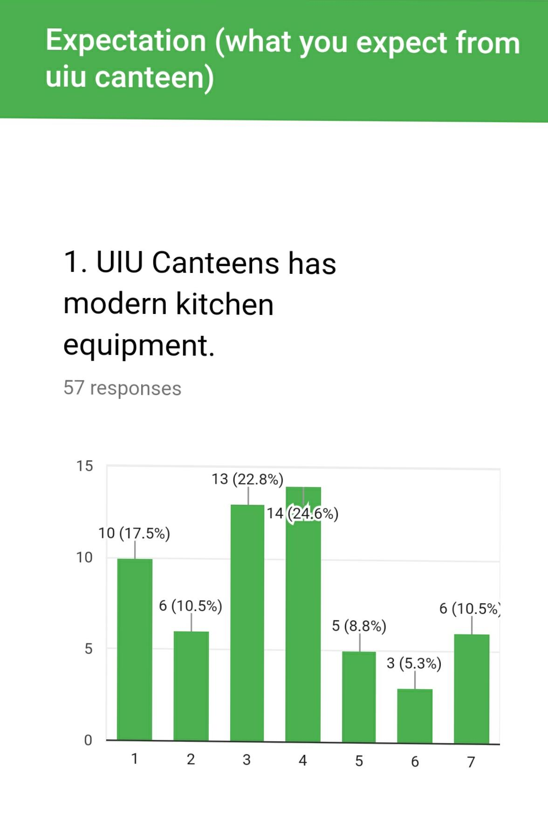
Let’s see a survey on the basis of graph. The survey completed on the basis of replying by more than fifty students of UIU. Here I can easily see the customer’s expectations against they perceived.
Here we can see the question number one includes UIU Canteen has modern kitchen equipment. The data shows from the bar chart is expectation of UIU students form the Canteen service which is available by UIU Canteen authority.

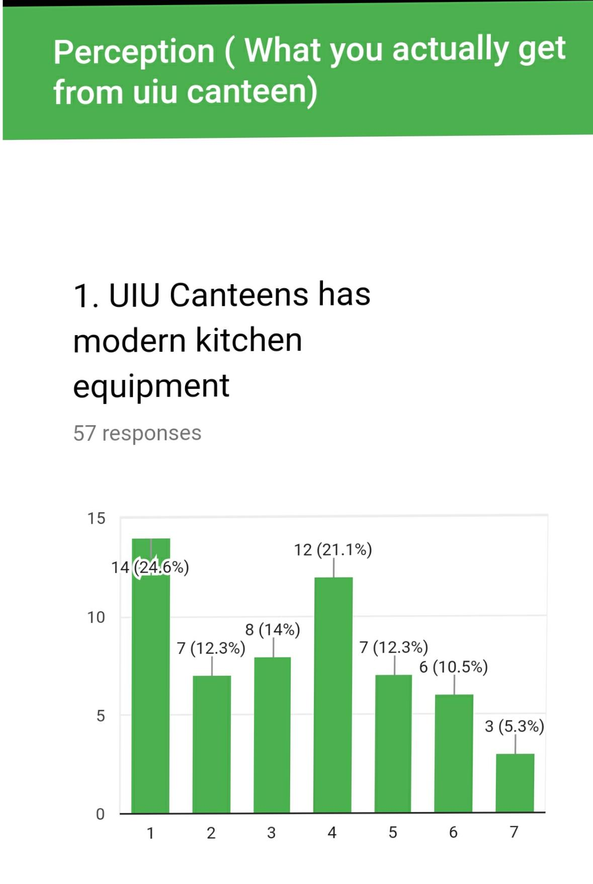
The Provider Gap (Khan Kitchen)
The provider gap consists-
- Listening Gap: We (Khan Kitchen) have to understand the customer need and want like. Also understand their problem and after hearing we have need to solve this. We have to think our customer needs and as per their needs we have to set our perception to make them happy.
- The service design and standard Gap: You already know what customers want but you are not capable to design your service. May be your policy does not meet with the Customer’s policy.
- The service Performance Gap: Here the listening gap and policy gap are okay. But the main problem is that performance gap is still available. Customers are not satisfied. Here the Human resources policy is involved. May be the lack of HR department Customers are not satisfied.
- Communication Gap: Many organizations in our country are committed beyond their capability. End of the day customers are dissatisfied because they don’t see the actual service when they are trying to compare with perceived service. As a result it creates a huge communication gap. If communication gap is created that time it will not be easy to create external communication beyond the organization. So. You should careful about your commitment. Trying to speak less and serve the people beyond the customer’s expectations.

Customer Expectations:
Some factors influencing Customer Expectations. It includes:
1) Word of mouth: Word of mouth is the passing of information from person to person by oral communication. May be the most easily recognized customer behavior benefit that a firm receives from long term customers is the free advertising provided through word of mouth communication. If customers are satisfied they will spread good comments about the service. Customer depend on the judgments of people close to them such as relatives, colleagues and friends. Student choose the canteen that provides the best services with economic cost. In the case of Khan Kitchen’s perspective most the student are marginally satisfied.
2) Personal needs: It affects the customer’s desire level. Students will be happy if they get desired level of service from Khan Kitchen. But as there are few food item available, some students are sent to other canteen as a result they feel dissatisfied. Some students complained that they were not given proper attention.
- How personal needs address? Answer: It address through knowledge and education. When you are knowledgeable that time you are conscious about your health.
3) Past experience: Student’s past experience is a crucial part of service industry. Most of the Khan Kitchen customer relate present services with the past experiences which is moderate level of satisfaction.

Major customer Expectations
1) Service provider pay full attention to their Complains: Customer expects service provider will carefully listen and understand their Complains. Students expect that Service provider will show sympathetic attitude towards their problem. They believe that if the doctors listen to them, they will be cured.
3) Caring attitude: Students expect caring attitude from all level of workers. Caring attitude gives them comfort, trust and a sense of reliability. The students feel happy and satisfied if the attitude towards them is comforting and friendly.
4) Economic charges: Customer of khan Kitchen expect economic charges for normal foods like rice, egg curry, bread. They also expect a fair rate for juice. So that they can afford all the expenses for their daily meal.

Customer perception:
1) Moderate services: Khan Kitchen provides moderate level of services to its customer. Service to customer slightly touches marginal level of satisfaction. Some students are not fully satisfied.
2) Costing factor: Some of the foods like noodles, tea are higher than other canteen. So many of the students cannot afford such higher costs. So they definitely switch the canteen to save their costing or expenditures. Khan Kitchen should also concern about that field.
3) Informal management: The management of the student from reception to serving foods is not properly coordinated. As a result student gets confused about where to go for order or paying bills. There is also lack of communication between reception and workers. Sometimes it harasses the customer.

ANALYSIS of UIU canteen Services

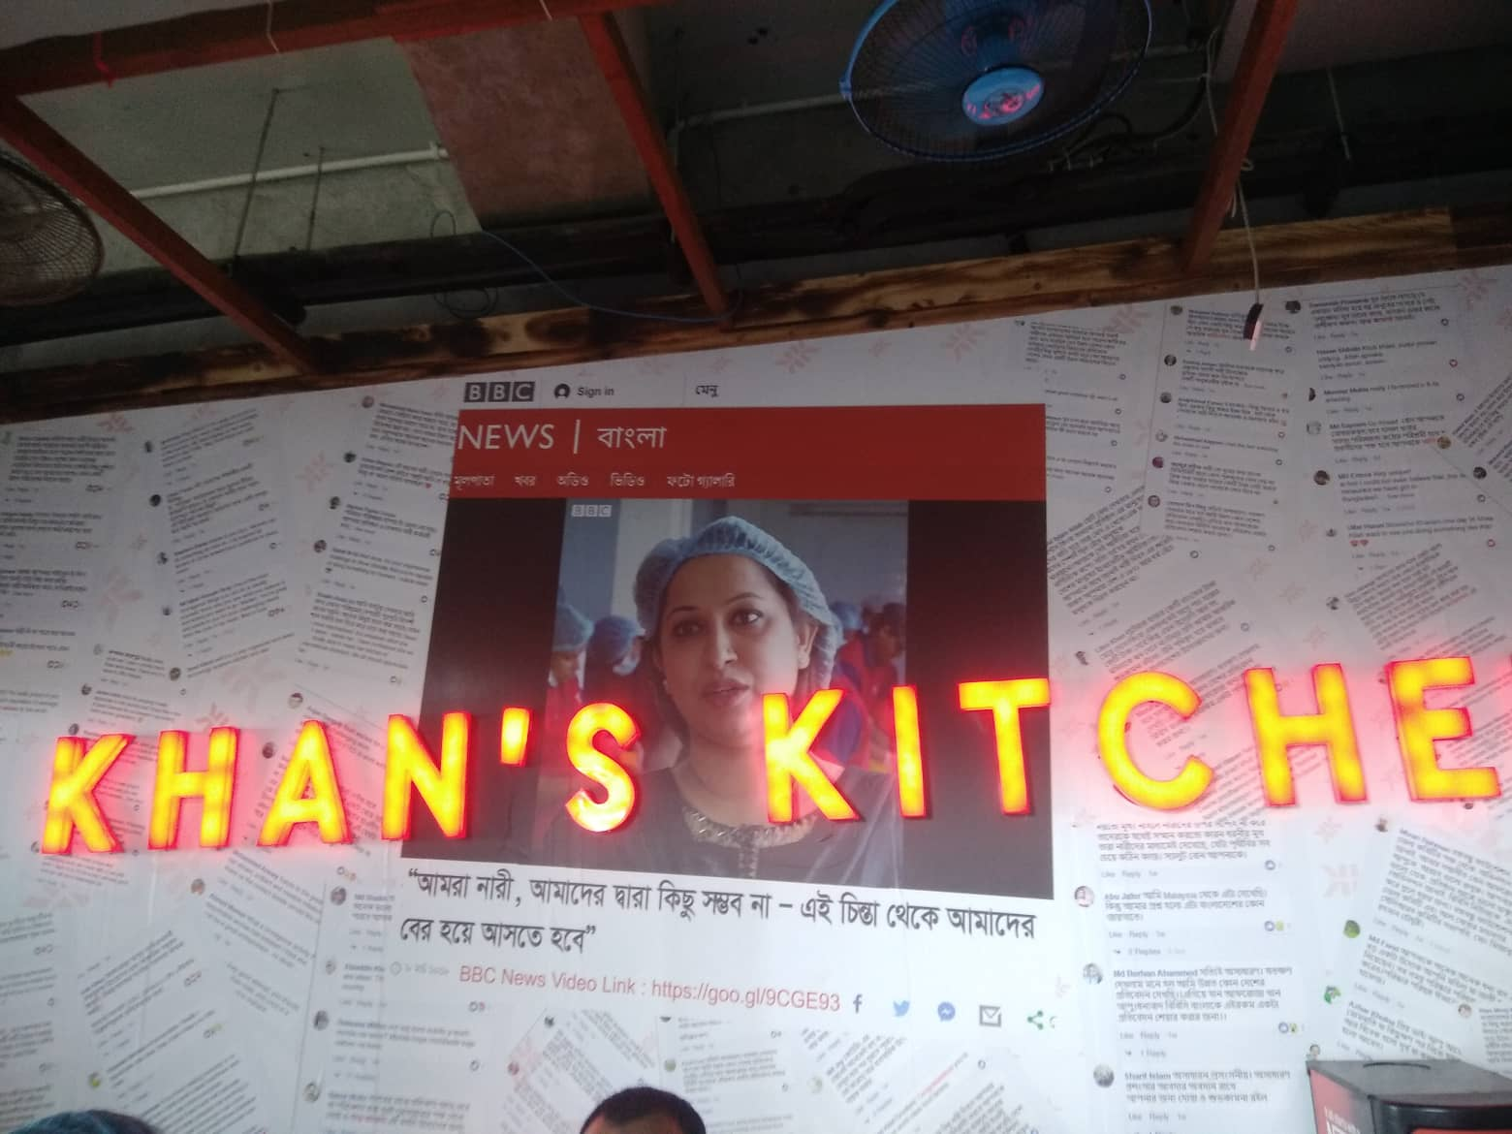

Data Analysis:
In this report I have evaluated the customer expectations and perception of services to measure service quality in service sector. SERVQUAL is the most applied approach or tool for ascertaining service quality had been to parallel customer expectations before a service encounter and their perception of the actual services delivered. SERVQUAL has generic dimensions or factors. These are stated below-

Tangibles: It is the personnel and information material, the appearance of physical facilities, equipment etc. I have made survey on canteen. Based on the tangibility dimension the findings, these are
Reliability: It is the ability to perform a promised service to the customer accurately and dependably.
Based on the reliability dimension the findings of the SERVQUAL model are-
Responsiveness: The desire and willingness to assist customers and deliver prompt service makes up the dimension of responsiveness.
Assurance: Knowledgeable and courteous employees who inspire confidence and trust from their customers establish assurance.
Empathy: The degree to which the customer feels the empathy will cause the customer to either accept or reject the service encounter. Empathy replaces access, communication, and understanding the customer
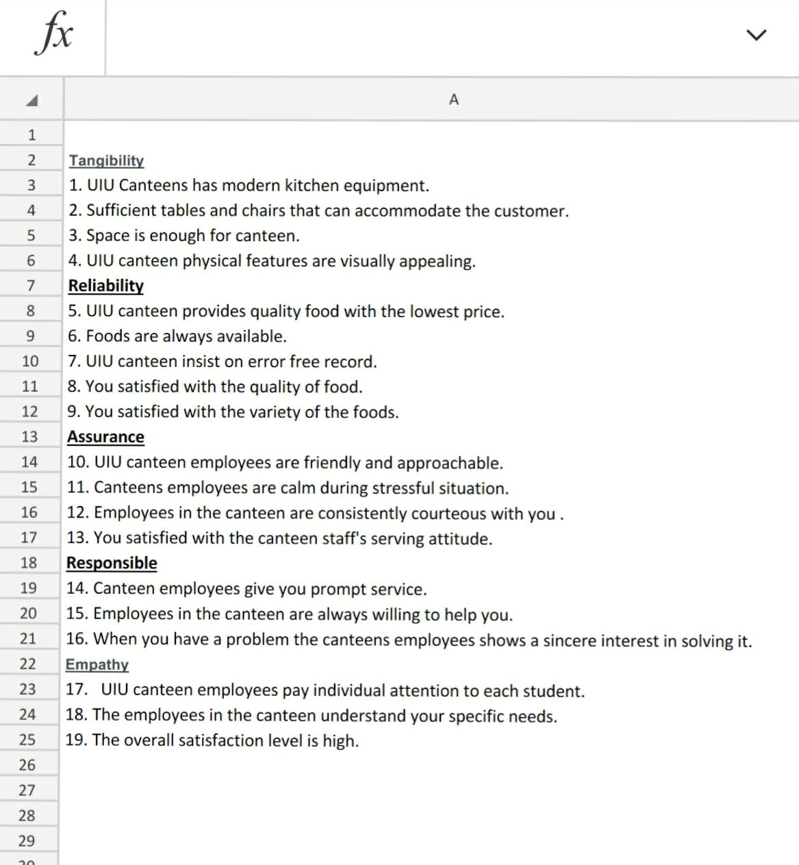

Interpretation (UIU Canteen Services)
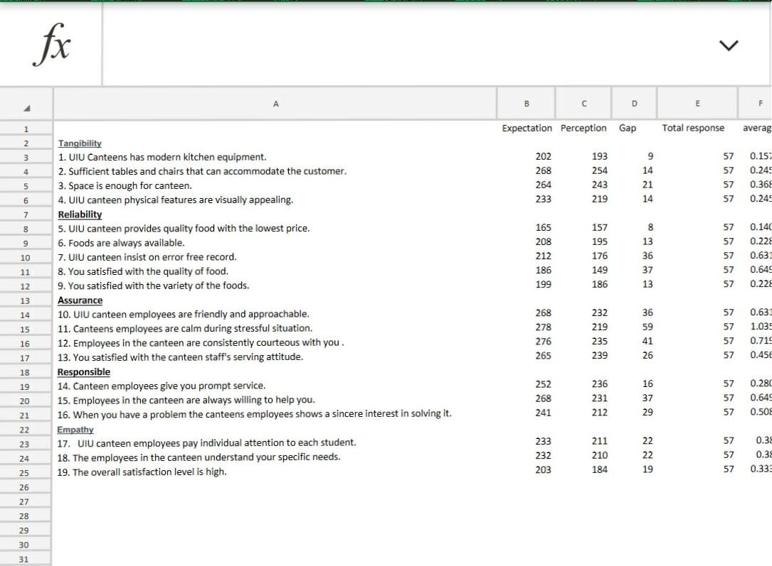
In the above analysis, we tried to evaluate the variations of providing service quality perceived by the customers though having the same quality equipment. We have seen the variations of providing service dimension in UIU canteen’s enough comparison. Because the service providers are not at all caring for its customers. It needs to be improved service.

Findings
The results indicated that customers’ perceptions failed to meet their expectations on the service quality of UIU canteens.
Quality: Canteen maintains medium standard in serving the population in every aspects of canteen facility. Starting from taking order of student to serve food and management of people the canteen maintain its quality .Achieving student satisfaction by continuous measuring and improving services.
Technology: The canteen is not update like other university canteen in terms of using technology. For an example, they are not use computers for record keeping and taking order for students. But other important instruments of modern technology like gas stove, coffee machine, fridges are available in canteen.
Lack of proper management: Canteen does not provide appropriate facilities to the student .They are even much focused towards their selling. The shortage of manpower hampers proper care and maintenance of the facilities.
Satisfaction:
- Service: UIU canteen provides moderate level of services. Student’s satisfaction is at marginal level.
- Integrity: Canteens adhere to moral principles and professional standards by a commitment to honesty, confidentiality, trust, respect and transparency.
- Compassion: canteens demonstrate their commitment to moderate level of care by providing a canteen service and supportive environment for their students and faculty.
- Cost: This canteen charges a high level of cost for food drinks and dessert items charges from the students.
Caring about Students: Caring of students is not up to the expectation level. Students are very conscious about their foods so they need to be handled with adequate service.
- Manpower: All canteens has lack of workers. With such little manpower it is unable to provide appropriate service which is required for better management of students

Limitations

In the time of questions get answered I have face a lot of limitations from the respondents due to not having the knowledge about the uses of data. . Among others the main limitations are:
- Some are truly illiterate about the questionnaire. I mean they are not experienced.
- The respondents are unlikely to give their full attention in filling up the questionnaire.
- Due to our Midterm exam, quiz and unexpected holiday, enough group discussions could not held as it should be.
Why I choose UIU Canteen for SERVQUAL Analysis
The chosen behind of UIU canteen is to create consciousness among the students of UIU. Because we all are human being. We have to go to the University for taking proper education as well as to complete our higher study. Everyday around 6000 students come to our university. If we deserve popper quality of education. We will also deserve the quality of food to survive in a better way. That is why I have chosen this topic to complete my SERVQUAL analysis. Since we are human being. We shall eat. The food should be halal and hygienic as per our body needs. We never eat the dustbin food like animal. So the food is our great concern to live along with health. If we eat the non- hygienic food we can’t survive in the long run. To provide better quality of food and along with awareness I have chosen this topic. SERVQUAL Analysis of UIU canteen shows that how the students expect about their eaten food. Also it shows that the proper guideline of UIU Canteen’s employees must show how their behavior should be done to the University students. This analysis shows the employees of UIU canteen how they can achieve their actual goal to serve a better quality of food with hospitality.

SERVQUAL basically done their survey and analysis on the basis of five dimension. It includes tangibles, responsiveness, reliability, assurance and empathy. To complete my report I had done so many things along with survey and analysis on the basis of this dimensions.

Recommendation

Service providers will still want to make certain their employees appearance, uniforms, equipment, and work areas on-site (closets, service offices, etc.) look good. By doing this survey I figure out that the main problem of UIU transport service is basically on their visual appealing

Dimensional Gap


Dimensional Gap
0.10

0.08

0.06

0.04

0.02

0.00
1 3 5 7 9 11 13 15 17 19 21 23 25 27 29 31 33 35 37 39 41
-0.02

-0.04

Recommendations for Transport Services
So, finally here is the dimensional gap, here we can see that the gap of tangibility is so high. TANGIBLES even though this is the least important dimension, but appearance matters. Just not as much as the other dimensions. Service providers will still want to make certain their employees appearance, uniforms, equipment, and work areas on-site (closets, service offices, etc.) look good. By doing this survey I figure out that the main problem of UIU transport service is basically on their visual appealing. Student’s expectation is high but they didn’t exactly meet up it.
So here are some points we can give as suggestion on this note-

  - As it’s a private university transportation service the university can renovate the vehicles as they use the old BRTC bus they can color it again to look more attractive
  - Then as our university campus is quite far students have to spend almost 2 to 2:30 or 3hours on bus, for this time only fan is not enough. University should use AC on the transport service.
  - Then the condition of windows are also not good UIU can use high quality & sun ray prove glass for windows.
  - Then students complain that seats are not so comfortable, as per they pay huge for transport so UIU should think for the comfortable seat arrangement’s.
  - Then transport attendance have to be more sincere about students and handling their problems.

And the most minimum gap is in the Assurance dimension (-0.02). Which means that UIU assure a safe transport service for students and make up with the expectations of the students.
Other dimensions are in a neutral position not so good nor too bad. Some match up the expectation and perception some may goes down on the level of perception and expectation.

Recommendations for UIU Canteen Services
This study demonstrates the usefulness of the SERVQUAL approach as a measure of service quality. The results of the study indicate that the SERVQUAL scale could make a valuable contribution by enhancing the understanding of the perceived service quality of UIU canteen. The measurement scale also serves to identify symptoms and the underlying problems that inhibit the effective provision of quality services in canteens.
Once the attributes of canteen services from the customers’ perspective are more clearly known and understood, its service providers will be in a better position to anticipate consumer requirements rather than to react to consumer dissatisfaction. The attributes of reliability, responsiveness and assurance have been identified by respondents to be the most important dimensions of service quality. Empathy and tangibility are found to have the lowest weighted SERVQUAL scores. This brings out canteens management should improve upon the tangibility aspects like improving physical facilities. It should provide individual customer attention and understand the specific needs of the individuals.

Conclusion

SERVQUAL dimensions are covered with Customers’ assessments. It includes Customer’s expectations and perceptions across all five dimensions of SERVQUAL. Service providers (UIU Canteens & UIU Transport) need to task on all of dimensions, but it should accentuate them in order of appreciation. If sacrifices surely take places, then it will use these degrees as a conductor for which one to reaction.
SERVQUAL has the capability to provide rapid service, systematically rank highly in both respondent teams, while the most pathological dimensions of tangibility, assurance, and empathy vary with the appreciation depending on the user’s sight of mind and the circumstances.

I am ranking the branches in terms of quality of providing service in the below:
This research has raised some important new questions not addressed by earlier studies on service quality.
If our findings are correct, individuals who research service levels with SERVQUAL have new limitations to co-dimension. If they accept our findings and also accept that SERVQUAL accurately measures service quality, the findings suggest that UIU canteens should focus relatively more of their service quality efforts on the reliability and responsiveness and assurance dimensions.
Appendix

References

Zeithaml, V. A., Bitner, M. J., & Gremler, D. D. (2013). Services Marketing: Integrating Customer Focus Across the Firm6thedition. McGraw Hill.
Christopher H.. Lovelock. (2016). Services marketing: people, technology, strategy. 8thedition. Prentice Hall.
Hoffman, K., & Bateson, J. (2011). Services marketing: concepts, strategies, & cases. Cengage Learning.Book – Services Marketing
https://en.wikipedia.org/wiki/SERVQUAL#Development,of,the,model https://www.serviceperformance.com/the-5-service-dimension-all-customers-careabout/
http://www.serviceperformance.com
https:/issu.com/zszs/docs/services marketing

