

Thesis Report
On
“Factors Influencing the Adoption of Industrial IOT for the Manufacturing and Production SMEs in Bangladesh.”

Submitted to:
Mr. Ahmed Imran Kabir
Lecturer, School of Business & Economics(SoBE)

Submitted by:
Maksudur Rahman
ID: 111 191 118
Submission Date: 14th December, 2024

Letter of Transmittal

Maksudur Rahman
United International University
ID: 111 191 118
December 14, 2024
To
Mr. Ahmed Imran Kabir
Lecturer, School of Business & Economics(SoBE)
United International University

Subject: Thesis submission of “Factors Influencing the Adoption of Industrial IOT for the Manufacturing and Production SMEs in Bangladesh”.

Dear Mr. Kabir,
I am glad to submit my thesis “Factors Influencing the Adoption of Industrial IOT for the Manufacturing and Production SMEs in Bangladesh” as a requirements of the BBA degree at United International University.
This paper focuses on factors influencing the adoption of Industrial IOT for the Manufacturing and Production SMEs in Bangladesh, which highlighting on how organizational readiness mediates other factors such IIOT expertise, security and privacy, and top management support.
I am highly thankful for your support and guidance throughout the research, which was very helpful in preparing this work. For any clarification or additional details feel free to contact me.
Thank you for your Consideration.

Sincerely,
Maksudur Rahman

Acknowledgement

Firstly, my sincere gratitude to Mr. Ahmed Imran Kabir Lecturer at School of Business & Economics(SoBE), United International University, for his precious guidance, inspiration and feedbacks throughout the research process. His insights and expertise have been helpful for successful completion of this thesis.
I am also thankful to all my respondents from various SMEs who gave their valuable time and participate in the survey and share their valuable insights, which was a great contribution to the findings of the study.
Additionally, I am also appreciative of my friends and family for their invaluable encouragement and support, which kept me going during the entire process.
Finally, I acknowledge the care of United International University, whose academic environment and resources provided me the foundation to complete this research successfully.
I offer my heartfelt thanks and appreciation to everyone who has made a direct or indirect contribution.

Abstract

This study primarily focuses on how Industrial IOT being adopted and how it benefits manufacturing and production SMEs in Bangladesh. Utilizing IIOT, SMEs can efficiently work in their manufacturing and production settings, easily engage with their vendors and different parts of the organization. This research analyses key factors influencing IIOT adoption including IIOT expertise, protection of data as well as focusing on top management support. By SEM analysis and surveys, the research findings demonstrate that IIOT has ability to improve meet sustainable manufacturing and production objects in SMEs. Though many challenging factors such as IIOT expertise, security concerns, and support from top management create significant barriers.
Keywords: Industrial IOT, Manufacturing and production, SMEs, Data security in IOT, Industry 4.0 adoption, Manufacturing sector in Bangladesh.

Table of Contents
Letter of Transmittal 1
Acknowledgement 2
Abstract 3
1. Introduction 5
1.1 Era of Digital Revolution 6
1.3 Problem statement 8
2. Literature Review 9
3. Hypothesis Testing 11
3.1 IIOT Expertise 11
3.2 Security and Privacy 12
3.3 Top Management support 13
3.4 Organizational Readiness 13
4. Methodology of the study 15
4.1 Study context 15
4.2 Research and Questionnaire Design 15
4.3 Sampling and Data Collection 16
4.4 Data analysis 16
4.5 Mediation Analysis 17
5. Results and Data Analysis 17
5.1 Respondent’s profile 17
5.2 Model Measurement. Validity and Reliability 19
5.3 Discriminant validity 21
5.3.1. Fornell-Larcker Criterion Analysis 21
4.3.2. Heterotrait-Monotrait (HTMT) Analysis 22
5.4 Cross Loads 23
5.5 Assessment of the Structural Model 24
5.6 Hypothesis Testing (Direct and Indirect Effects) 26
6. Conclusion 27
7. Limitations and Future Research Directions 28
8.Reference 30
Appendix 34

1. Introduction
Industrial Internet of Thinks(IIOT) is collection of applications, platforms, systems and tangible items that use technology to exchange information and interact with individuals both within and out of organization (Sivathanu, 2019). Additionally, it assists designers in gathering data on their goods to gain a better insight of their quality and usability. So that they can set themselves apart from rivals. Industrial IOT is the collection of information technology, operation technology, Industry 4.0, Industry 5.0 and fog computing. The IIOT supports a vast array of networked industrial systems and facilitates the harmonization and exchange of information among analysts, hence improving industrial performance (Sivathanu, 2019).
The Internet of Things (IOT) is a ubiquitous computing system that uses sensors from various devices to collect, analyze, monitor and process data in order to integrate functionality from real world (Korte et al., 2021). Among other issues, IOT in one of IR 4.0’s most important concerns for example Artificial Intelligence (AI), smart factories, big data, machine learning. Product designers can use the Internet of Things’ capacity to produce vast amounts of data throughout the production stage to enhance the quality of their products. As a result, this more consistently meets end users requirements (Khan & Javaid, 2022; Rana & Sharma, 2019).
Small and medium sized businesses (SMEs) are typically privately held, partnership, or limited firms with fewer than 250 employees. The main goal of small or local enterprises or SME’s, is to supply the community with goods, products, and services. Manufacturing, agricultural, lodging, building, mining, gas the extraction process, production, food services, utilities, and wholesale businesses are example of SMEs. (Belhia & Bentaouaf, 2022).
In developing nations like China, Japan, Korea, Australia, and New Zealand, the use of IIOT in SMEs is growing quickly. This is because there is a chance for increased output, quality assurance, effectiveness, elimination of supply chain problems, and cost savings. (Chowdhury & A Raut, 2019). Quality control, lower expenses, supply chain problem elimination, efficient resource management, and time management during the planning phase are just a few of the advantages and developments that the IIOT adoption brings to manufacturing and production SMEs (Chowdhury & A Raut, 2019). Furthermore, IIOT quickly updates the industrial activities digital environment. IIOT is a network of physically connected devices, such as controllers, gauges, and motors, that are integrated into internet-connected machines and systems. This allows them to communicate with and exchange data within the industrial setting (Boyes et al., 2018). IIOT is transforming SME operations in developing nations in the area of retail, manufacturing, packaging, agriculture, construction, banking and insurance, transportation, and automation.

Era of Digital Revolution
The late 18th and 19th century industrialization drive began with the industrial Revolution 1.0. The development of machinery, such steam engines, that took the role of manual labor is what defines IR 1.0 Railroads and steamboats, among other new modes of transportation, boosted the usage of steam of steam power and enhanced the efficiency of water power. Additionally, IR 1.0 introduced the development of water canals and machine tools (Mohajan, 2019a). The discovery of electricity, the internal combustion engine, mass production, petroleum, alloys, assembly line manufacturing, chemical industries, and electrical communication technologies (telegraph, radio, and telephone) marked the beginning of the second IR (Mohajan, 2019b). Electrical devices took place of steam engines in IR 2.0. In the manufacturing and production sectors, shift automation and data exchange are hallmarks of the industrial Revolution 3.0, commonly referred to as the digital revolution. Transistors, programmable logic controllers, integrated circuits, and digital logic systems were among many electronic gadgets created during IR 3.0. The corresponding derived technologies of the digital revolution, including computers, digital mobile phones, microprocessors, and the internet, are likewise the foundation of IR 3.0 (Xu et al., 2018).
The current analog world is being transformed into a modern, digital one via the digital revolution. However, Industrial Revolution 4.0 uses any of these advanced technologies of define the increasing trends towards automation and data exchange in technology and processes within manufacturing and production industries, such as artificial intelligence, cloud computing, cognitive computing, cyber-physical system, and the internet of Things (IOT) (smart factories and smart manufacturing). Additionally, it encompasses the creation of novel materials and technologies like robots, augmented reality, virtual reality, automated data entry, and 3D printing (Xu et al., 2018). The fifth stage of the industrial revolution, known as “IR 5.0” is centered on a confluence of cutting edge technologies, including artificial intelligence (AI), big data, cyber security, automation, cloud computing, and the Internet of Things (IOT). Together, these elements propel the IR 5.0 (Elangovan, 2021).
The IIOT paradigm has strong and exploratory implication for IR 4.0 and IR 5.0. Businesses like SME’s uses IOT based devices and sensors to produce goods and services like industries machineries and vehicles (Dhirani et al., 2021). Products, connections, sensors, the cloud, data visualization, and external data are some of the items that make up the IIOT products. Adoption of IIOT benefits producers and manufacturers in terms of quality improvement, cost reduction, downtime, throughput and monitoring (Kalsoom et al., 2021).
Numerous studies have demonstrated the potential of IIOT to boost operational efficiency and offer a competitive edge. Nevertheless, a number of contributing variables contribute to the delayed embracing IIOT in manufacturing and production SMEs in developing nations. An empirical investigation is required to comprehend these elements in order to suggest the IIOT adoption strategy for SMEs engaged in manufacturing and production in emerging nations. The research focuses on understanding the underlying trends in developing countries and identifying the various factors that influence the adoption of IIOT in manufacturing and production SMEs. Recent academic literature indicates a gap in developing nations manufacturing environment in IIOT adoption. Current research also considers individual, organizations, and environmental factors when adopting advanced technologies, but the majority of studies only focus on the technological factors. As a result, the researchers believe that there is a strong need of SMEs in developing countries to transition to IIOT adoption in order to obtain improved prospects. (Javaid et al., 2021) According to Javaid this paper gives a summary of the IIOT, its related technologies, and its main advantages and characteristics for manufacturing SMEs. With the use of IIOT, the paper examines how smart modification has changed the manufacturing sector and finds 29 important uses of IIOT in manufacturing SMEs. IIOT monitors a number of distributed and outsourced operations, including supply of commodities, transportation, warehouse data, product storage, condition, and delivery.
The main goal of the study was to investigate the variables affecting the use of industrial iot in Bangladeshi SME’s manufacturing and production. We surveyed more than 100 professionals in Bangladesh who are experts in this sector of engineering, logistics, MIS, and IT to collect their opinions. We also examined unavoidable issues regarding Industrial IOT (IIOT) and future research areas that must addressed when implementing IIOT in Manufacturing and production industries.

1.3 Problem statement

The use of IIOT in SMEs for production and manufacturing are expanding quickly in industrial nations like China, Japan, Korea, Australia, and New Zealand. The researchers do observe, however, that developing nations such as Bangladesh, Malaysia, Pakistan, and Saudi Arabia have not adopted IIOT in SMEs for manufacturing and production (Jadala et al., 2021; Umair et al., 2021; Vuković et al., 2021). Adoption of IIOT is intended to provide the manufacturing and production sectors with a number of benefits and enhancements, including quality control, cost reduction, supply chain problem diagnosis, effective time management during the planning stage, and optimal resource use. Manufacturing companies can improve their overall operations and reap significant benefits by using IIOT technologies (Umair et al., 2021). Moreover, it is yet unknown what factors influence SMEs engaged in manufacturing and production to adopt IIOT (Vuković et al., 2021). Furthermore, evaluating the impact of IIOT adoption on people, organizations, technology, and environmental surrounding in both developed and developing nations has a flaw. IIOT is changing how SMEs do business in the areas of retail, construction, agricultural, finance and insurance, transportation, production, manufacturing, packaging, and automation. Nevertheless, little is known about how IIOT is being adopted by SMEs engaged in manufacturing and production in developing nations. To deal with the important issues surrounding the implementation of IIOT.

2. Literature Review
Industrial IOT(IIOT) made the real world manufacturing and production process much easier. (Shah et al., 2024) They Conducted comprehensive review of existing studies, and used TOEI frame work. Their study focuses to enhance productivity and competitiveness, it addresses challenges encountered by SME’s in developing countries. Their study shows efficiency significantly impacts IIOT adoption in manufacturing SME’s and capability is related to SME’s technical knowledge and capacity, acceptability affects the adoption of IIOT technology in SME’s. On the other side (Sivathanu, 2019), They used TOE frame work that combines technological, organizational, and environmental contexts to adoption of IIOT. The state that organizational readiness and top management support are very important for adoption of IIOT also security and privacy concerns significantly affects intention of IIOT adoption. Their finding shows compatibility with the existing technology influence the adoption also competitive pressure and vendors support is important for adoption intentions in IIOT. Cost and security are key determinants the study provides insights for ACMSME’s policymakers. Similarly, (Mitra et al., 2024) They used Structured equational model for data analysis, their analysis shows factors influencing IOT integration and growth there key factors include competitiveness, regulatory support and management support. They used quantitative analysis for data collection that highlights IOT’s potential for decision making and operational support. Factors like regulatory support, competitiveness and cost savings significantly affects IOT adoption. Management support and manufacturing growth indirectly impact adopts IOT adoption. For instance, (Ahmetoglu et al., 2022) this study found out six critical factors for adoption of IOT which are Technological, organizational, environmental, human, benefit and value. Digitization highly influence analytics in IOT outcomes while high cost inhibits Intention of IOT adoption for the success of IOT adoption human factors are crucial. (Peter et al., 2023) This paper focuses on IIOT in manufacturing businesses in developing economies like Nigeria and South Korea. The paper highlights the need for digital technology implementation. IIOT provides financial opportunities and challenges for manufacturing businesses. Implementation of digital technology is slow in undeveloped countries in these countries cyber security and data integrity major challenges. This also outline user acceptance and cultural behavior impact on the adoption and Big data is crucial for strategic decision making. (Beliatis et al., 2021) This paper was made for GPV electronics manufacturing company in Denmark. This paper aims to improve production efficiency and product traceability. They compare The Industrial IOT technology as attributes for traceability solution. (Kalsoom et al., 2021) This paper uses systematic literature review methodology for analysis. This paper explores IOT application in manufacturing industry 4.0. The paper states that high IOT Implementation cost slow technology adoption in manufacturing sectors the research collaboration in IOT and in industry 4.0 is limited. (Madni et al., 2022) This paper identifies factors influencing IOT adoption in E-Learning. They state that IOT application enhance learning efficiency and student engagement, challenges for IOT in education including security and privacy. They also find out that IOT adoption is limited in developing countries their significant factors are privacy, infrastructure, and financial constraints. Individual, organizational, technological and environmental factors influence IOT adoption. (Jeansson & Bredmar, 2019) The study identifies internal and external drivers of value creation. This paper states that digital transformation is complex, dynamic, and ongoing. SMEs need to manage external and internal digital environment simultaneously. (Kumar et al., 2022) This paper identified ten challenges of IIOT implementation. This paper states that block chain technology can mitigate data security and reliability challenges, IIOT technology enhance manufacturing processes efficiency and traceability. The study emphasizes the urgency of digitalization in manufacturing SMEs. The research highlights the need of holistic technology implementation strategies. (Sun, 2012) This paper discusses RFID technology’s business value and potential, RFID enhances real-time visibility in supply chains. IIOT optimizes supply chain management and transparency. Smart meters revolutionize utility operations and data transmission. RFID can transmit data even when devices are off. Anti-counterfeiting labels help verify product authenticity. (Khan et al., 2020) This paper states that in order to achieve maximum operational efficiency and higher production, look at the upcoming IIOT technologies, which are an extension of IOT for industrial system. The state of the art research efforts are examined in terms of IIOT designs, communication protocols, frameworks, and data management strategies once a precise definition of the word is given. Recent issues with IIOT technology domains such data management, interoperability across heterogeneous technologies and protocols, customer trust, wireless coexistence, big data analytics, edge decentralization, IOT operating systems, and public safety are examined together with enabling technologies for IIOT. (Majstorovic et al., 2021) in the same way, The success of Digital manufacturing (DM) models for SMEs in Serbia is discussed, along with an example of best practices for DM in specific SMEs that use the concept of DM as a basis for the application of the IR 4.0 model. In conclusion digitization is a prerequisite for the moment in the development of the Serbian economy that is the goal of the application of IR 4.0. DM application in SMEs are also provided, including the use of computer aided design, computer aided manufacturing, cloud computing, BDA, ERP, IIOT, and smart supply chain.

3. Hypothesis Testing
IIOT proficiency refers to the organization’s degree of information system expertise as well as the abilities and know-how to use information system(IS) efficiently in accordance with the needs of the company (Crook & Kumar, 1998).
Manufacturers continuously encounter challenges to decrease their environmental impacts while maintaining competitiveness. However, the use of IIOT supports sustainable practice and innovation, it becomes easier to move towards an efficient manufacturing and production system. As a result, we reached at the following hypothesis:

3.1 IIOT Expertise
IIOT proficiency refers to the degree of information system expertise of the organization as well as the ability and knowledge to use IS efficiently in accordance with the needs of the business (Crook & Kumar, 1998). Current research demonstrate the SME’s lack of IS experience is a problem and engaging outside experts might be challenging. (Morgan et al., 2008). Additional research revealed that SME adoption of IOT is impacted by their lack of IOT competence (Palacios-Marqués et al., 2015). Small and medium sized businesses (SMEs) must have a solid grasp of the Industrial IOT and hot to strategically integrate it into their current operations. Research shows the SMEs frequently encounter obstacles such a lack of technical know-how, budgetary limitations, and change aversion (Nara et al., 2021). Training staff, encouraging cross- departmental cooperation, and interacting with technological vendors for customized solutions are all part of building IIOT competence (Sommer, 2015). In order to remain competitive in an increasingly digitalized industrial landscape, SMEs can use IIOT to improve operational efficacy, predictive maintenance, and real time decision making by developing this fundamental competence.
H₁: IIOT expertise has a beneficial or negative impact on Bangladeshi manufacturing and production SME’s adoption of IIOT.

3.2 Security and Privacy
One of the most crucial elements of the IIOT infrastructure and a top organizational issue is security. The past studies related to IS and IOT are mentioned about the security-related worries regarding data, institution and system security (Chan & Chong, 2013; Chen et al., 2014; Medaglia & Serbanati, 2010; Oliveira & Martins, 2008; Tao et al., 2014; Weber, 2010). Data security and privacy are essential for the IS to operate well. (Saedi & Iahad, 2013) Created a theoretical framework that addresses the significance of privacy and security for manufacturing expertise’s adoption of IIOT. Small and medium emprise (SME’s) adoption of the industrial IOT is severely hampered by security and privacy issues. IIOT system’s interconnectedness makes them more vulnerable, putting SMEs at risk for things like industrial espionage, illegal access, and data breaches (Lu & Zhu, 2019). Strong cybersecurity frameworks, such as data encryption, secure communication protocols, and frequent security audits, must be put in place to address these issues (Li & Li, 2017). SMEs frequently lack the resources necessary to implement thorough security measures, so forming alliances with cyber security companies and utilizing could-based security solutions are essential tactics. SMEs can reduce risks and foster trust by putting security and privacy first, which will help the IIOT integrate successfully.
H₂: Security and Privacy has a beneficial or negative impact on Bangladeshi manufacturing and production SME’s adoption of IIOT.

3.3 Top Management support
Top management is the primary decision-maker when it comes to technology adoption and purchases. According to the additional research, management support for IS adoption is a crucial prerequisite for business to use IT (Daylami et al., 2005; Jeyaraj et al., 2006; Lin, 2009). Top management makes ensuring that resources are allocated appropriately for the workplace’s adoption of new technology (Vahtera, 2008). Support from upper management is a cruciual factor for the Mobile Supply Chain Management (Chan & Chong, 2013). Foe small and medium sized businesses to successfully use the industrial IOT, top management support is essential. In addition to acknowledging the strategic importance of IIOT, leaders must actively support its deployment by providing funds, establishing precise objectives, and cultivating and innovative culture (Kamble et al., 2018). Additionally, improving alignment of IIOT efforts with organizational goals and operational capabilities is made possible by senior management participation in decision making (Mittal et al., 2018). SME executives may improve organizational readiness, reduce adoption hurdles, and promote sustainable digital transformation by exhibiting leadership and giving IIOT investment first priority.
H₃: Top management support has a beneficial or negative impact on Bangladeshi manufacturing and production SME’s adoption of IIOT.

3.4 Organizational Readiness
Organizational readiness is imperative for any technology’s adoption. This reference can be used to examine the technological and financial constraints that SMEs face when it comes to adopting new technology and ensuring organizational readiness. Additional research on behavior theories and innovation that indicates organizational preparedness (Bandura, 2009). Prior studies of IS adoption confirms that, The adoption of IS innovation is influenced by organizational preparedness (Chen et al., 2010; Jedermann & Lang, 2008). (Hsu & Yeh, 2017) the study happened in Taiwan about adoption of IOT and Logistics demonstrates that a key factor in IOT adoption is organizational readiness. For small and medium enterprise (SMEs) to successfully implement the industrial IOT organizational readiness is a crucial factor. A supportive corporate culture, technology infrastructure, and the availability of qualified staff are all components of readiness (Mittal et al., 2018). Through working training, updating old system, and encouraging cross-functional cooperation, SMEs must assess their current capabilities and fill any gaps (Horváth & Szabó, 2019). Long-term adoption also depends on financial preparedness, which includes setting aside money for IIOT initiatives and obtaining outside finance if required (Kamble et al., 2018). According to research, SMEs are better equipped to handle obstacles including resource limitations and technological complexity when they take a proactive approach to preparation (Ghobakhloo, 2018). SMEs may guarantee a more seamless transition to IIOT and attain enhanced operational efficiency and innovative capability by establishing a strong foundation of organizational readiness.
H₄: The association between IIOT expertise and IIOT adoption by Bangladeshi manufacturing and production SMEs is mediated by organizational readiness.
H₅: The association between security and privacy and IIOT adoption by Bangladeshi manufacturing and production SMEs is mediated by organizational readiness.
H₆: The association between top management support and IIOT adoption by Bangladeshi manufacturing and production SMEs is mediated by organizational readiness.

Figure 1 demonstrates the assumptions that IIOT adoption and IIOT expertise, security and privacy, and top management support have favorable and significant link (H_{1,} H_{2,} H₃). Additionally, it shows the hypotheses that the organizational readiness mediates relationship between the IIOT adoption and IIOT expertise, security and privacy, top management support (H_{4,} H_{5,} H₆).
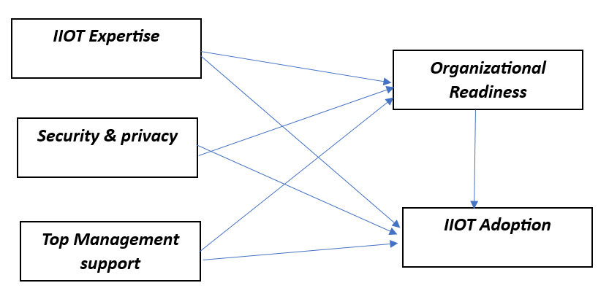
Figure 1. The background of the study.

4. Methodology of the study

4.1 Study context
This study primarily focuses on the production and manufacturing sector in Bangladesh. Amon the developing countries Bangladesh is one of developing countries with rapidly raising manufacturing sector. This study aims to identify the parameters impacting Bangladeshi manufacturing and production SME’s adoption of industrial IOT and how this countries manufacturing sector become more competitive and sustainable.

4.2 Research and Questionnaire Design
Scientific approach was followed by the study, which allow us to extract empirical knowledge from data driven hypothesis. This study also carried a comprehensive quantitative analysis to understand the elements impacting Bangladeshi manufacturing and production SME’s adoption pf industrial IOT. MIS, Engineering and IT experts have contributed their ideas and provide responses the qualitative questions.
We utilized total five variables in our final survey, which comprise 16 questions. We confirmed that the questions were clear, easily understandable and contains the information that we must comprehend the elements that affect the adoption of IIOT in SMEs engaged in manufacturing and production. The survey instrument was created using three “IIOT expertise” elements (Pudjianto et al., 2011). Also ‘Security and privacy’ of IIOT with tree items were adopted (Chan & Chong, 2013; Kim & Garrison, 2010). ‘Top management support’ utilized three items (Pudjianto et al., 2011; Wang et al., 2010). ‘Organizational Readiness’ have been adopted four items (Hossain et al., 2017; Lin & Lin, 2008; Oliveira & Martins, 2010; Thong & Yap, 1995; Wang et al., 2010). Also for ‘adoption intention’ three items were used (Chan & Chong, 2013). We used Likert scale to measure each question from (1) strongly disagreeing to (5) strongly agree. Via google form we constructed the online survey.

4.3 Sampling and Data Collection
We were able to collect complete and valid responses of 128 participants. However, due to inaccurate answers, we excluded 28 of them from our samples. Our response rate was 78.13%. They findings of the study were tested by a survey of 100 people. All participants have constructed to take part in the study. We also have informed each respondent their inputs will be used in the research only. VIF values were between 1 to 5, indicating moderate collinearity.

4.4 Data analysis
SEM (structure equational modelling) evaluation was done to make sure the study model was correct. Testing the data analysis and examining the model’s dependability was feasible, correctness by Smart PLS 3.2.9. The minimum r-square approach explained by (Hair et al., 2019; Polas et al., 2022) helped us obtain the sample size needed for SEM analysis. Therefore, to forecast what will occur PLS-SEM is the most precise method. It works with both data and structure models at the same time (Cepeda-Carrion et al., 2019; Khan et al., 2019; Sarstedt et al., 2020) It is also a very good way to view at the route models that are very complex. The PLS-SEM can work with very small amount of samples and still give very precise and exact data. This is the reason why PLS-SEM was very good tool for our research. The measurement and structure model was examined using the alpha coefficient and additional statistical tests, such as discriminant and convergent validity.

4.5 Mediation Analysis
This study contains, a two-step method (Sarstedt et al., 2020) was utilized to find out how organizational readiness could affect adoption intention of IIOT in Bangladeshi SMEs engaged in production and manufacturing. The first step viewed the effect of ‎‎‎‎‎‎IIOT expertise, security and privacy, and top management support on organizational readiness. The indirect effect of IIOT expertise →‎‎‎‎ organizational readiness → IIOT adoption, security and privacy → organizational readiness → IIOT adoption, and top management support → organizational readiness → IIOT adoption were significant in this study. The researchers examined the effects on the intention to implement IIOT for H4, H5, and H6 using IIOT expertise, security and privacy, and top management support in manufacturing and production without removing the mediator (organizational readiness).

5. Results and Data Analysis

5.1 Respondent’s profile
The data of the following survey were collected from various manufacturing industry professionals, shows demographic information of the participants. Table 1 shows the following distribution: the predominant age group is 21-30 years, representing 72% of respondents, underscoring workforce of young people. Males constitute most of the survey population at 80%. In terms of marital status, a significant majority of the respondents are single (62%), which align with the demography of younger agers. Educationally, most respondents have an undergraduate degree (56%), and a substantial portion (69%) have work experience of less than five years, indicating a relatively less experienced workforce. This demographic profile shows that the industry is dominated by young workforce, single male with basic level of higher education and limited experience. The primary focus is to get different angles that shows how IIOT influences manufacturing and production SMEs of Bangladesh.
Table 1. Demographic profile of Respondents
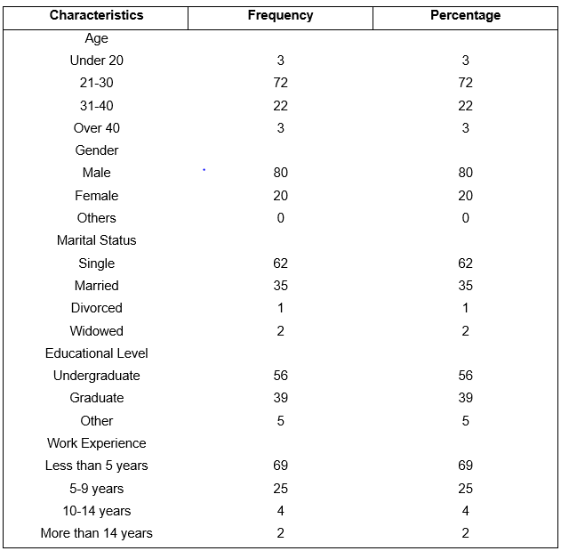

5.2 Model Measurement. Validity and Reliability
In structural equational model (SEM), model measurement, validity, and reliability are vital components for examine the model’s quality. Validity is the assessment to test the model measures what it is supposed to measure. This embraces discriminant validity (whether constructs are different from on another), convergent validity (whether indicators of a construct are correlated), and construct validity (whether the latent variables are accurately signified by their indicators). Contrarily, reliability is the consistency of the measurement, which is typically measured using composite reliability (CR) or Cronbach’s alpha, that shows how well a group of indicators constantly measures latent variables. Validity and reliability provide assurance the measurement model’s correctness and reliability, deliver a solid source for additional SEM inquiry.

Table 2 displays review of the model. Above 0.50, the outer loading is acceptable. Table 2 demonstrates that the study’s outer loading exceeds 0.50 (Dash & Paul, 2021). It is recommended that the internal consistency of dependability be examined if the overall reliability score is greater than 0.70 (Peterson, 1994). Table 3 shows the study is more reliable than or equal to 0.70. Table 2 shows that Cronbach’s alpha is typically higher than 0.70. In two cases it is less than .07 showing moderate reliability. As a result, all values are strong reliable except for Cronbach’s alpha criteria values for security and privacy and IIOT adoption Intention. Using the average variance extracted (AVE), the convergence validity was calculated. To apply convergence validity both items should have loading factors greater than 0.50. Table 2 shows AVE numbers are greater than 0.50.

Table 2. Measurement of model assessment
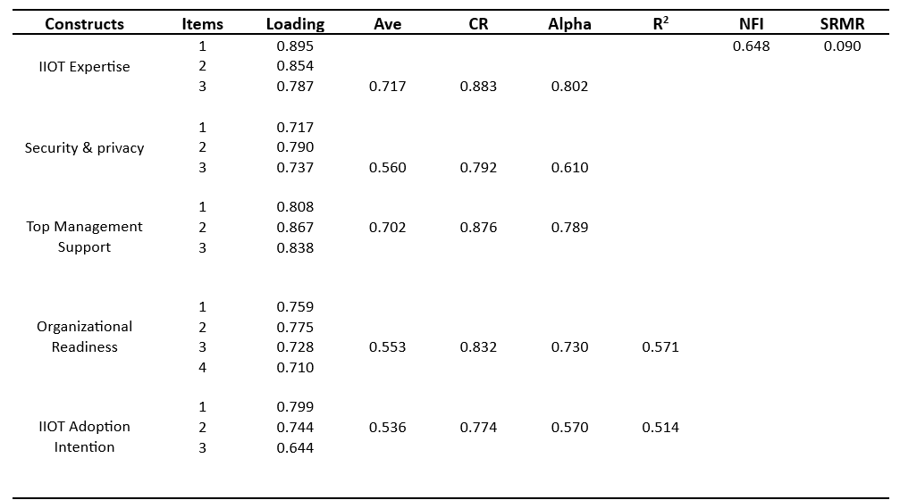

Table 3. Values of the model’s Cohen’s indicator (f²) and Stone-Geisser indicator (Q²) in the SEM.
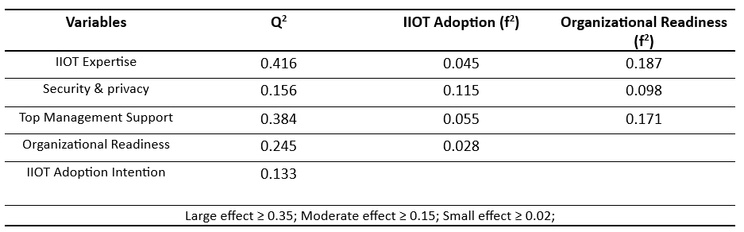
Testing the model with R² values (Hair et al., 2019) of 2%, 13%, and 26% provides the organizational readiness is affected by outside factors that are significant, accounting for 57.1% of its variation. Additionally, the decision to IIOT adoption intention explains 51.4% of the variation in the increase in IIOT adoption intention. The model accurately fit with the goal and the data, moderate NFI is shown (Dash & Paul, 2021) of 0.648 and low SRMR (Hair et al., 2019) of 0.090.
Table 3 shows, Q² numbers above zero shows model has predictive relevance and can accurately predict the outcomes. Importantly organizational readiness has impact on how IIOT is used. This proves that the model is great with predicting the future and fits data very well overall.

5.3 Discriminant validity

5.3.1. Fornell-Larcker Criterion Analysis
In structural equational modeling (SEM), the Fornell-Larcker criterion is a method used to assess discriminant validity, which verifies that one construct in a model is different from others. It creates the connection between individual construct and the other with the square root of the average variable extracted (AVE) of each construct. If individual construct’s square root of the AVE is greater than its connections with other constructs in the model, discriminant validity is confirmed. This proposes that its own indicators share more variance with its own construct’s than by other constructs. There is similarity between square root of latent variable (LVs) and AVEs in Table 4 we used the Fornell-Larcker measure (Fornell, 1981) to determine the model’s reliability. The average value of every factors is the square root of a number in range between (0.732 to 0.847). The table shows all diagonal values (displaying each construct’s AVE square roots) are higher than their respective row’s and column’s off-diagonal values, supporting the discriminant validity of all the constructs. This means individual construct is different and varies more from its own measurements than from those of other constructs, for model validation it is a desirable outcome.
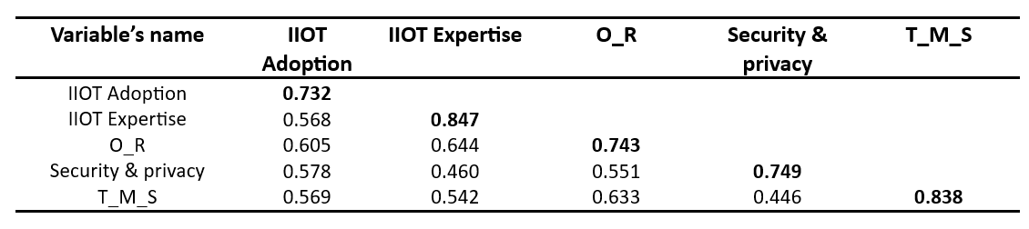
The diagonal values are the greatest values in each row and column which are square root of the latent variable’s AVE.

4.3.2. Heterotrait-Monotrait (HTMT) Analysis
The evaluation of discriminant validity discovered that all the HTMT values were below 0.90, except two values organizational readiness and security and privacy in IIOT adoption column values are little bit above 0.9. In Table 5. HTMT below 0.90 verify the discriminant validity of the variables (Cheung et al., 2023; Hair et al., 2019).

Table 5. Discriminant validity using the Heterotrait-Monotrait (HTMT) analysis.
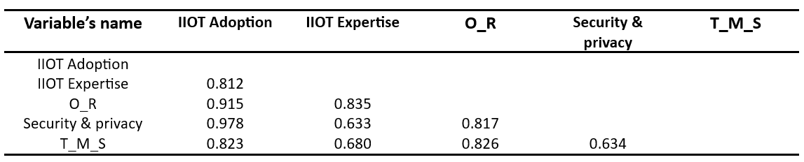
Note: Discriminant validity exist if the HTMT<0.90

5.4 Cross Loads
In structural equational modeling (SEM), cross-loadings happen when indicator greatly loads various factor, not simply the one it is destined assess. This proposes that the indicator is representing numerous latent variables and not unique to one construct. An indicator should have moderately load on other factors and comparatively higher loading on its assigned factor. Cross-loadings point out problems like inappropriate selection of items or constructs that are overlapping, which compromise the validity of the model.
Table 6 provides the values of cross-loads of individual item on different latent variables in the structure equational model (SEM), to assess discriminant validity which are the key (Dash & Paul, 2021; Hair et al., 2019). In SEM the discriminant validity id adequately supported when individual item loads significantly higher on its own constructs (Latent variable) then on others constructs. Table 6 shows each item loads higher on its own constructs than on others, proposing that model contains good discriminant validity. Individual constructs effectively capture difference to its specific measurement, distinct form other constructs in the table.

Table 6. Values for each item’s cross load in the SEM.
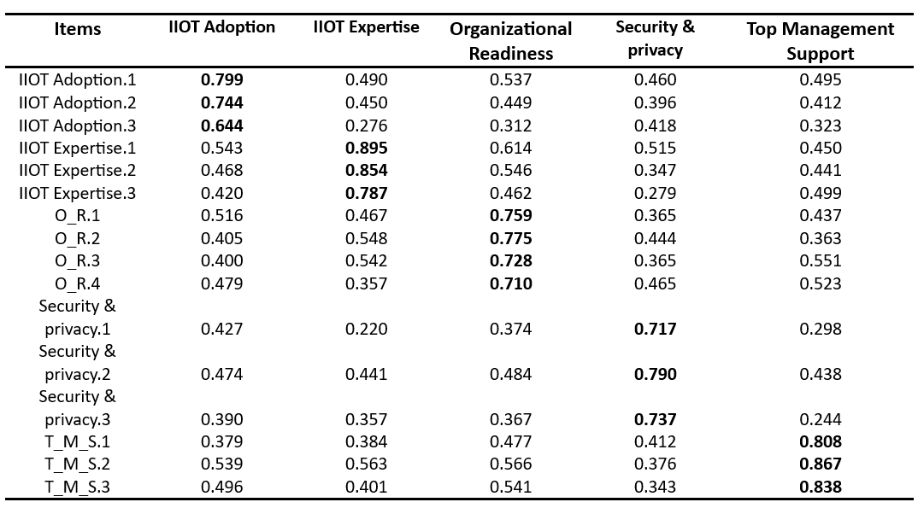

5.5 Assessment of the Structural Model
Figure 2 displays the structural model assessment. Through bootstrapping method using 1000 samples the t-values and R-square values were determined.

Figure 2. Standardized SEM results.
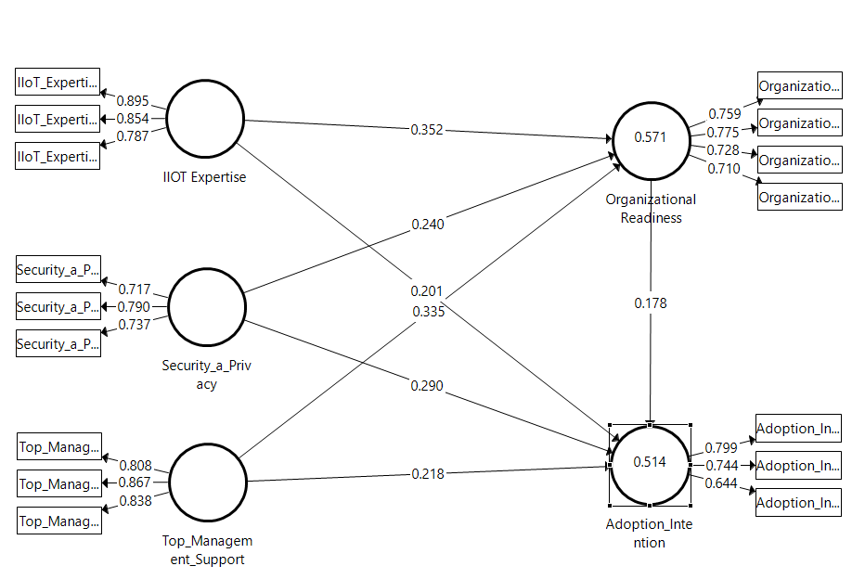

Using Smart PLS 3.2.9 these standardized SEM were made regarding two things, outer loading seems to be high. Every variable’s route coefficients seemed to be in fine shape.

5.6 Hypothesis Testing (Direct and Indirect Effects)
The outcomes of both indirect as well as direct hypotheses are shown in Table 7. T-values were checked using bootstrapping. Based on p-value of Smart PLS 3.2.9 using 95% confidence range were possible.
Table 7. Result of indirect as well as direct effect hypotheses
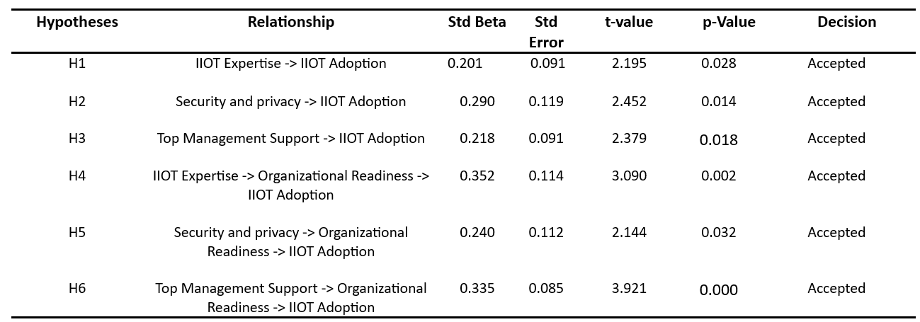
According to the first hypothesis, IIOT adoption intention that uses industrial IOT for manufacturing and production SMEs is positively and significantly correlated with IIOT expertise. Findings showed that IIOT expertise is highly linked with IIOT adoption intention (ꞵ=0.201, t= 2.195; p<0.05). This information shows that our original hypothesis was true.
According to the second hypothesis, IIOT adoption intention that uses industrial IOT for manufacturing and production SMEs is positively and significantly correlated with security and privacy. Findings showed that security and privacy is highly linked with IIOT adoption intention (ꞵ=0.290, t= 2.452; p<0.05). This information shows that our original hypothesis was true.
According to the third hypothesis, IIOT adoption intention that uses industrial IOT for manufacturing and production SMEs is positively and significantly correlated with top management support. Findings showed that top management support is highly linked with IIOT adoption intention (ꞵ=0.218, t= 2.379; p<0.05). This information shows that our original hypothesis was true.
According to the forth hypothesis, organizational readiness plays mediating role in the connection between IIOT expertise and adopting IIOT in SMEs engaging in production and manufacturing. Findings shows that organizational readiness strengthen the link between IIOT expertise and adoption intention (ꞵ=0.352, t= 3.090; p<0.05). This information shows that our original hypothesis was true.
According to the fifth hypothesis, organizational readiness mediates the connection between security and privacy and adopting IIOT in SMEs engaging in production and manufacturing. Findings shows that organizational readiness strengthen the link between security and privacy and adoption intention (ꞵ=0.240, t= 2.144; p<0.05). This information shows that our original hypothesis was true.
The sixth hypothesis states that, organizational readiness mediates the connection between top management support and adopting IIOT in SMEs engaging in production and manufacturing. Findings shows that organizational readiness has positive and significant relation between top management support and adoption intention (ꞵ=0.335, t= 3.921; p<0.05). This information shows that our original hypothesis was true.

6. Conclusion
The factors impacting the adoption of IIOT in manufacturing and production SMEs in developing nations such as Bangladesh are presented in this paper. This study demonstrates that the following elements impact IIOT adoption: organizational readiness, top management support, security and privacy and IIOT expertise.
Top management support is crucial for IIOT adoption and organizational readiness significantly affects IIOT adoption intention also security and privacy concerns has significant impact on adoption decision of IIOT.
By understanding these elements and how they connect to one another, allows organizations to develop plans to improve their competitive edge and promote long-term success in SMEs in Bangladesh. Additionally, the report offers insightful information for SMEs looking to handle the challenges of digital shifts and use the unlimited potential of use of IIOT for organizational success. Numerous factors are driving IIOT adoption in manufacturing and production SMEs, however IIOT expertise, security and privacy, top management support and as a mediation organizational readiness are the most important factors that influences IIOT adoption intention.

7. Limitations and Future Research Directions
This paper’s geographical restriction to the setting of a developing nation like Bangladesh is one of its drawbacks. To further understand the “pre” and “post” adoption determinants of IIOT in manufacturing SMEs, more research can be done. The precise model may be used in future research to replicate this study in new domains, such as different industry sectors or business sizes, such as huge corporations in different nations. The researchers could expand the study’s conceptual model to include the constructs in order to investigate how IIOT adoption affects business performance. Additional research can be done to receive more detailed grip of the topic and find out difficulties and conflicting factors which are hindering IIOT implementation. Performance of the firm requires focused attention. This conceptual model gives a compact base that might expand and utilized in various settings, for example various firm size, different geographic regions, and other areas of business. Further study on big organizations is interesting since they may have distinctive operational difficulties and resources that may have effects in their IIOT adoption journey. Similarly, accompanying similar researches in different nations mainly with different industrial and technical development can produce comparative outlook resulting improving in the international discussion on IIOT adoption. Accumulation of constructs in to the conceptual model to measure the touchable and intangible benefits in adoption of IIOT on performance of business is another stimulating direction for future study. More detailed understanding of IIOT’s organizational influence should be established by analyzing metrics such as customer satisfaction, productive benefits, cost saving, and market competitiveness. Furthermore, removing the obstacles for adoption of IIOT is a crucial part for additional research. Lack of funding, cyber securities, technical know-how, and change aversion this issues are continuously hampering adoption intention. Policymakers, technology providers, and industry stakeholders can develop more SMEs friendly environment by methodically investigate these resistance factors.

8.Reference

Ahmetoglu, S., Che Cob, Z., & Ali, N. A. (2022). A systematic review of Internet of Things adoption in organizations: Taxonomy, benefits, challenges and critical factors. applied sciences, 12(9), 4117.
Bandura, A. (2009). Social cognitive theory of mass communication. In Media effects (pp. 110-140). Routledge.
Belhia, Y., & Bentaouaf, K. (2022). Promoting SMEs Sector for development: The Algerian Experience. المشكاة في الاقتصاد التنمية و القانون, 7(1), 85-100.
Beliatis, M. J., Jensen, K., Ellegaard, L., Aagaard, A., & Presser, M. (2021). Next generation industrial IoT digitalization for traceability in metal manufacturing industry: A case study of industry 4.0. Electronics, 10(5), 628.
Boyes, H., Hallaq, B., Cunningham, J., & Watson, T. (2018). The industrial internet of things (IIoT): An analysis framework. Computers in industry, 101, 1-12.
Cepeda-Carrion, G., Cegarra-Navarro, J.-G., & Cillo, V. (2019). Tips to use partial least squares structural equation modelling (PLS-SEM) in knowledge management. Journal of Knowledge Management, 23(1), 67-89.
Chan, F. T., & Chong, A. Y.-L. (2013). Determinants of mobile supply chain management system diffusion: a structural equation analysis of manufacturing firms. International Journal of Production Research, 51(4), 1196-1213.
Chen, S., Xu, H., Liu, D., Hu, B., & Wang, H. (2014). A vision of IoT: Applications, challenges, and opportunities with china perspective. IEEE Internet of Things journal, 1(4), 349-359.
Chen, Y., Zhang, H., & Zhang, Y. (2010). Research on the development of internet of things industry in China. Science and Technology Management Research, 30(20), 103-106.
Cheung, G. W., Thomas, H., Lau, R. S., & Wang, L. C. (2023). Correction to: Reporting reliability, convergent and discriminant validity with structural equation modeling: A review and best-practice recommendations. Asia Pacific Journal of Management. DOI, 10.
Chowdhury, A., & A Raut, S. (2019). Benefits, challenges, and opportunities in adoption of industrial IoT. International Journal of Computational Intelligence & IoT, 2(4).
Crook, C. W., & Kumar, R. L. (1998). Electronic data interchange: a multi-industry investigation using grounded theory. Information & Management, 34(2), 75-89.
Dash, G., & Paul, J. (2021). CB-SEM vs PLS-SEM methods for research in social sciences and technology forecasting. Technological forecasting and social change, 173, 121092.
Daylami, N., Ryan, T., Olfman, L., & Shayo, C. (2005). Determinants of application service provider (ASP) adoption as an innovation. Proceedings of the 38th Annual Hawaii International Conference on System Sciences,
Dhirani, L. L., Armstrong, E., & Newe, T. (2021). Industrial IoT, cyber threats, and standards landscape: Evaluation and roadmap. Sensors, 21(11), 3901.
Elangovan, U. (2021). Industry 5.0: The future of the industrial economy. CRC Press.
Fornell, C. (1981). Structural equation models with unobservable variables and measurement error: Algebra and statistics. Publications Sage.
Ghobakhloo, M. (2018). The future of manufacturing industry: a strategic roadmap toward Industry 4.0. Journal of manufacturing technology management, 29(6), 910-936.
Hair, J. F., Risher, J. J., Sarstedt, M., & Ringle, C. M. (2019). When to use and how to report the results of PLS-SEM. European business review, 31(1), 2-24.
Horváth, D., & Szabó, R. Z. (2019). Driving forces and barriers of Industry 4.0: Do multinational and small and medium-sized companies have equal opportunities? Technological forecasting and social change, 146, 119-132.
Hossain, M. A., Standing, C., & Chan, C. (2017). The development and validation of a two-staged adoption model of RFID technology in livestock businesses. Information Technology & People, 30(4), 785-808.
Hsu, C.-W., & Yeh, C.-C. (2017). Understanding the factors affecting the adoption of the Internet of Things. Technology analysis & strategic management, 29(9), 1089-1102.
Jadala, V. C., Pasupuletti, S. K., Raju, S. H., Kavitha, S., Bhaba, C. M. S., & Sreedhar, B. (2021). Need of intenet of things, industrial iot, industry 4.0 and integration of cloud for industrial revolution. 2021 Innovations in Power and Advanced Computing Technologies (i-PACT),
Javaid, M., Haleem, A., Singh, R. P., Rab, S., & Suman, R. (2021). Upgrading the manufacturing sector via applications of Industrial Internet of Things (IIoT). Sensors International, 2, 100129.
Jeansson, J., & Bredmar, K. (2019). Digital transformation of SMEs: Capturing complexity.
Jedermann, R., & Lang, W. (2008). The benefits of embedded intelligence–tasks and applications for ubiquitous computing in logistics. The Internet of Things: First International Conference, IOT 2008, Zurich, Switzerland, March 26-28, 2008. Proceedings,
Jeyaraj, A., Rottman, J. W., & Lacity, M. C. (2006). A review of the predictors, linkages, and biases in IT innovation adoption research. Journal of information technology, 21(1), 1-23.
Kalsoom, T., Ahmed, S., Rafi-ul-Shan, P. M., Azmat, M., Akhtar, P., Pervez, Z., Imran, M. A., & Ur-Rehman, M. (2021). Impact of IOT on Manufacturing Industry 4.0: A new triangular systematic review. Sustainability, 13(22), 12506.
Kamble, S. S., Gunasekaran, A., & Sharma, R. (2018). Analysis of the driving and dependence power of barriers to adopt industry 4.0 in Indian manufacturing industry. Computers in Industry, 101, 107-119.
Khan, G. F., Sarstedt, M., Shiau, W.-L., Hair, J. F., Ringle, C. M., & Fritze, M. P. (2019). Methodological research on partial least squares structural equation modeling (PLS-SEM) An analysis based on social network approaches. Internet Research, 29(3), 407-429.
Khan, I. H., & Javaid, M. (2022). Role of Internet of Things (IoT) in adoption of Industry 4.0. Journal of Industrial Integration and Management, 7(04), 515-533.
Khan, W. Z., Rehman, M., Zangoti, H. M., Afzal, M. K., Armi, N., & Salah, K. (2020). Industrial internet of things: Recent advances, enabling technologies and open challenges. Computers & electrical engineering, 81, 106522.
Kim, S., & Garrison, G. (2010). Understanding users’ behaviors regarding supply chain technology: Determinants impacting the adoption and implementation of RFID technology in South Korea. International Journal of Information Management, 30(5), 388-398.
Korte, A., Tiberius, V., & Brem, A. (2021). Internet of Things (IoT) technology research in business and management literature: Results from a co-citation analysis. Journal of Theoretical and Applied Electronic Commerce Research, 16(6), 2073-2090.
Kumar, R., Sindhwani, R., & Singh, P. L. (2022). IIoT implementation challenges: Analysis and mitigation by blockchain. Journal of Global Operations and Strategic Sourcing, 15(3), 363-379.
Li, X., & Li, F. (2017). Adversarial examples detection in deep networks with convolutional filter statistics. Proceedings of the IEEE international conference on computer vision,
Lin, H.-F., & Lin, S.-M. (2008). Determinants of e-business diffusion: A test of the technology diffusion perspective. Technovation, 28(3), 135-145.
Lin, L. (2009). An integrated framework for the development of radio frequency identification technology in the logistics and supply chain management. Computers & Industrial Engineering, 57(3), 832-842.
Lu, Y., & Zhu, M. (2019). A control-theoretic perspective on cyber-physical privacy: Where data privacy meets dynamic systems. Annual Reviews in Control, 47, 423-440.
Madni, S. H. H., Ali, J., Husnain, H. A., Masum, M. H., Mustafa, S., Shuja, J., Maray, M., & Hosseini, S. (2022). Factors influencing the adoption of IoT for E-learning in higher educational institutes in developing countries. Frontiers in Psychology, 13, 915596.
Majstorovic, V., Jankovic, G., Zivkov, S., & Stojadinovic, S. (2021). Digital Manufacturing in SMEs based on the context of the Industry 4.0 framework–one approach. Procedia Manufacturing, 54, 52-57.
Medaglia, C. M., & Serbanati, A. (2010). An overview of privacy and security issues in the internet of things. The Internet of Things: 20 th Tyrrhenian Workshop on Digital Communications,
Mitra, A., Seetharaman, A., & Maddulety, K. (2024). A Structural Equation Model Study for Adoption of Internet of Things for the Growth of Manufacturing Industries in Australia. Journal of Comprehensive Business Administration Research.
Mittal, S., Khan, M. A., Romero, D., & Wuest, T. (2018). A critical review of smart manufacturing & Industry 4.0 maturity models: Implications for small and medium-sized enterprises (SMEs). Journal of manufacturing systems, 49, 194-214.
Mohajan, H. (2019a). The first industrial revolution: Creation of a new global human era.
Mohajan, H. (2019b). The second industrial revolution has brought modern social and economic developments.
Morgan, C. W., Kochanek, C. S., Dai, X., Morgan, N. D., & Falco, E. E. (2008). X-Ray and optical microlensing in the lensed quasar PG 1115+ 080. The Astrophysical Journal, 689(2), 755.
Nara, E. O. B., da Costa, M. B., Baierle, I. C., Schaefer, J. L., Benitez, G. B., do Santos, L. M. A. L., & Benitez, L. B. (2021). Expected impact of industry 4.0 technologies on sustainable development: A study in the context of Brazil's plastic industry. Sustainable Production and Consumption, 25, 102-122.
Oliveira, T., & Martins, M. F. (2008). A comparison of web site adoption in small and large Portuguese firms. International Conference on E-business,
Oliveira, T., & Martins, M. F. (2010). Understanding e‐business adoption across industries in European countries. Industrial Management & Data Systems, 110(9), 1337-1354.
Palacios-Marqués, D., Soto-Acosta, P., & Merigó, J. M. (2015). Analyzing the effects of technological, organizational and competition factors on Web knowledge exchange in SMEs. Telematics and Informatics, 32(1), 23-32.
Peter, O., Pradhan, A., & Mbohwa, C. (2023). Industrial internet of things (IIoT): opportunities, challenges, and requirements in manufacturing businesses in emerging economies. Procedia Computer Science, 217, 856-865.
Peterson, R. A. (1994). A meta-analysis of Cronbach's coefficient alpha. Journal of consumer research, 21(2), 381-391.
Polas, M. R. H., Kabir, A. I., Sohel-Uz-Zaman, A. S. M., Karim, R., & Tabash, M. I. (2022). Blockchain technology as a game changer for green innovation: Green entrepreneurship as a roadmap to green economic sustainability in Peru. Journal of Open Innovation: Technology, Market, and Complexity, 8(2), 62.
Pudjianto, B., Zo, H., Ciganek, A. P., & Rho, J.-J. (2011). Determinants of e-government assimilation in Indonesia: An empirical investigation using a TOE framework. Asia Pacific Journal of Information Systems, 21(1), 49-80.
Rana, A. K., & Sharma, S. (2019). Industry 4.0 manufacturing based on IoT, cloud computing, and big data: Manufacturing purpose scenario. International Conference on Advanced Communication and Computational Technology,
Saedi, A., & Iahad, N. A. (2013). An integrated theoretical framework for cloud computing adoption by small and medium-sized enterprises.
Sarstedt, M., Ringle, C. M., Cheah, J.-H., Ting, H., Moisescu, O. I., & Radomir, L. (2020). Structural model robustness checks in PLS-SEM. Tourism Economics, 26(4), 531-554.
Shah, S., Madni, S. H. H., Hashim, S. Z. B. M., Ali, J., & Faheem, M. (2024). Factors Influencing the Adoption of Industrial IoT for the Manufacturing and Production SMEs in Developing Countries.
Sivathanu, B. (2019). Adoption of industrial IoT (IIoT) in auto-component manufacturing SMEs in India. Information Resources Management Journal (IRMJ), 32(2), 52-75.
Sommer, L. (2015). Industrial revolution-industry 4.0: Are German manufacturing SMEs the first victims of this revolution? Journal of Industrial Engineering and Management, 8(5), 1512-1532.
Sun, C. (2012). Application of RFID technology for logistics on internet of things. AASRI procedia, 1, 106-111.
Tao, F., Zuo, Y., Da Xu, L., & Zhang, L. (2014). IoT-based intelligent perception and access of manufacturing resource toward cloud manufacturing. IEEE transactions on industrial informatics, 10(2), 1547-1557.
Thong, J. Y., & Yap, C.-S. (1995). CEO characteristics, organizational characteristics and information technology adoption in small businesses. Omega, 23(4), 429-442.
Umair, M., Cheema, M. A., Cheema, O., Li, H., & Lu, H. (2021). Impact of COVID-19 on IoT adoption in healthcare, smart homes, smart buildings, smart cities, transportation and industrial IoT. Sensors, 21(11), 3838.
Vahtera, A. (2008). Organisational factors affecting IT innovation adoption in the Finnish early childhood education.
Vuković, M., Mazzei, D., Chessa, S., & Fantoni, G. (2021). Digital Twins in Industrial IoT: a survey of the state of the art and of relevant standards. 2021 IEEE International Conference on Communications Workshops (ICC Workshops),
Wang, Y.-M., Wang, Y.-S., & Yang, Y.-F. (2010). Understanding the determinants of RFID adoption in the manufacturing industry. Technological forecasting and social change, 77(5), 803-815.
Weber, R. H. (2010). Internet of Things–New security and privacy challenges. Computer law & security review, 26(1), 23-30.
Xu, M., David, J. M., & Kim, S. H. (2018). The fourth industrial revolution: Opportunities and challenges. International journal of financial research, 9(2), 90-95.

Appendix
