

Internship Report On
Recruitment and Selection Process of Kazi Farms Group



Internship Report on
Recruitment and Selection Process of Kazi Farms Group
Course Code: INT 4399

Submitted to
Nasrin Akter
Assistant Professor
School of Business & Economics
United International University

Submitted By
Farhana Islam
ID: 111 142 193
School of Business & Economics
United International University

Date of submission: 10th December, 2019
Letter of Transmittal
10th December, 2019
Nasrin Akter
Assistant Professor
School of Business and Economics
United International University
Subject: Submission of Internship Report
Dear Mam,
It’s a matter of great pleasure for me to tell you that recently I have completed my internship from Kazi Farms group and also completed my internship report.
It indeed is a privilege for me to become a part of one of the largest poultry industry in Bangladesh. This opportunity gave me valuable insights about the corporate world as well as idea about how things are done in a professional way.
While preparing this report I tried my best to follow your every instruction. I took help and suggestions from my organizational supervisor Md. Ibban Rashid, Manager of Talent Acquisition, Human Resource Department. The entire report I made is based on my practical knowledge in Kazi Farms Group’s corporate head office in the HR department.
I would like to convey my gratitude and appreciation for your kind co-operation, guidance, supervision in making this report. It will be an honor for me if you find this report informative enough to fulfill the requirements. I will be happy to provide any kind of further information regarding this report
I therefore pray and hope that your honor would be kind enough to grant this internship report and oblige thereby.
Your obedient student
Farhana Islam
Id: 111 142 193
School of Business and Economics
United international University

Acknowledgement
At first I want to thank Almighty Allah for his immense blessings for making me able to complete the Internship Report. Without his support and blessings I would not be able to make this four years of BBA Program successfully. I also want to thanks my parents for their support throughout the whole journey.
I want to thank my honorable internship instructor Nasrin Akter, Assistant professor, School of Business and Economics - United International University. Without her help, support, guidelines I would never be able to make this report. All her effort motivated me to make this report more perfect. Her advice helped me a lot to understand critical aspects of this report.
I also want to thank my organizational supervisor Md. Ibban Rashid, Manager, Talent Acquisition, Human Resource Department and who helped me to learn many things during my internship period and also helped me to make this report.
Last but not the least I want to thank my friends, colleagues who also helped me, motivated me gave their valuable time for me while making this report.

EXECUTIVE SUMMARY
Internship report is a major part for completion of BBA degree. After finishing of all academic courses of BBA program students are supposed to complete internship program which gives them practical knowledge of professional world. The time period of internship is three months .I got the opportunity to work as an intern in the Recruitment and Selection division of Human Resource Department of Kazi Farms Group by the help of UIU Career Counseling (UIUCC).
As a part of the report, with the help of my respective supervisor of internship program, I have chosen the topic “Recruitment and Selection Process in Kazi Farms Group”. The recruitment and selection process is one of the most important yet critical task of an organization. Recruitment and selection process helps to get a proper candidate by attracting them towards the organization. Through a proper recruitment and selection process an organization can get good employee which increases success rate and development of an organization. Recruitment and selection process reduces the cost of training and development, helps to increase organizational and individual effectiveness. It reduces turnover rate of an organization and it also helps to reduces legal complexity.
The whole report consists of seven chapters. The first chapter is all about Introduction, Scope of the Study and Objectives of the Report, Methodology of the Report and lastly the Limitations of the report. In the second chapter, I have given the literature review of the report which includes recruitment and selection process, their importance and how this process can help to develop an organization and so on. In the third chapter, I have given the overview of Kazi farms group, corporate information of Kazi farms group, products and services, mission and vision, so that the reader can get a clear idea about the organization.
The fourth chapter is all about the whole process of Recruitment and Selection, how they do it, which way they do it, after how many days later they do it, sample of job advertisement, challenges the employees face during the process etc. Chapter five gives clear idea about what I have found regarding the process, the problems, the barriers in the process. In this chapter I have also given my recommendation, solutions to the problems, and then comes the conclusion, which includes overall remarks and experience of mine during my internship period. The last two chapters consist reference and appendices used in the internship report.
Table of Contents

1. Introduction 1
1.1 Scope of the Study 1
1.2 Objective of the Report 1
1.3 Methodology 2
1.4 Limitations 2
2. Literature Review 4
2.1 Human Resource’s Purpose and Role 4
2.2 What is Recruitment 5
2.3 Purpose of Recruitment 5
2.4 What is Recruitment Process 5
2.5 Factors Affecting Recruitment 7
2.6 What is Selection and Selection Process 8
2.7 Purpose of Selection Process 9
2.8 Importance of Recruitment and Selection Process 9
3. Organizational Background 11
3.1 Overview of Kazi Farms Group 11
3.2 Corporate information of Kazi Farms Limited 11
3.3 Current Product & Services of Kazi Group and Kazi Food Industries Limited 12
3.4 Associates and Sister Concern of Kazi Farms Group 13
3.5 Vision Statement 14
3.6 Mission Statement 14
3.7 Objective of Kazi Farms Limited 14
3.8 Values 15
3.9 Number of Employees at a Glance 15
3.10 Departments at Kazi Farms Group 16
3.11 General Structure for All Department at KFG 18
3.12 HRD department of Kazi Farm Group 18
3.13 General HR functions and general responsibilities in KFG 19
3.14 Hierarchical positions at HR Department 21
4. Recruitment and Selection Process Analysis 23
4.1 Recruitment Process of Kazi Farms Group 23
4.2 Ways of Recruitment 25
4.3 Selection Process of Kazi Farms Group 26
4.4 Challenges of Both Parties 29
5. Findings, Recommendations and Conclusion 33
5.1 Findings 33
5.2 Recommendations 34
5.3 Conclusion 35
5.4 Roles and Responsibilities of Internship 35
5.5 My Job Responsibility 36
5.6 Experience 36
6. Reference 38
7. Questionnaire 40

Chapter One
Introduction

Introduction
Recruitment and Selection is one of the most important aspects of Human Resource Management. In this Report we will see how Kazi Farms Group accomplishes their Recruitment and Selection process. We will also get to know the problems and challenges regarding this process.

1.1 Scope of the Study
The Scope of the Study is to get to know about the “Recruitment and Selection process” of Kazi Farms Group. This report is sort of real life case study of an organization which means it is the illustration of the selected Organization. This report has the scope of covering different aspect of human resource Management which includes HR practices like “Recruitment and Selection” process. This report may help the HR department to identify the Difficulties or short comings the employees are facing regarding the process. Any reader of this report will get to know about the Organization’s profile, services it is offering. The university students and teacher can get useful information about the Organization and can compare their theoretical learning’s with my practical experience.

1.2 Objective of the Report
Based on two objectives I have prepared this report.
Primary Objective:
The primary objective of this report is to describe the “Recruitment and Selection process of Kazi Farms Group” and differentiating the theoretical knowledge from practical application while attempting to complete the internship as a requirement for BBA program.
Secondary objective:
- To get to know the “Recruitment and Selection” process of Kazi farms group.
- To experience “Recruitment and Selection” process of Kazi Farms Group.
- To identify problems regarding the system.
- To recommend suggestions according the problems.

1.3 Methodology
For achieving the specific objective, Data was both collected from primary and secondary sources. To collect data
Primary data: I directly talked with the respective officers of Recruitment and Selection team – Human Resource department and had face to face conversation with them and their opinions are collected through questionnaire. Which is attached in the Appendices.
Secondary data: Visited the website of Kazi farms group, some online articles journals regarding recruitment and selection process etc.

1.4 Limitations
The limitations are the difficulties that one may face while doing something. I have also encountered some difficulties doing the report. Such as -
- Major problem was secrecy of Information’s. There is a strict rules regarding disclosing any sensitive information.
- Sufficient current Data was not available.
- Insufficient written document which can be helpful.
- Unbearable work pressure of the personnel in HR department which increased my difficulty more because I got less chance to gather information from them.

Chapter Two
Literature Review

Literature Review
This report is all about “Recruitment and selection process” of Kazi Farms Group. First, we will understand what “Recruitment and selection process” is in an organization.
Human Resource Management concerned with directing workforce towards the betterment of an organization. Human resource deals with employee related issues such as hiring, motivating, developing etc. Human resource management concentrated on employee satisfaction and maximum contribution of employees to the achievement of organizational goals. Functions of human resource management are -
- Managerial Function: Managerial function concerned with HR Planning, Organizing, Directing, Controlling etc.

- Operative Function: Operative Functions deals with Recruitment and Selection, Job analysis and design, performance appraisal, Training and Development, Wage and Salary administration, employee welfare, labor relations etc.

- Advisory Function: Advisory Function deals with Advise to the top management, department head, etc.

2.1 Human Resource’s Purpose and Role
Human Resource is the harmonization of an organization’s people to achieve specific business objectives, fulfill staffing needs and maintain employee’s satisfaction. Human resource achieve this by use of people, process, and technology which focuses on internal parts of the organization .The role of Human resource management is to organize people so that they can perform work activities effectively and this is possible when people are viewing as assets not costs to the organization. Seeing people as assets is part of contemporary human resource management and human capital management.

2.2 What is Recruitment
Recruitment is the process of attracting pool of candidates to apply for a certain vacant position. In other words we may say through recruitment we can discover sources from where we can get potential employees.
Edwin B. Flippo defined the recruitment process – Recruitment is the process of searching the candidates for employment and stimulating them to apply for jobs.

2.3 Purpose of Recruitment
- To identify current and future requirement of job.
- To help choosing right candidates.
- To attract potential employee to apply.
- To define present and future demand
- To connect employee with the applicant.
- To help evaluating the effectiveness of the various recruitment techniques.

2.4 What is Recruitment Process
There are several steps to complete the recruitment process. This is a systematic process which starts with recruitment planning, recruitment strategy, searching the candidates, screening, and lastly evaluation and control. The process are given below in details –

- Recruitment Planning: Recruitment planning is the first step of the Recruitment process. In this stage the vacant position are analyzed and described. A structured recruitment plan is mandatory to attract a pool of candidates. recruitment planning involves activities like identifying vacancy, job analysis, job description, job specification, etc

- Identifying Vacancy: The Initial step of recruitment plan is to identifying the vacancy. This process begins with the receiving recruitment requisition from the concerned department. This contains- number of posts to be filled, number of position, duties, responsibilities, qualification and experience.

- Job Analysis: Job analysis is the process of identifying duties, responsibilities, skills, ability needed for a job. Job analysis helps to understand what type of tasks are important, how to accomplish them.

- Job Description: Job description is a detailed, more informative written statement of a specific job. Job description includes Title of the job, location, summary of job, working condition etc.

- Job Specification: Job Specification identifies certain specification needed for a job. Job Specification provides statement about what type of qualification, experience, skills a candidate should poses to hire.

- Job Evaluation: In this step value of a certain job is measured or determined. The main purpose of job evaluation is to determine which job commands how much pay.

- Recruitment Strategy: Recruitment Strategy is the Second step of Recruitment process. Recruitment strategy is set up for hiring the resources. While preparing a recruitment strategy HR team follows some points such as Make or hire employees, Types of recruitment, Geographical area, Sources of recruitment. To develop a Recruitment Strategy HR team need – setting up a board team, analyzing HR strategy, collecting data etc.

- Searching the Candidates: There are two types of sources from where potential candidates can be attracted. One is External Source another one is Internal Source. External Sources are – Employee Agencies, Advertisement, Job fair, Educational Institute, Unsolicited Applicants, Professional Organization, Internal Sources are – Promotion, Transfer, Employee Referral etc.

- Screening or Shortlisting the Candidates: Short listing or screening of candidates is done after completing the process of sourcing the candidates. This step is important because it helps to remove unqualified, irrelevant candidates.

- Evaluation and Control: This is the last stage of Recruitment process .in this stage the validity and effectiveness of the process and methods are assessed. The performance of the recruitment process is thoroughly checked and evaluated. The costs incurred in the recruitment process such as salaries to the recruiter, Advertisement cost, Administration expense, cost of recruiting suitable candidates etc are evaluated and controlled effectively.

2.5 Factors Affecting Recruitment
There are few factors which affecting the recruitment process. Those factors can be divided into External Factors and Internal Factors.
External Factors are-
- Demographic Factors: The potential Employee’s age, religion, Gender, Occupation etc.
- Unemployment Rate: There are many areas where employment rate is very low, hiring new employee will be easier from those area.
- Competitors: Competitors are the biggest external factors. There are many organizations existing in the market right now. For hiring qualified candidates an organization should consider other organization’s strategy and offer better packages.

Internal Factors are-
- Size of the Organization: Size of the organization is one of the important internal factors that affect the recruitment process. The more the organization will be big the more employees will be needed.
- Recruitment Policy: Recruitment policy differs from organization to organization. Some organization hires internally, some hire externally.
- Image of the Organization: If the organization that is hiring has good reputation in the market will attract more potential qualified employees.

2.6 What is Selection and Selection Process
Selection is the process of choosing the right candidate with the needed qualification and capabilities to fulfill the jobs in the organization. After recruitment, selection process starts. There are several steps which completes the full selection process. They are –
- Initial Interview: After notifying the candidates, Initial interview is taken to get insight about the candidate. The interviewer ask basic question to interviewee.

- Written Test: Written tests are also taken in some organizations along with interview for making the process more effective and choosing the more qualified candidate.

- Computer Test: Many organizations take computer test to see or test the technological knowledge of a candidate.

- Final Interview: In the final interview interviewer negotiate with the interviewee about the salary and tells about the nature of the job and others details.

- Reference Check: The organization usually asks for reference to the candidates to check the authenticity of the documents that they provided. This reference could be from the educational institute or from the organization where he/she was formerly engaged.

- Medical Examination: Medical examination is conducted to check the physical or mental condition of the candidate whether he/she is able to perform the work or not.

- Offer Letter: The candidate who passes all the rounds of selection process is given offer letter by the head of HRD along with the Managing Directors sign.

- Probation Period: Employee who doesn’t have any experience must have to go through a probation period like 3 months or more than that which varies organization to organization.

2.7 Purpose of Selection Process
- To choose or select suitable candidate.
- To increase organizational profitability.
- To create better environment.
- To reduce turnover Rate.
- To reduce Training and developmental cost.

2.8 Importance of Recruitment and Selection Process
A good Recruitment and Selection process contributes a lot towards the development of an organization. Recruitment and selection process determines the business success that affects the whole organization. Recruitment and Selection process –
- Through recruitment and selection process an organization can easily attract and select good, qualified candidate which is a benefit for the organization.
- A proper or good employee does his/her job well which leads the organization towards the success.
- Proper recruitment and selection process saves time and money for training and development by choosing proper candidate.
- Ensures transparency in the hiring process.
- Recruitment and Selection process reduces legal complexity by following systematic process.

- A good recruitment and selection process increases the growth of overall organization.
- Helps to increase individual and organizational effectiveness.

Chapter Three
Organizational Overview

Organizational Background

3.1 Overview of Kazi Farms Group
Kazi Farms Group is an agro business enterprise and presently the largest poultry hatching and ay old chick production facility in the country. It was established in 1996 as a hatchery of imported eggs day-old chicks. The following year it started its own parent farms, and in 2004, productions started in our grandparent (GP) farms. In 2006 they established the largest and most advanced feed mill in the country with technical assistance from Cargill USA and Buhler Switzerland. Now Kazi Farms Group (KGF) has over 70 broiler parents farms, operates 2 chicks parents farms, 3 parent growing farm, 7 hatcheries, 2 feed mills, layer parent farms, broiler grandparent (GP) farms.

3.2 Corporate information of Kazi Farms Limited
Name of the Company | Kazi Farms Group
Type | Private
Industry | Poultry
Founded | 1996
Founded | Kazi Zahidul Hasan, Kazi Shahidul Haque
Owner | Kazi Zahidul Hasan
Employees | 10000
Corporate Office | Ahmed Kazi Tower, Building 35, Road-2, Dhanmondi, Dhaka-1205, Bangladesh
Table 1: Corporate Information

Current Product & Services of Kazi Group and Kazi Food Industries Limited

- Broiler parent chicks and broiler chicks: Broiler chicks of Kazi Farms Group are believed to be the best performing chicks in the domestic market, and sold at a best over other broiler breeds.
- Layer chicks and table eggs: Kazi Farms Group is also the distributor of Hy-line brown and white layers in Bangladesh. Kazi Farms own commercial layer farms which is the largest producer of commercial table eggs in Bangladesh.
- Feed: KFG extended its operation into poultry feed manufacture in 2006. Within a very short period, it has become renowned as a market leader in both quality and volume.
- Bellissimo: Kazi Food Industries Limited is a recent project of the Kazi Farms Group, Located in Beron, and Ashulia. KFIL produces and sells premium dairy ice cream with minimum 10% milk fat (as per international standard) under the brand name Bellissimo.
- Kazi Farm Kitchen: A range of frozen food products are sold under the brand name Kazi Farms Kitchen.
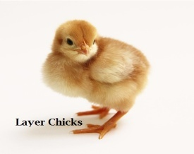


3.4 Associates and Sister Concern of Kazi Farms Group
- Kazi Farms Limited (largest poultry house in Bangladesh established in 1996)
- Kazi Food Industries Limited— located at Beron in Ashulia, Dhaka; some of its popular brands are Bellissimo, ZaNZee, and Kazi Farms Kitchen.
- Sysnova Information Systems Limited (IT Company at Dhanmondi, Dhaka)
- Kazi Media Limited (Deepto TV, a private TV channel) Central Women’s University- The ﬁrst private university in Dhaka, for women established in 1993)
- Kazi Zahural Haq College (Gopinathpur, Gopalganj)
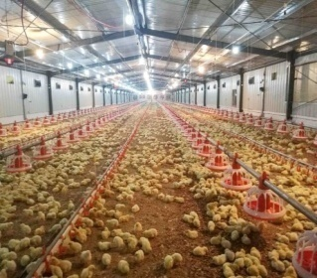

3.5 Vision Statement
- Kazi Farms expand their product and process offerings to align with key customer’s needs.
- They will invest in long-term strategic partnerships with branded Industry leaders who value excellence in quality, food safety, innovation, corporate social responsibility, talent and facilities in support of their core business.
- Aggressively, they will manage their reputation and market their brand to attract select customers to their core capabilities,
- They will use their continually evolved systems to help us imagine, develop and reﬁne breakthrough solutions.

3.6 Mission Statement
- Achieving customer satisfaction by producing best quality agro based product, service, and contributing to the healthy life style of the people.
- Improving the quality of working life of all employees, encourage and developing a motivated team of professional, whose mission will be attaining the vision of the organizations. They are responding to the expectation of stakeholders, society and environment at large.

3.7 Objective of Kazi Farms Limited
- Maximization of proﬁt along with the beneﬁts of employees and customers is the main objective of the farm. In addition, the order objectives are:
- Bringing modern farming facility to the doorstep of public through farming services
- Taking part in the development of national economy through productive operation of the Farm’s resources
- Connecting people to modern farming practice by the best application of improved information and technology, so that they get encouraged to continue and feel proud of farming with Kazi Farm Limited.
- Ensuring highest use of the professional work force through enhancement of their aptitude and competency.
- Elevating the image of the Farm at home and abroad by sustained expansion of its activities.

3.8 Values
- Kazi Farms demonstrate uncompromising integrity and ethics.
- Their people are the source of their success.
- They are passionate about their customers.
- They deliver absolute quality.
- Kazi Farms innovation to drive mission-critical solutions.
- They balance environmental stewardship, social responsibility and proﬁtable growth.

3.9 Number of Employees at a Glance
KFG has approximately 10000+ employees, staffs, labors including male and females in managerial and non-managerial roles.

Figure 1: Gender of Respondents

3.10 Departments at Kazi Farms Group

KFG carries out its business activity with a coordinated workforce under the supervision of strong management-

Figure 2: All Teams at KFG
- Production Team: Production team consists of factory employees who are responsible for producing products according to sales demand of Kazi Farms Kitchen’s products.
- Accounts Team: Accounts team is responsible for maintaining different accounts of Kazi Farms Kitchen like cost, income etc.
- Purchase Team: Purchase team is responsible for sourcing of raw materials, negotiating with possible supplier to get product at a suitable price to minimize the cost of purchasing raw materials.
- Key Accounts Team: Team Key Accounts is responsible for corporate sales (selling bulk amount of frozen food products in Modern trade/super shops) and managing frozen food items in different super shops, department stores, retail stores. Finding new opportunity of investment (giving company freezer to retailer and super shop or events to participate etc).
- Franchise Team: Franchise team is responsible for analyzing opportunities to establish franchise store in different area based on potential of that area (consumer buying power, demand/ interest in company’s products, population, capability of possible franchisee etc.).
- Research and Development: Research and development team is responsible for developing new product, upgrading/improving existing products, observing market condition, competitors, and consumers changing behavior and needs and demands.
- Sales: sales team is responsible for ensuring sales of products to the dealer and retailer who eventually sell the products to the final consumers. Target of sales is given to each employee of the sales team which they are motivated to achieve. Employees get bonus/ reward/ promotion based on their performance.
- Marketing and Branding: Marketing and Branding team is responsible for performing marketing activities like advertising, promotion, communication and positioning their products in the mind of consumer through their performance.
- Audit: This team ensures compliance with established internal control procedures by examining records, reports, operating practices, and documentation, verifies assets and liabilities by comparing items to documentation.

- IT: IT team is networking professional. Their Role is managing network devices (routers, switches, Wi-Fi, firewalls, appliances) and working closely with system administrators

3.11 General Structure for All Department at KFG

GM
DGM
AGM
Sr. Manager
Manager
Deputy Manager
Assistant Manager
Sr. Executive
Executive
Sr. Officer
Officer
Trainee Officer/ Management Trainee
Figure 3: General Structure for Departments

3.12 HRD department of Kazi Farm Group

To Operating the whole business process, they need huge employees. Human Resource is the most important assets for any companies. If any company properly use their employees, they can get sustainable competitive over their competitor. Kazi Farm Group has more than 10000 employees. To maintain this huge number of employees they have a well-structured HR policy. In every HR functions like employee recruiting, salary and leave policy and employee welfare, Kazi Farm follows the labor law. But on the other hand, HR functions like employee evaluation, employee performance management or appraisal system, organization development, setting organization culture; they have their own rules and policies. Now a day, performance appraisal system is an important element or tool used by organizations to guide employee performance alignment with organizational strategy. It is a big process to successfully maintain employee performance management. When employee performance is increased, ultimately it is useful for the organization

3.13 General HR functions and general responsibilities in KFG

In HRD there are four teams working together-

Figure 4: HRD Functions

- Operation & Payroll Team: Operation Team maintains all the disciplinary activity, payroll activity, policy making, conducting employees interview, checking employees personal ﬁle-documents and given employees necessary thing like SIM, laptops, mobile, modem and some other office equipment.
- Training & Performance Development Team: Work of the development team is making employees goal sheet, Job Description, making the organ gram of the organizations, succession planning of the employees, training and development, working on performance appraisal and performance management, calculated employees behavioral and official performance and updated their working status on database.
- Recruitment & Talent Acquisition Team: All recruitment related activities like making interview question paper of candidate, creating database of interview candidate, data entries of selected candidate for interview and those who are recruited. Maintaining and updating database of the employees, ﬁle processing, updating personal ﬁles, checking the documents of personal ﬁles, checking the references and sending mails, makings phone calls to customers, candidates. Maintaining the external resumes and preparing ﬁnal settlement data are the activity performed.
- ER & Admin Team: This team mainly focuses on consultation on new and existing policies, creating benefit packages, as a union representative, negotiating new contracts, complying with all laws.

3.14 Hierarchical positions at HR Department
GM - HR
CEO KFIL

DGM
Organizational Development & Talent Mgt.

Manager
Talent
AGM
ER & Admin
Sr.Manager
Operation&MISS
Asst.Manager
KFIL

Manager
Dy.Manager
ER&Admin
Sr.Manager Training&Development
Tra
Sr. Executive (2)
Talent
Asst. Manager
Sr.Executive
ER
Sr.Manager-Org.Development
Sr.Officer
Executive
payroll
Executive
TA, TM , OD
Executive-Org.Development

Sr. Officer (4)

Trainee Officer (2)

Figure 5: Hierarchical positions at HR Department

Chapter Four
Recruitment and Selection Process Analysis

Recruitment and Selection Process Analysis

In this chapter -” Recruitment and Selection Process Analysis”, we will know how Kazi Farms Group conduct the whole process in details by discussing about which way they conduct it, how they do it etc. First we will know about the “Recruitment Process” followed by Kazi Farms Group.

4.1 Recruitment Process of Kazi Farms Group
Most of the organization follows a certain Recruitment process which includes recruitment planning, strategy, sourcing, short listing, evaluation etc. Kazi Farms Group also follows the same process.
Recruitment is one of the important part of Human Resource Department. Here is the process of recruitment followed by Kazi Farms Group –

- Receiving Man Power Requisition: First HR receives a man power recruitment requisition form by a respective supervisor of the concerned department. For example sales department need new sales executive. So the supervisor send a man power recruitment requisition form to the HRD. Sample of Man Power Requisition Form is attached in the Appendices.

- Justify or Analyze the Requisition: After receiving the requisition form, HRD analysis the need whether they really do need a man power or not. In short they evaluate the need. In this stage directors approval is also needed. After the directors approval HR proceeds to the further procedure.

- Select KSA for Particular Position: HRD selects Knowledge, Skills, Abilities needed for the certain position.

- Making a Pool of Candidate: In this step HRD creates a pool of candidates by using external or internal sources. For external source they post advertisement in different job sites, Job fair, Educational institute etc. Advertisements are approved by the general manager of the HRD and then are posted in different job sites and print media. For print media they use “Bangladesh Protidin” and job sites are BDjobs.com and Jobs.com. In print media both managerial and non-managerial job advertisements are posted. Advertisements are given for a certain period of time. After that time no application from the candidates is received by the HR.

- Short listing: This step is all about short listing the candidates after receiving all applications. Short listing is done on the basis of needed qualification, experience etc.

- Notifying the Candidate: After short listing HRD notify the candidates over the phone call or SMS for initial interview. Candidates having no experience need to give written test along with computer test and candidates having three years or above experience in related field only have to give interview.



Figure 6: Recruitment Process

4.2 Ways of Recruitment
Kazi Farms Group attracts candidates using both external and internal use. In simple words they use both the external and internal sources. For external sources they use:

- Advertisements: Advertisements for vacant positions are posted in print media and job sites. For print media they use “Bangladesh protidin”. And for the job sites they use “Bdjobs.com”, jobs.com etc.

- Job Fair: Different organizations arrange job fair where many candidates drop their Curriculum vitae. Kazi Farms Group also participates in the fair for attracting candidates.

- Educational Institutions: Educational Institutions are one the greatest source of getting quality full candidates. For example: this year in January Kazi Farms Group arranged a seminar at “BRAC University” and then also conducted an examination for “Management trainee” position.

For internal source they use-
- Promotion: By giving promotion to a certain employee they also fulfill a vacant position.

- Transfer: As kazi Farms Group has different regional office across the whole country so transferring certain employee from one place to other is another way of sourcing employee

- Employee Referral: Employee Referral is another way of recruiting people internally. Employees working presently in Kazi Farms Group sometimes refer candidates for a vacant position.

4.3 Selection Process of Kazi Farms Group
After completing the whole recruitment process, HRD conduct the selection process for hiring candidate. The process followed by Kazi Farms Group are given bellow-

- Initial Interview: The very first step of selection process is “Initial Interview”. Initial interview is taken by the supervisors of the concerned department along with one HR officer.
- Written Test: Candidates having no experience need to give written test, but candidates having 3 years of experience need not to give any written test. They only have to give initial interview. The type of question depends on the nature of the position. Usually a combination of multiple and narrative type of questions are set in the written test. All multiple type of answers are exclusively checked by HR.

- Computer Test: Computer test is as same as written test’s policy. Candidate having no experience need to give computer test. MS Word, MS Excel etc expertise are checked in this segment.

- Final Interview: After passing the previous segments qualified candidates are being called for the final round interview. Final interview is conducted by concerned department’s General Manager and one HR manager. In this round negotiation about salary is discussed along with other topic. Kazi farms group try to take employee with their current salary if the candidate is working somewhere else. However they increase the salary by 25% and offer them.

- Reference check: Candidates from the final round Interview must have to submit photocopies of their certificates of educational intuitions like School, College and University. HRD check the authenticity of the certificates. It’s an important part of Selection process. If HRD finds any problem in the certificates or other educational documents then the candidate will be disqualified immediately.

- Medical Checkup: Medical checkup is done to see the physical or mental ability of a candidate whether he/she will be able to do the job or not.
- Offer Letter: After all the procedure, selected candidate for hiring will be given an offer letter.

- Release Order Collection: Candidates who are employed with another company must provide their release order to the HR at the joining time at Kazi Farms. Joining will not be accepted without release order if the person was working before. This step helps to avoid legal complicacy raised by the previous organization.

- Probation period: Usually for the fresher’s probation period is 6 months and for the experienced is less than 6 months.

In case of Non Managerial issues Recruitment and Selection Process is not done by the head Office. Only requisition form from the regional office is send to the HRD and then with the director’s approval HRD publishes the advertisement in the newspaper for sourcing. After that respective unit’s head does the hiring process.
A diagram of the selection process is given on the next page.



Figure 7: The Selection Process

4.4 Challenges of Both Parties
There are some challenges that are faced by the both HRD and candidates. Such as-
- As we all know Kazi Farms Group is one of the largest poultry industry In Bangladesh. It has Feed Mill, Hatchery, compost plant, Farms etc. which are located at different areas of Bangladesh. Getting quality full personnel for Feed Mill, Hatchery is quite tough. which is a big challenge for the organization.

- Kazi Farms Group has their own private satellite television channel named “Dipto Tv” . This channel is wholly owned by Kazi Farms Group and operated under Kazi Media. As the operations of “Depto Tv” is increasing day by day the need of more media based people is also increasing which is quite tough to find.

- Another biggest challenge for The Recruitment team is there is no written policy for “Recruitment and Selection” process. So doing the whole process in a systematic way is difficult sometimes.

- Kazi Farms group conduct candidates written test and computer test in their head office. But there is no proper arrangement for this. Limited seating arrangement, very few computers make the process more difficult. This is both a challenge for both the party.

- Sometimes hiring senior officers is also a challenge for the recruitment team. At the last moment candidates do not join due to having better offer in somewhere else.

- Kazi Farms Group use Linux Operating System in their computers. Candidates are not familiar with this operating system since it is less used by general people. For this reason candidates face trouble during their computer test as they are using completely new user interface to deal with. Also they use “Libre Office” Instead of “Microsoft Office” which are completely different from each other. This also causes trouble for the candidates.

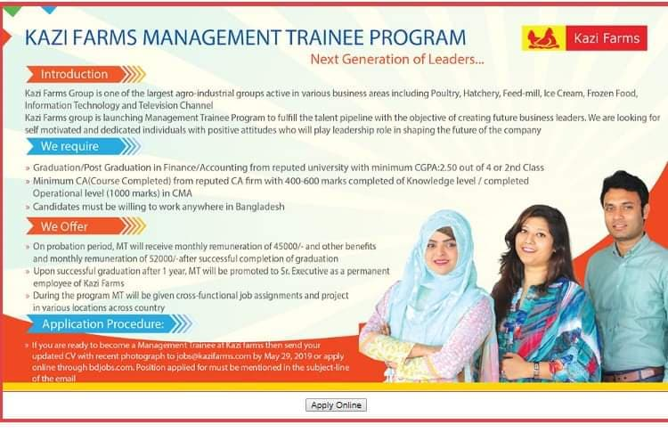
Figure 8: Sample Job Circular for Managerial Level

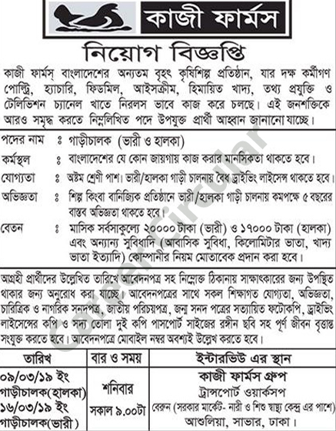
Figure 9: Sample Job Circular for Non-Managerial Level

Chapter Five
Findings, Recommendations and Conclusion

Findings, Recommendations and Conclusion

5.1 Findings
While doing the internship program I have closely worked with the recruitment team and observed some problems regarding the whole process. They are –
- Slow Hiring Process: Slow hiring process is one of the main problems. They take too much time to hire employees. For example, after the written test and initial interview they take two weeks or more time to let them know whether they are selected or not for the next stage. Slow hiring process can results in loosing potential candidate.

- Insufficient Employees in HRD: Number of Employees at HR department is not sufficient comparing to the work load. This is affecting the overall department and activities.

- No Written Policy: As we have discussed earlier in the analysis part that there is no written policy regarding the recruitment and selection process. So there are no rules to follow strictly. This creates confusions often and makes the process more complicated.

- Unresponsive Management: Another problem is unresponsiveness of top level management. After completing the first round interview and written test, HRD needs to confirm the date of final interview to the qualified candidates but getting a date from the top level management is very tough as they remain very busy in other works. Because of that they sometimes lose good candidate.

- Unresponsive Candidates: Candidates sometimes don’t show up on their final interview which create problem in future.

- Communication Gap: There is a big communication gap between regional office and HR head office. Sometimes HRD fails to understand the needs of what kind of employee the regional office need.
- No Pay Structure in the Job Advertisement: There is no pay structure mentioned in the job advertisement. Pay structure mentioned in the advertisement makes the process simpler as there is no need of discussing salary with the candidate and it ultimately saves time as well.

5.2 Recommendations

- Recruiting more efficient man power in HRD.
- Hiring process should be on time so that don’t have to lose potential candidate.
- They should add more recreational activities which will motivate them to work in a more efficient way.

- Written policy regarding “Recruitment and Selection” process should be made.

- Communication gap between head office and regional office should be lessened up.

- Pay structure should be mentioned in the job advertisement.

- Good and friendly working environment should be provided in order to get more efficiency in work.

5.3 Conclusion
Kazi Farms Group is one of the biggest poultry industry in our country. Kazi Farms Group is doing well in their business but they have to be more upgraded regarding their recruitment and selection process because an organization will develop when, they have good employees working over. To select and hire efficient employees’ organization need efficient recruitment and selection process .I have observed several problems regarding the process while doing my internship which are hampering the overall process. Despite of doing well in the business they should focus on the process more and Take necessary steps to solve the problem.

5.4 Roles and Responsibilities of Internship
I worked as an intern in the HR department (head office) of Kazi farms group. More specifically I was working in “Recruitment Team” of HR department.
There are four teams working in the HRD-
First team is Operation team which maintains all the disciplinary activities like payroll, policy making, checking employees personal files and given other necessary documents like Sim card, Laptop, mobile etc.
Second team is Development team. The work of development team is to make the goal sheet of employees, succession planning, training and development, performance appraisal. Performance management etc.
Third one is the Recruitment team. All recruitment and selection activities like sourcing, making interview questions, arranging interview. Maintain and update database of the employees, updating personal files and other lots of necessary tasks are done by the recruitment team.
Fourth team is ER and Admin. This team mainly focuses on consulting new and existing policy, benefit packages, and so on.

5.5 My Job Responsibility
- Sorting out curriculum vitae on the basis of needed qualification.
- Contacting candidate for initial interview.
- Knowing their expected and previous salary.
- Make the schedule of the interview.
- Conducting interview, preparing assessment form of the candidates.
- Conducting written and computer test.
- Contacting the candidates who couldn’t make it for the interview.
- Scanning all the documents for newly joined employees.
- Filing the documents of the employees.
- Helping others when the department was full of workload.

5.6 Experience
My experience during the three months of Internship program was good. I learned a lot from every aspect of my work. The biggest learning that I got is practical knowledge is far different from theoretical knowledge. I got to learn about corporate culture, norms, etiquette, how to handle work pressure. My supervisor helped me a lot to understand things, helped me to complete my given task perfectly and so on. So overall I can say this leanings will definitely going to help me in future.

Chapter Six
Reference

Reference

- Significance of Recruitment and Selection. (n.d.). Retrieved from https://www.ukessays.com/essays/business/significance-of-recruitment-and-selection-business-essay.php
- Recruitment Process. (n.d.). Retrieved from https://www.tutorialspoint.com/recruitment_and_selection/recruitment_process.htm
- The Importance of the Recruitment & Selection Process. (2019). Retrieved from https://bizfluent.com/info-7957387-importance-recruitment-selection-process.html
- Employee Selection - Purpose of selection process. (n.d.). Retrieved from http://www.whatishumanresource.com/employee-selection
- Company background. (n.d.). Retrieved from https://www.kazifarms.com/

Chapter Seven
Appendices

Questionnaire

Dear Sir/Madam as a part of my report on “Recruitment and Selection process of Kazi Farms Group” I would like to ask you some question which will help me to gain some in depth insight about this topic. Kindly co-operate with me by answering the following questions.
Name:
Position:
Department:

- How many employees does Kazi Farms Group currently have?

- Do you Follow recruitment and selection process?

- What are steps do you follow in recruitment process?

- What are the steps you follow in the selection process?

- Is there any frame work regarding the process?

- Can you briefly explain the whole process?

- How do you source candidates?

- How many days later you conduct the recruitment and selection process?

- How many days does it take to complete the whole process?

- Is there any policy regarding the whole process?

- Does HRD complete both the Managerial and Non managerial recruitment and selection process?

- Do you face any problem to complete the process?

- What are the challenges do you and the candidates face during the process?
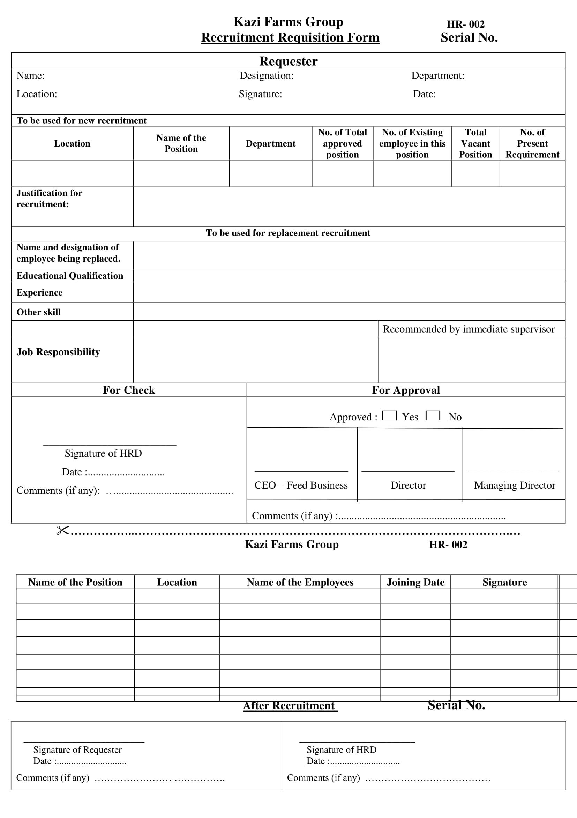
Figure 10: Recruitment Requisition Form

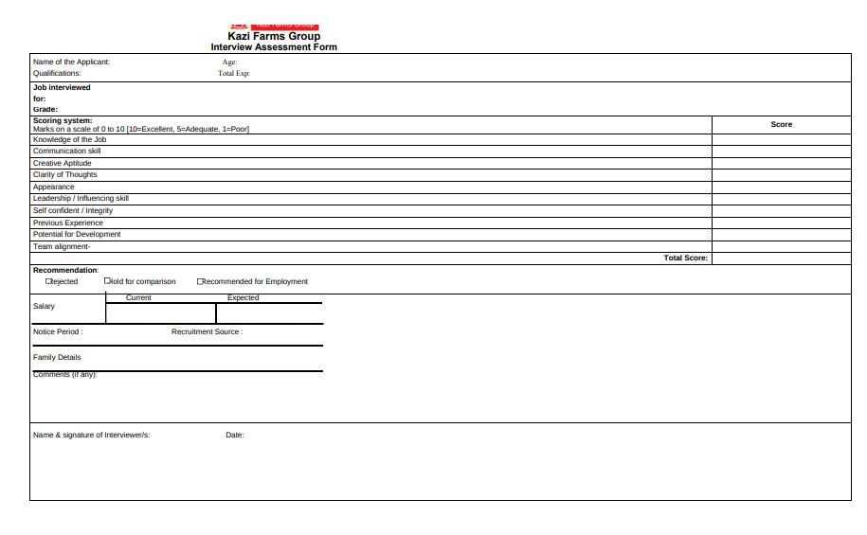
Figure 11: Interview Assessment Form

