Internship Report
On
Talent Acquisition Procedures



Talent Acquisition or Hiring Procedure of Piickme Ltd.: An Internship Report


Prepared For
Dr. Abu Zafar Md. Rashed Osman
Associate Professor
School of Business & Economics
United International University (UIU)

Prepared By
Jannatul Ferdous
ID- 111 151 304
School of Business & Economics
United International University (UIU)

Date of Submission:

Letter of Transmittal

To
Dr. Abu Zafar Md.Rashed Osman
Associate Professor
School of Business & Economics
United International University (UIU)

Subject: Submission of Internship Report
Dear Sir,
I would like to submit my graduate fellowship report about Talent Acquisition Procedure of Piickme Limited in Human Resource Department, which arranged like a method for the accomplishment of the BBA program of United International University. During this work, I tried to follow each and every guidance you advised. This is a very enlightening experience to work on this new initiative and I fully enjoy my internship time of Piickme Limited. The authorities increased their collaboration whenever it time.
Moreover, I want to express my gratitude for your support and patience with me. Hence, I would be admiring if you go through this document and give your judgement to this work considering the limitation.

Sincerely,
Jannatul Ferdous
ID: 111 151 304
Major: HRM
School of Business & Economics
United International University

Executive Summary

This graduation fellowship report about 3 months at Piickme Ltd under HR Department from 02.02.2019 to 02.05.19 as a prerequisite of my BBA program on School of Business, United International University. In that aspect I receive the practical knowledge that is related with my theoretical knowledge. I also achieved commendable knowledge about the ride sharing industry.
Piickme Ltd is fully a Bangladeshi Transportation technology company which provide several E-Commerce & other Services of Bangladesh and Established in 2018. The form of the report is used to identify how theories and concepts can be exercised in the aspect of IS (Information System) of Piickme Ltd. Generally, primary source and secondary source were used to prepare this document. Primary source came from my regular observation, Interview with Head of HR & administration & other department. Secondary source was collected by website, PA guidelines and so on. Trying to diminish the distort and generate an equitable report. The Piickme Ltd. is the rapidly growing online transportation organizations in Bangladesh because they are highly performance oriented. Hence, different kinds of management development programs are introduced to update their employee’s performance. Here we try to look out how Piickme Ltd. operate their talent acquisition procedure. Trying to provide some recommendation which may help to improve their process. Finally, this report is a combination of the theories and concepts regarding talent acquisition that is used in Piickme Ltd. for attaining the academic purpose.

Table of Content
Letter of Transmittal i
Executive Summary ii
Chapter One: Organization 1
1.1 Introduction 1
1.2 Scope of the Report 2
1.3 Objective of the Report 2
1.4 Sources of information 3
1.5 Limitations 3
Chapter Two: Literature Review 4
2.1 Human Resources Management 4
2.2 Integrating the Functional areas of HR 4
2.4 Talent Acquisition 8
2.5 Importance of Talent Acquisition Procedure 8
2.6 Talent Acquisition Procedure 9
2.6.2 Recruitment Planning 9
2.6.3 Recruitment channels for upper & mid-level 10
2.6.4 Recruitment Channels for junior level 10
2.6.5 Sourcing and advertising 10
2.6.6 Assess and Interview candidate 10
2.6.7 Selection Process 10
2.6.8 Employment Offer 10
2.6.9 Successful Onboarding 10
Chapter Three: Company Overview 11
3.1 Background of the Company 11
3.2 Corporate Information of the Piickme Ltd. 11
3.3 Services of Piickme Ltd. 12
3.4 Corporate Governance 15
3.5 Vision & Mission 16
3.6 Corporate Responsibility 16
Chapter Four: Findings & Analysis 18
4.1 Problem Statement 18
4.2 Research Methodology 18
4.2.1 Research Approach: 18
4.3 Data analysis and interpretation 18
4.3.1 Graphical representation by following table & graph 19
Chapter Five: Conclusion 24
Appendix 25
References 31

Chapter One: Organization

Introduction
Graduation fellowship is a time of task experience offered by an institution for a limited time. It is a partial requirement of graduation. It helps to enhance concept about the practical field for any student. I have got a chance to do my internship in Piickme Ltd.
In Bangladesh Piickme Ltd. is trying to be more than a ride sharing company. This report is about on ride sharing industry and to identify how this platform makes their Human Resource Management operations (hiring procedures) and how they manage their admin activities. It is the reason why I have taken Piickme Ltd. They are utilizing their data and technology to improve everything from transportation to payments across a region of more than 200 million people in Bangladesh. To work with governments, riders, users, and the community, their target is to bring out the true potential of the region by solving transportation and unemployment problems and that will lead further progress. They are focused on pioneering with new commuting and payment alternatives for Riders and users emphasizing on expense, time and convenience. For maintaining and managing all these prospective they involve with various human resource functions. To get a proper idea I have worked there as an intern. Besides HR department, director and other department also handle the recruitment process.
I am very glad to for getting the opportunity to accomplish my practical training in the HR Division of Piickme Ltd. The internship program will base on the Practices and Policies of Piickme Ltd. I have started my internship in 2nd February to 3rd May 2019. During that period, I willingly worked in that department and learned so many essential things about HRM (especially talent acquisition) in practical situation that will helpful to build my professional skill and thereby.

1.2 Scope of the Report
As the report has been made through extensive search and from the prospectus of the company that is bring by the asset management, it was helpful to prepare the report. While making this paper, there was a great opportunity to gain a deeper understanding of all the tasks conducted by the organization.

1.3 Objective of the Report
Piickme Ltd. was basically started their journey from September 1, 2018 with its bike services around Dhaka City. Soon after its success in bike service, Piickme Ltd. saw that it could further help thousands of people suffering from the immense traffic problems by providing car service; it’s secure and reliable service for the customers. For getting this service you just have to download the app from the play store, ride on your preferable vehicle, and
get to your desired destination at a fixed rate.
Some basic objectives of are given below:
• Determine customer focus and build relationship based on integrity, superior service;
• Assembling an honest, open and good environment;
• Making judgements based on merit;
• Reducing unemployment across Bangladesh;
•Working as a team to serve the excellent interest;
• Implacable in pursuit of business innovation and development;
• Providing acknowledgement and reward on performance;
• Get rid of traffic problem of Dhaka city;
• Cash on delivery service with the amusement of merchant and customers.

1.4 Sources of information
All the facts included here has been gathered from both of the sources.
Primary sources:
- Face to face conversation with Head of HR & administration;
- HR- Executive and some other employees’ interview.
- Day to day observation
Secondary Sources:
- Each employees job description of Piickme Ltd., HR Division.
- Guideline regarding the performance appraisal that is provided by the human resource department.
- Websites.

1.5 Limitations
• Each employee has some limitation;
• Lack of rues and regulation applied in other department that is provided by HRM division.
• The HR department was uncomfortable to give some of sensitive data and information because of accessing difficulty,
• The term of the internship period is brief time whereas HR Divisions a vast area, after doing the regular office works that was from 10:00 AM to 7:00 PM it was difficult to go through in depth within this short duration of time.
• Privacy.

Chapter Two: Literature Review

2.1 Human Resources Management
HRM associates with all management decisions and practices that directly influence the people, or human resources, who work at the organization. Human resource management is playing a vita role in organization success. HRM deals with panning, organizing, staffing, leading and controlling of attending to their labor relations, health and safety, and fairness concerns.

2.2 Integrating the Functional areas of HR
Staffing in HRM
Staffing includes the recruitment, selection, and socialization of employees. Staffing is important because it is the process by which you look for people who best match the job description of any available position in the organization. Being able to hire the right person for the job means that you can maximize that person's chances of playing his role in the company.
Training and Development
Training is one of the crucial part of HRM. Training is the process of teaching new or present employees the basic skills they need to perform their jobs. It involves the changing of skills, knowledge, attitudes, or social behavior.
ADDIE is the acronym for the Model’s five steps: analysis, design, development, implementation and evaluation. Here is an in depth look at the five steps of the training process or ADDIE process:

Figure 2.1: ADDIE Process
Analysis Phase:
The trainer gathers data by identifying the organization’s requirements, objectives, learning gaps and employee need.
Questions of the analysis phase addresses include:
Who are the learners and wh.at are their characteristics?
What is the desired new behavior?
What types of learning constraints exist?
What are the delivery options?
Design Phase:
It deals with learning objective, assessment instruments, exercises, training content, subject matter analysis, lesson panning and media selection. The design phase should be systematic and specific.
Development Phase:
It is a foundational step in the process, ensuring that the information gathered in the analysis phase and utilized in the design phase is adequately transmitted to employees in the implementation phase.
Implementation Phase:
It includes conducting training sessions, making relevant training materials available and maintaining the flow of training sessions to ensure maximum audience retention.
Evaluation Phase:
It reviews the effectiveness of each individual phase and modifies them if needed in subsequent executions. The best dimension of success is increased productivity and efficiency in executing tasks after training

Work life cycle

Figure 2.2: Career-impacted life stages
Motivation in HRM
The motivation function begins with the recognition that individuals are unique and the motivational techniques (job satisfaction, employee performance appraisal and compensation) must reflect the needs of each individual. The wage should be increased, the facilities should be insured and social security should be confirmed. These are the types of common motivational ways. Staff motivation is the cornerstone of open and flexible. Monetary benefits and services can be performance bonus.
Maintenance of employees
Maintenance of each employee of a company is very important task. The maintenance function is concerned with providing those suitable working conditions that employees are necessary in order to maintain their commitment to the company.
The relationship between top-level management and staff members should be flexible, good so that they can develop their commitment to each other.

2.3 Human Resource Planning
Human Resource Planning is the process of forecasting the future human resource requirements of the organization. It, thus, focuses on the initial economic concept of demand and supply in context to the human resource (HR) capacity of the organization. HRP have to be flexible enough to meet short-term workers' challenges to change the business environment for long periods. The HRP is started with evaluating the current capacity of human resources.
Purpose of HR Planning.
- To replace the right person to the right place in a right time to fi the vacancy.
- Formation and execution of HR policies
- Better relationship between union and management
- Facilities professional growth
- Improves the development of the company
HR Planning Process

Figure 2.3: HR Planning Process
1. Objectives of human resource planning: HR planning must be equitable with overall organizational plans. It should be concerned about staffing with expected vacancies rather than matching existing personnel with existing jobs.
2. Current manpower stock: Current manpower stock must be continuously managed by every department. Manpower inventory must have the accurate bio data of each individual.
3. Demand/ supply forecasting: Firstly, the organization must check the demand of manpower after every one year, two-year so on. For this purpose, employment trends to show the number of employees on payroll during last say three years to show the trend. Replacement needs appear due to the death, retirement or termination of the employees. Growth and expansion helps in constituting a number of positions at work place.
4. Determining net requirement: HR manager must verify the demand and supply of the manpower before deriving at any conclusion.
5. Redundancy and Redeployment: In redundancy where surplus employees cannot be offered voluntary retirement scheme and in case of redeployment the surplus employees in one department can be transferred to another department where deficit of employees estimated.
6. Employment program: This is needed to prepare programs of recruitment, selection, transfer and promotion to achieve organization goal.
7. Training and development: It is very necessary for the employees to keep them updated in the job they are doing.
8. Evaluation of Human resource planning: After doing all the above steps it is important to evaluate the effectiveness of human resource planning.

2.4 Talent Acquisition
Talent acquisition is a process whereas the main goa is to recognize and meet a the labor requirements a company may have. Talent Acquisition teams are mostly responsible for finding, acquiring, assessing, and hiring candidates to fill open job position.

2.5 Importance of Talent Acquisition Procedure
People are the most essential operator of every company's success. It makes talent acquisition one of the most important departments of every firm. However, the role of every talent acquisition specialist is complicated/complex, and it hold a lots of responsibility.

2.6 Talent Acquisition Procedure
The procedure of talent acquisition and the way of recruitment have changed dramatically. Talent acquisition today looks much distinctive. Talent acquisition professionals need to have many more skills, as their main job has become to bring talent.
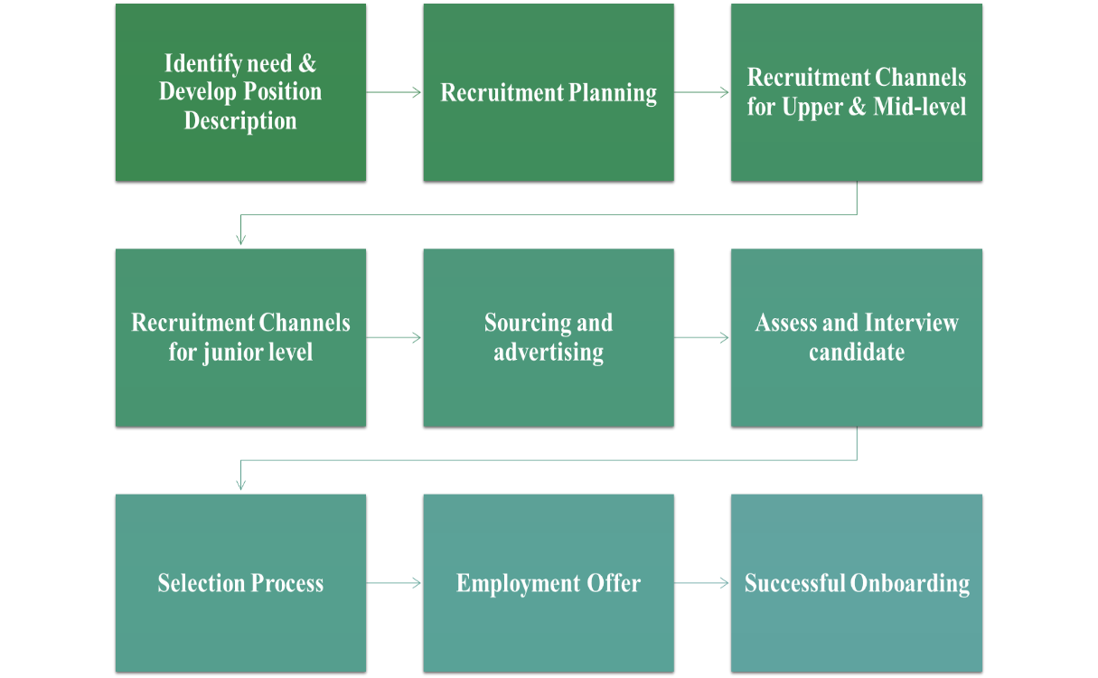
Figure 2.4: Talent Acquisition Procedure
2.6.1 Identify need & Develop Position Description
Employing units who need a new position, or to backfill an existing position, should use this. This is an opportunity to check the organizational structure, staffing skills and expertise, and advance the alignment of the workforce.
A job description (JD) contains job-related criteria and serves as a guideline for the performance expectations of a position. Job descriptions also help establish parameters and guidance around the hiring and selection process. It can also be used as a guide for flourishing interview questions, evaluating candidates, and formulating reference check questions.

2.6.2 Recruitment Planning
A thorough recruitment plan will map out and identify means to attract a diverse and qualified applicant pool. The hiring manager is encouraged to collaborate with his/her respective HR Liaison and then, as needed, the respective talent acquisition professionals to determine and develop the sourcing plan.

2.6.3 Recruitment channels for upper & mid-level
For recruiting the upper & mid-level candidate for an organization HR department provide different ads in different recruitment channels for instance, LinkedIn, BDjobs.com, so on.

2.6.4 Recruitment Channels for junior level
For recruiting the junior candidate, HR department provide different ads in different recruitment channels not as like upper & mid-level management for instance, various types of groups, vacancy announcement, vacancy announcement in BD & so on.

2.6.5 Sourcing and advertising
For hunting the appropriate candidate all company search for different sources & provide different kinds of advertisement in different sector, area or sites.

2.6.6 Assess and Interview candidate
Before beginning the evaluation of the application materials, the hiring director should review the minimum requirements of the position and review the desired qualifications with the search committee and / or partners as applicable.
Arranging interviews is a necessary step in the selection process. Intentionally designed and well-executed interviews are key questions to look at. Interviews should be structured.

2.6.7 Selection Process
The Selection is a process of picking the right candidate with prerequisite qualifications and capabilities to fill the jobs in the organization. The selection process is quite extended and complex as it involves a series of steps before making the final selection.
This process begins just after recruitment and divides the candidates in two parts those who will be offered job and who will not be. The selection process differs from organization to organization and even from department to department within the same organization.

2.6.8 Employment Offer
This step of the selection process is to give the selected candidate in a vacant position. Developing offers through e-mails or letters is sometimes more formal part of this process. Compensation and benefits will be defined as offers.

2.6.9 Successful Onboarding
After following all above steps finally they successfully onboard the right candidate at the right place at a right time to fulfill the vacancy.

Chapter Three: Company Overview

3.1 Background of the Company
Piickme Ltd. is more than just a ride-sharing platform in Bangladesh. They utilize data and technology to improve everything from transportation to payments across a region of more than 200 million people in Bangladesh. Working with governments, riders, users, and the community, their target is to bring out the true potential of the region by solving transportation and unemployment problems that will lead further progress for a better future. Piickme Ltd. was basically started their journey from September 1, 2018 with its bike services around Dhaka City. Soon after its success in bike service, Piickme Ltd. saw that it could further help thousands of people suffering from the immense traffic problems by providing car service; it’s faster and ensuring secure and reliable service for the customers. You launch a request through the app, hop on the back seat of a two-wheeler, and get dropped at your desired destination at a fixed fare rate. Piickme Ltd. Launch their Car Service on February 14, 2019 after its success in bike service.

3.2 Corporate Information of the Piickme Ltd.
Company name | Piickme Ltd
Corporate Headquarter | Piickme Ltd. Alamin Apon Heights Plot No. 27/1/B Rd No. 3 (13th/E) Shyamoli, Dhaka- 1207, Dhaka, Bangladesh.
Year of Establishment | September 1, 2018
Business Category | Computer & IT
Constitution | Private Company
Business Type | Service Provider
Main Products | Ride Sharing Service
CEO | Omar Ali Raj
Director | Meskat Hossain
COO | Amit Chakrabortty
Number of Employees | 51-100
Logo | 
Table 3.1: Corporate Information of the Piickme Ltd.

3.3 Services of Piickme Ltd.
Piickme Ltd. started their journey with providing bike service to the customers. Soon after its success in bike service, Piickme Ltd. saw that it could further help thousands of people suffering from the immense traffic problems by providing car service; it’s faster and ensuring secure and reliable service for the customers. And they are planning about launching scooter service to the customers.
Their Services:
 Bike 12৳/KM, Use Piickme bike ride sharing and enjoy the fast and smart way to get around your city.
 Car 20৳/KM, Piickme car is to provide you the most comfortable ride. Where ever you and headed to.
 Scooty 12৳/KM, Our most unique service Piickme Scooty to ensure the women empowerment safety and security. This service will be coming soon at Piickme Ltd.

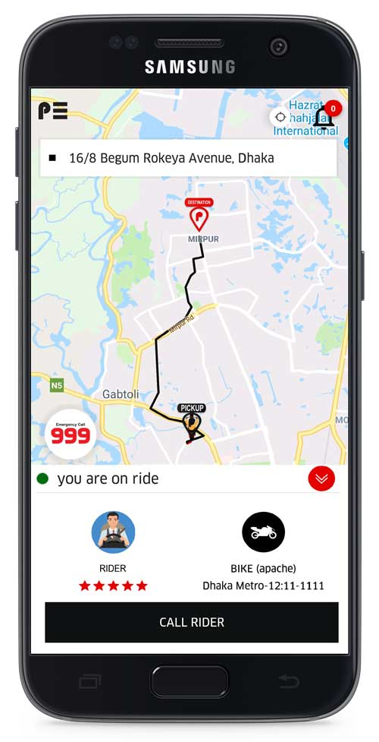
How It Works for Riding Purpose

Download Piickme App
Go to Google Play Store & App Store and download the “Piickme” app

Set Your Destination
Type in your pick-up and drop-off locations to get your estimated fare

Send a Piickme Request
Piickme will find you the nearest available Rider

Get a Rider
You will find a Rider

Give Confirmation Code

You will be given a confirmation code, provide it to the rider.

Start Your Ride
Our Rider will take to your destination safely.

Complete Payment
After you complete a trip, you have to pay Rider

Give a Rating

After you complete a trip, you can rate your Rider

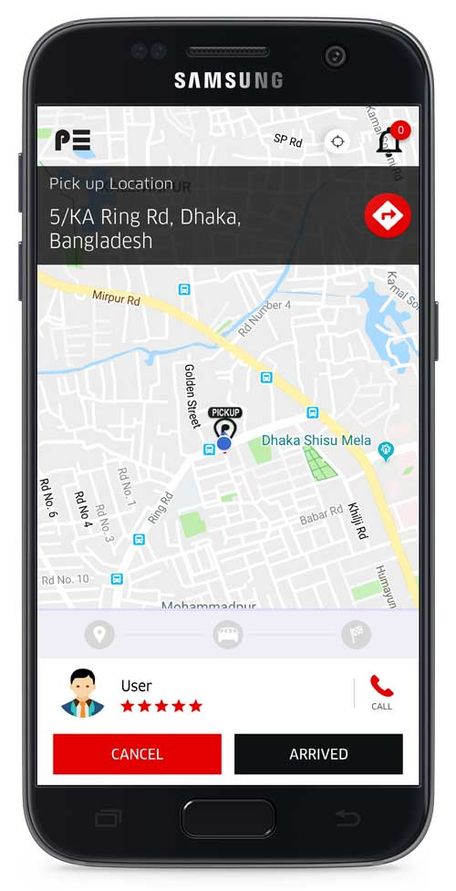
How It Works for Driving Purpose

Take Confirmation Code
User will give you a confirmation code & put the confirmation code in the app.

Start Ride
Take your user to his destination & safely drop your user.

Collect Payment
Collect the payment from your user.

Give a Rating
Rate your user.
Download Piickme Rider App
Go to google play store & download the piickme rider app
Go Online
Go Online & Wait for a ride request
Accept a Ride Request
See pickup & destination location and Press accept button
Go to Pick up Location
Go your user’s pickup location

Procurement and Custody of Supplies
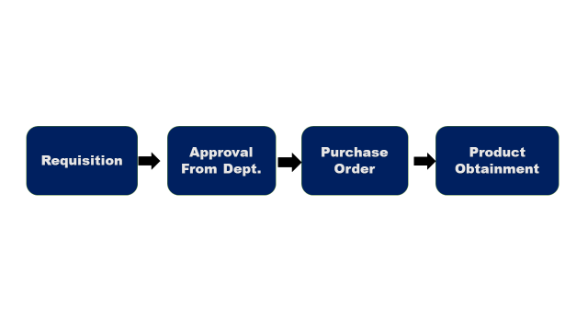Figure 3.1: Requisition of Products
Only authorized persons may purchase supplies in the name of Piickme Ltd. No employee whose regular duties do not include purchasing shall incur any expense on behalf of Piickme Ltd. and without express written approval.

3.4 Corporate Governance
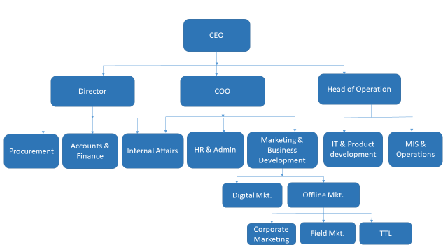

Figure 3.2: Corporate Governance

Human Resource & Administration: Human resource is the most important asset in the business. The heart of an organization lies on its people. The HR department of Piickme Ltd. use Bdjobs.com, LinkedIn and some Facebook pages to recruit and find the right candidate for the vacant post. Administrative and management are the backbone of the business. The administrative and management function is to conduct business, planning, decision making and financial review. The administration department of Piickme Ltd. keeps the record of every employee. The logistics support is also maintaining by this department. Laptops, mouse, desk, internet connection, dialer credit, SMS credit, complains/suggestions of the employees.
Marketing/Promotion: Promotional activities and advertising are the best ways to communicate with the target customers. Competent marketing and promotional activities will drive long-term success, profitability and growth in market shares. Piickme Ltd. marketing team makes some promotional offer to its customer.
MIS & Operations: MIS & Operations department is Culpable for interacting with customers regarding inquiries, complaints and orders. It is very important for a business to maintain and create relationship with their customers. Piickme Ltd. has some few customers’ service officers. Piickme Ld. also makes outbound calls to the driver and customers. Customer service officers of Piickme Ltd. also reply to messages comes from the Facebook page and website.
Accounting and Finance: Responsible for accounting, planning and organizing the company’s finances. Piickme Ltd. Accounts and finance department produce the company’s financial statements.

3.5 Vision & Mission

Corporate Vision
The vision of Piickme Ltd. is to be the pioneer where focusing on commuting and payment alternatives for Riders and users emphasizing on expense, time and convenience.

Corporate Mission
The mission of Piickme Ltd. is to bring out the true potential of the region by solving transportation and unemployment problems that will lead further progress for a better future.

Core value & Aim
Being a leading leader in Bangladesh's ride sharing service, company has their own value of the substance. Each successful organization has a set of standards of organization to help their employees achieve their goals as well as those of the companies. They summarize the essence of identity acquisition and the purpose of their existence.

3.6 Corporate Responsibility
Piickme Ltd. is focusing on some key areas of corporate social responsibility, that can help to create a cohesive map foremost. As:

Relations with Community

HR team should encourage the relations with the community for implementing reward programs, and different social involvement and practices.

Some examples of the programs can be include sending emails and company newsletters to staff members, that highlight employees and managers involved in community relations as well as creating monthly reward programs to recognize efforts by individuals within the company.
Training with Development
Training is a learning experience in that it seeks a relatively permanent change in an individual that will improve his or her ability to perform on the job in an organization. Whereas development is an ultimate result of the training. As an organization will get the developed employee through the training.
In training process, the fellow organization formulate KSA and its implementation happens in development area of each employee. Training gives an employee the opportunity of learning and in development area an employee will get to know the result of the learning.

Chapter Four: Findings & Analysis

4.1 Problem Statement
I was involved with this project to determine the employee job satisfaction level comparing to their job performance & quality of work. I am observing in my three months’ internship in Piickme Ltd. and found some problems. Exploring the problems of job performance & quality of work of Piickme Ltd. such as leave encashment, conflict of leave management, dissatisfaction about earned leave and some other issues.

4.2 Research Methodology
My major focus was to find out the employee’s satisfaction level comparing to their quality of work, job performance that have been followed by Piickme Ltd. So I had done a survey according to my research. The outcome had found through the questionnaire, so the information that I needed easily got it from the survey.
4.2.1 Research Approach: For this research I have used quantitative approach.

4.3 Data analysis and interpretation
After collecting all the data, the data have been analyzed & then explained through graph, table etc. I have used MS Word, SPSS to analyze data. Since the sample size is more than 30 so, I have used T-test for the study. In order to analysis the data a 5-point Liker scale has been used. Likert scale is given below:
Opinion | Weighted
Strongly Disagree | 1
Disagree | 2
Neutral | 3
Agree | 4
Strongly Agree | 5
Table 4.1: Likert Scale

4.3.1 Graphical representation by following table & graph
Descriptive statistics
It is useful for describing the basic features of descriptive statistics information, for example, the summary of the scale variables and data measurements. Showing the descriptive statistics by using SPSS:
Descriptive Statistics
 | N | Minimum | Maximum | Mean | Std. Deviation
 | Statistic | Statistic | Statistic | Statistic | Statistic
JP | 31 | 2.50 | 5.00 | 4.2043 | .54892
JS | 31 | 2.25 | 4.88 | 3.5887 | .67946
QW | 31 | 2.80 | 5.00 | 3.8258 | .53850
Valid N(list wise) | 31
Table: 4.2
Interpretation: This table is shown that for a mean of 4.2043, the standard deviation is .54892 in JP, JS contains mean of 3.5887 with the standard deviation .67946 and QW contains mean of 3.8258 with the standard deviation .53850.
So, this can be concluded that job performance contains the high mean that is the central value of a discrete set of numbers.
Frequency Distribution
Showing the frequency distribution by using SPSS:

Gender
 |  | Frequency | Percent | Valid Percent | Cumulative Percent
Valid | Male | 25 | 78.1 | 80.6 | 80.6
Valid | Female | 6 | 18.8 | 19.4 | 100.0
Valid | Total | 31 | 96.9 | 100.0
Missing | System | 1 | 3.1
Total |  | 32 | 100.0
Table: 4. 3
Interpretation: It can be shown that 80.6% male are in Piickme who involved with work whereas the female contains only 19.4%.
Experience
 |  | Frequency | Percent | Valid Percent | Cumulative Percent
Valid | 0-5 Years | 25 | 78.1 | 80.6 | 80.6
Valid | 6-10 Years | 4 | 12.5 | 12.9 | 93.5
Valid | 11-15 Years | 2 | 6.3 | 6.5 | 100.0
Valid | Total | 31 | 96.9 | 100.0
Missing | System | 1 | 3.1
Total |  | 32 | 100.0
Table: 4. 4

Interpretation: The table is shown that Piickme has the most employee with 0-5 Years experiences that is 80.6% and remaining 20.4% employees are experienced with 6-10 Years and11-15 Years.
So, it can be concluded that they should hire more experience personnel to get the highest job performance with great quality of work.

Education
 |  | Frequency | Percent | Valid Percent | Cumulative Percent
Valid | B.Sc | 18 | 56.3 | 58.1 | 58.1
Valid | BBA | 5 | 15.6 | 16.1 | 74.2
Valid | MBA | 5 | 15.6 | 16.1 | 90.3
Valid | BA | 2 | 6.3 | 6.5 | 96.8
Valid | M.S.S | 1 | 3.1 | 3.2 | 100.0
Valid | Total | 31 | 96.9 | 100.0
Missing | System | 1 | 3.1
Total |  | 32 | 100.0
Table: 4.5
Interpretation: In that section we can see that 58.1% employees work in Piickme have completed their B.Sc. as this company is IT based company. The lowest percentage that is 3.2% employee had completed their M.S.S. So, we can conclude that though it is IT based company others graduated personnel should get the chance to prove themselves.
Regression Analysis
Regression analysis itself a powerful statistical method that allows us to examine the relationship between two or more variables of interest.
Model Summary
Model | R | R Square | Adjusted R Square | Std. Error of the Estimate | Durbin-Watson
1 | .198ª | .039 | .030 | .55700 | 1.661
a. Predictors: (Constant), QW, JS
b. Dependent Variable: JP
Table: 4.6
Interpretation: We can see that the R square value .039 that indicates 3.9 percent of the variation in average job performance can be explained by variability in an employee’s quality of work and job satisfaction. R-squared values less than 50% because people are fairly unpredictable.
ANOVA
The following table shows how well the regression equation fits the data (i.e., predicts the dependent variable) and is shown below:
ANOVAª
Model |  | Sum of Squares | DF | Mean Square | F | Sig.
1 | Regression | .353 | 2 | .176 | .568 | .573^{b}
1 | Residual | 8.687 | 28 | .310
1 | Total | 9.039 | 30
a. Dependent Variable: JP
b. Predictors: (Constant), QW, JS
Table: 4.7
Interpretation: As the F-Value (.568) is greater than .05 so that we can conclude that there is no relationship among Quality of Work and Job satisfaction with Job Performance of Piickme Ltd employees.
The coefficients table provides us with the necessary information to predict JP from JS and QW, as well as determine whether JS and QW contributes statistically significantly to the model.
Coefficientsª
Model |  | Unstandardized Coefficients |  | Standardized Coefficients | t | Sig.
 |  | B | Std. Error | Beta | t | Sig.
1 | (Constant) | 3.372 | .881 |  | 3.825 | .001
1 | JS | .021 | .150 | .026 | .139 | .891
1 | QW | .198 | .189 | .194 | 1.047 | .304
Table: 4.8
- Dependent Variable: JP
t =.139(JS), 1.047(QW)
Sig. = .891(JS), .304(QW), α = 0.05
Null hypothesis will be accepted as the significance JS (0.891) and QW (.304) is greater than α value (0.05). Therefore, JS and QW are not statistically significant.

T-Test
Group Statistics
 | Gender | N | Mean | Std. Deviation | Std. Error Mean
JP | Male | 25 | 4.2400 | .59722 | .11944
JP | Female | 6 | 4.0556 | .25092 | .10244
Table: 4.10

 | Independent Samples Test
 | Levene’s Test for Equality of Variances |  |  | t-test for Equality of Means
 |  |  |  |  |  |  |  |  | 95% Confidence Interval of the Difference
 |  | F | Sig | t | DF | Sig.(2-tailed) | Mean Difference | Std.Error Difference | Lower | Upper
JP | Equal variances assumed | 2.109 | .157 | .733 | 29 | .469 | .18444 | .25149 | -.32990 | .69879
JP | Equal Variances not assumed |  |  | 1.172 | 20.098 | .255 | .18444 | .15735 | -.14369 | .51258
Table: 4.11
Interpretation: Equal variances will be denoted with a p-value greater than 0.05 that is (.469>0.05). As the Sig value is greater than the value of .05, we can conclude that, there is a difference between the means but we cannot conclude that a significant difference exists. The differences between condition Means are likely due to change and are probably due to the IV manipulation.

Chapter Five: Conclusion

As per the requirement of school of business program, I was accredited to finish my graduation fellowship report on Piickme Ltd. and under the supervision of Dr. Abu Zafar Md. Rashed Osman, Associate Professor of United International University.

Doing my internship provide me with the opportunity to gain hands on work experience that was not possible to achieve in the classroom. Piickme Ltd. is now one of the fastest growing ride sharing company in our country. I had a great exposure while working in Piickme Ltd. My internship helped me to develop essential skills and build the confidence by performing essential tasks in the organization. While working with Piickme Ltd. I have developed good organizational and communication skills. This internship was an on-the-job learning experience which amplified my chances for early career success. It provided me with a realistic work preview and offered practical, supervised learning experience. It was a pleasure to work with a supervisor & others executive officers. They try to increase their business line and they recently got the license from BRTA. From here, we will able to know about the talent acquisition section of Piickme Ltd. Employees are important part of an organization. So company should look after their employees by providing some facilities. Talent acquisition for a particular position is very important part of an organization. To maintain a good acquisition procedure is very appreciating for the company. I would like to conclude by saying that it had been a substantial experience for me. Moreover, the survey that I conducted gave me a stronger and more helpful knowledge about the whole research. This report may contain few deficiencies yet I have tried my best to maintain accuracy. I hope this can be a supportive resource to use in future.

Appendix

Your gender:
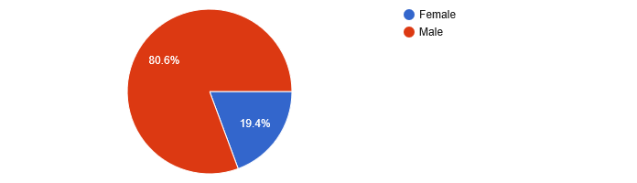

Please mention your number of year experience

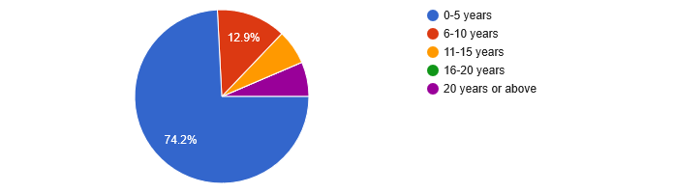
Please mention your level of education

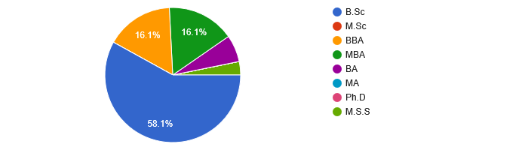

Questionnaire:
Job Performance
Find Effective solutions to problems
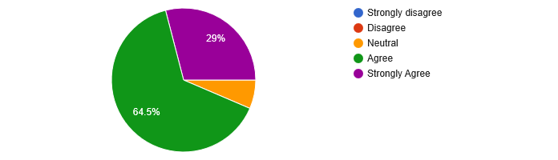
I adapt easily to changing situations
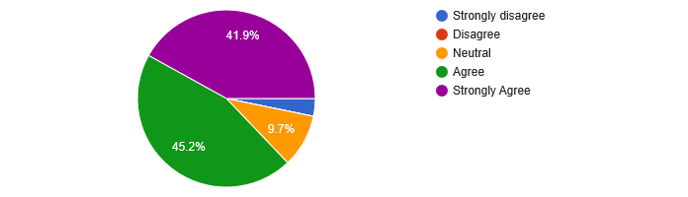
I assume a sense of ownership and responsibility in the quality of the performance
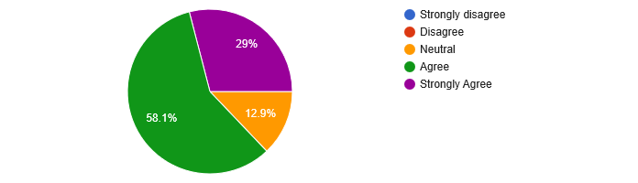

I strive to meet deadlines
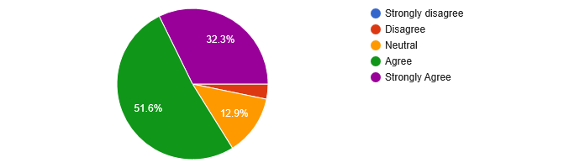
I encourage colleagues to do more than what is expected
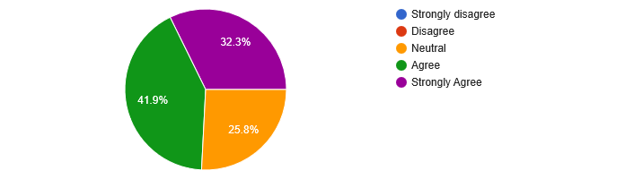
I create effective work relationship with others
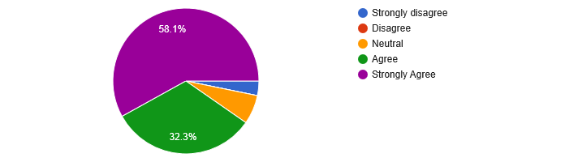
Job satisfaction
I believe academics staffs of my organization are well-trained
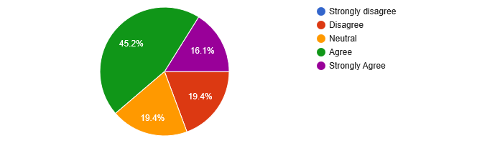

I believe transparent performance evaluation system is in practice for stuffs
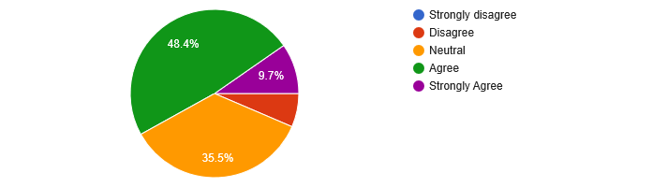
I believe performance based rewards system is in practice
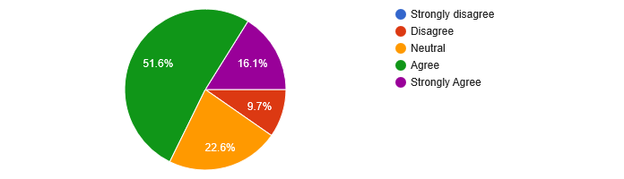
I believe staffs are enjoying homely work environment
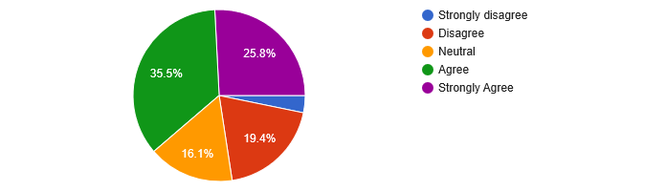
I believe competitive compensation package is enjoying staffs
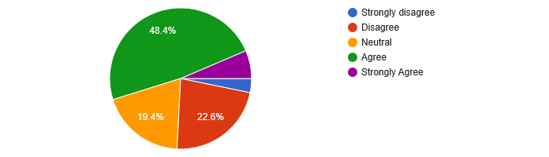
I believe supervisors are more concerned about employees
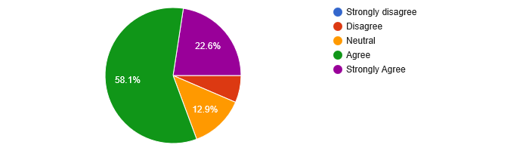
I believe timely and unbiased promotion is a common practice of my organization
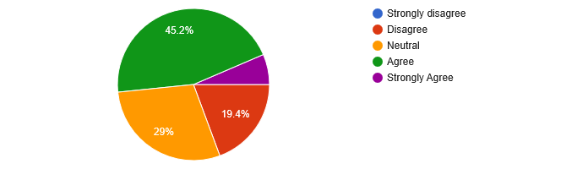
I believe staffs are enjoying job freedom
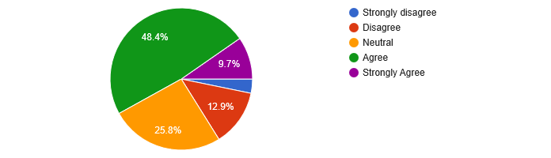
Quality of Work
I believe, I am making fewer mistakes when performing my jobs
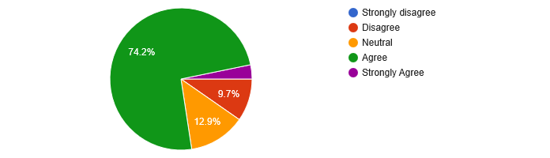
I receive fewer compliments about my jobs
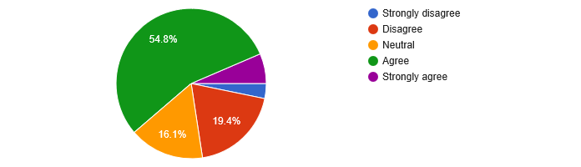
My supervisor is always satisfied about my jobs
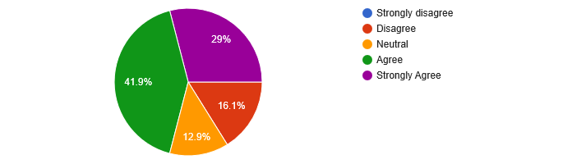
I believe customers are satisfied by my jobs
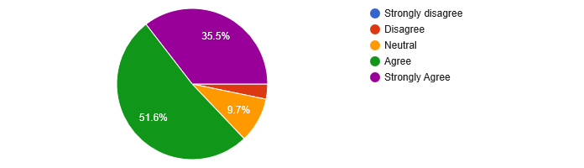
I believe, my co-workers satisfaction is high about my jobs
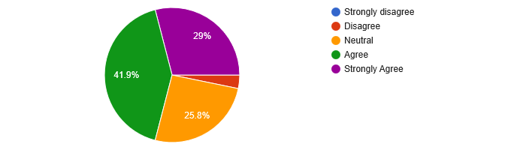

References

1. IBM SPSS software: https://www.ibm.com/analytics/spss-statistics-software
2. ABOUT US - Piickme - Ride With Freedom. (2019, April 1). Retrieved from Piickme - Ride With Freedom: https://www.piickme.com/about
3. StudiousGuy. (n.d.). Retrieved from Human Resource Management: https://studiousguy.com/human-resource-management/
4. https://piickme.com/

