

Bangladesh ICT Sector and Nascenia Limited


Internship Report on
“Bangladesh ICT Sector and Nascenia Limited”

Submitted To
Dr. Md. Mohan Uddin
Professor of Finance
School of Business and Economics, UIU
Submitted By
Faiza Tahsin Maisha
ID: 111 151 639
Course Code: INT 4399
School of Business and Economics
Date of Submission
December 17, 2019

Letter of Transmittal

December 17, 2019
Dr. Md. Mohan Uddin
Professor of Finance
School of Business & Economics
United International University
Badda, Madani evenue, Dhaka- 1212.

Subject: Submission of Internship Report.
Sir,
It is my pleasure to submit the internship report on the topic that you have assigned named “Bangladesh ICT Sector and Nascenia Limited”. I tried my level best to complete this report by following your instructions.
The purpose of this report is to study the current market condition of the IT industry and relate my experience to find out how my designated organization, Nascenia, is keeping pace in this highly competitive national and international market. This report contains the practical experience, knowledge and analysis that I have gained during the 4 months of internship program while working with Nascenia Limited. I hope the experience I have achieved from here will add value to my career.
I hope this report serves its intended purpose and meets the objectives and requirements of my internship and find your acceptance.
Sincerely yours,

____________________
Faiza Tahsin Maisha
ID: 111 151 639
School of Business & Economics
United International University

Acknowledgement

At first, I am grateful to almighty Allah for giving me strength for preparing this report. Also, I have been blessed with so many people in my life that have provided me with academic support. I would have not been able to accomplish the completion of this report without their continuous supports and guidance of the following individuals.

I am very thankful to my supervisor, Dr. Md. Mohan Uddin, Professor of Finance, School of Business & Economics, United International University for his cordial support and guidance during the internship period. This would have been very difficult to prepare this report without his guidance and advice.

Finally, I would like to express my sincere gratitude to Nascenia Limited. My deepest gratitude is to my Supervisor Fuad Bin Omar, Chief Operating Officer, Nascenia Limited for his immense help in many ways. I was blessed with the endless support of my supervisors and colleagues.

Executive Summary

This report is prepared on Nascenia Limited, a progressive IT Company in Bangladesh. The ultimate purpose of the report was to study the present condition of Nascenia limited and how it is keeping pace with the fast pacing local IT industry.
The IT sector of Bangladesh is matured and developed enough not to be ignored by its contribution to the national income of the country. Entrepreneurs are highly encouraged to launch IT companies here which are creating hundreds of thousands of IT jobs, resolve unemployment problems and, consequently, help Bangladesh become a middle-income country by 2021 which is known as ‘Vision 2021’. According to the Bangladesh Association of Software and Information Services (BASIS) survey, there are more than 800 software and ITES companies, 30,000+ IT professionals and 1,800 crores (USD 250 million) worth IT industry is existing in our country.
Nascenia is a private limited company incorporated in Dhaka that started its operation in 2010 with a mission to enrich people’s life by creating unique software. It has proven experience in designing, developing and maintaining more than 100 web and mobile/tablet applications across 20 countries in this world with over 90% client satisfaction. The primary target market of Nascenia is from North America, Canada, Japan, and Europe.
As an intern of the Business Development department of Nascenia Limited my main duty was to assist the team with all the business-related tasks. Mainly I posted content and wrote blogs for the company website. Another major duty was to assist the team in preparing proposals and presentations.
In this report, I have analyzed the overall IT industry, the organization, and my internship experience. According to that analysis, I have come up with a summary and some recommendations which can help Nascenia to get a better and more improved business development structure.
Above all, working at Nascenia Limited has been a great opportunity. I experienced and learned a lot of things from this internship that was not enough in the academic courses. The punctuality, dedication, communication, challenges, and experience will help me go a long way.
Contents

Chapter 1: Introduction 1
1.1. Background 2
1.2. Objectives 3
1.3. Significance 3
Chapter 2: Analysis of the Industry 4
2.1. Specification of the industry 5
2.2. Size, trend, and maturity of the industry 7
2.3. Seasonality 9
2.4. External Economic Factors 9
2.4.1. Reduction in Budget 10
2.4.2. Fluctuation of exchange rates 10
2.4.3. Inflation 10
2.4.4. Interest Rate 10
2.5. Technological factors 11
2.6. Political, legal, and regulatory factor 11
2.7. Barriers to entry 12
2.8. Supplier Power 13
2.9. Buyer Power 13
2.10. Threat of Substitutes 14
2.11. Industry Rivalry 15
2.12. Summery of Challenges and Opportunities 15
Chapter 3: Analysis of the Organization 18
3.1. Organizational overview and history 19
3.1.1. Overview 19
3.1.2. History 20
3.2. Trend and Growth 21
3.3. Customer Mix 21
3.4. Product/ Service Mix 22
3.5. Operations 26
3.5.1. Organogram of the company 27
3.5.2. How They Work 27
3.6. SWOT Analysis 28
3.6.1. Strengths 28
3.6.2. Weaknesses 28
3.6.3. Opportunities 29
3.6.4. Threats 29
3.7. Strategies to Meet the Challenges and Opportunities 29
Chapter 4: Internship Experience 30
4.1. Position, Duties and Responsibilities 31
4.1.1. Writing blogs and quora for company website 31
4.1.2. Assisting team in preparing proposals and presentations 32
4.1.3. Exploring opportunities for tender participation 32
4.1.4. Posting contents on different websites 32
4.1.5. SEO Skills 32
4.2. Training 33
4.3. Contribution to Departmental Functions 33
4.4. Evaluation 33
4.5. Skills Applied 34
4.6. New Skills Developed 34
4.7. Application of Academic Knowledge 35
Chapter 5: Recommendation 36
5.1. Recommendation for Improving Departmental Operations 37
5.2. Recommendations for Improving Self-Performance 37
Chapter 6: Conclusion 39
6.1. Conclusion 40
References 41

Chapter 1

Introduction

Background:

The report entitled “Bangladesh ICT Sector and Nascenia Limited” has been prepared as a requirement for the BBA Internship Program by Faiza Tahsin Maisha, Business Development Intern, Nascenia Limited. This report contains insights into the current situation of Bangladesh’s ICT sector and the company Nascenia Limited.
The ICT sector of Bangladesh is becoming matured and developed day by day. It is considered a potential sector for the contribution to the national income of the country. Nowadays, the IT sector is playing a vital role in dispelling the unemployment problems of young graduates in our country. This sector will resolve the unemployment problem and, consequently, help Bangladesh become a middle-income country by 2021 which is known as ‘Vision 2021’.
The ICT sector of Bangladesh, though significantly smaller than offshoring giants like India, Malaysia, and the Philippines, has demonstrated one of the highest growth rates globally which indicates a huge potential and higher interest by the investors. A survey shows that the domestic sector is expected to reach nearly USD 4.6 to 4.8 billion by the year 2025 (figure:1).

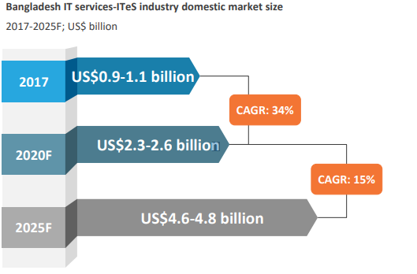
Figure 1: Bangladesh IT services-ITeS industry domestic market size (Source: Everest Group Research 2017)
While most of the IT companies are focused on country services, several companies are providing services globally and regionally. The major countries that get services are the USA, UK, Canada, Australia, Japan, and countries of the EU. Bangladesh has already grabbed the attention of mid-sized and large service providers such as IBM and Wipro, NTT data and WPP, and TCS. Key industries served by these market players consist of banking, telecom, and manufacturing.
For the purpose of completing my internship, I have joined the IT-based company “Nascenia Limited” under the supervision of Dr. Md. Mohan Uddin. To gain in-depth knowledge of the ICT sector and identify the prospects of this sector I have prepared an internship report based on this organization..

Objectives:

- To analyze the present market condition of the ICT sector of Bangladesh.
- To identify the factors that influence the ICT industry.
- To analyze the operations and strategies of Nascenia Limited.
- To illustrate the overall internship experience.
- And finally, to develop some recommendations for their improvement.

Significance:

This report is very important because it will carry the weight of my professional experience that will help me in the future. From this report, I will be able to measure my proficiency as a corporate which will assist me in building my career. Additionally, this report will be beneficial to both the IT companies and the individuals who have an interest in the ICT sector as it will include the analysis of the IT industry and analysis of the company “Nascenia Limited”. Moreover, I will do a PESTLE (except social and environmental factors) analysis and SWOT analysis that will showcase the present market scenario of Bangladesh’s IT industry. Lastly, I will include some recommendations that will help the organization as well as me to do better in the future.

Chapter 2

Analysis of the Industry

2.1. Specification of the industry:

With the passage of time, Bangladesh has improved immensely in the IT sector and the software industry. This sector is matured and developed enough not to be ignored by its contribution to the national income of the country. Nowadays, the IT sector is playing a vital role in dispelling the unemployment problems of young graduates in our country. Moreover, the number of new and enthusiastic young entrepreneurs is increasing, as they are remarkably building sustainable business organizations through their creativity and passion. Bangladesh, with its huge under-utilized manpower (cheaper than other European and Asian countries), can get advantage from these initiatives, providing an established foreign investment platform with a standard nationwide IT infrastructure and the skilled labor force is created.

Information technology (IT) provides fast and easy access to information that is essential for the development of a country. Bangladesh Association of Software and Information Service (BASIS) recently carried out a research on the IT industry and found out that most of the IT companies are performing software development activities and a large number of those companies are involved in providing different types of IT related services. Most of the companies are engaged in providing IT Enabled Services (ITES) such as data/form processing, content management, graphics designing, software development, website development, and designing, etc. In ITES category knowledge process outsourcing and automation services are known as BPO (Business Process Outsourcing). As the mobile phone sector in Bangladesh is well-developed, ICT related trade services will progress specifically in BPO.
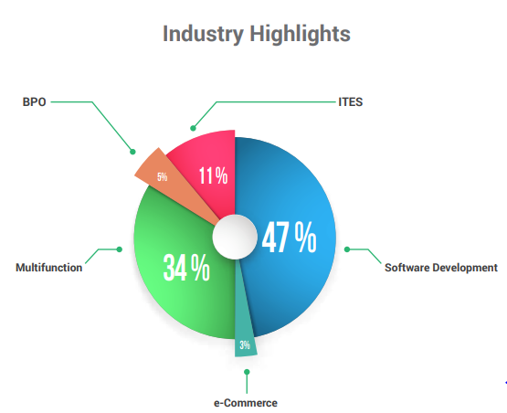
Figure 2: Types of firms (Source: ICT industry white paper & BASIS annual report 2017)

- Nearly half(47%) of the market is shared by the software development firms
- 34% of the firms are multifunctional
- ITES covers 11% of the market
- Whereas, BPO and e-commerce divisions cover respectively 5% and 3%
However, considerable achievements in the IT industry have already been made over several years towards building a 'Digital Bangladesh' and more initiatives are yet to come. To fully capitalize on the opportunities proposed by the worldwide IT expansion, Bangladesh should thrust effectively towards the further development of the IT sector to become the center of attention of foreign investors competing with other technologically advanced/well-sized Asian countries. At the same time, entrepreneurs needs to be encouraged enough to launch IT companies here. Both these efforts would create hundreds of thousands of IT jobs, resolve unemployment problem and, consequently, help Bangladesh become a middle-income country by 2021 which is known as ‘Vision 2021’.

2.2. Size, trend, and maturity of the industry:

According to a survey of 2017, BASIS (Bangladesh Association of Software and Information Services), the national trade body for Software and IT-enabled service industry of Bangladesh shows that the number of registered software and ITES companies in Bangladesh is more than 1500. And the number of total IT firms is more than 4500, earning revenues of USD 800 million. It is assumed that there are more than a hundred unregistered IT companies in our country. More than 300,000 professionals are working in the IT sector. Total industry revenue of 44% came from software development services whereas, 56% of the revenue came from IT Enabled Services (ITES).
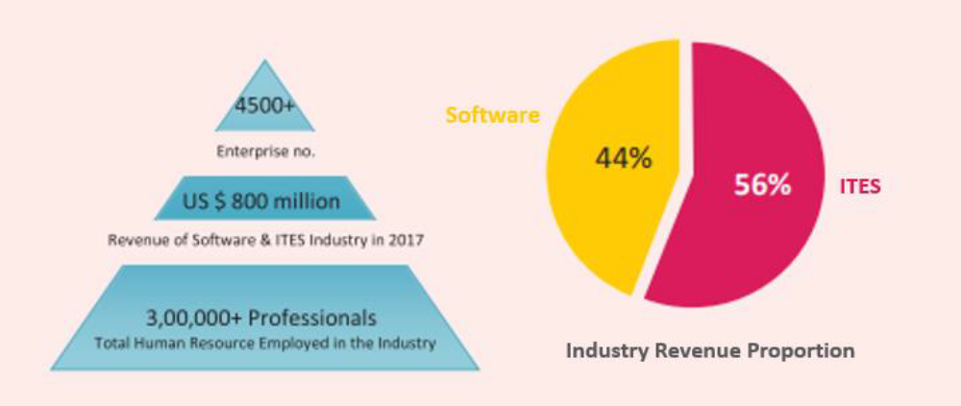
Figure 3: Bangladesh Software and ITES industry (Source: BASIS survey 2017)

A recent survey of BASIS on one hundred IT companies shows that over 70% of the IT companies are developing and maintaining software for their clients. Introduction of new payment methods for example- online payment, payment via credit card/ debit card, or other mobile options are such examples of modern trends. Approximately, 45% of the firms involve themselves in software development as their core business and the others involve them in specializing web development or design, cloud storage services, e-commerce, e-learning, and listing or payment services, etc.
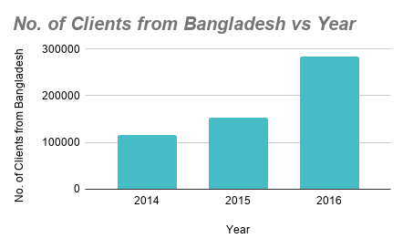
Figure 4: No. of clients from Bangladesh over the years (Source: BASIS survey 2017)
The graphical comparison of BASIS (2017) reveals the increasing number of clients from Bangladesh over the past three years. In the year 2014, the number of clients was 115,848; in 2015 the number increased to 153,855 and during the year 2016 it touches the peak with 284,271 clients. The number of foreign clients also increased to 25,263 during the year 2016. With the passage of time, local clients, as well as foreign clients, are increasing. So, in case of contributing to the national income of Bangladesh, the potentiality of the IT industry is very high. Data Source: The ICT Industry White Paper of Bangladesh, BASIS survey 2017.
A major fact has been noticed that most of the IT firms continue their business in the local market. A statistics of BASIS proves that 63% of them are focused on the local market and the rest 37% are trying to put a mark in the global market by maintaining their quality. The trend shows that there has been a continuous growth of 20-30% in the local market. Around 110 of the IT solution companies are focusing on the local market regarding ERP (Enterprise Resource Planning), HR software, Accounting software, Sales automation, and Inventory management system, etc. There has been a massive demand for IT specialists in Banking and other financial sectors like leasing, insurance, and MFIs. Previously, most of the banking institutions were dependent on foreign software development companies but nowadays they are switching to the local software development companies.

2.3. Seasonality:

IT solution companies are mainly service providers. These companies do not have any specific seasonality. They directly deal with individual clients or organizations. According to the client’s needs, they provide services at any time of the year. Attracting and retaining potential clients are the main targets of IT companies. When a client approaches the company, the developers gather information of what customers want. Based on their requirements they make a blueprint of the customer’s requirements, deploy the ideas, add some creativity to the product and finally launch it. Most of the software development companies follow the cutting-edge technique that fully depends on the customer’s choice. Some companies also provide after deployment services according to the customer’s needs. Individuals or both domestic and foreign companies are the potential clients of any software company in our country. If the company is renowned for its good performance, consists of creative and efficient professionals, quality projects and successful deliveries; it has a high chance of attracting customers from home and abroad. The marketing strategies and SEO (Search Engine Optimization) activities are mainly responsible for attracting customers and clients. During the year, depending on these activities and various strategies; customers approach the company. When the customer’s business needs and the profile of the software company match, they consider it to be a good company for their projects.

2.4. External Economic Factors:

The external economic factors play a vital role in deciding how a company makes decisions. The economic factors that can affect the business include- interest rates, exchange rates, VAT, taxes, inflation, recession and demand/supply. The economic factors not only affect the company but also the whole industry. It is beyond anyone’s control, as it makes overall impact on the nation. The government has already taken necessary initiatives to improve the recent condition of the ICT industry.

2.4.1. Reduction in Budget:
With the motto ‘Digital Bangladesh’, people are also on the right track to move forward with government rules and regulations of economic growth through developing the IT sector. In the fiscal year 2017 to 2018, there was a 40% increase in the budget allocation of the ICT industry. But there was a reduction in the budget during the fiscal year 2018 to 2019. This reduction had a negative impact on the IT industry. It is estimated that the outsourcing sector has a worldwide market of USD 700 billion; where Bangladesh's share is only USD 800 million. The government of Bangladesh can inject a major investment of USD 1 billion over consecutive five years (USD 200 million every year) to complement the ongoing 'Digital Bangladesh', which will accelerate the development of the IT industry and utilize this sector as a platform for sustainable growth.

2.4.2. Fluctuation of exchange rates:

Bangladesh has a repeated history of an unstable economy. The main problem that the ICT industry faces is the fluctuation of exchange rates. As Bangladesh provides quality software services at a reasonable price, it is an attraction for the European, Japan, and North American clients. When the currencies of these countries increase against the currency of Bangladesh, the businesses face difficulties whether they go for forwarding contract or futures contracts.
2.4.3. Inflation:
As exchange rates increase, the cash outflow of Bangladesh will be more than the cash inflow. As a result, the price of daily commodities will increase leading to inflation. There will be demand/supply instability in the economy and inflation will result in a recession in the economy. Both the clients and the firms will be discouraged to do business in this economic condition.
2.4.4. Interest Rate:
The ICT sector of Bangladesh, though significantly smaller than offshoring giants like India, Malaysia, and Phillipines, has demonstrated one of the highest growth rates globally which indicate a huge potential and higher interest by the investors.

2.5. Technological factors:

The recent tech revolutions played a massive role to boost the development of Bangladesh’s ICT sector. According to the International Telecommunication Union (ITU), the number of internet users has nearly increased from 6.5% of the population in 2013 to 18.2% in 2017 and continues to grow. While only 1.9% of the population has a fixed-broadband connection, 30% of the population has a mobile-broadband subscription. However, Bangladesh’s position is still 147 out of 176 on the ITU’s ICT Development Index 2017. The Sustainable Development Goals (SDG) continues to achieve its development goals largely through the effective diffusion of Information and Communications Technologies (ICT) in Bangladesh. Such as the Access to Information Project (a2i) which is a one-stop-shop digital center that has saved poor Bangladeshis more than $1 billion, E-learning portals, and the easier as well cheaper access to internet has boost the development. During the last 5 years, the Government has successfully launched 3G and 4G network technologies for both general and commercial use. They have also established a legal framework to promote e-commerce containing e-payment and mobile banking. For the maintenance of the security of e-payment and e-commerce; the government has started giving license to the authorities. Moreover, the bandwidth capacity of the submarine cable has been increased to 200 GBPS from 44.6 GBPS. The fast and easy access to the internet has emerged to new entrepreneurs in the ICT industry.

2.6. Political, legal, and regulatory factor:

In determining the success of any business, the legal and regulatory environment plays a crucial role. The government imposes taxes among other regulatory measures to increase the national income and to protect consumers from exploitation. Bangladesh follows a parliamentary democratic system. Due to the unstable political situation of our country the ICT industry has to face a lot of challenges. Because of the unstable political situation, the companies lose valuable foreign customers.
In 2009, the National ICT Policy was broadly amended in areas including education, science, and technology, employment generation, infrastructural development, private sector development, businesses, agriculture, health, and nutrition, etc. According to the law, each registered company must follow government regulations and pay a certain amount of tax every year to exist in the ICT industry. The company also needs to be solvent and have enough liquid assets to handle any big project (especially public/Government projects). However, some advantages to the startup ICT firms are provided by the government.
- A registered startup business will get 7 years of tax exemption and an 80% vat exemption on rentals and utilities from the government.
- Foreign employees will get a 50% personal tax reduction for 3 years.
- Every Software and ICT Service company, including the ones under foreign ownership, is exempt from income tax until 2015.
- Government-sponsored long-term equity funds, as well as short term working capital financing, are provided to the ICT companies.
- An advanced hi-technology and software technology park have been established by the government to facilitate the development of the overall infrastructure needed by companies. Moreover, the Government of Bangladesh has established the Bangladesh Hi-Tech Park Authority to operate the Hi-Tech Park.
A large number of IT companies mainly the larger and more established IT companies) have developed expertise in targeting the government or, public sector market. Though the expectation was high because of the government’s new aim towards Digital Bangladesh, it did not prove any significant change in budget throughout 2009 and 2010. However, from early 2011 things have started to change to some extent and in the last few months, there are some distinctive positive changes in the trends for software and other IT services by different departments of the Government.
The World Bank created a country assistance strategy for Bangladesh offering financial and technical assistance. The strategy had been followed from 2011 to 2014 and played a vital role in the ICT sector in developing Bangladesh’s growth, competitiveness and governance agenda.

2.7. Barriers to entry:

According to the World Bank (2014), Bangladesh holds the 130th position out of 189 economies in ‘Ease of doing businesses’ whereas, in 2013 the position was 132th. This ranking reflects the regulatory environment for starting and operating a business in Bangladesh. The ICT industry is considered to be the second largest industry that brings the most export money. As the barriers are less, the possibilities in this industry are much higher. Young graduates with knowledge and passion are becoming entrepreneurs by entering the business. Other than legal, political, and regulatory factors, security issues, funding, financial requirements, etc. there are other barriers in entering the ICT industry. These are given below:
- Inadequate number of skilled and experienced employees
- Large foreign IT and software companies
- Insufficient knowledge of entering the industry and its functionality
- Lack of awareness in social development or, CSR activities

2.8. Supplier Power:

To run an ICT company both skilled human force and advanced technologies are required. The pieces of machinery, electricity, rent and internet connection fall in the criteria of fixed costs. So, there are fewer bargaining options. And in the case of human resources, skilled, educated and experienced employees are always in top priority. For the advanced positions, the companies require more experienced employees. Moreover, Bangladesh lacks efficient software developers because of vast foreign employment options in this sector and brain drain. Therefore, the remaining skilled and efficient employees have strong bargaining power with the ICT companies.

2.9. Buyer Power:

Buyer of the ICT companies ranges from individual to private, public and foreign organizations. Nowadays, businesses want to upgrade their strategies and want to make it easier to reach their customers. That is why website designing & development, application development, and SEO (Search Engine Optimization) is needed. Banking and other financial sectors are the targeted domestic group for the Bangladeshi ICT sector. Although the banking software market is currently dominated by foreign software firms, local companies are maintaining and implementing these software solutions. A number of companies have already developed software solutions providing a range of services related to banking. Manufacturing sectors like garments, textiles, and pharmaceuticals have demanded IT solutions like ERP, HR information systems, production, accounting, and financial management software. As the Government of Bangladesh has initiated a new motto of ‘Digital Bangladesh’, there are lots of new projects lying for the ICT companies. Moreover, Bangladesh provides cheap yet quality solutions for IT and software than any other country in the Asian and European subcontinent. That is why Bangladesh is the prior choice of foreigners to get their projects done. They prefer software firms or, developer groups over freelancers or, individual developers. Therefore, the revenue of around one-third of these companies is fully based on export. To fully capitalize on the possibilities offered by the global IT expansion, Bangladesh is stepping heavily towards further development of the IT sector to grab the attention of foreign investors competing with other technologically advanced Asian and European countries. Bangladesh has opted for digitization to exploit the opportunities offered by the Digital Age and keep pace with technologically advanced countries. Above all, we can say that buyer power is very high in the ICT industry.

2.10. Threat of Substitutes:

The software and IT service industry in Bangladesh has matured and crossed a long road over the last few decades. With the local IT market, the global IT market is also increasing with an absolute pace. According to the 2017 survey of BASIS, there are an estimated 4500+ IT firms in Bangladesh with 300,000+ professionals working in the IT sector. With the increasing number of professionals and companies, the ICT industry is becoming highly compatible. As there are fewer barriers to entry fresh graduates with appropriate skills and knowledge are taking business initiatives. Entering this market is easy but existing is tough. Moreover, foreign organizations are making the market more competitive, as our local customers trust them more for their projects. The buyers have more options to choose from. Therefore, as the threat of substitute is very high, the company has to make sure that they are providing the best services at a reasonable price.

2.11. Industry Rivalry:

The ICT industry is a very competitive industry. With new emerging companies and their techniques, there is much industry rivalry seen. The 2017 BASIS survey found out that, 43% of the local IT companies had a presence in both local as well as foreign IT markets. Furthermore, 48% of Bangladeshi IT companies served exclusively to the local market and the remaining 9% of Bangladeshi companies catered to the foreign clients. The ICT industry is not that old in our country. As a result, there is no large and renowned ICT company like abroad. That is why the ICT firms are competing to get a competitive advantage. They are focusing on skilled human resources, innovative strategies and the latest technologies to attract and retain customers. Most of the ICT firms give quality solutions at an affordable price. The companies with a good history, successful projects, and experiences get priority in this market. Existing in this highly competitive industry is difficult especially for the newcomers. In spite of having fewer entry barriers, it is quite hard for small firms to exist because clients prefer to rely on large and foreign firms.

2.12. Summary of Challenges and Opportunities:

- Challenges: There are some challenges that the industry players must consider to determine their success. The IT industry of Bangladesh has the necessary potentials to compete in the international market keeping pace with our neighboring country like India, which has almost twice the revenue of ours in the industry. But scenarios are changing as Bangladesh is proving its capabilities to the world, but to ensure the sustainability of those capabilities the industry must take on some challenges to make them a strong player in the world market.
- Development of High-Tech Infrastructure:
The development of high-tech infrastructure is an important thing for the country. Without high tech infrastructures, the IT sector could not go much further. In the era of digitalization, technology changes rapidly for that we need to remain up to dated and dynamic as well. But the current scenario of the IT infrastructure of our country is not satisfactory. It is a hope that things are changing and the industry is mature now, in the past few years the infrastructures have developed, yet it needs to be up to the mark by which we can challenge the international competitors in the market. One of the good news is the development of the power sector; the frequent discontinuity of electric supply has been reduced to a convenient level. The internet connection of the country still needs to be improved. Most of the IT companies face the problem of slow internet that eventually lowers their productivity and efficiency. The government of Bangladesh must put emphasis on the IT industry if their vision is to fulfill the 2021 dream.
- Training of the Talents:
Every year thousands of graduates from IT backgrounds are expecting to enter the domestic industry. But without proper training and scope, they are not able to add much value to the industry. Moreover, talented graduates are leaving the country for better options. To reduce the brain drain, the industry needs to be resourceful in case of employment. Also, the IT personnel need to be well trained with all the latest technological upgrades. The government of the country is determined to providing all the support by subsiding in the training of IT personnel and trying to make unskilled people skilled in the IT sector.
- Intellectual Property (IP) Rights and Data Privacy Concerns:
An intellectual property right is one of the biggest issues in creative industries like IT. Without the strong presence of IP rights, people who are in the field of creating and innovating IT applications will at first want their innovations to be protected. Bangladesh’s IP rights and data privacy concerns are not that good. The legal and regulatory situation of the country is less favorable for the IT and ITES market comparing to the off-shoring giants like India, Malaysia, and the Philippines.

Bangladesh is currently ranked 99 out of 138 in the World Economic Forum’s (WEF) IP protection index. We need to improve our position in this index in order to prepare a well-established platform for the competitiveness of the industry. The protection of intellectual property will encourage more tech enthusiasts to join the industry. And those who have completed higher education from foreign universities will likely to return to the country. Thus they will be able to use their knowledge and passion for the betterment of the industry, eventually for the country.

- Opportunities: The opportunities of ICT industry in Bangladesh have been appreciated by several global ICT companies.

- Operation of large MNC’s: A Korean technology firm named SAMSUNG has established a high-end Research and Development center employing over 250 engineers in Bangladesh. Another Norwegian company named VizRT, that makes content production tools for the digital media industry. This company is building ICT production companies in Bangladesh. Other global IT companies (such as AMD, SYMPHONY, LG and IBM) are currently in the process of setting up back-office R&D or, support centers in our country.
- Employment creation: Because of these high-income jobs are created that would motivate foreign-trained Bangladeshi employees to return to the home country who can contribute to Research and Development, and also help attract foreign companies to do business in our country. This will also reduce brain-drain. Moreover, the benefits provided by the Government of Bangladesh for the startups are a great opportunity for this industry.
- Tax advantages: The constant economic growth of Bangladesh will fasten the demand for IT-enabled services at every sector of the economy. The government’s discovery of ICT as a major thrust sector of the economy and the granting of tax advantages to all IT companies are an attractive proposition for any IT company to earn large returns from a dynamic domestic market.
- Cost Advantage: Rising labor costs in India and the Philippines is opening opportunities for Bangladesh to grab some of the ITES and BPO market as these are the most cost-sensitive industries. The already skilled freelancers of our country are available who can take advantage of labor cost arbitrate of the BPO and ITES markets.

Chapter 3

Analysis of the Organization

3.1. Organizational overview and history:

3.1.1. Overview:

Nascenia Limited is a custom web and mobile application development company in Dhaka, Bangladesh operating since 2010 (10 years of operation). It is an award-winning software development company working for European and North American clients. It has a technical team with expertise in Web technology (using Ruby on Rails, PHP, ASP.net), Mobile technology (for Android and iOS), and Artificial Intelligence (IBM Watson, Tensor Flow, Dialog flow, NLP, Deep Learning). Nascenia is renowned as an outstanding Ruby on Rails outsourcing company. It has been working with clients all over the world including the USA, Canada, EU, UK, and AU. Nascenia is a complete organization for any business owner who is looking for a one-stop solution to develop software, mobile/ web app or website for their business and also want to check if there's an issue in their existing system too. Nascenia has a talented pool of developers, designers, project managers and SQA engineers too. Nascenia has 91% client satisfaction regarding maintaining deadlines efficiently and keeping the confidentiality of their projects. Nascenia is-
- ISO 9001:2015 certified
- Oracle partner in Bangladesh
Moreover, Nascenia has ITEE passers, Certified Scrum Masters, PMP, AWS Solution Architects, AWS Business Professionals, and AWS Technical Professionals in the team. They have the right skill-sets and size to build and deliver complex software. Their enthusiastic team has the capability, and the willingness, to conduct troubleshooting at their office.
The key personnel of Nascenia has been working on RoR since 2008. It is a technology agnostic company and always adapt to cutting edge technological services. Over the past several years, their excellence was built on Android, iOS, Titanium, Ruby on Rails, PHP, .net, Xamarin, Node.js, Angular.js, MySQL, PostgreSQL, NoSQL, J2ME, and so on. Nascenia follows SCRUM to deliver projects.
Nascenia helps the clients transform their operations to automation through mobile and web-based solution. Some of their valued clients include UNDP, Telenor group, Robi Axiata, Khan Academy, International Finance Corporation, PricewaterhouseCoopers (pwc), Bangladesh University of Professionals (BUP).


Nascenia has proven experience in designing, developing and maintaining more than 100 web and mobile/tablet applications across 23 countries in this world.

3.1.2. History:

Back in 2010, Nascenia started its journey by three young entrepreneurs named Shaer Hassan (CEO), Fuad Bin Omar (COO) and Fattahul Alam (CTO). These 3 C-level executives (CEO, COO, and CTO) have cumulative industry experience of about 40 years. The C-level executive team comprises of Computer Engineer from top-ranked university of Bangladesh and MBA from IBA. In the beginning, they mainly offered cloud-based services, website design/development, and iOS/Android app development, etc. to their clients. A certain period after setting they met a Danish entrepreneur named Jasper, who hired the Nascenia team to build up 100 websites for his company named ‘Better Collective’. This was the big turning point of their business. Like Jasper, many other clients relied on Nascenia for their outsourcing services. Currently, they are serving clients from more than 23 countries all over the world mainly from Japan, Europe, and North America. They are frequently working with clients from Norway, India, the USA, Canada, Denmark, Australia, Switzerland and so on. Nascenia provides high-quality service to its clients at an affordable price. Meanwhile, Nascenia grew bigger, today it has more than 70 talented employees and completed over 100 successful projects. Today, the company is in its 10th year of success and is targeting to be one of the top software companies of the country.

3.2. Trend and Growth:

Nascenia has come a long way since it started its journey 10 years ago. Its vision is to be the number one software company in Bangladesh in terms of revenue, export, and the number of software engineers. Also to be the most sought after brand among CSE graduates in Bangladesh. At the beginning, like any other business Nascenia also had to face ups and downs. But its remarkable growth was seen until the year 2014. To support growth and ensure quality the team always hires the best talent from universities, like Dhaka University, BUET, KUET, IUT, KU, NSU and UIU. It has been more than nine years and the team is getting stronger.
With business growing, it targets to employ 500 people by 2021, and eventually become one of the most renowned software companies in Asia. There is no end to peoples’ ideas, intelligence, and aspirations. Based on this, the company intends to keep those dreams materializing as it exists.
As recognition of its outstanding performance in the field of software development, it has won the following awards:
- President's Award for Industrial Development 2017
- National Productivity and Quality Excellence Award 2017 (awarded by the Ministry of Industries of Bangladesh)
- BASIS Outsourcing Award 2015
- BASIS Outsourcing Award 2014
- Red Herring Asia 2013
- GP Microsoft GrameenPhone Alo Ashbei Contest 2010

3.3. Customer Mix:

Nascenia provides solutions to both institutions and individual customers. The company is mainly serving clients from Europe and North America. Nascenia has referable clients in Norway, Sweden, the UK, Nigeria, India, Switzerland, Canada, and the USA as well. They are now targeting the potential market of Japan and many other countries in Europe. Banking and other financial sectors are the targeted domestic group for the Bangladeshi ICT sector. Although the banking software market is currently dominated by foreign software firms, local companies are maintaining and implementing these software solutions. A number of companies have already developed software solutions providing a range of services related to banking. Manufacturing sectors like garments, textiles, and pharmaceuticals have demanded IT solutions like ERP, HR information systems, production, accounting, and financial management software. As the Government of Bangladesh has initiated a new motto of ‘Digital Bangladesh’, there are lots of new projects lying for the ICT companies. Moreover, Bangladesh provides cheap yet quality solutions for IT and software than any other country in the Asian and European subcontinent. That is why Bangladesh is the prior choice of foreigners to get their projects done.

3.4. Product/ Service Mix:

Nascenia is a custom software service provider based on cloud-based web and mobile applications. For web applications, they mainly use Ruby on Rails, PHP, Dot Net, CSS, Nodejs, Angular JS, and React JS; and for mobile applications iOS and Android. They also provide support activities to their clients in front-end design. The key personnel of Nascenia has been working on RoR since 2008. The most strong technology stack of Nascenia is Ruby on the Rails framework and it has the largest RoR team of Bangladesh. RoR involves a rapid development cycle and a strong ecosystem. Using RoR, the clients get plenty of things done in a limited budget and time. This framework is especially helpful to serve the fast-growing startups to grow their business.

Some of the products and services of Nascenia Limited are listed here:

1. Digitization of Robi App: Both of the android and iOS apps of Robi was built by Nascenia. This website of “My Robi App” is done for Robi Axiata Limited, the second-largest mobile network operator in Bangladesh. It is a joint venture between Robi and Axiata Group that is a combined company of Malaysia, Bharti Airtel Limited of India and NTT DoCoMo Inc. of Japan.

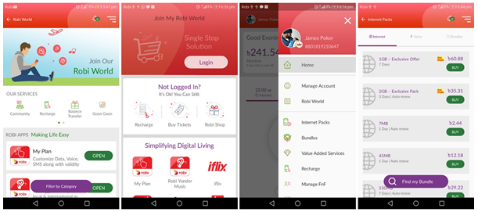
Axiata holds 68.7% controls stake in the entity while Bharti holds 25% and the remaining 6.3% is held by NTT DOCOMO of Japan.

2. Bangladesh University of Professionals (BUP): BUP is one of the renowned public universities in Bangladesh. Nascenia has designed and developed the website of BUP, and Centre for Higher Studies and Research (CHSR) program management platform. They are also responsible for the annual maintenance of the website.
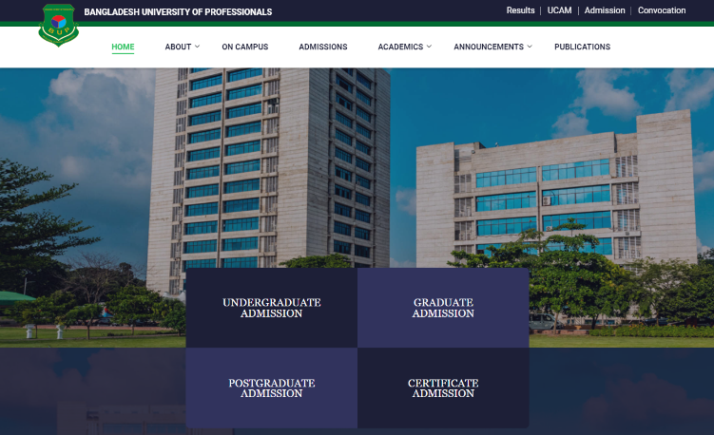

3. Snapknot: SnapKnot established in 2010, helps users to find a perfect wedding photographer. Wedding photographers can get listed here. People can search through a list of photographers based on individual needs. People can also evaluate wedding photographers by comparing photography based on their area. It is a self-service online marketing platform for wedding photographers, a free online search and collaboration tool for engaged couples that helps them quickly and easily find their perfect wedding photographer.
It is created by two Guys of the USA and is one of the fastest growing online wedding photography organizations.
4. LearnSocially: LearnSocially is an all-in-one learning platform that let people teach their unique knowledge to the knowledge seekers with easy monetization systems. LearnSocially is a SAAS platform that creates an online teaching program. One can create online courses through the web interface and reach to end-users. Website hosting and payment processing all are managed by this platform.

5. My Tonic: This website named “My Tonic” is done for Telenor Health, one of the subsidiaries of Telenor Group that is a Norwegian multinational telecommunications company. It is one of the largest mobile telecommunications companies with operations around the world, focused on the Scandinavian, Eastern European and Asian regions. Telenor has operations in 29 countries including network services in 13 countries. 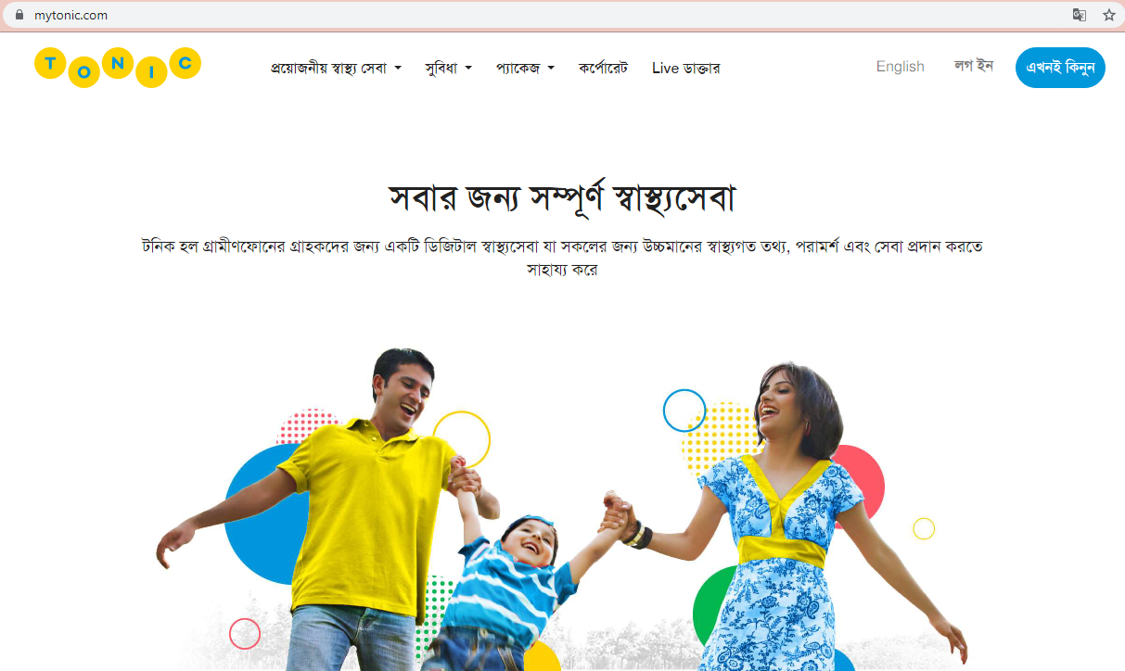

Tonic is an expression of Telenor Health’s view that technology can have the greatest impact when it is used to ‘connect the dots’ across an individual’s wellness and health experience.

6. Biyeta: Biyeta is one of the largest, fast-growing and most trustworthy websites that rethinks the Bangladeshi virtual matrimony market. It was designed to keep the user’s personal information secure and connect users based on their mutual preferences. This website is owned and operated by Nascenia.
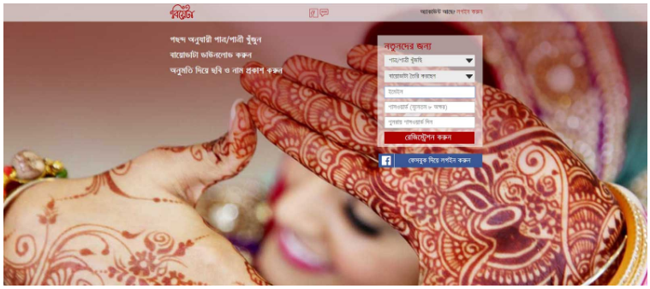
7. BDIPO: BDIPO is a hub of Initial Public Offering (IPO) for the investors of Bangladesh, made and owned by Nascenia. It also provides search results of IPO lottery, and keeps the customers updated by latest news of IPO. It also sends IPO alerts of new IPO by emailing the investors, and published results.
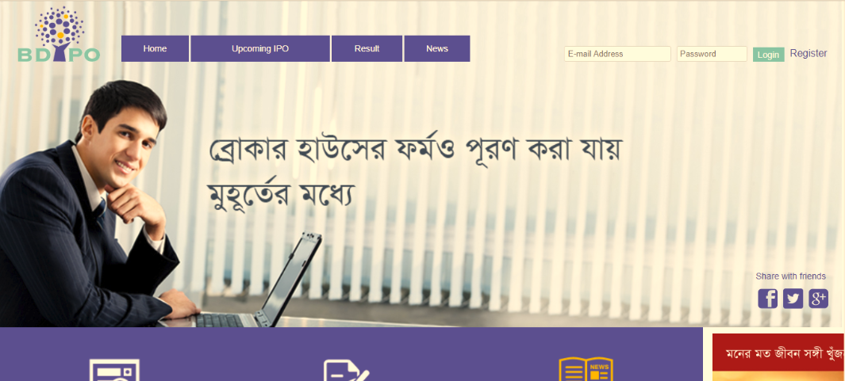
Team Nascenia converts ideas to a cloud-based web and mobile applications. This organization deals with all the intermediate steps including requirement analysis, wireframe design, UI design, coding, testing, deployment, and post-delivery maintenance. They also practice Scrum (Agile) to manage the projects.

3.5. Operations:

Nascenia Limited has 3 C-level executives (CEO, COO, CTO) having cumulative industry experience of about 40 years. The CEO manages the overall activities of the organization whereas, the COO is accountable for the business development activities and the CTO is in charge of the technical activities. Under them, there is a dynamic team of Engineers is working.

3.5.1. Organogram of the company:
Following is the organogram of Nascenia Limited-
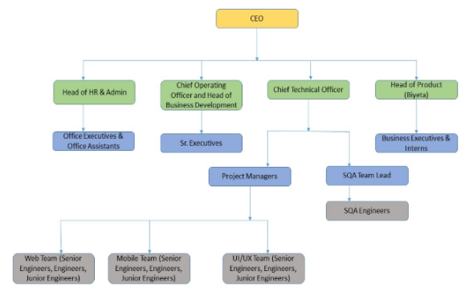
Figure 5: Organogram of Nascenia Limited

3.5.2. How They Work:
Following picture shows from contact with the client to the step by step development phases of the product until delivery.
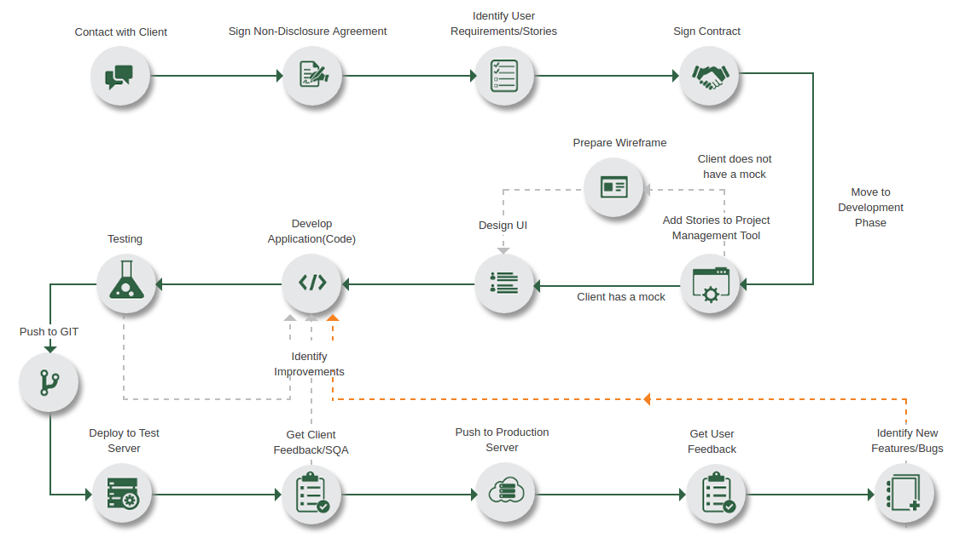
Figure 6: The step by step development Phases of the product until delivery

Nascenia Limited initiates its business procedures by communicating with their potential clients. After an initial agreement, a Non-disclosure Agreement is signed between them. It protects the confidential information of the client. The client then provides the company with their project requirements and after analyzing everything, they sign the final contract for starting their development process.

3.6. SWOT Analysis:

3.6.1. Strengths:

Nascenia’s core strength is its highly talented, experienced, skilled software engineers. They have a disciplined approach towards their business standards and policies. They have up to date and strong technological support. They are committed towards their clients. They always believe in team work that has bought about success in the projects for past few years. They always maintain accountability and transparency with the clients that have made them trustworthy in the IT industry. Nascenia’s another major strength is their existing and potential clients.

3.6.2. Weaknesses:

They lack necessary man power and skilled number of employees. They need more talented software engineers to keep pace with the leading companies in the market. Slow internet connection and electricity are also major weaknesses; these hamper the productivity of the company. Poor management system is another weakness of the organization. The rules and regulations are less which hinders the work environment.
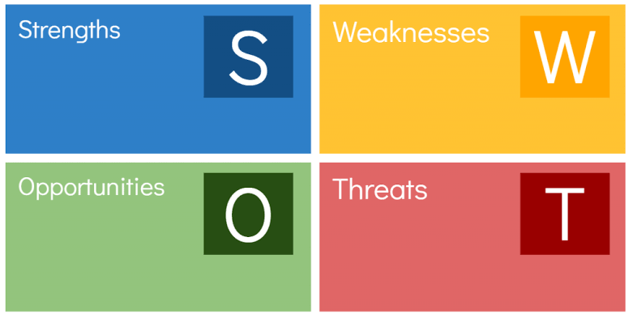
Figure 7: SWOT Analysis

3.6.3. Opportunities:

Nascenia has vast number of opportunities in front of them if they are able to adopt proper marketing strategies. They need to increase investment and prepare a strong platform to attract potential clients. The introduction of digital payment system is a big opportunity for doing business with the foreign companies or individuals. It will be easier for them to spread business globally. Every year almost 1,500 CSE background students complete their graduation; this can be a great opportunity for Nascenia to hire talents and shape them according to the needs of Nascenia.

3.6.4. Threats:

The IT industry of the country is becoming matured as more companies are registering in the sector. Nascenia’s biggest threat is the new companies entering in the market. Another threat is the already existing large number of companies in the industry. A big concern for Nascenia is the employee turn-over rate, as it is a startup company, there is a threat that the employees may leave for more established company.

3.7. Strategies to Meet the Challenges and Opportunities:

Nascenia Limited can use its opportunities by hiring young graduates and providing them proper training so that they can perform better. To reduce the employee turnover rate Nascenia can take initiatives such as increased salary, provide insurance facilities, vacation perks, performance bonus and recognition of the high performers. Also, they can make time-based contracts for working in the company. Nascenia is also going for expansion in the future. They are trying to recruit young talents from home and abroad. Nascenia will provide them with the necessary training and development programs. Besides, Nascenia organizes workshops and educative sessions frequently so that the employees are knowledgeable enough about the changes in the industry. By sincerely maintaining these strategies Nascenia will be able to provide better output in the near future.

Chapter 4

Internship Experience

4.1. Position, Duties and Responsibilities:

I was assigned as a Business Development Intern at Nascenia Limited. The vital responsibility was to help the business development team in carrying out the business-related activities. I worked under the supervision of Fuad Bin Omar, the Chief Operating Officer of Nascenia Limited and Tanzina Ireen, the Assistant Manager of Nascenia Limited. I had the opportunity to perform a variety of tasks in the Business Development Department. The duties and responsibilities include:

4.1.1. Writing blogs and Quora for company website:
Blogging is good for SEO because it helps rank a website in search engines especially when the blogs are high quality and relevant to the audience's interest. Moreover, through branding it helps to catch potential clients. During my internship period, I have written some blogs for the company. Most of the blogs were tech blogs as it is an IT-based company. There were some non-tech blogs too. The topics of the blogs were assigned by my supervisor. The link of the blogs was shared to different websites for online traffic generation. Besides writing blogs I also wrote Quora answers from the company.
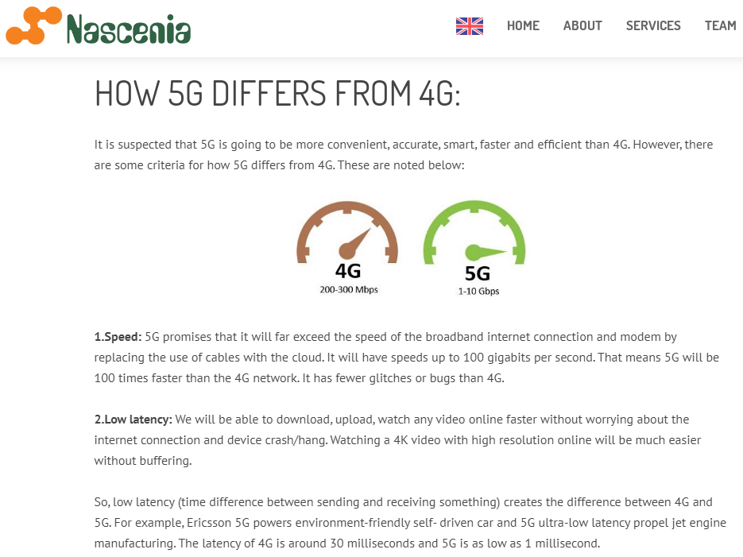

4.1.2. Assisting team in preparing proposals and presentations:
The most important thing I have learned was the preparation of Tender documents, Business Proposal Submission, Expression of Interest (EOI) and Request for proposals (RFP). I helped the business development team to prepare the documents of tenders, Business Proposals, and EOI. The tender document consists of two parts; they are Technical proposal and financial proposal. We had to prepare proposals according to the Terms of Reference (TOR) document. Terms of reference provided the purpose and structures of a proposal. I helped the team to submit the proposals within the deadline. Throughout my internship period, we submitted several tender proposals, RFP and EOI proposals. Some of those proposals were Technical Proposal for Digitization of Robi and Airtel app (MyRobi), Technical and Financial proposal for Design & Development of LIUPCP website for UNDP Bangladesh, Technical and financial proposal for developing Bangladesh University of Professionals website, etc. Nascenia Limited was awarded the contract for UNDP and BUP tenders after evaluations.

4.1.3. Exploring opportunities for tender participation:
Daily responsibility of mine was to search and explore opportunities for tender participation. There are various sources to search for tenders. The sources are the Tenderbazar website, the e-Tendering website of UNDP, National e-Government Procurement (e-GP) portal, A2i (Access to information) website of Government, etc.
4.1.4. Posting contents on different websites:
I opened the profile of Nascenia Limited on numerous Websites. There I posted contents and shared links regularly. Some of the websites were Behance, Sitejabber, Dribbble, Sortfolio, Pearltree and so on. This is one kind of digital marketing of the company.
4.1.5. SEO Skills:
Following the guidance of SEO specialist Fatema Tuz Zohra, I learned some effective SEO activities. The activities include on-page optimization and keyword research (keywords everywhere). I assisted her on the Mediaider website (product of Nascenia), Wordpress, and Wikipedia.

4.2. Training:

There was no formal training policy for anyone in the company. Employees learn and gain experience directly from the tasks. Supervisors gave some guidelines to perform the tasks. After completing the tasks, they observe it and provide corrections if necessary. A day in every week the supervisor arranged a session where we could learn digital marketing courses from Udemy (e-learning website). Besides, Nascenia Limited arranged educative sessions every week to make the employees know enough about the current technologies and trends of the industry.

4.3. Contribution to Departmental Functions:

Being a Business Development intern, I tried to perform the business development activities of Nascenia Limited. As mentioned earlier, I helped the team for preparing technical proposals, writing blogs, writing quora answers, exploring opportunities for tender participation and performing some SEO activities. In preparing the technical proposal my main duty was to sort the CVs of the employees according to the structure. Besides, I also searched for prospect clients from different countries like the USA and Canada. In an excel sheet, I sorted the data of the clients. Posting content on different websites was a regular task of mine. This is how I contributed to the departmental functions.

4.4. Evaluation:

I have tried my best to finish every task properly that was assigned to me. I can notice the progress from the beginning to the end of the internship period. I have gathered a lot of knowledge about how to run a business, how to do marketing, attract and retain clients. It has developed my communication skills, punctuality, and computer skills. As an introvert I faced difficulties at the beginning, later the employee's friendly behavior put me to ease. It has developed my professional skills. Time management, teamwork, and inter-dependent communication were the most important things that I have learned and experienced. I was also able to maintain professionalism in writing. Before joining Nascenia I had minimal knowledge about IT companies and their tasks but now I have enough knowledge about it. By doing research, listening to the supervisors and writing tech blogs have increased my knowledge. The supervisors appreciated my dedication to the work very much.

4.5. Skills Applied:

The skills that I had experienced previously include:

- Communication skills: From academic courses, I developed my communication skills. The presentation skill has helped me a lot to communicate with my colleagues in English.
- Computer skills: From the computer course I learned about Microsoft Excel, Word, and PowerPoint. Writing skills: I had to write blogs and prepare proposals, which were written in English. As I had good writing skills, it helped me a lot to fulfill the tasks.
- Avro keyboard: I used the Avro keyboard to write blogs in Bengali.
- Photo and video editing skills: I knew some editing skills that have helped me a lot during my internship.

4.6. New Skills Developed:

I have developed a lot of skills during the 4 months of internship period with the help of my supervisors and colleagues. The skills include:

- Professionalism: I had to communicate with my colleagues and the other employees of the organization by maintaining professionalism.
- Teamwork: I had to work with the business development team of Nascenia Limited. We were a 6 people team and we worked under the COO. The tasks were divided among the members by him.
- Time management: We prepared our tasks within the given time with accuracy and efficiency. At the beginning of the day I wrote the duties I need to perform on a sticky note and performed every task accordingly.
- Leadership: At one task I had to prepare CV’s of each employee. For this I had to direct the employees, collect information from them, put information on place and finally prepare the CV. This has helped me to develop the leadership quality.
- Browsing skills: To find prospect individual clients and companies I had to browse efficiently. I also had to find out all the information of those clients and companies.
- Punctuality: Each employee has a time tracker ID of the company. I had to login and logout on that ID on time. This regular habit has made me punctual.
- Hard work and dedication: I tried to finish the tasks the day it was assigned to me. My hard work and dedication was appreciated by the colleagues.
- Conflict management: I also learnt how to avoid and handle the conflicts. In this case, the assistant manager of the company has helped me a lot.

The skills that I have adopted here will help me further in the corporate environment.

4.7. Application of Academic Knowledge:

There is a huge difference between what theories we study in the classroom and how it is applied in real life. But some of the courses helped me a lot during the internship. The courses are Business communication, Organization Behavior, Marketing courses, Computer course, and English courses. In business communication, I had learned about how to write an email, resume, and CV. I applied those skills here. In organization behavior learning about the rules of an organization and how to behave in a corporate environment, has helped me a lot. Learning the elements from the computer course played a vital role as most of the tasks were based on Microsoft word, excel, and PowerPoint. Applying the knowledge from the marketing course has also helped me as this organization’s business mostly depends on marketing. The English courses have helped me to write blogs without any grammatical errors and speak fluently. Besides all these courses I have also used the knowledge of accounting to help colleagues prepare “Accounting Software” for Nascenia Limited. Also, the presentation skill gained from every course has developed my fluency in English.

Chapter 5

Recommendations

5.1. Recommendation for Improving Departmental Operations:

Nascenia limited is a small private company with almost 70 people. The company has divided people into small teams and assigned different projects. However, there were a few things that lagged formality and hampered departmental operations. These are noted below:
- When I joined Nascenia Limited, there was no formal orientation. So, I faced a little difficulty knowing the employees, the rules-regulations and their working structure.
- The number of medical and casual leave is very unlikely.
- Employees have to work on Friday which is quite tiresome whereas other organizations remain closed on this day.
- The entrepreneurs need to delegate some power to employees so that they can have a voice in the organization. If employee opinions are prioritized, the operations will run smoothly and also the productivity will be high.
- Compared to the employee facilities, the working pressure is very high.
- Because of low employee facilities most of the experienced employees leave the organization. So, the organization should hire employees’ time to time and on a contractual basis.
- International clients face difficulties communicating because of the language barrier.
- The internet network of the organization is not up to the mark. As a result, productivity is hampered.
- The organization needs to invest some money and effort into their marketing activities.

5.2. Recommendations for Improving Self-Performance:

- I need to be calm and patient in terms of performing any task. Doing tasks fast, I had made a lot of mistakes.
- I need to be a multitasker to keep pace with the workload. Because organizations are dynamic places.
- I should avoid being disappointed and demotivated so easily. Sometimes I could not meet my supervisor’s expectations. That demotivation hampered my performance.
- Anxiety and nervousness are one of the main problems that I face while talking to someone superior to me and performing any important tasks. I need to work on these two things.
- I should concentrate more while doing any task. I get distracted so easily and various errors occurred because of it.
- I should take criticisms in a constructive way and put effort into the areas I am weak.

Chapter 6

Conclusion

6.1. Conclusion:

Working in Nascenia Limited has been a great opportunity. There were a few ups and downs during the four-month internship period. As an Intern, I learned a great deal from here and gathered some experience that will help me in the near future. As there was no formal orientation, it was a bit challenging to find out the rules and regulations and their work structure. It took me some time to learn the work structure. I learned a great deal of being punctual and managing time. While maintaining inter-departmental communication, in terms of communicating I learned to maintain professionalism.

Considerable achievements in the IT industry have already been made over several years towards building a 'Digital Bangladesh' and more initiatives are yet to come. To fully capitalize on the opportunities proposed by the worldwide IT expansion, Bangladesh should thrust effectively towards the further development of the IT sector to become the center of attention of foreign investors competing with other technologically advanced/well-sized Asian countries. Nascenia limited follows strong ethical guidelines and maintains quality to satisfy their client’s requirements. With a vision of becoming the number one software company in the country, Nascenia is growing very rapidly. Nascenia has a very small team compared to other companies but all it has is professional and experienced developers. To grab more opportunities, Nascenia needs to expand its team as well as focus on marketing activities more and more.

References:

Bangladesh Association of Software and Information Services (BASIS) Publications. IT and ITES Industry Overview 2018. Retrieved from:
https://basis.org.bd/publication/ba96136a3b168568073f9800e5b0f5b9.pdf

Bangladesh Association of Software and Information Services (BASIS) Survey. IT and ITES Industry Overview 2017. Retrieved from:
https://basis.org.bd/resource/About_Industry.pdf

Everest Global Inc. Report (2017).Betting on Future - The Bangladesh IT- ITES Industry is Poised for Growth. Retrieved from:
http://lict.gov.bd/uploads/file/publication_5a3f7c94c9458.pdf

ICT Sector Study Bangladesh, Nyenrode Business University. Retrieved From:
https://basis.org.bd/resource/ICT%20Sector%20Study%20Bangladesh.pdf

Company Information collected from:
https://www.nascenia.com/

An Article on Bangladesh’s IT Industry, retrieved from:
https://www.thedailystar.net/op-ed/bangladeshs-it-industry-1324174

The Evolution of Nascenia Limited, Retrieved from:
https://futurestartup.com/2017/07/12/an-interview-with-shaer-hassan-co-founder-and-ceo-nascenia/

