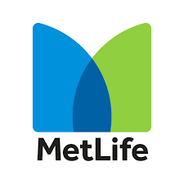

Internship Report
On
“Change Management and Recruitment Activities of MetLife Alico: An Evolution”

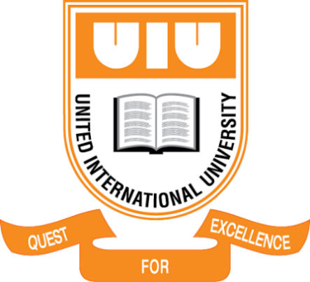

UNITED INTERNATIONAL UNIVERSITY

Submitted To
Md. Kazimul Hoque
Assistant Professor
School of Business and Economics

Submitted By
Nasrin Sultana
ID: 111 153 118
Course Code: INT 4399
Program: BBA
Major: Human Resource Management
United International University

Date of Submission:
13th January, 2021

Letter of Transmittal
To
Md. Kazimul Hoque
Assistant Professor
School of Business and Economics

Subject: Submission of Internship Report

Honorable Sir,
I have prepared my internship study on " Change Management and Recruitment Activities of MetLife Alico: An Evolution" with your guidance.
I have attempted to concentrate on the specific data in my report that will cover the report goals. But, no doubt, on your sharp scale of acceptance and remarks, my commitment and contribution will be better judged.
As a consequence, to your every concern, I forward my internship paper. I sincerely hope that this report will comply with the specifications proposed by you in the report. Instead, I would welcome the chance to consult with you in case of any further clarity or elaboration on my job.
Thanking you,

Yours Sincerely,
Nasrin Sultana
ID: 111-153-118
Program: BBA
Major: Human Resource Management
United International University

Acknowledgment
First, under the HR team of MetLife, I have prepared my internship report by the grace of Almighty Allah and I am thankful for getting the opportunity of working with them. MetLife Bangladesh HR team has supported me a lot.
The progress and result of this internship report required huge support and assistance from different individuals, and with the completion of my report, I am incredibly privileged to bring this all together. Everything I have done is sole because of the given support, and I will not fail to show my gratitude towards them.
I am thankful to Mr. Md. Tauhidul Alam, Director, and Head of Human Resources, MetLife Bangladesh, to give me this huge opportunity of doing an internship in the Human Resources Department at MetLife Bangladesh and providing me with all the assistance that has made me finish the internship report duly. I am greatly thankful to him for providing me with the guidance and assistance necessary, despite his busy schedule of managing the corporate affairs.
I would also not forget to remember Ms. Sangita Dutta, Senior Executive of Human Resources, Mr. Md. Saifur Rahman Khan, Manager, Human Resources, and Efti Rahman Strategy & Transformation, Regional Distribution of Metlife Asia region (Hong Kong, Malaysia, Vietnam, India, Japan, Korea, Australia, Bangladesh), Human Resources, MetLife Bangladesh for the encouragement and for their timely support and guidance till the completion of my internship.
I heartily thank all the internal associates of MetLife Bangladesh for their supporting hands and suggestions during the conduction of the project.
Finally, I owe my deep gratitude to my internship supervisor faculty, Md. Kazimul Hoque,
Assistant Professor, United International University, for taking a keen interest in my internship report work and guiding me throughout the report by giving all of the required information.

Executive Summary
MetLife is a multinational, health, and life insurance company. MetLife started its venture in Bangladesh back in 1952. MetLife Bangladesh is registered under the name of American Life Insurance Company (Alico). Alongside all the departments, MetLife Bangladesh has a very strong human resources department that is strategically supporting the organization to reach its goal.
Change management capabilities are paramount in this fast-changing world if somebody wants to survive. However, it can distract the staff as a whole while an organization is facing dramatic change. If it's introducing new technologies or programs, transitioning to new procedures, or having the workforce community on board with a new boss or chief, as business executives and staff juggle their work duties and copes with the transition, productivity is always sacrificed. A change management professional may be required to supervise the whole process and oversee it from all sides for organizations to adapt quickly and positively to change.
Everybody has to learn to handle the transition, no matter how their work leads. Taking control of transition helps them to predict the next encounters and prepare for themselves. It is much more effective and constructive than empowering their work-life and perspective to be buffeted by the moving breeze. Their skills in change management will help them handle the journey, whether the change is in their personal lives and will carry over into their workday or the change is connected with work.
TABLE OF CONTENTS
Topic | Page
Chapter 1  - Introduction  - Origin of the Report  - The objective of the Study  - Limitation of the Study  - Research Methodology | 3-5  3  3  4  4  5
Chapter 2  2.1 Literature review | 8-11  8
Chapter 3  3.1 Organizational overview and profile  3.2 Mission and Vision of MetLife  3.3 Product and Service Offerings by MetLife  3.4 Organizational structure of MetLife | 12-15  12  13  14  15
Chapter 4  4.1 Theoretical analysis  4.2 MetLife FA recruitment  4.3 The reason behind the change  4.4 Numbers of the campaign  4.5 Recruitment process (2020) | 20-31  20  23  25  27  31
Chapter 5  5.1 Findings  5.2 Recommendations  5.3 Conclusion | 36-41  36  39  41
References | 42
Appendices | 44

CHAPTER 1
INTRODUCTION

1.1 Introduction
Since the beginning of human societies, men have wanted various forms of safety or cautionary practices for owners, their families, and the generation upcoming. Despite these safety expectations considered to be common, assurance of them was never easy. Various types of risks and hazards surround human life. The insurance business has originated to cover the losses arising from these types of associated risks and dangers with life. The idea of insurance is generally the spreading of the risks of one into many different shoulders to carry. It can be described as a cooperative mechanism for the distribution of losses caused by a particular risk to several individuals being exposed to the different risks and agreed to insure them against the different types of risks. The insurance is considered to be a contract where the insurers agree for indemnifying the insured against any losses occurring from unforeseen hazards or contingencies, upon receipt of a consideration known as the premium.
Insurance offers effective hand and mind insurance against loss of property and sufficient resources to generate more wealth for the country's economic development. With society's advancement, the scope of general insurance is increasing. Playing one of the most important parts of a country's economic system, this risk-sharing financial practice that was implemented in the mid-18th century in this area can be highly beneficial to the general people as well as the economy in the geography.

1.2 Origin of the Report
The internship Report involves getting realistic experience by physically engaging in real jobs. Practical preparation means a way by which a person or a trainee can acquire knowledge of the relevant subjects and be able to apply his academic expertise in the area of real-life activity. To gain a full understanding of something, practical preparation is required. This report, therefore, attempts to illustrate the expert understanding of the working environment in the real world.
Business Study here at United International University offers four year's BBA program majoring in different related fields. The creation of theoretical knowledge about business management, which is the foundation of practical knowledge, is the BBA academic curriculum. This BBA internship report program is an effort to provide business students with an introduction to a real-life business scenario in which the application and applicability of the theoretical principles learned in classrooms can be observed and assessed. This report is the prerequisite for the fulfillment of the internship program as per the norm.

1.3 The objective of the Study
The goals of this internship study are for scholarly purposes. The report aims to collect information and experience of the corporate working environment in close touch with the organization and the experts who guide and make strategic decisions to boost a financial institution's growth. In this respect, the focus of this report is on the information gained from the project program.
- To figure out any big issues in Bangladesh's insurance sector recruiting system;
- Identifying the key prospective field where reforms in insurance companies such as MetLife in Bangladesh could take place.
- Awareness of the general situation of transition management in the recruiting system;
- To know the adverse result that came with the adjustment
- Being mindful of the opportunities and the outcome;
- To propose or suggest such required steps to address current challenges and to take necessary steps for increasing the efficacy and performance of the recruiting and selecting method of MetLife.

1.4 Limitation of the Study
- Time limitation: Time is a key factor in completing any type of project effectively. I did not get enough time to do this report to conduct an in-depth analysis, interview, and survey on the company. It is also difficult to get adequate free time from the corporate executives as they remain busy with their work and life.
- Confidentiality of data: They do not want to share their internal things. It's difficult to gather primary data due to the confidentiality of the data.
- Resource limitation: There are not enough resources available to prepare an in-depth report on MetLife’s recruitment as well as change Management System.
- The limitation that occurred by pandemic: Due to Covid 19 it was really hard to get in touch with anybody which playing a role as an obstacle to constrict the amount of data collection as well as resources.
- Different between theory and practical implications: There can be certain differences or changes in identifying theories and real-life adaptations of practical implications.

1.5 Research Methodology
The research methodology is very important to follow for a study project like this to be successful. The methodologies of the research help to structuralize the total process of the project in such a way that fulfills the needs and aim. Ideally, qualitative or quantitative research is being followed by a research project.
Qualitative Research:
The qualitative research researches the manner of descriptive form. In other words, the collection of information and the analysis part of researching for concluding is based on the descriptive type of data, which is informative but not numeric.
Quantitative Research:
The quantitative form of research deals with the numeric type of data, or information that resembles the mathematical form, to come up with the statistical analysis for having the solution to the problem discussed in the research project.
Sources of Data
Data sources are very important to select for a research project because it is necessary to select proper sources of information to gather necessary data for analysis. In the current research, I am focusing on two main types of data sources: primary and secondary. There is a survey developed by me using the website of MetLife Bangladesh to gather primary data from the managers and employees of the company. The secondary data is collected from the secondary sources which are the official website of the company along with the company documents for qualitative analysis. The Human Resource department of MetLife Bangladesh has assisted me to collect the necessary data from both sources mentioned.

CHAPTER 2
LITERATURE REVIEW

2.1 Literature review
Laszlo Bock, the co-founder, and CEO of HUMU and author of several work-related books have said, "Hiring is the most important people function, and most of us are not as good at it as we think. Refocusing the resources on hiring better will have a higher return than almost any training programs that can be developed". The importance of resource allocation and utilization of proper resources are discussed.
For many companies, hiring new employees does not mean any change in the company's work environment. However, the driving force behind the change can be much higher because of this hiring process than any other. The resources are very necessary to be identified by the management. Having a job advertisement, taking interviews and other matters require the utilization of resources that are suitable to meet the demands and needs of the organizational talent gap.
As Carla Harris from Wall Street said, “Your human talent is your most important talent.” The importance of human resources is also understood by knowing what Lawrence Bossidy said regarding this. The saying is to bet on people and not on strategies. The strategies to achieve organizational goals are important, but not as important as the human resources available. By reshaping the talent management programs and developing the talent available, the companies can have strategies that are far more effective.
Multinational companies are striving today to fulfill the unexpected demands of the business. Organizations should be prepared to adjust, to retain standards, and to fulfill stakeholder needs, to the constantly evolving and highly competitive climate ("Auditing Recruitment and Selection Functions", 2017).
Change management is a systemic strategy that entails the discussion of the transfer of corporate priorities, fundamental principles, and organizational practices.
The key objective of any effort to handle internal change is effectively adopting techniques and approaches to imply changes that are appreciated and embraced by the people.
When systemic changes happen regularly in agile workplaces or teams in change management, the factor of communication has become essential for the success of many enterprises ("Capital Changes Corporate Actions Daily", 2021).
Different organizations must change on the fly due to the sudden changes in the environment, politics, or other external factors. The WTO indicates various possibilities (optimistic and pessimistic) for the evolution of the rate of world merchandise trade in the coming years.
The revisiting moments to the initial proposals have been occurring in the corporations in these turbulent times. Due to remote working being a form of standard for many different organizations, the companies are in ways evolving or adapting to the new changes. They are also rethinking the new ways the communication and interactions between the individuals and teams are happening. The organizational structure and organizational culture have also been affected due to this as new arrangements are required to be made.
One of the most liked and followed people in the global business sector is Steve Jobs, the co-founder of Apple Inc. He has said that he had learned over the years to not doubt the capabilities and capacities of people, just by expecting great things from people, the leaders, and top management can certainly make them do great things, as per his beliefs. Kevin Donaldson, an entrepreneur and author has opined, "Hiring the wrong people is the fastest way to undermine a sustainable business."
For many of the companies, however, the reforming or changing scenario has not been very seamless. Many frustrating incidents regarding this new condition have been observed by the employers and employees as well (Connerley & Rynes, 2010).
People are one of a company's essential components of accomplishment. Unapproved non-appearance, lack of sufficient time/vacation plans, decline in profitable hours, and so on the impact the company's effectiveness.
Precise reporting of leave balances, etc., contributes to greater employee retention and encourages companies to effectively involve workers. Implementing a solution for effective leave scheduling would mean that workers motivate their companies to properly prepare their leaves. This greatly decreases work interruptions and reduces the time and effort expended by HR to retain reliable leave reports at the same time ("Change Management Process Flowchart (MetLife)", 2021).One of the important sayings regarding change management by Amelia Earhart is, “The most difficult thing is the decision to act, and the rest is merely tenacity. The fears are paper tigers. You can do anything decided to do.” As per DeAnne Aguirre, the philosopher and author, strong and sustained change comes from constant communication, not only during the implementation process of the change but also after the major elements of the change plan are in place. With different kinds of communication channels and factors involved, the overall effectiveness of the change management is maintained.

CHAPTER 3
COMPANY OVERVIEW

3.1 Organizational overview and profile
MetLife in the World
Metropolitan Life Insurance Company, known as MetLife in brief was founded on March 24, 1898. MetLife, Inc. is one of the leading multinational suppliers of life insurance, annuities, employee compensation, and wealth management, with 90 million clients in over 60 countries. By representing nearly 100 million consumers and 90 of the Fortune 100® customers, the company holds the top position in the markets of the US, Latin America, Asia, Europe, and Middle East ("Decision Insights - MetLife's major changes", 2021).

MetLife in Asia
Before MetLife, Inc. persuaded him, MetLife Bangladesh, founded in 1952, was referred to as 'ALICO.' In November 2010, and it was co-branded globally as 'MetLife Alico' and later as 'MetLife' in 2015. With over 16,000 ground forces and staff, it has served more than 1 million customers in Bangladesh. The biggest insurance company in the nation is also considered to be MetLife Bangladesh. Since 1997, it has held the position of market leadership. MetLife has 9 country-wide distribution offices, along with 14 customer touchpoints, as well as 56 unit offices and 217 agencies. They have over 20000 financial associates all over Bangladesh.
The business has obtained a quick way to cope with each regional sector by using MetLife, solid establishment, and world-class expertise. MetLife promoted its intention to increase its emerging market growth opportunities and further expand its presence to include Malaysia, Vietnam, and Myanmar in Southeast Asia's rapidly developing markets. MetLife currently operates in 11 Asian markets: Japan, South Korea, China, Australia, Hong Kong, Malaysia, Vietnam, Myanmar, Nepal, India, and Bangladesh. As of June 30th, 2014, MetLife Asia's regional headquarters are based in Hong Kong. MetLife Asia is gradually becoming a key pillar of MetLife's strategy by leveraging its global investment and insurance expertise, best-in-class skills, and local know-how.
MetLife Bangladesh effectively provides financial protection for this country's people by providing various sorts of insurance, including life insurance or insurance for accidents, health, etc. They also provide group life insurances, different employee benefits, or annuities. The company has several market savings plans, education policies for children, Shariah-based saving schemes (takaful). The Highest Tax Payer Award for Excellence from NRB, Bangladesh was received by MetLife Bangladesh.

3.2 Mission and Vision of MetLife
MetLife’s mission is to build some important values for the owners of the policies and field forces, along with the employees and other stakeholders, with the provision of products and services that maintain effective quality in the process of distributing for the markets and in the process of investing to financial institutions by which the general people are being served.
The key vision of MetLife is to be the insurance company in the country or environment that is the most innovative and finest, as well as socially responsible, by providing the best values to the clients, customers, partners, employees, and shareholders.
The mission and vision statement of the company is based on the quality of the products or services being provided to the public with the required distribution channels and the maintenance of corporate social responsibility through the process of financial investing and support to meet the requirements of different stakeholders being related to the company.
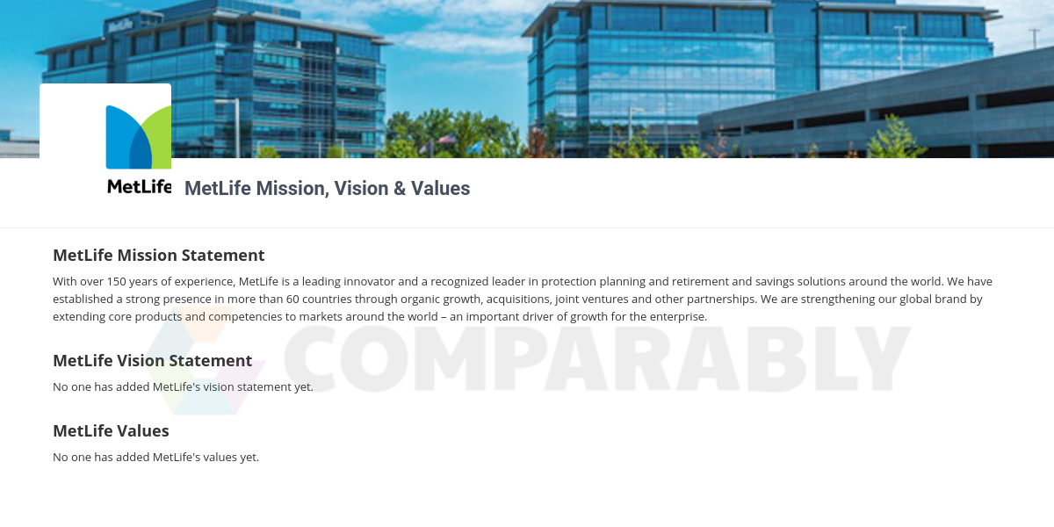

3.3 Product and Service Offerings by Metlife
Life Insurance
MetLife's life insurance products and services consist of term life insurance as well as different forms of permanent life insurance, such as insurance for whole life and final expenditure for the whole life. These programs differ depending on the length, coverage amounts provided, and the requirements for medical tests. The business also provides community life insurance, offered by employees consisting of term life, lifelong life, and compensation for having accidental death and dismemberment.
Dental
MetLife provides community dental insurance policies for individuals, staff, retirees, and their families for over 20 million individuals and provides dental plan management.
Disability
MetLife also offers disability products for individuals as well as employee and association groups who receive them through their employer. If an individual is not being able to work then there is individual disability income insurance that can replace a part of the lost income of that individual. MetLife also provides disability insurance for short and long terms for different groups.
Annuities
MetLife is one of the largest annuity providers in the world. According to Investment News (2010), MetLife achieved $22.4 billion in sales during 2009. The company also offers different kinds of annuities to the people, such as variable, deferred, and immediate annuities.
Auto and Home
MetLife Auto and Home is the brand name for the nine private insurance firms related to MetLife. Home insurance options from MetLife include homeowners' insurance, insurance for the condo, rental insurance, renters' insurance, and also the insurances for mobile homeowners. The MetLife home insurance plans available offer compensation for possessions or property damage from natural disasters or burglary and various legal costs incurred by accidents suffered on the property of a person.
Other products
Critical illness insurance also covers MetLife's goods. There are fee-based planning, planning for retirement, management of wealth and properties, residential and commercial mortgages are the financial services. The firm also offers healthcare, education, and non-profit agencies with retirement plans and other financial services.

3.4 Organizational structure of Metlife
The flat hierarchy of management is being maintained in MetLife Bangladesh where all departmental heads report to the General Manager and General Manager also has to report to the Chairman.

The list of departments is provided:

- Sales  - Underwriting  - General Services | - Policy Administration  - Takaful  - Claims | - Policy Administration  - Takaful  - Claims
- Medical Network  - Legal  - Ethics and Compliance | - business excellence  - Product and actuarial  - Agency Management | - internal audit  - government relations  - Communications
- Finance  - Branch Customer Services  - Operations | - Information Technology  - Employee Benefits  - risk management | - Call Center  - Human Resources  - Training  - Brand and Marketing

General Manager and first Line Reports
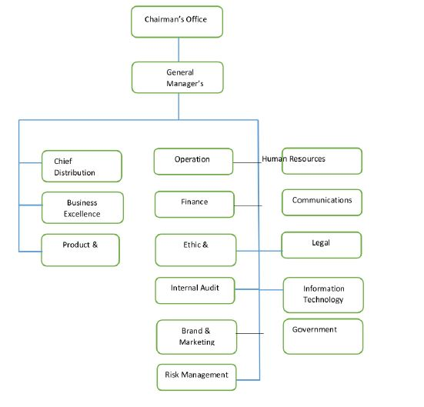

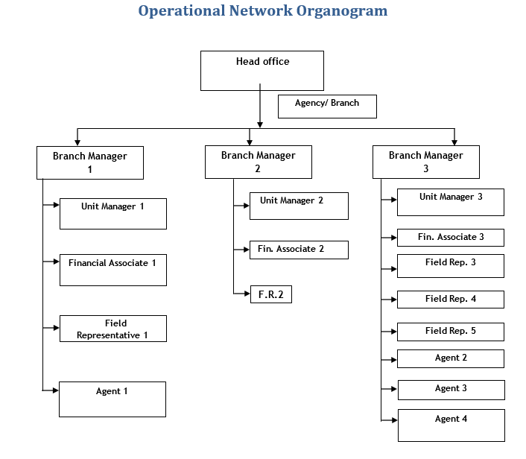
Here usually under one branch manager, there are 2 unit managers and under each unit manager, there are usually 20 financial associates.

CHAPTER 4
THEORETICAL ANALYSIS

4.1 Change management and recruitment system
Change management is the systematic approach in which dealing with organizational transition or enhancement occurs. There are also the requirements of changing the company objectives or procedures, as well as innovation needs that influence a change in the organization. The main goal of the change management is ultimately introducing effective methods to implement and monitor changes so that the workforce involved in the organization can sufficiently adapt to the new changes. There are formal protocols followed to shift requests, and responding to the requests for change. In all cases, change is a must for all organizations as they need to keep up with industry standards and changes being it operational, process, or otherwise helps firms like MetLife sustain in the market.
The overall process of change management must consider the improvement or replacement necessary, as well as the impacts they can have on the different procedures or structures and the employees. There is a necessity for enough preparation and testing phases for the changes to be successful. The process includes communication to the staff members, proper planning and introduction to the changes, and tracking methods for changes. Naturally, with the general unknowns of transition, we're uncomfortable, and even more so when we have a legitimate reason to be anxious about our ability to do our jobs well.
There are several different impact factors, can be caused by the change occurring within an organization, which are needed to be understood and explored. The factors include organizational processes, organizational structure, and systems, job roles, etc. The approaches are taken and the tools utilized to implement a definite change in the organization occur in the systems, structures, processes, and job roles of that organization. Ultimately the change is adopted in reacting to the specific organizational problems or even an opportunity, such as requirements of utilizing modern technology like Artificial Intelligence or AI to analyze customer data more effectively. The problems faced by the organization are based on the internal and external environment, which includes politics, environment, society, technology, economy, and legal factors in the external affecting matters. It is necessary for the current day and age that the organizations, like the company MetLife which has a multinational market to fulfill customer needs and demands, have to be more competitive as the industries are thriving and general consumers have more options to choose from. Another reason behind the change is the requirement of improved organizational efficiency, to develop productivity, fulfilling the service delivery quality needed along with the market needs.
The recruiters from the HRM department must be getting used to the new tool for the marketing solutions of recruitment and selecting viable candidates who are marketing professionals. It is also necessary for them to be innovative and exemplary. They can also gain important experiences during the transition periods. Companies like Metlife depend a lot on marketing tools to survive in the market especially in the Indian sub-continent and modern tools like social media marketing can help them reach a wider market and sell more insurance.
Certainly, change management is extremely hard as proper planning and understanding are necessary. However, change management inspires organizational realization of change, or the realization among the workforce regarding the changes needed, which enables personal and professional transition relatively easier. Thus the transition state of the change management is a very important part, which is also similar to the management, although management deals with the utilization of the knowledge, tools, and skills to achieve the tasks that fulfill the requirements of an employee. There are established processes for managing change, such as planning for change, managing change, and implementing change. The tools involved in the change management process are the individual model for change, communication aspects, coaching and training, management of the resistance to change, etc. Some examples of change management might look similar to project management, as they need both of the management to successfully achieve the goals. For example, the merging process of two organizations and the acquisition process of one organization by another requires the integration of the different systems, structures, processes, and job roles as well as the utilization of proper skills and techniques or tools to successfully meet the objectives of the merging or acquisition. Another example is the development of a new channel for sales, which directly impact organizational systems and job roles. Also, necessary project management is required for the new sales channel to be initiating, planning, executing, monitoring, controlling, and closing.
The relearning of the recruiters is also being observed in the recruitment process as they might have facing new tools or techniques. It is necessary to be using these new tools for enhancing the efficiency of the process. The recruitment manager plays an important part in this by providing directions to being adapted to the tools and familiarity with the new processes. For example, during the current ongoing pandemic, the recruiters are selecting candidates for their company utilizing digital mediums. These mediums and tools, such as video-sharing tools, might not be known to some recruiters for effective operation. The recruitment manager can help a lot in this regard. For example, he can indicate the ways to properly reporting the results or outcomes of the sessions.
It is imperative to understand the amount of change needed in an organization. For example, the disruptions created by the change to the individual's regular working aspect are measured along with the different value and cultural systems of the organization, as well as the historical changes to the organization for understanding the change requirements. To be able to change MetLife's employees by hiring new employees to the system, it is necessary that certain aspects like positive and negative impacts to the individuals and teams working are evaluated, so that the changes might not make the whole thing worse. Thus the communication factor is very important where the key messages are communicated to the employees by the change managers. The key messages include the requirements of change to the organization and the positive outcomes the change can bring. Also, the strong coalitions of the leading personnel are very much necessary.
The trickiest part of the planning and predicting in change management is the human elements of change, although being the crucial part of paying attention. However, there are different reasons as the recruitment process, which is new, might fail. In this regard, the recruitment has to put into practice the proper recruitment process that takes into consideration the attributes of the candidates and selects the right person for the right job.
Platform or Process Integration
Integrations are not just about how well the current stack fits with the new technology or process. It's all about how goodly it combines with the team’s daily activities. Integrations are therefore not solely a discussion with operations experts and technical managers; they also need to be shared with the end-users.
Think of the two ways to look at a new process: on the one hand, it can be seen as yet another job on the list of managers, a new method to log in every day and every week, or a new briefing system to put together. Not so attractive to your team, and also not attractive to anyone else.
If on the other hand, this latest approach either addresses current meetings or briefings or even removes the need for any of them, then it's all good news. The tool that plays nicely with the rest of the stack translates to greater exposure, a better holistic approach to the acquisition of talent, and the development of value to the entire enterprise.
This often links back to the human aspect. It is important to get buy-in and persuade people if they are not educated about it to follow a new way of life.
However, it does go a little deeper than that. It is related to how the whole company frames and perceives the transition, and it is influenced by how the team communicates about it and what data it shares.
Talk about why it matters to you or the team, and to the organization, and the applicants instead of talking about the steps of the process. Share examples of how the applicant's journey will improve because of the new process for the better. Communicate the early milestones and successes you have designed in the preparation for implementation. For each stakeholder, adjust to the optimal end state, not just for you.
And we mean by any stakeholder, individuals outside of the association, too. Explaining what will be different in this transformation to the marketing department early on, and will help you set up, for example, a new process for workplace branding campaigns. They might be unable in moving quickly and give you valuable support, of you wait until needing them to be brought in the process, and possibly not be motivated either.

4.2 METLIFE FA RECRUITMENT
Having a total of about 20000 sales force where about 10000 are involved and about 3000 sales force are super active from them, making most of our companies daily revenue.
As a result, we have provided them with CRM Next and we have provided them with TAB to run. To improve their capability and adaptability to the new platform, a member of the change management team still works with them every day.
As of this year, MetLife has taken the licenses to use the CRM next to the global edition to carry the good team to the digital platform to become the strongest. As MARS, the complete form goes with the recruitment solution for MetLife associates. It’s the first time our Corporate Excellence Team has taken our future sales force to MetLife in its history (Systems, 2021).
Recruitment Process (Until last year)
Recruitment is the process in which companies take in new workers to fill in the gaps and reach the company goals. Before the digitized version, the unit managers used to approach with the merits and demerits of being a financial associate to the people who are known to them as well as the unknown once as well.
Step 1
And when this potential candidate agrees to the terms and conditions then they are given 3 days of tremendous training or said to be 72 hours of training.
Step 2
NID cards and certificates are taken manually.
Step 3
Also, the 60000taka (ANP) policy is submitted to the unit manager manually approved by the Branch Manager.
Finally, they have to give viva to agency executives.
In this particular phase, the business excellence team noticed too many demerits, though they tried to take the proper advantage of the digitalized period.

They discovered downsides such as:
- Finding individuals manually and so many left in between has been very time-consuming.
- It is not easy for the candidates to arrive at the branch for 3 days consecutively as not every branch is to the candidates' nearest spot or they might have their problems so couldn't make 3 days practice.
- Candidates trust headquarters rather than the division, where the trust problem exists and makes them de-motivated. These make the unit managers demotivated and less connected to the candidates.

4.3 The reason behind the change
- According to a recent survey, the number of internet users in Bangladesh increased by 3.3 crores between 2010 and 2019, taking another 20% of the population online.
- Comparing to our neighboring country India has added 36.1 crore new users, or 26% of its population, over the same period, and Pakistan added 4.8 crore new users or 22% of its population. The study was released last week by the Grouped Special Mobile Association (GSMA), 'advancing digital societies in the Asia Pacific: a whole-of-government approach'. The group represents the interests of the world's operators of mobile networks.
- Data from the Bangladesh Telecommunication Regulatory Commission showed that the number of internet users in Bangladesh reached 11.11 crore in September, a 13 percent rise compared to the same time in 2019.
- In the last decade, Bangladesh has seen tremendous growth in the number of mobile internet subscribers," Mustafa Jabbar, minister of post and telecommunications, told The Daily Star yesterday. The 5G service is now available in the Asia Pacific region in more than 10 countries, including Australia, Japan, Singapore, South Korea, and Thailand, the study said.
- By 2025, six percent of all Bangladesh's mobile connections will become 5G subscribers, bringing the nation well below the Asia Pacific average of 23 percent, the report said. Bangladesh, however, did better than Vietnam and Indonesia, whereby 2025 the number of 5G users would be 5% of their active mobile connections. Last year, the BTRC formed a committee to prepare draft guidance on 5G services and originally intended to launch the facility by 2023. The Covid-19 pandemic, however, has caused all plans for several months to come to a halt.
- A separate GSMA study published in July reported that 4G would dominate the market in Bangladesh, with 46% of users in 2025.3G subscribers will account for 30 percent at the time, and 18 percent will still be wired to 2G. But only 10% of internet users had 4G access at the end of 2019, 40 percent had 3G, and the remaining users use it for calling purposes only.
- The pandemic has created some barriers to the expansion of local 4G networks, according to the Post and Telecommunications Minister.
- However, by March 2021, I can assure you that there will be no problem with 4G networks, “However, I can assure there will be no problem in 4G networks by March 2021,"
- The sharp rise in the number of users using the internet and social media showed a path for the business excellence team to take the privilege to grab this opportunity. This had a positive response while numbers gradually increased.
- The diagrams below show a brief of the whole part
Internet users in Bangladesh
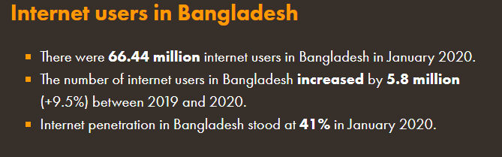

Mobile connections in Bangladesh
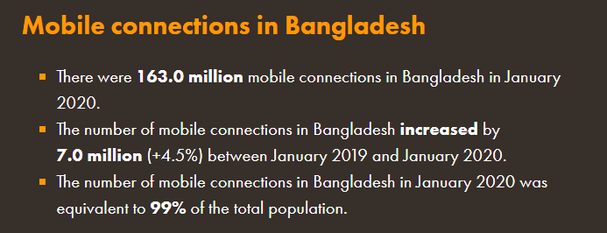
Social media users in Bangladesh
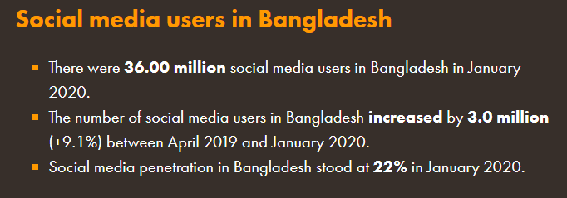

4.4 Numbers of the campaign
The campaigns have been started from late 2019 on a trial basis. After seeing tremendous success from the trial they started as a whole package.
Few are focused only on Facebook, whereas others are centered on various apps advertisement or news portals Instagram, etc
Till now there are two campaigns that our marketing team has focused vastly on named AD047 AND AD70 to AD082.
This advertisement required the candidates to put their name and phone number and a message to go to their phone number having our MARS website registration link.
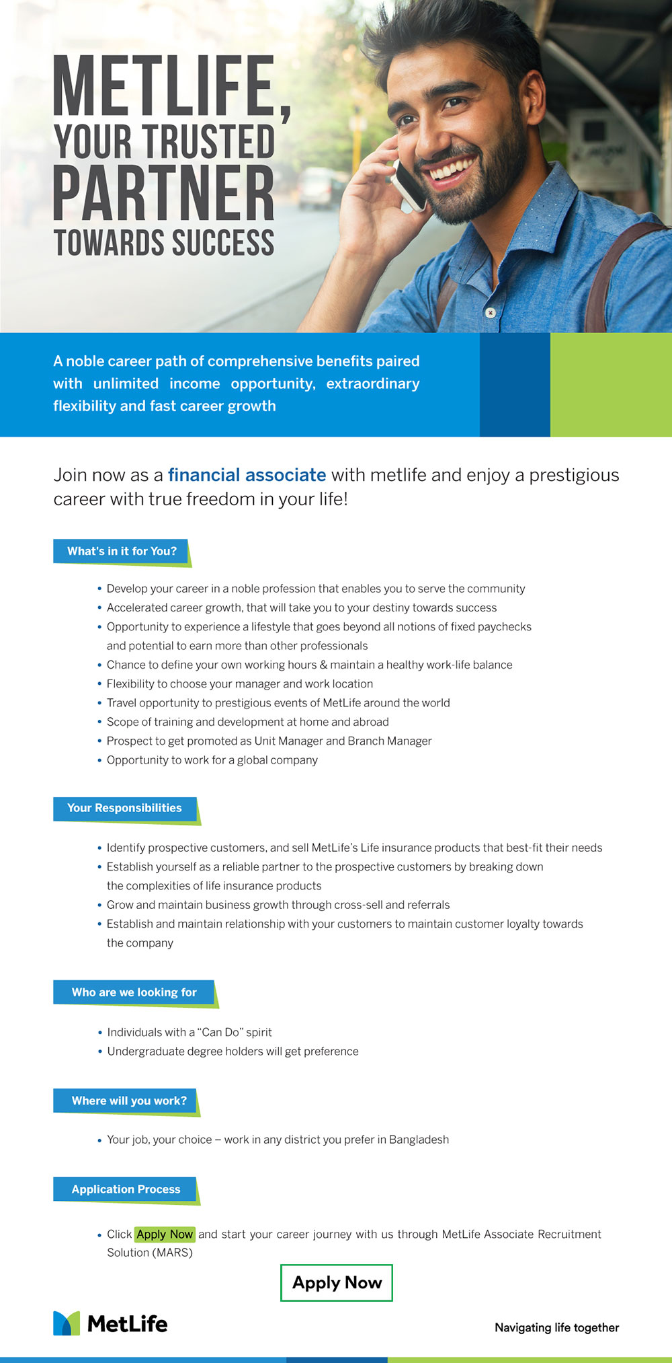
Figure: Recruitment for Metlife
Some lucrative offers given by MetLife to motivate the unit managers as well as their branch managers which are given below,
A Demo of The Recruitment Campaign 2020 that is run by the management:
Awards for New FA:
Waiver of Training Expense of Tk. 575 for all recruits if completed within the contest period.
- Of each FA during the period.
- Cash Bonus for Managers during August 16 - September 30, 2020:
- UM's will get Tk.1, 500 if 10 MARS candidates from his/her unit get enrolled and pass the exam during August 16 - September 30, 2020.
- UM's will get Tk.1, 000 for completing recruitment (BM viva/AE signature by September 302020) of each FA during the period.

Awards for Unit Managers (UM):
1. Gift Voucher:
UM's recruiting 04 (four) FAs during the full campaign period will qualify for a trip to Cox's Bazar by AC bus.
2. Trip to Phuket, Thailand
UM's recruiting 10 (ten) FAs during the full campaign period will qualify for a trip to Phuket,
Thailand.
Awards for Branch Managers (BMs)
- Trip to Cox’s Bazar (single by road):
Branch Managers will qualify for a trip to Cox's Bazar by AC bus if there are a total of 10 (ten) recruitments from the agency during the full campaign period.

- Trip to Cox’s Bazar (double by air):
Branch Managers will qualify for a trip to Cox's Bazar with a spouse by air if there are a total of 15
(fifteen) recruitments from the agency during the full campaign period.
- Trip to Phuket, Thailand
Branch Managers will qualify for a trip to Phuket, Thailand if there are a total of 20 (twenty) recruitments from the agency during the full campaign period.
- Trip to Phuket, Thailand + US$100.00
Branch Managers will qualify for a trip to Phuket, Thailand and US$100.00 (as miscellaneous
expense allowance) if there are a total of 25 (twenty-five) recruitments from the agency during
the full campaign period.
- If any BM fails to qualify as a BM, he/she may qualify for any award of UM by recruiting under self Unit.
For full campaign period awards, there will be an option for Gift Vouchers of a reputed company, and any UM; BM can opt for Gift Voucher of an equivalent amount instead of any award, it qualifies.
Terms and Conditions that are required to be fulfilled by the UM and BM to get all these opportunities are:
- FAs who already got code through MARS but could not complete required business for
recruitment will be considered recruited if complete all business &amp; other requirements within campaign period;
- All existing conditions for Financial Associate recruitment (minimum bachelor’s degree, necessary papers, etc.) will remain applicable.

- Self/ Spouse/ Children policies will not be considered for any manager’s reward.

- The last date for paying the license fee is December 24, 2020.

- All papers related to FA Training Program must be submitted to the Training department by January 15, 2021;
- All other requirements for recruitment must be submitted to the Agency Services Department by January 28, 2021;
- Signed agreement for all recruits must reach the Agency Services Department by February 15, 2021;
- FAs terminated in non-production criteria once may be recruited again with AE’s recommendation but “will not” be considered for any manager’s reward;
- Qualifier managers must remain in-force to his/her position at the time of rewards distribution;
- The second premium of monthly mode policies must be deposited within due time;
- FAs who completed ATP earlier but were not recruited don't need to do ATP again now. But they need to submit all training related papers to the Training Department by January 15, 2021;
- There will be 2 (two) months, January - February 2021, observation period. New FAs who will produce at least 01 life policy (submitted and paid) with Tk. 30,000 ANP during the observation period will only be considered recruited for managers' awards;
- MARS based candidates must submit businesses by December 24, 2020, and complete the BM interview by December 27, 2020.

4.5 Recruitment process (2020)
An applicant will now choose from 3 ways in which they can join us as financial partners.
#Regular: it's a phase in which a person comes from our MetLife website and knows for himself all the terms and conditions.
# Marketing: a person runs on multiple channels across our promotions that our marketing team runs.
# Manual: specifically picked by our supervisors, often personally understood by the unit managers, often carried by them.
In all, there are almost 15 processes that applicants have to go through are given below,
Registration: It reflects the number of prospective candidates who through different ad campaigns from different applications, sign up for our marketing platform. A candidate needs to have the name, email address, and phone number for this sign-up.
Then they receive a note of gratitude for being chosen for the MetLife recruiting scheme, while a connection is given to them to determine their eligibility in a small form.
Eligible: Eligibility is based on a few considerations, such as
    - The required standard of education is an HSC pass
    - Not representing either country or military service directly,
    - Had no interest in any political party,
    - And last but not least, the nominee would have been 20 years or older also less than 65 years,
Orphan: In this process, the applicant has to pick a manager from our MARS website from his unique position. Since Bangladesh has approximately 200 branches, applicants may select unit managers from their nearest venue.
Tag Pending; in this section, the manager still did not approve the candidate's appeal.
Tag Accepted: In this phase, the proposal is approved by the unit manager, who calls the confirmation candidate later in two days and asks him to complete the further process and come to the division.
Tag Rejected: There are different reasons why an applicant is rejected by the boss. Some are some applicants who believe they are not appropriate for the position because this is a commission-based job so they wanted a full-time pay job.
Candidates do not answer the call, but they are dismissed by the boss since they are unaware of their dedication during the tour.

Training Modules Started: Right after accepting the tag from candidates they asked the candidates to complete the training accepting the tag from applicants to understand the mechanism of the journey of the financial associate and about the organizations themselves.
These modules are types of video and it takes 3 days or more to get around 7 modules.
Exam Booked; the candidates fix a suitable period after the end of the training when deciding with the manager as the manager plays an important role through the process. The exam depends on the modules for the preparation.
Send ATP Application Form: This form is for applicants to fill in their NID card details and submit a 3-megabyte file of the NID.

Fieldwork Summary: Our Manager brings them with them to the field here so that they can learn the process when teaching the tips and tricks to the candidates
Upload Documents: Here are uploaded to their profile the educational certificates as well as MICR cheque from bank id or bank statement.

Send Reference Information: To this section 4 technical references should be added. And such entities are checked by our call center members.
BM Viva and AE interview: this is the last step in which the applicants take part in a short interview with our executive agent and branch manager if they are finalized and accepted at this stage.
Acknowledgment: whereas a candidate needs to download two pdf copies. One is a welcome letter and a rule book. Without the download of these two things, the process will not be completed.
Admin system
In this whole procedure, the HR admin system is the most essential platform for the management team who has total access to it whereas the team gets to see the real-time view of the financial associate’s journey. They provide support to change the password if needed which is known as an OTP issue also if any of their uploaded documents are rejected we get to see the full view of the whole document so that we have provided full support to the candidates.
A problem shared by the candidate if it is true that is verified by the system and later fixed by HR. The main report is generated from the admin system which is later presented to the head leaders of MetLife. By whom later decides the plans and procedures that need to be taken to improve better.

CHAPTER 5
FINDINGS AND RECOMMENDATION

5.1 Findings
MetLife has been operating for more than 150 years globally and in this period they have done well to become the no. 1 insurance company in the world and they have done so by reading the environment and adjusting their business process to it. Some important statements can be found based on the discussions and analysis. In this part these statements are discussed in parts include change obstacles and change benefits. They are necessary to know as to exploit the benefits to the change and work towards minimizing the obstacles of change. The change obstacles can later be reduced by applying change management processes.
Obstacles of changes
- Training has about 7 modules which require fast internet so it becomes such a lengthy process especially when the candidate is from the rural area it becomes tough for them as the recruits cannot be analyzed as thoroughly as well as they face so much buffering with the internet.
- There consists of so many different steps, that the HR team might face difficulty in managing their time which might result in employee dissatisfaction. Dissatisfied employees can later be very unhappy about the decision taken for having organizational change. There is a certain gap between the agency services with the sales force. Such as they have to wait too long and wait for the problem.
- There is a system bug that appears in every stage. The company software has to be updated continuously and slow internet in rural areas makes the job even harder. The company must employ technologies that are modern and have faster internet. There are different broadband solutions and mobile internet services available in the country which can be used in this aspect.
- Heavy documents can’t be uploaded and this means the papers have to be sent to the offices by post which can be time-consuming. Every document needs to be converted and then be uploaded and checked by the authority.
- Four people are required for their reference and the candidate wait for the call center to verify all those seems quite unnecessary and it makes the process lengthy. The company has to be bold about this and can make necessary adjustments according to the goal of achieving the most positive outcomes from this change management.
- So many unnecessary updates in the system make the system bulky and use a lot of resources. There are some modern tools and techniques which might help the organization in this regard.
- Requires a very strong password while registration and 60% of the time candidates do not get that process and the system does not accept their registration. The designing of the registration process needs to be easier as the people in our country are less educated than other modern developed world countries. That is why proper design is necessary where the candidates would be getting the most needed help. The help section where the various questions and answers can be included to educate the users.
- After submission of a policy as well as fieldwork the candidate has to wait for so long in the underwriting department. Where the process is lagged.
Bad Implementation

- Often in preparation for implementation, the team leaders of the new method don't commit enough. They put a few pieces of training on the team calendar and declare it done, and this is a shame because it is probably the easiest part to prepare for implementation in advance, particularly if you have a supplier to help you. Ensuring adoption within the team is in their best interest, so take advantage of that support.
- The team gives itself success chances by giving every step of the execution a simple timetable, deadlines, and smart goals. Again, it's not just about getting users to happen first and how step-change performance can be calculated.

Benefits of change
Digital presence
This is the most obvious gain, perhaps. The position on the Internet multiplies the reach of the business and distribution outlets through tools such as retail retailers, social networks, websites, corporate sites, etc. This presence is the focus of their online or digital approach with some firms, and they have also moved their industry from conventional ways to online trading, with all things matter.
New contact channels with customers
The digital footprint also opens up not just distribution platforms, but also modern methods of engaging with clients via Email, smartphones, social networks, etc. Today consumers of any organization with a digital identity have many means of reaching the company.
There are ways for revenue generation and consumer loyalty to be improved, but it also requires additional obligations. And this is why it takes doing things well to offer support to all these emerging contact networks.
- MARS was created to overcome the barriers that were faced before.
- Many more candidates are interested now so the probability increases that of MetLife having successful financial associates.
- So business numbers also significantly increased even though there has been a pandemic throughout the whole world.
- Recruitment and the business didn’t stop while the world stopped for 3 months. The MARs team continued to train them through the pandemic situation to overcome the situation. It improves efficiency and productivity
- The innovation is being encouraged because digital transformation forces fast to act and with the beginning of the movement, the inertia is harder to stop. The innovative skills and minds among the general employees would certainly influence the total number.

5.2 Recommendations
If the HR team may take some steps, the problems of the recruiting and selection process of MetLife Bangladesh can be more coordinated. Any suggestions are provided below that may help mitigate the recruiting process's problems.
- System bug should be resolved because it slows down the whole operation, which eventually brings a challenge to reaching an effective system target. Enabling the IT technicians in this regard can help a lot.
- As for the orphan candidates who go through so much confusion while choosing a manager, some do not even know that step. And according to a specific report generated showed that 40 % of the candidates leave from that stage. Which is worrisome. So they should automate this stage so they are immediately contacted by the managers.
- Our IT department should be enriched with more active holders of IT expertise. Various outsourcing companies would be happy to provide the skills and tools and technologies necessary to develop the IT expertise of the company.
- There are some modern tools and techniques which might help the organization in this regard. The big data management and Artificial Intelligence can be of big assistance as the big data would provide the efficiency of the bulky data management and the Artificial Intelligence would help analyze the overall system to determine which is important and which is not, resulting in the faster and effective transaction of system data
- Whereas they should depend less on our vendors so the cost would minimize and the time taken to fix a problem will take much lesser time. So if any problem appearing they can always back up and support other teams that require IT support. As given an example that now when any IT related problem faced by an HR, it is sent to the executives then it is passed on to the vendor. It is a totally week process of fixation.
- Training modules should be lessened while decreasing the number of videos would enable them to regain their motivation to move forward the steps and here our unit managers can play a big role. As they can train physically if needed when candidates scant support the internet.
- Reference section where instead of 4 persons they can put a maximum of two or one. Also, the change managers and leaders can choose to take none for the role.
- More training should be provided so the unit managers so can easily support any difficulties faced by our candidates. The training and coaching system should be properly planned and executed with SMART goals being set.
- Last but not least steps should be taken for the candidates to remain enthusiastic. The change managers are the communicators who would motivate the change to happen in the organization. Thus they need to learn the importance of motivating or influencing subordinates.
- Top leaders should aim to minimize the difference between the field force and the department operation to provide better service. So those with poor technology experience will quickly get their way around it.
By following these, the MetLife Bangladesh HR team can make their selection and recruitment process more standard.

5.3 Conclusion
In conclusion, we have developed the idea that insurance is a service industry. The innovative approach, need-based product, any suitable structure can be going up to the insurance business and the company earns a lot of business and goodwill. There are bright stars for the future development of insurance organizations.
Also, getting this huge opportunity of working for MetLife Bangladesh HR team, I have learned a lot about the corporate environment. The recruitment and selection process of the company MetLife Bangladesh has provided me to gather HR experiences. The guidance and directions I have been shown will be creating a greater impact on the career I choose in the future. This was surely a great pleasure for me to work with the team. I have learned the effective ways by which I can get perfect and eligible candidates for different positions in the process of recruitment and selection. The HR team has also guided me with the experiment and analysis process. I must say in the end that this project journey with MetLife Bangladesh will always remain in a special corner in my mind.

References

(2021). Retrieved 7 January 2021, from https://www.pmi.org/learning/library/metlife-pmo-deliver-clear-benefits-11053.
Auditing Recruitment and Selection Functions. (2017), 40(2), 5-6. https://doi.org/10.1002/mare.30246
Capital Changes Corporate Actions Daily. Wolterskluwer.com. (2021). Retrieved 7 January 2021, from https://www.wolterskluwer.com/en/solutions/corporate-actions-taxability-management/capital-changes-corporate-actions-daily.
Change Management Process Flowchart (MetLife). Gartner. (2021). Retrieved 7 January 2021, from https://www.gartner.com/en/documents/3889470/change-management-process-flowchart-metlife-.
Connerley, M., & Rynes, S. (2010). Does total quality management affect applicant perceptions of recruitment and selection processes?. Journal Of Quality Management, 1(2), 207-225. https://doi.org/10.1016/s1084-8568(96)90014-0
Decision Insights - MetLife's major changes. Bain. (2021). Retrieved 7 January 2021, from https://www.bain.com/insights/decision-insights-metlife-major-changes-business-spectator/.
Evans, R. (2009). SURVIVING THE SKILLS SHORTAGE: EQUAL OPPORTUNITIES IN RECRUITMENT AND SELECTION. Library Management, 12(2), 4-14. https://doi.org/10.1108/01435129110137237
Jain, A. (2015). How Recruitment Enables Firms to Change Their Expertise. Academy Of Management Proceedings, 2015(1), 14001. https://doi.org/10.5465/ambpp.2015.14001abstract
Marie Ryan, A., & Derous, E. (2016). Highlighting Tensions in Recruitment and Selection Research and Practice. International Journal Of Selection And Assessment, 24(1), 54-62. https://doi.org/10.1111/ijsa.12129
Metlife.com. (2021). Retrieved 7 January 2021, from https://www.metlife.com/content/dam/metlifecom/us/sustainability/pdf/data/policies-codes/environment/MetLife_Environmental_Policy_August_2020.pdf.
Recruitment and Selection Practices in Nigerian Institutions of Higher Learning. (2019). https://doi.org/10.7176/ejbm/11-30-15
Sayce, S., Weststar, J., & Verma, A. (2012). The recruitment and selection of pension trustees: an integrative approach. Human Resource Management Journal, 24(3), 307-322. https://doi.org/10.1111/1748-8583.12012
Systems, B. (2021). Blueprint | MetLife Case Study. Blueprintsys.com. Retrieved 7 January 2021, from https://www.blueprintsys.com/casestudy/metlife.
Technology, M. (2021). MetLife Centers Its Strategy on Digital Transformation. MIT Sloan Management Review. from https://sloanreview.mit.edu/article/metlife-centers-its-strategy-on-digital-transformation/.
The 10 Best Organizational Change Management Strategies. Online.champlain.edu. (2021). Retrieved 7 January 2021, from https://online.champlain.edu/blog/best-organizational-change-management-strategies.
W, C. (2016). Best Practices and Emerging Trends in Recruitment and Selection. Journal Of Entrepreneurship & Organization Management, 05(02). https://doi.org/10.4172/2169-026x.1000173
Wheatley, S. (2010). Making the Right Investment – Recruitment and Selection. Legal Information Management, 10(4), 279-282. https://doi.org/10.1017/s1472669610000940
Working as a Management Consultant at MetLife: Employee Reviews | Indeed.com. Indeed.com. (2021). from https://www.indeed.com/cmp/MetLife/reviews?fjobtitle=Management+Consultant.

Appendices

Candidate Profile

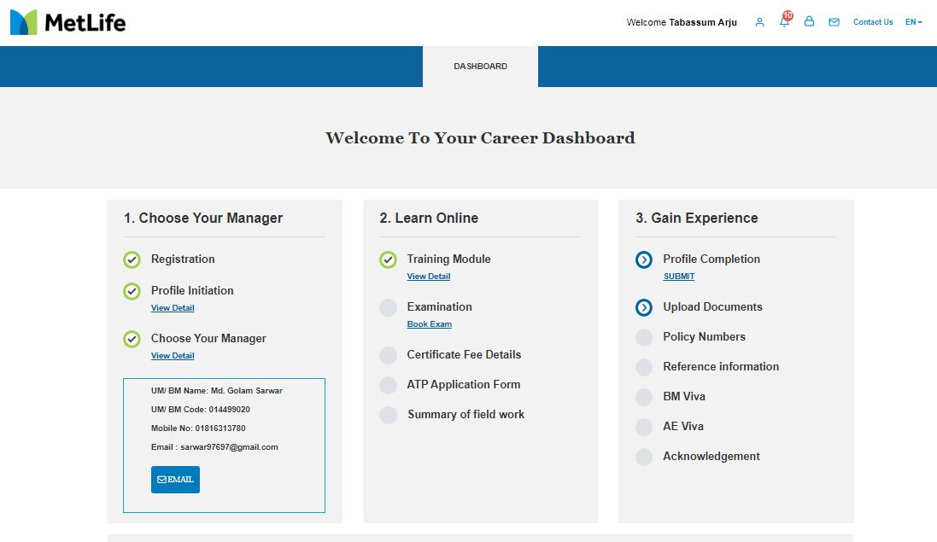

Stages and counts for the recruitment process for MetLife



