

A PROJECT REPORT ON

SAFETY AND MAINTENANCE ASPECTS: THE CASE OF GARMENTS INDUSTRY IN BANGLADESH

UNITED INTERNATIONAL UNIVERSITY
DHAKA, BANGLADESH
A PROJECT REPORT ON
SAFETY AND MAINTENANCE ASPECTS: THE CASE OF GARMENTS INDUSTRY IN BANGLADESH

SUPERVISED BY
NASRIN AKTER
ASSISTANT PROFESSOR
SCHOOL OF BUSINESS AND ECONOMICS
UNITED INTERNATIONAL UNIVERSITY

PREPARED BY
JAKIA TASLIM
ID: 111 151 494
BBA PROGRAM
UNITED INTERNATIONAL UNIVERSITY

DATE OF SUBMISSION
9th June, 2020
UNITED INTERNATIONAL UNIVERSITY
Letter of Transmittal

To
Nasrin Akter
Assistant Professor
School of Business and Economics
United International University
Subject: Submission of project report.
Dear Madam,
You will be glad to know that I have recently completed my survey on 120 garments workers and based on the survey findings I have prepared my project report on “Safety and maintenance aspects: the case of the garment industry in Bangladesh”.
We know that the garments industry of Bangladesh, that started its journey in last three decades ago, has become the largest contributor (about 84%) of Bangladesh economy in FY18. Bangladesh is now the world's leading garment exporter, second only to China and its garment industry employs 6.6 million workers in a population of over 1.5 million. Thousands of factories in the country are mostly concentrated around the capital Dhaka city and thousands of rural residents are looking for work and family life. In recent years, as the industry has grown so large, safety concerns have also affected foreign buyers due to frequent accidents and worker deaths. Most have studied climate protection in various manufacturing industries in western countries, but little is known about the clothing industry produced in developing countries such as Bangladesh. Therefore, the study have been prepared to measure & analyse the safety and maintenance of Bangladesh garments.
I also want to emphasize that the report has been prepared following the report format and without any information being copied or inserted directly from another source. In addition, all information used in the report is valid and relevant to the title.
Therefore, if you firmly accept and are satisfied with my report on the project, it would be highly appreciated.
Your most obedient student,
Jakia Taslim
ID: 111 151 494
BBA Program
United International University
Acknowledgement

At the beginning of this report, I want to thank my "Almighty Allah" for the blessings and skills through what I have completed my four years of BBA (Bachelor of Business Administration) courses at United International University. I also want to mention my parents here for having supported me, financially and motivationally, to continue my path accordingly.

I want to thank my project supervisor and my honourable course professor Nasrin Akter, Assistant Professor, School of Business and Economics (SoBE), United International University, for all the encouragement and sharing the precious time during this three-month project program. The format of the report, which I had received from her, was very useful for me to understand how to present a project report and encourage me to start part by part.

I would like to thank Amana Knitex Limited, Century Apparels and Rahman Knit Garments for collaborating with me as I collected information on worker surveys. I am very grateful and appreciate the effort of the workers to answer my questions from the busy schedule.

Finally, I want to thank all my classmates, friends and relatives for helping me every time, I have encountered difficulties during the period of my life in BBA.

Executive Summary

The garment industry in Bangladesh, in fact, is the livelihood of the urban and rural poor, as it is the only large sector that requires labor and therefore offers enormous job opportunities. Half of the population of Bangladesh still depends on agriculture and faces the worst poverty. Although the service sector is developing rapidly in Bangladesh and contributes 50% of the national GDP, its contribution to employment is only 34.6%. Although the garment industry has achieved impressive results, there are still several serious problems in this sector, such as poor working conditions in factories and a lack of social and environmental responsibility. The recent massacres of the fire in Tazreen Fashions (2012) and the collapse of Rana Plaza (2013) reflect unknown stories about safety and working conditions in the garment sector in Bangladesh. It has recently raised serious concerns when these fatal disasters have left thousands of people dead and created skepticism about national and international stakeholders such as manufacturers, governments, employers' associations, home buyers, unions. The study aims to clarify the current situation regarding the safety and maintenance of workers in the clothing sector. To assess the scenario, 120 workers from three renowned garments in Bangladesh are randomly selected to participate in a survey that highlights worker safety and awareness among the three garments. Furthermore, the study is being prepared to encourage all companies working in the RMG sector in Bangladesh to implement the establishment and safety and maintenance policies so that Bangladesh never faces any deprivation in the workplace regarding safety and maintenance for poor workers who really have a great contribution to the current economy of Bangladesh.

Table of Summary

Chapter One: Introduction
1.1 Background of the study 2
1.2 Scope of the study 2
1.3 Objectives of the study 3
1.3.1 General Objectives 3
1.3.2 Specific Objectives 3
1.4 Methodologies of the study 3
1.4.1 Study Method 3
1.4.2 Data Type 4
1.4.3 Data Collection Procedures 4
1.4.4 Sample Size 4
1.4.5 Presentation Method 5
1.5 Study Limitations 5

Chapter Two: Literature Review
2.1 Safety and Maintenance 7
2.2 Ways to improve Safety and Maintenance in workplace 7
2.3 Safety and Maintenance on Garments Industry 8
2.3 Safety and maintenance policy in Bangladesh 9

Chapter Three: Organizational Profile
3.1 Profile of Amana Knitex Limited 13
3.1.1 The Mission of Amana Knitex Limited 13
3.1.2 The Vision of Amana Knitex Limited 13
3.2 Profile of Century Apparels Limited 13
3.2.1 The mission of Century Apparels Ltd. 14
3.2.2 The vision of Century Apparels Ltd. 14
3.3 Profile of Rahman Knit Garments 14
3.3.1 The Mission of Rahman Knit Garments Limited 14
3.3.2 The Vision of Rahman Knit Garments Limited 14

Chapter Four: Findings and Analysis
4. Analysis of Safety and maintenance aspects of garment industry in Bangladesh 16

Chapter Five: Recommendations and Conclusion
5.1 Recommendations 33
5.2 Conclusion 35
Reference
Appendix- Survey Questionnaire

Chapter One

Introduction

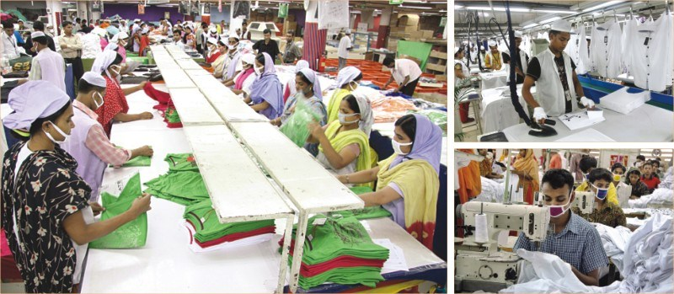

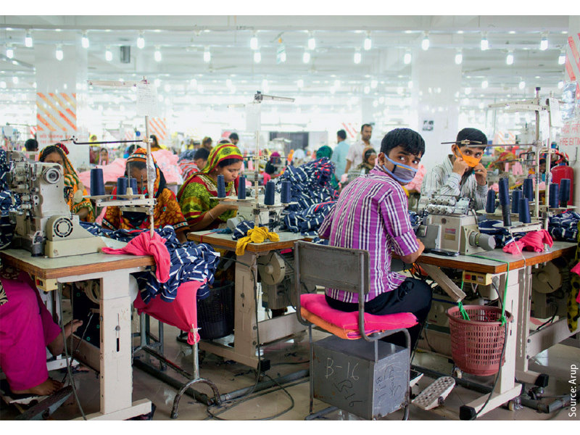

1.1 Background of the study
The study was conducted as it is a prerequisite to complete the BBA program at the United International University. Each student in the BBA program must complete their degree through the process of preparing an internship report or project / thesis paper. In an internship program, students must join an organization as an intern and work there for three months. The student must prepare an internship report during this internship based on their field of study and organization, as well as their job responsibilities. On the other hand, the project or thesis program offers students a wide range of opportunities to apply their knowledge in a sector or company without joining the company as interns. At this stage, students must observe, collect information from primary and secondary sources to meet their study requirements. For all of these project program benefits, I chose to work within the project program and selected my project title "Safety and maintenance aspects: the case of the garment industry in Bangladesh".

1.2 Scope of the study
The RMG industry, acts as a promoter of Bangladesh's prosperity, has made a contribution to the reconstruction of the country and its economy which it is now the main export source for Bangladesh. Textile and clothing represents around 84% of export earnings of Bangladesh, 76% of which come from the clothing and garments sector. It is often informed the sector will lag behind because of proper environmental policy, workers safety and maintenance facilities. Therefore, it could be a great collapse for the growing economy of Bangladesh if we don’t provide attention on several sides of this Ready-made Garments (RMG) sector. This study will be very productive and useful for any RMG manufacturer to guarantee a safe environment and guaranteed maintenance within their organization by establishing an adequate safety and maintenance plan. Not only will this report encourage formal guidelines for developing the safety and maintenance policy, but it also will help manufacturers to understand the need for the policy. The report was prepared by observing unforeseen events in the past, such as the Tazrin fire, the Rana Plaza collapse which helps clothing manufacturers discover the type of loss in previous clothing relationships that occurred in due to lack of safety and maintenance policies. The survey and results all help to understand the safety and maintenance scenario of the garment industry in Bangladesh.

1.3 Objectives of the study
The purpose of preparing the report are listed below in two parts:

1.3.1 General Objectives
- To apply the theoretical knowledge into the practical scenario;
- To share the survey findings to portray the real picture of safety and maintenance of Bangladeshi garments;
- To prepare the project report as it is a pre-requirement of achieving the BBA degree from United International University.

1.3.2 Specific Objectives
- To describe the RMG industry of Bangladesh and its contribution to the economy;
- To analyse the safety and maintenance issues;
- To analyse the scenario of safety and maintenance through the survey findings of three reputed garments of Bangladesh;
- To suggest recommendations for the improvement of safety and maintenance in garments of Bangladesh.

1.4 Methodologies of the study
According to Brown (2006), "methodology is the philosophical framework or foundation methods of a study. In this part of the study methodology, I will focus on the research methods, data selection and presentation, and designs that have been used throughout the study and have justified the rationale I chose to describe the pros and cons of each method and design that actually applies to the study.

1.4.1 Study Method
The study method is followed by exploratory research techniques that usually based on a discussion of a situation that is not commonly discussed in previous. Exploratory research is "a preliminary study that clarifies the exact nature of the problem to be solved". It is used to ensure that other research is taken into account during the experiment, as well as to establish research priorities, collect data and refine certain topics that may be difficult to detect without exploratory research. It can include the following technologies:

- Secondary research, such as literature review and/or available data
- Formal qualitative research through focus groups, in-depth interviews, pilot/case studies.
- Informal qualitative methods, such as discussions with employees, managers, consumers, or competitors.
Exploratory research can add quality and knowledge to research that is essential for research. It allows researchers to be creative to gain maximum understanding of a topic. This study will, therefore, be conducted with an external audience, so this is a great opportunity to learn what works or what doesn't. Third, it provides a better understanding of the researcher’s objectives during the project. Taking all this information into consideration, the study has been prepared in the exploratory research technique.

1.4.2 Data Type
The Study contains mostly qualitative data and according to the requirement of the study topic quantitative data are also used. Here,
The Qualitative data describes quality or characteristics. It is collected through questionnaires, interviews, or observations and usually appears in narrative form.
The Quantitative data are used when investigators try to quantify the problem or solve the "what" or "how much" of the research question. These are data that can be counted or compared on a digital scale.

1.4.3 Data Collection Procedures
Data has been collected from two sources. The sources are described below:

a. Primary Sources:
- From formal and informal communication with the garments executives.
- Though survey questionnaire to collect information from the 120 garments workers.
- From self-observation of safety and maintenance of the three garments.

b. Secondary sources:
- From several published books and articles.
- From newspaper such as Dailystar articles.
- From internet blogs of several economic and garments observer of Bangladesh.

1.4.4 Sample Size
The report has been prepared by surveying 120 workers who are selected randomly from three reputed garments and each of the garments 40 respondents were selected randomly to collect their opinion on safety and maintenance of their garments. A printed Google forms based questionnaire were served to them translated in Bengali so that they can understand each question and mark into the options that fit best to their opinion. Then, the opinion were transferred into Google forms again so that I can receive the automated spreadsheet prepared by Google forms. Later, based on the Google spreadsheets findings I have given them a graphical presentation through pie charts and bar charts to help the readers of the report to understand the findings easily.

1.4.5 Presentation Method
The responses of 120 workers from 3 reputed garments of Bangladesh are presented in the study through graphical research techniques that have used pie charts and bar charts to show their opinion as a percentage form. It will help the readers of the study to compare and understand the findings very easily.

1.5 Study Limitations
- Due to time and resource constraints, most of this report is based on secondary data collected from various home electronic magazines.
- If the worker's sample size and garments number are larger, for instance, workers sample size 5000-10000 from at least 20 garments the search results will be more precise. Limited access and short time frame due to technical limitations that are limited the study into three garment factories.
- Due to time constraints, the process involves a large number of people, so determine where to collect the information. Researchers also cannot interview many important people due to inaccessibility, such as owners, administrators or presidents.
- Taking photos is prohibited in most areas of the place as they have the potential to be part of the secrets of each item of clothing. Confidentiality restrictions limit the ability of researchers to collect and analyse much of the data.
- One of the main limitations of reporting is confidentiality. Gathering information is particularly difficult since most of it is focused on clothing and cannot be cited in reports.
- These garments were re-inspected on January 23, 2020. If there is a change in the factory production process after this date, it will not be merged here.

Chapter Two

Literature Review
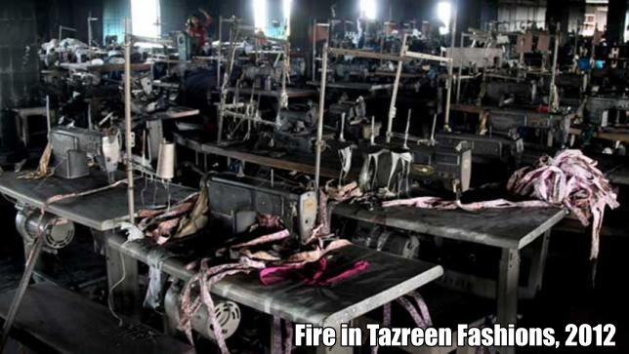
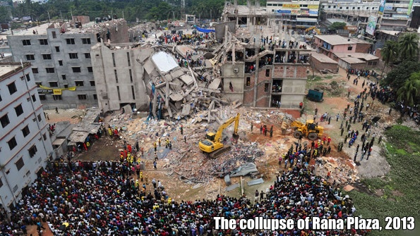

2.1 Safety and Maintenance
Worker safety refers to providing a safe environment, safe equipment, and safety procedures in the workplace to ensure the health and safety of workers. Although organizations have a moral obligation to ensure worker safety, hazardous workplaces can also have serious legal and financial consequences for employers. Worker safety can also be referred to as worker security or occupational health and safety.

At the same time, all workplaces perform some form of maintenance work on their premises. This includes maintenance of all types of equipment, buildings, and transportation. There are two types of maintenance work. These are routine-wise or preventive maintenance tasks that are usually planned and required to ensure that everything is working properly and corrective maintenance in the event of problems or failures. Therefore, maintenance covers a wide range of activities including repair, maintenance, replacement, inspection, and testing.

In addition, maintenance is a high-risk activity with specific risks and risks, including parallel to continuous processes and close contact with machines. In normal operation, automation often reduces the possibility of human error that could cause an accident. In maintenance activities, unlike normal operations, direct contact between the worker and the machine cannot be significantly reduced: maintenance refers to activities in which workers must be in close contact with the process. It usually involves abnormal work, unconventional tasks, and is usually performed under special conditions, such as working in confined spaces.

2.2 Ways to improve Safety and Maintenance in workplace
Workplaces are often complex environments with competing and conflicting needs. This can hinder the safety of workers. However, an organization that maintains a good health and safety environment for employees can improve employee morale and efficiency, and ultimately contribute to the growth and profitability of the organization. Occupational safety can be guaranteed in the following ways:
- Create a safe work environment, safe equipment, and safe procedures to limit threats to workers' health and safety.
- Provide workers with appropriate personal protective equipment.
- Provide training and safety guidance to workers.
- Establish appropriate safety oversight.
- Ensure that working hours do not harm the safety and health of workers.
- Ensure that workers do not experience extreme mental and physical fatigue.
- In addition to these obligations, employers must also comply with the organization's safety policies and procedures and use safety equipment appropriately.

2.3 Safety and Maintenance on Garments Industry
With population growth and rapid industrialization, safety and maintenance have become a major concern. According to ILO data, there are 317 million accidents in the workplace each year and more than 2.3 million people die from accidents at work. Unqualified work safety practices can be attributed to the annual economic burden which represents 4% of the world's gross domestic product (GDP) (ILO, 2017). Research has recognized the importance of safety interventions to ensure safety in the workplace and reduce accident rates (Locke et al., 2007; Cohen, 2013). Most countries address workplace safety issues in two ways by setting up safety associations and developing safety laws and regulations. In the United States, the establishment of the Occupational Safety and Health Association (OSHA) has resulted in a reduction of over 65% in deaths and accidents at work (OSHA, 2016). After the end of the First World War, with the development of social and labor movements, the International Labor Organization (ILO) was established in 1919. Japan passed the Industrial Health and Safety Act (ISHL) in 1972. , which significantly reduced the number of deaths from work in the country (Reich and Frumkin, 1988). China is the fifth largest trading nation in the world and often suffers from industrial risks. The Chinese government has approved the Occupational Safety Act (2002), which focuses on factory safety management systems, training content and routine inspections of manufacturing activities (Walker, 2015). The European Union (EU) directive establishes the minimum requirements to ensure safety and health at work and the Member States must comply with these standards by implementing national regulations. The International Labor Organization works with governments, employers and representatives in 187 Member States to ensure safe and dignified work for men and women (ILO, 2017). Bangladesh has been an active member of the International Labor Organization since 22 June 1972 and has ratified 35 ILO conventions, including 7 fundamental conventions (ILO, 2017).

The workplace safety and maintenance conditions in RMG factories in Bangladesh have been poor because most factories do not comply with labor laws and international labor standards (Ahamed, 2012). The RMG sector is the largest export industry in Bangladesh and has experienced phenomenal growth in the past 25 years. The sector contributed 75% of foreign currency earnings and accounted for 13% of Bangladesh's GDP growth (Firoz, 2011). Despite the remarkable results achieved by remittance income and job creation, the sector suffered the worst industrial accident in history. One of the deadliest incidents involved a fire at Tazreen Fashions in Ashulia, Dhaka, on November 24, 2012, which killed 111 workers and injured more than 300 workers (Chowdhury and Tanim, 2016). Since the Tazreen fashion factory fire, there have been at least 142 fires at the RMG factory in April 2017, killing 1,148 workers (Centro de Solidaridad, 2017). The collapse of Rana Plaza in 2013 is considered one of the deadliest accidental structural failures in history and has raised concerns about job security around the world in Bangladesh (ILO, 2016). The building collapsed on April 24, 2013 due to poor structure, killing 1,129 people and injuring around 2,500 (Alam and Hossain, 2013; Butler and Hammadi, 2013). Failure to comply with safety issues in the workplace is considered the main cause of their failure (Ansary and Barua, 2015).

In spite of the tremendous growth of the Bangladesh RMG sector, the capacity of regulators, especially the labor inspection sector, has not grown at the same rate. The Department of Inspection for Factories and Establishments (DIFE) was established in 1972 to enforce the country's labor laws. However, DIFE has limited manpower, infrastructure, and logistical support and cannot meet the needs of many factories and business organizations (GoB, 2016). Major industrial accidents, such as the collapse of Rana Plaza and the burning of Tazreen, reflected the need for a complete restructuring of the Bangladesh labor inspection system (GoB, 2015). In this context, DIFE was extensively updated in 2014. Later, Accord and Alliance were also established improve workplace safety. The Accord is an independent and legally binding agreement between brands and unions to work towards a safe and healthy textile and clothing industry in Bangladesh where no worker should fear fire, building collapse or other accidents that could be prevented with reasonable health and safety measures.

2.3 Safety and maintenance policy in Bangladesh
The Bangladesh garment industry (RMG) has become the backbone of the Bangladesh economy, accounted for 80% of the country's total exports. It is now the world's second-largest clothing exporter, and its clothing exports in 2011 exceeded $17 billion. The garments industry has flourished and the number of garments factories engaged in the production of clothing has grown rapidly in recent years. Currently, there are around 4,000 or 5,000 garment factories in Bangladesh, ranging from large leading suppliers to small factories, mainly as subcontractors and large customers.

The industry is characterized by low cost and rapid production, depending on labor and low-cost production costs to compete with its competitors. The garment industry in Bangladesh employs over 3 million workers, most of whom are young women and still the highest-paid garment workers in the world. Lack of alternative work options, coupled with the prevalence of poverty, means that these women are forced to accept low-paying jobs and perform them in workplaces that do not meet the most basic safety standards.

The rapid development of the industry has led to the conversion of many buildings constructed for other purposes, often without authorization, into factories. Others have added additional programs or increased manpower and machinery to levels beyond safety. In order to achieve production targets, many factories operate 24 hours a day; the process of building a factory or converting another building to a ready-made factory is usually done as quickly and as economically as possible. Things are unstable, escape routes are inadequate, and equipment is unsafe.

When the Spectrum factory closed to buy clothes like Karstadt Quelle and Inditex, In April 2005, 64 workers were killed and 80 injured. The incident focused on the poor security of the department, which generally employs more than 3 million workers in buildings that are not suitable for this purpose. Although the specter tragedy has raised concerns about safety concerns in the global clothing industry, nothing seems to have been done to encourage factory owners or governments to take the systemic measures necessary to improve worker safety. Clothes in Bangladesh. As a result, more workers are killed or killed each year.

From the time when the spectrum collapsed, the Clean Clothing Movement (CCC) has worked with unions, local and international NGOs to fight for workers' rights, and the International Textile, Garments and Leather Workers Federation (ITGLWF), which invited workers to be affected by this justice and their families. Factory disaster. This includes campaigns targeting specific cases involving fires, collapses, and trampling that have caused unnecessary death and injury to clothing workers. The CCC also supports calls for broader change in the industry, calling on employers, brands, and retailers, and the government of Bangladesh to take action to prevent further tragedies. To date, each campaign has focused on protecting and respecting the rights of Bangladeshi workers in safe workplaces and the need to injure or kill workers as a result of security and maintenance incidents.

Currently Bangladesh government is giving high priority and providing strict rules and regulation to improve workers safety and maintenance. After Rana Plaza collapse, Accord and Alliance have been established. The Accord was established to provide a safe working environment where workers don't have to worry about building collapse, fire, or other accidents that can be prevented with reasonable health and safety measures. It is an independent, legally binding agreement between the brand and the factories, designed to provide safe and healthy work for Bangladesh's clothing and textile industry. The agreement covers factories that produce ready-made garments (RMG), as well as home textiles and fabrics and knitting accessories selected by the signing company. And Alliance, Bangladesh Workers Safety, is a legally binding five-year commitment to improve the safety of Bangladesh garment factories (RMG). It was organized by a bipartisan political centre in 2013 and was convened and chaired by former Senate majority leader George Mitchell (D-ME) and former U.S. Senator Olympia Snow (R-ME). Organizations create consensus-based solutions. The collaborative process involves clothing companies and stakeholders, including the governments of the United States and Bangladesh, policymakers, NGOs, members of civil society and trade unions.
Chapter Three

Organizational Profile

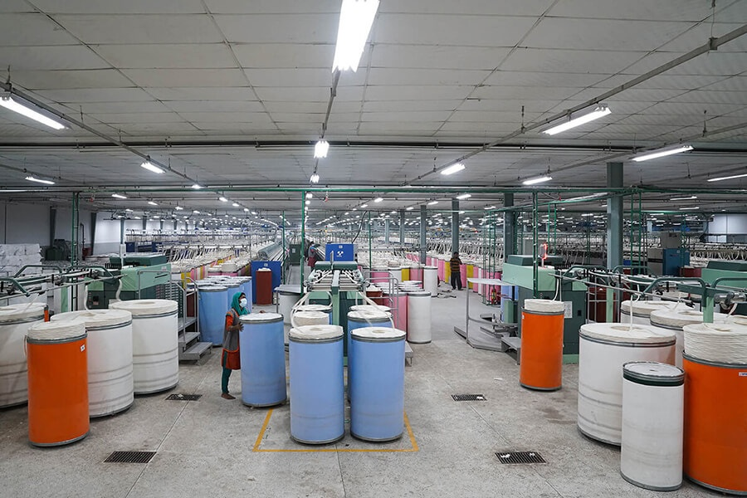



3.1 Profile of Amana Knitex Limited
Amana Knitex Limited started its trip to Bangladesh in 1996 with few machines and human resources and started exporting in 1997. It is located in the city of Narayanganj, just 35 km from Dhaka International Airport. From the start, Amana has maintained a constancy in the production of knitted garments of 100% exportable quality. In addition, its productivity increases at a rate of growth while maintaining all the standards of a compliance factory.

During its ten years of activity, Amana has perfected its quality control system, which includes scrupulous controls to ensure flawless production. The team of quality control experts also extends its operations to the supply of raw materials and machinery. Amana has continuously restructured this system and now has a unique ability in terms of touch-ups and low repair rates in the industry. Amana always follows the best AQL requirements of its customers to guarantee quality clothing. The Amana quality support team (QA) leaves no room for errors and can quickly guarantee its customers superior product quality. Amana Knitex Ltd has received the Oeko-Tex 100 standard, Business Social Compliance Initiative, ACS Registrars Quality Assurance. ISO 9001 certificates, therefore, appeared as a customer-oriented and compliant organization.

3.1.1 The Mission of Amana Knitex Limited
The mission of Amana Knitex Ltd is to produce quality clothing while ensuring all the prerequisites of the buyer.

3.1.2 The Vision of Amana Knitex Limited
Amana Knitex Ltd.’s vision is to be the best garment manufacturing industry in this region.

3.2 Profile of Century Apparels Limited
Century Apparels Ltd began its journey to Bangladesh in 2000. The chairman of Century Apparels is Shahina Afroze Hossain and Iftekhar Hossain Salim is the managing director. The factory of Century Apparels Ltd is located at Majdair, Fatullah, Narayangong, - 1400, Bangladesh. Since year 2000, the company has gradually made great strides in terms of quality, commitment, social and environmental responsibilities, which has made the company a garments manufacturer's reputation and a Bangladeshi knitwear exporter. In addition, the success of the production of Century Apparel clothing depends on the decisions of senior management experts, as well as the performance of mid-level management and the total number of workers. In addition, senior management at Century Apparels has skills and experience in the Bangladesh apparel industry.

3.2.1 The mission of Century Apparels Ltd.
To provide the best quality services to its competitors, Century Apparels Limited will devote itself to its management skills, skilled workers, safe factory environment, social compliance, and environmental responsibility.

3.2.2 The vision of Century Apparels Ltd.
To be the best for total customer satisfaction by providing quality products with standardized services.

3.3 Profile of Rahman Knit Garments
Rahman Knit Garments (RKG) Ltd. is a clothing and fashion company based in Hariharpara, Panchabati, Narayanganj, Dhaka, Bangladesh. Among the total number of workers working here, 587 men and 384 women. RKG offers different types of knitting, dyeing, cutting, sewing and finishing machines, mainly supplied by Italy, Belgium, Spain, France, Taiwan, the United States, the United Kingdom, China, Norway, etc. All chemicals and dyes used for dyeing and finishing are well marked. They manufacture their products for their buyers and customers who come from international markets such as France, the United Kingdom, the EU, the United States and Germany. Their customer profile is good and high-end like Seacotex Group, K-mart, Solo, B&C, Madonna, Tommy, JJB Sports, Isarporta, Marks & Spencer, Reitman's, Tom Tailor, Kappa, etc. It has an average production where tons of packaging and dyed and finished yarn fabrics are produced daily. The production is controlled by technical personnel. The entire production factor decision is made by highly qualified textile graduates. The company first started its industrial training in 2015.

3.3.1 The Mission of Rahman Knit Garments Limited
To increase productivity, efficiency, and product value through human resource development, research, and development of new strategies and innovations while providing world-class service to customers.

3.3.2 The Vision of Rahman Knit Garments Limited
Rahman Knit Garments will always endeavour to continue its position as a world leader in high-quality clothing. Driven by the desire to support its customers, the company aspires to meet and exceed its expectations through continuous innovation and creativity, remaining faithful to universal social and environmental ideals.
Chapter Four

Findings and Analysis

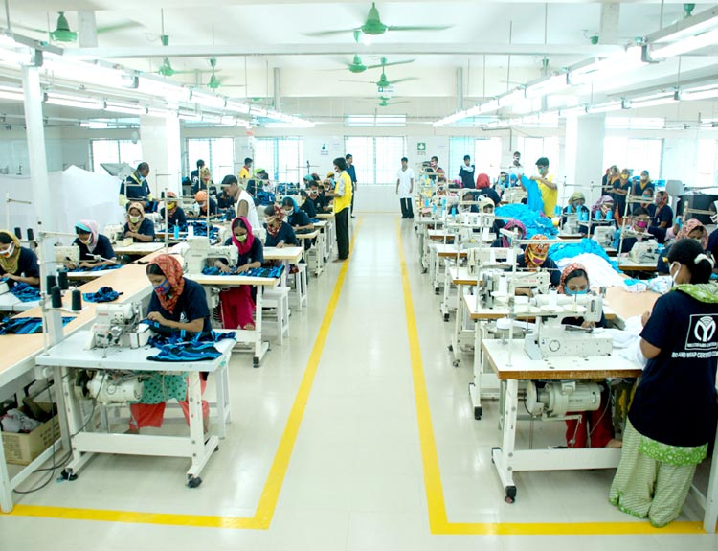
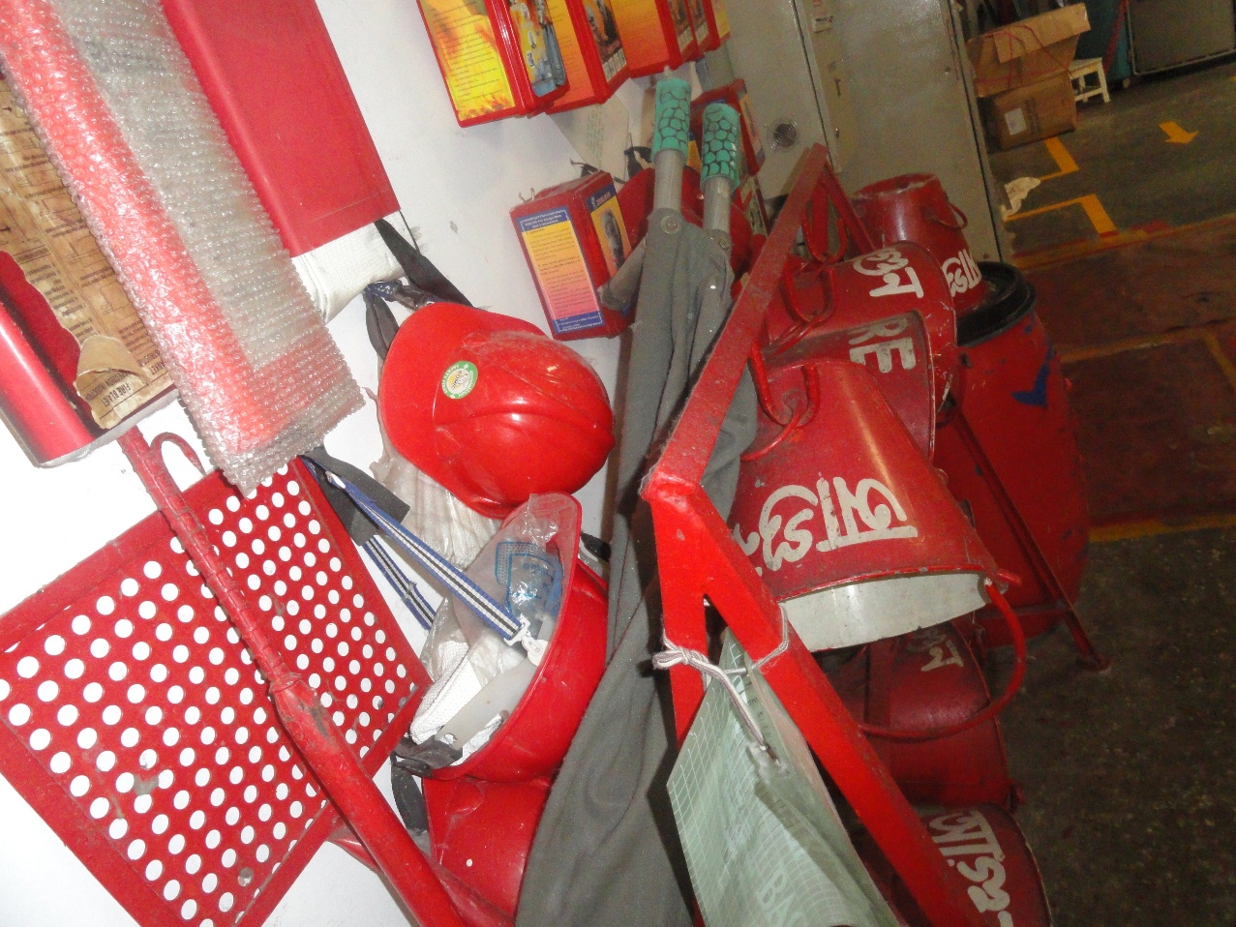

4. Analysis of Safety and maintenance aspects of garment industry in Bangladesh
To analyse the safety and maintenance aspects of garment industry in Bangladesh a survey questionnaire were prepared on three reputed garments of Bangladesh such as Amana Knitex Limited, Century Apparels Limited, and Rahman Knit Limited. Total 120 respondents were randomly selected from the three consecutive garments and 40 respondents from each. The demographic, educational and skills based findings after collecting responses are listed below in the chart 1:
Gender | 55% are female | 45% are male
Age | 45% are between 24-29 | 33.3% are between 18-23 | 15.8% are between 30-35
Experience | 50.4% have 1-3 years | 37.8% have 3-6 years | 10.9% have 6-8 years
Income | 81.7% earns BDT 8000-12000 | 15% earns BDT 12001-16000 | 4% earns BDT 16001-20000
Institutions | 40 respondents from Amana Knitex Ltd | 40 respondents from Century Apparels Ltd | 40 respondents from Rahman Knit Garments
Education Level | 86.7% have Secondary level education | 5% have class 4 level education | 4% have class six level education
Chart 1: Demographic, educational and skills of workers

As respondents were randomly selected, there were several types of designation holding workers are there who respond in the survey. The designations are listed below in the bar chart.
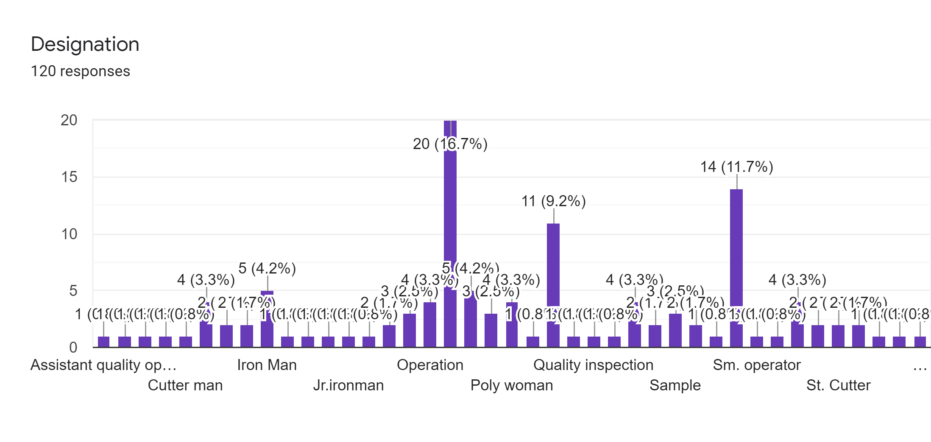

Particulars/ Statement
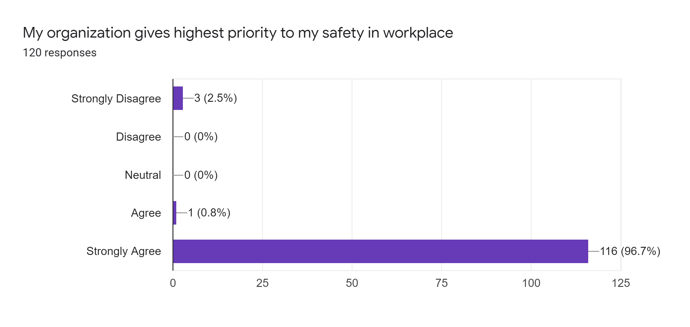
Interpretation:
The question were asked to identify whether the three garments are giving importance to the workers safety in workplace. The answer options were given following the Likert scale and it is found that 116 out of 120 workers have marked on strongly agree that affirms that the three garments are providing highest priority to their workers safety and maintenance issues. Though there are only 3 or 2.5% respondents are here who strongly disagreed with the statement.

Fire Safety in the workplace
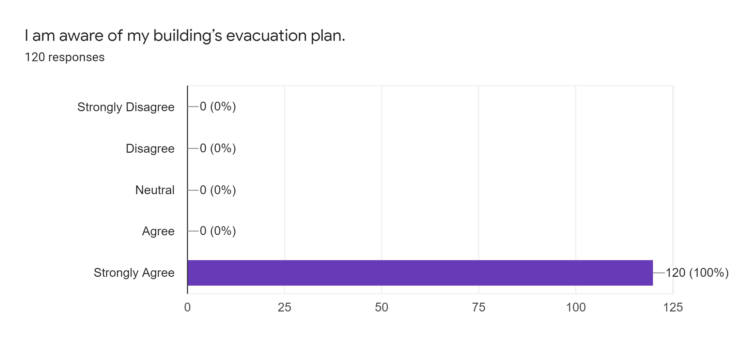
Interpretation:
The question arises to identify whether the workers of the three garments are aware of the building's evacuation plan to quickly leave the building in the event of an emergency in the workplace. Response options were provided following the Likert scale and it was found that 120 out of 120 workers firmly accepted that all the workers are aware of the building's evacuation plan.
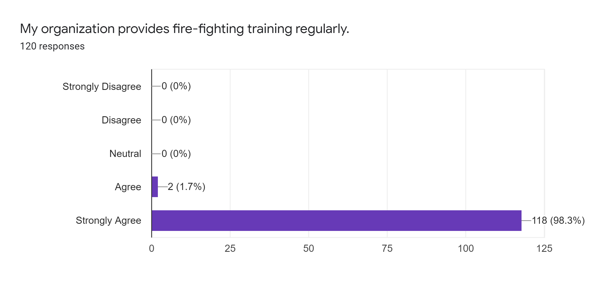
Interpretation:
120 workers were asked to train in fire control and it was found that out of the 122 personnel, strong people strongly agreed and 2 others agreed. This means that these three clothing companies are training their staff to fight in case of a fire in the workplace.

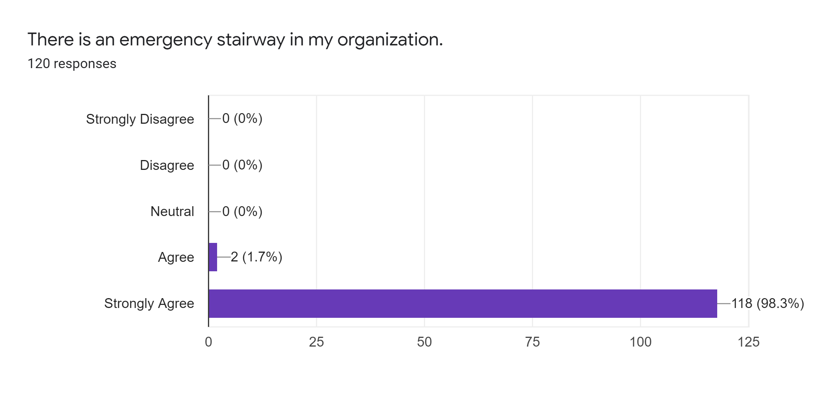
Interpretation:
The statement added that the three garments have an emergency stairway in the workplace so that workers can use them when needed. It was found that 118 workers agreed strongly and 2 workers agreed which means there was an emergency stairway for three workers.

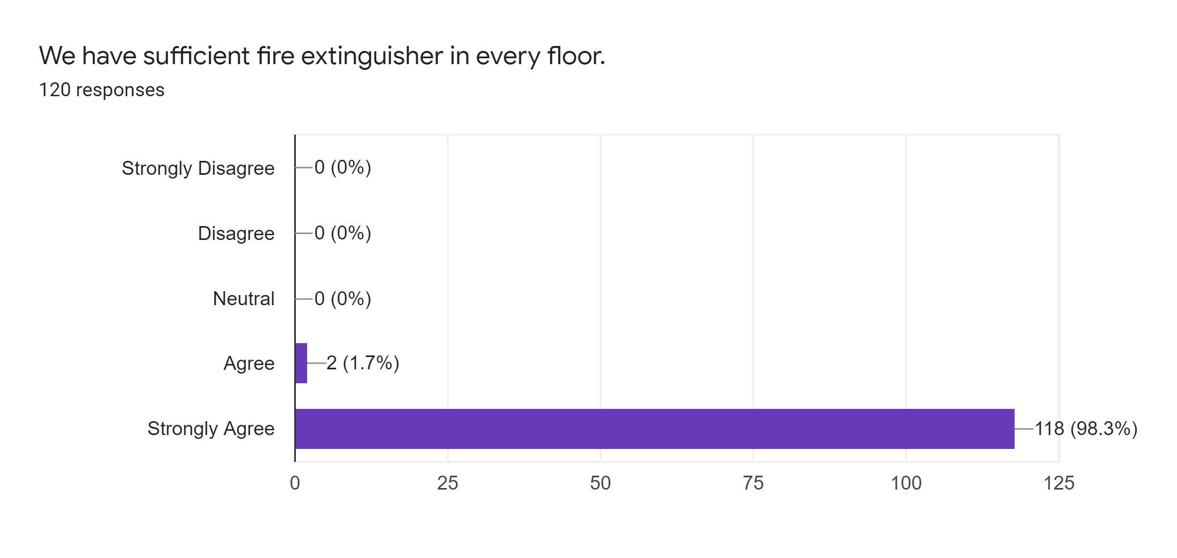

Interpretation:
The statement added to identify whether the three garments hold sufficient fire extinguisher in floor. It is found that 118 workers agreed strongly and 2 workers agreed with the statement. Therefore, it can be said all the garments have sufficient fire-extinguisher in every floor.

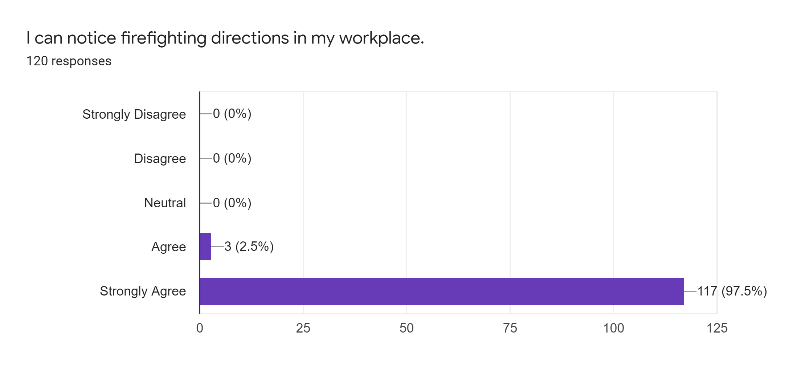
Interpretation:
The statement were given to identify whether there visible fire-fighting directions in each garments and it is found that 117 workers agreed strongly and 3 agreed with the statement. So, it can be said the notice of fire-fighting directions are visible and exist in each three garments.

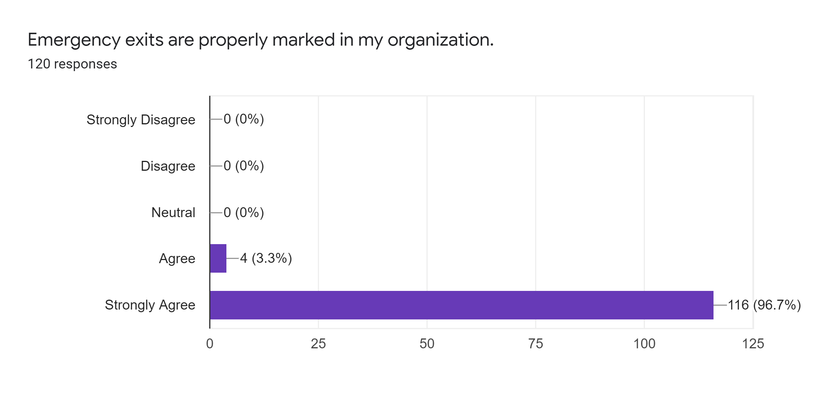
Interpretation:
The statement was added to each garment to identify if their emergency departures were properly identified, and it was found that 116 workers strongly agreed and 4 agreed on the statement. Thus, it can be said that emergency departures are visible and correctly marked on every three garments.
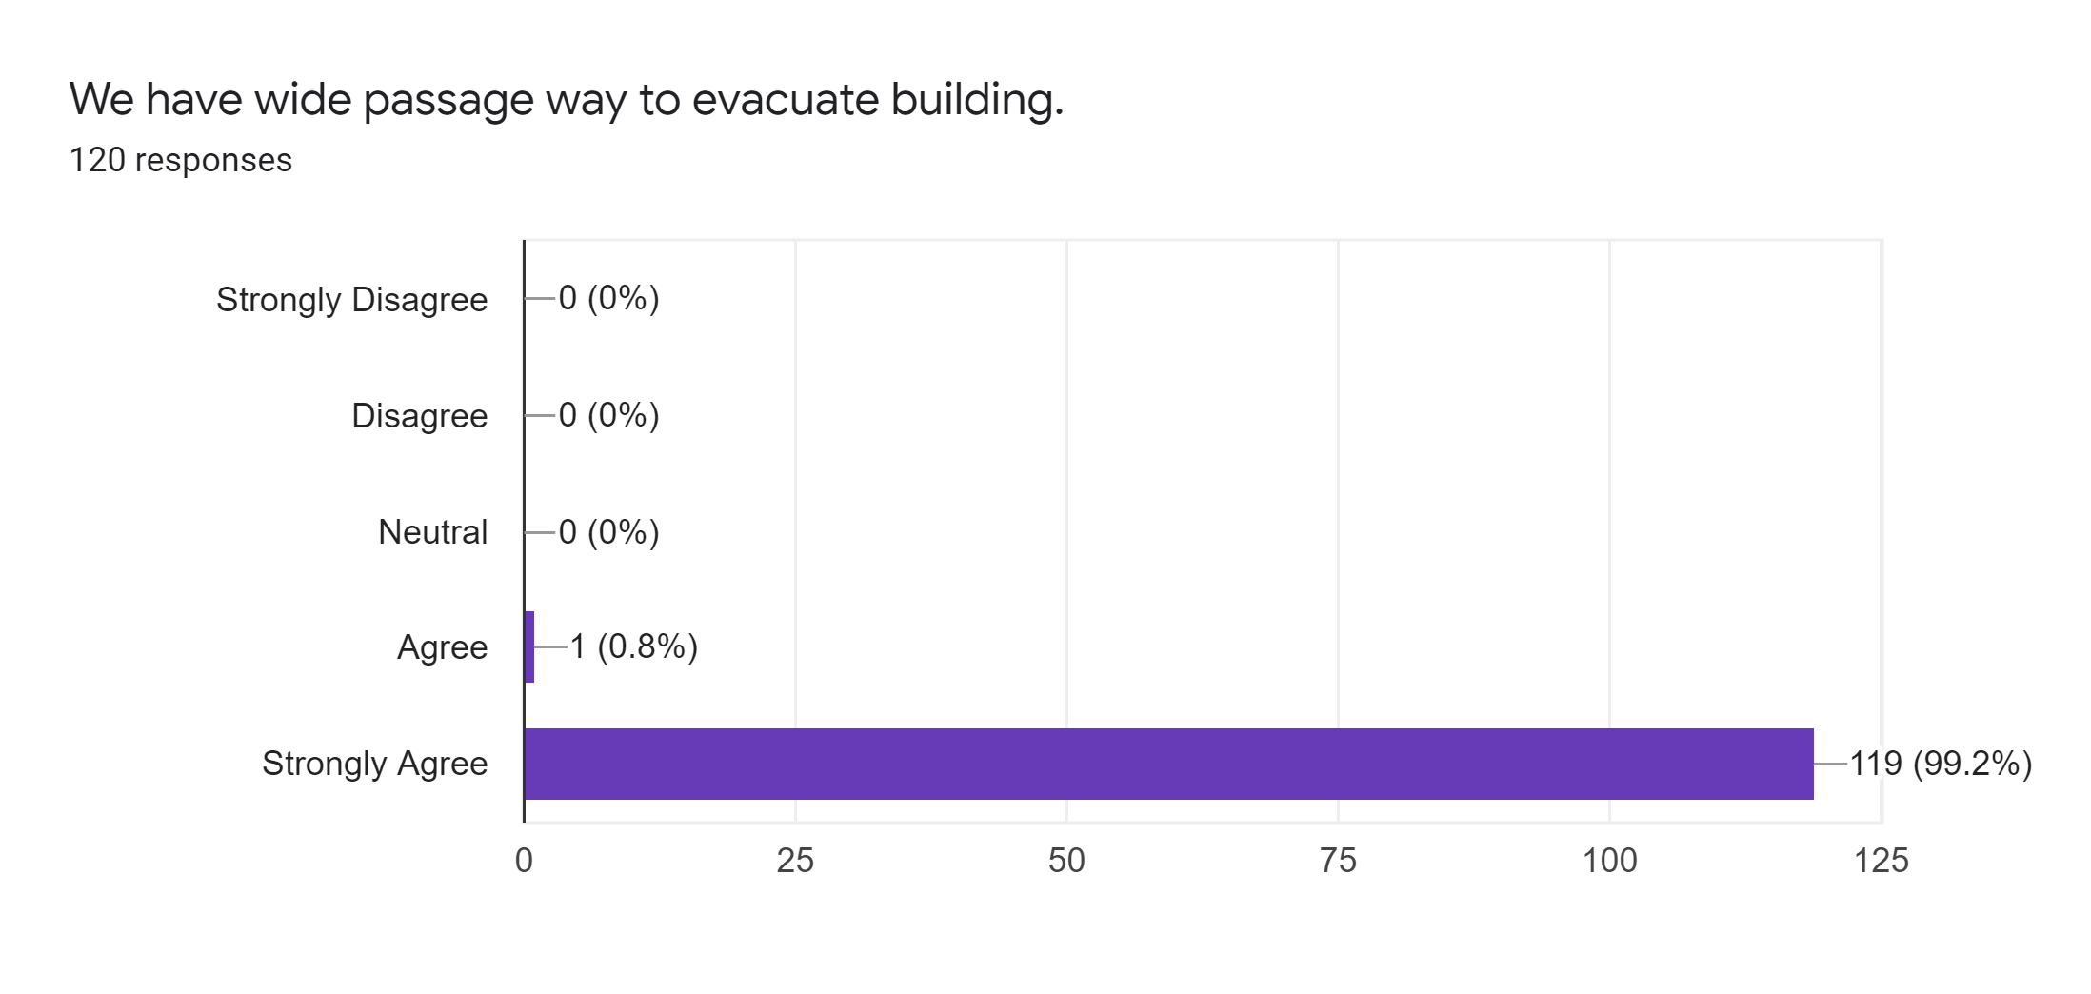
Interpretation:
The statement was added to each garment to identify if their emergency passages are wide enough to evacuate the building when required, and found that 119 workers strongly agreed and 1 agreed with the statement. Thus, it can be said that emergency passages are wide enough to evacuate all the workers from the building if necessary.

Safety regarding Machinery
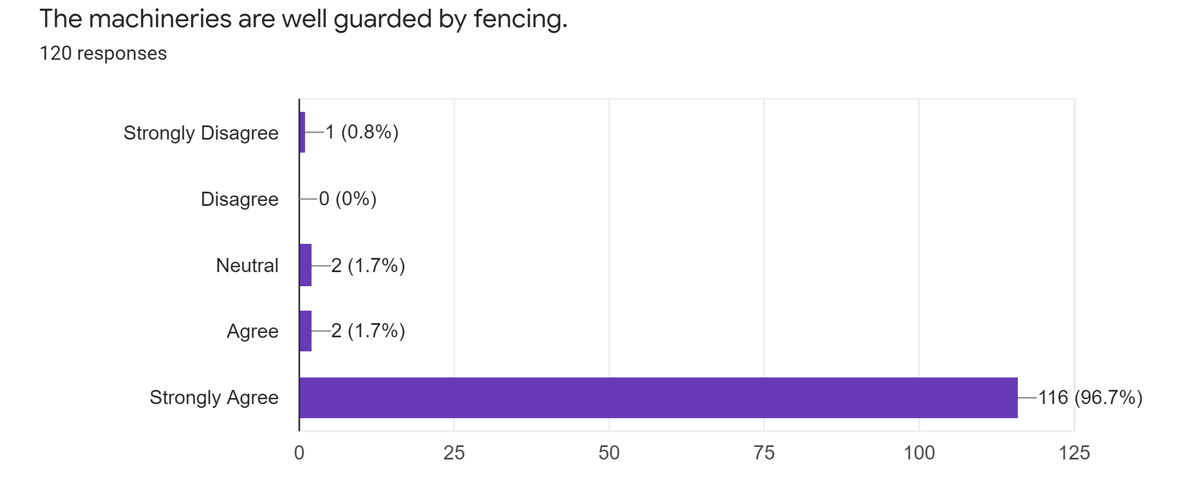
Interpretation:
The statement was asked to identify whether the three garments were fencing their machinery to protect their workers. Of the 120 workers, 115 workers strongly disagreed, 2 workers agreed, 2 disagreed and 1 strongly disagreed. This means that companies provide security through their machinery fence.

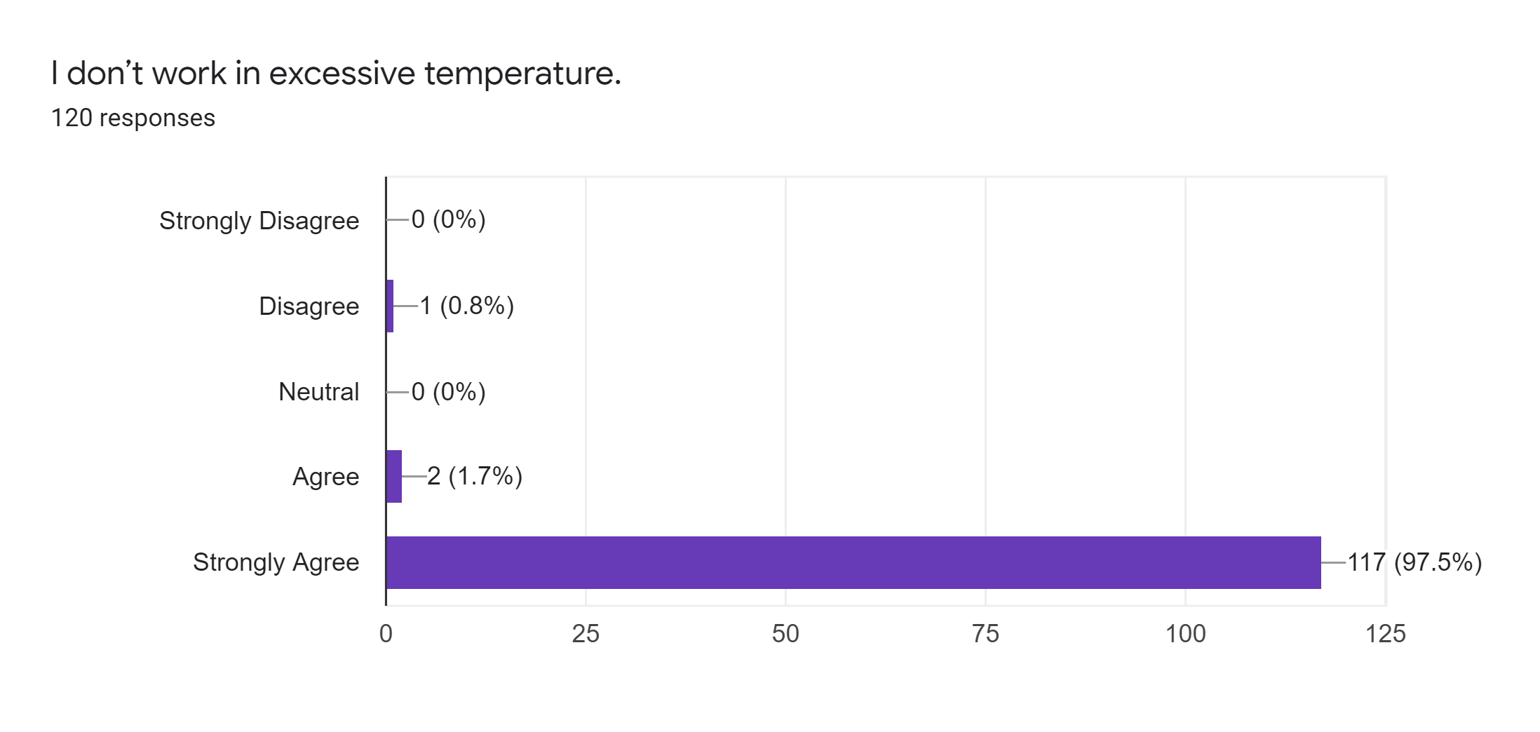
Interpretation:
The statement was added to identify if employees have to work under excessive temperatures that can cause them health problems. 117 respondents strongly disagreed, 2 agreed and 1 disagreed with the statement. Thus, it can be said that the workers do not work under these conditions under extra temperature.
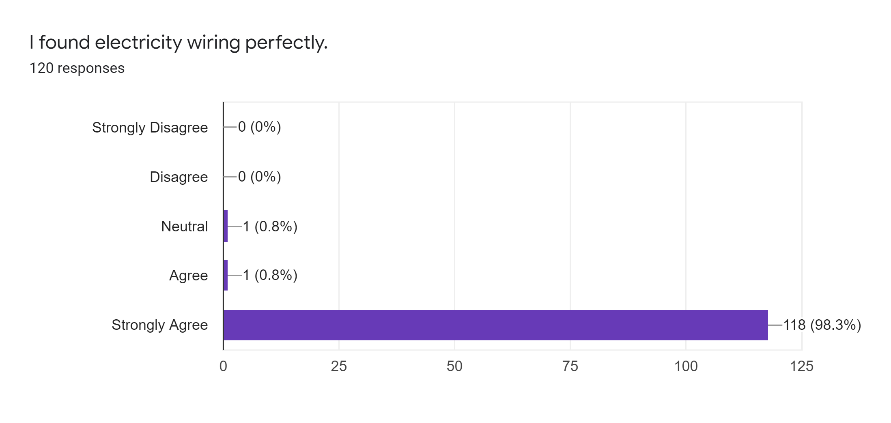
Interpretation:
Out of 120 workers 118 strongly agreed, 1 agreed and only one disagreed with the claim of knowing exactly where the electrical cables are located. As we know, if workers are not aware of electrical cables/wires, risks can occur at any time. Therefore, it is a good sign that almost all workers know their electrical cables.

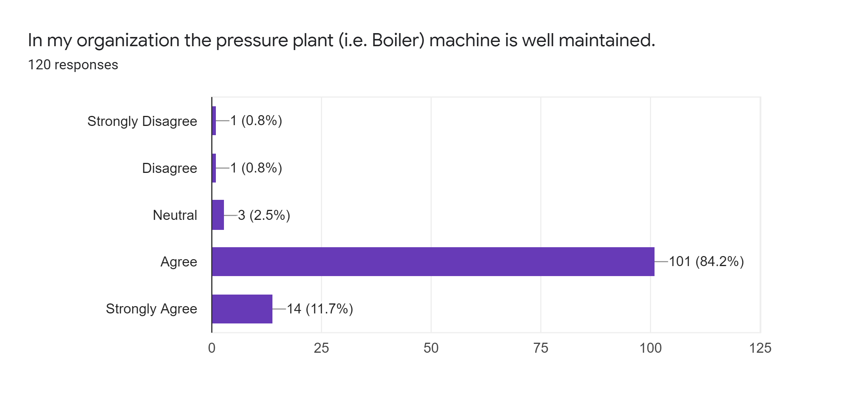
Interpretation:
To identify whether every companies are maintaining their boiler/pressure plant well, the statement was added. Out of 120 respondents, 101 agreed, 14 strongly agreed and 3 were neutral that proves that all three companies are maintaining the Boiler/pressure plant in a well prepared way.
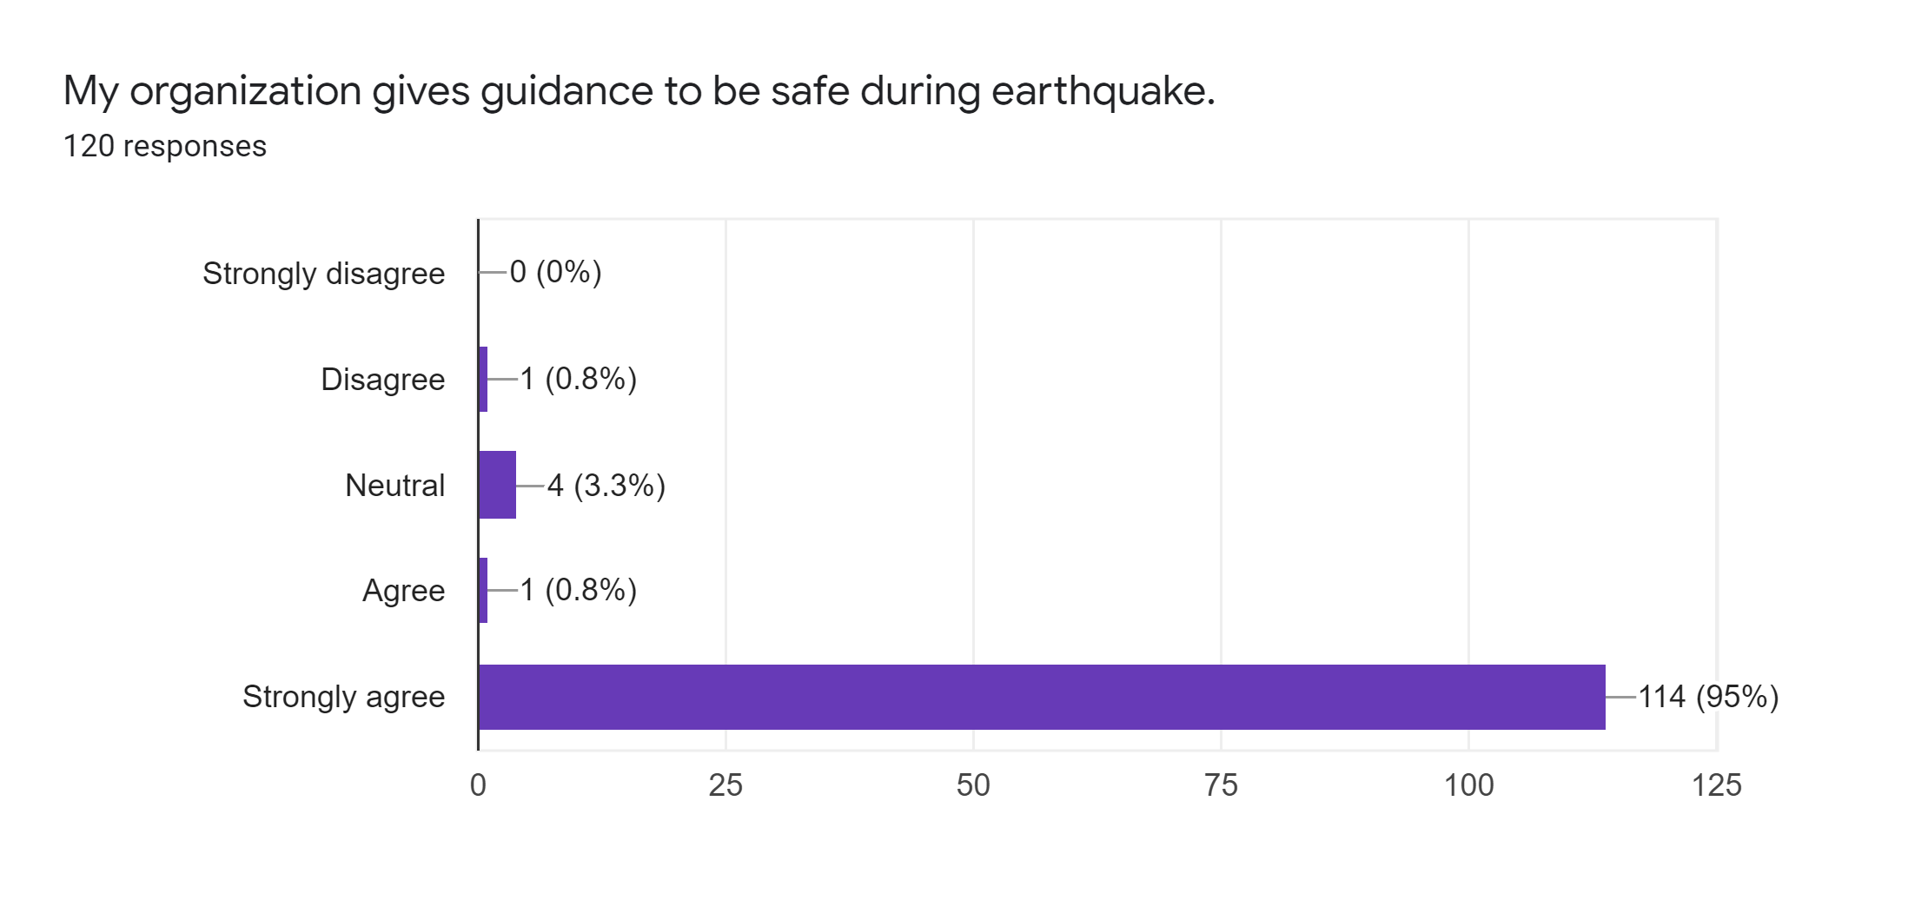
Interpretation:
To identify whether the three garments are training its workers about earthquake escape, the statement were added. It is found that 114 workers strongly agreed, four are neutral. Therefore, it can be said that all the garments are providing guidance to their workers about earthquake escape.

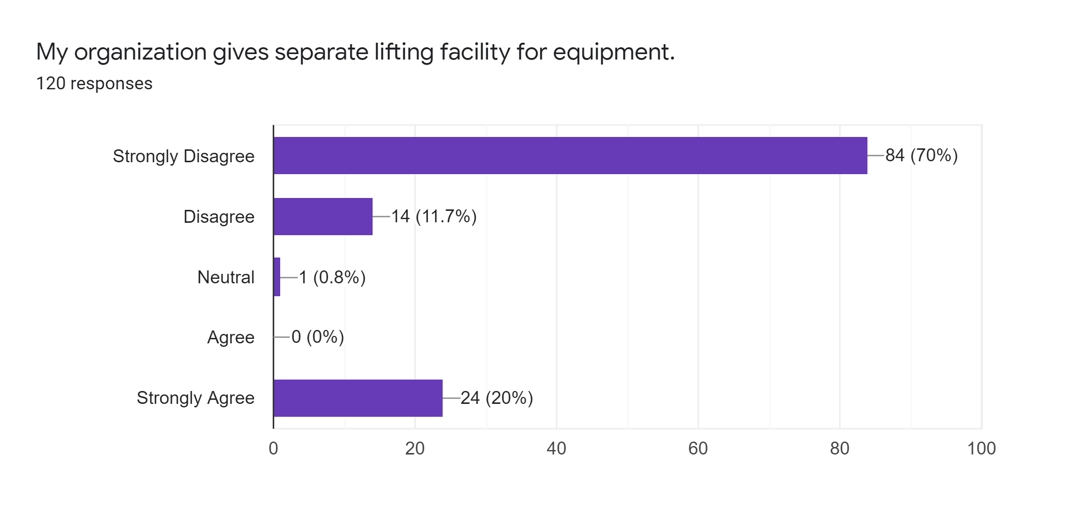
Interpretation:
The statement was added to recognize if there are separate lifting structures for equipment in the three garments because without separate lifting operators workers can get injured when trying to escape or can cause disturbance when there are multiple workers waiting for an elevator. 84 workers were found to strongly disagree, 14 disagree with the claim. On the other hand, 24 workers strongly agreed with the claim. It can be concluded that the garments are not offering separate lifting facilities to their workers.

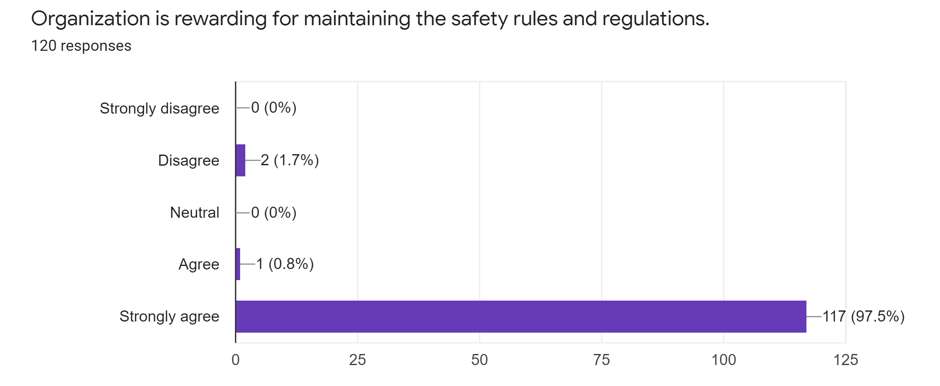
Interpretation:
Occupational safety is very important for all employees in the sector because all workers want to work in a safe and secure environment. Health and safety are the key factor for all industries to promote the well-being of employees and employers. Therefore, the statement was added to identify whether garments are rewarding their workers for maintaining safety rules and regulations, It is found that 117 workers responded strongly agree, only 2 disagree and 1 agreed with the statement. It can be said that all the three garments are rewarding their workers for maintaining safety rules and regulations.

Workers welfare Related Issues
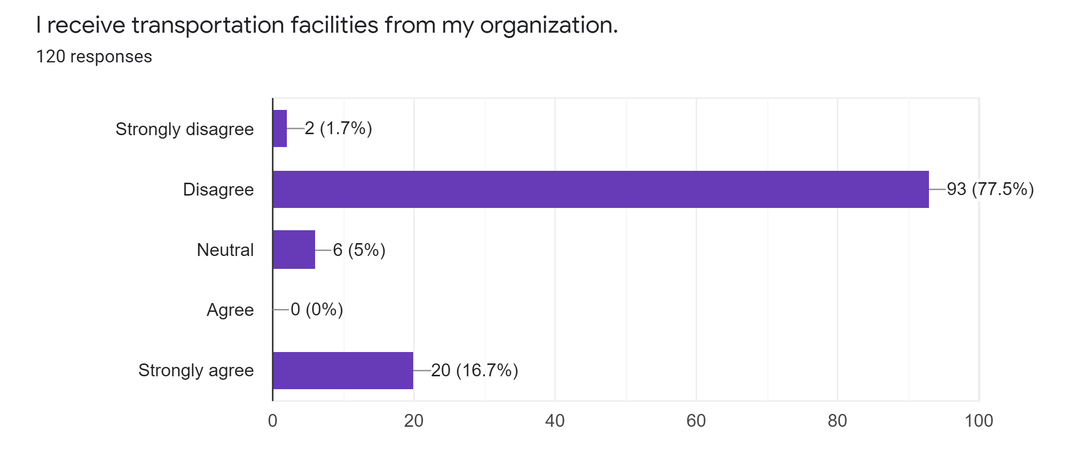
Interpretation:
The statement was utilized to detect whether companies are providing transportation services to their workers. Mostly, around 93 workers replied that they disagreed with the statement and 2 workers also responded strongly in disagreement. On the other hand, 20 workers agreed to have transportation facilities from their organization.

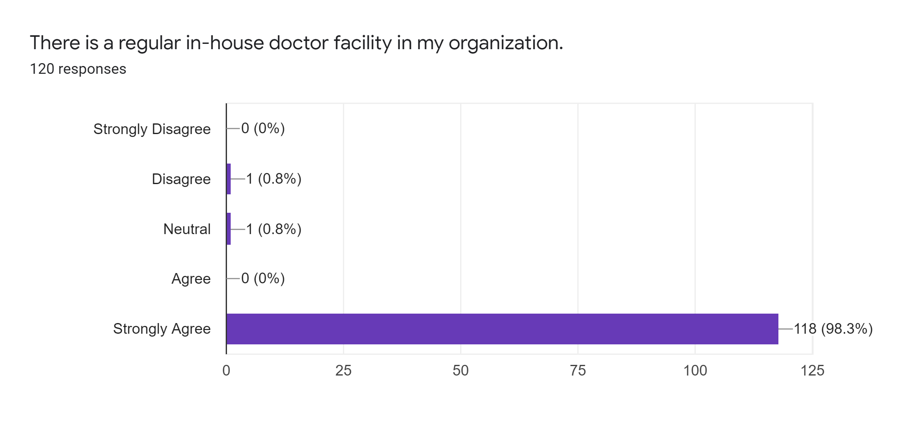
Interpretation:
To ensure the safety of workers from any uncertain risk, it is very important to have an internal medical facility. This is why the statement was added to detect whether the three garments are providing internal medical facilities to their workers. 118 workers agreed strongly, 1 neutral and 1 disagreed. Hence, it is very clear that all garments has internal doctors for workers' health problems.

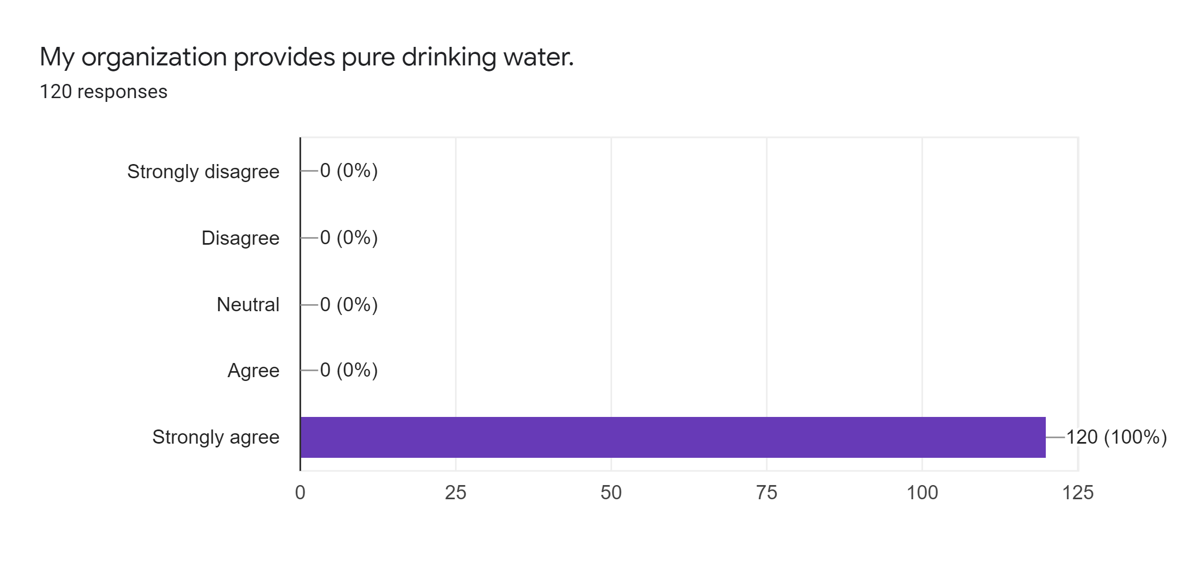
Interpretation:
Out of 120 workers, all responded that their jobs provided facilities for clean drinking water. We all know that the lack of pure drinking water can affect workers in many ways, from mental exhaustion to muscle cramps. Few other proven reasons why drinking clean water improves the health of a person at work reduce stress, help lose weight, help detoxify the body, and help digestion and defecation.
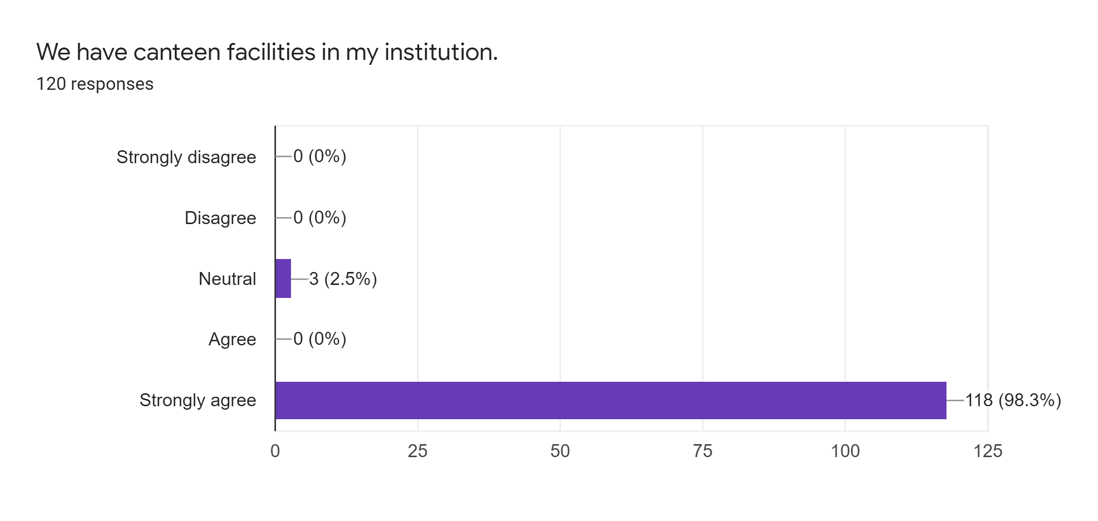
Interpretation:
Out of 120 workers, 118 workers strongly agreed with the statement that ensure that the garments are providing canteen facilities to their workers.

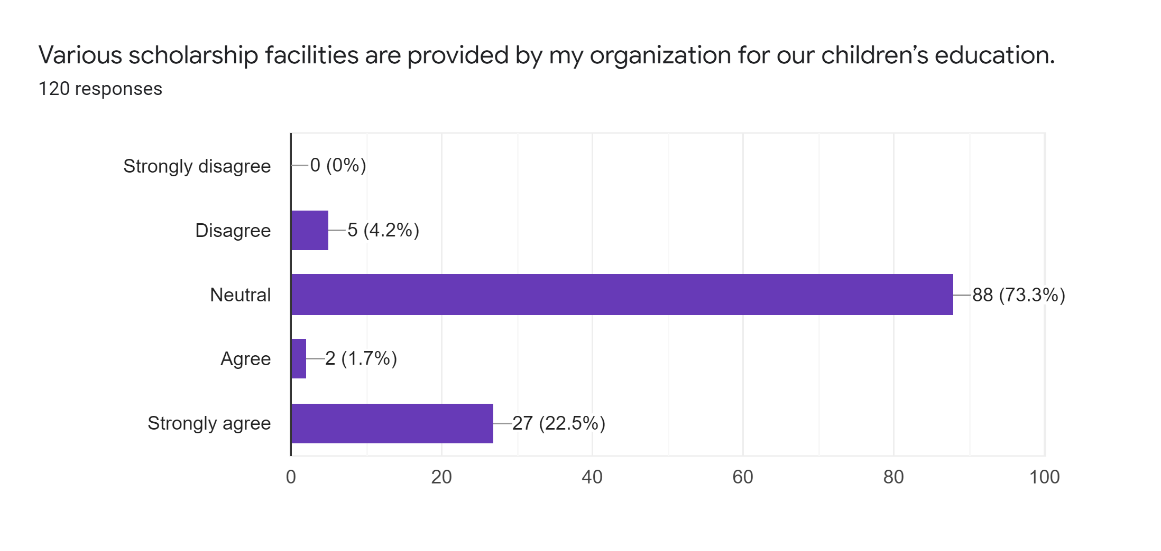
Interpretation:
We know that if companies assign scholarships to their employees for the education of their children, workers will feel confident and more motivated for their work. The statement was added to find out if these three companies offer such scholarships to their workers. 88 workers were neutral in this declaration, which is granted because companies do not offer them any scholarships for the education of children, although 27 workers also strongly agree with the declaration.

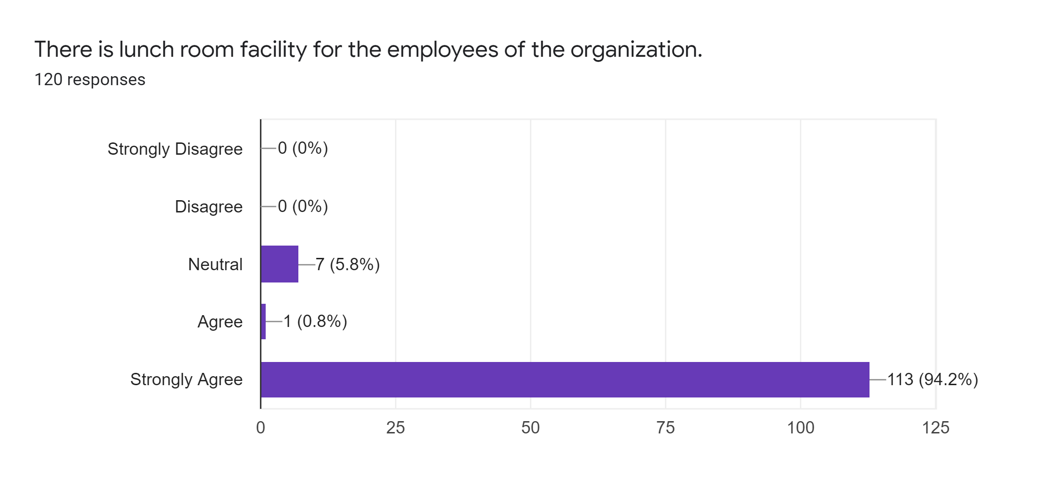
Interpretation:
113 of the 120 workers responded that launch facilities were available for workers in their organization. Therefore, it can be said that the three organizations provide dining facilities to their employees for lunch.

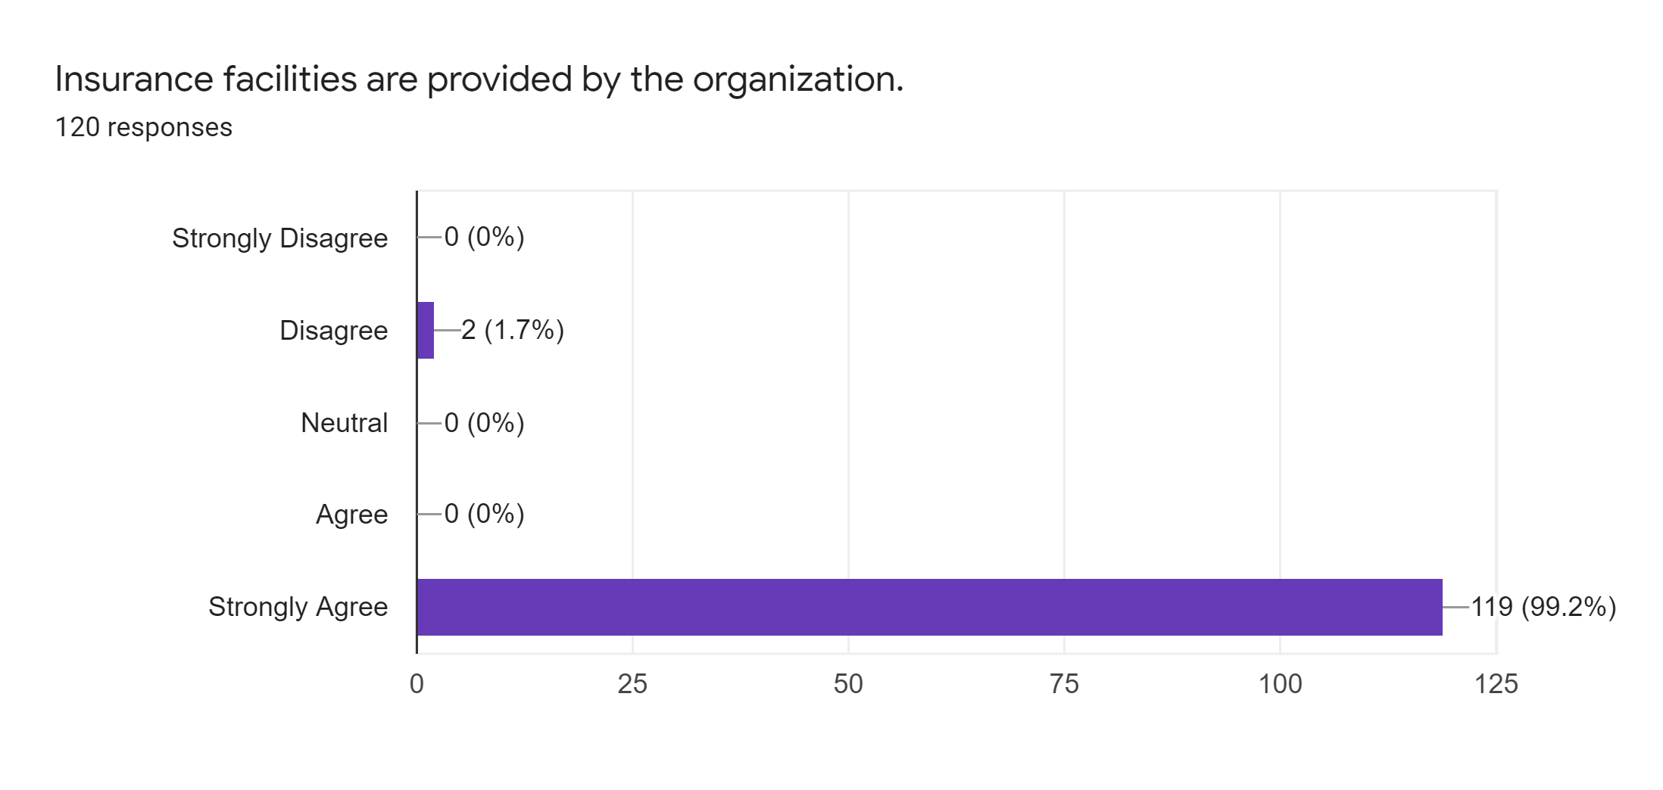
Interpretation:
119 out of 120 workers supported by agreeing strongly that their organization are providing insurance facilities to them.

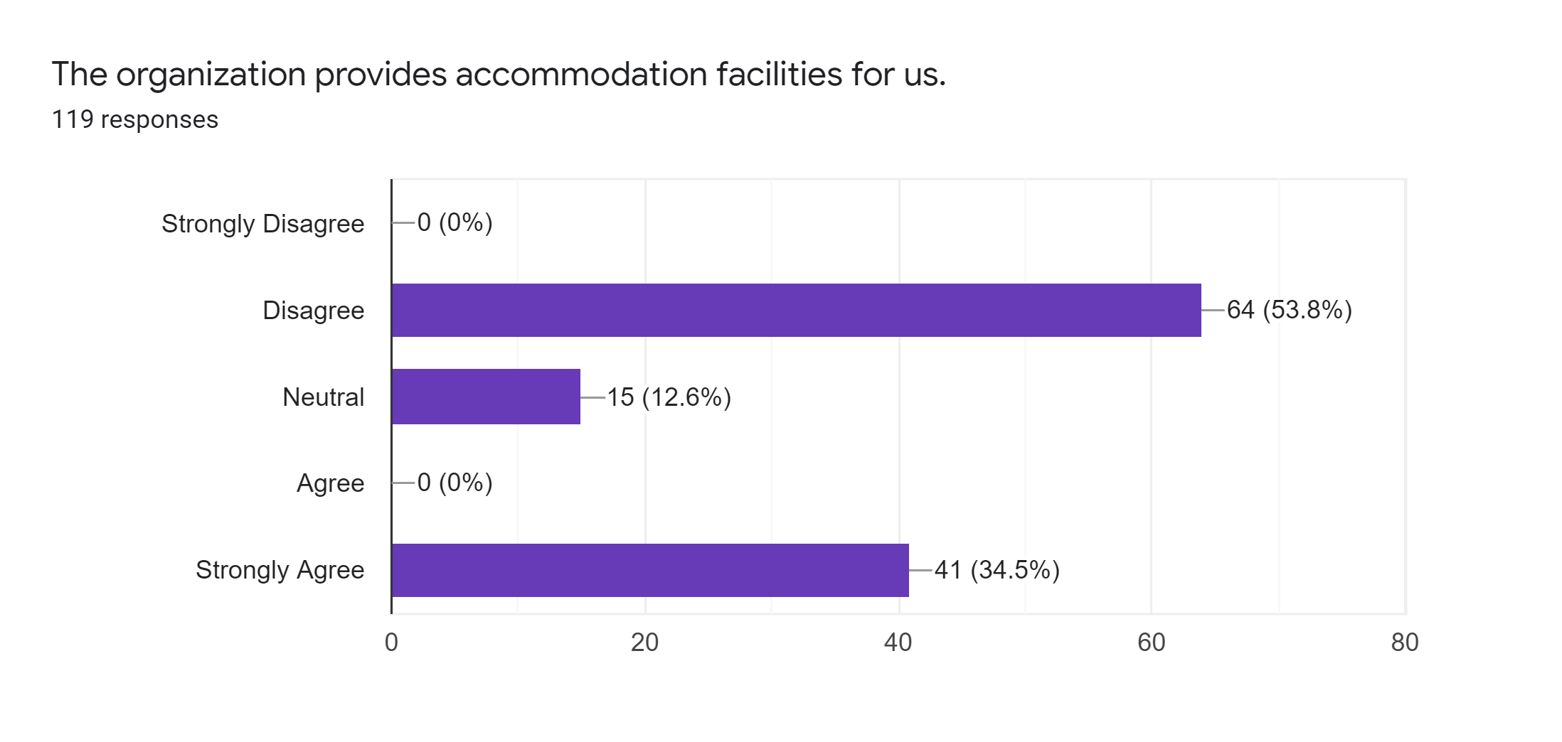
Interpretation:
In this statement, a total of 64 people in disagreement and 24 neutral responses were recorded, which implies that these organizations do not provide housing for all their workers, but rather that they provide housing for some of their workers as 41 workers strongly agree with the statement.
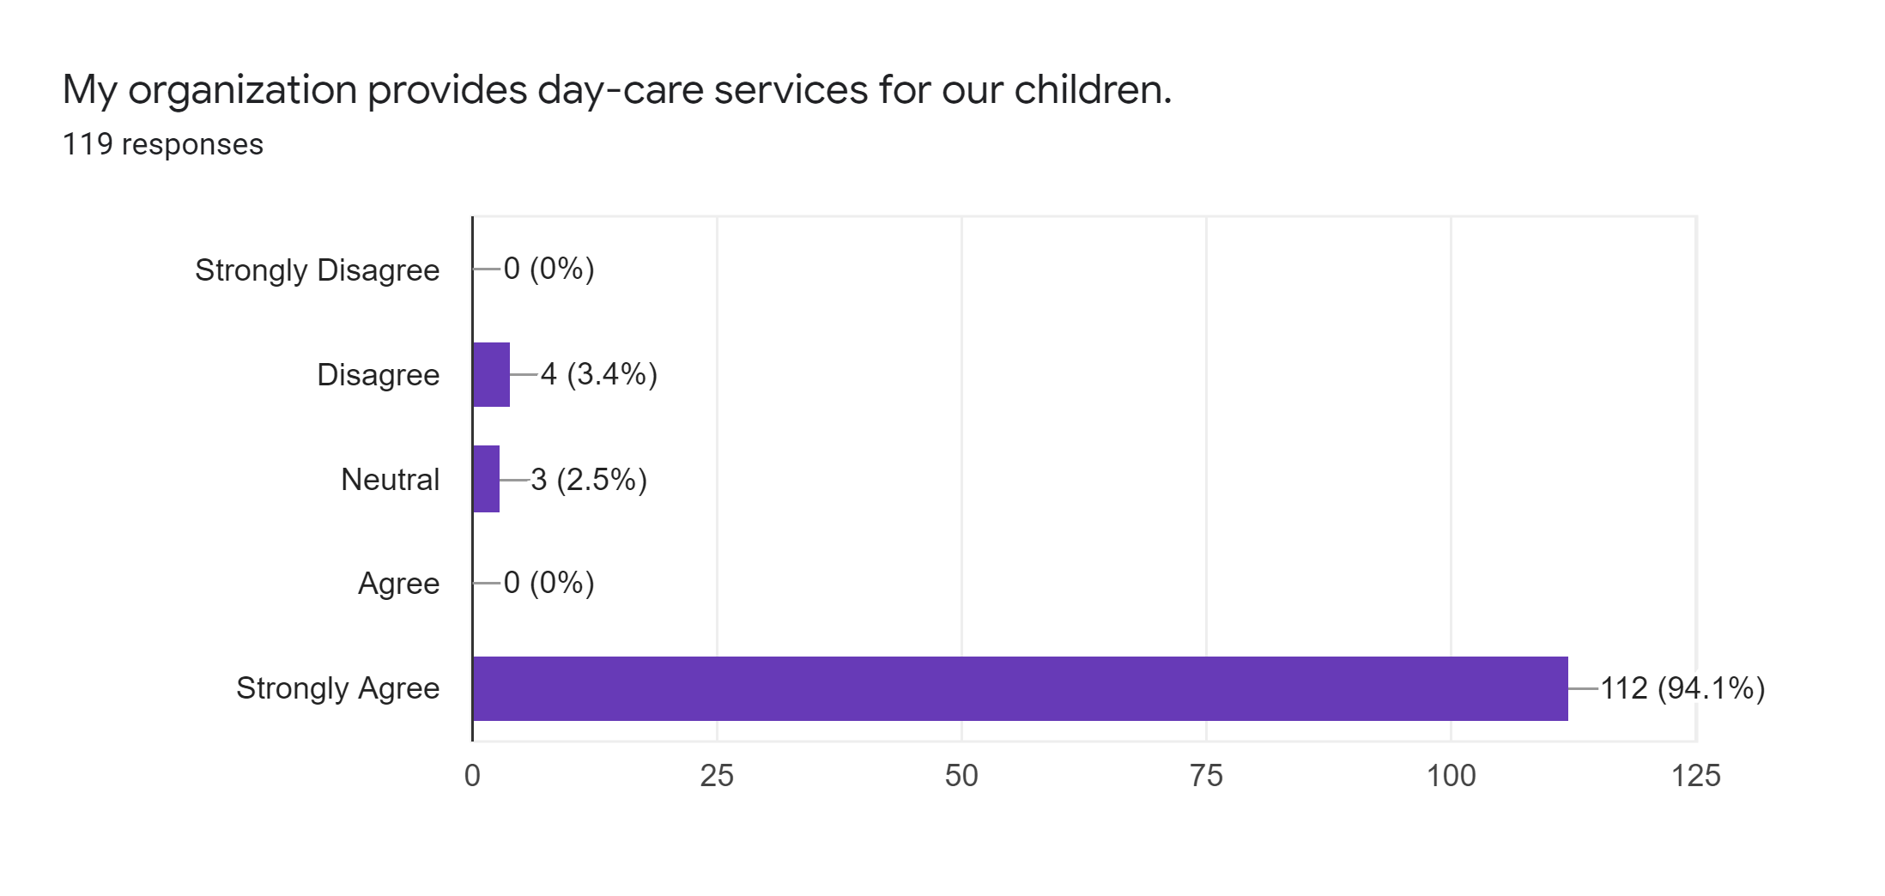
Interpretation:
Childcare in the workplace is generally an on-site facility that provides childcare for employees. The establishment is limited in age. Services are generally available at an employer-subsidized rate, or some companies may offer this benefit for free. 112 out of 120 workers replied that their organization had childcare for their children.

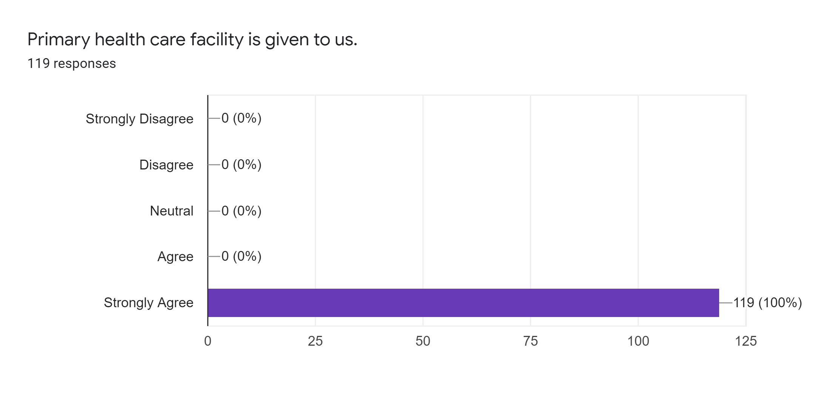
Interpretation:
119 workers strongly agreed with the statement that their organizations are providing primary health care facility to them.

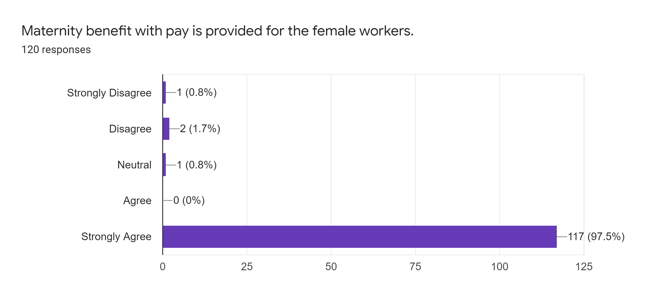
Interpretation:
The maternity allowance is a payment paid to women on maternity leave and covered by social insurance. Usually, workers request payment at least 6 weeks before they want to take maternity leave. 117 of the 120 workers established that their organization had maternity benefits.

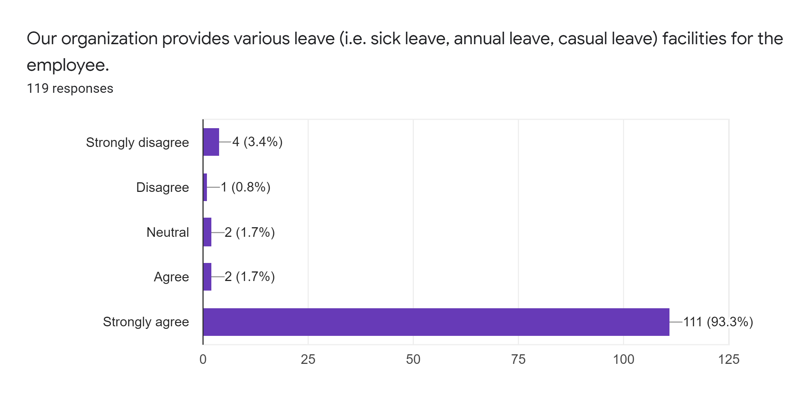
Interpretation:
111 out of 120 workers responded that their organization provides various leave such as sick leave, annual leave, and casual leave facilities for them. There are 4 strongly disagreed, 1 disagreed and 2 neutral responses were also recorded in the statement.

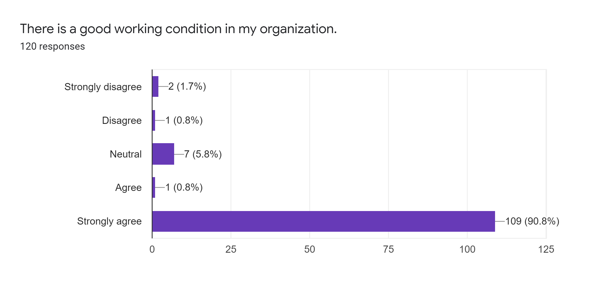
Interpretation:
In this statement, 109 workers were strongly agreed and 1 agreed that supports that the three garments are providing good working conditions to their employees.
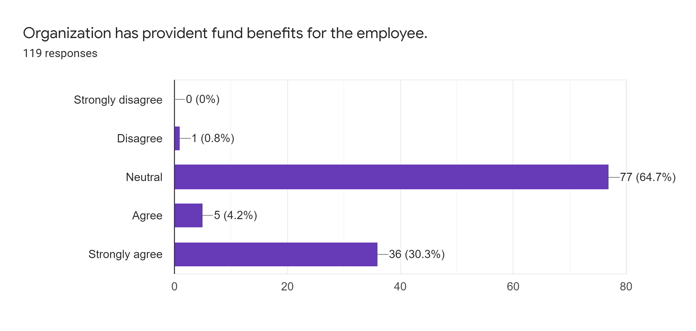
Interpretation:
In this statement, a total of 77 neutral responses and 1 disagreement responses are recorded and it can be said that these organizations do not offer employees provident benefits. On the other hand, there are 36 workers who strongly agree and 5 strongly agree that this means that organizations provide emergency funds to a few workers for maybe any particular reason.

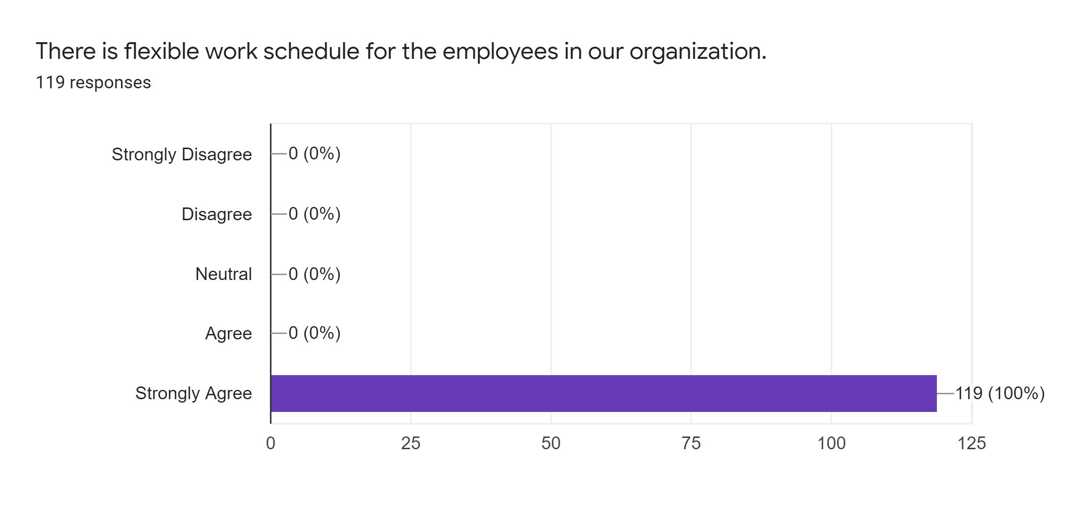
Interpretation:
Out of 120 workers, 119 strongly agreed that they have flexible work schedules available that are offered by their organization.
Job Satisfaction Issues
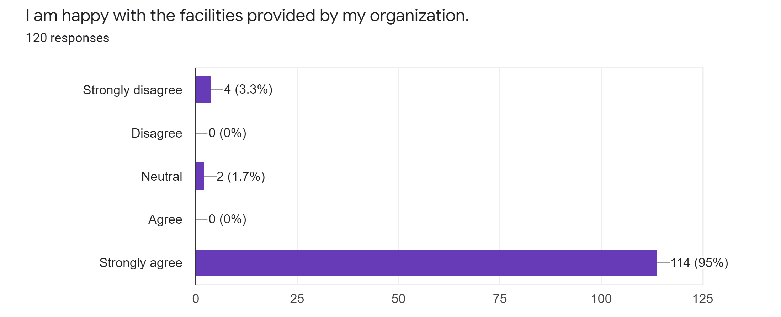
Interpretation:
Employee happiness is often linked to the measurement of individual success. A happy employee generally shows positive performance at work, which improves results in the workplace. As we know, "happiness comes before success". Therefore, the statement was added to analyse whether workers are satisfied with their organization. It is found that 114 workers are strongly agreed with the statement. As large proportion of workers are happy with their organization and a few who strongly disagreed (4) and neutral (2), it can be said that workers are happy in their organization.

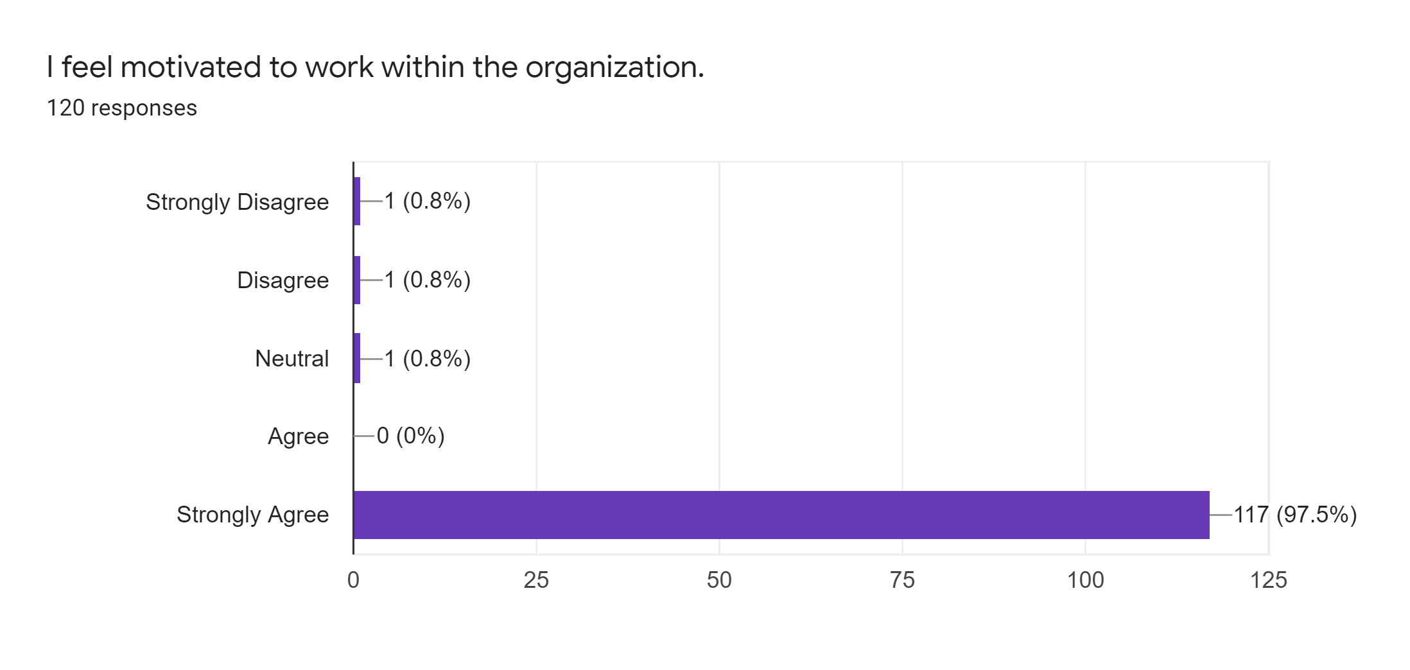
Interpretation:
According to Robbins in Mobbs and McFarland (2010), motivation in the workplace is defined as the desire to exercise high levels of commitment to organizational goals conditioned by the ability of the effort to meet certain individual needs. The above statement was to identify the workers motivation at their work. It is found that 117 out of 120 respondents are strongly agreed that they feel motivated to work within their organization.

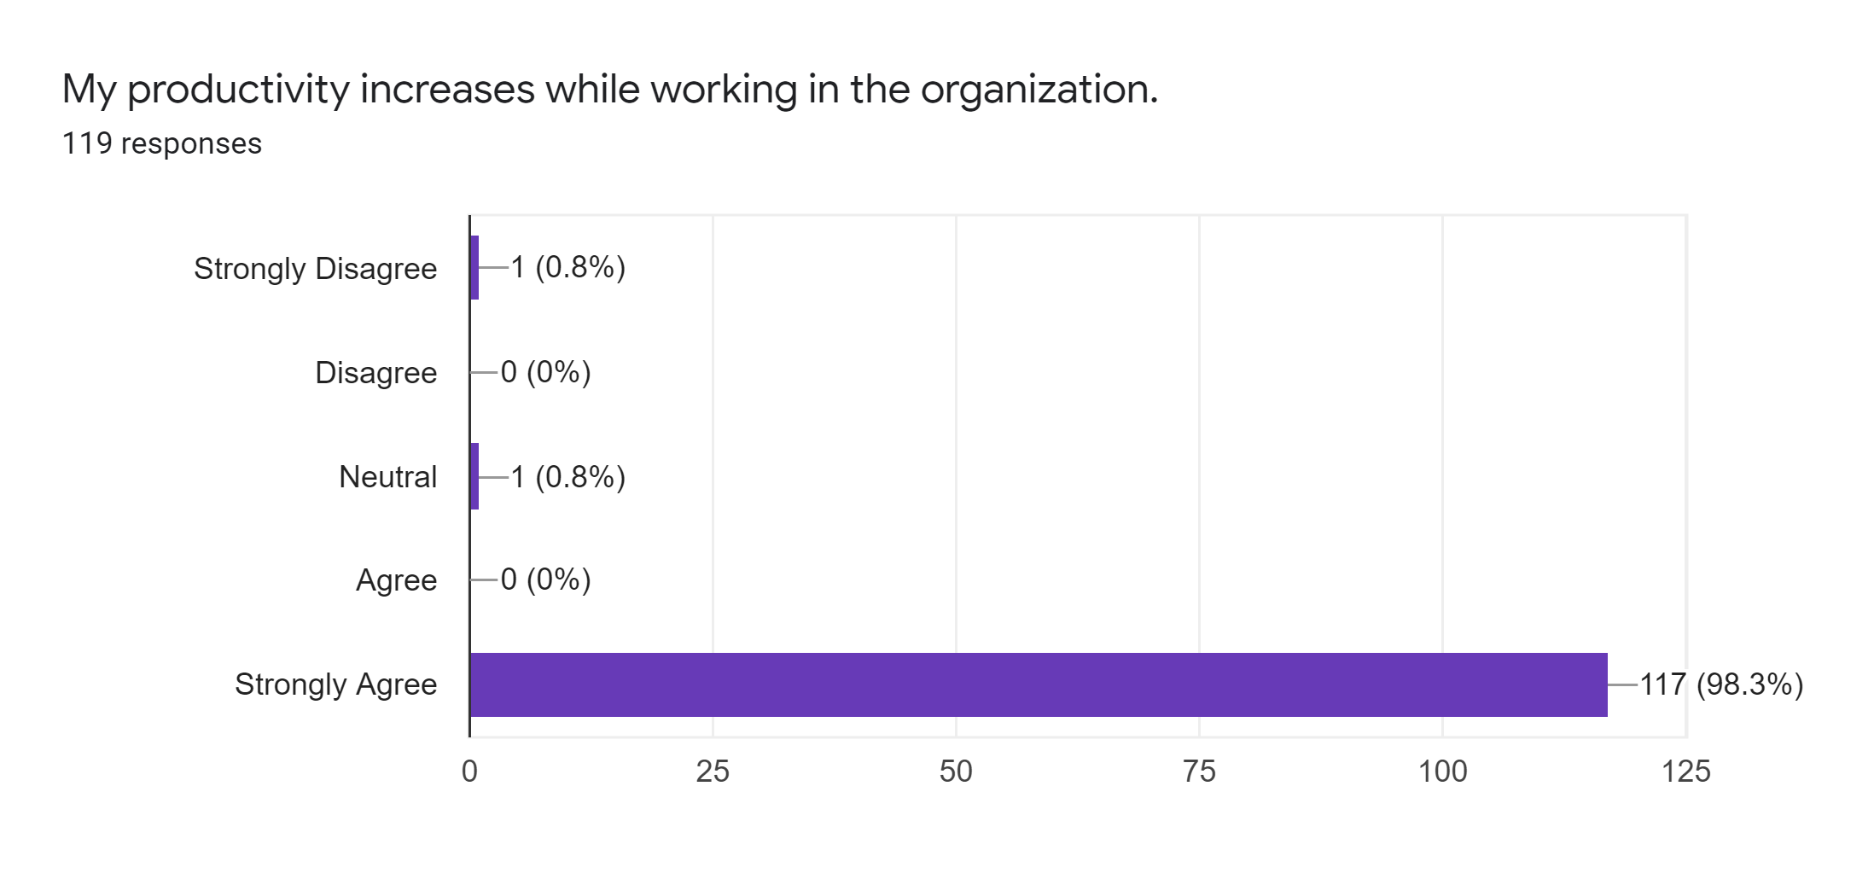
Interpretation:
Productivity at work refers to the efficiency with which workers achieve the goals of a business and produce goods or services for customers. Examples may include the speed with which workers produce a product in a factory, process requests for technical support for garments. After collecting the responses, it is found that 117 workers or around 98.3% workers have realized that their productivity have increased while performing their tasks in their organization.

Chapter Five

Conclusion and Recommendations

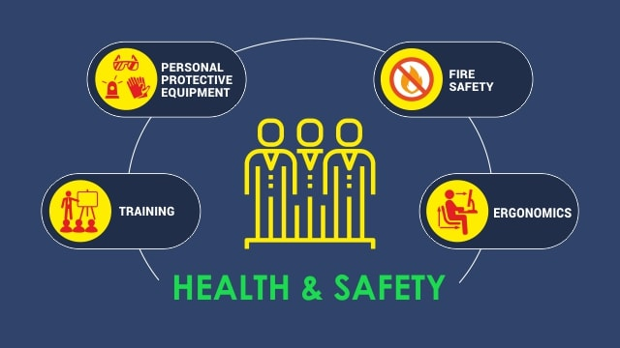

5.1 Recommendations
The establishment of the Accord and Alliance in the garments sector in 2013, its workplace safety activities brought an important organizational learning experience to Bangladesh. Stakeholders in the Ready-Made Garments (RMG) value chain have tried a new form of compliance assurance for the first time. First, international distributors/buyers/brands and trade unions participate to ensure the safety of the manufacturer's workplace; secondly, local contractors now require high levels of safety and maintenance standards in their factories; thirdly, the supervision and control mechanisms of local public agencies Shortcomings and the need to improve their procedures are appreciated; Fourth, RMG workers can understand safety issues and concerns and how to respond to factory emergencies. The study attempts to determine the current situation of the garments sector in Bangladesh in terms of safety and maintenance. After analysing the research results in the survey responses, some shortcomings in terms of safety and maintainability were discovered. Here, based on these shortcomings, there are a few suggestions listed below so that Bangladeshi garments can provide greater safety for its workers.
- The requirement for regular medical examination of personnel engaged in hazardous operations.
- Provide adequate lighting, ventilation, and temperature for workers.
- The use of dangerous machines is prohibited during working hours and at night for young people and women.
- Check the elements harmful to health, such as dust, gas, smoke, etc. Associated with a specific operation.
- Enclosure requirements for enclosures and mechanical protections, for new mechanical enclosures.
- For units employing 500 or more workers, a pharmacy provided by a physician is required.
- Requirements for cranes and other lifting equipment, hoists and elevators, rotary machines, pressure systems.
- Enclosure requirements for enclosures and mechanical protections, for new mechanical enclosures.
- Need to provide adequate first aid facilities.
- Building security requirements should be properly maintained.
- Policies and actions must be taken against fire and explosion.
- The maximum weight of a lift carried or carried by men, women, and youth.
- Sanitary services, such as sanitation, urinals, spittoons, drinking water, must be provided.
- Report accidents and occupational diseases accordingly.
- All garments should offer their workers basic facilities such as cafeteria, dining room, washing machine, bathroom, children's room needs.
- Visible actions to avoid dangerous fumes.
- Welfare officers from units requiring 500 or more workers.
- Develop policies for flooring, stair and hallway requirements; wells, manholes, floor openings, etc.

Furthermore, Government organizations, non-governmental organizations and local stakeholders need to work together to improve conditions:
- Provide employers with information and help them understand their health and safety obligations and the measures that must be taken to fulfil these obligations;
- Evaluate the activities of factory and research institute inspection agencies and other regulatory agencies in an effort to improve the way they seek compliance and enforcement;
- Provide garments management personnel with training in health and safety management;
- Helping trade unions raise health and safety issues with employers and law enforcement agencies;
- Promote the reform of Bangladesh’s health and safety legislation to provide adequate protection for workers;
- Conduct research to better understand the health and safety conditions at work in Bangladesh, including the number and circumstances of deaths and injuries and the necessary changes in working methods.

5.2 Conclusion
The Tazreen fire and the collapse of Rana Plaza had caused a stir worldwide and had sparked a sense of awareness among Western governments and consumers. They were in high demand for the brand and their constant demand for low-priced products had forced many factory owners to lower the threshold for workplace safety. This prompted the buyer to take action. More than 200 clothing brands from more than 20 countries in Asia, North America, Europe, and Australia signed the "Bangladesh Fire Safety and Fire Safety Contract" in 2013. It is a legally binding five-year agreement between brands and a union aimed at creating a safe and healthy clothing sector in Bangladesh. A group of 27 North American resellers created a similar platform in 2013. Its name is "Bangladesh Workers Safety Alliance". The factory owner and the government of Bangladesh also responded positively. Despite the limitations, the owner has invested between 500 and 1 trillion BDT to repair each factory and the government has strengthened its supervision of some 5,000 factories, located mainly in Dhaka and Chittagong. All stakeholders made it clear that the conditions of the factory have improved significantly in the past seven years. However, there is still a lot of work to do.

The study aims to analyse the workers Safety and maintenance aspects: the case of the garment industry in Bangladesh through surveying 120 workers randomly from three reputed garments of Bangladesh. It is observed that all that three garments have sufficient safety and maintenance preparation to save their workers from any uncertain situation. But as we cannot decide based on only three garments that all of the garments are providing sufficient safety to their employees, several suggestions for garments as well as for government are listed in the recommendation part so that other can implement to improve their safety and maintenance policies.

Reference
(a) Ahamed, F. (2011). Working conditions in the Bangladesh Readymade Garments Industry: Is Social compliance making a difference? Ph.D. Thesis, La Trobe University, Australia.
(b) Alam M.J., Mamun, M.Z. and Islam, N. (2004). “Workplace Security of Female Garments Workers in Bangladesh”, Social Science Review, Volume 21, No. 2, pp. 191-200.
(c) Absar, S.S. (2001). “Problems Surrounding Wages; The Readymade Garments Sectors in Bangladesh”, Journal LMD Labour and Management in Development, Volume 2, p. 7.
(d) MacLaury J. Government Occupational Safety and Health Regulations, 1877-1917. Washington (DC): United States Department of Labour; n.d. [mentioned on July 26, 2015]. Available at: http://www.dol.gov/dol/aboutdol/ history / mono-regsafeintrotoc.htm
(e) Eves D. "Two steps forward, one step back". A brief history of the origins, development and implementation of UK health and safety law. National Committee for Occupational Safety and Health (NOSHC); 2015 [mentioned on July 26, 2015]. Available at: http://www.historyofosh.org.uk/brief/#chapter01
(f) Takahashi K, Ishii Y. Historical evolution of administrative measures for occupational diseases in Japan. Geneva: International Labour Organization (ILO); 2013 [cited International Journal of Occupational Safety and Ergonomics (JOSE) 5832015, July 26]. Available at: http://www.ilo.org/wcmsp5/groups/public/—ed_protect/—protrav/—safework/docum-ents/publication/wcms_234221.pdf
(g) Zhang X, Wang Z, Li T. The current state of occupational health in South Asia. About Health Back Med. 2010; 15 (5): 263-270. DOI: 10.1007 / s12199-010-0145-2
(h) Majumder, P.P. (1998). “Health status of the Garment workers in Bangladesh; Findings from a survey of employer and employees”, Bangladesh Institute of Development Studies (BIDS), Dhaka, Bangladesh

Appendix
Survey Questionnaire
