Internship Report
On
“Recruitment & Selection Process”

Of






Internship Report
On
Recruitment &Selection Process of “Renata Limited”

Course Code:
Submitted To:
Dr. Mohd Hasanur Raihan Joarder
Professor, School of Business & Economics
United International University (UIU)
Submitted By:
Anika Tahsin
ID: 111 131 098
BBA Program
United International University

Date of Submission:

Letter of Transmittal

12thjanuary 2018
Dr. MohdHasanurRaihanJoarder
Professor, School of Business & Economics
United International University (UIU)

Subject: Internship report on “Recruitment process of Renata Limited.”

Respected Sir,

With all respect and immeasurable gratification, I am submitting my internship report on “Recruitment process of Renata limited” which you have imputed me as an obligatory requirement of this internship program. It is really a huge expectancy from me to gather enough immense information and understanding the subject matter in a bountiful way.

I have given my highest effort to prepare a fruitful & trustworthy report. This report will provide clear belief about the overall recruitment process of renata limited. I am welcoming your investigation on this report, because, this will provide me the chance to learn more and redouble my knowledge. I expect you will consider all the errors that may take place in this report in spite of my best effort.

Thanking you and we hope that this report will merit your approval.

Sincerely,
Anika Tahsin
ID: 111131098
BBA Program
United International University

Acknowledgement

At the very beginning, I would like to express that I am very my much thankful to Almighty Allah for giving me the strength to finish the internship report at the scheduled time. This required plenty of time and attention in every step of it. However, it gave me a true feeling of creation and helps me to understand my ability to work. And Of course, some very special people cannot go without mentioning.

At first, I want to show my gratitude to Dr. Mohd H R Joarder sir. And After that Mr. Md. FuadHasan Lotus from Renata Limited. (Senior Deputy Manager). He had been more like a Big brother and gave me suggestion, advice about how to deal the corporate world.
Last but not the least in addition I acknowledge the management team and personnel of renata limited for their great collaboration for generating this report a successful and extensive one. I must say that without their support it would have been very hard for me to prepare such report. I am thankful to them with all of my feelings.

Table of Content
- Executive Summary viii
- Chapter 1
- Introduction 2
- Origin of the Study 3
- Objective of the Report 3
- Broad Objective 3
- Specific Objective 4
- Nature of Study 4
- Sources of Data 4
- Limitation 5
- Limitation of Time 5
- Confidentiality of sensitive information 5
- Lack of knowledge for corporate world 5
- Short Experience 5
- Chapter 2
- Literature Review 7
- Employee recruitment and selection 8
- Recruitment 8
- Typical strategically recruitment Process 9
- Selection 10
- Strategy 10
- Rise organizational effectiveness 11
- Organizations Image 14
- Recruitment Sources 14
- The internal source 14
- Employee Referrals and Recommendations 15
- External Sources 16
- Advertisements 16
- Employment agencies 16
- Job fairs 16
- Online Recruiting 16
- The selection process 17
- The selection Process Chart 18
- Initial screening 19
- Completing the application form 19
- Comprehensive Interviews 19
- Conditional Job Offer 19
- Background Investigation 20
- Medical/Physical Examination 20
- Job Offer 20
- Chapter 3
- Organization Overview 22
- Company Background 22
- Company Profile 23
- Organogram of Renata Limited 24
- Organization Logo 25
- Subsidiary Companies 25
- Renata Agro Industries Limited 25
- Purnava Limited 25
- Renata Oncology Limited 26
- Corporate Social Responsibility 26
- Healthcare for employees and their families 26
- Support to charitable organizations 27
- Scholarship for meritorious students 27
- Women’s empowerment 27
- Financial assistance to ex-employee and their families 27
- Organization Vision and Mission 27
- Responsibilities at Renata as an Intern 28
- A Study on the implication of HRIS in Renata LTD 29
- Empress HRIS 30
- Chapter 4
- The Main Agenda of the Report 35
- The right people in the right place at the right time 35
- Employee Requisition process 35
- Recruitment 36
- Collection of applicants’ CVs 36
- Sorting Collected CVs 36
- CV Screening Criteria of Renata Limited 36
- Communicating with the applicants 36
- Preparing Summary of the applicants 37
- Interview arrangement 37
- Evaluation Process 38
- Chapter 5
- Data Analysis and Interpretation 40
- Analysis of Question answer 40
- My Observation 44
- Recommendation 45
- Conclusion 46
- Bibliography 47
- Appendix 48

Executive Summary
Renata Limited (in the past Pfizer Limited) put a surprising push to be on the best and now they assuming the part of driving position and they are currently the quickest developing pharmaceutical and creature wellbeing item maker in Bangladesh. Human pharmaceuticals and creature wellbeing items are the principle business item for Renata ltd. When it is about piece of the pie, Renata Limited has turned out to be fourth biggest pharmaceutical organization and in creature wellbeing item area it has moved toward becoming business sector pioneer. In the wake of serving the nearby need Renata sends out items in various nations, for example, Afghanistan, Belize, Cambodia, Ethiopia, Guyana, Honduras, Hong Kong, Kenya, Malaysia, Myanmar, Nepal, Philippines, Sri-Lanka, Thailand, United Kingdom, and Vietnam. With roughly taka 50 million of capitalization Renata ltd is recorded on the Dhaka Stock Exchange. Bangladesh pharmaceutical industry is for the most part overwhelmed by local producers. Of the aggregate pharmaceutical market of Bangladesh, the nearby organizations are getting a charge out of a piece of the pie stretching around 75%, while the MNCs are having a piece of the pie of 25%. Bangladeshi pharmaceuticals firms create 82% of the market locally; privately based MNCs represent 13%, and the last 5% is transported in albeit 257 pharmaceutical organizations are enrolled in Bangladesh, just around 150 are powerfully delivering drugs The main 30 to 40 organizations rule nearly the whole market; the best 10 hold 70% of local piece of the pie; and the best two, BEXIMCO and SQUARE, catch over of the market. The business structure is generally thought. Contrasting and that, the best ten Japanese firms produced around 45% of the household business income in 2006, while the main ten UK firms created roughly 53%, and the best ten German firms created roughly 60% (IMS Health 2015). Bangladesh is intending to enter exceedingly managed advertise and to accomplish that a high venture is joining to assimilate the most up to date innovation.


Chapter 1
Introduction

Pharmaceuticals ventures which are center of wellbeing area developing as a standout amongst the most modern and hey tech fabricating segment in Bangladesh. In light of enhance statistic trademark, instruction levels, attention to medicinal services, developing per capita salary, positive approach this industry is advancing and their commitment in the economy of Bangladesh is extremely recognizable. It is obvious that the advancement of this area see another measurement after the statement of Drug Control Ordinance-1982. This new point of reference of improvement wind up apparent in view of the expert learning, musings and creative thoughts of drug specialists working in this segment. Pharmaceuticals associations have entered the worldwide market including European and American market and endeavoring to catch advertise with their superior and quality fare meds. This area likewise serves 95% of the aggregate need of medication in the nearby field with the plan to grow send out market. So to quality this area, ventures have been built up with latest innovation, hardware and experts. Pharmaceuticals a dynamic and power segment of Bangladesh which is additionally the second-biggest supplier or supporter of the administration exchequer. Bangladesh Pharmaceutical Industry has turned into the second most noteworthy supporter of the national salary after the articles of clothing division which is likewise heading towards independence in taking care of the neighborhood demand. It is additionally alluded as the biggest cubicle escalated business division of the nation. As indicated by the report of Directorate general of medication organization (DGDA), there are 450 generics drugs, 120 are in the controlled class i.e. in the basic medication list. The staying 340 generics are in the decontrolled class, the aggregate number of brands that are enlisted in Bangladesh is right now evaluated to be 5,300, while the aggregate number of dose structures and qualities are 8,300. Around 85 percent of the medications sold in Bangladesh are non specific and 15 percent are licensed medications. Bangladesh pharmaceutical industry is for the most part commanded by household producers. Of the aggregate pharmaceutical market of Bangladesh, the neighborhood organizations are getting a charge out of a piece of the pie stretching around 75%, while the MNCs are having a piece of the pie of 25%. Bangladeshi pharmaceuticals firms create 82% of the market locally; privately based MNCs represent 13%, and the last 5% is foreign albeit 257 pharmaceutical organizations are enlisted in Bangladesh, just around 150 are powerfully delivering drugs The best 30 to 40 organizations command nearly the whole market;the main 10 hold 70% of household piece of the overall industry; and the best two, BEXIMCO and SQUARE, catch over of the market. The business structure is moderately focused. Contrasting and that, the main ten Japanese firms produced around 45% of the household business income in 2006, while the best ten UK firms created roughly 53%, and the best ten German firms produced roughly 60% (IMS Health 2015). Bangladesh is intending to enter exceedingly controlled market and to accomplish that a high speculation is fusing to assimilate the most up to date innovation. There are some eminent organizations that have just entered the exceedingly directed market and got the UK MHRA, EU, Philippines, TGA Australia and GCC endorsement and some are in the process to get the USFDA and UK MHRA endorsement. Through this accreditation these organizations will have the capacity to send out solution and through contract producing understanding.
Origin of the Study
This report has been prepared as a requirement for the completion of the Bachelors of Business Administration (BBA) program of the United International University After the completion of my credit courses of BBA program, I joined Renata Limited for the internship program under the Human Resource Division. My organizational supervisor was Mr. Md. Fuad Hasan Lotus, Senior Deputy Manager of Human Resource Division, Renata ltd. I have been working there for Two months.

Objective of the Report:
The motive of the report is to give an enhance analysis on overall Recruitment process of Renata Ltd. This report will reveal how Renata Ltd focusing on different processes of recruitment & selection, the effectiveness of recruitment through performance appraisal and HR related activities.
Broad Objective
- To identify what type of recruitment process is used by Renata Ltd.
- The effectiveness of recruitment process of Renata Ltd.
- To enhance my experience.

Specific Objective
- For having the internal and external system of recruitment by the management and the administration.
- To Recount the Human Resource Management Practices of Renata Ltd.
- To analyze employee requisition process in this organization.
- Analysis of position and requirement.
- To recommend necessary steps for overcoming problems.
Nature of Study
This is the exploratory type of research. Information has been collected and finished the report in both Primary and Secondary sources.
Sources of Data
Primary data
Primary data has been collected through Face to face conversation, Questionnaire and interview.
Secondary data
Sources of secondary data of this report are:
- Different textbook.
-Website and Facebook page of Renata Ltd.

Limitation
Although I have tried my best to make this report based on facts and complete information available, but I had to pass through some limitations that I believe are inexorable. I had to do a lot of hard work in order to gather all the information, carrying out the calculation and complete the assignment. I could not get much information from websites.
Limitation of Time
I had a little opportunity to spend enough time to prepare this type of big report within a short period of time. Because within 2 months of internship program most of the time I was busy with office work and family issues. For this reason, I have to hurry for completing this report within the time.
Confidentiality of sensitive information
Because of many of the information related to the organization composition and theproduct itself were confidential and secretive, there might be some information diversion in the report at some places.
Lack of knowledge for corporate world
One of the biggest limitations is there is a lacking’s of deep knowledge about the real corporate activities. It took some time for me to adjust with the new environment and get adjust to the daily work schedule

Short Experience
I am in the learning period and have small experience for reporting on such a big project. I have tried heart and soul to prepare the report professionally.

Chapter 2
Literature Review

Literature Review
Successful employment planning is designed to identify an organizations human resource needs, once those needs are known an organization will strive to meet them. Recruitment is the process of discovering potential candidates for actual or anticipated organizational vacancies. Or from another perspective it is a linking activities that brings together those with jobs to fill and those seeking jobs.
Recruiting is a major Human resource activity. Depending on the size of the company. HR departments estimate that they are going to spend between 50% to 70% of their time on recruiting new employees each year. Recruiters essentially promote the organization to prospective applicants. An effective recruiting process requires a significant pool of diverse candidates to choose from. Achieving a satisfactory pool of candidates may not be easy. And recruiters need to know the best places to recruits qualified candidates. This can be particularly challenging in times of economic growth that result in a tight labor market and overwhelming during difficult economic times, resulting in over qualified candidates or an overabundance of resumes.
The Global turmoil has observed the importance of Human Resource Management in both business and public life. The raging business climate brought in the wake of globalization, change in technologies, linearization etc. An efficiently run Human Resource Management can provide your organization the most suitable structure and Human Resource Management can help an organization to reach their destination. Generally there are six HR Functions from which an organizations choose the practices whichever they need at the time of their expected time. Decider and Kramer (2008, P58) says that every one of these capacities are imperative useful region of HRM, they are: 1. Employment examination, 2. Employment plan, 3. Enlistment, 4. Determination, 5. Preparing and Development, 6. Execution administration, 7. Pay structure, 8. Motivating force, 9. Advantages, and 10. Work/Employee relations.

Employee recruitment and selection
Recruitment
Recruitment is the process of attempting to locate and encourage potential applicants to apply for existing or anticipated job openings.
Key questions
Before proceeding any further question with recruitment the following questions should be considered
1. What is the purpose of the job? Where does it fit in with the rest of the team?
2. What sort of person is required to effectively carry out the job?
3. Can the job functions or responsibilities be re allocated or modified or eliminated entirely?

Who should recruit?
The responsibility for recruitment will vary from company to company. In a small company the most practical method can be for the manager raising the requests to recruit and hire his or her own staffs.
General Manager: Recruits all the executive staffs.
Company Secretary or accountant or CFO: Recruits all the accounting and clerical staffs.
Production Manager: Recruits factory labors.

Typical strategically recruitment Process:

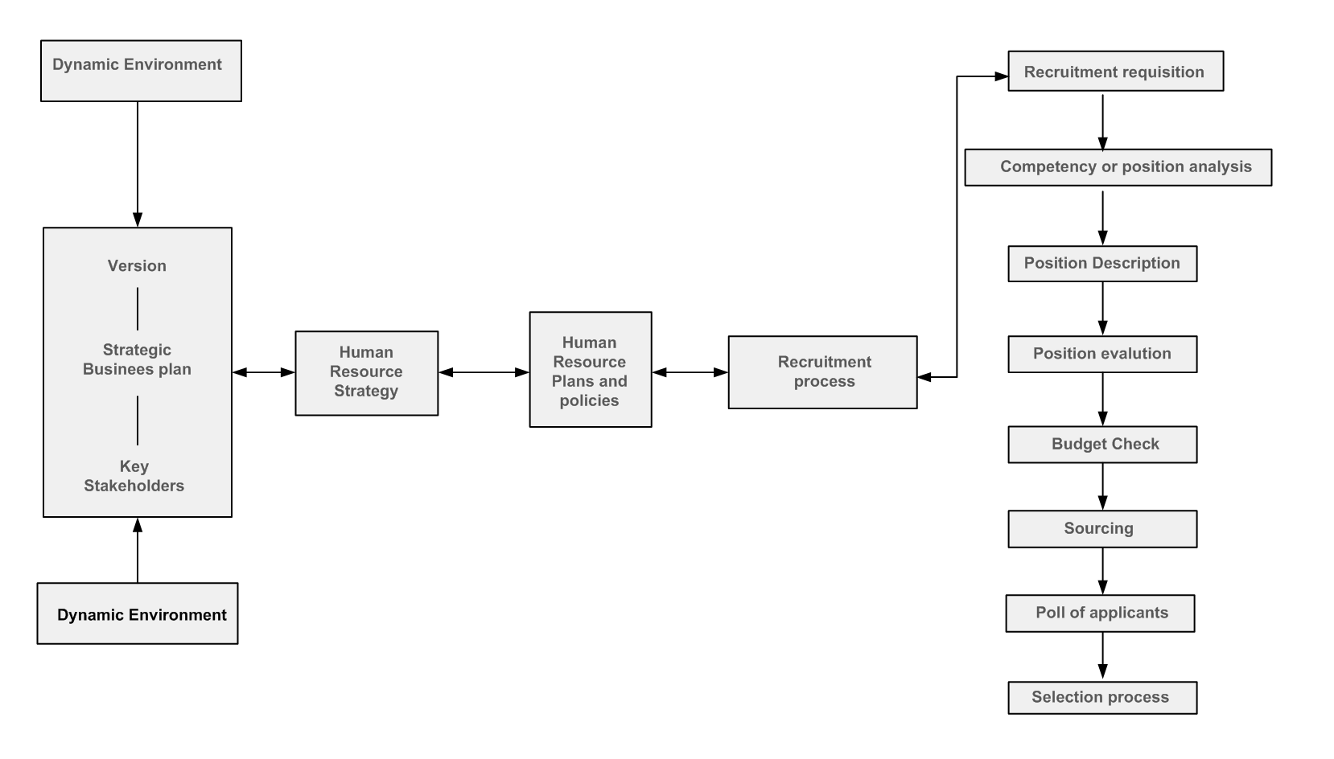

Recruitment can be prescribed as searching for and attaching a pool of potential candidates with the desired knowledge, skills and experience. This facts allow an organization to select the most appropriate people to fill-up the job vacancies against defined position descriptions and specifications.

The motive of the recruitment process is to find the biggest pool of applicants to provide the greatest scope to select the best people for the required roles in an organization.

Getting the best applicants for a role can be a competitive advantage for an organization. As an ineffective recruitment and selection system can make a result in enormous disruption, reduced productivity, interpersonal difficulties and interruptions to operations, customer service and long term costs.

Selection
After being identified through the recruitment process the most appropriate candidate, or candidates are identified through a selection process. Interviewing, reference checking and testing are included. The purpose of the selection process is to ensure the best person or people are appointed in.

Strategy
When you have an effective recruitment strategy then you are going to get paramount to the success of any organization. But the recruitment and selection function can become a costly and inefficient process if not approached in a systematic and proactive manner. A recruitment and selection strategy:
- Make sure that the organization has the necessary skills, knowledge and quality to meet current and future strategic and operational requirements
- Ensures that the supply meets demand requirements
- Increases the pool of potential applicants
- Enhance the selection process by ensuring that only those applicants that meet the requirements of the position are selected for further inquisition.
- Can have an impact on the likelihood that a suitable candidate will accept a job offer.

Rise organizational effectiveness.

Recruitment is a core functions of Human Resource management. It is the first step of appointment. A process in which an organizations finds for qualified applicants and tries to attract potential employees is called recruitment process. Selection is a process by which an organizations recruiting manager can identify those candidates with good knowledge, skills and abilities which will help the managers to get most qualified candidates (DeCieri&Karmer 2008, P30).

The main objectives of recruitment and selection is to get the qualifies employees at a minimum cost. Managers of Human Resource Department always try to select or choose the right candidates for the right positions. The success of recruiters and employment specialists measured by the number of positions they fill and how much it has taken. Now a days it has been noticed that many organizations which want to fill their job vacancy very quickly always failed to get their desired candidates. Usually it happens because they are not following the actual recruitment process. And the organizations put much more effort to have a good HR practice and good process of recruitment will get more sources to get quality candidates (Russo, Rietveld, Nijkamp &Gorte 2000). Organizations must pay high cost which have a bad recruiting process. Because, a wrong candidate will bring a big loss and those candidates doesn’t retain in that organization. As a result turnover rate increases (Chan & Kuok 2011).

Employers must provide employees necessary tools for their success and their betterment. They should give them or arrange for them an orientation training to help them. These training or briefing will help employees to adjust with a new culture or new environment. Many HR departments also arrange leadership training. Administration preparing might be expected of recently enlisted and advanced chiefs and directors on points, for example, execution administration and how to deal with worker relations matters at the division level.

Preparing isn't just instructing representatives to build the aptitudes workers need to play out their occupations impeccably; it is additionally the impression of the dedication of the businesses (Story and Sisson 2003). As of late numerous associations has begun putting resources into preparing and advancement. Since if any associations needs a solid workforce then they should offer preparing to them. Preparing and advancement has turned out to be progressively recognized in human asset administration segments (Oakland and Oakland 2001). Presently, ponders over an extensive variety of enterprises and segments have discovered an especially imperative connection between speculation on preparing and representative duty (Basis and Buren 2001). For instance, considers finished by Irving and Thomas (1997) and walking ton and Wilkinson (1997) center around representative responsibility among clinic heads, medical attendants, benefit specialists and administrative workers were more dedicated to their employments and their accomplishment of the goals of the association when they felt that the organization thought about their preparation and improvement needs. In short one might say that suitable preparing can expand representative maintenance limit of an association since it influences workers to feel perceived and certain for their propelled level abilities and qualities. Preparing and improvement additionally builds up representative's characteristics (Kyndt Et al 2009; Visser 2001).

Execution Management is the way toward making the workplace empower to perform to the best of their capacities. Execution administration is a persistent procedure of distinguishing, estimating and creating execution in associations by connecting every individual's execution and destinations to the association's general mission and objectives. It is a progressing procedure of correspondence between an administrator and a worker that happens consistently, in help of achieving the vital targets of the association. Execution is comprehended as accomplishment of the association in connection with its set objectives. Armstrong and nobleman has characterized execution administration as a vital and coordinated approach in conveying maintained accomplishment to associations by enhancing execution of individuals by building up the capacities of groups and people.

There are many advantages associated with the implementation of a performance management system. A performance management system can make the following important contributions:

- Motivation to perform is increased: Receiving positive feedback about one’s performance increase the motivation for future performance.
- Self-esteem is increased:Receiving feedback about one’s performance fulfils a basic need to be appreciated and valued at work. This, in turn, is likely to increase employees’ self-esteem.
- Self-insight and development are enhanced:The members in the framework are probably going to build up a superior comprehension of themselves and of the sort of advancement exercises of significant worth to them as they advance through the association. Members in the framework likewise pick up a superior comprehension of their qualities and shortcomings, which can enable them to better characterize future vocation ways.

Pay structure is essential component in Human resource administration. AS De Cieri Kramer (2008, P62) State, the compensation framework has an imperative part in actualizing distinctive sort of systems in the association. The work execution and their outcome relies upon their compensation scale. On the off chance that any worker get high installment that implies he has high aptitude or information. De Cieri and Kramer (2008, P62) Says that an association which gives abnormal state of pay and advantage to their workers contrasting with their rival organization can guarantee that this organization can draw in and hold very qualified representatives. On the off chance that representatives get safe place, enough pay, benefits then it is straightforward they will be exceptionally fulfilled and they will give more vitality, more push to their work. This terms alludes to an associations push to control, screen, and deal with the connection amongst businesses and representatives. On the off chance that an association got a decent worker relations program which can give reasonable and reliable treatment to all the representative then this will make a decent notoriety to the association. Reasonable treatment is Necessary since representative will be persuaded enough to be focused on their association and occupation. Representative relations programs chiefly center around issues which influences workers pay and advantages, strong work-life adjust, and safe working condition and condition. In a unionized workplace, the worker and work relations elements of HR might be joined and dealt with by one pro or be totally separate capacities oversaw by two HR authorities with particular skill in every zone. Worker relations is the HR train worried about reinforcing the business representative relationship through estimating work fulfillment, representative commitment and settling working environment strife. Work relations capacities may incorporate creating administration reaction to association sorting out battles, arranging aggregate bartering assertions and rendering understandings of worker's guild contract issues.
Organizations Image
Business marking influences the organization to name emerge when candidates are investigating bosses. Basically it is tied in with showcasing the organization. Top employment hopefuls choose to take a position in light of the work included and what they will realize, do, and progress toward becoming.

Rich Floersch, official Vice leader of overall human asset at McDonalds, considers the organization business marking so important that he burned through two weeks working at a McDonald's eatery in Illinois( which included scouring the washrooms floors) to discover more about the organization culture and discovered what makes a decent store director or eatery specialist.
Floersch claims that, “I really believe that the strongest employment brand that you can have is one where employees says that they are proud to work for their companies.”
Strong employment brands can be developed by HR or they may grow organically from a strong organizational missions or culture.

Recruitment Sources
Certain recruiting sources are more effective than others for filling certain types of jobs.

The internal source
Numerous expansive association endeavor to build up their own particular passage level representatives for higher positions. These advancements can happen through an inside hunt of current worker who have offered for the activity, been recognized through the associations human asset administration framework or even been alluded by kindred representatives. Organizations like UPS, McDonalds utilize this strategies. The advance from inside wherever conceivable approach has these favorable circumstances:

- Promotes goods public relations.
- Build Morale.
- Encourages individuals who are qualifies and ambitious.
- Helps with recruiting entry level workers
- Reduces training issues and costs.

There can be unmistakable inconveniences, anyway to utilizing inward sources. Advancing from inside an association makes issue if the associations utilize less qualifies worker simply because they are there, when fantastic applicants are accessible outwardly. Inner quests may likewise produce infighting among match contender for advancements and reduction confidence level.
Employee Referrals and Recommendations
One of the better sources for individuals who will most likely perform effectively on the job is recommendation from a current employee. Because employees rarely recommend someone unless they believe the individual can perform adequately. The recommender always give the applicant more realistic information about the job.

There are of course some potentially negative features of employees’ referral. For one recommenders may confuse friendship with job performance competence. Individuals like to have their friends join them at their place of employment.

External Sources
In addition to looking for candidates, organizations often open up recruiting efforts to the external community. These efforts include advertisements, online board jobs, employment agencies, and unsolicited applicants.

Advertisements:
Most of us have seen many kind of advertisements about job recruitment. For example, “Now hiring- HR executives” for appointment or for further information call 01******** . So these kind of advertisement we see when an organization wants public to see. They wants public to know that they have vacancy. We have learned that advertisements is the most popular way.

Employment agencies:
Three different types of employment agencies exist to help employers and workers. Such as public or state agencies, private employment agencies, and management consulting firms. They all provide valuable employment matching service.

Job fairs:
Once thought to be a little old fashioned and not very cost effective, job fairs are making a comeback as an effective recruiting tool. Often held on or near university or college campuses. This is actually a very good opportunity to build a company’s brand. The primary aim is to collect resume and to contact with prospective employees.

A new twist on the concept is virtual job fairs. They have the same purpose and feel as traditional job fairs, but are held online.

Online Recruiting:
Newspaper, advisements and employment agencies may be on their way to extinctive as primary sources for conveying information about job opening and finding the job candidates. Now most of the companies, big or small companies are using internet for recruiting. They are giving advertisements of vacancy or on their personal website. Every companies are now maintaining more or less their personal website. Also now we have social media. For example now we are connected in Facebook, twitter, pinterest, LinkedIn from which we can get the information.

The selection process

Selection activities follow a standard pattern, beginning with an initial screening interview and concluding with the final employment decision. The selection process typically consists of eight steps.

- Initial Screening
- Completion of the application form
- Pre-employment test
- Comprehensive interview
- Conditional job offer
- Background investigation
- Medical or physical examination
- Job offer.

The selection Process Chart
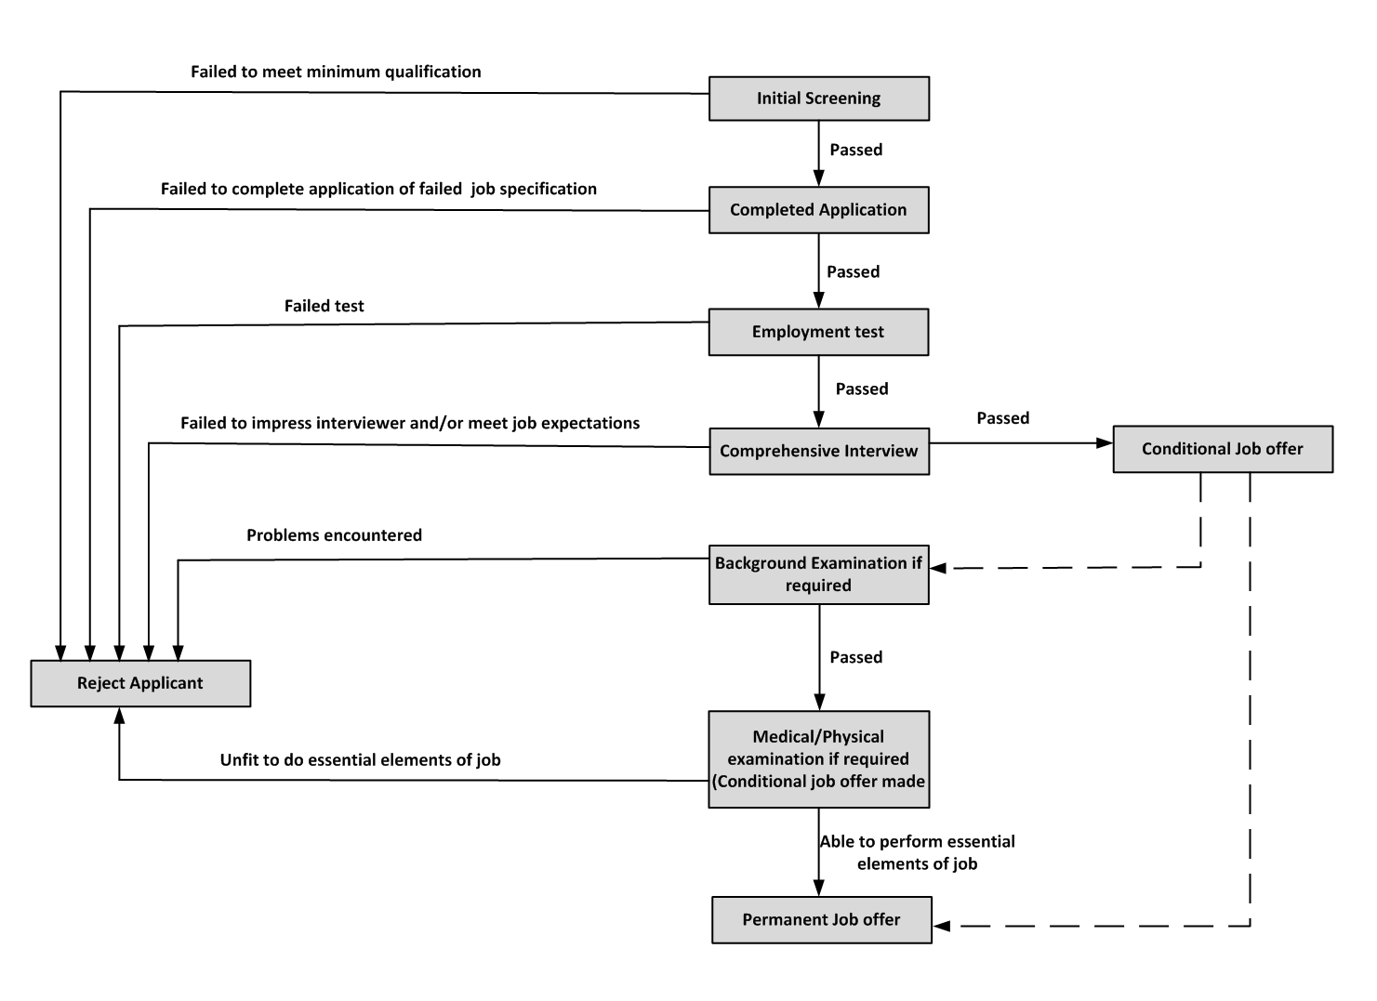

Initial screening
The first step in the selection process involves the initial screening of potential candidates. If the company’s recruiting effort has been successful they will have a pool of potential applicants. The organization can eliminate some of the candidates based on their job description and job specifications. HRM needs to keep the telephone screening interview short. Many organizations are replacing telephone screening with online video screening. An important point during initial screening phase is to identify a salary range.
Completing the application form
After completing the phone screening interview, applicants may be asked to complete the organizations applications form. In general the application form includes the applicant’s information, education, experience, skills, and references.
Comprehensive Interviews
After the application for, initial screening applicants required the comprehensive interview. The applicant may be interviewed by HRM interviewers, senior managers within the organization, a potentials supervisors or some variations. The comprehensive interviews designed to probe areas not easily addressed by the applicants form or tests, such as assessing the candidates motivations, values, ability to work under pressure.
Conditional Job Offer
If a job applicants has passed each step of the selection process so far, a conditional job offer is usually made. Conditional job offer typically comes from HRM representative. The conditional job offer implies that if everything checks out such as passing a certain medical test, physical test, then the condition will be removed and job will be offered.

Background Investigation
The next step is to conduct a background investigation of applicants who are potential employees. Background investigation is to check out the information applicants gave correct or not.
Medical/Physical Examination
The next to last step in the selection process may consist of having the applicants take a medical or physical test. Physical exams must be utilized as a determination gadget or screen out person who can't physically agree to the necessities of a vocation. For instance, firefighters must perform exercises that require a specific physical condition. Regardless of whether it is climbing a stepping stool or conveying a harmed casualties. An organization must demonstrate that any required restorative freedom is work related.
Job Offer
Individuals who perform successfully in the preceding steps are now considered eligible to receive the employment letter.

Chapter 3
Company Profile

Organization Overview
Renata Limited first laid in Bangladesh as Pfizer limited as a foreign company. In 1972 it started its operation. Pfizer shifted their proprietary of its Bangladesh operation to local shareholders in 1993. After the entitlement handover, the name Pfizer was changed to Renata Limited.

Renata Limited (formerly Pfizer Limited) put a remarkable effort to be on the top and now they playing the role of leadingpositionandthey are now the fastest growing pharmaceutical and animal health product producer in Bangladesh. Human pharmaceuticals and animal health products are the main business product for Renata ltd. When it is about market share, Renata Limited has become 4th largest pharmaceutical company and in animal health product sector it has become market leader. After serving the local need Renata exports products in different countries such as Afghanistan, Belize, Cambodia, Ethiopia, Guyana, Honduras, Hong Kong, Kenya, Malaysia, Myanmar, Nepal, Philippines, Sri-Lanka, Thailand, United Kingdom, and Vietnam. With approximately taka 50 million of capitalization Renata ltd is listed on the Dhaka Stock Exchange.

Renata limited has three manufacturing sites Mirpur, Bhaluka, Rajendrapur with eight manufacturing facilities. Moreover, Renata Oncology Limited runs two manufacturing facilities.

Company Background:
Renata Limited (formerly Pfizer Laboratories (Bangladesh) Limited) is one of the top 10 market player in term of revenues and market share. Renata basically dealing with the human pharmaceuticals and animal health products.
And they got their lion share of income from it. They are also involved in animal therapeutics and nutrition products manufacturing. Renata currently have more than 5000 employee in the organization who are working in their three manufacturing sites in Mirpur, Rajendrapur and Bhaluka.

They started their journey in 1972 as a foreign company Pfizer (Bangladesh) Limited and maintained service for 21 years. It serves for two decades however in late 1990s Pfizer has changed its focus point from formulations to research. This conversion divested their attention and interest from many countries including Bangladesh. The situation deficeted to transfer of ownership and Pfizer transferred the dominion of its Bangladesh operations to local shareholders, and the named it Renata Limited.
Renata ltd is have near about 300 generic pharmaceutical products including hormones, contraceptives, anti-cancer drugs, oral preparations, cephalosporin, parenteral preparations as well as other conventional drugs. Also about 95 animal therapeutics and nutrition products are produced by them.

Company Profile:
Under the Companies Act 1913, Pfizer Laboratories (Bangladesh) first started its journey as a public limited company in 1972. On 12 May, 1979 it was listed with Dhaka Stock Exchange. Subsequently, the company was renamed as Renata Limited in 1993. The corporate head office of the Company is situated at Plot # 1, Milk Vita Road, Section-7, Mirpur, Dhaka - 1216.

Organogram of Renata Limited

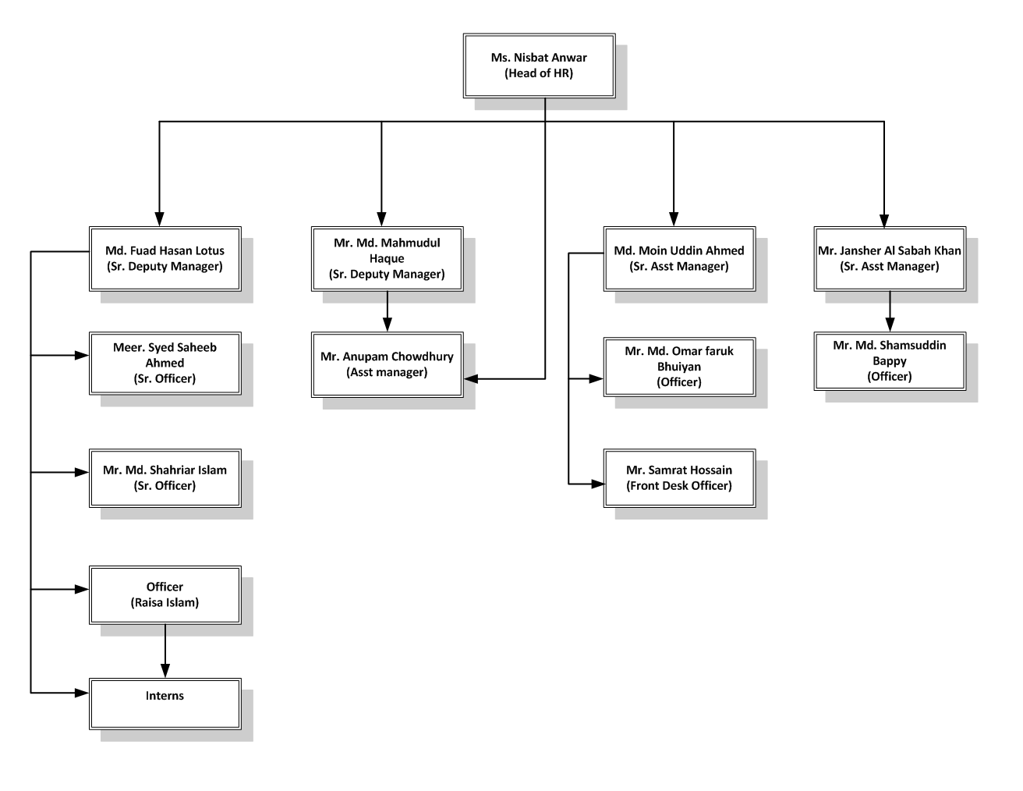

Organization Logo

Subsidiary Companies
Renata Agro Industries Limited
Renata Agro Industries Limited is a subsidiary Company of Renata Limited. It wasumbled on 7 September 1997 as a private limited Company under the Companies Act 1994 with authorized share capital of Tk. 150,000,000 divided into 1,500,000 ordinary shares of Tk. 100 each. The Company inaugurated its commercial operation from October 1998. The principal activities of the Company formed of poultry breeding and hatching and selling of various agro based products.
Purnava Limited

Renata Limited owned this Purnava limited subsidiary company. Purnava wanted to make sure or they wanted to ensure a healthy and preventive lifestyle, so that’s why they avoided the medicated healthcare product. It was incorporated as a private limited company under the companies Act 1994 on 17 August 2004.It was authorized with share capital of Tk. 200,000,000 divided into 2,000,000 ordinary shares of Tk. 100 each. In 2009, Purnava Limited started its commercial operation journey. The principal activities of the Company are manufacturing, marketing and distribution of all kinds of consumer goods, consumer durables, food items, edible oils etc. and to engage in the business as traders, importers, exporters, commission agents of all kinds of goods and services including pharmaceutical products.

Renata Oncology Limited

Renata Oncology Limited was incorporated as a subsidiary Company of Renata Limited on 12 August 2012 under the Companies Act 1994. It started as a private Limited company with authorized share capital of Tk. 1,000,000,000 divided into 100,000,000 ordinary shares of Tk. 10 each. The principal activities of the Company are manufacturing, marketing and distribution of drugs and medicines, allopathic and indigenous and particularly produce and prepare biological and non- biological drugs, injectable of all kinds of tablets of all sorts, serum, vaccines syrup both medicated and non-medicated.

Corporate Social Responsibility
The main focus of corporate social responsibility of Renata is taking care for the employees, doing favor to disadvantaged members of our society, and building a preservable community and environment. This includes:

Healthcare for employees and their families
All the permanent employees, their spouses, and children are covered by Renata health care program. This wide program includes surgery, hospitalization, as well as routine doctor visits.
Support to charitable organizations
JAAGO Foundation is a non-profit organization that works to provide education to children from socially and economically disadvantaged backgrounds. Various support functions work to ensure the sustainable growth of their core schooling program as well contribute to improved livelihoods within affected communities. Besides JAAGO, there is also The Poverty Fight Foundation which is a dedicated non-profit organization working to reduce poverty in Bangladesh. Renata reinforced their program aiming to empower children through education. Bangladesh Infertility Management Centre (BIMC) is a modern and international standard test tube baby and infertility treatment center has been working since 2005. The Centre has taken initiative to develop a “Women Cancer Prevention and Research Centre” under it with a view to help in screening women for prevention of different types of female cancers. It will also perform research work and provide low cost services to under privileged women.
Scholarship for meritorious students
HOPES (Helping Organization for Promising and Energetic Students) runs a scholarship program for meritorious students. Renata Limited sponsored students for studying medicine under the aegis of this program.
Women’s empowerment
In 2015, Mafia Nazreen became the first Bangladeshi to scale all the seven summits. Earlier, Renata supported her expeditions to Mount Elbrus and Everest. Carstenz Pyramid, the final climb of her seven summits expedition was also sponsored by Renata.
Financial assistance to ex-employee and their families
From time to time Renata Limited provided financial assistance to ex-employees and their children.

Organization Vision and Mission
Vision
To establish Renata permanently among the best of innovative branded generic companies.

Mission
To provide maximum value to our customers, shareholders, colleagues, and communities where we live and work.

Responsibilities at Renata as an Intern

When it is about to learning, Renata Ltd. is a suitable and near perfect place to learn different view of work life. This is also an organization where an employee can have work life balance. Also it is an adversity to get the opportunity to work for Renata Ltd.

My activities and responsibilities included:

Empress- HRIS (Human Resources Information System). HRIS has diverse uses and advantages; great enhanced HRIS helps association for the most part in dealing with all HR data. It additionally helps in recoding and investigating workers and hierarchical data and reports, for example, representative handbooks, crisis departure systems, and security strategy (Fletcher, 2005; Lee, 2008; Ball, 2001; Martinsons, 1994). HRIS has organization benefits also including enlistment, position changes and individual data refreshing totally coordinated with finance and the other budgetary programming and bookkeeping frameworks in association (Martinsons, 1994; Fletcher, 2005; Lee, 2008; Ball, 2001).
This is the main project that I was assign to. My responsibilities on this project was to update the basic information of the employees in the software. Renata Limited keep up a personal file for every employee and a “given” or “particular” employee ID number is assigned to every employee to track the employee information. My task was to

- Cross check the basic data of the employee information to see whether the given information was Genuine / true or not.
- Checking whether any important documents were missing or not and take a note of it.
- Cross checking the beneficiary form of the employee to see if there any information was missing or not.
- Maintaining a excel sheet that contains corrected information of the employee.
- Input data in the software after cross-checking the data.

A Study on the implication of HRIS in Renata LTD
Through an enormous amount of planning and development Renata build its information system from traditional way to full fledge HRIS. Previously all the HR management was manual focus which requires a huge amount of time to get it done. Information was scatter and managing the information was a difficult task. As Renata is a huge company with a wide range of division such as depot, plant it requires a huge time and effort to get the information all at once. It is difficult to align the whole management and keep a good track of it through the manual process which creates a miscommunication between head office and the other operational sites. So, HRIS gives a new wings in the HR working process. It took Renata ltd three years to develop a full fledge information system with a huge investment. They are still working in its development and adjusting it with their requirement. So far they are trying to maintain a global standard for their HRIS.
In Renata ltd they use many software to manage its information system. Basically they use different types of software for their information system such as Empress HRIS, ERP, Legacy, and RMC. All branches and departments cannot access all the information in the software. Different branches and departments have the right different to access different information.

Empress HRIS
Now comes the full fledge HR software where mainly whole HR activities runs. The software for human resource information system is basically known as human resource management system for Renata ltd and they name it empress which is developed by a local vendor. Regular HR operational tasks are done through it. Through the application of this software Renata tracks and manages its workforce information which gives HR professionals a better analyze over workforce staffing, productivity and come up with a better management design. This is the core HR function software.

The reason behind launching a new software EMPRESS whereas other software were already on the run was only because of its user friendliness. The oracle that was in the organization for past two years though a really expensive and hi tech software, it was not that user friendly for every level of employee. As the organization’s revenue comes from the sales department, it is necessary to have accurate information about sales related transactions. But the problem with Oracle was that it was way too up to date for general user. The software was rigid in its nature as it was difficult to input any data beyond the programed one. The data entry on this software was also difficult as it has usage of different codes which takes lot of time to get adjusted. As the sales representative working on the field level educated but their skills are not properly developed they were facing problems in using oracle. Also Oracle is an expensive software to maintain. Keeping all those factor in mind, EMPRESS has been launched for the sole usage of HR division to ease the process of employee management.
Empress is a much easier HRIS system which is run by the HR division for better efficiency. It is a more user friendly software than the previous one yet less expensive to maintain. Moreover the upside of this software is that any changes when necessary can be made in this software.

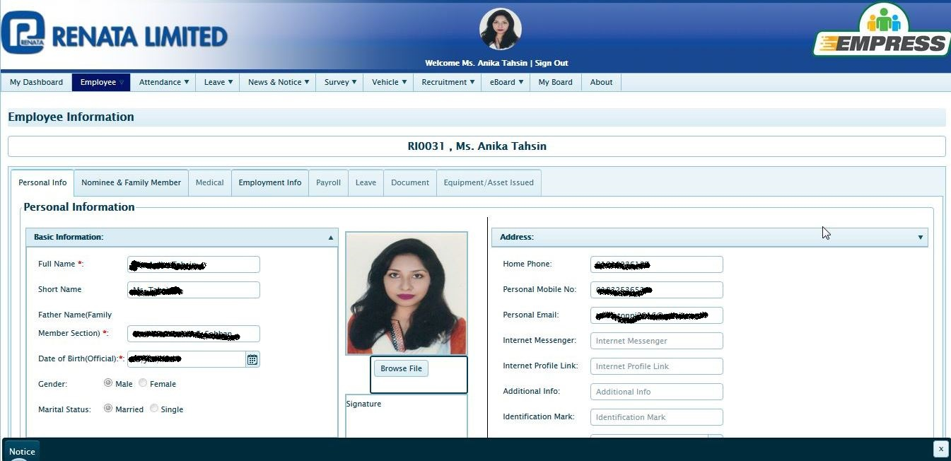

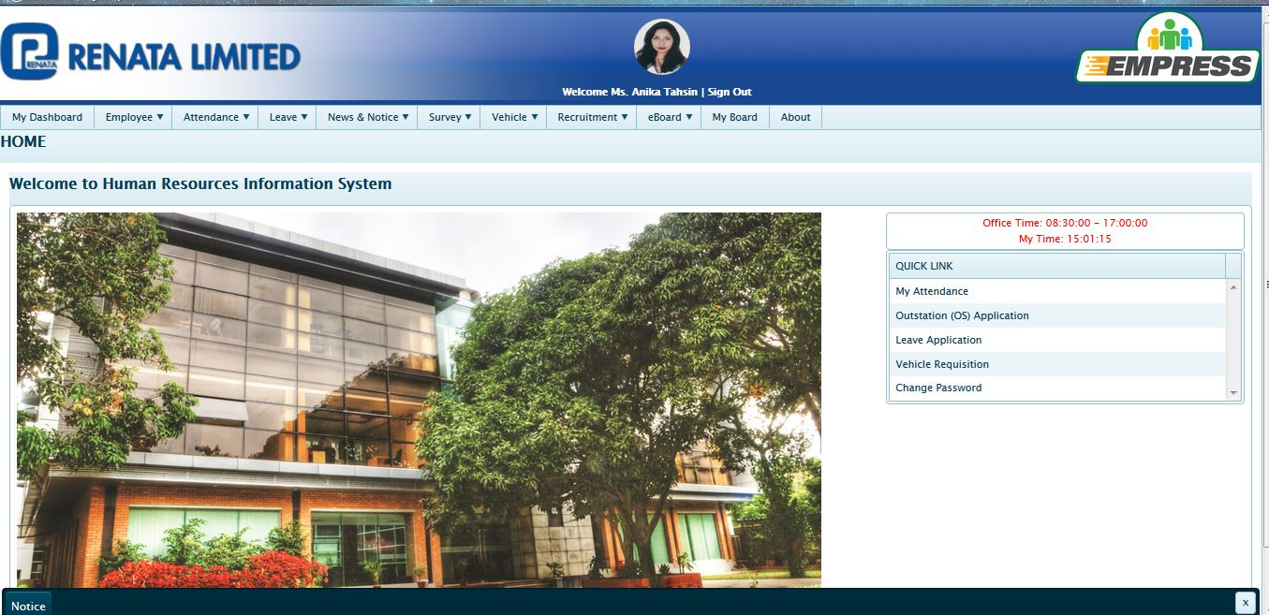
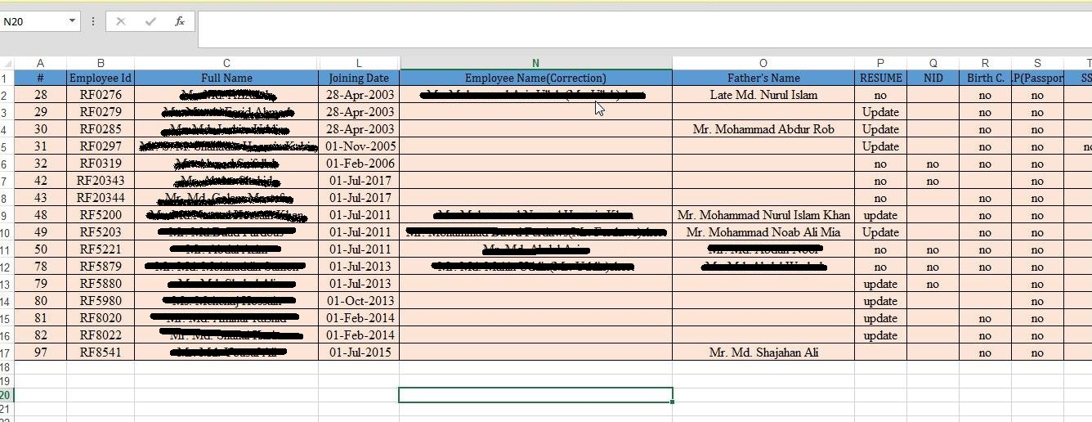
Excel Work: As an intern my task was also maintain an excel file. I put all the information which is missing. I kept record by maintaining an excel file. A screenshot is given up.
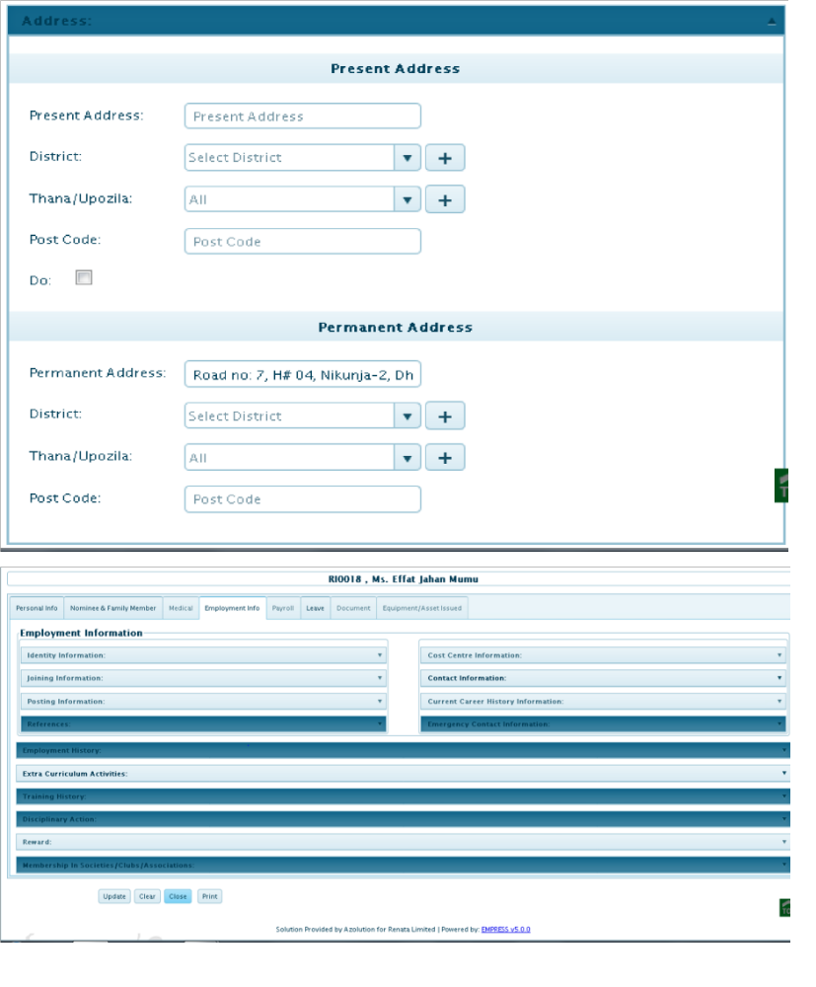

Address, contact information and emergency contact:
Employee present and permanent address are provided along with the contact information such as mobile/phone no, email address etc. There is also a section for emergency contact where employee provided contact details are recorded to contact the person in case of emergency. A screenshot is given up

Education and employee skills:
I was asked to input information about employee’s academic qualification recorded with the verification of academic certificates. For example SSC which year, group, result, school. There is also a section for employee skill where their proven skills are recorded which helps to assign work.

Chapter 4
Recruitment and selection system
of Renata Limited

The Main Agenda of the Report
The right people in the right place at the right time
Every company’s HR department’s goal is to provide the best qualified candidate according to Department’s need in the right positions at the right time. Human resource management department also emphasizes to make an efficient hiring and staffing process. They always look for ways to make hiring methodology efficient. They also try to use further analytical methods in recruitment process to understand the employee’s need, employee levels and most importantly the effectiveness of the existing recruitment strategies. The reason for Renata Limited HRD's enlistment and determination process is to give confirmation of opening will be filled by the most skillful group of HR. Renata Limited give break even with openings for work to all candidates maintaining a strategic distance from inclinations of bigotry, religion, sexual orientation, age, handicap or some other criteria passable by the statutory laws of the nation.
Employee Requisition process
The employee requisition is the first recruitment process of this organization. In this step the approval of employee seizure is taken to start the recruitment process. For this, department first have to understandand need to analyze the ongoing current activities, the organizations future upcoming expansion plans, working situations and culture. Department also explore the competencies needed for the specific devoid position, which includes job title, deliverables for the certain job, the measure of key obligations and other critical details which are needed. Recruitment and selection is the human resources function of identifying, attracting, screening and hiring the most qualified candidate for a job opening. When entering upon the recruitment and selection process, an entrepreneur must figure out many things. Before meeting with a job applicant, the hiring manager must decide upon the responsibilities of the position. He must also be clear about the educational background, professional experience and qualitative manners he seeks in the ideal candidate. In addition, he must identify a salary that is in line with the organization’s budget.

Recruitment
- Collection of applicants’ CVs
When requisition announcement for any position comes, the first thing they dot is to prepare a circular. After that applicants drop their CVs through E-mail or by dropping it personally. When they give circular on BD JOBS, it automatically finds out that which CVs matches (percentage) with the specific job description. The required amount of CVs is collected within 20/30 days. And then my work starts. I started collecting those CVs and I reserve those CV’s for further appraisements.

- Sorting Collected CVs
After the submission deadline of the CVs, as per instruction I sort out the CV’s. It is my responsibilities to gather information about the position and the job responsibilities of that position. I was provided some sorting criteria to sort the CVs by them. The sorting criteria usually included- education, institution, age, experiences etc. These criteria were based on the necessityof the position they are searching for.

- CV Screening Criteria of Renata Limited
- Applicants can’t apply several times for the same position.
- If the job is entry levels job then they will first give priority to the public university students. Then they consider the result.
- If the job is Midlevel job then they give priority age, University, experience, result.

- Communicating with the applicants
This was a challenging task for me becauseI had to communicate with them andI needed to be prepared for their queries. Usually they had so much queries some were pertinent, some were irrelevant. It became more complicated when I needed to convince the applicants about our working environment. Sometimes, our demandswere not matching with the applicants and sometimes applicants’ preferences were not matching with our company’s policy. Sometimes they have demand for different time slot or demand for a different new schedule for interview which is quite difficult to arrange. At the end, this task helped me to develop my communication skills. Also this task helped my skill of convincing people in a calm and proper manner.

- Preparing Summary of the applicants
After that a date will be settled for composed test or meeting. I have to set up a rundown of chose applicants before do the composed test or meeting. I have to set up a synopsis sheet in which candidates name, number, instructive capability, and years of experience will be incorporated. It encourages an evaluator to experience the competitors plot initially.
- Interview arrangement
- Interview call: From the selected resumes interview call is given 2/3 days before the interview date through Phone/ SMS/ E-mail.
- Interview board: Generally interview board includes minimum 3 interviewers, two from Human resource management department and one from the specific department where recruitment is needed.
- General interview questions: During the interview, the hiring manager asks the candidate questions specific to their background and how it relates to the job at hand. Some common interview questions are:

1. Tell us about yourself. / Tell us about yourself which is not written on your CV.
2. Tell us your specialty. It could be your strength and weakness?
3. Why should we hire you?
4. Where do you want to see yourself after five years from now?
5. Why do you want to work in this organization?

Evaluation Process
Renata Maintain Different Process for Different Segment
They have some different departments. And in case of recruitment the process is also different. For example:

- Marketing Department
At first they take composed test. And after that underlying meeting will be taken by Head of HR or Head of Marketing and afterward last meeting will take their overseeing Director. As we realize that Renata is a deals centered organization so they give more spotlight on their business division. What's more, they won't do any sort of bargain on marking.
- Quality Department / Quality control Department / Research and Development Department
Applicants face at first written test and then lab test and after that a final interview.

- Human Resource Department
At first applicants will face written test. After that a communication skill test. After that a leadership skill test. And then a presentation and finally Head of HR will take an interview.
- Field Force
At first they take a written test along with a walking interview. When they select from them then applicants will be given a 45 days training with a lumsum amount. Then training manager will evaluate them and took a final interview and then finally they get the job.

Chapter 5
Data Analysis and Interpretation

Data analysis and interpretation
The analysis has done from the interview answers of three recruiting managers of Renata Limited. The managers who have participated this question answer session are:
1. Mr. Md. Fuad Hasan Lotus
Senior Deputy Manager
Human Resource Division
2. Ms. Israt Jahan
Senior Officer
IT Department
3. Mr. Md. Shahariar Islam
Senior Officer
Human Resource Division

Analysis of Question answer:

Question no. 1 focuses on: number of qualified candidates:

After analyzing the first question that is, “Is the number of qualified candidates is consistently fewer than requirement?”

Three of the recruiting officer finds that the number of qualified candidates is always higher than requirement, but in a different situation, it varies. Ms. Israt Jahan, Senior Officer of IT Dept. said, as being a well reputed company many high profile candidates do apply in Renata ltd. The observation of Mr. Md. Shahariar Islam said the same thing. He considered the present workforce status to show that, the number of qualified candidates is gradually increasing in terms of the requirements. HRD wants to hire someone who can be beneficial and make other co-worker’s life easier. So, they select the resume that demonstrates the past successes which can be accomplished for them. They avoid the resume which only lists just work duties and tasks and don’t focus on the achievements. Another recruiting manager Mr. Md. Fuad Hasan Lotus, Senior Deputy Manager, Human Resource Division has different opinion that it cannot be said surely that they always get fewer qualified candidates than the requirement. It actually varies from situation to situation. Also it depends on requirement and on the importance. However, the final justification is that in most cases, they find qualified candidates with the necessary technical knowledge required to perform the respective jobs.

Question no. 2 focuses on: the hiring stage where qualified candidates are found

The question was in which hiring stage qualified applicants are found?

Different recruiting officers answered this question differently. Two of the officer of HRD has different observation about this question. On the other hand, Mr. Md. Shahariar and Ms. Israt have given same opinion. Mr. Md. Shahariar Islam, Senior Officer, HRD said, at the screening stage they find the required qualified candidates. The search committee evaluates applicant’s qualifications and subject them to intense scrutiny to determine which applicants are the most qualified for the position. Mr. Md. Fuad Hasan Lotus, Senior Deputy Manager, HRD said, the qualified candidates are finally found after the first interview. Ms. Israt Jahan, Senior Officer, IT Dept. said, they find qualified candidates at the entry level which is screening level of the recruitment process. So, their final justification is that they find the qualified candidates at the CV screening stage but sometimes they find qualified candidates at the first interview level.

Question no. 3 focuses on: Cope up capacity of employees with the company culture

The question was, “Are newly hired employees fitting in well with the company culture and other employees?”

Most of the officers answered this question almost similarly. The senior IT officer has said, the new employees are fitting in well with the company culture and other employees. They are welcomed by the department & it seems to have a good adoption from both sides. The senior officer and senior deputy manager of HRD has said sometimes newly hired employees take time to fit in the organizational culture and some can easily fit in because they are selected wisely before taking entry in the organization. Md. Shahariar Islam said, in most cases they eventually fit with the company's culture. Since when they intend to enlist another colleague, they centre around how well that planned worker will fit into this organization culture. Some flourish with strict procedures and limited measures of progress, similar to month to month portions. Others lean toward a more casual way to deal with business, with a ping-pong table set up to empower imaginative energies. Employing the correct kind of individual bodes well than attempting to fit a square peg into a round opening. A representative who's not a solid match for this organization won't remain long, and after that they'll need to begin the contracting procedure once more. Talking candidates for positions at each level – from section level to top-level administrators – HRD more often than not centers around the candidate's close to home attributes and qualities. At that point, build up a rundown of work inquiries to decide whether a candidate would be a solid match with the correct abilities and the correct mentality to incorporate into this organization culture.

Question no. 4 focuses on: Performance of newly hired employees

The question was, “Is the performance of newly hired employees meets the expectation of managers?”

The answer of this question has been given averagely by the recruitment officers. The IT officer said, this may take a little bit longer time to handover important responsibilities to freshers but they seem to be very serious & eager to take over the platform. The senior officer of HRD said, Performance of newly hired employees meets the expectation of managers by ensuring schedule and conduct regularly occurring one-on-one meetings, continue to provide timely, on-going, meaningful “everyday feedback”, elicit feedback from the employee and be available to answer questions, explain the performance management process and compensation system, discuss performance and professional development goals, Give employee an additional assignment. If expectation doesn’t meet they also provide the necessary training to the employees. Senior Deputy Manager of HRD said, Sometimes employees do mistake, everyone do, so considering that part most of the time employees are able to meet the expectations. So, the answers of the managers do not give a clear image that the performance of newly hired employees meets the expectation of managers or not.

Question no. 5 focuses on: time to fill a vacant position

The question was, ‘How much time does it take to fill a vacant position?’

Two of the HR recruiting officer has given the same answer of this question. They said that it normally takes 2 weeks to 1 month and the recruitment depends on the job description and urgency of filling the vacant position. The senior IT officer said, Most the times there is no empty post in IT department because employees are very attached to this department. But if there is any vacant position it takes a very short time to fill. So, according to three of the officer’s opinion, it takes 2 weeks to 1 month to fill a vacant position which is very short.

Question no. 6 focuses on: time to fill a vacant position

The question was, “what are the constrains you face during recruitment?”

Different recruiting officer answered this question differently. IT department face different problems from other departments. Ms. Israt said, the first problem they face is Mostly freshers apply but IT department needs more experienced people. Another problem is, Sometimes there are a huge number of qualified people so it is difficult to CV Screen and select for only one position available. In short, candidates have to face a huge competition to get the desired job. Mr. Md. Shahariar mentioned about four problems, they are: 1. Sometimes They need to make a Speedy Hire for urgent recruitment as a result they don’t get the perfect person for the position, 2. They also face problem for not having enough resources to get the perfect candidate, 3. They face difficulties to find workers who fit the company culture, 4. Sometimes understanding and using the job analysis is not effective enough as because it doesn’t meet the organizational need. On the other hand Mr. Md. Fuad Hasan mentioned about problems which are similar to as Mr. Shahariar has siad, which is, they face problem when they have shortage of time for recruitment but somehow they manage it always to get the desired candidate. So, after analysing the answer of this question it can be found that they mainly face problems at the time of speedy hiring as a result some of the hire candidates face problem to fit in the company culture. So, different department face different problems at the time of recruitment.

My Observation
- A regular training session for the employees is organized by Renata HR to ensure employee development. And this is very positive side of the organization as well as for the employees.
- In every month Renata organizes celebrity training session. The guests or the celebrities also shares their real life experience, they share their struggles, thoughts, which works like a motivations for the sales force of renata.
- Their HRIS software is still in the finalization stage, while working I have faced some technical issues.Through this incident the organization could know where the problem is in the software and immediate measures can be taken to solve the bugs in the software.
- The Empress HRIS (Human Resource Information System) software is approachable only for the employee of Officer and above level. For security measures this software can only be used in the Renata Limited Network only. Employee cannot use the software in open network.
- Sometimes there are mismatch of information. Sometimes the information doesn’t match with the documents or there are no information at all. These created hindrance and confusion while working thus slowing down the other process.
- As this organization is operating for a long time there have been many changes and updates being made in the employee information system. When they are updating the new software there were many information boxes that should have been filled up though they were not necessary in the past, many employee didn’t have it. So Due to the change of Employee Information format over the time there are mismatch in the provided information and present scenario.
- The confusion with information happened due to lack of supervision from the divisional end. It is the duty of the concerned authority to ensure that the employee is providing the necessary and important documents and information.
- HR Division has introduced the Role Profile Project so that they can make the organizational procedures more structured as well as managing more accurately the organizational works, responsibilities, requirements and competencies. The idea of maintaining role profile is almostnew so this is very difficult to merge all the old and raw data and unstructured job descriptions in to the new role profile format.

Recommendation
In this part, I came up with the following recommendations that might help Renata limited to enhance their efficiency and make the organization more organized and stronger.

- The end user should be given necessary access so that they can have better access to their personal management system. It will make them feel authorized and important to the company.
- Day to day follow up of the software will help to maintain the skill and help to achieve the project vision.
- The organization should arrange more training sessions for the employee to have better knowledge on the software.
- Employees should get advancement training along with training on system from the management.
- Management should be confirmed the proper supervision of employee information record system. The supervisors should be more concern about the employee information’s documents.
- Renata is now focusing on the structured role profile of the employee which is a very good move in increasing organization efficiency. It needs to be ensured that the job responsibility is being matched with the employee ability and skills.

Conclusion

For any organization HRM is an important andobligatory part. The exact implementation of the HR practices and activities helps the organization in the long run. That is why Renata always gives high priority in the overall HRM practices.

HRIS (Human resource information system) plays a dynamic part, when it comes to the total representation of the organization. Doing Investment in a HRIS combined with the company’s goals, objectives and values is the investment of its long term goals, profit and success. It is the chain with the progress of the employees and employee development has the direct impact on organization performance. It is essential to give more focus on employee betterment so that they are competent enough. Also if organization focuses on employee growth, employee will feel more connected to the organization.

.

Bibliography

- https://www.ahri.com.au/assist/recruitment-and-selection
- https://books.google.com.bd/books?id=ndwp9W6TYi4C&printsec=frontcover#v=onepage&q&f=false
- https://books.google.com.bd/books?id=s6K81LePGqEC&printsec=frontcover#v=onepage&q&f=false
- Fundamentals of Human Resource Management (David A. DeCENZO) (Stephen P. Robbins) ( Susan L. Verhulst)
- https://renata-ltd.com/
- https://en.wikipedia.org/wiki/Renata_Limited
- https://www.facebook.com/RenataLimited/

Appendix
Name of interviewee: Ms. Israt Jahan
Designation:Senior Officer
IT Department

Interview questions for recruiting managers:

- Is the number of qualified candidates is consistently fewer than requirement?
- As being a well reputed company many high profile candidates do apply. So, the situation is reverse.
- In which hiring stage qualified applicants are found?
- Mostly on entry level.
- Are newly hired employees fitting in well with the company culture and other employees?
- Yes, new employees are welcomed by the department & it seems to have a good adoption from both side.
- Is the performance of newly hired employees meets the expectation of managers?
- It make take a little bit longer time to handover important responsibilities to fresher’s but they seem to be very serious & eager to take over the platform.
- How much time does it take to fill a vacant position?
- Most the times there is no empty post as employees are very attached to this department. But if there is any vacant position it takes a very short time to fill.
- What are the constrain you face during recruitment?
- Mostly fresher’s apply but IT needs more experienced people.
- Sometimes there are a huge number of qualified people so it is difficult to select for only one position available. In short, candidates have to face a huge competition.

Name of interviewee: Mr. Md. Shahariar Islam
Designation: Senior Officer
Human Resource Division

Interview questions for recruiting managers:

- Is the number of qualified candidates is consistently fewer than requirement?
- If we considering our present workforce status, the number of qualified candidates is gradually increasing in terms of the requirements. We want to hire someone who will make our lives easier. So your resume should demonstrate what your past successes can accomplish for them. Avoid listing just your work duties and tasks, but instead focus on your achievements.
2. In which hiring stage qualified applicants are found?
- At the screening stage, the role of the search committee is to evaluate applicant’s qualifications and to subject them to intense scrutiny to determine which applicants are the most qualified for the position.
3. Are newly hired employees fitting in well with the company culture and other employees?
- In most cases they eventually fitted with the company's culture. Since when we are intending to contract another colleague, we center around how well that imminent worker will fit into your organization culture. Some flourish with strict procedures and limited measures of progress, similar to month to month portions. Others lean toward a more casual way to deal with business, with a ping-pong table set up to invigorate inventive energies. Enlisting the correct sort of individual bodes well than attempting to fit a square peg into a round opening. A representative who's not a solid match for your organization won't remain long, and after that you'll need to begin the enlisting procedure once more. Talking candidates for positions at each level – from section level to top-level directors – we as a rule center around the candidate's close to home attributes and qualities. At that point, build up a rundown of work inquiries to decide whether a candidate would be a solid match with the correct abilities and the correct outlook to incorporate into your organization culture.
4. Is the performance of newly hired employees meets the expectation of managers?
- Performance of newly hired employees meets the expectation of managers by ensuring #Schedule and conduct regularly occurring one-on-one meetings. Continue to provide timely, on-going, meaningful “everyday feedback.” Elicit feedback from the employee and be available to answer questions. Explain the performance management process and compensation system. Discuss performance and professional development goals. Give employee an additional assignment. Also provides the necessary training.
5. How much time does it take to fill a vacant position?
- Usually 2 weeks to 1 month depending on the job description and urgency
6.What are the constrain you face during recruitment?
- The need to make a Speedy Hire. Not having enough resources. Being unable to find the perfect candidate for a certain position. Finding workers who fit the company culture. Understanding and using analytics effectively.

Name of interviewee: Mr. Md. Fuad Hasan Lotus
Designation:Senior Deputy Manager
Human Resource Division

Interview questions for recruiting managers:

- Is the number of qualified candidates is consistently fewer than requirement?
- Not always, but it varies from situation to situation. Also it depends on requirement and on the importance.
- In which hiring stage qualified applicants are found?
- After first interview.
- Are newly hired employees fitting in well with the company culture and other employees?
- Yes. In some cases after few times.
- Is the performance of newly hired employees meets the expectation of managers?
- Sometimes people do mistakes. Everyone do. So considering that part most of the time they are able to meets the expectations.

5. How much time does it take to fill a vacant position?
- Usually 2 weeks to 1 month depending on the job description and urgency

6.What are the constrain you face during recruitment?
- Sometimes we faces some problems and they are
A. We face problem when we have shortage of time for recruitment. But somehow we manage it always.
B. Being unable to find the perfect candidate for a certain position.

