Consumer Buying Behavior in the Fashion Apparel Industry of Bangladesh

Tamanna Alam Tultul

This internship report is submitted to the School of Businesses & Economics, United International University as a partial requirement for the fulfillment of Bachelor of Business Administration Degree

Consumer Buying Behavior in the Fashion Apparel Industry of Bangladesh

Submitted By
Tamanna Alam Tultul
ID: 111 161 109
Major in Marketing
School of Business and Economics
United International University

Supervised by
Kawsar Ahmmed, Ph.D.
Professor
School of Business and Economics,
United International University

Date of Submission: February 19, 2023

Declaration of the Study
As a student of Bachelor of Business Administration program at United International University, I, Tamanna Alam, declare that the work detailed in this report has been completed only for academic purposes. I prepared this document to fulfill the academic requirements.
Furthermore, I certify that I am the only source of the data included in this report. No previously published or written work that has been accepted for academic credit at United International University or any other academic institution is included. The data included in this study comes from a dependable origin that has been appropriately referenced.

Tamanna Alam Tultul
ID: 111 161 109
Bachelor of Business Administration
Major in Marketing
School of Business and Economics
United International University

Acknowledgment
To begin, I would want to express my thankfulness to Allah for the favor with which I was successful in completing my internship report on time and effectively. Both of these accomplishments would not have been possible without Allah's help.
On the other hand, I would like to express my gratitude to Kawsar Ahmmed, Ph.D., Professor of School of Business and Economics, United International University. His valuable assistance, meticulous attention to detail, and willingness to consider the versatility of my viewpoints has been very helpful to me during this procedure. His insightful guidance enabled me to compensate for the gaps in my knowledge and generate a report of quality that meets industry standards. I genuinely want that he would serve as a guiding light for me in the subsequent stages of my life and I pray that this will be the case.
In conclusion, I would like to want to express my gratitude to each and every individual who filled out the online survey and for the time and effort that they put into it. Because to them, I was able to do in-depth research on the topic and write the paper within the allotted time.

Letter of Transmittal
January 04, 2023
Kawsar Ahmmed, Ph.D.,
Professor
School of Business and Economics,
United International University
Subject: Submission of report on “Consumer Buying Behavior in the Fashion Apparel Industry of Bangladesh”.

Dear Sir,
My project report is titled “Consumer Buying Behavior in the Fashion Apparel Industry of Bangladesh” and it is being submitted to you for your evaluation and assessment in order to fulfill the requirements of the Bachelor of Business Administration program at United International University.
Therefore, I am submitting my project report for your evaluation and consideration. To the best of my ability, I have completed the task in line with your instructions and my personal evaluation of my skills and abilities. If there are any follow-up questions about my report, I feel obligated to address them.

Tamanna Alam Tultul
ID: 111 161 109
Bachelor of Business Administration
Major in Marketing
School of Business and Economics
United International University

Executive Summary
Purchase intent, also known as buyer intent, describes the extent to which customers are willing and inclined to buy a product or service from you within a certain period of time. This study aims at evaluating consumer buying behavior in the fashion apparel industry of Bangladesh. The fashion industry in Bangladesh has seen the emergence of a lot of new branded goods and commodities, which has resulted in the development of a variety of brand tactics and marketing. People's traditional interest in clothing has been modified as a result of branded apparel, and businesses in the clothing sector are competing against one another to increase their market share of profits. Businesses from both local and foreign branded have shown interest in the flourishing fashion sector as well as the expanding market. It is essential for a brand to understand the customer's purchase intention because this increases the likelihood of the consumer preferring the brand, continuing to use the brand, having a positive feeling of confidence in the brand, and experiencing a sense of relief in their mind about the purchase.
This paper provides a better understanding of customers’ purchase behavior in the fashion apparel sector of Bangladesh in order to increase the level of satisfaction experienced by the customers. The evaluation of customer purchase intention has been analyzed based on the five elements, which are distinctiveness, consumer group distinctiveness, brand quality, organizational associations, and image consistency. For the purpose of generating this project report, we used a quantitative approach in the form of an online survey to gather in-depth data from 88 participants. As a result, 88 people were included in the sample, with more women than men providing responses. For the purpose of conducting studies on the topic, a standardized questionnaire has been created. The gathering and analysis of the data are carried out in a statistical and descriptive manner, respectively. A descriptive analysis was used for the statistical research that was conducted. Based on the results of the survey, it seems that consumers' perceptions of a brand's image consistency have a significant impact on whether they are willing to make a purchase of a product from that brand's company. However, the following may also influence consumers' decisions to buy fashion industry brand items: consumer group; organizational distinctiveness; associations; brand quality; and distinctiveness.

Keywords: Fashion Industry, Distinctiveness, Brand Quality, Organizational Associations, Purchase Intention
Table of Contents

Declaration of the Study i
Acknowledgment ii
Letter of Transmittal iii
Executive Summary iv
CHAPTER 01 7
INTRODUCTION 7
1.1 Introduction of the Report 8
1.2 Objectives of the Report 8
Broad Objective 8
Specific Objectives 8
1.3 Scope of the Report 9
1.4 Methodology of the Report 9
Sources of Data 9
1.5 Limitations of the Problem 10
CHAPTER 02 11
LITERATURE REVIEW 11
2.1 Consumer Behavior 12
2.2 Consumer Buying Behavior in Fashion House 12
2.3 Consumer Purchase Intention 13
2.4 Brand Image Consistency 14
2.5 Brand Association 16
2.6 Distinctiveness or Perceived Quality 17
2.7 Consumer Group Distinctiveness 18
CHAPTER 03 20
OVERVIEW OF FASHION BRAND 20
Overview of Fashion Brand Companies in Bangladesh 21
About Aarong (BRAC) 21
About Yellow (BEXIMCO) 24
About SadaKalo 26
CHAPTER 04 28
ANALYSIS AND DISCUSSION 28
Data Collection and Analysis Plan 29
Demographic Characteristics of Respondents 29
Ratio of Gender 29
Ratio of Participants’ Age 30
Ratio of Participants’ Occupation 30
Ratio of Preferred Brand in Fashion Industry 31
Survey Statement Analysis 31
Distinctiveness 31
Consumer Group Distinctiveness 33
Brand Quality 35
Organizational Associations 37
Image Consistency 39
Purchase Intentions 42
Descriptive Analysis 44
CHAPTER 05 47
RECOMMENDATIONS AND CONCLUSION 47
Recommendations 48
Find Ways to Engage a Greater Number of Customers towards Brand 48
Improve the In-Store Environment Better 49
Influence Consumer’s Attitude towards Brand 50
Conclusion 51
References 52
Appendix 55
Survey Questionnaire 55

CHAPTER 01

INTRODUCTION

Introduction of the Report
In the history of clothing, a new look has emerged at the beginning of each decade, and before one style goes out, another one quickly takes its place. Branded clothes have transformed people's traditional interest in clothing, and businesses in the clothing industry are fighting to grow their market share of profits. Foreign and domestic businesses alike have shown interest in the booming fashion industry and the rising market. The attributes of the branded product and the characteristics of the individual customer are the primary determinants of a consumer's intention about a certain product. It is important for a brand to be connected with the personality of the consumer, since this increases the likelihood of consumer preference, continued use, a good feeling of confidence, and a sense of relief in the mind of the customer. Both the subjectivities and the objectivities of a consumer's attention may be directed toward a brand. The objective form provides information on the brands, market share, promotional costs, and the strength of distribution systems and the subjective form reflects the brand image, as well as the brand connection, brand awareness, and brand preference. There are a number of major of branded companies in the fashion industry of Bangladesh like Aarong, Yellow, Shadakalo and Dorjibari that are competing with one another to provide customers with the highest level of elegance and luxury conceivable in their items. The main purpose of preparing this project report is to analyze and identify what factors can be affected to the customers’ purchase intention towards branded items in the fashion apparel industry of Bangladesh.

Objectives of the Report

Broad Objective
The broad objective of preparing this report is to study on consumer purchasing behavior in the fashion apparel industry of Bangladesh.

Specific Objectives
- To get an overview of Branded Companies in the Fashion Apparel Industry of Bangladesh;
- To analyze and identify the factors of consumer purchasing behavior in the fashion apparel industry of Bangladesh.
- To provide suggestions about the lacking of branding and marketing activities of consumer purchasing behavior in the fashion apparel industry of Bangladesh.

Scope of the Report
The focus of this research is on enhancing Branded Fashion Firm's bottom line by a closer look at the company's branding strategies, activities, and methods for fashion apparel business through implementing effective marketing and branding strategies. The study's primary purpose is to provide insight on the rationale behind the company's sustainability branding strategies which can be impacted on their purchase intention towards brand. The research also makes an effort to provide insight on the topic of how successful the company's efforts are at retaining existing customers towards their brands. The purpose of this research was to identify the factors of branding and marketing's current functions and identify areas for growth. We also look at how customers in Bangladesh's fashion industry market perceive the industry's various rivals.

Methodology of the Report
In order to compile the report, both primary and secondary sources of data and information have been utilized.

Sources of Data

Primary Sources
The following are the sources from which the fundamental secondary data utilized in the creation of this report were obtained:
- Using online surveys created using Google Forms to collect data and the sample size for the procedure of interviewing and conduction randomly is 88 individuals.
For the purpose of conducting studies on the topic, a standardized questionnaire has been created. The questionnaire was developed using five likert scales, each having a score range from 1 to 5, where 1 = strongly disagreed, 2 = disagreed, 3 = neutral, 4 = agreed, and 5 = strongly agreed, and where there are a total of 21 statements based on the following five criteria: distinctiveness; consumer group distinctiveness; brand quality; organizational associations; and image consistency.

Secondary Sources
Additionally, the report incorporates a variety of various kinds of secondary data. The following is a list of examples that may be considered secondary information sources:
- Internal sources:
  - A few details about the operation of the fashion branded companies.
- External Sources:
  - Journals, articles and newspaper
  - Web-based studies and articles on a variety of topics connected to the tourist industry sites.
  - Web site of fashion branded companies.
  - Ad Firm data.

Limitations of the Problem
During preparing the report and the study of the topic, I have faced some limitations that are listed below:
- Another significant obstacle that was encountered over the period of the study was maintaining the confidentiality of the data collected from the various marketing employees; there are a number of situations in which information that is up to date is kept from the general public.
- It is quite challenging to acquire accurate information and to collect it;
- A great number of procedural concerns were handled directly in the operations by the upper management level, which may have also given rise to the same kind of limits;
- Time and resource constraints also acted as limiting factors;
- Because each and every employee is engaged in their work, they do not always have time to provide a response to the question being asked because they are too busy;
- Due to the very limited timeframe, I was unable to conduct research on a large scale.
- Customers are not willing to make the time and expense required to fill out the questionnaire. There are some individuals who are quite unfriendly when they say no.

CHAPTER 02

LITERATURE REVIEW

Consumer Behavior
Taking into account that consumer behavior can be defined as a reaction that is observed either directly or indirectly, there are a number of distinct and varied substantive sectors of human development. These sectors include physical, perceptual, cognitive, linguistic, personality, and social development (Esposito, 2017). CB is influenced by factors that include cultural (culture, subculture, social class), social (groups, family, roles), personal (age, career, economic power, lifestyle, personality), and psychological aspects (motivation, perception, learning, beliefs, and attitudes) (Kotler, 2022). CB is a field of study that examines how individuals, groups, and organizations choose, purchase, use, and discard goods, services, concepts, or experiences to satisfy their needs and desires and to avoid receiving negative reinforcement. This is done with the goal of maximizing positive reinforcement and minimizing the likelihood of receiving unfavorable reinforcement. In the first place, the customer wants to feel at ease and satisfied with their time spent buying (Kotler, 2022).
To get an understanding of the factors that contribute to this reward and loss aversion, it is necessary to do processes and outcomes on the factors of motivation that include emotion, attention, cognition, and memory (Milakovic, 2021). People make decisions based on their habits, their own experiences, and streamlined versions of standards and guidelines (Kahneman, 2011). They strive for coherence in both their ideas and their perceptions, keeping in mind that collective actions are the product of an outside force that transmits social signals (Solomon, 2017). Several cognitive biases, including "social proof" and "the herd effect," provide empirical support for the persuasive power of mass peer pressure on purchasing decisions (Kahneman, 2011). The identification of competitive advantages in brand-consumer interactions is made possible by collecting and analyzing consumer data at the right time, as well as by gaining insight into customers' immediate needs and wants (Krzyk, 2012).

Consumer Buying Behavior in Fashion House
In the history of clothing, a new look has emerged at the beginning of each decade, and before one style goes out, another one quickly takes its place. Jamdani, Reshmi silk, Rajshahi silk, and other forms of handiwork are among Bangladesh's most cherished exports. Superfine silk; Dhaka Muslin, yarn decorated with elaborate hand embroidery, is perhaps the most well-known yarn to come out of this section of the subcontinent. When a marketer has a firm grasp of their target demographics’ tastes, they are better able to win over and keep those people as customers. Branded clothes have transformed people's traditional interest in clothing, and businesses in the clothing industry are fighting to grow their market share of profits. Foreign and domestic businesses alike have shown interest in the booming fashion industry and the rising market. Highly trendy clothing, especially for women, may now be purchased for a surprisingly cheap price. Women, in general, are seen to perceive shopping as a hedonic and enjoyable pastime. It seems that women have a generally optimistic outlook on shopping and look forward to participating in this group activity. The clothes a woman wears are a crucial aspect of her identity and an integral component of her daily life. The definitions of 'brand status,' 'brand attitude, “readiness to pay premium, “self-respect,' 'brand name,' 'brand popularity,' 'brand image, “reference groups,' and 'cultural impact' are examined, along with the links between these concepts and consumer behavior. In recent years, a slew of Bangladeshi boutiques and menswear labels have debuted lines aimed squarely at the country's rising generation of educated professionals and students.

Consumer Purchase Intention
The concept of purchasing intention refers to a possible choice to acquire a certain goods, such as giving serious thought to buying a particular brand and instruments that make the evaluation of potential purchases more straightforward (Porter, 1974 ). A buyer's perspective, assessment, and the external factors all contribute to the formation of a buyer's purchase intention; this is a primary reason to predict buyer behavior (Fishbein, 1975).
The term "purchase intention" refers to a consumer's desire to buy a certain product or service and is used to describe their level of interest in making a purchase of that good or service (Xiao, 2018). The motivation to buy is a dependent variable that is affected by several independent factors. A respondent's attitude toward a purchase or use of a service might be gleaned from their stated plan to buy or use the item or service. Multiple studies provide support to the idea that consumers' familiarity with a brand influences their propensity to buy that brand (Dubois, 1995).
The attributes of the branded product and the characteristics of the individual customer are the primary determinants of a consumer's intention about a certain product (Porter, 1974 ). It is important for a brand to be connected with the personality of the consumer, since this increases the likelihood of consumer preference, continued use, a good feeling of confidence, and a sense of relief in the mind of the customer (Biel, 1993). The ability of a brand to differentiate itself in the eyes of customers, therefore influencing their purchasing decisions and increasing their desire to buy is referred to as brand image (Aaker, 1997). Both the subjectivities and the objectivities of a consumer's attention may be directed toward a brand. Information on brands, market share, promotional expenses, and distribution system strength may be found in the objective form (Reddy, 1994) whereas a brand's image, connection with its target audience, and awareness among consumers can be found in the subjective form (Aaker D. , 1990). Brand equity is heavily influenced by how well products are perceived to perform (Aaker J. , 1997). The term "perceived quality" refers to the consumer's subjective appraisal of the product rather than its objective quality (Porter, 1974 ). (Biel, 1993) And (Reddy, 1994) both find that consumers' perceptions of a company's brand have a substantial impact on their propensity to make a purchase. The extent to which people remember and associate a brand with its products or services is known as brand awareness (Dubois, 1995). Aaker distinguished between "brand recognition" and "brand domination," the latter of which is achieved when a customer can think of nothing else save the brand in question. According to (Aaker D. , 1990), customers may benefit from brand connections if they make them more likely to purchase the brand and if they lead to more favorable sentiments about the brand overall. The two main ways people learn about a product are via (a) their own personal experience with the product and (b) the ease with which they may get and evaluate the product for themselves (Fishbein, 1975).

Brand Image Consistency
The name of the brand, any image, symbol, word used for brand, or any combination of these is a brand, and it is one of the most significant aspects of marketing. Brand image refers to the one-of-a-kind impression that consumers have of the brand. One other definition of brand image is the emotional connection consumers have when they think about a brand (Malik, 2012). According to (Keller, 1993), a brand's image is "the set of memories and associations consumers have with a product." According to (Aaker J. , 1997), the definition of brand image as the mental connection people has with any feature of a business. A customer's mental representation of the brand is comprised of his impressions of the product's qualities. Customer recall may be based on factual information, conceptual links, or even mental pictures. It's the mental picture that buyers have in their heads when they consider using the goods. They' connections with a brand, whether based on objective or subjective criteria, will be stronger if consumers know and like that brand. According to research published by (Lin, 2007), there is a high correlation between how consumers feel about a brand and their propensity to buy products from that brand's rivals. The likelihood of a consumer making a purchase decision for a certain brand increases if, in comparison to other brands, it has succeeded in building a favorable image in the minds of its target demographic. Simply said, a brand's image is the set of characteristics that consumers associate with a certain product, as chosen by the consumer from among the many possible combinations. Many factors, such as brand values, brand advantages, pricing, packaging, style, color, etc., are used in brand evaluation (Sondho, 2007).
Customers' tendency to make a purchase is positively influenced by a favorable impression of the brand. A consumer's desire to make a purchase may be inferred from their perception of a company's brand (Dewanti). The chance of a consumer's intention to make a purchase rises in direct proportion to the strength of the brand's image. Increasing the perceived value of a brand increases the likelihood that consumers will make a purchase of that brand (Lin, 2007). Customers' perceptions of a company's brand are one of the most crucial factors influencing their decision to make a purchase. It compels clients to form a favorable and favorable picture of a product in their thoughts in comparison to other brands that are in direct competition with that product. Customers are given the ability to choose whatever product they would want to prioritize and ultimately buy as a result of this. If the product has a positive reputation as a brand, it will foster a constructive and lasting connection with the buyers, which will lead to a rise in consumer loyalty, which will manifest itself in the form of more future sales. It is quite common to establish a good brand image, which will create the long term connection between consumers and brand. This relationship will benefit both parties. There are several fundamental components that could be included in a brand's image, such as the brand's personality, product characteristics, and product advantages. When a brand's image is strong, consumers have a greater tendency to shop with that brand in mind. Advertising has a considerable impact on brand image, which in turn has a somewhat significant association with consumers' intentions to make a purchase of the marketed product or service. The marketing and advertising of the brand is responsible for the moderate connection that exists between them (Tariq, 2013).
Therefore, it is possible to say that the image of the brand has a considerable and favorable link with the customer's intention to purchase and this can be influenced also to the purchase intention.

Brand Association
Everything that comes to mind when you think of a certain brand is called a "associative memory" (Aaker D. , 1990). The uniqueness of a brand can sometimes be recaptured through the power of association. Associating a positive emotion or attitude with a brand can increase sales and encourage a more positive brand perception, both of which are beneficial to the company (Aaker D. , 1990). (Keller, 1993) Defines brand association as the set of memories connected to the brand node that stores the brand's meaning for consumers. Attitudes, benefits, and attributes are the three main types of brand associations that (Keller, 1993) identified. The characteristics that set one brand apart from another are known as its "attributes," and they include things like how consumers feel about a product's quality and the values that drive their decision to buy that brand. The customers' perspectives on the band as a whole are reflected in their brand attitudes (Chattopadhyay, 1988) and the associations that are related to the brand functions reflect a higher level of idea than those that refer to the qualities; in addition, these associations are more easily accessible to the customer and remain in their memory for a longer period of time.
(Aaker D. , 1991) Defines brand associations as the collection of positive and negative connotations that customers mentally associate with a particular brand. Customers and businesses place a high value on the memories associated with a brand. Brand associations are used by marketers to accomplish things like position items in a distinctive way, raise awareness of the brand, boost positive customer sentiment, and hint at the benefits of purchasing and using the brand in question. However, consumers utilize brand associations to store, categorize, and recall data about brands for use in decision-making (Aaker D. , 1991). Although several studies have been undertaken on individual aspects of brand associations (Keller, 1993), none have unified these aspects in a single study to quantify their interconnectedness. There are a variety of scales available to evaluate consumers' feelings toward various brands. (Park, 1994) Created items to estimate and quantify one dimension of dental paste brand associations, such as the brand's capacity to combat plaque, halt the development of cavities, and revive stale breath. Many different types of specialized scales have been created and utilized for many years in various functional and application contexts. The question of whether or not brand connections are a multidimensional or a one-dimensional construct is another important issue that has not been experimentally investigated in the previous research. Successful marketers know that associating their brand with positive feelings in the minds of their target audience is crucial to the success of their business.
Therefore, it is possible to conclude that the customer's brand association has a large and favorable link with consumers’ intention to purchase and this can be influenced also to the purchase intention.

Distinctiveness or Perceived Quality
As (Zeithaml, 1988) points out, it's an important factor in customers' decisions about which brands to buy. Perceived quality is a broad evaluation of the customer, which differs from objective quality (Levy, 2012). The subjective image one forms about a product as a whole is what we mean when we talk about the quality one is given by a brand. Nonetheless, it will often be defined by the underlying dimensions, which may include aspects of the objects such as their reliability and performance. According to, "perceived quality" is the widespread belief among buyers that their chosen product or service is better to those offered by competitors (Aaker D. , 1991). Perceived quality is the buyer's subjective judgment of the goods; it is essentially the buyer's thoughts about a certain brand (Zeithaml, 1988). The term "perceived quality" refers to how a product or service is perceived by a consumer to perform its intended function. Customers' impressions of quality come first. Therefore, it's distinct from a number of closely similar ideas, including:
- Actual or objective quality is defined as the degree to which a product or service provides an exceptional level of service.
- The kind and amount of the components, services, or features that is included in the product as the product-based quality.
- Quality in manufacturing refers to compliance to the specification and aiming for "zero faults."
Previous studies have shown that consumers distinguish clearly between store brands and national brands in terms of quality (Cunningham, 1982). Some stores go out of their way to stress the good quality of their store brands, yet consumers tend to choose name brands over those sold under their own names because of the perception of a quality gap between the two (Hoch, 1993). These stores create premium, high-quality store brands with the goal of competing with popular manufacturer brands, and some of them even try to publicize their store brands in the media (Tsiotsou, 2006). Consumers' impressions and evaluations of a brand's quality are what matter most when it comes to measuring its perceived quality. With a favorable brand image, people are more likely to buy the product and spread the word about how great the company is. Advertisements, word-of-mouth, and favorable associations with a brand may all have an impact on how consumers see its quality. Quality perception is also impacted by a variety of other factors, including consumers' prior experiences, levels of education, awareness of potential dangers, willingness to pay, the timing of the purchase, the event's significance, and the customers' social and cultural milieus (Corfman, 1985). Perceived quality and desire to buy are both affected by how consumers feel about a certain brand. (Lin, 2007) Claim that a competitive advantage may be established between two brands via the dissemination of positive brand messaging. Customers' actions will be influenced and decided by how they perceive the brand.
Managers use advertising as a method of shaping public opinion of their goods by the manipulation of external indicators that indicate excellence (Milgrom, 1986). Product-related qualities such as brand name, packaging, promotion, and pricing are examples of extrinsic cues (Zeithaml, 1988). Inasmuch as quality is a summary construct, it is not always possible to make an objective assessment of it (Aaker D. , 1991). According to (Zeithaml, 1988), consumers' perceptions of quality might be decisive in the final decision.
So it can be said that, distinctiveness or brand perceived quality has significant and positive relationship with customer purchase intention and this can be influenced also to the purchase intention.

Consumer Group Distinctiveness
Consumers often look for details about a product before purchasing it. The buyer researches the product by looking at it, feeling it, asking questions of other buyers, and sometimes reading up on it as well. Customers shift their focus to learning as much as they can about a product so that they may build more accurate expectations about how much they will like using it. There comes a moment in the shopping process when the shopper decides they have seen enough information and will not continue their research. Although the Internet has made it simpler than ever to get information, customers are still making purchases with incomplete data due to the time and effort required for searching and analyzing the data they find (Chen, 2004).
Informed buyers should prioritize digesting messages in a manner that helps them feel like they're making progress toward a goal. Since customers who have more information at their disposal are more likely to make rapid choices, this expectation accords with empirical findings (Thunholm, 2005) and show greater selectivity in the information they consider as a basis for decisions (Lindquist, 2003), even to the point of sometimes overlooking useful information or prematurely stopping the evaluation process (Wood, 2002).
On the other hand, consumers who are less well-versed in a topic tend to choose an evaluation mode, which encourages them to adopt processing techniques that allow them to give each piece of information serious and thorough thought. According to this line of thinking, customers with less information shop around more often than those with more extensive knowledge (Mitchell, 1996). They are also more likely to use data-driven processing, which allows them to gather and weigh all relevant facts (Chi, 1982). Based on these results, it seems that customers with less background information might benefit from using an assessment processing mode, which is characterized by in-depth comparisons across options.
So it can be said that consumer groups’ distinctiveness or their information acquisition has significant and positive relationship with customer purchase intention and this can be influenced also to the purchase intention.
- Brand Image
- Brand Association
- Distinctiveness
- Consumer Group Distinctiveness
- Brand Quality

Consumer
Purchase Intention

CHAPTER 03

OVERVIEW OF FASHION BRAND

Overview of Fashion Brand Companies in Bangladesh

About Aarong (BRAC)
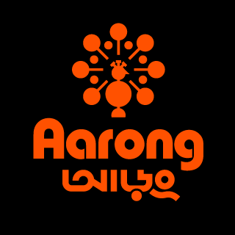
Founded in 1978 to help the impoverished by raising demand for well-liked items created in Bangladesh and encouraging their export, BRAC (Building Resources Across Community) is a CSR (Corporate social responsibility) focused handicraft specialized organization. Aarong is a section of BRAC. The result's designers and creators are credited in ads. As for Aarong, such connections can't be relied on to be the mainstay. Regardless, they rekindle interest in local handiwork and provide new notoriety to existing forms. And what's more, the province's traditional arts and crafts. From its humble beginnings, Aarong has grown into a thriving international enterprise presenting ethnically distinctive and aesthetically pleasing crafts made of anything from handloom cotton and Brac silk and Endi to terracotta, bamboo, jute, and more. That's why Aarong will be recognized as a synonym for quality, innovation, and exclusivity in every corner of Bangladesh and beyond. Aarong Need began with a single store and is now one of the largest retail chains in Bangladesh, with fifteen locations throughout the country's major cities (Dhaka, Chittagong, Khulna, Sylhet, Comilla, Narayangonj). In addition, the London, United Kingdom-based individual has already completed their work. For all of Aarong's boasting about its 65,000 artisans—85% of them are women—he also actively encourages a more diverse range of representations. Aarong also acts as a guardian and advocate for established norms and strategies. It has a large library of architectural plans where artifacts from our diverse artistic past, including Nakshikatha workmanship and Jamdani, have been extensively researched and saved for display and future use.

Brand History
BRAC, the largest NGO in the world, could not have been founded until 1972. In 1976, BRAC made a promise to help the poor by relieving poverty and giving them more opportunities. Similarly, as a consequence, it kicked off a little activity that should promote sericulture among women in the Manikganj area. In 1978, Aarong may have been predetermined by need to help the underprivileged and financially strapped silk producers of Manikganj. The idealistic goal of these women is to provide voice and agency to the expressions and artworks of marginalized craftsmen and women in rural areas. At the time, a few of sellers in Dhaka were their ideal customers. In only a few years, Aarong had expanded from you to stop selling at that one store from among the world's most impressive retail chains in Bangladesh. Now, Aarong requires a massive team of 65,000 craftsmen, including experts like as weavers, potters, metal workers, jewelers, jute workers, box weavers, wood carvers, cowhide specialists, and more. Most of the women involved in these crafts are in need of assistance, and this is a promising indicator that women's empowerment is improving in these communities. It is possible that Aarong has become the best place for independent groups and family businesses to sell their wares to a national and international audience. As an illustrative example of the connecting space where rural women and men may sell their crafts to supplement their family's income, Aarong will be preserved forever.

Logo History
When we go to a local fair, there are many unique and creative items that we see and learn about. Since then, Aarong has established itself as a suitable town in which you may calculate 110 items in line with imaginative, straightforward, and widely accepted portrayal. Tom looks over the results of it eventually. Furthermore government oversight Both the domestic and international business communities recognized the value of the Aarong logo immediately upon its introduction.
The claiming Aarong logo looks like a peacock, which is an animal often associated with prosperity and prestige. Because of the vivid, iridescent, distinctive bright pattern done on its tail, it may be quite appealing. It's possible that the peacock in the emblem is orange. Aarong uses this logo to convey the urgency with which its products need assistance. Also, the image is as magnificent as a peacock. Image-wise, it also wants to highlight the natural, environmentally friendly nature of its products.

Products of Aarong
Although Aarong, a major Bangladeshi fashion business, first opened its doors with the intention of assisting the underprivileged and financially struggling silk growers of Manikganj, the company quickly grew and expanded from a single store to become one of the country's largest retail chains. This business has been actively expanding into international markets since 1984. Parallel to Aarong's expansion, the breadth and depth of the company's product offerings have expanded as well. Aarong now offers over a hundred different product lines. Here are some of Aarong's outputs:
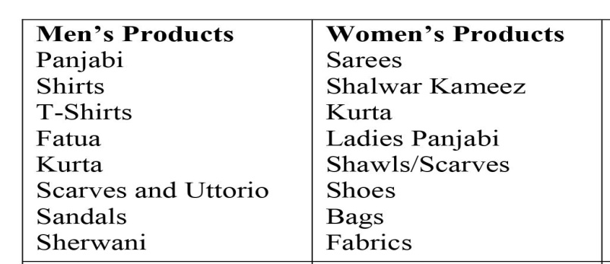
Table 3.1: Listing of Products in Aarong Fashion House

Mission, Vision and Values
Vision: Contemporary reality, where everyone who needs a chance will see their potential, despite the prevalence of abuse and isolation in our society to date.
Mission: The purpose is to enhance people's lives by removing barriers such as lack of education, health, and fair treatment in society. As a result of Aarong's prayers, many people will be helped through financial and social programs that teach them they may achieve their full potential.
Values: values would have the same opinion as people towards BRAC - a group that exemplified the actuality of a novel Advance with its all-encompassing strategy for progress. Your pride and motivation are constantly bruised by the knowledge that over 325,000 individuals around the country have benefited from Aarong's activities.

Services
The disabled craftsmen and low-income rural women who are employed by Aarong have access to a wide variety of specialized programs and services. Aarong was founded to improve rural residents' economic standing and social standing. They did this by focusing on three key problem areas. Working capital, marketing assistance, and training & development opportunities all fall under this category. Aarong argues that these three factors make it difficult to find meaningful work in rural places. To make up for these deficiencies, Aarong offers a few services to its employees and vendors. The following describes these assistance offerings:
- To encourage increased effectiveness In addition, profitability of the time being invested in researching item delivery.
- Interactions between advertising and the final product are crucial for craftspeople. Plus, we can now rest easy knowing that our data is easily accessible.
- To ensure reasonable quality for manufacturers' outreach efforts to far-flung areas.
- Enhancing products by tailoring their configurations And I'm on board with it, too.
- To development cause nature and marketability to supply training and education skills.

About Yellow (BEXIMCO)

Bangladesh's most popular online fashion boutique, Yellowclothing.net, stands out because to its high-quality, innovative designs and fabrics that are recognized all over the globe. Customers that have rebellious tastes in design can sway the company's opinion. It started operations in 2004 as a retail outlet for BEXIMCO, the company's parent brand, and has since expanded to 19 physical locations across Bangladesh and Pakistan in addition to its 24/7 online presence. We have been providing first-rate building at an exceptional value ever since we opened. It sells fashionable clothing, perfumes, and accessories for men, women, and children, as well as items for decorating one's house. The most well-known fashion website now is yellowclothing.net. Fabrics and clothing may be purchased here by the general public with little effort. The website yellowclothing.net has gained a large international following. Fashion from Yellowclothing.net is now available in Canada, India, Pakistan, and Sri Lanka. The majority of the site's organization is handled by this Russian-language program's main supervisor. Prestashop was used to update online catalog data in real time. There is information on every piece, including price, country of origin, color, pattern, fabric content, and care instructions. This is helpful since it encourages the customer to research the product thoroughly before making an online purchase. It also encourages people to learn more before making a retail visit. At the moment, this is functioning as a backend for a "Shopify" website. Finding the customer on the website is a breeze. Customers may easily buy what they need without having to create an account. Shopify, on the other hand, makes it easy for customers to set up an account and then buy whatever it is they desire.

Seasons of Yellow Clothing
The two Bangladeshi locations of Yellowclothing.net operate according to the same fundamental seven-season pattern. Here are the dates for each season:
- Spring
- Summer
- Eid ul Fitr and Eid ul Adzha
- Fall
- Autumn
- Winter
- Boishakh
At this time, it is the summer of 2019 and the spring of 2020. In order to make each holiday and season more joyous and festive for their customers, the color yellow is always front and center. Yellow has made the decision to provide more customer happiness as a result of the increased enthusiasm with which Bengali people celebrate these events and as a result of their altered purchasing patterns in accordance with customary celebrations. Yellow has recently been celebrating the holiday of "Eid ul Fitr" and providing its patrons with unwavering assistance.

Mission and Vision
Mission: If you're looking for a reliable full-service merchant, go no farther than Yellow E-commerce and their expertly coordinated vertical assembly facilities. The same goes for our innovative and scientific abilities, which set us apart from the majority of South Asian vendors. Without a doubt, all of our efforts will improve the standard of living for all citizens. We fully acknowledge that in the final analysis, we are answerable to all of the stakeholders in whom we have a stake, including but not limited to our employees, our customers, our commercial partners, our scientific personnel, and our investors.
Vision:
- Profit demonstrates management and assistance, including high-value items like as apparel in the United States, Europe, and the Middle East.
- The emphasis should be placed on "modernization" and "quickness" rather than cotton and modest labor. Give your customers the clothes and supplies they want.
- Rule these markets with your superior products.
- Emphasizing the development of more refined planning fabrics for Men's, Women's, Children's, and Young Children's apparel.
- Giving complete customer satisfaction and gaining an advantageous edge.
- Meet the requirements of the customer in terms of design..

About SadaKalo
Sadakalo is a clothing brand with a novel idea, showcasing high-end designer apparel in only black and white. The label has its origins in the cultural wealth of Bangladesh.
Despite having a purely commercial goal, Sadakalo's brand effort is inspired by the idea of turning a dream into reality. A fantastical world where the simple contrast of two monochromatic hues—Black and White—spawns an incredible range of possibly limitless design options. Everyone has to keep up with the latest trends at some point. A designer's goal is to arouse an unspoken yearning in the target audience, so that when the product is finally delivered, the buyer would feel as enthusiastic as the designer did about having the final product in their possession. Sadakalo meticulously crafts its wares with that one goal in mind.
Sadakalo first opened its doors to the public on October 4, 2002, in a little shop in Shimanto Square, but the anticipation and excitement surrounding the event were out of this world. Sadakalo quickly reaped the benefits of the motivation provided by each of their customers. Because of this, a second location was opened in Banani well before the first store had been open for a full year. Sadakalo's loyal customer base encouraged us to open a third store in the entertainment district of Baily Road, and then a fourth and largest store, "Designers' Corner," on Gulshan Avenue in November 2006. All of these stores were created with one goal in mind: to showcase the finest examples of black and white design by the world's most renowned fashion houses. The designers' enthusiastic reception helped the showroom, which showcased 10 of the world's foremost designers, to open for business. From Pahela Boishakh 1415 (April 2008), we opened our fifth store in Uttara. Another one of Sadakalo's claims to fame is its novel take on recurring themes.
- Sadakalo joined DeshiDosh in 2009 in Bashundhara City. a) Deshidosh. Ten of Bangladesh's most prestigious fashion firms have joined forces to form Deshi Dosh. One of the criteria used to choose these 10 design studios was their focus on Bangladeshi goods. A second Deshidosh store was launched at Afmi Plaza, Chittagong, in that same year.
- Go beyond Vision strategy saw the company extends its operations to fashion-forward international hubs like New York and Florida in 2009 and 2010, respectively. Sadakalo now operates eleven stores, including nine in Bangladesh and one in the United States.
- Miscellaneous Duties: Sadakalo celebrates national holidays like Ekushe, Independence Day, and Victory Day with great enthusiasm and appreciation. Similarly, the company goes all out to mark the occasion of Boishakh. Our own language and culture are being used to celebrate holidays like Mother's Day, Father's Day, Friendship Day, and Valentine's Day.
Sadakalo Fashions Ltd. has created a new line, Beyond Sadakalo, as an expansion of its well-known brand Sadakalo. It was in 2002 when Sadakalo's quest began. Right from the start, its originality and sophistication won over the hearts of the country's fashion.

CHAPTER 04

ANALYSIS AND DISCUSSION

Data Collection and Analysis Plan
The methods and approaches that were utilized in the implementation of this research study have been analyzed in considerable detail throughout this chapter. This study covers a variety of subjects, including factors and variables related to the issue at hand, the construction of a questionnaire design, the selection of an appropriate sample size, the gathering of data, and the analysis of data.

Demographic Characteristics of Respondents
The results of this survey were based on the responses of 88 participants who differ from gender, age, occupation and preferred brands. As a result, the size of the sample is 88.

Ratio of Gender
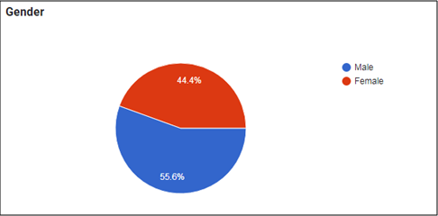
Figure 4.1: Ratio of Gender
Participants in the survey consisted of males 55.6% percent of the cases and females 44.4% of cases (see figure 4.1). As a direct consequence of this, there are a greater proportion of male respondents to this survey than there is of female respondents.

Ratio of Participants’ Age
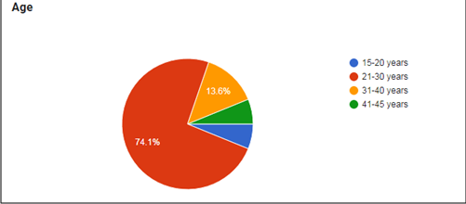
Figure 4.2: Ratio of Participants’ Age
There were a total of 81 individuals who took part in the survey; 74.1% of respondents are fallen in the group of 21-30 years age; 13.6% of respondents are 31-40 years age; 6.2% of respondents are 15-20 years age and 5.2% of respondents are 41-45 years age.

Ratio of Participants’ Occupation
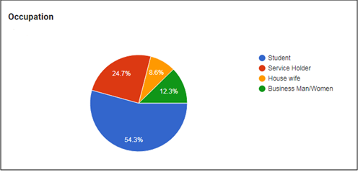
Figure 4.3: Ratio of Participants’ Occupation
There were a total of 81 individuals who took part in the survey; 54.3% of respondents’ occupation is Student; 24.7% of respondents’ occupation is Service Holders; 12.3% of respondents’ occupation is Businessman and 8.6% of respondents’ occupation is Housewife.

Ratio of Preferred Brand in Fashion Industry
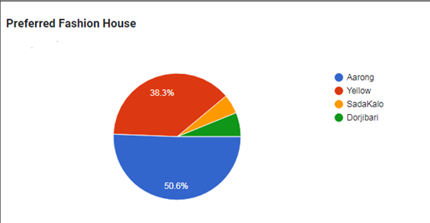
Figure 4.4: Ratio of Preferred Brand in Fashion Industry
There were a total of 81 individuals who took part in the survey; 50.6% of respondents’ preferred brand is Aarong; 38.3.7% of respondents’ preferred brand is Yellow; 6.2% of respondents’ preferred brand is Dorjibari and 4.9% of respondents’ preferred brand is SadaKalo.

Survey Statement Analysis

Distinctiveness
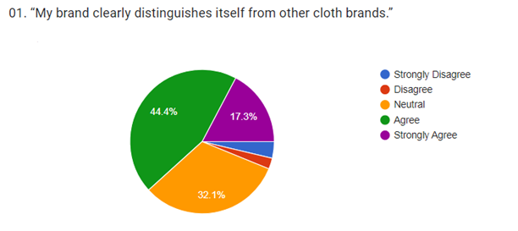
Figure 4.5
According to the figures displayed in Figure 4.5, a total of 61.7 % of respondents agreed with this statement. On the other hand, 32.1% respondents are neutral and 6.2% respondents are disagreed on this statement and they think their brand does not distinguish itself from other cloth brands.
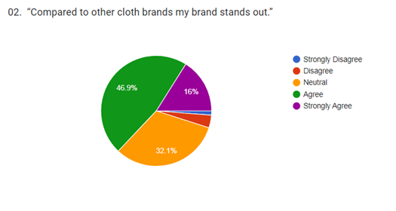
Figure 4.6
According to the figures displayed in Figure 4.6, a total of 62.9 % of respondents agreed. On the other hand, 32.1% respondents are neutral and 4.9% respondents are disagreed on this statement.
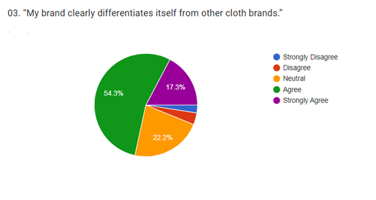
Figure 4.7
According to the figures displayed in Figure 4.7, a total of 71.6 % of respondents agreed. On the other hand, 32.1% respondents are neutral and 4.9% respondents are disagreed on this statement.
In summary, it can be said that, consumers distinguish clearly between store brands and national brands in terms of quality. And according to the data, the majority of respondents (On average 57%) agreed that for getting high quality of products with having long durability and good performance, their brand is distinguished from other clothing brands. And also for being the superiority of a product or service compared to the other brand their brand stands out compared to other cloth brands. For it, the majority of the respondents’ purchase intention is being tended to be the Aarong and Yellow brand rather than Dorjibari and SadaKalo brand.

Consumer Group Distinctiveness
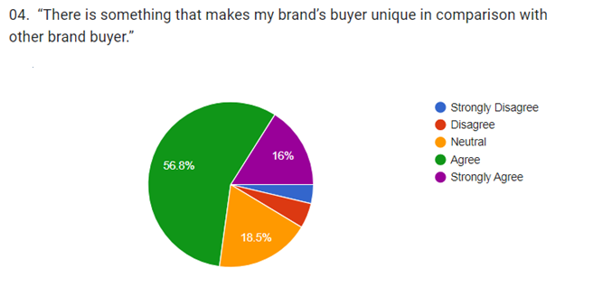
Figure 4.8
According to the figures displayed in Figure 4.8, a total of 72.8 % of respondents agreed. On the other hand, 32.1% respondents are neutral and 4.9% respondents are disagreed on this statement.
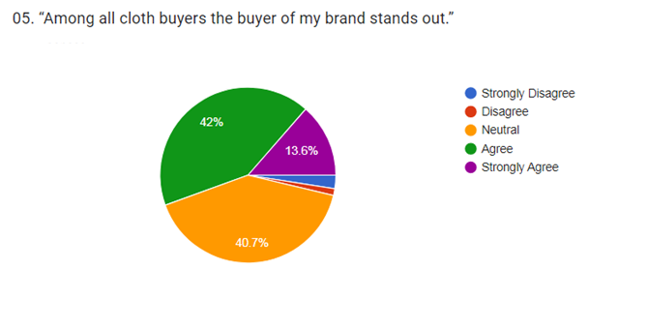
Figure 4.9
According to the figures displayed in Figure 4.9, a total of 55.6 % of respondents agreed. On the other hand, 40.7% respondents are neutral and 3.7% respondents are disagreed on this statement.
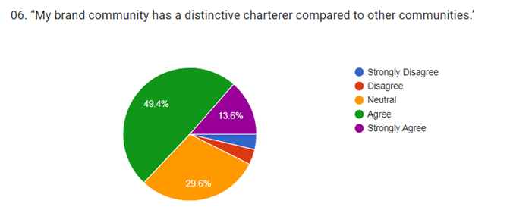
Figure 4.10
According to the figures displayed in Figure 4.10, a total of 63.0 % of respondents agreed. On the other hand, 29.6% respondents are neutral and 7.4% respondents are disagreed on this statement.
In summary, on the basis of data and overall agreement average 56% average, it can be said that consumer groups’ distinctiveness or their information acquisition has significant and positive relationship with customer purchase intention and this can be influenced also to the positive word of mouth about the brand. For it, the majority of the respondents’ purchase intention is being tended to be the Aarong and Yellow brand rather than Dorjibari and SadaKalo brand.

Brand Quality
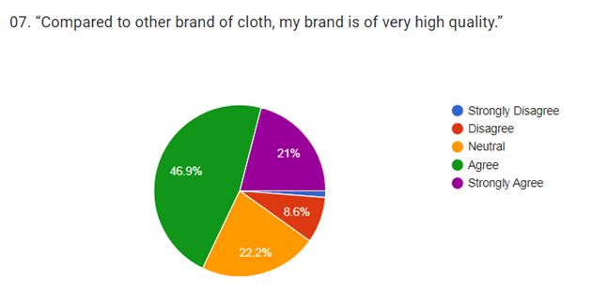
Figure 4.11
According to the figures displayed in Figure 4.11, a total of 67.9 % of respondents agreed. On the other hand, 22.2% respondents are neutral and 9.8% respondents are disagreed on this statement.
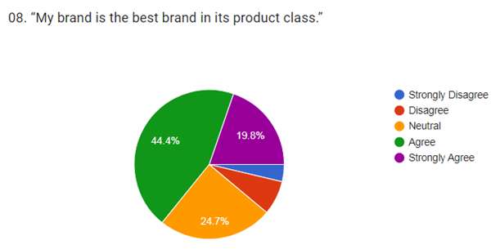
Figure 4.12
According to the figures displayed in Figure 4.12, a total of 64.2 % of respondents agreed. On the other hand, 24.7% respondents are neutral and 11.1% respondents are disagreed on this statement.
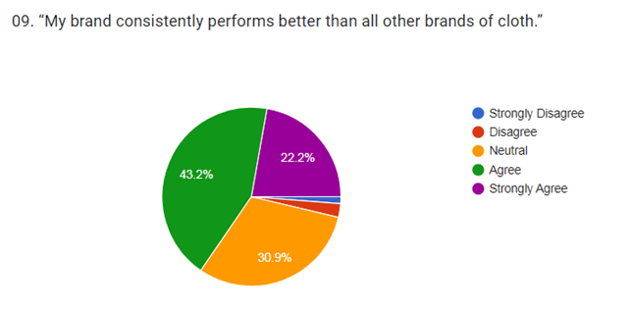
Figure 4.13
According to the figures displayed in Figure 4.13, a total of 65.4 % of respondents agreed. On the other hand, 30.9% respondents are neutral and 3.7% respondents are disagreed on this statement.
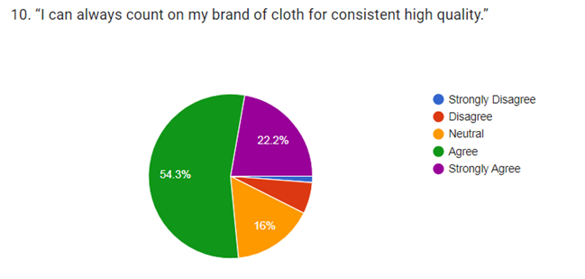
Figure 4.14
According to the figures displayed in Figure 4.14, a total of 76.5 % of respondents agreed. On the other hand, 16.0% respondents are neutral and 7.4% respondents are disagreed on this statement.
In summary, on the basis of data and overall agreement average 53.5% average, it can be said that a brand quality has a large and favorable link with consumers’ intention to purchase items from their brand store. The kind and amount of the components, services, or features, brand logo, brand image and quality of the products that is included in the brand quality.

Organizational Associations
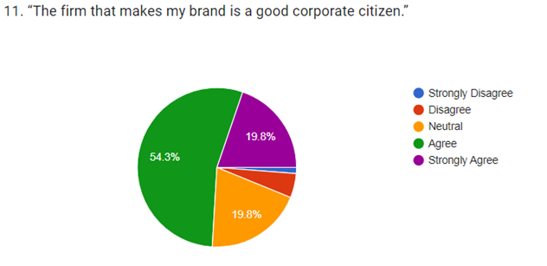
Figure 4.15
According to the figures displayed in Figure 4.15, a total of 74.1 % of respondents agreed. On the other hand, 19.8% respondents are neutral and 8.7% respondents are disagreed on this statement.
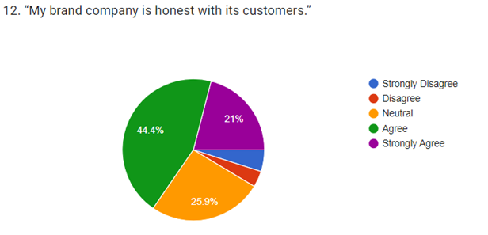
Figure 4.16
According to the figures displayed in Figure 4.16, a total of 65.4 % of respondents agreed. On the other hand, 25.9% respondents are neutral and 8.7% respondents are disagreed on this statement.
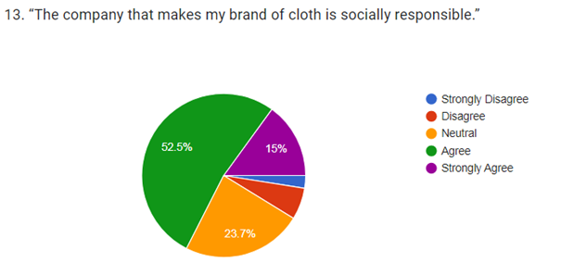
Figure 4.16
According to the figures displayed in Figure 4.16, a total of 67.5 % of respondents agreed. On the other hand, 23.7% respondents are neutral and 8.7% respondents are disagreed on this statement.
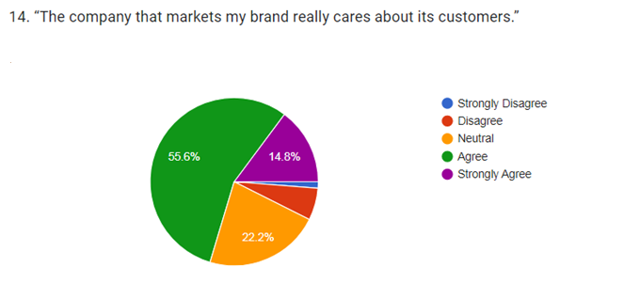
Figure 4.18
According to the figures displayed in Figure 4.18, a total of 70.4 % of respondents agreed. On the other hand, 22.2% respondents are neutral and 7.4% respondents are disagreed on this statement.
In summary, it can be said that consumers make use of brand associations or organizational associations to process, organize, and retrieve brand-related information from memory for use in subsequent purchase choices. Brand associations or an organizational association is consisted of CSR activities, integrity, trusted and caring about the customers. On the basis of data and overall agreement average 56% average, it can be said that brand association or organizational association has a large and favorable link with consumers’ intention to purchase items for their brand store. For it, the majority of the respondents’ purchase intention is being tended to be the Aarong and Yellow brand rather than Dorjibari and SadaKalo brand.

Image Consistency
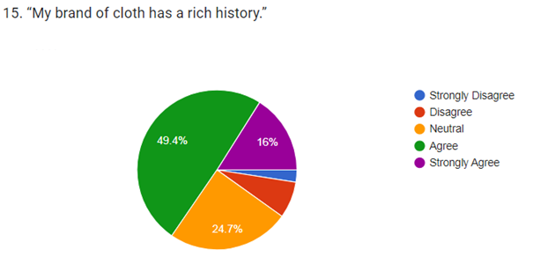
Figure 4.19
According to the figures displayed in Figure 4.5, a total of 70.4 % of respondents agreed. On the other hand, 22.2% respondents are neutral and 7.4% respondents are disagreed on this statement.
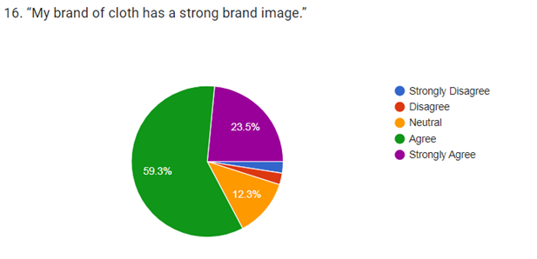
Figure 4.20
According to the figures displayed in Figure 4.20, a total of 70.4 % of respondents agreed. On the other hand, 22.2% respondents are neutral and 7.4% respondents are disagreed on this statement.
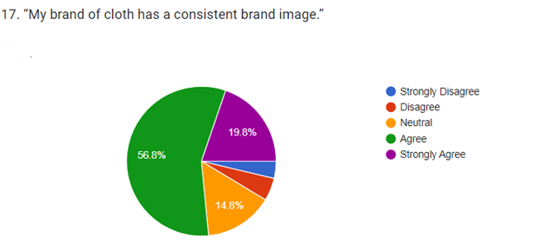
Figure 4.21
According to the figures displayed in Figure 4.21, a total of 70.4 % of respondents agreed. On the other hand, 22.2% respondents are neutral and 7.4% respondents are disagreed on this statement.
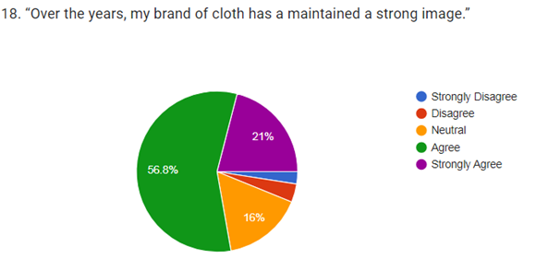
Figure 4.22
According to the figures displayed in Figure 4.22, a total of 70.4 % of respondents agreed. On the other hand, 22.2% respondents are neutral and 7.4% respondents are disagreed on this statement.
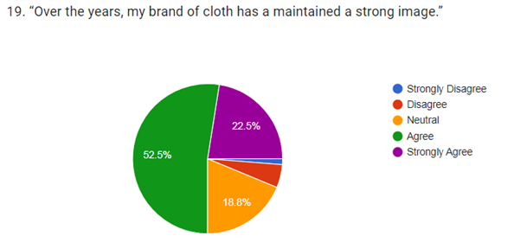
Figure 4.23
According to the figures displayed in Figure 4.23, a total of 70.4 % of respondents agreed. On the other hand, 22.2% respondents are neutral and 7.4% respondents are disagreed on this statement.
In summary, it can be said that the name of the brand, strong image; symbol; positive word about the brand and product quality is one of the most significant aspects of tend to the interest of customers’ purchase intension. The likelihood of a consumer making a purchase decision for a certain brand increases if, in comparison to other brands, it has succeeded in building a favorable image in the minds of its target demographic. On the basis of data and overall agreement average 65.8% of respondents said, a brand's image is the set of characteristics that consumers associate with a certain product, as chosen by the consumer from among the many possible combinations. Many factors, such as brand values, brand advantages, pricing, packaging, style, color, etc., are used in brand image evaluation. For it, the majority of the respondents’ purchase intention is being tended to be the Aarong and Yellow brand rather than Dorjibari and SadaKalo brand.

Purchase Intentions
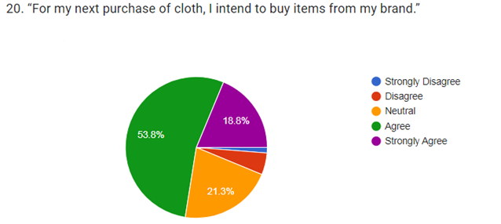
Figure 4.24
According to the figures displayed in Figure 4.24, a total of 72.6 % of respondents agreed. On the other hand, 21.3% respondents are neutral and 6.3% respondents are disagreed on this statement.
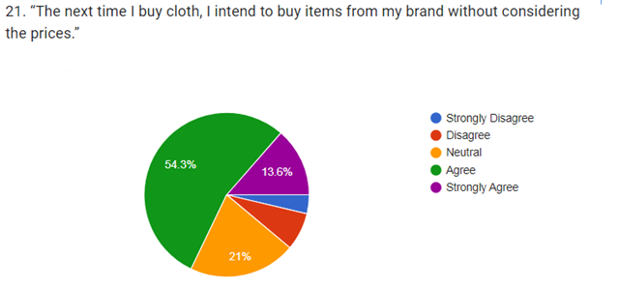
Figure 4.25
According to the figures displayed in Figure 4.25, a total of 67.9 % of respondents agreed. On the other hand, 21.0% respondents are neutral and 11.1% respondents are disagreed on this statement.
In summary, it can be said that the desire to make a purchase is a dependent variable that is influenced by a variety of both internal and external circumstances. The amount of brand exposure is significantly related to shoppers' propensities to make purchases. The respondent's attitude toward acquiring a product or availing themselves of a service might be gauged by looking at their purchase intentions. The two main ways people learn about a product are via their own personal experience with the product and the ease with which they may get and evaluate the product for themselves. And for it, on the basis of data and overall agreement average 38.5% of respondents said that for having positive experiences on their liked brand, they again come to visit their brand store to purchase another items and they do not consider the prices for the good quality of items and strong brand image. For it, the majority of the respondents’ purchase intention is being tended to be the Aarong and Yellow brand rather than Dorjibari and SadaKalo brand.

Descriptive Analysis
Calculation of Variance: To find out the factors that impact the customers’ purchase intention on Fashion Industry Brand in Bangladesh is main objective for this study and descriptive statistics were utilized to identify each of the variables in the study and the variables were evaluated using variance scores and compare with the purchase intention’ average score which is 5.00.
This study is carried out in order to have a better understanding of the factors or variables that cover up the impact on the customers’ purchase intention on Fashion Industry Brand in Bangladesh.
 |  | SD | D | N | A | SA | Total | Variance | Average | Variance from Purchase Intention
Distinctiveness
01. | “My brand clearly distinguishes itself from other cloth brands.” | 3 | 3 | 29 | 39 | 14 | 88 | 0.411714 | 0.4104 | 5th
02. | “Compared to other cloth brands my brand stands out.” | 1 | 4 | 28 | 42 | 13 | 88 | 0.43624 | 0.4104 | 5th
03. | “My brand clearly differentiates itself from other cloth brands.” | 2 | 4 | 19 | 15 | 48 | 88 | 0.383515 | 0.4104 | 5th
Consumer Group Distinctiveness
04. | “There is something that makes my brand’s buyer unique in comparison with other brand buyer.” | 3 | 5 | 16 | 50 | 14 | 88 | 0.414044 | 0.4180 | 2nd
05. | “Among all cloth buyers the buyer of my brand stands out.” | 2 | 2 | 34 | 39 | 11 | 88 | 0.434104 | 0.4180 | 2nd
06. | “My brand community has a distinctive charterer compared to other communities.” | 3 | 4 | 27 | 43 | 11 | 88 | 0.416347 | 0.4180 | 2nd
Brand Quality
07. | “Compared to other brand of cloth, my brand is of very high quality.” | 1 | 8 | 42 | 20 | 17 | 88 | 0.395751 | 0.4137 | 4th
08. | “My brand is the best brand in its product class.” | 3 | 6 | 22 | 40 | 17 | 88 | 0.39478 | 0.4137 | 4th
09. | “My brand consistently performs better than all other brands of cloth.” | 1 | 2 | 27 | 38 | 20 | 88 | 0.433031 | 0.4137 | 4th
10. | “I can always count on my brand of cloth for consistent high quality.” | 1 | 5 | 15 | 48 | 19 | 88 | 0.433626 | 0.4137 | 4th
Organizational Associations
11. | “The firm that makes my brand is a good corporate citizen.” | 1 | 4 | 18 | 47 | 18 | 88 | 0.437242 | 0.4150 | 3rd
12. | “My brand company is honest with its customers.” | 4 | 3 | 23 | 40 | 18 | 88 | 0.394714 | 0.4150 | 3rd
13. | “The company that makes my brand of cloth is socially responsible.” | 2 | 5 | 21 | 45 | 15 | 88 | 0.419698 | 0.4150 | 3rd
14. | “The company that markets my brand really cares about its customers.” | 1 | 6 | 19 | 48 | 14 | 88 | 0.432205 | 0.4150 | 3rd
Image Consistency
15. | “My brand of cloth has a rich history.” | 2 | 6 | 23 | 44 | 14 | 89 | 0.415769 | 0.4240 | 1st
16. | “My brand of cloth has a strong brand image.” | 2 | 2 | 12 | 52 | 20 | 88 | 0.441739 | 0.4240 | 1st
17. | “My brand of cloth has a consistent brand image.” | 3 | 4 | 14 | 50 | 17 | 88 | 0.416399 | 0.4240 | 1st
18. | “Over the years, my brand of cloth has a maintained a strong image.” | 2 | 3 | 15 | 51 | 17 | 88 | 0.435409 | 0.4240 | 1st
19. | “Over time, my brand has been very consistent in what is stand for.” | 1 | 4 | 16 | 47 | 20 | 88 | 0.436726 |  | 1st

Interpretation: From table 5.3 found that the high variance is Image Consistency comparing to the average score of 5.00 of customers’ purchase intention and it can be said that can Image Consistency can affect on the customers’ purchase intention towards fashion industry brand items. On the other hand, Consumer Group; then Distinctiveness Organizational; then Associations Brand Quality and lastly Distinctiveness may also impact on the customers’ purchase towards fashion industry brand items.

CHAPTER 05

RECOMMENDATIONS AND CONCLUSION

Recommendations
In this chapter, the primary findings that we obtained from the analysis that was performed earlier, which are useful for developing brand and marketing strategies, will be further developed into marketing implication, and some recommendations and ideas for additional study will also be presented.

Find Ways to Engage a Greater Number of Customers towards Brand
From the point of view of the degree of involvement, it has been established that fast fashion is a low degree involvement product in general situation. This indicates that customers of fast fashion do not have a strong motivation to process information, and in particular, they do not exert a great deal of cognitive effort to search for and understand the brand's advertisements. Because a greater amount of effort has to go into developing product information when there is a lesser degree of involvement, it may be negative to an industry's marketing efforts when that level of involvement is low. Because of this, successful fast fashion firms are seen to make a significant effort to increase their level of participation. For instance, Aarong is putting a lot of effort into it right now. Currently, customers may pick up a complimentary copy of "Aarong" at any of the retailer's locations. It is a novel approach to attract prospective customers or followers to purchase the firm's goods and to show interest in its fashion concept. The magazine features stunning visuals and stories covering the latest developments in the world of fashion, all of which have been hand-picked by H&M to coincide with the brand's newest clothing brands. Some of the magazine's layouts are obviously essentially adverts for H&M's wares, complete with attractive women and corner price tags. While customers are interested in these novel concepts and products, they are also delighted to gain a lot of knowledge about fashion. Consumers will get more engaged in the brand and in fast fashion in general if they are provided with news like this.
In addition, not every person is involved to the same degree; therefore, it will be to the benefit of the marketers to find the group of customers who have a high degree of involvement and to take advantage of these individuals. Furthermore, in reality, not every individual is involved in the same degree. Some young people are really engaged in fast fashion; they spend a lot of time and money on the most recent trends, and they love to talk to others about what they've learned or what they think other people should wear. Also crucial is the fact that "followers" may interact with them via a variety of platforms, including Look book. To see which style blogs are gaining the most followers and popularity, nu readers may use the "leader" section. Because word-of-mouth is more credible and trustworthy only when not obtained via conventional marketing methods, brands can't simply employ those "fashion opinion leaders" to wear the brand's clothing and parade them around while praising the firm to their followers. In order to make the most of opinion leaders and encourage participation from a greater number of customers, the first thing that has to be done is to include opinion leaders in a manner that is as natural as is humanly feasible. The marketers should identify the opinion leaders, which are also a lot of work, and then they should concentrate on staying in touch with them. This can be done by sending them subscribed emails about new products, discounts that have recently been offered, or even just the latest fashion trends. This will help them to maintain a positive mental image of the brand. For instance, the Yellow brand offers a special discount to customers who have spent above a specific amount of money, which may maintain the interest of future opinion leaders while also motivating consumers to consume more. Even though it is an efficient method for engaging a greater number of customers through the social circles of opinion leaders, there are still some customers who are not in touch with those reference groups. In this situation, it is necessary to conduct certain campaigns or projects, such as the numerous socially responsible projects and partnerships that Aarong has participated in. For example: when Aarong gets going in a village, it doesn't only start doing activities; it also builds out the village's infrastructure, like a playground or a medical clinic. Aarong places a lot of emphasis on helping women get and keep well paying employment, bettering their living situations, and advocating for their rights. Through these efforts, a positive image of the brand is created in the minds of customers, and it is likely that this image will further entice individuals to seek out further information on their own initiative.

Improve the In-Store Environment Better
An elaborate store display and environment can help the marketers emphasize the point-of-purchase materials and communicate brand image and brand fashion ideas to consumers without extra high promoting service charge, making it an important factor in the sales strategy of fast fashion brands. Many customers feel discouraged from making purchases at fast fashion retailers because of the negative impact the stores' environments have on their shopping experiences. For example, mothers may feel anxious about their children's behavior in the store, and there may be a long line of people waiting to use the fitting rooms. In light of the fact that the potentially negative effects of certain situational influences on fast fashion brands should never be disregarded, companies in the fast fashion industry should make an effort to collect feedback from customers regarding the circumstances in which they make purchases. However, many fashion brands today are primarily concerned with the opinions of their customers regarding their products. Therefore, in order to enhance the situation at the shop, it may be done in the following three respects:
- First, in order to show that the fashion brand companies care about the customers' feelings, they should strive to expand the number of dressing rooms in order to cut down on the amount of time customers have to wait, as well as provide a small area where employees may watch customers' children while they shop; or to install more mirrors inside shops in order to spare customers the effort of looking for them; also, some decoration and organization of the store's layout in order to make customers feel more at ease while selecting clothing would be good; because, from the perspective of the person, even customers in the lower-priced market segment want to be shown respect and provided with high-quality service.
- Second, from the perspective of the brands' sales strategies, putting the latest main items on the models in the most visible position near the entrance can promote the sale and also kind of solve consumers' problem of "too many choices" by leading the consumers get certain ideas of styling, in this way the brand can emphasize certain collection or item, like Aarong, Yellow did to emphasize a collection of summer or eid cloths, and Shada Kalo or Dorjibari did to put their latest main items on the models in the most visible position near the entrance.
- Thirdly, from the perspective of the respect for the brands' image building, a pleasant store situation may increase a brand's relationship marketing at retail level, and the brand's décor style will also represent the brand's style. This is a respect for the brands' image building.

Influence Consumer’s Attitude towards Brand
Attitudes are famously difficult to change since they influence every aspect of a person's thought process and serve as the rationale for their actions after they've been created. Even though a campaign can be used to work on it, word-of-mouth will still be a more effective way in really changing people's attitude. This is because people believe the words of someone we know or someone who says them without aiming in certain business benefit are much more reliable. Even though a campaign can be used to work on it, word-of-mouth will be a more effective way in really changing people's attitude. When faced with a situation such as this one, the fast fashion firm might make an effort to capitalize on word-of-mouth communication in order to change the perspective of its customers. If, for example, consumers have a negative perception of Shada Kalo and Dorjibari's quality despite the fact that the brand indicates that it is of high quality in all regards, and if, furthermore, Shada Kalo and Dorjibari's quality is not actually that bad, it follows that Shada Kalo and Dorjibari must engage in some very concrete activities to make some consumers aware of the improvement, such as allowing consumers to observe the testing of their products and encouraging them to share their opinions about the brand with others.

Conclusion
This paper's goal is to improve the fashion garment industry in Bangladesh by understanding more about client preferences and buying patterns. Distinctiveness, consumer group distinctiveness, brand quality, organizational connections, and image consistency have all been evaluated as factors in the assessment of customer purchase intention. We employed a quantitative strategy in the form of an online survey to collect in-depth data from 88 participants for the purpose of writing this project report. The survey's findings suggest that customers' impressions of a brand's Image Consistency play a major role in determining whether or not they would buy a product from that brand. Nonetheless, the following may also affect customers' preferences while shopping for fashion industry brands: consumer group, organization's distinctiveness, connections, brand's distinctiveness, and product's quality and distinctiveness.

References

Aaker, D. (1990). Brand extension: the good, the bad, and the ugly. Sloan Management.
Aaker, D. (1991). Managing Brand Equity: Capitalizing on the Value of a Brand Name, the Free Press. New York, NY.
Aaker, J. (1997). Dimensions of brand personality; Vol. 34 No. 3. Journal of Marketing Research, 347- 56.
Biel. (1993). Converting image into equity. Brand Equity and Advertising, Lawrence Erlbaum Associates, Hillsdale, NJ.
Chattopadhyay, A. a. (1988). the situational importance of recall and inference in consumer decision making'', J. ournal of Consumer Research, June, Vol. 15, 1-12.
Chen, Y. a. (2004). When Shopbots Meet Emails: Implications for Price Competition on the internet. Quantitative Marketing and Economics, 2, 233-255.
Chi, M. T. (1982). Expertise in Problem Solving in Advances in the Psychology of Human Intelligence, Vol. 1. Robert J. Sternberg, ed. Hillsdale, NJ: Lawrence Erlbaum Associates, 11–76.
Corfman, H. M. (1985). Quality and value in the consumption experience: Phaedrus rides again, in Jacoby J & Olson JC (Eds) Perceived Quality: How Consumers View Stores and Merchandise. Lexington Books, Lexington MA, 31-57.
Cunningham, I. H. (1982). Generic brands versus national brands and store brands. Journal of Advertising Research, Vol. 22 No. 5, 25-32.
Dewanti, R. I. (n.d.). Analysis of influence brand image and brand trust towards purchase decision. Ubaya International Annual Symposium on Management.
Dubois, B. a. (1995). Observations – understanding the world of international luxury brands: the dream formula, Vol. 35 No. 4. Journal of Advertising Research, 69-76.
Esposito, G. S. (2017). The development of attachment: Integrating genes, brain, behavior, and environment. Behavioural Brain Research, 325, 87–89.
Fishbein, M. &. (1975). Belief, attitude, intention and behavior: An introduction to theory and research. Reading, MA: Addison-Wesley.
Hoch, S. a. (1993). When do private labels succeed?” . Sloan Management Review, Vol. 34 No. 4, 57-67.
Kahneman, D. (2011). Thinking, fast and slow. Macmillan.
Keller, K. (1993). Conceptualizing, measuring, and managing customer-based brand Equity. Journal of Marketing, Vol.57, 1-22.
Kotler, P. K. (2022). Marketing Management (16th ed.). Pearson Education Inc.
Krzyk, T. &. (2012). Redes Sociais na Internet: contextualização, mercado e desenvolvimento. Cippus, 1(2), 74–97.
Levy, S. &. (2012). Does advertising matter to store brand purchase intention? A conceptual framework. Journal of Product & Brand Management.
Lin, N.-H. &. (2007). The Effect of Brand Image and Product Knowledge on Purchase Intention. . Journal of International Management Sciences.
Lindquist, J. a. (2003). Shopper, Buyer and Consumer Behavior: Theory and Marketing Applications, 2nd ed. New Delhi : An imprint of Dream tech Press.
Malik, P. D. (2012). Aaker's Brand Personality Framework . Journal of Basic and Applied Sciences Research.
Milakovic, I. K. (2021). Purchase experience during the COVID-19 pandemic and social cognitive theory: The relevance of consumer vulnerability, resilience, and adaptability for purchase satisfaction and repurchase. International Journal of Consumer Studies.
Milgrom, P. a. (1986). Price and advertising signals of product quality . Journal of Political Economy, Vol. 94 No. 4, 796-821.
Mitchell, A. A. (1996). The Assessment of Alternative Measures of Consumer Expertise. Journal of Consumer Research, 219–39.
Park, C. a. (1994). A survey-based method for measuring and understanding Brand equity and its extendibility . journal of Marketing Research, Vol. 31, 271-88 .
Porter, M. (1974 ). Consumer behavior, retailer power and market performance in consumer goods industries. Rev. Econ. Stat, 56(4): 419-436.
Reddy, S. H. (1994). To extend or not to extend: success determinants of line extensions. Journal of Marketing Research, Vol. 31 No. 2, 243-62.
Solomon, M. R. (2017). Consumer behavior: Buying, having, and being. Boston, MA: Pearson.
Sondho, S. L. (2007). THE EFFECT OF BRAND IMAGE ON OVERALL SATISFACTION AND LOYALTY IN THE CONTEXT OF COLOR COSMTEC . Asian Acedmy of Manegement Journal.
Tariq, M. I. (2013). Customers Perceptions about Branding and Purchase Intention. . Journal of basic and Applied Sceintific Research.
Thunholm, P. (2005). Planning Under Time Pressure: An Attempt Toward a Prescriptive Model of Military Tactical Decision Making in How Experts Make Decisions . m.
Tsiotsou. (2006). The role of perceived product quality and overall satisfaction on purchase intentions. International Journal of Consumer Studies, 30(2), 207-217.
Wood, S. L. (2002). Prior Knowledge and Complacency in New Product Learning. Journal of Consumer Research, 416–26.
Xiao, A. Y. (2018). Factors affecting purchase intentions in generation Y: An empirical evidence from fast food industry in Malaysia. Administrative Sciences, 9(1), 1-16.
Zeithaml, V. (1988). Consumer perceptions of price, quality, and value: a means-end model and synthesis of evidence. Journal of Marketing, Vol. 52 No. 3, 2-22.

Appendix

Survey Questionnaire
“CONSUMER BUYING BEHAVIOR IN FASHION APPAREL INDUSTRY OF BANGLADESH”
Dear respected respondent,
The following questionnaire is to collect information from people who are purchasing clothing products from branded fashion house. It’s about the challenges of marketing and brand department of the fashion house industry where they are facing on implementing appropriate brand strategy in fashion house industry of Bangladesh. The information will be kept confidential and be used only for research purposes.
Gender | - Male |  | - Female
Age | - 15-20 years | - 21-30 years | - 31-40 years | - 41- 45 years
Occupation | - Student | - Service Holders | - House Wife | - Business
Preferred Fashion House | - Aarong | - Yellow | - SadaKalo | - Dorjibari

S.L | Statement | S.D (1) | D (2) | N (3) | A (4) | S.A (5)
Distinctiveness
01. | “My brand clearly distinguishes itself from other cloth brands.”
02. | “Compared to other cloth brands my brand stands out.”
03. | “My brand clearly differentiates itself from other cloth brands.”
Consumer Group Distinctiveness
04. | “There is something that makes my brand’s buyer unique in comparison with other brand buyer.”
05. | “Among all cloth buyers the buyer of my brand stands out.”
06. | “My brand community has a distinctive charterer compared to other communities.”
Brand Quality
07. | “Compared to other brand of cloth, my brand is of very high quality.”
08. | “My brand is the best brand in its product class.”
09. | “My brand consistently performs better than all other brands of cloth.”
10. | “I can always count on my brand of cloth for consistent high quality.”
Organizational Associations
11. | “The firm that makes my brand is a good corporate citizen.”
12. | “My brand company is honest with its customers.”
13. | “The company that makes my brand of cloth is socially responsible.”
14. | “The company that markets my brand really cares about its customers.”
Image Consistency
15. | “My brand of cloth has a rich history.”
16. | “My brand of cloth has a strong brand image.”
17. | “My brand of cloth has a consistent brand image.”
18. | “Over the years, my brand of cloth has a maintained a strong image.”
19. | “Over time, my brand has been very consistent in what is stand for.”
Purchase Intention
20. | “For my next purchase of cloth, I intend to buy items from my brand.”
21. | “The next time I buy cloth, I intend to buy items from my brand without considering the prices.”

