Analysis on Market and Business Strategy of Honda,
DHS Motors Limited

Md. Bodiuzzaman Badhon

This report is submitted to the School of Business & Economics, United International University as a partial requirement for the fulfillment of Bachelors of Business Administration Degree.

Analysis on Market and Business Strategy of Honda,
DHS Motors Limited

PREPARED BY
Md. Bodiuzzaman Badhon
ID: 111 143 029
BBA Program
United International University

SUPERVISED BY
Dr. Kawsar Ahmmed
Associate Professor
School of Business and Economics
United International University

Date of submission: August 28, 2019

LETTER OF TRANSMITTAL
To,
Dr. Kawsar Ahmmed
Associate Professor
School of Business and Economics
United International University
Subject: Submission of internship report on “Analysis of Market and Business Strategy Of Honda, DHS Motors Limited”.
Dear Sir,
I am very glad to inform you that I have recently completed my 3 months long internship program from HONDA, DHS Motors limited. Meanwhile my internship program at HONDA, I have gathered information and prepared my internship report on “Analysis of Market and Business Strategy Of Honda, DHS Motors Limited”.
DHS Motors Limited has been the leading player in the automotive industry of Bangladesh for 3 years. It is the only Honda Automobiles dealership holder in Bangladesh. The main activity is to sell new cars as well as motorcycles and provide after-sales service of HONDA through its own sales and service center located in Mohakhali, a major location for sales.
I would like to declare that all the steps of the report outline, you had provided to me, are followed while preparing this report. The data and information, used in the report, are relevant and valid. Additionally, I want to ensure you that no information are directly copied or used from any sources to avoid plagiarism related issues and all information on HONDA are aggregated and prepared by me.
I would be highly grateful if you accept my internship report and oblige thereby.
Yours most obedient,
Md. Bodiuzzaman Badhon
ID: 111 143 029
BBA Program
United International University

PREFACE
Right at very beginning, I want to thank my Almighty Allah and my parents for supporting me till now and for helping me to complete this 4 years of BBA program from United International University and also for helping me to complete my internship program successfully.
Secondly, I want to show my gratitude and I am highly thankful my course faculty as well as internship instructor, Dr. Kawsar Ahmmed, Associate Professor, School of Business and Economics, United International University for providing me the report outline and accept me to work on my preferred topic that is highly relevant to my field of study. Additionally, the report outline and the time and effort that he provided to me was proved highly important to prepare this internship report. Without all these the report could not be completed in this short period of time.
Thirdly, I want thank Shaheen Ahmed, Assistant Manager, DHS Motors Ltd. (Honda) who helped me to understand about the internship program at Honda and later helped me to aggregate varieties of information about HONDA. Shaheen Ahmed is an individual of strongly motivated to continue a long-term career in DHS Motors Ltd and to have a significant role in organizational development and personal fulfillment and to work in a stimulating and competitive environment, where a strong sense of responsibility and commitment is required. He is a true leader who shows the dignity of work provides job satisfaction and the possible way to learn the workplace, grow and reach the top spot in the organization's ranking.

Finally, I want to thank to all my friends and colleagues who helped me to arrange the information and also helped me to understand several terms of the DHS Motors business strategy. All of their effort for me are highly appreciated and necessary for me.

Executive Summary
The purpose of preparing the report is to analyze and understand the business strategy of Honda, DHS Limited of Bangladesh. Strategies are the action plan put in place by the managers to achieve the goals of the company and other related objectives. Additionally, business and market strategies are the determinants of the success of any business. The report is going to cover the general company overview of Honda, DHS Motors Limited, a SWOT analysis, Porter’s five-factor analysis and the supply chain management of Honda around the world to find out the market positioning strategies of this highly reputed company. The analysis and findings of the report have three parts. In the first part, the company is being analyzed by a SWOT analysis to find out the internal and external factors or variables that can have a positive or negative impact on Honda, DHS Motors Limited. Next, The company is being analyzed through the porter’s five-factor model to know about the companies buyer’s demand, supplier’s demand, rivals, and the threats of new entrants or the barriers of the new entry that are made by the Honda, DHS Motors Limited. The analysis also conducted on the supply chain management of Honda at the end. The report also consists of few recommendations according to my conceptual and educational knowledge on market strategy so that Honda, DHS Motors can improve its market strategy.

Key Words: Business Strategy, Supply Chain Management, SWOT Analysis, HONDA, DHS Motors Limited Bangladesh Ltd.

Table of Contents

Chapter One: Introduction of the Study
1.1 Motivation of the study 2
1.2 Objectives of the study 2
a. Primary objectives: 2
b. Specific objectives: 2
i. To analyze the Honda, DHS Motors limited company as a whole. 2
ii. To analyze the strategic market analysis of DSH Motors. 2
iii. To recommend few suggestion based on the market analysis. 3
1.3 Limitation of the study 3
1.4 Significance of the study 3
1.5 Organization of the remaining chapters 3

Chapter Two: Organization overview
2.1 Organizational Profile 6
2.1.1 Global Scenario of HONDA 6
2.2 Mission, Vision, and Philosophies 7
2.2.1 Mission of HONDA 7
2.2.2 Vision of HONDA 7
2.2.3 Philosophies followed by HONDA 7
2.2.5 Core values of HONDA 7
2.3 Products and Services of HONDA 8
2.4 Organogram of HONDA 9
2.5 Strategic Market Analysis concept 11
2.7 Necessities of Strategic Market Analysis 11
2.8 Components of Market strategy analysis 12
a. Analysis of Porter's five forces 12
b. SWOT analysis 12
c. Supply chain/value chain analysis of services. 12
d. Pest analysis 12
e. Gaming of War 12
f. Analysis of Early Warning 13
g. Four-corner analysis. 13

Chapter Four: Analysis and findings
3.1 SWOT Analysis of HONDA, DHS Motors Ltd 15
3.2 Porter’s Five Forces Model Analysis of HONDA, DHS Motors Ltd 16
3.2.1 Customer's bargaining power: 16
3.2.2 Suppliers bargaining power: 17
3.2.3 Threats of substitute products: 17
3.2.4 Threats of the arrival of new competitors: 17
3.2.5 The rivalry between existing competitors: 18
3.3 Analyzing the Supply Chain Analysis of HONDA, DHS Motors Ltd 18
3.4 Recommendations 22
3.5 Conclusion 23

Reference 24

CHAPTER ONE
INTRODUCTION OF THE STUDY

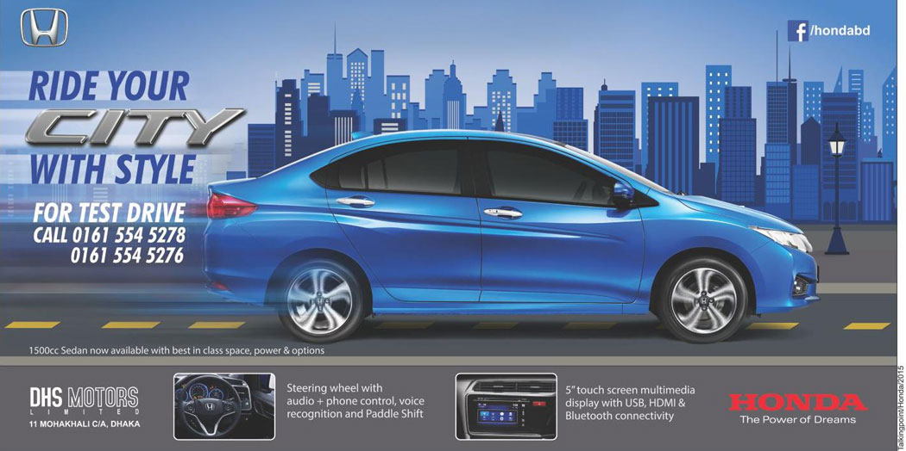

1.1 Motivation of the study
The primary motivation for conducting the study is to achieve the BBA degree from United International University where each student must go through the process of internship or project program. In the internship program, students have to join any organization from where they can learn the practical working culture of that organization. Then, they have prepared a report based on their instructor suggested and accepted topic and submit it to finally complete the BBA degree.
The specific motivation of the report is to analyze and understand the strategic market of Honda, DHS Limited in Bangladesh. As mentioned earlier, the report title is “Analysis of Market and Business Strategy Of Honda, DHS Motors Limited”, therefore, the main motivation and concentration of the study are to find out the business and market of HONDA is Bangladesh. Although there is no dictionary for strategic market analysis, it is a market analysis related to a business strategy or corporate strategy as a whole. Strategic market analysis is designed to help companies of all sizes make informed business decisions, especially in relation to strategy.

1.2 Objectives of the study

The Internship Report is a systematic investigation into a problem in which a researcher attempts to give a clear view from any perspective of an organization. In order to achieve accurate discussion, clearly defined objectives are very important. A clearly defined goal leads a researcher in the right direction. Clearly defined goals are an important feature of a good research study. Without a clear goal, a researcher is useless and without direction to conduct the study. No repeatable scientific results can be expected without the intended target. The objectives of the report are separated into two parts:

Primary objectives: the primary purpose of preparing the report is to attain the BBA degree from United International University as it’s a pre-requirement.

Specific objectives:

To analyze the Honda, DHS Motors limited company as a whole.

To analyze the strategic market of DSH Motors

To recommend few suggestions based on the market analysis.

1.3 Limitation of the study
Each study has its limitations. By clarifying the limitations of the study, the reader will better understand why the results should be interpreted under those conditions. A clear description of the limitations of a study also shows that the researcher has a holistic understanding of his or her study. Therefore the limitations of my study are:
- Prepared in short time: The report is conducted between the times of performing internship responsibilities at HONDA, DHS Motors Limited. Within this short three months of time, preparing such and long and detailed report was difficult.
- Secrecy of the organization: Honda. DHS Motors has a lot of confidentiality restriction to use their confidential information in public publications.
- Lack of resources: the primary and secondary resources on HONDA, DHS Motors Limited are very rare with proper and informative information. I have to arrange a lot of formal and informal communication to collect my study relevant information.

1.4 Significance of the study
Strategic market analysis studies can be ideal for university-level marketing students and vocational school education to improve students' knowledge and entrepreneurial skills. The objectives of this internship report are designed to help students improve their academic skills, develop work skills, implement career plans, and participate in career paths in preparation for a practical work environment or field career. After graduating from the university. Furthermore, the report helps managers of DHS Motors to understand the current Honda Products market and how they can strategize to tackle the competition. Any reader of the report will understand the current market situation of Honda, which is one of the best-selling brands in Bangladesh.

1.5 Organization of the remaining chapters
The remaining chapters of the study consists the Overview of HONDA, DHS Motors, Literature review, Findings and analysis of the report. A general company description is going to take place in the organization overview. The business critical terms that can create confusion to readers who have less understandings on business, are going to simplify in the literature review chapter. The findings and analysis chapter is going to be the main analysis chapter of the report where a SWOT analysis, porter’s five factor model and the supply chain of HONDA around the world are being analyzed. Finally, few recommendations are going to be included based on the findings of the study.

CHAPTER TWO
ORGANIZATION OVERVIEW OF HONDA
DHS MOTORS LIMITED

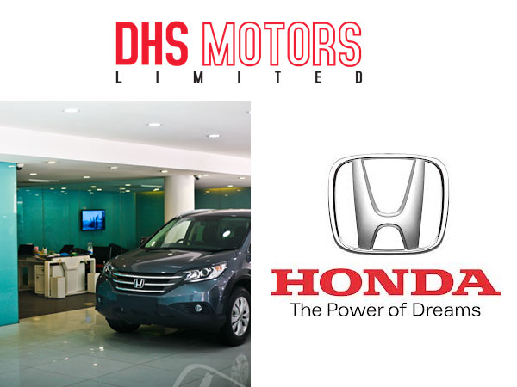

Part A

Organizational Profile
DHS Motors was established in the year 1994 as the exclusive distributor of Honda cars in Bangladesh. A year later, DHS Workshop was inaugurated to provide better service to Honda customers benefiting from Honda's standard after-sales service.
The first range includes HONDA Domani, Honda Accord and CR-X. Later, in the year of 1996, Honda Integra, Civic, and Legend were launched, by selling of new sedans in civilian market. In the following years, DHS Motors introduced new models such as CR-V, HR-V, and City. At the age of 28, DHS Motors became the first distributor of hybrid cars in Bangladesh.
The current goal of DHS Motors is to improve the customer experience through advanced training, advanced training and workforce skills development, competitive segmentation pricing, competitive advantage increased segmentation and extended maintenance. Our goal is to make Honda the best brand of cars in Bangladesh by creating a national distribution of Honda sales, parts and accessories. The construction of a second showroom in Dhaka is already underway in the city center, in the Tejgaon industrial zone.

2.1.1 Global Scenario of HONDA
Honda is the world leader in engine production and market leader in the global market. Honda operates 120 production sites, employs 167,231 people in 25 countries worldwide. In the following years, Honda expanded into the larger market: In 1, Honda launched its first foreign subsidiary, American Honda Motor Co. Ltd, established in 1964, and established the first subsidiary in Thailand. Asian Honda Motor Co. London Ltd. (Europe's first Honda market) 1965 Honda Motor is located in Sao Paulo, Brazil (now Honda Sud America Latina).
Honda's success is largely based on the continuous innovation on which Honda is built. In today's automotive world, Honda is the biggest motorcycle manufacturer and the world's nine largest automotive manufacturers. To date, Honda has a market share of 10.2% and is ranked fifth in the UK (the most exclusive/annoying market). In the motor industry in the North America, Asia, and UK, the Honda Company is becoming a technical force in the motorcycle industry.

Mission, Vision, and Philosophies

2.2.1 Mission of HONDA
The mission statement of HONDA, DHS Motors is "To maintain a global vision and commit to providing products of the highest quality, also at a reasonable price, will always be a supportive state-of-the-art of after-sales service, within the a timely supply for customer satisfaction."

2.2.2 Vision of HONDA
The vision of HONDA DHS Motors Ltd, encourage it to create a larger market for BD as a market leader and to create customer satisfaction after using their products.

2.2.3 Philosophies followed by HONDA
Honda's philosophy includes company policies and management principles, including key principles. It is not only shared by all conglomerates but is the basis of all the company's activities and sets the standards of behavior and decision making for all members of the Honda Group. Driven by their dreams and reflecting their values, Honda will continue to share the joy and excitement of sharing this joy and enthusiasm with its customers and communities around the world to become a business.

2.2.5 Core values of HONDA
The Core values of HONDA consist of two broad parts and each have particular sub-section:

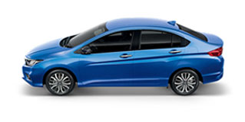
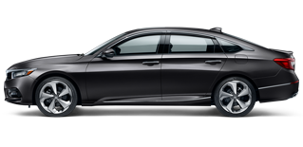
Products and Services of HONDA
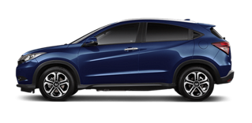
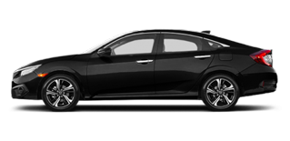
Product Model: (1) HONDA ACCORD (2) HONDA CITY
Product Model: (1) HONDA Civic Turbo (2) HONDA HR-V

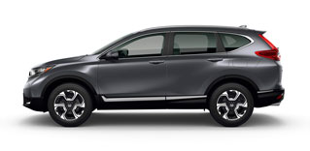
Product Model: HONDA CR-V TURBO

The cars showed above are the currently most selling products of HONDA, DHS Motors. Though the company is highly popular for its bikes or motorcycles, for the motorcycle parts and its after sales services. The products that HONDA Co. producing and distributing worldwide are listed below:

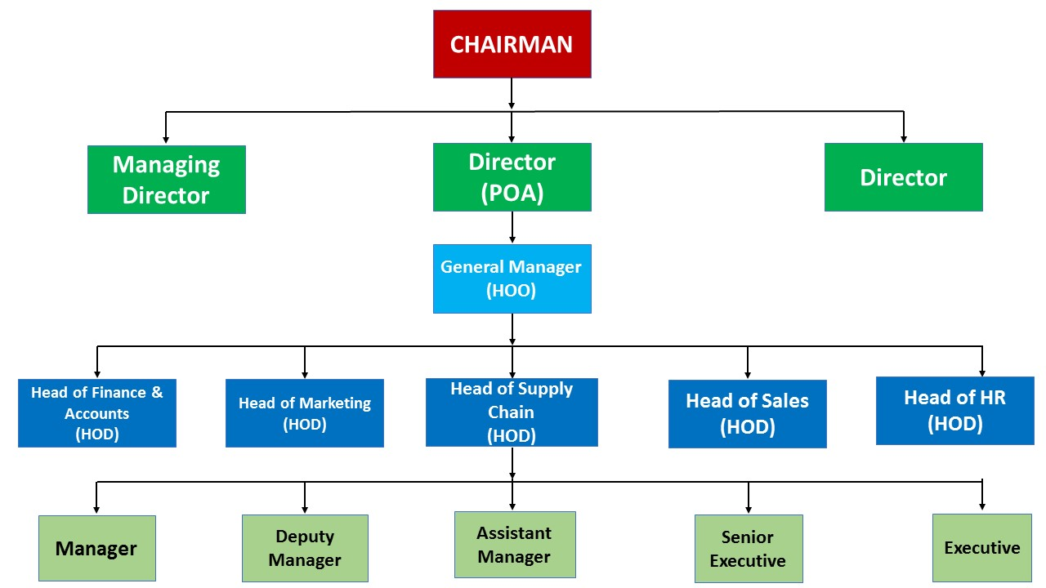
Organogram of HONDA
Chart: Organogram of HONDA, DHS Motors

Part B

2.5 Strategic Market Analysis concept
With the creation, launch, and implementation of new technologies, the business is going through an era of global change that is also rife with the timely progress of the Industrial Revolution. To keep pace with these changes, companies are taking advantage of the competitive advantages offered to them by effective strategic market analysis. Strategic Market analysis is a term that describes the study of how a particular market is developed. When a market goes up and down, it grows and changes, allowing us to follow this movement and then track it downwards, which is the goal of market analysis. The goal is to provide a clear picture of the overall market trends. This type of analysis also examines the underlying factors of market development along with customer information. In a nutshell, strategic marketing analysis serves as a kind of business plan, presenting a detailed plan that can be followed to have the most potential for business success.

2.6 Necessities of Strategic Market Analysis
Most industry leaders can agree on the need to analyze business data, and this need continues to grow. In fact, 92% of successful companies strongly agree that empowering analysis is strategic for future success. Indeed, the strategic market analysis offers a series of important advantages without detailing the commercial dynamics of the company. Some of the benefits include:
- Strategic Adaptation Analysis: This form of market analysis allows companies to assess their capabilities by assessing not only external considerations but also internal entities.
- Strategic Expenditure Analysis: This form of market analysis focuses on business expenses, comparison costs and the comparison of each expense, to provide a clear picture of a company's competitiveness with respect to another.
- Strategic financial analysis: This form of market analysis examines in detail how a company's financing is prepared based on the cost of materials and sales.
And as advances in technology have enabled companies to more closely analyze their markets, advanced applications and tools are enabling companies to automate their analytics processes. If used properly, strategic analysis tools offer businesses of all sizes the ability to see exactly which factors affect the market, and their position in the market, while maintaining a simple learning curve.

2.7 Components of Market strategy analysis
In order to perform any kind of precise strategic analysis, an organization must consider several methods. The most recognized methods of analysis are:

Analysis of Porter's five forces
This method is used to determine if a new product or service will be profitable. It focuses on suppliers' energy valuation, purchasing power, competition, replacement threats, and new entry threats.

SWOT analysis
SWOT analysis is the most prevalent tactical approach that refers to strengths, weaknesses, opportunities, and threats. This method identifies and tracks all internal and external factors that can have a positive or negative impact on the strategy.

Supply chain/value chain analysis of services.
Value chain analysis is used to break down and quantify the activities that a company performs to create value for its customers, it analyzes its overall competitive advantage. It divides an organization's activities into core activities and supporting activities sets a cost for each activity, and identifies activities that are fundamental to the success or not.

Pest analysis
By focusing on the political, economic, social and technical factors involved, PEST analysis is performed as a variant of SWOT analysis and often for a simple SWOT analysis.

Gaming of War
Companies can use war games to test specific situations without compromising any aspect of the business and create simulations to collect data on possible outcomes.
Also, some applications and tools can provide significant benefits for strategic market analysis. These tools often use smart automation to identify market opportunities, identify inspectors, identify targeted customers, improve value proposition, compare competitors, and more.

Analysis of Early Warning
In order to detect and prepare for important events, a preliminary alert analysis is used. They use several key variables to verify the probability of a given scenario.

Four-corner analysis.
This approach sheds more light on the analysis of competitors and the determination of actions they can take in different situations. The four priorities are future objectives, current strategies, assumptions, and capabilities.
Among all of these strategic market analysis tools, I am going to apply SWOT, Porter’s Five Factor Model and Supply chain Analysis to find out the Market and business strategy of Honda, DHS Motors Limited.

Chapter Three

Findings and Analysis
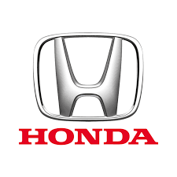

Part A

3.1 SWOT Analysis of HONDA, DHS Motors Ltd
SWOT analysis is a strategic business strategy that helps an individual or organization to analyze the strengths, weaknesses, opportunities, and threats associated with a company's competition or marketing strategy. Its purpose is to clarify the goals of the company and to identify adverse and internal and external factors conducive to achieving these objectives. Analyzers of SWOT analysis often ask and answer questions to generate useful information for each category in order to execute the tool and identify its competitive advantage. SWOT has been described as a proven strategic analysis tool but has also been criticized for its limitations. Here, A SWOT analysis has been conducted in regards of HONDA, DHS Motors Limited.
3.1.1 STRENGTHS
- Manufacture high-quality products.
- Fully compatible with suppliers (HONDA engines)
- Create products that are always close to the customer.
- Have pioneer engineering in hybrid technology
3.1.2 WEAKNESSES:
- In non-luxury vehicles and spare parts, prices are much higher than those of other car manufacturers.
- The product is rather a brand and harmless in terms of style.
- Bad product line.
3.1.3 OPPORTUNITIES
- The service center generates huge profits through reliable service. (For HONDA and other brands)
- The company must work in vehicles with low emissions and other alternative energy sources.
- An offer in a truck company would be profitable because these types of vehicles have the highest profit margin among all others.
- Now, familiarize yourself with the availability of economical parts.
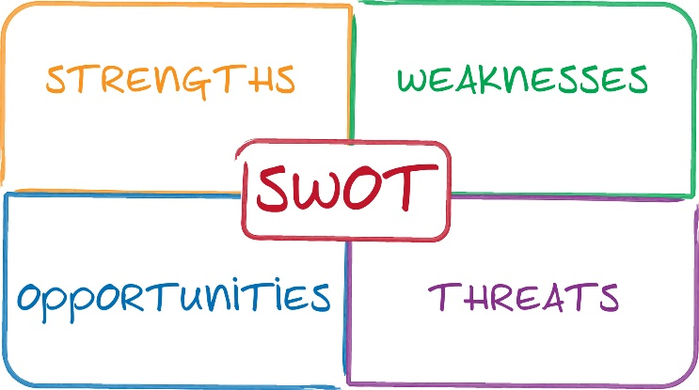
3.1.4 THREATS:
- Customer price sensitivity.
- Changes in government rules and regulations.

3.2 Porter’s Five Forces Model Analysis of HONDA, DHS Motors Ltd
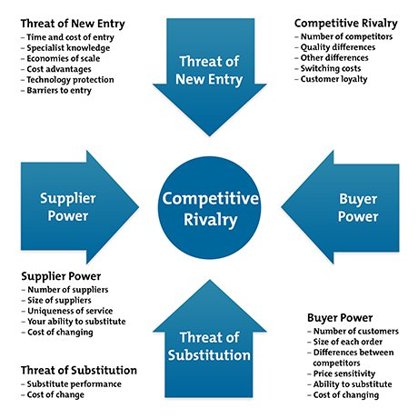
Porter's Five Forces is a model that identifies and analyzes five competitive forces that shape each sector and helps identify sector weaknesses and strengths. Frequently used to identify the structure of a sector to determine the company's strategy, the Porter model can be applied to any segment of the economy to seek profitability and attractiveness. In addition, it is a strategic business analysis model that explains why different sectors can maintain different levels of profitability. The model was published in Michael E. Porter's book "Competitive Strategy: Analytical Techniques for Industries and Competitors" in 1980. It is widely used to analyze a company's industrial structure and business strategy. Porter has identified five undeniable forces that play a role in the configuration of all the markets and industries of the world. Strengths are often used to measure the intensity of competition, attractiveness, and profitability of a sector or market. These forces are analyzed below to analyze the HONDA, DHS Motors Limited's strategic business analysis.

3.2.1 Customer's bargaining power:
It can certainly be said that any company who wants to grow has to build a good relationship with its customers in the business world. Though Honda is complicated, it is noteworthy that Honda has many competitors in the Bangladeshi market. Customers usually be confused while deciding which brand will be the best choice. It depends not only on the renowned company but also depends on the quality and price. Here, the bargaining power of the consumer is very high. For example, the Honda Air Blade Scooter presents the most fuel-efficient engine technology as a sports and fashion model. The company quickly attracted the youth. Usually, the company creates a shortage of air blades in the market to get a high price.

3.2.2 Suppliers bargaining power:
For HONDA, the suppliers bargaining power is high. DHS Motors Limited, the only distributor of Honda does not manufacture any type of automobile rather than it imports a car from HONDA. Therefore the supplier bargaining power is high. DHS Motors Limited has to depend on Honda completely.

3.2.3 Threats of substitute products:
As we know, the existence of a close substitute products increases the consumer's tendency to accept it in response to rising prices. This means that Honda can have economic value and higher performance compared to Honda's competitors. This product will replace Honda products on the market. The result is a simultaneous reduction in Honda's market share and profits. DHS Threats, Engine Substitutes In the high bid market, many automobile makers have many competitors in the automotive industry and they compete indirectly and directly with Honda, such as Suzuki, Hyundai, Nissan, Toyota, KIA, and Mitsubishi. Therefore, the threat of alternative products is high in the Bangladeshi car market.

3.2.4 Threats of the arrival of new competitors:
The projected significance is that each company's advantage in marketing with many existing competitors will be lower than the highest level of the lower comic market, as many of its competitors are already doing well. Bangladesh has a government policy according to which, no local company can manufacture the car since the country has a contract with Japan. Meanwhile, Bangladesh can import cars from other companies. Honda only allows a dealer in each country. Therefore, the threat of entering new competitors is very low. Any company interested in the automotive sector, such as BD Distributors, can position itself as a net importer because the level of competition is high and the threat of new competitors less.

3.2.5 The rivalry between existing competitors:
The five characteristics mentioned above are important for the automotive industry as they allow a competitive analysis. Honda, DHS Motors has a number of rivals that must compete violently with Uttara Motors Ranks, Rankon Motors, Navana Motors, etc. Modified changes to one of these competitors will affect Honda's performance. To compete with these rivals, Honda has continued to research, innovate, develop, and improve to compete in the automotive sector with its three rivals. The current competitors of Honda in the Bangladeshi automobile market, DHS Motors are very strong and is the main market leader that occupies most of the market. Other competitors are also stronger, as the impact of existing competitors is greater.

3.3 Analyzing the Supply Chain Analysis of HONDA, DHS Motors Ltd
Due to the global network and diversity of the workforce, Honda is facing a few problems that will make the company indomitable once it is resolved. Because Honda operates worldwide, it has difficulties managing its inventory. While the company is already working on a production system on time to avoid financing and waste money, this does not mean that it is difficult for its customers to find and buy the requested model. Even at the top of sales, sometimes customer requests or orders can be very difficult to attach quickly and, due to possible barriers, can result in sales and loss of customers left by other competitors. Understanding and effectively coordinating the various forces of cultural activities that can also control communication barriers is another important issue for organizations. Remote communication is not difficult, but the real problem is understandable if it is not solved correctly can lead to the loss of the organization and the loss of market control. The analysis of supply chain management of Honda is conducted below:
Honda's supply chain management function works to the fullest by integrating all departments and distributing all tasks correctly. The role of several employees has been defined with their supervisors, who help improve workflow and increase productivity. Greater connectivity between all departments and staff helps Honda to manage such a global base and compete effectively with its competitors. The general direction of the supply chain of
Honda operates according to the following process:
- Purchasing Policy: Due to the recognized global nature of the purchase by the service company, Honda is committed to maintaining open trade, managing the workforce equivalent, regardless of size, location, and national basis. From this global environment, Honda has industrialized and put in place a simple buying strategy that can be characterized as the following belief: "Honda will buy at most modest distributors needed to the satisfaction of the customer".
- Cost: In modern times the competition for the supply parts must be strong. Honda is committed to providing decent returns and good value for money. Retailers should probably take note of their thinking, machines and get more production.
More labor is integrated with Honda in the production of value or in search of value. Honda periodically requires traders to work hard to reduce this rate. Honda will provide dealers with a substantial annual assessment of its volume so that they can adjust the rate of each quantity driven by different vehicle models.
- Quality: Quality is the most important feature to protect customer satisfaction. Honda believes that incentives must be integrated into the creative process throughout the entire production process. The guarantee of excellence lies in all retailers and all discrete employees. The promise made by retailers at every level, from the highest companies to the discrete employees, is crucial to moving tirelessly toward excellence.
- Customer Satisfaction: The idea is that Honda dealers don't just sell their parts; also sell pieces of parts at home to their customers. Honda imagines that every dealership develops equal insurance and customer satisfaction. To satisfy customers, Honda needs the expertise of its distributor.
- Management: The distribution management team is customer-oriented and provides realistic management for the entire company. The hard work of this national organization builds collective trust between the dealer and Honda.
- Development: Qualify humble traders to meet the needs of the clientele forever, to meet the wishes expressed and to provide great encouragement. Honda relies heavily on merchants known for its growth and improved knowledge. The personality is accentuated in the pursuit of progress. It's part of the call, depending on the strategy and the uniqueness they need. This invention marks the label of your invention. Distributors may have the ability to understand the requirements of these exceptions instead of their devices with excellent budget presentation and extensive experience.
- Distribution: Honda is working on projects that require a lot of time. To respond quickly to customer requests, it is increasingly interesting to manufacture products in short delivery times. Distributors likely have a reliable and expanding manufacturing company, able to meet short delivery times and integrate into meeting lines. At the right time, the portfolio is reduced, eliminating waste and thus restoring production efficiency. Sender Manufacturing's application at the right time attracts distributors for interest rates and incentives.

Part B

3.4 Recommendations
This chapter is shares few suggestions according to my educational knowledge to improve the marketing and business strategy of HONDA, DHS Motors Ltd. Properly implementation of this suggestion may help for the betterment of the company. The recommendations are separated into two parts.
- Recommendations of market strategy of Honda, DHS Limited
- Hire an expert to improve your digital marketing
Social media is often the means by which people search for car dealers or mechanics. People are often skeptical about the automotive industry, so they want to know what other customers think of their experience. Honda's positive interactive image on Facebook and other sites can create a miracle for DHS Motors Ltd.'s reputation in the community.
- Celebrate the distributorship's anniversary
As a strong company, when the retailer has been open for a few years, it deserves its distributorship's anniversary. Therefore, during the celebration, make sure that the company focuses on all marketing activities. Even if the retailer or repair center does not plan to sell or promote it, it is a good way to contact them, so they know they have been there for so long.
- Become the center of the automotive community
Regardless of whether DHS Motors is a distributor, the organization must participate in the local automotive community. Joining an automobile club or a monthly "car and coffee" event is a great way to connect influential people in the automotive industry with your brand. The people who participate in this type of activity are not just Honda’s customers, they are reliable friends will ask them for advice from tires to car dealers. Moreover, through social media, DHS Motors can increase its participation through photo contests and tags.
- Celebrate the distributorship's anniversary
As a strong company, when the retailer has been open for a few years, it deserves its distributorship's anniversary. Therefore, during the celebration, make sure that the company focuses on all marketing activities. Even if the retailer or repair center does not plan to sell or promote it, it is a good way to contact them, so they know they have been there for so long.
- Focus on the customer experience
The reason for the market change in the automotive industry is that it must pay more attention to the customer's experience because it is always a key transformation of the industry. While car dealers may have difficulty competing with price, strong customer experience and strong customer experience can differentiate the company, generate recommendations and generate noise.
- Encourage return visits through loyalty/reward programs
When customers come to DHS Motors Ltd, for the first time, constant high-quality maintenance is needed to ensure the life of the vehicle, this could be a permanent relationship. The consumer will come back to the company instead of looking for a place. For example, "Buy 4 car oil and get 5 free!"
- Recommendations to improve the overall business of HONDA, DHS Motors Limited
- The adequate inspection of parts and other accessories must be carried out by experienced and well-qualified personnel to avoid any accident at launch or even at a later stage.
- The simultaneous launch of the same car model worldwide at the same price will facilitate the management of the complete cycle.
- Regular training of employees, regardless of their designations and background, will contribute to the maintenance of supply chain management.
- The price of cars, as well as their parts, should be lower. Because our country is growing and it is not practical for residents to buy these expensive cars and other components at a high rate.
- The HONDA DHS Motors Limited's product line should be expanded as it is limited in Bangladesh. A company must have a product differentiation strategy in order to benefit from its different products.
- They must develop their product line, which means that DHS Motors Ltd is trying to import more Honda car models to serve the comic book market.
- They should have increased their promotional activities as a new brand to educate customers.
- DHS Motors Ltd must motivate its employees in the supply chain department and make them more competent. With DHS, engines gain a competitive advantage through supply chain service.
- As soon as possible, they should develop their market through outlets in Dhaka and outside Dhaka.

3.5 Conclusion
Customers in Bangladesh are looking for the best quality at a reasonable price to their families. The show is an important cultural feature of Bangladesh. As analyzed, the company should focus on reducing the cost of cold spare parts, which will attract the mass market rather than niche. It will also bring a positive change in the mindset of the customers. HONDA, DHS Motors Ltd must supply many lines for heavy commercial vehicles to meet the demand for the industrial segment of the market. With this in mind, Honda should highlight its competitive advantages: reliability, energy efficiency, value for money, timely delivery, cutting-driven service, cost reduction.
The purpose of this internship report was to analyze the market and business strategy of HONDA, DHS Motors Ltd through SWOT, Porter's five-factor model, and Supply chain management of HONDA. Analyzing these areas the purpose of this internship report may successfully be fulfilled.

Reference
(1) The company information, Retrieved from: https://honda.com.bd/about-us/

(2) Honda starts manufacturing in Bangladesh, from Dhaka Tribune Journal, Article available at: https://www.dhakatribune.com/business/2018/11/12/honda-starts-manufacturing-in-bangladesh

(3) Honda Inaugurates New Motorcycle Factory in Bangladesh, Article Available at: https://global.honda/newsroom/news/2018/c181111aeng.html
(4) Michael E. Porter, "How Competitive Forces Shape Strategy," May 1979 (Vol. 57, No. 2), pp. 137-145.
(5) "External Inputs to Strategy | Boundless Management". Courses.lumenlearning.com. Retrieved 2017-12-06.
(6) Tang, David (21 October 2014). "Introduction to Strategy Development and Strategy Execution". Flevy. Retrieved 2 November 2014.

