Internship Report on “Corporate Governance of Edgeworks Ltd.”

Submitted To:

James Bakul Sarkar
Associate Professor
United International University (UIU)

SubmittedBy:

AnikKumarDey
ID:111 171234



SchoolofBusinessandEconomics

UnitedInternationalUniversity

DateofSubmission:

23rd December, 2022

LETTEROFTRANSMITTAL

December21,2022

JamesBakulSarkarAssociate Professor
UnitedInternationalUniversity

Madani Avenue, Dhaka.

Subject:Submission of Internship Report on "Corporate Governance of Edgeworks Ltd."

DearSir,

With due respect, I want to inform you that I have completed my internship program at Edgeworks Ltd. and also prepared an internship report on the topic "Corporate governance of Edgeworks Ltd." by doing a proper analysis regarding the corporate governance of Edgeworks Ltd. So,I want to present my internship report right now.To make my paper special, I used primary and secondary data sources. I interviewed the Edgeworks Ltd. officers for the primary data, and I gathered secondary data from papers, reports, and websites.

Finally, I have successfully prepared my internship report with my greatest effort, and I expect that you will be very satisfied reading my report.Therefore, I sincerely hope and pray that you would accept my internship report. Thank you very much for your thoughtful assistance.

Sincerely yours,AnikKumarDeyID:111 171234

DECLARATIONOFTHESTUDENT

I, Anik Kumar Dey, declare that I have prepared this internship report on the topic "Corporate Governance of Edgeworks Ltd." My internship period was a very valuable time for me. I have made a proper analysis of Edgeworks Ltd. and its overall operations to prepare this report. By writing this report, I was able to gain a lot of knowledge.

For the report, I gathered both primary and secondary data. This internship report was probably well-written by me, I'm assuming. I can also guarantee that this report is one of the BBA program's original report.

ACKNOWLEDGEMENT

I would like to convey my heartfelt gratitude to my supervisor, James Bakul Sarkar, Assistant Professor, Department of Accounting, United International University, for helping me through the duration of my internship and serving as a mentor who incredibly understands. I am thankful for his assistance, guidance, scheduled meetings, and advice, all of which inspired me and helped me greatly in finishing my report.Without his constant aid and instruction, I would not have been able to complete this report in a manner that is appropriate.

I also want to thank Md. Kamrul Hasan, Assistant Manager (Sales & Marketing) of Edgeworks Ltd., and the entire service operation team of the organization for providing me with such knowledge and support throughout my internship period.

Finally, I'd want to thank everyone for their assistance, encouragement, and suggestions. I couldn't have finished this report without any of these.

TABLEOFCONTENTS

LETTEROFTRANSMITTAL 2
DECLARATIONOFTHE STUDENT 3
ACKNOWLEDGEMENT 4
TABLEOFCONTENTS 5
EXECUTIVESUMMARY 8
CHAPTER1: INTRODUCTION 10
  - Background 10
  - Scope 10
  - Limitation 10
CHAPTER2: COMPANY PROFILE 11
  - Focus 11
  - Trust 11
  - Passionfor People 11
  - BreakthroughCulture 11
  - State-of-the-Art Showroom and Office 12
  - MarketingStrategy 12
  - Installation 13
  - Commissioning 13
  - OurEmergency Service 13
  - Safety 13
  - InternationalExperience 13
  - MajorProjects 13
  - OrganizationalChart 18
  - Boardofthe Organization 18
CHAPTER3: OBJECTIVES & METHODOLOGY 20
  - Objectives 20
    - PrimaryObjective 20
    - SecondaryObjective 20
  - Methodology 20
    - Typesof Data 20
    - DataCollection Process 20
    - SampleSize 21
    - SamplingTechniques 21
    - Area and Timeof Research 21
CHAPTER4: CORPORATE GOVERNANCE OFEDGEWORKS LTD. 22
  - Composition of BOD 22
  - Independenceof BOD 22
  - Transparencyand Expertise in Director Appointment 22
  - Appraisaland Remuneration of theDirectors 23
  - StakeholderCommunication 23
  - ExecutivePerformanceAppraisal and Remuneration 23
  - EmployeeRemuneration 23
  - RiskManagement 24
    - Risk Policy 24
    - RiskManagement System 24
  - EthicsManagement 24
    - EthicsManagement System 24
    - InternalAudit 24
    - ReinforcementofEthics Management 25
    - EthicsRegulations 25
  - HumanResourceDevelopment 25
    - HRDStrategy 25
    - TechnicalTraining(EnhancementofTechnicalCompetence) 25
    - AdministrativeTraining(ReinforcementofCommonCompetenciesandTrainingasJobExperts) 25
  - HRManagementatOverseasCorporations 26
    - AdvancingtheHRSystem 26
    - CapacityBuildingforOverseasCorporations 26
CHAPTER5:FINDINGS,RECOMMENDATIONS&CONCLUSION 27
  - Findings 27
  - Recommendations 28
  - Conclusion 29
REFERENCE 30

EXECUTIVESUMMARY

Edgeworks Ltd. is a vertical transportation business that was founded by Md. Zahidul Islam, the CEO and Managing Director. Md. Zahidul Islam is an electrical engineer as well as a member of the Institute of Engineers, Bangladesh, and has over 20 years of experience in the vertical transportation area. He started this business as an entrepreneur by sharing his experience.

Edgeworks Ltd. has a contract with Hyundai Elevator Co. Ltd. and acts as a third party for that company because it is a well-known company with a strong brand reputation. Currently, Edgeworks Ltd. is a valuable agent of Hyundai Elevator Co. Ltd. and has also received an award from the company for being its exclusive agent in Bangladesh.Edgeworks Ltd. is a large company with a vast array of operations and activities. The organization has lots of departments, including the Accounts Department, Finance Department, Sales & Marketing Department, IT Department, Maintenance & Commissioning Team, Service Team, Installation Team, etc. The company has a huge number of employees working in its organizational departments and operations.

The report's introduction is contained in Chapter 1. In Chapter 2 of the study, it is specifically described how Edgeworks Ltd. was founded, its history, mission, values, commitment to people, showroom condition, marketing plan, organizational structure, and managing board. The objectives and methodology of the report are given in Chapter 3 of the report.

In Chapter 4, the corporate governance of the company is provided.This report is being written on the subject of Edgeworks Ltd.'s corporate governance. The stakeholder communication, appraisal, remuneration of the employees, risk management, ethics management, and human resource management of the organization are given in detail in this chapter. The overall process and system for maintaining these operations are elaborately discussed in this chapter.

The findings, suggestions, and conclusion are given in chapter 5. The company's findings and observations are presented in this chapter, along with some crucial suggestions for organizational development.

Because of its higher worth today, Edgeworks Ltd. has a solid reputation and brand identity. Since the beginning of its operations, the organization has operated quite successfully. The organization is currently producing substantial revenue and profit each year. The organization's board has plans to increase funding for the company and grow operations.

CHAPTER1:INTRODUCTION

Background

This internship report is prepared on the "Corporate Governance of Edgeworks Ltd." Corporate governance plays a vital role in any business organization. The administration and control of the organization should be maintained properly. The top management of business organizations always puts forth high effort to monitor the organization effectively toward the business goal. They constantly work to keep all of the divisions, departments, and activities running so that the organization can accomplish its aims.

Scope

In this study, both the primary data and the secondary data are used to represent the corporate governance of Edgeworks Ltd. Different aspects of the corporate governance of Edgeworks Ltd. are discussed here specifically. The overview and background of Edgeworks Ltd. are also discussed here.The officers of Edgeworks Ltd. are personally interviewed in order to gather the primary data. The secondary data is gathered using websites, papers, and reports.

  - Limitations

During the preparation of this internship report, I had to face some limitations. I was unable to gather a large amount of data and information on Edgeworks Ltd. due to the organization's many secrets. The overview, background, and many other data and information about the company are given on the official website and in the annual report of the organization. I have collected those data and provided them in this report. However, due to privacy concerns, much important data and information about their business are not available on their official website or in their annual report. So, I could not get the data and information and provide them in this report.

CHAPTER2:COMPANYPROFILE

Edgeworks Edgeworks Ltd. is a company that operates a vertical transportation business. The Managing Director and CEO of Edgeworks Ltd. are Md. Zahidul Islam is an electrical engineer and also a member of the Institute of Engineers, Bangladesh. He has many years of vertical transportation experience. By having those experiences, he developed entrepreneurship skills. He started the vertical transportation business by sharing his experience and establishing a company named Edgeworks Ltd.
Edgeworks Ltd. heard about the Hyundai company and became aware that Hyundai elevators and escalators are famous and have a strong brand image. So, they made a contract with the Hyundai Elevator Co. Ltd. Edgeworks Ltd. is a valuable agent of Hyundai Elevator Co. Ltd. and also got an award from the company for being their exclusive agent in Bangladesh.

EdgeworksLtd.highlyfocusesontheElevator&Escalatormarketandtheyarecurrentlythemarketleader. Other aspects of the company arebelow:

Trust

At Edgeworks Ltd., the directors have trust in the employees and their working abilities. The company members are all consistent with each other and with the company vision.

PassionforPeople

Edgeworks Ltd. gives high importance to the well-being of its employees and clients. They want strong bonding between the organization and its employees. They are passionate about what they are doing, and they create opportunities for organizational development.

BreakthroughCulture

The company considers innovation, growth, development, and improvement as vital to its business. They set goals, formulate strategies, take risks, and utilize many opportunities in the business.

State-of-the-ArtShowroomand Office

Edgeworks Ltd. established an office in Dhaka with the modern idea of having contemporary provisions that complemented the international brand image. This showroom established new standards for local benchmarks. There is a reception area in the showroom. When clients and guests come into the showroom, the members of the reception area welcome them courteously and also lead them into the showroom. In the showroom, there are life-size cabins with hall fronts. There are many accessories in the same style. The showroom enables the customers to choose their designs by supporting them effectively.
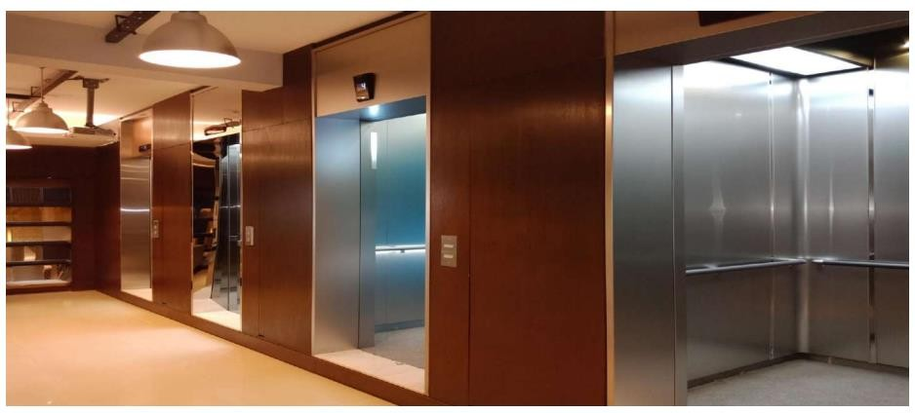

Figure1:State-of-the-ArtShowroom

MarketingStrategy

Edgeworks Ltd. is hiring new workers in their organization and also preparing a sales team in the marketing area regarding the vertical transportation system with those members who are capable of effectively approaching the customers’ requirements, supplying and installing elevators, escalators, moving walkways, parking systems, etc. Currently, there are efficient marketing officers in the company who measure the lift shafts from their projects, make good offers, and provide design for the lift shafts, overheads, machine rooms, etc. Their significant consultancy will always be available for the best marketing solution for the company.

Installation

Edgeworks Ltd. has a valuable team constituted of professionals who are experts in the installation activities of the vertical transportation system and are also capable of successfully implementing the plans. The team is capable of executing the operations effectively and supplying high-level equipment promptly. Thus, the installation of reliable equipment occurs.

Commissioning

In the commissioning department, there are engineers with local expertise and also other engineers with training from foreign countries. The department oversees the wiring, slow-speed running, slow-speed adjustment, high-speed running, high-speed adjustment, testing, callbacks, troubleshooting, etc.

OurEmergencyService

To help the clients use the purchased equipment effectively, Edgeworks Ltd. runs an emergency service. This is a mobile group where engineers are available 24 hours a day, 7 days a week. So, the company can provide instant solutions to clients.

Safety

The company maintains safety in the organization. While using the products, they take measures for the health and safety of the employees and the customers.

InternationalExperience

Edgeworks Ltd. has international experience in the high-speed installation of Hyundai elevators in Sri Lanka.

MajorProjects

The major projects of Edgeworks Ltd. are given below:

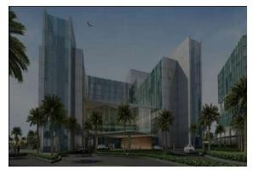
Project:RetailShoppingMallSite:DhakaAirport
Units:9Elevators,24Escalators
Speed:1.75m/sec(6),1.5m/sec(3),0.5m/sec(24)BuildingCharacteristics: Commercial

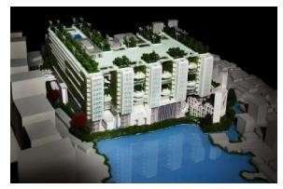
Project:BRACUniversityNewCampusBuildingSite:Merul Badda
Units:9Elevators,26Escalators
Speed:0.4m/sec(1),1.0m/sec(2), 2.0m/sec(6),0.5m/sec(26)BuildingCharacteristics: Commercial

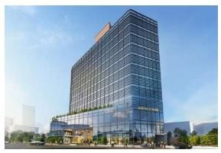

Project:UnionTowerSite:Bashundhara
Units:6 Elevators,6 Escalators
Speed:1.75m/sec(5),2.0m/sec(1),0.5m/sec(6)BuildingCharacteristics: Commercial

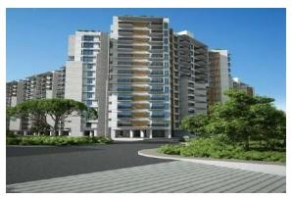
Project:THEOASISSite: MoghbazarUnits:18 Elevators
Speed:1.5m/sec
BuildingCharacteristics:Residential

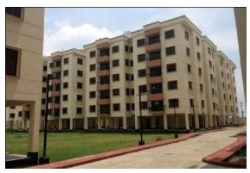

Project: BRAC TownSite:Gongi
Units:17Elevators
Speed:1.0m/sec
BuildingCharacteristics:Residential

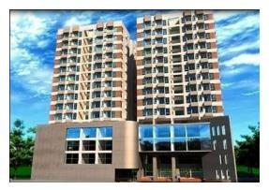
Project:MorshedAlamShoppingComplexSite:Chowmuhani
Units:2 Elevators,8 Escalators
Speed: 1.0 m/sec (2), 0.5 m/sec (8)BuildingCharacteristics:Commercial&Residential

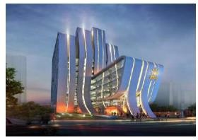

Project:BRACAarongSite:Dhanmondi
Units:4Elevators,10Escalators
Speed: 2.0 m/sec (2), 0.5 m/sec (10)BuildingCharacteristics:Commercial

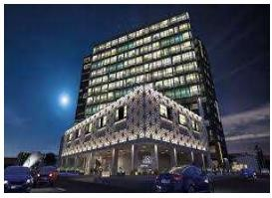
Project:JCXBusinessTowerSite:Bashundhara
Units:6 Elevators,2 Escalators
Speed:2.0m/sec(5),1.75m/sec(1)&0.5m/sec(2)BuildingCharacteristics: Commercial

OrganizationalChart

Theorganizationalchart ofthe company isgivenbelow:
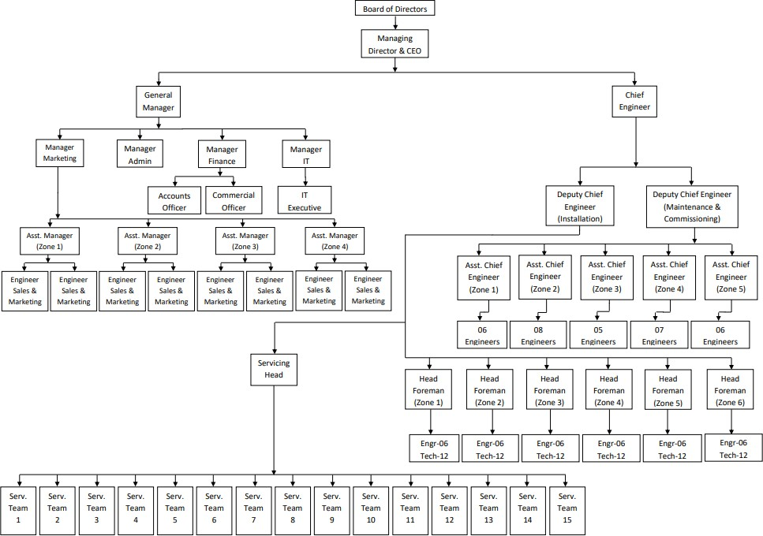

Figure2:OrganizationalChart

BoardoftheOrganization

Theboard oftheorganization is givenbelow:

SlNo. | EmployeeName | Department | Designation
1 | BarunKumarDey | Accounts | GeneralManager
2 | Md.ShofekulIslam | Accounts | AccountsOfficer
3 | Md.SadekAhmed | Sales&Marketing | Manager

4 | M.Mahdi-Al-Mahmud | Sales&Marketing | AssistantManager
5 | Md.Nuruzzaman | IT | Manager
6 | Md.SohanMahmud | IT | ITExecutive
7 | IzazAhmmed | Maintenance &CommissioningTeam | ChiefEngineer
8 | MamunHowlader | Maintenance &CommissioningTeam | DeputyChiefEngineer
9 | Md.Nurul Amin | ServiceTeam | TeamLeader
10 | Md.ShaponHowlader | InstallationTeam | InstallationinCharge
Figure3:BoardoftheOrganization

CHAPTER3:OBJECTIVES&METHODOLOGY

Objectives

PrimaryObjective

The completion of the Bachelor of Business Administration (BBA) program and receipt of the BBA program credential from United International University are the main goals of this internship report (UIU).

SecondaryObjective

The following list includes this report's particular goals:

- Understanding the overview and background of Edgeworks
- Understanding how the organization is cooperating with the people of Bangladesh by serving their products and services
- Identifying the marketing strategy of the company along with the office and showroom
- Edgeworks' corporate governance aspects are appropriately represented.
- Representing the findings and observations of the
- Recommending some important issues for the improvement of the organization

Methodology

TypesofData

Primary data and secondary data are the two categories of data. Primary data are those that the researcher has personally gathered. Primary data comes from a variety of sources, including questionnaires, surveys, observations, interviews, and experiments. Information that has been compiled from secondary sources. Books, newspapers, journals, websites, print media, etc. are sources of secondary data.

DataCollectionProcess

To prepare the research, both the primary data and the secondary data are collected.Edgeworks Ltd. officers were personally interviewed to get primary data. Various technical questions were posed to the organization's various employees. After asking them questions, they provided their valuable opinions.The primary data were discovered by taking into account their feedback, and they are reported in the study. The secondary data were gathered from websites, articles, and Edgeworks Ltd.'s annual report.

SampleSize

Ten employees of Edgeworks Ltd. are used as the sample in this study paper. Five employees are from the senior level and five employees are from the subordinate level in the sample of ten employees.

SamplingTechniques

The research for this publication was conducted using a random sample technique. 10 workers are chosen at random. For the purpose of composing the study report, five employees from the superior level and five employees from the subordinate level are chosen at random.

AreaandTimeofResearch

This research is prepared based on the "Corporate Governance of Edgeworks Ltd."Here, a detailed presentation of the general facets and problems of the company's corporate governance is made. The preparation of the internship report, which included gathering primary data and secondary data from various sources, took close to two months.

CHAPTER 4: CORPORATE GOVERNANCE OF EDGE WORKSLTD.

CompositionofBOD

The Board of Directors (BOD) of Edgeworks Ltd. is the primary decision-making body. They assess the company's management policies and regulations, as well as its major issues, to establish superior corporate value. They explore the interests of the shareholders of the company, and based on that, they make the decisions for the company. The board of directors of the company administers the Audit Committee and the Personnel Committee. At present, there are a total of five directors at Edgeworks Ltd. Out of them, 2 members are internal directors, 2 members are external directors, and 1 member is a non-executive director.

Independenceof BOD

The external directors of Edgeworks Ltd. are obliged to operate 25% or more of the total activities of the Board of Directors (BOD) as per the rules of the company. Now at present, the 2 external directors of the company are involved in the top management issues. They attend all of the committee meetings of the Board of Directors (BOD) to make important decisions because they have independence in the decision-making process. They provide their remarkable opinions on different issues facing the company regarding its business objectives. They are independent in the office environment.

TransparencyandExpertiseinDirectorAppointment

The internal directors of Edgeworks Ltd. are nominated by the board of directors of the company. They are appointed to participate in the important meetings of the organization. They are very effective members of the organizational meetings, as they highly influence organizational decision-making. The external directors of Edgeworks Ltd. are nominated by the Outside Director Recommendation Committee based on their expertise and efficiency. They are appointed at the general shareholder meeting to give their important opinions regarding the organization.

AppraisalandRemunerationoftheDirectors

Generally, Edgeworks Ltd. appraises the directors periodically regarding their duties and responsibilities. The Board of Directors of the company is very effective, and all of the directors are very expert and proficient. They fulfill their roles and responsibilities properly, and for that reason, the company appreciates them highly. There is a limit on the remuneration of the directors, which is set at the annual meeting of the organization. The company's directors are compensated for their performance evaluation.

StakeholderCommunication

The members of Edgeworks Ltd. regularly communicate with the stakeholders of the company through different communication channels regarding important meetings, events, and other issues. The members of the company provide all of the relevant information related to the company to the stakeholders and consider their opinions in the decision-making of the organization.

ExecutivePerformanceAppraisalandRemuneration

Edgeworks Ltd. employs a large number of people, including executive officers. The management of the company evaluates the executives and provides them compensation based on the payment criteria set by the company. The company pays them their basic salary based on their position, with a basic bonus (according to the operating profit of the company and its increase rates) and an over-profit bonus (according to the company’s excess operating profit beyond the profit target). Besides this, the executive employees get some assessments regarding human resources, safety, and the environment according to their position.

EmployeeRemuneration

There is a limit on the remuneration of the employees, which is placed by the management of the organization according to Article 388 of the Commercial Act and the Articles of Incorporation. The CEO of Edgeworks Ltd. receives BDT 72 million per year in salary, bonus, and severance pay. The managers receive BDT 52 million each annually. The executives receive BDT 38 million each annually. The average payment per employee is BDT 5 million annually.

RiskManagement

RiskPolicy

Because of the business extension, many risks arise both internally and externally. So, those risks need to be identified and also need to be decreased. At Edgeworks Ltd., the management identifies the financial and non-financial risks that can affect the organization's operations and also develop different strategies to control and address those risks effectively.

RiskManagementSystem

In Edgeworks Ltd., the management identifies the risks inside the organization and also identifies the causes of those risks. The major risks are maintained by the major departments according to the policy established by BOD. The BOD has established various policies for risk areas such as currency, interest rates, LC, credit, and so on.

EthicsManagement

EthicsManagementSystem

In 2007, an Ethics Management Team was established in the company to empower the auditing of the organization. The team checks the overall process of the organization and evaluates the company’s ethics. If the organizational policies and ethics are not maintained properly, then corrective actions are taken to improve the organizational process. In maintaining corporate ethics, the company makes efforts to improve the transparency, accountability, and profitability of the organization to establish an ethical organization.

InternalAudit

The internal audits of the company are diversified into three categories: regular audits, special audits, and confirmatory audits. Regular audits are conducted based on the audit schedule prepared by the authority. The special audits are conducted according to the direction of the CEO of the company. The confirmatory audits are conducted to justify whether necessary actions are taken by the working-level departments on the issues identified by the regular audits and the special audits. In the year 2020, a total of five audits were conducted (three regular audits, one special audit, and one confirmatory audit).

ReinforcementofEthicsManagement

For organizational employees, ethics regulations, ethics management casebooks, online training, and online surveys are implemented. In the year 2020, a self-diagnosis process was developed to maintain an ethical culture in the organization and to reinforce the organization's ethics management.

EthicsRegulations

The ethical regulations of the company are given on the official website so that the stakeholders can learn about them and help the company develop high ethical values. In the year 2019, these ethical regulations were revised, and some new ethics were established for some specific works.

HumanResourceDevelopment

HRDStrategy

Because of the COVID-19 pandemic, the overall business condition of the organization declined. So, they get conscious of the future and make an effort for sustainable growth. The organizational authority has established rules and policies to increase the professionalism of the organization, including training programs for each particular position to increase employee skills.

TechnicalTraining(EnhancementofTechnicalCompetence)

The training of the organization has been extended, and technical training has been included. The HR department of the organization is conducting customized training for the employees technicallyto provide them with technological knowledge.

Administrative Training (Reinforcement of Common Competencies and Training asJobExperts)
Because of the COVID-19 pandemic, outsourced training decreased. So, the organization is empowering its employees by conducting several training programs for them. They are providing training for all sectors, including research and development, sales, production, finance, accounting, HR, etc.

HRManagementatOverseasCorporations

AdvancingtheHRSystem

With the advancement of the HR system, Edgeworks Ltd. continues its business operations. Each HR function is operated in the organization for organizational improvements, operational processes, and systematic evaluation.The firm authorities planned to offer systematic leadership training in 2021 to enhance employees' performance in general and to strengthen managers' leadership capacities.

CapacityBuildingforOverseasCorporations

The HR department of the company has arranged a remote online leadership training program for overseas corporations. They have developed the skills and competence of the employees and the leaders by providing effective training to them. They are operating the global CDP training program for domestic employees to develop their global competence. They also operate the global CoP program for empowering global business, regional diversity, and global communication.

CHAPTER5:FINDINGS,RECOMMENDATIONS&CONCLUSION

Findings

I've discovered a few things during my internship. These conclusions are provided below:
- There is a lack of proper management in the organization. The management policies, laws, rules, and regulations of the organization are not appropriate. The organization's leader has failed to publish organizational standard management for organizational operations and employees. For this reason, organizational operations are not maintained effectively.
- The work environment of the organization is not good. There are so many employees inside the organization, but the space of the organization is not very broad according to the number of employees. So, the work environment of the organization becomes too noisy. The staff of the organization is not very friendly. That’s why the employees can't speak frankly to each other about operational issues.
- There is a lack of proper resources in the organization. In reality, an organization requires a large number of resources to keep its operations moving in the right direction. But, according to the number of employees, there is a lack of sufficient resources in the organization. As a result, the organization's employees suffer greatly in their organizational activities and tasks.
- The organization's human resources (HR) department is not as effective as it should be. The head of the HR department and the other officers of the HR department are not very efficient and expert at performing their operations and activities. They are unable to manage employee management activities effectively.
- The leadership quality of the organization is not good. The superiors of the organization always dominate the subordinates about how to maintain the organization's operations and activities. The organization's superiors lack the knowledge and skills required to lead. Their leading management is not good enough to monitor the subordinates. As a result, it has a significant impact on the organization.

- There is insufficient labor in the organization. Being a valuable organization, it needs excessive numbers of employees to perform organizational operations and activities. But because of insufficient labor, the organization can’t maintain operations effectively.

Recommendations

The recommendations of Edgeworks Ltd. are given in the following:

- The organization should implement proper management in their organization. The head of the organization should need to establish standard rules, laws, and policies in their organization by communicating with the other employees of the organization. The board of the organization should organize a meeting with the staff of the organization and make appropriate decisions regarding the policies, laws, and regulations.
- The organization needs to create a good work environment to motivate the employees to perform organizational tasks. The office environment needs to be wide and massive. The managers of the organization need to be friendly and helpful to their subordinates so that the employees feel free to ask them anything related to official activities.
- The head of the organization needs to bring more resources into the organization for operating organizational tasks and activities. As there is a lack of sufficient resources in the organization, the organization needs to invest more money and buy more resources for the organization. The employees will then find it easier to carry out their tasks and activities.
- The organization needs to make the HR division stronger by hiring some effective people in that division. The HR division of the organization is weak, and they are unable to maintain their tasks effectively. The organization should assign some expert employees to the HR division and provide them with proper training so that they can conduct employee management activities effectively.
- The organization should improve its leadership management. The pioneers of the organization are not skilled enough to administrate the employees of the organization. So, the organization needs to keep those members in the leading positions who are experts and will be able to perform the leadership tasks in the organization.

- The company needs to increase the number of employees in the organization. Being a highly valuable organization, it needs a huge number of employees to maintain organizational operations effectively.

Conclusion

Edgeworks Ltd. is maintaining standard systems and policies in their organization for implementing business growth and achieving their business goal. The officers and employees of the organization are well-skilled and can conduct business operations properly. Although the organization has a limited number of resources, the staff can perfectly operate the business tasks and activities with those resources. When employees join the company, they receive extensive training. As a result, they can demonstrate well-rounded performances while carrying out organizational tasks and activities. The officers are not only good at work performance but also good at humanity. They are very helpful to the clients, and they nicely cooperate with them while providing services. Their behavior and attitude are very positive. They always have a positive attitude toward the organization's members and the people they serve. As there are different negative aspects in the organization, which are discussed in the findings part, Edgeworks Ltd. can facilitate organizational work effectively with its labor and resources. Many necessary steps for the organization's improvement are outlined in the recommendation section. The owners of the organization need to invest more money in the organization, make the office environment wider and more massive to create a good work environment, and purchase more resources for the organization to operate the organizational tasks effectively in a short time. The organization should hire more employees for their organization toward the achievement of the business goal. The board of the organization is planning to develop many strategies for the organization's future growth. Being a valuable organization, it needs to be properly operated for customer satisfaction. At present, the organization is running very effectively with its employees and resources. The board of the organization expects that the organization will achieve potential growth in the future.

REFERENCE

EdgeworksLtd(2021) EdgeworksLtdAnnualReport2020

EdgeworksLtd(2021) EdgeworksLtdAnnualReport2021

Edgeworks Ltd. (2022). Www.facebook.com. https://www.facebook.com/Edgeworks-Ltd-1682220912015736/
HYUNDAI ELEVATOR. (2022). Www.hyundaielevator.com. https://www.hyundaielevator.co.kr/ICAEW. (2022). What is corporate governance? Www.icaew.com.
https://www.icaew.com/technical/corporate-governance/principles/principles- articles/does-corporate-governance-matter#:~:text=Corporate%20governance%20is%20the%20system
Lutkevich,B.,&Lewis,S.(2020).WhatisCorporateGovernance?-DefinitionfromWhatIs.com.SearchSecurity. https://www.techtarget.com/searchsecurity/definition/corporate-governance
Wikipedia Contributors. (2018, November 11). Corporate governance. Wikipedia; WikimediaFoundation.https://en.wikipedia.org/wiki/Corporate_governance

