Livelihood Sustainability of Jamdani Weavers: A Case Study

Manisha Akter
United International University

Supervisor: S M Asif Ur Rahman
Assistant Professor
School of Business & Economics
United International University

Abstract
Jamdani is a traditional fine fabric produced around Dhaka, the capital of Bangladesh. Though produced and found in several parts of the country as well as in neighboring country also, it is commonly known as Dhakai (Made-in-Dhaka) Jamdani. UNESCO recognized Jamdani as intangible cultural heritage in 2013; while it got registered as Geographical Identification (GI) product of Bangladesh in 2016- the first recognized such product of the country. It requires traditional handloom weaving technique practiced by weavers in this region for centuries. This laborious, time consuming task of weaving also comes at the price of patience, aesthetics and intellectual merits of the weavers. A number of researches have been done on history, making, and improvement of Jamdani as a product itself, however, hardly any such could be found on livelihood sustainability of the people behind this age-old craft. The purpose of this research is to explore deeper inside the lives of Jamdani weavers, their sorrows and sufferings, dreams and aspiration, and to formulate ideas about how their livelihood situation can be made better. The research will enfold a number of real case scenarios, focused group discussion (FGD) method has been adopted to collect primary data, whereas a number of printed documents sourced from both the internet and published journals will be consulted for secondary data. Results showed that though afore-mentioned recognitions help protect the identity and ingenuity of this cultural heritage; weavers belonging to this craft need something more to translate these recognitions into their own livelihood benefits. The Jamdani weavers are passing their lives with sufferings. They are not happy with their livelihood because they do not get expected wage, cannot fulfill demand properly. It implies that, though many steps have been taken for holding on this tradition the ultimate beneficiaries are not the weavers. Necessary steps should be taken for ensuring sustainability in livelihood of Jamdani weavers.

Keywords: Jamdani, handloom, weaving, Geographical Identification, sustainability.

Introduction
The term ‘Jamdani’ is of Persian origin where the compounding word ‘jam’ means flower, and ‘dani’ means vase or container (Chakrabarti, S. 2016). Weavers use traditional handlooms to create floral motif in geometric forms. Jamdani is reputed among the fashion connoisseurs around the world equally for its authentic unique design and craftsmanship. Jamdani weaving in Bangladesh has an ancient history. Recognizing uniqueness of it, UNESCO acknowledged Jamdani as an intangible cultural heritage in 2013. Along with that, it got registered as Geographical Identification (GI) product of Bangladesh in 2016.Jamdani Industry has had a great contribution in our national economy. Historical records show, the then British rulers exported Jamdani worth 5 million Rupees in 1787. Yearly it adds more than Tk 10 billion to the national exchequer (Khan, M.2016).

Time, patience and intellectual merit are critical inputs, besides money, in production of Jamdani. Weavers, both male and female, of every age including children work from dawn to dusk. It is natural to think they earn a sustainable livelihood. Factors like rising cost of raw materials, price hike of daily necessities, and insufficient wages (Hosen. Z, 2015, December 15) put the people engaged in production of Jamdani in real hardship. Many of them have already switched profession while another significant number are struggling with keeping body and soul together. This research paper, hence, aims to cast light on the livelihood of Jamdani weavers. To get deeper into the issues, a more respondent friendly and socially empowering data collection method –Focused group discussion (FGD) was employed. Collected contents were analyzed to do qualitative judgments.

Literature Review
Human civilization is old, perhaps the art of weaving is as old as that. History of Jamdani dates back to the Mughal rule when the royals, both male and female, were fond of Muslin, a much finer, delicate hand weaved fabric. It is thought that today’s Jamdani is a descendant of Muslin. However, with the decline of Mughal Empire it lost its most loyal patrons and started to fade away. Later on, colonial British rulers systematically limited the manufacturing and marketing of hand-made Muslin/ Jamdani in order to find buyers for factory-made cheaper textile imported from Europe.
Exquisite mixture of ecological and geographical conditions made the basin of the river Shitalakhya (near Narayanganj) only place suitable for weaving Jamdani. From the ancient times, the knowledge and skills of weaving have been passed down to generations. Few decades back, though, Indian authorities registered Jamdani from Andhra Pradesh as “Upadhaya Jamdani Sarees” (serial number 106 and application number 122) which came as a potential threat for the development of Jamdani Industry in Bangladesh (Shahed, Husne, A. 1985).
For the progress of the Jamdani saree at Noapara of Tarabo union under Narayanganj district The Bangladesh Small and Cottage Industries Corporation (BSCIC) has established a Jamdani Industrial City and a Research Centre at a cost of Tk 5.86 crore. There are 409 plots and 399 plots have been distributed for the industry among entrepreneurs (Khan, M.2016).
The handloom has high percentage of contribution in the nation's economy (Ahmed, M. U 2001). In 2000, there were only 1600 weavers which increased to 15000 from 3000 families in 2013. 12383 is the total number of Jamdani weaving units, according to Bangladesh Handloom Board. Per week about 2000 (estimated) Jamdani sarees are being produced. Besides fulfilling national demand, Jamdani sarees are exported to South Asia, Europe, Middle East and North America. In 2011, Bangladesh Weavers Product and Manufacturing Business Association (BWPMBA) organized the International Jamdani Taant Bastra Mela (Handloom Textile Fair) in which spot order was worth Tk. 0.12 billion that verifies the aggregate demand for Jamdani. Though there is no formal data, it is believed that India is the leading importer of Jamdani. In 2010-11, the total export of Jamdani saree was $10.41 million (Iqbal, I. 2015). Bangladesh exported Jamdani sarees worth of $15.41 million in 2015-16 which was $11.84 million in 2014-15 (Khan, M.2016). More than 2 lakh pieces of Jamdani sarees are made by the Bangladeshi weavers every year and those are also exported out of the country. Around 68000 people are involved, directly and indirectly, with manufacturing and marketing of Jamdani (The Daily Star. 2016, November 18).
Sustainability of the weavers in specific, and the industry as a whole, now-a-days has met the greatest challenge of all time. The older generations of weavers are disinclined/ incapable to pass on the skills to newer generations. The very crucial ecology of the river Shitalakhya is under threat because of the waste from sprouting heavy industrial establishments. For the shortage of working capital, weavers cannot expand their business which is compulsory to maintain the smooth growth. (Asian Development Bank, 2002). Financial support from conventional banking sector is hard to find; specialized institutions such as Grameen Bank and Proshika recently proposed small amount of loans for supporting them under micro credit initiative. However, relatively higher cost of micro-credit funds is higher further aggravating the living of weavers (Khan, M.2016).
To develop the sector, special allotments have been proposed in the national budget; the proposals included Tk 10 core credit with easy interest, 25 percent money incentives for training centers for design and special allocation and stopping of Jamdani smuggling (www.banglanews24.com, 2014, May 15). In line with that, Bangladesh Small and Cottage Industries Corporation (BSCIC) have established a Jamdani Industrial City and a Research Centre. The senior secretary of the center said, “GI tags to the product would ensure good prices in the international market and thus be beneficial for the people involved in the trade”. (The Daily Star. 2016, November 18).

Methodology
This study is qualitative in nature, attempting to explore deeper inside the lives of Jamdani weavers, their sorrows and sufferings, dreams and aspiration, and to formulate ideas about how their livelihood situation can be made better. Focused group discussion (FGD) method has been adopted to collect primary data and a number of printed documents sourced from both the internet and published journals were consulted for secondary information. Sampling was conducted at Jamdani Palli Noapara, of Tarabo union under Narayanganj district. 5 sessions of Focused group discussions (FGD) were conducted. The following table shows the formation of participants in each focused group:

No. | Number of people | Method
1 | 5 | Focused group discussion
2 | 4 | Focused group discussion
3 | 6 | Focused group discussion
4 | 6 | Focused group discussion
5 | 4 | Focused group discussion

The following section presents the research findings.

Findings and Discussion
The questions that were formed for the FGDs are given below:
- Age
- Marital status
- Number of family members
- Place of birth
- Highest educational status
- Monthly income
- Daily work hour
- Reason(s) behind choosing Jamdani weaving as profession.
- Skill or ability to do any other work apart from Jamdani weaving (alternative livelihood skill)
- Problems of day-to-day life
- Fulfilling basic family needs with the money earned (Sustainability)
- Knowledge about Geographical Identification (GI) and its significance in their lives
- Contingency planning (if any) in case of declining income
- Future aspiration and change of profession for self as well as for next generation
- Personal pride regarding current profession
- Government and non-government initiatives and their sufficiency
- Suggestions for sustainable existence and growth of Jamdani industry and people depending on it
Before going to further discussion, let us visualize three scenarios from Noapara Jamdani Palli:
- 55 years old Goni Mia (pseudo name) learnt how to weave when he was 15. He did not ever read a book but weaving for a long time has had its toll: he suffers from blurry eyes. Now he has to run a family of 5 members. He amasses around 15000 tk per month which would be a good total to fulfill family needs a year ago. But now it is not. Price hike of daily necessities has worsened off his livelihood. He seeks a pay rise keeping up with increased profits earned by resellers.

- Fatema (pseudo name), niece to Goni Mia, supplements her rickshaw-puller husband by working in the same loom along with her uncle. She is a 23-year-old married woman with 2 school going children. Fatema earns around 10000 tk a month. For this, she gets up early in the morning, cooks for the family, then gets her children ready for school. After completing household chores, she joins her work and work till night. She hardly gets any time to rest and ponder. Unhappy Fatema says, “I would give up if I could, but I need the money for my family. It feels bad because wages are not enough. It hurts”, she added, “Those who work do not get the reward of hard work; those who sell, get all.”

- Sajib (pseudo name), while arranging his tools in the loom said with grief, “If only India had stopped copying us it would be very good; our product price would have increased, we could have got better wage. If customers have come and bought directly from us, they would get authentic Jamdani, and we could get proper price. You know, the resellers charge more and give the weavers as less as they can”. Sajib, now 26, is unmarried. He came in to this profession at the age of 15. His birthplace is Brahmanbaria. He came to Jamdani Palli for supporting his family. He cannot fulfill his family demand with the wages. When he came here he got Tk. 5000 now he got Tk. 12000 monthly after working from morning till night.
The analysis of data got from the Focused Group Discussion (FGD) shows that, people aged 12-25 year are mostly involved in the manufacturing while a few others are aged above 40. Among the weavers, a good number are married. Maximum people come to this profession from extended families having about 5-10 members in each. Most of the people of Noapara Jamdani Palli have their own place and handlooms. People from different districts– Kishoreganj, Brahmanbaria, Bhairab, Mymensingh are found here doing the job of weaving. Very few of them continue their study beyond class 5 and some of them are also illiterate. The senior weavers generally get Tk. 10000-15000 per month, sometimes as high as Tk.20000while juniors in the trade get as low as Tk. 5000-6000.
Though they work from dawn to dusk, most of them lead a stressed life because of meager wages. The reasons behind choosing the work is they like to do the work, to become self-dependent, to help the family, to learn livelihood skills since many of them are still young and some of them told it was their ancestor’s job so that they choose this profession. Almost all the weavers told that they do not do any other work apart from this.
It is a matter of regret that they are the people who are most important for holding on this tradition but they are not aware about Geographical Identification where The Department of Patents, Designs and Trademarks (DPDT) would register the weavers who make Jamdani for using the Geographical Identification (GI) tag in Jamdani products, subsequent to the GI registration (The Daily Star. 2016). After telling about GI briefly, most of them told it would be really useful to stop producing copied products in India or other places. One of the weavers, Babul (pseudo name) said, “It will be helpful because no one will be able to fake Jamdani, our market and tradition will not be lost, tradition will survive. Textile Mills make fake Jamdani which will deteriorate the market and tradition further”. “The benefit of Dhakai Jamdani is it will survive, like it has survived for ages. Weavers do not have any loss or benefit”, said an optimist Runa (pseudo name).
Most of them told that their financial condition has worsened. Price has increased; income is raised though the real benefit goes to investors/owners of the loom and the trade’s people. Among the weavers Dulal (pseudo name) said, “If income decreases persistently, I will leave this work and do any other type of trading but weaving”. Only two weaver said that they want to stay in this profession in future and the other said no because they get minimum wage. Another weaver Jewel (pseudo name) said, “If I can, I will leave the work now; it feels bad because enough wage is not got. If I leave, I may work in Garments or any other work”. However, many of them do not know what profession they will choose if they leave the profession.
All of them who are married told that they do not want to bring their children in this profession. Among unmarried weavers some told no, want to educate, do not know about future from now, some told yes and some told income is low so do not want to teach them (children) the technique. A weaver Ratan (pseudo name) said, “I am not happy in this work, the price of everything raises but the value of our work does not raise”. Another Rofik (pseudo name) said, “I am happy, this work is good”. Some of them like the work because they think it is comfortable to do. A female weaver Fatema (pseudo name) said, “Since this is not giving enough wages, this work will not be done for long”. They think this industry needs to be sustained because it is our age old tradition. They also told that the fake, inferior quality Jamdani sarees create doubt in the minds of customer sand take away profit and satisfaction. If the market condition turned well and import of Jamdani from India could be stopped or limited, the industry would have developed more. They think, apart from government if any private companies come into invest, or giving easy short term loans it will be helpful.
While doing the work they face many problems; during the monsoon, the yarn gets glued/sticky or torn for which the pattern in the saree are not perfect. Because of the delicate nature of the job, most of the time they suffer from blurry eye sight. Weaving needs two people in the loom, because if anyone gets sick the work gets stuck.
Therefore, it appears from the above discussion that day by day the price of everything rises but compared to that wages of weavers are not increasing. Those who resell finished products take the lion’s share of profit. Now they are not satisfied with wages and other benefits. In addition to these, the profusion of fake factory-made Jamdani and import of Upadhay Jamdani sarees from India simply add insult to injury. So their lives became miserable. It is necessary to realize that if the weavers are not contented, sustainable development of Jamdani industry will be severely hindered if not stopped totally. The past findings also show that due to lack of training, fewer wages the very existence of the weavers is threatened. It will by turn lead to the ultimate extinction of an age-old tradition of human civilization.
Recommendation
For improving livelihood sustainability of Jamdani weavers, government can take steps such as providing legal provisions for giving acceptable wages, creating link with the exporters for ensuring sustainability, compensating the weavers in emergency periods, improving living standards etc. In conjunction, private companies may come forward in help of the weavers, and may invest in this industry. The past discussion also reviewed that monetary incentives for training centers for design and special allocation and stopping of Jamdani smuggling, for the industry had been proposed. Along with that, our government should stop or limit import of Indian Jamdani and take stringent measures to save Dhakai Jamdani from illegal smugglers.
Future Research Direction
The discussion in this research casts light on livelihood sustainability of Jamdani weavers through a qualitative analysis. A quantitative study may help policy makers formulate models for coming up with better scientific solutions to address the issues.

Reference
- Ahmed, M. U (2001):″Globalization and Competitiveness of Bangladesh’s small- scale industries (SSIs)”: An Analysis of the Prospects and Challenges, in CPD/UPL published, Bangladesh facing the challenges of Globalization, IBRD.
- Asian Development Bank (ADB) (2002). “Strategic Issues and potential Response- Small and medium Enterprise Development and export expansion”, Yearly Report, Research, Asian Development Bank, ADB, Dhaka.
- banglanews24.com. (2014, May15). Incentives to help Jamdani export. Retrieved from
http://www.banglanews24.com/index.php/business/article/20919/Incentives-to-help-Jamdani-export
- Chakrabarti, S. (2016). THE TRADITIONAL ART OF JAMDANI WEAVING: A GLORIOUS PAST AND A SHINING FUTURE. Retrieved from
http://www.craftsvilla.com/blog/traditional-art-of-weaving-jamdani-saree/
- Hosen. Z, (2015, December 15). History of Jamdani Saree. Retrieved from
http://blog.jamdani.com/history-of-jamdani-saree/
- Iqbal, I. (2015, March 8). Protection of Jamdani. The daily star. Retrieved from
http://www.thedailystar.net/protection-of-jamdani-33014
- Khan, M. (2016). INTANGIBLE CULTURAL HERITAGE OF HUMANITY ABOUT BANGLADESH. European Centre for Research Training and Development UK, Vol. 4, No.9, pp.4-16.
- Shahed, Husne, A. (1985). Saree. Dhaka Bangla Academy
- The Daily Star. (2016, 18 November). Jamdani finally gets recognition. The Daily Star Retrieved from
http://www.thedailystar.net/frontpage/jamdani-finally-gets-recognition-1316581
- The Daily Star. (2016, 18 November). Jamdani finally gets recognition. The Daily Star Retrieved from
http://www.thedailystar.net/frontpage/jamdani-finally-gets-recognition-1316581
- Zohir, I. S. (1996): “An Assessment of Industrial Policy in Bangladesh”: What Policies are We Talking About? February.

Appendix
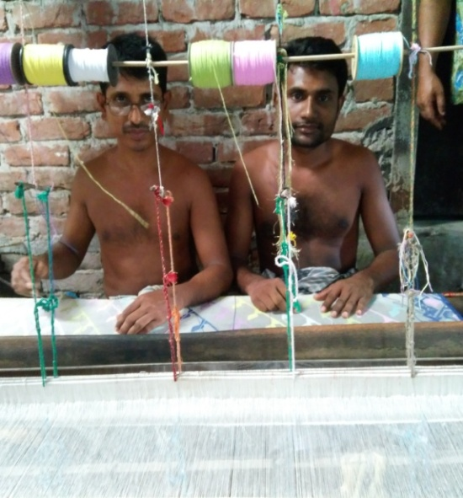
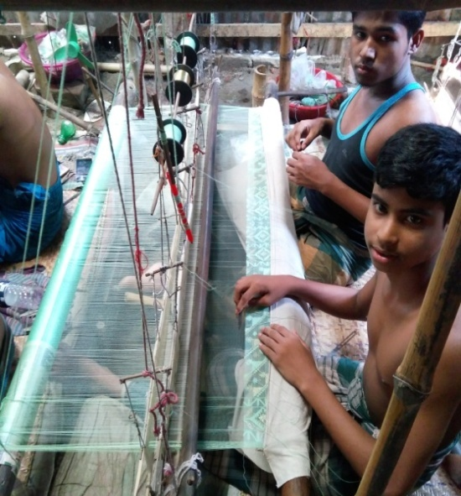
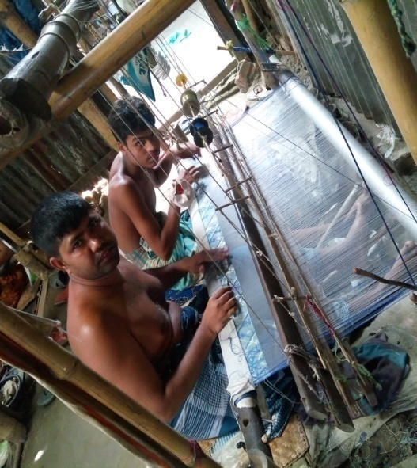
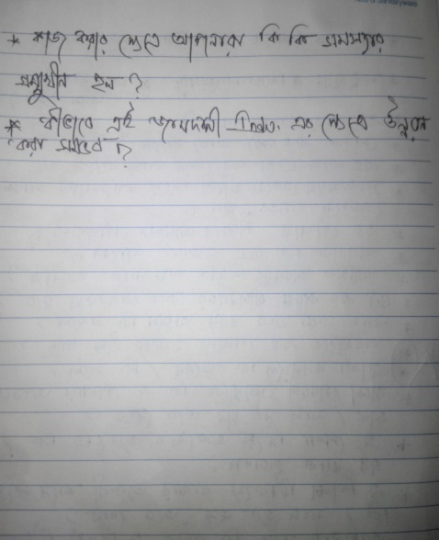
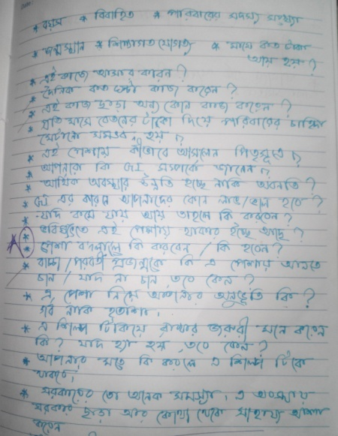
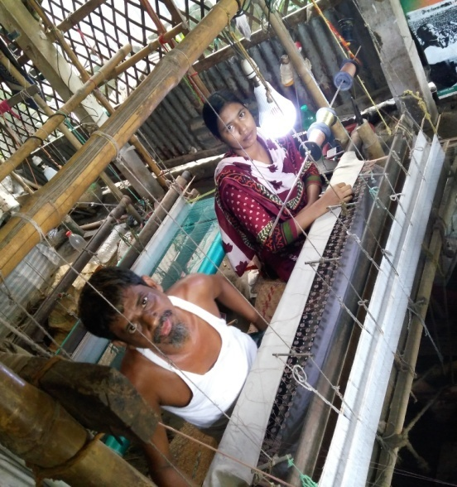
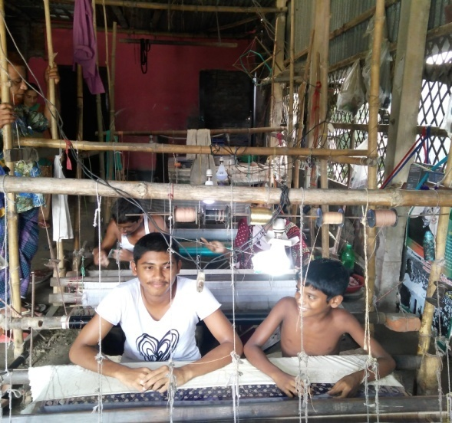
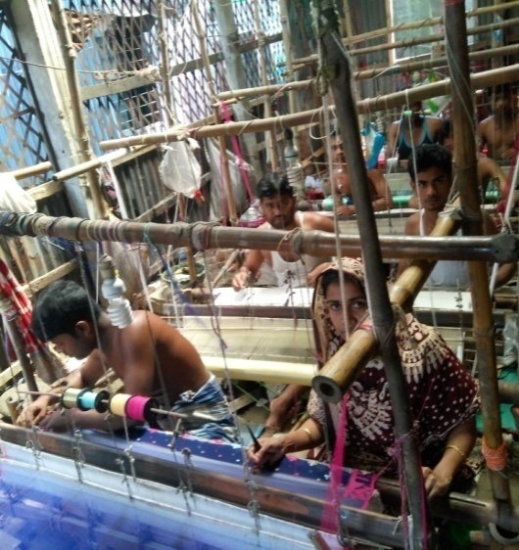
The raw questions for the FGD method and some pictures taken during conducting FGDs:

