Report On
EVALUATION OF HUMAN RESOURCE MANAGEMANT PRACTICES AT
MODHUMOTI BANK LIMITED



Submitted To
Dr. Mohammad Badruddozza
Associate Professor
School of Business and Economics

Submitted By
Atia Ashrafi
ID-111 142 080

Date of Submission: July 24, 2020
Letter of Transmittal
Date: 24/07/2020
Dr. Mohammad Badruddozza
Associate Professor,
School of Business & Economics
United International University, Dhaka
Subject: Submission of the Internship Report.
Dear Sir,
It is an honor and pleasure for me to present to you the internship report on "Human Resource Management Practices at Modhumoti Bank Ltd." as a prerequisite for completing the BBA program. During the internship program period, it has been made at MMBL which is based on my practical learning and the information collected from my supervisor, colleagues, staff, and websites.
This report is aimed to exhibit how to practice human resources management at MMBL. It was a pleasure as well as a challenge to work in the bank and prepared this report which has helped me meaningfully to enhance my knowledge and skills.
I, therefore, manifest my profound gratitude to you for the kind cooperation, guidance, and supervision in preparing this report successfully. Hope this report will be considered by you and obliged thereby. I shall be happy to provide any amendment on any relevant matter.
Sincerely yours,
…………………
Atia Asharfi
ID 111142080
United International University
Acknowledgment

All commendation is for Almighty ALLAH that has imparted on human beings which is the crown of creation and has awarded with knowledge and wisdom. I am very thankful to the Almighty who provided me the bravery to complete this report. On the other hand, let me show my gratitude and heartiest thanks to all who have supported me to complete this report and certainly except the support of them.
I would love to give heartiest thanks and gratitude to my Internship supervisor Dr. Mohammad Badruddozza, Associate Professor at United International University, School of business and economics; I'd say without his worthy directions it would have not been possible to fulfill this report.
Furthermore, my gracious appreciation goes to Mr. Atiqure Ahmed Akond, senior manager at Modhumoti Bank Ltd. who has guided me to learn endless ways the functions of the HR Department, especially talent obtainment. In addition, I am obliged to the Head of HRM, Mr. Shafiqul Rahman who bricked the way for me to have my internship completed in such a well platform. I can say assuredly the experience I have achieved here will be significant for my future career.
A special appreciation goes to all the staff of the HR Department of Modhumoti Bank Ltd. for their helping hands and support during my entire internship period. I am also thankful to high officials and all the officials, and staff for their welcoming behavior, cooperation and all the other services during my studies.

Table of Content
Executive Summary |  | V
Chapter 01  Introduction |  | 01
Origin of the report  Objective of the report  Research of Methodology  The Scope of Study  Limitation |  | 02  02  02  03  03
Chapter 02  Company Overview |  | 04
Modhumoti Bank Limited  Strategic Objective  Retail Banking  Organizational Hierarchy |  | 05  06  08  09
Chapter 03  Literature Review |  | 10
Human Resource Management  Human Resource Planning  The design of work system  Function of HRM  Training and Development  Compensation  Employee Benefits |  | 11  12  15  16  17  23  25
Chapter 04  Human Resource Practice |  | 28
Human Resource Management  Human Resource Planning  Staffing Planning  Prime Bank Limited  Hiring Process  Training and Development |  | 29  30  31  34  37  39
Chapter 05  My Observation |  | 44
My Observation |  | 45
Chapter 06  Conclusion |  | 46
Conclusions |  | 47
Reference |  | 48
Appendix |  | 49

Executive Summary
In this report, manifold general activities of Modhumoti Bank Limited have been tried to illustrate by me and also found out the lacking of these activities. The impact of these activities on the bank’s profitability has also been shown. This report is equipped on the basis of my three months of practical experience at Modhumoti Bank Limited. The internship program helped me to know about the realistic situation of corporate life. In this modern evolution age, the bank plays a vital role to keep the economic development wheel going appeasement banking service is a concourse of all general banking activities.
Now the concise history of The Modhumoti Bank Limited, Central Bank Law founded on 19 September 2013 by all rules and regulations of company and shares under the Companies Act 1994 and the bank companies Act 1991 along with The Bangladesh Bank BRPD (Baking Regulation and Policy Department) policies. The vision of this bank is to guide a new generation of local commercial banks by surpassing customer delivery through acumen empowered employees with smart use of technologies and a scale of high quality of products and services. As an agent banking is served by Modhumoti bank Ltd.
Starting this report with the profile of an organization called Modhumoti Bank Limited with its background history, vision, mission, products, and services are offered by them. The next section is followed information about my internship activity and job responsibility during the internship period at the Bank. After that section, it comes to the greatest section which contains the project, HRM Practice in Modhumoti Bank Ltd. Each chapter arranged with a detailed explication of the HR functions with relevant examples pursued by Bank HRD. The next part of the report is about some significant factors regarding HRM practice in Modhumoti Bank Ltd.
In this report, I tried to comprehend my real-life experience in branch banking and also to acknowledge various banking functions and banking activities system on my way to complete the internship.

Chapter 01
Introduction

Origin of the Report:
This internship report is a manifestation of three months internship program which is mandatory to get a Bachelor’s degree in Business Administration program from United International University. I am very lucky that I got the chance to work at Modhumoti Bank Limited, where I gathered experience in general banking activities. My learning was not only limited to general banking because my job was to design a job analysis or a working model that enriched my knowledge in HR. basically This report has been prepared for my three months of internship experience that I gained by serving MMBL to meet the requirements of United International University.
Objectives of the Report:
The vital objective of this internship study is to a gain realistic and practical understanding of the role of human resource management at Modhumoti bank limited. The inclusive objectives and specific objectives of the study are given below:
- Inclusive objectives: This study focuses on the confidentiality of the current business environment, the internal culture of the corporate world and the general idea of ​​talent acquisition practices at Modhumoti Bank limited.
- Specific objectives: This report more specifically entails the following aspects:
- To give an overall synopsis of the organization.
- To accrue knowledge about the functions and achievements of the HR department
- To analyze major findings of Talent Acquisition process
- To formulate recommendations for possible improvement
- To evaluate employee satisfaction of the organization
- To learn the method and types of interviews used in the selection process
- To know the source of recruitment
- To relate the theoretical learning with the real-life situation
Research Methodology: Basically research methodology refers that are adopted in research process to collect, assemble and evaluate data. This report was prepared in systematic procedures. It has been conducted through accumulating information from primary as well as secondary sources.
The Primary source of data:
- The practical deskwork experience in MMBL.
- Informal interviewing employees.
- Personal observation and regular interaction with the staff.
- Discussion with the Manager, Sr. Executives and executives.
- Regular note maintenance.
- Communicate with the Talent Acquisition Team of the HR Department.

The Secondary source of data:
- Articles and books of the related topics
- Analyzing several confidential reports
- Browsing Website on current HR practices
- Online data from the website of MMBL
- Relevant file study
The scope of the study: The scope of the study was determined at an initial stage and so far it is important to know its requirements. This report is based on my practical experience of 3 months of practical training at MMBL. It was a wonderful opportunity for me to practice and implement the whole process for the bank in general. This will help me to get rid of the confusion between practical knowledge and theoretical knowledge. This internship period has helped me to understand a lot of things about the Bank's human resources climate and practices. As an intern at MMBL, I could access many areas such as banking as a whole banking activity, clearing, writing cheques, writing pay orders, opening accounts, etc. It was a very difficult task for me to know all the banking sectors, as time was very limited. The Human Resources Department helped me to make this report.
LIMITATION: Each effort has its own limitations. On the way of my work, I have suffered many obstacles, I was fortunate to learn from practicing a reality. I was observed well-registered employment as well as the selection process and human resource practices of this organization. Some limitations as follows:
- Whereas my major was HR but in my internship period I performed in the General Banking section and on account of that I couldn't accrue an adequate amount of information.
- Major obedience of the study is superabundant access to information that impeded the scope of the analysis required for the study.
- Some data is not allowed to provide of confidential information of high importance.
- Even though all employees were collaborative to me, some of the time was too much workload so they were unable to provide enough information. That’s the reason enough analysis could not be made.
- Another limitation was a short period of time as my internship program, so didn’t get sufficient knowledge of the overall human resource management practices in the organization.
- Lack of acceptability of preceding and latest data.
- Some strategies of operation were restricted to handover.

Chapter 02
Evaluation of Human Resource Management Practices


Overview of Modhumoti Bank Limited:
Modhumoti Bank Limited is one of the fastest-growing fourth-generation private commercial bank of the country, a scheduled bank incorporated in Bangladesh as a public limited company limited by shares under the Companies Act 1994 as well as the bank companies Act 1991.
The bank started operation on 19 September 2013 focusing to be responsible for banks and contribute all sections. Modhumoti bank unveiled its plans in 2018 that they pay particular attention to becoming a bank for Small Middle Enterprise in rural areas. MMBL offers unlimited financial quality products and services and it’s also becoming an integral part of the community. This bank promotes others to go ahead for positive changes and improve the lives of people around by providing shareholders the highest level of stability, honesty, reliability, and quality of services through practicing standard principles in accordance with the guidelines by Bangladesh bank.
At MMBL, exclusive offer to our priority customers. As Priority Bank of Modhumoti Bank is a premium bank, exclusive symbols designed to give their clients high-quality banking, financial advice, and investment support. Special attention will be paid to priority banking customers at an exceptional level of service. All the financial needs are met by a dedicated account manager, providing the customers with a customized banking experience focused on the highest levels of customer service and efficiency. Currently, the service is coordinated by their branch in Gulshan, Dhaka, and Agrabad, Chittagong. Priority Bank promises a new level of banking far beyond. Priority Bank is designed to meet the 5-star luxury standard as well as its ensuring a premium banking experience.
MMBL has set up itself as one of the quickly developing neighborhood private banks. It has at present a system of 40 branches serving a significant number of the main corporate houses and is gradually moving towards retail keeping money. Its other conveyance channel is the mutual ATM System. MMBL has 32 ATMs as an individual from ETN alongside eleven different banks. In 2017, the bank was able to build agent point in a good number of unions, which are presently at 366 unions of the country. The MMBL thinks that the implementation of an effective policy on financial inclusion through expediting substitutive delivery networks; can be served the unbanked population of the country effectively and efficiently. MMBL is one of the largest taxpayers in the country’s banking sector and it regularly fulfills tax obligations on time. This has a significant impact on our government treasury.

VISION: The vision is to lead the new generation of local commercial banks by excelling in customer delivery through insight empowered employees, smart use of technology and a full range of highest quality products and services.


MISSION:
- Fast customer service.
- Maintain sustainable growth.
- MMBL follows strong business ethics
- Offer quality financial services with latest
technology.
- Provides smooth return on shareholder’s equity.
- Maintain Corporate Social Responsibility.
- Explore un-banked areas.
- Attract and retain qualified human resource.

Strategic objectives:
- To lead business operation in a clear manner which is based on marketing mechanism along with the legal and social framework and also as focused in our mission unto vision of the organization.
- Customer efficient, innovative and quality products and services providing with luscious delivery system in such process where we shall compete with ourselves every moment.
- To avail a meaningful in the direction of the progress of the nation through socially responsible business.
- Assuring suitable growth to generate profit and fair return to the shareholders
- Enhancing the career of employees though training for retaining good employee and attract

Core values:

- Ethics
- Teamwork
- Responsibility
- Transparency
- Innovation
- Customer centricity

Commitment:
- Target on customer satisfaction Dedicated to delivering the best financial service to retail, corporate, small medium Enterprise (SMEs), government, and individual customer.
- Perfect tactics to meet the upcoming demands of the market.
- Dividing the values and faith of the customer.
- Rich as the customer grow.
- Depositing emulative price with hidden costs.
- Assuring the safety and security of the valuables of the customers set in trust with us.
- Creating and managing long term relationships best on mutual trust.
- Catering sublime degree of professionalism and use of neoteric technology
Product and services:
- Corporate banking:
Corporate and structured finance:
- Leases finance
- Tread finance
- Long term loan
- Trust receipt
- Bill discount
- Agency functions
- Working capital
- Letter of guaranty
- Syndication agreement and Participation
- Equity finance and Arrangement

- Retail banking:
Cultivation loan:
- Modhumoti shamolima (crop loan)
- Modhumoti shamolchhaya (farm loan)
- Modhumoti shamolmaya (any husbandry purpose loan)
Small and Medium Enterprise:
- Modhumoti Labonnyo (only for woman )
- Modhumoti Borshian, a saving account for senior citizens.
- Modhumoti Freedom Fighters, saving account for freedom fighter.
- Modhumoti Salary Account
- Modhumoti Patshala ( for student)
- Modhumoti Goti
- Modhumoti Progoti
- Modhumoti Moushumi
- Modhumoti Taronno
Treasury product:
- Call money /notice money
- Assured liquidity support
- Reserve REPO
- Commercial Paper
- SWAP
- Term Deposit
Foreign exchange:
- Fixed income security
- Coupon security /treasury bonds
- Discount securities /treasury bills
- Fc Term deposit
- Fc overnight placements
- Spot
- Forward
- Bangladesh bank bills
Retail credit products:
- Modhumoti Personal Loan
- Modhumoti Dishari ( teacher’s Loan )
- Modhumoti Vehicle Loan
Home Loan:
- Modhumoti Thikana
- Modhumoti Ashroy
Automated Card:
- Debit and Credit Card with VISA
- ATM Debit Card through ‘Q-Cash’ & NPSB Network
Green Banking (social responsibility)
Internet Banking

Organizational Hierarchy:

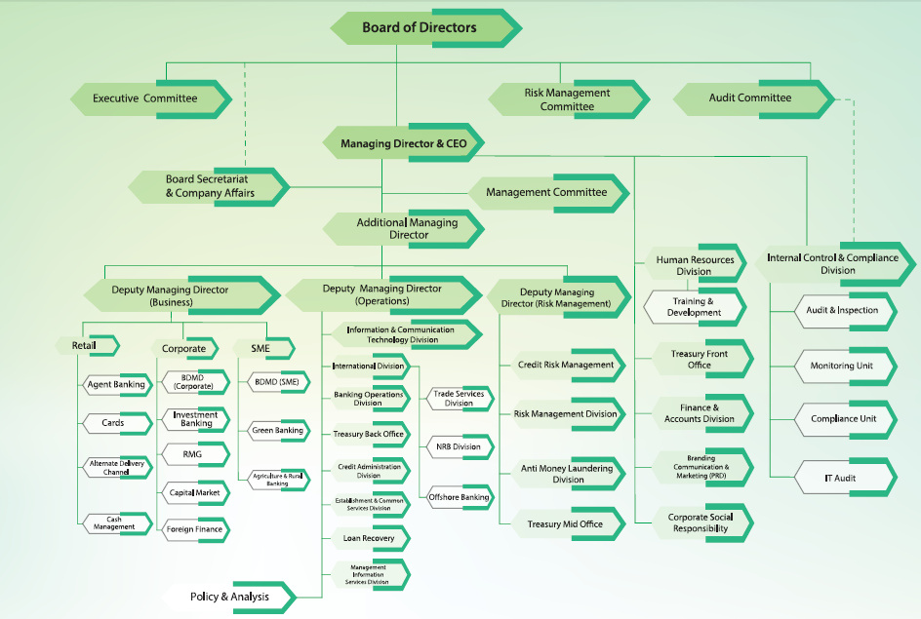

Chapter 03
Literature Review on Human Resource Management

HUMAN RESOURCE MANAGEMENT
The role of human resource management in an organization that has evolved dramatically in recent years.HR plays a vital role in the overall success of the business. HR has the ability to build the organization's capacity to embrace and capitalize on new circumstances, ensuring that helps the organization plan and overcome any resistance to change.
This strategic approach to effectively manage people in the organization, it also helps their business to achieve a competitive advantage. HRM is basically concerned with the management of human energy and competencies. These competencies consist of skills, knowledge, attitude, and potential. Human resources management practices play a vital role in attracting, motivating, rewarding, and retaining employees.

Laws Regulating Employment
External Environment
-Competition
-Government Regulation
-Technology
-Market Trends
-Economic

Employee Separation
Staffing

Training
HR Strategy
-HR Planning
-Design of Jobs & Work Systems
-What workers do
-What workers Need
-How jobs interface with others

Business Unit
Strategy
Performance Management
Corporate
Strategy
HR Information System
Compensation
Internal Environment
-Culture
-Structure
-Politics
-Employee Skills
-Past Strategy
Labor Relations

HR programs and policies that clearly follow the corporate strategy; a flexible, more dynamic organization through change and adaptation; and a tighter focus on customer needs, key and emerging market, and quality.
A model that illustrates how this can be accomplished and this model will provide the framework of human resource management.
The HR strategy focal point is the strategic goals of an organization and objectives and interpretation of them into a constant, integral, reciprocal set of programs and policies for maintaining employees. HR strategy is build up in an enthusiastic manner; with HR staff working to design likewise improves appropriate HR systems that meet the expected level of conditions which the organization will implore.
Human Resource Planning: The 1st component of the human resource management strategy is human resource planning. Without discussion on human resource planning an overview of human resource management would not be finished. The HRP is particularly concerned with its different phases of development, conceptual issues, objectives, significance, and linkages with other organizational roles. With this backdrop, they then have to understand HRP and why HRP has become so important that they now have successful management of the origins.
HRP aid organizations to recruit, retain, and optimize the deployment of staff to meet business objectives and provide answers to changes in the external environment. The process implicates acquisition by analyzing the proficiencies of the present workforce, being undertaken by the manpower forecast, and taking any steps to guarantee that supply meets demand. Human resource planning has historically been utilized and guaranteed by organizations to the extent that it is the right of someone to do the right job at the right time. Organizations must carry out HR planning to meet the business objective and gain a competitive advantage through using manpower. Human resource planning consists of two ways which are strategic HRP and traditional HRP. Strategic planning set organizational direction duly listing measurable objectives.
Successful manpower planning is accrued when we following those processes. Those are given below:
  - Requires a team approach and a process to look at, not a single act
  - Must have the support of senior management
  - Must have line management ownership and human resource personnel involved in the process
  - The Must Align strategic manpower planning program with department culture, service, and vision
  - Necessitates creative thinking that may challenge and change the status quo
  - Moving into the most qualified candidates for must be responsible
  - Future promotions on Influence the decision-makers
  - Must be tailored to each departure needs and structure
  - An employee with his or her individual development requirements with strong management support.

Thus HRP requires the development of the strategy of appropriate recruitment, improvement, and retention as well as timeliness to address gaps and surpluses to ensure the organization will have appropriate manpower to meet its future function recruitments.
Enhance
Shareholder Value
Customer and
Employee Satisfaction
Increased Performance

Through

- Effective management of staffing, retention and turnover through selection of employees that fit with both strategy and culture
- Cost-effective utilization of employees through investment in identified human capital with potential for high retention
- Integrated HR programs and policies that clearly follow from corporate strategy
- Facilitation of change and adaptation through a flexible, more dynamic organization
- Tighter focus on customer needs, key and emerging markets, quality

The traditional HRP approach is a very lengthy process. Traditional HR focuses only on employee relationship and they control their employee bureaucratic ways, policies, and procedures. Traditional HRP is transactional change follower and responses to slow reactive fragmented and short term. So strategic HRP is the best rather than traditional HRP.
Beginning a strong HR strategy that is clearly connected to the organization’s strategy is inadequate. HR strategy needs to be communicated, practiced, and perhaps most important spelled out and writing down.HR can play four different roles which are:

1. HR becoming a partner
2. HR becoming an expert
3. HR becoming a champion for employees
4. HR becoming an agent
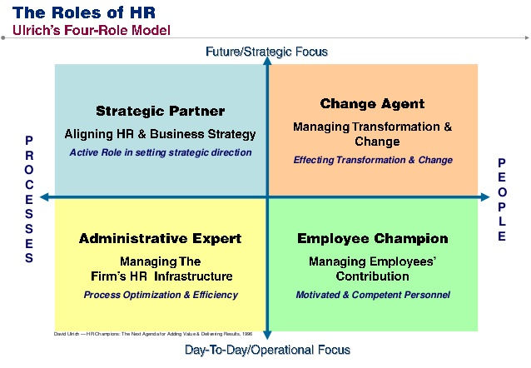
HR can play their roles based on employment models. To better understand these employment models, a system was developed by Lepak and Snell. According to Lepak and Snell first analyzed the characteristics of human resource capital using two dimensions which are strategic value and uniqueness. It increased efficiency, effectiveness, exploit market opportunities, and neutralized potential threats. On the other hand, uniqueness is the degree to which it’s specialized and not widely available. These two dimensions form the matrix, presented in which identifies the 4 types of employment modes.

Quadrant 3:
Contractual Work
Arrangements

Compliance-Based HD Configuration
Quadrant 2:
Job-Based
Employment

Productivity-Based HD Configuration
Quadrant 1:
Knowledge-Based
Employment

Commitment-Based HD Configuration
Quadrant 4:
Alliances/
Partnerships

Collaborative-Based HD Configuration
High

Uniqueness

Low

Strategic Value
Low
High

The design of the work system: the 2nd component of HR strategy is the design of the work system, which is responsible for designing a job and work system that needs to fully assess the skill, knowledge, and abilities required by the organization both currently and in the future. This system attempted to promote efficiency in organizational operations by allowing workers to specialize in a particular task and gain high levels of competence in their work. The term of job specialization is an affordable number of jobs provided to compete in order of efficiency and cost minimization. If the job design is not appropriate then the employee feels boring and monotonous in their job. Employees are not the only ones to go beyond the basic robotic function of most of their work; they are consequently unable to contribute in any meaningful way. Job enlargement serves few diversifications by enlarging the number of tasks, activities. The job enlargement of verification is job rotation, where workers are rotated across an organization within a different specialization position. This rotation program can continue throughout the career of the employee seeking new skills, competencies, experience, and knowledge base. Where work is designed then employees have significant responsibility for their work. Job enrichment initiatives involve increasing the amount of responsibility or merely adding tasks to employees has.

Model for the design of work systems

What Workers Do
What Workers Need

Work System
How Jobs Interface with other jobs

The design of the work system also needs to consider what workers need and want in order to carry out their job responsibilities. On the other hand, all employees do not work for the same reasons, nor do they expect the same things from their employers. However, employees expect some consideration those are given below:
- To understand their need and respect them as individuals
- To be more aware of employee needs for work /life balance
- training and experience to make a contribute
- To have an independent voice for an individual employee right
- To ensure workplace safety
The final component of job designing is an understanding of how individual jobs may have interdependencies with other jobs as well as how individuals jobs can interface with others. There are 3 types of task interdependence:
- Pooled: This interdependence is where individual employees can work independently of each other's work but utilize some coordination of their activities.

- Sequential: It directs to work that flows from one individual to another, where one individual relies on the timely competition of the work attribute from another coworker.

- Reciprocal: It happens when the workflow is not as in pursuant interdependence but random. Work can be processed by the employees so that their flow is not necessarily predictable and hourly spontaneous to suit an immediate condition.

When individual employees work interfaces with others, concern to be paid to design the work system to allow for an efficient flow. The design of the work system is not easy. Allocation of tasks and responsibility must be balanced with employee’s needs.
The function of HRM: HR functioning is all about determining present and future next recruitment and personnel. Many necessary functions of your business are handled by the human resources department. The key function of HR activities, such as labor law compliance, staffing, training and development, performance appraisal management, compensation, employee relations, and employee separation, etc. In short, HRM is all about acquiring the service of people, improve their skills, motivate them toward their job, and ensure that they continue to maintain their commitment .On the other hand HRM is concerned about the employee recruitment process for retirement. Although there are many functions of HRM, here is a list of some key function:
Employee Law Compliance: The employer-employee relationship within the employment law covers all rights and obligations. Many of the legal disputes of businesses are related to employee rights and regulation. Employee Law is important to protect employee rights from unsafe or unhealthy conditions in the workplace. Several federal laws protect individuals’ unfair treatment in the workplace. All employees should enjoy equal access, treatment, and opportunity in employment. Employment law has a significant impact on an organization’s ability to implement HRM. The federal law that prohibits discrimination based on gender orientation. In the position selecting process, some burdens can be faced for discrimination, on account that employee’s law is important for this process to select employees for any organization.
Selection and recruitment: To every organization recruitment and selection process is very important because it curtails the costs of mistakes such as engaging incompetent, unmotivated, and under-qualified employees. It is an expensive process which is against an unqualified candidate and hiring the new employees. The employment process first step is recruitment, which motives at gaining and maintaining an efficient employee. Theoretically, recruitment is the process of employing prospective employees and applying them to inspire and search for employment. In short, it increases the number of applicants and the number of posts vacant and thus provides an opportunity to select a management person.
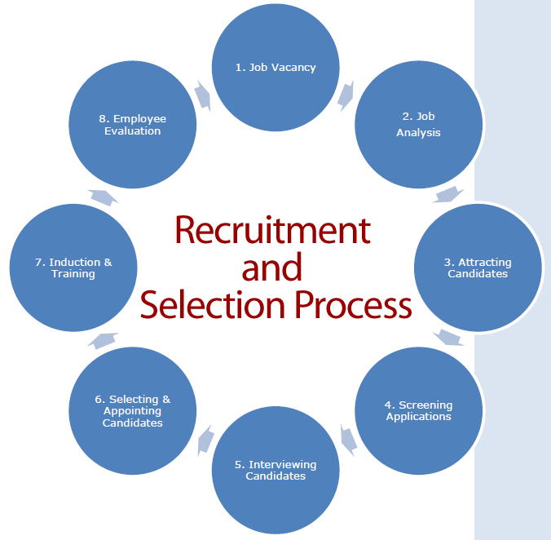
Screening may be considered an essential part of the recruiting procedure, even though in view it as the 1st step in the selection process. Even recruitment prohibits screening from its scope. The selection process will start after the applications have been considered along with shortlisted.
JOB analysis and design: Job analysis is the process of describing the nature of a job and specifying the human requirements, such as skills, and experience needed to perform it. The finished work of the job evaluation process is the job description. A job description spells out the work duties and activities of employees. Job descriptions are a potential source of information to employees, managers, and personnel people in view of job gratified has a great impact on personnel programs moreover practices.
Training and Development: Training is the core function of human resource management. It has a vital role in achieving the competitive advantage of the organization. Training practices that help them to gain a competitive advantage in their market as well as it helps them grow the business and improve customer service by giving employee with the knowledge and skill they need to be successful. The overall goal of training and development is learning which mentions achieving knowledge, skills competencies, attitudes, or behavior. It needs to exhibit learning how it contributes to the company's competitive benefit through enhancing employee performance. Formal education, courses, and events that are developed and organized by the company like face to the face training programs and online programs are referred by formal training and development.

The Role of training & development
Formal Training & Employee Development
Knowledge
Management
Learning
Human Capital

Performance Improvement
Reach business Goals

Informal
Learning

Informal learning refers to training that is learner initiated, involves action and doing, and is motivated by intent to develop. It accrues without the trainer or instruction and its breath, depth, and timing are controlled by the employee. Before providing the training need assessment is important because this refers to whether training is needed or not. If need assessment is wrong then all things are wrong. Some methods are used in need assessment. Need assessment will be accurate when multi-technique is applied. Thus methods are given below:
1. Organization analysis gets clear information about training is needed or not. SWOT analysis helps to find out which training is appropriate for that purpose. Need assessment depends on the organization’s strategic dimension and it helps to the make decision to need training or not. Need assessment identifies that do you have enough resources available or not for training.
2. Personal analysis or individual employee performance analysis provides clear knowledge of whether training is needed for the person or not. The person who wants to learn, they will be given their time. When you ready to learn then you will be provided adequate time from their organization.
3. Task analysis helps to understand employee’s input, output, consequences and feedback. Task analysis figures out the main reason for the poor performance of employees and training increase self-efficiency toward their work. Training should be given about the self-confidence of employees, by this their self-efficiency will increase and it is important to be ensured the training they have taken will implement to the organization accurately. When employees know during a training session about their improvement, their efficiency will increase. Employees will be motivated by those who have already succeeded in training and also training will be maintained by them.
After conducting the needs assessment process we should have to be ensuring the employee’s readiness for taking the training programs. Technically training involves a change in attitude, skills, or knowledge of a person with the resultant improvement in the behavior. When designing effective training then we have to make sure that employees have the motivation and basic skills necessary to master the training content.

Training Design Process
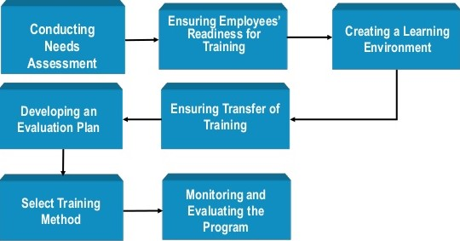

The training design process is based on principles of Instructional System Design (ISD).ISD refers to a process for designing and developing training programs. Regardless of the specific ISD approach used, all share the following assumption:
- Training design is effective only if it helps employees reach instruction or training goals and objectives.
- Measurable learning objectives should be identified before the training program begins.
- Evaluation plays an important part in planning and choosing a training method, monitoring the training program, and suggesting changes to the training design process.
The second step is to ensure that employees have the motivation and attitudes toward the basic skills necessary to master the training content.

- On-the-job Methods
    - Job Rotation
    - Coaching
    - Job Instruction
    - Committee Assignments
    - Apprenticeship
    - Internship
- Off-the-job Methods
- Classroom Lectures
- Audio-Visual
- Simulation
- Vestibule Training
- Case Studies
- Role-Playing
- Programmed Instructions
Performance appraisal: To appraising the performance and particular situation in comparison to the objective which was to be achieved is under the process of performance analysis. Since staff encouragement, point of view and behavior advancement, communicating as well as convenient individual and organizational targets. O the other hand fostering is a positive relationship between management and staff performance appraisals are important. Performance appraisal referred to as performance review of employees within the organization. Performance appraisal can be done with the following objectives:
- To place the potency and weakness of employees’ performance.
- To take steps a recompose to employees regarding their performance and connected status.
- To identify the employee’s needs
- To raise the employees on the basis of performance and competence.
- To support exhibit individuals, increase organizational performance, and feedback into business planning.
- To review the performance of employees in a given amount of time.
- To justify the blank between the actual and the desired performance.
- To help the management in practicing organizational control.
- Helps to maintain the relationship and communication between superior- subordinates and management-employees.
- To diagnose the power and weakness of the individuals so as to destine the training and development needs of the future.
- To take step feedback to the employees regarding their past performance.
- Provide information to support the other personnel decisions in the organization.
- Provide clarity of the prospects and responsibilities of the functions to be performed by the employees.
- To define the effectiveness of the human resource functions of the organization such as recruitment, selection, training, and development.
- To abate the adversity of the employees.
More precisely, performance appraisal defines as a systematic evaluation of an employee's current, or previous performance as well as future effectiveness by supervisors or homely with his performance. Employee's job-related behaviors and outcomes can be defined by this which helps reward, motivate, and authorize employees at work. It also helps to justify the future potentials of an individual.
However, performance appraisal is a more extensive term for such operations because it uses extends beyond ascertaining expediency for promotion. Such activities may be training and development, salary increment, transfer, discharge, etc. besides promotion.
Performance appraisal process:
- Establishing performance standards: The first step is to establish evaluation criteria with contractors. It will be used to compare the basis with the actual work of the employees. These standards require employees to succeed or have varying degrees of organizational goals and objectives. The criteria should be clear and objective. When employee performance cannot be measured, care should be taken when describing the criteria.
- Communicating the standards: Once identified, it is the institution's responsibility to communicate with staff in the organization. Employees must be familiar with the standards and the criteria must be clearly stated to employees this will help them understand their roles and what to expect.
The standards should be communicated to the assessor or the evaluators, and if necessary, the standards can be modified at this stage with relevant comments from the staff or residents.
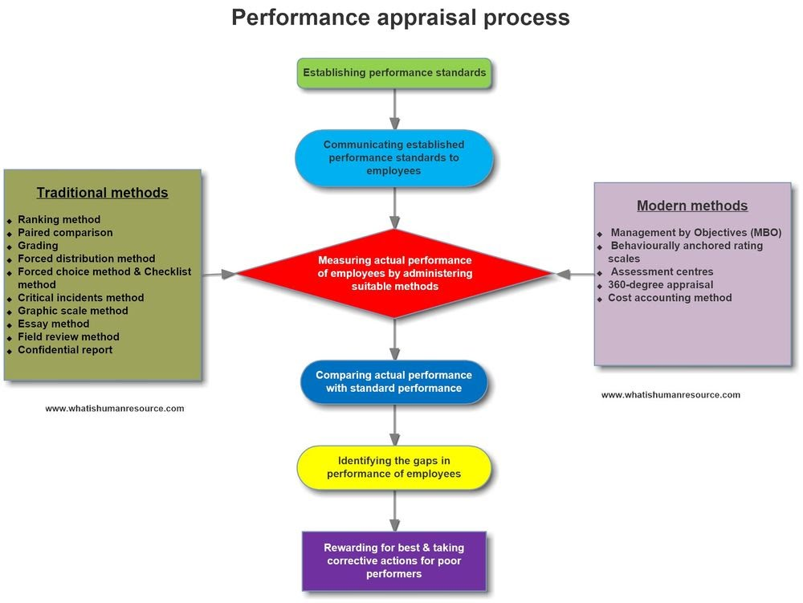
3. Measuring the actual performance: The most difficult part of the performance appraisal process is measuring the actual performance of employees by performing the job during a specific time period. This is an ongoing process that will be followed up throughout the year. This step requires an accurate election of proper measurement techniques, make sure that personal influence does not involve the result of the process, and provide assistance rather than personnel intervention.
4. Comparing actual performance with desired performance: Actual performance is compared to the required or standard performance. The comparison shows the differences in how employees set standards. Organizational performance in a negative variance of required performance or less than actual performance. This includes recalling, evaluating, and analyzing employee performance data.
5. Discuss the appraisal with the employee: Results evaluation is communicated and discussed with employees on an individual basis. The purpose of this discussion is to communicate and listen. Results, problems, and possible solutions for solving problems and reaching consensus are discussed. Future work of employees in a positive position. Managers' comments on performance appraisal should be a way to help employees make the mistakes right and motivate them to do better but not to discourage them. Feedback tasks must be dealt with successfully with extreme caution as they can lead to emotional outbursts. Sometimes employees need to be prepared and receive feedback, and this may be positive or negative depending on the nature and attitude of the staff. Effective organization, missions, as well as projects those are constantly highlighted and monitored. Most of the organizations surveyed that continuous monitoring is the latitude to which employees fitting pre-defined criteria.
6. Decision-making: The Human Resources Manager is responsible for making decisions related to employee performance evaluation. Human resource management managers’ rewards, promotions, democracy, transfers, and sometimes staff comment and posting Staff rely on employee performance appraisals. The decision was taken by the human resources manager to match the results of the employee performance evaluation with preventing complaints or disturbances because they affect the overall performance of the institution.
Advantage of performance appraisal: It is said that performance appraisal is an investment for the company which can be justified by the following advantages:
Promotion: It assists the supervisors to outline the advertising programs for capable employees. In this regard, disorganized workers can be dismissed in case.
Compensation: Performance Appraisal helps in walking out compensation packages for employees. Merit rating is possible through performance appraisal. Compensation packages which consist of bonuses, additional benefits, high allowances rates, and basic salary are based on performance appraisal. The criteria should be merit rather than seniority.
Employee Development: The systematic procedure of performance appraisal helps the supervisors to frame training policies and programs. It helps to analyses the strengths and weaknesses of employees so that new jobs can be designed for efficient employees. It also helps in framing future development programmers.
Selection backup: It helps to recognize the validity and necessity of the selection process. The supervisors come to know the validity and thereby the strengths and weaknesses of the selection procedure.
Communication: Effective communication between employees and employers is one of the most important. Through performance appraisal, communication can be needed s in the following ways:
a) Through performance appraisal, employers can understand and accept the skills of subordinates.
b) The subordinates can also understand and create trust and confidence in superiors.
c) It also helps in maintaining a cordial and congenial labor-management relationship.
d) It generates the force of work and improves the morale of employees.
All of the above factors ensure effective communication.
Motivation: Performance appraisal serves as a motivational tool. By assessing employee performance, a person's effectiveness can determine whether goals have been achieved. It motivates people to do better and helps them improve their performance in the future.
Compensation
Other names for compensation include wage or remuneration, payment, salary. But grammatically, there is a difference between the label to obtain compensation for the type of label used in the event of an accident or death in the framework of the employee's work. Compensation and salaries can be used interchangeably when the payment period is monthly for one employee, such as calculating salaries.
Paying compensation or compensation is the employer who has a primary duty, and failure to fulfill his obligation to pay a permanent crime. Likewise, the bonus or bonus is the employee's right to search for work performed and private employees in court. There are workers, procedures, and methods for paying workers compensation and compensation, in addition to procedures for labor laws and labor relations.
According to the principles of natural justice, the employer must receive a fair wage or equal wages in exchange for equal wages, which is the fundamental right of the employee.


Compensation or remuneration is a major incentive for every employee and also serves as a key employee retention factor in an organization that functions as a human resource manager for a hectic mission. Unjustified or inadequate compensation will cause dissatisfaction and can sometimes cause disturbances among staff who may seek to manage the organization. In addition, such an organization will face many legal procedures and penalties, and as a result, this will cause significant damage to the organization's reputation and the image of the business owner.

Select a rational method to provide the HR staff with the number of employees who must be paid for certain jobs. Compensation relates to the preservation of human resources. Since compensation is a huge cost to many organizations, it is of great importance in HR planning. The rewards affect employees to the extent that people are more likely to be attracted to organizations that offer a higher level of alternative work. This is linked to employee development by providing an important incentive to motivate employees to achieve higher levels of professional performance and better pay in the organization.
Compensation represents both the intrinsic and extrinsic rewards employees receive for their work. Together, the company's total compensation system that describes both the intrinsic and extrinsic compensation system. Intrinsic compensation follows employee psychological state which outcome from their work performance and external allowance involve both monetary and nonmonetary rewards. Monetary compensation represents the core compensation. Monetary compensation programs to reward employees base on their level of work performance or for gaining job-related knowledge and skills. On the other hand nonmonetary compensation includes protection programs, paid time off, and services.
Total Compensation System
Total Compensation

Intrinsic Compensation

Extrinsic Compensation

Adjustment to Core Compensation
Cost of living
Seniority
Merit
Incentive
Person Focused

Job Characteristics
Skill Variety
Task Identity
Task Significance
Autonomy
Feedback

Discretionary Employee Benefits
Health Insurance
Disability Insurance
Life Insurance
Retirement Plans
Paid Time Off
Accommodation and Enhancement

Legally Required Employee Benefits
Social Security Act
Workers’ Cooperation Laws
Family & Medical Leave Act

Core Compensation
Hourly Wage
Annual Salary

Employee Benefits
One of the core functions of Human resource management is the administration and management of the benefits of employees. Employee benefits are another pattern of allowance to employees other than pay for work performed. In essence, the human resource activity or carry out employee benefits split huge characteristics of the compensation function. Benefits include both the legally required items and those offered at the employer’s discretion. The cost of benefits has to lift to such a point that they have become a core application in manpower planning. After all employee benefits are mainly related to the maintenance area, as they provide for many employee needs. Basically employee benefits are classified into compulsory or statutory benefits and discretionary or voluntary benefits. Compulsory lawful benefits should be implanted into an employee by his employer without a lack of success. In case if an employer fails to provide statutory benefits to his or her employee’s such an employer is liable for penal action and deprived employees can see a court of law so as to claim their right to statutory or compulsory benefits. Whereas discretionary or voluntary benefits purely dependent upon the will and wish of his or her employer, failure of providing such benefits cannot be enforceable in the court of law. Benefits like flexible work, paid vacations, work from home, earned leaves, and other employee benefits; here is a list of voluntary employee benefits provided by the corporates.

Compulsory or statutory benefits for employees
- Provident fund
- maternity leave
- Bonus minimum for employee
- Workmen compensation in case of accidents and death of an employee in the course of employment
- Employees State insurance provides the following benefits to the employees whoever got covered according to the Employees State Insurance act 1948.
Contribution
The contribution due to the institution in regard to an employee ought to contain the employer's allowance and employee's contribution at a defined rate.
- Sickness benefit
- Medical benefit
- Disablement benefit
  - Temporary disablement benefit (TDB)
  - Permanent disablement benefit (PDB)
  - Dependents Benefit (DB)
- Maternity benefit
- Unemployment allowance
- Funeral Expenses
Motivating employee
The basic feature of human resource management is employee motivation, as it is one of the functions, it should be identified the factors which causing demotivation of employees and alter them into factors that inspire employees by the HR managers. Employees who are motivated are tending to work more when compared unmotivated to employees, according to a study. The major factors that inspired employees have been listed below.

Pay and benefits
It is the right payment of an employee for justifying when the work is done to his or her employer and payment of salary is the primary duty of the employer. Having a debonair salary inspires employees, indeed it plays as a retention factor also. It is additional to the salary of employees’ benefits of employees and it is classified into voluntary benefits and statutory benefits which are included with social security benefits which are mandatory given to employees. There some examples of employee benefits are paid vacations, dependent benefit, medical benefit, free food, payment of bonus, payment of gratuity, and provident fund.
Working conditions
Maintaining and providing well-working conditions not only motivates employees but also prevents employers from facing legal action by the court of law as they are mandatory according to labor laws. Good working conditions include providing flexible timings to work, giving correct workload to avoid stress, maintaining a healthy environment and HR managers should see that there is work-life balance to their employees. Having all those will definitely motivate employees to work efficiently and also avoids distractions from work.
Company policies
The company policies which are made by an organization should not be in conflict with the labor laws and principles of natural justice. The goal of having policies or making policies is just for making employees feel comfortable and to be treated in an undiscriminating manner. Good company policies will drive employees to dedicate themselves to the organization and to catch up with its goals and objectives.
Employer brand and reputation
Everyone wants to work in well reputed and at an organization which has brand value. It is all because of the elation one will feel working in such organizations and keep employees motivated. In order to retain and have a foothold in such organizations by employees, one will try to stay motivated. Constructing employers’ brand and reputation is a continuous process in which the organization should try to be the best in all aspects compared to its competitors.

Career development
In the top ten motivating factors for employees, career growth is one of the important ones. In a join no employee wants to remain in the same position for a long period, he or she wants to move forward in a career by achieving promotions in-time, which makes any employee feel happy and motivated as taking a promotion in a job is the most delighted and memorable moment for any employee. To develop the employee’s skill set and knowledge for career development the HR managers should give opportunities to employees.
Job security
Preference of employee’s job security standards is in the hit list. Job security is the first factor for any employee and foremost important before taking up any job. In a job having job security will make an employee overlook all other inconveniences. In a job, the sense of security will develop confidence in employees which will make them go forward whole handling ticklish in tough situations in the job, in other words, job security conducts as a motivating factor.
Employee safety: Looking after the safety of employees so as to avoid workplace injuries accidents to the employees, since the employer shall be made liable for such incidents at the workplace or during the course of employment.
Recognition
It is not just enough of providing employee benefits to their employees to keep them motivated, staying unrecognized make employees feel no value to the organization and makes them frustrated. In the job giving recognition and appreciating employees will make them feel their importance and value to the organization and make employees stay motivated.
Healthy relationships
Consisting of good relationships with superiors and colleagues in an organization is a priority for any employee since improper communication and misunderstandings with superiors and colleagues lead to psychological stress which makes employees demotivated and shows an effect on work life. Having healthy relationships with superiors and colleagues will help and have support in getting things done easily and also keep employees happy at work that boosts their energy levels and make them stay motivated.
Employee healthy measures:
Maintaining cleanliness at the workplace, and they have to make sure that they are providing a healthy working environment, washing and cleaning facilities with freshwater, etc.

Chapter 04
Human resource practices at Modhumoti Bank Ltd

Modhumoti Bank is safer, more flexible, and customer-focused with increased profitability since its inception. The bank management wants to develop a customer service position.
A satisfied well-equipped employee will lead the customers to become more contented through the service excellence within establishing a culture within the organization and it is believed by the Madhumoti Bank.
MMBL believes that human resources are important not only to run a financial institution or to increase profit or customer satisfaction but also even to establish a suitable and healthy relationship amongst stockholders in a long period. Modhumoti bank limited made a lot of effort to properly develop and enhance the capacity of its human resources under suitable planning. These bankers strive to hire and maintain a talented workforce, and always keep them motivated by offering them a comprehensive career, where they are not concerned with the remuneration or financial aspects of accuracy.
Modhumoti bank limited setting not in terms of financial figures only but also in terms of the work environment, employee benefits, healthy organization culture, employee engagement, potentiality development, and learning environment. These banks opt to maximize employee potentials through a better working environment and by developing their skills through continuous learning opportunities. The human resources division of the bank consists of a dedicated team that is specialized in developing a superior framework for developing the human capital of the bank. MMBL is going to add another gem in its feather as its sets to install its own Human Resource Management Information System (HRMIS).

HUMAN RESOURCE MANAGEMENT AT MODHUMOTI BANK LIMITED: Organizational strategic goals and objectives and translating them into a consistent integrated, complementary set of programs and policies for managing employees are focused on by HR strategy which is taken by MMBL. MMBL follows the strategic approach of practically managing people for their organization, this approach helping to grab a competitive advantage. Basically this bank is concerned with the management of human energy and competencies. These competencies consist of skills, knowledge, attitude, and potential. Human resource management is focused on by MMBL because HRM is the function affiliating the most effective use of people to gain both organizational and individual goals. In attracting, motivating, rewarding, and retaining employees these practices play a vital role.

Model of Strategy HR Management

Laws Regulating Employment
External Environment
-Competition
-Government Regulation
-Technology
-Market Trends
-Economic

Employee Separation
Staffing

Training
HR Strategy
-HR Planning
-Design of Jobs & Work Systems
-What workers do
-What workers Need
-How jobs interface with others

Business Unit
Strategy
Performance Management
Corporate
Strategy
HR Information System
Compensation
Internal Environment
-Culture
-Structure
-Politics
-Employee Skills
-Past Strategy
Labor Relations

MMBL formulated corporate strategy at the top management level. This strategy may be influenced by both internal and external environmental forces. Internal environmental forces play a pivotal role in formulating a corporate strategy as well as a business strategy. So many exterior forces also affect corporate strategies. MMBL analysis both internal and external environmental forces. Among these forces, competition and government regulations play the most significant roles. The next stage of, strategic human resource management after formulating the corporate strategy is a business strategy. MMBL constructed for each business unit as per it’s all in all objects. MMBL is to formulate a well-conceived HR strategy incorporating HR planning and job design approaches.
Human Resource Planning at Modhumoti bank limited: Just as planning is important in our daily lives’, planning forms an integral part of an organization. An organization’s successful outcome reclines to a significant extent to the skill, creativity, and dedication of its employees. Planning is not easy. It desires a lot of concentrated attempts to come with such a program that would help simplify the work. MMBL HR professionals put in a lot of effort in order to launch an efficient HR planning program. In order to become an HR professional formal training is mandatory. This bank has to understand HRP and why HRP has become so important for the bank. MMBL believes that the employees work hard in order to achieve those numbers and how to successes as well as MMBL will depend on how you consider recruitment. HRP aid organizations to recruit, retain, and optimize the deployment of staff to meet business objectives and provide answers to changes in the external environment. The process implicates acquisition by analyzing the proficiencies of the present workforce, being undertaken by the manpower forecast, and taking any steps to guarantee that supply meets demand. MMBL believes that HRP helps to ensure the right people at the right place at the right time. It helps to cope with the dynamic environment. They want to implement equal employment opportunity that’s why they develop human resource planning. MMBL makes proper HR plan for evaluating the environment in which the organization operates, assesses, the strengths and weakness of the organization, and set objectives. This clear set out objectives and evaluation somehow help to reduce the uncertainty of the future. When HR planning is effectively done than it helps the work going smoothly and also gains success in the present times. MMBL following those processes of manpower planning are:
- Must support top-level management
- To improve the alignment of staff and other resources
- It begins with an evaluation of present staffing, containing even if it suitable the organization’s needs, and then progress on to predicting future staffing needs depend on business goals.
- Must be tailored to each departure needs and structure
- Future promotions on Influence the decision-makers
- Necessitates creative thinking that may challenge and change the status quo.
Four Step to Strategic Human Resource Planning

Step 4
Review and evaluate your HR plan

Step 3
Develop talent strategies

Step 2
Forecast HR requirements

Step 1
Assess current HR Capacity
Employee Relations

Recruitment

Selection

Training & Development

Hiring

Performance Management

Remuneration & Benefits

Supply Forecasting

Demand Forecasting
It can result in a huge loss or financial crisis of poor HR planning or the absence of the same in an organization. To be filled with vacancies it may take a long time. Needless to say, it impedes work and has an adverse effect on the organization in a long way. 4 steps should be followed by them about strategic human resource planning. Those are given below:

Assess current HR capacity: To assess your current staff MMBL follows the first step in the human resource planning process. Before making any moves to rent new employees for their organization, it's mandatory to understand the talent they already have at their disposal. Enrich a skills inventory for each of their current employees. It can be done in a number of ways by them, such as asking employees to self-evaluate with a questionnaire, looking over past performance reviews, or exercising an approach that assembles the two. Use the template below to visualize that data:

8
7
7
8
7
9
8
Company Average
Customer Support
7
10
7
8
5
5
7
7
5
10
7
10
5
6
Engineering
8
10
5
9
6
10
9
Human Resource
Marketing
7
10
5
8
10
6
8
8
7
7
9
5
10
10
Sales
Department Average
Organization
Content Creation
Teamwork
Computer
Software
Literacy
Communication
Leadership
Forecast HR requirements: The moment the full inventory of the resources is ready; it’s time to initiate the forecasting for future needs. For that they have these following question criteria:

- Will the company need to grow its human resources in number for fulfilling the future demand?
- Will the need to stick to our current staff but improve their productivity through efficiency or new skills training programs?
- Are there potential employees available in the marketplace to meet the requirements of the MMBL?

It is pivotal to assess both the company’s demand for qualified employees and the supply of those employees either within the organization or outside of it. And this process needs to be carefully managed to stabilize that supply and demand.

Demand forecasting: It is believed by them that demand forecasting is the elaborated process of determining future human resource needs in terms of amount, the number of employees needed, and quality the caliber of talent required to meet the MMBL's current and future needs.

Supply forecasting: Supply forecasting ordains the current resources available to meet the demands. They will know which employees in your organization are available to meet their current demand by their previous skills inventory. They will also want to look outside of the bank for potential hires that can meet the needs not filled by employees already present in the bank.

Matching demand and supply: Demand and supply matching is where the hiring process gets tricky and where the leavings of the human resources management planning process comes into place. They will develop a plan to link the MMBL's demand on account of the quality staff with the supply available in the market. It is believed by them that they can gain this by training current employees, hiring new employees, or combining the two approaches.

3. Develop talent strategies: First, they determine their staffing needs through the process of assessing their existing HR capacity and making a forecast of future supply and demand of HR, after that deliberately they inaugurate the process to develop talent. And this Talent development process is a very pivotal part of the strategic human resources management process for the organization.
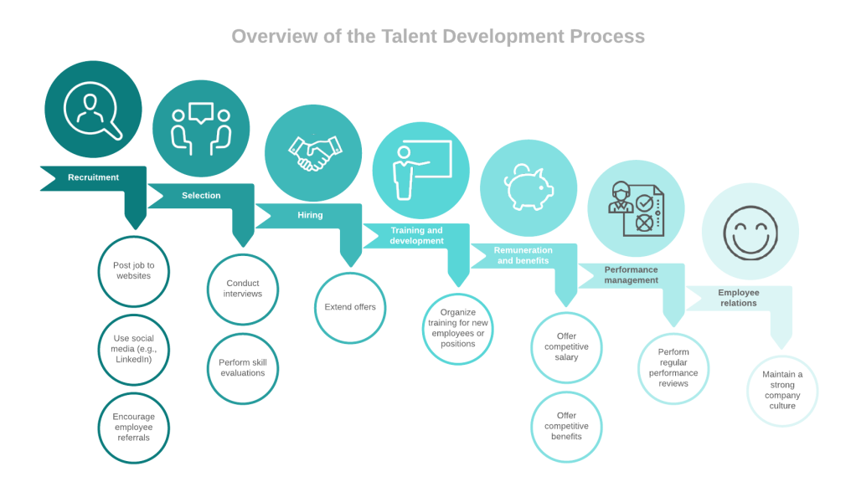
Staffing plans of MMBL:
It is believed by MMBL that their employees are one of the greatest assets. It is also said by the HR professionals of MMBL that human capital is the biggest "investment challenge" for employees. Plagued by turnover, skill blanks, over-employment, less productivity, and ever-changing business landscapes, it is no surprise that businesses are struggling to keep up. Those issues can be mitigated with a strategic staffing plan. When the staffing plan is commenced by them the plans they have to go through some questioners. They are as follows:
- What work needs to be done?
- How many candidates we can recruit?
- What skills and experience are necessary to theirs?
- What skills gaps need to be filled?
Additionally, a staffing plan helps their business to:
- Reduce labor costs and maximize productivity.
- Eliminate skills gaps.
- Increase employee engagement.
- Increase employee retention and reduce turnover.
- Improve customer experience.
- Streamline business growth.
A transparent staffing plan assists enclose issues that could delay improvement or prevent the quality of the products and services that would result in hapless customers along with off-track business opportunities. Doing staffing plans not only help companies effectively recruit, hire, and develop employees, but they also help guide budgeting and financial decisions within the organization.
How is staffing management calculated by the MMBL?
They usually do the staffing plan by following three main steps, those are as follows:
1. Determining current staffing levels: They evaluated their staffing needs, they can outline recommendations for how to address these needs, which might be included in recruiting and hiring new talent, promoting internally, focusing on training and employee development, or put together contractors to their staff. These prognoses and recommendations will help them to develop their overall human resources plan for the organization. They need to know what overarching goals are for the business before MMBL dive into staffing plans and changes. These goals are typically sketched in a strategic business plan. Use this plan to refine the bank's objectives and align the staffing plan accordingly. Their two plans align have to be ensured.
It is believed by them to develop a staffing plan; it is needed to understand the first current staffing environment. They will first need to fasten that data into one source of truth. Work with business leaders and managers to help them ensure exact and complete data on their human resources. Once they have their staffing data in one place, so it could be assessed by them the current staffing environment and begin to pull actionable acumen from the data.
They pay attention to particular issues:
1. The number of people on staff.
2. To imprecate retirement numbers.
3. Staff formation.
4. Team size and who works where.
5. High performance and potential leaders.
6. The workforce skills and competencies.
7. The low performance or "flight risks" could reveal turnover.
8. Turnover rate.
It is better to understand by pulling out these data will help the current staffing landscape and more accurately justify staffing needs and opportunities down the road. The lucid chart is used by them to identify important relationships, correlations, or gaps in staffing.
- Forecasting future staffing needs: After assessing their current staffing landscape, it is time to be ensured some prognostics about their future staffing needs. They conduct their staffing needs assessment. They will want to envisage the factors that can affect staffing decisions and opportunities, including:
- Business goals
- Turnover rates and projections
- Expected mergers or acquisitions
- New product launches
- Investments
- Changes in the economy
- Competitors attracting key talent
These internal and external factors can be influenced by the entire workforce and their staffing needs.
Trend analysis: To redact a trend analysis, which starts by accruing historical data. They focus on collecting information for at least the past five years. Because it is believed by them that the larger the sample size, the more proper the results. So the data can be collected by them on the following:
- Transfers and promotions
- Employee turnover
- Years of service
- Performance
- Employee demographics
- Skills and qualifications
- Past work experience
- Hiring and retirement patterns
The data have been collected by them and they can analyze it to understand turnover rates over time as well as to detect trends or patterns between the data sets.
Ratio analysis: It is maintained by them the ratio analysis which is a dual-purpose forecasting process that both predicted staffing demand and compares forecasting results against a bank standard.
Gap analysis: When their current and future staffing assessments are completed, this can be compared to the two reports for gaps. In other words, look at where their staff is now and where it needs to be.
After completing staffing need analysis, the staffing plans of them might include recommendations to accomplish a corporate training program to address skills gaps or to develop succession policies to streamline handoffs following retirements or promotions.
Selection: A pool of qualified applicants has been connected by them, conduct interviews and skills appraisals to determine the best fit for their bank. So they form of following stages:
1st Stage: Generate for the above roles is used by them within the team through advertising vacancies in external recruitment sources as well as an internal recruitment source. Which applicants will be passed the initial screening of their applications on the basis of basic requirements of the positions out of among all of the applications for works?
2nd Stage: Therewithal screening of applications will assume responsibility on the basis of qualifications of applicants and other criteria.
3rd Stage: Those will be chosen for the interview among applicants who are invited. The fundamental principle for the choice at this stage will be based on the suitability of candidates for roles proclaimed on the basis of knowledge and other criteria.
4th Stage: The interview will be taken from their remaining applicants for the positions in the team and as a result of interviews few candidates will be remaining still with the chance of being an employee to the vacancies in the team.
5th Stage: To all remaining candidates offers of employment will be made and as a result of arbitrating with them about their pay package and other aspects of their future employment, people who recount the roles of 'plant', evaluator, implementers, co-coordinator, resource investigator, team-workers, completer, and 'specialist' will be elected to be members of the team and they become new hires for the bank.
It needs to be approached professionally for the recruitment and selection process in order to gain their objectives. When the recruitment and selection plan outlined above meets all the requirements outlined overhead and ensures that a large number of applicants are allured for different positions within the team, the most suitable efficient selection methods which are at the same time cost proficient.

The hiring process of MMBL: Regulate the final candidates for open positions and mark up offers. Hiring new employees should be breathtaking MMBL gets fresh ideas, talent, and a motivated individual to fill a new need or put their own spin on an existing preface.
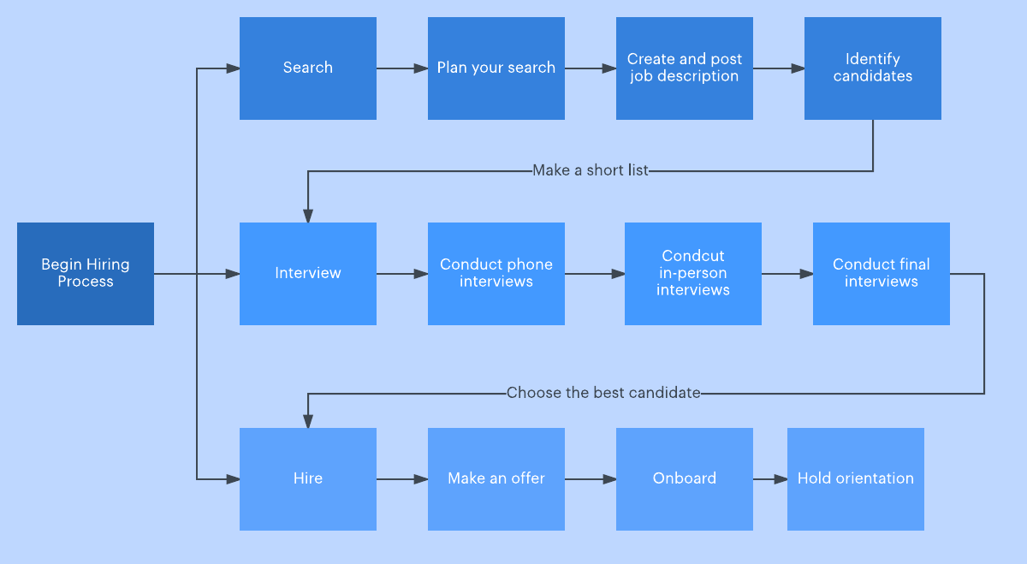
Plan search
In their employee hiring process as the first step, the planning phase gives them with an opportunity to streamline their hiring process steps and generate goals for a reasonable hiring process timeline, they will make sure when they are prepared for and conscious of the work that lies ahead. It might encourage them to make a hiring process checklist to stay accountable.
These things they will need to ask:
What is a necessity?
Who will involve in the hiring process?
Is there any approval that you have?
Create and post a job description
They are capable to write a clear description that demonstrates the available role to potential candidates. A clear job description is done by them because they allure a potential candidate to their bank.
Identify candidates
As they take up responses to their job posting, a system will be needed in place to confine their applicant pool. Depending on their bank's structure, from an HR team, they may have helped screen initial applicants, or they could be responsible for their whole interview process. With multiple candidates potentially submitting work samples, other materials, and references, this part of the process can be confusing quickly without proficient organization.
As candidates are being identified by them, follow these tips at every interview stage:
Phone interviews: For the role, this step assures candidate meets minimum qualifications, and that job expectations and salary extent meet their needs as well.
In-person interviews: A structured interview will serve you far better in forecasting an employee's performance than an unstructured one will, during this step. Count on an interview format planned out ahead of time to procure valued information, more easily compare candidates, and provide your interviewee the best experience possible.
Final interviews: At this stage, they should have a few pools of qualified candidates left to envisage, and it's a good time to look for the opinions of other team members involved in the hiring process before creating a final decision.

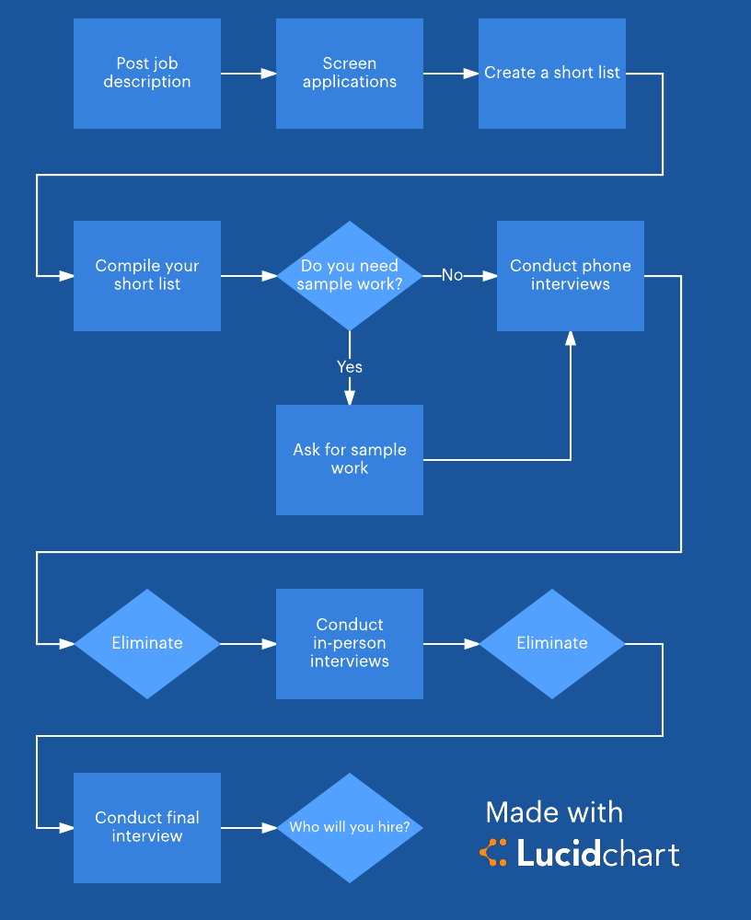
Make an offer
The arrival of a final decision and an offer letter contracts with it a sigh of relief for both parties, after the severity of the interview stage. As they enhance an offer, negotiations and counter-offering may be important, if it is planned sufficiently by them at the starting of the process, they won’t have to scramble to figure out the limits of what they can offer to the candidate they feel is best for their bank.

Onboarding and orientation
When it seems final of the accumulation of a signed offer letter, they risk missing out on the candidate they've worked so hard to trace if they check out before onboarding and orientation. Making their new employees feel welcome and providing them a roadmap for their first few days in their new role is exigent to retention.
At the starting of a new job, new employees are anticipated to complete paperwork, meet their team, and learn work systems. Make sure they and their team are prepared by generating a Lucid chart template to arrange a hiring process checklist for this phase, and then share the template with their newly hired employee to apprise them of what their first few weeks on the job will look like.
After they've choked the search by carrying away all postings, they can breathe a sigh of deliverance or turn their attention to the next position they need to hire for. Regardless of how repeatedly they hire, how much responsibility they have, and what their bank they are in, and their future employees will avail from the bank and clarity that comes out of incorporating Lucid chart into their hiring method.
Training and development at MMBL: It is believed by MMBL that it has the exigent role of gaining competitive advantage of the bank. After feasible staffing, the next stage of SHRM is training. Training is a process of incrementing knowledge, skills efficiencies, and changing the attitude of employees for acquiring goals properly. Practices of training that help them to achieve a competitive advantage in their market as well as it helps them rise the bank and enhance customer service by providing the employee with the knowledge and skill they need to be successful. The overall goal of training and development knows which mentions gaining knowledge, skills competencies, attitudes, or behavior. To exhibit of learning is needed for how it contributes to the bank's competitive convenience through improving employee performance.
After hiring new employees, bring them on board. Arrange training to get them up to speed on their bank's methods. Exhort them to continue to develop their skills to fit their bank's needs as they change. Search more ideas on how to develop their own employee onboarding process, and then get started with this onboarding timeline template.
Moreover, they have to arrange a training program for the existing employees of the bank. The existing employees are learned to refresh and improve their knowledge. If any corrective or updating takes place in technology, training will be given to cope up with those changes. For instance, the employees are learned about the use of new equipment and work process. Increasing the growth of the bank is helped by training. So MMBL gives the training in two ways those are given below:
On the job training at MMBL:
On the job training process are those which are given to the employees within the everyday working of disquiet. It is a normal and cost-effective training process. The skilled, as well as semi-skilled employees can be well training by dealing with such a training process. The employees are learned in a genuine working scenario. The main slogan of such training is "learning by doing". Instances of such an on-job training process are job-rotation, temporary promotion, coaching, etc. MMBL is instructed on this training program for its employees to enhance their performance.
Off the job training at MMBL:
These processes are those in which training is given away from the actual working condition. It is normally used in the case of new employees. Instances of off the job training process are seminars, workshops, conferences, etc. Such a process is expensive and is effective if and only if a big number of employees have to be learned within a short time period. Off the job training is also known as vestibule training. MMBL arranges training at least 1 in 2 months.
It is thought by them often a time that the biggest advantage of learning is that they get high growth of the MMBL. The employee who takes the important training is more able to perform in their job. The training will provide the employee with a great understanding of their responsibilities within their role, and in turn, build their confidence. This confidence will improve their overall performance and this can only benefit the MMBL.
MMBL often think that the investment in training shows their employees that they are worthy. The training generates a supportive workplace. Employees may achieve access to the training they wouldn't have else known about investigating them. Through training opportunities, employees who feel appreciated and challenged may feel more amusement toward their jobs.
A development program brings all employees to a pick level so they all have similar skills and knowledge. This helps abate any weak links within the bank that rely massively on others to complete basic work tasks. Productivity usually increments when MMBL accomplishes training courses. Increased proficiently in processes will assure project success which in turn will enhance the bank turnover and potential market share. It is believed by MMBL that ongoing training of the workforce can exhort creativity. New ideas can be shaped as a direct result of training and development.
Staffs are more likely to feel costly if they are invested in and therefore, low likely to change employers. Recruitment costs, therefore, go down on account of staff retention. A strong and successful training strategy that helps to improve their employer brand and make their bank a prime consideration for graduates and mid-career changes will be made sure by them. Training makes MMBL more catching to potential new recruits who seek to enhance their skills and the opportunities connected with those new skills.
Performance appraisal at MMBL: To determine the performance and particular condition in comparison to the objective which was to be gained is under the method of performance analysis. Attitude and behavior improvement and fostering a positive relationship between staff and management performance determinations are necessary for staff inspiration. Following performance appraisal method is maintained by MMBL:
  - Establishing performance standards: They place evaluation criteria with contractors. It is used to compare the basis with the actual work of the employees. To succeed or having dissimilar degrees of bank goals and objectives, these standards are required. It should be clear of the criteria and objectives.

  - Communicating the standards: It is needed to be familiar with employees with the standards and the criteria should be clearly stated to employees this will help them understand their roles and what to look forward to. It is important to the standards to be communicated to the assessor or the evaluators, and if essential, the standards can be modified at this status with pertinent comments out of the staff.
  - Measuring the actual performance: It is being measured by them of the actual performance of employees by performing the job during a specific time. This step is required for careful selection of proper measurement techniques, ensuring that personal biases do not pay off the outcome of the method and give assistance rather than personnel intervention.
  - Comparing actual performance with desired performance: To the required or standard performance their actual performance is compared. The differences in how employees set standards are shown by the comparison. Recalling, evaluating, and analyzing employee performance data are completed by them.
  - Discuss the appraisal with the employee: The results of the evaluation are communicated and practiced with employees on an individual basis. Manager's comments over performance appraisal can be a way to help employees make the right errors and inspire them to do better but not to demotivate them. Feedback tasks must be negotiated with ultimate caution as they can command emotional outbursts.
  - Decision-making: They make decisions connected to employee performance evaluation. The decision took by the human resources manager of MMBL to match the results of the employee performance evaluation with confining complaints or disorders on account of the effect the overall performance of the bank.
Different types of the employee review process are used by MMBL. Such as supervisor meets supervisee to speculate mistakes and insights and give constructive feedback, self-evaluation process as well as incorporate feedback from mates, direct and non-direct supervisors. It is often thought by MMBL that performance appraisal distributes as a motivational tool. A person's effectiveness can determine whether goals would have been gained by assessing employee performance or not. People are motivated to do better by this and that helps them enhance their performance in the future.
Compensation System at MMBL: Employees receive for their work as compensation which represents both the idiosyncratic and extrinsic rewards. MMBL to being justified payment is the right of an employee when the work is done to his or her employer and payment of salary is the primary duty of the employer. It is provided by MMBL that the base pays to the employees for performing their job. MMBL adjusts base pay level consequent to buying power and standard of living. Seniority based pay system is followed by MMBL which who have been with the employer, profession, or job for the longest epoch of time.
Furthermore, the merit pay system is important to be followed by them. It helps an employer distinguish between the performances of high and low performing employees and award the performance of the higher performer. It is believed by MMBL that to promote some standards as coworker positive relationships, teamwork, and feasible customer service merit pay is more effective. It is essential to be followed by them of a goal-oriented system which is Management by Objective (MBO). MMBL creates pay a system it is a modern and systematic process. The flexible pay policy is used by MMBL because employees like packages that best gratify their unique needs.
When actual productivity exceeds the targeted level MMBL gives to their employee to achieve sharing bonuses. These Bonuses range diverse by 5% to 10% of an employee's final base pay. Rucker’s plan is important to be used by them because their main focus is on employee involvement and give monetary incentives to exhort employee participation. Sometimes they provide group incentives to their employee which is mandatory. On the basis of the basic salary of the employee Incentive pays basically additional payment. When performance standards are met by MMBL then they reward their employee. MMBL exhort their individual employees and work teams dissent in how much they pay a subscription to the bank, both in what they do as well as in how well they do it. Incentive pay is used by MMBL to pay off employees on their performance basis and to attract, retain, and inspire high performers and to be pure to all employees. It is often thought by MMBL that Compensation and benefits are two of the best instruments for banks to recruit and retain quality employees. It allures the top talent available in the bank.
MMBL focuses on employee benefits: Employee benefits packages are focused on by MMBL which may include overtime, vacation, medical insurance, and retirement benefits, etc. To their employees, it is being offered by them of benefits because it shows they are invested in not only their overall health but their future. It can be helpful for a solid employee benefits package to allure and retain talent. It is believed by them that employee benefits can enrich their bank's bottom line by engaging employees to participate in wellbeing programs. It is recommended that talking with their employee benefits advisor or specialist to learn more about the benefits and solutions there is committed to giving by them.
MMBL takes step statutory benefits for employees like Maternity leave, provident fund, and bonuses cause of accidents and death of an employee in the course of employment, sickness benefit, disablement benefit, medical benefit. The factors should be identified by them which causing demotivation of employees and change them into factors that encourage employees by the mangers of HR. Having a handsome salary basically inspires employees; it plays as a role of retention also. Voluntary benefits and statutory benefits are classified into them which comprise social security benefits that are provided to employees compulsorily.
Good working conditions are being maintained and provided by them which not only inspire employees but also confines employers from facing legal action by the court of law as they are compulsory according to labor laws. Good working conditions comprise providing supple timings to work, giving the right workload to get off stress, a healthy environment is being maintained by them and HR managers should see that there is work-life balance to their employees.
It is a dream of everyone to work in well reputed and at a bank that has marvelous brand value. Because of the merriment, one will feel working in such banks and keep employees inspired. One will attempt to stay motivated in order to absorb and have a niche in MMBL. In all aspects, MMBL should try to be best distinguished from its competitors. They are also concentrating on the employer's career growth because the employee does not want to stay in the same position for a long period, they want to go forward in career by gaining promotions in-time, which helps them feel happy and inspired.
Employee job security is the first factor and foremost significant before taking up any job. The security of the job at MMBL will make their employees overlook all other inconveniences. It is often thought by MMBL that the sense of security will enhance confidence in employees. This will make them move forward, in other words, job security deals as an inspiring factor.
It is known very well by them that are not adequate for providing employee benefits to their employees to keep them inspired. So it is given up to employees of appreciating and recognition which will make them feel their importance and make employees stay inspired.
MMBL focuses on good relationships with superiors and colleagues for any employee. Because improper communication and misunderstandings with superiors and colleagues that creates stress and it makes employees demotivated. So MMBL gives a center of attention to a healthy relationship between superiors and colleagues which will help and have support in getting works done easily and also keep employees happy at the workplace.
MMBL concentrates on employee’s safety so as to get off workplace injuries accidents to employees since the employer will be liable for such incidents at the workplace. It is also maintained by MMBL to treat their employees equally.

Chapter 05
My Observation

My Observation
It was an intimate experience and opportunities for works on MMBL to have an authentic corporate atmosphere as well as to meet with corporate people working there. I got the opportunity to do my internship in the banking sector.
When I started my internship at MMBL, I had no idea how the work procedures and what to do. I was totally unfamiliar with that kind of atmosphere. One of my supervisors introduced me to all employees and helped me to calm my anxiety and stay as sharp as possible. I have observed their environment and that was friendly enough and they were co-operative to each other. Senior employees were so helpful to me. I was taught about several things about how to do a job by them. MMBL organizes training programs sometimes for the employees to flourish themselves. This bank has been continuing its operation since inception with an aim to become a safer, more agile, and customer-oriented organization whilst increasing profitably. They commit to meet their customer needs effectively. It was observed by me that they serve all their customer segments in the best way of manner. The bank has given its effort properly to develop and build up the capacity of its human resources under suitable planning. MMBL always keeps them motivated by offering a comprehensive career to them. My observation anticipates that employees of there are not motivated because of staying in the same position for a long period. They are not compensated in accordance with the effort they make towards the company and that's why they got demotivated sometimes.

Values that have been added to my learning curve
In the context of my internship at Modhumoti Bank Ltd., I have come across so many significant things that help me grow more effectively and efficiently in terms of serving clients of the organization. Here in the below section, I would like to mention my learning:
- In the first week of my internship I learned about the bank account opening process.
- How to note down the pay order.
- All the files and document's an inward entry that comes to head office of MMBL.
- Several inward noted files are transferred to a specific person, and department.
- To specific persons all files are transferred for the proof, the received person needed to give signs to the inward book.
- Phone calls picking up from inside and outside of office.
- Entry to the book of outgoing files and pointed it by serial number.
- Deal and help with customers by giving information, forms, opening account, etc.
- Learned about MMBL's services and products.
- Different forms with different types of account completing that are needed to open as a specific account at MMBL.
- Known about all individual forms on how to complete, and the information, details and paperwork which needed to complete the form.
- Photocopy of files and printing, design any context, keep all the different files to the right position, and keep the accurate paper to a specific file.
- Thanks letters are being noted by the specific seal and signed by the manager.

Chapter 06
Conclusion

Conclusion
With the increment in the economic development of Bangladesh, the role of the financial institutions has become excessively crucial. The Banking system and service can bring rural people more financially advanced and treat as a regular customer of the bank. On account of the agent banking service of MMBL, is a very special and unique service that can provide transaction flexibility to rural people.
There are some issues of MMBL which are needed to be resolved, notwithstanding it is a process and has greater expectancy to develop further ones the problems are resolved.
As students only acquire theoretical knowledge, the internship program is very effective and important for business students. Through this program students gain their practical knowledge so that they can relate the theories to reality. I am fortunate enough to complete my internship program such as a reputed organization which is MMBL. Moreover, I got the chance to work in the General Banking Department. Although the period of internship is very short to acquire in-depth knowledge, nevertheless it provided me the taste of the commercial world.
Modhumoti Bank Ltd. is being worked remarkably to become one of the pioneers in banking. Their management is well organized. However, it is needed to be launched advanced technologies and software to provide the fastest service to its customers. If then can ensure their customers about the quality, and advanced services, it will give them the opportunity to draw new and bigger clients.

Reference
- https://www.managementstudyguide.com/human-resource-management.htm
- https://www.businessmanagementideas.com/staffing/staffing-process-9-important-steps-involved-in-staffing-process/2346
- https://www.toppr.com/guides/business-management-and-entrepreneurship/human-resource-management/selection-process/
- https://www.hrhelpboard.com/training-development/training-and-development-process.htm
- https://www.toppr.com/guides/business-management-and-entrepreneurship/human-resource-management/performance-appraisal/
- https://hr-guide.com/jobanalysis.htm
- https://hr-guide.com/jobevaluation.htm
- https://www.managementstudyguide.com/importance-of-hrm.htm
- https://www.managementstudyguide.com/role-of-hr-manager=in=people-empowerment.htm
- https://www.managementstudyguide.com/talent-management-by-successful-companies.htm
- https://businessjargons.com/strategic-human-resource-management-process.html
- https://books.google.com.bd/books?hl=en&lr=&id=XSSUAIWy4UQC&oi=fnd&pg=PR15&dq=human+resource+management+dipak+kumar+bhattacharyya+pdf+&ots=Oquv1tjxMF&sig=yx_fglBvZIuEJdgVo05G1qJzqeQ&redir_esc=y#v=onepage&q&f=false
- https://www.academia.edu/39035303/PDF_Download_Human_Resource_Management_15th_Edition_Free_Online
- https://books.google.com.bd/books?id=gcGjAgAAQBAJ&printsec=frontcover&source=gbs_ge_summary_r&cad=0#v=onepage&q&f=false
- https://books.google.com.bd/books?id=oBECes_gOYC&printsec=frontcover&source=gbs_ge_summary_r&cad=0#v=onepage&q&f=false
- https://papersowl.com/blog/human-resources-research-topics

Appendix

- How to manage your employee?
- Explain the way that recruitment can control the implementation of the Human Resources Strategy?
- What compensation process you have to follow?
- What is your overall approach to HRM and managing their department wise employees?
- How does your bank treat their employees?
- How to motivate your employees?
- Explain the relationship between their employees and the bank?
- Do you provide on the job training or off the job training?
- Do you think training is important to develop your employee’s skills?
- What internal or external obstacles might affect your training programs?
- How to calculate Incentive pay for their employees?
- Do you think they are satisfied with their compensations?
- What problems do you face during the manpower planning?
- How to evaluate them and what process you have to follow?
- What types of benefit Modumoti Bank Ltd provide to their employees?

