Internship Report On
“A Study on Financial Performance
Evaluation & Tax/VAT Related Issues at Unique Hotel & Resorts Ltd.”

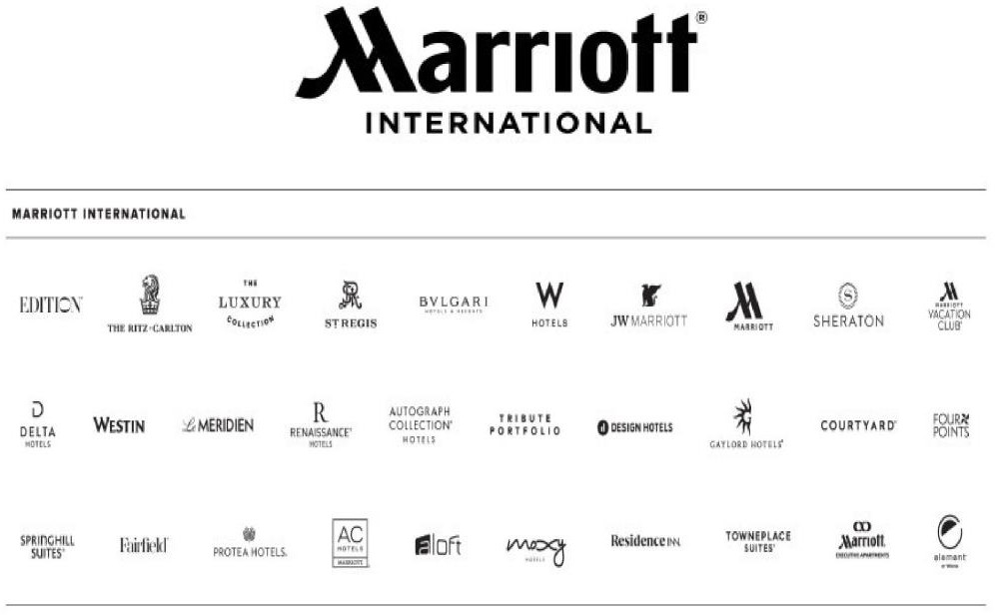






Internship Report
On

A Study on Financial Performance Evaluation & Tax/VAT Related Issues at Unique Hotel & Resorts Ltd.

Submitted To

Dr. James Bakul Sarkar Associate Professor
School of Business & Economics United International University

Submitted By

Sharif Abul Hasnat UIU ID: 111 – 172 – 112
Bachelor of Business Administration (BBA)

Date of Submission

21st June 2023


LT - 1
Letter of Transmittal

Date: 21st June 2023
Dr. James Bakul Sarkar
Associate Professor
Schools of Business & Economics (SOBE)
United International University (UIU)
Vatara, Satarkul, Madani Avenue, Dhaka – 1212

Subject: Submission of internship report on “A Study on Financial Performance Evaluation & Tax/VAT Related Issues at Unique Hotel & Resorts Ltd.

Dear Sir,

This is my humble attempt to let you know that this is the report you estimated as to prepare a survey on the topic, “A Study on Financial Performance Evaluation & Tax/VAT Related Issues at Unique Hotel & Resorts Ltd.”

Finishing my BBA (Bachelor of Business Administration) degree is a requirement for me. The study, in my opinion, substantially met its objectives, notwithstanding a few faults. You gave me the chance to write a report on this topic, which I appreciate. I tried my best to finish the report by the deadline and to the standards I had established.

To myself, I'm hoping you won't mind accepting my report. For me, providing more details about this subject will be a pleasure. My report is intended to fulfill your expectations and maybe help you make a wise decision.

Your Sincerely Sharif Abul Hasnat 111 – 172 – 112

AK - 1

Acknowledgement

First and foremost, I would like to express my gratitude to God for enabling me to finish this report on "Accounting and Information Systems." A study of United Commercial Bank Ltd.
I want to thank my supervisor of Dr. James Bakul Sarkar, Assistant Professor, who oversaw my internship.
Thank you to the professor of the UIU BBA Department for his involvement and guidance; without it, I would not have been able to finish this report. He gave me the go-ahead to pursue the topic I had selected.
Again, I want to thank you everyone at Unique Hotel & Resorts Ltd those who assist me to complete internship successfully there. I also especially thankful to my reporting boss Tasfia Tabassum Mahbub (Senior Executive – Corporate Reporting) Finance & Accounts at Unique Hotel & Resorts Ltd, Jone Kumar Gupta (Chief Financial Officer of Unique Hotel & Resorts Ltd), Shoumendra Kumar Sumon (Senior Executive – VAT & Tax at Unique Hotel & Resorts Ltd). Sonjib Mondol (Senior Executive – Finance & Accounts), Rabeya Farzana Mery (Senior Executive – Finance & Accounts), Md. Mizanur Rahman (Senior Executive – Finance & Accounts), Md. Abu Shakil & Md. Zahid Hossain (Deputy Manager – Finance & Accounts), Md. Raihan Ali (Senior Executive – Finance & Accounts) and many more.
Last but not least, I want to express my gratitude to United International University for sponsoring the internship program, which offers students a wonderful chance to gain practical experience connected to their academic goals.

TOC

Table of Contents:

Part - 1 Executive Summery 1
Part - 2: Introduction 2
  - Introduction 2
  - Company Profile 2 to 4
Part - 3: Organizational Background and Industry Perspective 5
  - Mission & Vision of Unique Hotel & Resorts Ltd 5
    - Mission of Unique Hotel & Resorts Ltd 5
    - Vision of Unique Hotel & Resorts Ltd 5
    - Strategic Objectives of Unique Hotel & Resorts Ltd 6
    - Core Values of Unique Hotel & Resorts Ltd 6
  - Products & Services of Unique Hotel & Resorts Ltd 7
    - The Westin Dhaka 7 to 8
    - The Sheraton Dhaka 8 to 10
    - Hansa, A Premium Residence 10 to 12
    - Unique Hotel & Resorts Ltd.’s Upcoming Projects 12
      - Unique Acropolis’s 12
      - Hotel Taj & Vivanta 13
    - Corporate Divisions of Unique Hotel & Resorts Ltd 13 to 15
    - Financial Stability of Unique Hotel & Resorts Ltd 15
      - Credit Rating Performance & Term Ratings of Unique Hotel & Resorts Ltd 15 to 16
      - Business Expansion & Business Performance of Unique Hotel & Resorts Ltd 16
        - Business Expansion 16 to 17
        - Business Performance 17 to 18
        - Financial Performance 19
        - Capital Structure & Leverage 20
        - Liquidity & Fund Flow Analysis 20
  - Risk Analysis of Unique Hotel & Resorts Ltd 21
    - Quality Maintenance Risk 21
    - Security Risk 21
    - Market Risk 22
TOC
    - Owner – Operator Agreement Risk 22
    - Global Instability Risk 22
  - Rating Comforts & Rating Concerns of Unique Hotel & Resorts Ltd 23
    - Rating Comforts 23
    - Business Prospects 23
    - Rating Concerns 23
    - Business Challenges 24
  - Applications of Financial Reporting Standards at Unique Hotel & Resorts Ltd 24 to 25
    - Observance of the International Accounting Standards 25
      - Compliance on International Accounting Standards at Unique Hotel & Resorts Ltd Perspectives (IAS Rules & Regulations) 25 to 30
3.6.1.1 Non-Applicable Compliance on International Accounting Standards at Unique Hotel & Resorts Ltd Perspectives (IAS Rules & Regulations) 31 to 32
  - Focuses on International Financial Reporting Standards 32 to 33
    - Compliance on International Financial Reporting Standards at Unique Hotel & Resorts Ltd Perspectives (IFRS Rules & Regulations) 33 to 34
    - Non-Applicable Compliances on International Financial Reporting Standards at Unique Hotel & Resorts Ltd Perspectives (IFRS Rules & Regulations) 34 to 37
  - Tax & VAT Compliances at Unique Hotel & Resorts Ltd 37
    - About Tax & VAT Acts, Rules 37
    - About Mushak & Challans 38 to 43
    - Tax & VAT Rates for Unique Hotel & Resorts Ltd 44 to 46
    - Unique Hotel & Resorts Ltd Tax & VAT Payments to the Government Treasuries …46 to 51
  - Unique Hotel & Resorts Ltd Tax & VAT Deduction & Collection from Vendors 51
  - A Comparative Cost Comparison for Unique Hotel & Resorts Ltd, Westin Dhaka, Sheraton Dhaka & Hansa, A Premium Residence 52 to 54
Part - 4 Objectives to The Study 55
  - Primary Objectives… 55
  - Secondary Objectives… 55
Part - 5 Methodologies of The Study 56
  - Primary Source 56
  - Secondary Source 56
  - Scope of The Report 56

TOC
Part – 6 About My Internship Experience 57
  - About My Duties & Responsibilities… 57
  - Trainings… 57
  - Personal Evaluation 58
  - Application of Academic & Educational Knowledge 58 to 59
Part – 7 Findings & Analysis of The Study 59
Part – 8 Recommendations & Conclusions 60
  - Recommendations… 60
  - Conclusions… 61
Part – 9 References… RF

Part – 1. Executive Summary:
1
The author has accomplished his internship report for Unique Hotel & Resorts Ltd. with a view to evaluating the company's financial and tax compliances with VAT, as well as his roles and obligations during the four months of internship there. The brief explanation of his internship experiences includes introduction, organizational background and industry perspective, objectives of the study, methodology of the study, findings and analysis, Recommendation & conclusion and finally reference.

2

Part – 2. Introduction

Introduction

In terms of the world economy, Bangladesh is currently considered a middle-income nation. The business opportunities here are expanding and developing every day. As a result, a large number of foreigners and investors are entering Bangladesh for business, various projects, travel, and visiting reasons.
Although Bangladesh is one of the world's smallest nations, this region is rich in natural beauty. Therefore, there are several tourist attractions and rest areas located around the nation. Both domestic and foreign tourists visit the diplomatic and economic zones in large numbers. They require accommodations for these visitors as a result. Therefore, it is crucial to have top-notch hotel and motel amenities for the best lodging options, in addition to additional entertainment facilities like a gym, restaurant, swimming pool, bar, etc.
Bangladesh, particularly in the major cities like Dhaka, Chottogram, Cox's Bazar, Sylhet, etc. These hotels and motels are divided into categories based on their 3/4/5-star ratings, client reviews, entertainment and refreshment options, etc.
In order to emphasize the significance of these challenges, Unique Group, a prominent corporate conglomerate in Bangladesh, maintains a dedicated business unit that is in charge of the country's hotel sector. The sister company of the Unique Group, Unique Hotel & Resorts Limited (UHRL), is engaged in and taking on numerous sizable hotel and resort projects.

3

Company Profile

The first "Five - Star" hotel amenities in Bangladesh were introduced in 2007 by Unique Hotels & Resorts Ltd (UHRL). In Bangladesh's private sector, "The Westin" Hotel is the "First 5-Star Hotel Management." Unique Hotel & Resorts Ltd. (UHRL) was founded in November 2000, notwithstanding this. But on July 1, 2007, Unique Hotel & Resorts Ltd.
received a certificate of business initiation for the name "The Westin Dhaka."
Unique Hotels & Resorts PLC Ltd is a publicly traded company that is listed on both the Chittagong Stock Exchange (CSE) and the Dhaka Stock Exchange (DSC). The registered office is located at plot #1, CWN (B), road #45, Gulshan 2, Dhaka 1212 as its address & The company’s head office is situated at 51/B, Borak Mehnur, Kamel Ataturk Avenue Banani, Dhaka – 1213. | 
About Unique Group:
Unique Group (UG) Ltd is one of the longest conglomerates and also foremost diversified business entities in Bangladesh. The journey had started at the 1980. And the year 1999, by signing of the management contract with Star Wood
International Hotel Chain, USA.

 | Unique Group (UG) Ltd has more than 25 business associates and more than 20 total companies. Unique Group is focusing on the  particular business sectors:

4

    - Hotel & Hospitality: Sheraton Dhaka, The Westin Dhaka (franchised from Marriot Boney) Hansa – A Premium Residence (the project of Unique Hotel & Resorts Ltd).
    - Real Estate: Borak Real Estate Ltd

    - Facility Management: Hansa Management Ltd.
    - Human Resource Development & Export: Unique Eastern (Pvt) Ltd, Tribeni International Ltd.
    - Energy & Power: Unique Meghnaghat Power Ltd (UMPL), a 584 MW gas combined cycle power plant, that is contributing the electricity power to the Westin Dhaka, Sheraton Dhaka as well as Borak Mehnur. (a 22 multistoried building).
    - Ready Mix Concreate: Borak Ready Mix Concreate.
    - Auto Bricks & Tiles: Unique Ceramics Ltd
    - Healthcare: Gulshan Clinic Ltd
    - Newspaper: Daily Amader Shomoy (Bangla – newspaper), The Business Post (English & online news portal).
    - Tours & Travels: Unique Tours & Travels, Borak Travels
    - Agro & Dairy Farm: Arial Agro Ltd
    - Education & Training: Update college, Borak Polytechnic Institute
    - Stock Brokerage: Unique Share Management Ltd
    - Technology: MySys and Uninet Global Ltd.
    - Networking: Bangla Tel Ltd

5

Part - 3 | Organizational Background & Industry Perspective:

Mission, Vision & Objectives

Mission:

The aim of Unique Hotel & Resorts Ltd (UHRL) is to completely comprehend the demands of its guests and employees, consistently exceed the expectations of its stakeholders, and provide its clients with the best possible world-class customer service.

Vision:

We will work to maintain our position as the best-in-class provider of real hospitality services in Bangladesh and throughout this region by ensuring the most effective services.

6

Strategic Objectives:

To fulfill the goal and objective by providing top-notch services through innovation and ongoing development of the highest caliber.
- To work to uphold the brand's reputation by providing excellence with the ultimate goal of developing into a commercial behemoth that is competitive worldwide.
- To embody a strong set of values that includes a positive outlook and goal-oriented behavior.
- Becoming the most sustainable company service that will excel by protecting the interests of customers, stakeholders, staff, the economy, and the general public.
- The goal is to maintain its entrepreneurial spirit a vibrant spirit with an instinctive drive to scale new heights.

Core Values:

The essential values of Unique Hotel & Resorts PLC are always important. Our belief in "SPIRIT" entails the following:
- S – Synergy
- P – Preparedness
- I – Innovative Mind
- R – Rating Customer First
- I – Improving Continuously
- T – Teamwork

7

Products & Services

In the previous discussion, we discovered that Unique Hotel & Resorts Ltd. (UHRL) is the sole owner of three world-class hotel brands. From Marriott Bonvey, two of them—The Westin Dhaka and Sheraton Dhaka—are acquiring franchises. Marriott Bonvey is the new name for Marriott International.

We also discovered that Marriot Bonvey has more than 8,000 properties spread across 139 different countries and "30 International 5 - Star" hotel brands like Westin, Sheraton, ST. Regis, Renaissance, and Radisson. By franchising, granting licenses, or even directly operating in several nations around the world, Marriott Bonvey allows the use of its hotel chain brand names.
Again, Hansa – A Premium Residence, is the full ownership of Unique Hotel & Resorts Ltd. This hotel is situated at Abdullahpur, Uttara, Sector – 10, with world-class hotel with the best gymnasium & restaurant amenities.

The Westin Dhaka:

Business hubs, embassies, eateries, retail establishments, entertainment venues, and historical attractions are all located within a two-mile radius of the Westin Dhaka. for which  Banani and Gulshan are renowned. | 

8

 | This upper-class resort's 235 well-furnished guestrooms and suites are extremely roomy. Refresh in your room or suite at a spacious luxury hotel, which includes a mini-refrigerator, high-speed WIFI, a Westin Heavenly Bed that is wonderfully comfortable, and 24-hour room service. When it's time to eat, pick from a choice of delicious international alternatives at one of our five restaurants and bars, which include everything from a Pan Asian buffet to outstanding Italian cuisine. Relax in our heated outdoor pool, work out at the Westin Workout, or  rejuvenate at our spa.

Strengths:
Strong brand awareness and dominance in the corporate market and also situated in a safe area in the CBD. secures contracts with corporations and diplomats’ Strong participation in the Marriott Bonvoy program; highly qualified, experienced, and trained service personnel; The best reputation for cuisine and customer service.

Opportunities:
The target market's purchasing power has grown as a result of the nation's steady GDP growth. expanding domestic leisure market demand. The ability to host large groups (MICE) or residential meetings while collaborating with the Sheraton Dhaka. Following COVID, ongoing and forthcoming government megaprojects will significantly increase demand.

9

Sheraton Dhaka

The well-known Marriott International brand Sheraton Hotels & Resorts debuts Sheraton Dhaka in the vibrant  capital of Bangladesh. | 

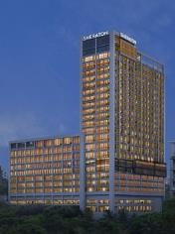 | Sheraton Dhaka is located in the center of Banani, a developing commercial area and a part of the city, 15 minutes' drive from Hazrat Shahjalal International Airport.  Diplomatic district of Dhaka. The upscale hotel is 10 minutes' drive from Banani's renowned restaurants, corporate headquarters, embassies, shopping centers, and other  attractions.

The upmarket establishment has 248 elegantly decorated bedrooms and apartments. The attractively furnished guestrooms provide the Sheraton Sleep Experience as well as other distinguishing Sheraton features. The Sheraton Club Lounge is designed to exude luxury while offering a place to relax in comfort and take advantage of the exclusive benefits of lounge check-in, daily breakfast, and 24-hour canapé service.

Strengths:
Due to the former Sheraton building (now Intercontinental), there is a strong brand recall in Dhaka. There are also modern F&B areas and a staff of chefs. A strategic location near the CBD will help secure strong FIT and F&B walk-in; a large, pillarless ballroom in the CBD will help secure high-volume banqueting events; 13 function rooms will help drive multiple events; experienced foreign chefs will set a

10

new standard for the city's F&B experience; spacious guest rooms, among the largest in the city; the Marriott Bonvoy program's popularity; and dining options like 250 cover All Day Dining and Yum!

Opportunities:
High-end residential areas nearby are anticipated to generate F&B demand. The hotel's room to space ratio will help position the establishment as a convention venue for sizable events. Upcoming commercial offices in the Banani area, such as Uber and others, to create a Corporate base for the establishment.

HANSA – A Premium Residence


"HANSA Residence" is now open for business under Unique Hotel & Resorts PLC. 76 keys to a luxury property (3 Star) in Uttara with two top-notches, a restaurant, a pool on the roof, a gym, and numerous more amenities.

11

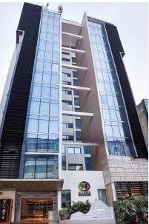 | The top hospitality management company and proprietor of "The Westin," Unique Hotel & Resorts PLC, is the owner of HANSA - A Premium Residence.  Having worked in the hotel sector for more than 20 years, Dhaka and Sheraton Dhaka" HANSA is the first luxury apartment in Bangladesh to offer all services on par with those offered by major national and international hotels. Situated in Uttara, the expanding Ready-Made Garment (RMG) commercial district of Dhaka City, HANSA is well situated close to the international airport, giving its guests the opportunity to go from the airport to their hotel  in less than

10 minutes and in a very practical location to move manufacturing area. HANSA sets the standard for luxury lodging in Bangladesh, whether traveling for business or pleasure.

Strengths:

Strong brand recognition and control of the corporate market as a sibling brand under UHRL. Location- extremely close to prominent Factories, A full-service hotel with top-notch amenities, including a swimming pool, only in Uttara, an international airport, and an emerging business center. Associates with exceptional talent, training, and experience. Position 1 on TripAdvisor for the best reputation for food and service.

12

Opportunities:
Due to the nation's steady GDP expansion, the target audience's purchasing power has grown.
- Growing domestic leisure market demand.
- Various commercial offices are currently open in Uttara, particularly in the RMG sector.
- The soon-to-be-opened Hansa BAR will be a popular travel spot for passengers traveling in business class.

    - Unique Hotel & Resorts Ltd.’s’ (UHRL) Upcoming Projects:

      - Unique Acropolis:

The third-highest structure in Dhaka and one of Bangladesh's tallest skyscrapers is slated to be built: Unique Acropolis.  It can be found on Gulshan Avenue in Dhaka's  business district. The target completion date will be in 2023.  Unique Acropolis’ Facilities:  - Serviced residences.  - More than 800 cars can be parked in the basement of the Hyatt Hotel 7.  - Admin Block | 

13

Hotel Taj & Vivanta:
 | Taj and Vivanta, two Indian hotel chains, will open in Bangladesh under the ownership of Borak Real Estate Ltd (BREL), a subsidiary of the local enterprise Unique Group.  The hotels will be run by both Borak and renowned Indian hospitality organization Indian Hotels organization Limited (IHCL).  The Westin Dhaka, Sheraton Dhaka, and HANSA are currently operated by Marriott International's 5- star properties by Unique Hotel and Resorts PLC, a top hotel and hospitality management business in  Bangladesh.

A Taj Club will house 60 signature brand stores, celebrity boutiques, and celebrity eateries inside the Taj hotel where both domestic and foreign customers would be able to purchase international branded goods.

3.3.4. CORPORATE DIVISIONS OF UNIQUE HOTEL & RESORTS LTD:

The corporate division of Unique Hotel & Resorts Ltd (UHRL) is effective and robust. In this corporate division, the managing director, Mr. Noor Ali (MD), is in charge of the company's operational and managerial decisions while the chairperson, Mrs. Salina Ali ma'am, holds the

14

highest position on the board of management. Additionally, Unique Hotel & Resort Ltd (UHRL) has a pool of independent board members who have been nominated by the company:
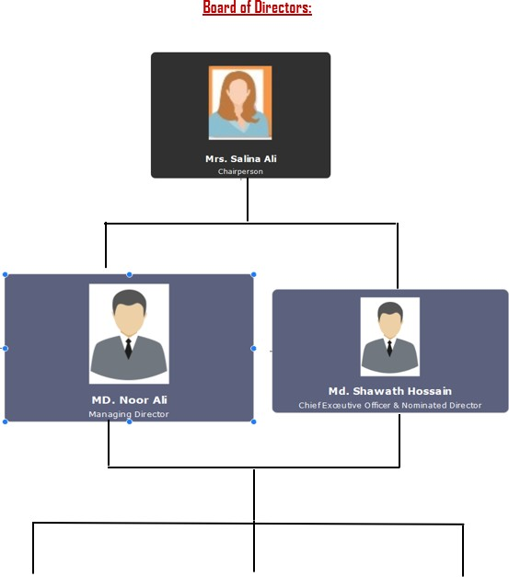

15

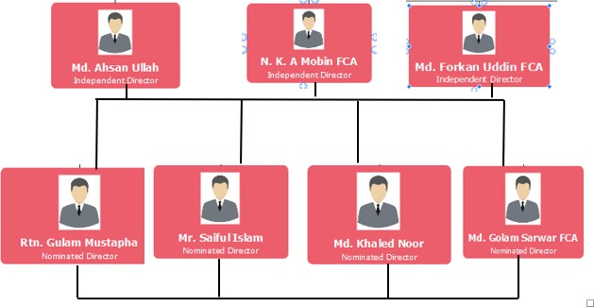

3.3.5 Financial Stability of Unique Hotel & Resort Ltd:

Credit Rating Performance & Term Ratings of Unique Hotel & Resorts Ltd:

From April 17,2022 to till April 16, 2023, there is the “Outstanding” rating in Credit Rating Performance. Again, on 17th April 2023. it is still remaining the same {AA+ (Double A Plus)} on long term ratings as well as {ST – 1} on short term rating.
According to CRISL rating (Credit Rating Information & Service Ltd) has reaffirmed that:
        - AA+ (Double A Plus) indicates the higher safety for timely repayment.
        - ST - 1 indicates the highest certainly of timely repayment

There are several guidelines and methodologies of Credit Rating Information & Service Ltd on these particular securities & industries:

16
- Asset Backed Security
- Airlines Industry
- Banks
- Financial Institutions
- Debt Instruments
- Bank Loan/ Facility Rating
- General Insurance
- Government Support Entities
- Investment Company
- Life Insurance
- Trading Concerns
- Telecommunication
- Small & Medium Enterprise
- Corporate
- Merchant Banks
- Micro Finance Institutions
- Municipality
- Securities Firm
- Readymade Garments (RMG)
- Real Estate and Construction
- Fast Moving Consumer Goods

Business Expansion & Business Performance of Unique Hotel & Resorts Ltd:

        - Business Expansion:

Due to the growth of business opportunities as well as success in Hotel Business, Unique Hotel & Resorts Ltd is continuously developing and constructing a New Five Star Hotel Chain

17

“Hotel Taj” franchised from Hotel – Taj {Hotel – Taj – Mumbai Authority (Hotel – Taj Tata Ltd}. at 43 Kemal Ataturk Avenue, Banani – 1213. This hotel is situated just left behind at “The Westin Dhaka”. Again, Unique Hotel & Resorts Ltd management is diversifying its portfolio and going to establish a private economic zone that named “Sonargaon Economic Zone Ltd” and also recently decided to start a new business in the aviation industry in Bangladesh named “Hansa Aviation Ltd.”

Business Performance:
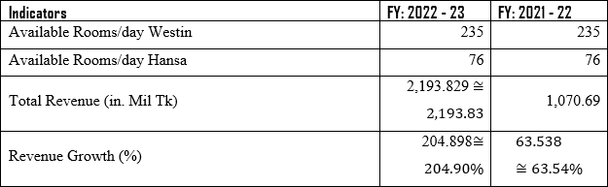
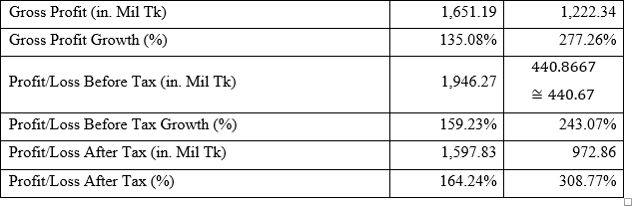


18
Business Performance
FY 2022 - 23 FY 2021 - 22

300.00%

250.00%

200.00%

150.00%

100.00%

50.00%

0.00%
Revenue Growth (%) Gross Profit Growth (%) Profit/Loss Before Tax Profit/Loss After Tax
Growth (%) Growth (%)

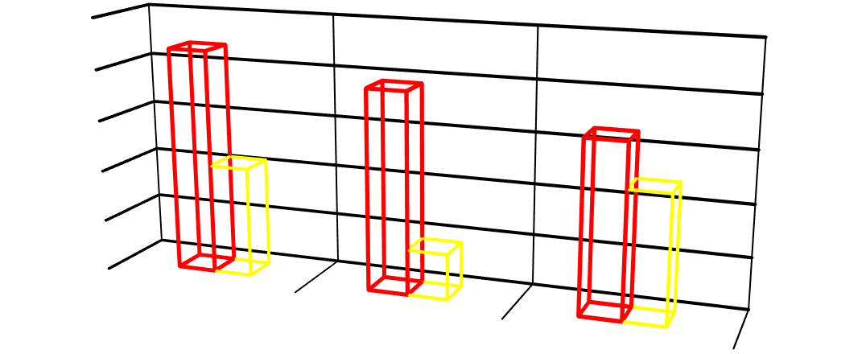
Business Performance
FY 2022 - 23 FY 2021 - 22
2,500.00

2,000.00

1,500.00

1,000.00

500.00

0.00
Total Revenue (in. Mil
Tk) Profit/Loss Before Tax (in. Mil Tk)
Gross Profit (in. Mil Tk)

19

Financial Performance:
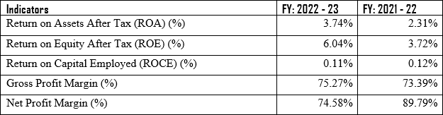


Financial Performance
100.00%
80.00%
60.00%
40.00%
20.00%
0.00%
FY 2021 - 22
Return on
Assets After
Tax (ROA) (%) Equity After
Tax (ROE) (%)
Return on
Return on
Capital Employed (ROCE) (%)
FY 2022 - 23
Gross Profit
Margin (%)
Net Profit
Margin (%)
FY 2022 - 23 FY 2021 - 22

20

Capital Structure & Leverage:
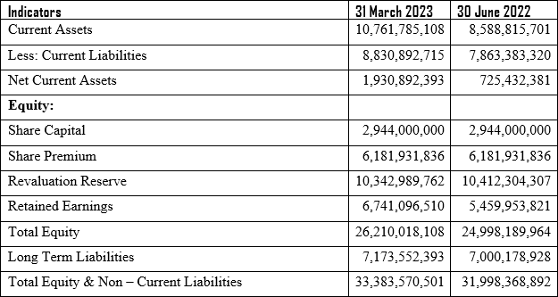

        - Liquidity & Fund Flow Analysis:

Indicators | 31  March 2023 | 30  June 2022
Quick Ratio | 1.21 | 1.08
Current Ratio | 1.22 | 1.09

21

Risk Analysis of Unique Hotel & Resort Ltd:

Quality Maintenance Risk:
One of the most crucial strategic tools of the best practices in hotel management is total client satisfaction through quality. On the other hand, hotel companies cannot completely satisfy customers unless they are aware of their competitive position in the shifting market and understand the potential for ongoing service development. The company is in an excellent position because of its affiliation with a chain that is well-known internationally and because of its skilled management team. In order to establish a positive market image, Unique Hotel & Resorts Ltd. (UHRL) has been preserving quality ever since it was founded. However, because the sector must compete with high- quality services, the hotel might not be at danger for poor quality up keep, until and unless it severs its ties to Marriot Bonvey, the hotel may not be at danger for poor quality maintenance

Security Risk:
The sad occurrence, various political unrest, as well as significant attacks on foreign visitors in recent years, have had a negative impact on the nation's reputation in security-related matters. As a result, many tourists from other countries are reluctant to visit Bangladesh and discourage others from doing so in the future. Therefore, these circumstances had an impact on every industry in Bangladesh, but mainly the hotel and tourism industries. These circumstances have been gradually changing day by day as more foreigners visit and conduct business in Bangladesh. The Westin Dhaka has the highest security surveillance for all guests, which is maintained by The Westin Dhaka authorities, to emphasize the security facilities of both foreign and local guests. Moreover, a connection between an emergency system relates to the Gulshan Police Station. In the event of an emergency, they will act quickly to send reinforcement.

22

Market Risk:
During the time period under review, unfavorable market conditions, such as the global impact of the COVID-19 pandemics and the war between Ukraine and Russia, had a significant influence on the company's sales and profitability. Most often, the risk results from declining demand for the good or service, which would negatively impact the business's success. The competition for lower prices, revenues, profit margins, market shares, etc. has increased in the case of Unique Hotel & Resorts Ltd., which has had a negative effect on its business's financial health, strong brand reputations, resource strength, etc.

Owner – Operator Agreement Risk:
The continuous management agreement made clear the operator's role and responsibilities, management fees, reimbursable expenses, termination of the arrangement, etc. Both the owner and the operator may end the aforementioned contract at any point within the specified time limit. If the parties have a long-standing contractual connection, the owner may need to create another contract. Operating a five-star hotel or managing the property themselves. It could not be able to influence a large enough number of international visitors if it cannot operate under any branded operator.

Global Instability Risk:
The tourism industry, which deals with a variety of variables including attractions, transportation, lodging, intermediary amenities providers, and so forth, is largely dependent on global stability. However, events like the COVID-19 epidemic, the conflict between Russia and Ukraine, global economic instability like the dollar crisis in many currencies, etc. had a significant impact on the global economy. A severe recession is anticipated for the global economy in the near future as well. Following analysis, it was discovered that the COVID scenario had a significant impact on Unique Hotel & Resorts Ltd.'s operational performance. It is quite challenging to run the business effectively and efficiently in addition to the recent challenges with the currency crisis and the rising rate of global inflation.

23

Rating Comforts & Rating Concerns of Unique Hotel & Resort Ltd:

To analyze the financial stability and risk analysis of Unique Hotel & Resorts Ltd, we can put our observation on 2 parts:

Rating Comforts:
      - Equity Based Capital Structure
      - Strong Brand Image – The Westin Dhaka
      - Market Leadership
      - Strong Group Support
      - Suitable Location
      - Sound Facilities and Infrastructures
      - Innovative service Facilities Compared to Its Competitors

Business Prospects:
- Increasing Occupancy Rate at Expected Level
- Innovation & Render New Services to Meet Clientele Demand

Rating Concerns:
- Operational Risk
- Quality Maintenance Risk
- Owner – Operator Agreement Risk
- Deterioration of Financial Performance
- High Administrative & Finance Cost

Business Challenges:
24
- Increasing Competition in the Market
- Global Impact of COVID – 19 Pandemics

Application of Financial Reporting Standards at Unique Hotel & Resort Ltd:

Most of the laws in place in the area prior to independence were adopted by Bangladesh once it gained its freedom. The Securities Act of 1920, the Capital Issues (Continuance of Control) Act of

1947, and the Securities and Exchange Ordinance of 1969 were all laws the government implemented to regulate the securities market.
It is noteworthy that Bangladesh created its own Securities and Exchange Rules in 1987, about 16 years after gaining independence. These rules primarily address the requirements for joining and remaining a member of a stock exchange (Rule 3), the manner in which that member conducts business (Rule 4), the requirement that both the stock exchange and the members maintain books of audited accounts and other documents (Rules 5, 7 and 8), the requirement that issuers submit annual and half-yearly reports (Rules 12 and 13), etc.

An audited balance sheet, an audited profit and loss account, an audited cash flow statement, and
(iv) notes to the accounts are required to be included in the annual report that the issuer must submit in accordance with the Securities and Exchange Rules of 1987 (Rule 12(1)(1)).

Additionally, per Rules 12(1)(2) and 12(1)(3) of the Institute of Chartered Accountants of Bangladesh, the financial statements of the issuer must comply with the International Accounting Standards and the International Standards of Auditing as published by the International Accounting Standards Committee and the International Auditing Practices Committee of the International Federation of Accountants, respectively.

25

Unique Hotel & Resorts Ltd is not different to the other public limited companies financial reporting and audit compliance. So, Unique Hotel & Resorts Ltd authority has to follow the rules and regulations of International Financial Reporting Standards (IFRS), International Accounting Standards (IAS), as well as The Securities & Exchange Rules, 1987; The Securities & Exchange Ordinance, 1969; The Regulations of Dhaka Stock Exchange Limited and Chittagong Stock Exchange Limited; and so on.

    - Observance of the International Financial Reporting Standards:

3.6.1.1 | Compliances on International Accounting Standards at Unique Hotel & Resorts Perspectives  (IAS Rules & Regulations):

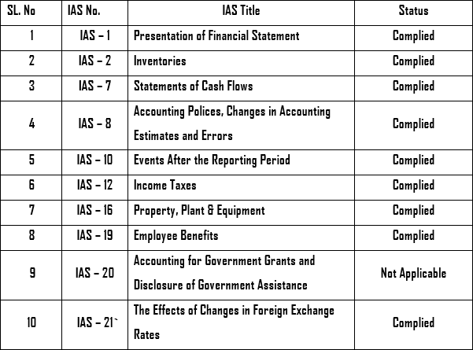

26

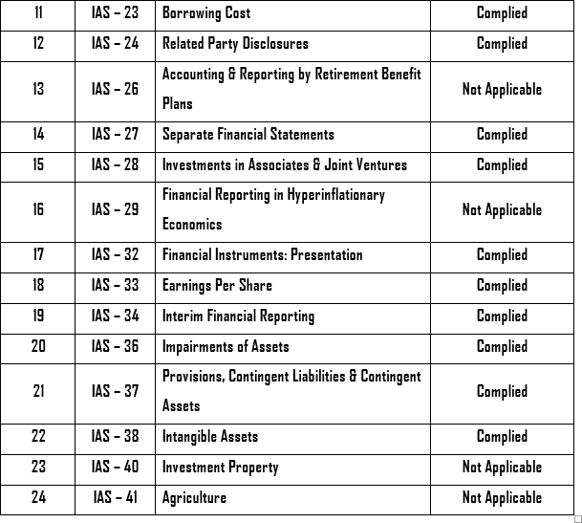

According to The Securities & Exchange Rules (1987), Unique Hotel & Resorts Ltd follows the following International Accounting Standards (IAS) rules for the transparencies on the financial as well as the financial statements preparation.
IAS – 1: Presentation of Financial Statement, Status: Complied, Unique Hotel & Resorts Ltd has to follow because:
      - A financial position statement as at the end of the period
      - A statement of equity changes during the time period;

27
- A cash flow statement for the period; notes, which provide a review of key accounting
and also
      - When a company applies an accounting policy retrospectively, restates items in its financial statements retroactively, or reclassifies items in its financial statements, it must provide a statement of financial position as of the start of the prior comparative period

IAS – 2, Inventories: Status: Complied, the lower of cost and net realizable value is used to calculate inventories (stock and stores). The average cost formula is used to assign the cost of inventories. The cost of inventory includes the purchase price, conversion charges, import duties, other non-refundable taxes, and other expenses incurred to bring the inventory to its current location and circumstances.

IAS – 7, Statements of Cash Flows: Status: Complied, Statement of Cash Flows requirements were followed in the preparation of the cash flow statement. The "Direct Method" was used to prepare the cash generated from operating activities in accordance with the Securities and Exchange Rules of 1987 and the benchmark treatments of IAS 7, whereby key classes of. Gross cash inflows and outflows from operating activities are both reported.

IAS – 8, Accounting Policies, Changes in Accounting Estimates & Error: Status: Complied, Accounting procedures, adjustments to accounting estimates, and mistakes. As a result, comparison data has been updated to the start of the previous quarter.
However, the retrospective application reduces the company's net asset worth per share as of June 30, 2022, by Tk. 0.02 (0.1% of reported). Because of this, the Company does not view this impact as having a major effect on the data in the statement of financial condition at the start of the previous quarter, or on June 30, 2022.

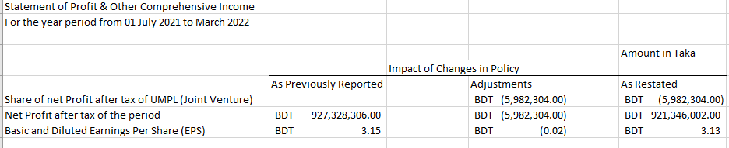
28

IAS – 10, Events after Recording Period, Status: Complied, Events after the Reporting Period, adjusting events that provide additional information about the Company’s position at the end of the reporting period are reflected in the financial statements and events after the reporting period that are not adjusting events are disclosed in the notes when material. The Company have no adjusting or non-adjusting events after reporting period.

IAS – 12, Income Taxes: Status: Complied, according to the Income Tax Ordinance of 1984, income tax expense for the current year is computed by the company using the best estimate of assessable profit for the year at the applicable tax rate. According to IAS 12: Income Taxes, current tax refers to the anticipated tax due on the taxable income.
Using the tax rates that were legislated or in effect at the reporting date, for the period, including any adjustment to tax payable with respect to prior periods. According to the Finance Act 2023, Unique Hotel & Resorts Limited, a publicly traded company, utilized a tax rate of 20% for the reporting period.

Temporary discrepancy that is taxable:
All taxable temporary differences result in the recognition of a deferred tax liability, with: the exception of those that
Initial acknowledgment of kindness; or
The initial identification of a debt or asset in a transaction which; Neither is a business combine;

29
Affects neither the accounting profit nor the taxable profit (loss) at the time of the
transaction.
IAS – 16, Property, Plant & Equipment, Status: Complied,
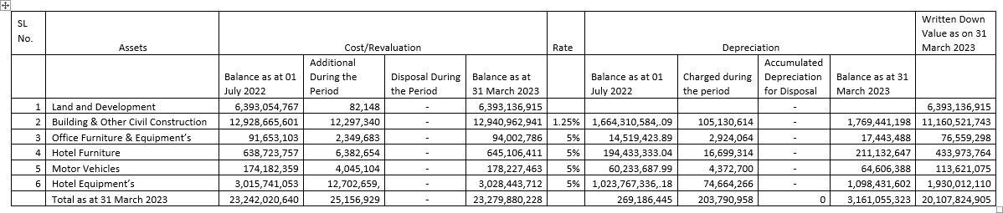

Unique Hotel & Resorts Ltd has transferred Tk.194,61,43,279 from Construction Work in Progress to Property, plant & equipment for the restaurants and banquet hall operated under "Sheraton Dhaka". The restaurants and banquet hall have been operating through obtaining Restaurant License from District Commissioner Office, Dhaka under Bangladesh Hotel & Restaurants Act, 2014. The licenses were obtained on February 03, 2022. As a result, UHRL hasdepreciated the restaurant cost from when the restaurants are available for use, i.e. February 2022. Total area of Sheraton Dhaka is 497,121.25 sqft out of which total area for the abovementioned restaurants and banquet hall are 86,047.72 sqft upon which depreciation has been charged. Unique Hotel & Resorts Ltd. Schedule of Property, Plant and Equipment as at February 28, 2023.

30
IAS – 19, Employee Benefits, Status: Complied,

- Temporary employee advantages: Obligations for short-term employee benefits are calculated on an undiscounted basis and are deducted as the relevant service is rendered.

- Plan with defined contributions (Provident fund): An organization makes predetermined contributions into a post-employment benefit plan known as a defined contribution plan. a distinct business and is under no actual or implied obligation to make further payments. For their qualified permanent employees, the corporations operate a separate defined contribution plan. The criteria are determined in accordance with the guidelines outlined in the corresponding Trust Deeds and Rules. The Income Tax Ordinance of 1984 recognizes a distinct provident fund plan for the companies. Tothe provident fund, all permanent employees contribute 10% of their base pay, and the firms match their contributions.

- WPPF, or the Workers' Profit Participation Fund: In compliance with Bangladesh Labor Act, 2006 (as amended to 2013), Unique Hotel & Resorts Limited allocates 5% of its profit before tax after charging a contribution to WPPF. The requisite fund has been transferred to the trustee's bank account for the year ending in June 2021, and a Board of Trustees for the WPPF has been established.
In accordance with the aforementioned Act, the Board and Government Welfare Fund.

To respect this standard, the authority of Unique Hotel & Resorts Ltd has distributed its Provident Fund among the employees and staffs:

Particulars | Amount in Taka
80% of Employees | 3,87,06,387
10% Govt. Welfare Fund Part | 48,38,298
10% Employees. Welfare Fund Part | 48,38,298

31

3.6.1.2 | Non-Applicable Compliances on International Accounting Standards at Unique Hotel &  Resorts Perspectives (IAS Rules & Regulations):

IAS – 20, Accounting for Government Grants and Disclosure of Government Assistance, Status: Non-Applicable,
One of Bangladesh's most well-known groups of industries belongs to Unique Hotel & Resorts Ltd. Additionally, this privately-owned property is owned. Once more, this group has no relationship or involvement with any government agency or department. IAS 20 thus cannot be applied to financial reporting.

IAS – 26, Accounting & Reporting by Retirement Benefit Plans, Status: Non- Applicable, the limited corporation Unique Hotel & Resorts Ltd (UHRL) is privately held, as was previouslystated. Although this business attempted to operate as a public limited company, it is entirely privatelyowned. Therefore, no allowance is made for employees who are up to 60 years old or who have retiredfrom their position. Actually, IAS- 26 is reported into Bangladesh's government sectors.

IAS – 40 Investment Property & IAS – 41 Agriculture, Status: Non-Applicable,
The accounting for real estate (land and/or buildings) kept for rental income, capital appreciation, or both is governed by IAS 40 Investment Property. With some exclusions, investment properties are initially valued at cost and may then be valued using a cost model or a fair value model, with increasesin fair value under the fair value model being recognized in profit or loss.
The accounting for agricultural activity, or the conversion of biological assets (alive plants and animals) into agricultural products (the harvested end product of the entity's biological assets), is outlined in IAS 41 Agriculture. According to the standard, biological assets must normally be valuedat fair market value minus selling expenses.

Unique Hotel & Resorts Ltd. does not generate revenue or operating income from leasing or propertyrent in the explanations that follow.

32
Additionally, IAS-41's agriculture sector is not applicable because UHRL lacks any
active stockcompanies or start-up businesses to conduct its own catering or operate its restaurant franchises.
The Unique Hotel & Resorts Ltd. authority does not apply IAS 40 and IAS 41 to their financial reporting for the reasons listed below.

Focuses on International Financial Reporting Standards (IFRS Rules & Regulations):
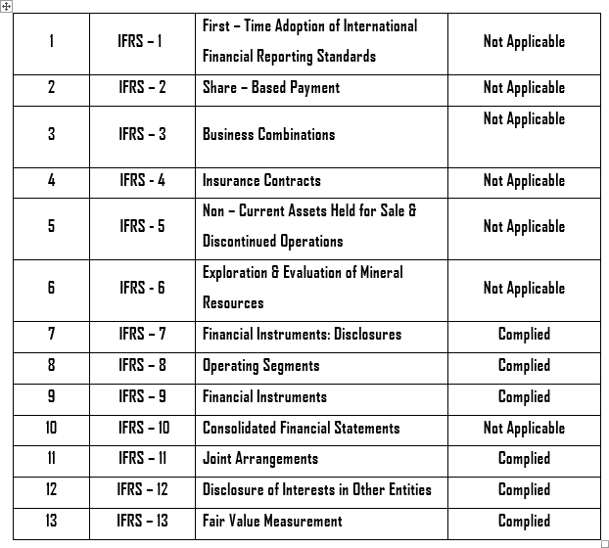


33

3.7.1 | Compliances on International Financial Accounting Standards at Unique Hotel &  Resorts Perspectives (IFRS Rules & Regulations):

IFRS – 7, Financial Instruments: Disclosures, Status: Complied,
The disclosure of information regarding the importance of financial instruments to a company as well as the nature and amount of risks associated with those financial instruments, both in qualitative and quantitative terms, is required by IFRS 7 Financial Instruments: Disclosures. Regarding a variety of other topics, including transferred financial assets, specific disclosures are necessary.

IFRS – 8, Operating Segments, Status: Complied,
According to IFRS 8 Operating Segments, specific classes of organizations (mostly those with publicly traded securities) are required to publish details about their operating segments, goods and services, operating regions, and key clients. Both the identification of operational segments and the measurement of reported segment information are based on internal management reports.

IFRS – 9, Financial Instruments, Status: Complied,
The classification and measurement requirements for financial assets, financial liabilities, and some contracts to acquire or sell non-financial objects are laid forth in IFRS 9. When an entity becomes a party to the contractual terms of an instrument, it is required by IFRS 9 to recognize an asset or a liability in its statement of financial position. When a financial asset or financial liability is initially recognized, the entity measures it at its fair value plus or minus transaction costs that are directly related to the purchase or issuance of the financial asset or financial liability, if the asset or liability is not at its fair value through profit or loss.

34

IFRS – 11, Joint Arrangements, Status: Complied,
The accounting by entities that jointly control an arrangement is described in IFRS 11 Joint Arrangements. Joint control refers to the legally agreed-upon division of control. Agreements subject to joint control are either classified as joint operations (representing rights to assets and obligations for liabilities, which are appropriately accounted for) or joint ventures (representing a share of net assets and equity).

IFRS – 12, Disclosure of Interests in Other Entities, Status: Complied,
A comprehensive variety of disclosures about an entity's interests in subsidiaries, joint ventures, associates, and unconsolidated "structured entities" must be made according to the consolidated disclosure standard known as IFRS 12 Disclosure of Interests in Other Entities. Disclosures are laid out as a series of goals with specific instructions on how to achieve those goals.

IFRS – 13, Fair Value Measurement, Status: Complied,
IFRS 13 Fair Value Measurement establishes a single IFRS framework for assessing fair value and mandates disclosures concerning fair value measurement. It is applicable to IFRSs that either require or authorize fair value measurements or disclosures. The Standard's definition of fair value is based on the idea of a "exit price" and employs a "fair value hierarchy," leading to a market-based measurement as opposed to an entity-specific one.

IFRS – 15, Revenue from Contracts with Customers, Status: Complied,
IFRS 15 requires such firms to give users of financial statements more detailed, pertinent disclosures and specifies how and when an IFRS reporter must recognize revenue. The standard offers a single, five-step model with a set of guiding principles that should be used for all client contracts.

3.7.2 | Non - Applicable Compliances on International Financial Accounting Standards  at Unique Hotel & Resorts Perspectives (IFRS Rules & Regulations):

35

IFRS – 1, Fair Value Measurement, Status: Non-Applicable,
IFRS 1 Initial Adoption of International Financial Reporting Standards outlines the steps a business must take when using IFRSs as the foundation for its general-purpose financial statements for the first time. The IFRS allows for a few restricted exceptions to the general rule that each IFRS must be followed by the end of its first IFRS reporting period.

Actually, this IFRS – 1 regulation is applicable when a company or organization operates and reports for the 1st time in the financial reporting. But Unique Hotel & Resorts Ltd has already elapsed its business operation more than 20 years. So, the application of IFRS – 1 is not applied here.

IFRS – 2, Share – Based Payment, Status: Non-Applicable,
IFRS 2 Share-based payment transactions, including those with workers or other parties that will be settled in cash, other assets, or equity instruments of the organization, must be recognized by an entity in its financial statements. These transactions may involve granted shares, share options, or share appreciation rights. For share-based payment transactions that are resolved in cash or equity, as well as those where the entity or supplier has a choice of cash or equity instruments, specific requirements are incorporated.

IFRS – 3, Business Combinations, Status: Non-Applicable,
When an acquirer takes control of a business (via an acquisition or merger, for example), the accounting is described in IFRS 3 Business Combinations. Such business combinations are recorded using the "acquisition method," which typically requires that obligations assumed and assets acquired be valued at fair market value at the time of the acquisition.

Unique Hotel & Resorts Ltd has no business combination or acquisition from the other business entities or companies. This company just takes franchises of two brand names and hotel chain services from Marriot Bonvey (Westin, Sheraton). So, UHRL has not applied IFRS – 3, rules & regulation into its financial reporting.

36

IFRS – 4, Insurance Contracts, Status: Non-Applicable,
With a few exceptions, all insurance contracts (including reinsurance contracts) that a company issues and all reinsurance contracts that a company possesses are subject to IFRS 4 Insurance Contracts. The standard offers a temporary exemption from the requirements of some other IFRSs, including the requirement to consider IAS 8 Accounting Policies, Changes in Accounting Estimates, and Errors when choosing accounting policies for insurance contracts, in light of the IASB's comprehensive project on insurance contracts.

IFRS – 5, Non – Current Assets Held for Sale & Discontinued Operations, Status: Non- Applicable,
Unique Hotel & Resorts Ltd. is a fully operational company with ST-1 short-term business economic solvent ratings and AAA long-term solvent ratings. Unquestionably, it is asserted that a company's operation cannot be stopped. IFRS 5 is therefore not applicable to the financial reporting in this case.

IFRS – 6, Exploration of Evaluation Mineral Resources, Status: Non-Applicable,
The Westin, Sheraton, and Hansa Premium Residence hotels are just a few of the hotel brands owned by Unique Hotel & Resorts Ltd. Because of this, the corporation is not involved in the exploration or assessment of mineral resources.

IFRS – 10, Consolidated Financial Statement, Status: Non-Applicable,
A parent business is really reported on in a consolidated financial statement under specific group sectors. However, in this instance, Unique Hotel & Resorts Ltd. (UHRL) is a sister concern or associate business firm of Unique Group. UHRL is the parent company of three hotel chains (hotel chains are referred to as IFRS-5"). Therefore, IFRS 10 is not used in the financial reporting in this instance.

37

IFRS – 14, Regulatory Deferral Accounts, Status: Non-Applicable,
IFRS 14 Regulatory Deferral Accounts enables an organization that is a first-time adopter of IFRS to continue accounting for "regulatory deferral account balances" in accordance with its prior GAAP, with some limited changes, both on initial adoption of IFRS and in subsequent financial statements. Specific disclosures are necessary, and regulatory deferral account balances and changes are shown separately in the statements of financial condition, profit or loss, and other comprehensive income.

IFRS – 16, Leases, Status: Non-Applicable,
No property under lease generates revenue or operation income for Unique Hotel & Resorts Ltd. There is no requirement to use IFRS 16 in the financial reporting for this consciousness.

Tax & VAT Compliances at Unique Hotel & Resort Ltd:

3.8.1 | About Tax & VAT Acts, Rules:

The authority of Unique Hotel & Resorts Ltd. is required by the Value Added Tax Act of 1991 (also known as the "VAT Act of 1991"), the Value Added Tax and Supplementary Duty Act of 2012, and the Value Added Tax and Supplementary Rules of 2016 to pay government taxes and VAT to the National Board of Revenues and to submit VAT returns for its business activities. Sheraton, Westin, and Hansa are the three hotel chains that Unique Hotel & Resorts Ltd. has collected VAT challans from. The company has also calculated the total taxes, VAT, and accumulated challans from the three hotel chains. It has also prepared Mushak 9.1, Mushak 6.3, and Mushak 6.10, as well as the withholding tax returns.

3.8.2 | About Mushak & Challans:

On my 4 months experience at Unique Hotel & Resorts Ltd, I have experienced at these challans and returns:
38
- Mushak 9.1
The VAT Returns Submission Proof at the NBR (National Board of Revenue) is known as Mushak
9.1. Mushak 9.1 now mentions the provision of goods and services to institutions. Again, Mushak
9.1 VAT returns comprise the purchases and materials of the production supply. Furthermore, when submitting VAT returns to NBR, the Assistant Revenue Office (ARO) or Revenue Officer (RO) signs Mushak 9.1 and the VAT returns submitted. The person submitting returns to NBR should keep the signed Mushak 9.1 for future use as proof that the VAT returns were submitted and in case

there are any questions or disputes regarding the submission of VAT. Again, according to Section 47, Value Added Tax and Supplementary Rules of 2016 VAT Returns Mushak 9.1 should be submitted along with VAT Challans within 15 days in a month, which refers to a particular month VAT Returns should be submitted at NBR or Tax Circles the following months’ first 15 days.
Mushak 9.1 has 12 parts in the form:

- Tax Payers’ Information
- Return Submission Data
- Supply – Output Tax
- Supply – Input Tax
- Increasing Adjustments (VAT)
- Decreasing Adjustments (VAT)
- Net Tax Calculation
- Adjustments for Old Current Balance
- Accounts Code Wish Schedule (Treasury Deposit)
- Closing Balance
- Refund
- Declaration

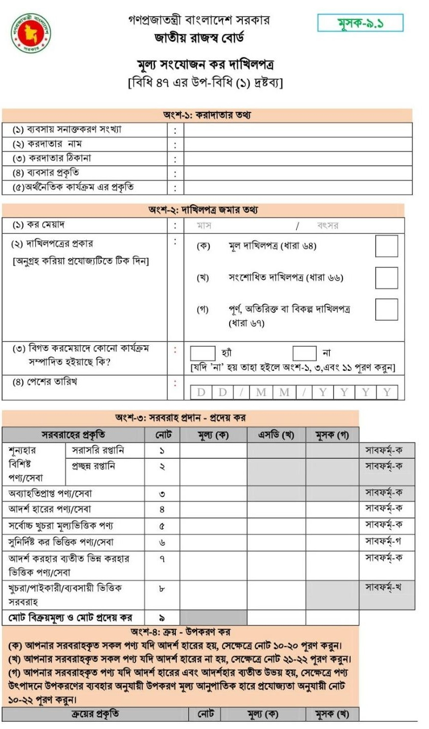39

40

  - Challan 6.3
A receipt for a purchase is referred to as a VAT invoice. To sell or offer services that are subject to VAT, a VAT invoice shall be submitted in support of each such sale. Surcharge and value-added tax. The receipt or cash memo in support of the sale of goods or services in Form 6.3 showing the quantity of goods or services, the price, and the amount of VAT is the VAT invoice, according to Section 51 of the Value Added Tax and Supplementary Duties Act 2012. The Mushak-6.3 invoice format is part of the 2016 Value Added Tax and Supplementary Duties Rules. Every registered taxable supply must have a VAT invoice issued by the provider on or before the date that VAT is due.


41

The 2019 Financial Act or the New VAT Act both stipulate that Challan 6.3 must be created in two copies. Unique Hotel & Resorts Ltd. receives two copies from its suppliers: one is given to the customer (Unique Hotel & Resorts Ltd.), and the other must be kept by the vendors for a minimum of five years.

Challan – 6.10
For submission to the VAT Office of information relating to purchases and sales through invoices from local markets of any registered and listed establishment, please use the prescribed form as per Rule 42(1) of the Value Added Tax and Supplementary Duties Rules, 2016. Any business in the local market that was VAT registered or listed throughout the tax period through Mushak 6.3, all Mushak valued at more than Tk 2,00,000, must submit to the VAT department. It can be provided between the first and fifteenth days of a certain month, together with the application form, but not later. The purchase and selling information must be provided individually in Section 6.10 after being filled out in the sub-form of the submission form.
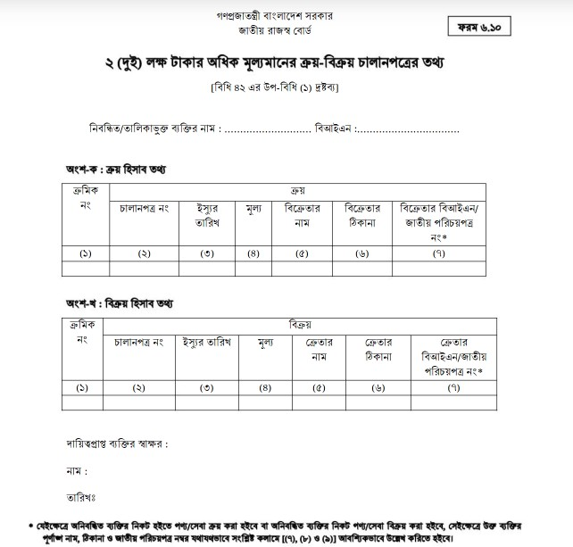

42
- Withholding Tax Returns
To oversee and regulate the effectiveness of the TDS system, Bangladesh has made the filing of Withholding Tax Returns (WTR) mandatory. According to the terms of the Income Tax Ordinance of 1984, it has evolved into one of the standards of tax compliance. It makes it simple to know how much tax has been collected or withheld every six months and calls for the submission of the Withholding Tax Returns twice a year.
Here are the reasons of submitting Withholding Tax Returns:
- Encouragement and/or upkeep of compliance concerns;
- If necessary, prevention of delinquencies and revenue loss.

Submission Deadline for Withholding Tax Returns:
- Withholding Tax Returns submission is required twice a year, and examples include:
- All TDS that was deducted or collected between January and June must be reflected in the first return.
- All TDS that was deducted or collected between July and December must be represented in the second return.
We are required to deposit taxes that have been deducted or collected at the time of WTR submission via challan in the Central Bank or any other bank that Bangladesh Bank has approved. However, the deadline for submitting the challan is still different.
**Withholding Tax Returns is prepared under section 75/A, Income Tax Ordinance 1984, (Ordinance No. XXXVI, 1984) **

43
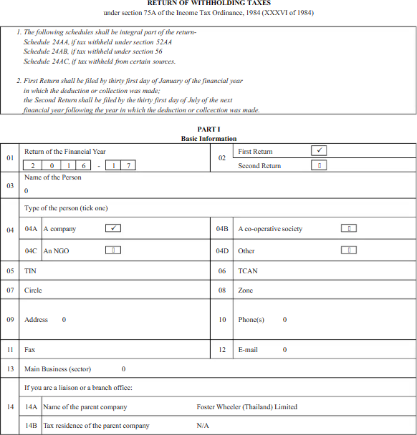

44
3.8.3 | Tax & VAT Rates for Unique Hotel & Resorts Ltd

Three hotel chains have a known parent firm, Unique Hotel & Resorts Ltd. Two of them are worldwide brands (Westin and Sheraton) that Marriot Worldwide has licensed to operate, and Hansa, A Premium Residence, is a completely owned subsidiary of Unique Hotel & Resorts Ltd. The Value Added Tax and Supplementary Duties Act of 2012 mandates that AC (air-conditioned) hotels pay 15% VAT on their gross receipts. Even non-AC hotels and restaurants are required to pay 7.5% VAT on their sales under HS Code S001.10. However, there are variations in the VAT systems used by UHRL (Unique Hotel & Resorts Ltd.). Hotels with BARs (alcohol: whiskey, beer, and other hard drinks) and lodging facilities fall under HS Code S001.10. Even under HS Code S001.20, those establishments that offer food together with BAR services like beer, tequila, whisky, etc. must pay an additional 20% in taxes to the government in order to provide these services. As a result, the Westin Dhaka and Sheraton Dhaka officials must pay an additional 20% charge for the BAR amenities.
Additionally, the primary economic activities of Unique Hotel & Resorts Ltd. are services and imports. Services include hotel chain restaurants, meals, and a la carte facilities, as well as bar amenities. once again to import alcoholic beverages from abroad, such as whiskey, beer, champagne, etc. Along with importing alcohol for restaurant facilities, people also bring in furnishings and foreign materials for food production.
I'll list some of the HS codes for goods and beverages that Unique Hotel & Resorts Ltd. hinted it would import below:

45
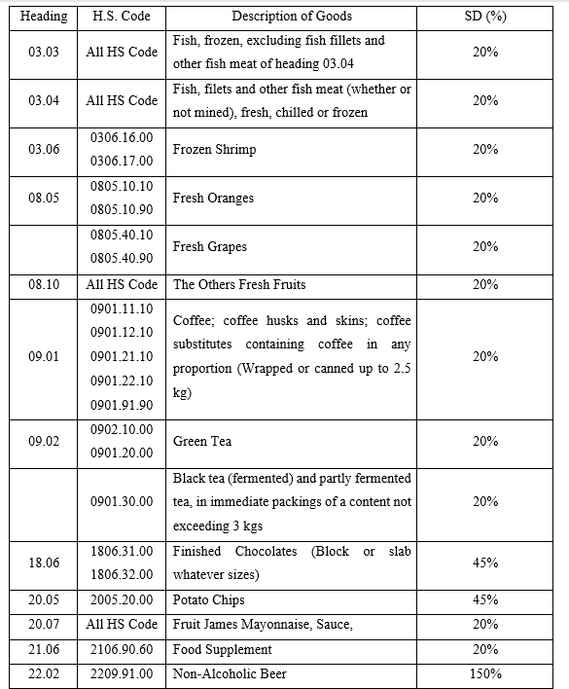

46

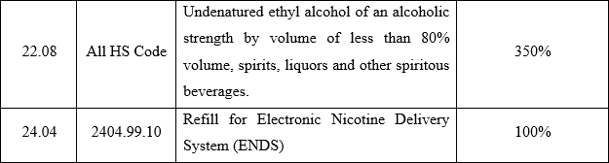

3.8.4 | Unique Hotel & Resorts Ltd Tax & VAT Payments into Government Treasuries:

Being a parent company of 3 hotel chains, Unique Hotel & Resorts Ltd pays its Vat & Taxes on the regular basis into the different government treasuries like (NBR, Tax Circles) and assists the economic growth of the country. On my 4 months internship period, I have noticed the following 4 months VAT payments at NBR (National Board of Revenues):

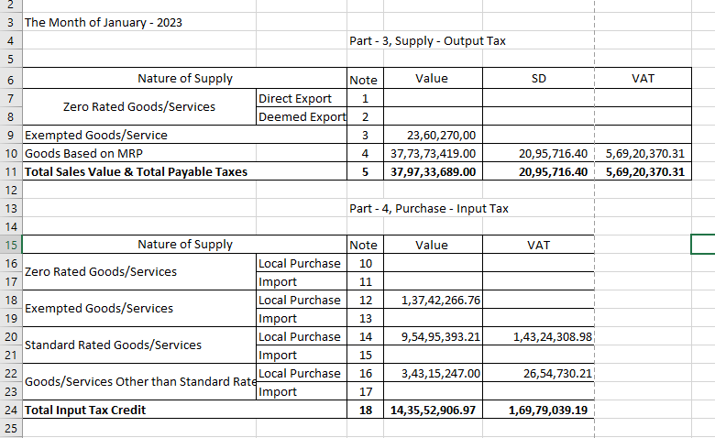
47

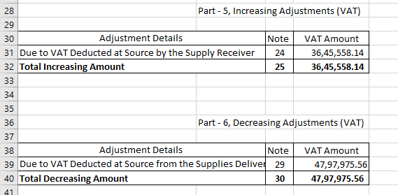

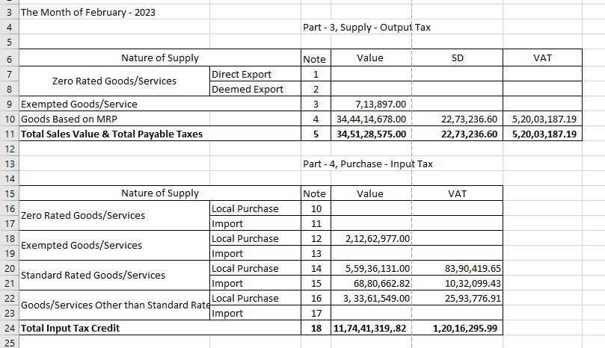
48

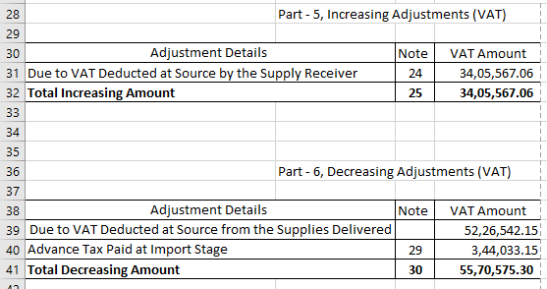

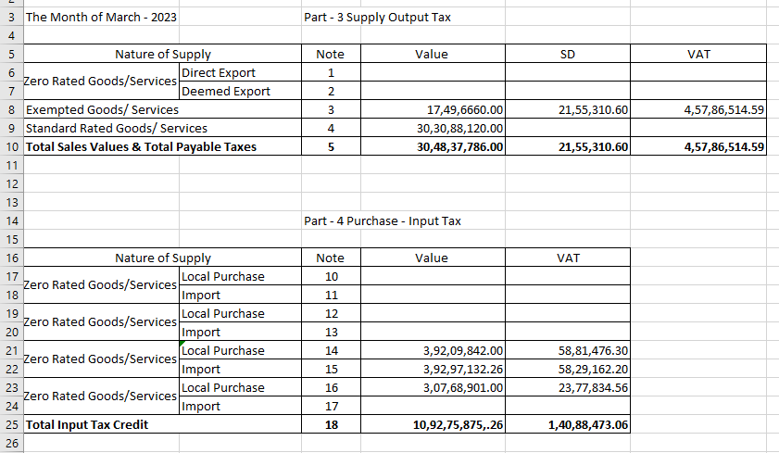
49

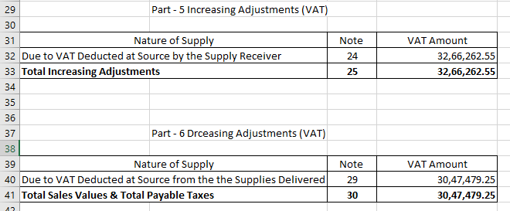

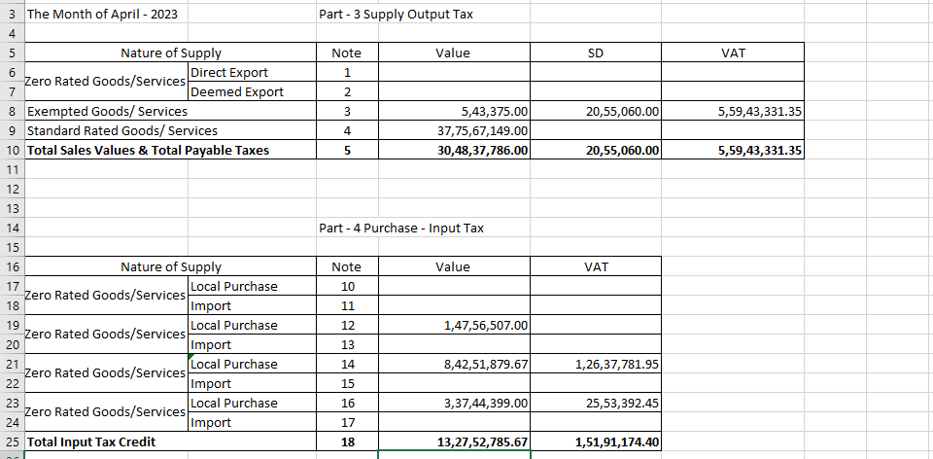
50

51

3.9 | Unique Hotel & Resorts Ltd Tax & VAT Deduction & Collection from Vendors:

The Unique Hotel & Resorts Ltd. authority receives bill documents, challans, and cash memos along with Mushak 6.3 and Mushak 6.10 in accordance with Financial Act 2022, Section 184/A. Additionally, they receive copies of corporate tax and VAT returns submitted to government treasuries like NBR and Tax Circles, as well as Proof of Submission Returns (PSR) copies from vendors and suppliers. We are asking those vendors and suppliers who fail to submit Mushak 6.3, Mushak 6.10, PSR (Proof of Submission Returns), corporate tax returns, and VAT returns to send us the missing paperwork that we requested they submit. If the vendor or supplier submits the required documentation on time, it is advantageous for both parties; otherwise, the authority of Unique Hotel & Resorts Ltd. will deduct 15% of the tax from the prices the vendor or supplier bills for the goods or services in question and will adjust Mushak 9.1, Increasing Adjustments (VAT) section.

52

3.10 | A Comparative Cost Comparison for Unique Hotel & Resorts Ltd, Westin Dhaka,  Sheraton Dhaka & Hansa, A Premium Residence:

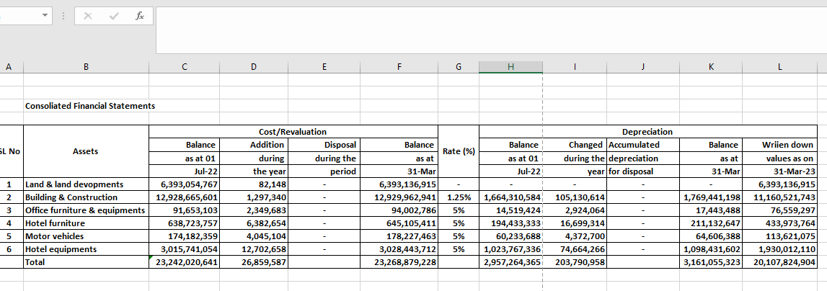

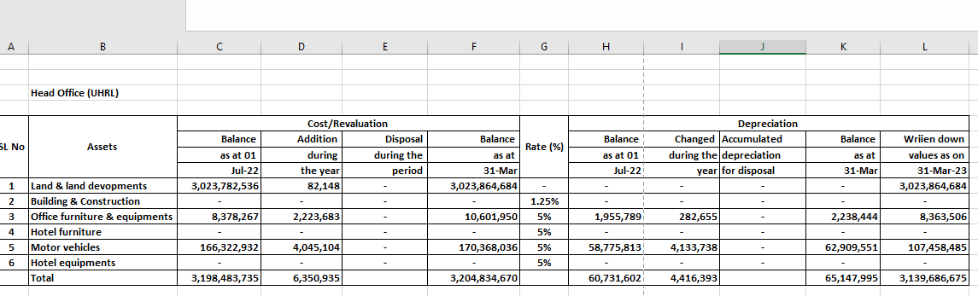
53

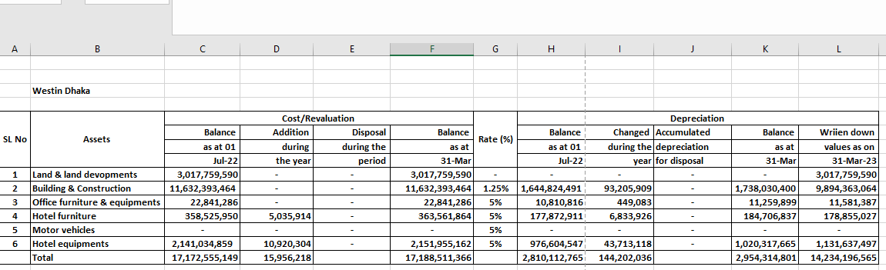

54

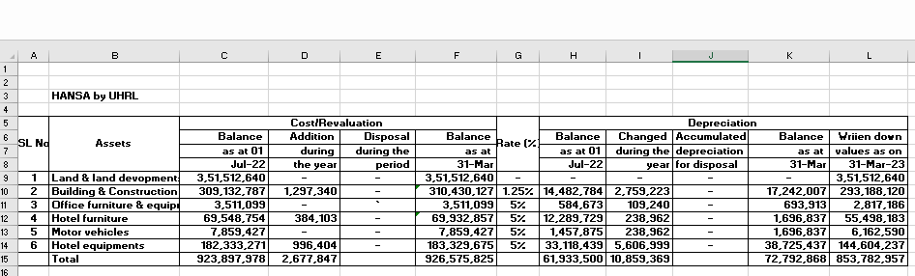

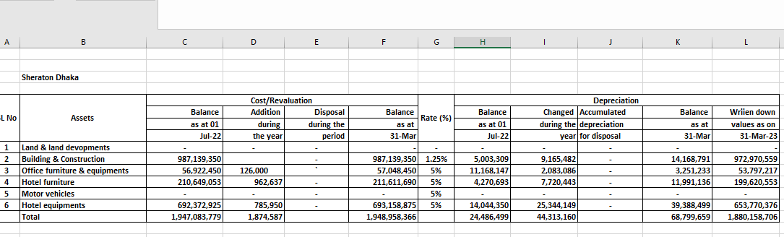

Part 4 | Objectives of The Study:

My internship at the Finance & Accounts Department of Unique Hotel & Resorts Ltd. is motivated by two different types of goals:
55

4.1 | Primary Objectives:

To complete my final and last INT 4399 (Project & Internship) course for my accounting- focused BBA (Bachelor of Business Administration).

4.2 | Secondary Objectives:

The purpose of the study is to understand the current conditions of the hotel sector in Bangladesh, particularly those of two worldwide brands (Westin and Sheraton), their financial and economic status, their contributions to the growth of the national economy, and their taxand VAT compliances. I've listed some of the learnings from Unique Hotel & Resorts Ltd. below:
  - IAS (International Accounting Standards) & IFRS (International Financial Reporting Standards) application on the financial reporting
  - Mushak 9.1, Mushak 6.3, Mushak 6.10
  - Corporate Behavior & Ethics
  - High Value & Regular Value Bank Cheques Clearing into Commercial Bank
  - Challans, VAT Returns
  - Corporate Purchases & Hotel Operation System
  - Hotel Chain Revenue & Expenses

56

Part 5 | Methodologies of The Study:
Into my internship, I have gathered information into two ways:

5.1 | Primary Source:

On this stage, I have collected information by talking to my senior colleagues and gathering information from them. My reporting boss Tasfia Tabassum Mahbub Apu (Senior Executive – Corporate Reporting), Rabeya Farzana Mery Apu (Senior Executive) in Finance & Accounts & Md. Mizanur Rahman (Senior Executive) in Finance & Accounts would help to give information about The Westin Dhaka cab service for foreign guests, Unique Meghnaghat Power Station, Master Roll account information about Unique Groups’ another project “South Park”, the Bankers of Unique Hotel of Resorts Ltd etc.

5.2 | Secondary Source:

At this stage, I helped Annual Reports of Unique Hotel & Resorts Ltd & its websites. (www.uhrl.com), different documents of Unique Hotels & Resorts Ltd, different books on Accounting as well Bangladesh’s Tax & VAT rules & regulations.

5.3 | Scope of The Report:

In this report, I will discuss Unique Hotel & Resorts Ltd.’s financial & economic conditions based on CRISL (Credit Rating Information and Service Ltd). Besides, I would discuss almost every sister concerns of Unique Group Business. Again, I have learned how to submit VAT returns at NBR (National Board of Revenue) and LTU (Large Tax Unit). Through my 4 months internship, I have learnt more about bank reconciliation statement, write a deposit slips for a cheque deposit into a commercial bank. It is very fortunate for me to learn about bank guarantee and several times I am was going to different commercial banks to claim bank guarantee for Unique Hotel & Resorts Ltd.

57

Part 6 | About My Internship Experience:

6.1 | About My Duties & Responsibilities:

On my 4 months internship duration, (from February 14, 2023 to June 13, 2023), I was assigned for the following duties & responsibilities:

- To reconcile bank statements (month wish)
- To go different commercial banks with bank cheques for withdrawing cash and cheque deposit.
- To go NBR (National Board of Revenue) & Tax Circles for different corporate issues
- To keep & preserve vouchers (Bank Payment Vouchers, Journal Vouchers, Cash ReceiptVouchers etc.) according to project & month wish file.
- To receive bills and invoices from the vendors/suppliers and register into bill entrybooks.

6.2 | Trainings:

During my internship period, I had gotten the opportunity of 2 training that were conducted byUnique Hotel & Resorts Ltd.

- Training on Accounts & Bookkeeping: This training taught me how to keep different accounting procedure, the responsibility of an accountants, IAS & IFRS rules applied & regulations etc.
- Roadshow on Cybersecurity: This also taught me the cybersecurity on e
– mail, data transfer, malware, phishing and ethical hacking etc.

58

6.3 | Personal Evaluation:

In my internship program, I have observed several important things at my offices, those are:

  - My colleagues are very friendly and cooperative
  - They are really good at keeping track of time; each person occasionally arrives at the office at 9:00 a.m.
  - During our break, we receive free refreshments.
  - We have a wonderful working environment.

6.4 | Application of Academic & Educational Knowledge:

I've explored roughly 40 topics throughout my Bachelor of Business Administration (BBA) education. Some of these have a direct bearing on my internship. On the other hand, practical knowledge is more effective than theoretical knowledge.
- Introduction to Business & International Business: By learning theorical knowledge at university life on franchise business & its functions but my practical experience at Unique Hotel & Resorts Ltd more about the franchised business because Unique Hotel & Resorts Ltd takes 2 international hotel brands (Westin, Sheraton) from Marriot Bonvey, business conglomeration.

- Financial Accounting & Advanced Financial Accounting: Debit & credit effects on transaction, bank reconciliation statement, vouchers, IAS & IFRS application, consolidated financial statements

- Taxation: Different income & corporate tax rules, income tax slabs, HS Codes for SD, AIT& VD for taxation.

59
4. Banking & Insurance: Different types of bank guarantees, high value,
regular value checkclearings, cheques deposit, A/C payee cheques etc.

Part 7 | Findings & Analysis of The Study:

To study this report, my main findings and analysis are listed below:

The Unique Hotel & Resorts Ltd. authority adheres to IAS (International Accounting Standards) and IFRS (International Financial Reporting Standards) when preparing its financial reports. Annual reports are also uploaded to the www.uhrl.com website as well as published in hard copy books each year. However, it is regrettable that several hotel chains, including Bhaiya Hotel & Resorts Ltd. and Bay Hill Hotel & Resorts Ltd., do not provide their annual reports on their websites. Finding the financial positions of other firms and the current financial circumstances of Bangladesh's hotel industry are therefore very challenging.

Bangladesh's first ever franchised international hotel operation the two international hotel brands (Westin and Sheraton) that I stated in the aforementioned description in my internship report have been franchised by Unique Hotel & Resorts Ltd. from Marriott Bonvey. Once more, Tata Group and Vivanta recently franchised another illustrious hotel chain, "Hotel Taj," under the control of Unique Hotel & Resorts Ltd. Hopefully, by 2025, Unique Hotel Resorts Ltd. will manage this Hotel Taj. Once more, Marriot Bonvey St. Regis's other worldwide hotel brands will run under Unique Hotel & Resorts Ltd.

To pay tax and VAT on a regular basis into government coffers, support the expansion of the national economy, and be upfront and transparent about other government fees, while other hotel chains in the nation remain silent about their financial situations and operational challenges.

60

Part 8 | Recommendations & Conclusions:

8.1 | Recommendations:

It is quite challenging for me to offer advice or any recommendations to such large organizations as Unique Hotel & Resorts Ltd. because every official there has more education, professional training, and work experience than I have. However, I'm going to mention a few ideas that can help Unique Hotel & Resorts Ltd. run more smoothly. They are:

- To employ solar power for the generation of electricity, or even to use wind power if this is feasible for a larger solar power output. Unique the Westin Dhaka Hotel, Sheraton Dhaka Hotel, and Borak Mehnur (Head Office) Banani, Dhaka-1213, all receive their electricity from the Meghnaghat Power Station, a natural gas-powered power plant. The United States Dollar (USD) problem, rising prices for natural gas and oil, high production costs for power, and high operating expenses for hotels are all contributing factors. Again, the collapse of the global economy and the political unrest have discouraged many foreigners from visiting the nation. As a result, hotel chains do not make as much money as they had hoped. Therefore, now is the best moment to switch to using renewable energy and get the benefits.

- Additional training and skill-building resources, like SAP, cybersecurity development, and professional bookkeeping,

- To update the ERP system (Entrepreneur Resource Planning) for routine banking, petty cash, cash and check register, and inventory management transactions.

61
8.2 | Conclusions:

In comparison to other industries, the hotel sector now plays a significant role in Bangladesh. Many people in our nation enjoy traveling and staying at hotels and restaurants outside of their home cities. As a result, there are more hotels and restaurants. Not only are there more hotels and restaurants, but there are also more job prospects available in the nation. One of the forerunners and leaders of Bangladesh's hotel sector is Unique Hotel & Resorts Ltd. We are aware that the Hotel Sheraton was operating in Bangladesh prior to the Liberation War in 1971. Due to various political unrests and operational challenges, the Hotel Sheraton authority left Bangladesh in 2000 and transferred its infrastructure to the Hotel Rupshi Bangla authorities. However, this Sheraton Hotel returned to Bangladesh under a franchise agreement with Unique Hotel & Resorts Ltd. Once again, Unique Hotel & Resorts Ltd. is one of the largest and most complex business chains in hotel operations. It is the owner of two local and two foreign hotel brand chains. Additionally, there are two additional international hotel chains being built. Following the development of these hotel chains, Unique Hotel & Resorts Ltd. recorded the biggest achievement of its business.

9 References & Important Web Links:
RF

1 | Kieso, D. E., Weygandt, J. J., & Warfield, T. D. (2019).  Intermediate Accounting, Wiley PLUS Card with Loose-leaf Set. Wiley.
2 | Stice, E. K., & Stice, J. D. (2011). Intermediate  Accounting. Cengage Learning.
3 | Edmonds, T. P. (2000). Fundamental Financial  Accounting Concepts. McGraw-Hill Companies.
4 | Rahman, A. (2022, November 8). ভ্যাট চালানপত্র (মূসক-  ৬.৩). Chartered Journal. https://charteredjournal.com/mushak-6-3/
5 | (2023). Charteredjournal.com.  https://charteredjournal.com/mushak-6-10/
6 | Skinner, S. J., & Ivancevich, J. M. (1992). Business for the  21st century. R.D. Irwin.
7 | and. (2022). Unique Hotel And Resort. Uhrlbd.com.  https://www.uhrlbd.com/uhrlfinancial11.php
8 | The Value Added Tax and Supplementary Duty Act, 2012.  (n.d.). https://nbr.gov.bd/uploads/acts/18.pdf
9 | https://ird.gov.bd/site/notices/96f1f991-b156-4f33-9285-  2e31a764e229/Value-Added-Tax-and-Supplementary-Duty- Rules-2016
10 | সহজ ভ্াষায় নতু ন ভ্যাট আইন ২০২২ – ২৩, ৯ম সংস্করণ, ড.  মমাোঃ আব্দরু রউফ। (১ম ও ২য় খন্ড)

