ERP Software Business in Bangladesh: Insights & Practices with Pinovation Tech Ltd.

Imtiaz Hossain

This report is submitted to the school of Business and Economics, United International University as a partial requirement for the degree fulfillment of Bachelor of Business Administration

ERP Software Business in Bangladesh: Insights & Practices with Pinovation Tech Ltd.

Submitted by:
Imtiaz Hossain
111162064
Major: Marketing

Supervised by:
Dr. Kawsar Ahmed
Professor
School of Business and Economics
United International University

Date of submission: November 24, 2025

Letter of transmittal

Dr. Kawsar Ahmmed
Professor
School of Business and Economics
United International University

Subject: Internship Report Submission.

Dear Sir,
With due respect, it can be informed that according to provided guiding principle, I really feel honored to submit my internship document report entitled “ERP Software Business in Bangladesh: Insights & Practices with Pinovation Tech Ltd.”
The report has been prepared with the utmost sincerity, ensuring that the content remains precise, well-structured, and enriched with relevant recommendations. I have made every effort to present my learning and observation in a meaningful way, and I earnestly hope that this report fulfills the academic requirements and meets your expectations.
I hope that this report will fulfill your expectation properly.

Best Regards,
Imtiaz Hossain
111162064
School Of Business and Economics
United International University

Declaration of the student

It is hereby declared that
- The internship report is my own work and effort when during completing degree in United International University.
- This internship report does not include any material that has used for any degree or diploma in any institution.
- I have noted & acknowledge primary sources of assistance.

Imtiaz Hossain
111162064
School of Business and Economics
United International University

Acknowledgement

It’s really matter of joy for me that working as an intern and writing my Internship report to fulfill the requirement of BBA degree. I would like to express my thankfulness to honorable faculty, Dr. Kawsar Ahmed, Professor, School of Business & Economics, United International University for provide enough facilitation that help me to complete this full internship report. I want to give thanks Mr. S.M. Raihan Mahbub (Shovon), Director of Pinovation Tech Ltd. for unconditional support in the workplace of Pinovation Tech Ltd. I also want to express my gratitude to my family, company associate, my supportive colleagues and all the well- wishers for giving me enough confidence and help me in every stage of life.

Finally, I really express to give thanks my all honorable faculties in my BBA program at United International University for guiding me enough strong for the corporate life.

Executive Summary

An Enterprise Resource Planning (ERP) system is integrated software that helps a business manage and streamline its core processes, such as production, inventory, procurement, sales, finance and accounts, and human resources, within a unified platform.
ERP systems improve business efficiency by centralizing data, reducing manual work, and enabling faster, more accurate decision-making. ERP systems help different departments collaborate smoothly by sharing real-time information.
The purpose of the study is to explore how ERP systems enhance organizational efficiency by integrating processes, improving data accuracy, and supporting better decision-making.
After 2005, Bangladesh’s software industry has risen rapidly. Pinovation Tech provides user-friendly integrated business automation service. The main objective of the company is to provide suitable, affordable, reasonable, and user-friendly service to clients. Pinovation Tech is the market leader in real estate & construction business ERP software service providers in Bangladesh. Pinovation Tech has been providing ERP software service in different industries such as real estate, construction, manufacturing, trading, and government service since 2010. Pinovation Tech Ltd. (also known as PinTechERP) is a Bangladesh‑based ERP software company whose main focus is developing ERP (Enterprise Resource Planning) systems with customization & tailored service.
During my internship period, I found that the company’s main objective is to provide the best services to clients for ensuring proper client satisfaction. Pinovation Tech always focuses on ensuring and improving services to give the best output to clients.
Pinovation Tech helps businesses become more efficient by digitizing & automating business processes. Pinovation Tech is ensuring operations are integrated (various departments under a single system) so that there is less manual duplication and more real‑time insight. Providing good customer support, fast implementation, and cost‑effective solutions to its clients without facing any difficulties in Bangladesh since 2010.
Keywords: ERP Software, Insights & practices, Business Performance, Pinovation Tech Ltd, Bangladesh

Table of Contents
Letter of transmittal 3
Declaration of the student 4
Acknowledgement 5
Executive Summary 6
CHAPTER I 9
INTRODUCTION 9
Background of the Report 10
Report Objectives 10
Scope and limitations of the Report 11
CHAPTER II 12
COMPANY AND INDUSTRY PREVIEW 12
COMPANY PREVIEW 13
INDUSTRY PREVIEW 21
CHAPTER IV 28
INTERNSHIP EXPERIECNE 28
Position, duties, and responsibilities 29
Contribution to all departmental functions Total Departments of Pinovation Tech: 30
CHAPTER V 35
RECOMMENDATIONS AND CONCLUTIONS 35
Recommendations for Improvement 36
Conclusion 36
Reference: 37

CHAPTER I

INTRODUCTION

Background of the Report

This report is based on the responsibilities I carried out during my three-month internship. The internship program served as an essential component of the BBA program, designed to help student, bridge the gap between academic learning knowledge and professional work culture. Its primary objective is to prepare graduates for the challenges of job life. I feel fortunate to have had the great opportunity to work with top rated ERP software company Pinovation Tech as a Business Development Intern, which provided me with valuable exposure and experience.

Report Objectives

The main objective of the internship report is to complete and fulfill the demand of intern program of BBA.
- To gain practical experience related to the BBA coursework.
- To understand the organization’s daily operations and workflow.
- To develop professional skills such as teamwork and communication.
- To identify insights and lessons that will help in future career development.
- To examine the organization’s operational activities and management process.

Scope and limitations of the Report

Scopes of the report are given below:
    - This report covers the vision, mission, company background and core business activities of Pinovation Tech.
    - This report also focuses on the range of products and services offered by Pinovation Tech, their features, and their role in the technology sector.
    - The report marks the company’s internal structure, corporate practices, management practices, and operational support strategies that contribute to its performance.
    - This report explores the company’s technological changes & innovations, R&D efforts, and contributions to the IT industry.

Limitations of the report given below:
    - Three months of internship was limited due to time limitation.
    - As the technology sector changes rapidly, some data and insights may become out of date over time.
    - Pinovation Tech maintains deep privacy to disclose company’s confidential private data.

CHAPTER II

COMPANY AND INDUSTRY PREVIEW

COMPANY PREVIEW

Vision: Seek competitive advantage for our clients through the creative use of contemporary technologies.
Mission: To become a dependable growth partner for our clients, business associates, and employees by providing time tested, secure, and cost effective ERP solutions that stand the test of time.
Pinovation Tech Ltd. is a top rated custom made ERP software private limited company in Bangladesh, dedicated to developing advanced level ERP solutions. In 2010 the ERP software company journey began when our Chairman founded the company with just two team members. From the very simple start, we have grown steadily and today stand among the few pioneering firms in the field of Enterprise Resource Planning (ERP) software.
At present, more than 80 of Pinovation Tech ERP systems are successfully operating across respected organizations, a testament to our commitment to quality and client satisfaction. We see ourselves not just as a service provider, but as client’s technology partner supporting every aspect of their operations so their business can thrive.

Our strength lies in understanding client’s unique needs and tailoring solutions that perfectly fit client’s workflows. Since inception, our mission has been to create integrated business systems that seamlessly connect every department and activity within one unified platform.
A team 60 dedicated people are currently working permanently in the company. Pinovation Tech has already delivered 120+ ERP’s software in reputed group of companies to medium and small company. Pinovation Tech has currently 15,000+ no of regular active users in provided service industries.

- Pinovation Tech Limited was founded in 2010
- First ERP launched in 2011
- Expanded team to 30+ employees in 2015
- Launched cloud ERP in 2020
- Now serving 15000+ active users
- Total ERP delivered 80+
- Company operates through several core departments including Software Development, Business Development, Operations, HR & Admin, and Finance.
- Member of BASIS & ISO(9001:2015) certified company
- Total services of Pinovation Tech are ERP service, Domain & Web Hosting, Software Hosting, E-mail & Antivirus Solution, Software Training service, ERP Consultancy, SMS Service, Web & E-commerce.
- Industry covered: Real Estate, Construction, Leather & Footwear, Food & Beverage, Agro Business, Pharmaceuticals, Plastic & Recycling, Manufacturing, Steel & Aluminum, Power & Energy, Automotive & Motorcycle, Tiles & Ceramics, Trading, Service.
Client Lists of Pinovation Tech: Rupayan Group, bti, Edison Footwear, Edison Real Estate, Edison Properties, Edison Technologies, EBS, Manama Development, Credence Housing, Assure Group, Suvastu Space Development, Paragon Group, Tropical Homes, F.B Footwear, Runner Group, MG Group, CPDL, Finlay Group, Unicorn Healthcare, and etc.

Office Location: 8th Floor, 14/A Farmgate, Dhaka-1215, Bangladesh.
Contact: +8801309026(597-603)
Mail Address: info@pintechltd.com, sales@pintechltd.com
Website: www.pinovationtechltd.com
Product Website: www.pintechltd.com

Home & Abroad Practices in Software Service Industry:

The software industry in Bangladesh has shown significant growth, mainly driven by outsourcing, freelancing, and providing customized IT services for local and foreign markets. Compared to this, software industries in developed countries emphasize large-scale product innovation, advanced research, and emerging technologies such as artificial intelligence and cloud solutions. In Bangladesh market currently focuses on cost-effective service and timely delivery the project, rather international market practices focus on creating and building globally competitive products. Two different markets indicates that the scope for local market is to enhance research and innovation in order to compete on a larger scale domestically and globally.

Country | Company
Germany | - SAP  - Software AG  - Proalpha
America | - Microsoft  - Oracle  - Salesforce
China | - Yonyou  - Kingdee  - Digiwin  - MetaERP
India | - In4Velocity  - Tally ERP  - Ramco Systems  - Fluentgrid  - Edunext Technologies
Srilanka | - Finakle ERP  - ERP Lanka

England | - Sage Group Plc  - CGram Software
Russia | - 1C Company

ERP Software Providing Companies in Bangladesh:
- Pinovation Tech
- Brain Station 23
- Pridesys IT
- Divide IT
- Logic Software
- ERP.com.bd
- Jibika Plexus
- Mir Infotech
- Amar Solution
- ERP Next Bangladesh
- Akij IBOS
- Smart Software
- Tirzok Private Ltd.
- Biznify
- Kolpolok Limited
- Databiz
- Advanced Software & IT Services
- Nextzen Limited
- Zaman IT

Classification of Product / Service Mix

Serial No | Product Title | Product Logo
1 | PintechERP (Flagship Product) | 
2 | PinBuild+  (Real-Estate, Construction, Land, Interior Business ERP Solutions) | 
3 | PinCraft  (Manufacturing Business ERP Solutions) | 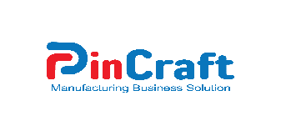
4 | PinSole  (Footwear Industry ERP Solutions) | 
5 | PinProfit+  (Trading & Service Business ERP Solutions) | 
6 | PinCRM  (Customer Relationship Management related ERP Solutions) | 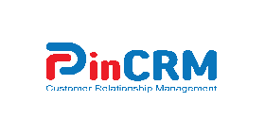
7 | PinPMS  (Human Resource Management Solutions) | 
8 | PinBook Cloud  (Accounting solutions for small business) | 
9 | PinPOS  (Point of Sale Management System) | 

Discussion on SWOT Analysis

The most important vital part of shaping an organization’s marketing strategy is to conduct a SWOT analysis. SWOT analysis enables a company to identify clearly its internal strengths and weaknesses and also recognizing the external opportunities and threats this could occur in a marketplace. It also helps in a business ensures better decision-making and sustainable growth in a time period.
Pinovation Tech conducting SWOT analysis and provides valuable insights into the company’s position in the IT and ERP development sector. By conducting SWOT analysis Pinovation Tech marks where the company excels, areas that need improvement, the potential scope for expansion, and external challenges that must be addressed to remain competitive in market.
Strength Point of View:

Pinovation Tech’s strengths are:
- Best Sales Service: Pinovation Tech tries to give their best effort after sales until the total project deliver within time frame. Software development service & operational support service plays major role there.
- Local Market Position: Pinovation Tech is provided ERP solutions since 2011. Till now they are delivered 100+ ERPs solutions in different group of companies. Currently in Bangladesh market the company’s position is so strong.
- Modular System: Pinovation Tech is Offered different modules (production, BOQ, finance, inventory, HR/payroll, sales, POS, Accounts & Finance, Credit Realization, CRM, Customer Care), enabling single system adoption across multiple business functions.
- Cloud Facilitation: Pinovation Tech offers flexibility for clients that prefer cloud facility enable system as well as those that need on-premises (Local Server System) deployments for different company policies such as compliance or connectivity reasons.
- Brand Value: Pinovation Tech capture position in the mind of client by ensuring superior client support and also meet clients expectation properly. It’s make for the company huge brand name in the field of ERP sector.
- Loyal Customer Network: Pinovation Tech gets benefits from its customer base. This network plays a key role in generating positive referrals, as satisfied clients often recommend their services to others such as new prospects. When a new prospect make call them its clients, clients provide positive feedback about software system. As a result, a significant portion of new potential prospects come from positive word of mouth and recommendations from existing ones.
- Client Repetition: Existing clients of Pinovation Tech give new opportunities for their other concerns and share positive word of mouth to new potential clients.
- Industry Familiarity: Demonstrated use cases in manufacturing, trading and retail make it easier to offer industry-specific templates and faster rollouts.

Weakness Point of View:
- User experience consistency: The interface and mobile experience are not uniformly modern or intuitive, which can slow user adoption, especially among non-technical staff.
- Insufficient Investment: Pinovation Tech mainly generates revenue from direct sales, additional customization charge and monthly support service charge. They are not willing to invest money from borrowing bank and financial institution, that’s why facing problem for investment.
- Need Investment in Technology: Organization should focus more in technology to give better service. They need to invest more capital in technology, suppose they are using now #C language, they need to update the system to core.
- Low Number of Human Resource: Pinovation Tech needs human resource to deliver a project in significant time frame. Sufficient level of stuffs can help to maintain workflow effectively.
- Less Focus on Social Media: Pinovation Tech do not use X, Tweeter, Telegram, IMO, Tiktok, Viber for their marketing campaign properly. Currently prospects more focus on social platform. So, Company can target them.
- Limited Public Evidence of Large-enterprise or International Reach: At Pinovation Tech most visible material focuses on domestic clients and SMEs; there’s little public proof of large multinational deployments or regional offices, which may limit trust for big buyers in terms of system and support service.
Opportunity Point of View:

- Market Expansion: ERP software business in Bangladesh gradually day by day. Employees are now not interested to do office tasks manually by following traditional method, rather they are interested to do the task digitally by shortest possible time with hassle free. That’s why market size expanding continuously.
- Rising Digitalization of SMEs in Bangladesh and the Region. Growing interest in cloud ERP, accounting automation, payroll and CRM for SMEs is a natural addressable market for Pinovation Tech’s offering.
- Verticalization and Packaged Solutions. Packaging industry-specific modules (e.g., construction project controls, real-estate sales + inventory workflows) can speed sales cycles and increase margins.
- Export to Nearby Markets / Partnerships. Regional expansion (starting with Bangladesh’s neighbors or expatriate-led firms) via partner channels or cloud SAAS (Software as service) positioning can scale revenue without large local investments.

Threats Point of View:
- Increasing Competition: Continously new competitors are entering the market. New competitors are entering the market by offering the new business model to its clients. Suppose some of them offering subscription method, licensing method, SAAS method, etc.
- Client Bargain Power: Most of the time low level of service provided company is try to convince the prospect by offering most affordable price. This is the most significant scenario for a well-known service provider company like Pinovation Tech.
- Competition of Global Products: International popular brands such as SAP, Oracle, TallyPrime are increasing competition in market. These products create pricing and feature pressure in local market all the time.
- Rapid Technology Change: In ERP software industry movement of technological change is common factor. For rapid technological change, each company have to maintain R & D on software features and platforms. AI integration system is now so popular in local and global market.

- Security and Trust Risk: Most of the time potential clients are afraid of their data security to implement new ERP system for their company. For data security issue low level of trust involve in prospects mind that’s create pressure to generate new sale.
- Price Sensitiveness: Price sensitiveness is a critical part among buyer and seller in ERP sector. Local customers always want type of global features enrich product in low price. This point actually hits the service level and support activities.

INDUSTRY PREVIEW

Over the last decade the ERP software industry in Bangladesh has grown rapidly, driven by the digital transformation of country’s efforts, government initiative of digitalization, increasing adaptation of technology, company digitalization and the need for efficient business automation operations. Companies are now move away from manual paperwork toward automated systems, demands for ERP solutions has continuously increased among sectors such as government projects, footwear sector, manufacturing, trading, service, construction, multi-dimension business, textile & garments, education and also other sectors.

Local industry is marked by rising competition as both local & international software firms enter the market. Local custom made ERP software companies such as Pinovation Tech, Pridesys IT, IBOS, Brain Station 23, Smart Technologies and Logic Software primarily focus on offering the most affordable & customizable tailor solutions suited to Bangladeshi regulations, tax systems, and business practices. On the other hand, global ERP super giants like SAP, Oracle, and Microsoft target larger enterprisers with standardized higher priced solutions.

Cloud computing system, mobile based ERP, AI driven features, and automation are reshaping the industry, by the main impact of technological advancement. Corporate companies now search for real time good looking dashboards, integrated module system with smart workflow system, 100% accurate reporting, and user friendly interfaces to support decision making and overall business issues.
Currently industry faces challenges in price sensitivity among small and medium enterprise business, shortage of skilled IT professionals, technological change, data security trust.
Overall expansion of business in local market, growing E-commerce platforms, government digitalization project and automation initiatives, and SME business automation creates strong opportunities for ERP provider companies. So finally it can be said that the ERP software industry in Bangladesh remains one of the fastest growing segments of the IT sector.

Specification of the industry

The ERP software industry mainly focus on integrated different business functions such as production, inventory management, supply chain management, accounts & finance, HR into a single smart digital system. Within this sector, Pinovation Tech established themselves as market pioneer in Bangladesh for custom made ERP solutions. The company, established in the year 2010, has delivered 100+ ERP projects and serves 15000+ of active users.
Pinovation Tech is offered web-based ERP with cloud-enabled system, ensuring real-time data access, modules with customization, and scalability. Standard features like as smart dashboards, advanced reporting system, make their ERP solutions user-friendly and adaptable to different organizational needs with customization facility.
Comparison with global ERP brands, Pinovation Tech emphasizes affordability and a understanding of local business practices. Like global leaders in areas such as advanced AI integration or large-scale deployment it not compete properly, it offers the lowest value by tailoring solutions for local market.
Combination of features and flexibility of service, lowest price than international brands, and industry-focused design has allowed Pinovation Tech to establish a strong presence in the ERP software industry in Bangladesh.
Pinovation Tech mainly are offered custom tailor made ERP software in Bangladesh based on multiple industries. Building a software system is not task task for a resourceful company, a lot of things to consider here. A main part of this sector is heavy financial investment and time. Because no one can clearly identify that how much investment should be require and when the project will be completed. That’s why Pinovation Tech takes necessary step for those companies who are willing to adopt business automation at affordable price with shortest possible time to implement the system.

Technological factors point of view

Pinovation Tech is always try to make software operational services more professional in terms of client satisfaction. Prospects can easily find all the information from company website (www.pinovationtechltd.com) & also specific product based website (www.pintecherp.com). They can find all information about industry wise ERP software modules and related information of the question, suppose question in mind that why they need ERP software, how to get Pinovation Tech’s service, payment terms of service, pricing policies, knowledge about product portfolio, project implementation processes and industry covered areas etc.
In terms of promotional campaign Pinovation Tech use social platform, like Facebook, LinkedIn, WhatsApp, and Mail campaign to attract their potential prospects. Social media marketing professional of Pinovation Tech is give post about their products and features.
Pinovation Tech maintains a YouTube channel for demonstrating video contents. YouTube channel mainly use for their promotional video about software features and relevant activities.Pinovation Tech use Meta Ads for Facebook post and Google Ads for others platforms. Pinovation Tech has a team of SEO specialists. They are mainly take care for SEO (Search Engine Optimization) on website, Google ranking, Facebook, Instagram, LinkedIn and other pages ranking.

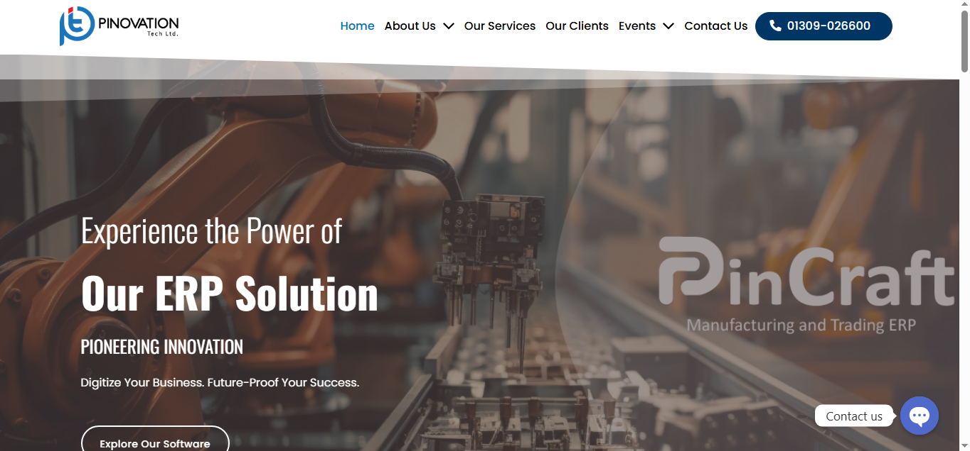

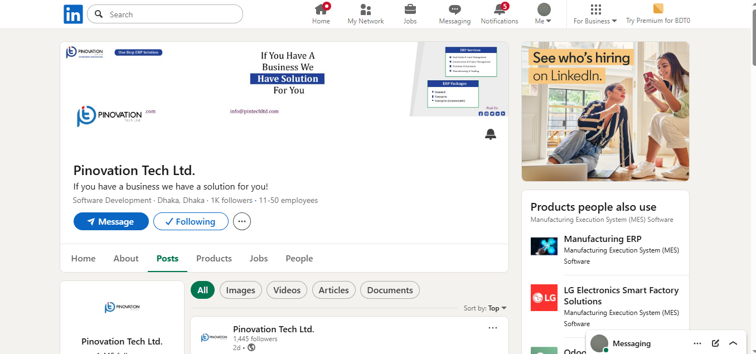

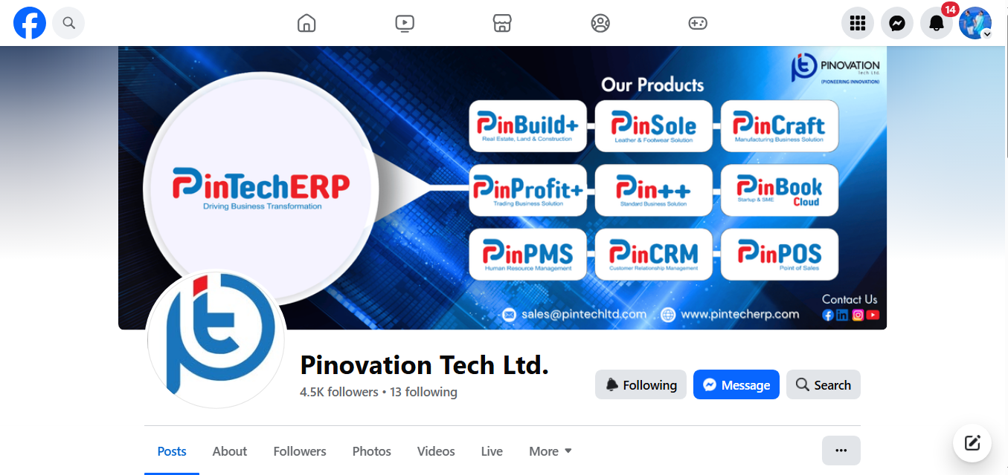

Barriers to entry

Competition in ERP software market is increasing day by day, there are so many new companies are entering the market constantly to grab the market opportunities. Pinovation Tech have to keep their position as market leader in ERP software industry specifically based on real estate & construction sector of Bangladesh. It’s really difficult for a company to retain the position in existing competitive market. In terms of capturing market leader position, Pinovation Tech has to take new initiatives such as technological innovation, custom made tailor service based on requirements, R & D on requirements, and etc.

Buyer Power
New Entrants: The ERP software market is witnessing the arrival of new competitors. Therefore, Pinovation Tech must introduce more attractive offers and flexible packages to draw in potential clients; otherwise, it risks losing its current market-leading place.

Threat of Substitutes
- Cloud-Based Alternatives: Many businesses are shifting toward affordable cloud-based ERP solutions such as Zoho, Odoo, or QuickBooks, which can serve as substitutes for Pinovation Tech’s traditional ERP systems.
- Customized In-House Software: Some medium and large organizations prefer to develop their own in-house ERP or management systems, reducing dependence on third-party providers like Pinovation Tech.

- Consultancy and Outsourcing Services: Some companies now outsource their financial or operational management to specialized service providers, minimizing the need for ERP-based internal management.
- Rapid Technological Changes: Continous technological innovations and changes may lead to new digital tools or platforms that may provide as effective alternatives of ERP systems, threatening Pinovation Tech’s long-term product relevance.
- Emerging Alternative Technologies: Rapid technological innovation may give lead to new products or services in existing market that perform similar functions more efficiently or at a lower cost, reducing demand for Pinovation Tech Ltd.’s offerings.
- Open-Source Solutions: Free or low-cost open-source ERP platforms are becoming more popular, offering flexibility and customization options that can attract cost-conscious clients.

CHAPTER III

INTERNSHIP EXPERIECNE

Position, duties, and responsibilities

At Pinovation Tech, I worked as an Intern in Business Development department. Pinovation Tech has two offices in separate locations, Head Office & Corporate Office. I worked in corporate office. It can be truly said that working environment was very good, and employee friendly. All employees were very helpful and supporting stuffs were very polite.

Duties and Responsibilities:
- Conducting field visit for promotional activities.
- Meeting or exceeding sales goals.
- Fixing meeting with prospective clients.
- Communicate with prospects for demonstration meeting.
- Maintaining social media platforms to give posts and feedback of comments and queries.
- Conducting mail campaign for promotional activities.
- Assist in schedule to demonstration meeting.
- Cooperation with operational team in internal meeting issue.
- After demonstration meeting making quotation and submission to prospects.
- Communicate and follow up with prospects, understanding their needs & serving them properly.

Training

Training session from Pinovation Tech:
- Microsoft Office Course: This course enhanced my skills, gain knowledge in using Microsoft Office application properly. This course helped me adequately perform all essential documents formatting and run functions efficiently.
- Training on Communication Skills: I do believe this training program improved my communication skills, which was useful during my internship period when I needed to communicate with clients regularly. This course helped me a lot to build confidence and establish better connections with them.
- Training on Buying Behavior: Buying behavior training helped me to understand client’s psychological issues and sales process.
- Training on “Prospects Approach”: Training on “Prospects Approach” especially important for me, because I knew about different level of prospects approach, it’s all about purchase decision of target potential clients. Its helps me to generate sales qualified lead.
- Training on “Software Related Queries & Answer”. It helps me a lot to gain knowledge about software features and functions.
- Training on “PinTechERP”: Basically PinTechERP is a main flagship project of the company. Training on PinTechERP helps me a lot to gain knowledge on total product portfolio and features.

Contribution to all departmental functions Total Departments of Pinovation Tech:
- Programmer Department: Programmer department mainly focuses on queries writing, testing, and implement code. Team members and associates work on developing system logic, fixing bugs, and ensuring the system that each program runs smoothly. They collaborate with other technical persons to integrate different modules and ensure product stability within integrated system. .
- Developer Department: The Developer Department of Pinovation Tech transforms all requirements into functional software solutions. Developers designs and builds applications, websites, and ERP systems using modern programming language and frameworks. Developers are also responsible for add new features and modules, and updating existing version to new version to keep up with technological trends.
- Operational Department: Main task of operational department is to oversee the client’s daily activities to ensure smooth operation and workflow. It coordinates between departments, manages resources, monitors project timelines, and ensures that client projects are completed on time schedule. Operation team plays a major role in maintaining overall organizational efficiency.
- Business Development Department: The main role of business development department focuses on expanding the company’s market reach and client base, identification of new business opportunities, builds partnerships with clients, and maintains relationships with existing clients. Business development team also conducts market research and establishes strategies to increase new sales.
- Accounts & Finance Department: Accounts and Finance department manages overall financial activities, such as budgeting, billing, accounting, payroll, and expense and credit tracking. Accounts team ensures financial planning, cash flow handle, and compliance with tax and audit requirements properly. They provide regular financial reports to support strategic decision-making.
- HR & Admin Department: Employee recruitment, training, and performance management are handled by HR team. Admin team manages administrative tasks such as attendance, office operations, and employee welfare management. Combination of both departments ensures a good work environment and helps to maintain company policies and organizational discipline properly.

I worked with Pinovation Tech under Business Development department as an Intern Executive. Here I helped them to conducting and performing on field visit to get sales qualified lead (SQL), manage Facebook page, Instagram page, and LinkedIn profile, YouTube channel for promotional campaign and relevant activities.

Applied of Skills

- Interpersonal skills
- Team work
- Networking
- Adaptability
- Communication Skills
- Time Management
- Creative Thinking
- Content Making
- Problem Solving
- Convincing
- Business Analysis
- Negotiation
- Influencing
- Inspiring

New skills developed

- Social Media Management: During my internship period I managed the Pinovation Tech’s social media platforms like Facebook, Instagram, and YouTube channels and LinkedIn. I know how generate idea and create engaging content, maintain consistency on platforms, and analysis on audience engagement. Now I can manage and grow a company’s social media presence with professionalism.
- Time management: Working under pressure and strict deadlines helped me to identify giving wok priority from highest to lowest important tasks. Communicating with potential clients have to maintain work priority on need basis.
- Branding: I learned how to use effective branding techniques and ideas to build product identity and awareness in a professional way..
- Business Planning: Presence of involvement in marketing strategy sessions, I learned and developed an understanding of how to plan and execute business goals effectively.
- Demand Forecasting: I gained knowledge on forecasting of clients demand and queries.
- Documentation: Prepared potential clients requirements and related documents and maintaining proper records improved my attention to detail and professionalism in written document.
- Sales & Marketing: Directly involved in sales activities such as demonstration meeting, quotation submission, negotiation, and deal closing and also promotional campaign, which help me to understand customer needs.
- Branding: To build product identity and awareness, need to know about effective branding techniques properly.
- Positioning: I learned how to strategically position product in the market to highlight unique features strategically and gain competitive advantage than other brands.
- Business Analysis: I learned business analytical skills by evaluating competitors, market trends, studying different products, and identifying potential business opportunities for growth and improvement in ERP & tech sector.
- Work Under Pressure: Managing different projects (Real Estate, Land, Manufacturing, Trading) simultaneously helped me to become more result oriented and focused. I learned well to maintain quality and efficiency of project task at the same time.
- Product Line Development: Worked with operational team gained practical knowledge on tech products, and developing marketing strategies to expand product lines, and also help to meet evolving customer needs.
- Complex Problem Solving: For solving complex problem, firstly need to identify the root cause, and then come up with proper creative result oriented solutions. At Pinovation Tech I strength my abilities to solve complex problem in a proper way.

Application of academic knowledge

- Team Work: Learned to collaborate effectively with colleagues and maintain a comfortable working environment that supports productivity.
- Time Management: Applied time management skills to complete assigned tasks and projects on time.
- Learning New Skills: Stayed eager to gain new knowledge and adapt to modern tools and techniques used in the company.
- Goal Setting: Set clear, achievable goals and implemented them efficiently to meet organizational objectives.

CHAPTER IV

RECOMMENDATIONS AND CONCLUTIONS

Recommendations for Improvement

Recommendations for Pinovation Tech:
  - Pinovation Tech needs heavy investment in IT infrastructural change. That’s the reason company need to find additional investment to compete with tech pioneer companies (Divine IT, Pridesys IT, Logic Software) who spend huge money for technological upgradation.
  - Existing price of PinTechERP products are huge than competitors specially (PinBuild+, PinSole, and PinCraft). Most of the time prospects cannot bear their premium price. So I think company can offer customize special price for small & medium range companies.
  - At this current moment Pinovation Tech need to consider for promotional activites. Proper marketing and promotional campaign helps to generate lead adequately in time frame. We know that the aim of marketing is to make sales super flows.
  - Pinovation Tech needs more supportive operational persons for smooth operations.

Conclusion

The ERP software business in Bangladesh is becoming increasingly competitive as more local and international companies enter the market. Despite this competition, it remains a highly promising and expanding industry due to the growing digital transformation of businesses across the country. Pinovation Tech can strengthen its position by investing more in research and development to create user-friendly and customizable ERP solutions that meet local business needs. Pinovation Tech needs to focus on promotional programs, collaborate with tech influencers, upgradation of technologies, to enrollment of courses to employees for enrichment of knowledge. By following mentioned strategies, Pinovation Tech can enhance brand reputation and capture market leader position of the ERP software market in Bangladesh in future.

Reference:

Ahmed, S., & Karim, R. (2023). ERP adoption trends among SMEs in Bangladesh. Journal of Business Systems, 12(2), 45–59. https://doi.org/10.1234/jbs.2023.012
Pintech ERP. (n.d.). PintechERP. https://pintecherp.com/
Pintech Ltd. (n.d.). Pintechltd. https://pintechltd.com/
Pintech Ltd. (n.d.). Facebook page. https://www.facebook.com/share/1A99hake8X/

