
Competitive Study of DeshiFarmer


Submitted to: Prof. Dr. Khandoker Mahmudur Rahman
Designation: Professor
BBA Department
Submitted by: Md. Ifaz Amin
ID: 111-161-154

Submission Date: 30th November 2022
Company: Deshifarmer

Letter of Transmittal
30th November 2022

Prof. Dr. Khandoker Mahmudur Rahman
School of Business and Economics
United International University

Subject: Internship Report Submission

Dear Sir,
With due respect, it is my utmost pleasure to be your student and have this opportunity to present this report on “Competitive Study of Deshifarmer” as final part of my BBA curriculum. I have come by what I believe to be thorough information and data available. This internship experience will endure as a valuable asset and experience in my life. I've worked very hard preparing this report and with sincerity tried to make the paper a ample one. I have tried to provide a clear concept of my entire experience and learning as an intern.
“Deshifarmer” is a tech based supply chain for fresh produce & aim to work for the development of farmers' lives & SME businesses. Their vision is to empower each and every farmers' lives in Bangladesh by improving price stability, easy trading, productivity and reducing garbage. These things will happen through a traceable and trackable user friendly tech-enabled supply chain by Deshifarmer.
I would like to express my gratefulness to you for your supervision, constant support & recommendations while preparing the report. It would be a blissful for me if you find my report instructional and useful. I've given my finest to gather the information. Thank you for all your guidance, which has helped me meaningfully in preparing this report.
Sincerely yours
Md. Ifaz Amin
ID No. 111-161-154

Acknowledgement
In the beginning, I would like to express my gratitude to Almighty Allah for whose kindness and blessings I was able to complete my three months long internship at Deshifarmer. It would never be possible for me to complete both my internship period and this internship report successfully. I would like to express my sincere regards and heartiest thanks to my supervisor, Prof. Dr. Khandoker Mahmudur Rahman, School of Business & Economics, United International University for Sir’s constant supervision, keen support, enthusiastic encouragement, and relentless help during the preparation of the report. I firmly believe that without Sir's valuable guidance preparing this report would not have been possible. Sir has given me his valuable opinion on the topics enriched my knowledge to carry out the whole report and be able to portray the information in a logical sequence. Whenever, there was a query, or I needed clarification he has given light to it instantly.
Furthermore, I would like to express my gratefulness and respect towards my superior Ms. Sumaiyah Mousinin for her continuous support, guidance and inspiration throughout my tenure as an intern. She has always been a guiding light and never failed to motivate me to learn better. All the people I met during the internship process were extremely cooperative and kind which help me settle in Deshifarmer and provided me with the experience I will be needing to develop myself in future endeavors.
Lastly, a big thank you goes to United International University for providing us such an opportunity to come closer to the real world and enriching our knowledge about the corporate world through their internship program.

Declaration
I am Md. Ifaz Amin, Student of Business and Economics (Marketing) of United International University, Bangladesh and I do hereby declare that the internship report on “Competitive Study of Deshifarmer” is an original work. This has not been preliminarily submitted for any degree, parchment, assignment, project, title or any other recognition.

Md. Ifaz Amin
ID No: 111-161-154
School of Business and Economics
United International University
Table of Contents
List of tables/figures 6
Executive Summary 7
1. Company Profile 8
1.1 Vision: 8
1.2 Mission: 8
1.3 Objective: 9
1.1.1 Corporate Division/Department 10
1.1.2 Details of the product lines and services: 11
1.1.3 Operation Details: 12
1.1.4 Philanthropic Activities/CSR: 14
2. Internship experience/observation details 20
2.1 Job Responsibilities: 20
2.2 Functions of the department: 21
3. Recruitment and Selection Process 24
3.1 Why is it necessary to have a proper recruitment and selection procedure in place? 24
3.1.1 What is recruitment? 24
3.1.2 What is the definition of selection? 25
3.2 Main differences between recruitment and selection process: 25
4. Competitive Study: SWOT Analysis 27
4.1 Strengths: 27
4.2 Weaknesses: 27
4.3 Opportunities: 28
4.4 Threats: 28
5. Recommendations 29
5.1Discussions/Implications 29
5.2 Conclusion 30
5.3 References 31
6. Appendices 32
6.1 Defining SME business: 32
6.2 Defining SDG: 33
6.3 Defining B2B Market: 34
7. Questioners 35

List of tables/figures

Image Number | Page Number
1.1 | 10
1.2 | 17
1.3 | 17
1.4 | 18
1.5 | 18
1.6 | 19
1.7 | 27
1.8 | 32
1.9 | 33
2.0 | 34

Executive Summary

Deshifarmer is an agri-tech fresh produce supply chain in Bangladesh that provides direct market access to farmers following the circulatory system of economy through fair price for all in the value chain, and to keep feeding Bangladesh sustainably.
Currently it has empowered 4500 small scale farmers including people that lean more on the newer side. 400 of the 4500 farmers are hard working women. Every day they are serving 200 wet market retails. This is just a small achievement from a big vision.
Sustainable Development Goals (SDG’s) are a set of 17 connected global pretensions designed to be a design to achieve a better and further sustainable future for all. Here at Deshifarmer, the agricultural sector must follow the SDG’s. It is very crucial for this sector to follow the SDG’s for a better and sustainable future. Deshifarmer contributes to the SDG by following the no poverty guideline. Here there are more than 30,000 farmers employed with more than 30% profit. There is gender equality. 397 women farmers are empowered and getting equal benefits as men. There is decent work and economic growth. 20 rural employment is generated in 6 farmer’s points. Deshifarmer believes in responsible consumption. The current post harvest wastage is 35%-45% but through Deshifarmer it is 5%-8%. 20 farmers have already adapted to organic practice here keeping climate action in mind.

1. Company Profile
Bangladeshi people never expected a cold chain and tech enabled fresh produce supply chain until Deshifarmer came into the market. Deshifarmer is the first one to do so. It is a tech-based supply chain for fresh produce and aim to work for the development of farmer’s lives and SME businesses. They are developing innovative tools and sustainable solutions all the time keeping in mind a neutral and positive environmental impact.

1.1 Vision:
Deshifarmer’s vision is to empower farmers' lives through raising productivity, price stability, easy trading, and food waste reduction through a traceable, trackable user-friendly tech-enabled supply chain. It involves paperless databases to digital currency. This eventually will boost the business of the SMEs & will lead to create an environment on the face of the Earth that will impact and change the world not for just a few but for the masses, no matter what their background, gender, religion & region be.

1.2 Mission:
Deshifarmer follows farm to plate strategy aiming to make food system transparent, traceable, sustainable, fair & healthy. Process starts from sourcing produce from farmers at “farmers point” & after Quality Control in “fulfillment point” doorstep delivery from dispatch point; to the businesses within minimum 12 hours. The whole process is end to end trackable & transparent.

1.3 Objective:
Deshifarmer is continuously working to reduce post-harvest wastage from farm to retail. Its agriculturalists team is making small innovations following 2 strategies:
Separate packaging, handling and storage for ETHYLENE PRODUCING FOODS and ETHYLENE SENSITIVE FOODS.
Budget friendly solution for post-harvest cooling which is helping the weight loss of the produces and increasing shelf life.
By supporting Deshifarmer you are helping our farmers to get fair prices and in return you are getting safe food with a fair price, and also less pollution to environment by utilizing production technologies (Ghosh, n.d.), (Rummana et al., 2008). If you are in the food business or willing to be a part of our Deshifarmer family, we are always there. If you have farmers near you who is struggling with direct market access or not getting fair prices, we are there for them. We are just a message away.

1.1.1 Corporate Division/Department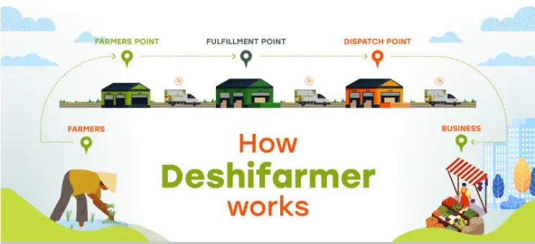
Image 1.1

1.1.2 Details of the product lines and services:
Supply chain platform:
- Apps for all stakeholders
- Self-learning pricing engine
- Seasonal Data
- Sourcing and pricing intelligence
- ERP for supply chain
- Quality and traceability
- Algorithms operation, logistics routing
- Payment and collection

Apps at Deshifarmer:
- Retail App
- SR App
- Corporate/Canteen/Restaurant App
- Delivery App

1.1.3 Operation Details:
Deshifarmer operates in 5 stages.
First we go to our designated farmers or they get enlisted with us. We make sure the produce we are getting is fresh without any compromise.
Secondly we got to the farmer’s point. Here we choose our fresh produce. We select rural areas based on some criteria (farmer population, harvest volume). Then we set up that specific area as farmer’s point. It is a hub from where we buy produces from our onboard farmers while we make sure a fair price for them so that they do not have to fall to any syndicate. We also give our farmer’s guidance on market demand and better ways to grow produces.
Thirdly, our fulfilment point is a whole link in our supply chain, helping us to regulate our inventory, ordering process, customer experience and shipping, whether between suppliers or direct to the buyer (Kotler et al., 2021). Under our contentment point there are a couple of farmer’s point from where the produces come based on territory. Once farmers point receive the produces after basic quality check and weighing again the process of washing, drying, sorting, grading starts. After this the produce will be weighted and crated according to the demand forecast of dispatch point and directly send to dispatch point in bulk.
Fourth comes the dispatch point. Upon receiving in bulk, produce will be segmented and separated as per business requirement and directly go out for doorstep delivery. Any last minute canceled product are stored in perfect temperature to avoid waste. As Deshifarmer follows the strategy farm to plate we are committed from farmers to business in a 12-16 hour time frame. Based on the routing plan and farmer’s population we have set up a 2000sqft farmers point and 3000sqft dispatch point at Boliarpur, Savar. We have started from Savar. As we know Savar is a significant gateway of Dhaka from north side of Bangladesh. We plan to improve to northside such as Manikganj, Tangail, Sirajgonj, Bogra, Rajshahi, Panchagarh, Rangpur and Dinajpur and south side Jessore, Khulna as farmers density is high and most fresh produce grow there.
Lastly is the business point where the fresh produce is in the market ready to reach the customers.
Presently, it's running a pilot project in Savar with 200 growers. It's supplying vegetables and fruits – both seasonal and non-seasonal – to 10 stores in Dhaka megacity under this pilot project.

1.1.4 Philanthropic Activities/CSR:
FOR FARMERS | FOR BUSINESSES | FOR CONSUMERS
- Fair Price where farmers realize 25% more revenue.  - Guidance on market demand, minimize farming related costs & maximize the profit margin.  - Transparency in Weighing & Pricing.  - One platform for all of their produces.  - Payment in the quickest time. | - Competitive prices.  - Saves time while ensuring more revenue.  - Hassle free doorstep delivery.  - Quality ensured produces.  - Efficient order process with no bargaining.  - Syndicate will no longer have control over market. | - Safe & Chemical free produces direct from farmers.  - Satisfactory hygiene practices throughout the farm to plate process.  - Footprint in empowering farmers.  - Ensuring food standard  - Fair price
Deshifarmer shows responsibility not only towards their consumer but as well as their businesses and farmers.

For farmers:
Deshifarmer promises farmers fair price where they get 25% more revenue. Vegetable prices keep rising. Currently during Ramadan prices of almost all kinds of vegetables have gone up by Tk15-20 per kg. But we make sure the farmers’ get their fair share.
Farmers sometimes do not have the idea of the market demands or how to cut costs and wastage (Bennett & Franzel, 2013). For that reason we give guidance to them on market demand, minimize farming related costs and maximize the profit margin.
Both our farmers’ and we keep full transparency and fairness while weighing and pricing so that in this way everyone gets the fair share.
To keep it easy for the farmers’ we are one platform for all their products. They do not have to look for different places to sell different types of products.
The time period of taking the products and giving the farmers’ their share is very constraint. We do payment in the quickest time.
For businesses:
We try to keep prices competitive for business so that they do not suffer any loss but we try to make sure the price is not manipulating the market as well. We try to save time while ensuring to generate more revenue.
We provide hassle free doorstep delivery. Products that come after sorting and grading we ensure quality produce. We have no bargaining policy which makes our loop more efficient.
We believe in no syndicate. This saves time and money for all of us in the business. So there is no control of that in the market.
For consumers:
We deliver absolutely safe and chemical free produces from farmers.
We give satisfactory hygiene practices throughout the farm to plate process. We are leaving a footprint to empower the farmers’.
We are dedicated in giving out the best and fresh produce. We ensure the food standard is up to the mark. We believe in giving out fair prices without any syndicate or compromise.

Where the price and demand is rising during Ramadan, Deshifarmer is always trying to bring efficiencies in the fresh produce supply chain of Bangladesh so eventually we can bring price stability in the market.
Perishable's loss can be minimized by harvesting on time. Harvesting and handling speed is of ultimate significance as soon as crop maturity has passed because of the sensitive nature of vegetables. Detainments or too early for any reason may end in major quality loss once the yield reaches crop maturity. Which may bring low request value. Our agriculturist team is typically giving advice on the right time of harvest so that our farmers can get fair and best price.
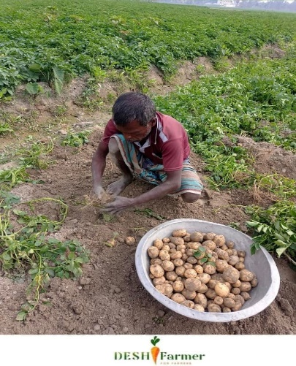
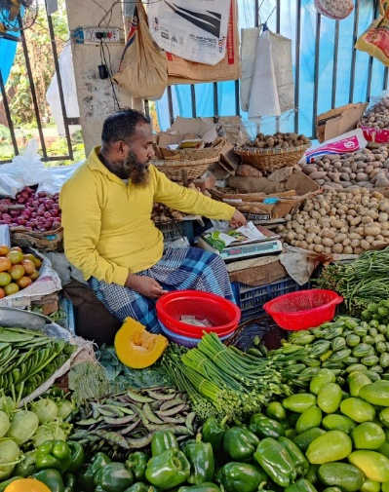
Image 1.2
Farmer at work
Image 1.3
The Wet Market

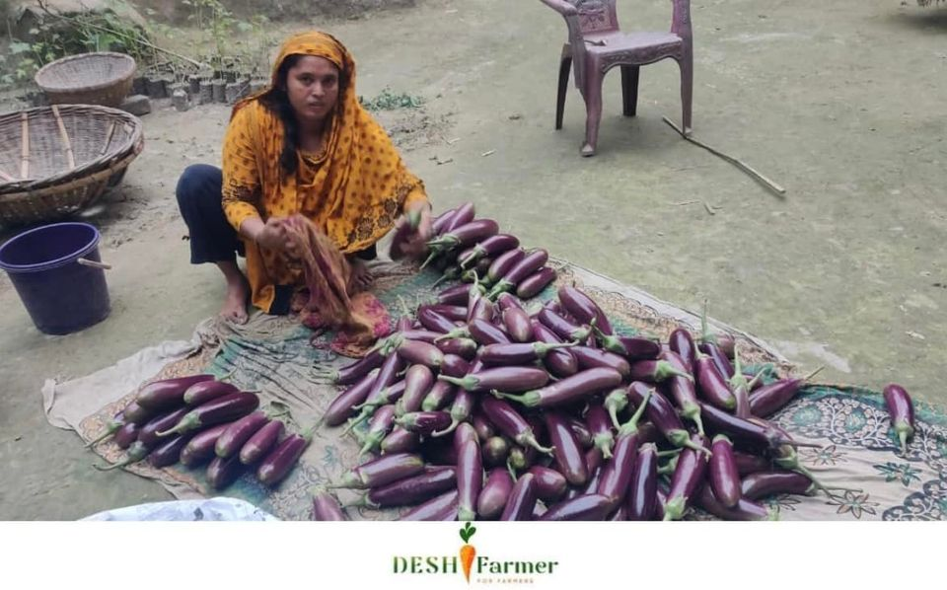
Image 1.4
Women at work who get equal benefits as men.
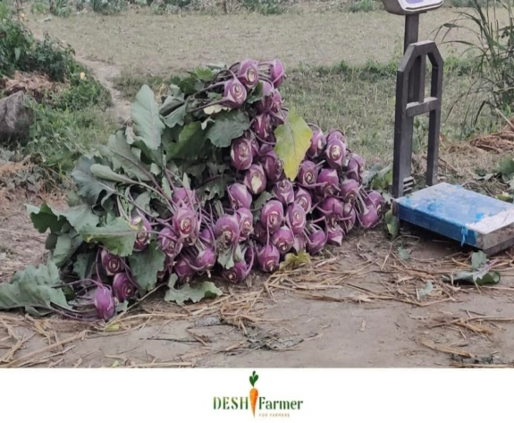
Image 1.5
Fresh produce at farmer’s point

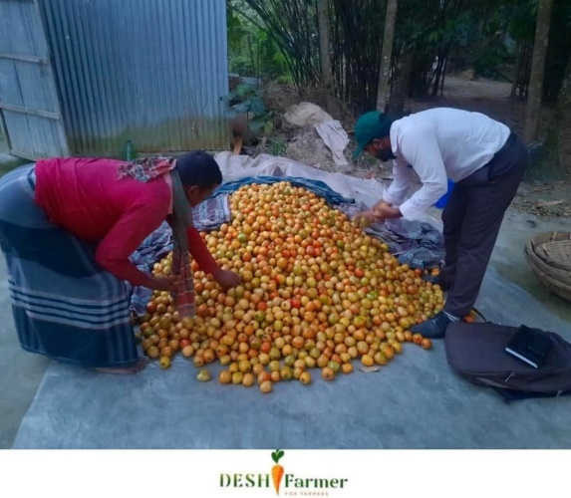
Image 1.6
Fresh produce for another round of sorting

2. Internship experience/observation details

2.1 Job Responsibilities:
I was assigned to the business development team as a part of my internship program. My internship program was an exciting and stimulating learning experience, but most importantly I learned how to work under the pressure of real-life responsibilities and its consequences. This practical orientation is necessary and essential for anyone who is entering the current workforce. Some of the major things I have learned during my internship are:
- The importance of punctuality and regularity.
- Weight of the responsibility
- The importance of being able to interact and successfully work alongside everyone.
- The importance of asking questions and fully comprehending instructions. The importance of caring for the task that has been assigned and completing it effectively.
Mainly, I worked helping developing posts for social media with my supervisor. My work was to check the daily messages. How to boost the page and keep an eye on all the activities on social media.
Also, one important thing I have had a great experience in was working under a self-made woman which made me realize how women are empowering this country and how they are giving out so much to this world.

2.2 Functions of the department:

Deshifarmer functions in 3 major departments.
- The Corporate Department
- The Warehouse Department
- The Sales Department

Table 2.2.1
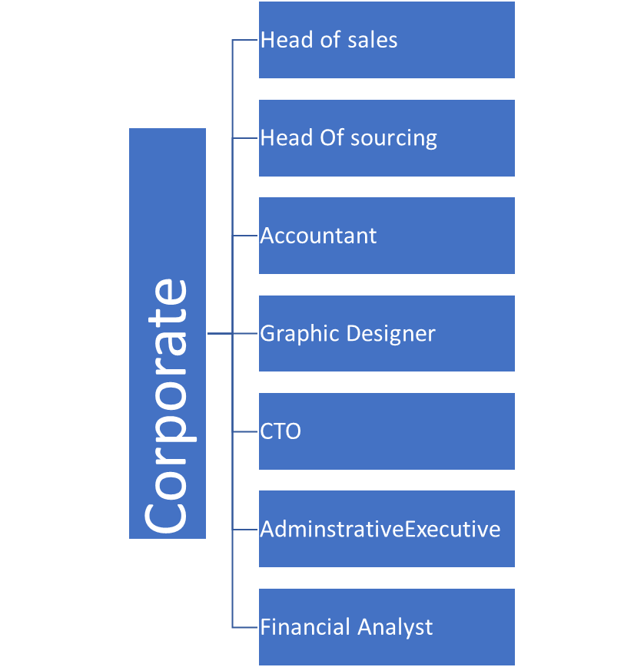

3. Recruitment and Selection Process

The HR department's main task is recruitment for the organization. One of the most important areas of consideration for HR while involved during a variety of areas similar as worker engagement, development, statutory compliance, data administration, and lots of further, is appealing, choosing, and onboarding good individualities for the establishment.

3.1 Why is it necessary to have a proper recruitment and selection procedure in place?

3.1.1 What is recruitment?
The process of attracting good individualities for a job post is comprehended as recruitment, whereas the system of relating and opting the deserving applicant for that position is comprehended as selection.
The benefactions of every worker are critical to the survival and substance of a company. As a result, choosing the precise existent for the position is critical. Within the same way that a square peg does not fit into a round hole. The system by which people are offered positions in an association is known as recruitment. It's when the mass-market looks for potential workers and encourages them to refer for posts within the company. This is frequently only one phase in the hiring procedure, but it's a lengthy one that includes a number of responsibilities that begin with a study of the job needs and end with the worker's appointment. The subsequent are some of the duties that are involved in the recruitment process:
• Examining the work specifications
• Posting the work opening
• Getting people to use for the position
• Managing the reaction
• Inspecting the applications
• Creating a shortlist of qualified candidates
Human Resource (HR) professionals are generally responsible of recruitment whether internally or externally. Internal recruitment sources are elevation, transfers, connection or references of ex-employees, retire workers.

3.1.2 What is the definition of selection?
The process of relating an individual with the necessary qualifications and capacities from a pool of job aspirants to fill open positions in a company is known as selection. It's frequently an HR process. It uses a variety of strategies to help distinguish between good and unqualified aspirants. The word's election' indicates the position of the right existent in the proper job. Selection is that the process of using multitudinous tactics to help newbies in determining which seeker is perfect fit for the job. The key points are given below:
- Screening of the candidates.
- Exclude the candidates who aren't a good fit for the job.
- Taking different types of tests including - aptitude test, IQ test, performance test, etc.
- Interviewing the eligible candidates.
- Reviewing the references for further procedure.
- Medical examinations of the candidates.
In the process of employment, the choosing process takes a lot of time. Managers of HR has to be very cautious during the process.

3.2 Main differences between recruitment and selection process:
The procedure of recruitment involves the evolution of good methods for attracting additional applicants to a appointment vacancy, while the system of selection involves relating the most qualified applicant for the job. Recruitment precedes the choosing procedure, and thus the selection procedure is only finalized when a job proposal is created and presented to the named applicant by appointment letter. Therefore, as to fully understand the contrast between recruitment and selection, there are some key points to stay in head.
- Recruitment procedure is to find candidates to fill the empty position and encourage them thoroughly to apply for the position. Selection means choosing the most qualified candidate from huge number of applicants and offering them to their desired job.
- Recruitment is obviously a positive process intended at attracting more and more job seekers. But selection process sometimes a negative process for those applicants who aren’t a good fit. Rejecting the unfit candidates is a harsh thing to do.
- From the two processes, recruitment is comparatively naiver. The recruiter paying less attention to scrutinizing individual candidates in recruitment process, On the other hand, selection procedure involves a more precise examination of the candidates where recruiters aim to find out every minute detail about each candidate, in order that they can choose the perfect match for the job.
- Recruitment process which takes less amount of time. Even in economic nature it is less demanding. Because it only involves identifying the needs of the job and encouraging candidates to apply for them. Selection involves a good range of activities, which may be both time-consuming and expensive.
- Communication of vacancy is completed so through various sources such as the internet, newspaper, magazines, etc. in recruitment. Also in recruitment distributes forms easily so candidates can apply. Assessment is completed so through various evaluation stages, like form submission, written exams, interviews, etc. during the choice process.
Deshifarmer recruits its employees externally. They have 2 criteria’s of selecting their employees. First are their corporate level employees who are selected from BD jobs per requirements. There is a shortlist made of the selected CVs. Then an interview session is taken from which the employees are hired. Second set of employees are hired in the same way through a website. Interview sessions are conducted.
However, Deshifarmer believes in one policy for their employees working on field for their warehouse department which is ‘hire and fire’. This happens when low level workers keep breaking the chain of command. It becomes very difficult for the process if there remains a gap. So to avoid this they must not break the chain of command and work efficiently.

4. Competitive Study: SWOT Analysis

SWOT stands for Strength, Weakness, Opportunities and Threats. The SWOT analysis determines and identify the company’s external and internal Strength and weakness, Opportunities and threats. The general analysis of a company’s strength, weakness, opportunities and threats is understood as SWOT analysis if we like to understand it in simple term. A SWOT analysis can show new function business or corporate strategies to accomplish this alteration. SWOT analysis of Deshifarmer is discussed below.
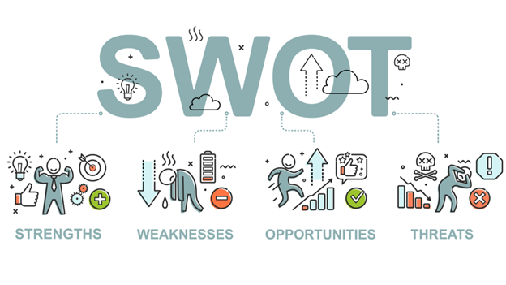
Image:1.7

4.1 Strengths:
Deshifarmer is the first tech-enabled agro-based business of Bangladesh. The Chairman of the company herself worked dedicatedly to make good contacts and strong links with government providing subsidies. Deshifarmer also has a nation-wide presence. Because, the famous newspaper and blog portal of Bangladesh “The Business Standard” published the great work and achievements of Deshifarmer. Last but not the least, Deshifarmer’s Chairman has a great control over all the operations and distribution process.

4.2 Weaknesses:
Every sort of business has their own set of strength as well as weaknesses. Deshifarmer is nothing exceptional. They have their set of weaknesses too. First weakness is that Deshifarmer is into a niche market. The idea of this sort of business is brand-new to Bangladesh. That’s why it is not very familiar to everyone. In Bangladesh, Customers have a strong attachment to bazars and superstore where they can have their day to day usable agro products. The new concept like Deshifarmer will take time to have a place in their daily-life. There is another thing which can be define as a weakness. The business model does not accommodate towards top-up shopping. Also there are some lacks confirmed market positioning.
How to overcome the weaknesses: With the help of social-media marketing and government links, these weaknesses of Deshifarmer can be easily overcome.

4.3 Opportunities:
Deshifarmer created a trend. It is the very first healthy eating trend created by Deshifarmer. Customers demanding garden-fresh and healthy food. The second most important factor in the product purchase is the healthiness of food. People over 45 is the biggest group of consumers who demand healthy food every day. With this ageing people and their demands, creating more customers. Deshifarmer is one of the biggest agro-based online platform in Bangladesh which is contributing the tech-friendly culture in a positive way.

4.4 Threats:
As every other growing business there are some threats here. The agro-based market is very saturated in Bangladesh. That’s why there is low opportunities for growth. Also, there are some similar business forming like Deshifarmer which are very competitive.

How to overcome the threats: Deshifarmer can overcome the threats by their better offers and services from others. Deshifarmer’s main key is consistency.

5. Recommendations

5.1Discussions/Implications
One of the first cold chain and tech-enabled fresh produce supply chain in Bangladesh is Deshifarmer. They have a great vision. Their vision is to empower each and every farmers' lives in Bangladesh by improving price stability, easy trading, productivity and reducing garbage. These things will happen through a traceable and trackable supply chain by Deshifarmer.
Deshifarmer selected rural areas based on farmers' density and harvest volume to source vegetables. The workers of Deshifarmer are so dedicated and punctual. They visit the farms themselves to make sure the product quality and finalize deals with farmers. The time of collection of the products is usually early morning or evening. They also deliver the products at the farmers' point as soon as possible after collection. All the required sorting and weighing of the products are done at the fastest possible pace at farmers’ point.
The farmers' points are also used as mini-hub. Apparently, there are some farmers' points under one fulfillment point. In farmers’ points we buy goods from our farmers and send them to the fulfillment point. After that, there comes the success point. The success point completes washing, drying, grading, and packaging of the products for the customers. After this process we are able to dispatch. We usually dispatch in bulk. Deshifarmer did direct research to know the market demand, farmers' interest and hurdles before launching this platform. It had been very complicated working with the farmers as none of them were ready to co-operate at the very beginning of the journey of Deshifarmer.
We didn't even get back our investment sometimes. Even getting fair prices was a big challenge. But Deshifarmer sustained after all the obstacles. Deshifarmer seems different from other similar business ventures. They're paying us 20-25% more than the syndicators. They also buy vegetables in bulk which helps us to be less bothered about rotten vegetables. That’s why there's no sign of getting losses.

5.2 Conclusion
Deshifarmer may be a tech-based supply chain for fresh produce & aim to work for the development of farmers' lives & SME businesses. Deshifarmer believes that eventually everything will become technology based. They’re developing Innovative tools & sustainable solutions all the time keeping in mind a neutral & positive environmental impact. People will become more tech friendly and Deshifarmer is the perfect agricultural platform to start this change for farmers. As we know from the previous statement, Deshifarmer has a clear vision. Their vision is to empower each and every farmers' lives in Bangladesh by improving price stability, easy trading, productivity and reducing garbage. These things will happen through a traceable and trackable user friendly tech-enabled supply chain by Deshifarmer.
It involves paperless databases to digital currency. This eventually will boost the business of the SMEs & will cause create an environment on the face of the Earth that will impact and change the world not for just a few but for the masses, regardless of what their background, gender, religion & region be.

References

https://www.tbsnews.net/features/panorama/deshifarmer-technological-solution-menace-middlemen-299935?fbclid=IwAR1Mg7HsE0w2f8IuRUWgvp-E1erNbmIhbuiAA248HtOT3K_I8GDDsjbj07I
https://deshifarmer.co/?fbclid=IwAR0ChVV-M1GCX-B4_v1kwjPze63RhgLQckojy1x3i1pmHjJnkzOKCeTC3p4
Bennett, M., & Franzel, S. (2013). Can organic and resource-conserving agriculture improve livelihoods? A synthesis. International Journal of Agricultural Sustainability, 11(3), 193–215. https://doi.org/10.1080/14735903.2012.724925
Ghosh, B. K. (n.d.). Rising Consumption Inequality in. 1–64.
Kotler, P., Keller, K. L., Ang, S. H., Tan, C. T., & Leong, S. M. (2021). Marketing management: an Asian perspective.
Rummana, R., Rahman, K. M., Aziz, S., & Nishat, B. (2008). urban pollution in dhaka city: a tri-partite qualitative model for alleviation and prevention. Proceedings: International Conference on Sustainable Urban Environmental Practices, 297. https://doi.org/10.13140/RG.2.1.3285.2962
The Prestige Magazine ‘Harvesting Happiness’ article, n.d.

Appendices

6.1 Defining SME business:
Businesses that maintain revenues and assets or variety of employees below a certain threshold are called small and mid-size enterprises or SMEs. There are some variations of definition on SMEs. Different country has their own set of definition on SMEs. The definitions clearly says what constitutes a little and medium-sized enterprise (SME). There are some size criteria which must be met to define a business whether it’s under SME business or not. Also, infrequently the industry in which the company operates in is taken into account. SMEs play a vital role in the nation’s economy. They outnumber large enterprises vastly, recruit vast figures of entities. They are typically entrepreneurial personality, assisting to shape invention.


Image 1.8

6.2 Defining SDG:
The SDGs are mentioned to as Global Goals, repose on the success of the MDGs. MDG stands for Millennium Development Goals. SDG aim to go further to end all forms of poverty from the country. The new goals are very unique. All countries, poor, rich and middle-income they call for action to market prosperity while protecting the planet and its environment. They recognize that ending poverty must go on with arrangements that can construct a profitable growth and also address that a range of social necessities including education, health, social protection, and job openings, while deal with global climate change and environmental protection.
Image 1.9

6.3 Defining B2B Market:
Business-to-business (B2B), also called B-to-B, may be a form of transaction between businesses, like one involving a manufacturer and wholesaler, or a wholesaler and a retailer. We all know the name or sign B-TO-B or B2B. The full form is Business-to-business. It is a form of transaction between businesses. For deep understanding, One involving in manufacturer and one in wholesaler, or one in wholesaler and one in retailer. Business-to-business is a form of transaction which conducted between companies. The transaction between company and an individual customer is not a part of B2B. In the division between business-to-consumer (B2C) and business-to-government (B2G) transactions, business-to-business (B2B) stands.
.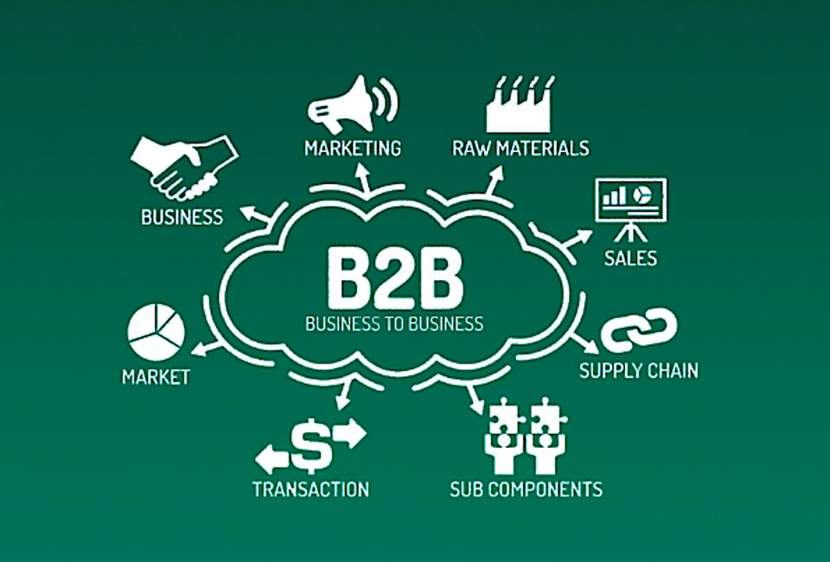
Image 2.0

7. Questioners

- Why should people buy products from DESHIFARMER?
Ans: Because, We are providing the products at a fair price for both customers and farmers.

- What’s the process of weighing and pricing?
Ans: Total transparent in weighing and pricing.

- What about the payment process for the farmers?
Ans: Payment will be at the quickest time. We give farmers their deserving price through bank or any sort of online payment system.

- What is the benefit for the employees?
Ans: They will be ensured with more revenues if they save time as much as they can.

- What are the benefits as a customer?
Ans: The customers can have hassle free doorstep delivery with quality ensured products.

- What factor do you consider for selecting the DESHIFARMER platform?
Ans: Quality service and products.

- For demand forecasting, what sort of system is used by DESHIFARMER?
Ans: Sales forecasting system based on market check.

- Is there any possibilities that the business participate in social development activities?
Ans: Yes, The business model plays a vital role in social development activities.

- What kind of media advertising do you use?
Ans: Direct selling, social platforms, Tag etc.

- What kind of sales promotion activities do you use?
Ans: Campaign, sponsorship provide etc.

- What is the reason you are using the transportation in fare?
Ans: Easy to operate, monitor and ensuring safety while delivering.

- How do you assemble order from consumer or customer?
Ans: By using personal source or collect data from Wholesalers and retailers.

