Internship Report
on
General and Service Operation Activities at
G. Kibria & Co

MD: Mahadi Hasan Emon

This report is submitted to the school of Business and Economics, United International University as a partial requirement for the degree fulfillment of Bachelor of Business Administration
Internship Report
on
General and Service Operation Activities at
G. Kibria & Co

Submitted To
Ms. Zinnatun Nesa
Assistant Professor
School of Business & Economics (SoBE)

Submitted By
MD: Mahadi Hasan Emon
ID: 111 193 120
Major: Finance
Department of Bachelor of Business Administration

School of Business and Economics

United international university
Date of Submission: 04 August, 2025

Letter of Transmittal

04 August, 2025
Zinnatun Nesa
Assistant Professor
United International University
Dhaka, Badda, Madani Avenue, United City

Subject: Internship Report on “General and Service Operations Activities at G. Kibria & Co.”.

Dear ma’am,
It is with a great pleasure that I hereby submit my Internship Report, which is named General and Service Operations activities at G. Kibria & Co. The report encompassing all stipulations relating to General and Services of G. Kibria & Co., has been provided to the best extent in my capability to provide an interesting and educative report.
I believe this report will meet the criteria that you have mentioned in the course of INT4399.

Sincerely Yours,
Md: Mahadi Hasan Emon
ID: 111 193 120
School of Business and Economics (SoBE)
United International University

Certification of Similarity Index

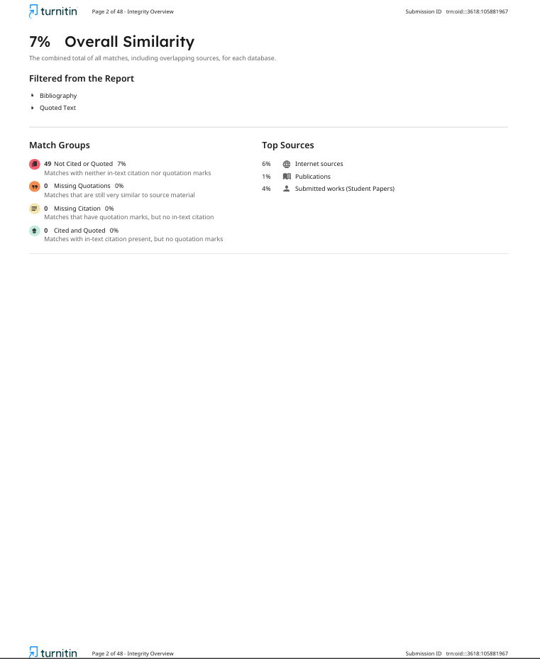
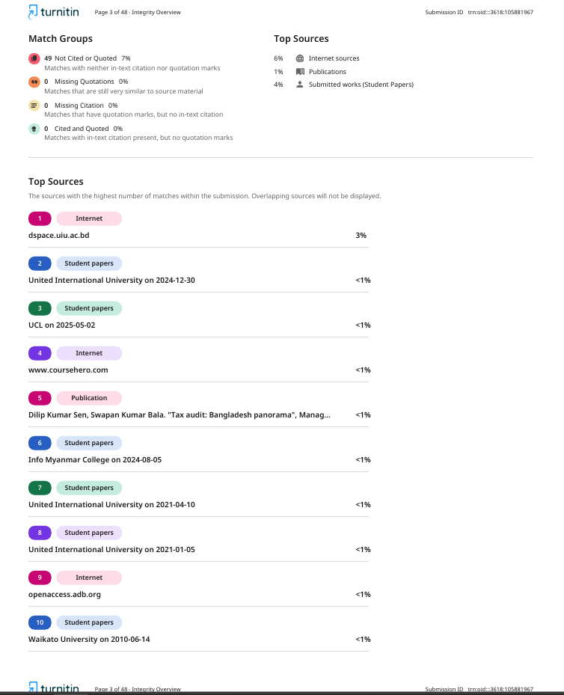

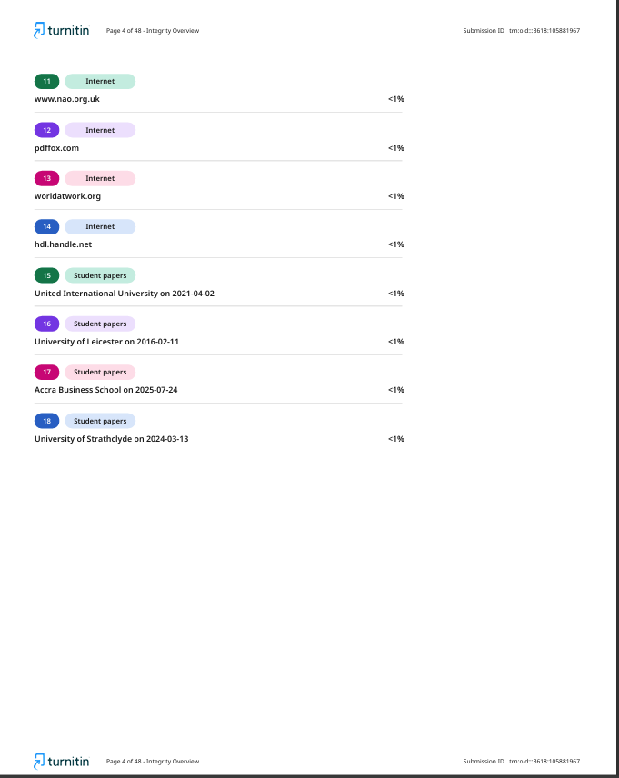

Declaration

I, Md: Mahadi Hasan Emon, highly confirm that the whole internship report entitled with the title of “General and Service Operations Activities at G. Kibria & Co. - Chartered Accountant (CA) firms” is a writing by myself. I can assure of not resorting to any form of plagiarism to complete this report. I can confirm that the report is prepared just so as to fulfill the required academic requirements of Internship not otherwise.

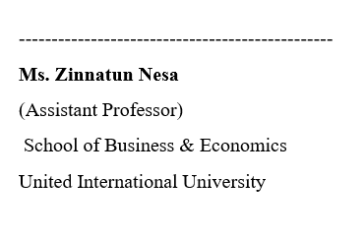
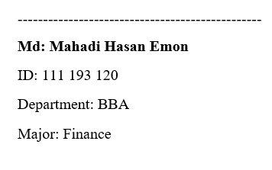

Acknowledgment

I would like to be thankful to my work and academic supervisors in United International University and G. Kibria & Co. who have helped me and guided me to complete the internship report on “General and Service Operation Activities at G. Kibria & Co”.
I should express my gratitude to the office of BBA program and the faculty members who have assisted me throughout the years. Next, I would like to thank clients of G. Kibria & CO. who took part in my small sample survey and management and employees who made me understand a bunch of things about the real-life accounting activities.
Finally, I pay my obligation to those referenced websites that helped me by providing lots of information. Without this help, it will be so tough for me to complete my report or to reach me on my destination.

Executive Summary

This internship report highlights the experience of my work at the company of G. Kibria & Co., a leading Chartered Accountant (CA) firm in Bangladesh, providing audit & assurance, taxation, business process outsourcing & corporate finance & advisory services. The main aim of this internship was to fill the knowledge gap between theoretical and practical world by getting exposure into the working of a professional CA firm. During the internship term, I was posted with a major assignment on the auditing for the “Ahmed Group”. I was allowed to watch the financial statements draft preparation, planning, auditing of documents, tax returns filing as well as communication with clients. The report also gives insight into the perceptions of the clients concerning the quality of services provided by the firm, the areas where the firm does it very well, and other areas that it needs to improve. Despite the limitations in the observation scope, the internship has helped me to learn a lot about professional accounting practices and management of their client.

Table of Contents
Letter of Transmittal i
Certification of Similarity Index ii
Declaration v
Acknowledgment vi
Executive Summary vii
List of Figures x
List of Abbreviations x
Chapter 1: Introduction 1
1.1. Introduction 1
1.2. Background of the Report 2
1.3. Objective of the Report 2
1.4. Limitation of the Study 2
1.5. Scope of the Study 3
1.6. Motivation 3
1.7. Methodology 3
Chapter 2: G. Kibria & Co. Profile 4
2.1. Chronological Background of G. Kibria & Co 4
2.2. Management 5
2.3. Work and Activities of G. Kibria & Co 6
2.4. Office Presence and Operational Coverage of G. Kibria & Co 8
2.5. Core Areas of Professional Services 9
Chapter3: My Role and Responsibilities During Internship 11
3.1. Assignment 11
3.2. Work Responsibilities: 11
3.3. Sales 13
3.4. Overhead 14
3.5. Salary 14
Chapter4: Overview and Learning in a CA Firm 16
4.1. Interpretation of Knowledge Acquired During Internship 16
4.2. Service Operations in a Chartered Accountant Firm 17
4.3. Taxation Services and Compliance Management 18
4.4. Audit and Assurance Services 18
4.5. Financial Advisory and Business Consultation 19
4.6. Foreign Accounting and Outsourcing Services 19
4.7. Documentation, Client Communication, and Professional Standards 20
4.8. Professional Environment and Ethical Conduct 20
Chapter 5: Comparative Analysis with Academic Knowledge 22
5.1. Service Operations 22
5.2. Evaluation of Service Operations from the Client Perspective 24
5.3. Client Complain 25
5.4. Client Advantages 26
Chapter 6: Evaluation of Service from Client Perspective 28
Chapter 7: Findings & Conclusion 33
7.1 Findings: 33
7.2. Conclusion: 33
Bibliography 34

List of Figures
Figure 1: G. Kibria & Co. - Audit & Assurance
Figure 2: G. Kibria & Co. - Taxation
Figure 3: G. Kibria & Co. - Business Process Outsourcing
Figure 4: G. Kibria & Co. - Corporate Finance & Advisory Services
Figure 5: Management Structure of G. Kibria & Co.
Figure 6: Scope of Work and Operations at G. Kibria & Co
Figure 7: List of Israq’s all Unit
Figure 8: Audit team – workflow & reponsebilities
Figure 9: Survey Question -1
Figure 10: Survey Question - 2
Figure 11: Survey Question - 3
Figure 12: Survey Question - 4
Figure 13: Survey Question - 5
Figure 14: Survey Question - 6
Figure 15: Survey Question - 7
Figure 16: Survey Question - 8

List of Abbreviations
- CA - Chartered Accountant
- FCA - Fellow Chartered Accountant
- ICAEW - Institute of Chartered Accountants in England and Wales
- CFAB - Certificate in Finance, Accounting and Business
- IFRS - International Financial Reporting Standards
- ISA - International Standards on Auditing
- BBA - Bachelor of Business Administration
- ICAB - Institute of Chartered Accountants of Bangladesh
- NGO - Non-governmental organizations

Chapter 1: Introduction

1.1. Introduction
Accounting profession is very crucial in ensuring there is a level of transparency and accountability as well as efficient running of economic sphere of a nation. As the economy of this country diversifies, and businesses grow in size, the need of having competent accounting professionals has grown larger in Bangladesh. The main role of Chartered Accountant (CA) firms is the maintenance of financial discipline, as their services range widely and include: audit, tax, advisory, and consultancy divisions that have large array of diverse clients. As the world around is changing due to advancement in technology, changes in the regulatory environment, and the emergence of strong expectations of corporate governance, the CA firms operating in Bangladesh should not remain largely unchanged because in order to retain competitiveness, CA firms have to evolve in line with the changing environment.
G. Kibria & Co., Chartered Accountants, is one of the well-known professional services firms in Bangladesh with the reputation of commitment to excellence and integrity. This firm was set up with the objective of offering quality services and thus it offers extensive solutions in the fields of auditing, accounting, taxation, advisory and consultancy. It caters to a diversity of customers such as the corporate sector as well as the multinationals to a great deal and in this way also adds to the country with the accounting reporting and regulatory system.
Unlike most of the established firms, G. Kibria & Co. focus on continuous professional growth and upgrading, utilization of advanced technology, and also follows and maintain to international standards, including the International Financial Reporting Standards (IFRS) and the use of the International Standards on Auditing (ISA). The company maintains a high standard of corporate ethics and it is in line with the legal regulations in the country as well as the international best standards of corporate governance. The profession of Chartered Accountant is slowly emerging as an individual benefiting and intellectually satisfying career option that promises a lot to the person in terms of personal and professional development. Being a graduate of United International University, as a Bachelor of Business Administration (BBA) major in Finance, I was always interested in majoring in auditing, financial accounting, and advisory services. To have a working exposure and increase my knowledge regarding the working environment, I decided to do my internship in G. Kibria & Co. The company has a strong reputation, high energy in terms of the work culture and concern toward new opportunity which is made me to join this firm as the starting point of my career.
This internship has enabled me to acquire practical experience on how assignments related to the practice of accounting standards, audit process, financial reporting, and client service are done. It has been a very nice experience to gain an insight into what a professional services firm does really on day-to-day basis and it has also boosted my technical and interpersonal skills immensely, and I think the internship has given me a good foundation to start a career in accounting and finance later in life.

1.2. Background of the Report
In this report, I describe my internship at one of the best firms of Chartered Accountants called G. Kibria & Co., Chartered Accountants in its main activities audit, accounting, taxation and advisory services. Throughout the intern period, I mainly audited, and during this time I watched and helped in carrying out the audit procedures on a diverse sect of organizations. According to this field experience, the report talks of the major audit techniques, financial reporting procedures, and client service practices of the company. It also studies how these practices work in real world to achieve transparency in financial reports, regulatory compliance and general improvement of performance of businesses.

1.3. Objective of the Report
The main objective of this report is to accomplish my BBA degree by completing this report. Another important objective is aim to bridge the gap between academic learning and real-world professional accounting practices insight i acquired.

1.4. Limitation of the Study
Surveys with small sample sizes present several limitations that can affect the reliability and validity of the results. To start with, a small sample might fail to give representative of organization resulting to biased findings. It is such a limited range of diversity that results can be less generalizable. Moreover, sampling errors extend as a result of small sampling areas thus, it can be difficult to any meaningful conclusions.

1.5. Scope of the Study
The Scope of the study is to know how a CA firm helping other organization throguh the verity accounting to maintain their cash flow, taxation solution and verify internal audit team report with external audit team report.

1.6. Motivation
Motivation of this report is to document the practical knowledge and reflect on the valuable professional experience I gained during my internship. Through this report, i aim to highlight the knowledge and skills I developed in the field of accounting.

1.7. Methodology
I needed some information to complete this report. The data that I needed was acquired through the annual report of G. Kibria & Co. and through their management information system. I also interviewed employees & articleship student of G. Kibria & Co. and gathered valuable data in the head office of this company in Niketon, Gulshan.
Sources of data:
There were two types of data used to complete this report.
Primary Data: This type of data has been collected from survey and interview
Secondary Data: This type of data has been collected from internet, journal and newspaper.

Chapter 2: G. Kibria & Co. Profile

2.1. Chronological Background of G. Kibria & Co
A well and reputed professional service firm in Bangladesh is G. Kibria & Co., Chartered Accountant (CA) firm. The firm which was started back in 1983 has continued to expand to become one of the most successful Chartered Accountancy firms in the country. In this case, G. Kibria & Co. has continued being focused on providing quality services in the field of auditing, corporate risk services, taxation, business process outsourcing, consulting and financial advisory. The company has been known to upkeep a commitment in regards to ethics, customer satisfaction and professional expertise.

Figure 3: Business Process Outsourcing
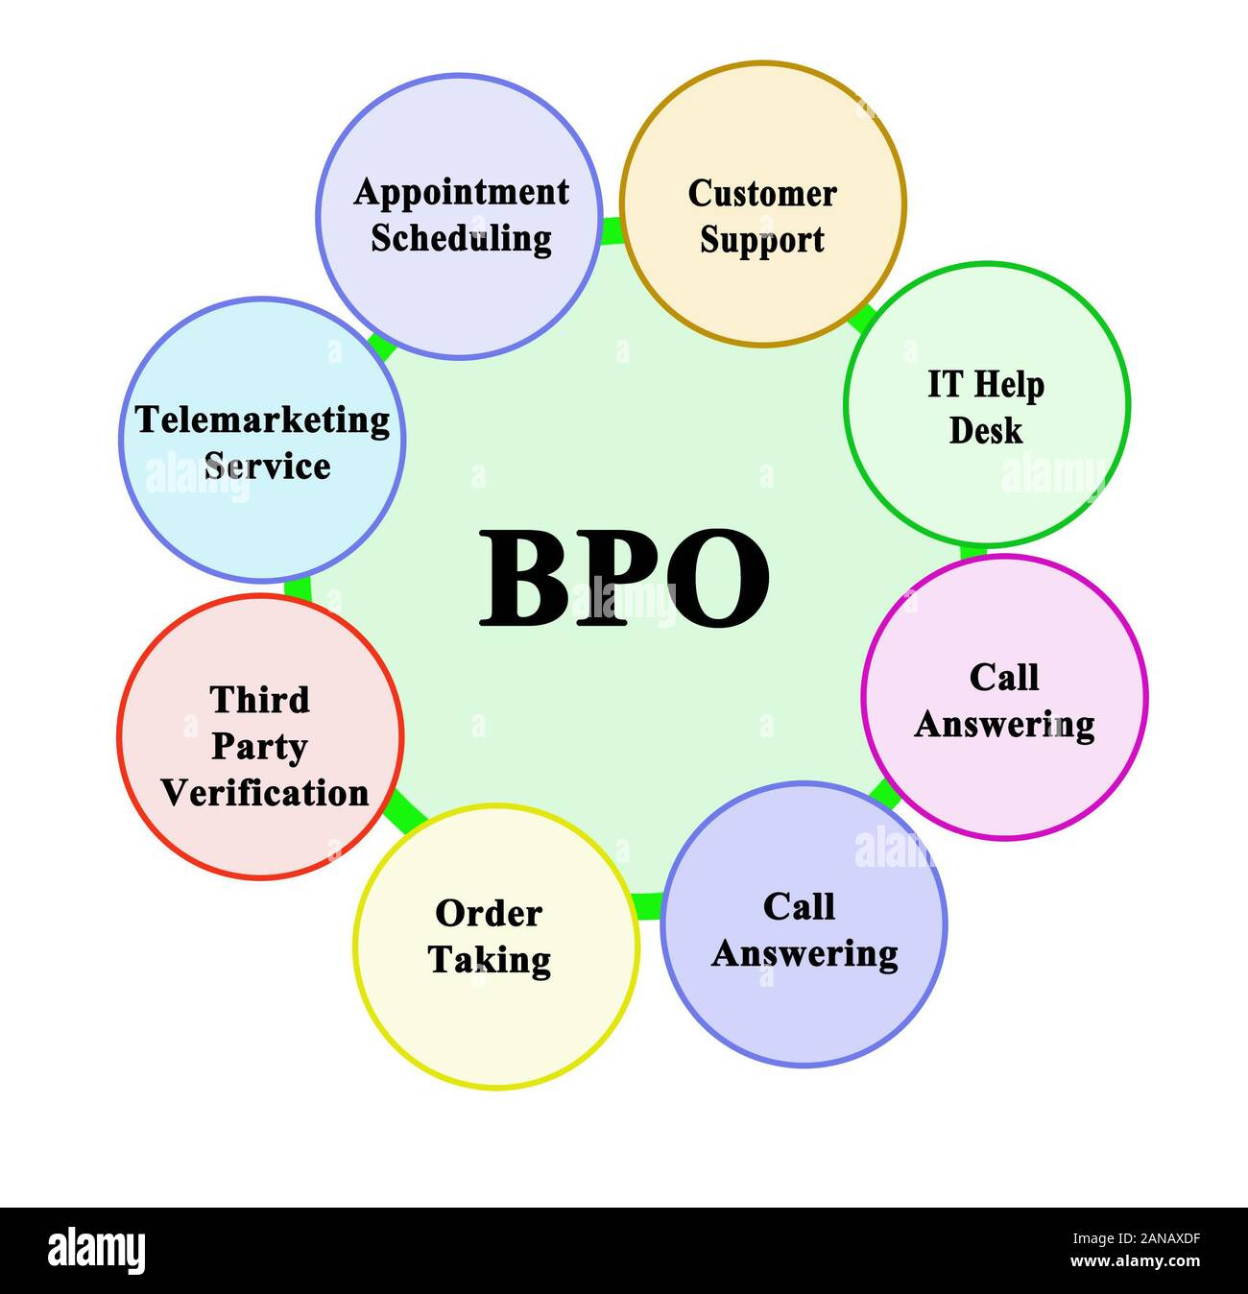
Figure 1: Auditing & Assurance


Figure 2: Taxation

Figure 4: Consulting and Financial Advisory

Figure 0-2consulting and financial advisory

Figure 0-3: Auditing & AssuranceFigure 0-4consulting and financial advisory

The practice of G. Kibria & Co. follows the regulatory requirements of the Institute of Chartered Accountants of Bangladesh (ICAB) and the practice also complies with the international standards such as the International Standards on Auditing (ISA) and Internation Financial Reporting Standards (IFRS). The firm has been able to offer its services to many and varied range of clients over the years comprising of both private and the public companies, the non-governmental organizations (NGOs) and the government institutions.
G. Kibria Kibria & Co. has been very significant in enhancing financial transparency and accountability in Bangladesh business environment. The firm has enhanced the corporate governance and the practices of financial reporting activities through its reliable audit practices as well as its expertise in consultancy services in different sectors of the economy.
The firm is equipped with a group of experienced Chartered Accountants and practitioners who are knowledgeable of the industry and have a commitment of learning continuously. With the help of modern technology and keeping abreast with the changing tax regulations, financial guidelines and international best standards the firm will be in position to deliver the accurate, timely and relevant services to its clients.
G. Kibria & Co. has strong reputation over the years regarding integrity, independence, and service to the client. With the nature of change in the regulatory and financial environment, the firm keeps on adapting, innovating, and increasing its fields of competence. The fact that it constantly maintains a focus on quality, compliance, professional development, makes it be able to make a significant contribution to the economic development of the country, as well as strengthen confidence in financial reporting and assurance services in Bangladesh.

2.2. Management
In 1983, Mr. A. K. Gulam Kibria, FCA established the G. Kibria and Co., Chartered Accountants. Mr. Kibria is a very well-respected personality in the accounting profession and he was the elected President of the Institute of Chartered Accountants of Bangladesh (ICAB) in 2003. The firm has emerged to a great extent under his leadership and has also gained reputation of quality and integrity in the sphere of professional services. G. Kibria & Co Bangladesh is headed by a group of dedicated and qualified Chartered Accountant practitioners with the vision of practicing professional, ethical and client centered services. The company is organised in partnership form with top partners in charge of critical areas of operation that include audit, taxation, advisory, and training.
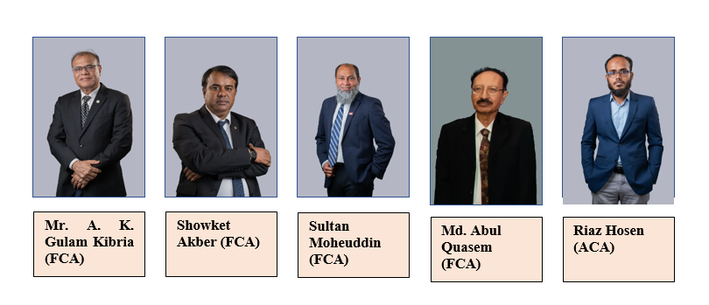
There are five partners in the company now:
Figure 5: Management Structure of G. Kibria & Co.
Besides the partners, G. Kibria & Co. is also supported by some directors who carry most important roles in the operations of the firm. Mr. Shah Rafsan Kibria, ACA (Bangladesh), CPA and CA (Canada) are a director who is engaged in the management of the strategic initiatives of the firm. Mr. Shahrear Kibria CFAB (ICAEW) and BFP (ICAEW) are also attached to the firm. They are both sons of the founding partner, Mr. A. K. Gulam Kibria and they are determined to perpetuate the legacy of professionalism and excellent service delivery.
Additional directors are Mr. Hasanur Rahman and Mr. Mahbub Anam Suman who support further development of the firm as well as its operative efficiency. In unity, the expertise of the leadership team is enormous, which proves that G. Kibria & Co. is a name that people can rely upon when it comes to accounting, audit, taxation, and advisory services in Bangladesh and other countries.

2.3. Work and Activities of G. Kibria & Co
since its inception in 1983, G. Kibria & Co., Chartered Accountants (CA) has contributed in the area of financial accountability and transparency in Bangladesh. The firm is incorporated under the Institute of Chartered Accountants of Bangladesh (ICAB) and provides a large area of services that includes audit & assurance, taxation, business process outsourcing & corporate finance & advisory services.


Figure 6: Scope of Work and Operations at G. Kibria & Co

The company collaborates with a wide variety of entities that include multinational corporations, private firms, non-governmental organizations, and government. Its assurance and advisory services will help advise its clients to stay in accordance with the regulatory standard, advance the performance of its operations and enhance its financial performance. G. Kibria & Co. also has strong reputation in carrying out such statutory audit which is compliant to the requirements of the national and international standards of IFRS and ISA.
In addition to ordinary auditing and taxation, the company offers extra value-added services such as management consulting services, feasibility studies, internal control assessment as well as corporate restructuring. The services ensure that the clients make informed decisions with data and avoid financial and operational uncertainties and respond to business environment changes.
G. Kibria & Co. has gained a good reputation as regards to its work standards, technical expertise and quality ethics. Within the company, continuous learning and professional development is given a big priority. In this regard, it conducts regular training programs, workshops, and knowledge sharing activities in making its team including interns up to date on changes in the financial laws, tax regulations, and international accounting rules.
Having the motto to build financial discipline and thus help achieving the sustainable economic growth of Bangladesh, G. Kibria & Co. is a leading and reputable name in the accounting and auditing sector in the country. Dedication to transparency, professionalism and excellence in servicing its clients remain its hallmark and legacy.

2.4. Office Presence and Operational Coverage of G. Kibria & Co
G. Kibria & Co., Chartered Accountant are based at Niketan, Dhaka. This strategic position gives the company a chance to conveniently deal with many clients both in governmental and corporate areas. In spite of the fact that the firm is not a commercial bank that has its branch offices, it has extensive country coverage in terms of its project-based and client-specific requirement.
It has a flexible non-decentralized working model whereby the professional teams often travel to several divisions and districts to execute audits, consultancy services and field work. Such a strategy would allow G. Kibria & Co. to carry out personalized services by going to the places of the clients and thus effective communication and on-time completions would be achieved.
The G. Kibria and Co. is engaged in the business of auditing, and corporate risk services which further spreads in the whole of Bangladesh. The countrywide supports of the firm enable the firm to operate in both the urban centers and remote regions and hence help uplift the financial systems and governance in various sectors.
Furthermore, the company has good working terms with regulatory bodies, development agencies and world-audit networks. Such affiliations raise its credibility, knowledge sharing capabilities and access to best practices in the world and this gives it more strength in service delivery and operation.
G. Kibria & Co. has been able to maintain a brand reputation in the form of trust in the accounting profession through strategic positioning, mobility and professional network and has continued to serve its clients in Bangladesh with virtues and values and consequently has established an honorable record.

2.5. Core Areas of Professional Services
G. Kibria & Co., Chartered Accountants provides comprehensive professional services of auditing, taxation, assurance and business advisory services. These services are designed to enable clients to attain a transparent financial status, meet the statutory regulations and make qualified strategic decisions. The company offers its services to a wide range of customers consisting of public or even the privately owned companies, non-government organizations (NGOs) as well as other ventures funded/sponsored by donors in diverse areas of the economy. The main areas of services are the following:
Audit and Assurance Services: G. Kibria & Co. carry out statutory, internal and compliance audit on the lines of International Standard on Auditing (ISA) and the recommendations of the Institute of chartered Accountants of Bangladesh (ICAB). These services aim at making sure that there is fairness, reliability, and accuracy of financial statements. Audit process also assists in determining the risks to organizing, assessing of internal controls systems, and also increasing the confidence of the stakeholders.
Taxation Services: The company offers complete taxation services such as income tax planning, VAT compliance and minor tax kinds as well as union tax returns of individuals, firms and foundations. These services are provided in compliance to the laws and regulations of the National Board of Revenue (NBR) so that the clients can fulfill their requirements of tax dues and at the same time ensuring tax effectiveness within legal provisions.
Advisory and Consulting Services: G. Kibria & Co provides business advisory such as advisory services and consulting services, including business planning, financial, and business consulting, feasibility studies, corporate restructuring as well as risk assessment. The services help the clients enhance their financial performance and solve operational issues as well as make sound business decisions.
Internal Control Review and Risk Management: In order to reinforce organizational governance G. Kibria & Co. performs thorough examination of internal control systems. These reviews outline weaknesses in the areas and give recommendations in order to reduce the weakness hence reducing the risk, and help improve the efficiency with which the operation as well as eliminate chances of fraud, or financial misstatements.
Training and Capacity Building: The firm provides training and capacity building opportunities including training and workshops on audit, taxation, financial management and compliance related issues as part and parcel of its professional development initiatives. These programs are also geared at developing client capacity and general financial literacy in entities.

Chapter3: My Role and Responsibilities during Internship

3.1. Assignment
During my three-month internship working with G. Kibria & Co., headoffice at Niketan, Gulshan. I was assigned as an external auditor for “Ahmed Group”, the head office is at Kalachandpur, Norda, Bashundhara, Dhaka. As an external auditor, my key duty was to ensure data accuracy. The students (CA-Chartered accountants) used to input data first and my job role was to ensure that there matches between the data requisitions and the excel file.
I was specifically assigned to audit information regarding sales, manufacturing overhead as well as salaries. I have also communicated frequently with the internal auditor of Ahmed Group. The head of the accounts department, Mr. Prosanta Dash.
During thius time, I foused to learn the method of extracting and confirming data at different sources such as the ERP ledger, hard copy files, vendor receipts and factory payment receipts. I was also learned how to do the purchase files, how to collate the bank statements, how to do a daily record of the expenses relating to overhead.

3.2. Work Responsibilities:

As an external euditor at Ahmed Group, i had been in charge of several tasks. Usually, I reported to work at 10.00 AM and left at 6.00 PM. We used to go to Gazipur in the beginning of every month and “Ahmed Group” runs five factories as mentioned below:
Figure 7: List of Israq’s all Unit

There, we collect raw data like inventories of finished yarn and raw cotton were also collected to ensure accurate inentory count. We also took factory salary sheets, a process usally take two days.
After coming from the factory, we compose an email of document requisition as listed below:
TEAM FORMATION
Director sets team at beginning of month

DOCUMENT PREPARATION
Head office prepares requested documents within two days

DATA INPUT
CA student input data into excel next two days
DATA VERIFICATION
Employees verify data and transfer to new excel within two days
REPORT SUBMISSION
Head of team analyzes data, prepares report submit report to business
REQUISITION
- Challan Register
- Inventory
- Local & Foreign Sales
- Local & Foreign Purchase
- Sales Return (Local & Foreign)
- Wastage Sales
- Bank Statement, Bank Ledger & Bank Reconcilation
- Salary Sheet, Disbursement Copy & Ledger
- All Loan Statements, Bank Confirmation Letter & Ledger

Figure 8: Audit team – workflow & responsibilities

After we received the documents, chartered accountant (CA) students’ duty to input all the collected data in Excel. When they had entered, my role was to verify the excel entries each data with requisition to ensure there was accuracy of sales - local & foriegn and manufacturing overhead as well as salary sheet.
Once review process was finished by me, i had to marked it which is indicate of verified by me, i delivered the data to another member who is responsible for the final report prepare.

3.3. Sales
Sales are one of the main sources of income of the Ahmed Group and development of the sales file was one of the main issues which i was assigned to complete during the audit procedure.
There are two types of sale:
1. local sale and
2. Foreign sale.
Ahmed group generate its significant revenue from foreign sales. To begain the sales audit, we initiate an email asking the sales requisition, through which we obtain the ERP data. On the basis of this information, i prepare a list of LCs (Letters of Credit) and ask to provide us the following supporting documents to each of the LCs:
- Proforma Invoice
- Delivery Order
- Delivery Challan
- Commercial Invoice
- Bill of Exchange
- Forwarding Letter
- Bank Acceptance
- LC Document
The CA students just collect these documents, scan them and organize them based on LC number and factory unit name (e.g., ICML - 00843889423947).
The data by the ERP is entered by the CA students in excel and my part as auditor is to ensure that every entry is correct. I cross check every data to the concerned delivery challan and strike the scanned receipts. There is also a special Excel file that contains any missing files. The information included in the report about the absence of the documents is followed by our email asking the person to provide the absent papers. This is because the final audit report is made depending on the data we have gathered and analyzed.

3.4. Overhead
Overhead cost is used to describe those expenses which are not directly linked to the production cost. Ahmed Group has a track record of their overhead expenses on a Cashbook Register which they record on daily basis on the incomes and outflows of cash connected in an office maintenance, employees, and guest’s expenses.
We as an external auditor, by the end of each month we go and get their cashbook and the supporting vouchers and we scan them into a PDF form to see whether the amount shown in the cashbook and the amount contained in the supporting document is accurate. The data on added cost of operations is also used in obtaining the data on the cashbook and register in Excel. In the PDF we have highlighted what we have taken to facilitate easy cross checking and also when there is shortage of something we can easily detect it.

3.5. Salary
Salary accuracy naintaining is vital role for all organization. Ahmed Group has five units that fall under Ishraq division and the payment of the salaries is undertaken by head office of Ahmed Group. The high number of staffs in these units requires that there should be a proper auditing of salaries.
To audit salaries accurately, three key documents are required:
- The ERP ledger
- The Factory Salary Sheet
- The Bank Disbursement Copy
The initial action in the exercise is to establish the Factory Salary Sheet which is obtained by the auditor whilst taking the inventory count at the beginning of the month. According to this sheet, the payroll is made at the head office and passes the salaries through bank. The second process is that the factory will hand over the Factory Salary Sheet to the Ahmed Group head office. The payments are then done by the accounts in the head office using the bank and we take the copy with the Bank Disbursement which indicates that the salaries have been paid. The third and the last step is done once the salary payments have been done. The payment information is added to the ERP ledger by the head office, and therefore the process and documentation workflow of the salary are complete
Following the cross matching of ERP ledger, factory salary sheet, and the bank disbursement copy where I input all the information in the excel. When the sum of the three sources is same, then the salary data is viewed to be right. But when we can find differences, we talk with the Head Office Accountant, to find out the cause of differences. Then the discoveries and explanations are noted down and become part of the end audit report.

Chapter4: Overview and Learning in a CA Firm

4.1. Interpretation of Knowledge Acquired During Internship
This chapter contents presents my knowledge on different professional functions and duties which I acquired on my internship program in G. Kibria & Co. Chartered Accountant (CA) firm. The experience has provided me with the practical aspects of accounting as well as knowledge about auditing and client service, which have played a great role in my professional growth. Some of the main lessons that I learned are:
Learning Basics Accounting Process: Although my internship only requires me to work with auditors, I was able to understand and learn the fundamentals of accounting processes since I monitored day basis operations including ledger entry, bank reconciliation, salary sheet and overhead cost preparation where i was one of accounts associate to help in the preparation of monthly audit report.
Audit Experience: I had experience to implement audits such as the use of vouching, review of documents as well as checking financial transactions on source documents. I also came to know about the need of audit planning and ethical responsibility of an auditor.
Client Handling and Communication: From the internship, I have attended to clients in getting information and with some clarifications and this has improved my ability to communicate successfully. I got to know how to communicate professionally, how to uphold the privacy of the clients, and how to maintain the expectations.
Regulatory and Compliance Knowledge: I am acquainting myself with tax regulations, VAT returns, and regulatory returns that are to be filed to the local authorities.
Utilization of Accounting Software: I got experience on such accounting and audit software as QuickBooks, MS Word-Excel-based templates, and it made me more efficient in data entry, financial analysis and reports.
Analytical and problem solving: The tasks involved analysis of financial data, detection of issues and provision of solutions. This experience made me be more detail oriented as well as thoughtful, which are inherent in every position in the field of finance or accounting.
Teamwork: I had to work under the guidance of the senior auditors and accountants in this position, and I understood how to communicate in a team, distribute the responsibilities, and contribute to any common goals.
Ethics and Professional Conduct: The experience of dealing with real customers and meeting real financial information gave me understanding of actually how vital it is to have morals, integrity, and professionalism in line of accountancy.
Work place etiquette and environment: I had the opportunity of the work in corporate environment & CA firm, the way things get done including punctuality, dress-code, documentation in a CA office, which helps myself better in the future when being in a full-time professional career.

4.2. Service Operations in a Chartered Accountant Firm
Chartered Accountant (CA) firm, service operations are vital towards the provision of accuracy, convenient, and less-enforceable professional services. Such operations are a set of organized procedures through which the clients in the field are served like audit and assurance, taxation, accounting and advisory. During my internship at G. Kibria and Co., i noted that the organization has ensured that service excellence is done through workflows, professionalism, and client-oriented practices. The management of the processes in the firm is key to accuracy and consistency. Personal data filing on client, preparing working papers, following the audit checklists are covered with the help of universally accepted documentation and software. The structured method will minimize the risk of mistakes and make sure that the regulatory and professional standards are followed.
Direct interaction with the clients, timely reporting and delivery of the deliverables with stringent deadlines are major aspects entailed in service delivery in a CA firm. Training is usually given to articleship students and junior staff to help in vouching, reviewing documents and simple computation of taxes as the senior staff monitor this process. Issue of confidentiality, accuracy and sensitivity is important in ensuring integrity and reputation of the firm.
The component of client relationship management is also essential. To retain clients, the company keeps in close contact with them in order to be in a better position to gauge their corporate requirement and offer corresponding solutions. The elements of professionalism, ethical conduct, and responsiveness are focused at all levels of dealing with clients. This does not only reinforce client confidence but also business long-term relations.

4.3. Taxation Services and Compliance Management
Taxation is one of the general service areas in G. Kibria & Co. The company gives professional taxation services to individual taxpayers, businesses as well as companies. As an intern, I got a chance to take part and witness the preparation and submission of:
- Individual and corporate income tax Returns (ITR).
- Registration and month end Vat returns.
I also became acquainted with the tax file documentation, correspondence process with National Board of Revenue (NBR). I was able to see how the firm undertakes tax planning to clients in order to incur maximum allowable benefits as established by the law. Roles in tax compliance work also demanded that the clients should make initiative towards meeting time limits of submissions, answering the queries that tax authorities raise, and giving professional presentations during the audits. The experience provided me with a fantastic insight into the taxation system of Bangladesh and how the theoretical knowledge can be applied to the reality.

4.4. Audit and Assurance Services
G. Kibria & Co., audit and assurance services are some of the most important tasks. Some clients that the firm does audits to include:
- Private limited companies.
- Development projects funded by donor agencies.
- Foreign clients
In the course of internship in this area, I acquired with the whole cycle of the audit which began with issuance of the engagement letter, the assessment of the risks, internal controls and ended with the fieldwork and the final audit report. I participated in the process of reviewing source documents including invoices, receipts and ledgers, and also helped in compiling working papers that would facilitate the audit results.
In the process, I have come to know the value of professional uncertainty, applying materiality judgments and ensuring proper documentation as mentioned in International Standards on Auditing (ISA). This experience enhanced my thinking power and made me very good about the importance of being precise, objective and independent when providing quality assurance services.

4.5. Financial Advisory and Business Consultation
Besides the services related to compliance, G. Kibria & Co. has strategic financial advice and business consultation services to its clients. As an intern, I was able to attend a number of client meetings in which partners and senior associates gave their professional advice on the following topics:
- Financial restructuring.
- Business expansion strategies.
- Budgeting and financial forecasting.
The company assists startups and small to medium sized companies (SMEs) in formulation of business plans, feasibility studies and the development of financial models to make investment and financing easy. As a result of this exposure, I got to learn how financial information is considered and how it is transformed into actionable plans. I also noticed that the professional consideration of a Chartered Accountant can be improving the operation and sustaining business growth of a client.

4.6. Foreign Accounting and Outsourcing Services
To meet the needs of the foreign client’s objective, G. Kibria & Co. has diversified its service portfolio and incorporated the services of foreign books and outsourced bookkeeping to its international clients, who mostly from Canada during my internship, i was able to witness most of the activities performed as part of this service area which include, but not limited to:
- Bookkeeping and ledgers on cloud-based accounts software like Quickbook online.
- Tracking account payable and receivable, bank reconciliation.
- Estimation of financial reports on a monthly and quarterly basis concerning client specific standards such as GAAP and IFRS.
Under these services, firm outsourcing contracts are generally offered to foreign companies and small enterprises who would like to outsource their accounting services to a trusted company of Chartered Accountants abroad. It is in this department of the company that I was exposed to the forms of international reporting on financial matters as well as the complexities involved in communicating cross-border to clients. It also underlined the fact that there is a growing need in the direction of remote accounting services and the rising significance of digital accounting instruments in the current global business environment.

4.7. Documentation, Client Communication, and Professional Standards
Proper documentation and communication with the clients should be the core of any activity of the Chartered Accountant firm. In the course of my internship, I had an opportunity to notice that G. Kibria & Co. has a well-organized confidential system of client files, which, as a rule, consists of:
- Services agreement and engagement letters.
- Documentation dealing with audit assignments and tax assignments.
- Reports, summaries and correspondence to clients or overseeing organizations.
I was also able to draft emails to various clients under supervision and noted professional ways of communicating to clients. Discipline, clarity, professionalism and confidentiality were always stressed. It was through this that I learnt the need to follow both schedules and to be true to the standards of the firm in terms of high-quality client service.

4.8. Professional Environment and Ethical Conduct
The chance of working in the professional setting of the Chartered Accountant firm was, perhaps, the greatest positive experience in my internship. G. Kibria & Co. has quite a strict and ethical work culture that has been disciplined the working environment as the key values of any level of the organization through the importance of punctuality, accountability, and even confidentiality. These values were revived daily on a regular basis through the interactions and daily practices.
During my internship, I noticed that ethical practices influenced the manner in which the firm treated clients and, as such, the activity of the firm on a variety of tasks such as tax planning and advisory services, audit process and financial reporting was guided by ethical standards. All the tasks were fulfilled in a responsible attitude with regard to the strict adherence to the legislation, standards, and professional codes of conduct.
The interns and other junior employees were not only meant to be responsible in their work but also embrace the professional values that were regarded as the most important part of being a very good employee including honesty, objectivity, professional competence, and due care. Frequent communication, mentoring and effective communication with open pathways towards the same created a learning-friendly environment.
In addition, I found the positive and cooperative corporate culture of the company to be of great significance to me. Group discussions, knowledge exchange, and readiness of the supervisors and colleagues in higher ranks of authority to mentor me played a big role in my personal growth and in the effective completion of tasks. This experience taught me more of the significance of ethical behavior, cooperation and professionalism in establishing a fruitful career as an accountant.

Chapter 5: Comparative Analysis with Academic Knowledge

5.1. Service Operations
Service operations in a Chartered Accountant (CA) firm indicates that it is a strategic and systematic way of operating professional services given to the firm to businesses, government institutions and individuals. As compared to the organizations that deal with delivering physical commodities, CA firms offer knowledge-based and intangible services that include auditing, taxation, financial reporting, advisory and regulatory compliance. All these are done based on accuracy, openness, privacy and customer satisfaction in terms of effective service delivery.
The services that are proposed by the CA firm have a high level of client orientation. Given the fact that these services are usually related to the co-creation of value where interaction with clients matters a lot as well as data sharing and collaboration, these services require that effective service delivery depends on professional communication, client specific needs, statutory and ethics standards.
The service operation of a CA firm should normally include the following elements:
Service Design and Client Engagement: Service design at a CA firm implies the design of encounters on the basis of the individual needs of a customer. This comprises setting the scope of work, schedules, deliverables and compliance architecture. As the customers will include small firms to large companies, a standard but flexible approach is necessitated in order to be efficient and consistent. The client onboarding process includes initial meetings with them, the analysis of their requirements, and organization of agreements, and it determines the base of effective service delivery to clients.
Resource and Capacity Planning: Financial activities are cyclical in nature such as taxations, auditing services, corporate risk and consulatation services are performed by CA firms every year. Depending on their level of expertise, complexity and deadline, the managers, as well as articleship sudent get assigned by the projects. Effective capacity planning will avoid late deadlines or overdependency on certain personnel in any engagement with the client thereby establishing a smooth operation in all client engagements.
Process Optimization and Workflow Management: Be precise and shorten turnaround time, CA firms always optimize their inner process. This can be in form of templates, checklists, audit programs, or portal in client data. The timely provision of services is also facilitated by the workflow automation tool, document management system, or accounting system (QuickBooks, Tally, or ERP). In making outputs to be in line both with the firm regulation and standards, quality control reviews and internal audits are the important sides in this equation.
Technology Service Delivery: The implementation of technology has revolutionized the way CA firms have rendered their services. Taking permission, communication and documentation processes take place on cloud-based accounting software, on secure client portals, data analytics tools, etc.
Performance Assessment and Quality Control: Evaluation of performance on a regular basis is crucial to the quality performance of a CA firm. Client ratings, project wrap up schedules, mistake rate and personnel levels of utilization are frequently assessed to determine strong and weak areas. Audits and periodic reviews are also compliant to professional standards that have been issued in regulatory bodies like the Institute of Chartered Accountants. There is a need to have quality control standards as in the case of assurance and attestation services where the trust of the people is in effect.
Regulatory Compliance and Ethical Requirements: Compliance with laws, tax and Ethical requirements is a key feature of the operations of a CA firm. Regardless of whether the businesses are engaging in financial statements preparation, audit, or providing consultation, they are required of being in line with both national and international standards such as IFRS, GAAP, or local taxes. Ethics and independence cannot be compromised, since they ensure that integrity is maintained by the firm and client relations are long-term.
Client Relationship Management and Value Creation: In addition to the delivery of the technical service provision, the CA firms invest in establishing long-term relations with the clients. The value-added services that make high-performing firms include regular updates, proactive advisory, responsiveness towards inquiries and business insights. This enhances loyalty among clients as well as opens up the doors of referrals and cross service interactions.
Sustainability and Social responsibility: CA firms today are becoming more awake about their contributions to making the world more sustainable. It entails counselling the clients on Environmental, Social and Governance reporting, allowing the business to reach financial transparency, and ethical tax practices. Internally, the companies are inclined to decrease the use of paper, encourage the use of digital processes and inclusive workplace, which reflect to society.

5.2. Evaluation of Service Operations from the Client Perspective
Perspective from the client is another important indicator of effectiveness and quality of service operations of any professional services firm that deals with chartered accountant. G. Kibria & Co is a CA firm with established reputation and its perception by the clients is determined by a lot of factors that define their satisfaction with the services, and their experience. These perceptions are crucial in not only retaining the current client relationships, but in also enabling new relationships to come based on the word-of-the-mouth and reputation.
In general, the firm service operations should be assessed on the basis of some of the leading dimensions, such as the preciseness of financial reporting, timeliness of customer service distribution, readiness to answer questions and complaints, professionalism, and temperance concerning the standards of ethics and regulation, but not only these mentioned dimensions of service operations assessment. Its ability of ensuring that quality standards are upheld in all the sectors of its service platforms like auditing, taxation, financial advisory and compliance services have helped this firm to establish a favorable image amongst its clients.
The focus on professionalism and reliability is one of the most significant advantages that G. Kibria & Co can be supported by clients. According to the clients, the staff of the firm is always knowledgeable on the issue regarding finances and regulations, which increases their trust in the services being offered by the firm. The client trust and satisfaction levels are further enhanced based on the capacity of the firm to offer clear and practical financial counselling depending on the needs of each client.
The communication activities of the firm are also favorable besides technical expertise. Effective communication, prudent communication, and active feedback to the clients are seen as a part of the service process providing them a feeling of being involved and ensures them. This free-flow of information makes the clients feel that their issues are being solved and that the company is really interested in helping them achieve their financial objective.
This can allow CA firm to conduct continuous improvement which results in the improved service delivery to their client as well as improve the relationship between them and their client since the latter will be satisfied by the fact that their feedback has been taken into consideration. Customer surveys are one of the strategies that can be utilized in this type of industry that emphasizes precision, reliability and enjoyment to increase customer outreach and subsequently growth. The research carried out sample survey of few respondents who are customers of the company. It is noted that the nature of the study is the limitation since the sample size is six of verity organization & business accountant.
G. Kibria & Co. has also successfully integrated technology in its operation of services, and this has made it convenient and efficient to the clients. Documentation, communication and data management using digital tools have simplified processes as well as minimizing the turning around time. All these have helped clients experience a smooth service delivery as they have been able to access reports, tender documentation and get prompt response with ease.
Customers are also aware of the professionalism of confidentiality and integrity of the firm. Working with sensitive financial data on a daily basis, it is important in this profession to maintain the trust of the clients due to the privacy policies set in place, and due to rules of professional conduct. G. The Kibria & Co. have proven that they can perform responsible treatment of client information and this enhances professional authority of the firm.
Compared to G. Kibria & Co., the perception of the client regarding the operations of the service is positive. Customers cherish the professional standards of the firm, individual treatment, sense of responsiveness and other issues like providing high quality services of the firm on a regular basis. Such perceptions do not only confirm the talent of the firm in its operation, but also ensures lasting relationships with clients as well as continuous growth in an atmosphere that places high premium on competition in terms of provision of professional services.

5.3. Client Complain
the general services of the firm are under four very big sections. Depending on the level of services that are offered, and the expectation of the clients, as well as internal procedures in G. Kibria & Co. (CA) firm, clients may lodge divergent complaints at the firm. The issues that are usually likely to be common are usually classified into different categories like service related concerns, communication, the process of delivering documents in time and also f the professionals involved were playing their part.
At one time or another when I was in audit section, I have been witnessing cases where the reports of external audit do not concur with the internal one. These differences are normal but they can be curbed with good records and reconciliation. The main criticisms against the business were with the aspects of auditing, bookkeeping, taxes and more signatures. The given managers, in their turn, tried to be serious about quickly and professionally handling and fixing these problems.
The firm has organized requisition process to reduce misunderstandings and make the process easier before any engagement is done. Clients are supposed to give all the necessary documents in time. Nevertheless, delayed submissions of documents or incompleteness of them usually resulted in inconsistency in audit reporting. Furthermore, inability of explaining the absence of documents is another cause of communication lapse between the firm and its clients.
Such gaps may lead to a misalignment in the outcome of the audit or even a slow provision of the services. Such problems can be dealt with and client dissatisfaction may be minimized by means of enhanced documentation procedures, preemptive communication. As soon as an issue is reported, the concerned officer or a manager evaluates the case in details, and keeps the client updated about the best possible solution which should be met with satisfaction.

5.4. Client Advantages
The strategy of G. Kibria clients is to provide a service and other services that are committed to quality, integrity and efficiency. Despite being a reputed Chartered Accountant firm, G. Kibria & Co. has a number of unique benefits which it can offer to its clients, it will help them to build long-term professional relations with a client and to satisfy a client. Such benefits are:
Expertise and professionalism: The company also has highly qualified and skilled personnel with high level of ethical standards and is highly knowledgeable in terms of audit, taxation, financial reporting and advise services.
Importance on a personalized service approach: Each customer is regarded as such and services are packaged in line with the actual requirement in their sector or line of business that makes the financial solutions provided by them practical and made to be relevant.
Delivery of aervice at the right time and with the accuracy: G. Kibria & Co. lays a lot of stress on the delivery side of the service, deadlines, and provision of the correct reports, which keeps the client within the regulatory stipulation and any penalty imposed by the regulator.
Effective client communication: The process of communication (noting that it should be frequent) allows telling clients about the progress and making documentation transparent, thus enlisting the client to the service process.
Use of modern tools and technology: The company adopts digital technology and technology services in its activities, which has quicker deliveries, safe management of data and improved convenience to customers.
Such client centered benefits have made G. Kibria & Co., a reliable and competent professional associate, which has encouraged long term commitments in diverse number of industries and sectors.

Chapter 6: Evaluation of Service from Client Perspective
Client: The clients of G. Kibria & Co. include a verity type of organizations, from private company to corporate entities. These clients rely on firm’s expertise in auditing, corporate risk services, accounting, taxation, consulting and financial advisory. The main goal of a clients is maintained accurate financial transaction.
Purpose of the Survey: The aimed of the survey was to explore about why client choose G. kibria & co (Charterd Accountant) services, particularly for their use of tools and methods in report preparation, over other firms in the same field.
Sample of Survey: The samples of this survey have been collected from the client of G. Kibria & co.
Survey Tools: This survey is made through the Google forms.
Survey Question Answer
- Duration of Service Usage with G. Kibria & Co
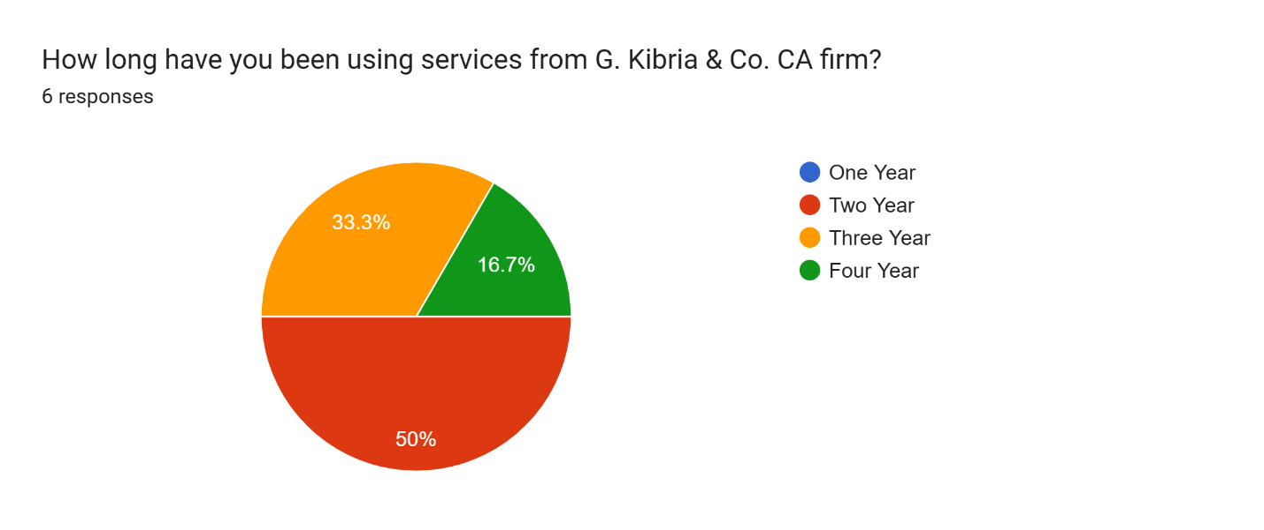
Figure 9: Survey Question -1
In this case, it depicts that 50% client utilized services in two years, 33.33% in three years. In contrast, four-year client was 16.7%.

- Type of Services Used from G. Kibria & Co.
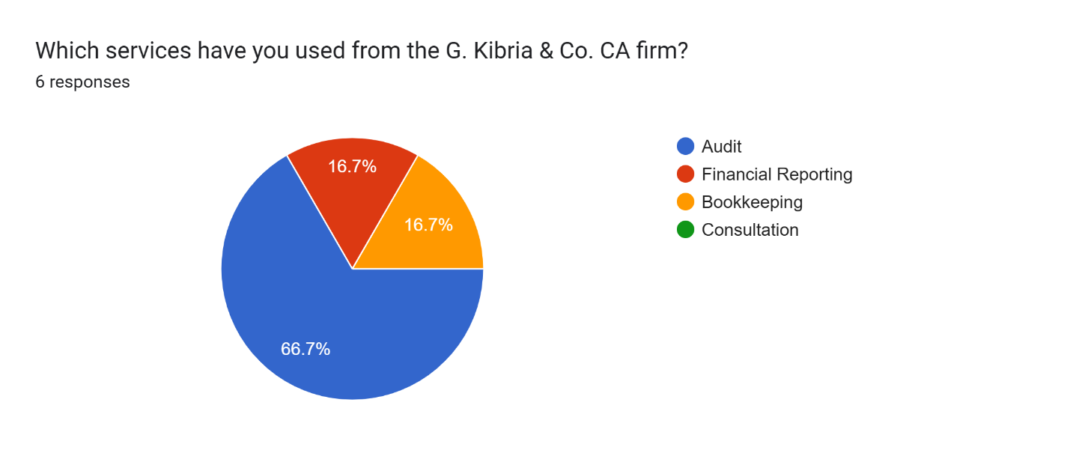
Figure 10: Survey Question - 2
Even with financial reporting and Bookkeeping service, the clients reached only 16.7%. However, nearly 66.7% client are availing audit service.

- Perception of Confidentiality in Handling Financial Data by G. Kibria & Co.
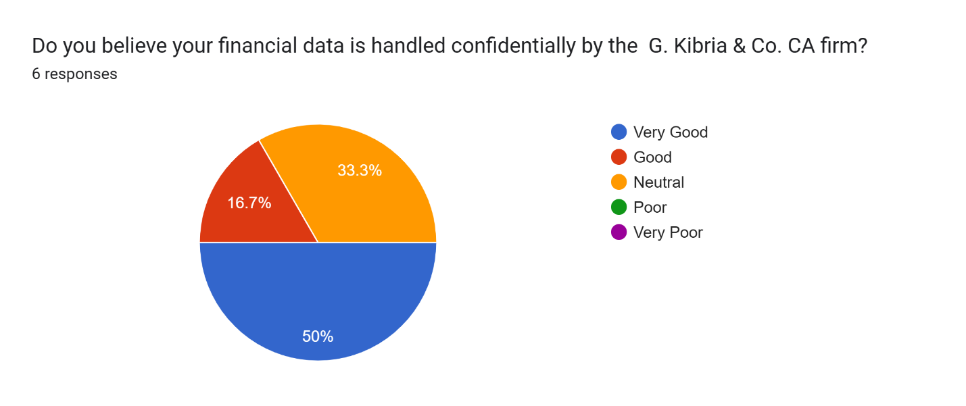
Figure 11: Survey Question - 3
Only 33.3% client neutral, 16.7% client feel good and 50% client percived very good.

- Client Satisfaction with the Professionalism of the CA Firm
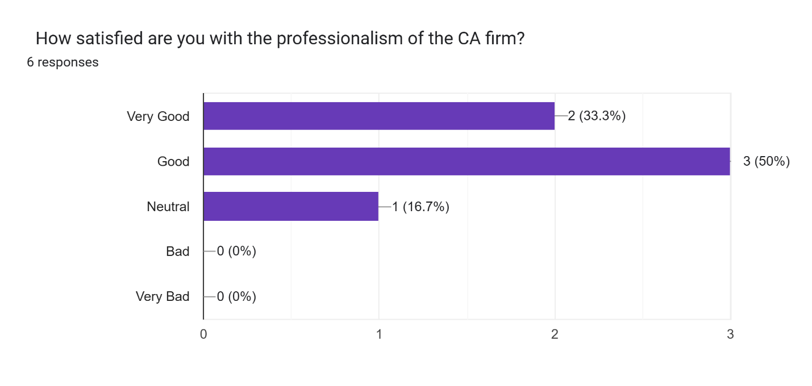
Figure 12: Survey Question - 4
Based on the survey, one can arrive at the conclusion that 50% client percived good, 33.3% client feel very good and the 16.7% client think it is neutral.
- Impact of Professional Accounting on Decision-Making
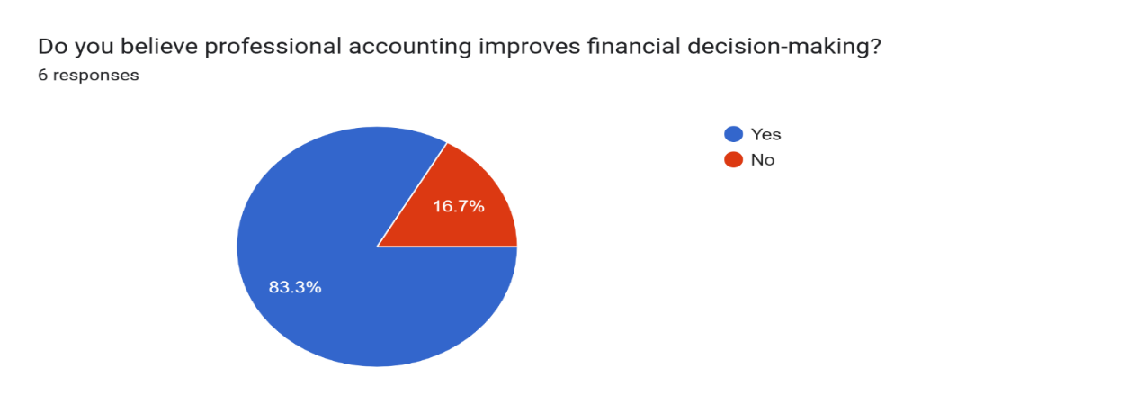

Figure 13: Survey Question - 5

Based on accounting professionalism, 83.3% client agree that professional accounting improves financial decision and 16.7% client has separate opinion.
- Preferred Accounting Software Used
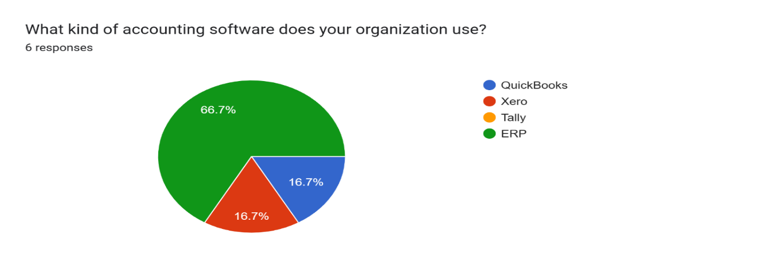
Figure 14: Survey Question – 6
Only 16.7% client use QuickBooks & Xero, remaining using is ERP.
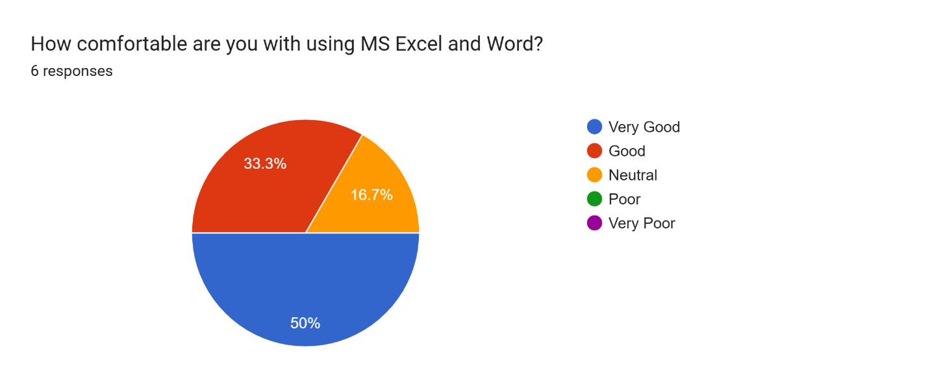
- Knowledge of Using Excel

Figure 15: Survey Question - 7
Here it shows that 50% client can use very good, 33.33% client are good. On the other hand, 16.7% neutral.

- Importance of Using Excel in Accounting Tasks
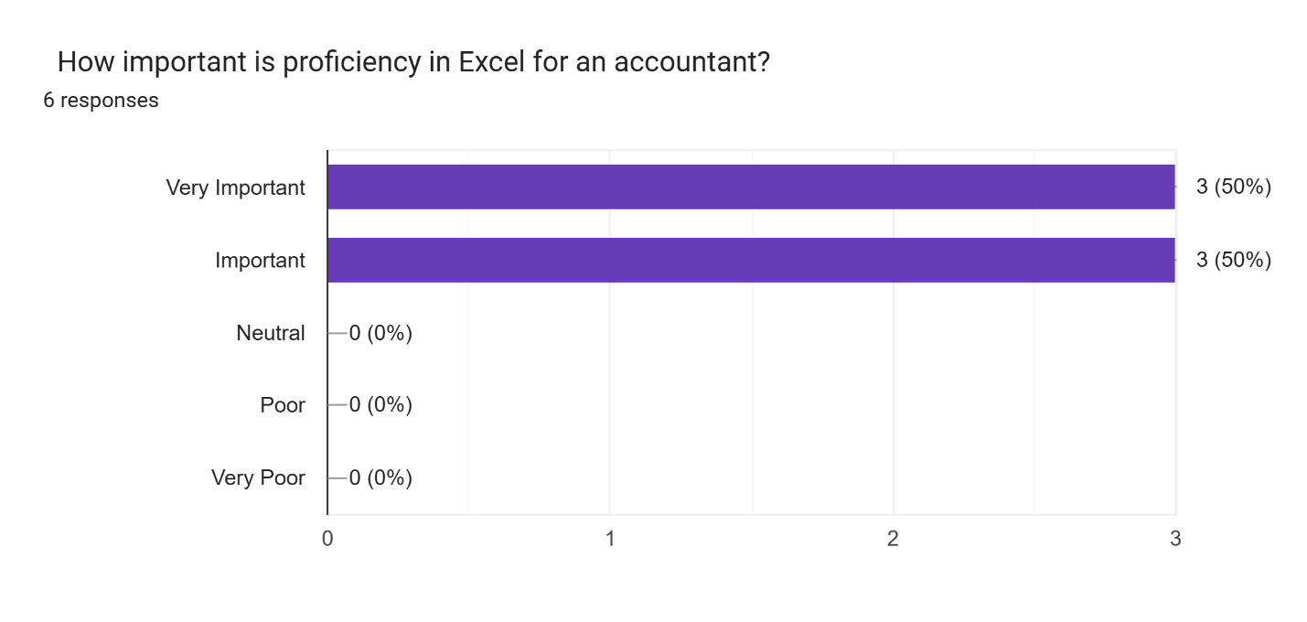
Figure 16: Survey Question - 8
Excel is very important for accounting that think of 50% & 50% think just important.

Summary of Client Feedback: The survey reveals that a majority of clients (83.3%) have been engaged with G. Kibria & Co. for up to three years, with audit services being the most utilized (66.7%). Clients generally perceive the firm’s confidentiality practices and professionalism positively, with over 80% expressing satisfaction. Most respondents believe professional accounting enhances financial decision-making, and while ERP is the dominant software used, Excel remains an essential tool, with half of the clients rating their Excel skills as very good.

Chapter 7: Findings & Conclusion

7.1 Findings:
In the analyses of the operations of a firm in terms of service provision, customer reviews as well as the professional ethics, G. Kibria & Co is strongly suggested to be a trustworthy and competent firm in Chartered Accountancy.
- The company has qualified and experienced personnel who are well trained in the matters of accounting standards, taxation regulations, audit practices and financial advisory.
- G. Kibria & Co. will provide individual solutions; personal attention to each client with his or her unique needs will be given.
- The company regularly finishes tasks in time and provides services that are accurate which allows the client to sanction regulatory charges and ensures proper financial management.
- Frequent communication with the clients and a prompt reaction to inquiry demonstrates commitment to provide transparency and trust by the firm.
- The use of modern tools and digital platforms allows the firm to accelerate the speed and security of service operations and to make the latter convenient.
- G. Kibria & Co. is very professional in terms of ethics and confidentiality, which leads to building confidence to the clients and long-term relations in business.

7.2. Conclusion:
G. Kibria & Co. is a well-established Chartered Accountant firm in Bangladesh in terms of providing high quality professional accounting services in those areas where the services are well needed i.e. audit, tax, accounting and financial consultancy etc. The firm has a workforce of service providers who are specialized and experienced to provide individual solutions to individual needs of the clients in its different industries.The company gives importance to accuracy, punctuality, as well as ethical conduct in each of its operations. Through incorporation of modern technology and excellent communication with the clients, G. Kibria & Co. guarantees effective delivery of services and long lasting client satisfaction. Its disciplined client service, regulatory compliance, and dedicated commitment to continuous improvement has made the firm a full service representative, a trusted advisor, and a long-term partner to corporate as well as individual clients.

Bibliography

G. Kibria & Co. Website (2025) https://gkibriaandco.com/
Global Management Network International (GMNI) (2024) https://www.gmni.com/find-a-firm
All Chartered Accountant (CA) Firms List. Institute of Chartered Accountants of Bangladesh (ICAB) (2024) https://www.icab.org.bd/page/all-ca-firms

