UNITED INTERNATIONAL UNIVERSITY


Internship Report
On
Strategic Marketing Practices Of Romask Limited

Submitted to
Muhammad Hasan Al-Mamun
Assistant Professor
School of Business & Economics
United International University
Submitted By
JoyontaBiswas
ID: 111 131 523
BBA Program
School of Business & Economics
Date of Submission: April 10, 2019

Strategic Marketing Practices of Romask Limited

Letter of Transmittal

To
Muhammad Hasan Al-Mamun
Assistant Professor
School of Business and Economics
United International University
Dhaka, Bangladesh

Subject: Submission of Internship Report
Dear Sir,
It is a great pleasure to submit my Internship Report to you as a part of my BBA program under your direct supervision on the topic titled “Strategic Marketing Practices of Romask Limited”. I am fortunate enough that Romask Limited allowed me to work in this reputed company independently. I got the opportunity to work in their marketing team for collecting various information and generating market insights. The provided information in this report is based on the data collect during my internship period through market visits, performing different job responsibilities and available sources. I tried my best to provide the appropriate information in the most meaningful and coherent way. I hope you will find the report very informative. If you need any clarification and/or explanation then I would like to assure you that I will be present for the desired clarification.

I would like to express my sincere appreciation and gratitude to you for helping me to prepare this report.

Sincerely Yours
Joyonta Biswas
ID: 111 131 523
BBA Program
School of Business and Economics
United International University

Executive Summary

The report is intended to focus on the strategic marketing practices of Romask Limited. Here I described the strategic marketing practices of Romask Limited. The report is mainly concerned with how they are segmenting the market, who are their target customers and how they are positioning their business and how they are striving to create value for their customers.

Romask Limited is a printing press company here they are printed the all kind of offset, art card and paper board. Most of the paper they purchase in local market of Nowa Bazar in Dhaka city and some paper they collect directly from manufacturing company like Bashundhora Paper Mill and Papertech Paper Mill.

The purpose of this report was to find out how RomaskLimited is involved in the strategic marketing process and conduct the required tasks, such as segmentation, targeting, positioning, and developing the marketing program.

Romask Limited identify that market segmentation makes it easier for marketers to personalize their marketing campaigns. . RomaskLimited is mainly focused on the big company as their target customer like Bank and Pharmaceuticals Company. They basically rely on word-of-mouth and personal sales as promotional efforts. They usually follow cost-based pricing strategy, calculating the unit cost and then adding a certain mark-up to that unit cost to determine the ultimate price to be charged. Distribution strategy is mainly based on direct distribution through personal salesmen.

Key Words: Marketing Strategy, Custom Printing Industry

Table of Contents
Executive Summary 4
- Introduction 7-9
- Organization Background 10-15
Industry Perspective 16-19
- Objective and Methodology of the Study 20-22
- Finding Of The Study 23
    - Segmentation……………………………………………………………………………………………………….…24-28
    - Targeting………………………………………………………………………………………………………………….28-30
    - Positioning……………………………………………………………………………………………………………….31-33
    - Marketing Mix………………………………………………………………………………………………………...33-34
    - Product…………………………………………………………………………………………………………………...34-35
    - Price…………………………………………………………………………………………………………………………36-38
    - Place…………………………………………………………………………………………………………………….….38-39
    - Promotion………………………………………………………………………………………………………………..…..40
- SWOT Analysis…………………………………………………………………………………………………………………….41
    - Strength….…………………………………………………………………………………………………………………….41
    - Weakness……………………………………………………………………………………………………………………..41
    - Opportunity………………………………………………………………………………………………………………….42
    - Threats………………………………………………………………………………………………………………………….42
- Recommendations………………………………………………………………………………………………………………43
- Conclusions…………………………………………………………………………………………………………………………44
- References………………………………………………………………………………………………………………………….45

Introduction

The topic is “Strategic Marketing Practices of Romask Limited. Here I described the strategic marketing practices of Romask Limited. The report is mainly concerned with how they are segmented the market, who are their target customers and how they are positioning their business and how they are striving to create value for their customers.

Strategic marketing is the way a firm effectively differentiated itself from its competitors by capitalizing on its strengths to provide consistently better value to customers than its competitors. In principle it’s simple, but it means a lot more than getting creative with the marketing mix. Armed with a thorough understanding of the firm’s capabilities and aspirations, the customer market and the competitive landscape, the goal of strategic marketing is to maximize a firm’s positive differentiation over competitors in the eyes of its target market. (Shane Davies)

According to the Philip Kotler “ Marketing Mix is the combination of four elements, called the 4P's (Product, Price, Promotion and. Place), that every company has the option of adding, subtracting, or modifying in order to create a desired marketing strategy” .

Segmentation, targeting & positioning (STP) is a strategic approach to modern marketing techniques and demonstrates a link between the overall market and how any business plans its marketing activities to compete in that market. Many times STP is referred to as a process where segmentation is developed initially, one or more target market is selected and then the positioning of the final product or service takes place. The overall purpose of STP is to guide the business to the planning and implementing a marketing mix program which is appropriate for both the company and the targeted group of people. The STP practice is very useful in the development of any company marketing. Communications plan as it allows the marketers to prioritize their propositions and then aim in delivering relevant and personalized messages so as to get intact with a different type of audience.

“The Marketing Mix is the set of tactical marketing tools --Product, Price, Promotion and Place--that the firm blends to produce the response it wants in the target market”. (Principles of Marketing(15e, Kotler and Armstrong, 2014)

Before launching the product we must decide the marketing mix for the target market. Here the following questions must be answered--
- Which product or what types of benefits consumer want from the products?
- What will be the price of our products?
- Should we go competitive price or penetration pricing or need to identify that how much money buyers are willing to pay for our products?
- How to reach the target consumer and select appropriate promotional strategy to inform people about our products?
All these things we need to analysis before launching the product. An integrated marketing framework must be developed clarifying the target market and the roles each of the marketing mix elements will play for creating the desired results.

Organization Background

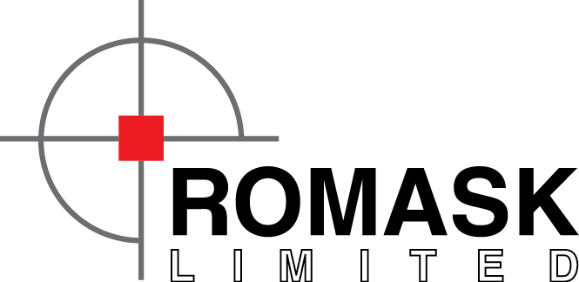

A pure Printing Solution

Romask Limited a Sister concern of Rangs Group. It was established in the 2nd may 1995. Romask is engaged in Offset printing of magazines, brochures, books, greetings cards, calendars, pharmaceutical packaging, annual reports for financial institutions, flyers, posters, business cards, Auto Carbon Items like challan book, Money Receipt, Gate pass all kind of auto carbon items we are made. Machinery includes 3 x Heidelbergs from Germany, 1 x Fuji from Japan, Roland Record from Germany, Praktika from Germany, Speed Master, Sord bi color and MO-Z-BI Color accompanied by lamination, cutting and binding machines. We also have our own generators for uninterrupted power supply. Vibgyor is the designing arm of Romask with state-of-the-art technology to provide our customers the best service at all times. We also have our own apparel sourcing house which specializes in men's, ladies and children's bottom items. Yearly turn is over more than 14 million.
Mission:
To provide the Best quality printing item inanpromised time.

Our Guiding Force
A staff member of 81 personnel supports the company efforts stated in the mission statement of the company. Everybody serves with cordial manners to our valued clients.

Among the technicians.some of them are top graded skilled performers in the printing and allied Sectors. With these resources they have fulfilled the requirements of their dignified clients and have great confidence in quality and efficiency in the service.
List of Manpower (Technical & Non Technical)

Chief Accountant 01 Person
Accountant 02 Person
Store Manager & others 03 Person
Factory Manager 01 Person
Production Manager 01 Person
Manager Sales & Marketing 04 Person
Supervisor (Q.C) 02 Person
Machine Man (Operator) 10 Person
Machine Assistant 20 People
Machine Helper 10 Person
Binder (Permanent) 07 Person
Binder (Casual) 20 Person

ROMASK has gota opportunity so far to serve as a printing company under the mentioned our GROUP of company. Renowned companies till date-
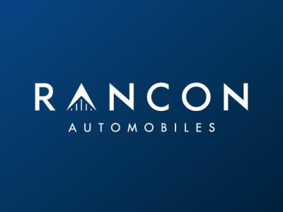
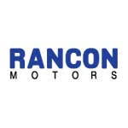


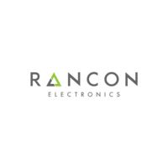

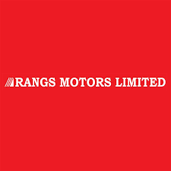

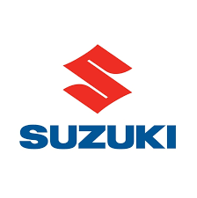
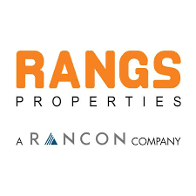




I would like to disclose here the names of our related esteemed Companies of Bangladesh:
1. Lafarge Holcim
2. International Beverage Ltd
3. ACI Limited
4. Incepta Pharmaceuticals
5. Gaco Pharma
6. Anondo Dhara
7. Dutch Bangla Bank Limited.
8. Sunlife Insurance
9. Mid land Bank
10. Prime Bank
11. Parkway Hospital.

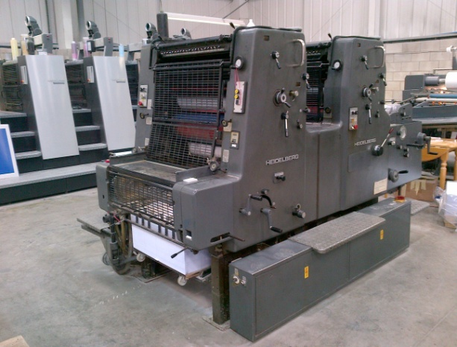
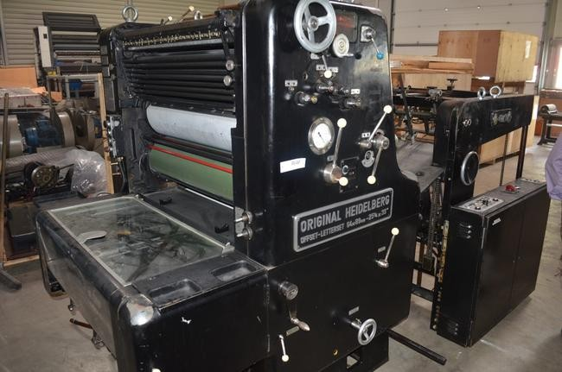
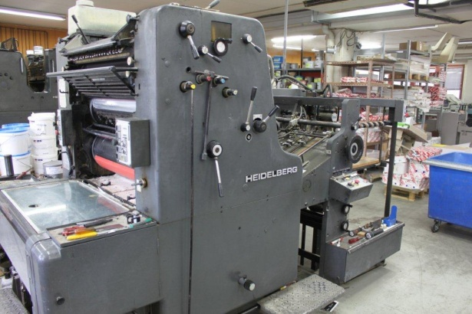
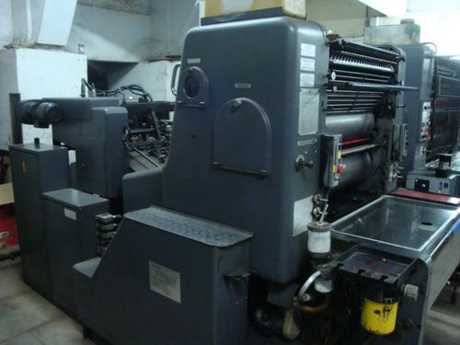
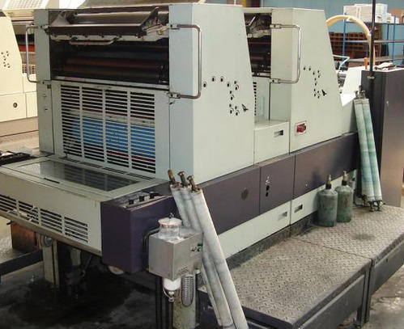
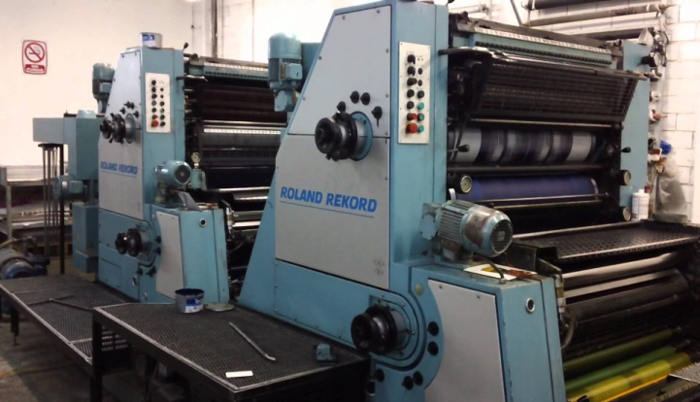

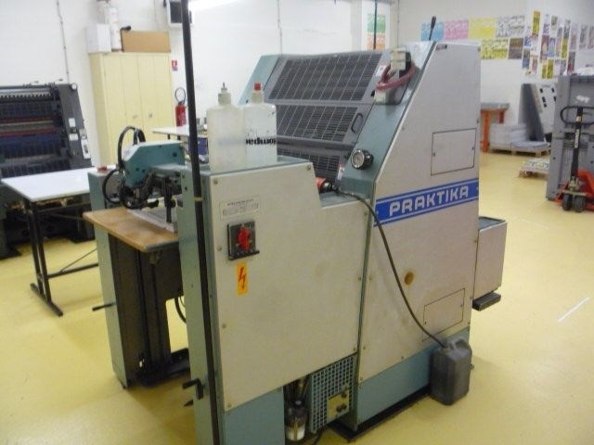

Industry Perspectives

Romask Limited is a printing press company here they are printed the all kind of offset, art card and paper board. They are print account opening form, deposit book, calendar and every necessary item for every Bank which they are used. For pharmaceutical company they are print journal, literature, medicine carton, show card and etc. for other corporate company they print brochure, different type of book, poster and etc. Romask Limited is mainly focused on the big company as their target customer like Bank and Pharmaceuticals Company.
Different type of paper is the main raw material of a printing press company. Romask limited purchases their paper from various sources. Most of the paper they purchase in local market of Nowa Bazar in Dhaka city and some paper they collect directly from manufacturing company like Bashundhora Paper Mill and Papertech Paper Mill. Other printing material they are purchase in local market. Before purchase the paper they prepare the comparative statement for the paper price. Here I show the paper consumption of the romask limited in a calendar year.
Description | GSM | UPC | Qty
Offset paper | 120,100,80,70,61,58 | 500 pages per Ream | 25000 Ream
Art card | 350,300,250,200 | 100 sheet Pack | 50000 Pack
Swidish board | 350,300,200 | 100 sheet Pack | 5000 Pack
Cromolex | 300 | 100 sheet pack | 20000 pack
Art paper | 200,170,150,120,115,100 | 500 pager per ream | 10000 pack
Auto carbon | 47 | 500 pager per ream | 3000 Ream
Ledger paper | 61,58,55,68 | 500 pages per ream | 2000 Ream
Craft paper | 120,100,90,80,70 | 500 pages per ream | 1500 Ream
Maniphol Paper | 61 | 500 pages per ream | 1500 Ream
Sticker paper |  | 100 sheets per pack. | 2000 Pack
Other |  |  | 1000 Ream
Roamsk Limited also uses the foreign Emboss paper, Black Paper and different type of special paper for their production on the basis of customer requirement.

Customer service process of Romask limited:

Romask sales team they collect the customer product requisition in physically or Romask customer provide their product requirement in mail and then romask try to check their product sample on that basis they make the primary costing of the product after complete the primary costing they add the profit into the primary costing after that they found the unit price of the product and Romask give the price quotation to their customer and then their customer give the Work Order with design for the product. When they get the work order they provide the proof file to their client for the approval. And when they are approving the design romask go for the final print and deliver the product.
There are lot of competitor for Romask Limited. There are more than 5,000 printing press in Dhaka city and they think every printing press is their competitor. List of their main competitor:
- Every printing press which are located in Arambag or Fokirapul.
- Bashundhora Printing press.
- Siddiq printing press.
- Print media
- Digital graphic press.
- Eastern printing press.
- Dina Printers.
- Brac Printers.

Romask always try to identify the inside information for their competitor. They always stay very careful about their competitor based on:
- Where they are buying their paper.
- How much does it cost them at quotes
- How they are target the customer.
- Follow the promotion activity
- What kind of product material they provide to their customer in low price.
Romask always provide the best service to their client.
- Romasak Limited tries to meet the needs of each of their customers.
- Whenever their client fell confused about to set the product requirement Romask sales person help them to determine the product's requirement. What would be better to use any kind of things that they share?
- They also help them to make the printing design.
- After the product is manufactured, they provide products at their client's workplace at their own initiative.
- Romask always try to work all kinds of small quantities or big quantities? They don’t say no for any work.

Objectives and Methodology of the Study

Origin:
The purpose of this report was to find out how Romask Limited is involved in the strategic marketing process and conduct the required tasks, such as segmentation, targeting, positioning, and developing the marketing program.

Objective:
I have chosen the Romask Limited (A sister concern of Rangs Grorp) because I am finished my Internship under this company. The objective of this report were
- To identify the business segmentation practices.
- To know how they are targeting there market and customer.
- To explain how they are using the positioningstrategy fortheir business.
- To evaluate the process of developing and executing the marketing program by clarifying product, pricing, place, and promotional strategy.

Scope:
While doing this report I will get to know the strategic marketing practice of Romask limited personally by working on this company. I get to know how important the segmentation is for the company, their target market, their market positioning and their marketing mix to improve their business. And how this company can achieved their business goals by formulating and implementing effective marketing strategy.

Methodology:

Primary Sources
I collected primarydata directly from the officials. I was working there as aninternso that I can know the every information for all department through personal interactions.

Secondary Sources
The sources of the secondary data include company’s website, text book and information from internet about the segmentation, targeting, positioning and marketing mix.

Limitations:

I have faced some limitations also. It’s a printing company.This organization runs their business in a traditional way because of that they don’t follow the strategic marketing practices in a standardized way. And as an intern of that company I can’t provide the all information for maintain integrity and ethical obligations to the company.
- Since they are not practicing the strategic marketing process in a standardized way so that it was difficult to describe the process clearly.
- I did not get any past marketing information of this company so that
I have to rely on my own interpretations.
- To protect the organizational confidentiality, some parts of the report will be edited.
- Most examples have been provided with imaginary figures to keep with the organizational rules.

Finding of the Study

Segmentation:
Market segmentation is the process of dividing a market of potential customers into groups, or segments, based on different characteristics. The segments created are composed of consumers who will respond similarly to marketing strategies and who share traits such as similar interests, needs, or locations.
Why is market segmentation important for Romask Limited?
Romask Limited identify that market segmentation makes it easier for marketers to personalize their marketing campaigns. By arranging their company’s target market into segmented groups, rather than targeting each potential customer individually, Romak can be more efficient with their time, money, and other resources than if they were targeting consumers on an individual level. Grouping similar consumers together allows marketers to target specific audiences in a cost effective manner.
Market segmentation also reduces the risk of an unsuccessful or ineffective marketing campaign. They think when marketers divide a market based on key characteristics and personalize their strategies based on that information; there is a much higher chance of success than if they were to create a generic campaign and try to implement it across all segments.
Marketers can also us segmentation to prioritize their target audiences. If segmentation shows that some consumers would be more likely to buy a product than others, marketers can better allocate their attention and resources.
To describe the steps of Market Segmentation in the Romask Limited point of view, the following narrative is will be useful.
Romask Limited this an company of paper printing press where they are printing many paper like, calendar, brochure, Book, pharmaceuticals printing item, The bank's press paper is the thing to do like account opening form, deposit book, annual report printing and many other paper related printing item this company are printed. The reason why they divided their business divisions and focus on all kinds of big companies printing things. In every established pharmaceuticals, Bank and other corporate houses, they print lot of things in every year. An established pharmaceuticals company they are spending almost 5crores taka in every year in there printing material. (This example is based on the RangsPharma) and every established Bank they are spending near above 4 to 5 crores taka in every year for their printing stationary. That’s why romask limited segmented their market in this type of company in Dhaka city. Because every company head office are located in Dhaka city.

- Identify the target market
Romask limited is very clear about their first and foremost step is to identify the target market. The Romask Limited is very clear about who all should be included in a common segment. They make sure the individuals have something in common. Like, this an offset paper printing company so they are segmented their business on Every Commercial Bank, Insurance company, Pharmaceuticals and many corporate Office because every company’s printing material is different. Romask they are not focused any individual company. The management is very clear on the target market and has separate strategies for product promotion amongst both the segments.
- Identify expectations of Target Audience
Once the ROMASK decide their target market, it is essential to find out the needs of the target audience. Their product must meet the expectations of the every single company. Their marketing officer, sales person interact with the target audience to know more about their interests and demands.
- Create Subgroups
Romask ensure their target market is well defined. They create subgroups within groups which gives effective results.

- Review the Needs of the Target Audience
ROMASK know that it is essential for their growth plan to review the needs and preferences of individuals belonging to each segment and sub-segment. The consumers of a particular segment must respond to similar fluctuations in the market and similar marketing strategies. They give suggestions according to the needs of all their clients. They try their best to fulfil all kind of needs and expectation of their client. Every time they provide the product sample to their client before thework order is given.

- Name your market Segment
It was very difficult to identify the name of market segment for the ROMASK because they are run their business in very traditional way. But in general they are basically targeting the business market, not the individual customer market.
- Marketing Strategies
The must devise relevant strategies to promote brands amongst each segment. Remember you can’t afford to have same strategies for all the segments. But in ROMASK point of view this kind of company can use one or more strategy at a time because this is an traditional printing press company. They make sure there is a connection between the product and the target audience. Their marketing efforts can be summarized below:

- Review the Behaviour
They need to review the behavior of the target audience frequently. They know very well that in every year the client demand and requirement is not same. But one thing is very different for this kind of company is their product demand is same but product requirement is not same. Because in every the Bank, pharmaceutical and corporate house, they are changing their product requirements. And that’s why ROMASK should study the details of their target audience.

- Size of the Target Market

The number of individuals in a certain market who are potential buyers and/or sellers of a product or service. Companies are interested in knowing the market size before launching a new product or service in an area. Romask limited is very clear about their market size. They try to do their businesses in all kinds of Commercial banks, pharmaceuticals, insurance companies and many big corporate houses. This kind of company purchases many printing items in every year. And ROMASK always try to create a big market for their businesses in the best possible means.

4 types of Market segmentation and how ROMASK segment with them:
There are 4 types ofMarket segmentation which are most commonly used. Market segmentation is one of the oldest marketing trick in the books. With the customer population and preferences becoming wider, and the competitive options becoming more available, market segmentation has become critical in any business or marketing plan. In fact, people launch products keeping the market segmentation in mind.
There are three ways to classify what the customer wants. It is known as

However, to decide the needs, wants and demands, you need to carry out segmentation first. And in segmentation, the first step is to determine which type of customer will prefer your products. Accordingly, that customer will be from your targeted segment. Who would want your product and whether it falls in the needs segment, the wants segment or the demands segment. Once you decide the product you are going to make, then you decide on the market segmentation.
There are 4 different types of market segmentation and all of them vary in their implementation in the real world. Let us discuss each of them in detail.
Romask Limited segmented their business on the basis geographical areas. They are doing their business only in Dhaka city and they target the corporate house those established in Dhaka.

Targeting:
What is a Target Market?
A target market is a group of consumers or organizations most likely to buy a company’s products or services. Because those buyers are likely to want or need a company’s offerings, it makes the most sense for the company to focus its marketing efforts on reaching them. Marketing to these buyers is the most effective and efficient approach. The alternative - marketing to everyone - is inefficient and expensive.
Six steps to defining Romask Limited target market

1. Understand the Customer Problems that Romask Solve
ROMASK Provide the printing solution to every company. Every Bank, Pharmaceuticals, and corporate housesprinta great bulk of materials and Romask offer them to provide the huge quantity printing item in the shortest possible time.

2. Paint a Picture of Romask Limited Target Customer:
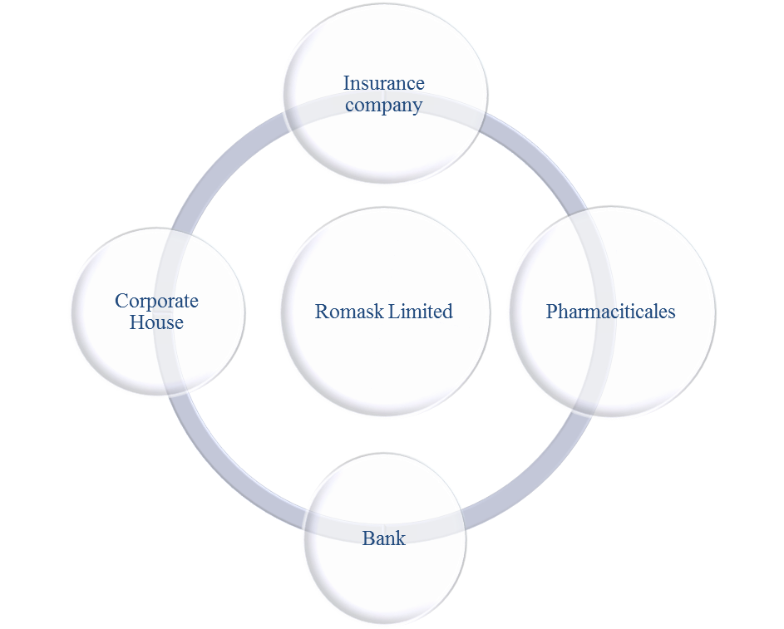

3. Which Specific Customers Will Benefit From Our Offer?
Romask Offer the printing materials of every company like bank they offer the Account Opening form, annual report, deposit book and many printing material which bank can use in there official purpose. In Pharmaceuticals Company they offer to print Show card, literature, journal, promotional item, insert and carton. In every corporate company they offer the brochure and leaflet etc. Romask ensure the every company that they have an enough capacity to print large volume of printing item.

4. Think About Mass Markets

Romask Follow the mass marketing, they target every big and small company. Romask know very well that every company has needed many printing material for their business purpose. And romask have an enough capacity to provide their printing item.

5. What Company Expertise Can You Offer?
One way of deciding on the right markets to pursue is to think about your business and its employees.
- Romask Limited has an 8 top class printing machine where they are print every type of paper printing items. And this company can run their business for last 23 year. And they have enough experienced machine man for printing.
- They have enough knowledge about printing and large volume of printing quantity.

6. Competitors
Romask Limited is very careful about their competitors. They thing every small and Big Printing press is their competitor. Like:
- Bashundhara Printing Press.
- Siddique Printers.
- Dina Printing Press.
- Print Media.
- Eastern Printing Press.
- Digital Graphics Design.
- Brac Printers.
These are some big competitors for Romask Limited.

Undifferentiated Marketing Strategy:
When we discuss differentiated and concentrated marketing strategies, it is also important to understand undifferentiated marketing strategies. Basically, in an undifferentiated marketing strategy, marketers use the same message for all segments of market. This is similar to mass marketing. Marketers typically create a message that appeals to everyone, so the message is often general or simple to allow more people to relate.
Romask Limited follows the undifferentiated marketing strategy. They use the same message for their entire target customer. They can print all kind paper for every company whatever their client want. This is a great advantage for Romask that and they can get a chance to work every type of company.

Positioning

Definition:

A marketing strategy that aims to make a brand occupy a distinct position, relative to competing brands, in the maid of the customer. Companies apply this strategy either by emphasizing the distinguishing features of their brand like what it is, what it does and how etc. or they may try to create a suitable image inexpensive or premium, utilitarian or luxurious, entry-level or high-end, etc., through advertising. Once a brand is positioned, it is very difficult to reposition it without destroying its credibility.Also called a product positioning.

7 Types of Market Positioning
Market positioning is the process of establishing and defending a valuable position for products and services relative to the competition. Positioning can encompass branding, advertising, promotion, pricing, product development, sales, distribution and operations. The following are common types of market positioning.

Customer Needs
In every company Identifying There targets customers and how they will fulfill a set of needs. This can include functionality and experience.
Romask can also identify their target customer and they have an enough capacity to fulfill their customer need. Romask have enough machinery and enough manpower for producing the large volume for printing items. Every Bank and pharmaceuticals company need more printing item for every year and Romask take the advantage and ensure them they have enough capacity and experienced to fulfill their need.

Customer Perceptions
Finding a way to capture the imagination of your target customer. Romask always look forward to give the highest value of their customer. They try to make a trust of their customer mind that they can produce the product in using the top class printing material and top class machine. And show the best work in their company.

Brand Recognition
Promoting basic visual symbols and information such that customer’s recognize you in a crowded market.
Romask Limited It is a sister concern of RANGS GROUP so it is their one kind of advantage to capture the new customer. But Romask always try to make company own brand value. And try to ensure every customer that they are capable for doing the large and small volume of work.

Pricing
Pricing is a primary form of competition. In many markets, the lowest price competitor with a reasonable level of quality tends to win.
In printing industry it was very difficult to set a price of the product. Every printing company they face problem for price setting. In market positioning Romask set their price based on the cost, customer based and most importantly competitor value based.

Quality
Often the only way to avoid intensive price competition is to offer a superior level of quality that your target customers strongly prefer.
ROMASK Limited highly promoting to deliver the best quality product to their every customer. And they can use this term in their market positioning. Every company must be want the best product for their suppliers and Romask ensure them they can provide the best quality product for their every customer.

Convenience
In market positioning ROMASK Limited very careful about their convenience service. They can collect the order by door to door service. They can provide the after sales service. They also offer the alternative option for every printing material and design. Their product order system is too easy. Customer can give the work order in mail.

Customer Service
Every company tries to provide the best customer service. A better customer service can improve company sales. Romask Limited provides the after sales service for their client. Whenever a customer fell confuse to use the material on their product printing Romask sales person give the product description and better solution for their problem and give more option for using what kind of materials they can use in their product
Marketing Mix
‘Marketing mix’ is a general phrase used to describe the different kind of choice organizations have to mare is the whole process of bringing a product or service to market. The 4Ps is one way probably the best known way of defining the marketing mix, and was first expressed on 1960 by ‘E. J. McCarthy’ in his Book.



The marketing mix definition is very simple, it is about putting the right product or a combination there of in the place, at the right time, and at the right price. The difficult part is doing this well, as you need to know every aspect of your business plan.

Marketing Mix 4p:
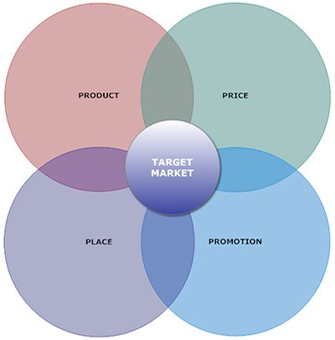

A Product is an item that is built or produced to satisfy the needs of a certain group of people. The product can be intangible or tangible as it can be in the form of services or goods.

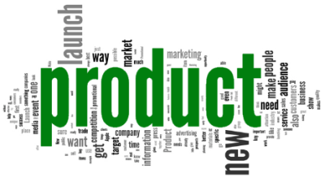

ROMASK LIMITED it is a goods provider company. It’s a commercial paper printing company so that they are producing many paper printing items. They print all kind of paper related item in every govt and non govt company’s. They produce the product on the basis of their client demands.

There are several steps that are to be seen by the ROMASK LIMITED before they produced the product:

- Romask Limited got a requisition or product requirement for their client.
- Romask give the price quotation to their client based on their product requirement or demand.
- When their clients approve their price they got a work order and design for that product.
- Romask take the approval of the product design of their client before go to the final print.
- Finally they print a complete product based on their client demand and deliver the product for their client.
Romask ensure the right type of product that is in demand for their market.
All in all in developing the right product Romask think something for how they offer a better product for their customer and client than their competitors.
- They try to give the 100% satisfaction for their client. In printing industry the company must provide the same product which printing sample is given by their client before the final printing.
- Can Client use this kind of product for their company business purpose?
- Is it possible to print the item based on their client demand?
- How can we ensure the quality of the product?
- Identity the difference between our product and our competitor product quality?
- What does the product look like?
- How could we ensure our printed product is better than others?
- Are there any necessary features that romask missed out?
- How can we brand our printing product?
- What is the most it can cost to provide and still be sold sufficiently profitably

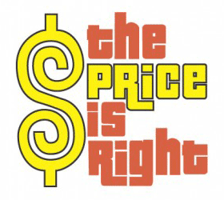

The price of the product is basically the amount that a customer pays for to enjoy it. Price is a very important component of the marketing mix.

It is also a very important component of a marketing plan as it determines your firm’s profit and survival. Adjusting the price of the product has a big impact on the entire
Marketing strategy as well as greatly affecting the sales and demand of the product.

Good pricing strategy helps you determine the price point at which you can maximize profits on sales of your products or services. When setting prices, a business owner needs to consider a wide range of factors including production and distribution costs, competitor offerings, positioning strategies and the business’ target customer base.
While customers won’t purchase goods that are priced too high, your company won’t succeed if it prices goods too low to cover all of the business’ costs. Along with product, place and promotion, price can have a profound effect on the success of your business.
ROMASK follows some strategy for set their product price which is given bellow:

Romask it’s an established printing press company. Before they set their product price they are follow some aspect which are related to their product development. In a printing press company their price setting system is different because they are doing their business in very traditional way. The method of determining the prices is a little more traditional.

Cost based pricing: Romask they are set their product price based on the cost. Here 1st they prepare the primary costing of their printing item. In primary costing they can analysis the price of paper, plate, print proof, print charge, binding, lamination, spot, foil, emboss, screen print, pasting, carring and delivery change. After that they can set the Vat, AIT and profit and complete the costing. And set the total price of the product.
Customer Value Based: Romask Limited sometimes set their price based on their loyal customer. There have some client like RangsPharma, Bank Asia, InceptaPharma and many more company who are print more product in this company and Romask treated them very well and provide the best quality printing. So Romask supply the product in their break even costing price. Because this kind of big company can take huge amount of printing item in Romask.
Competitive Based: Romask know very well that every day the market are more competitive. If they want to stay in market they must be compete in their competitor. That’s why romask limited set their price based on their competitors. It was very difficult in printing business to know the competitor price before set own product price. But romask Process department is more experienced and they can understand how much difference will be happen on the competitor price. Based on this assumption they set the price.
Pricing at a Premium: Romask Limited sets premium pricing in low quantity product.Because their printing charge is higher than the other small printing press. Romask charge the premium price in their concern company which under the RNAGS GROUP.
Penetration Pricing: Romask set the lowest price when they are given the 1st tender and big amount of tender in new company. Romask always try to take big amount of printing work. And that’s why they try to charge the low price for get the job.
Price Skimming: Sometimes they give the high price in the tender in some selective company. Because they know that company can take the revised price again and Romask can take advantage for giving the price quotation of the product. But it will be happen in very rare. Only 5% company can ask to give the revised quotation.
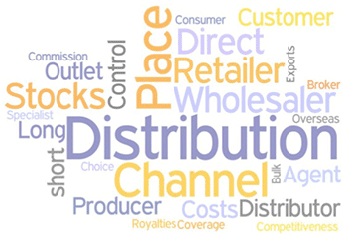

Placement or distribution is a very important part of the product mix definition. We have to position and distribute the product in a place that is accessible to potential buyers.
This comes with a deep understanding of your target market. Understand them inside out and you will discover the most efficient positioning and distribution channels that directly speak with your market.

Romask limited are doing their business in direct distribution.

They are using the direct distribution channel because they have no branch office and no strategic business unit. They collect the order from their customer and print it on their own press and after complete the product and deliver to their customer.

This is how ROMASK LIMITED completes the product and delivers to their customer.



Promotion is a very important component of marketing as it can boost brand recognition and sales.
Romask limited use the Personal selling option to promote their company personal selling is where businesses use people to sell the product after meeting face-to-face with the customer.
Romask sales team promote the product through their attitude, appearance and specialist product knowledge. They aim to inform and encourage the customer to buy, or at least trial the product.
Romask also want to make a good relationship with their target customer. So in promotional strategy they are use the public relation option to create a new customer and hold the existing customer. They provide the every kind of solution of their customer printing product, if any company can’t make the design they help them and create the printing design. They provide the information to their customer of what kind of material they can use in their printing item. ROMASK sales team provide the paper sample and other material to their customer so that they can select the best option to use in their printing.
Actually ROMASK LIMITED this is a printing company and they run their business in very traditional way in traditional business it was very rare to see the use of promotional strategy.
So it was very difficult to me to find out the promotional strategy and promotional activates ROMASK can use.

SWOT Analysis of ROMASK LIMITED:
During my internship and job time at Romask Limited I can find out their Strength, weakness of the business, Opportunity of their Business and identify their business threat. Here I am share the Strength, weakness, opportunity and threat of the ROMASK Limited.
Strength:
- They have enough printing machinery. They have total 8 big printing machinery those gives the high impression and ability to complete large volume of work.
- They have enough machine man for print. Over 60 machine men who are run their printing machine and complete other work.
- This company has an enough capacity to done the large volume of printing work.
- Romask Limited is belong to the sister concern of RANGS GROUP. So they can take the advantage of the brand value of RANGS and they can attract the big customer like Bank and Pharmaceuticals who are printed more paper printing item in every year.
- They are running their business in very legal way. And they have every legal document so that they can submit in company document in every company for the company enlistment.
Weakness:
- Their product price is high.
- No promotional activity.
- No investment in their business.
- Their machinery is too old.
- No sales and marketing team.
- They have no quality control officer.
- They cannot always provide the products at the right time.
- Their printing quality is very bad because of their old machinery.
- Their printing raw material is not always stay in their stock.
- Their raw material purchase or procurement system is too much lengthy.

Opportunity:

- It is a concern of RANGS GROUP so they can easily create the new outside customer and client.
- Their office environment is so well then other printing press. They have well established office and production house with modern facility.
- They have enough ability to do the large volume of printing work and they can easily target the big company.
- If they can create a good sales and marketing team they can extend their business.

Threats:
- Many company they are doing their office work in online they are not using or printed the paper printing item. And it was true that after 5 to 10 year later most of the company’s can doing their office task in online and everything will be paper less.
- Paper rate was increase day by day. That’s why the product price is not stable and ROMASK isn’t stock the paper.
- They have no sales and marketing team so that they can’t add with the other new customer and they can’t provide 100% satisfaction to their existing customer and they are failed to hold their existing customer.
- In printing business every company give the work for those company who are give the lowest rate in tender. But Romask always fail to compete their competitor in price because their price is too high then other printing company given. So Romask create a negative approach of their customer mind that they are never come into the lowest rate in tender that why they loss many customer.
- They are doing their business without market research.

Recommendations

For a long year I have been doing my job at Romask Limited. During my job time I have identify lot of problem of the ROMASK LIMITED.
- This is the sister concern of RANGS GROUP but they have no own brand Value.
- They have no sales and marketing team in their company.
- They have only 4 or 5 paper suppliyer and only one supplier on hand who can provide the other raw material of their printing. Because ROMASK buy their raw material on credit.
- The company owners of ROMASK LIMITED they are not invest money in this business.
- Their machinery is too old then other printing press. And many time romask fail to match the printing colour.
- They need to buy a 4 colour machine because of to live in the printing business.
- Need the quality control officer.
- They must reserve their printing raw materials in their company store.
- They must charge the low price in their product and they must try to make low costing rate in their primary product costing.
- Those who are work in ROMASK LIMITED company owner or managing director they must be give their employees to 100% right for make the decision.
- Market survey must be needed for ROMASK LIMITED.

Conclusions
This organization has a great opportunity to do the good business because they have an enough ability to service their client. They have enough machinery and enough machine men are work in Romask and they have the ability for do the big printing job. The most important advantage in company is they are belonging to RANGS GROUP and this group has good brand value in Bangladesh market. Romask can easily attract the new client for this group name. during my job time I have noticed their lot of problem if they want to stay in today competitive market they must be solve their problem as soon as possible. if any client is run way for their company that client will give a bad impression for the company.
- They must be build a sales team at list 3 or 4 member and one senior manager will be there who can monitor the sales team and especially who can strong ability to prepare a good primary costing of the product pricing.
- Immediately they will solve their machinery problem. Need to update their machinery and add the new 4 color printing machine.
- Try to make a competitive price costing of the product thinking of their competitors.
- Try to deliver the product in due time. Because always they are failed to deliver the product in due time.
- Lot of work they does it outside their company like binding, pasting, fowil, screen print, emboss if this thing they are do in their in-house that time they can reduce the costing price.
- The company owner and partner they must invest the money in the business because without invest you are not make the company bigger. And mostly give the full freedom for their employees for take the decision.
- In every year this company have use lot of paper for their production so they must try to purchase the paper in import. If they do so, then the paper will be able to buy it at a lower price.

- Promotion activity is the most important part of a company to promote them to other company. They must focused the promotional activity for their company for attract the new client.

References:
- Google
- https://www.goodreads.com/book/show/74280.Principles_of_Marketing
- https://www.worldsupporter.org/en/chapter/41634-summary-principles-marketing-kotler

F. Piercy David W. Cravens & Nigel (2014-2015), Strategic Marketing (Ninth edition) McGraw-Hill International edition.
- E. J. McCarthy Marketing Mix Definition.
- Romask Limited Official Document.

