

Internship Report
On
“Factors employee has faced during the recruitment and selection process in Genuine Technology & Research Limited’’



Internship Report
On

“Factors employee has faced during the recruitment and selection process in Genuine Technology & Research Limited’’

Submitted to
Yeasmin Islam
Assistant Professor
School of Business & Economics
United International University

Yeasmin Islam Assistant professor
School of Business & Economic United International University

Yeasmin Islam Assistant professor
School of Business & Economic United International University

Submitted by
Md. Zakaria Khan
ID: 111 151 584

Yeasmin Islam Assistant professor
School of Business & Economic United International University

Yeasmin Islam Assistant professor
School of Business & Economic United International University

Date of Submission: 02nd June, 2021

Letter of Transmittal
February 27, 2021
To,
Yeasmin Islam
Assistant Professor-Management
School of Business & Economics
United International University

Subject: Submission of Internship Report on “Factors employee has faced during the recruitment and selection process in Recruitment & Selection Process of GTR”.

Dear Madam,
Here is my internship report on "Factors employees encountered during the recruitment and selection process in GTR's Recruitment and Selection Process: A research paper on Genuine Technology & Research Limited has been assigned as a partial requirement as part of the Bachelor of Business Administration course (BBA). This training gave me the opportunity to connect my hypothetical data to company culture. As far as dependability goes, I've compiled what I believe to be the most relevant statistics. I did everything I could to make this report a success. Any flaws may appear as a result of my blunders. I was hoping you'd forgive me for my blunders.
Therefore, may I want and hope that you will evaluate my efforts and, as a consequence, cooperate.

Sincerely Yours, …………………………… Md. Zakaria Khan
ID-111 151 584
Program-BBA

Student Declaration

I’m Md Zakaria Khan undergraduate (UIU) United International University BBA (Bachelor of Business Administration). I hereby declare that I accomplished the research and the entire report under the supervision of Yeasmin Islam, Faculty of Business Administration, United International University, on "Factors employees faced during the recruitment and selection process in GTR: A Research on Genuine Technology & Research Limited" (UIU).

Md. Zakaria Khan ID-111 151 854
Program-BBA
Major in Human Resources Management

Acknowledgement

Due to the fact that the effort used on this report is little in compared to the immense barriers we face in our professional life, I am pleased to say that I worked incredibly hard to ensure that this report accurately depicts my time as an intern at Market Access. To begin, I would want to express my gratitude to God for enabling me to successfully complete my internship program.
Second, I'd want to express my appreciation to those who stood by my side as I prepared this work. I'd want to convey my appreciation to my internship professors for their unflinching support, which enabled me to complete my research work.
Finally, I'd want to convey my appreciation to everyone at Genuine Technology & Research Limited for assisting me in numerous ways as a more junior intern and for their steadfast support, without which this report would not have been completed. It was a delight to work with the planning team, who generously contributed their knowledge and expertise.

Executive Summary

This report is set up on the complete insight and information that has been assembled through the temporary position program offered by GTR. The report starts with the presentation of GTR and its functionalities. It at that point proceeds onward to the different activities that have been taken part in and the learnings that have been figured out how to accumulate from them. The report covers the information that has been gained from this undertaking as an understudy. In this report talked about GTR how runs its recruitment cycle. In this report, capacities, and guidelines of enlistment arranging, their deficiencies are uncovered which are drawing them, over and over, have been clarified and a few suggestions are given which may likewise assist with improving their situation. In Recruitment and Selection Process, the CV assortment method of GTR and CV shortlisting measure have been clarified. Additionally, the full interaction of choosing an applicant has been portrayed. The real undertaking mirrors whatever has been done and continued dependably in the Genuine Technology and Research Limited during the temporary job time frame. My genuine assignment and exercises show the exercises and level of learning. Moreover, the report likewise gives an impression of the proposal's method of GTR that can perform better and make a significantly more grounded maintainable future for themselves and their employees.

Table of Contents
1. Introduction 9
1.1 Background of the Report: 9
1.2 Rationale of the report 9
1.3 Scope of the Report: 9
1.4 Objective of the Report: 10
1.4.1 Primary Objective: 10
1.4.2 Secondary Objective: 10
1.5 Methodology: 10
This study followed a structured process from topic selection to final report preparation. 10
1.5.1 Sources of data: 10
1.5.1.1 Primary sources: 10
1.5.1.2 Secondary sources: 11
1.6 Limitations of the Report: 11
2. Literature Review 13
3. Organization Part 17
3.1 Background of the Organization: 17
3.1.1 Corporate Information: 17
3.1.2 Corporate Governance: 19
3.1.3 Organization Organogram: 19
3.2 Recruitment & Selection process of GTR: 21
3.3 Sales & Marketing: 21
3.4 Source of Advertisement uses for CV collection: 22
3.4.2 Campus Recruitment: 23
3.4.2.1 Independent University Bangladesh (IUB) Job fair: 23
3.4.2.2 United International University (UIU) job fair: 23
3.4.2.3 Basis soft Expo 2020: 23
3.5 GTR Recruitment Process & Selection process: 23
4. Analysis and Finding 27
Findings of the Report 34
5. Recommendations and Conclusion 36
References 39
Appendix 41

Chapter-1 Introduction

1. Introduction

1.1 Background of the Report:

All undergraduate BBA students at United International University are obliged to participate in an internship. Students must complete an internship program and work as an intern in a business to receive a bachelor's degree in business administration. As a result, for my internship, I chose "Genuine Technology and Research Limited" and worked as a human resources intern there for three months. Hands-on instruction is included in this internship..
The major goal of an internship application is to get a student acquainted with the working environment. The most crucial responsibility for interns is to apply theoretical concepts to real-world situations. The goal of the internship was to learn about human resources-related job practices while also getting a sense of the organization's culture.
The paper, titled "Factors employees encountered during the recruitment and selection phase in the Recruitment and Selection Process of GTR," was submitted to Yeasmin Islam, (Assistant Professor) of United International University's school of business and economics. This study was submitted by Md. Zakaria Khan, a student enrolled in United International University's internship program. Submission is scheduled for February 2, 2021.

1.2 Rationale of the report
All companies must have a recruitment and selection process. The primary objective of this report is to demonstrate the critical nature of these two positions in every organization and to integrate theoretical concepts with practical work experience. The efficiency of any company can be enhanced by recruiting and employing the best employees. As a result, an organization's recruitment and selection processes are vital to ensuring that it hires only the best employees.

1.3 Scope of the Report:

This thesis is entirely focused on observations made while interning at Genuine Technology and Research Limited for three months. GTR demonstrated accurate knowledge and information regarding this topic. There is an opportunity to observe the actual situation since both the study subject and the GTR HR are present.
• Applicable in a real-world environment.
• Aids in the application of what we study in Academy to real-world situations.
• Acquired skills in successful communication with a coworker.
• Assists in comprehending authentic business culture.
• To gain exposure to the real business world.

This study is the culmination of a three-month internship application conducted in GTR and prepared as a prerequisite for the BBA application at United International Business School. As a result, this record was created based on the "Factors an individual encountered during the recruitment and selection phase in the recruitment and selection process."

1.4 Objective of the Report:

Based on primary & secondary objectives this report has been prepared. These are given below -

1.4.1 Primary Objective:

The primary objective of this study is to complete the bachelor's degree in business administration and obtain real-world experience. As an HRM major, I was fascinated with how an organization's human resources department operated.

1.4.2 Secondary Objective:

• Is concerned mainly with the recruiting and selection process.
• Describe the GTR hiring process and the associated activities.
• To impart a thorough understanding of the field of human resource management and commercial business employer selection.

1.5 Methodology:

This study followed a structured process from topic selection to final report preparation.

1.5.1 Sources of data:

Both primary and secondary sources of data for the report has been used.

1.5.1.1 Primary sources:

- Observation and insight into organizations gained while working in the human resources department.
- Interacted Interacted. with supervisors and subordinates to collect data.
- Attended numerous job fairs to gather information.
- Participated in various short session programs offered by GTR, which assisted in the data collection process.

1.5.1.2 Secondary sources:

- GTR website
- Yearly Review of GTR
- Different books, newspapers, journals, and data, etc.

Methods of data collection:

- Observations: Data were gathered by observation. To collect data, the company's personnel and environment had to be studied, as well as the candidate who sat in on the job interview. These factors influenced the collection of data.

- Documents and Records: Throughout the internship, various GTR documents and records were checked, and some GTR documentation was prepared. These variables greatly helped in the data collection process.

- Oral histories: Various pieces of information about GTR were gathered during my internship at GTR by department colleagues. They informed me of GTR's history. These factors helped in the collection of data.

1.6 Limitations of the Report:

The following are the study's limitations:

These constraints originated on a personal and organizational level. The following restrictions applied:

- Budgeted Time for the research: Collecting all of the requisite data in such a short period of time is extremely difficult.

- Data Insufficiency: Though officials attempted to assist, their hectic schedules hindered them from providing me with the assistance required for the report. The organization's website, too, is devoid of content. If this restriction had not existed, the research would have been more valuable.

- Personal Limitation: Because of the covid-19 pandemic, there was a gap. Employees were allowed to complete official tasks via the internet this time (work at home).

Chapter-2 Literature Review

Literature Review

Human resource planning is the mechanism by which a business determines the number of workers it requires. They recruit both high-quality and large-quantity employees for their company. Human resource planning enables businesses to attract and retain both high-quality and quantity staff. The human resource planning process ensures that the requisite number of workers is maintained, avoiding both a manpower surplus and a shortage. From a human resource management perspective, the primary most critical and challenging human resource management strategy for achieving organizational goals is recruitment and selection strategies, since the outcome of recruitment and selection strategies can be extremely efficient for an organization if the right person is chosen id with the right skill mix, but they can also be extremely ineffective if the wrong person is chosen with the wrong skill mix.

Recruitment is the method of id identifying. qualified applicants for current or expected organizational openings (De Cenzo and Robbins 1999). The recruitment process is ongoing in order to balance the organization's and candidate's demand and supply for vacant positions. To choose the best applicant, various companies employ a variety of different methods, depending on their business position, company size, and candidate availability.

Employee recruiting is a method in which. work requirements, organizational attributes, and applicant skills are matched. (1998, Tilly and Tilly). Essentially, businesses conduct recruiting processes to identify the most qualified applicants who can contribute the most to the company's achievement of its objectives.

Recruitment refers to the processes and operations undertaken by a business with the primary objective of locating and hiring new employees. (1998, Barber). Selecting the best candidates is a difficult task for businesses, and to accomplish this, businesses employ various processes such as screening, identifying, and interviewing in order to select the most qualified candidates.

Human resource planning is the act of recognizing and balancing possible employee requirements. They'll figure out how many workers will be needed in the future. a year ago (Jonathan Rice). A company's potential demands and employee needs must be determined first, and then a proper incentive and training program must be developed to ensure that employees are successful in their given jobs.
To address future issues, organizations should execute human resource planning effectively. (along with N. e., 2003). Human resource planning ensures that staff and positions are a good match while preventing manpower shortages or surpluses. Labor supply, predicting labor demand, matching expected labor demand with supply, and promoting organizational priorities are four critical steps in the HRP process. Firms do maintain cohesion between these processes in order to address possible issues.
This research discovered that without adequate human resource planning, organizations cannot achieve their objectives. Organizational capital contribute to sustainable growth and development of various organizations, with workers possessing a variety of skill sets, talents, and expertise. (2011) (W.G). The primary practice in human resource management is human resource planning. Human resource planning is critical for businesses who believe workers are an integral part of the organization; as a result, businesses pay close attention to the HRP process and make every effort to identify and hire the best candidate.

When an organization is able to id prepare effectively, it aids in the achievement of the organization's goals. Thus, organizations collect data for goals and objectives first, and then organize personnel, resources, and competencies necessary to achieve those goals and objectives. (2011) (Gopi Krishan). To determine the human resource priorities of organizations and agencies and to adapt to evolving and newly emerging environmental trends, organizations must identify and review their corporate objectives and prepare government documents such as budget speeches and other necessary documents such as strategic and business plans.
For any business, the human resource function is critical, and the HRP process enables the human resource function to function correctly, such as providing accurate and timely information on when to conduct employee recruitment and saving the company additional costs. (2012) (Dwevedi). In every organization, the human resources department is critical in terms of identifying the best candidates, recruiting, training, encouraging, and streamlining processes. Additionally, by implementing an efficient HRP strategy, businesses can save money by removing or minimizing external training, restricting non-essential expenses, updating total compensation plans, freezing non-essential HR projects, recruiting a temporary workforce, tracking and limiting overtime, and redistributing work internally.

Human resource management practices support organizational goals, which are realized by strategic strategies implemented through training and growth. This enables companies to increase employee profitability. Recruitment and selection for an enterprise that is following an HRM strategy in one organization. (ibid., 2009). Human resource planning considers the organization's whole set of standards, as well as the management processes, policies, and resources necessary to satisfy those criteria. All human resource operations are built on the foundation of human resource strategies.

Chapter-3
Overview of the Organization

Organization Part

3.1 Background of the Organization:
Genuine Technology & Research Ltd. (GTR) is a software development and automation technology firm situated in the Bangladesh. They helps organization accomplish their vital technologies by providing services such as IT solutions, market growth consultancy, and industrial systems. GTR (Genuine Technology and Research Limited) was created in 2005. It develops software for enforcing laws in new marketplaces.

3.1.1 Corporate Information:
Genuine Technology & Research Ltd.'s corporate details, including relevant staff and numbers, are summarized below...

Table 1: Organization Information

Particulars | Information’s
Company Name | Genuine Technology & Research Ltd.
Founded | In 2005
Services are | - Apparel CAM & CAD  - CCTV System & solution  - Fire Safety Solutions  - Software Solutions  - Biometric Solutions  - Power Backup Solutions  - Public Addressing System  - HQA Light (sister concern)
Corporate Dhaka Branch | Uttara-HM Plaza, Suite: 01 for 9th floor & Suite: 05 for 11th floor, Sector: 03, Uttara,  Dhaka-1230
Company Logo
Website link | http://www.gtrbd.com/
Main office | GT Tower 113, High-Level Road, Wasa Circle, Lalkhan Bazar,  4203-Chittagong
Numbers,of Employees | 65
Top Corporate Clients | - Unilever  - BSRM  - KSRM  - Square  - Abul Khair  - 4H group and many more
Competitors are | - Prime Asia Ltd.  - MAS TECH WINDA Technology Ltd.  - Best tech

3.1.2 Corporate Governance:
Corporate governance refers thathow businesses are managed and driven. Corporate governance establishes a positive relationship between the company's management, shareholders, board of directors, and the priorities that are regulated.

3.1.3 Organization Organogram:
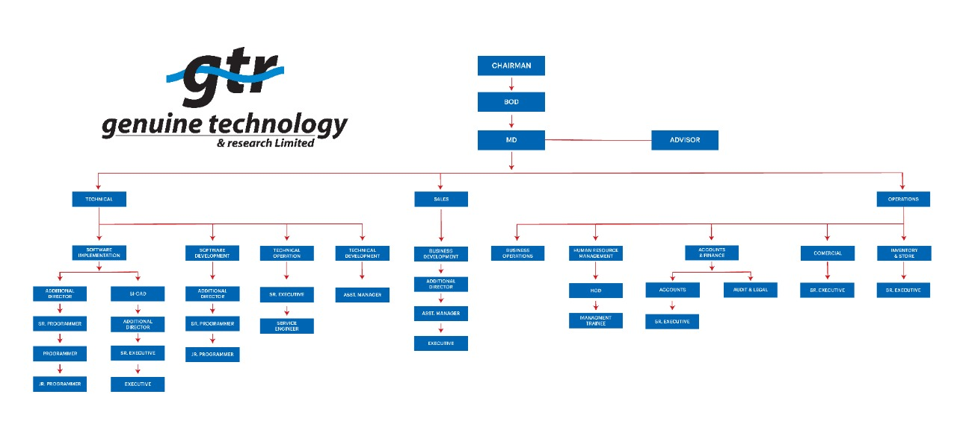

3.1.3 Products & Solutions of Genuine Technology & Research Ltd.
GTR develops products thatare aligned with the goals of its clients. GTR aims to build long-term relationships with its customers in order to deliver the best possible service and products. Some of the products and services available are as follows:
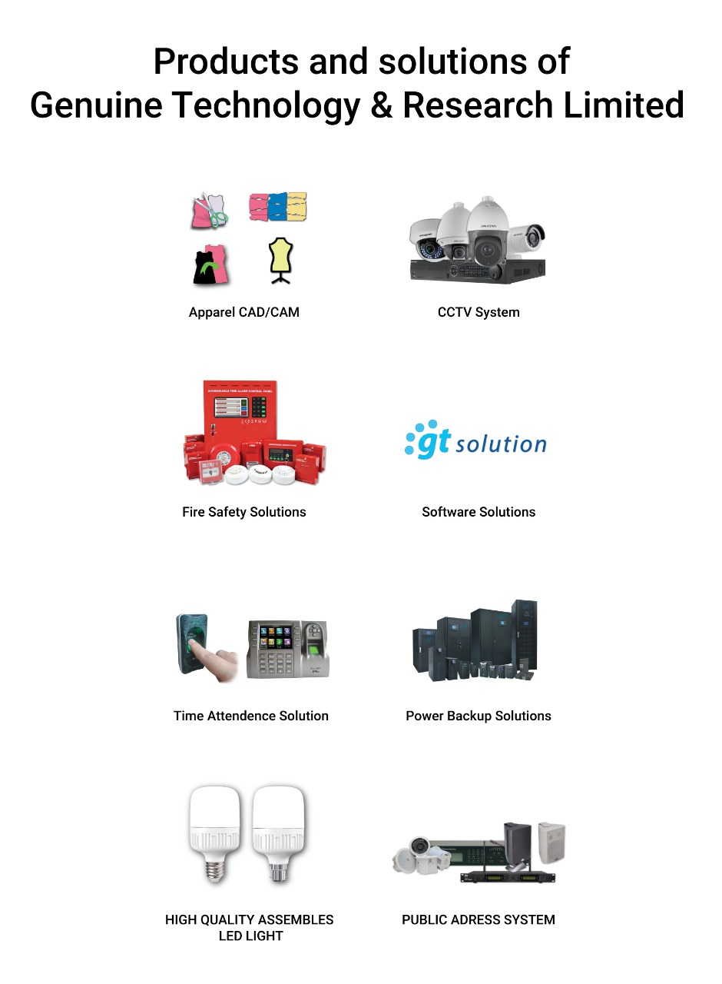

3.2 Recruitment & Selection process of GTR:

GTR's recruitment process is a fantastic experience. First and foremost, an internal survey of GTR's employee recruitment and selection process was conducted.

Analysis of the job:
At first GTR analysis their job. They gather information for a job, such as roles and responsibilities, necessary skills to perform a job, physical and mental effort to perform a job, working conditions, and atmosphere for a job, through the job analysis process.
Description of the job:
A job description is an organized, factual statement of the duties and responsibilities of a specific job. In brief, it should tell what is to be done, how it is done, and why.
Specification of the job:
A job specification is a statement of minimum acceptable human qualities to perform a job properly.
(Job analysis, description, and specification will be prepared by HOD/HR Officer with Management approval.)

3.3 Sales & Marketing:

When GTR lookingfor candidates for their business, they have a few requirements. For the post of Sr. Executive/Executive – Sales & Marketing (Apparel CAD Sales) GTR job context is they look for some honest and hardworking employees. Candidates have to be experts in products and service sales. Employees who joined in the sales and marketing sector have to maintain good client relationships to meet the target sales.
Relevant experiences are:

      - Should have knowledge of Garment's Machinery and Apparel CAD Software.
      - A thoroughly good relationship with customers to increase the market share.
      - Employees should have the ability to work under pressure.
      - Maintain awareness and keep abreast of constantly changing software, hardware systems & peripherals.
      - Ability to maintain positive business relationships to ensure future sales.
      - Ability to achieve sales targets and outcomes within deadlines.
      - Strong communication skills in English & the Bengali language.
      - Ability to apply time-effective and cost-saving solutions.

For this role, GTR is looking for a full-time candidate. BBA/MBA (major in Marketing) or B. Sc in EEE are the educational requirements for this position. Freshers are welcome to apply. Candidate must have have 2-3 years of experience. Experience in the related field is needed. The candidate's age should be between 22 and 28 years old.

3.4 Source of Advertisement uses for CV collection:

At the preliminary stage, HR has to collect CVs from different sources. The following process is followed to amaze CV:
Employee Vacancy, add in-

- GTR website.
- LinkedIn page.
- Facebook page.
- Different job fair.
- HR outsources.
- Official Email.
Source of recruitment: In GTR two are three sources of recruitment

Source of Internal recruitment:

      - Company’s own website.
      - Placement consultants.
      - Employee reference.
      - From internship student.
      - The employee of Relatives.

Source of External recruitment:

      - Advertisement in the newspaper.
      - Campus Recruitment.
      - Notice Board.

3.4.2 Campus Recruitment:
As an internee, an employee recruitment responsibility in GTR was availed to me. From the very beginning of hiring an employee in GTR required my involvement was spontaneous. This was a great achievement in my internship. Moreover, in campus recruitment my involvement was greatly appreciated by the GTR personnel.

3.4.2.1 Independent University Bangladesh (IUB) Job fair:

On 11th Feb 2020 in IUB a job fair was attended by me. The fair was started at 10.00 AM. finished at 4.00 P.M. My duties were to represent GTR and collect CV from fresh graduate & interested candidate. Those who come to drop CV in GTR stall had been explained about GTR, GTR job responsibility, job vacancy, and so on as a GTR representative.

United International University (UIU) job fair:

Secondly, a job fair at UIU took place for 2 days on 24th February & 25th February 2020. In UIU job fair my role was as a GTR representative and UIU middle person between two parties to make a millstone in the program. In this job fair, everything about GTR work environment and working facilities were explained by me to UIU students to make them interested in GTR. Here the response from candidates was spontaneous & overwhelming and had been able to collect most of the CV. This was the most successful program to represent GTR and CV collection programmed.

Basis soft Expo 2020:

Basis soft expo 2020 in ICCB was also attended by me. My learning in this fair was tremendous on how to gain competitive advantage for the GTR.

3.5 GTR Recruitment Process & Selection process:

At the first, CV of fresh graduate and experience are sorted out and then they are called
out through text, to participate in interview according to the job descriptions.
GTR Recruitment & Section process at glance:
Step 1: Recruitment Need Assessment and generate memo.
Step 2: Collecting CV

Step 3: CVs are sorted into categories based on their aspect.

Step 4: 1st direct interview for experienced/1st written test for freshers.

Step 5: 2nd interview for experienced/ 1st viva for freshers.

Step 6: 3rd interview for experienced/ 2nd viva for freshers.

Step 7: 3rd viva for freshers

Step 8: Give Presentation both freshers & experienced.

Step 9: Initially selection of candidate.

Step 10: Finally, negotiation with the selected candidate.

Step 11: Provide joining letter.
Submit for approval by management.

- For the fresh graduates – Candidates arecalled for a written exam. Candidates passing the written exam arecalled for the viva. Those who selected in viva. The top management gives them a presentation. Candidates are provided with the necessary follow-up regarding the presentation. When they come up with a presentation, they are sent to top management and those candidates get selected based on their performance. Appointment letter given by HR department.
- For the experienced – Firstly, candidates are called for aninterview. Those which candidates are selected in the interview top management gives them a presentation. Candidates are provided with the necessary follow-up regarding the presentation. When they come up with a presentation, they are sent to top management and those candidates get selected based on their performance. Appointment letter given by HR department.
During the recruitment process, documentation for candidate and employees were prepared by me.

Documentation: In the internship period few official documentations has been prepared by me. For instance, documents for new intern & their job description for all departments, BD, HR, Inventory, Commercial, CAD, SD, SI, Account, and their entry and exit procedure have been developed. In addition, inquiries from FLS, CAD, and the operations department were collected, and documents were prepared for the candidate rules regulation procedure.

Chapter-4
Analysis and Finding

Analysis and Finding

Descriptive Analysis:
The research attempts to identify the “Factors employee has faced during the recruitment and selection process in Recruitment & Selection Process of GTR”. To conduct the research primary and secondary sources of data is used. Primary data are collected using a questionnaire. 15 Question were prepared and 20 HR Official were selected as a respondent. Out of 20 respondents, 17 respondents were male and 3 respondents were female. Then made a table with the result.
A structured questionnaire in a 5-point scale was developed for the recruitment & selection process of GTR. A five-point scale ranging from 1 to 5 with 1 indicating strongly disagree and 5 indicating strongly agree was used in this regard
However, the table is not very informative so to come up with the conclusion some pie chart has been Created.

Question no. | Particulars | Strongly disagree |  | Disagree |  | Neutral |  | Agree |  | Strongly Agree
Question no. | Particulars |  | % |  | % |  | % |  | % |  | %
1 | The job description was clear and understandable. | 3 | 15 | 0 | 0 | 6 | 39 | 0 | 0 | 11 | 55
2 | Recruiter at this organization is professional. | 1 | 5 | 0 | 0 | 5 | 25 | 3 | 15 | 11 | 55
3 | Recruiter explained the details of the job clearly. | 0 | 0 | 0 | 0 | 3 | 15 | 2 | 10 | 15 | 75
4 | Recruiter explained the details of the whole hiring process clearly. | 0 | 0 | 0 | 0 | 2 | 10 | 0 | 0 | 18 | 90
5 | The organization is maintaining timeliness in recruitment and selection process. | 0 | 0 | 0 | 0 | 2 | 10 | 1 | 5 | 17 | 85
6 | Recruiter made you feel comfortable during the interview. | 0 | 0 | 2 | 10 | 3 | 15 | 0 | 0 | 15 | 75
7 | The recruiter offers a healthy and safe interview environment. | 0 | 0 | 0 | 0 | 1 | 5 | 0 | 0 | 19 | 95
8 | The recruiter asked relevant questions. | 0 | 0 | 0 | 0 | 0 | 0 | 0 | 0 | 20 | 100
9 | Recruiter do not discriminate against gender and physical appearance. | 0 | 0 | 0 | 00 | 0 | 0 | 0 | 0 | 20 | 100
10 | During the interview, I was able to communicate information about my relevant skills, experience, and career goals. | 0 | 0 | 1 | 5 | 1 | 5 | 2 | 10 | 16 | 80
11 | The selection methods used by the organization are reliable. | 0 | 0 | 0 | 0 | 2 | 10 | 3 | 15 | 15 | 75
12 | The recruiter studies your resume thoroughly before the interview. | 0 | 0 | 0 | 0 | 5 | 25 | 1 | 5 | 14 | 70
13 | The recruiter ask question based on your resume information. | 0 | 0 | 0 | 0 | 0 | 0 | 2 | 10 | 18 | 90
14 | Recruiter at this organization was helpful. | 0 | 0 | 1 | 5 | 0 | 0 | 1 | 5 | 18 | 90
15 | Overall, this organization recruitment & selection process method is good. | 0 | 0 | 0 | 0 | 4 | 20 | 15 | 75 | 1 | 5

- The job description was clear and understandable.

2. Recruiter at this organization is professional.

3. Recruiter explained the details of the job clearly.

4. Recruiter explained the details of the whole hiring process clearly.

5. The organization is maintaining timeliness in recruitment and selection process.

6. Recruiter made you feel comfortable during the interview.

7. The recruiter offers a healthy and safe interview environment.

8. The recruiter asked relevant questions.

9. Recruiter do not discriminate against gender and physical appearance.

10. During the interview, I was able to communicate information about my relevant skills, experience, and career goals.

11. The selection methods used by the organization are reliable.

12. The recruiter studies your resume thoroughly before the interview.

13. The recruiter ask question based on your resume information.

15. Overall, this organization recruitment & selection process method is good.
14. Recruiter at this organization was helpful.

Findings of the Report

The findings from the above analysis including pie charts & survey are listed below

- The plurality of voters was more than favorable, and their composition reflected several positive characteristics, including concise job descriptions, professionalism, succinctness of the employer's recruitment process, rapidity of the selection process, relevance of the recruiter's questions, and discrimination based on gender and physical appearance.
- While the firm's existing recruitment process is competent, it does have certain flaws, which are addressed in suggestions, and the hiring staff as a whole is being scrutinized.
- The most critical component of the firm's recruiting and selection strategy was that we must take into account the ratio of turn-up and line-up candidates, and upon further study, I discovered that the majority of workers concur.
- The most critical component of the company's recruiting and selection strategy was that we could evaluate the ratio of turn-up and line-up applicants, and upon inquiry, I discovered that more than half of the respondents agreed.
- The percentage of eligible candidates returning to join the appropriate candidate was pretty effective and large in number, owing to the employees being picked believing that they are being examined thoroughly and effectively.

Chapter-5
Recommendation
and Conclusion

Recommendations and Conclusion

Recommendations:

There are a few points to suggest in GTR. They make every effort to provide the best service possible to their customers and employees. However, there are several areas that could be changed.

    - GTR has an exceptionally low proportion of female employees. GTR employs a total of 65 people, three of whom are female. Female employees should be prioritized at GTR.
    - As GTR increases employee compensation, employee satisfaction increases and turnover decreases.
    - GTR should place a greater focus on its human resources department. The GTR human resources department is small, with only two employees. One employee will be based in Dhaka and another in Chittagong. Both are recent graduates. Management trainees apply to employees in the human resources department.
    - GTR must improve both the work environment and the enforcement of its corporate culture in order to increase employee satisfaction.
    - GTR wants to train its employees to alleviate their professional difficulties. Which would result in a decrease in employee turnover.
- GTR does not market their products or services. They do not place a high enough premium on marketing activities. New talent acquisition techniques, such as campus training and apprentice programs, should be implemented. To identify the appropriate individuals with the appropriate skills.
Conclusion:

To summarize, working as an intern for Genuine Technology & Research Limited was an excellent opportunity. They are a market leader in the business-to-business (B2B) sector. When it comes to tech and consulting help, GTR is a name you can trust. GTR's management teams are highly trained, diverse, and diligent. Human resources departments and management techniques are somewhat similar at various pinnacle companies. GTR has always prioritized their staff, placing a higher premium on human resource management. They agree that human resource planning is a critical mechanism that connects human resource practices directly to the organization's plans and objectives. My participation in the recruitment and selection process at GTR was entirely voluntary. It was an eye-opening experience that helped me develop personally and academically as well as professionally. Additionally, the curriculum has aided me in analyzing and comprehending the career direction that a BBA student can pursue. Each and every moment spent working on various GTR projects and gaining information will be treasured in my memory.

37
References

References
al, N. e. (2003). Human Resource planing practice in Managing Human Resource. Retrieved from https://www.researchgate.net/publication/313269693_Human_Resource_Planning_Practic e_in_Managing_Human_Resource_A_Literature_Review
al., j. e. (2009). Human Resource Planing practice in Managing Human Resource. Retrieved from https://www.researchgate.net/publication/313269693_Human_Resource_Planning_Practic e_in_Managing_Human_Resource_A_Literature_Review
Dwevedi. (2012). Human Resource planing practice in Managing Human Resource. Retrieved from https://www.researchgate.net/publication/313269693_Human_Resource_Planning_Practic e_in_Managing_Human_Resource_A_Literature_Review
Genuine Technology & , R. (n.d.). Genuine Technology & Research Limited. Retrieved from http://gtrbd.com/
Gopikrishan. (2011). Human Resource Planing Practice in Managing Human Resource . Retrieved from https://www.researchgate.net/publication/313269693_Human_Resource_Planning_Practic e_in_Managing_Human_Resource_A_Literature_Review
Jonathan Rice, 2. (1991). Human Resource planning practice in Managing Human Resource. Retrieved from https://www.researchgate.net/publication/313269693_Human_Resource_Planning_Practic e_in_Managing_Human_Resource_A_Literature_Review
Robbins, D. C. (1999). Human Resource planing practice in Managing Human Resource. Retrieved from https://www.researchgate.net/publication/313269693_Human_Resource_Planning_Practic e_in_Managing_Human_Resource_A_Literature_Review
Tilly, T. a. (1980). Human Resource Planing practice in Managing Human Resource. Retrieved from https://www.researchgate.net/publication/313269693_Human_Resource_Planning_Practic e_in_Managing_Human_Resource_A_Literature_Review
W.G, S. (2011). Human Resource Planing practice in Managing Human Resource. Retrieved from https://www.researchgate.net/publication/313269693_Human_Resource_Planning_Practic e_in_Managing_Human_Resource_A_Literature_Review

38

Appendix

39

Appendix
Questionnaire on “Factors employee has faced during the recruitment and selection process Genuine Technology & Research Limited’’
Dear respected participant,
The following questionnaire is to collect information from people who participated in Genuine Technology recruitment process at 2020. It’s about the factors they have faced during their recruitment in the context of the recruitment process followed by Bangladeshi IT Firm Genuine Technology & Research Ltd. The information will be kept confidential and be used only for internship research purposes.
Sl. No | Particulars | Strongly Disagree | Disagree | Neutral | Agree | Strongly Agree
Sl. No | Particulars | 1 | 2 | 3 | 4 | 5
1 | The job description was clear and understandable.
2 | Recruiter at this organization is professional.
3 | Recruiter explained the details of the job clearly.
4 | Recruiter explained the details of the whole hiring process clearly.
5 | The organization is maintaining timeliness in recruitment and selection process.
6 | Recruiter made you feel comfortable during the interview.
7 | The recruiter offers a healthy and safe interview environment.
8 | The recruiter asked relevant questions.
9 | Recruiter do not discriminate against gender and physical appearance.
10 | During the interview, I was able to communicate information about my relevant skills, experience, and career goals.
11 | The selection methods used by the organization are reliable.
12 | The recruiter studies your resume thoroughly before the interview.
13 | The recruiter ask question based on your resume information.
14 | Recruiter at this organization was helpful.
15 | Overall, this organization recruitment & selection process method is good.

40

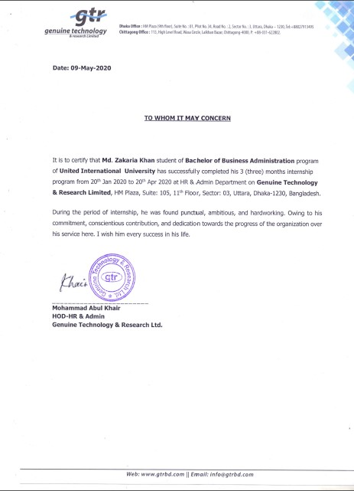
41
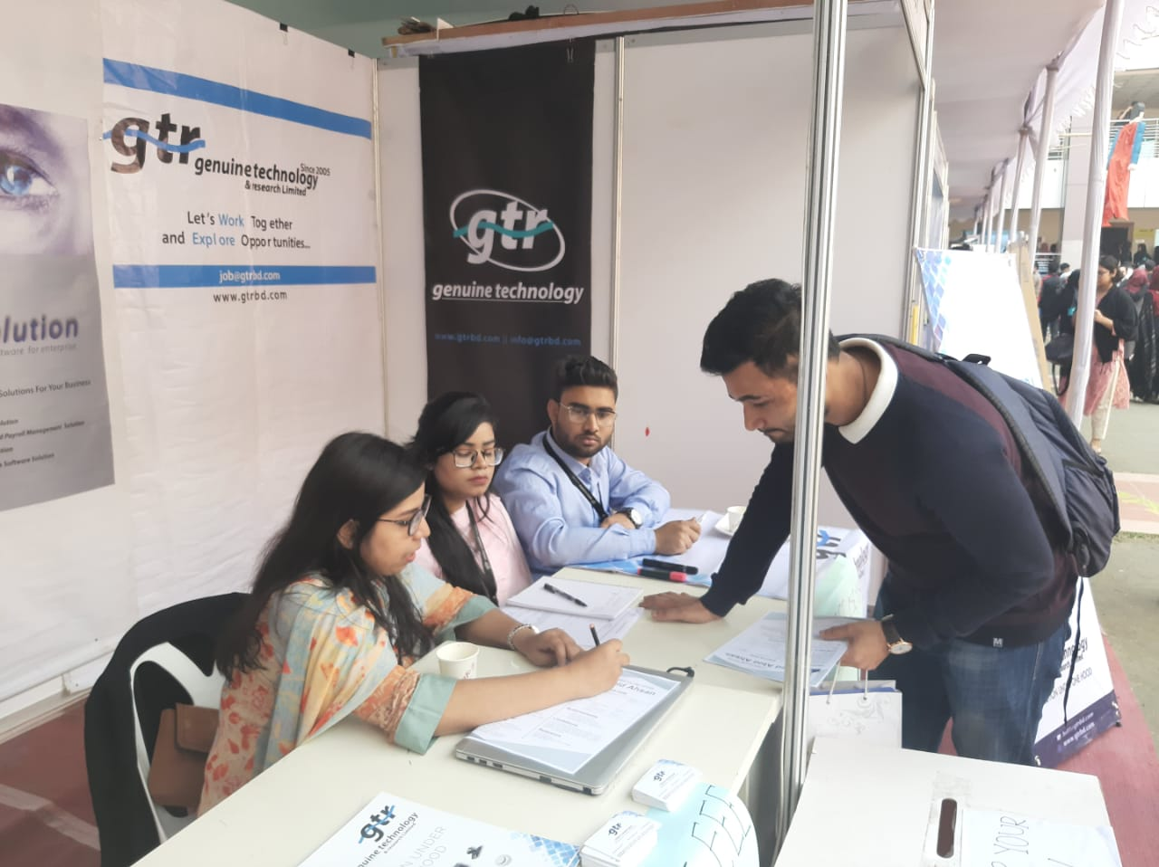

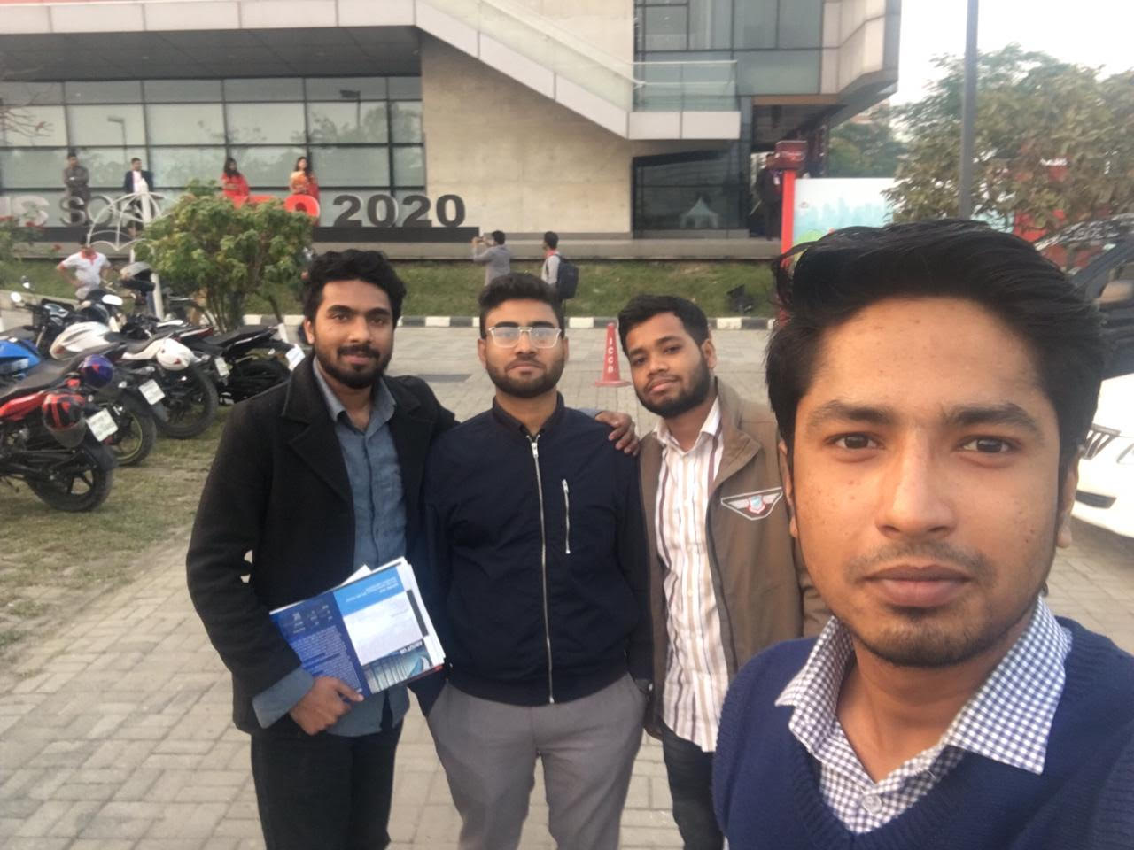
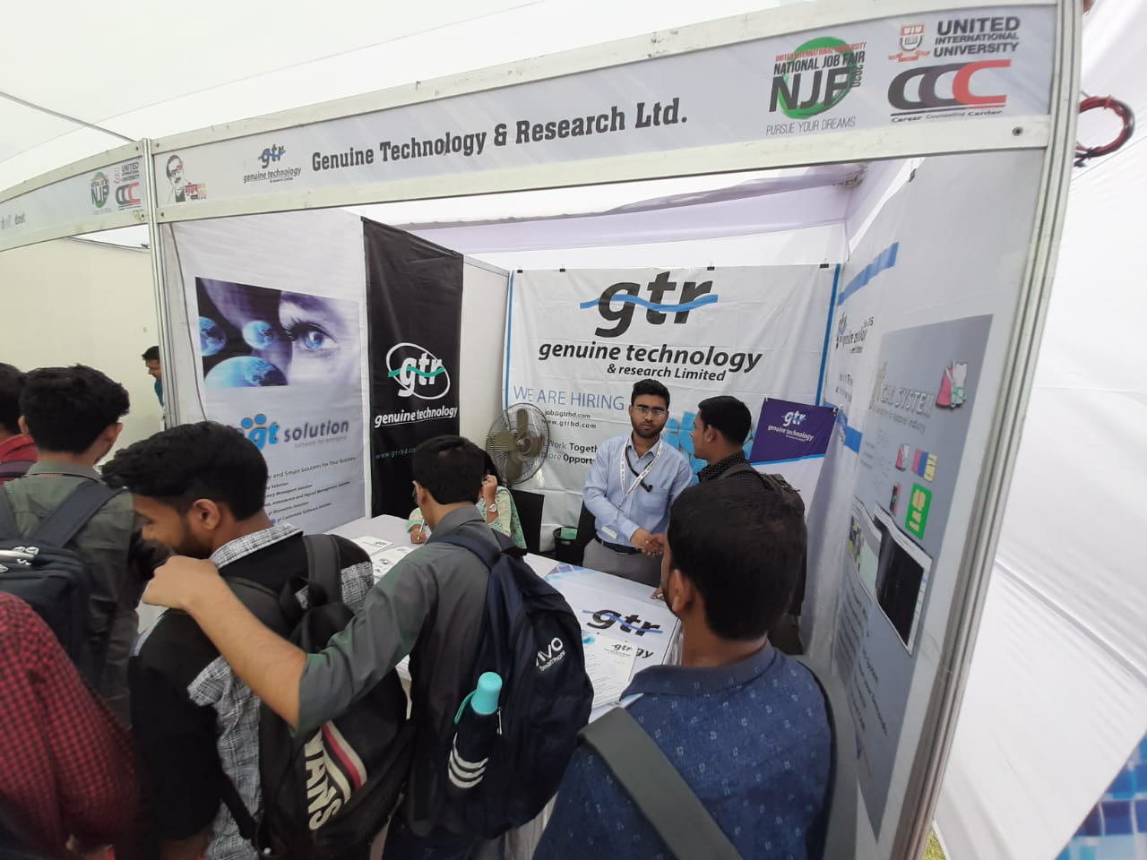
42
Independent University of Bangladesh (IUB) job fair held on 2020

United International University (UIU) Job Fair held on 2020

Basis Soft Expo held on 2020

