“Business Process Outsourcing” of Data Path limited

Mohammad Shahjahan

This report is submitted to the school of Business and Economics, United International University as a partial requirement for the degree fulfillment of Bachelor of Business Administration

Title of the report

Submitted to:
Name: Dr. Md. Qamruzzaman
Designation: Associate Professor
Major: Finance

Submitted by:
Name: Mohammad Shahjahan
Id:111 171 052
Major: Finance
Trimester: 14

School of Business and Economics
 United international university

Date of submission: 13/10/2021

Letter of transmittal

Date: 13/10/2021
Dr. Md. Qamruzzaman
Associate Professor
School of Business and Economics
United International University
Subject: Submission of the Internship Report on “Business Process Outsourcing” of Data Path limited.
Dear Sir,
It is my great satisfaction to submit my Internship Report on “Business Process Outsourcing” of Data Path limited which is required for the completion of my Bachelor of Business Administration (BBA) degree. This report contains all my knowledge and experience that I gained from my Internship period during Data Path Limited. The whole internship tenure was very interesting and exciting for me as an Employee of Data Path limited. This report is mainly based on “Business Process Outsourcing” Department of Data Path limited which is one of the most important department compared to other departments.
I tried my best to follow your guidelines while writing this report. I am very much thankful to you as without your help It would have been difficult for me to complete this report. Now It would be very much kind of you if you accept my report and help me complete my degree.
Sincerely,
Mohammad Shahjahan
111 171 052

Certification of similarity index

Declaration of the student

I Mohammad Shahjahan student of United International University, School of Business and Economics declare that the internship report on “Business Process Outsourcing” of Data Path limited is prepared by me and it is not submitted for any degree, diploma, tittle or recognition.

________________
Mohammad Shahjahan
ID - 111 171 052
School of Business & Economics
United International University

Acknowledgement

Firstly, I would like to thank the Almighty Allah without whom I am nothing and without his support I would not be able to complete my report on time. Then I would like to thank my internship supervisor Dr. Md. Qamruzzaman, associate professor, United International University for helping and guiding me throughout this whole internship tenure.
Next I would like of express my gratitude to Md shahadat Hossain Chowdhury, Manager of outsourcing department for continuously guiding me throughout the whole period.
Next I would like to thank the senior members of outsourcing department and also my colleagues for helping me whenever I faced trouble and also for their friendly behavior.
Lastly, I would express my gratitude to all the faculty members of United International University for preparing me to what I am today.

Abstract/ Executive summary

During my final trimester at United International University for completing my “Bachelor of Business Administration” I have done my internship in Data-path limited with a four-month period. The topic of my Internship report is Business Process Outsourcing” of Data Path limited.
In this report I have tried to provide the information about the company and its operations. I have focused on its BPO department which is very skilled among other departments. The July business services is directly related to the BPO department. The BPO is serving July services along with other TPA in USA.
During my four months of internship I got to know the company very well and understand their work and its importance. I got lots of training regarding the work and learnt about many software. I also developed by Excel skills while working among these skilled instructors and friendly colleagues. I had the opportunity to perform live work and contribute to the departmental function of BPO through the project works according to the client demands. I can say the overall journey was quite attractive, interesting and challenging for me as an Intern.in this 4 months I got opportunity to test myself In all aspects. So I can say working for Data-path is one of the best decision I have ever made.
The main work of BPO is serving its clients through many services like, plan administration. Plan doc preparation, plan setup/process and plan review and also project works.

Table of contents for Internship
Table of Contents
Letter of transmittal 4
Certification of similarity index 5
Declaration of the student 6
Acknowledgement 7
Abstract/ Executive summary 8
Table of contents for Internship 9
List of Figures 11
List of Tables 11
List of Abbreviation 12
CHAPTER I: INTRODUCTION 13
1.1 Background of the Report 13
I.1 Objectives of the Report 14
I.2 Motivation of the Report 14
I.3 Scope and limitations of the Report 14
I.4 Definition of Key term 15
CHAPTER II: COMPANY PREVIEW 17
2.1 Company Analysis 17
2.2 Overview and history 17
2.3 Industry analysis 24
CHAPTER III: INTERNSHIP EXPERIECNE 26
4.1 Position, duties, and responsibilities 26
4.2 Training 29
4.3 Contribution to departmental functions 30
4.4 Evaluation 30
4.5 Skills applied 30
4.6 New skills developed 31
4.7 Application of academic knowledge 31
CHAPTER IV: CONCLUSIONS AND KEY FACTS 32
5.1 Recommendations for improving departmental operations 32
5.2 Key understanding 32
5.3 Conclusion 33
Reference 34
https://www.data-path.net/services-outsourcing/?temp=outsourcing 34
Appendix-A: 34

List of Figures

- Figure 2.1.5: Operations
- Figure: 2.1.5 SWOT analysis

List of Tables

- TABLE: 4.1 census file used in my calculation

List of Abbreviation

TPA: Third Party Administration
RK: Record Keeping
ACP: Average Contribution Percentage
ADP: Average Deferral Percentage
ASPPA: American Society of Pension Professionals & Actuaries
DOL: Department of Labor
IRS: Internal Revenue Services
IRC: Internal Revenue Code
RPF: Retirement Provident Fund
SIMPLE: Savings Incentive Match Plans for Employees

CHAPTER I: INTRODUCTION

Background of the Report

Internship program is one of the finest way to apply the theoretical understanding into practically. The process of American retirement plans is very much tough enough h to execute. To execute the retirement plan effectively and properly is very challenging for American organizations as well as very costly in order to keep a separate retirement plan department. For this they basically hire a third party administrator named “July Business Services” which is the mother company of Data-path limited. The work process of outsourcing in July business services is quite tough to execute and also to train new employees for outsourcing because of the nature of the job. Both the trainer and trainees are still learning about the job and still face problems regarding retirement plans as it is very much detailed work. Every piece of knowledge, ideas and American laws regarding retirement plan is very hard to remember in detail. Data-path made scope for intern to learn this job in a period of 4months internship tenure. I have learned lots of work regarding the outsourcing department and still learning about the job.

Objectives of the Report

The objective of this report is to interpret and analyze the “outsourcing” industry in Bangladesh and USA as well as the report outlines my 4months of challenging and interesting internship tenure.

Motivation of the Report

The motivation of the report is the retirement plan system in USA. The way they value their employees and provides them with as much benefit as possible including Employee contribution that contains- deferral, Roth and catchup and also Employers contribution which includes, Match, safe harbor match, safe harbor non-elective and Profit sharing.

Scope and limitations of the Report

This report contains the topics and areas related in making the retirement plan. In Data-path I am highlighting the outsourcing department in my research. The employees working for outsourcing department, their experience in this field and their previously completed plan helped me very much to complete this report on time.

Limitations of the report
While preparing this report I have faced some limitations. They include,
- Some important and relevant information are not shown here due to confidentiality like, social security number (SSN) of employees involved in the plan.
- The earnings and deferral of employees in the plan.
- The formula or percentage the US company is providing to their employees.
- Did not find any useful information on the web due to the lack of publications.
- Since the laws are changing every year, providing 100% accurate information is difficult.
- Lack of time to collect information due to job constraints

Definition of Key term

Allocated Compensation: the total compensation remaining after the deductions of overtime, bonuses and pay before participations.
Eligible employees: the employees who are in the plan after completing all the rules and regulations needed to participate in the plan like, age, hours of service, years of service and date of participation.
Fiscal year and prior year: the fiscal year refers to the current year in which the plan is valued for and the prior is considered as the previous year of the valuation year.
Highly compensation employees; the employees who earns more than $12000 in prior year is known as highly compensated employees. Also if they have more than 5% ownership in the company they are HCE.
Key employees: An employee can be a key employee if they have more than,
- 5% ownership in the company
- 1%ownership
- Officer title
Entry date: the date in which the employees will get participation in the plan.
TPA; third party administrator. In Data-path’s case the tpa is July Business Service for whom Data-path is working.
Testing; the plan must meet certain conditions to get tax-advantage. One of the most important test is Top-heavy test, coverage test, discrimination test, compensation test, ADP and ACP test.

CHAPTER II: COMPANY PREVIEW

Company Analysis
Data-path is a private company operating in Bangladesh, working for July Business Services which is the mother company of Data- path limited. July Business services which is situated in Waco, Texas, USA is a TPA operating in USA and Bangladesh.
Mission; helping the clients effectively with the help of latest technologies available. Transformation and innovation is the core of Data-path limited.
Vision: to achieve the leading position in the outsourcing industry. To evolve into a next generation BPO from a traditional BPO.

Overview and history
Data-path is a privately owned company working for July business services. They are constantly providing USA retirement plan administration service. Data- path is also a subsidiary company of July business services and it is in one of the leading names of in 401k industry. The owners of July business services are John Humphrey and Jim Hudson. July business service has more than 4100+ clients.

- Trend and growth
Data-path is in constant growth and doing business for the end answer for their customers. The company started with 5 employees in 2008 and now it has over 200= employees and counting. Data-path has only one goal and it is to serve the customers in best possible way.

- Customer mix
Data-path limited is working for July business service and other third party administration.

- Product/service mix
Data-path is providing a huge range of services to July business and USA clients.
Plan design: Data-path creates attractive and best plan for the employers by following the rules and regulations of USA Government and their goals. The company is specialist in creating the retirement plan.
Plan Document: they are specialist in preparing the plan doc by the help of their ERISA consultants.
Plan setup: Data-path is sets up the retirement plan very efficiently. In the plan setup Data-oath provides service like,
- Setting up the paperwork
- Loan policy
- Submission of the contributions

Plan administration: Data- path have very talented and specialized employees for this plan administration field and continuously providing services.
Plan operation support: in this field Data-path provides all the necessary information a client needs in order to estimate the plan. This field involves,
- Eligibility calculation of plan
- Vesting calculation and matching
- Contribution allocations
- Distributions process

Compliance testing: Data-path provides their client full support in all aspects. Among them testing is very important. Data-path provides many testing like,
- ADP and ACP test
- Minimum coverage test
- Discrimination test
- Top heavy test

Tax Compliance; the company provides signature tax returns forms to all clients in order to satisfy all tax filing requirements. The services include,
- Form 5500
- Form 5330
- Form 1099 R and form 945

Recordkeeping: Data-path constantly provides automated recordkeeping services through their group partners and July business service’s everyday valuation of recordkeeping stage. The services include,
Participants quarterly statements, plan sponsor accounts access etc.

Payroll service: Data-path decreases the clients work pressure and increase the work efficiency by providing the payroll services to its client.

- Operations
Data-path limited began their journey with only 5 employees and now its over 200+ and the owner formed a team of highly skilled people.
Building a skilled team: Data-path is constantly trying to build and improve the whole team and July is also helping them to achieve that.
Building strategic partnership: Data-path partners some famous RK organizations like, American funds and Mass mutual in order to provide more effective support to the clients.

Figure: 2.1.5: operations

Accounting department: the accounting financial services are provided by this department. The department is responsible for billing of the work, stock statistics, and compensations of the employees.
Allocation department: the objective of the allocation department is to dispense the members of each plan members cash and update to the workflow 5500.
Distributions department; this department is responsible for the disbursement of each participant cash while on retirement or transferring to different company. To complete the task, the team required a software named Relius.
Workflow 5500 department: Data-path receives a ready “form 5500” each year for July services. The form is responsible for annual return on employee benefit plan for filing department of labor.
Human resource department: human resource department is very important for Data-path and is responsible for the safety of the organization. The HR department is responsible for Recruitment and selection and everything happened in Data-path limited.
IT department: The team is highly qualified and advanced in technology helps the company to operate effectively and provides every support regarding security.
Outsourcing department: the most important and biggest department in the Data-path limited and is fully connected to July business services. The department provides all the outsourcing support to July and other TPA in the USA.
Sales department: the team is responsible for the sales of the Data-path limited and convincing the new clients to take up the retirement plan with Data-path.
Software development team: the team continuously tries to update and advanced the software made by them which is used by other departments.

- SWOT analysis

The SWOT analysis of Data-path limited is describes below,

Strengths

Strong solid culture: the entire Data-path follows a strong helping culture in which everyone helps others to research and gain knowledge. The company provide prayer room for both men and women with friendly environment. The company also have a huge dinning space for the employees to participate in the lunch together.
Attractive pay scale and holidays: the company gives attractive pay to the employees along with bonuses every year. They also have 2 days off in every weekend. The company also gives extra holidays from USA end as Data-path is working for July.
Appraisal system: the company follows good appraising system for their employees. If someone do good they value their work and appraise them along with performance bonus.

Weakness
Dependency on July business services: Data-path employees cannot access the files until July business employees uploads information regarding plans and this process is a bit time consuming.

Opportunity
Business development: in current time Data-path is mainly working for the July business Services but in the future they can work for other bigger TPAs like July business.
Advancement of technology: the outsourcing work is mainly dependent on technology and day by day it is developing which will make the work more effective and efficient.

Threats
Data safety: at present time it is very much easier for hackers to attack the servers through phish mails and the outsourcing work is mainly on the domains. So it very vulnerable to hackers.
Competition: the outsourcing work is becoming very popular in Bangladesh day by day as many people are jumping into the work. If new business like Data-Path comes to business it will be competing for Data-path.

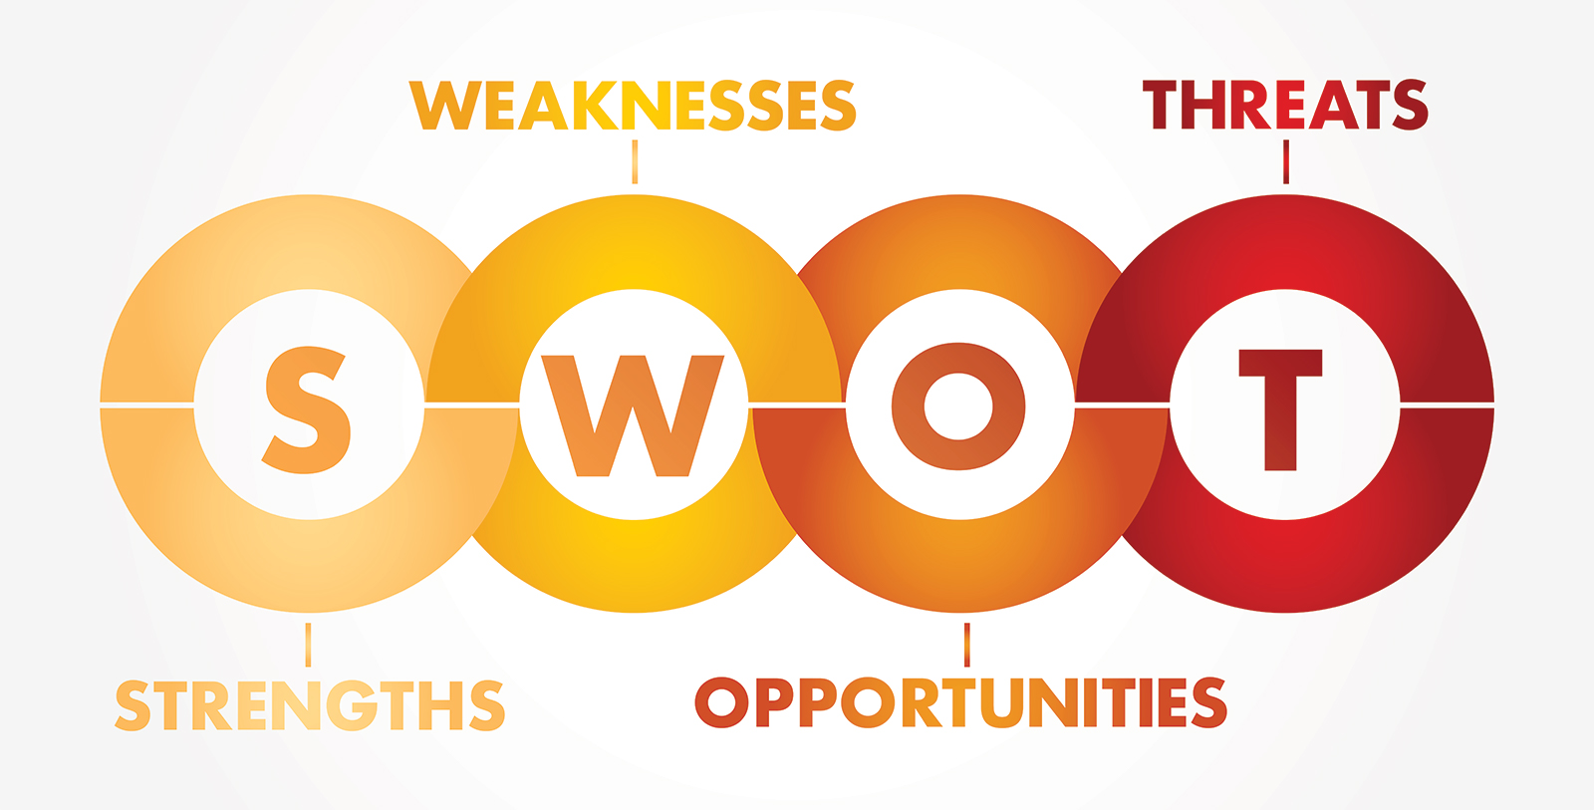

Figure: 2.1.5 swot analysis

Industry analysis

- Specification of the industry
Outsourcing
Outsourcing is a type of business where a TPA, third party is involved. A number of work being done In outsourcing by TPA like, project outsourcing, retirement plan outsourcing, software development and many more as required by the client.

- Size, trend, and maturity of the industry
Outsourcing Is a huge business and it is growing at a constant rate day by day. The level of outsourcing started to grow within the past 1 or 2 decades. Outsourcing business creates huge manpower and it is serving many businesses.

- External economic factors

The huge industry can serve its customers and setup the businesses and give solution to enterprises. The clients get the benefit of without funding themselves. The price will be paid but the outsourcing companies can expand the total cost among customers.

- Technological factors

Since the technology is developing day by day the future of outsourcing is in good condition. The technology is helping the outsourcing work a lot. The outsourcing companies must be in full update to technology as the clients can switch to rivals any time without any hassle.

- Barriers to entry

In order to enter this type of industry it is quite difficult as it need a bunch of skilled and experienced people with huge capital investment for IT support.

- Supplier Power

In the industry of outsourcing the supplier’s expertise and performance is very much needed as if the suppliers output is improved than the quality of product will improve.

- Buyer Power

The buyers should always provide useful and full information s to the TPA’s and also pay the costs on time in order to get the full support of the supplier’s.

- Threat of Substitutes
Since the Europe is developed in this field and sooner Bangladesh will also become advanced this field as the Government is encouraging the sector so the possibility of switch is high in the future.

- Industry rivalry
The existing rivals are trying to get the customers and also the newcomers are trying very hard to enter the industry and sustain. In order to hold the customers for a long term, a good long term relationship is necessary which is possible from a huge investment within the market place to gain good position and profits. To hold the customers a good efficient service needs to be given in future also and enjoy the business.

CHAPTER III: INTERNSHIP EXPERIECNE

Position, duties, and responsibilities

I was offered an internship position at Data-path limited. I was offered the internship position at Business Process Outsourcing(BPO) department. Data-Path offers BPO to the candidate who are from finance and accounting backgrounds. My internship period started on 23rd June and it is going to end on 23rd October.

Duties and Responsibilities
Being an internee, my duties and responsibilities were not very difficult except of following the task provided by the trainers. From day 1, I was given small basic tasks to perform alongside the training. The tasks vary all the time. Sometimes my trainer told me to do write a report on the previous worked they finished, then they give some excel calculations regarding the basic retirement plans. I was also given a chance to participate in their team wise meetings and note down the important aspects of the plan. I was then given project works regarding clients demand such as extracting data from a non-copy able pdf documents. Sometimes the document was small consisting of 1000 words and sometimes 4000-7000 words. Then sometimes my instructor gave me to make deferral calculations in excel with the help formula and macro functions.
As the days passed I got more tough project works based on client demand, it was copying and pasting the payroll of employee compensation and contributions from a non-copy able pdf into an excel sheet. The task was very tough because I had to copy and type in the excel sheet from a document that consists of more than 1000 pages. The task was tough because the document consisted of many information’s and I had to find the accurate compensations participant wise and type without an error. If any typo occurs than the client would complain about the task to the head management team. I then prepared some practice materials for the upcoming interns. The materials involved, eligibility calculations, date of participation calculation, sorting the non-eligible participants from the plan.
I then used the software named Datair to make plan process. The whole plan process was challenging as it consists of everything I learned at training sessions. At first I have to go through the plan document of about 60 pages to gather the information about the plan then I go to software and start to input the information based on plan doc and its requirement. Sometimes the plan doc does not contain all information regarding plan process, so I have to communicate with our client through email and ask for the necessary information.
Every time I had to do the plan process, the software generates many information regarding the calculations but we cannot rely fully on the software and we had to do all the calculations manually like, eligibility calculations, census check, refund calculation if needed and importing and exporting the accounts information in the software and match with the Asset reconciliation.
Then sometimes the whole plan was completed by the client and given to us for review. The reviewing of the plan was easier than doing whole plan as in the review the calculations were done and we just needed to cross check that all the information are given or not.

CENSUS FILE
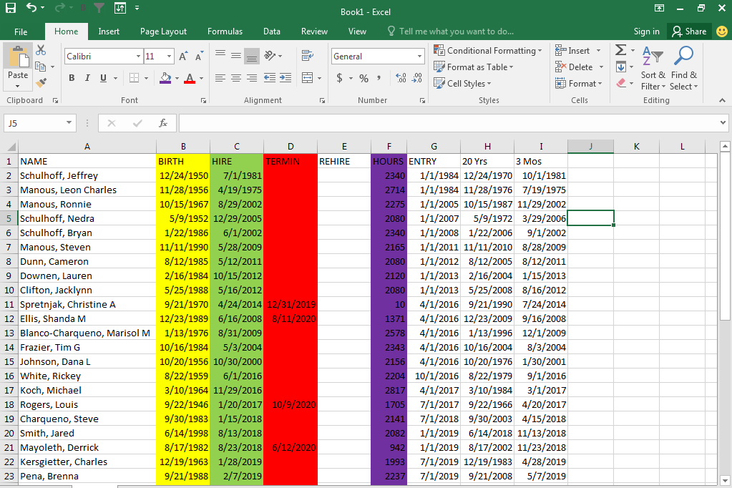

TABLE: 4.1 census file used in my calculation

Training

We were 12 interns in the same batch, and were given a training of 2 weeks. At the very first they introduced us to all the trainers and whole departments. Then they slowly introduce us to their work, software’s they use and given a training schedule of 2 weeks. In the first week we were just only given training on Microsoft Excel and it continued few days. After practicing the basics and also advanced excel we were trained about the basics of the retirement plan name “Retirement plan fundamentals” (RPF). This training passed almost 4 days as there was very much information we needed to know in order to do plan. The RPF had a book of around 790 pages consisting of each and every information.
After the RPF training, we were trained for calculations like, eligibility calculations, date of participation calculation. The calculations were quite tough for us at that moment because were never use to it and the calculation was based on RPF study which was quite difficult to remember. Then we were give training on testing like, ADP, ACP Top heavy, coverage etc. this testing were very important to learn and execute as after the plan process we needed to check the testing section whether all the test were passed or failed. If the test passed then our plan process is done but if not, then we were taught to do refund calculations in order to correct the testing results. This took almost 1 week to learn.
Next we were given training about all the software Data-path uses, they are, RELIUS, DATAIR, FT. WILLIAM etc. we were given the small knowledge about the software only at that time. Then we were allocated to individual team inside BPO and I was in the APCI team. Our total member including me was 16 which is the most in any department. I along with few internees were given extra in depth training about the software our team use DATAIR. Then all the trainings we learned before was repeated with details as every client has separate procedures. Out APCI training ended after all topics. Then we were all doing plan process and plan review along with lots of projects works. This was just small training, but if someone wants to continue with Data-path they will be given a training of about 8-12 moths In order to learn full work.

Contribution to departmental functions

I have lots of contributions in our departmental functions with my excel skills I have done so many projects work and all the work was used in preparing the plan process form my seniors and also reviewing. This was my live work but my plan process and reviewing was based on previous completed plans. Since the work is very much sensitive our main work was only used for practicing purposes.

Evaluation

We were evaluated in every step of the internship tenure. The seniors evaluated us based in our works and also by our ability to adapt and learn new things and apply it in our work.

Skills applied
I had some skills on excel which was helpful for me adapt quickly as the whole work process was on Excel. My MS word skill was also used here in creating charts and figures. My best skill was adapting skill that’s helped me very much and allowed me to learn quickly.

New skills developed

After getting training at Data-path I learns lots of excel shortcuts, excel functions and formulas and how to use it efficiently. Then I learned time management skill while working here as well as few important Software like, DATAIR, RELIUS, and FT. WILLIAM which is very good for me. I then learned excel macro function and all the corporate skills needed while working here.

Application of academic knowledge

Since Data-path limited is an Outsourcing company that follows and do USA retirement plans, so my academic knowledge is not used during my internship but it helped me doing this report very well.

CHAPTER IV: CONCLUSIONS AND KEY FACTS

Recommendations for improving departmental operations

Make training process easier: Data-path is giving 2 weeks of training but their work is very much complicated in terms of understanding. It would be better if Data-path divide training phase for the whole four month of internship tenure so it would be very easier for interns to catch the information. This will increase the understanding of the interns which will return as improve productivity.
Developing the Softwares: the entire Data-path is doing the work on softwares like, UNIFY, DATAIR, RELIUS AND FT. WILLIAM. Some of the software issues like slow loading, crashing, high cost of Relius accounts. By solving these problems Data-path can increase their departmental operations.
Internet connectivity: overall Data-path internet connection is good but sometimes it hampers the work when connected to VPN for working in USA end. If internet is faster than the whole organization will increase efficiency.
Office space: Data-path many of the senior employees are now in home office due to the unavailability of sitting arrangements which might slower the operational process. So the organization should increase their spacy by shifting or by taking another floor.

Key understanding

From this report we can understand the system of Data-path limited and its departments. How it is running and BPO department is the main department of the company which is growing day by day. The outsourcing is rising and it will be very much competitive in the near future in Bangladesh.

Conclusion

There are lots of companies doing outsourcing in Bangladesh but none of them are like Data-path as it is totally related to USA retirement plan. The company is providing non-stop services to July Business services and the clients are happy with Data-path. The company started in 2008 with only 5 employees and now it is showing how much growth it wanted and they are now a member of 200+ employee and still counting significantly. They want to achieve top position as the BPO in the outsourcing industry. The industry is growing as well becoming competitive in all aspects. The company wants to get bigger and bigger and for this they are hiring more and more interns and trying to convert them into the assets of the company. In this report I tried to highlight overall BPO department as described above. Even though not every useful information is provided due to confidentiality. I can say that the BPO is the largest and most important department of the company and it is rising day by day. The customers of BPO are happy as the company is very promising to their core values and serving its valuable customers.

Reference

https://www.data-path.net/services-outsourcing/?temp=outsourcing

https://www.julyservices.com/

✓ Retirement Plan Fundamentals-1, Published from ASPPA, edition 2008
✓ Retirement Plan Fundamentals-2, Published from ASPPA, edition 2008

✓ IRS (Internal Revenue Service) Reporting Guidelines for Retirement Benefit Plan, Published from IRS, edition 2008

Appendix-A:

