Internship Report on
“The impact of employee engagement on overall performance of the Al-Arafah Islami Bank PLC”

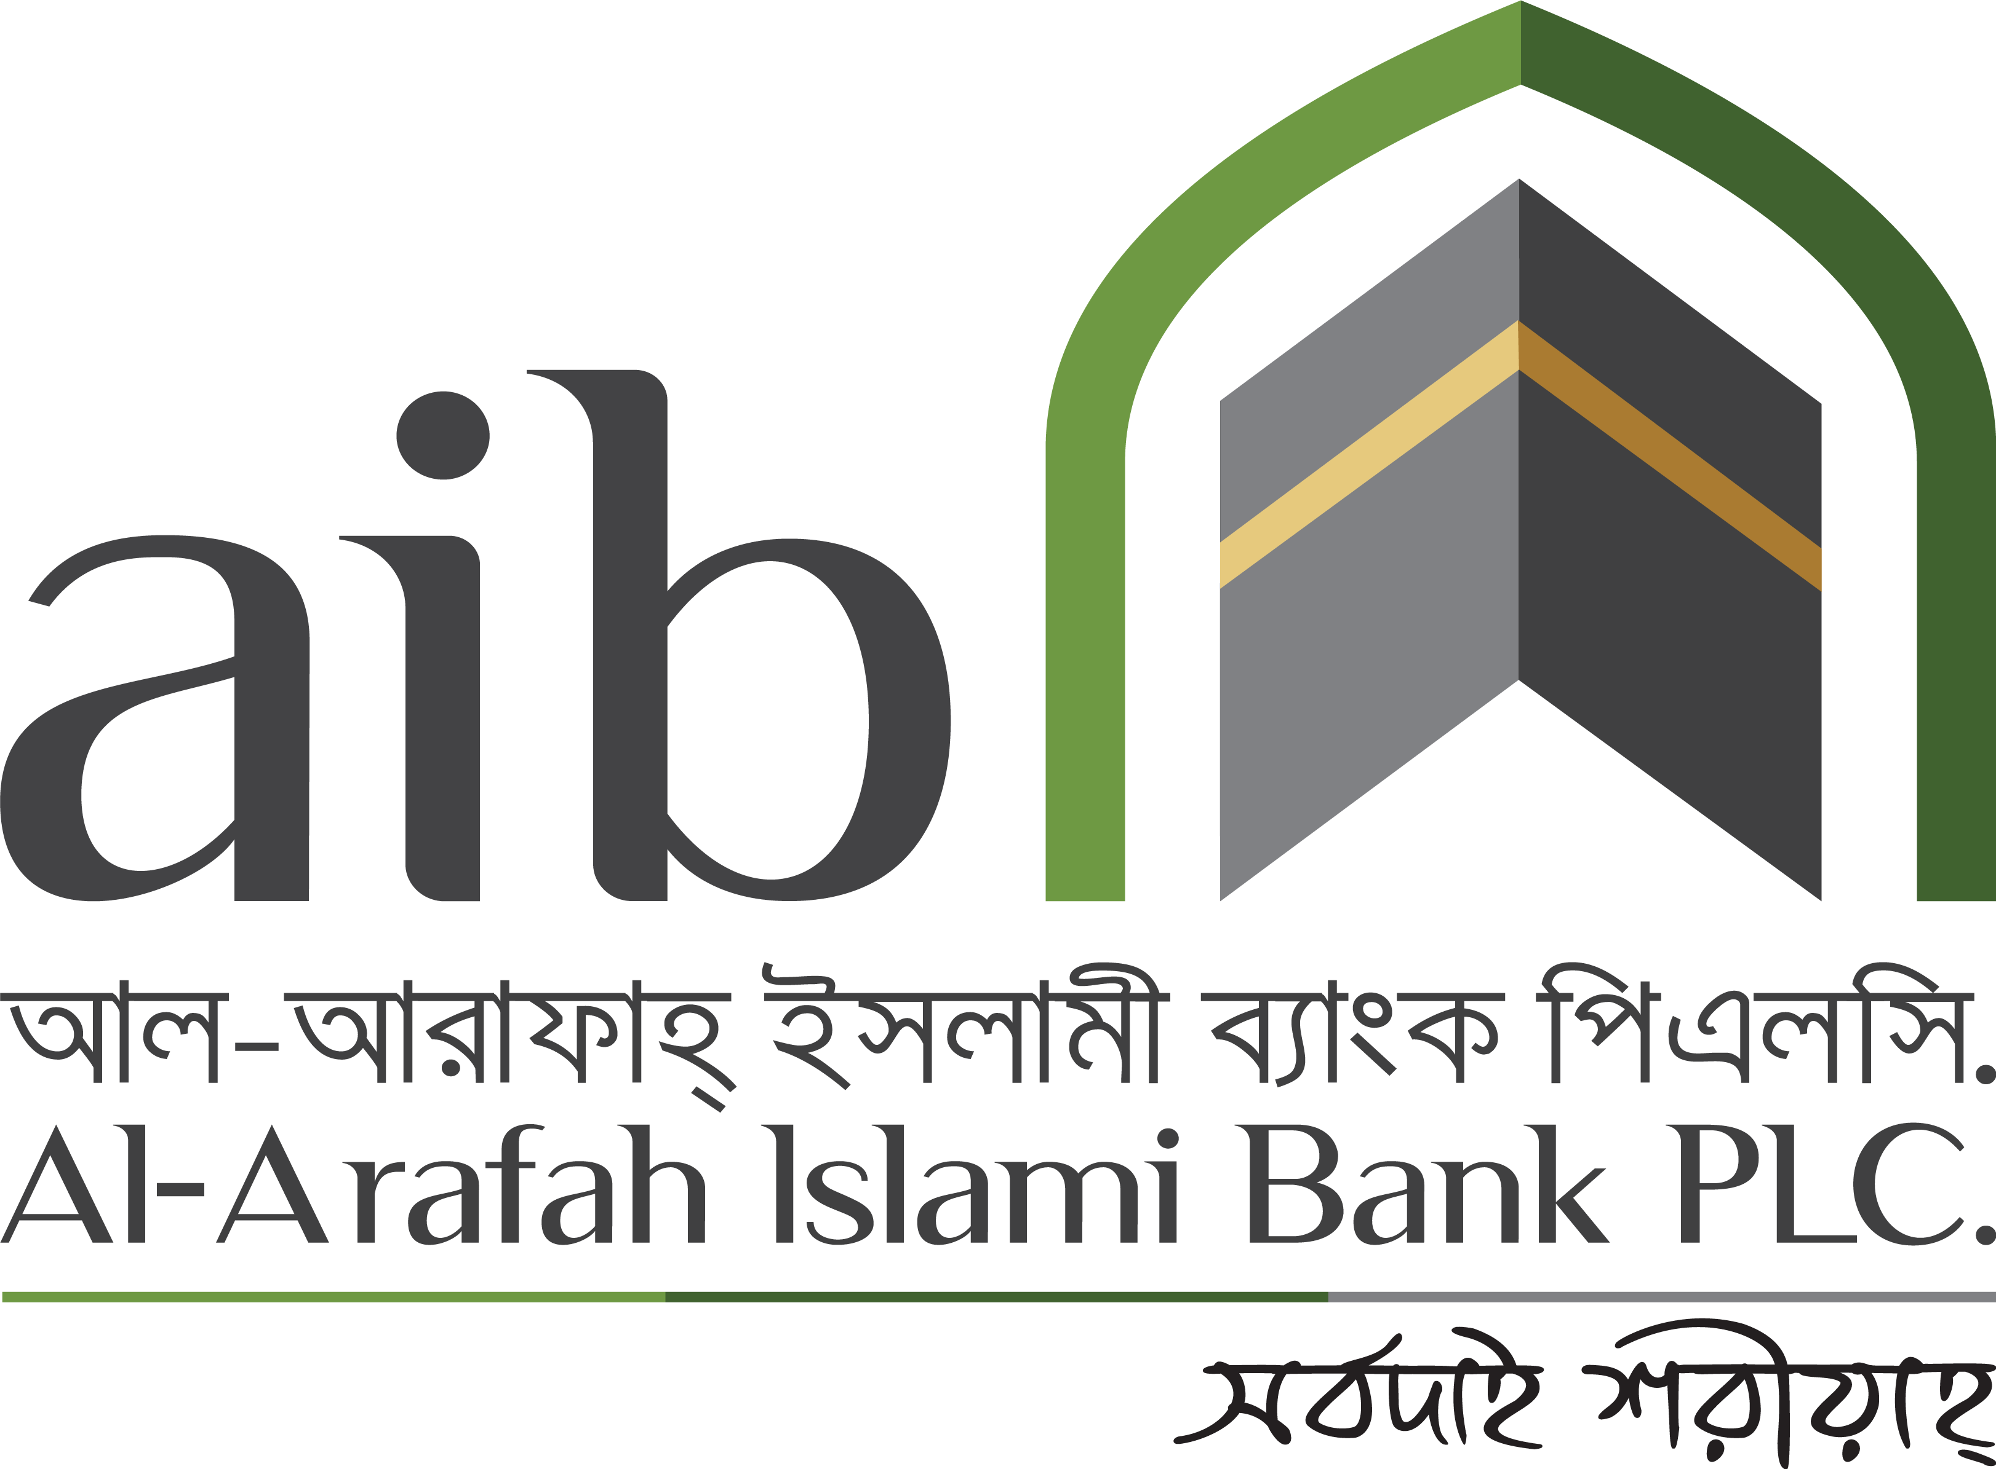

Name of the Student:
MD. Shahriar Islam Shanto
ID: 111 193 084

This Internship Report will be submitted to the School of Business and Economics, United International University to meet my Bachelor of Business Administration Degree Requirement

Internship Report on
“The impact of employee engagement on overall performance of the Al-Arafah Islami Bank PLC”

Submitted to:
Jakowan
Assistant Professor
School of Business & Economics (SoBE)
United International University

Submitted by:
MD. Shahriar Islam Shanto
ID: 111 193 084

School of Business and Economics
United International University
Date of Submission:
December 26th, 2024

LETTER OF TRANSMITTAL
December 26th, 2024
Mr. Jakowan
Assistant Professor, School of Business & Economics (SoBE)
United International University
Subject: Submission of Internship report on “The impact of employee engagement on overall performance of the Al- Arafah Islami Bank PLC”.
Dear Sir,
With due respect I hereby humbly presenting you the internship report on Al- Arafah Islami Bank PLC as a course requirement for the completion of the Bachelor of Business Administration program (BBA). This internship report is written based on the Employee Satisfaction of the employees of the Mirpur Branch of Al-Arafah Islami Bank PLC. I have used both primary and secondary sources to gather data for incorporating in this report. My heartfelt gratitude towards you, as without your guidelines I would not be able to complete this report.
Last but not least, I worked really hard to write my internship report, which I hope you will find very fulfilling. I therefore sincerely hope and pray that you would allow me to submit my internship report. Thank you so much for your considerate cooperation.
Sincerely yours,

MD. Shahriar Islam Shanto
ID: 111 193 084

INDEX OF SIMILARITY CLARIFICATION
Title of the report: The impact of employee engagement on overall performance of Al-Arafah Islami Bank PLC
Student name: MD. Shahriar Islam Shanto
Student id: 111 193 084
Supervisor: Mr. Jakowan, Assistant Professor, School of Business and Economics (SoBE)
Department: Bachelor of Business Administration (BBA)
I would like to verify that my internship report is authentic and inimitable and no similar information will be found or no plagiarized materials will be detected, therefore I have not used any unethical practices to complete this report.

Student’s Full Name & Signature:
MD. Shahriar Islam Shanto

-----------------------------------

DECLARATION OF THE STUDENT
I, Md Shahriar Islam Shanto, declare that I have organized this internship report to the topic “The Impact of employee engagement on overall performance of the Al-Arafa Islami Bank PLC”. I've learned a lot of valuable skills during my internship. I've done the appropriate research on Al-Arafa Islami Bank's human resources. I have learned a lot of new knowledge while preparing this report.
In order to prepare the report, I have gathered both primary and secondary data. I guarantee that I prepared my internship report thoroughly. Additionally, I guarantee that this report is one of the BBA program's unique reports.
Student’s Full Name & Signature:
MD. Shahriar Islam Shanto
-----------------------------------

ACKNOWLEDGEMENT

I want to begin by thanking Almighty for allowing me to finish this report and for keeping me healthy during the whole Internship time.
Secondly, this report would not have been complete without the guidance of my supervisor Mr. Jakowan, Assistant Professor (SoBE), Department of Human Resource Management, United International University, for whom I am extremely grateful and respectful. I am thankful for his support, direction, scheduled meetings, and assistance, all of which encouraged me and assisted me greatly in concluding my report. I would not have been able to properly accomplish this report without his constant backing and supervision.
I also want to express my gratitude to the entire Al-Arafah Mirpur branch team, as well as Jannatul Ferdousi (Senior Principle Officer), MD.Aminur Rahman Khan (SEO), Saleh Ahmed (Executive officer ) for all of their information, reports, and assistance during my internship.
Lastly, I want to express my gratitude to everyone who has supported, aided and pointed me in the right direction; without their assistance, this would not have been possible. I learned a lot from the projects I was given and from every member of the staff. These would be very helpful to me in the future. Working for the company was a terrific experience, and if given the chance, I would love to continue being involved with it.

EXECUTIVE SUMMARY

This research paper makes an attempt to study the impact of Employee engagement on overall performance of Al-Arafah Islami Bank PLC. The study assign with the study of literature on Employee Engagement theory, and Human Resources Strategies. This study is based on Primary and Secondary data which is collected through my own idea, doing surveys and employees interviews.
Through primary and secondary data analyses, this report seeks to understand the positive/negative correlation between employee engagement and its subsequent impact on the organizational performance.
This research will analyze the employee’s satisfaction and their engagement toward their organization. I conducted the report through many employees survey and their valuable feedback, and then gathered all of their information to complete my report. In this project I will discuss many employees working experiences to their organization.
The aim of the report is to present the importance and effect of employee engagement in the assemble sector and increase the employees engagement toward their work and also motivate them to active their work.
The report will be conducted through a comprehensive review of employees to know whether the employees are satisfied or dissatisfy in their organization and its employee engagement is very important part of an organization and to continue an organization to do a better work in future it’s very needed.

Table of Contents

LETTER OF TRANSMITTAL i
INDEX OF SIMILARITY CLARIFICATION ii
DECLARATION OF THE STUDENT iii
ACKNOWLEDGEMENT iv
EXECUTIVE SUMMARY v
CHAPTER 1: INTRODUCTION 1
1.1 Background of the report 1
1.2 Objectives of the report 1
1.3 Scope and Limitations of the Report 2
1.4 Methodology of the Report 2
1.4.1 Types of data 2
1.4.2 Data Collection Process 3
1.4.3 Sample Size 3
1.4.4 Sampling Techniques 3
1.4.5 Area and Time of Research 3
1.5 Literature Overview 4
CHAPTER 2: ORGANIZATION OVERVIEW 7
2.1 Background of Al-Arafah Islami Bank PLC 7
2.2 Organogram of Al-Arafah Islami Bank PLC 9
2.3 Vision 11
2.4 Mission 11
2.5 Value 11
CHAPTER 3: EMPLOYEE ENGAGEMENT & OVERALL PERFORMANCE OF AL-ARAFAH ISLAMI BANK PLC 15
3.1 Human Resource Management 15
3.3 Core Functions of Human Resource Department in Al-Arafah Islami Bank PLC 16
3.4 Recruitment Process of AIB PLC Bank PLC 17
3.5 Internal Recruitment 19
3.6 Selection 19
3.7 The Compensation System 19
3.8 Training and Development 19
3.9 Promotion 20
3.10 Employee Engagement 21
3.11 Relation Between employee engagement and Overall performance 21
3.12 Survey questions and results 24
CHAPTER 4: INTERNSHIP EXPERIENCE 45
CHAPTER 5: FINDINGS & RECOMMENDATIONS 48
5.1 Findings 48
5.2 Recommendations 49
CHAPTER 6: CONCLUSION 51
REFERENCE 52

Table of Figures

Figure 1 Management Hierarchy 9
Figure 2 Chain of Command 10
Figure 3 Management Hierarchy of AIB PLC 14
Figure 4 Structure of HR Department in a Large Organization 16
Figure 5 Core HR Process in HR department of AIB PLC backed by the Human Resources Manual. 16
Figure 6 External Recruitment Process of AIB PLC 18

CHAPTER 1: INTRODUCTION

Background of the report
The purpose of this internship report is to ascertain how employee involvement affects Al-Arafah Islami Bank PLC's overall performance. Any business or organization's human resources are a crucial component that greatly affects the organization's worth. Today, one of the key business factors influencing an organization's performance is employee engagement. In general, the desire and sentiments of the employee for the company are referred to as employee engagement. It is widely regarded as the engine of overall performance, creativity, and productivity. It boosts customer happiness, retention, and operational efficiency—all critical components for long-term growth in a cutthroat industry.

Objectives of the report
The purpose of this study is to assess the impact of employee engagement on the overall performance of Al-Arafah Islami Bank PLC. The purpose of this study is to:
1. This study will look at the relationship between employee engagement dimensions such as job satisfaction, organizational commitment and motivation and the bank’s KPIs such as productivity, customer satisfaction and profitability.
2. Identify specific factors in the bank’s work environment, management and corporate culture that affect employee engagement.
3. Assess the role of employee engagement in achieving operational excellence and determine how these programs ultimately support profitability, customer retention and growth of the organization.
4. Provide useful suggestions to Al-Arafah Islami Bank PLC with a view to developing effective employee engagement strategies that will improve better performance, yielding long-term success for the organization.

Scope and Limitations of the Report
Scope: In order to clearly depict the organizational performance and employee engagement of Al-Arafah Islami Bank, this study has used both qualitative and quantitative data. A handful of the Al-Arafah bank representatives and I had private conversations. The main sources of secondary data are their web sites and annual report.
Limitations: Due to their many organizational privacy issues, I had to recognize certain constraints when I was writing this internship report, which led to the establishment of a border for me to collect different degrees of information. The Bank's annual report and official website provide details about the organization's operations, background, products and services, and other aspects. I collected these data points and included them into my report. However, a lot of crucial information about their company is kept private and is not available on their official website, annual report, or other platforms.

Methodology of the Report

Types of data
Primary and secondary data are the two categories of information used to organize a report. Experts create primary data by carrying out different experiments and investigations. Numerous sources, including surveys, questionnaires, experiments, observations, and interviews, can provide primary data. Secondary data collection includes company’s website, documents, employee files, policy files, academic books, online journals and articles.

Data Collection Process
To prepare the research, both primary and secondary data are collected. Primary data is obtained through in-person interviews with employees of Al-Arafah Islami Bank. The secondary data was obtained from the official website, articles, and annual report of Al-Arafah Islami Bank.

Sample Size
In this research paper, 12 employees of Al-Arafah Islami Bank PLC was taken as the sample. All of the employees were adults and they were aware of the purpose for the sample.

Sampling Techniques
For this report, the employees of Al-Arafah Islami Bank PLC working in Mirpur, Dhaka were selected. The data was carefully managed to protect employees’ privacy considering the organizational ethics.

Area and Time of Research
"The impact of employee engagement on overall performance of Al-Arafah Islami Bank PLC" served as the basis for this study. The goal of this study is to illustrate the relationship between employee engagement and the organization's performance. It took nearly three months to finish this study and produce the internship report using primary and secondary data from various sources.

Literature Overview
1. Introduction to Employee Engagement and Organizational Performance
The emotional dedication that workers have to their company and its objectives is known as employee engagement, and it has emerged as a key issue in organizational performance studies and human resource management. Employee engagement, according to Kahn (1990), is based on how personally involved workers are with their jobs, which affects both their productivity and psychological health. (Kahn, 1990). According to Saks (2006), motivated employees are more likely to perform effectively and make beneficial contributions to the performance and culture of the company (Saks, 2006). Given these benefits, organizations such as Al-Arafah Islami Bank PLC have begun to prioritize employee engagement as a means to boost organizational effectiveness.
2. Employee Engagement and its Determinants
Training, career promotion, feedback systems, and rewards are just a few of the human resource strategies that have an impact on employee engagement. According to research, a high degree of involvement can be fostered by elements like work-life balance (Rich, B. L., Lepine, J. A., & Crawford, E. R., 2010), effective leadership (Macey, W. H., & Schneider, B., 2008), and clear communication (Bakker, A. B., & Demerouti, E., 2008). Strong employee engagement tactics help Al-Arafah Islami Bank PLC, which competes fiercely in the financial industry, retain talent and improve overall performance. According to this research, fostering employee engagement in financial institutions requires HR procedures that are adapted to the demands of the workforce.
3. The Relationship between Employee Engagement and Organizational Performance
Employee engagement and organizational success are directly related, according to a substantial body of research. According to research by Harter, Schmidt, and Hayes (2002), businesses with more engaged employees are more profitable, productive, and satisfied customers. This is due to the fact that engaged workers are more motivated to contribute to the success of the company since they are dedicated to both their job responsibilities and the organization's vision and values (Harter, J. K., Schmidt, F. L., & Hayes, T. L., 2002).
Employee engagement is crucial at Al-Arafah Islami Bank PLC since customer trust and service quality are directly related to the banking industry's success. In a client-focused sector like banking, an engaged workforce promotes loyalty, improves customer experiences, and eventually boosts profitability. Furthermore, research by Gallup (2017) revealed that companies with engaged workers were 21% more profitable, highlighting the significance of engagement as a predictor of financial success in the banking industry. (Gallup, 2017).
4. Human Resource Practices and Employee Engagement at Al-Arafah Islami Bank
At Al-Arafah Islami Bank, human resource management techniques are essential to fostering employee engagement. Engagement levels are greatly influenced by career development opportunities, efficient communication channels, and recognition initiatives (Noe, R. A., Hollenbeck, J. R., Gerhart, B., & Wright, P. M., 2017) According to research by Baumruk (2004), motivated workers are more likely to stick with a company, which lowers turnover and related expenses. HR procedures at Al-Arafah Islami Bank are intended to assist staff members by offering competitive pay, performance reviews, and continual training (Baumruk, 2004). This aligns with findings from studies by Robinson, Perryman, and Hayday (2004), which underscore the positive impact of employee recognition and feedback on engagement.
Additionally, by bringing employee goals and organizational objectives into alignment, performance management systems help to create a feeling of purpose. This alignment is especially important at Al-Arafah Islami Bank PLC since staff members are urged to give their best work in order to satisfy customers and legal requirements, which affects the bank's reputation and position in the market.
5. Employee Engagement and Customer Satisfaction
Customer satisfaction is impacted by employee engagement, which is particularly significant in service-oriented industries like banking. According to research by Schneider, White, and Paul (1998), motivated staff members are more likely to deliver outstanding customer service, which has a direct effect on customer satisfaction and retention. The goal of Al-Arafah Islami Bank's engagement strategy is to develop a dedicated staff that enhances client satisfaction, hence promoting loyalty and retention. By lowering absenteeism and turnover, employee engagement also affects organizational performance. According to a 2003 study by Allen, Shore, and Griffeth, companies with high levels of engagement report lower turnover rates, which lowers the expenses related to hiring and training new employees (Allen, D. G., Shore, L. M., & Griffeth, R. W, 2003). Lower turnover not only saves costs but also maintains service quality, which is critical for Al-Arafah Islami Bank PLC as it builds long-term relationships with customers.
6. Challenges in Employee Engagement within Financial Institutions
Even though there is ample evidence of the advantages of employee engagement, financial institutions face difficulties in establishing and maintaining engagement. Financial firms frequently deal with constraints associated with regulatory compliance and quickly evolving financial markets, which can lower employee engagement and morale (Rich, B. L., Lepine, J. A., & Crawford, E. R., 2010). Al-Arafah Islami Bank PLC is no exception, facing both industry-specific challenges and competition from other banks for talent retention.
Implementing techniques like job creation and work autonomy might help ease some of these difficulties and enable employees to participate more completely in their responsibilities, according to studies by Bakker and Demerouti (2008) (Bakker, A. B., & Demerouti, E., 2008). However, Al-Arafah Islami Bank PLC’s challenge is to continuously adapt its HR practices to maintain engagement despite external pressures.
Research continuously shows that employee involvement improves organizational performance, especially in service industries like banking. Employee engagement boosts profitability, productivity, and customer satisfaction—all of which are critical to the expansion and competitiveness of Al-Arafah Islami Bank PLC. Effective HR practices—like clear communication, frequent feedback, career development, and work-life balance initiatives—have been shown to improve engagement levels, despite the difficulties in maintaining them.

CHAPTER 2: ORGANIZATION OVERVIEW

Background of Al-Arafah Islami Bank PLC
Islam is seen as a faith that encourages a well-rounded way of living. Being prosperous in this world and the next is the primary goal of this lifestyle. Therefore, one should emulate Muhammad's lifestyle and adhere to the teachings of the Quran in all areas of life in order to be flawless. Al-Arafah Islamic Bank PLC was founded on September 27, 1995, in Dhaka, and began operations on June 18, 1995, based on these principles. If we were to name the bank's directors, we would discover that they are a group of trustworthy, capable, and devout individuals who have helped the bank grow. The chairman, AZ.M. Shamsul Alam, is a writer and scholar of Islam who was a high-ranking official in the government of Bangladesh. Good customer service and the usage of contemporary technology that is appropriate for today's environment should be highlighted if we were to identify the key components of banking success. An examination of AIB PLC's business model reveals that it offers a variety of services and goods that may be tailored to each individual client's requirements. They are dedicated to helping the country's economy. Additionally, the bank promises to give its clients greater opportunities. They can provide a range of options for overseas commerce, microfinance, SME banking, deposits, and investments. We discovered alternatives including the Al Wadiah Term Deposit Plan, Mudaraba Savings Deposit Plan, Mudaraba Fixed Deposit Plan, and Mudaraba Short-Term Deposit while looking over the deposit plans. They allocate funds to small investments, transportation, workplaces, and places of worship like mosques and madrasahs. We looked at SME banking services and found that they cater to women, small businesses, entrepreneurs, and commercial firms. Its microfinance efforts are concentrated on assisting rural business owners in enhancing the social circumstances and employment opportunities of rural residents. Additionally, AIB PLC provides a range of services, including money transfer, SMS banking, and Internet banking. With 180 branches and 8 SME units, AIB PLC employs 3,682 people in total. There are 22,142 members of the bank overall. As of December 2020, the bank's paid-up capital was roughly Tk 1, 0649.02, while its registered capital was Tk 1,500 million. (Al Arafah Islami Bank PLC: Financial Statement, 2024). To satisfy the demands of its clients, the bank follows the most recent business trends. Al-Arafah Islamic Bank PLC has become one of Bangladesh's most contemporary businesses thanks to the will of Allah, the resolve of Islamic bankers, and the choice of the company's directors. Therefore, Bangladesh is determined to develop its financial and fiscal institutions in accordance with Sharia law. Due to the importance of the government, there are seven Islamic banks operating in the financial sector of Bangladesh. The banks are as follows:
- Islamic Bank Bangladesh PLC.
- The Oriental Bank Ltd. (Al-Baraka Bank Bangladesh Ltd.)
- Al – Arafah Islami Bank PLC.
- Social Investment Bank Ltd.
- Shahjalal Islamic Bank PLC.
- Exim Bank PLC.
- ICB Islamic Bank

Organogram of Al-Arafah Islami Bank PLC
Figure 1 Management Hierarchy
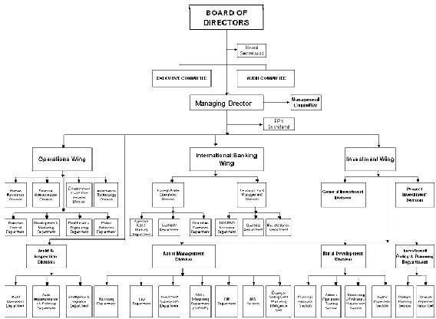

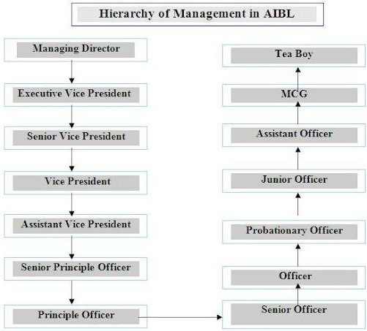
Figure 2 Chain of Command

Vision
To lead Bangladesh's Islamic banking industry and make a major contribution to the expansion of the country's economy (Al Arafah Islami Bank PLC profile, 2024).

Mission
AIB PLC is dedicated to fulfilling the will of Almighty Allah in this life as well as the next. Additionally, it seeks to spread banking methods based on Shariah. Additionally, it provides high-quality services by utilizing the most recent technological advancements. By upholding strict corporate principles, it guarantees prompt and seamless customer service. It strives to maintain a consistent and competitive return on shareholder equity while achieving balanced growth. Additionally, it guarantees creative baking at a reasonable cost. Attracting top-notch human resources is its goal. Additionally, there is a strong commitment to the expansion of the national economy. Additionally, there is a strong commitment to the expansion of the national economy. The best possible financial services using cutting-edge technology (Al Arafah Islami Bank PLC profile, 2024).

Value
Every top business aims to always hold a dominant position. Al-Arafah Islami Bank PLC is one of the biggest banks in Bangladesh, as I mentioned earlier. The goal of this well-known banking institution in Bangladesh is to continue to play a major role in our national economy and to preserve its leadership position. To offer financial services through its locations across the nation to corporate clients, small and medium-sized enterprises, and retail customers. To create cutting-edge goods and services by combining principles, policy, and technology. AIB PLC aims to have a major footprint in our nation by actively participating.(Al Arafah Islami Bank PLC profile, 2024).

Products and Services
The above-mentioned banks have the below mentioned products and service offerings:

- Al wadiah current account (CD).
- Mudaraba short notice deposit (SND).
- Mudaraba savings deposit (MSD).
- Mudaraba term deposit receipt (MTDR).
- Monthly installment-based term deposit (ITD).
- Monthly profit-based term deposit (MPTD).
- Al-Arafah monthly Hajj deposit (MHD).
- Al-Arafah term Hajj deposit (THD).
- Monthly installment-based marriage savings investment scheme (MIS).
- Al-Arafah savings bond (ASB).
- Foreign currency deposit (FCD).
- Pension deposit scheme (PDS).
- Cash deposit waqf deposit scheme (CWD).
- Mudaraba lakhpoti deposit scheme (LDS).
- Mudaraba millionaire deposit scheme (MDS).
- Mudaraba (special) pension deposit scheme (MSPDS).
- Mudaraba kotipoti deposit scheme (MKDS).
- Mudaraba double benefit deposit scheme (MDBDS).
- Mudaraba triple benefit deposit scheme (MTBDS). (AIB PLC Profile, 2024)

Objective of Al-Arafah Islami Bank
One of Al-Arafah Islami Bank PLC's primary objectives is to prepare for the rapidly increasing challenges of globalization in the twenty-first century and to set up new channels for innovative banking, such as an automated one-stop shop. In order to satisfy the demands of corporate clients, they also hope to provide a broad variety of financial and commercial services to both domestic and foreign enterprises. With the introduction of technology, the future of the banking sector has been reevaluated, and AIB PLC thrives on pursuing this objective. They have already launched several services, such as online banking and Islamic wallets (Al Arafah Islami Bank PLC profile, 2024).

Management Hierarchy
There is a certain management hierarchy according to the branch systems of Al-Arafah Islami Bank PLC (Al Arafah Islami Bank PLC: AIB PLC management, 2024). This is explained below with a Chart:
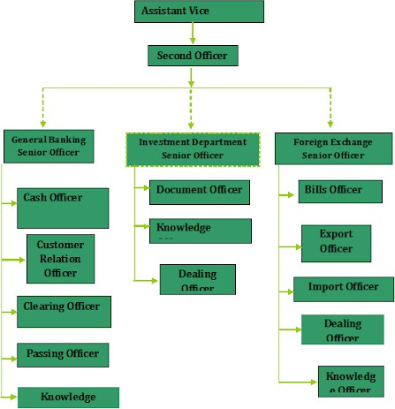
Figure 3 Management Hierarchy of AIB PLC

CHAPTER 3: EMPLOYEE ENGAGEMENT & OVERALL PERFORMANCE OF AL-ARAFAH ISLAMI BANK PLC

Human Resource Management

The goal of human resources is to help people grow and develop so they can become more competent, creative, and fulfilled. Any organization's employees are its backbone; without them, operations could not function. By assisting them in becoming more competent and responsible people, the aim is to establish an atmosphere where workers may contribute to the best of their abilities. This strategy is predicated on the idea that increasing human potential and offering opportunities results in increased operational efficacy. The fundamental tenet of the human resource strategy is that people will produce superior outcomes. The activities to be performed and the kind of personnel needed are decided by the bank. Employing competent applicants, educating them, assisting with their performance, and setting up procedures to guarantee their continued engagement and productivity are all under the direction of the HR department. The HR Department at Al-Arafah Islami Bank PLC is in charge of hiring, training, and development, benefits and pay for staff members, performance reviews, and awards. The Human Resources Department helps the firm achieve its goals by carrying out these essential tasks. Human Resource Department of Al-Arafah Islami Bank PLC
In addition to hiring, training and development, organization development, performance reviews, rewarding, control, and maintenance, the human resources department is one of the most crucial departments. The Human Resources Department has had seasoned executives working on all tasks from its inception. The Human Resources Department of People Insurance Bhaban's headquarters in Motijil is directly under the direction of the top management.

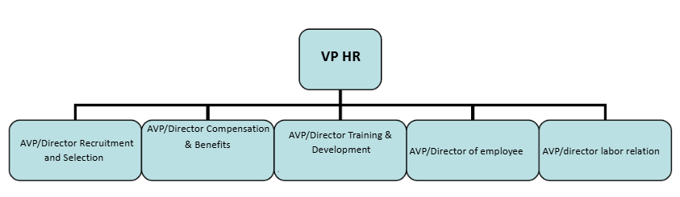
Figure 4 Structure of HR Department in a Large Organization

Core Functions of Human Resources Department in Al-Arafah Islami
Bank Limited(AIB PLC)
Core Functions of Human Resources Department in Al-Arafah Islami
Bank Limited(AIB PLC)

Core Functions of Human Resource Department in Al-Arafah Islami Bank PLC

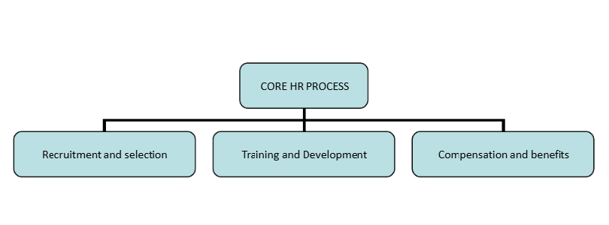
Figure 5 Core HR Process in HR department of AIB PLC backed by the Human Resources Manual.

Recruitment Process of AIB PLC Bank PLC

Recruitment and selection are by far the most important processes for any firm since they involve selecting the most qualified applicant for the position. Companies need to be very careful with this work because it will identify the type of employee that will have a big impact on the organization's performance in the future. The human resources department of the company usually handles this work.
Similarly, AIB PLC's HR department is in charge of hiring and selection. AIB PLC employs both external and internal hiring practices. External Recruiting: External recruitment is the process of hiring new people from outside the organization who have different backgrounds and skill sets.There are numerous benefits to hiring from outside sources, including:
● Workers typically have new knowledge and skills
● More creative and vivacious ideas to integrate into daily tasks
● hiring from outside sources broadens the workplace's diversity
● Opportunities for young people without jobs are increased

External recruitment is a process that requires careful planning and execution. Initially, AIB PLC must identify the most suitable channels for advertising job vacancies. Currently, there are numerous platforms available for organizations to post job openings, aiming to attract a diverse pool of candidates. AIB PLC primarily favors utilizing newspapers and job websites for this purpose.

Subsequently, the Human Resources department must determine the budget and assess which channels yield the best results. Based on this evaluation, they will allocate funds accordingly to the chosen platforms. It is also essential for them to clearly outline the job specifications and responsibilities to ensure that potential candidates fully comprehend the expectations of the role. In summary, the diagram below illustrates the external recruitment process of AIB PLC in a structured manner.

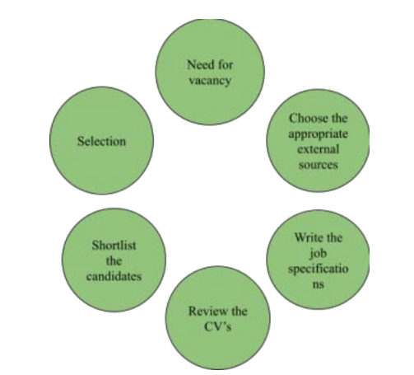
Figure 6 External Recruitment Process of AIB PLC

Internal Recruitment
The process of choosing applicants for new roles from among current staff members is known as internal recruitment. Promotions, transfers, and employee or position approval are typically what start this procedure. The fact that internal hiring typically requires less finance is one of its benefits. Since they are already familiar with the talents and abilities of their present workforce, many employers like this strategy. Furthermore, employees who receive promotions or transfers are likely to be more devoted than those who are hired from outside.

Selection
A reputable company will also screen applicants to find the best fit for the position. This is accomplished through a variety of exams and evaluations intended to gauge their level of expertise. Those who successfully finish the evaluation and interview stages will be chosen for the role. It is important to note that funding will be needed for this selection stage because poor planning will result in unanticipated costs.

The Compensation System
It was revealed that employees receive additional perks in addition to their base pay, such as pensions, bonuses, three-year performance bonuses, and pay hikes. Additionally, workers receive financing, help with transportation, and health insurance. The group offers non-monetary perks in addition to cash assistance, such as ten required vacation days annually. Additionally, AIB PLC offers its workers compensated maternity leave, with female employees receiving six months of paid leave.

Training and Development
Employee development and grooming are given more importance in modern firms since people are seen as vital resources. In order to cultivate informed and experienced staff inside the firm, human resources has made training and development a vital obligation.

With the aim of developing knowledgeable, moral, committed, and driven human resources to improve the banking system, Al-Arafah Islami Bank PLC founded its own Training and Research Institute, AIBTRI (AIBTRI, 2024).
The core values upheld by AIBTRI include:
a. Taqwa: Instilling awareness of the presence of Allah the Almighty.
b. Amanah: Ensuring that employees manage accounts with the highest level of honesty and integrity.
c. Al-Mas'uliyyah: Holding employees accountable for their actions to the Director General of the Institute and the Human Resources Division of the Bank.
d. Al-Adal: Ensuring that all decisions made are in the best interest of both the people and the organization (AIBTRI, 2024).
AIBTRI conducts both annual and monthly training sessions, skill enhancement programs, and seminars aimed at boosting employee productivity, improving management practices, enhancing customer satisfaction, and more. The training and development initiatives provided by AIBTRI not only benefit the organization but also foster employee confidence, broaden their skill sets, facilitate quicker promotions, and enhance overall efficiency.

Promotion

AIB PLC typically refrains from advertising, much like other Islamic banks. Discounts on specialty dining, retail, entertainment, and medical services are not provided by the bank. In contrast, these policies are offered by numerous banks as part of their marketing initiatives, such as BRAC Bank, Oriental Bank, Lanka Bangla, and Standard Chartered Bank.

Employee Engagement
AIB PLC places a strong emphasis on its employees' ongoing professional development. To improve its workers' skills and abilities, the bank hosts a lot of trainings, workshops, and seminars. In addition to improving workers' abilities and output, these training courses aim to foster leadership qualities and bring staff members into line with the company's principles. Performance and job satisfaction both rise as a result. The bank is also in favor of identifying methods to enhance the organization's performance, raising awareness of the importance of doing so, and keeping staff members for an extended period of time. Through a variety of official and informal recognitions, the bank has consistently honored its staff members for their accomplishments, dedication, and hard work. Workers will receive jobs, bonuses, and rewards for their contributions to the company. As part of its dedication to assisting staff in juggling their personal and professional lives, the bank provides health benefits, paid time off, and flexible work schedules. Numerous medical and health services, including stress management, health insurance, and health evaluations, are provided by the bank. These services guarantee employee loyalty by demonstrating the bank's concern for the physical and mental well-being of its staff.

Relation Between employee engagement and Overall performance

The connection between employee engagement and overall organizational performance is extensively documented, demonstrating how engaged employees contribute positively to a company's success. The following points outline this relationship:
1. Enhanced Productivity
In general, engaged workers are more driven to work and, as a result, deliver better work. For instance, AIB PLC Bank PLC will launch new financial products, quicker transactions, and improved customer service. According to research, employees who are committed to taking responsibility for their work might do better than what is needed for their position, which raises the bar. Profitability and organizational performance are directly impacted by higher production levels.
2. Improved Customer Satisfaction
Employees are more committed to offering excellent customer service, as evidenced by their objectives, output, and customer-facing efforts. Demand for a product can significantly boost client loyalty and satisfaction. In service sectors like financial services, where fostering relationships with clients is essential to company success, this is particularly crucial. Customer retention and sales of goods like loans, savings plans, and service capital are directly impacted by customer satisfaction in the banking industry.
3. Reduced Absenteeism and Turnover
Engaged workers will be less inclined to miss work and leave. Reducing absenteeism will promote sustainable productivity and efficiency while also stabilizing the workforce. The low rates offered by AIB PLC Bank PLC guarantee continuity and stability in client relationships. Low staff turnover can also reduce the expense of hiring and training new hires, which can boost the bottom line of the company.
4. Fostering Innovation and Problem-Solving
The committee staff of AIB PLC Bank PLC frequently contributes their thoughts and recommendations. Because they are more ready to work together, share ideas, and solve problems, people in collaborative workplaces are more likely to be innovative. A competitive edge may result from this innovation, particularly in a market that is evolving quickly.
5. Strengthened Organizational Culture
The spirit of employees in the bank creates a good organizational culture that encourages cooperation and collaboration between different departments. Employee engagement often results in a supportive and collaborative environment where employees feel cared for and motivated. Cultural fit is the foundation for overall performance improvement.
6. Enhanced Organizational Culture
Top Techniques Increasing employee involvement will contribute to the development of a productive workplace that encourages cooperation and teamwork among all departments. An environment where workers feel appreciated and supported should be fostered by employee engagement. Better project delivery, improved communication, and more alignment with the organization's objectives are the outcomes of this leadership.
7. Financial Performance
Together, these elements contribute to the organization's financial success since teamwork can boost revenue, client retention, and customer happiness. Businesses with high levels of engagement will report increased income and revenue growth, according to numerous studies by Gallup and other HR-focused organizations.

Survey questions and results
Question no. 1
Does the Human Resource policies at Al-Arafah Islami Bank PLC encourage a high level of employee engagement?
- Strongly Agree
- Strongly Disagree
- Neutral
- Agree
- Disagree
Table no.1
The table shows the employees response

 | Responses |  | Percentage
Strongly Agree | 8 |  | 70%
Strongly Disagree | 0 |  | 0
Neutral | 2 |  | 15%
Agree | 2 |  | 15%
Disagree | 0 |  | 0
Total |  | 12 | 100%

Analysis:
The above table gives information about the Employee’s feedback about the question Human Resource policies at Al-Arafah Islami Bank PLC encourage a high level of employee engagement. Of 12 employees, 70% strongly agreed, 0% strongly disagreed, 15% Neutral and 15% agreed 0% disagree has been responded
Chart no.1
Chart shows the employees responses

Interpretation
The above Chart gives information about the Employee’s feedback on the level of employee engagement of the organization. Of 12 employees, 70% strongly agreed, 0% strongly disagreed, 15% Neutral and 15% agreed 0% disagree has been responded
Question no.2
Do the recruitment and onboarding processes make new employees feel engaged and motivated?
- Strongly Agree
- Strongly Disagree
- Neutral
- Agree
- Disagree
Table no.2
The table shows the employees response

 | Responses | Percentage
Strongly Agree | 4 | 33%
Strongly Disagree | 0 | 0%
Neutral | 2 | 17%
Agree | 4 | 33%
Disagree | 2 | 17%
Total | 12 | 100

Analysis
The table gives information about the Employee’s feedback on the recruitment and onboarding processes making new employees feel engaged and motivated. From 12 employees those are involved in the survey, 33% strongly agreed, 0% strongly disagreed, 17% Neutral and 33% agree and 17% disagreed has been responded.
Chart no.2

Chart shows the employees responses

Interpretation
The above chart gives information about the Employee’s feedback on the recruitment and onboarding processes in the organization. Of 12 employees, 33% strongly agreed, 0% strongly disagreed, 17% Neutral and 33% agree and 17% disagreed has been responded.

Question no.3
Is all employees working are treated equally in the Organization?
- Yes
- No
Table no.3

The table shows the employees response

 | Responses | Percentages
Yes | 10 | 83%
No | 2 | 17%
Total | 12 | 100%

Analysis
A majority (83%) of employees felt they are treated equally, while 17% disagreed.

Chart no.3
Chart shows the employees responses

Interpretation
The results suggest general satisfaction with equality in treatment, although a small percentage indicated otherwise.

Question no.4
Does the bank provide sufficient training and development opportunities to enhance employee engagement?
- Yes
- No
Table no.4

 | Responses | Percentages
Yes | 8 | 67%
No | 4 | 33%
Total | 12 | 100%

Analysis

The above table gives information about the employees feel supported in the Organization. Among 12 employees, 67% answered YES and 33% are marked as NO and they don’t think the bank provides enough training and development opportunities.

Chart no.4

Interpretation
The above chart gives information about what employees feel about the training and development of the Organization. Among 12 employees, 67% are marked as YES and 33% are marked as and they don’t think the bank provides enough training and development opportunities.

Question no. 5
Does Performance appraisal and feedback systems at the bank help improve employee engagement?
- Yes
- No
Table. 5

 | Responses | Percentages
Yes | 9 | 75%
No | 3 | 15%
Total | 12 | 100%

Analysis

The above table gives information about whether the performance appraisal and feedback systems at the bank help improve employee engagement. Among 12 employees, 75% are marked as Yes and 15% are marked as No for performance appraisal and feedback systems at the bank to help improve employee engagement.

Chart no.5

Chart shows the employees responses

Interpretation
The above chart gives information about whether the performance appraisal and feedback systems at the bank help improve employee engagement. Among 12 employees, 75% are marked as Yes and 15% are marked as No for rated for performance appraisal and feedback systems at the bank to help improve employee engagement.

Question no. 6
Does the compensation and benefits package at the bank motivates employees to perform better.
- Strongly Agree
- Strongly Disagree
- Neutral
- Agree
- Disagree
Table. 5
The table shows the employees response

 | Responses |  | Percentage
Strongly Agree | 7 |  | 58%
Strongly Disagree | 0 |  | 0
Neutral | 1 |  | 8%
Agree | 2 |  | 26%
Disagree | 1 |  | 8%
Total |  | 12 |  | 100%

Analysis:
The above table gives information about the Employee’s feedback about the question , Does the compensation and benefits package at the bank motivates employees to perform better.Of 12 employees, 58% strongly agreed, 0% strongly disagreed, 8% Neutral and 26% agreed 8% disagreed.
Chart no. 5
Chart shows the employees responses

Interpretation
The above Chart gives information about the Employee’s compensation and benefits package at the bank and whether it motivates employees to perform better. Of 12 employees, 58% strongly agreed, 0% strongly disagreed, 8% Neutral and 24% agreed 8% disagree has been responded which gives us a clear view of how the employees feels about the banks compensation and benefits package.

Question no.7
Do the banks Work-life balance initiatives positively impact employee engagement?
- Yes
- No

Table no. 7

 | Responses | Percentages
Yes | 9 | 75%
No | 3 | 25%
Total | 12 | 100%

Analysis

The above table gives information about the employees satisfied or dissatisfied with the banks Work-life balance initiatives. Among 12 employees, 75% are satisfied and they marked yes and also 25% employees are dissatisfied with their work-life balance initiatives.

Chart no. 7
The chart show employees’ work life balance

Interpretation
The above chart gives information about the employees satisfied or dissatisfied with the banks Work-life balance initiatives. Among 12 employees, 75% are satisfied and they marked yes and also 25% employees are dissatisfied with their work-life balance initiatives.

Question no.8
Do highly engaged employees tend to perform better and contribute more to the bank's goals?
- Yes
- No

Table no.8

 | Responses | Percentages
Yes | 11 | 92%
No | 1 | 8%
Total | 12 | 100%

Analysis
The above table gives information about the employees who are highly engaged and tend to perform better and contributes more to the bank’s goals. Among 12 employees, 82% are marked as Yes and 8% are marked as No for rated employees.

Chart no. 8

Interpretation
The above Chart gives information about the employees who are highly engaged and tend to perform better and contributes more to the bank’s goals. Among 12 employees, 82% are marked as Yes and 8% are marked as No for rated employees. Here we can see majority of the employees marked yes for the question which emphasizes that employee engagement is a crucial thing for better performance and overall performance of the organization.

Question no. 9
Do Employees who are engaged are more likely to provide better customer service?
- Strongly Agree
- Strongly Disagree
- Neutral
- Agree
- Disagree
Table. 9

The table shows the employees response

 | Responses |  | Percentage
Strongly Agree | 8 |  | 67%
Strongly Disagree | 0 |  | 0
Neutral | 1 |  | 8%
Agree | 2 |  | 17%
Disagree | 1 |  | 8%
Total |  | 12 |  | 100%

Analysis:
The above table gives information about the Employee’s feedback about the question, Do Employees who are engaged are more likely to provide better customer service. From the 12 employees, 67% strongly agreed, 0% strongly disagreed, 8% Neutral and 17% agreed 8% disagreed.
Chart. 9
Chart shows the employees responses

Interpretation
The above Chart gives information about the Employee’s feedback about the question, Do Employees who are engaged are more likely to provide better customer service. From the 12 employees, 67% strongly agreed, 0% strongly disagreed, 8% Neutral and 17% agreed 8% disagreed. From the Chart it can be seen that 8 respondent answered strongly agree because they feel that being engaged with the organization as well as the employees can motive them to provide good customer service as if they are a family as a whole, so ones bad performance can affect the whole organizations values and goals.

Question no. 10
Does a lack of employee engagement negatively affects the bank’s financial performance?
- Strongly Agree
- Strongly Disagree
- Neutral
- Agree
- Disagree
Table. 9
The table shows the employees response

 | Responses |  | Percentage
Strongly Agree | 10 |  | 83%
Strongly Disagree | 0 |  | 0
Neutral | 2 |  | 17%
Agree | 0 |  | 0%
Disagree | 0 |  | 0%
Total |  | 12 |  | 100%

Analysis:
The above table gives information about the Employee’s feedback about the question, Does a lack of employee engagement negatively affects the bank’s financial performance? From the 12 employees, 83% strongly agreed, 0% strongly disagreed, and 17% Neutral and 0% agreed 0% disagreed.
Chart. 10
Chart shows the employees responses

Interpretation
The above Chart gives information about the Employee’s feedback about the lack of employee engagement which effects the overall financial performance of the Bank. From the 12 employees, 83% strongly agreed, 0% strongly disagreed, and 17% Neutral and 0% agreed 0% disagreed. From the Chart above, 10 respondent answered strongly agree because they feel that lack of employee engagement can affect negatively on the bank’s financial performance because they all have to work together every day to solve critical problems those which are unique and cannot be solved alone.

Data Analysis Summary
This report shows the relevant employees of Al-Arafah Islami Bank PLC and the overall results. The survey report shows the Engagement of employees of Al-Arafah Islami Bank PLC. It is difficult to collect information from employees while conducting research because employees provide high security and believe that sharing information will harm the institution. Some employees are satisfied with their jobs, while some employees are not satisfied with their jobs and all evaluations will show this result. Some employees think that their jobs are difficult and they are not trained enough. According to Al-Arafah Islami Bank PLC’s employee engagement survey, while the majority of employees are satisfied with human rights policies, performance appraisals and life performance reviews, recruitment, training and compensation are areas that need further improvement. 92% of survey respondents emphasize the importance of engagement in increasing customer traffic and organizational results, saying engaged employees perform better, align with organizational goals and contribute to financial success. Recognizing differences can improve overall engagement and organizational performance.

CHAPTER 4: INTERNSHIP EXPERIENCE

I started my internship at Al-Arafah Islami Bank PLC, Mirpur Branch, Dhaka from July 11, 2024 to 2024 and the 3-month internship ended on October 11, 2024. During my internship at Al-Arafah Islami Bank PLC, I conducted a report focused on evaluating employee engagement and its impact on overall performance of the Bank. As one of the leading Islamic financial institutions, the bank is committed to providing professional support to its employees and emphasizing their responsibilities and contributions to the success of the organization. During my internship, I had the opportunity to see employees participate in changes in their personal performance and improve their team and job performance in various ways. I helped design and distribute employee engagement surveys to multiple departments. These questions are designed to measure factors such as career development, communication, recognition, work-life balance and job satisfaction. The main purpose of my internship is to gather insights into how employee engagement affects the performance of the organization, especially in the Bank's business department. I was tasked with collecting data through surveys, interviews and secondary research to investigate the relationship between employee satisfaction and motivation and the performance of Al-Arafah Islami Bank PLC. I also faced some challenges during my internship. This included collecting information on all employees. Many people participated in the survey, but many refused to give honest answers to my questions, which affected the reliability of the survey.

Working session in Al-Arafah Islami Bank PLC,
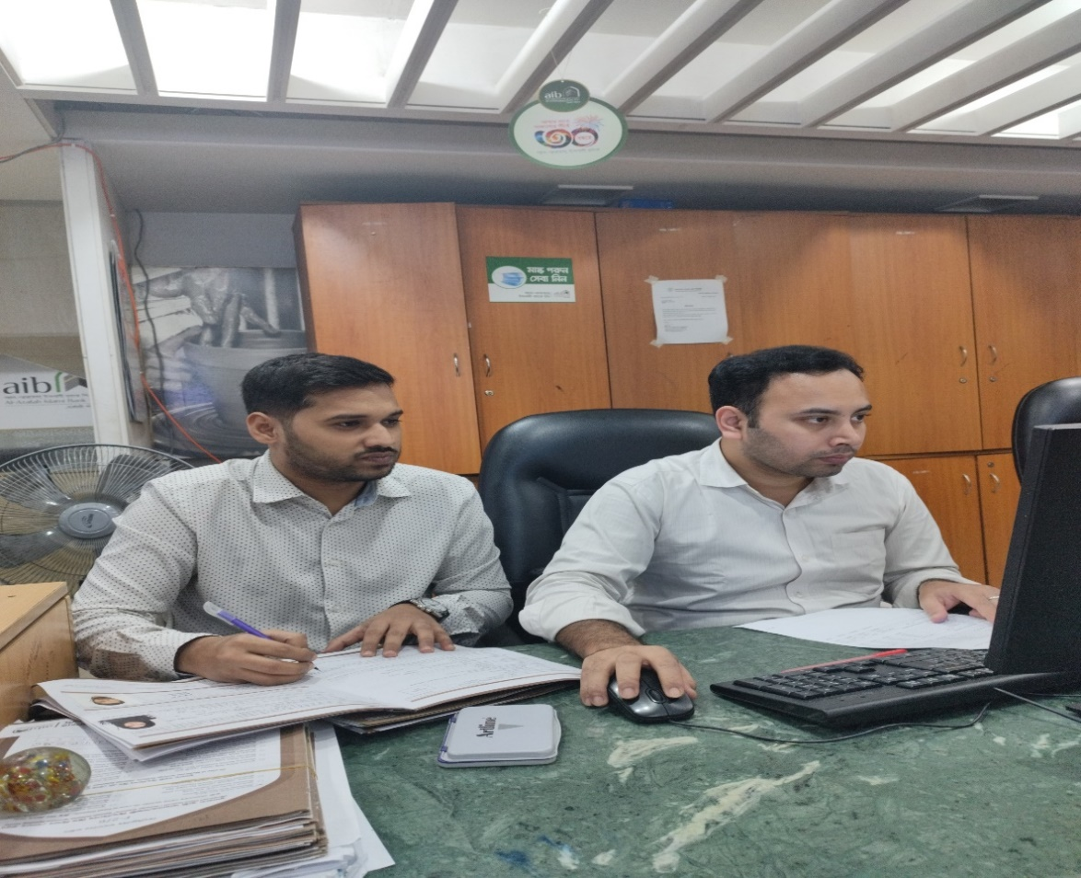
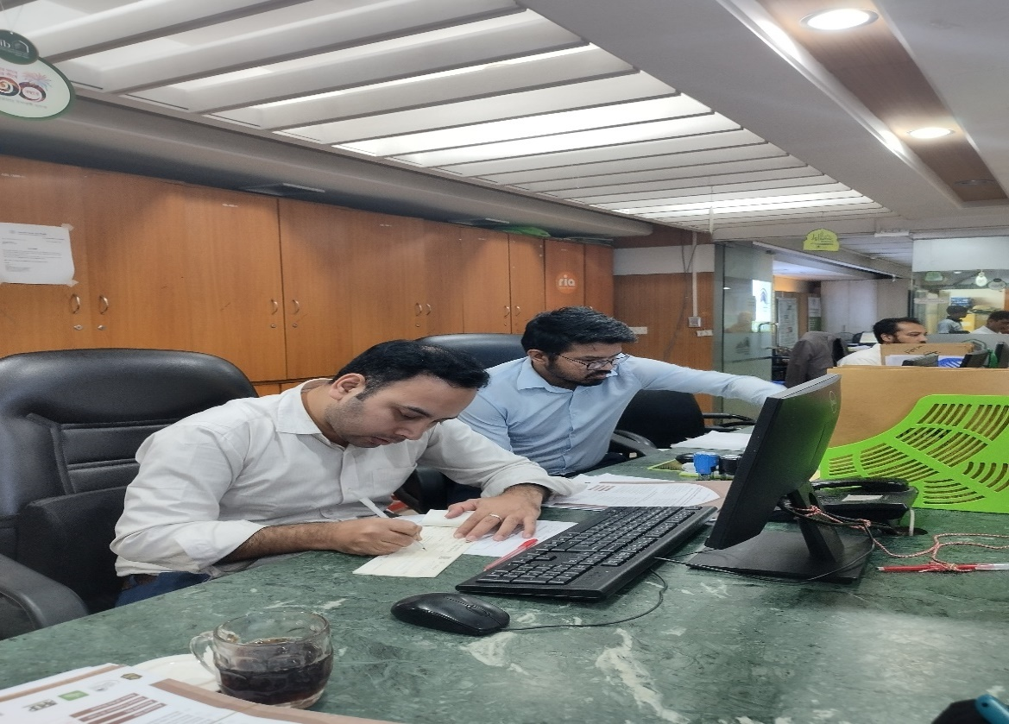
Al-Arafah Islami Bank PLC (AIB PLC) has reached a significant milestone, celebrating its 30th anniversary on 29th September

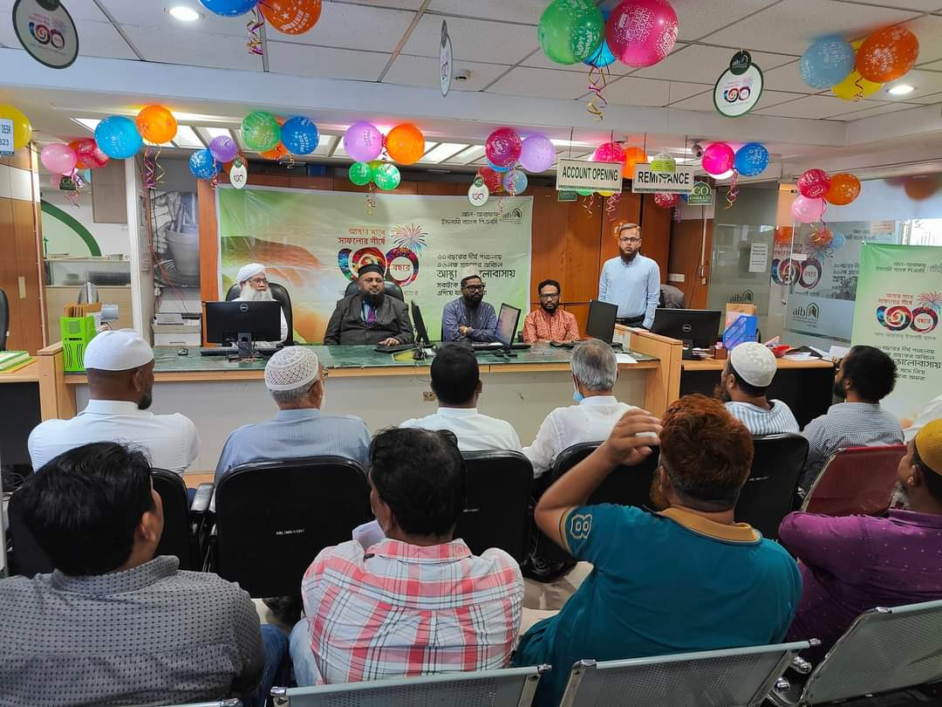

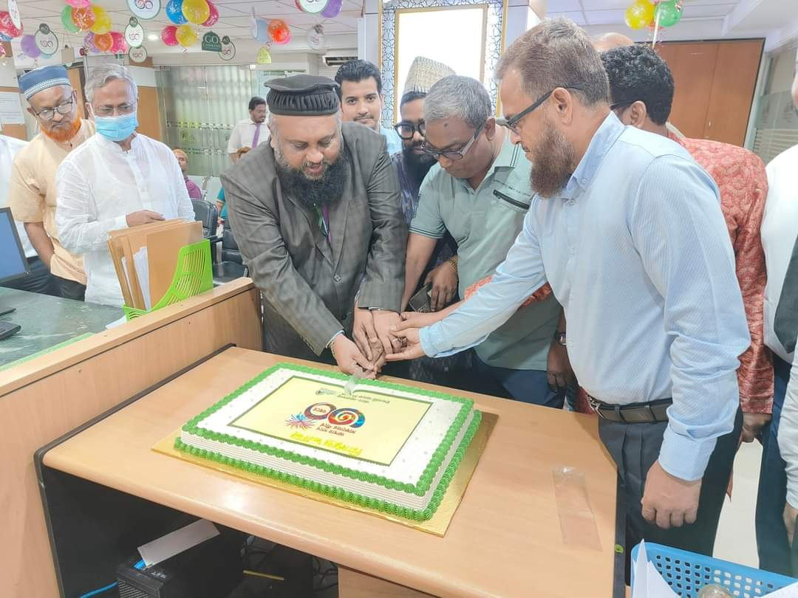

CHAPTER 5: FINDINGS & RECOMMENDATIONS

Findings

Increased Productivity:
Employee engagement and increased productivity are definitely related, according to research. Because they are more dedicated to their work, engaged employees at Al-Arafah Islami Bank PLC perform effectively both individually and as a team across all divisions.
Improved Customer Service:
According to the survey, people who felt appreciated and included interacted with consumers in a more professional and enthusiastic manner. The bank's competitive edge will be strengthened as a result of higher client satisfaction, which will boost consumer trust and enhance overall service quality. Despite having strong customer service, Al-Arafah Bank needs to keep improving if it wants to stay ahead of other financial institutions.
Lower Turnover and Absenteeism:
According to my research, employees are more likely to stick with a company because of the sense of fulfillment and belonging that various initiatives provide. This is further supported by low training and recruitment expenses linked to rapid turnover.
Higher Innovation and Creativity:
By encouraging them to suggest ways in which the company can increase efficiency and therefore improve delivery, their commitment and sense of belonging to the organization will increase.
Organizational Impact of Culture:
The culture of the bank was positively impacted by all of these individuals that are involved with the institution. The culture has been beneficial. Workers feel more in line with the company's objectives and ideals, and they have more faith in management.

Recommendations

Improve Communication and Recognition Programs:
To boost staff engagement, Al-Arafah Islami Bank PLC had to do more to promote candid communication and acknowledgment. Employees who receive regular feedback—both constructive and positive—may feel more appreciated and inspired. When accomplishments are acknowledged by the public, people feel more accomplished and perform better overall.
Career Development and Growth Opportunities:
Planning and training should be given more attention by Al-Arafah Islami Bank PLC in order to boost staff engagement. Employees that feel there is a clear path to advancement inside the company will be more engaged and perform better.
Improve Work-Life Balance Programs:
Working hours, ability to work remotely, and health. This can reduce burnout, increase job satisfaction, and build long-term commitment. Al-Arafah Islamic Bank PLC should develop this area.
Measure Engagement Levels on a Regular Basis:
To gauge staff satisfaction, pinpoint opportunities for development, and monitor the outcomes of current collaborations, the bank ought to hold focus groups and employee engagement surveys. HR and management will be able to make well-informed decisions for improvement with the help of data-driven insights. can enhance teamwork.
Provide Autonomy and Empowerment:
Employees who feel empowered are more equipped to take ownership of their work and make meaningful contributions to the company's success. Participation is key. The goal of banks should be to create.

Strengthen Leadership Development:
Leadership development programs that help managers gain the skills they need to empower their teams. Good leadership helps create an environment of trust, transparency, and collaboration.
Promote Social Responsibility Initiatives:
Participating in some social media or promotional activities allows employees to share the results with the organization's mission, which means greater engagement.

CHAPTER 6: CONCLUSION
My internship experience with Al-Arafah Islami Bank PLC has been a very intense experience as Al-Arafah Islami Bank PLC is one of the leading organization in the banking sector. While working with Al-Arafah Islami Bank PLC, I gained suitable understanding of the banking sector.
I have developed essential skills in Management, Employee engagement, Learning and development, Performance appraisal and Compensation which I believe will be a great valuable gain for my future endeavors. The whole report on measuring the impact of employee engagement on overall performance has also given me the confidence to talk and gather information of the individual’s professional and personal life which will later benefit me in my corporate journey.
The opportunity to work with experts and volunteers intrigued me with the basic plan and the sustainability approach developed. The idea that the community becomes a valuable asset for people made me believe that anything is possible if enough effort is put in. As a result, engaged employees are loyal, motivated and committed to goals, which leads to increased productivity that increases customer satisfaction and innovation. Participation in decision-making or simply connecting employees to the organization can create the best culture and have a positive impact on the company's work and finances. Increase the bank's reputation in the competitive banking sector. In this regard, Al-Arafah Islami Bank PLC needs to invest more in employee engagement strategies if it is to achieve sustainable growth and make profits in financial assistance in the business sector.
Leadership and management practices such as providing performance improvement opportunities, recognizing employee participation, and maintaining open lines of communication are also considered important in empowering employees. These practices not only support the personal development of employees, but also help increase the company's competitive advantage in the financial market.
Finally, the positive correlation between overall performance and employee engagement emphasizes how crucial it is to cultivate a committed and driven workforce in order to achieve long-term organizational success.

REFERENCE

Al Arafah Islami Bank PLC profile. (2024, September 25). Retrieved from Al Arafah Islami Bank PLC: https://www.aibl.com.bd/about-us/aibl-profile/
Al Arafah Islami Bank PLC: AIB PLC management. (2024, September 25). Retrieved from Al Arafah Islami Bank PLC: https://www.aibl.com.bd/management-team/
Al Arafah Islami Bank PLC: Financial Statement. (2024, September 25). Retrieved from Al Arafah Islami Bank PLC: https://www.aibl.com.bd/financial-statement/
Allen, D. G., Shore, L. M., & Griffeth, R. W. (2003). The role of perceived organizational support and supportive human resource practices in the turnover process. Journal of Management,29(1), 99–118.
Bakker, A. B., & Demerouti, E. (2008). Towards a model of work engagement. Career Development International,13(3), 209–223.
Baumruk, R. (2004). The missing link:The role of employee engagement in business success. Workspan,47, pp. 48–52.
Gallup. (2017). State of the Global Workplace Report. Washington, D.C.: Gallup Inc.
Harter, J. K., Schmidt, F. L., & Hayes, T. L. (2002). Business-unit-level relationship between employee satisfaction, employee engagement, and business outcomes: A meta-analysis. Journal of Applied Psychology,87(2), 268–279.
Kahn, W. A. (1990). Psychological conditions of personal engagement and disengagement at work. Academy of Management Journal, 33(4), 692–724.
Macey, W. H., & Schneider, B. (2008). The meaning of employee engagement. Industrial and Organizational Psychology, 1(1), 3–30.
Noe, R. A., Hollenbeck, J. R., Gerhart, B., & Wright, P. M. (2017). Human resource management: Gaining a competitive advantage. McGraw-Hill Education.
Rich, B. L., Lepine, J. A., & Crawford, E. R. (2010). Job engagement: Antecedents and effects on job performance. Academy of Management Journal, 53(3), 617–635.
Robinson, D., Perryman, S., & Hayday, S. (2004). The drivers of employee engagement. Institute for Employment Studies.
Saks, A. M. (2006). Antecedents and consequences of employee engagement. Journal of Managerial Psychology, 21(7), 600–619.
Schneider, B., White, S. S., & Paul, M. C. (1998). Linking service climate and customer perceptions of service quality: Test of a causal model. Journal of Applied Psychology, 83(2), 150–163.

