
Internship Report
On
Investment Corporation of Bangladesh (ICB)

Submitted to
Muhammad Rehan Masoom
Assistant Professor
School of Business & Economics
United International University

Submitted by
Rezaul Amin Jeesan
ID: 111-141-132
Submission Date
3rd November 2019

Letter of Transmittal
To

Muhammad Rehan Masoom
Assistant Professor
Department of Marketing
School of Business
United International University

Subject: Submission of Internship Report on Investment Corporation of Bangladesh.

Dear Sir,
I aim to submit the internship report of my three months long internship program in Investment Corporation of Bangladesh. This report produces been developed to meet the necessity of my internship program.

I have set my most genuine attempt to make this report a thriving one. It has been a happy & enlightening adventure for me to serve in the organization & make this report. It was also a vast reservoir of learning for me.

I want to address my faithful appreciation to you for your kind supervision & advice in making the report. If you want either more interpretation for any portion of this Internship Report, I would gladly give any learning about this Internship report on the Investment Corporation of Bangladesh.

Yours Sincerely
Rezaul Amin Jeesan
111-141-132

November 3, 2019

Acknowledgments

My acknowledgment starts by appreciating my great faculty, Muhammad Rehan Masoom, who has given me advice for making this Final Internship Report and also gave me the arrangement for making this report. I want to give my warm-hearted thanks to the Investment Corporation of Bangladesh (ICB), which has given me a great understanding of information, enough data and finally, cooperated with me for the success of this report successfully. Finally, last but not least, I would like to praise every staff, notably my supervisor Md. Zahirul Islam, for his genus help about the report. Without him, it would not be achievable for me to do this difficult job. I got all the essential guidelines, cooperation, information from him to complete this difficult duty. I am very much grateful to the Investment Corporation of Bangladesh (ICB), its administration, particularly employees of Facilities, for their sincere help to make this report with proper information and data. I am also thankful to the different officials & my colleagues who supported me while doing the narrative by providing their advice, support, and knowledge, which were important to me. Their kind of cooperation helped me in making my report favorably.

Executive Summary
Investment Corporation of Bangladesh (ICB) is one of the most essential sanctioned corporations in Bangladesh. They work as a non-financial bank system with a vital step in a range of projects offered by the government to stimulate the pace of industrialization and to develop a well-organized and active capital market, mainly the securities exchange in Bangladesh. This report illustrates the knowledge and skills acquired from working in ICB as an intern for three months. The report consists of a short explanation of ICB and its missions, visions, strategies, and purposes and the products and services ICB are providing. Next, it described the fundamental roles of each department of ICB and the principal responsibilities as an intern in the department. In the trials and practical knowledge, The intern experience was, in every way helps to develop skills. Under the rule, it has enhanced and developed some corporation skills, which can be of high quality like presentation skills, multitasking, adaptability, being patient, and content. Finally, ICB leads to career ideas by helping to realize the value of corporate experience.

Contents
CHAPTER 1 1
INTRODUCTION 1
1.1 Importance of Study 2
1.2 Objectives of the Study 2
1.3 Sources and Methods of Data Collection 3
1.4 Limitations of the study 3
CHAPTER 2 4
Overview of the corporation and the department and its people. 4
2.1 Overview of the corporation 5
2.1.1 Background of corporation 5
2.1.3 Vision of the corporation 5
2.1.4 Mission of the corporation 6
2.1.5 Core Values of corporation 7
2.1.6 Business Policy of corporation 7
2.1.7 Functions of corporation 7
2.1.8 Products and services of the corporation 8
2.2 Department 10
2.2.1 Administrative Division 11
2.2.2 Merchandising Division 12
2.2.3 Funds Division 13
2.2.4 Accounts and Finance Division 14
2.2.5 Computer Division 15
2.2.6 Loan Appraisal Division 16
2.2.7 Implementation and Recovery Division 17
2.2.8 Legal Affair Division 18
2.2.9 Secretary’s Division 19
2.2.10 Branch Division 19
2.2.11 Subsidiary Companies of ICB 19
2.2.12 Equity and Entrepreneurship Fund Division 20
2.3 People 21
CHAPTER 3 22
Internship Experience 22
3.1 Job responsibilities 23
3.1.1 Task Area 23
3.1.2 Daily Activities 24
3.1.3 Visited Department 24
3.2 Our assignment and contribution towards ICB 26
3.2.1 Learned Objectives 27
3.2.2 Interaction with employment supervisor and coworkers 28
Day to Day Activity 29
Feb 17th – Feb 21st 29
Feb 24th – Feb 27th 31
Journal – Week 3 33
Work Done 33
Learned Objectives & Achievement 33
Planning & Research Development 33
Business Development Department 34
Portfolio Management Department 34
Observation 35
Notable Incidents 35
Journal – Week 4 36
Work Done 36
Learning Objectives 36
Central Account Department 36
Fund Management Department 36
Observations 37
Notable Incidents 37
Journal – Week 5 38
17th March – 21st March 38
Work Done 38
Learning Objectives 38
Budget and Risk Management Department 38
Data Admin and Management Information System (MIS) Department 39
Observations 39
Notable Incidents 39
Journal – Week 6 40
24th March – 29th March 40
Work Done: 40
Learned Objectives 40
ICB Securities Trading Company Ltd. (ISTCL) 40
Observations: 40
Notable Incidents: 41
Journal – Week 7 41
31st March 2019 – 4th April 2019 41
Learned Objectives 41
ICB Capital Management Ltd (ICML) 41
Observation 42
Notable Incidents 42
Journal – Week 8 43
7th April 2019 – 11th April 2019 43
Work Done 43
Learned Objectives 43
Appraisal Department 43
Bankers to the Issue Department 43
Observations 44
Notable Incidents 44
Journal – Week 9 45
14th April 2019 – 19th April 2019 45
Work Done 45
Learned Objectives 45
Equity and Entrepreneurship Fund Department (EEF) 45
Observations 46
Notable Incidents 46
Journal – Week 10 46
21st April – 25th April 46
Work Done: 46
Learned Objectives: 46
Observations: 46
Notable Incidents: 46
Chapter 4 47
Bangladesh Shilpa Rin Sangstha 47
4.1 Historical Background: 48
4.2 BSRS Purpose: 48
4.3 BSRS Organization Formations: 49
The process of making group and group decisions: 49
Functional Composition of BSRS: 50
4.4 Operational composition of BSRS: 50
A. Industrial Banking: 51
B. Merchant and investment banking: 52
C. Commercial Bank: 53
Capital and Recourses: 54
4.5 Profit or loss of BSRS: 56
CHAPTER 5 57
Recommendation and conclusion 57
5.1 Findings: 58
5.2 Recommendation 59
Conclusion and Implication 60
5.3 Conclusion 60
Bibliography 61
Bibliography from websites 61

CHAPTER 1

INTRODUCTION
Introduction
Investment Corporation of Bangladesh is one of the most famous governmental establishments in Bangladesh, and it has three subsidiaries and seven categories all over Bangladesh. At the moment in Dhaka Stock Exchange, ICB has about 698 million agreements outstanding and has a 30% cash payout and a 5% stock dividend with stock and excess out "Other Comprehensive Income" of about 23 thousand million. It is an "A" market section institution listed in 1977. The shareholding portion of the government is 27%, champion/director is almost 70%, and institute & public are within 1.5 to 1.7%. ICB is a strong establishment in terms of cash reserve; they have zero short-term and long-term credits.

1.1 Importance of the Study
This report has been developed to meet the demands of the Internship Program at United International University, Bangladesh. This report is a result of an almost three-month internship program. I worked as an intern in Investment Corporation of Bangladesh (ICB) for three months, where I have got experience in the sufficient condition of the capital market and associated experience how each department works, which is an essential step for the growth of ICB. I have worked under two offices and three subsidiaries companies where I came to know a lot about ICB. I operated under the substantial supervision of Mr. Zahirul Islam.

1.2 Objectives of the Study
- The objectives of doing this internship are to:
- Become a better understanding of real life
- The increase in knowledge of the job I will have in the tomorrow
- Interpret the capital market that I will spend on in the tomorrow
- Explain the work and management of investment banking in Bangladesh
- Understand the roles of each department of Investment Corporation of Bangladesh (ICB)
- Examine the peculiar job arrangement and working situation
- Have a concept about job nature

1.3 Sources and Methods of Data Collection
To make this report, I have managed data information from the office itself, from the website, from annual reports of ICB, etc.
Unusual primary data information is gathered in face-to-face interaction from:
- The view of all departments
- The qualified officers at an appropriate department
Secondary data includes
- Ordinance and Annual Reports of ICB
- Daily Newspaper, journals, and books
- Bangladesh Bureau of Statistics
- Monthly Review of DSE and CSE
- Websites

1.4 Limitations of the study
There are particular restrictions that I have met during my internship to get precise data about ICB
- Less Transparency from Officials
- A small number of information given in related papers and document
- Lack of necessary information
- Capital is quite lightweight and deficient in our country, some of the reviews cannot be used to resolve the enforcement of ICB

CHAPTER 2

Overview of the corporation and the department and its people.

Overview of the Corporation

2.1 Overview of the corporation

2.1.1 Background of the corporation
Investment Corporation of Bangladesh is a sanctioned corporation of "Government of the People's Republic of Bangladesh," founded on 1st October 1976 under No 40. Of “Investment Corporation of Bangladesh Ordinance, 1976. It is principally an investment bank working in Bangladesh, placed to stimulate the movement of industrialization and to produce a second securities market in Bangladesh. (Annual Report of Investment Corporation of Bangladesh, 2017-18)
ICB is one of the most prominent investors in the share market of Bangladesh. ICB provides institutional care to satisfy the ownership gap of the companies. Because of the national policy of expediting the proportion of maintenances and investment to promote a self-reliant economy, ICB assumes an essential and crucial role. (Annual Report of Investment Corporation of Bangladesh, 2017-18)
2.1.2 Objectives of the corporation
ICB has four main objectives to sustain the other organizations as well as for the country.
- To strengthen and expand the field of investment
- To improve the capital market
- To gather the preservations
- To accommodate for things ancillary to it.

2.1.3 Vision of the corporation
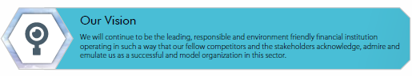
Fig. 1 Vision of ICB (from the annual report)

2.1.4 Mission of the corporation
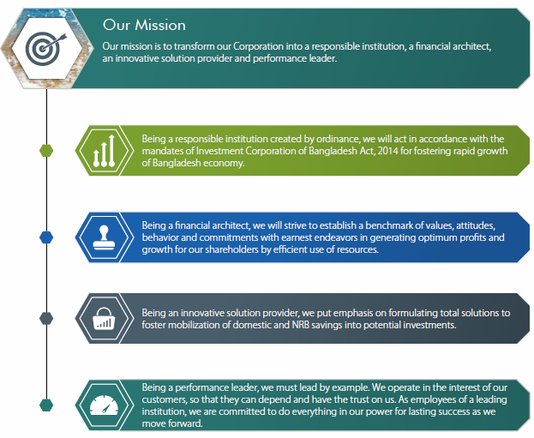
Fig. 2 Mission of ICB (from the annual report)

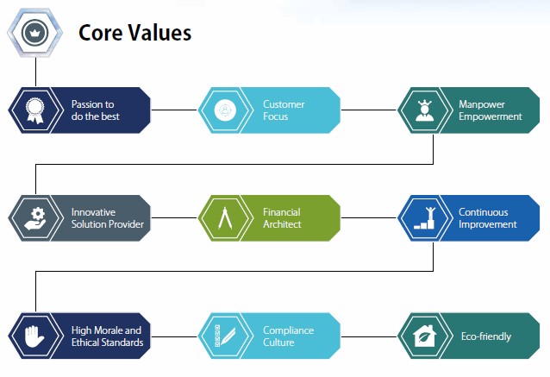
2.1.5 Core Values of the corporation
Fig. 3 Core Values of ICB (from the annual report)

2.1.6 Business Policy of the corporation
There is a particular business policy that ICB
serves
- To work on a financial situation with proper consideration to the industry of industry, commerce, clients, investors and the public in general
- To give financial support to schemes regarding their technical, economic and financial viability
- To manage ownership assistance and loans for schemes only or through a consortium of financial companies including banks
- To promote and strengthen entrepreneurship in the country
- To
increase expenditures
protection
- To encourage small and medium savers for investment in
- To produce employment probabilities
- To strengthen and expand the center of investment in agro and data & contact technology (ICT) sectors.

2.1.7 Functions of the corporation
The principal purposes of ICB are given below:
- Immediate purchase and sale of shares and debentures including position and equity
alliance
- Playing in the position of Unit Funds and Mutual Funds
- Furnishing contract finance only and within syndication
- Managing investment accounts
- Managing unit fund
- Maintaining portfolios and leading part in buying & selling of securities
- Giving advance upon mutual fund records managed by ICB and its subsidiaries
- Giving a bank guarantee
- Performing as trustee and
guardian
- Playing in the investment of joint-venture businesses
- Giving investment counseling to investors
- Engaging in government divestment
schedule
- Adding new business revised to market interest
- Venture Capital Financing
- Get a role in merger, taking and asset modernization movements
- Achieving Equality and Entrepreneurship Fund (EEF), Entrepreneurship Support Fund (ESF) and other unique plans announced by the Government of Bangladesh
- Managing the actions of the subsidiaries organizations as handling the company
- Take a role in offloading percentages of state-owned companies.

2.1.8 Products and services of the corporation
There are some products and services of ICB that are presented to the customers as well as for the different corporations to build the expansion of the capital market and to expand the investment field. The products and services and their functions are:

Products and Services | Functions
Private Equity and Placement of Shares | - To change the business  - To promote fast industrialization of the country
Margin Loan Accounts | - To decrease the danger of investment  - To defend the share of the investors
ICB Unit Fund | - Provides the chance to small and medium savers to spend their savings in a stable and comparatively low-risk portfolio  - Have tax benefits
Advance upon ICB Unit Fund, Bangladesh Fund Certificates, etc. | - To reach their contingency fund terms for the ICB Unitholders
Sponsor of Mutual Funds | - For the growth of the mutual fund business
Trustee & Custodian Services | - To declare debenture and mutual fund  - To securitized bonds
Portfolio Management  - ICB's owned two portfolios  - Unit Fund portfolio | - To improve the capital market
Investment in the Secondary Market | - To increase the use of ICB for supporting the capital market
Merger & Acquisition | - To increase their industry  - To disrobe the plans that no longer match into the near range of service meeting the Corporation  - In honor of developing up the cost and financial arrangements, to secure the most favorable likely operational outcomes
Investment in preference shares | - To increase the investment policy of ICB
Stock Market Operations | - To obtain the capital market active
Debenture Financing
Lease Financing | - For the acquisition of capital machinery, equipment and carrier to the proposed companies

Table 1: Products and Services of ICB
Department & the people

2.2 Department
ICB is a sanctioned corporation, and it is often operating as a non-financial business. They have 49 departments in their head office, three subsidiaries corporation, and seven branches all across Bangladesh. Departments are interlinked in many kinds of connections like face to face, database, and even in telephones.
There are 49 departments in ICB and all those departments are very much significant to the development of ICB. There are various departments under the various divisions that are given below:
Divisions | Departments
Administrative Division | Personnel Department  Establishment Department
Merchandising Division | Investors Department  Shares Department  Transaction Department
Funds Division | Unit Sales Department  Unit Registration & Procurement Department  Mutual Funds Department
Accounts & Finance Division | Central Accounts Department  Projects Loan Account Department
Computer Division | System Analysis Department  Programming Department  Data Management Department
Loan Appraisal Division | Loan Appraisal Department  Economic & Business Research Department
Implementation & Recovery Division | Project Implementation Department  Recovery & Follow-up Department
Legal Affair Division | Public Issue Department  Law Department  Audits and Method Department
Secretary’s Division | Secretary’s Department  Public Relation Department
Branch and Subsidiary Control Division | Branch Office Department
Subsidiaries of ICB | ICB Capital Management Ltd  ICB Asset Management Company Ltd  ICB Securities Trading Company Ltd
Table 2: Divisions and Departments of ICB

2.2.1 Administrative Division
- Personnel Department: Frequently trades with the human resources of the corporation – that is, to establish rules and regulations of the right person to the right place in two separate methods - Direct Recruitment & Promotion. They also use ambition steps for the employee who violates the rules and regulations of the organization – that is, insufficient punishment and heavy punishment. The other functions of these departments are:
Functions:
- To get essential rules, regulation, policies for the effective administration of the corporation
- To manage all personnel concerns including support, posting, change, obsession, leaves
- To prepare all promotion, time-scale encashment
- To process registrants, retirement cases
- To trade with retirement advantages, including reward, pension, provident fund, etc.
- To examine the state pay scale, fixation increment, etc.
- To bargain with all things linking to ICB employees Union and ICB officers Association.

- Establish Department: Dealings with the buying and selling of office supplies, office equipment, etc. etc. They also keep the utility service like telephone bill, electricity bill, etc. This unit dividends cost into two categories – Revenue Cost and Fixed Cost. The primary function of this department

2.2.2 Merchandising Division
- Investor Department: Their principal performance policy is to acquire the investment of small and new investors of the capital market by encouraging them to start an investment account in the concerned department. They trade with the "Investors Scheme." The principal purposes of this department are:
Functions:
- Open and manage an investment account
- Sanction loans upon deposits in the investment account
- Purchase and selling of shares on behalf of the investors
- Counsel investors in honor of giving up their portfolios
- Issue income tax certificates, portfolio statements, account statements, etc.
- Assist the investment account owner
- Assemble commission as a banker to the issue brokerage commission for the businesses
- Retain the financial report of the investment account
- Processing of withdrawal of funds
- Establish fund status of individual accounts
- Posting of all transactions

- Shares Department: Serves as a superintendent of securities and facilitates the real transfer of the share. This department has to make those up exercises into five sections: "Investor Portfolio," "Sales and withdrawal," "Fund's portfolio," "Securities Reconciliation," & "Procurement."
- Transaction Department: Electrocutes the sales and purchase order of shares of the various portfolios – ICB Unit Fund, ICB Mutual Fund, and Government Portfolio. Before execution, they require to be informed of the physical presence of shares of the "Share Department."

2.2.3 Funds Division
- Mutual Funds Department: Works as supervisor of all mutual funds. There remained an overall eight kinds of mutual funds that they have entered into the share market. Their main functions are:
Functions:
- Keep the ledger with name, address and number of certificates alone, with different portfolio number for each mutual fund individually
- Check the signature of the owners in the 117 forms
- Development of special warrants to the owners of the documents
- Distribution of last dividend warrants to the holders of the document after fulfilling significant formations
- In case of an exchange of ownership of mutual funds, certificate holder conveniences the transfer
al method
- Adapt for re-issue or duplicate copy of the certificate in the case of loss or harm of documents
- Accepting application for the exchange of address, correction of names and delivering the identical to the computer department
- Design for dividing the shares portions as and when required following the stock exchange precepts
- Plan for revalidating the date of remittance of dividend on dividend warrant

- Unit Sales Department: ICB has launched its mutual fund that is recognized as an "ICB Unit Fund" which is an open-end fund into which the small and medium savers take the chance to spend their savings in a balanced and almost low-risk portfolio.
Their principal roles are soon to sale, repurchase, and change of Unit Certificates after the business operation of "ICB Asset Management Company Ltd" began.
- Unit Registration & Procurement Department: This section often concentrates on these things –
- Keep a separate file for unit holder below "Cumulative Investment Plan (CIP)"
- Check the signature of the transfer deed
- Issue dividend warrants and CIP certification to the owners
- Secure unit documents of different identifications from the publication process
- Issue unit certificates to ICB sale officers/branches as well as selected bank branches

2.2.4 Accounts and Finance Division
- Central Accounts Department: Their principal goal is to keep and do all kinds of letters and payments of ICB, their other primary functions are:
Functions:
- Make income tax revenues and meters linking to accounts
- Make bills including plans account preservation of plans
- Make salary records, overtime statements, etc.
- Prepare final accounts
- Keeps account toward government loans and debentures and also of "Unit & Mutual Funds."
- Manage relationship with outside audit and portfolio ledgers and also of investor's accounts and portfolio ledger
- Estimation of regular interests
- Posting and balancing of ledgers and prepare of supply flow statement of the Corporation
- Ensure proper budgetary and cost control

- Projects Loan Accounts Department: Their principal goal is to keep project loan statements and supply the control up to date important data of the project. Other than that, their various functions are:
- Issue check to the plan after receiving payment order from the project implementation department and any recoverable value in the
- Compute interest on the paid amount (half-yearly compounded cyclic interest rate using days average)
- Support loan ledger, excitement, suspense, ledger, etc.
- Analyze the loan as per rules and get proper preparation
- Make important declaration related to project credit
- Get necessary description adjustment for class set as per the decision of the jurisdiction

2.2.5 Computer Division
- System Analysis Department:
Functions:
- Operating system study where ICB seems the need for cyclic variation in computerization setup
- Completing unmatched small hardware and software associated maintaining tasks on the various workstations, web system, server, and other parts and give education to the staff of other departments about the method of computer
- Any other assignment was given by management

- Programming Department:
Functions:
- Customizing the software detailed in the modern computerization state according to the differences in terms of the ICB with time
- Present active support to the staff of policy analysis section for the education of the help of another department regarding computer usage
- The approach peak load of data record and data processing work for all different departments of ICB

- Data Management Department:
Functions:
- The handling peak load of data entry and data processing work for all other departments of ICB
- The management presented any other assignments

2.2.6 Loan Appraisal Division
- Loan Appraisal Department: ICB presents credit facilities to the public limited companies to reach the beneficiary ownership gap. The two methods they offer to the proposed public limited companies within "Direct Underwriting for BMRE" and "Underwriting through bridge financing." Primary functions of this department are:
- Get investment project from sponsors
- Place appraisal address to the Board
- Appraisal management on technological features of the plans
- Arrange evaluation report on Project Appraisal Committee
- Issue sanction reports to the plans
- Carry a gathering of the Project Appraisal Committee
- To improve the capital market
- Organization of share and debenture
- Education in bond financing
Acts as a "Trustee" on debenture on behalf of the bondholder
- Planning Research and Business Development: This area is the decision-maker. The primary function of this department are:
- To take a role in the portfolio management judgment
- Develop and give an annual report of ICB, annual report of mutual fund and unit funds
- Conduct reception of the securities sales or buying and with sales committee
- Bear securities sales or purchase decisions to the merchandising division.
- Provide five years of performance appraisal reports of registered companies
- Provide board memo about the information of divisions on ICB's portfolios, unit fund, and mutual funds
- Prepare to offload of government part of shares in separate companies and state-owned institutions
- Manage liaison with "Ministry of Finance," "Bangladesh Bank" and give ICB relevant information to engaged parties

2.2.7 Implementation and Recovery Division
- Project Implementation Department: The principal duties of this department are:
Functions:
- Assistant implementation of the sanction projects
- Prepare the case for removal of sanctioned project
- Follow-up the plan until the start of commercial service
- Inspire the project to go for further loans and leads them to LAD
- Give the procedures for restoration of dues to the recovery department

- Recovery and Follow-up Department: The following are the functions of this department:
Functions:
- Collect the principle and interest due to the sanctioned project
- Review the financial statements and examine the sectional study review and individual project review
- Mail a letter to the project for giving payments and reminds if necessary
- Grant Counseling to go for the public issue
- Improvement of projects within permitted reschedules of loan and waiver of overdue, interest, etc.

2.2.8 Legal Affair Division
- Public Issue Department: This department is liable for the changes in ICB. E.g.:- Recently, ICB has selected specific significant changes in sanctioning bridge loans to the unsatisfactory return of loan sectioned by a company, Bridge loan would only be held for very particular sectors. Advantage has produced to direct underwriting, direct investment in the debenture, and equity participation through the position of share. The ultimate purpose of giving direct underwriting and placing of stock is to support the plans to go for public issues.
- Law Department: This section manages any legal affairs of ICB. The main functions are:

Functions:
- Provide proper documents, advance agreements, share agreements, demand promissory notes, memorandum and deposit of little deed, etc.
- Determine the difference between underwriting-cum-advance compliance, underwriting agreement, and supplementary documents, etc.
- Rule litigation matters, make the proper notice and refer cases to right charges and agree with a licensed advisor in the court
- Examine the legal issue linked to employee loan offices and other matters associated with the law.

- Audit and Method Department: This function works following the "Managing Director" of ICB, and without his endorsement, no transactions take place. The main goal is to block out the problem and brings transparency. This unit, with regards to ICB, makes three kinds of audits – external audit, internal audit, and commercial audit. The principal purposes of this department are to check out that all jurisdictions are well maintained or not, advise new methods in ICB, and recognize the error that is made by other departments.

2.2.9 Secretary’s Division
- Secretary Department: Main duties of secretary departments are:
- Organize a gathering of the Board Directors, Executive Committee and other Committees
- Issue Notices of Board and other Committee meetings, prepare agenda and memos, etc.
- Place working papers to the member of Board/Committee
- Send resolutions of the meetings for implementation – concerned departments
- Communicate with the stockholders on different related subjects etc.
- Public Relations Department: This unit is operating on the outside part of the ICB that can support ICB to enlarge or expand all over the country. The following are the functions of this department:
- Keep the close relationship with the "Ministry of Finance" and other attention
- Improve to write all types of official advertisement
- Aid sharpening ICB through mass-media
- Distribute any internal newsletter or magazine etc.

2.2.10 Branch Division
- Branch Office Department: This section often controls 7 branches of ICB in Bangladesh. Their principal functions are to lead an audit and investigate all branches of the corporation inside and outside Bangladesh and, finally, to have overall control over any types of random inspections in any offices.

2.2.11 Subsidiary Companies of ICB
- ICB Capital Management Ltd.: ICB Capital Management Limited can act all sorts of merchant banking business and to work as a member of financial markets portfolio managers, issuers underwrite or co-underwrite or sub-underwrite lending activities to finance capital leasing projects bridge financing and give long-term loan reducing bill of change and also give credit means through credit cards internet counsel regarding investment and industrial entity.
- ICB Security Trading Company Ltd.: ICB Securities Trading Company Ltd is one of the subsidiaries companies of ICB that:
- Acts as a part of the Stock Exchange
- Holds over-the-counter markets
- Brings out business agent, CDs agent, jobbers or dealers in-stock shares
- Brings out securities, commodities, papers, bonds obligations, debentures stocks, foreign currencies, treasury bills in Bangladesh or abroad
- Opens and maintain investors accounts
- ICB Asset Management Company Ltd.: ICB Asset Management Company Ltd has this following function –
- Accomplishes assets of any trustee or funds of any type and character
- Holds get, sells or deals in such assets or any trusts or funds
- Manages and administrates prepared or grant funds
- Regulates various systems of various kinds for trusts or funds
- Takes role in the management of mutual fund operations
- Operates, conducts, accomplishes and establishes service for industrial, trading and commercial activities
- Invests funds in shares and securities
- Carries on business as financial and monetary agents to merchandise shares and other securities

2.2.12 Equity and Entrepreneurship Fund Division
- Equity and Entrepreneurship Fund Department: The Government of Bangladesh (GOB) had locked up an Equity Development Fund (EDF) in the budget 2000-01 identified as "Equity and Entrepreneurship Fund (EEF)" with a way to promoting the investors to spend in the somewhat risky but promising two sectors – software industry & food-processing/agro-based industry.
  - It mostly arises from Bangladesh Bank's guidance that ICB requires to follow to carry out this fund. To become available for this fund, the basic guidelines are:
  - Any organizers have to be new in business, and their business must be from the software industry or food-processing and agro-based culture
  - The sponsor or entrepreneurs who are applying for EEF support must have to be a “Private Limited Company registered under the Company Act 1994
  - Stabilized old companies can also get EEF support if they set up a subsidiary new private limited company
  - The whole project value including net working capital should be a least 0.5 crore and a maximum of 5 crores for the software industry and a minimum of 0.5 crores and a maximum of 10 crores for the agro-based sector
  - Any debtor cannot apply for EEF.

2.3 People
In this corporation, there are many branches and three principal subsidiaries all over Bangladesh. They have so far around 600 employees working under ICB, including one chairman, one managing director, nine directors, and one company secretary. They are interacting with each other within the database as it is a big sanctioned corporation and various branches all over Bangladesh in a peace and harmony way. The tension is a tiny bit high for the employees here, as I have seen so far.

CHAPTER 3

Internship Experience

Internship experience

3.1 Job responsibilities
I am still currently working as an intern in Investment Corporation of Bangladesh, the principal task I have addressed most of the times is to examine the Dhaka Stock Market and how they are mainly operated and how the shares are acquired or sold in terms of cash or cheque. They frequently delivered a brief detail about the companies affiliated with ICB, and the loan sanctions are given to those businesses to develop the capital market and improve the investment all over Bangladesh.
I am designated in every departments because each day our duty is to get a more excellent knowledge about the departments functions, and some department let us work to have a decent details about the paperwork they are operating on and just to have a knowledge about the capital market and how our subsequent age will increase the investment in order to make a robust correlated market and have a more significant planned development of the country.
During the intern, I discovered many things about the different departments of the Investment Corporation of Bangladesh. I worked as a data entry operator most of the time.

3.1.1 Task Area
Under the supervision of Mr. Zahirul Islam, I had to operate most of the time at the Human Resources Department and under the guidance of assistant general manager "Mr. A.S.M Haidar-uz-Zaman” in Portfolio Management Department.

The hierarchy is given below for my intern work:

Fig 4: Task Area of my position in ICB

3.1.2 Daily Activities
Department | All departments of ICB
Supervisor | Mr. Zahirul Islam
Working Time | 10 am to 6 pm
Holiday Time | Friday and Saturday as usual holiday and government holidays
Table 3: My activities during intern at ICB

3.1.3 Visited Department
Beneath the supervision of Mr. Zahirul Islam, I have to attend many divisions that consist of different departments of ICB. The administration has given me the rights to visit every department and find information about the contemporary situation of ICB. The following departments I have visited are given below:

Divisions | Departments
Administrative Division | Personnel Department  Establishment Department
Merchandising Division | Investors Department  Shares Department  Transaction Department
Funds Division | Unit Sales Department  Unit Registration & Procurement Department  Mutual Funds Department
Accounts & Finance Division | Central Accounts Department  Projects Loan Account Department
Computer Division | System Analysis Department  Programming Department  Data Management Department
Loan Appraisal Division | Loan Appraisal Department  Economic & Business Research Department
Implementation & Recovery Division | Project Implementation Department  Recovery & Follow-up Department
Legal Affair Division | Public Issue Department  Law Department  Audits and Method Department
Secretary’s Division | Secretary’s Department  Public Relation Department
Branch and Subsidiary Control Division | Branch Office Department
Subsidiaries of ICB | ICB Capital Management Ltd  ICB Asset Management Company Ltd  ICB Securities Trading Company Ltd
Table 4: Listed departments that I have attended throughout my internship
ICB has provided me no special post, so my primary task is to examine what the duties of different departments are and how they manage everything. By the guidance of my supervisor, I can understand the purposes and provided me in this situation and also assemble information which will be important to make my excellent professional life

3.2 Our assignment and contribution towards ICB
- Assignment
ICB didn't give hard work because it is a very conventional organization, and they are often restrained from their business work by the Administrators as well as from the government. So it is restrained so that data may not be flowed by the student. So they gave us a few assignments:
- Every department provided us decent knowledge about ICB and the duties of the departments how they are offering towards the public, to the employees of ICB.
- At the HR Department, they provide us to manage the serial number of paperwork that is deeply official.
- At Portfolio Management, they have provided us the duty to check the basics about the Dhaka Stock Exchange and how they are completely examining the share price within their refined software.
- Again at the portfolio management, they have provided us a piece of paperwork contains a single portfolio holder that includes his name, joint holders, client code, BOID. The picture is shown below:
- Contribution
- ICB has 0% shares operating on the foreign sector; they get to acknowledge an impression from the interns from each university as they are preparing to sell or buy shares on the various sections so that the market would develop and formulate a vibrating market.
- ICB is making a decent network by us on earning information from one department and giving it to another department.
- More active working position by supporting them on paperwork and typescript on Microsoft Word

3.2.1 Learned Objectives
I have discovered a lot from ICB about the organization as well as the capital market. Most importantly, I have discovered the job experience that I have observed so far.
Things that I have acquired from ICB
- Buy and Share of portfolios, securities, bonds, and Unit Fund, etc.
- Management of the ICB
- Relationship between employees
- Basic Idea about Dhaka Stock Exchange
- Management of the portfolios
- Management of Board of Directors on ICB
- Verified within some annual reports on various companies in the library sector of ICB
- Verbal Communication
- Banking and Investment
- Laws implemented by Govt. for ICB
- Idea of “Financial Statements”, “Consolidated Financial Statements” & “Pro-forma Financial Statements”
- Physical change of Shares
- Execution of “buy and sell” of shares
- Cooperation with government bodies

3.2.2 Interaction with employment supervisor and coworkers
We ought to go on every floor of ICB (That is 14th floor to 21st floor of BDBL Bhaban, Motijheel, Dhaka) and three Subsidiaries Company that is located in Kakrail and local office that is placed in Naya Paltan.
The communication with coworkers (mostly senior officers and AGM/DGM) is lovely. It was a delightful time for us to have more regular contact, and they greeted us with regards and gave us refreshments. They have greater experience, and they perfectly presented it to us with such enthusiasm and diversely, we were guided with their knowledge power.
As for communication with the supervisor, there was a lack of connection because our task table is on the 20th floor, and our supervisor sits on the 14th floor. So, there was a gap in time and conversation that drove to problems for us. Most of the season, our supervisor is very busy with his work and gave us a little bit of time with us. He is a precise person, but as a human being, he is providing for us as he gave us a decent job experience.

Day to Day Activity

Journal – Week 1

Feb 17th – Feb 21st
By the blessing of Almighty Allah, I began my internship at “Investment Corporation of Bangladesh (ICB)," a sanctioned institution, on 17th February 2019. There were other interns as well from various universities, and we were thrilled to discover the capital market and how it is developing in Bangladesh. On the very first day, ICB's HR Senior Officer Zahirul Islam has provided a guideline to obey the steps by steps in each day. Each day will embrace every department of the organization.
The first day we covered the "Discipline, Grievance & Appeal Department," this department completely works often on the inside part of the organization; they largely focus on the complaints and the employees' offerings to the organization. Is every employee following the rules and regulations that are performed by the government? The government makes Forty-seven rules and regulations because it is a government organization. On the 2nd day, we reached the "Human Resources Department," but the day was not held due to the working situation of AGM of this department as she was involved with the paperwork. On the third day, we cover the "Pension and Welfare Department," which work not only for the employees but also works for the buyers who are mostly shareholders. They discussed about the three separate funds they contribute to the clients and employees – that is "Provident Fund", "Kallyan Fund” & “Super Annuities Fund”. At 4th day, we retrieve data from “Secretary Department”, they often focus on the chairman and training director and them are also associated with the merging of Bangladesh Development Bank (BDBL) from "Shilpa Bank" and "Shilpa Rin Sangstha". They also spoke about ICB's distribution into different "ICB Security Trading Company Ltd.," "ICB Capital Management Company Ltd," and the new subsidiary "ICB Asset Reconstruction Ltd."
Work Accomplished: ICB has given little paperwork to have the serial of various papers and acquire about the capital market in a given piece of paper and how it works on those departments.
Learned Objectives:
- Internal Part of the organizations – How they work, how they concentrate on the capital market, how the employees are giving to this organization.
- Three funds for the employees and clients – "Provident Fund," "Kallyan Fund," & "Super Annuities Fund."
- Two diverse dividends – "Cash Dividends" & "Stock Dividends."
- Merging of “Shilpa Bank” & “Shilpa Rin Sangstha” into “Bangladesh Development Bank Bangladesh (BDBL)”
- Division of ICB into different subsidiaries – "ICB Security Trading Company Ltd.," "ICB Asset Management Ltd." & "ICB Asset Reconstruction Ltd."

Journal – Week 2

Feb 24th – Feb 27th
I have begun my 2nd-week internship at the Investment Corporation of Bangladesh (ICB). This week, we have reached the "Public Relations Department," "Procurement and Common Service Department," "Real Estate Department," and "Law Department
."
On the first day, we reached the "Public Relations Department" where we obtain the experience of how to dispense with the capital market with the public and what's their view towards the entrance of the capital market. PRD of ICB regularly interacts with the media and sharing the financial and economic situation daily and weekly to ICB head, Stock Market, Bank, etc. ICB announced the financial and economic condition of newspapers, radio, and any other media communications. This department also issues "Government Order" by financial and other ministers and publishes annual meetings to various newspapers and media. They are also liable for the appearance of dairy, leaflets, etc. They will examine the bad news of ICB and change into a good story so that the public will not adjudicate ICB. On the second day, we couldn't cover the "Procurement and Common Service Department" due to some inevitable factors.
On the third day, we covered the "Real Estate Department," this department regularly includes the assurance of the fixed assets. They primarily concentrate on the support of the fixed assets, works associated with fixed assets. They often have the rental place, including floor rental, partition, decorations, "Managing Directors" Home, etc. They also buy and keep furniture, electrical instruments, etc. They manage the utility expense and records of the fixed assets; they also seek for the outsourcing, security, and yet for the cleanliness. This department also revealed a little bit about the "Procurement and Common Service Department," they are often liable for the payment of the fixed assets. These two departments are associated with each other. The primary task of the P&CSD of ICB is to work for the registered companies to secure the advantages of ICB. On the fourth day, we could not reach the “Law Department” due to the short appearance of the interns.
Work Done: No works were given this week.

Learned Objectives:
- Interaction with the public. (Public can gain better idea about ICB)
- Issue of "Government Order" for economic and other ministries.
- Assurance (basically maintenance) of the fixed assets.
- Purchase of the fixed assets.
- Work for registered companies to get a better advantage.

Journal – Week 3

Work Done
In the 3rd week of internship at Investment Corporation of Bangladesh (ICB), the activities that are prepared that the "Portfolio Management Department" provided us a small idea of how they handle the portfolio investments. They recorded data of registered portfolios that they are funding in from various companies.

Learned Objectives & Achievement

Planning & Research Development
In the 3rd week of the internship on day 1, we continued to include "Planning and Research Development," where they explained how ICB plans to develop their organizations and explained how to examine those plans that can make a more favorable view of the organizations. This department often concentrates on the purposes of the ICB. This purpose is:
- Development of the Capital Market
- To strengthen and expand the support of the investments
- Mobilization of
Reserves
- To fit for resolution ancillary to it.
They have also given 7 branches that are located in Sylhet, Chittagong, Barguna, Rajshahi, Khulna, Barisal, and Naya Paltan (Dhaka) and three subsidiaries – "ICB Security Trading Company Ltd.," "ICB Asset Management Company Ltd" & "ICB Capital Management Ltd." They explained how they prepare for the following five years that include every department of the organization yearly and quarterly; this data is then collected from all branches to the ICB and later to the Financial Ministry of Bangladesh following the supervision of the Managing Director. They also examined the market crash or growth. They included a little bit of antiquity about ICB and the improvement of Bangladesh with the help of the introduction of share market, mutual fund, and unit fund. The intention of making an income of ICB often directed on capital gain, interest income, dividend income, and fee & commission.

Business Development Department
Day 2, we reached the "Business Development Department," they explained the goal of this department that is
- Business Development Fund
- Corporate Social Responsibility Fund (CSR)
- Donation Fund
To develop the business, this department has to develop special rules and guidance from the government. To create the company, they often focus on the two things – 1) Business Industrialization & 2) Capital Market. The principal thing is their primary will is to give a fund to the companies that will help those organizations to ascertain and will enter into the market. This providing fund will also develop the companies who are enlisted in DSE. The share of the new companies will be included to the public, and the public will buy those shares and become a part of the shareholder of the company and so will increase the number of publics into the market. The company & the market will expand. This department serves to fulfill the goal of the development of the capital market is to offer the new companies into the market, building the existing companies to gain more capital market, branding, CSR Fund – for the development of food, education, etc., Business Development Fund, Donation Fund.

Portfolio Management Department
Day 4, we reached the "Portfolio Management Department," this department concentrates on the performance of the buy and sell off the financial assets and works on the first and professional analysis. They concentrate further on a long-term investment than on a short-term investment. They work beneath the managing director (MD), general manager (GM), assistant general manager (AGM) of ICB. The performance is made by the decisions of the MD, GM, and AGM whether the financial assets are sold & bought or not. They look after the market till 2.30 pm. All the data and information are designated with the aid of the software, and this is then returned to the Managing Director and is certified by the signature of MD. They often concentrate on the IPO, but first thing first, they make sure to see the overall appearance of that company and keep a history check before spending in IPO. They keep posting for a bonus, writing shares, IPO, etc., and reconciliation – that is, target achievement and creating a capital gain. The original review often based on qualitative and quantitative. This department primarily concentrates on the first portfolio, such as ICB Unit Fund, ICB Bond, and ICB Fund.

Observation
During the instructions at the "Portfolio Management Department," we recognized the data gathered that ICB purchased shares from various divisions like banks, RMGs, etc. that are performed in their customized software.

Notable Incidents
There are no notable occurrences.

Journal – Week 4

Work Done
No task was given this week, just had a normal office.

Learning Objectives
We included "Central Account Department" & "Fund Management Department," and we dropped out two other various departments due to the conferences of those departments in this week

Central Account Department
This account frequently consists of the events that are occurring daily, weekly, monthly, quarterly, semiannually, and annually; they even count the hourly as well. Some sections work on each department so that this department can learn to understand what activities are happening. Even payments are settled here from input works to output works. They made the transactions within software identified as KSL, CL, etc. They list every acquisition into several sections – liabilities, assets, incomes, and expenses, where all this is given to journals, ledgers, trial balance, and lastly, into four financial statements – balance sheet, income statement, cash flow statement, statement of equity. They have given the identical way of activities in other subsidiaries companies and ICB's trades, and all the three subsidiaries' operations are divided in consolidated financial statements. They are also included in petty cash, cheque payments, and VAT/TAX. They ensure the incomes and expenses as well as the assets and liabilities.

Fund Management Department
This department often centers on the money that will make the value of ICB. They are liable for the increase of funds, description of the risk and results of any projects, fundraise, collection, and utilization of funds. They often focus on the money that is made within the internal source and external source.
- Internal source - Retained Earnings
- External source – Money Market & Capital Market, mostly on capital market
They concentrate on less on the money market because they have to connect with Bangladesh Bank as it is a government institution. Revenue produces from bank guarantee, sell of IPO and debentures, etc. They have described the basis of the money market (mostly on debt instruments) that ICB is/used to involve in the money market.
ICB is associated with debt implements that are consist of call money market – a loan that is for less than a week, whether it is acquired or lend. ICB uses the call money market for only one day, and the primitive key of this is to commit. ICB used to connect with the term deposit, fixed deposit, repurchase agreement (REPO) and reverse repurchase agreement (Reverse REPO). ICB purchase the fixed deposit (e.g., term deposit) that is then withdrawn after the term has ended or given at a predestined number of days notified. ICB purchases "Repo" and then sell at a bit more expensive price and also sells "Repo" and then purchase at a higher rate that is "Reverse Repo," The AGM of this department also described a little bit about "Security Liquidity Reserve" and "Cash Reserve Requirement." ICB is not associated with fixed deposits and repo/reverse repo because the risk is high if the organization goes bankrupt.
This department gave the outside part of ICB, that is how ICB produced through the statute, and not from the law. But recent days it is now operating under statutes of government, and it stands for both public and private commercial banks.

Observations
The AGM approved a paper of a fund offering to the company that ICB is accommodating to develop and signed a document of their "Kallyan fund” calculation with a signature.

Notable Incidents
It was a busy, tumultuous day for the other departments as there were many meetings in various departments that had bounded our few departments' guidance.

Journal – Week 5

17th March – 21st March

Work Done
There were no works given to us.

Learning Objectives
This week, we reached the "Budget and Risk Management Department" and the "Data Admin and Management Information System (MIS) Department" at the Investment Corporation of Bangladesh (ICB).

Budget and Risk Management Department
It has to be one of the most useful departments we met and supervised by Senior Officer of this department, Wahid Sir. Assistant General Manager (AGM) also was prompt and encouraged us to develop new things and approaches to budget and specifications about risk management and how ICB operates every risk. They showed us the distinctions among planning and budget, the plan is more of a "what to do, how to do when to do," whereas the budget is the planning but in a numerical expression. They also required to understand what common ideas we have about the financial and fiscal policy, and they told that the one we learned in university is more or less complex than the practical one in Bangladesh. They also described the distinctions between the money market and capital market; the money market controls the lending securities that are a short-term basis, whereas the capital market controls the long-term lending securities (E.g., Borrowing) as well and also equity securities. This is how they gave a peculiar detail about their budgets.
They informed about the management of risks; they mostly focus based on the return of ICB in a legal and controlled way, limited use of resources, ensure the internal control, financial costs, banks, credit risks, and market risks. They also give the proper documentation of the projects that they are associated with and manage every risk to maintain the stability of the organization. Risk information is kept through skills as it is a capital market organization. They secure the budget that is made by looking at the present and future; the future is prophesied through forecasting. They even control the company and also the upper-level management that ICB is giving money to increase the capital market as well as the security of that company and ICB as well.

Data Admin and Management Information System (MIS) Department
This department works on three primary functions
- Data Admin – They are often based on Information Technology (IT). All the events that are taking place are input into the software under this part of the department.
- Management Information System – They are often centered on both Information Technology (IT) and Management. All the data from every department and also from the categories are managed. The data are managed in software that is connected between all the departments and Data Admin & MIS department.
- Credit Information Bureau (CIB): This department ensures the loans of a company and checks the traditional data of the company monthly under CIB that is maintained by Bangladesh Bank. Bangladesh Bank launched the "Collateral Information Security System (CISS)" that is all the lending and financing is involved in the software and watch every security system of a particular company. And it is transferred to the Bangladesh Bank.

Observations
We didn't obtain any remarks that are associated with the departments.

Notable Incidents
"Budget and risk management department" are associated with those exercises that are given below
- The "Budget Committee does memo," and it succeeds in the "Investor department" and is certified by the Board afterward
- This department checks every revenue income & expense and also capital releases and capital expenditures
- They connect budgeted performance with the actual performance quarterly.

Journal – Week 6

24th March – 29th March
Work Done: We were exchanged from the central headquarter to the subsidiary company "ICB Securities Trading Company Ltd. (ISTCL)" that is located in Kakrail.

Learned Objectives
This week we only reached the subsidiary of ICB that is "ICB Securities Trading Company Ltd (ISTCL)"

ICB Securities Trading Company Ltd. (ISTCL)
We got to understand a little part about the subsidiary company form; this is given below:
- ISTCL was established as a subsidiary company of Investment Corporation of Bangladesh (ICB) in the year 2000 to complete the stock brokerage functions.
- ISTCL was launched by the Government of the People's Republic of Bangladesh and the Asian Development Bank as a part of the restructuring extended of ICB under the Capital Market Development Program.
- ISTCL is performed under its own Memorandum and Articles of Association, Bangladesh Securities & Exchange Commission (BSEC)'s rules and regulations, and other relevant laws of the land.
- ISTCL started brokerage activities in Dhaka Stock Exchange (DSE) and Chittagong Stock Exchange (CSE) after receiving the license from BSEC on 13th Aug 2002 & 7th Feb 2004, respectively.
- ISTCL began its Stock Dealer Function from 15th Feb 2010
- ISTCL allows stock brokerage services
They have held most data private as it might get a more meaningful impression on the subsidiary company as well as on ICB.
Observations: There were no particular measurements
Notable Incidents: We discerned a small concept about the brokerage business of this subsidiary company.

Journal – Week 7

31st March 2019 – 4th April 2019
Work Done
There was no work given to us.

Learned Objectives

ICB Capital Management Ltd (ICML)
As we were reaching an impression about the subsidiaries of ICB, we have introduced "ICB Capital Management Ltd (ICML)" this week.
They discuss the services they give to the customers and the companies. They are associated with the amenities like "Portfolio Management", "Discretionary Account Management", "Equity and Entrepreneur Fund (EEF)", "IPO reported and prospectus", "NOC for Passport", "Right to Information (RTI)", "Issue Management and Underwriting", "BD Fund Trustee, Custodian and Consultancy"
They often discussed investment and entrepreneur Fund (EEF), issue management & underwriting and BD Fund Trustee, Custodian, and Consultancy.
- Equity and Entrepreneur fund (EEF)
EEF was founded by the Government of People's Republic of Bangladesh in FY 2000-2001 to supporting little and medium entrepreneurs to invest in the risky. They also decided to spend in the encouraging sectors (Software industry, food processing & agro-based industry). EEF is one of the most important actions taken by ICB Capital Management Ltd that has created employment for young people and improving the socio-economic situation of the country. Other than that, EEF has also supported in offering to join the proteid terms of section people, provincial base development, de-centralization, women empowerment, digitalization, and poverty alleviation.
- Issue Management and Underwriting
ICML gives issue management, underwriting and consultancy services to possible companies through "Initial public offering (IPO)", "Repeat public offering (RPO)", "Right Issue", "Private Placement of shares", "Debt securities – Bond, Debenture etc.", "Preference share" and "Corporate Advisory, Capital Restructuring, Mergers & Acquisitions" in order to promote long term debt and equity from the primary market or acts as a manager to the issue of shares and debentures that can helps in prospectus, getting approval from SEC and provides publication of the same.
- BD Fund Trustee, Custodian, and Consultancy
Following merchant banking actions, the Company began Trustee and Custodian services in 2011 is the Trustee and Custodian of ever most comprehensive open-ended Mutual Fund of the country, namely "Bangladesh Fund." (ICB Capital Management Limited, n.d.)

Observation
There are no remarks.

Notable Incidents
There are no notable events

Journal – Week 8

7th April 2019 – 11th April 2019

Work Done
There is no work given to us.

Learned Objectives

Appraisal Department
We met the Appraisal Department, where we have discovered that ICB grants credit fluency to the public limited companies to join the successor equity gap.
There are two modes of giving credit facilities – "Direct Underwriting for BMRE" and "Underwriting through bridge financing."
The primary purposes of this department is to sustain investment proposal from sponsors, place appraisal report to the board, apprise management on technical features of the projects, issue sanction letters to the plans, conduct meeting of the project appraisal committee, to develop capital market, placement of share and debenture, placement of stock and debenture, participating in bond financing, acts as on debenture on behalf of the bondholder.

Bankers to the Issue Department
This unit operates on the public issue of open-end and closed-end mutual funds but acting as a "banker to the issues."
- Open-end Mutual Fund: A fund that continues to sell and repurchases its heritage after its initial public present and stands ready to sell an additional number of shares and thus keep going larger. The open-end fund company can buy or sell their shares.
- Closed-end Mutual Fund: A closed-end investment company functions like any other public firm. Their stock is purchased on the regular secondary market, and the supply and the demand limit the market price of its share. It has a specific target amount for the funds and cannot sell more shares after its first offerings. Its increases in terms of several shares are issued like any other company's new issues arranged and quoted in the stock exchange.
The objective of this department is:
- To promote sustainable maturity in business
- To give the greatest works for keeping balance and growing Capital Market
- To increase its paid-up capital base for investment in both primary and secondary market
- To pay off the adopting of the corporation

Observations
We examined "Price Sensitive Information for Rights Issue" from the Bank to the issue department of ICB that appears in the form of an endorsement letter by BSEC. The following message contains
- Number of Rights Share to be issued
- The proportion of the Issue
- Issue Price of the Share
- Amount of Rights Share to be issued
- The record date for Entitlement of Right Shares
- Subscription opening and closing date
- Manager to the Issue
They also gave the data of bankers to the issue of rights share, indicating which banks are associated with the theme of the right stocks. For E.g. They gave a letter of "price-sensitive information for rights issue" where ICB was needed as well beside Bangladesh Development Bank Limited (BDBL), IFIC Bank Ltd., Standard Bank Ltd in August 2014.

Notable Incidents
There are no notable events.

Journal – Week 9

14th April 2019 – 19th April 2019

Work Done
There is no work given to us, but we are displaced from the head office that is located in Motijheel to the district office that is placed in Naya Paltan.

Learned Objectives

Equity and Entrepreneurship Fund Department (EEF)
The Government of Bangladesh (GOB) had locked up an Equity Development Fund (EDF) in the budget 2000-01, identified as "Equity and Entrepreneurship Fund (EEF)," to support the investors to spend in the slightly risky but promising two sectors – software industry & food-processing/agro-based industry.
It essentially stretches from Bangladesh Bank guidance that ICB requires to follow to give out this fund. To match available for this fund, the basic guidelines are:
- Any entrepreneurs have to be new in business, and their business must be both from the software industry or food-processing and agro-based culture
- The sponsor or entrepreneurs who are using for EEF guide must have to be a "Private Limited Company filed under the Company Act 1994
- Fixed old companies can also get EEF support if they set up a subsidiary new private limited company
- The entire project cost including net effective capital should be a least 0.5 crore and a height of 5 crores for the software business and a minimum of 0.5 crores and a height of 10 crores for the agro-based sector
- Any debtor cannot apply for EEF.

Observations
No remarks have seen.

Notable Events
There are no notable events

Journal – Week 10

21st April – 25th April

Work Done:
No action has given to us

Learned Objectives:
We couldn't discover due to the elections happening in ICB in this week. The condition is very serious, and every officer in specific departments that we were able to cover, are busy with elections as well as the works that they have left for the corporation.

Observations:
Elections were the most remarks I have seen, ICB is only concentrating on that.

Notable Incidents:
Politics is the reason that ICB is attaining now. Individual leadership can develop the proper progress of ICB.

Chapter 4

Bangladesh Shilpa Rin Sangstha

4.1 Historical Background:

Bangladesh Shilpa Rin Sangstha (BSRS) is a monetary advancement foundation of our nation. BSRS is a techno-logical or advancement bank. It is a nationalized enlisted bank. BSRS is running tirelessly for the mechanical expansion of our country. In addition to modern cooking, it has another retailer and commercial bank.
BSRS advanced to be under the Bangladesh Order Shilpa Rin Sangha, 1972 known as presidential Order No. 128 of 1972 by combining the benefits and liabilities of three associations:
On December 16, 1972, Pakistan Industrial Credit and Invest Corporation Limited (PICIC) was renamed as Bangladesh Credit and Invest Corporation Limited
On January 7, 1972, the Investment Corporation of Pakistan was renamed as Investment Corporation of Bangladesh. At that point on March 16.1987, the Bangladesh Investment Advisory Center (IACB) converged with Bangladesh Shilpa Rin Sangha (BSRS). Bangladesh Shilpa Rin Sangtha has both business and corporate branches. Bangladesh Shilpa rin Sanstha also received permission to initiate commercial banking transactions. Bangladesh Shilpa Rin Sangstha has its system, which is the operational rule of BSRS called "Bangladesh Silpa Rin Sangstha Order 1972”.

4.2 BSRS Purpose:
BSRS is one of the persuasive nationalized amplifies the monetary foundation in Bangladesh. Like some other improvement financial organization, its principal target is to give credit administrations and additional help to the modern organization, support, and grow the speculation base in Bangladesh. The primary goals of BSRS have been referenced:
- Stimulate the advancement of the nation by giving credit administrations and other help for the formation of new ventures, just as for the guideline, improvement, substitution, and improvement of existing enterprises in the general population and private segments.
Implement gives economic support for foreign and local money in schemes that are affordable, economically viable, financially sound, and culturally acceptable.
I have promised to provide support to promised businesspersons in defining projects and developing schemes for promoting export-oriented and import-substituting schemes.

- Understand the benefit of investing in less developed states in Bangladesh
- Involves the country to modern expansion by introducing credit conditions for the public and private sectors
- Provide root finance in Bangladesh
- Provide all the guidance, support, and protection for industrial areas.
- Improve finance in Bangladesh
- An attempt to introduce enterprise in developed and undeveloped areas of Bangladesh
- Modernization of production unit in Bangladesh

4.3 BSRS Organization Formations:
The BSRS Board of Directors is chosen by the Government of Bangladesh, which is a Managing Director and three Directors and a Chairman. General Managers and Managing directors are excessively selected from the Government and are responsible for the everyday task of the bank. MD is the (CEO) of the bank, and four divisions oversee four GMs:
- Project approval and Implementation department
- Department of recovery and law
- Department of Finance and Accounting
- HR and administration office
The above four sectors have 18 branches with six Deputy General Manager. As of now, the total numbers of representatives in 239, of which 117 are curve official and 122 are official/non-officials.

The process of making group and group decisions:
Two panels are performing in this organization
- Policy committee
- Exclusive committee
Policy Committee: Board individuals are the top management of the organization. The far-reaching approach, course, and executive of BSRS issues are undertaking are vested in the Board of Directors.
Supervisory committee: The supervisory committee is made out of the senior head of the organization. The Managing Directors is the Chief Executive Officer and is associated with the everyday issues of the organization.

Functional Composition of BSRS:
There are seventeen operating branches in four categories at the main office in the capital of our country. BSRS has one budgetary banking branch in Motijhil, Dhaka, and a corporate subsidiary in Karwan Bazar in its BSRS building. Motijhil Commercial chapter began operation on May 04, 1997, and the Karwan Bazar corporate department started the process on Octobar29,2000. In any case, any operation unit is commanding by one Assistant Director-General these regions are:
- HR
- Real estate and service department and project approval department
- Legal department 1 and 2
- Recovery department 1 and 2
- Loan classification cell
- Account credit department
- Department of investment banking
- Central Banking department
- Inspection and adult department
- Department of public relations
- Board department and MIS and computer department

4.4 Operational composition of BSRS:
BSRS is the number one specialized bank in our country. It’s a financial development institute (DFI). It was based on October 31, 1972, in agreement with the 1972 BSRS order, to provide continues operations and additional support to industrial enterprise and to strengthen and expand the financial base of Bangladesh. This Sanstha is considered as a baking company.
Now BSRS is trading with three top enterprises as an operation that is seen as three wings
- Industrial Banking
- Merchant and Investment Banking
- Commercial Banking

A. Industrial Banking:
Bangladesh Shilpa Rin Sangstha, as a government DFI, is joining by government policy, for example, Industrial Policy. The primary target of BSRS is to give loans and other compensation to an industrial firm. BSRS provides patrons with a quick loan in a diversity of way. Classes-
Medium- and long-term investment: BSRS gives medium and long-haul home loans to borrowers. An advance can be far a long time or over five years. If a: -
A loan term of more than five years, than a long-term loan or,
A loan term of fewer than five years, than a medium-term investment.
Now a day BSRS don't give short term loan for the sponsors. For these loans, supporters and BSRS have shaped the term and conditions for approval, authorization, and repayment.
Delivery of the total amount of in the Consortium:
From the very beginning, BSRS provides the only loan for the firms. Here, the entire loan amount is provided by the bank. Thus, a credit bank carries all the uncertainties. To expand the risk, a Bangladeshi bank allowed the consortium to become a bank. BSRS is the research at the banking consortium. As per the Bank of Bangladesh technique, BSRS now gives credits to different banks; this strategy is called club financing or syndicate financing or banking consortium. Here BSRS has engaged with financing other money related establishments or advancement banks. Here, the primary bank will be discrete, while different banks and money related foundations will give advances to support and a professional rata premise. They will take the head enthusiasm at the proportional rate.
On account of private financing, and understanding is come to between the bank and its benefactors, in any case, on account of syndicated financing understanding; an agreement is being progressed between the bank. The central bank and its supports: when the advance sum surpasses 10,000 million TK, banks can back the consortium. To screen all banks, the vulnerability here is low for all banks. Right now, BSRS has four project consortiums.
New loan and E loan:
BSRS provides credit to create new business. At the same time, it is also offered investment for balancing, modernizing, replacing, and expanding enterprise on a specific basis.

B. Merchant and investment banking:
To build up the capital market by reinforcing little financial specialists, just supporting backers of protections, the bank offers Merchant Banking Operation. BSRS investment Banking strengthens the middle person between the financial specialist and the guarantor.
- The exercise in the sectors are
- Direct stock underwriting and Underwriting Bridge Credit
- Debt credit
- Banker for public release Mutual Fund
Investment Banking:
BSRS is a full individual from Dhaka Stock Exchange Limited. The organization assumes an enormous job in fortifying the nation's capital market as an institutional speculator. From 2005 to 2006, BSRS depended on 182.43 million TKN, procuring portions of 85 associations from the essential and auxiliary market. All the while, BSRS traded pieces of 10 recorded organization in the measure of 35.11 million TKN in the ancillary exchange and the portions of one registered organization in the quantity of 1.11 million TKN from the trade. Sangstha totaled 27.71 million TK as capital and degree of profitability increment
Investment portfolio:
Toward the start of the financial year 2005-2006, BSRS had protections of 196 undertaking for 406,26 million Tenge in it's objective’s collection. As of June 30, 2006, BSRS interests in protections of 208 companies added up to 565.33 million tenges. Significantly, the portion of portions of the recorded organizations added up to 4889.24 million TKN as of June 30, 2006, the market valuation of which added up to 758.48 million TKN, which demonstrates as capital addition of 296.24 million TKN
Mutual fund activates:
In 1996, BSRS made a shut end unit investment subsidize with a paid-up capital of 50.00 million Tk. The store is a characteristic wellspring of standard pay for authentication holders. The store announced a seven percent profit for 2004-2005

C. Commercial Bank:
Bangladesh Shilpa Rin Sangstha started her business banking activity in May 1997. To get ready, stores for reserve for increasing your income through comprehensive activities. Currently, commercial banking focused on:
Mobilization of deposit
Issue of installment request
Fixed store check
Sales and purchase of Investment Corporation of Bangladesh, reserve funds testaments, prize securities, and so forth.
Plus, the client's advances and SODs are given through business banking branches. The remote trade business is offered on a restricted scale by the Motijheel member. It tends to be expressed that as of June 30, 2006, client stores in two business banking arrived at 250.64 million Tk. The organization goes about as an open discharge broken in its business banking branches.
Current deposit and other accounts for the last two years: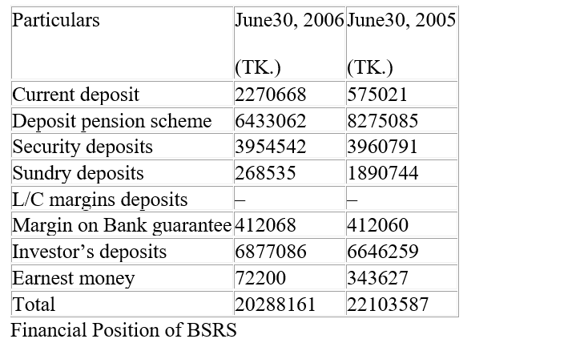

Capital and Recourses:
BSRS resources now consist only of local cash since 1985, BSRS has not had any foreign monetary fund. Until 1985, outside money stores were credit extensions coordinated by the legislature from various universal and local loaning organizations. Foreign currency holds likewise expanded because of the portion of direct credit lines from multiple nations and receipt of outside money from the legislature or any bank or budgetary foundation. The neighborhood BSRS money reserve comprises of paid-in-capital, assets made from income, client stores, and government advances. The total capital of BSRS as of June 30, 2006, amounted to 2338.59 million Tk including reserve and surplus
The reserve position of BSRS as of June 30, 2006, in introduced here: (Tk in millions)
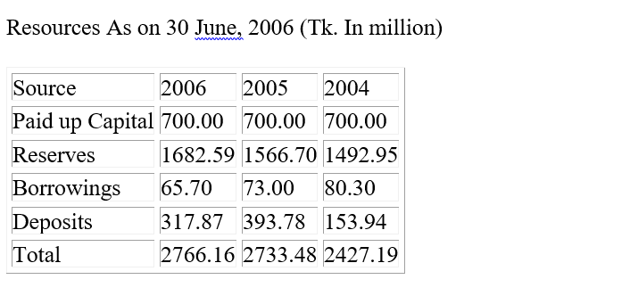

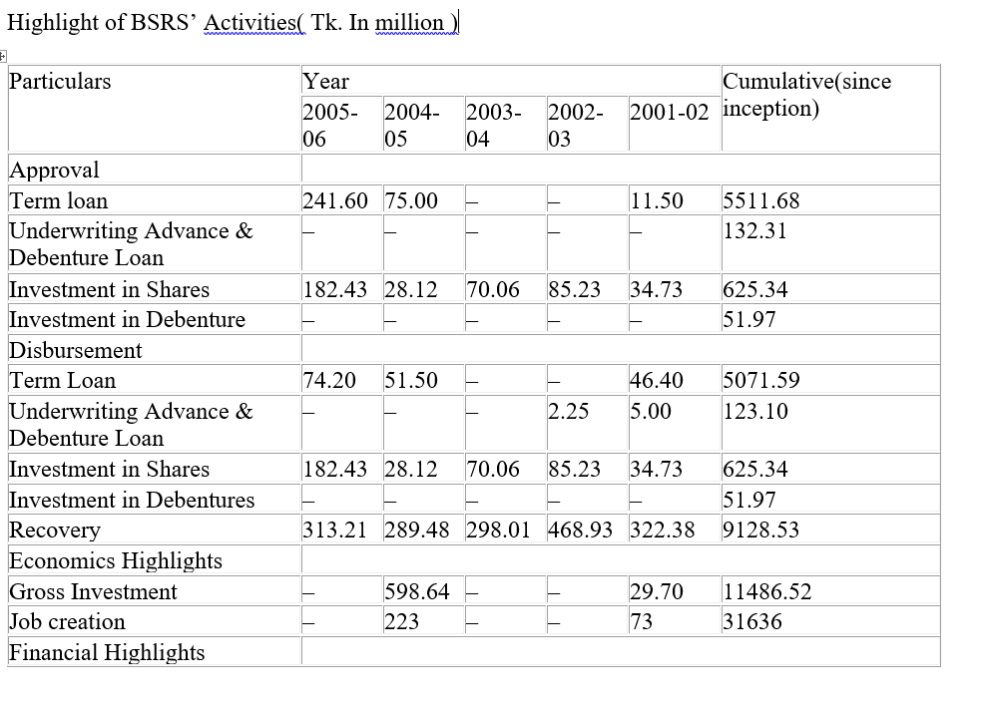
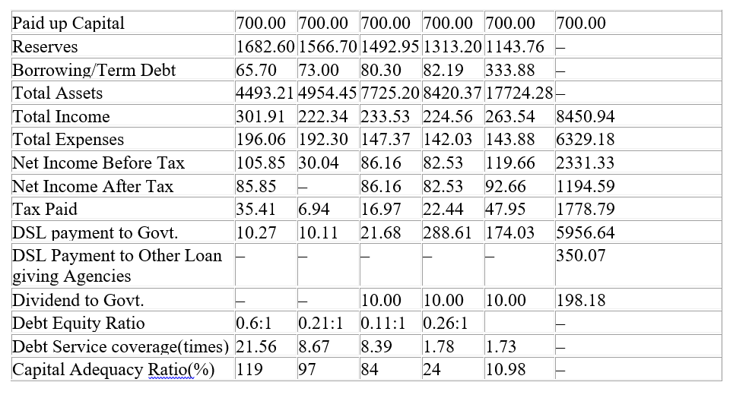

4.5 Profit or loss of BSRS:
During the fiscal year 2005-2006, BSRS earned a pre-charge benefit of 105.85 million Tk, as per examination, up to 30.04 million Tk in the earlier year. We can expect that the interest was acquired considering advances and profit due to ventures dependent on comprehension of money. During the year, the advantage was not paid to the government as everything of pre-charge benefit introduced for duty motivations behind the earlier year.
Total revenue, total costs, and all-out benefit for the last five years:
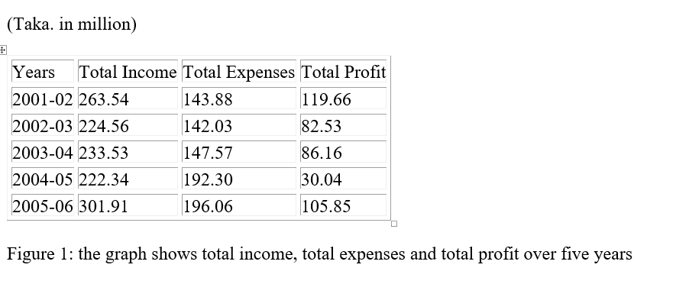

CHAPTER 5

Recommendation and conclusion

5.1 Findings:
While I was doing intern in ICB I faced a lot of challenges and difficulties. The challenges are given below:
- Political Issue: Since ICB is Government institution there are a lot of political issues going on while we were doing intern there. I face encountered 2/3 situations where there were conflict between Managing Directors and the political person which was very disturbing for the employees as well as interns like us.
- Lack of Communication: ICB is a very large organization owned by the Government. I have faced a lot of problem while communicating with other employees and there was no one who will guide us where we will take our next brief since everyone is busy with works.
- Time Consuming: There are plenty of communication gaps between the coworkers and the supervisor. Most of the intern students are absent in the working day so it’s very difficult to do the task which was given to us and supervisor is so busy with their work that they don’t have that much time to guide us with our tasks.
- More Experience Hand needed: There is a lack of experience in the worker that I think can be improve. Because of this lack of experience I found difficulties while I was working in the organization.
- Corporate Culture: Most of the employees are not following the culture of the organization and it creates gap between employees and other employees. I have faced lot of difficulties at the beginning to cope up with the situation.
- Difficulties in practical works: In our university life most of the things that we learned are based on theory and there is a lot of difference between theory and practical knowledge so I find little bit difficulties while I was having practical working knowledge in ICB
- Less work was given to me: Since ICB is Government organization and mostly deals with the share markets of our country so they didn’t gave us that much of tasks because most of their work are highly confidential so we didn’t have that much work experience in the organization.
- No proper warnings for interns: Most of the intern were absent in the working day but the there was no proper warning for them because most of the employees are busy doing their work so I found some difficulties while taking brief from each departments.

5.2 Recommendation
I can give some suggestions to the organization that can help with the problem which they are facing right now.
- Make a proper network between employees with online communications with their own made communication software system. As they have their database and their own made software, they can create software that can bring close together for communication.
- The political issues can be resolve outside their organization. It will bring the inside nature of the organization more clean and provide employee a better working environment.
- ICB should hire more sufficient and skilled person in the organization for the betterment of the organization and both our country.
- Rational persuasion is the best solution for ICB; this would bring a better environment in communications, employees can present a logical, well-response explanation of why their idea is believed to be the best option in a particular situation. There will be fewer disagreements between every employee.
- ICB should provide more works to the interns in order to build a good knowledge about the real life work experience of the interns
Multitasking could be a solution to bring work more efficient and less time-consuming. This could help to identify the problems with jobs and creates balanced communication, and the tasks can be done more professionally.

Conclusion and Implication

5.3 Conclusion
Investment Corporation of Bangladesh (ICB) is one of the prestigious statutory corporations that have been enormous to the country. They are bringing changes monetarily and even in a non-financing way. It previously brought such a significant number of improvements in the nation with their Mutual Funds and Unit Funds that have developed the capital market quickly. ICB is the country's property; they draw out the best in investment and growing the speculations to individual’s to-individuals that would make greater decent variety all over Bangladesh and in this manner builds up the nation's best market.

Bibliography
- Alam, N. E. (2015). A Study on Performance Analysis of ICB. Dhaka.
- Annual Report of 2017-18 of Investment Corporation of Bangladesh. (2019). Dhaka: Investment Corporation of Bangladesh.
- Annual Report of 2016-17 of Investment Corporation of Bangladesh. (2018). Dhaka: Investment Corporation of Bangladesh.

Bibliography from websites
- Eligibility for Equity Support from the Equity and Entrepreneurship Fund Unit. (n.d.). Retrieved from Bangladesh Bank: https://www.bb.org.bd/aboutus/dept/eef/eligibility.php
- Investment Corporation of Bangladesh. (n.d.). Retrieved from Wikipedia: https://en.wikipedia.org/wiki/Investment_Corporation_of_Bangladesh
- Investment Corporation of Bangladesh - Transforming Towards Tomorrow. (n.d.). Retrieved from Investment Corporation of Bangladesh: http://icb.gov.bd/zindex.php

