Upholding rights and reducing inequalities among forced migrants: a case of Act for Displaced

Mohammed Thouhid Aziz

This internship report is submitted to the School of Businesses & Economics, United International University as a partial requirement for the fulfilment of Bachelor of Business Administration Degree

Upholding rights and reducing inequalities among forced migrants: a case of Act for Displaced

Submitted by:
Mohammed Thouhid Aziz
ID: 111151277
Major: Marketing
School of Business and Economics
United International University
Bangladesh

Supervised by:
Kawsar Ahmmed, PhD
Professor
School of Business and Economics
United International University
Bangladesh

Date of submission: 19 February 2023

Letter of Transmittal

Dr. Kawsar Ahmmed
Professor
School of Business and Economics
United International University

Subject: Submission of internship report

Dear Sir,

This is to inform you that I am a regular student at your institution. By incorporating your guidance into action, I submit this internship report as required for the coursework.

The three-month internship program helped me learn a lot. This helped me gain practical knowledge of working with clients and performing various tasks with specialised software. This report is based on an overview of the company and the experience I gained during my internship program at Act for Displaced.

While I have encountered many challenges during the preparation of this report, primarily time constraints, I have attempted to be as critical and analytical as possible. This is to the extent of my knowledge. I hereby declare that all the information provided is accurate.

Sincerely
Mohammed Thouhid Aziz
111 151 277

Declaration of the Student

It is my honour to declare that this report on Act for Displaced has been authentically prepared by me, Mohammed Thouhid Aziz, a student of Bachelor of Business Administration at United International University. The submission of this internship report did not violate any copyright act on purpose and I further declare that none of the content of this report was submitted to any other institution for the purpose of awarding any degree.

Mohammed Thouhid Aziz
ID: 111 151 277

Acknowledgement

Firstly, All thanks goes to Almighty Allah for blessing me with the strength to accomplish my internship at Act for Displaced for a period of four months. Secondly, I would like to thank my parents for upbring me till date and supporting me throughout my whole journey as guardian. Without their support it was impossible to complete my toughest journey of internship.
To begin, I would like to thank my honourable supervisor Dr. Kawsar Ahmmed for providing me with the necessary guidance and information for the completion of this internship report. My sincere gratitude goes out to Tafhimur Rahman (Executive Director, AFD), who provided all the necessary tips, guidelines and support during the internship period, as well as the entire digital outreach team for their assistance and support in any way they could and for providing me with the opportunity to achieve my best.

Executive Summary

Act for Displaced (AfD) is a Bangladesh-based think tank providing evidence that challenges the current ways of working in humanitarian aid and displaced affairs. Act for Displaced aims to transform ideas within the humanitarian, social, and business sectors, and turn them into innovations, knowledge, and strategies. The Act for Displaced works to equip humanitarian responders with knowledge, skills, and competencies so that people affected by crises get the right help when they need it most. Partnering with organizations across the humanitarian sector, Act for Displaced promotes principled humanitarian response through collaborative knowledge production and services.

This report is a detailed overview of my internship journey at Act for Displaced as a digital outreach associate. Act for Displaced offers services such as insights content and news content, Stories/Poetry/Interviews, and global opportunities. Act for Displaced implement these services by providing a platform for individuals and organizations to connect, share information, and support each other in the field of conflict, displacement, and peacebuilding globally. The services provided by AfD benefit the audience or consumers by providing them with valuable information, resources, and support in their work related to conflict, displacement, and peacebuilding.

Lastly, my report includes a discussion of the online service quality which I always fancy to get exposure from the real-life scenario. Engaging in a training program for seven weeks of my internship journey to self-equipped and applying the acquired knowledge to real work spheres was an epiphany. Furthermore, I have provided some recommendations regarding the activities that the Act for Displaced should undertake in order to increase the productivity of departmental operations. The recommendations I have made are intended to benefit them and then the overall conclusion is provided from completely my point of view.

Keywords: Non-profit organisation; Community development; Buddy group; Real-life documents; Act for Displaced

Contents
Letter of Transmittal iv
Declaration of the Student v
Acknowledgement vi
Executive Summary vii
CHAPTER 1 | INTRODUCTION 1
1. Background of the Report 2
1.1 Objectives 2
1.2 Significance 3
1.3 Scope and Limitations of the Report 4
1.4 Definition of Key Terms 4
Chapter Two 6
Analysis of the NGO/NPO Sector in Bangladesh 6
2. Introduction 7
2.1 Specification of the Sector 7
2.2 Political, Legal, and Regulatory Factors 7
2.3 Major Organisations in this Sector 8
2.4 Summary of Challenges and Opportunities 16
Chapter Three 17
Analysis of the Organisation: Act for Displaced 17
3. Introduction 18
3.1 Overview and History of the Act for Displaced 18
3.2 Target Groups of Act for Displaced 18
3.3 Product/Service Mix for Target Groups 18
3.4 Strategies to meet the Challenges and Opportunities 20
Chapter Four 21
Internship Experience 21
4. Introduction 22
4.1 Position, Duties, and Responsibilities 22
4.2 Training 22
4.2.1. First online workshop 23
4.3 Contribution to Departmental Functions 25
4.4 Evaluation of Internship Performance 27
4.5 Application of Academic Knowledge 27
4.5 New Skills Developed 29
Chapter 5 30
Recommendations and Concl 30
5. Introduction 31
5.1. Recommendations for Improving Departmental Operations 31
5.2. Recommendations for Improving Self-performance 31
References 32
Annexure 1 33

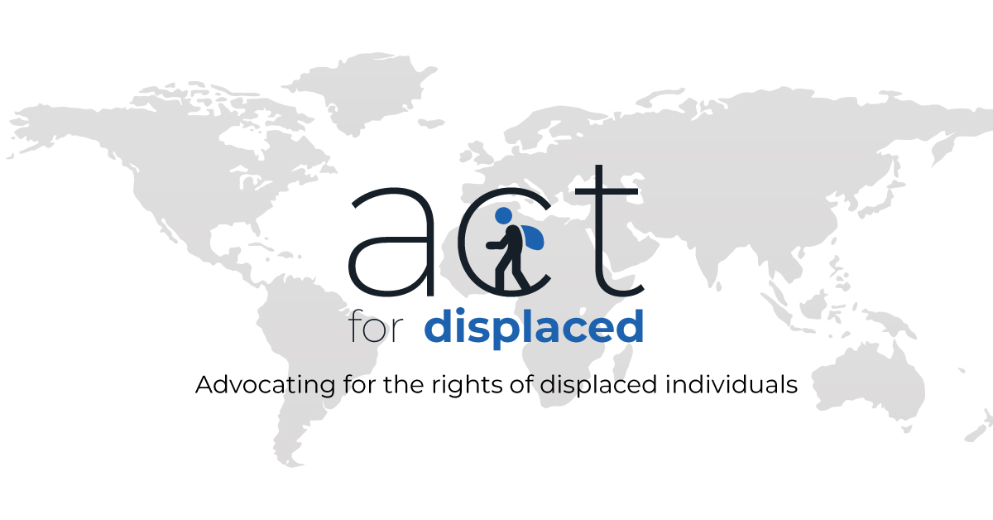

CHAPTER 1 | INTRODUCTION

1. Background of the Report

1.1 Objectives

The key objective of this report is to portray the overall pieces of evidence and experiences derived through the internship journey. This study will focus on a vast area, from analysing the organisation and the sector in Bangladesh to depicting Internship Experience.
More specifically, in analysing the sector, several issues are being discussed throughout the document that includes;
- Specification of the relevant sector,
- Discussion of political, legal, and regulatory factors,
- Analysing the major organisations in this sector, and
- Finally, summarising the key challenges and opportunities of the sector.

In addition, by analysing the organisation, this report is being constituted to provide its audience with more in-depth information on issues surrounding the overview and history of the Act for Displaced, target groups of Act for Displaced, product/service mix for target groups, strategies to meet the challenges and opportunities etc.

Lastly, while writing this report, experience gained throughout the internship period is designed and documented by diverging into a few tasks that includes the portrayal of position, duties, and responsibilities, training opportunities, contribution to departmental functions, evaluation of internship performance, application of academic knowledge, and the development of new skills.

1.2 Significance

As a course requirement, this document is being submitted to Kawsar Ahmmed (PhD), a full-time professor at United International University, Bangladesh. During the process of writing this document, the process of piling knowledge into action through the process of leveraging the knowledge acquired from the educational journey and the experience acquired from the internship period with Act for Displaced was actively considered.
Upon completion of this internship, I am writing this report to reflect on the professional aspects of it as well as to reflect on the skills I have acquired. As a student, I felt that this internship held the potential to provide me with the real work experience that I needed to put my education into practice, grow my leadership skills, and give me a competitive advantage when it comes to applying for permanent employment in the future.
This report seeks to address some of the most acute issues concerning organisational behaviour analysis, and relevant sector analysis by drawing on the extensive experience gained. The concise and practical recommendations in each section are expected to provide insights to future interns and pertinent other parties to give them a better understanding and ability to address the issues in organisational responsibilities and actions as they pertain to their current assignments.

Putting evidence into work settings where academic knowledge of service quality model was instrumentalized to address the five gaps. The significance lies also in the section of recommendations provided for the organisation that I worked for four months as an internee , utilising that AFD and relevant actors could be benefited equally to better their service.

1.3 Scope and Limitations of the Report

1.3.1 Scope of the report

As an intern, I worked with the digital outreach and content development team of Act for Displaced. Where I was responsible for maintaining social media accounts and publishing posts as per schedule every day, acting as a focal for the outreach of the website contents to a broader audience across the globe by research and target audience segmentation and assisting the content development team in creating the right contents for the social media handles and the website. The opportunities I explored in that practical field also provided me with an opportunity to expand my knowledge as a whole. This report is entirely based and prepared on my practical work experience while working at Act for Displaced. Moreover, it will also help the students to clear up the confusion between practical knowledge and theoretical knowledge by reducing the distinction between them. This report significantly helped me a lot to understand the atmosphere and environment of an organisation. Furthermore, I had the opportunity to work with many brilliant minds across the globe as an intern at Act for Displaced, which helped me develop my language and people skills, understand social media dynamics, retrieve information and insights, and turn them into data in order to assist management in making managerial decisions about where to invest and what business opportunities to pursue. Being a global content creation platform, learning everything about it was virtually impossible within such a short timeframe.

1.3.2 Limitations of the report

There had always been challenges working with Act for Displaced, given its entirely online nature, including:
- As team members came from different countries, collaborating with them and aligning time was a challenge.
- It's true that some groups and countries do not want to talk about the displaced or acknowledge them. As a result, we ran into some difficulties publishing content in their regions or groups or communities, or sometimes reports were issued against the content posted on social media.
- It was quite challenging for me as an intern to understand and cope with the development sector since I had a business background and had to tackle hurdles during my internship as both sectors’ dynamics were different.
- I found it difficult to collect data for doing background research for creating content due to the fact that there was not enough information concerning displaced people on a global scale.

1.4 Definition of Key Terms

NGO/NPO Sector: As the name explains, NGOs refer to non-governmental organisations, whilst NPOs refer to non-profit organisations. As a nonprofit organisation (NPO), one does not aim to make money as it believes in the primacy of giving back to society so that all additional income earned by the organisation goes toward the cause that is the focus of its efforts. In addition, nonprofit organisations are frequently used for trusts, cooperatives, advocacy groups, charities, and organisations that are concerned with the environment and religion. Almost all NPOs use volunteers in their management roles; however, not all of them use paid staff in their management positions.
Refugee: Refugees are people who have fled war, violence, conflict or persecution and have crossed an international border to find safety in another country. They often have had to flee with little more than the clothes on their back, leaving behind homes, possessions, jobs and loved ones. Refugees are defined and protected in international law. (Bascom, 2001)
Displaced People: Person or group of people who have been forced to flee or to leave their homes or places of habitual residence as a result of, or in order to avoid, in particular, the effects of armed conflict, situations of generalised violence, violations of human rights or natural or human-made disasters, and who have not crossed an internationally recognized border. (UNHCR, n.d.)
Knowledge-driven Platform: A platform or entity which produces knowledge products. For instance: articles, research papers, blogs, news etc.
Buddy Group: A group of people who hold similar expertise or position come together for discussion.
Mentoring: Mentoring is a learning relationship, generally focused on long term career development. The primary purpose is to drive personal growth; building skills etc. (Mentoring, n.d.)
AFD: Act for Displaced, a think tank and a non-profit organisation, where I completed my internship journey.

Chapter Two

Analysis of the NGO/NPO Sector in Bangladesh

2. Introduction

The social development scene in Bangladesh is characterised by a strong presence of non-governmental organisations (NGOs) and non-profit organisations (NPOs). Bangladesh's vibrant and unique hard to reach areas are prone to disasters making early humanitarian response rigid and that is where local actors like NPOs and NGOs are building bridges through their humanitarian work. The NGOs emerged following the war of liberation to help the communities in distress as part of post-war rehabilitation. (Zohir, January 2004) Afterwards, with assistance from foreign donor agencies, they expanded their activities to deliver a variety of services including microcredit, essential healthcare, informal education, women empowerment and rights advocacy. (Zohir, January 2004) This chapter focuses on the overall analysis of the development sector and how it is shaped by various factors.

2.1 Specification of the Sector
As far as Bangladesh is concerned, the Act for Displaced falls under the umbrella of the NGO/NPO sector. Among the world-renowned Non-Profit Organisations (NPOs), Bangladesh is believed to be the home of some of them. Bangladesh has made significant achievements in the field of social development in the last few decades, largely thanks to the constant support from the government and the widespread activism of the non-profit sector in the country. The NPO sector of Bangladesh has developed a number of pioneering models of development that have since been taken up by a number of the development organisations in other countries, and which are now being followed. NPO like AFD has a myriad of untapped opportunities to explore both nationally and abroad.
Profits are not the only purpose of this kind of business. Any commercial establishment, no matter how big or small, has the role of making money as one of its major activities. In spite of this, there are some businesses that are extremely concerned with the welfare of society as a whole. Non-profit organisations and charities are such businesses (e.g. Act for Displaced) that work to improve the lives of people through their activities. Like regular corporations, these businesses have all the parts inherent in any company, like company policy, internal budget and employees. The only difference is that their primary concern is the welfare of society. Charities and non-profits are usually funded partly by donations. But the prime purpose of their activities is to uplift parts of society that are at risk. And true to everything on this planet, nothing operates in isolation from each other. Like any other business, these are also affected by the macro-factors that influence any other company.

2.2 Political, Legal, and Regulatory Factors
2.2.1 Political Factors
Changing political climates have a profound effect on non-profit organisations and charities just as they do on any other business. These types of businesses must operate within an environment that is often volatile due to the fact that it can be detrimental to their well-being. It is worth noting that charities and nonprofits are largely financed through donations, as I have mentioned previously. There are many of these that come through political channels. In the event that the political landscape changes, such funding can be slowed down as a result.
Considering the fact that articles and content in the Act for Displaced digital platform are composed of diverse backgrounds some of that may offend political interests and may lead to a conflict of interest as a result.
As a result of political unrest, infrastructural damage in Bangladesh is very common and directly impacts the entire country during times of unrest. Considering that AfD is a knowledge-driven content creation platform, one might think that political physical unrest would not affect this kind of platform, but this kind of unrest can affect the entire system, including online organisations too, since the internet goes down during unrest, so it affects the whole system.
2.2.2 Legal Factors
There are legal limitations that apply to charities and nonprofits, just like they apply to any business. Such organisations are often in possession of sensitive information and are privy to it. Therefore, the mishandling of critical data may result in serious legal consequences in the future.
In light of the fact that the laws of the different countries differ significantly, it is almost certain that the dynamics will also be different. In one country, something may not be considered illegal, while in another country, it might be considered illegal. By using a rigorous editorial process, the content may be handled in such a way as to prevent the creation of sensitive content.
2.2.3 Regulatory Factors
NGOs are governed by two major sets of laws: one governing their legal entity and another regulating their relationship with the government. NGOs can establish a legal identity with a recognized government structure under several laws, including The Societies Registration Act 1861, The Trust Act 1882, The Cooperative Society Act 1925, and The Companies Act 1913 (amended in 1994). Government-NGO relationships are impacted in a significant manner by the laws and ordinances that pertain to the registration of NGOs with Government agencies. Since 1990, all NGOs working with foreign funds in Bangladesh have been registered and regulated by the NGO Affairs Bureau (NGOAB), which has the authority to register, monitor and assist them in any way that may be required.

2.3 Major Organisations in this Sector
NGOs are non-governmental organisations that are not part of the government. It is worth noting that these organisations have been working in Bangladesh since 1971 (Hossain, 2022). At that time Bangladesh suffered many problems like, economic, social, and humanitarian degrees and lack of funds and stagnant economic progress forced Bangladesh to rely on NGOs (Hossain, 2022). Currently, there are 2554 NGOs registered in Bangladesh. In the world, there are 233 foreign NGOs who are working in 27 countries including Bangladesh also (Hossain, 2022). The NGOs that are leading in Bangladesh are BRAC, Caritas Bangladesh, CARE Bangladesh, Oxfam Bangladesh, HEED Bangladesh, ASA, TMSS, BURO Bangladesh, Shakti Foundation, and Proshika (Hossain, 2022).

2.3.1 Detail Descriptions of the Major Organisations in this Sector

BRAC (Bangladesh Rural Advancement Committee) is one of the largest development organisations in the world and the largest NGO in Bangladesh. It was founded in 1972 in response to the humanitarian crisis caused by the war of independence in Bangladesh and has since grown into a multi-faceted organisation working to reduce poverty and empower people in Bangladesh and several other countries in Asia and Africa.
BRAC's programs are designed to tackle poverty and empower people in a holistic and sustainable manner. It operates in multiple sectors, including health, education, legal services, microfinance, and more (BRAC, n.d.). Some of BRAC's key programs and initiatives include:
- Health: BRAC operates a large health program in Bangladesh, with a focus on maternal and child health, nutrition, and reproductive health services. It also provides community-based health services and works to prevent the spread of infectious diseases, such as HIV/AIDS and malaria.
- Education: BRAC operates a large network of schools and provides non-formal education programs for children and adults. It also provides teacher training and works to improve the quality of education in Bangladesh.
- Microfinance: BRAC provides microfinance services to poor and marginalized communities in Bangladesh, helping people start or expand small businesses and increase their income.
- Livelihoods: BRAC operates a range of programs to help people increase their income and improve their livelihoods, including programs in agriculture, livestock, and fisheries.
- Emergency Response: BRAC has extensive experience in providing emergency response and humanitarian assistance in Bangladesh and has been instrumental in responding to natural disasters and other emergencies in the country.
BRAC's impact has been substantial, and it has been instrumental in reducing poverty and improving the lives of millions of people in Bangladesh. Its programs have been recognized and praised for their innovation, sustainability, and impact, and it continues to be a leading player in the development sector in Bangladesh and beyond.
Caritas Bangladesh is a non-profit organisation that was established in 1967 as the social service and development arm of the Catholic Church in Bangladesh. It is a member of the global Caritas network, which is one of the largest humanitarian and development organisations in the world. The organisation's mission is to promote social justice and reduce poverty in Bangladesh through a range of humanitarian and development services.

Caritas Bangladesh works with people of all faiths and backgrounds and prioritizes the most vulnerable communities, such as women, children, and ethnic minorities. The organisation has a presence in all 64 districts of Bangladesh and works with local partners to deliver its programs. Caritas Bangladesh operates under the guidance of the Catholic Bishops' Conference of Bangladesh and is registered under the Societies Registration Act of 1860.
The organisation's programs focus on several key areas, including disaster response and preparedness, healthcare, education, and livelihood support. In times of emergencies, Caritas Bangladesh provides immediate relief to affected communities and helps them to rebuild their lives. The organisation's healthcare programs include primary healthcare, maternal and child health, and HIV/AIDS prevention and treatment. Caritas Bangladesh also supports education initiatives, including literacy programs, vocational training, and scholarships for underprivileged children.
In addition, Caritas Bangladesh's livelihood support programs aim to improve the economic conditions of marginalized communities. These programs include microfinance, agriculture development, and small business support. The organisation works closely with local communities to identify their needs and develop programs that address those needs.
Caritas Bangladesh is committed to social justice and human rights, and it works to promote these values through advocacy and awareness-raising initiatives. The organisation also prioritizes environmental sustainability and climate resilience in its development programs. Overall, Caritas Bangladesh plays a critical role in addressing poverty and promoting social development in Bangladesh.
CARE Bangladesh is a non-profit organisation founded in 1949 and is a part of the global CARE International network. The organisation's mission is to fight poverty and social injustice in Bangladesh by empowering marginalized and vulnerable communities, especially women and girls. CARE Bangladesh works in close collaboration with communities, civil society organisations, and the government to address the underlying causes of poverty and inequality.

CARE Bangladesh has a presence in 60 districts of Bangladesh and operates through a network of local partners. The organisation's programs focus on several key areas, including health, education, livelihoods, and disaster risk reduction. CARE Bangladesh prioritizes women's empowerment in all of its programs and works to ensure that women and girls have equal access to education, healthcare, and economic opportunities.
The organisation's health programs aim to improve the health and well-being of the most vulnerable populations, including mothers and children. These programs include maternal and child healthcare, nutrition, and the prevention and treatment of infectious diseases such as HIV/AIDS, tuberculosis, and malaria. CARE Bangladesh's education programs focus on increasing access to quality education for all, especially girls, and improving the quality of education in schools.
CARE Bangladesh's livelihoods programs aim to improve the economic conditions of marginalized communities through a range of interventions, including microfinance, entrepreneurship training, and support for agriculture and fisheries. The organisation works with communities to identify their needs and develop programs that promote sustainable livelihoods and economic growth.
In addition, CARE Bangladesh is committed to disaster risk reduction and response. The organisation works to build the capacity of communities to prepare for and respond to disasters, including floods, cyclones, and earthquakes. CARE Bangladesh also provides immediate relief and long-term support to affected communities following disasters.
CARE Bangladesh is committed to promoting human rights, gender equality, and social justice in all of its programs. The organisation works closely with communities, civil society organisations, and the government to advocate for policies and practices that promote these values. Overall, CARE Bangladesh plays a critical role in addressing poverty and social injustice in Bangladesh and is a key partner in the country's development efforts.
Oxfam is a non-profit organisation that works to reduce poverty, promote social justice, and fight inequality. Oxfam has been operating in Bangladesh since 1972, and its mission is to create lasting solutions to poverty and injustice in the country. Oxfam Bangladesh focuses on several key areas, including economic empowerment, gender justice, humanitarian response, and climate change.

Oxfam Bangladesh works in close partnership with local organisations and communities to achieve its goals. The organisation's economic empowerment programs focus on building the capacity of women and marginalized communities to access and control resources, such as land, finance, and markets. Oxfam Bangladesh provides technical support, training, and financial assistance to help these communities build sustainable livelihoods.
The organisation's gender justice programs aim to promote gender equality and women's rights. Oxfam Bangladesh works to address the root causes of gender inequality, including discriminatory social norms, laws, and policies. The organisation also supports women's leadership and political participation and provides support to survivors of gender-based violence.
Oxfam Bangladesh's humanitarian response programs aim to provide immediate relief to people affected by natural disasters, conflicts, and other emergencies. The organisation works to ensure that affected communities have access to basic necessities, such as food, water, shelter, and healthcare. Oxfam Bangladesh also provides longer-term support to help communities recover and rebuild their lives.
The organisation's climate change programs focus on building the resilience of vulnerable communities to the impacts of climate change. Oxfam Bangladesh works with communities to identify and implement strategies to adapt to changing weather patterns, such as improved water management, sustainable agriculture, and disaster preparedness.
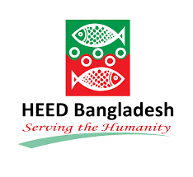
Oxfam Bangladesh is committed to promoting social justice, human rights, and environmental sustainability. The organisation works to raise awareness and advocate for policies and practices that promote these values. Oxfam Bangladesh is a key partner in the country's development efforts and plays a critical role in reducing poverty and promoting social justice in Bangladesh.
HEED Bangladesh (Health, Education and Economic Development) is a non-governmental organisation that was founded in 1974. Its mission is to empower the poor and vulnerable people of Bangladesh by improving their access to health care, education, and economic opportunities. HEED Bangladesh operates in different parts of Bangladesh and serves over 10 million people through a network of healthcare clinics, schools, and economic development programs.
HEED Bangladesh's health care programs focus on providing primary healthcare to poor and marginalized communities. It operates a network of clinics and hospitals, including mobile clinics that provide services in remote areas. HEED Bangladesh's health care programs also include community health education and awareness-raising campaigns to prevent and manage common diseases, such as tuberculosis, HIV/AIDS, and malaria.
HEED Bangladesh's education programs aim to increase access to quality education for children, especially girls, from poor and marginalized communities. The organisation operates primary and secondary schools that provide education to thousands of children. Its education programs also include adult literacy and vocational training programs to help adults acquire new skills and increase their employability.
HEED Bangladesh's economic development programs focus on creating sustainable livelihoods for poor and vulnerable communities. The organisation provides support to small and medium-sized enterprises through microfinance programs and business development services. Its economic development programs also include training in agriculture and fisheries, handicrafts, and other income-generating activities.
HEED Bangladesh is committed to promoting social justice, human rights, and environmental sustainability. The organisation works to raise awareness and advocate for policies and practices that promote these values. HEED Bangladesh is a key partner in the country's development efforts and plays a critical role in reducing poverty and promoting social justice in Bangladesh.

ASA Bangladesh is a non-governmental organisation that was founded in 1978. Its mission is to empower poor and marginalized people in Bangladesh by providing access to financial services, health care, education, and other essential services. ASA Bangladesh is considered one of the largest and most successful microfinance institutions in the world and has transformed the lives of millions of people in Bangladesh.
ASA Bangladesh's microfinance program provides small loans to poor people who do not have access to formal banking services. The organisation operates a network of microfinance branches throughout the country, and its microfinance programs have helped millions of people to start and expand small businesses, generate income, and lift themselves out of poverty.
ASA Bangladesh's health care programs aim to provide affordable and accessible health care services to poor and marginalized communities. The organisation operates a network of health clinics and hospitals, including mobile clinics that provide services in remote areas. Its health care programs also include community health education and awareness-raising campaigns to prevent and manage common diseases.
ASA Bangladesh's education programs focus on providing access to quality education for children, especially girls, from poor and marginalized communities. The organisation operates schools that provide education to thousands of children. Its education programs also include adult literacy and vocational training programs to help adults acquire new skills and increase their employability.
ASA Bangladesh's other programs include water and sanitation programs, disaster relief and recovery programs, and advocacy and awareness-raising campaigns to promote social justice and human rights.
ASA Bangladesh is committed to promoting sustainable development and environmental sustainability. The organisation works to raise awareness and advocate for policies and practices that promote these values. ASA Bangladesh is a key partner in the country's development efforts and plays a critical role in reducing poverty and promoting social justice in Bangladesh.
TMSS (Thengamara Mohila Sabuj Sangha) is a non-governmental organisation that was founded in 1964 in Bogra, Bangladesh. Its mission is to empower poor and marginalized people in Bangladesh by providing access to financial services, health care, education, and other essential services. TMSS Bangladesh operates in different parts of Bangladesh and serves millions of people through a network of healthcare clinics, schools, and economic development programs.

TMSS Bangladesh's health care programs focus on providing primary healthcare to poor and marginalized communities. It operates a network of clinics and hospitals, including mobile clinics that provide services in remote areas. TMSS Bangladesh's health care programs also include community health education and awareness-raising campaigns to prevent and manage common diseases, such as tuberculosis, HIV/AIDS, and malaria.
TMSS Bangladesh's education programs aim to increase access to quality education for children, especially girls, from poor and marginalized communities. The organisation operates primary and secondary schools that provide education to thousands of children. Its education programs also include adult literacy and vocational training programs to help adults acquire new skills and increase their employability.
TMSS Bangladesh's economic development programs focus on creating sustainable livelihoods for poor and vulnerable communities. The organisation provides support to small and medium-sized enterprises through microfinance programs and business development services. Its economic development programs also include training in agriculture and fisheries, handicrafts, and other income-generating activities.
TMSS Bangladesh is committed to promoting social justice, human rights, and environmental sustainability. The organisation works to raise awareness and advocate for policies and practices that promote these values. TMSS Bangladesh is a key partner in the country's development efforts and plays a critical role in reducing poverty and promoting social justice in Bangladesh.
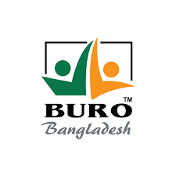
BURO Bangladesh is a non-governmental organisation that was established in 1990. Its mission is to reduce poverty and empower poor and marginalized people in Bangladesh through microfinance and other development programs. BURO Bangladesh is considered one of the largest and most successful microfinance institutions in the country and has transformed the lives of millions of people.
BURO Bangladesh's microfinance program provides small loans to poor people who do not have access to formal banking services. The organisation operates a network of microfinance branches throughout the country, and its microfinance programs have helped millions of people to start and expand small businesses, generate income, and lift themselves out of poverty.
BURO Bangladesh's health care programs aim to provide affordable and accessible health care services to poor and marginalized communities. The organisation operates a network of health clinics and hospitals, including mobile clinics that provide services in remote areas. Its health care programs also include community health education and awareness-raising campaigns to prevent and manage common diseases.
BURO Bangladesh's education programs focus on providing access to quality education for children, especially girls, from poor and marginalized communities. The organisation operates schools that provide education to thousands of children. Its education programs also include adult literacy and vocational training programs to help adults acquire new skills and increase their employability.
BURO Bangladesh's other programs include water and sanitation programs, disaster relief and recovery programs, and advocacy and awareness-raising campaigns to promote social justice and human rights.
BURO Bangladesh is committed to promoting sustainable development and environmental sustainability. The organisation works to raise awareness and advocate for policies and practices that promote these values. BURO Bangladesh is a key partner in the country's development efforts and plays a critical role in reducing poverty and promoting social justice in Bangladesh.

Shakti Foundation is a non-governmental organisation that was founded in 1992 with the goal of empowering poor and marginalized women in Bangladesh. Its mission is to provide access to financial services, health care, education, and other essential services to help women and their families break the cycle of poverty.
Shakti Foundation's microfinance program provides small loans to women who do not have access to formal banking services. The organisation operates a network of microfinance branches throughout the country, and its microfinance programs have helped thousands of women to start and expand small businesses, generate income, and lift themselves out of poverty.
Shakti Foundation's health care programs focus on providing affordable and accessible health care services to poor and marginalized communities. The organisation operates a network of health clinics and hospitals, including mobile clinics that provide services in remote areas. Its health care programs also include community health education and awareness-raising campaigns to prevent and manage common diseases, such as tuberculosis, HIV/AIDS, and malaria.
Shakti Foundation's education programs aim to increase access to quality education for children, especially girls, from poor and marginalized communities. The organisation operates schools that provide education to thousands of children. Its education programs also include adult literacy and vocational training programs to help adults acquire new skills and increase their employability.
Shakti Foundation's other programs include disaster relief and recovery programs, and advocacy and awareness-raising campaigns to promote social justice and human rights.
Shakti Foundation is committed to promoting gender equality, social justice, and environmental sustainability. The organisation works to raise awareness and advocate for policies and practices that promote these values. Shakti Foundation is a key partner in the country's development efforts and plays a critical role in reducing poverty and promoting social justice in Bangladesh.
Proshika is a non-governmental organisation in Bangladesh that was established in 1986 with the aim of reducing poverty and empowering marginalized communities. Its mission is to promote sustainable development, social justice, and human rights through a range of programs and initiatives.

Proshika's programs include microfinance, education, health care, agriculture, and community development. Its microfinance program provides small loans to poor people who do not have access to formal banking services. The organisation operates a network of microfinance branches throughout the country, and its microfinance programs have helped thousands of people to start and expand small businesses, generate income, and lift themselves out of poverty.
Proshika's education programs focus on providing access to quality education for children, especially girls, from poor and marginalized communities. The organisation operates schools that provide education to thousands of children. Its education programs also include adult literacy and vocational training programs to help adults acquire new skills and increase their employability.
Proshika's health care programs aim to provide affordable and accessible health care services to poor and marginalized communities. The organisation operates a network of health clinics and hospitals, including mobile clinics that provide services in remote areas. Its health care programs also include community health education and awareness-raising campaigns to prevent and manage common diseases.
Proshika's agriculture and community development programs aim to improve the livelihoods of poor and marginalized communities by promoting sustainable agriculture, natural resource management, and community development. The organisation works with farmers and local communities to develop and implement sustainable farming practices, and to promote community-based natural resource management.
Proshika's other programs include disaster relief and recovery programs, and advocacy and awareness-raising campaigns to promote social justice and human rights.
Proshika is committed to promoting sustainable development, social justice, and environmental sustainability. The organisation works to raise awareness and advocate for policies and practices that promote these values. Proshika is a key partner in the country's development efforts and plays a critical role in reducing poverty and promoting social justice in Bangladesh.

2.4 Summary of Challenges and Opportunities
Challenges:
- The members of the AfD team represent a wide range of nationalities since it is an international platform. It can be challenging to work with a team that has diverse backgrounds, diverse cultures, and different time zones, which poses a threat to productivity.
- AfD advocates for displaced people from all over the world and it creates content in support of the vulnerable people living in countries such as Palestine, Syria, Myanmar, etc., that are in desperate need of help. There might be challenges in this regard, as some developed nations tend to remain silent and sometimes even take sides against these countries under the banner of terrorism.
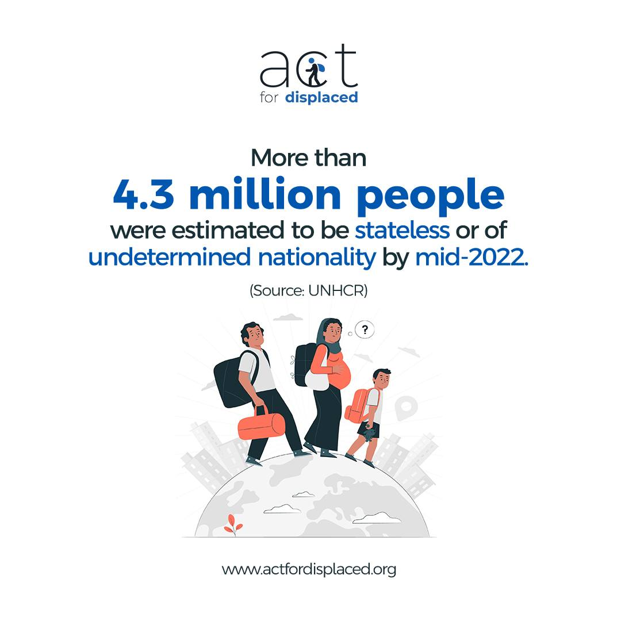
- Limited resources are also a vital thing to consider that poses a threat.

- Opportunities:
- Due to AfD being an entirely online platform, it is possible for young people across the globe to come, learn, and research about forced migration and human rights from the convenience of their own countries.
- There are few organisations in the world that equip and connect young humanitarians worldwide to raise awareness and provide a comprehensive analysis of the humanitarian situation everywhere. It is a golden opportunity for every young mind to practise and share their findings and opinions for raising awareness through knowledge dissemination.
- Unlike other organisations, AfD runs without any funding and team members volunteer their time.



Chapter Three

Analysis of the Organisation: Act for Displaced

3. Introduction

3.1 Overview and History of the Act for Displaced
The Act for Displaced, with its headquarters in Dhaka City in Bangladesh, was established in the month of February 2020. Since its inception, Through the support of AfD, young people from across the globe have been engaged in conducting research and discussing forced migration issues. As a result, their findings and opinions have been published in order to spread awareness of forcibly displaced people's struggles, and their stories, and advocate for the rights of displaced people in order to reduce the inequalities that they face throughout the world.
In the world, there are approximately 84 million people who are displaced due to persecution, war, and conflict. There are an additional 48 million people who are internally displaced. The organisation's strong advocacy and commitment to inclusion help raise awareness about the rights of the displaced and empower young voices to speak up for them. In its work, Afd aims to ensure that the Sustainable Development Goal No. 10 (REDUCE INEQUALITY WITHIN AND AMONG COUNTRIES) of the United Nations is met. AFD's work aims to achieve this.

3.2 Target Groups of Act for Displaced
Humanitarians, researchers, students, and academics from across the globe who share a common interest in Refugee Rights, Climate Displacement, Forced Migration, and Youth Empowerment are the target audience of the Act for Displaced.

3.3 Product/Service Mix for Target Groups
Product and service mix refers to the range of products and services offered by a company or organisation. It includes the various features, functions, and benefits that are provided to customers or clients, and can be an important factor in determining the success of a business or organisation. A well-designed product and service mix can help a company to attract and retain customers, differentiate itself from competitors, and generate revenue and profits. In the case of a non-profit organisation like http://www.actfordisplaced.org,the product and service mix can include a range of content and services that are designed to support the organisation's mission and objectives. This could include news and analysis, personal stories and interviews, job and internship opportunities, and other resources that are intended to support the work of individuals and organisations working in the field of conflict, displacement, and peacebuilding.
Bringing young humanitarians together to engage them in discussions, research, and analysis by providing a platform to share their findings and opinions for raising awareness through knowledge dissemination tools that include:
- Insights Content
- News Content
- Stories/Poetry/Interviews
- Global Opportunities

On the Act for Displaced website, more than 260 insights, 60 news articles, 20 stories/poetry/interviews, and 10 global opportunities have already been published, with more than 370,000 views to date.
The product and service mix of AfD, which includes Insights Content, News Content, Stories/Poetry/Interviews, and Global Opportunities, benefit its readers or customers in a number of ways.
- Insights Content: By providing in-depth analysis and commentary on issues related to conflict, displacement, and peacebuilding, Insights Content helps readers gain a deeper understanding of these complex issues. The articles and reports offers insights and perspectives that are not available elsewhere, and help readers make more informed decisions about their work or their engagement with these issues.
- News Content: By providing up-to-date news and information on developments related to conflict and displacement around the world, News Content helps readers stay informed about important events and trends. This is particularly valuable for professionals working in the field, who need to stay abreast of the latest developments in order to be effective in their work.
- Stories/Poetry/Interviews: By sharing stories, poetry, and interviews with people who have experienced displacement or conflict, Stories/Poetry/Interviews help readers develop a deeper understanding of the human impact of these issues. These personal stories is inspiring or thought-provoking, and help readers connect with the issues in a more emotional and empathetic way.
- Global Opportunities: By providing information on job and internship opportunities, as well as training and educational programs, Global Opportunities help readers develop the skills and knowledge needed to work in the field of peacebuilding and conflict resolution. This is particularly valuable for students or young professionals who are interested in pursuing careers in this area.

Overall, the product and service mix of www.actfordisplaced.org benefit its readers/customers by providing them with valuable information, insights, and opportunities to engage with the issues of conflict, displacement, and peacebuilding. By staying informed and connected, readers could be better equipped to make a positive impact in their work or their engagement with these issues, and to contribute to a more peaceful and sustainable world.
The benefits of these products and services to readers and consumers include:
- Access to up-to-date and relevant information: The insights and news content provided by AfD helps readers stay informed about the latest developments in the field of conflict, displacement, and peacebuilding, which can be critical for their work.
- Access to personal stories and experiences: The stories, poetry, and interviews provided by www.actfordisplaced.org help readers to connect with the experiences of individuals who have been affected by conflict and displacement, which can help to deepen their understanding of these issues.
- Access to global opportunities: The job and internship opportunities, volunteering opportunities, and funding opportunities provided by www.actfordisplaced.org can help readers and consumers to connect with other individuals and organizations working in the same space, and to access the resources they need to succeed.

When compared to other organizations in the same space, www.actfordisplaced.org stands out for its unique blend of content and services, which is designed to provide readers and consumers with a comprehensive and integrated approach to addressing the challenges of conflict, displacement, and peacebuilding. By offering a range of products and services that are tailored to the needs of individuals and organizations working in this space, www.actfordisplaced.org is able to provide a valuable and impactful service to its readers and consumers.

3.4 Strategies to meet the Challenges and Opportunities
In the earlier section, two main challenges and three opportunities were listed which include but not limited to; the threat to the productivity of team members having diverse backgrounds, and discontented external parties, opportunities include but not limited to; work from home facilities, One of the very few platforms to practise humanitarian advocacy works through knowledge dissemination, Volunteering opportunities.
- It is possible for AfD to go for project-based work instead of 9 to 5 office hours as a way to mitigate the time difference between team members.
- As part of liaising with key external parties, it is imperative that no content which might be perceived by the donors as conflicting with their interests is published.
- As a strategy to ensure that the work is carried out with the maximum utilisation of the resources, AfD can occasionally motivate the team members with monetary or non-monetary rewards in order to increase engagement in the work.
Therefore, AfD can take a variety of actions, but not exclusively, to overcome the challenges that it faces in order to achieve its goals.

Chapter Four

Internship Experience

4. Introduction

4.1 Position, Duties, and Responsibilities
This section will demonstrate minutely about the position, duties, and responsibilities at Act for Displaced which is a non-profit organisation that advocates for the rights of displaced individuals. It is equally significant to analyse and understand the scope of contribution for the young minds who possess different backgrounds like business and others. To capitalise this fact into action, this report will try to focus on all the aspects related to business roles in the development sector.
As an intern, I worked as a Digital Outreach Associate with the digital outreach and content development team of Act for Displaced. Where my Duties And Responsibilities were:
- Maintaining social media handles and published posts as per schedule every day
- Acting as a focal for the outreach of the website contents to a wider audience across the globe by research and target audience segmentation.
- Assisting the content development team in creating the right content for the social media handles and the website.

4.2 Training
To carry out online the work of acting for displaced people around the world is completely a new and unique concept itself. Involving myself into such an initiative needs proper knowledge as the core function of AFD is developing articles and research contents for professionals, researchers, practitioners, students around the world.
As a business student, the journey and the scope of input and engaging in producing knowledge products for the platform was quite arduous. Hence, I felt the need to involve myself into the knowledge enhancement and capacity development activities.
For the fresh mind like us who do not have real life experiences and just wrapped up all the coursework of undergrad degree, AFD has designed their flagship internship programme in such a way that internees can learn by doing and do not need to go for the training opportunities outside the organisation. Involving interns into a blended programme where they can learn and apply the learnings in the real life context or settings. Instead of calling this as training, AFD is comfortable naming it as a learning journey for the interns.

>

Online lecture series

Buddy group

Mentoring

Online self-learning courses

Real Life Document/Blog Dev.

Mentoring and coaching

Buddy group
Selected for internship Programme.
Week 0
Online Workshop 1
Week 2

Week 1

Week 4
Online Workshop 2

Week 3

Week 5

Week 6

Week 7 – Week 16
Online Workshop 3
Applying the learning into work setting.

The Learning Journey Involves:

4.2.1. First online workshop
This is the first component, conducted online, of the training programme: A day-long event, when interns and supervisors (playing the role of facilitators) first meet and work together intensively in a highly interactive, experiential online workshop. The workshop builds skills and knowledge through plenary discussion, role-plays, small group work and individual presentations. The emphasis is on building on the intern's experience and relating the learning to Bangladeshi context in which the intern works. Workshop 1 sets up the group to move confidently into the phase ‘between workshops’ and introduces them to the various elements that they can take forward; with an action plan agreed.
Through this workshop, participants will be grouped into their buddies. Mentor and mentee will be identified.
4.2.2. Online Self-learning courses
Unlike others, I left workshop 1 with a clear plan of what I wanted to explore further in this intervening period. This phase of about four weeks is an opportunity for the interns to focus on gaining knowledge about the basic frameworks and theoretical understanding of Human Rights, Humanitarian Response, Gender Based Violence, Humanitarian Protection.
I was introduced with selected online courses on the issues which were available free of costs. Completion of those courses would bring all participants to a minimum level of knowledge of the basic building blocks of Human Rights, Humanitarian Response, Gender Based Violence, Humanitarian Protection. It required us to familiarise ourselves with definition and terminologies, and to answer some related questions.
We had to complete one of the following online courses individually.
1. I Know Gender 1-2-3: Gender Concepts to get Started; International Frameworks for Gender Equality; and Promoting Gender Equality throughout the UN System.
This course is provided by the UN Women Training Center. [Click to get the link]
2. Introduction to Gender and Disaster Risk Management: This course is provided by the World Bank Group Open Learning Campus. [Click to get the link]
3. International Normative Framework in Humanitarian Protection: This course is provided by the Humanitarian Leadership Academy in their kayaconnect.org platform. [Click to get the link]
Interns were assigned in Buddy Groups to design a training session of the learnings from their self-taught online course, and facilitate the session on the second online workshop.
4.2.3. Mentoring
I was given the opportunity to receive one-to-one mentoring sessions, from our Executive Director, who was an esteemed professional himself in his field with extensive experience in mentoring. This was an opportunity for me to solve any challenges or questions I had in taking forward my self-learning, and where I was encouraged to reflect on my skills development and its transfer to the work.
4.2.4. Buddy Group
A system of buddy groups of three or four interns were formed. Each group was encouraged to work together to support each other throughout the internship programme. The specific objectives of the buddy groups were to enable interns to:
- Share with peers the experiences of applying knowledge and skills learned during the programme;
- Build a network of professionals who can give support and feedback to each other.
I was encouraged to remain active members of my buddy group or keep in touch with other members by meeting online.
4.2.5. Online lecture series

In between the workshops, along with self-learning courses, buddy groups and mentoring, as a participant of the training course, I joined a series of lectures with national and international experts. The lectures were delivered online and included online group work.
Issues of the lecture series will include:
- Research Methodology, and
- Gender mainstreaming tools and techniques; Gender-sensitive risk assessment; and Gender-based capacity and vulnerability analysis; Gender and power dynamics
All together there was 8 (eight) hours of lecture in 4 (four) episodes on pre-agreed different dates. Two (2) hours of each lecture on topics.
4.2.6. Second online workshop
A day-long online workshop was conducted on the 4th week of the programme duration. In this workshop, we shared and presented our self-learnings with others using multimedia presentations, infographics, and videos. In my buddy group, we were assigned to design a training session and facilitate the session on the second workshop.
The workshop linked the preceding learning from the training courses, and set up as a group to move into the final phase of the learning journey.
4.2.7. Real Life Document/Blog Development
Instrumentalising our learnings, each of the internship programme participants were assigned a course work to complete over a period of two weeks. The course work consolidated our skills, knowledge and reflections around the learning from the training. The development of real life documents/blogs for website was a summary of our learning journey and the tangible outcomes of applying our learning.
Assignments were decided on in the period between workshops 2 and 3, typically over a period of two weeks. It was a piece of work that was supposed to be done within the participants' work that enabled me to apply my learning from the programme. Assignments include, producing a ‘secondary literature review’, developing ‘case story’, a ‘project concept note’, writing ‘articles’ and ‘blogs’.
4.2.8. 3rd and Final online workshop
Likewise preceding two, this workshop methodology was also highly interactive, experiential. Participants shared their assignments with the plenary where the works were critical and provided feedback with the lanes of the learnings from earlier exercises of the internship programme. Emphases were also given to build on participant experience and relating the learning to the context and theoretical framework of the topics.
As of this point, we are ready to apply the learning in the work environment during the rest period of week seven to sixteen.

4.3 Contribution to Departmental Functions
In Act For Displaced, during my four (4) month long internship period, I had to carry out most of the tasks in the following three phases with all departments mostly with R&D, Digital Outreach and Content Development, Digital Marketing teams.
- Planning
- Execution
- Performance

Execution Phase
Publishing final contents to the website and social media handles
Distribution and circulation of published contents to the relevent target group online.

Performance Phase
Monitoring and recording performance of each content using analytics
Sharing findings from individual content performance
Learning continuation by doing
Planning Phase
Involving with secondary document review with R&D Dept.
Engaging in draft content development for research & articles with Content Development Dept.
Participation in concept creation for Digital Marketing Dept.

4.3.1 Planning Phase
In this phase drafts, ideation, brainstorming, meetings, concept note, digital outreach strategy etc. were created in line with all relevant departments. I took part in meetings and took notes for creating meeting minutes for the executive team. As well as, contributed in the creation of research and study where my major responsibilities included assisting in designing the study method, preparing the draft questionnaire, planning and administering field visits, taking FGD notes, and assisting in preparing the draft. Additionally, I was engaged in preparing draft content for social media and website with Content Development Dept and participated in designing digital outreach strategy for Digital Marketing Dept.
For example: One digital outreach strategy that I suggested was to disseminate relevant contents to relevant facebook groups filtering out by keywords such as “displaced”, “refugee” etc. for finding target audience where refugee related content disseminated in refugee groups.
4.3.2 Execution Phase
After planning, this is the stage where I involved myself in operations of AFD as an intern, where I was responsible for publishing final contents to the website and social media handles and distributed and circulated published contents to the relevant target group online.
Drafted documents/articles/blogs were reviewed here, if satisfactory, went for the publication.
4.3.2 Performance Phase
In this phase, product performance is measured periodically. In the lens of how much popularity, reach, impressions, are generated by a specific content are monitored and necessary actions are taken accordingly.
As an intern, I was involved in the process of monitoring and recording performance of each content using google analytics and sharing findings and gaps from individual content performance to the higher management.
Most importantly, every intern’s learning was evaluated with feedback foreseeing their work performance.

4.4 Evaluation of Internship Performance
The pre and post-assessment form of internship period included a questionnaire consisting of 48 competency and knowledge based questions to understand the existing knowledge of the participants on humanitarian standards and understanding of overall complex humanitarian emergencies. To check the form, please see Annex: 1.
On a scale of 0 to 3 (where 0 is the least and 3 is the most confident) participants rated themselves on 48 competencies under the six Competencies Domain. The graph on the following page illustrates the progress of the participants in these competency domains, where the most progress made is in skills under humanitarian sector-specific.
The pre-assessment of the internees shows that the overall participant’s competency in understanding humanitarian context and Sphere standards was 43%. But after the successful completion of the training, post-assessment illustrates that their competency has increased to 63%.
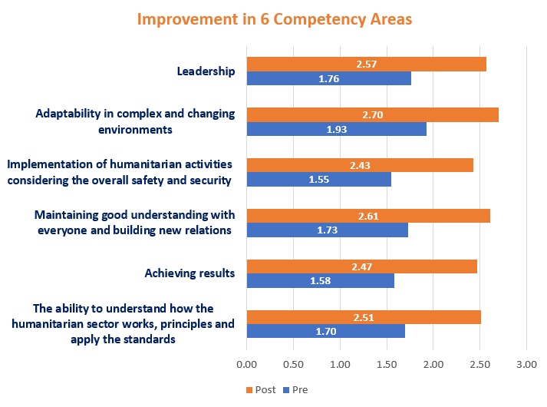

4.5 Application of Academic Knowledge
As an intern, the journey of instrumentalizing my academic knowledge into real work settings at AFD was thrilling. Though, engaging with pure online non-profit organisations has its own limitations. The nature of the service offered through Act for Displaced were quite niche but triguring for its consumers, I completely involved applying academic knowledge into practice initiating and designing my activities through the lens of service marketing.
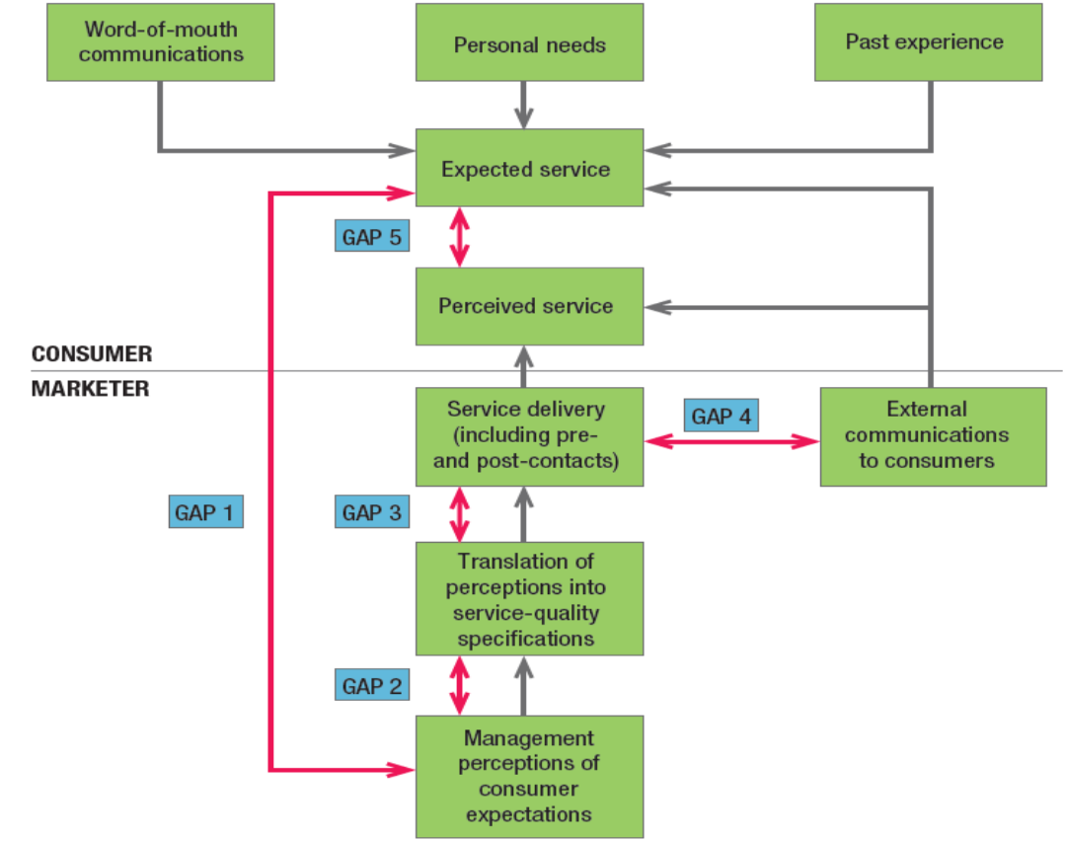
Service Quality Model
The model portrays the main requisite for delivering high service quality [1]. It indicates five gaps that hinder smooth delivery:
GAP 1: An apparent gap exists between consumer expectations and management perceptions. Management may fail to understand what customers want.
At AFD, it was always perceived that customers were capable of understanding top notch articles, and might find AFD website’s blog for shaping ideas of displaced related issues in depth.
Whereas, some readers were facing difficulties understanding the ideas of some contents. They also opined in social media platform’s that the perspective of some blogs, articles are one-sided.
As a solution, prior to the submission of any writings, we suggested the establishment of a council who would be responsible for editorship and would make sure the contents are politically correct.
GAP 2: this gap indicates the gap between management perception and service-quality specification, where management might correctly perceive customers’ wants but not set a performance standard.
Sometimes, contents related to current world affairs were not produced promptly because the content team was not instructed with the time-frame.
To address that, we initiated and set priority to work.
GAP 3: Gap between service-quality specifications and service delivery - employees may lack the appropriate training, may be incapable of or unwilling to meet the standard, or may be held to contradictory standards, such as giving customers prompt service and listening to their concerns.
The perceptions differ employee to employee, which may lead to poor delivery of work.
AFD created a platform of discussion where people with similar interests gather and create buzz. Interacting with mass people in such spaces might lead to unwanted conflict between members.
GAP 4: It is all about the difference between service delivery and external communications. Statements made by company representatives and advertisements have a significant impact on consumer expectations.
Across all spaces - Facebook, Instagram, Twitter, Linkedin, Website – digital outreach associates were actively engaging with the consumers. Sometimes, the perceived quality of contents were not met aligning with the ads that were shown to the target group.
With incessant effort, AFD tried to improve its content quality.
GAP 5: There may be a discrepancy between the quality of service perceived by the consumer and the quality expected by the consumer.
Producing contents and articles on the same topic might confuse the audience.
Hence, AFD reduced the frequency of producing similar contents to avoid unnecessary confusion amongst the readers.

4.5 New Skills Developed
My internship period allowed me to develop a number of skills, but here are five I can point to among the many I developed.
- Providing research, technical, field implementation, and coordination support to carry out research activities.
- Preparing project proposal draft and assisting in submissions for new projects.
- Preparing training and project reports.
- Communication, networking skills.
- Developed full working proficiency in writing and speaking English.

Chapter 5

Recommendations and Concl

5. Introduction

5.1. Recommendations for Improving Departmental Operations
The best way to create a perfect customer experience is to put ourself in the shoes of our customer in order to understand what they are going through. Recommendations includes:
- Making AFD website light so that people can load it easily on their devices.
- As it is a think tank, increasing transparency should be considered to smoothen the operations.
- Instead of going fully digital or online, AFD can reform themselves in a blended manner both with physical and online existence.
- Monetizing their contents by segmenting their contents could be initiated where premium contents could be available with a subscription fee.
- Collaborating with youths to engage them in community work could be done remotely as well.

5.2. Recommendations for Improving Self-performance
At the verge of my graduation, I strive for professional growth as well as personal growth, unlike others. Recommendations include:
- In my academic assignments, I procrastinated a lot, which is something I need to work on.
- Splitting works into milestones: breaking down tasks into small, to make it easily attainable milestones, with appropriate time frames, when working on a large project in order to ensure that I do not fall behind schedule or perform at a high level.
- Time management was one of the most important skills that I worked on during the internship.

References
Bascom, J. (2001). Refugees: Geographical Aspects. Science Direct, https://doi.org/10.1016/B0-08-043076-7/02578-X., 12895-12901. Retrieved from (https://www.sciencedirect.com/science/article/pii/B008043076702578X)
Dr. Atiur Rahman, P. D. (2017, May 06). CASE STUDY:MOBILE PHONE CASH TRANSFERS IN BANGLADESH. Japan. Retrieved March 20, 2021, from https://www.uniglobalunion.org/sites/default/files/files/news/mfs_bangladesh_case_study_v4.0.pdf
Hossain, M. (2022, February 13). Top 10 NGOs in Bangladesh | Humanity and Development. Retrieved from businesshaunt: https://businesshaunt.com/top-10-ngo-in-bangladesh/
Mentoring, A. o. (n.d.). Retrieved from https://artofmentoring.net/what-is-mentoring/
UNHCR. (n.d.). UNHCR. Retrieved from https://www.unhcr.org/what-is-a-refugee.html
Zohir, S. (January 2004). NGO Sector in Bangladesh: An Overview. ResearchGate, Economic and Political Weekly 39(36):4-10. doi:10.2307/4415513
V. A. Z. a. L. L. B. A. Parasuraman, “A Conceptual Model of Service Quality and Its Implications for Future Research,” Journal of Marketing, p. 44, 1985.
S. Zohir, “NGO Sector in Bangladesh: An Overview,” 4 September 2004. [Online]. Available: http://www.jstor.org/stable/4415513. [Accessed 4 september 2004].
M. Hossain, “Top 10 NGOs in Bangladesh | Humanity and Development,” 2022. [Online]. Available: https://businesshaunt.com/top-10-ngo-in-bangladesh/. [Accessed 13 February 2022].

Annexure 1

শিক্ষানবিশ পূর্ব এবং পরবর্তী মূল্যায়ন

মানবিক সহায়তার অত্যাবশ্যকীয়সমূহ এবং স্ফেয়ার স্টেন্ডার্ডস

প্রশিক্ষনার্থীর নাম
সংস্থার নাম
বর্তমান পদবী |  | মূল্যায়নের তারিখ

কর্ম-নৈপুণ্যের ক্ষেত্রসমূহ | ০ | ১ | ২ | ৩
মানবিক সহায়তা বিষয়ক কাজ বোঝা এবং এর নীতিমালা ও মানদণ্ড প্রয়োগে সক্ষমতা | ০ | ১ | ২ | ৩
১। দুর্যোগ-পূর্ব প্রস্তুতি হঠাৎ দুর্যোগ, দুর্যোগ ঝুঁকি হ্রাস, দুর্যোগকালীন সময়ে সাড়া প্রদান এবং উদ্ধার কাজসহ মানবিক সহায়তা কার্যক্রমে কাজ করার বিভিন্ন পর্যায় সম্পর্কে কর্মীর বোধগম্যতা এবং এ বিষয়ে কাজ করার দক্ষতা।
২। মানবিক সহায়তা কাজে রাজনৈতিক ও সাংস্কৃতিক প্রভাব এবং প্রয়োগ সম্পর্কে কর্মীর বোধগম্যতা এবং মানবিক বিপর্যয়ের অন্তর্নিহিত কারণ অনুধাবন এবং এ বিষয়ে সঠিকভাবে কাজ করার দক্ষতা।
৩। মানবিক বিপর্যয়কালীন সময়ে লিঙ্গ, মানুষের বৈচিত্র্যময় মানবীয় বৈশিষ্ট্য বিশ্লেষণ ও ব্যক্তি বা গোষ্ঠীর সার্বিক দিক সম্পর্কে কর্মীর জ্ঞান বা ধারণা এবং কর্মীর দক্ষতা প্রমাণ।

৪। প্রকল্পের সাড়া প্রদান কার্যক্রমে বিপদাপন্ন মানুষের প্রয়োজন, চাহিদা, দক্ষতা, কর্মক্ষমতা ও অভিজ্ঞতা আমলে নেয়ার প্রবণতা কর্মীর মধ্যে বিদ্যমান।
৫। মানবিক সহায়তা প্রদানের ক্ষেত্র প্রতিষ্ঠানের লক্ষ্য অর্জনে কর্মীর কাজ এবং তার পেশাগত আচরণ জাতীয় ও আন্তর্জাতিক মানবিক সহায়তা কাঠামো. আদর্শমান, নীতিমালা ও আচরণবিধি অনুসরণ করেছে।
৬। জবাবদিহিতা, নীতিমালা ও আদর্শমান নিশ্চিত করার সময় ক্ষমতার প্রয়োগের ক্ষেত্রে কর্মীর পেশাগত আচরণ ও দায়িত্বশীলতা।
৭। মানবিক সহায়তা কাজে প্রতিষ্ঠান ও অন্যদের ভূমিকা সম্পর্কে কর্মীর সচেতনতা।
৮। সমন্বয় প্রক্রিয়া অনুধাবন
ফলাফল অর্জন | ০ | ১ | ২ | ৩
১০। প্রকল্পের ব্যবস্থাপনা (প্রজেক্ট ম্যানেজমেনন্ট সাইকেল) বিষয়ে স্বচ্ছ ধারণা
১১। প্রকল্প বা কার্যক্রমের নকশা প্রণয়ন ও বাস্তবায়নে সক্রিয় ও কার্যকরি অংশগ্রহণের উদ্যোগ
১২। সম্পদের সর্বোচ্চ ব্যবহারের মাধ্যমে সঠিক ফলাফল ও যথাসময়ে সম্পন্ন করার বিষয়টিতে মনোনিবেশ করা।
১৩। কোনো সিদ্ধান্ত ও কার্যপ্রণালী বিষয়ে দুর্যোগ আক্রান্ত মানুষকে জানানোর দক্ষতা।
১৪। মতামতসহ প্রাসঙ্গিক ও দরকারি তথ্য সংগ্রহ করে সেগুলো বিশ্লেষণ করা। দুর্যোগ আক্রান্ত মানুষ এবং অন্যান্য সংশ্লিষ্ট পক্ষগুলোর কাছে প্রাপ্ত তথ্যের বিশ্লেষণ সঠিকভাবে প্রচার করা। তবে খেয়াল রাখতে হবে প্রক্রিয়াটি যাতে তাদের প্রত্যশা বাড়িয়ে না দেয়।
১৫। হঠাৎ পরিবর্তিত পরিস্থিতি ও ভিন্ন সাংস্কৃতিক পরিস্থিতিতে খাপ খাওয়াতে নিজেকে প্রস্তুত রাখার বিষয়টি স্পষ্ট করা।
১৬। সিদ্ধান্ত কখন গ্রহণ করতে হবে এবং সে সিদ্ধান্তে কারা জড়িত থাকবেন তা স্পষ্টভাবে বোঝা
১৭। লক্ষ্য অর্জনের ক্ষেত্রে সিদ্ধান্তের নানামুখী প্রভাব বিবেচনার করা।
১৮। সর্বজনীন সিদ্ধান্ত গ্রহণের ক্ষেত্রে পরিকল্পনায় ও সকলের প্রতিনিধিত্ব নিশ্চিত করা
সকলের সাথে সুসম্পর্ক বজায় রাখা এবং নতুন সম্পর্ক তৈরি করা | ০ | ১ | ২ | ৩
১৯। দুর্যোগ আক্রান্ত জনগণ, সংশ্লিষ্ট বিভিন্ন পক্ষ ও দলের অন্যান্য সদস্যদের সকলের কথা বলে তাদের নতুন ও বিচিত্র অভিজ্ঞতা শোনার প্রবণতা
২০। দুর্যোগ আক্রান্ত গোষ্ঠী ও সংশ্লিষ্ট পক্ষগুলোর সাথে কথোপকথন চালিয়ে যাওয়া
২১। কার্যক্রমগুলোর লক্ষ্য অর্জনে দলের মধ্যে ইতিবাচক ভূমিকা পালন করা
২২। দুর্যোগ আক্রান্ত জনগোষ্ঠীর প্রতি সম্মান, সহমর্মিতা ও সমবেদনা প্রকাশ করা
২৩। নিয়মিত যোগাযোগ রক্ষা করা। যোগাযোগের জন্য যথোপযুক্ত প্রযুক্তি বা মাধ্যম ব্যবহার করা
২৪। ভালভাবে কাজ পরিচালনার জন্য নেটওয়ার্কের সাথে সক্রিয়ভাবে অংশগ্রহণ করা।
২৫। সে সব সিদ্ধান্ত ও আচরণ আন্তর্জাতিক রেড ক্রস, রেড ক্রিসেন্ট সোসাইটি ও এনজিও বা স্বমালিকানা সংস্থার আচরণবিধির লঙ্ঘন, সেগুলোর বিরুদ্ধে যুক্তিযুক্ত প্রতিরোধ তৈরি করা।
সুরক্ষা ও সার্বিক নিরাপত্তার কথা বিবেচনা করে মানবিক সহায়তা বিয়ষক কর্মপরিচালনা | ০ | ১ | ২ | ৩
২৬। বিপদাপন্ন ব্যক্তি বা অন্যান্য প্রধান পক্ষগুলোর নিরাপত্তার দিকে মনোযোগ দিতে হবে
২৭। ঝুঁকি ও হুমকি চিহ্নিত করে নিজের ও সংগঠনের জন্য আশু সমাধানের পথ খুঁজে বের করা
২৮। ‘কোন অনিষ্ট নয় – do no harm’ নীতি অনুসরণ করা এবং সহযোগী ও বিপদাপন্ন ব্যক্তির ঝুঁকি হ্রাস করা।
২৯। মানবিক সহায়তার নীতিমালা ও মানদণ্ড অনুযায়ী নিজেকে তৈরি করতে হবে যেন কর্মক্ষেত্রে সবার কাছে গ্রহণযোগ্যতা পাওয়া যায়
৩০। সুরক্ষা ঘাটতিগুলো খুঁজে বের করে তা হ্রাসে প্রয়োজনীয় পদক্ষেপ নেয়া। এক্ষেত্রে সংগঠনের সুরক্ষা ও নিরাপত্তা নীতিমালার সাথে সঙ্গতিপূর্ণ পদক্ষেপ গ্রহণ করে কাজ করা
৩১। নিরাপত্তার গুরুত্বের কথা সব সময় মাথায় রাখা এবং সহকর্মী ও দলের সদস্যদের নিরাপত্তার দিকে নজর রাখা।
চাপ ও পরিবর্তিত পরিবেশে মানিয়ে নেয়া | ০ | ১ | ২ | ৩
৩২। দ্রুত পরিবর্তিত পরিস্থিতিতে সংগঠনের উদ্দেশ্য ও লক্ষ্য ঠিক রেখে কাজ করা
৩৩। বিচক্ষণতার সাথে পরিবর্তিত পরিবেশ ও প্রতিবন্ধকতা সামাল দেয়া
৩৪। মানসিক চাপ বুঝে তা কমানোর বিষয়ে মনোনিবেশ করা এবং দ্রুত পদক্ষেপ নেয়া
৩৫। জটিল ও প্রতিকূল পরিবেশের সাথে মানিয়ে নিয়ে গঠনমূলক ও ইতিবাচক মনোভাব বজায় রাখা
৩৬। নিজের কাজ ও অন্যের উপর এসব কাজের প্রভাব বোঝা ও সে বিষয়ে দায়বদ্ধ থাকা ও তা স্বীকার করা।
৩৭। চাপের মধ্যেও কাজের পরিকল্পনা, অগ্রাধিকারভিত্তিক কাজ ও কাজ করার মানসিকতা
৩৮। আচরণবিধি অনুসারে পেশাদারিত্ব বজায় রাখা ও নীতিমালা মেনে চলা।
৩৯। নিজের অবস্থানে দায়িত্বশীল থাকা। গ্রহণযোগ্য আচরণ, সততা ও ন্যায়পরায়ণ থাকা।
৪০। কর্ম দক্ষতায় প্রভাব ফেলে এমন অভ্যন্তরীণ ও বাহ্যিক প্রভাবগুলো সম্পর্কে সচেতন থাকা।
নেতৃত্ব দান | ০ | ১ | ২ | ৩
৪১। নিজের সক্ষমতা ও সীমাবদ্ধতা সম্পর্কে সচেতন হওয়া এবং অন্যের উপর এর প্রভাব সম্পর্কে অবগত থাকা
৪২। দক্ষতা সম্পর্কে জানা এবং সেগুলো কিভাবে দলগত কার্যকারিতা বৃদ্ধি করে তা স্পষ্ট করা।
৪৩। কর্ম দক্ষতার মান উন্নত করতে মতামতগুলো ইতিবাচক মনোভাব নিয়ে গ্রহণ করা এবং কাজে তার প্রতিফলন নিশ্চিত করা।
৪৪। দলকে উৎসাহ দেয়ার জন্য নিজেকে মনোযোগী শ্রোতার ভূমিকায় রাখা
৪৫। কার্যক্রমের লক্ষ্য অর্জনের জন্য অন্যকে ইতিবাচক উপায়ে প্রভাবিত করা।
৪৬। সুনির্দিষ্ট নির্দেশনা না থাকলে জটিল পরিস্থিতিতে বিশ্লেষণ ও পূর্ববর্তী অনুশীলনের ভিত্তিতে রায় প্রদান
৪৭। আরও ভালভাবে কাজ করার জন্য সৃজনশীল পরামর্শ ও উদ্যোগ গ্রহণের বিষয়টি প্রদর্শন করে।
৪৮। সাফল্য অর্জনে দৃঢ়তা

