Internship Report
on
Human Resource Management Practices of Social Islami Bank Limited

Maksuda Sultana Koly
ID - 111203012
School of Business and Economics
BBA Program, Major in Human Resource Management
United International University

This report is submitted to the School of Business and Economics, United International University as a partial requirement for the degree fulfillment of the Bachelor of Business Administration

Internship Report on
Human Resource Management Practices of Social Islami Bank Limited

Submitted to:
Ms. Shayla Khanam
Assistant Professor
School of Business & Economics
United International University

Submitted by:
Maksuda Sultana Koly
ID - 111203012
School of Business and Economics
BBA Program, Major in Human Resource Management
United International University


School of Business and Economics
United International University
Date of Submission: July 30, 2025

Letter of Transmittal
July 30, 2025
Ms. Shayla Khanam
Assistant Professor
School of Business and Economics
United International University

Subject: Submission of the Internship Report titled “Human Resource Management Practices of Social Islami Bank Limited”
Honorable Ma’am,
I am presenting the internship report titled ‘’Human Resource Management Practices of Social Islami Bank Limited’ with deep gratitude to Almighty Allah for granting me the opportunity to complete it successfully. This curriculum requirement belongs to the BBA program at United International University.
The report documents my educational developments and practical training experiences in the Human Resource Department of Social Islami Bank Limited. My understanding of Human Resource Management Practices at Social Islami Bank Limited stems from practical workplace experience, academic comprehension, online research, and first-hand conversations with professional staff.
I put all my efforts into creating this report using the proper structure and relevant and sufficient data needed to fulfill academic requirements. The work I have prepared should deliver valuable insights and meet your expectations.
Your valuable assessment would make me immensely thankful.
Sincerely,
Maksuda Sultana Koly
ID - 111203012
School of Business and Economics
BBA Program, Major in Human Resource Management

Certification of Similarity Index
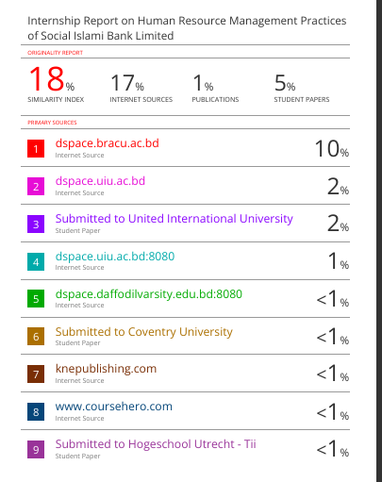
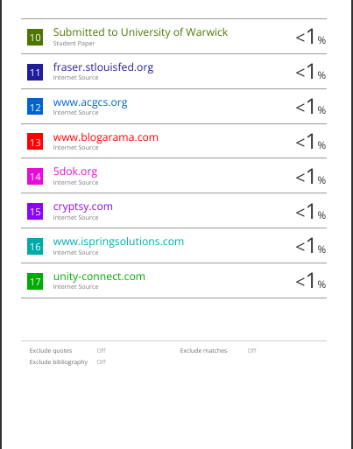

Declaration of the Student
I hereby declare that the internship report titled “Human Resource Management Practices of Social Islami Bank Limited” is an authentic record of my own work carried out during my internship from December 1, 2024, to February 28, 2025. The information provided in this report has not been copied from any other source and is based on my personal experience and observations during the internship.

Corporate Evidence
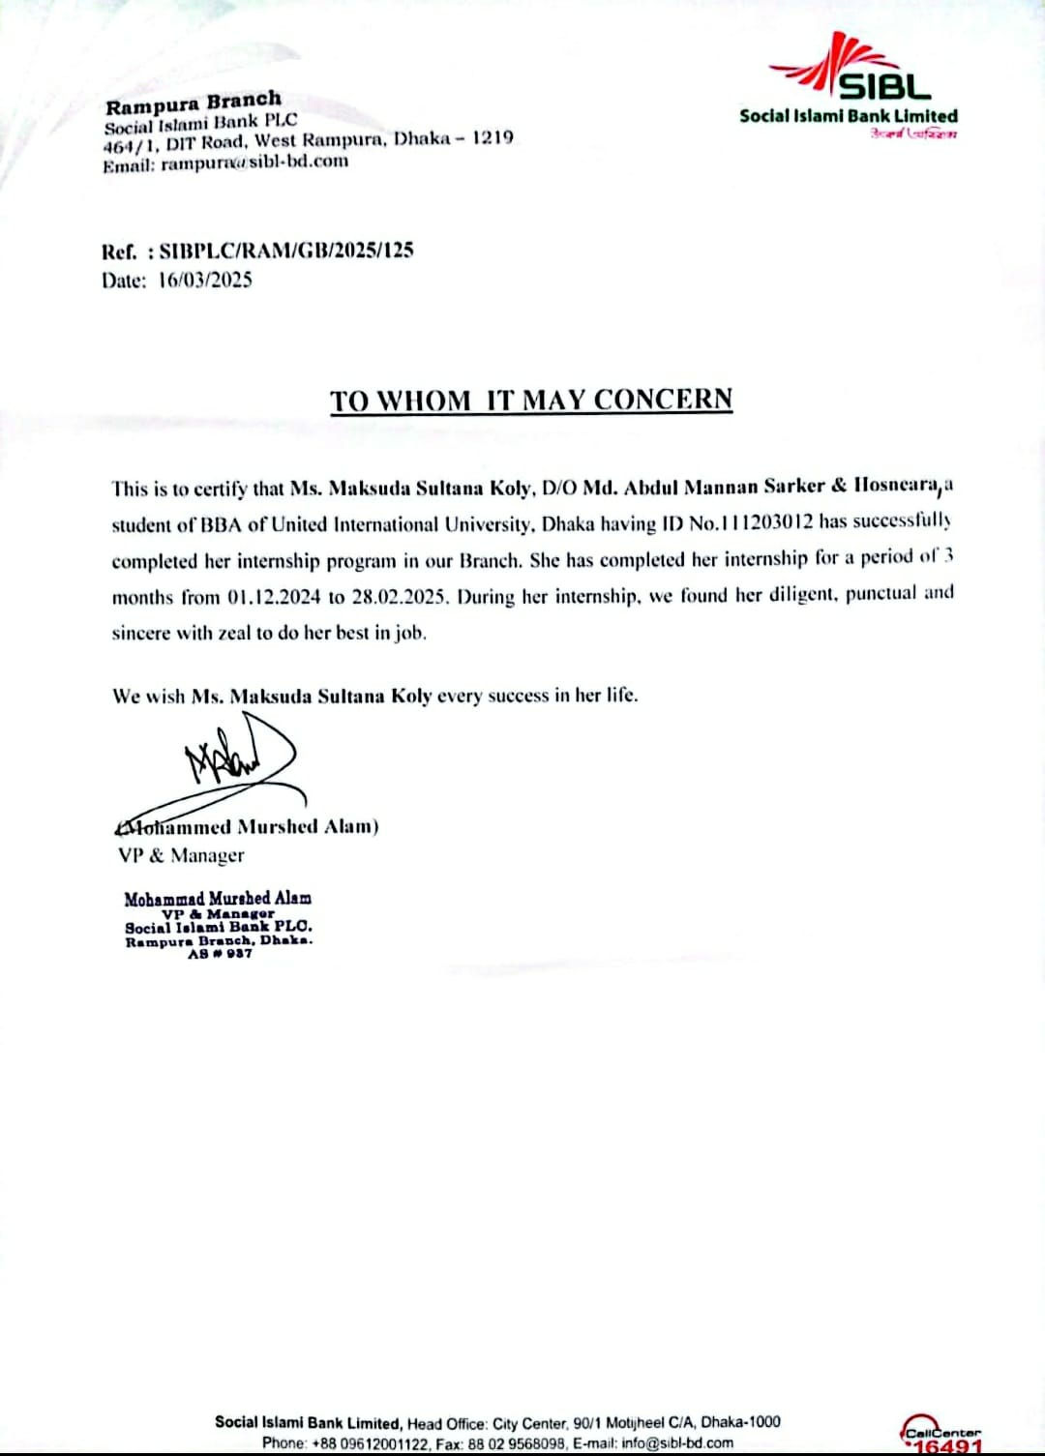

Acknowledgement
I would like to express my sincere gratitude to Social Islami Bank Limited (SIBL), Rampura Branch, for providing me with the opportunity to undertake my internship. My heartfelt thanks go to my supervisor, Ms. Shayla Khanam, for their constant guidance, support, and encouragement throughout the internship period. I also appreciate the cooperation and assistance of all the staff members at SIBL, whose insights and professionalism enriched my learning experience. Finally, I would like to thank my family, friends, and colleagues for their unwavering support throughout my academic journey and during the internship

Executive Summary
A business internship provides necessary practical experience in live supporting business operations by transforming academic understanding into practice-oriented skills. I had the privilege to work at Social Islami Bank Limited (SIBL) which stands as a leading financial institution in Bangladesh. My experience at Social Islami Bank Limited allowed me to study operational and managerial banking elements by observing Human Resource Management practices.
The institution grew into a renowned trusted financial institution beginning from when it first started operations. The bank has received extensive public admiration because it puts customers first while delivering financial services dramatically and maintaining ethical banking standards. My internship at SIBL Rampura Branch gave me personal experience observing commercial banking activities as well as corporate culture and employee performance contributing to organizational achievement. Human resources policies at the financial institution influence staff performance and motivational levels as well as operational effectiveness and represent a compelling study focus.
This report examines exclusively the human resource management practices along with policies that SIBL utilizes. This report includes a summary of SIBL’s human resource approaches together with its recruitment system training curriculum employee assessment system along employee incentive packages. SIBL maintains its high standard of service through workforce development initiatives which I have tried to present. Observations made during my internship let me evaluate the effectiveness of SIBL's HR practices and detect enhancements required for these practices.
My role and responsibilities at the internship are described alongside a SWOT analysis that identifies the strengths weaknesses prospects and challenges of SIBL's human resource management policies. My observational and professional expertise allows me to provide recommendations for HR practice improvement at the bank. The document represents my internship learnings by reflecting on my active participation while explaining the vital role that human resource management plays in banking institution success

Table of Contents
Letter of Transmittal i
Certification of Similarity Index ii
Declaration of the Student iii
Corporate Evidence iv
Acknowledgement v
Executive Summary vi
List of Figures vvivi
List of Acronyms and Abbreviations vi
CHAPTER 01: INTRODUCTION 1
1.1. Background of the Report 1
1.2. Objective of the Report 3
1.3. Rationale of the Report 4
1.4. Scope and Limitations of the Report 5
1.5. Definition of Key Terms 6
CHAPTER 02: COMPANY AND INDUSTRY PROFILE 8
2.1. Company Analysis 8
2.1.2. Trend and Growth 11
2.1.3. SWOT Analysis of SIBL 13
2.2. Industry Analysis 17
CHAPTER 3: INTERNSHIP EXPERIENCE 24
3.1. Position, Duties, and Responsibilities 24
3.2. Training & Development 24
3.3. Contribution to Organization / Operations 24
3.4. Practical Exposure to HRM Operations 24
3.5. Familiarity with HR Tools and Compliance Practices 25
3.6. Evaluation 25
3.7. Human Resources Functions of SIBL 25
3.8. Skills Applied 33
CHAPTER 4: CONCLUSION AND KEY FACTS 35
4.1. Recommendations 35
4.2. Key Understanding 37
4.3. Conclusion 40
Appendix 43
Reference 43
Questionnaire: 44

List of Figures

Figure 1: Logo of SIBL
Figure 02: SWOT Analysis
Figure 03: Human Resource Planning of SIBL
Figure 04: Recruitment Advertisement Medium of SIBL
Figure 05: Employee Selection Process

List of Acronyms and Abbreviations

HRM – Human Resource Management
KPI – Key Performance Indicator
C&B – Compensation and Benefits
T&D – Training and Development
L&D – Learning and Development
EE – Employee
FTE – Full-Time Equivalent

CHAPTER 01: INTRODUCTION

Background of the Report
Internship experiences serve as vital instruments for professional development because they let people gain actionable industry expertise and first-hand practical applications of their skills. The experiences extend past conventional learning because students develop practical abilities as well as problem-solving skills and adapt to professional environments. Participating in internships provides real access to vibrant corporate organizations, which teaches actual information about banking procedures as well as interpersonal work dynamics and operational methods. The report analyzes the Human Resource Management (HRM) practices happening at Social Islami Bank Limited. The internship experience gave me a chance to transform academic principles into practical workplace applications through firsthand observation of professional implementation methods.
A nation’s economic development heavily relies on the banking sector because this sector powers financial operations offers credit services and maintains monetary stability across the economy. Financial institutions work within an age of fast globalization and technological progress that requires them to adapt their operations to changing economic environments together with developing industry trends. Business adaptation processes benefit from Human Resource Management because this practice controls workforce recruitment development and retention to achieve efficiency customer satisfaction and business sustainability.
Social Islami Bank Limited treats human resource management as a strategic concept that supports full organizational achievement. Employee growth receives total organizational support from Social Islami Bank Limited through standardized training provided by both internal and external instructors. The initiatives increase professional abilities while maintaining industry standard compliance and deliver better performance. The HR policy system at Social Islami Bank Limited implements structured compensation programs in addition to bonuses and advancement opportunities and performance-based incentives to develop staff motivation and an engaged work environment.
An organized human resource management system enables workplace commitment to organizational goals among employees. The HRM strategies at Social Islami Bank Limited aim to develop a productive work environment that fosters collaboration and achieves extended corporate targets. Through professional development and a combination of financial and non-financial incentives, organizational staff engagement grows along with employee sense of belonging. A financial sector that implements sound human resources practices will be able to preserve operational efficiency as well as sustainability in a highly competitive landscape.
The process of creating a complete study about banking operations taught me significant lessons even though it entailed various difficulties during my Human Resource Management major. This report focused primarily on human resource functions but general banking work exposed me to new information. Staff members at the organization guided interns to acquire practical experience in managing employees and system flows as well as handling regular banking operations. Professional growth has strongly benefited from the internship, which delivered critical practical expertise that will help ensure career success in HRM and corporate management.

Objective of the Report

Primary Objective
The major purpose is to complete the academic internship report, a partial BBA degree requirement. This internship is allotted 3 credits to comprehend its academic significance. Drawing from the insights gained during the BBA degree, particularly in the Human Resources classes, I endeavored to discern the various applications of HRM theories and concepts in the professional realm.

Secondary Objective
As secondary objectives, I have focused on understanding the following aspects of HRM practices in the banking sector, particularly within Social Islami Bank Limited (SIBL):
- Examine real-world HRM practices by observing how professionals manage daily responsibilities within the organizational structure of a bank.
- Gain insights into workforce management strategies, including employee onboarding, performance evaluation, and staff retention approaches.
- Explore the planning and implementation of HR policies, focusing on how these influence employee engagement and organizational culture.
- Investigate training and development (T&D) initiatives and their role in enhancing employee skillsets and productivity.
- Analyze motivational strategies adopted by HR to improve employee satisfaction and drive performance.

Rationale of the Report
The main purpose behind this report is to study the Human Resource Management (HRM) methods used at Social Islami Bank Limited (SIBL) through firsthand internship experience. The research design focuses on uniting academic human resource knowledge with operational financial industry methods.
The internship pursued a goal of comprehending the operational framework of HR activities including recruitment and training and performance assessment as well as compliance management within an Islamic banking environment. The study examines the role of HRM in building a workplace environment that maintains ethically compliant operations through efficient workforce management in banks that follow Shariah principles.
This report also serves the following purposes:
- Exploring HR Practices in Islamic Banking – To understand how HR operations are tailored to align with Shariah principles, employee well-being, and professional ethics.
- Linking HR Theories to Practice – To apply academic knowledge of HRM in areas like performance appraisal, compensation & benefits (C&B), and training & development (T&D) in a practical banking setting.
- Evaluating Professional Growth – To reflect on the HR-specific skills developed, such as communication, organizational behavior understanding, and employee engagement.
- Informing Career Development – To gain insights into the strategic role of HR in the banking sector and assess personal interest and preparedness for a career in HRM.

Scope and Limitations of the Report
This report focuses on the daily procedures of banks, which involve customer relations, account handling, loan processing, and remittance management systems. The Human Resource Management (HRM) functions of my placement included helping with employee documentation as well as maintaining applicant data for recruitment support and observing training programs for new staff members. Through the report I assume responsibility to perform compliance checks and assist with customer transactions in addition to designated duties. The report explores the expertise gained from my internship which includes mastery of Islamic finance products and development of improved communication and customer service skills and regulatory compliance knowledge that aligns with employee relations and compliance dimensions and training and development functions.

Limitations
Several limitations were encountered while conducting the study, which are as follows:
- Frequent schedule changes in 2020 and 2021 due to government and Bangladesh Bank guidelines made data collection challenging.
- Heavy reliance on secondary sources may have influenced the judgment and findings of the study.
- SIBL is a publicly listed company, and officials were unable to disclose certain internal information due to ethical constraints.

Definition of Key Terms

1. Internship – A temporary work experience that provides students or fresh graduates with practical exposure to an industry or profession.
2. Islamic Banking – A banking system that operates under the principles of Shariah (Islamic law), prohibiting interest (Riba) and promoting profit-sharing mechanisms.
3. Social Islami Bank Limited (SIBL) – A private commercial bank in Bangladesh that operates based on Islamic banking principles, offering various financial services such as deposits, loans, and investments.
4. Call Money Rate – The short-term interest rate at which banks borrow and lend funds to each other to maintain liquidity.
5. Remittance – The transfer of money by expatriates or foreign workers to their home country, contributing to the economy.
6. Know Your Customer (KYC) – A process in banking and finance that involves verifying the identity of clients to prevent fraud, money laundering, and financial crimes.
7. Deposit Scheme – A financial product offered by banks where customers can save money and earn returns over a fixed period under different structures.
8. Loan Processing – The series of steps taken by banks to evaluate and approve a loan application, including documentation, credit assessment, and disbursement.
9. Compliance – Adherence to banking regulations and policies to ensure lawful and ethical financial operations.
10. Banking Software – Digital platforms and systems used by banks to manage financial transactions, customer accounts, and operational tasks efficiently.

CHAPTER 02: COMPANY AND INDUSTRY PROFILE

2.1. Company Analysis

2.1.1. Overview and History of SIBL
Social Islami Bank Limited (SIBL) was established on July 5, 1995. The results resulted from a coordinated and dedicated effort by a consortium of Bangladeshi enterprises and individuals advocating for the proliferation of Islamic banking in Bangladesh. SIBL commenced its commercial operations on November 22, 1995. The primary objective of their operations was to illustrate the integration of the Islamic code of life with the economy, the banking sector, and all financial activities conducted by individuals and organizations. SIBL is tasked with implementing essential measures in its operations to promote the advancement of the nation's commercial, industrial, service, and agricultural sectors. The robustness of a nation's banking sector significantly influences its economic condition. A robust and prosperous banking sector signifies an expanding economy, implying that this growth will persist.
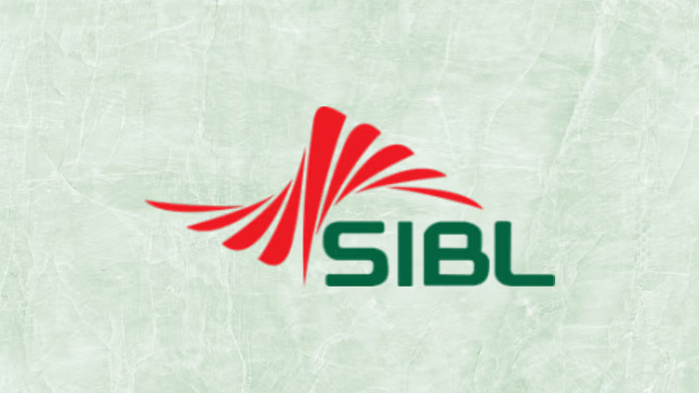
Figure 1: Logo of SIBL
Social Islami Bank Limited is a prominent private bank in the country that offers financial support to enterprises of various scales, emphasising the import and export of goods. LIM (Loan against Import Merchandise) and LTR (Loan against Trust Receipt) are financial instruments that facilitate the operational efficiency of import and export enterprises by addressing their financial requirements before to and subsequent to shipment. Consequently, the bank's role in assisting the nation's private sector is clear. The bank is integral to business financing. The corporate sector can access contemporary and prompt banking services by establishing diverse updated deposit and investment accounts, in addition to securing trade finance through instruments like letters of guarantee, letters of credit, and the collecting and discounting of invoices. SIBL can be depended upon by the business sector to furnish funds for projects anticipated to enhance the bank's profitability and stimulate the economy by generating employment and alleviating poverty. Businesses obtain financial support for various purposes, such as domestic and international fund transfers, equipment and consumer durable leasing, hire purchase agreements, installment sales of capital goods, real estate investments, participatory investment schemes, agricultural funding and expansion, as well as investments in education and health, among others. The firm, a prominent Islamic bank in the country, complies with a code of conduct and engages in philanthropic initiatives without the aim of generating profit wherever feasible. (Source: SIBL Annual Report, 2019)
Social Islami Bank Limited is a financial institution founded under the Companies Act of 1994. It is a scheduled bank functioning under a banking licence granted by the Bangladesh Bank, the central banking authority of Bangladesh. The bank commenced operations on November 22, 1995. SIBL is a contemporary bank having an authorised capital of Taka 1000 crore and a paid-up capital of Taka 893 crore. It is a commercial bank that adheres to Shariah law, resulting in significant operational variations. Social Islami Bank Limited was listed on the Dhaka Stock Exchange (DSE) in 2000 following its Initial Public Offering (IPO). In 2004, the bank commenced the provision of online banking services. SIBL was listed on the Chittagong Stock Exchange (CSE) in 2005. In 2007, the bank issued its inaugural rights share. The remittance service software was developed in 2008. In the subsequent year, the bank released its second rights share. The bank commemorated the inauguration of its 50th branch in 2010. Two subsidiaries of SIBL, SIBL Securities Limited and SIBL Investments Limited, were established in the same year. In 2010, the bank established a partnership with VISA and implemented Core Banking Software.
In 2011, SIBL implemented its concurrent audit system and issued its third rights share. In 2011, the bank commemorated the inauguration of its 75th branch, situated in Bashundhara. The bank has launched its Green Banking Window and its School of Banking. SIBL established its corporate offices in the Motijheel commercial area adjacent to City Centre in 2012. They initiated their offshore banking and internet banking operations in the same year. In 2014, SIBL possessed over 625,000 deposit accounts and in excess of 49,000 investment accounts. The bank commemorated the inauguration of its 100th branch. In 2015, SIBL launched the Mudaraba Subordinate Bond. In 2015, SIBL commenced the provision of agent banking services to capitalise on the expanding market. SIBL inaugurated its 125th branch, the Corporate Branch, in the subsequent year. The Internet Banking platform of SIBL, utilised by numerous individuals, was launched by the bank in 2018. The bank attained international acclaim that year when it received a rating from the global rating agency Moody's. As of 2019, SIBL operates 161 branches nationwide. The bank conducts various financial operations to facilitate the expansion of trade and commerce nationwide. Entrepreneurs can obtain SIBL services to assist in launching new enterprises and BMRE of industrial units. (Source: SIBL Annual Report, 2019)

2.1.2. Trend and Growth
SIBL seeks to implement a tripartite banking model that is lucrative, service-oriented, and technology-driven. SIBL delivers swift, accurate, and outstanding customer service. SIBL executes a long-term growth strategy that is both egalitarian and sustainable. SIBL, a leading bank in Bangladesh, provides technologically advanced services to improve consumer convenience. Moreover, they execute their banking activities following recognized Islamic standards. Their products are designed to deliver accurate and satisfying customer service. They have an attractive and proficient human resources team to deliver services to clients. They are empowering destitute families and generating employment opportunities for income production. Their mission encompasses all aspects of their current and future objectives. (Source: SIBL Annual Report, 2019)
SIBL's vision statement is "Working together to create a society that is more compassionate." The bank aims to establish itself as the premier Islamic bank in the nation by providing a diverse array of tailored products and services, adhering to ethical practices per Shariah principles, and leveraging advanced technological solutions through a highly competitive workforce. The bank consistently devises innovative strategies and adaptable approaches to enhance awareness, deliver optimal banking experiences to its clients, and maximize value for all stakeholders. The primary objective of the bank is to foster comprehensive economic development to alleviate poverty. (Source: SIBL Annual Report, 2019)
SIBL's motto is "Journey towards continuous excellence." The bank seeks to uphold the principles of its slogan by enhancing its financial capabilities to align with worldwide standards, refining its brand image, and instituting exemplary corporate governance processes. The bank modified its logo to enhance team cohesion among the members of the SIBL family. The bank is augmenting its branches to solidify its status as a household name.
SIBL offers agent banking services to enhance financial inclusion. Individuals residing in isolated regions of the country without access to banking institutions are offered financial services like cash deposits, cash withdrawals, foreign remittance distribution, fund transfers, and balance queries. Moreover, individuals utilising the bank's agent banking services can access a range of savings plans, including the DPS and Mudaraba Term Deposit.
SIBL has concentrated on providing its consumers with services that are prompt, personalised, and courteous. The bank is committed to cultivating and fostering robust connections with its clients. SIBL asserts its ethical obligation to deliver optimal financial services to its clients through the utilisation of cutting-edge technologies. To ensure the bank's long-term prosperity, it is essential to sustain these relationships. This will assist the bank in attaining optimal returns on shareholders' equity while safeguarding depositors' assets.
SIBL's goal is to make Islamic banking products known and accessible to everyone. To achieve this, the organization is working to promote Islamic banking and investments to potential and prospective clientele. Providing financial help to people in need and creating opportunities for families in poverty to earn money. As a result, the bank is also involved in promoting equity throughout society. SIBL offers a range of services to enhance the level of customer service provided. The services encompass branch banking, round-the-clock ATM access, VISA debit and credit cards, SMS banking, online banking, agent banking, electronic fund transfers, remittance services, and central clearing facilities.
2.1.3. SWOT Analysis of SIBL
SWOT analysis is a thorough evaluation of a company's vulnerabilities and prospects about its strengths, weaknesses, opportunities, and threats. This enables the company to maintain its current performance while anticipating future improvements to outpace its competitors. This tool can be employed by a corporation to evaluate its current status and to enable modifications in its strategic management. I performed a SWOT analysis on SIBL Bank, and my conclusions are detailed below:

Figure 02: SWOT Analysis
- Strength:
Social Islamic Bank Limited has cultivated a positive reputation within Bangladesh's banking industry. It is one of the most esteemed private commercial banks in Bangladesh. SIBL has a specialized training center, beneficial for a business and capable of decreasing training costs. The fundamental training is advantageous for individuals and organizations alike. The bank's senior management consists of individuals with substantial experience from esteemed organizations, and their banking expertise, abilities, and proficiency will promote the bank's further growth. Professionals at SIBL has specialized skills and expertise derived from their experience with the SIBL performance review system. Consequently, SIBL claims its possession of unique competencies and skilled personnel, together with exceptional leadership and managerial functions in its banking services. The bank's profits and deposits have markedly increased. All these metrics demonstrate that SIBL excels in customer happiness, service quality, cost-effectiveness, specialized expertise, and a positive public reputation.
- Weakness:
To promote comprehensive business growth, we must consolidate all pertinent information. The organization's deficiencies, similar to its strengths, are vital elements. In the SWOT analysis, I detected multiple deficiencies inherent to SIBL. SIBL has a restricted number of branches around Bangladesh. Like the Islamic Bank, they persistently fail to create branches in 22 separate districts. Moreover, the number of ATM booths in Dhaka city is limited. The bank's inadequate service quality has become a major issue. The bank failed to execute an enhanced recruitment policy for lower and mid-level roles. As a result, the bank's services appear to be declining gradually. Other banks have adopted mobile banking and online account opening services; however, SIBL has not yet provided these functionalities. The principal issue is that the bank does not possess a strategic plan. The banks lack long-term strategies concerning a focus on retail banking or a move to corporate banking. An effective and practical strategic plan should outline the future direction at this time.
- Opportunities:
Opportunities are a crucial component of SWOT analysis. One should first identify possibilities and thereafter undertake suitable actions to attain the objective. The growing population's steady development of consumer finance abilities presents an opportunity in retail banking. SIBL should focus on this option to attract more consumers and improve their retail banking services. on recent years, a multitude of private banks has appeared on the market. To maintain a competitive edge in this sector, SIBL must broaden its product range. Moreover, mobile wallets and mobile banking provide substantial benefits within modern banking systems. It may be included in their lineup. Supplementary online consumer services, including digital solutions, must to be provided.
- Threats:
Threats encompass any external factors that may adversely affect your organization, such supply chain disruptions, market volatility, or a shortage of qualified personnel. Proactively identifying risks and implementing measures to mitigate them is essential to prevent victimization and avoid stagnation in progress. Additional private banks have entered the market and are striving to acquire an increasing part of it. The intensity of competition will persistently increase, compelling banks to devise strategies to contend with both local and multinational banks. It is increasingly growing more competitive each day. Innovative marketing techniques must be implemented to maintain SIBL's prominence. Furthermore, the political situation in Bangladesh poses a significant threat to banks.

2.2. Industry Analysis

2.2.1. Specification of the Industry
A pillar of the world economy, banks enable credit distribution, financial transactions, and economic growth using their capacity to The banking industry is evolving dramatically with the fast improvements in technology, shifting consumer tastes, legislative changes, and more competitiveness. Emphasizing important trends, difficulties, possibilities, and future prospects, this report investigates the present situation of the banking sector:
2.2.2. Size, Trend, and Maturity of the Industry Trends
Digital Transformation and Fintech Integration in the Banking Sector: The banking industry is undergoing rapid digital transformation, driven largely by the integration of financial technology (fintech). As of 2024, the global fintech market is valued at approximately $340 billion, with projections to reach $882 billion by 2030, growing at a CAGR of 18.5%. This surge is reshaping traditional banking through services like internet banking, mobile banking apps, and contactless payments, reducing dependency on physical branches and improving convenience for consumers.
Fintech innovations such as blockchain-based payments, peer-to-peer (P2P) lending, and robo-advisory platforms are becoming mainstream. For example, global blockchain spending in the banking sector alone is expected to surpass $22.5 billion by 2026. These technologies are compelling traditional banks to either adopt digital models or collaborate with fintech startups to stay competitive.
Growth of Challenger and Neo Banks: Challenger and neo banks—digital-only banking institutions with no physical branches—are rapidly capturing market share. As of 2024, there are over 400 neo banks worldwide, with the global neo banking market valued at $90 billion, expected to grow at a CAGR of 47.1% through 2030. These banks are favored for their low operational costs, user-friendly mobile interfaces, and efficient customer service.
Challenger banks like Monzo, Revolut, and Chime cater primarily to millennials, Gen Z, and small businesses, offering services like instant payments, budgeting tools, and low-fee foreign exchange. In Bangladesh, local fintech-driven banks are also emerging, although the sector is still at an early stage of maturity compared to Western markets.
Government Regulations and Compliance Trends: The banking sector remains one of the most heavily regulated industries globally. Key compliance areas include Anti-Money Laundering (AML), Know Your Customer (KYC), data privacy, and cybersecurity. Regulatory frameworks such as Basel III and local compliance mandates continue to evolve, increasing pressure on banks to invest in compliance tech. According to Deloitte, compliance-related costs for financial institutions have increased by 15–20% annually in the last five years.
In Bangladesh, regulatory bodies like Bangladesh Bank have mandated digital KYC and are tightening oversight on digital payment platforms. This shift is pushing banks to implement advanced RegTech solutions for real-time monitoring and reporting.
Cybersecurity and Data Protection: With the increase in digital banking transactions, the need for cybersecurity has become paramount. According to IBM, the financial sector experiences the highest average cost of a data breach, at approximately $5.9 million per incident. Banks are now investing in AI-based fraud detection, blockchain protocols, and multi-factor authentication to protect customer data.
Globally, spending on cybersecurity in banking is projected to reach $53 billion by 2026, driven by the need to meet stringent data protection laws such as GDPR and CCPA.

AI-Powered Personalized Banking: Artificial Intelligence is revolutionizing the banking industry through hyper-personalized services. Banks are increasingly using AI chatbots, machine learning algorithms, and predictive analytics to tailor offerings. According to McKinsey, AI could deliver up to $1 trillion of additional value annually in global banking. Furthermore, over 60% of banks now report using AI in at least one business function.
These innovations not only enhance customer experience but also improve fraud detection, loan underwriting, and portfolio management.
Sustainable and Green Banking Initiatives: Sustainability is becoming a core focus in banking. The global green finance market is valued at over $540 billion, with green bonds issuance alone hitting $620 billion in 2023. Financial institutions are increasingly aligning with ESG (Environmental, Social, and Governance) principles by funding renewable energy projects, adopting sustainable lending criteria, and offering eco-friendly financial products.
In Bangladesh, banks like BRAC Bank and Dutch-Bangla Bank have initiated green banking practices, including the implementation of paperless systems and support for clean energy financing—although industry-wide maturity remains moderate.
2.2.2.1. Difficulties the Banking Industry faces
Inflation and Economic Uncertainty: Banking activities have suffered under global economic uncertainty, increasing inflation, and geopolitical concerns. Rising interest rates brought on by higher inflation change loan affordability and general credit demand.
Enhanced Competency from Big Tech and Fintech: Fintech firms and digital behemoths like Google, Apple, and Amazon—which are entering the financial services market—offer traditional banks fierce competition. These internet startups challenge established banking norms by using cutting-edge technology and huge consumer data to provide flawless financial solutions.
Changing Customer Altitudes: Consumers of today want quicker, more easily available, customized banking experiences. Meeting these expectations calls for ongoing digital transformation, user-friendly interfaces, and omnichannel banking solutions investment.
Operational Costs and Profitability Pressures: Technology improvements, regulatory compliance, and cybersecurity policies are driving growing operating expenses for banks. Maintaining profitability depends on finding a mix between cost-effectiveness and service excellence.
Cybersecurity Risk and Threats: Cybercriminals find perfect targets when banks migrate online. Serious hazards to banks and consumers are phishing assaults, ransomware threats, and fraudulent transactions. Two still significant concerns are improving cybersecurity infrastructure and informing consumers about digital hazards.
2.2.2.3. Banking Industry Prospective Areas
Broadening of Financial Inclusion: Especially in developing countries, the acceptance of mobile banking, digital wallets, and microfinance projects is promoting financial inclusion. By offering easily available and reasonably priced financial services, banks may leverage underprivileged people.
Blockchain and Virtual Currency: Blockchain technology and digital currencies give banks chances to investigate decentralized finance (DeFi) solutions, digital asset management, and cross-border payments with lowered transaction costs and improved security.
Artificial Intelligence and Automation: AI-driven automation can improve decision-making, simplify banking operations, and lower the hand-off of manual labor. In fields including fraud detection, risk assessment, and customer service, robotic process automation (RPA) and artificial intelligence-driven analytics raise effectiveness.
Open Banking and API Integration: Open banking rules are encouraging ecosystems of data-sharing that let outside developers construct creative financial solutions. Using application programming interfaces (APIs) allows banks to improve client experiences and generate fresh income sources.
ESG Investments and Sustainable Banking: Offering green financing solutions, sustainability-linked loans, and socially responsible investment products helps banks profit from the rising demand for ESG-aligned investments.
Driven by technological developments, legislative changes, and changing consumer behaviour, the banking sector will keep changing. Banks that embrace digital transformation, innovation, and sustainable practices will flourish even if issues such as cybersecurity concerns, economic uncertainty, and fintech rivalry always exist. Combining artificial intelligence, blockchain, and open banking will transform the sector even further and produce a more inclusive, quick, customer-centric banking ecosystem.

CHAPTER 3: INTERNSHIP EXPERIENCE

3.1. Position, Duties, and Responsibilities
Position: Intern at Social Islami Bank Limited, Rampura Branch
Duties & Responsibilities:
- Assisted in customer service operations, including account opening and KYC verification
- Processed and maintained financial documents such as deposit slips, cheques, and bank statements
- Supported loan processing by verifying required documentation
- Helped in handling remittances and fund transfers
- Assisted in compliance and regulatory documentation

3.2. Training & Development
- Learned about banking operations, including Islamic banking principles
- Gained hands-on experience in customer relationship management
- Understood the internal banking software and transaction processing
- Developed communication and problem-solving skills through client interactions

3.3. Contribution to Organization / Operations
- Enhanced customer service efficiency by streamlining document processing
- Assisted in reducing workload for bank officers by managing routine tasks
- Contributed to accurate financial record-keeping

3.4. Practical Exposure to HRM Operations
- Gained hands-on knowledge of core HRM functions such as recruitment, onboarding, and performance evaluation through academic and internship experience.
- Actively assisted in HR activities like employee record management, training coordination, and leave administration during internship at Social Islami Bank Limited.
- Developed a clear understanding of organizational HR practices within the banking sector through direct exposure and observation.

3.5. Familiarity with HR Tools and Compliance Practices
- Familiar with using HRIS for managing employee data, attendance, and leave records.
- Experienced in reviewing and working with internal HR policies related to compliance and employee conduct.
- Understand how HR departments align operational efficiency with legal and ethical standards, including KYC procedures.

3.6. Evaluation
Challenges Faced: Adapting to banking software, understanding regulatory compliance
- Achievements: Successfully assisted in handling client queries, improved document processing speed

3.7. Human Resources Functions of SIBL
Human resourcing process go through a critical phrase in this bank with different function working together to achieve the overall goal of the organization. These are
3.7.1. Recruitment and Selection
The process of hiring and selecting employees is an essential part of SIBL's operations. The organisation achieves its purpose when it hires individuals who are a good fit for its culture and criteria. SIBL Bank has developed a structured hiring process that allows them to successfully draw in the most competent people from a huge number of applicants. Finding someone to hire is a difficult task, especially in the banking industry. SIBL has a recruiting process that is designed to guarantee that the most qualified candidates are chosen from the pool of applicants. The process may take a significant amount of time, but it is worth it. The following steps and factors are prioritised in order to create a successful recruitment strategy:
Identification and Prioritization of Work
It is not practical to hire personnel for all vacant positions at the same time because each position has its own specific criteria. It is important to clearly define the main responsibilities of each position and to develop a hiring process that is tailored to those responsibilities ahead of time. At SIBL, recruiters are responsible for classifying employment positions and filling vacancies as needed.
Candidate Requirements
The recruitment of candidates will be effective only if the manager can clearly ascertain that the candidate will fulfil their anticipated duties. The candidate must also adhere to the following parameters:
i. Performance Level: Various job roles necessitate distinct competencies from candidates, contingent upon the job type. A candidate must meet the specified criteria for their application to be accepted.
ii. Experience Level: Not all issues may be resolved solely by experience; certain positions also require expertise. The SIBL bank manager endeavours to fill the position by aligning the requisite performance standards with the candidate's experience.
Candidate Category
Various types of personnel, both employed and unemployed, from diverse backgrounds are invited to apply, from which the SIBL management selects the most suitable candidate.
Employment Source
Which source will also be utilized under this registration system? The sources typically utilized by SILB managers to recruit personnel may be internal and external.
Qualified Employee
The managing committee of SIBL not only evaluates the source but also assesses the qualifications necessary for the position. Prior to convening and selecting personnel, management must assess their capacity to fulfill job responsibilities.
Employee Evaluation
Having considered all factors, it is now time to evaluate the criteria of an employee with those established by SIBL managers.
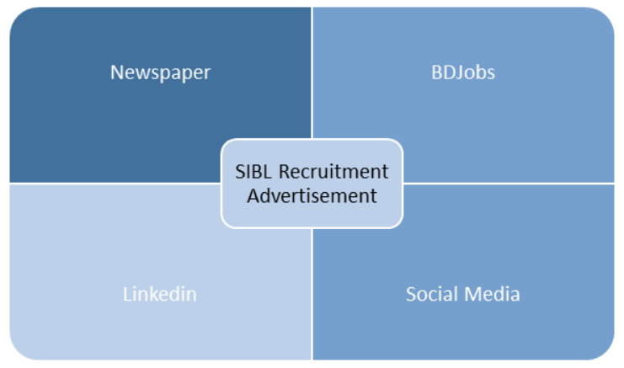
Figure 04: Recruitment Advertisement Medium of SIBL

Employee Selections
Selection constitutes a critical component of human resource management. Social Islami Bank has implemented a selection process to identify the most qualified candidates. Having evaluated all of these, it is now time to choose the qualified candidate. Selecting the most qualified staff facilitates the achievement of objectives. Each step must be completed to advance to the subsequent phase. The predetermined steps are:
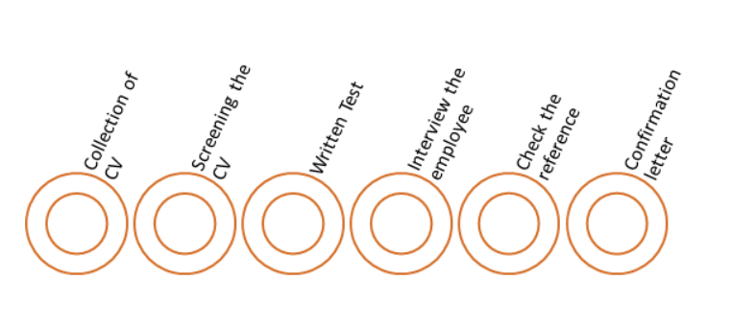
Figure 05: Employee Selection Process
Adhering to these methods enables the manager of Social Islami Bank to secure their preferred personnel. The procedure encompasses multiple stages. Each method assesses distinct abilities, experiences, knowledge, and related attributes. The entire process assists in eliminating undesirable and less competent personnel from exiting. Initially, they review all the selected CVs and subsequently eliminate those that do not satisfy the criteria. Subsequently, the managers arranged a written examination. Those who passed were picked for the physical interview. It is now time for the reference and employee orientation to commence. This is the procedure adhered to by Social Islami Bank for management.
3.7.2. Training and Development
The human resources of an organisation define its identity. It is imperative to keep personnel apprised. The staff are a significant asset to the organisation. Any organisation with trained personnel may effectively manage any crisis. In this changing Maintaining employee training is crucial for the benefit of both the organisation and its employees. The human resources department primarily concentrates on this aspect. For sustainable development, an organisation must prioritise human resource management. Skilled human resources enhance the organisation. Social Islami Bank Limited also underscores that. The bank's success is due to the efforts of each competent and deserving employee. Social Islami Bank has implemented an operational human resources system to enhance HR activities and policies designed to attain requisite skills and outputs. The bank seeks to achieve its goals by maximising production and reducing input. To achieve these levels, they engaged qualified workers at every tier. Through this upkeep, they attain optimal client satisfaction and sustainable goals. The 2018 annual report of Social Islami Bank states that there are 155 branches. This provides adequate time for the recruitment of competent staff to do the tasks and to execute their HR strategy. Social Islami Bank Limited demonstrates much concern for its employees. They have investigated all possible methods to sustain employee motivation in every imaginable way. Social Islami Bank operates a training centre where skilled professionals and experienced trainees educate and motivate staff for training purposes.
Steps in Training
i. Analysis of performance
ii. Finding the gap or lack in output of an employee
iii. Arranging proper tanning
iv. Evaluate the post-training performance of employees
Types of Training
SIBL provides two primary categories of training conducted in its specialized training facilities:
On-the-Job Training: SIBL provides on-the-job training using the following modalities:
Coaching: Designating an instructor as a mentor for employees and identifying skill deficiencies to facilitate their job performance.
Follow-up: Monitor the supervisor and endeavor to keep pace with their activities.
Skill acquisition: In the current competitive landscape, it is imperative to acquire diverse talents. The computer is now of utmost importance. The complete baking system operates through software. Acquiring this talent is crucial.
Impromptu assessment: Administering an impromptu assessment or requiring employees to execute their tasks allows the trainer to identify deficiencies, hence facilitating the provision of targeted training.
External Training (off training): Also referred to as vocational training. The components of the training are:
Videos and films: SIBL management occasionally supply work-related videos to familiarize staff with the tasks they are about to undertake.
Seminars: organizing seminars focused on the work, workplace, and evolving work environment, all of which are addressed in the seminars.
Case study: Assigning staff position-related instances and requesting them to resolve these issues. Such as the bank accounts that employees are unable to access.
Classroom lecture: Delivering a lecture on a certain topic constitutes an aspect of the external training process.
SIBL management prioritises personnel development and seeks to enhance their instincts. The HR manager provides comprehensive training that will benefit them in their lives.
Performance Evaluation
The effectiveness of the training provided by the organisation is entirely contingent upon the results or outcomes achieved. Performance evaluation provides employees with the perception that their performance is being assessed, prompting them to strive for excellence in the workplace. When employees contribute their efforts, it facilitates the organization's attainment of objectives. Furthermore, an additional benefits of performance review include the straightforward identification of deficiencies in performance. Furthermore, performance evaluation assists in developing the trepanning program. The management committee of SIBL Limited employs the following methods:
Weight checklist: The Bank employs this procedure to inform staff that their performance is being assessed and to clarify the criteria for evaluation. All descriptions are documented.
Critical incident method: In this performance appraisal technique, the SIBL management team documents all positive and negative aspects of employee performance during a certain timeframe.
Optimal and suboptimal performance appraisal method: In this procedure, employees document the highest and lowest performances for comparative analysis.
Ranking system: In this system, all chosen behaviours will be prioritised based on the established criteria.
Comparison method: in this ranking technique, employees are evaluated against their peers at the same level. The one who performs optimally will receive the assessment.
Graphic design: assess the efficacy based on the visual depiction. Provide the input, and the corresponding graphic will be elevated.
Behavioural Method: under this approach, employees are evaluated according to specific behaviours. Actions that will be monetized and facilitate the completion of the procedure.
Compensation & Benefits
Compensation is the remuneration that employees receive for their diligent efforts. Upon receiving compensation, employees develop loyalty to the organisation. Compensation may consist of monetary payments, rewards, and additional advantages such as outings, vacations, pensions, a safe environment, and a diverse workplace, among others. SIBL provides the subsequent incentives to its employees:
Bonus
Profit bonus: A portion of the monthly profit is designated for them, although it is formally distributed after a six-month period. Generally, 4-8% of the profit.
Festival bonus: The employee is entitled to two festival bonuses during each Eid celebration.
Employment Advantages
Promotions are a common approach to improving staff productivity in any organisation. At SIBL, progress is accompanied by enhanced remuneration. Furthermore, employees have the opportunity to utilise several loan programs at favourable rates from the bank.

3.8. Skills Applied
During my internship, I was actively involved in various Human Resource Management and operational tasks, particularly focused on financial documentation, data handling, customer interaction, and compliance support. My core responsibilities included:
Financial Documentation and Data Entry: I was responsible for maintaining accurate financial records and entering customer transaction data into the banking software system. This involved daily updating of ledger books, verifying customer account details, and assisting in the preparation of monthly financial statements. I ensured that all data entries were error-free, timely, and complied with the bank’s internal audit standards.
Customer Service and Problem-Solving: I regularly interacted with clients to address their inquiries regarding account status, loan processing, or general banking services. By responding professionally and efficiently, I contributed to improving customer satisfaction. I also helped resolve minor issues such as discrepancies in account balances or delayed transactions by liaising with relevant departments.
Regulatory Compliance Knowledge: My role required a sound understanding of the bank’s regulatory frameworks. I learned and followed the guidelines provided by Bangladesh Bank and internal policies regarding KYC (Know Your Customer), AML (Anti-Money Laundering), and other compliance protocols. I assisted in ensuring that customer records were properly updated and compliant with current banking laws and regulations.
Banking Software Proficiency: Throughout the internship, I worked extensively with the bank’s core banking software for tasks like customer information updates, financial entry processing, and report generation. I gained practical experience in using real-time banking platforms, which enhanced my technical skills and understanding of digital banking operations.
As a major banking organization throughout the country, Social Islami Bank Limited leads the market through its reputation as a Shariah-based financial institution. Many valuable lessons combined with vital insights from Social Islami Bank Limited resulted in an educative and satisfying professional experience that supported my learning at school and work-based knowledge acquisition. My specialization in Human Resource Management made me especially enthusiastic about observing how department operations function in the structured corporate environment of Social Islami Bank Limited

CHAPTER 4: CONCLUSION AND KEY FACTS

4.1. Recommendations
Renowned financial institution Social Islami Bank Limited (SIBL) has made major economic contribution to Bangladesh. It can be difficult for an intern to offer suggestions for a seasoned company. Based on my observations, nevertheless, I have found a number of areas where the general operational structure and Human Resource Management (HRM) policies of the bank may use improvement in efficiency and effectiveness.
1. Dedicated Client Information Desk: SIBL does not now have a specific department to answer consumer questions. Rather, bank officials supply information, which usually results in more work for them and client delays. Creating a specific client information department will help to simplify correspondence and raise customer service effectiveness.
2. Modernizing the Employer Process: The bank hires using an antiquated system devoid of automation. By lowering the time and effort needed for hand processing, a computerized recruitment system would remove duplicity and increase efficiency.
3. New Employee Orientation Program: SIBL does not offer a structured orientation session for just hired staff members. For people who are promoted or transferred inside the bank, this might not be a problem; nonetheless, it poses difficulties for fresh graduates. Starting a disciplined orientation program would enable fresh hires to adjust fast and improve their output.
4. Minimizing Banking Operations' Paperwork: The banking industry mostly depends on documentation and calls on clients to sign several times on one form. Sometimes clients neglect to sign, which calls for more bank visits. Reducing duplicate documentation or putting in place a more effective digital signature system would help operational effectiveness and customer experience.
5. Specialized HR Divisions: SIBL's HRM division does not have separate units for several HR purposes. This lack of expertise makes simultaneous management of several HR functions challenging. Separating payroll management, training, employee relations, and recruiting into departments will improve workflow.
6. HR Software Implementation: SIBL's HR procedures clearly lack the specific tools needed to store personnel data and screen resumes. By simplifying personnel records administration, performance reviews, and recruitment, a strong HR software system would help to lower administrative loads and enhance decision-making.
7. Building Backup Systems and IT Infrastructure: SIBL depends on banking applications housed on a central server. Should the server run across a problem, the whole system fails, therefore upsetting banking activities and maybe causing consumer unhappiness. Reliable backup systems or alternate servers would help to reduce operational downtime risk.
8. Improving Recruitment Strategy: The bank limits its capacity to draw a varied and qualified applicant pool by not running significant job advertising campaigns. By means of digital platforms, job fairs, and social media campaigns, raising the exposure of recruitment initiatives will help the bank to better reach qualified people and enhance its staff.
SIBL can develop its competitive position in the banking sector by tackling these areas, thereby improving operational efficiency, employee happiness, and customer service and hence strengthening its competitiveness.

Key Understanding
The term "Human Resource Management" refers to the techniques that an organization employs to manage its human capital. Because the human brain is extremely complicated, it is a critical and necessary component to govern. A business that has a capable and dedicated workforce can successfully handle any situation. The human resource process includes planning for workforce acquisition, recruiting and selecting qualified people, training and developing them to meet the needs of the company, and eventually motivating and compensating them to improve productivity. To summaries, human resources are concerned with increasing the productivity of an organization by improving its efficiency and effectiveness. For SIBL, they have adopted a well-organized process from hiring to mentoring and development of the employee of the organization through different well established and industry acceptable criteria. Human resource planning is crucial for all organizations, including the management of Social Islami Bank Limited. HR Planning assists the HR administration of Social Islami Bank in forecasting employee requirements. Strategic planning enables SIBL managers to devise approaches for attaining their objectives. SIBL employs adaptable techniques that can be modified to achieve short-term objectives while considering long-term requirements. SIBL management formulates plans to ensure preparedness for unforeseen circumstances. Candidate Requirements-
The recruitment of candidates will be effective only if the manager can clearly ascertain that the candidate will fulfil their anticipated duties. The candidate must also adhere to the following parameters:
i. Performance Level: Various job roles necessitate distinct competencies from candidates, contingent upon the job type. A candidate must meet the specified criteria for their application to be accepted.
ii. Experience Level: Not all issues may be resolved solely by experience; certain positions also require expertise. The SIBL bank manager endeavours to fill the position by aligning the requisite performance standards with the candidate's experience.
Candidate Category-
Various types of personnel, both employed and unemployed, from diverse backgrounds are invited to apply, from which the SIBL management selects the most suitable candidate.
The managing committee of SIBL not only evaluates the source but also assesses the qualifications necessary for the position. Prior to convening and selecting personnel, management must assess their capacity to fulfill job responsibilities.
The human resources of an organisation define its identity. It is imperative to keep personnel apprised. The staff are a significant asset to the organisation. Any organisation with trained personnel may effectively manage any crisis. In this changing Maintaining employee training is crucial for the benefit of both the organisation and its employees. The human resources department primarily concentrates on this aspect. For sustainable development, an organisation must prioritise human resource management. Skilled human resources enhance the organisation. Social Islami Bank Limited also underscores that. The bank's success is due to the efforts of each competent and deserving employee. Social Islami Bank has implemented an operational human resources system to enhance HR activities and policies designed to attain requisite skills and outputs. The bank seeks to achieve its goals by maximising production and reducing input. To achieve these levels, they engaged qualified workers at every tier. Through this upkeep, they attain optimal client satisfaction and sustainable goals. The 2018 annual report of Social Islami Bank states that there are 155 branches. This provides adequate time for the recruitment of competent staff to do the tasks and to execute their HR strategy. Social Islami Bank Limited demonstrates much concern for its employees. They have investigated all possible methods to sustain employee motivation in every imaginable way. Social Islami Bank operates a training centre where skilled professionals and experienced trainees educate and motivate staff for training purposes.
SIBL provides two primary categories of training conducted in its specialized training facilities such as SIBL provides on-the-job training using the following modalities. Designating an instructor as a mentor for employees and identifying skill deficiencies to facilitate their job performance. Monitor the supervisor and endeavor to keep pace with their activities. In the current competitive landscape, it is imperative to acquire diverse talents. The computer is now of utmost importance. The complete baking system operates through software. Acquiring this talent is crucial. Administering an impromptu assessment or requiring employees to execute their tasks allows the trainer to identify deficiencies, hence facilitating the provision of targeted training.
Also referred to as vocational training SIBL management occasionally supply work-related videos to familiarize staff with the tasks they are about to undertake. organizing seminars focused on the work, workplace, and evolving work environment, all of which are addressed in the seminars. Assigning staff position-related instances and requesting them to resolve these issues. Such as the bank accounts that employees are unable to access. Delivering a lecture on a certain topic constitutes an aspect of the external training process.
SIBL management prioritises personnel development and seeks to enhance their instincts. The HR manager provides comprehensive training that will benefit them in their lives.The effectiveness of the training provided by the organisation is entirely contingent upon the results or outcomes achieved. Performance evaluation provides employees with the perception that their performance is being assessed, prompting them to strive for excellence in the workplace. When employees contribute their efforts, it facilitates the organization's attainment of objectives. Promotions are a common approach to improving staff productivity in any organisation. At SIBL, progress is accompanied by enhanced remuneration. Furthermore, employees have the opportunity to utilise several loan programs at favourable rates from the bank.

4.3. Conclusion
The main objective of this report examines the human resources policies together with operational procedures at Social Islami Bank Limited. The document provides complete details about essential HR management activities including manpower evaluation stages together with talent acquisition and onboarding methods alongside assessment system development strategies and payment systems for staff alongside union management procedures. These departments have received specific attention to study the bank's HR practices which support both organizational targets and pleased staff members.
The bank seeks to achieve its goals by maximising production and reducing input. To achieve these levels, they engaged qualified workers at every tier. SIBL management prioritises personnel development and seeks to enhance their instincts. The HR manager provides comprehensive training that will benefit them in their lives. The report has recommended a few things that can be improved to get the best output according to the goal of the organization such as Dedicated Client Information Desk, Modernizing the Employer Process, New Employee Orientation Program, Minimizing Banking Operations' Paperwork, Specialized HR Divisions, HR Software Implementation, Building Backup Systems and IT Infrastructure, Improving Recruitment Strategy
As an organization, the bank keeps its Human Resource Management department at the top of its list of sensitive information hubs because this section handles employee data while managing internal policies and developing workforce plans. My research collected significant data points by synthesizing valuable information from authoritative sources such as annual reports of the bank and relevant digital publications while my most essential data came from direct meetings with HR personnel and other staff members.
The report contains an analysis section together with recommendations about areas that require enhancement according to my observations and learning. The bank encounters difficulties with specific HR activities execution together with poor coordination between teams and new opportunities to integrate employee-focused technology. The internship positioned itself as a vital link between classroom-based knowledge and real-world workplace experience while deepening my understanding of Human Resource Management practice in Bangladeshi banking institutions.

Appendix

Reference
Muhammad Umer Chapra. (1985). Towards a just monetary system. Islamic Foundation.
Nasim, A., & E Mediawati. (2019). Critical Study the Application of the Principle of Profit Sharing in Syirkah Mudharabah and Musyarakah in Islamic Banking. KnE Social Sciences, 3(13), 1351–1351. https://doi.org/10.18502/kss.v3i13.4289
Shahinoor Rahman, Md. (2016). Investment approval process of ISLAMIC banking - an identical investment approval process model: A case study on some selected islamic banks in bangladesh. International Journal of Business and Economics Research, 5(5), 155. https://doi.org/10.11648/j.ijber.20160505.14
The following web site was accessed on February 7, 2025:
www.siblbd.com
Sun, D. (2017, November). Azim arif elected SIBL chairman. Daily-Sun; Daily Sun. https://www.daily-sun.com/printversion/details/265537/Azim-Arif-electedSIBL-chairman
Zaheed, M., Al-Din, H., & Afrin, S. (2021). Human resource management practices and policies of social islami bank limited submitted to senior lecturer, BRAC business school. https://dspace.bracu.ac.bd/xmlui/bitstream/handle/10361/16485/16104067_BBA.pdf?sequence=1&isAllowed=y

Questionnaire:
- What are the key HR policies and practices followed by the bank to manage its workforce effectively?
- How does the bank recruit and select employees, and what criteria are considered in the hiring process?
- What training and development (T&D) programs are in place to enhance employee skills and career growth?
- How does the bank evaluate employee performance, and what appraisal methods are used (e.g., KPI, 360° feedback)?
- What are the major HR challenges faced by the bank, and how does management address them?
- What compensation and benefits (C&B) structures are implemented to attract and retain talent?
- How does the bank promote employee engagement and motivation within the organization?
- What diversity, equity, and inclusion (DEI) initiatives are undertaken in the workplace?
- How does the bank handle employee relations and grievance management?
- What measures are taken to ensure employee health, safety, and well-being?
- What role does technology (e.g., HRIS or ATS) play in streamlining HR operations at the bank?
- What succession planning strategies are in place to ensure leadership continuity?

