Internship Report on
“Customer Experience Department of IDLC Finance Limited”

Internship Report
On
“Customer Experience Department of IDLC Finance Limited”
Submitted To:
Dr. Seyama Sultana
Assistant Professor
School of Business and Economics, UIU
Submitted By:
Tahia Tahsin
111 143 134
Submission date:
31st august, 2019


UNITED INTERNATIONAL UNIVERSITY

Letter of Transmittal
August 31st, 2019
Dr. Seyama Sultana
Assistant Professor
School of Business and Economics,
United International University
Subject: Submission of a report on Customer Experience Department of IDLC Finance Ltd.
Dear Madam,
I am very delighted to submit the final term paper, as you requested. I have done this paper on, “Department of Customer Experience of IDLC Finance Limited”. My main incentive was to prepare this term paper according to your guidelines in accordance with your directions. I have tried my best to make my work as per your structures. I hope that I personally have done a satisfactory job considering my level of experience and capability and have been able to relate the fundamental things with realistic applications.
Moreover, I am extremely thankful for the opportunities that you gave me to express my innovative ability and I intently hope that you will like the work that I have done.
Sincerely yours,
Tahia Tahsin

ID: 111 143 134

Executive Summary
The internship report on IDLC finance Limited reflection of the three month internship experience, observations during this time and a brief overview of one of the most reputed Non Banking Financial Institutions ( NBFI) of Bangladesh. As an intern in the CED, I got the chance to perceive how the whole CED functions with corporate divisions to accomplish targets. Later, I will talk about the different products and services of IDLC Finance Ltd. Also talk about different department and their basic works. I will also talk about the SWOT analysis, and as I did some analysis and found some information I also put those in the report so far.

In order to highlight the different aspects of the three month internship attachment at the CED, critical analysis of the interactions with different departments as well as a critical analysis of CED and different job responsibilities have been described in different segments of the report. From the close observation of the organization based on the internship, some recommendations have come up that will hopefully help the organization better serve their customers, the banking industry and the economy of the country.

Chapter 1: Introduction

1.1 Introduction
Over the past few years, the IDLC group has become Bangladesh's largest multi-product multi-segment non-banking financial institution and one of the local stock market blue chips companies.The single product leasing that began in 1986 with five employees has now evolved into a $750 million multi-product company that has diversified into corporate, SME, retail and capital market section. Today IDLC is represented in 48 branches and in 15 towns with more than 1,300 employees. The business is committed to powerful economic results and viable practice.IDLC has been consistently recognized as a standardized bearer for the Bangladesh financial sector by independent bodies for the values underpinning its business. The IDLC has committed its employees to uphold the highest standards of ethics and compliance. Every worker follows the code of behavior of the company. IDLC engaged in CSR operations.
The IDLC group has embarked on a trip since 2011 to expand its capacities and become bigger and better than ever before. In 2016, they launched new technology, new products, new branch, new sales, channels, etc. The firm started to levy these investments and stepped up business seriously.
1.2 background of the study
BBA student needs the internship program. It's a three-month duration program. This program is eligible for students who have finished all the necessary classes. I was connected for three months to the IDLC Finance Limited in the internship program.
My Report is based on IDLC Finance Limited Customer Experience Department. I basically included a business overview, marketing scenario analysis, consumer purchasing process, SWOT, consumer behavior analysis, my responsibilities in this department, significant IDLC problems. My effort was to comprehend the company's environment and difficulties in the customer division that IDLC is facing.

Limitations of the report
Different viewpoints and encounters are needed to create a report. In my case, I faced a few obstacles to a full and immaculate report. These limits or constraints that pose my job are as follows:
- Time constraint was the main limit. During my internship, I discovered a lot of stuff. However, learning and developing knowledge about all the department's activities and activities was not enough for me. Hence I was unable to carry out more in-depth and detailed analyzes and to include them in my study.
- Each organization has its own privacy which is not disclosed to the outside world. There was no exception to this by IDLC Finance Limited. Some of my peers have not revealed enough data because of the organization's confidentiality. In some other cases, owing to company secrecy, I was not permitted to communicate some of my department's sensitive and confidential data.
Methodology

I have followed two types of reporting arrangement methodology. The two ways I gathered information:
- Primary data:
I gathered this information with the assistance of a business manager (Sadhan Kumar Das), talked directly to customers and discussed it with other customer expert department staff and many more agencies.
- Secondary Data:
My secondary method of data collected from different sources. Those are:
- Going through the websites
- Annual reports of IDLC Finance Limited.

Scope of the report
This study enables me know the clear real-time understanding of how IDLC's customer experience funding department operates more exactly on non-bank financial institution. It enables me to know how non-bank companies ' overall process. It also enables me know how clients and other business members are being treated. This study will offer you a concrete concept of IDLC's deposit scheme. I think my report will be of great assistance to those who want a non-bank financial institution orientation.

Chapter 2: Industry & Company Overview

2.1 Industry overview
Strategically analyzing includes the sector where an organization works. IDLC operates in a highly competitive environment in the economic sector. Five forces deter a company's average profitability in the company setting, which is known as the model of five porters’ forces. The IDLC-related model is discussed below.

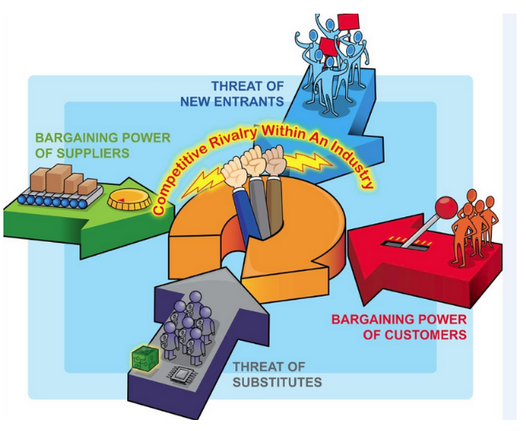
Picture: Porters Five forces model
- Rivalry among existing firms:

- Number of rivals–the financial services sector in Bangladesh is characterized by elevated competition rates with 56 banks and 33 NBFL working on the market.
- Switching costs–switching costs are small owing to a high level of service suppliers.
- Quality difference-although IDLC is a top quality service provider, there are few similar banks in terms of quality of service.
- Customer loyalty–clients are traditionally reasonably faithful, but the latest phenomenon of surplus liquidity and intense price war has greatly lowered loyalty.
By considering all the points, it is found that the intra industry rivalry is high in this sector.

- Threat of new entrants:
- First-mover advantage: first-mover advantage for the banking sector. Early firms, therefore, have an absolute benefit over new companies. The risk of fresh entry is therefore small.
- Scale-economic sector is highly economical in scale, so the risk of fresh entry is small.
- Legal barriers- the threat of new entrance is low because of legal restrictions.

All the points showed that, threat of new entrants is low.

- Bargaining power of buyers:
- Production costs-as buyers know the cost; buyers have a high bargaining power.
- Product differentiation-most products are virtually identical to those offered by different companies in the industry. So, here the buyer's negotiating power is high.
- Buying volume- for some buyers who can invest in large volume has the bargaining power very high.

By considering all the points, it has found that the bargaining power of buyers in banking and non-banking financial industry is high.

- Bargaining power of suppliers:
- Providers enterprise percentage-as large depositors are small in number, suppliers ' negotiating power is high.
- Advance integration-as providers can integrate, suppliers ' negotiating power is high.
- Concentration level-since providers are extremely focused, this industry's negotiating power is high.
- Switching between providers in this sector is not simple and expensive to switch between providers. Therefore, suppliers ' negotiating power is high.

It is found that, bargaining power of suppliers is high in this industry.

- Threat of substitutes:
- Whether industry- producing substitutes are profitable or not: in banking, non banking financial industry, the substitute product can be profitable.
- The price / performance connection of replacement products-in the banking, non-banking economic institutions, substitute products or services sector improves its price / performance relationship.

By considering all the points, we found that the threat of substitute in banking, non banking financial industry is high.

Some of names of the competitors of IDLC are given below:

- IIDFC
- RELIANCE Finance Limited
- UNITED Finance
- PRIME Finance & Investment Limited
- UTTARA FINANCE & investments Limited
- PHOENIX Finance
- LANKABANGLA Finance



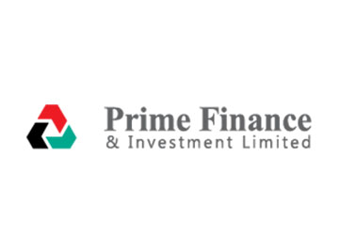

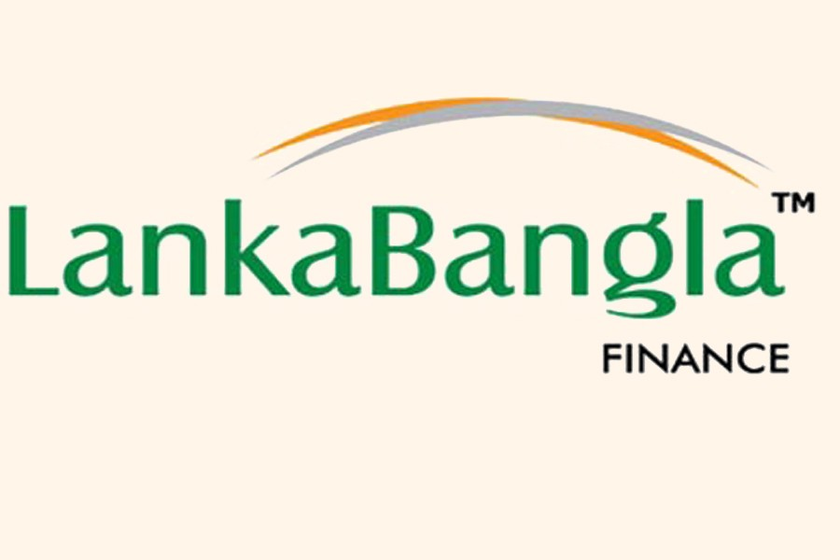
2.2: Company Overview
2.2.1: Historical Background
IDLC Finance Limited, Bangladesh's main rental organization, It was constructed in 1985. Its introduction to the globe was really a collective effort between a few neighborhoods and an institution linked to global cash, for example. Universal Finance Corporation (IFC), German Enterprise for Investment and Development (DEG), Kookmin, BankKorea Development Financing Corporation, Aga Khan Economic Development Fund, City Bank Restricted, Bangladesh IPDC, Sadharan Bima Corporation. With the development of this organization, 49 percent of the underlying distant shareholding was continually taken back. Lastly, in 2009, the neighboring followers took the organization's shareholding locationsFollowing the sanction of the Financial Institution ACT 1993, IDLC was permitted as a financial institution by the National Bank of the Country (Bangladesh Bank).
IDLC started with the goal of revamping our nation's present money-related administrations. The funding show was already linked only with banks in Bangladesh. Term funding meant taking strong account of banks ' developments, which was particularly muddle and had been defaulted for nearly every scenario. In such a case, IDLC provided fresh funding tools for one of Bangladesh's typical funding concepts. For example, Auto credit, house advance, business advance. Thus it is possible for individuals with restricted pay to enter.
2.2.2: Company Profile
IDLC Finance Limited started its adventure in 1985 as the nation's primary rental organization with a global coordinated effort and the lead sponsorship of the World Bank's International Finance Corporation (IFC). Korean Development Leasing Corporations, the Republic of South Korea's largest rental organization, provided specialized assistance.
IDLC, which has now grown as a multi-item money-related foundation driven by Bangladesh, has offices globally for enhancement, such as the Aga Khan Fund for Monetary Advancement (AKFED) and the German Investment and Development Company (DEG) other than the IFC, among its external shareholders. Notwithstanding KDLC, the other distant followers including the Korean Republic's Kookmin Bank and all these foundations together hold 47.3 percent of the organization's offers.
The new institutional shareholding structure that usually involves money-related foundations promotes the organization to always produce at the most amazing level making strategy by sharing participation and specialist methodology.
IDLC offers an assortment of money related administrations and answers for institutional and singular customers to meet their different necessities. The item that they are offering to the respected customers those are- incorporate Lease Finance, Term fund, Real Estate back, Short term fund, corporate fund, Merchant managing an account, Term store plans, Debentures and Corporate Advisory administrations.
In addition, IDLC has established two wholly-owned assistants, one of which is IDLC Securities Limited, which provides undeniable normal global business administration for both retail and institutional clients. The other is that IDLC ventures a major brand for the nation-wide speculation that keeps cash. The company is committed to hones of company and powerful execution of the budget.
2.2.3: Vision
We want to be Bangladesh’s no. 1 asset management company in terms of investors’ trust and Asset under Management.
2.2.4: Mission
IDLC Finance will center on quality development, predominant client encounter and supportable Business hones.
2.2.5: Strategic Objectives
There are some of strategic objectives have IDLC finance limited, those are-
- Growing and building our capacity pool
- Optimizing circulation point
- Growing shopper deals and management skills
- Growing and differentiating funding sources
- becoming the number 1 supplier of SME loans and updating the portfolio
- Focus on top-level corporate clients
- Consolidate capital market operations and upgrade capabilities
- Universally recognized corporate governance and viable corporate loans
- Create high-caliber and intentionally adapted portfolios
- Maximize corporate incentives through excellent growth management.

2.2.6: Strategy
IDLC Finance has used distinctive growth methodology through a Bangladesh-driven methodology that will truly do better for clients, and it also stays strongly held clients over the years.

2.2.7: Core Values
Center estimations of IDLC are entirely kept up by each worker and Encase of any money related dealings. The center qualities are

2.2.8: Organization Structure:

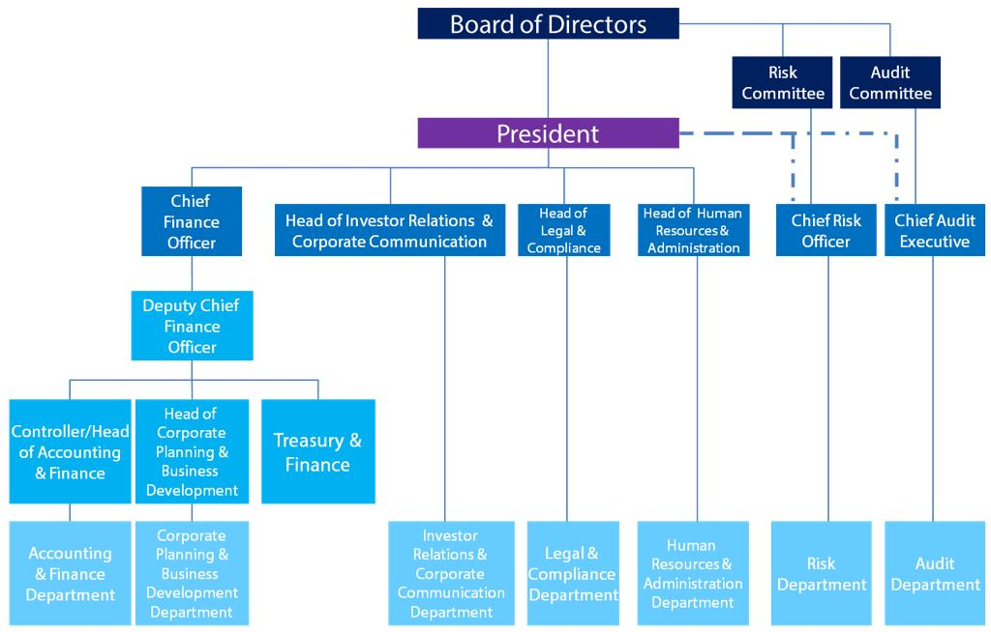
2.2.9: ORGANOGRAM OF IDLC Finance Limited:

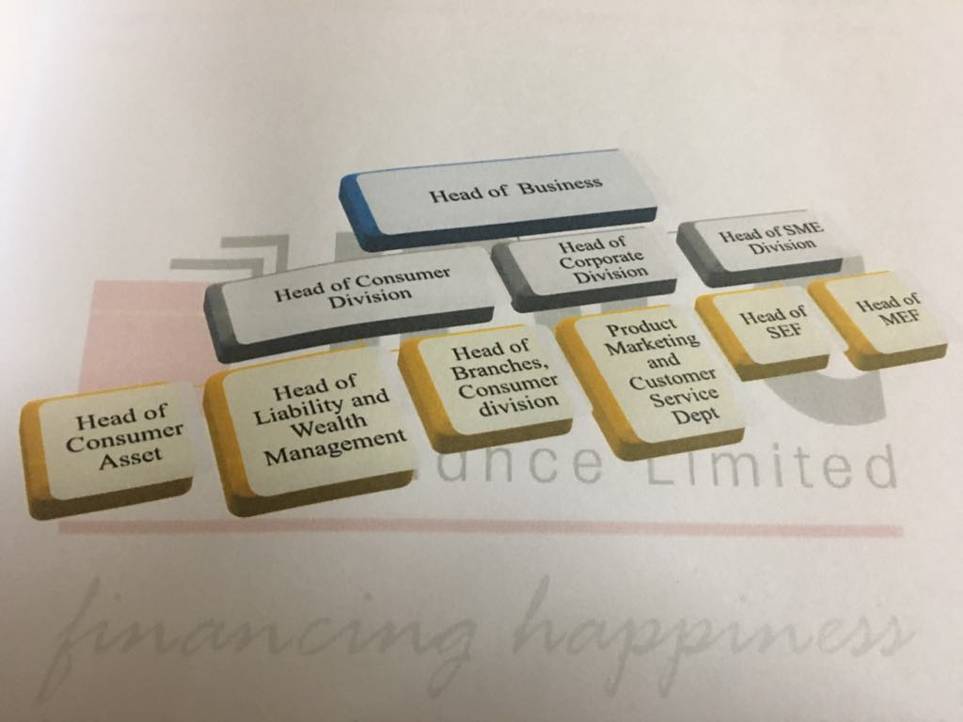

The organization's apex is the board of directors, in the following levels the executive committee and the managing director. The board comprises of the following directors:
Chairman of Reliance Insurance Ltd Five Directors nominated by
1) City Bank Limited, 2) Sadharan Bima Corporation (SBC), 3) Transcom Group, 4) Mercantile Bank Limited, 5) Monowar Associates ' Independent Directors.

ACTIVITIES OF THE BOARD
The Board appoints the Executive Committee (EC) on behalf of the business, which takes daily choices. Any loan request for sanction and disbursement must be endorsed by the EC. EC is also entitled to monitor and review other important day-to-day operational tasks, including corporate plans, budgets and borrowing operations. EC's structure is as follows:
a) Four Directors
b) The Managing Director / Chief Executive Officer and the Secretary of the Company shall be the Secretary of the ACTIVITIES OF THE MANAGING DIRECTOR The Managing Director (MD), appointed by the Board, shall be responsible for the overall organizational activities and shall also be responsible for the role of the head.
ACTIVITIES OF THE MANAGING DIRECTOR
The Managing Director (MD), appointed by Board, manages the overall organizational activities and also plays the role of the figurehead.
ACTIVITIES OF THE DEPUTY MANAGING DIRECTOR
The DMD sets the company's policies and reviews the company's operational performance including approval of significant loan proposals, significant fund procurement, budget and planning choices, and diversification.

2.2.10: List of the Board of Directors of IDLC Finance Limited
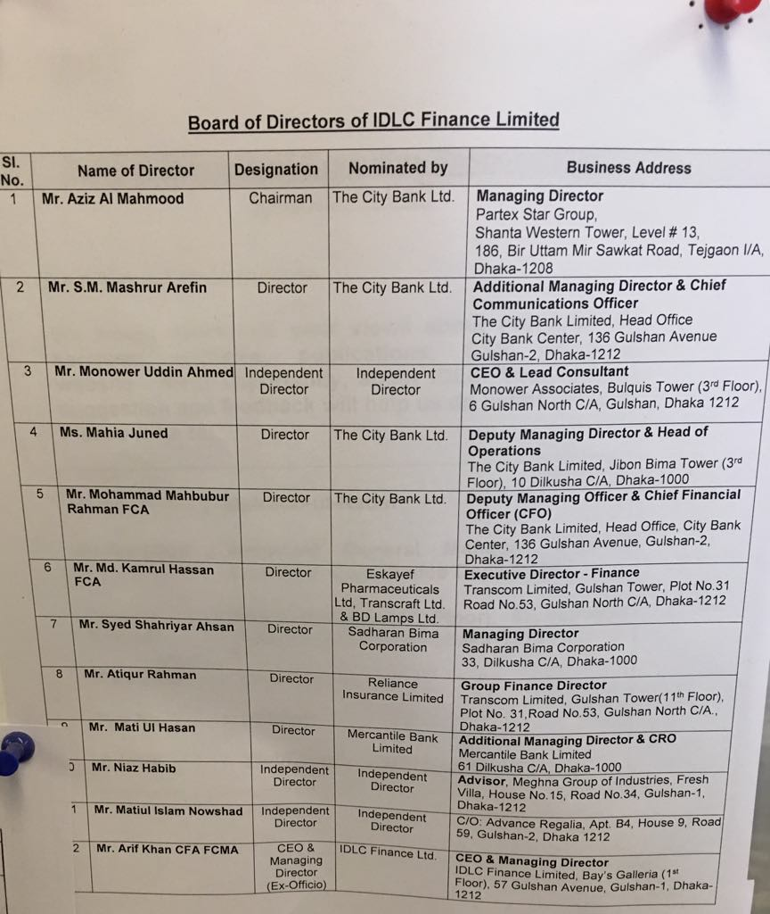

2.2.11: GUIDING PRINCIPLES
IDLC is a multi-product financial institution that provides institutional and individual customers with a variety of financial services and solutions to satisfy their varied and unique needs. Following are the guiding principles that first shape IDLC Customer's organisational practice:
Customer first: IDLC has grown with its clients, who are thought to be the core of all activities. Customer service is the core of the corporate philosophy of IDLC..
Innovation: In a complicated and difficult company setting, IDLC has continually launched fresh economic products to meet the requirements of entrepreneurs. The notion of innovation is integrated into the culture of work.
Professional Knowledge: IDLC employs skilled experts and the country's creative minds. Years of operational experience, extensive industrial database and skilled workers have provided them with unparalleled benefits.
Professional ethics: In all transactions with customers, the IDLC professional maintains the greatest degree of economic and business ethics. Over the past two centuries, IDLC has placed efforts into betting to satisfy customers and investors ' expectations.
One stop solution: Work at IDLC starts with the generation of ideas and then proceeds to the 12 feasibility study followed by funding arrangements to execute the project. IDLC provides advice, funding and even funding to customers through various funding methods, namely: lease funding, term loan, bridge loan, syndication, bridge loan, syndication, normal shares, preferred shares and debentures.
For the Company: Continuous pursuit of customer satisfaction by providing high-quality services.
For the Shareholders: Maximize shareholders’ wealth through a sustained return on the investment.
For the employees: Provide job satisfaction by making IDLC a center of excellence with opportunity of career development.
For the society: Contribute to the well-being of the society, in general, by acting as a responsible corporate citizen.
Goal: Long-term corporate philosophy maximization of the value of stakeholders: unload functions with adequate accountability for all actions and outcomes and bind them to the highest ethical norms.

2.2.12: IDLC Code of Conduct and Ethics

As per endorsed and concurred Code of Conduct, IDLC workers will:

- A law with respect, capacity, nobility and morality when it comes to customer management, opportunities, colleagues, offices, institution and open.

- Act and urge others to continue to think emphatically and truthfully about IDLC employees, their calling and IDLC in an expert and moral manner.

- Engage in maintaining and improving the fitness of all businesses and approaches.

- Use reasonable consideration and practice independent expert judgment.

- Not limit others from playing out their expert commitments.

- Continue to learn all appropriate laws, rules, morals and controls and agree to them.

- Uncover all circumstances that cannot be reconciled.

- Convey competent administrations in accordance with IDLC methods and relevant specific and competent standards.

- To classify and protect clients, people and others with whom they work together.

- Do not participate in any specialist leadership, including disappointment, extortion, trickery or distortion, or present any evidence that unfavorably reflects their genuineness, truthfulness, reliability or expert fitness.

IDLC representatives have a commitment to know and comprehend not just the direction contained in the Code of Conduct, yet in addition the soul on which it is based.

2.2.12: SWOT Analysis of IDLC Finance Limited

Strengths:
- Reputation and brand picture of IDLC Finance Limited:
- Three years of unsuspecting reputation as a conscientious, proactive and customer-centered budget expert cooperative.
- Remaining high among brands in the neighborhood.

- Customer centricity
- Items based on need and predominant measures of administration.
- Rapid fundamental leadership, transparent and moral.
- Training, management and administrative assistance for company.

- Infrastructure
- Management center of the world-class.
- Branches strategically identified.
- Framework for the uninterrupted transfer of benefits.

- Corporate administration and consistence
- Strict adherence to administration.
- Collaborative and proactive methodology to alter the operations of the administration and sector.
- Respectable institutional shareholding; Board of Directors with experience and expertise.
- Direct-owned visionary administration.
- Capital base management and productive asset management Liability management.
- Human resources
- Competent and empowered HR.
- Continuous preparation and progress.
- Highest level of adherence.
- A winning society grown through lengthy stretches of best-in-class rehearsals.
- Strong financial footing
- Solid capital base.
- Efficient management of resource requirements.
- ROA and ROE sound and continuous
Weakness:
- Staggering reserve expenditure as opposed to banks.
- Much expansion of the items and administrations offering hamper the attention of the Center Administrations Less People in Liability Marketing.
- Reliance on intrigue wage as a notable source of revenue— an impediment to being an NBFI.
- Reliance on term loan without value-based documents— an impediment to NBFI.
- Portfolio fixing in Dhaka and neighboring areas as a large majority of the Center Administrations
Opportunities:
- Giving administrations linked to 360-degree cash to all customer sections— shop products, developments, company, risk management and warning.
- Financing green.
- Open door for corporate and co-marking
Threats:
- Giving administrations linked to 360-degree cash to all customer sections— shop products, developments, company, risk management and warning.
- Financing green.
- Open door for corporate and co-marking

2.2.13: Shareholding Structure of IDLC Finance limited
The shareholder of IDLC Finance Limited can be divided into two extensive group namely Sponsors / Directors and General investors can be subdivided into two different categories which are Institutional Investors and Individual Investors.
The shareholding structure of IDLC Finance Limited is given below:

SL. NO. | Name of shareholders | Number of shares | % of total shares
1 | Sponsors / Directors
 |  | 60,854,056 | 24.21
  The City Bank Limited & Its Subsidiaries
 | The City Bank Limited ( CBL) | 25,137,225 | 10.00
 |  | 24,885,352 | 9.90
  City Bank Capital Resources Limited (CBCRL)
 | City Brokerage Limited | 10,831,479 | 4.31
 | Transom Group | 33,515,443 | 13.33
 | Eskayef Bangladesh Limited | 20,109,375 | 8.00
 | Transcraft Limited | 10,088,022 | 4.01
 | Bangladseh Lamp limited | 3,318.046 | 1.32
 | Shadharan Bima Corporation | 19,151,663 | 7.62
 |  | 18,852,532 | 7.50
  Mercantile Bank Limited
 |  | 17,595,702 | 7.00
  Reliance Insurance Limited
 | Sub-Total | 149,969,402 | 59.66

2 | General:
 | Institution:
 |  | 10,744,986 | 4.27
  Investment Corporation of Bangladesh
 | Bangladesh Fund | 8,040,750 | 3.30
 | EBL Securities Limited & EBL Managed Funds | 6,759,840 | 2.69
 | Eastern Bank Limited | 6,275,418 | 2.50
 | ICB Managed Funds | 2,817,066 | 1.12
 | Marina Apparels Limited | 2,513,671 | 1.00
 | Other Institutions | 17,839,565 | 7.10
 |  | 54,991,296 | 21.8
  Sub-Total
 | Individuals:
 | General Public | 35,712,452 | 14.21
 | Sub-Total | 35,712,452 | 14.21
3 | Foreign
 | Both Institutions & Individuals | 10,694,037 | 4.25
 |  | 10,694,037 | 4.25
  Sub-Total

2.2.14: NBFI in Bangladesh
Non-Banking Financial Institution in Bangladesh adds to the nation's financial development. After that, it allows activating placing something aside for speculation. However, they correspond equally to each other as each can build up his own specialty, so that IDLC can walk into a region where alternative NBFIs are not wandering, which ultimately reinforces the financial versatility of both. As stated by Goldsmith (1969), money-related progress in a country starts with improving the management of account foundations. NBFIs have turned out to be one player in the banking sector in the vicinity. Both can take on essential employment in influencing budget establishments such as insurance agencies, financial organizations, investment banks and some of them manage annuities and shared assets, but Fi does not In Bangladesh, the NBFIs are defined by those institutions that are permitted and regulated by the Financial Institutions ACT of 1993. In Bangladesh, the NBFIs offer administrations are for Industry, Commerce, Supply Finance, Agriculture, Housing and Real Bequest, are responsible for guaranteeing or ensuring company, Investment and re-interesting capital markets Numerous Non-Bank Financial Institutions can be highlighted from the organization's budget structure arrangement. Because of certain additional constraints and the unbending nature of the unique checks, banks were unable to distribute their duties in each of the forecast areas and were bound by a likewise limited offer of currency administrations and were unable to extend their operational peasantry. These downsides led to the appearance in Bangladesh of Non-Banking Financial Institutions to support the growth of industrialization and financial expansion.

2.2.15: The reason behind preferring IDLC (NBFIs) over Bank
The real administration of IDLC offers is fast correspondence with their customers because they don't recognize cash shops, but they also give budgetary administrations apart from ledgers. Therefore, the bank needs to manage the issues with the store, checks, pay-requests or draft requests, remote commercial financing and so on, the real disadvantages for which they can not impart to their clients as quickly as IDLC Finance. Moreover, IDLC Finance can authorize a credit within 1 day while the customer needs to sit tightly for 10 to 15 days in order to endorse an advance in a bank or other cash real Despite the reality that IDLC can give clients that compete with their capacity much more than 30 Lac BDT. Another office of IDLC Finance Limited is that it usually provides greater credit expenses for FDR than other banks because it has greater asset expenses and thus provides its clients greater financing costs. Generally speaking, these are the main reasons why a customer should choose IDLC Finance Limited.

2.2.16: IDLC Product and Services
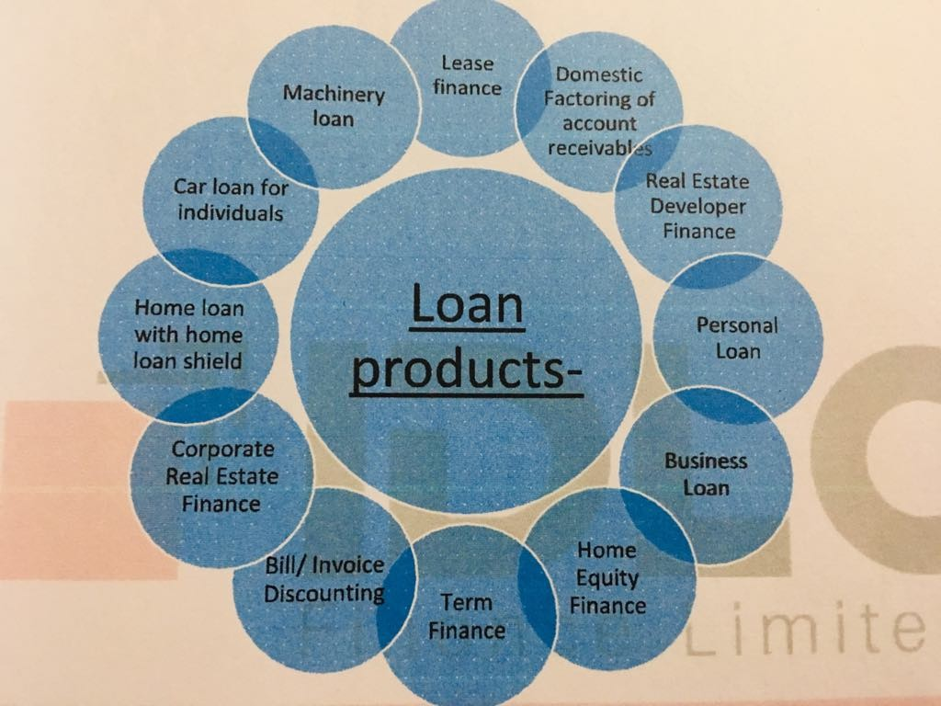

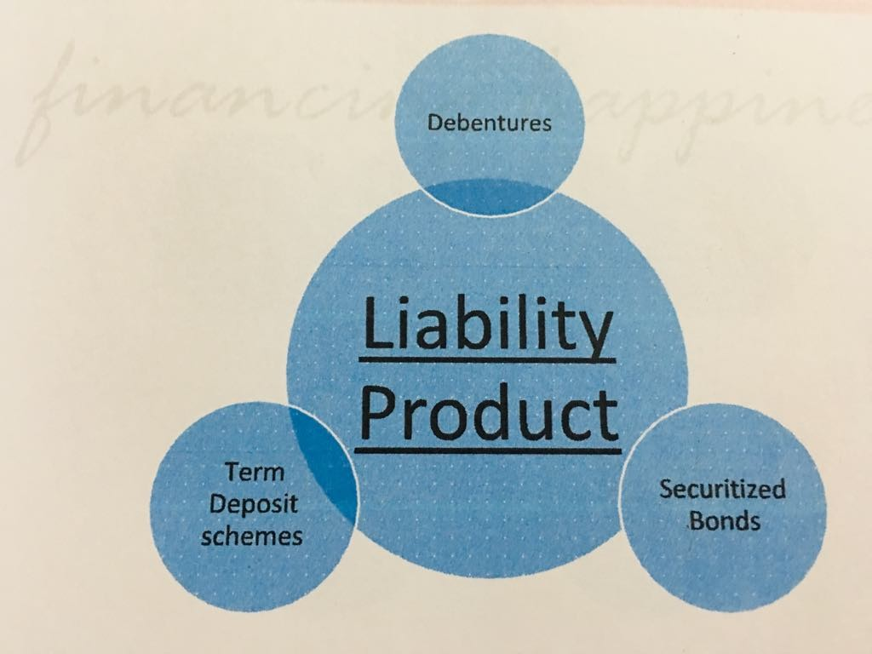
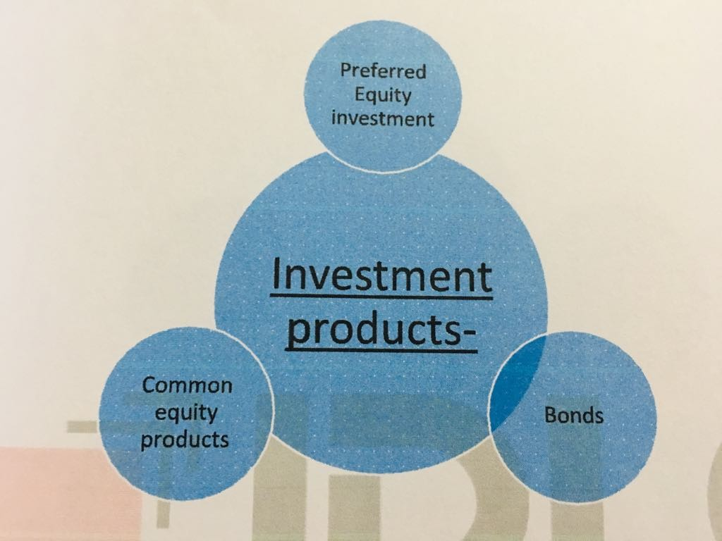

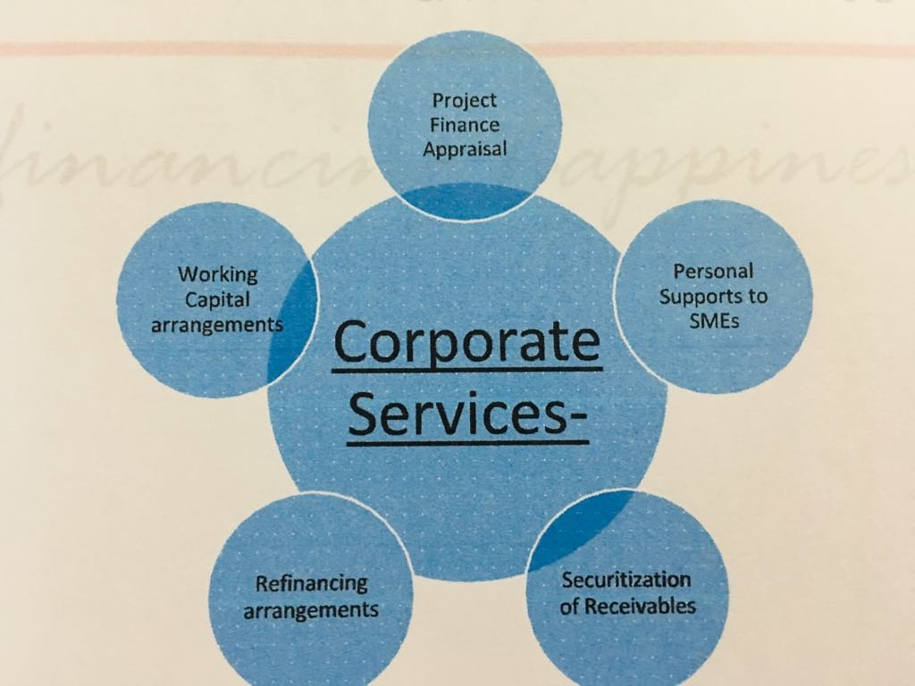

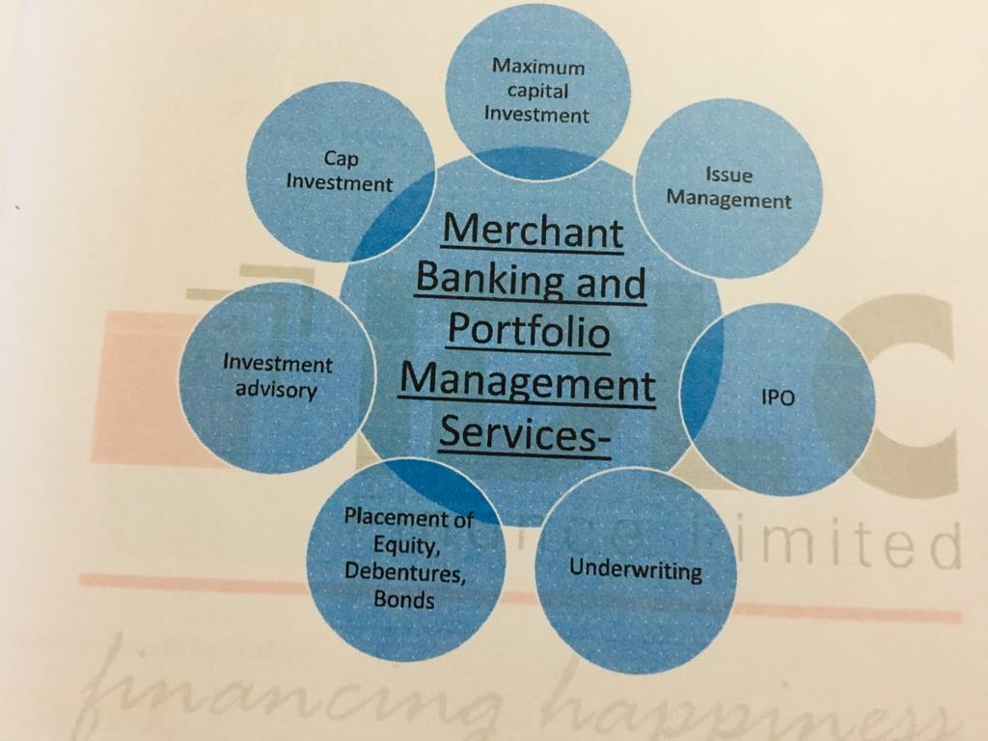

Chapter 3: Job Responsibility

Job Description
I am grateful to work for IDLC finance limited. IDLC finance is a leading non-banking financial institution in our country. Their reputation is getting higher day by day. Basically, they assign me to customer Experience department under Consumer Division in Gulshan Branch. The consumer Division is one of the key business drivers, playing a vital role in upholding IDLC’s brand image among consumers and contributing to increase growth in company’s asset and profitability.
• Consumer Division: Today, the consumer division has emerged as a major player in the home loan and car loan industry, capturing a increasing market share effectively. It also provides personal loans as well as chosen client segments, among other lending products.
• Consumer Division targets and achievement: The Managing Director appointed at Target each year. According to this goal, the entire consumer division is trying to reach this goal within one year. Their goal in 2019 is to provide 2000 crore taka loans. In June, they achieved their objective in six months. It is their excellent accomplishment. Not only does each branch have its own individual objective. To accomplish this objective, the Consumer Division must work very hard. The branch manager extremely appreciates the best performer; they are also rewarded by the manager based on their results. By adopting continuous improvement in their method and service and implementation, these goals will be supported.
Mr. Irteza A. Khan Head of Consumer Division said that “We will build on our staff orientation that they are not just in the business of selling home and car loans or term deposit products, but are present to serve the large interests of our customers, helping them realize their dreams by providing affordable and effective financial solutions”.
My Specific job responsibilities
During my Internship they assign me multiple of works which is really helpful for me so that I can learn different types of work. My job responsibilities are given below:
- Application for Apartment / Construction / Land / Commercial Space / Shop Technical Assessment Application for Developer Approval.

- Application for self-declaration.

- Single application for project authorization.

- Collect all CIB form and CRM Request.

- Collect all CIF form and CIF Request.

- Mail the corresponding staff for a particular request.

- Scan significant records and send them to the staff.

- Put in the documents the CIF numbers.

- Consulting with consumers

- Visiting the consumers in the field.

- Give entry of the RM and consumers names in an office notebook.

- Fill up the Consumers Application Form.

- Create e-tin account for consumers.

- Meet and greet session with daily customers.

Analysis
Consumer Buying Process Model
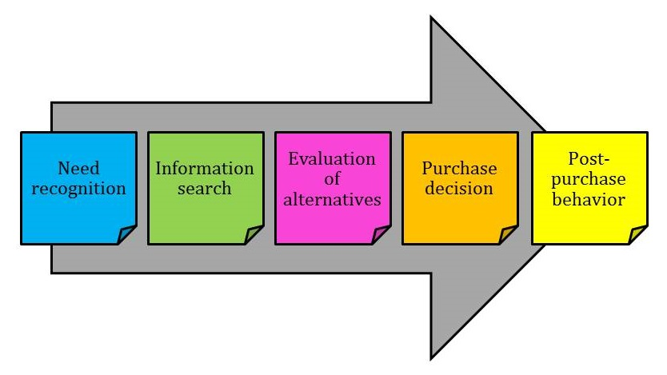
- NEED recognisition: The first and most significant stage in the purchasing process is the recognition of the need. This recognition happens when there is a leg between the real position of customers and the optimal and desired position. Consumer need differs in two circumstances, when clients need to buy a vehicle or apartment; it is not always feasible for consumers to lend cash to the satisfied quantity. Consumers needed some cash to take banks and NBFL loans in that situation. IDLC help make their dream come true for these individuals. IDLC offers loans of all types. Car loans, home loans, personal loans, small and medium sized companies. Say, for instance, if the consumer wants to buy a car because of transportation but is unable to buy the car because he hasn't got the cash. In that case, IDLC offers very quick services for car loans. Within 3 or 4 days, he can get the loan. In private loans, there are distinct kinds of customers, such as some customers who need cash for schooling or wedding or medical therapy or travel by forgein. Keeping all these requirements in mind, IDLC provides personal loans to customers of this type.
- Informal Search: Once the need is identified, the consumer's time to search for information on possible solutions to the problem. He will search for more or less data depending on the complexity of the decision but also on his level of participation when customers need any type of loans he / she is looking for alternatives. Now, due to many banks and NBFI, there are plenty of options for customers for a few days. Then all those banks and NBFI obtain the data from customers. There are two types of data.

- Internal Information: Consumers are already aware of this information. It comes from previuos experince, say, customers have already taken IDLC Finance Ltd's loans. As a consequence, he is familiar with the IDLC's products and services. There s one consumer who has been taking 10 years of IDLC Finance home loans in 2005. He provides the credit cash effectively without any issues. Now he went back to IDLC, he needs home renovation for his homes for interior design. This is one way of finding data for consumers.
- External information: this is product or brand data obtained from and acquired from friends and family. Other sources, such as advertising or speech by vendors, also exist. Suppose one customer receives IDLC loans. He can readily suggest that others take the IDLC loan. In the case of an existing IDLC client from IDLC, these things happen several times and advise others to take the loan from them. IDLC Finance Ltd's employee. Your friends and family are also sufficient to take loans from here.

- Alternative evaluation: Once the information is collected, the consumer will be able to assess the various alternatives offered to him, assess the most suitable for his needs and choose the one he thinks is best for him. In this situation, IDLC offers its products distinct packages. This enables customers choose the correct option. Like IDLC, it provides both variable and fixed interest rates that are great for customers. Variable interest rate implies that customers are expected to bring home loans at an interest rate of 12.25%. The government can alter that rate. Maybe everything relies on the Bangladesh Bank will boost or reduce. But a fixed interest rate is a type of loan or mortgage for which the interest dose rate does not fluctuate over the loan's lifetime. That's the same thing as that. It can only be increased or decreased by the bank of Bangladesh.
- Purchase decision: Now the customer has assessed the various alternatives and products available to meet his requirements, he will be able to choose the item or brand that appears suitable to his requirements, proceed to the real purchase itself. After gathering all the data, the customer decides that before buying a product customers have plenty of opportunities, he / she lastly chooses the best one that suits him / her the best. One customer, for instance, likes to purchase a vehicle, so he requires a car loan. He is a consumer in the A section. He's a multinational business general director. He also has many other alternatives. IDLC provides loans to the Consumer segment at an interest rate of 13 percent. Other economic firms also give the same rate of interest. This scenario is falling into a dilemma for the customer.
- 5. Post-purchase behavior: Upon purchase and use of the item, the customer will assess the adequacy of the initial requirements. Whether or not he made the correct decision when purchasing this item. In this situation, IDLC offers better service because we can see in many conditions that current customers need more loans, so without a good service customers will not be interested in taking loans from other organizations.

Chapter 4: Important issues

How overall IDLC Finance Limited operates
Departmental Activites
The different departmnents in the organization are vital to the day to day and long term goal achievement of the organizations. Like any other organization, different departments in the organization help to achieve different goals for the sustainability of the organization. IDLC is not an exception.
Treasury
Responsible for the management of the organization's short-term and long-term use of funds flow. I've seen my supervisor and peers interact daily with the treasury department during my 3-month internship period. If any person or corporate client who has deposited a big quantity deposited in IDLC Finance wishes to discontinue their deposits (in money), the (CED) must contact the treasury to ensure that sufficient funds are available to transfer their deposited quantity back to their corresponding bank account. This is a shortage of accountability on the part of the treasury department to manage daily funds. If the CED team fails or forgets to follow up with the treasury to inquire about resources for transferring to a customer account for any reason, there may not be enough funds available and the transfer method would most probably fail. The funds arranged for varied organizational purposes were otherwise spent most of the time without the concerted people being noticed.

Operations
The CED team must operate on a regular basis with the activities of deposit / liability (LO) and asset operation / credit administration (CAD). Most applications are processed by an Asset (Loan) client or by a Liability (Deposit) client and transferred to the corresponding Operations Department to complete the application. Before the Consumer Division's CED was formed, the CED was part of the organization's operations and consumer division. The department of operations used to receive, process and full client demands for consumer products in the first place. Now the Department of Operations only finishes the CED's mainly processed client applications for asset and liability clients. Recently, the department of activities has been "centralized." This means that all department staff will work from a centralized branch. This has complicated the process of offering customer service mainly. Some staff have already been moved to the centralized office and now all customer requests and associated records have to be passed on to them by offering scanned copies. This is a time-consuming method as the scanners at the opeartions department take a lot of time to scan a page. They finish some of the facilities themselves after receiving the applications from the pepole at the central brnach, for which the clients do not need any difficult copy / proof.
Administrations
Responsible within the organisation for general administrative operations. The CED team had regular interaction and dealing with the administration department concerning requested products such as visiting cards for couriers and had to interact with administrations from the head office of the corporate head office (CHO) for transferred calls and clients to the CED team. From what I saw, the administrative department most of the moment fails to provide the employee with services on time. It often requires much longer to arrive for couriers from other branches and visiting cards, account opening, and other kinds of forms required. This shows the administration's inner time management and effectiveness issue. Most of the moment, what I've seen is that not all of these distinct duties are delegated to distinct individuals, particularly the messengers who supply all of the above products.
Credit Risk management
Responsible for handling the organization's various kinds of credit risk. People who looked at CED's asset side had frequent communication with the Department of Credit Risk Management (CRM). Most asset / customer credit applications have been processed and forwarded to CRM for authorization.
Information Technology
Not only the CED team, but all departments have to interact commonly on a regular basis with the IT department. First, because every employee needs to authorize all their transactions by the end of the day, they need to do so. If they fail to do so, they will receive IT mail to authorize their pending transactions at the end of the day.
Second, staff sometimes experience log-in issues in their corresponding software module or have some sort of issue communicating on the organization's intra-net. To solve these issues, they need to communicate with IT. The IT Department also overlooks all of the organization's hardware and network communications.
Human Resources
Responsible for Recruiting appropriate people, training, organizing work seminars, paying and appraising performance of all of the employees of the organization. The CED team and HR team communicate with each other whenever there is a need for trainning and a trainning has been arranged. During my 3 moth as an intern, I have seen my colleagues attend two trainning programs at their gulshan branch and a seminar at the Gulshan Branch as ell. The Hr team organizes to make salary payments to all of the employees on the 24th of the respective month. In case of a holiday, the payments are usually made at an earlier date. I also received my salary payment from HR generally within 3 to 4 days after a month of working.
IDLC Investments Ltd.
A whooly owned subsidiary of IDLC finance Ltd., operates in the capital market. Their two products named MAXCAP and Easy investment fall under their discretionary prtfolio management. A capital market customer who is intereted to invest in these products can come into the IDLC Finance office, submit their cheque and filled in form for futher processing.
These forms and their deposit slip for their cheque are then sent by internal courier to the IDLC invesments branch while the cheque is cleared by the CED team.
IDLC Asset management Ltd.
An IDLC Finance Limited wholly-owned subsidiary that also works on the capital market. The mutual fund called' The Balanced Fund' by IDLC Asset Management Ltd. (AML) is a product for which the CED team is providing service. Any customer who wants to invest in the banced fund can submit to the CED team their completed form and check. The team checks when all the papers are in location and then places them for clearing on their account at the SCB.
SME Department
Small Enterprise Finance: IDLC provides small-scale businesses with funding facilities to conduct their company, production or service. In addition, such undertakings can also use funding infrastructure to develop business real estate.
Medium Enterprise Finance: SME, mid segment offers medium and long-term economic alternatives to a broad spectrum of customers who are on their way to emerging in the near future as successful corporate houses.
Supplier Finance: Supplier Finance is a rotating funding provided against receivables generated through the provision of products or the provision of loan facilities.

Consumer
Consumer Department include different types of deposits, home loan, car loan and personal loan.
- Deposits: “Save today, For a Better tomorrow” it is their tagnile for deposits

- Product | - Term | - Amount up to 50 lacs | - 50 lacs < amount < 1 crore | - 1 crore or above
- Regular term Deposit | - 3-5 months | - 8.50% | - 8.75% | - 9.00%
 | - 6-11 months | - 8.75% | - 9.00% | - 9.25%
 | - 12-15 months | - 9.00% | - 9.25% | - 9.50%
 | - 2 years | - 9.25% | - 9.50% | - 9.75%
 | - 3 years and above | - 9.50% | - 9.75% | - 9.75%
- 500 Days Term Deposit | - 500 days | - 9.00% | - 9.25% | - 9.50%
- Monthly Earner Deposit | - 1 year | - 9.00% | - 9.25% | - 9.50%
 | - 2 years | - 9.25% | - 9.50% | - 9.75%
 | - 3 years and above | - 9.50% | - 9.75% | - 9.75%
- Quaterly Earner Deposit | - 1 year | - 9.00% | - 9.25% | - 9.50%
 | - 2 years | - 9.25% | - 9.50% | - 9.75%
 | - 3 years and above | - 9.50% | - 9.75% | - 9.75%

- Home Loan: there are six type of home loan.

- APARTMENT PURCHASE LOAN: Features are given below
- Repayment through EMI.
- Conversion Facility from Fixed Interest Rate Variable.
- Early payment option in full or part.
- No hidden charges.
- Loan term : 25-65 years

- HOME EQUITY LOAN : Features are given below
- Loan amount: up to 75% of the value of the building including registration.
- Loan term: 15-20 years.
- Repayment via EMI.
- Early prepayment option in full or part.

- HOME LOAN SHIELD: feaures are given below
- Coverage: From 50% to 100% of the total home loan bades on your age, loan tenure and outstanding principal amount.
- Term : equal to the total term of the Home loan it covers.
- Reduces repayment burden on family in case of death of main earner.
- Lowest possible single premium.
- Free of cost medical examination from recognized hospitals.

- CONSTRUCTION LOAN: features are given below
- Loan Amount : up to 65% of the value of the building including registration.
- Loan Term : up to 20 years.
- Repayment via EMI
- Conversion facility from fixed to variable or vice versa.
- Technical advisory services available.

- REGISTER LOAN: features are given below
- Loan amount: up to 15% of total cost cost of property.
- Loan term: up to 10 years
- Repayment via EMI
- Conversion facility from fixed to variable or vice versa.

- LAND PURCHASE LOAN: features are given below
- Loan amount: upto 75% of the value of your land
- Loan tenure: upto 12 years
- Mortgage of the land requied
- Repayment via EMI.

- Car Loan:
- Loan amount : up to 80% of total cost
- Loan term: up to 6 years
- Repayment via EMI
- Fastest service
- Special discount on vehicle price offered by renowed dealers, under special arrangement with IDLC.
- Partial or full prepayment options.
- Technical advisory services available.

- Personal loan:
- Loan amount: taka 50000 to taka 10 lacs to suit your reqiurment
- Loan term: minimum of 1 year to a maximum of 5 years
- Fast processing and loan approval.
- Competitive interest rates. Individual rates are set based on the consumers financial status and facility amount.
- Early settlement option.
- Dedicated relationship managers and supportive service.
- Repayment through EMI.
- Early prepayments subject to payment of mimimum charges

4.1 Analysis and findings of the overall IDLC Finace Limited
Analysis:
Satisfied with service delivery time
 | Frequecy percent | Total | Cumulative percent
Poor | 1 | 6.67% | 6.67%
Average | 2 | 13.33% | 20%
Good | 2 | 13.33% | 33.33%
Very good | 7 | 46.67% | 80%
Excellent | 3 | 20% | 100%
Total | 15 | 100%

Figure 1: Satisfied with service delivery time

When asked about the service time delivery in IDLC, 46.67% said very good and 20% said excellent. Which means more than 66% were satisfied with service delivery time in IDLC.

Satisfied with staff behavior and professionalism
 | Frequecy percent | Total | Cumulative percent
Poor | 2 | 13.33% | 13.33%
Average | 3 | 20% | 33.33%
Good | 1 | 6.67% | 40%
Very good | 5 | 33.33% | 73.33%
Excellent | 4 | 26.67% | 100%
Total | 15 | 100%

Figure 2 : Satisfied with staff behavior and professionalism

When asked about staff behavior and professionalism of IDLC, majority were satisfied. Only 33.33% were dissatisfied but around 60% were satisfied.

Satisfied with staff knowledge and competency
 | Frequecy percent | Total | Cumulative percent
Poor | 1 | 6.7% | 6.7%
Average | 4 | 26.7% | 33.33%
Good | 1 | 6.7% | 40%
Very good | 6 | 40% | 80%
Excellent | 3 | 20% | 100%
Total | 15 | 100%

Figure 3: Satisfied with staff knowledge and competency

When asked about staff knowledge and competency of IDLC, 40% respondents very good and 20% respondents excellent that means 60% customer were satisfied with staff knowledge and competency of IDLC.

Satisfied with overall services of IDLC
 | Frequecy percent | Total | Cumulative percent
Poor | 1 | 6.67% | 6.67%
Average | 2 | 13.33% | 20%
Good | 2 | 13.33% | 33.33%
Very good | 4 | 26.67% | 60%
Excellent | 6 | 40% | 100%
Total | 15 | 100%

Figure 4: Satisfied with overall services of IDLC

When we asked about the satisfied with overall services of IDLC, 40% said excellent, 26.67% respond very good and 13.33% respond with good. Which means 80% people were satisfied with overall services of IDLC?

Would you recommend IDLC to others?
Over here the options are given below
Yes | NO | Not sure

 | Frequecy percent | Total | Cumulative percent
Yes | 7 | 50% | 50%
No | 3 | 20% | 70%
Not sure | 5 | 30% | 100%
 |  | 100%

Figure 5: Would you recommend IDLC to others?

When we asked people would they recommend IDLC to others, 50% people say yes which means they would recommend IDLC to others.
Findings:
From the study there were some tremendous findings that should have been identified already. The overall satisfaction level of the customers was almost 70% but the other was not happy with the overall service of CED department of IDLC Finance limited Gulshan Branch. On this basis, the summary of the findings are given below:
- When we asked about services delivery time of CED almost 66% respondents they were satisfied but rest 34% were not satisfied, so they need to work hard to serve customer quickly.

- When we asked about staff behavior and professionalism of IDLC, majority was satisfied but 33.33% were dissatisfied. So they need to improve their behavior with customers.

- When we asked about knowledge of staff and competency of IDLC, 66.70% were satisfied but other 34% were dissatisfied. So they need more training to improve their staff knowledge.

- When we asked about the satisfied with overall services of IDLC, 80% people were satisfied and 20% were dissatisfied with overall services of IDLC. This means few people were unhappy with the overall services, so IDLC should keep trying to serve properly.

- When we asked about people would they recommend IDLC to others, 50% people say yes, 20% say no and 30% were not sure. So they have to serve customer so that customer recommended other to solve their financial problem with IDLC.

Chapter 5: Conclusion & Recommendations

5.1 Conclusion
Today, the Consumer Division has emerged as a leading player in the home and car loan sector and successfully captured a growing share of the market. Very recently, banks and NBFI stared to take notice of the potential of this sector, in term of huge business opportunity, high margin and encouraging recovery rate. The current report aimed at critically examining the Performance of a private financial institution. The main objective of this report was to evaluate the financial analysis of IDLC finance ltd. along with how efficiently are providing services to its customer. From Financial Analysis it has been seen that the performance of IDLC finance ltd is really satisfactory. By working with this company help me to grow my potential skill and knowledge about the financial institution.

5.2 Recommendation

- IDLC can create more paid-up assets for future necessities by providing rights to present investors.

- Since the organization has no alternative approach for optimistic Islamic people, it is losing a huge client measure. In this manner, for the varied meeting of people, it is essential to get an alternative advantage and the correct approach.

- In the season of cash aggravation, it is vital to anchor the liquidity stance at the main place that can spare the organization.

- IDLC needs to interact correctly with the client and should continue to try to serve correctly.

- With the ultimate objective for IDLC Finance Limited to be more centered on the market, innovation is expected to become even more fresh and glamorous bundles and services.

- In the corporate segment, customer delinquency and default hazards are inherent components of large ticket funding.

- Credit office can give earnest records a fast response.

- Fundamentally cutting expenses will prompt a big profit for an organisation as it is now proven to be one of the finest techniques to stand out.

- In order to increase the current productivity, it is especially essential for the organization to gradually create additional source of income.

- To reduce the danger, all non-performing loans and advances should be cut off.

- Employee poaching by fresh respondents will make it likely that more inventive methods will be created.

References
https://aml.idlc.com/our_philosophy.php
Fourastie , J.F, (March 3, 2019), Jean committee Fourastie, Available: www.jeamfourastie.org/
Annual Report of IDLC Finance (2015-2018)
Monthly Business Review of IDLC Finance Limited
Saidur Rahman, Md (2018), ‘Credit Risk Management Practises in banks: An Appreciation’ Journal of Islamic Economics, Banking and Finance, Jul- Sep 2018, vol. 38 7, No. 3

Ahmed, M.U., Mannan, M.A., Razzaque, A., and Sinha, A. (2004), taking stock and charting a path for SMEs in Bangladesh, Bangladeh Enterprise Institute, Dhaka

Bangladesh Bank Guildeline and Circulars Regarding NBFIs

Assignment Point,. (2018). Internship Report On Non-Banking financial activities and performance of IDLC finance Limited - Assignment Point. Retrieved 19 march 2019, from http://www.assignmentpoint.com/buisness/internship-report-on-non-banking-financial-activities-and-performance-of-idlc-finance-limited.html

Perreau, F. (2013). The 5 stages of Consumer Buying Decision Process. Theconsumerfactor.com.
Retreved 19 december 2015, from http://theconsumerfactor.com/en/5-stages-consumer-buying-decision-process/
https://www.termpaperwarehouse.com/essay-on/Idlc-Report/48958
https://www.globalreporting.org/information/news-and-press-center/Pages/idlc-bangladesh-community-building-2019.aspx?dm_i=4J5,66TZR,UPKDYR,OD7YH,1

