Internship Report
On
“Analysis of ACI Animal Health Limited in Bangladesh: An Internship Experience Perspective”




Internship on
“Analysis of ACI Animal Health Limited in Bangladesh: An Internship Experience Perspective”

Submitted to
Prof. Dr. Md. Mohan Uddin
Professor
School of Business & Economics
United International University

Submitted by
Kaniz Fatema
ID: 111 152 150

Date of Submission: 27th August, 2019

Letter of Transmittal

Date: 27th August, 2019

Prof. Dr. Md. Mohan Uddin

Professor

School of Business & Economics

United International University

Subject: Submission of Internship Report.

Dear Sir,

It gives me enormous pleasure to submit the internship report on “Analysis of ACI Animal Health Limited in Bangladesh: An Internship Experience Perspective”.

I enjoyed preparing this report though it was challenging to complete it within the given time period. In preparing this report, I have tried my level best to include all the relevant information.

I would be glad if you accept the report and also requesting to consider limitations with a soft view that had made due to my limitations and oblige thereby.

With the best regards,

______________

KanizFatema
ID-111 152 150
BBA Program
Department of BBA (Finance)
United International University

Acknowledgement

All praises to the Almighty Allah, The Beneficent, and The merciful. Without his blessing none of this, would have been possible.

First and for mostly, I would like to convey my heartfelt gratitude and appreciation to Prof. Dr. Md. Mohan Uddin, Professor, School of Business and Economics, United International University, for granting me permission to work on my BBA internship under his constant reliable supervision. My heartiest thank to sir for providing me his sincere guidance, valuable advice and encouragement during the whole period of work.

I would like to thank Mr. Amzad Hossain, Business Manager at ACI Animal Health as my organizational supervisor. He provided me with necessary information and documents which was required to prepare this report.

I would like to thanks my fellow colleagues at ACI Animal Health Bangladesh Limited who supported me in thick and thin and made me feel at home and communicated practical advice which helped me carry on my duty as an intern. Without co-operation and support from each other it was not possible to do all the duties.

Last but not the least, I would like to thank my family members for their support in the crucial time4 and encouragement to prepare this report.

Executive Summary

Animal Health is similar to the human health. Healthy farm animals supply of protein from milk, eggs and meat. For those reason, 70% diseases are transferred between human and animal bodies. If the animals are attack some diseases humans are also attack same diseases. Animal Health Industry produces the vaccine and medicine to protect the animals from the diseases. In Bangladesh, total animal health size is 30000 crores BDT.
There are many renowned pharmaceuticals companies have separate animal health division in Bangladesh. ACI has also a animal health division which is part of the ACI Agribusiness. ACI animal health provides good quality products and collaborates with internationally. Their vision has to remove the protein gap of the country. Al the years, ACI animal health growth rate is increased over the previous year.
The main customers of the ACI animal health industry are- retail customers like farms and hatchery, Institutional customers like feed mill and traders.
ACI Animal Health has four types of products are- poultry, cattle, aqua and vaccine. Under these products there are some liquid and dry medicine and the injection. They set the price for the different pack size. ACI animal health try to promotion their products some magazine, leaflet and organize some agricultural fair.
ACI Animal Health produces their products own factories which are located at naraynganj and distribute the entire city.
In the SWOT analysis of ACI animal health, It has many chances to do well in the future due to market acceptance although there will be severe competitions. Meet the challenges ACI animal health provides some training and set the long terms goals.

In Internship at ACI Animal Health, I have gathered some practical work experience which is important for me to the corporate world. ACI animal health do not provided any interns students. My major responsibilities are incentive calculation, file documentation and bill payment.

ACI animal health has provided evaluation form to evaluate the intern. They follow the rating scale.

During internship period, I applied my skills like communication, problem solving, and time management, adaptability and teamwork. I also developed my new skills like some new method of MS Excel.
I applied my academic knowledge in the internship period like budget calculation and ratio analysis.

I have some recommendation of the ACI animal health and recommendation for improving self- performance.

Table of Contents

Executive Summary............................................................................................5-6

Chapter: 1 Introduction..............................................................................10

  - Background ………………………………………………………………………...11
  - Objectives............................................................................................12
    - Broad Objective.........................................................................12
    - Specific Objective..................................................................... 12
.
  - Significance........................................................................................ 13

Chapter: 2 Analysis of the Industry...................................................................14
2.1. Specification of the Industry.................................................................15
2.2. Size, Trend and Maturity of the Industry..............................................16
2.3. Seasonality............................................................................................17
2.4. External Economic Factors...............................................................17-18
2.5. Technological Factors...........................................................................18
2.6. Political, Legal and Regulatory Factors............................................18-19
2.7. Barriers to Entry.....................................................................................19
2.8. Supplier Power..................................................................................19-20
2.9. Buyer Power...........................................................................................20
2.10. Threat of Substitutes.............................................................................20
2.11. Industry Rivalry....................................................................................21
2.12. Summary of Challenges and Opportunities..........................................21

Chapter: 3 Analysis of the Organization.............................................................22
3.1. Overview and History.................................................................................23
3.1.1. Company Background...............................................................24
3.1.2. ACI Values................................................................................24
3.1.3. Distribution Network.................................................................25
3.1.4. Board of Directors......................................................................25
3.1.5. Business of ACI Limited.......................................................26-27
3.2. Trend and Growth...................................................................................27
3.3. Customer Mix.........................................................................................28
3.4. Product / Service Mix.............................................................................29
3.4.1. Product..................................................................................29-30
3.4.2. Price............................................................................................30
3.4.3. Place...........................................................................................30
3.4.4. Promotion....................................................................................30
3.5. Operations..............................................................................................31
3.6. SWOT Analysis................................................................................31-33
3.7. Steps / Strategies to Meet the Challenges and Opportunities................33

Chapter: 4 Internship Experience.......................................................................34
4.1. Position, Duties and Responsibilities...................................................35
4.2. Training.................................................................................................35
4.3. Contribution to Departmental Functions..........................................35-36
4.4. Evaluation.........................................................................................36-37
4.5. Skills Applied.........................................................................................37
4.6. New Skills Developed............................................................................38
4.7. Application of Academic Knowledge....................................................38

Chapter: 5 Recommendations..............................................................................39
5.1. Recommendations for Improving Departmental Operations............................40
5.2. Recommendations for Improving Self-Performance..................................40-41

Chapter: 6Conclusion......................................................................................42-43
Reference................................................................................................................44

Chapter: 1
Introduction

1. Introduction
1.1. Background
Internship program is offered to the students who completes all the credits and after completing the internship program they can complete their graduation. Internship program is an opportunity for the students to gather the practical knowledge and experience from the corporate world. In the internship period, students learn professional attitude, develop their personality and handle the challenges situation from the real business world.
I was started my internship program at ACI Limited on the month of May, 2019. I had to undergo the recruitment process which is interview. After the interview, I had the opportunity to work with ACI Animal Health. In the report, I tried to discuss about analysis of the animal health industry in Bangladesh. I also tried to describe about the analysis of ACI Animal Health Industry and internship experience at ACI Animal Health organization.
In Bangladesh, main domestic animals are cattle, poultry and aqua. Animals are attacked many diseases so the industry produce the medicine to safe the animal. Animal health industry is tried to reduce the protein problem of the people and they contribute the country’s economic growth.
Bangladesh is mainly an agricultural based country. In the agricultural sector, animal health is the sub sector to contribute the economic growth. The economic contribution of the agriculture sector is at 20.01 percent in FY 2010-11 and 19.29 percent in FY 2011- 2012. The livestock sector is contributing to GDP at 2.58 percent at constraint prices in FY 2010-11 and at 2.570 percent in FY 2011-12 respectively.
Growth of cattle and poultry
Name | 2010-2011 | 2011-2012 | 2012-2013 | 2014-2015
Cattle | 23.1 | 23.2 | 23.3 | 23.64
Buffalo |  |  |  | 1.46
Goat | 24.1 | 25.1 | 25.3 | 25.60
Sheep | 3.01 | 3.08 | 3.14 | 3.27
Chicken | 234.7 | 242.9 | 249.01 | 261.77
Duck | 44.1 | 45.7 | 47.25 | 50.52

Fig 1.1: Growth rate
Here we can see, the growth of cattle, buffalo, goat, sheep and poultry (chicken, duck) are accordingly increased from 2010 to 2015. Buffalo is not the growth from the 2010 to 2013. In 2014- 2015 the buffalo increase their growth.
This report was prepared by me to successfully earn the required internship credits for completing my BBA program, which is a part of BBA curriculum of the Department of Finance, United International University. I have written this report based on all the observations and experiences I had throughout my time at ACI Limited.

1.2. Objectives
1.2.1. Broad Objectives
The primary objective of my report is to discuss about the analysis of the animal health industry, discuss about the ACI Animal Health Industry and some recommendation.
1.2.2 Specific Objectives
The secondary objective of my report is discussed about the internship experience and responsibility I have been assigned with at ACI Animal Health Limited. Also describe applied my skills and develop my skills.
The main objectives of this report are-
- Analyze the contribution of Animal Health Industry in Bangladesh.
- Review the major responsibility of ACI Animal Health.
- Discuss the swot analysis of the ACI Animal Health.
- Provide some challenges of animal health industry.
- Describe my experience and which skills I applied.
- Developed my new skills
- Make some recommendation for better improvement for future.

1.3. Significance

Internship report is containing the real work experience related information. In this report, people know about the organization and different type of information.
Reading this report can help the individuals and institution. Because of this report I explain the animal health industry overview and history, size, trend and maturity, seasonality of the animal health products. Also I explain the economical and political factors, five forces model of the animal health industry.
This report also helps the ACI Animal Health industry because reader knows about the industry, their products, their customers and their work environment. Organization trend and growth, what type of customer and customer mix of the organization, how the organization designed their product, price, place, promotion. Analysis the SWOT which is helps to develop the organization from the competitor organization. SWOT analysis which is also helps the reader to evaluate potential growth opportunities of the Bangladesh. How the organization follows which steps or strategies to meet the challenges and opportunities.
It also helps the other interns to know what activities they can expect to do in the organization. I described my responsibility. When I prepared this report I collect all the information and analysis the information which is helped me to increase my experience.

Chapter: 2
Analysis of the Industry

2. Analysis of the Industry

2.1. Specification of the Industry:

Animal Health Industry

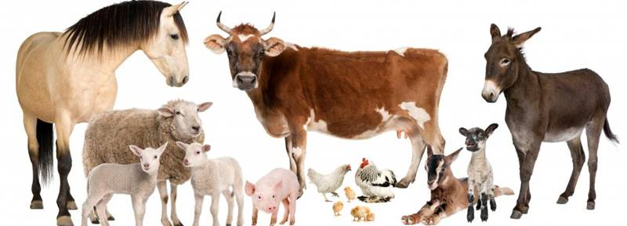
Animal health is almost as similar as the human health. A wholesome and sustainable supply of protein from milk, eggs, and meat begins with healthy farm animals. Moreover, approximately 70% of the diseases are transmitted between human and animal bodies.
The animal health industry is promotes livestock productivity and produce the vaccine and medicine to protect the animal from the diseases. Animal diseases damage the international trade and Bangladesh trade. So the industries try to control and precautions of the diseases. The products of animal health industry are vaccine, diagnostics and medical devices, poultry, cattle and aqua related services. The population has need to protein for survive; this protein comes from the animal health. Animal reduce the people’s protein gap.
The industry of animal health gives away value to society by protecting animals and as a consequence, humans, from diseases. The animal health industry has produces a lot of product to help cattle and poultry. The public health benefits we bring include safer and more secure food supplies, more efficient production for increased food supply, improved sustainability, and prevention of the diseases. In present time, animal health industry is included the government sector.

2.2. Size, Trend and Maturity of the Industry
In Bangladesh, different types of companies are producing healthcare products which consist of poultry, cattle and fish. Major of the pharmaceutical companies have a separate division of the animal health.
Name of the companies are:
- ACI Animal Health
- ACME Laboratories Ltd. (Animal Health)
- AVON Animal Health
- Eskayef Animal Health
- Reneta Limited (Animal Health)
- Navana Animal Health etc.
The total Animal Health size of Bangladesh is about 30,000 cores BDT. The growth of animal health is at 3.38 percent in FY 2009-10 and 3.54 percent in FY 2010- 2011. The livestock sector is contributes to the daily protein requirements, cultivation, production and export to share the GDP. The population of livestock and poultry was raised to 5.276 core according to estimate of the Ministry of Fisheries and Livestock.

The growth of this sub-sector stood at 3.38 percent and 3.54 percent (provisional) in FY 2009-10 and FY 2010-11 respectively. Though the share of the livestock sub- sector in GDP is small, it contributes to meeting the daily protein requirements, cultivation, production and exports. According to the estimate of the Ministry of Fisheries and Livestock, the population of livestock and poultry was raised to 5.276 crore. A lot people are becoming aware of the matter and taking the thing seriously. Domestic supply contributes only 1/4th or 25% of the total domestic demand. Especially the items are meat, egg, milk, fish and other protein and nutrition items.

In our country we are not fully integrated in our production and distribution. Integration is a new approach for agricultural production in most tropical countries and developing countries that agriculture is integrated one. Efficiencies and economies will come by sharing land space, labor, management, professionals, product and by-product utilizations, and infrastructures for production of multiple commodities.

The trend of the animal health industry is technological advancements and increasing research and development activities. In veterinary clinics, produced the data uploaded on the internet and shared with other researchers and clinics with technology. Now-a-days animal health industries produce new products and export the products in different countries. Government takes initiative and implements the animal vaccination programs.

2.3. Seasonality
Seasonal aspect of poultry industry is increased the poultry feed during July to September by 50% and decreased the poultry feed around 30% during November to February.
In cattle industry, seasonal aspect of demand for the livestock feed keeps similar throughout the year with a special pull during after in the year because of Eid- ul- Adha festivals.
In fisheries industry, demand of the fisheries feed is increased around 50% in July- September and decreased the fisheries feed around 30% in November- February.

2.4. External Economic Factors
The Animal Health is an important part of Bangladesh agriculture. As lot of people in Bangladesh are doing the animal health industry by starting the business itself. Its contribution to country’s GDP is about 2.5 percent.
Customers spend a very small proportion of its income on animal health until severely sick. And it’s not a good thing for the animal industry so far. Many of them are not that concerned and many not aware of the health of the animals and that is why customers spend less amount of income for animal health.
Per capita income of farmers is very slow. And eventually farmers are losing interest. And if that continues to happen then animal health will be in risk after few years. If the farmers not get paid what they deserve then the industry will fall soon or later.
The Incidence of taxes is very high. The biggest reason why animal health industry can fall or lay behind is that the taxes are too much higher than usual. Which make thing costly and customers lose interest to spend money and farmers not get enough money.
High interest rate government cost of funds is double. Because the interest rate of government costs high the fund cost become double and the animal industry health costs become high which is the only problem for the industry itself.
Adequate storage and transportation facilities for animal health dugs are lacking. The storage facilities for animal health drugs are becoming less day by day. Also the transportation facilities becoming a big headache, as the transportation is not the same as before. If the problem is not solved then animal health industry will be at great risk.

2.5. Technological Factors
Technology is a very important element of competitive advantage. Companies should innovate to reduce costs and to protect and sustain competitive advantage. This may include production technology, Internet marketing activities, lean manufacturing, Customer Relationship Management, and many other technological developments. Technical knowledge from day one did everything possible for the Industry of animal industry producers of several different kinds of dairy, poultry and aqua products along with other kinds of these products at a very lower price. A very vital fact is the upper side of the Animal Health Industry has a run with the technical faces have been added on farming works are almost in the pressure of downward fare and the necessity to a very big necessary of excessive optimizing in time frame of upward price.

2.6. Political, Legal and Regulatory Factors

2.6.1. Political

The political environment of Bangladesh is not very stable and calm. After each five years the federal government changes and some new problem always arises and the scenior happens almost every time. The Hortal and many other politics issue are normal problems in Bangladesh. Every business is affected by the unpredictable political issue.

The rules of a country influence laws that run are very much affect the business in the Bangladesh. The rulers of the Bangladesh are very much strong for creating the rules and regulation. For these particular reasons the business of Bangladesh are very much affected with the rules.
The govt. of Bangladesh making sure that the attitude and ethics is very much needed in this country. The Bangladeshi Government has not that kind of marketing activities about ads and promotions. The Bangladeshi can create any kind of advertising and promotions but there cannot be any with related to politics.

2.6.2. Legal and Regulatory
Animal Health Industry where the nature is leading should comply the terms and condition of the Bangladeshi Government. The Animal health industry get crepitate from the Bangladesh Standard Testing Institute for running in the country and also gave the government all the taxes as far as the rules.

2.7. Barriers to Entry:
The economies of scale are very hard to achieve in the animal health industry. And it makes it for those companies who produce a large amount and cost efficient. It becomes costly for the new comers. It causes threats for the barriers to entry.
The product variation is very strong within its industry; there the companies sell different products not the standard ones which are mostly available. Now a day’s customers also look for the products which are rarely available. There is also a reason which is the good looking advertising and customer after services.
The capital need among the full growth industry is in top, therefore, it become hard for the new comers in the industry because the expenditures become high. Capital cost becomes also high because of the research and many other development issues. So it is easy to understand that all these matters make it harder for the entrants as they become weaker in that particular industry.
The channel by which the new entrants can come into the industry is easy, which will help to find distribution channels and to start the business in an easy manner. There are only few shops who sell different products, and the new entrants can get the product on the display.
The Bangladeshi Government rules and regulation within the whole industry needed strong obligation toward licensing and all legal rules to be accepted so that the company can sell to the market. So that makes the new comers face problem to enter, therefore, the problems of new comers weak.

2.8. Supplier Power:
Supplier power arises when the customers demand get high and suppliers are few in numbers, and then the demand and power of the supplier get higher in the industry also. When the situation become like this then supply find customers for them. And this are the common scenario that the number of suppliers are less and the customers are much in number; so the supplier’s bargains stay.
The total amount of suppliers in the health industry of animals regulates a lot according to the comparison of the buyers. So the actual meaning is that the suppliers have very much lower control over the prices.
The suppliers give away the products which are more standardized; fewer are differentiated and have fewer costs. And it helps the customers to choose any suppliers they want to.
The suppliers of the industry don’t contend with any similar product, that means there are no alternatives for that specific product from that suppliers rather than any other.
The animal health industry operates in a simple manner which is the customer are important for any supplier. And that also means that the profit issues are also connected with the industry profits to suppliers.

2.9. Buyer Power:
There are a vast amount of suppliers in the animal health industry and there location can be similar or many but the amount of firm who produce the products are less in numbers. For which the buyers can select any other suppliers they want to but the number of firms are limited so the options remain less. So even if the buyers want to but there are no other options for the price reducing issue.
The option for alternative and different products is high but the problem is the firm that produces the product and the number is very few. So even if the customers want to but they can find alternative products but to find alternative firm is hard. So the bargaining power toward the customer is less.
The net income of the buyers in the industry is very poor. So the buyers are not able to buy products in higher price so there is some pressure to buy product in lower price. It also makes the customer more sensitive about buying the products. It proves that customers are not able to buy products in higher price and they become weaker in the industry.
To all type of customers the product quality is must, and those customers buy those product very often which is also important. So the customers in the industry are not that price sensitive. And the industry customers are weaker to the eyes of the industry.
There is no specific danger for the buyers to go backward. These things make the bargaining power of the customers in a weaker side.

2.10. Threat of Substitutes:
In Bangladesh, there are different types of animal health related companies where people can do their activities. The name of the companies is Acme animal health, Reneta animal health which is provides same type of product for the people. So it is the threat for the company.

2.11. Industry Rivalry:
There are many animal health industries in Bangladesh who runs their business successfully. They provide good quality products for the people who take care of the animals. Day by day the companies introduce the new products which is more effective for the aniamal.They produce the different types of vaccine and medicine which is protect the animal from the diseases. The companies have follows similar strategies. The existing firms who are from one industry have the similar kind of strategies as well. We all know that one of the industries runs through some rules and regulations and also follows the same strategies. So it becomes similar as the policies are same. The companies produce the same products but their price strategy is different. It is attract the customer which companies products they will purchase.

2.12. Summary of the Challenges and Opportunities

Animal Health Industry has faces some challenges and opportunities-

Try to build organized market from selling the animal health products. To build a organize market it is very difficult for the animal health industry as the industry is very small. So to build the market in a organize manner it takes many strategies and rules to follow. And if these things can be maintained accordingly then the growth of the industry is not very hard. If the animal health industry can sell their product in a regular base and can create the market in a organize way.
There is some lacking of the space of the animal health industry and it is a big challenge for the industry. If they can create more space for the animal health industry then the opportunities is very positive. There is also some issue with the physical security of the animal resources if those can be secured then more producers will produce more of the product. One of the great challenges for the industry is that the farmers are not that skilled and trained. So if the farmers can be trained properly then the farmers can do the improved animal farming. That’s how the proper resources can be found. Also farmers need to be instructed with the proper hygienic practices. Animal health industry should manage the value chain and manage everything properly effectively and efficiently. If all the above matters can be done properly then the growth of the industry is on the charge for sure.

Chapter: 3
Analysis of the Organization

3.Analysis of the Organization:
3.1. Overview and History:
ACI Animal Health is the part of the ACI agribusiness. It provides high quality medicine and vaccine for the livestock and fisheries farmers which resources collect from the veterinarians and fisheries experts. ACI animal health helps the farm-owners with effective information, update technologies and helps in identifying problems related to domestic animals and fisheries. Its wide range of innovation is committed to ensure protein availability of the country. Create value and add to the progressing achievement of the customer is the aim of ACI animal health industry. It is a highly proactive, powerful and variant business with a strong, scientifically expressed product portfolio.

Mission:

To attain the food security and food safety by reducing the protein gap of the country.

Vision:

Provide complete Integrated solution of animal health of the farmers to ensure the highest level of impact in their life and lead to a healthier nation’ through minimizing protein gap.

Positioning:
The positioning idea of ACI Animal Health is “Reliability” through “Quality Product in Affordable Price”.

3.1.1. Company Background:

Advanced Chemical Industries Limited (ACI)

ACI is one of the largest conglomerates industries in the Bangladesh. In 1992, the company was registered in name of Advanced Chemical Industries Limited (ACI).It is listing in Dhaka and Chittagong stock exchange. It operates through the three segments of the company are- pharmaceuticals, consumer brands and agribusiness.
ACI maintain the protective of the environment, health and safety of the employees, customer and community. They will integrate the business planning and decision making. ACI follow the international standards on quality management system and ensure the quality of products and services to achieve the customer satisfaction.

3.1.2. ACI Values:
ACI has maintain their values are two segment like-
Quality

Customer Focus

Fairness

Transparency

Continuous Improvement

Innovation

3.1.3. Distribution Network:
ACI has nineteen sales centers is located in different areas across the country. There are 500 skilled and trained manpower and 150 vehicles. Skilled people developed the distribution system. ACI Limited is strictly following the quality management system for their distribution network.

3.1.4. Board of Directors



Mr.M. AnisUdDowla Mr. GolamMainuddin Mrs. NajmaDowla Dr. ArifDowla
Chairman Director DirectorManagin Director


Mr. WaliurRahmanBhuiyan Mr. Abdul MuyeedChowdhury Mr. Md. Iftikhar-Uz-Zaman
Director Independent Director Director


Mrs. ShusmitaAnis Mr. Juned Ahmed Choudhury Ms. SheemaAbedRahman
Director Independent Director Director

3.1.5. Businesses of ACI Limited
ACI is one of the largest conglomerates of Bangladesh. The company operates through three reputable segments:

Antiseptic
Household
Insecticides

Insecticide
In
Crop Care &
Public Health

Household
Insecticides

[Cite your source here.]
Personal Care
Animal Health
Fertilizer
Home Care
Kitchen Care
Cropex

Fabric Care
Premiaflex Plastics
Female Hygiene
Seed
Commodity Foods
ACI Electronics
Electro

Electrical Division

Fig 3.1.4: ACI Business Concerns
ACI has some subsidiaries and joint ventures. This includes: ACI Formulations Limited, ACI Agrolink Limited, ACI Salt Limited, ACI Pure Flour Limited, ACI Foods Limited, ACI Edible Oils Limited, Premiaflex Plastics Limited, Creative Communication Limited, ACI Motors Limited, ACI HealthCare Limited, ACI Chemicals Limited, ACI Logistics Limited, ACI Godrej Agrovet Private Limited, Tetley ACI (Bangladesh) Limited and Asian Consumer Care (Pvt.) Limited.

3.2. Trend and Growth of ACI Animal Health:

The poultry, livestock and fisheries sector has faces some problems like diseases and poor health for the animal which is reason for the animal die at young age. In Bangladesh, people need protein which comes from the animal’s per capita meat, milk and egg. Sometime farmers cannot know the proper treatment of animal diseases and create the protein gap of the people. So ACI animal health is producing vaccine and medicine for the cattle, poultry and aqua.
ACI animal health is try to reduce the protein gap. So they launched premium quality of products for the cattle poultry and fisheries. They use the update technology to produce the vaccine. They are also collaboration with some international suppliers. Fewer of them are-
- CevaSanteAnimale, France
- Ayurvet Limited, India
- INVESA, Spain
- Kilko international Ltd, UK
- Tanin, Slovania
- Biovac Limite,Thailand
- CID Lines International, Belgium
- KenzyMedi, Canada
- Kum Yang, Korea
- Framelco, Netherlands

ACI Animal Health is achieved a significant growth of 31% in 2015 over the previous year in 2014. It also increased the growth rate in 2016 is 42% which is big achieved of the ACI animal health. In 2017, the growth of animal health is 14%. The cattle portfolio is 22% and the aqua portfolio is 24%.

3.3. Customer Mix:

ACI Animal Health produces medicine and vaccine for the animal to protect them from the disease. ACI Animal Health has three categories of the customer are-

- Retail Customer (60%)
- Institutional Customer (30%)
- Traders (10%)

Fig: Customer Mix

Retail Customer:

Different types of farms, hatchery like- poultry breeder farms, poultry hatchery, aqua hatchery they are the main customer of the ACI animal health products. They buy the 60% products for their farms.

Institutional Customer:

Different types of feed mill like- poultry feed mill, cattle feed mill they buy the 30% products for their mill.

Traders:

Traders buy the small amount of products from the ACI Animal Health.

3.4. Product/Service Mix:

The proper product mix is important to increase the sales of the organization. It helps the organization to determine which marketing strategy is right for their organization. It is a guide to improve a business. ACI Animal Health is also designed their product to increase their profit.

Product mix of Animal Health in the following way-

3.4.1. Product:
Animal Health has four major products. There are-

- Poultry Product
Under the poultry product there are different types of powder& liquid medicine items like:

- Aci-Levo(vet)Oral Powder: Minimum pack size 20gm to maximum 500gm

- Betamint: Minimum 100ml to maximum 5 liter

- FRA Butyrin Hybrid Dry: only one pack size 25 kg

Use this medicine farmers can protect the poultry from the diseases.

- Cattle Product
Under the Cattle product there are different types of injections & syrup items like:
- Acimac 1% Solution Injection: Minimum 5ml to maximum 25ml

- Azinc (vet) Syrup: 1liter to 3 liter

- Fortide: 1kg to 25kg

- Vaccine Product

Under the Vaccine product there are different types of injections items like:
- CvacIbdL: 500dose to 250 dose

- CevacTransmune: 1000dose to 5000dose

- Cevac MD Ripens: 1000doseto 4000dose
- Aqua product
Under the Aqua Product there are different types of liquid& powder medicine like:
- Aqua Photo: 100ml to 1liter

- Ariake 3: 50gm to 10kg

- Aqua Bond Powder: 1kg to 25kg

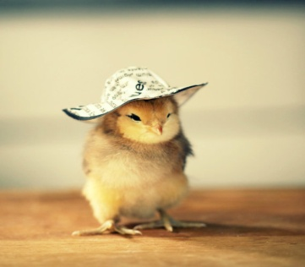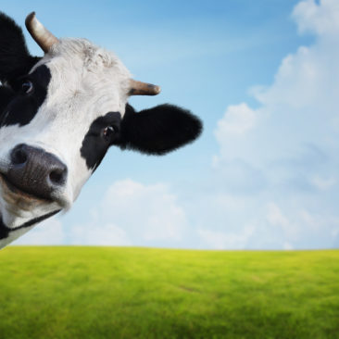
Poultry Cattle Vaccine Aqua

Fig 3.4.1 ACI Animal Health Products

3.4.2. Price:
ACI Animal Health is offered different price in different pack size. They provide good quality product in better price and target to capture a niche premium segment of the market.
3.4.3. Place:
The distribution network of Animal Health includes different farms in Bangladesh. The Farms are- Kazi Farms Group, Nourish Poultry and Hatchery, Milk vita, Provita Groups.
3.4.4. Promotion:
ACI Animal Health is promoted their products with the Brochure, Technical Presentation, Product sample, Leaflet, Fair and advertise on agricultural magazines like- Adhunik Krishi Khamar, Bangladesh Dairy & Poultry, PustyTattho, KrishiProjukti, Farms and Farmer 24.com etc.

3.5. Operations:
ACI Animal Health is improving the livestock and fisheries sector.ACI Animal Health is reaching its customers by manufacturing, importing, distributing and marketing their products. They produce their products at their own factory at Narayanganj and distribute the nationwide. The products are nutritional products, antibiotics, disinfectants, analgesic, and antihistamines which help for the animal health. The products are ensuring the highest level of quality. ACI try to improve the products quality they have invested in a laboratory where experienced pharmacist, chemist, microbiologist research.

3.6. SWOT Analysis:
SWOT is a strong brand image of the organization. Because of SWOT shows the organization’s strengths, weakness, opportunities and threats which is the total figure of the organization. After analysis the SWOT the organization set their plans how they work. Organizations always try to hold their strength. They attempt to overcome their weakness with grab the new opportunities. And they also create new ideas for the threats.

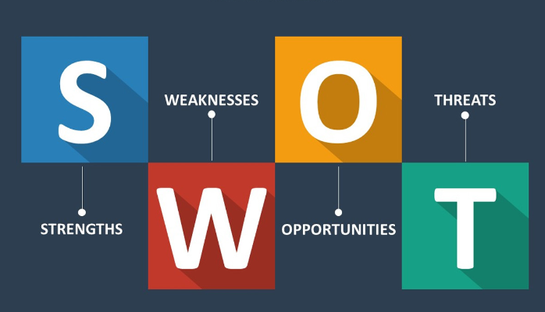
Fig 3.6 SWOT Analysis

SWOT analysis of ACI Animal Health-

Strength:
ACI animal health is company who got the trust of the customers. ACI animal health is another name of trust. They maintained that trust from the day one. Customers know that the product of the ACI animal health is hygienic, pure and standard quality is there. If the consumers are all happy and know that they can reliable on ACI animal health then the company is growing good and the future is also on a run. But the consumers need to try the product for come to know the product quality. For that good promotion is must. ACI animal health always uses good promotional activities for the attention of the customers. ACI animal health always uses technical persons to handle all the work properly. A person without skill cannot do the work accordingly. There is another thing which helps a industry to grow in a regular manner and that is the strategies and rules a company follows. ACI animal health has a structured rules and regulation to maintain which helped them a lot. ACI animal health always exports cattle and poultry products so the quality can be ensured all the time. These are the strengths of the ACI animal health company which are the solid ones for a company.

Weakness:
ACI animal health industry has few problems as well. The training that the industry provides is not enough to train a farmer perfectly. For providing the training facilities the amount of training should be increased. If the number of training is increased then the farmers can be trained with the fullest of skill. There is some technical person in the ACI animal health industry but they are not enough in numbers. The numbers should be increased. With the more technical persons the technical works cannot be done so the number should be increased. When they setup their product price or promoting new product, they always have to think about their competitors and they are forced to set the price in the lower price. ACI Animal Health is unable to reduce their cost that much. Because of the taxes on the products from the government that is why the cost of the producer’s product gets high. And that is the reason why ACI Animal Health is unable to reduce costs.ACI animal health industry has lack of appropriate marketing research. They don’t count on the research that much and count on the old formulas. They need to focus on the marketing research soon enough

Opportunity:
ACI animal health industry always tries to make differentiate products and try to innovate more and more. And what markets want from the company is that they can provide some innovative products for the market which is good for the profit and both reputation of the company. ACI animal health always tries to improve the product by all manners. Without quality of products once cannot sustain in a industry. And ACI always made sure that the customers are having the products which are quality full enough. ACI animal health also gives away employments opportunities to the students of animal science and BBA graduates.

Threats:
ACI animal health is reputed company that is for sure as far as the popularity is concerned but there is another thing which always need to be taken care of and that is similar products are also offered by many other companies so ACI should and do the creative research and try to launch some creative ideas and products also to sustain. As the level of competition is increasing day by day as similar products are offered by others so ACI have to try more creative to introduce new product. And the new entrants in the industry are also the big threats for the ACI animal health industry. Another thing is the political issues in the country. In Bangladesh the political environments vastly affected the business itself.

3.7. Steps/Strategies to Meet the Challenges and Opportunities:
ACI Animal Health is tried to meet the challenges and opportunities. ACI animal health is arrange a training program to improve the farming techniques and stop the animals die. They recruit the field level employee who learns the farmers how farming the cattle, poultry and aqua. When farmers know the animal’s disease then they use the vaccine for the animals to protect them. It is an opportunities for the ACI animal health to sell their vaccine and introduce the new vaccine. ACI has met the challenges they set a long term goals. Then ACI collaborate the international company for their products.

Chapter: 4
Internship Experience

4. Internship Experience
4.1. Position, Duties and Responsibilities:
I have joined ACI Limited on 7th May, 2019. I was appointed here as a Product Executive of ACI Animal Health Limited. I am a part of the marketing and branding team and have to perform diversified tasks that include monitoring and coordinating the activities of every other team like Sales, Operations and Distributions besides the core marketing activities. My regular accountabilities are-Read and understand the financial processes and procedures of the company and work accordingly. Assist the service officer in reviewing the financial statements and cross checking it to ensure accuracy. Try to complete the assigned task within the timeframe. Input the data entry and check the business card. I have performed any other job which is assigned by the supervisor.

4.2. Training:
ACI Animal Health do not provided any training program for the interns. They are provided different training programs for their employees like “Asian Diseases Veterinary Post-Graduate Training Course 2018”,"Dairy Farmers’ Training on Bovine Udder Health" to improve the employee and develop the organization.

4.3. Contribution to Departmental Functions:
The major contribution of departmental functions I was assigned with in last three months are described here in details:

Major Responsibilities of the Job: Incentive Calculation:
From the very beginning of my job at ACI Animal Health, the first major task was the monthly incentive calculation of the employee. Incentives are given those employees who are achieved the company target. I have checked those papers for correction.

Major Responsibilities of the Job: File Documentation:
Another regular responsibility I have documented the file with MS Excel containing employee name, id, amount of incentive and bank name.

Major Responsibilities of the Job: Bill Payment:
Bill payment, one of the regular responsibilities, is to paybill for the media partners where the ACI Animal Health industry advertises their products.
4.4. Evaluation
At the end of internship period the organization evaluate their intern with some question answer or number the work performance. When I started my internship at ACI Animal Health they provided an evaluation form. After completed the internship my supervisor evaluated my work performance.
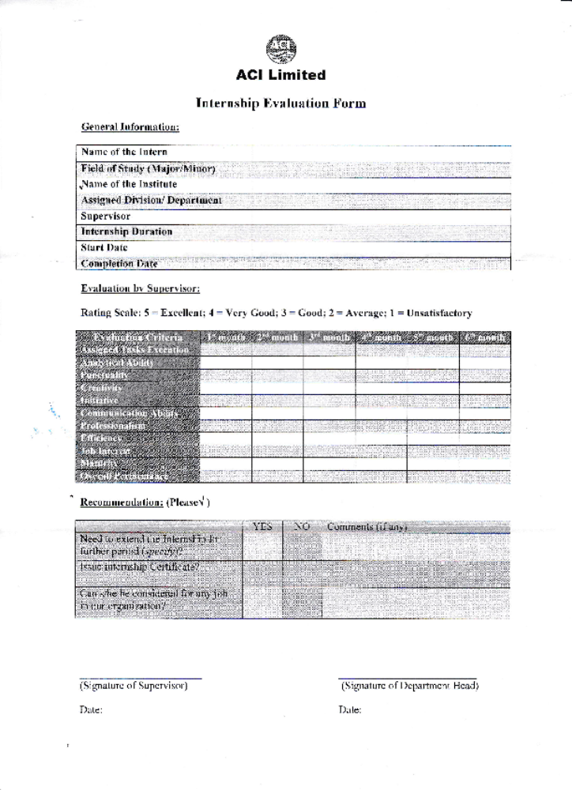
Fig 4.4: Evaluation Form (ACI Animal Health)
ACI Limited evaluates the intern with rating scale. 5 to 1 rating scale to evaluate the work performance.
5 = Excellent
4 = Very Good
3 = Good
2 = Average
1 =Unsatisfactory

4.5. Skills Applied:

During the internship period, I have tried to apply my skills to perform the task. I have applied those skills are-
- Communication Skills-
The ways I have used the communication skills are by getting my point across, by listening to what people are saying or not saying, listening to speak in public group, provide positive and negative feedback properly, write to better emails and network.

- Problem Solving-
I have applied the problem solving skills are by getting my points like, active listening the work instruction, analysis and research the task, decision making to complete the task.

- Organization and Time Management-
I have designed my work like prioritized the work importance, set up the deadline, start the task early and avoid the multitasking.

- Adaptability-
I have mentally prepared myself accept new roles and new surprise. So, I will be able to ready for the alternative solution.

- Teamwork Skill-
I have performed my work with a team. I show my honesty, collaboration with other people and responsible to the work with my team members.

4.6. New Skills Developed:
In my internship period, I have developed my skills. I have an opportunity to practice communication and teamwork skills. I gain my practical industry knowledge from the organizations and professionals. I have learned new methods to apply in MS Excel. I achieve a sense of execution by contributing to an organization. I have learned to complete the task within the timeframe and also developed my time management skills. I was also developed my English listening and speaking when I communicate the official conversation.

  - Application of Academic Knowledge:

Not many similarities are found between the academic we study and activities we do in the organization. But some similarity of my academic knowledge is budget calculation. I learned how to calculate the budget of organization monthly. During internship period, I have applied this knowledge to calculate the employee’s monthly budget papers. I have learned how calculate the ratio analysis. In the real work experience I have used the ratio analysis to calculation the employee’s incentive papers.

Chapter: 5
Recommendations

5. Recommendations

5.1. Recommendations for Improving Departmental Operations:

ACI animal health can to be a strong partnership between public and private sector to boost the growth in dairy sector. They need to build a more researchers centre to introduce the new vaccine.ACI animal health need to more promotional activities. If farmers do not know the products they cannot use the products for the animals. They need to improve their education and training program. Use new software to calculate the incentive paper. ACI need improved the breeding technology to produce the more milk. Employee doesn’t get their monthly incentive in timely.

5.2. Recommendations for Improving Self-Performance:

Developing Oneself:

It had been a great opportunity for me to be a part of ACI Ltd. I did learned how the incentive papers are calculated and organize them as they should be and put them in the excel for proper record, apart from that how the products are developed and how they send away to the market and how the market is continuously observed and controlled all these I came to know. I have discovered my strengths and weaknesses as I worked there and it helped me to gather all the knowledge related to this particular work and sector as well.

Effective Work Environment:

ACI animal health has a professional work environment which was attacked me. This company is the first priority of equality. Company provides the desk for different designations people. The employees of particular department sit together and the interns also sit here.

Enthusiastic Engaging Environment:

The work environment in the company is quite engaging and absolute professional. We have been given the full autonomy of the work so that we can work with the full dedication and appropriately. We get regular feedback on everything that we do. If we do any mistake, we are given appropriate guidelines by our supervisors, on the other hand, appraised when we do a task perfectly. This creates a great sense of enthusiasm among us which will eventually help in our work life.

Learning of Corporate Norms:

Although we are interns over there, but we get addressed just as other employees are. The terms “bhaiya” and “apu” are used in corporate setting regardless the designation and age of the employees. Other staffs members are treated with equal amount of respect which is quite impressive. The way our performance gets appraised gave me a very positive outlook regarding the corporate norms of this company.

Chapter: 6
Conclusion

6.Conclusion:

Working at ACI Animal Health has a great experienced for me. I learnt a great deal from there and also able to capture some corporate knowledge. When I was the intern at ACI, I was not aware the rules and regulations and how they work. I need some weeks to learn how the works to done there. I have developed my punctuality which is helped by other organization. I hope my internship experience build a good career to the corporate world.
This report is analysis the ACI Animal Health Industry. In Bangladesh, there are many animal health industry are establish to protect the animals from the diseases and poor health.
ACI Animal Health Industry produces the vaccine and medicine for the animal. They try to improve the livestock and fisheries sector. ACI animal health is effort to reduce the people’s portion gaps. They try to produce new medicine with new ideas. They maintain the good quality and set the reasonable price. ACI animal health gets more profits they need technical person who know about the animal diseases. They hire the persons who have educational background to the livestock, veterinary, animal husbandry.
ACI Animal Health is following the recommendations to achieve their dreams and vision. All the animal health industry have perform almost same. If ACI animal health is following the recommendations they can much better than previous.

References
1. VETERINARY INDUSTRY IN BANGLADESH: PRESENT STATUS AND FUTURE POTENTIALS Biplab Kumar Sen
2. BUSINESS OPPORTUNITY FOR DAIRY FARM IN Bangladesh, Mustafizur Rahman
3. Report of Core Capacity Assessment for Implementation of IHR 2005 in Bangladesh, Ministry of Health and Family Welfare, Technical Support: World Health Organization
4. ACI Overview, operations and growth available at http://www.aci-bd.com/our-businesses/animal-health.html
5. ACI products at https://acianimalhealth.com/portfolio/cattle-product/
6. Mission, vision and position here http://acianimalhealth.com/
7. ACI board of directors at http://www.aci-bd.com/about-us/board-of-directors.html
8. Animal Health Industry Challenges at https://www.thedailystar.net/round-tables/bangladesh-dairy-challenges-and-opportunities-1337251, http://bids.org.bd/page/researches/?rid=36
9. Economic factors at https://www.slideshare.net/kripalsinghniranjan/swot-analysis-indian-veterinary- healthcare-industry

