

INTERNSHIP REPORT ON
GENERAL BANKING ACTIVITIES OF
JAMUNA BANK LIMITED

Internship Report
On
“General Banking Activities of Jamuna Bank Limited”

Submitted To
Dr. Md. Shariful Alam
Associate Professor
School of Business and Economics

Submitted By
Syed Alif Ahmed Araf
ID: 111-161-286
Major In Marketing
Trimester summer 2020

School of Business and Economics
United International University


Date of submission
28th October 2020

Letter of Transmittal

28th October 2020
Dr. Md. Shariful Alam
Associate Professor
School of Business and Economics
United International University

Subject: Request for the appreciation of the Internship Report.
Respected Sir,

I am very happy to present my temporary job report on "General Banking Activities of Jamuna Bank LTD (Pragati Saroni Branch)". I have attempted to adhere to your significant directions, and ready to finish the theme examined the understanding and feature of the General Banking Activities of Jamuna Bank Limited. I have attempted to present the process of JBL General Banking Activities in my internship period.
A temporary job (Internship program) is a necessary concern for my BBA Graduation. To satisfy this prerequisite I have begun to functioning at JBL Pragati Saroni Branch in the General Banking Activities division from 28th July 2020 to 28th October 2020.
I have attempted to include important data with the goal of this report that the principle destinations can be perceived. Additionally, I assembled real-life working experience on the official atmosphere before performing the genuine work field yet this effort will be measured as a decent exhibition afterward your assessment.
Finally, I might want to pass on my appreciation and enormous gratitude to you for your direction, nice collaboration, and oversight to finish my temporary job report. I will be thankful if you consider my report is sufficiently pertinent to satisfy my necessities. Nonetheless, I will be glad to explain any inquiries if necessary.
Thanking You!!
Sincerely Yours,
Syed Alif Ahmed Araf
ID: 111-161-286

Certification of similarity index
Attached

The Declaration of Student

I am Syed Alif Ahmed Araf inform you that my report "General Banking Activities of Jamuna Bank Limited" is made only for my internship purpose because this is a required aspect of my BBA program to present a temporary job report.
Besides, I was enlivened and taught by my administrator “Dr.Md. Shariful Alam” Associate Professor, School of Business and Economics, United International University.

.....................................
Syed Alif Ahmed Araf
ID: 111-161-286
Bachelor of Business Administration
Major in Marketing
United International University

Acknowledgment

Above all else, I might want to omnipotent Allah for his beauty in achieving my temporary job report appropriately.

I got employed to work as an intern at the Pragati Saroni branch of Jamuna Bank Limited.
I make sure to give an honest effort to introduce my real works understanding and learning in this report. I might want to offer my thanks to my respectable administrator Dr.Md. Shariful Alam, Associate Professor, School of Business and Economics, United International University on the center of my heart for his benevolent help, direction, useful oversight, guidelines, and for persuading me to conduct this paper.

I am additionally grateful to the top of the Human resource department of Jamuna Bank Limited for permitting me to work in the Pragati Saroni branch. I would like to thank Mrs. Tahmina Rahman and Mr. Aninda Asfaq officers of the general banking department for supervising me and giving me key information to write a fruitful report. I am also grateful to Md. Hafizul Alam, Manager of the Jamuna bank, Pragati Saroni Branch.

Mrs. Labiba and Mrs. Rumpa Dey Senior executives also help me by providing key information. I am also grateful to Mr. Sanjeet and Mr. Asraf for their amiable reception. They were identical supportive in demonstrating the cycle of the task and gave important data to my report at whatever point I drew closer. Furthermore, I likewise might want to thank each partner for their help and significant season of offering significant data to me and making my work environment agreeable. I might want to thank every individual who cooperated with me to make my temporary job program an effective and essential one.

It was an extraordinary chance to perform a temporary job in such an association. The knowledge I have assembled will be a benefit for my upcoming professional arranging.

Executive Summary

An internship program plays a crucial role in providing a simulation of a real job experience. A better balance among theory and practice can be increased to complete this program. The report is a combination of three months internship program with Jamuna Bank Limited. I recognized different banking functions and day-by-day banking operations on my way to complete an internship.

The goal of this report is to obtain knowledge about the general banking activities of JBL. Primary as well as secondary data are used for preparing this report.

In the 1st chapter, I have discussed the introductory part, which has been developed to execute the entire report properly. Chapter Two discussed the “company and industry preview,” including company profile with Jamuna Bank’s history, its vision, mission, objective, core values, strategy, ethical principle, products and services, SWOT analysis, and operational network organogram. On the other hand, industry preview, including banking industry analysis with porters five forces study. In the third chapter, I have discussed General Banking Activities. I have mainly described the working experience of my internship period in JBL – Pragoti Saroni Branch, which is the core part of this report. Because it includes my job position, duties and responsibilities, my Contribution to the departmental functions, my observation and evaluation, skills applied, and new skills development, etc. The remaining part consists of recommendations and a conclusion.

Lastly, I evaluate that Jamuna bank provides better service to its customers, which plays a vital role in our country’s economy.

List of Tables

Charts & Tables | Page Number
Core values of Jamuna Bank Limited | 11
Product/ service of Jamuna Bank Limited | 14
Types of Banks | 22
Growth Stage of Banking Industry in Bangladesh | 23
My Activities in General Banking | 32
Three Types of Local Remittance | 39

List of Abbreviation

UIU | United International University
BBA | Bachelor of Business Administration
HR | Human Resource
PSB | Pragoti Saroni Branch
JBL | Jamuna Bank Limited
CSR | Corporate Social Responsibility
A/C | Account
L/C | Letter of Credit
PO | Pay Order
BOD | Board of Directors
SOD | Secured Over Draft
B/L | Bill of Leading
HO | Head Office
MD | Managing Director

Table of Contents
Letter of Transmittal iii
Certification of similarity index iv
Executive Summary vii
List of Tables viii
List of Abbreviation viii
Chapter One: Introduction 1
1.1 Introduction 2
1.2 The Rationale of a Study 3
1.3 Background of the Report 3
1.4 Objectives of the Report 3
1.5 The Methodology of the Study 4
1.6 Scope of the Study 5
1.7 Limitations of the Study 6
Chapter Two: Company And Industry Preview 7
2.1 Company Analysis 8
2.1.1 Overview and History 8
2.1.2 Mission and Vision 10
2.1.3 Corporate Slogan 10
2.1.4 Objectives of JBL 10
2.1.5 Core Values 11
2.1.6 Strategic Priority 11
2.1.7 Management 12
2.1.8 Ethical Principles 13
2.1.9 Product/Service Offerings 14
2.1.10 Service Marketing Mix of Jamuna Bank Limited 15
2.1.11 SWOT Analysis of Jamuna Bank Limited 18
2.1.12 Operational Organogram Network 20
2.2 Banking Industry Analysis 21
2.2.1 Specification of the Banking industry 21
2.2.2 Size, trend, and maturity of the industry 23
2.2.3 External Economic Factors 25
2.2.4 Technological Factors 26
2.2.5 Barriers to Entry 27
2.2.6 Supplier Power 28
2.2.7 Buyer Power 29
2.2.8 Threat of Substitutes 30
2.2.9 Industry Rivalry 30
Chapter Three: Internship Experience 31
3.1 Internship Experience 32
3.2 Position, Duties, and Responsibilities 32
3.2.1 Account Opening Segment 33
3.2.2 Local Remittance Segment 38
3.2.3 Accounts Segment 40
3.2.4 Cash Segment and Other Similar Activities 40
3.3 Contribution to Departmental Functions 41
3.4 Evaluation 41
3.5 Skills Applied and New Skills Developed 42
3.6 Application of Academic Knowledge 43
Chapter Four: Conclusions and Key Facts 44
4.1 Conclusion 45
4.2 Recommendations 46
REFERENCE 48
APPENDIX: A 49

Chapter One: Introduction



1.1 Introduction

A temporary job (Internship program) is a fractional prerequisite to complete the graduation. It proposals an incredible open door for any understudy to get some splendid thoughts regarding real work life. It is likewise a provoking encounter to set up a temporary job report which builds scholarly capacities as effective alumni. As an understudy of the BBA program, everybody needs to lead a pragmatic direction in any association for satisfying the necessities of the temporary job Program. The primary motivation behind the situation is to open the understudies to genuine work experience and this report is organized based on the Practical knowledge of the total banking business of Jamuna Bank Lt.
The banking industry is growing its hand in various budgetary occasions each day. Simultaneously, the financial cycle is getting quicker, simpler and the banking field is getting more extensive. As the interest for better facility expands step by step, they are accompanying distinctive creative thoughts and items. To get by in the serious field of the financial part, all financial associations are searching for better assistance chances to give their kindred customers. Subsequently, it has gotten fundamental for each individual to have some thought of the bank and banking method.
Remembering this and temporary job program was being remembered for the BBA educational plan. The objective of this examination is to uncover the understudy in the authoritative work circumstance and to give a chance to relating academic knowledge into real work life. Because there are a few contrasts among academic knowledge with real work life.
Customer satisfaction and faithfulness give an organization a preferred base over its adversaries and permits it to prosper in the business which results from enhancement to the high caliber of administration. Jamuna Bank Ltd. is one of the main suppliers of financial services countrywide. With its solid corporate picture and character, it can improve position in the brains of customers.

1.2 The Rationale of a Study

Customers’ expectations are increasing day by day because of many commercial banks are entering into our banking sector and through the huge competition of these banks. So at the present condition every bank particularly business banks are attempting to attract more customers by following different marketing strategy and also providing profitable offers for them. Accordingly, banks are impending additional access to their clients. But at present banks are facing some difficulties like interest rate is low on the other hand the inflation rate is high because of political instability and other various factors. So the top administration of the business banks must manage the circumstance.

1.3 Background of the Report

The temporary job program is an obligatory prerequisite for the understudies who desire to be a B.B.A former student. In the temporary position program, I was connected to the host association title “Jamuna Bank Limited” and this report is set up later the culmination of a quarter of a year Internship program. This report arranged on my handy involvement on the everyday financial exercises, academic knowledge, and beneath the nearby oversight of my inward help just as my authorized manager. The report has been named as "General Banking Activities of Jamuna Bank Limited"

1.4 Objectives of the Report

The principal target of the report will be to give a review of the "General banking activities of Jamuna Bank Limited – Pragati Saroni Branch" by way of satisfying the necessity of the BBA program. Though, the objective of this learning is more extensive. Destinations of the report are summed up in an accompanying way-

- To know about the details picture of Jamuna Bank Limited.
- To implement the academic information in the real life.
- To know about the entire branch banking procedures.
- To recognize how the different divisions of the branch work.
- To classify the overall financial exercises of Jamuna Bank Limited.
- To increase realistic experiences that will help us in our real working life.
- To realize in which segment the bank is working with legitimate effectiveness.
- To evaluate the overall financial accomplishments of JBL.
- To discover the limitations of the bank and recommending the best approach to resolve these issues.
- To evaluate the current position as well as creating future expectations.
- To suggest the effective activities of the administrations those are offered by Jamuna Bank Limited.

1.5 The Methodology of the Study

I have planned the approach or the technique wherein tactic the information will be gathered in an accompanying manner:

Primary Sources:

- Open discussion as well as a personal meeting with the individual officials in the office.
- Personal perception-like watching the methods which are followed by every division.
- Real-world keeping cashes the mechanism.
- Real-life working experience in each of the banking division.
- Casual conversations with the people who visited the bank.
- Learning from the related report's study that is given by the officials.
- Learning from the activities of Practical desk.

Secondary Sources:

- Yearly report of Jamuna Bank Limited.
- Journal and magazine which was distributed by Central bank.
- A broad and expanding investigation of the current records.
- The Internet is also used as a theoretical source of information.
- Convenient case interpretations.
- Website and newsletters are also used as major sources.

1.6 Scope of the Study

This report is organized and ready for my real work understanding when the time of working at JBL. It will beneficial to the understudies by decreasing the misperception among practical and theoretical information and it will provide a clear idea about real work life as well as theoretical knowledge. This report is also helping me with my better understanding of the organization’s culture and better knowledge about its activities. As I am an internee of JBL, I have done numerous assignments like record opening, clearing, preparing check, pay request composing, accounts close, LC register writing, preparing DR/CR voucher, and So on. It is quite difficult for an internee to know about the entire banking procedures within this short period but I try my best to know about this sector for preparing my report as well as my real work life.

1.7 Limitations of the Study

I feel lucky to perform at Jamuna Bank Limited in my temporary job time. Even though I performed as an internee to this organization, I got a major extension to know the activities and practices of the financial framework, particularly JBL. For setting up this report, I confronted a few hindrances and impediments which are as per the following beneath:

Shortage of Time: I got only three months to finish this report; so it was practically difficult to focus the entirety of the exercises of the financial framework; while a customary worker gets advanced following 1 or 2 years of his trial period. In this way, because of time constraints, a large number of angles couldn't be talked about in the current report.
Insufficient information resources: All kinds of data were not accessible for access, so it was unrealistic to get to and sum up them appropriately. Although I had help from different representatives it was insufficient for me because of their high work pressure in the bank. A few suspicions were made because of restricted data, so there might be some close to home mix-ups.

Absence of sufficient experience: Investigating a financial framework in commonsense corporate culture, that was a new experience in my life, so my inadequate experience was one of the primary constraints; I felt during the making of this report.

Confidentiality of Info: Every organization has some secret information’s that they never share with everyone. So as an intern/outsider of this organization they don’t deliver their every information to me. So this is one of the obstacles while making my report.

Chapter Two

Company And Industry Preview

COMPANY INDUSTRY PREVIEW



2.1 Company Analysis

2.1.1 Overview and History
Jamuna Bank Limited (JBL) becomes a third generation bank in Bangladesh. It mainly focuses on some specific aspects like

- Remaining with Time
- Managing Change
- Developing Human Capital
- Creating true Customers value

It offers business banking administrations in Bangladesh. It plays out a significant job to improve the business part. The development of this bank is awesome. Its trademark is to offer brief and snappy assistance to the clients. Jamuna Bank Limited has executed very much organized internet banking frameworks that make it simpler to offer brief types of assistance to the client. The bank chiefly participates in corporate banking, exchange fund, little venture money, venture account, retail banking, purchaser account, and partnership. Its scope of administration presents incorporates depository administrations, money the board administrations, installments and clearings, worker welfares, assortment administrations, resource the executives, safe store storage administrations, administrations, and SWIFT for unfamiliar exchange.
Jamuna Bank Limited (JBL) is a Banking Company recorded underneath the Companies Deed, 1994 of Bangladesh with its Head Office as of now at Jamuna Bank Tower; Plot# 14, Bir Uttam A. K. Khandaker Road, Block# C, Gulshan-1, and Dhaka, Bangladesh. The Bank began its activity on the third of June 2001.

Jamuna Bank Limited is a profoundly promoted new-fangled age Bank with an Official Capital and Paid-up Capital of Tk.10000 million and Tk.4488 million correspondingly.
JBL embraces a wide range of banking exchanges to help the advancement of exchange and trade of the nation. JBL's administrations are likewise accessible for the businesspersons to set up new accomplishments and BMRE of mechanical units. Jamuna Bank Ltd. is the first Bengali named private business bank was built up by a gathering of winning nearby business people considering a thought of making a model financial relationship with an alternate viewpoint to offer the esteemed clients, a wide-running of budgetary administrations and imaginative items for feasible shared development and achievement. The followers have rumored characters in the field of exchange, business, and enterprises. The Bank is being cultivated and ran by a gathering of profoundly instructed and proficient groups with separated involvement with money and banking. The Management of the bank continually centers on tolerating and foreseeing the client's desires. The scenario of the financial business is shifting step by step, so the bank's responsibility is to devise the technique and the new things adjust to the growing condition. Jamuna Bank Ltd. has just accomplished glorious advancement since its foundation. The bank has just arranged at the head of quality specialist organizations and is known for its infamy.

At present, the Bank takes enduring Online financial parts (of both Urban and Rural territories) arranges everywhere on over the nation having a savvy IT-spine. Other than antiquated conveyance focuses, the bank has ATMs of its own, offering to other accomplice banks and relationships all through the nation.
Jamuna Bank Ltd. offers various kinds of Corporate and Particular Banking Services, including all fragments of the general public inside the domain of directions and rules set somewhere around the Central Bank and other administrative foundations. According to the arrangements of Bangladesh Bank's permit, the Bank has open at first it offers to the general population by Pre – IPO and in this manner offered offers to the general society through IPO in the year 2004. The bank is enrolled in both Dhaka Stock Exchange Ltd. and Chittagong Stock Exchange Ltd.
The bank transaction hour is 10:00 A.M - 4:00 P.M and operational hours are 10:00 A.M. - 6:00 P.M. from Sunday to Thursday. It stays shut on Saturday, Friday, and govt. occasions.

2.1.2 Mission and Vision

Mission

The bank is focused on fulfilling the different needs of its clients through a variety of items at a serious cost by utilizing suitable innovation and offering ideal assistance so maintainable development, sensible return, and commitment to the advancement of the nation can be guaranteed with a propelled and expert workforce.

Vision
To become a leading banking institution and to play a significant role in the development of the country

2.1.3 Corporate Slogan

“You’re Partner for Growth”

2.1.4 Objectives of JBL

- To build up relationship banking and develop the quality of supervision through the progress of Strategic Marketing Tactics.
- To stay perhaps the finest bank in Bangladesh as far as gainfulness and resource excellence.
- To assurance an adequate control of degree in productivity.
- To keep the chance situation at an acceptable range (including any wobbly sheet hazard).
- To meet developing promises and responsibilities, to keep up satisfactory liquidity
- To seek a powerful arrangement of the board by guaranteeing dependability with ethical principles, truthfulness, and accountability at all levels.

2.1.5 Core Values

Core values are very specific and customer-oriented that Jamuna bank limited maintains while it is functioning. As per setting up the best help and confronting new difficulties, there is a particular guiding principle established through the bank which is given beneath:

Customer Concentration | Business Morality | Fair-Mindedness
Trust | Quality | Courtesy Harmony
Integrity | Teamwork | Unique Culture
Assurance | Admiration | Responsible Corporate Resident

Core Values of Jamuna Bank Limited

2.1.6 Strategic Priority

- To guarantee clients' ideal items and administrations to making the best clients' worth.
- To guarantee an agreeable situation of unfamiliar trade constantly.
- Focusing on the fare of both customary and nontraditional things and settlement.
- To keep up the nature of the benefit.
- Focus on lessening the expense of stores.
- Ensuring a simple increase of its administrations for the clients.
- Taking banking to the entranceway of general individuals.
- Helping oppressed and Providing CSR exercises individuals of the nation through the Jamuna Bank establishment.

To keep up a decent situation in the unfamiliar market JBL stays aware of the settlement and staying aware of the fare of conventional and non-customary things

- Investing in high risk situated business returns.
- Make known to financial transactions that are new to it.
- Maximizing the investor's qualities however much as could be expected.
- Strengthening strategies and procedures of danger the chiefs and ensuring the steady culture.
- Being aware of the green condition and acquainting it with each part of the banking activities.

2.1.7 Management

JBL is accomplished by exceptionally proficient individuals. Boards of directors are the only power to take the actions of this bank. There are 16 chiefs and 4 Independent Directors in the administration of the bank. All the administrators have a higher scholastic degree and have enormous knowledge of the business. There are various advisory groups in the bank for effective administration. The MD of the Jamuna bank limited is a person who is very progressive, sincere, and has huge experience in this banking industry. He is always motivating to the employees for their better performance and bringing innovative ideas and strategies into this bank. The board of directors and top management are always giving more focused on their customer’s needs and find out the better solution for satisfying these needs. At present JBL has become more reputed, well known, and achieving various achievements within its short period. Now, this bank is one of the top commercial banks in this country by providing better services and its good performance.

2.1.8 Ethical Principles

The moral guideline is considered as one of the most significant pieces of any association. Not just for making as much as benefit or income yet additionally JBL is likewise taking consideration for some moral advances which enough save the bank for its reality, for keeping it sufficient

- Following all the guidelines and instructions carefully everywhere on over the areas in the bank.
- Being reasonable with an equivalent open door for all the partners.
- Maintain solid security of client individual data.
- Maintain corporate culture among the worker and demonstrating preparing and workshops
- Projects must be very condition amicable.

Alongside business purposes, JBL has made Jamuna Bank Foundation which intends to give budgetary help to forlorn, and individuals who have fallen under unsure conditions just as sports, culture, social insurance, and network improvement adventures.

2.1.9 Product/Service Offerings

The Bank takes an assortment of methods that readied money related items and administrations. Such items depend on Monthly Savings Arrangements, User Credit Arrangements, Rent Finance and Individual Loan for Womenfolk and Workshop Finance Arrangement, and so on. Jamuna Bank Ltd is additionally acquainted with Q-money ATM cards for its esteemed clients giving 24 hours banking administrations over the Debit Cards. JBL deals with the accompanying administrations to the esteemed client. The Bank is giving various kinds of services. Several of them are referenced underneath:

Products/services of Jamuna Bank Limited

Time Deposit Arrangements | Tourists Cheque | Money-saving arrangements
Western Union money transfer | SME Loans | Hire buy
SMS Banking | Industrial Finance | WCF
Inward and outward Remittances and Collection | Import and Export taking care of and Finance | 24-hours Banking: Q-Cash ATM office
Online service | Credit/Debit card service | Islamic Banking
Loan Syndication | Venture Banking | Lease Finance
Project Finance | One-stop service | Personal Loan for Female
Commercial Banking | Trade finance | JBL DPS Plus

2.1.10 Service Marketing Mix of Jamuna Bank Limited

7’Ps of Marketing Mix

- Product
- Price
- Place
- Promotion
- People
- Process
- Physical Evidence

Product

Deposit Schemes | Project Finance | Hire Purchase
Remittance and Collection | Investment Banking | Corporate Banking
Loan Schemes | Lease Finance | International Banking
Import and Export taking care of and Finance | Personal Loan for Woman | 24-hours Banking: Q-Cash ATM facility Etc.

Price [Interest rate based on Scheme Duration]

6.10% 5 years of Lakhpati Deposit Scheme | 6.10% 5 years of Millionaire Deposit Scheme
6.10% 5 years of Kotipati Deposit Scheme | 7.00% 10 years of Double Growth Deposit Scheme
7.35% 15 years of Triple Growth Deposit Scheme | 6.25%5 years of Pension Deposit Scheme
6.10% 5 years of Mudaraba Hajj Savings Scheme | 6.25% 5 years of Rural Deposit Scheme

Place
Jamuna bank deals with their store, different sparing plans, loans, and different administrations to their client countrywide by establishing financial divisions at the appropriate and alluring areas. JBL provided a lot of inclinations to the client's benefit and simplicity of undertaking banking over the entire nation. Accordingly, they have: 112 branches the country over, 215 ATM corners the nation over, and Simplicity of online banking service

Promotion
Jamuna bank limited taking some promotional activities or strategies for acquiring their new customers. Some promotional activities are the following as that:

- They use social media platforms for their digital advertising purpose.
- Taking Blogging policy which makes a good profile and establishes expertise to this bank.
- Providing Special customer services that establish their brand image for others.
- Using Video Content Campaigns for their promotion.
- Using Digital Signage.
- Using Customer Data helps to better understand their customers that build up customer loyalty.
- Taking some special Sales Promotion.
- Maintain good Public Relations which help as their promotion.
- Taking Some Direct Marketing initiatives.
- Taking In-house Marketing like Personal Selling etc.

People

There are a total of 2,443 representatives in the Jamuna bank limited around the countrywide and they are trying to provide quality services to their clients. Here involved like Chairman Board of Directors, Managing Director, Deputy Managing Director, General Manager, Deputy General Manager, Assistant General Manager, Senior Principal Officer, Principle Officer, Senior Officer, Officer, Junior Officer, and Staffs.

Process

➢ JBL utilize different new and creative advances to offer norm and great types of services to clients. ➢ in the event of JBL, when opening a record the client ought to follow the accompanying methodology 1. Candidate fill-up application structure gave by bank 2. He/she is needed to sign in the example signature card 3. A record holder of the bank ought to introduce the candidate 4. The dependable authority looks at the tutoring and application structure. 5. Issuance of the deposit must be made in real money 6. After saving the money one checkbook, deposit book, an ATM card is given. 7. Record is opened

Physical Evidence

Physical proof in Jamuna Bank Ltd. alludes to substantial, noticeable touch focuses (Staff's attire, Ac, pen, papers, chair, table, logo, sign, images, area, yearly reports, pictures, corporate leaflets) which customers will experience before they get or buy the advantages of administration from banquet room and in the administration domain.

2.1.11 SWOT Analysis of Jamuna Bank Limited

Strengths

- It takes decent notoriety in the market.
- High improvement rate.
- The Existing appropriation and deals systems.
- An economic bit of help is given.
- Not busy with off the mark business practice.
- Focused Market.
- Administrators are profoundly talented.
- Heads are exceptionally competent and proficient.
- The Bank has numerous appealing store plans.
- Proficient administration practices in the Bank.
- All things considered, expanded credit portfolio.
- The store mix is amazingly strong.

Weakness

- The Future debt rating.
- Preparing programs are not a visit for representatives.
- The complexity of Credit Policy.
- Small amounts of the overall business on singular scholars.
- Few quantities of ATM corners.

Opportunities

- Per capita, the yearly salary is expanding.
- An Unfamiliar exchange is expanding step by step.
- Private Bank is getting more solid to the neighborhood open.
- Novel thoughts are coming into this industry.
- New products and services.
- New markets.
- Income level is at a constant increase.
- The Global market.

Threats

- Increasing Rates of Interest.
- There are Numerous Rivals in the Marketplace.
- Contenders have more stores.
- Govt. Forces Tariff On Profile.
- Govt. Forces To Decrease Interest Rate On Loans.
- New banks are impending into the flea market.
- Increasing cost.
- Govt. instructions and guidelines are turning out to be exacting step by step.
- Raising the cost of raw materials.

2.1.12 Operational Organogram Network

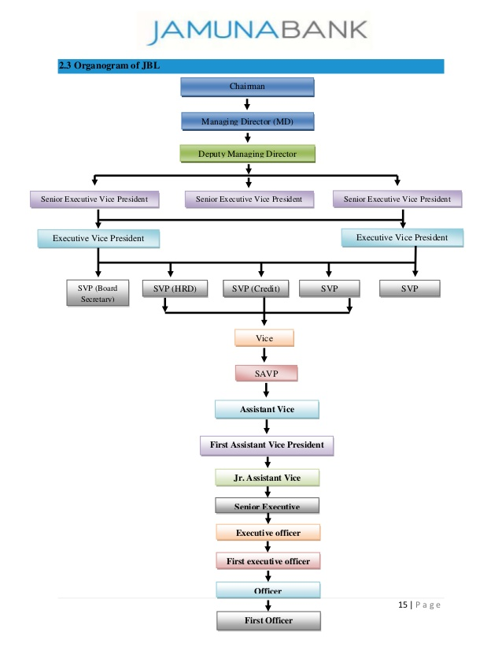

2.2 Banking Industry Analysis

2.2.1 Specification of the Banking industry
Bangladesh is an emerging nation. The banking segment assumes a crucial part of the country's economic growth. A country's banking system can well be considered to be an indicator of its growth in the economy. All around created banking framework is irreplaceable for present-day exchange and trade. Presently a-days, banks go about as caretakers of open cash as well as are basic as essential specialists for support of the sound budgetary situation of a nation.
Nationalized Commercial Banks (NCBs) be situated built up in Bangladesh in 1972 over and done with the union of twelve business banks that were working in pre-free Bangladesh permitting the helpless admittance to finance, lessening capital trip to far off nations, and expanding household venture was a portion of the essential target of this nationalization. That implies a general public with riches conveyed as impartially as could reasonably be expected. In any case, with time contrast those banks have changed their arrangements and procedures, which were not satisfying the class banking strategies of the administration. On an assessment of the exercises of business banks, it has been seen that the advances made by the financial business since nationalization was not amazing. The state-owned banks couldn't assume the due part in the execution of government projects and strategies. Henceforth, a pattern of de-nationalization of banks began in the mid-80.
Meanwhile, the strategy of the administration to the banking industry concerning monetary administration has changed later in 1976. That year private segment had been dependent to assume a greater function in the economy than previously. Likewise, to give more credit to nearby speculators the private division banking had been presented. The government chose to permit the setting up of neighborhood Private Commercial Banks (PCB) notwithstanding State-owned Commercial Banks (NCB) working in the nation.

Types of Banks

There are absolute 57 banks discovered in our list whereas 48 and 9 are Private and Public banks individually. Here involved 54 Commercial as well as 3 banks in a particular class. 9 Imported viable banks are presently working close to 48 homegrown banks in BD. Those imported banks are now working parts of the banks that are joined in out of the country.

✓ Private Banks in Bangladesh
✓ Public Banks in Bangladesh
✓ Local Banks in Bangladesh
✓ Foreign Banks in Bangladesh
✓ Commercial Banks in Bangladesh
✓ Specialized Banks in Bangladesh

Types of Banks

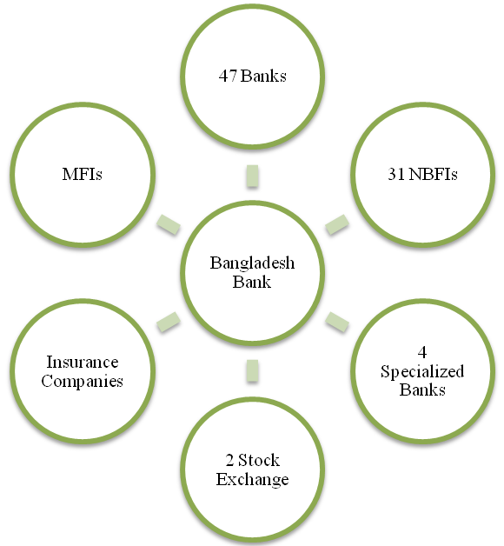

2.2.2 Size, trend, and maturity of the industry

The market size of an industry can be controlled in numerous ways, for example, Entire Revenue, Size of creation, the sum of clients, etc. Notwithstanding, if there should be an occurrence of the Banking part the component of market size is very unconventional as both the aggregate sum of stores and advances are taken into thought. Now Bangladeshi’s banking area is developing stage.
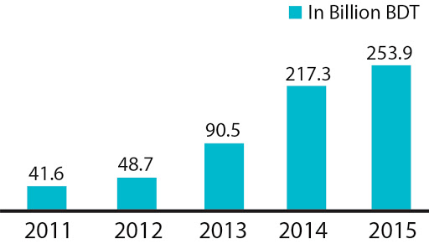

Growth Stage of Banking Industry in Bangladesh

Presently a-day banking division isn't just accessible in metropolitan individuals as it were. Rustic individuals are additionally including in this segment rapidly. Subsequently, the size of the heating industry is in the developing stage.

As of late the financial part and its administrations are transformed. In earlier days the financial balances were kept up genuinely and there were heaps of desk work to keep up a record and taking bank administrations. Be that as it may, these days all the banks are utilizing on the web to keep client subtleties and they can without much of a stretch utilize web-based banking.

They Can likewise do shopping through cards or send cash to anyplace with no desk work of banks. Standing banks and new banks additionally are attempting to make their techniques keeping this online pattern in their brain.

The pattern of portable banking is the most famous method these days. Bangladesh has just offered permits to 28 banks to exposed portable money-related administrations (MFS) and 19 have begun to work. For instance, Jamuna banks Mobile Banking joined business banks U-cash and so forth. Once more, Nagade/ Rocket can be an ideal case of how much this idea has gotten so famous in the middle of the individuals of this nation. Versatile banking has brought in cash move simple and helped the organizations also. Even barely some banks began specialist banking to not many locales.

There is likewise a pattern of E-banking which is the most up-to-date conveyance channel of banking administrations. Through this E-Banking, customers can take retail banking administrations through PC, TV, and cell phone. They can cover tabs or expenses and send cash even to another country following this pattern. In this way, these are the patterns of the Bangladesh banking industry.

The financial business of Bangladesh is presently in the developing stage. Among all the phases of the industry life cycle, we can realize that the financial business is taking the developing stage even though the shakeout phase doesn't appear to be excessively far away. A portion of the attributes of the change stage is now obvious. It is likewise obvious that the interest in banking administrations in Bangladesh has broadened day by all through the most recent couple of ages. The increasing amount of banks has an extraordinary effect on this reality.

2.2.3 External Economic Factors

The economies as well as the financial business (Banks) both are connected with one another. Pay streams whether the economy is consecutively or scarcely getting by during the hour of the breakdown. It influences how considerably national banks can admittance hooked on, or the spending stream, and the purposes for them, interfaces when clients get or spend assets at banks. Also, if inflation increases precipitously, the bank encounters the consequence; expansion influences cash worth and causes fluctuation. Alien financial specialists need to think cautiously before giving their capital when a specific nation's money is high. Trade rates as well as influencing external economic factors influence banks all around the world. For example, the US dollar sways different monetary forms, way of managing money or example, and inflation rates in different nations. On the off chance that swelling expands, at that point, the buying influence of cash will be less because expansion implies the buying influence of cash is a smaller amount. Simultaneously, the bank's loan fee will ascend in particularly in investment accounts, declarations of stores, and different items. Bank offers to pay fewer premiums now however the yearly rate yield will be striking. An ascent in dollar trade rates is ordinary yet it involves worry that it develops habitually.

2.2.4 Technological Factors


Now at this Moment, Technology is essentially accessible all over. At present many important tasks of the banking industries are completed online. Data innovation plays the middle stage and the client records of advances and protection, a few administrations can get into through on the web. Technology has enhanced banking systems and it becomes a continuous process. The greater part of the banks are presently offering their applications to make the offices smooth and helpful, for example, data of records, move of money, and installment of bills or complete check simpler. Cell phones can filter checkbooks and banks can prepare their method sitting in their area now. It reduces the time to save money and also working hours. Now through the ATM card, the customers can withdraw their money at any time and it is bringing great success to the banking industry now. Due to advance technological improvements, it’s quite easy to identify and investigate any fraud activities that are ensuring more safety and security in the banking industry now. These mechanical improvements create it more supportive to draw in the administrations of the bank and banks are currently applying innovations due to capability with one another adequately every bank should receipts mechanical support now.

2.2.5 Barriers to Entry

Doorman's Five Forces Exploration of the Banking business and Again Bank Threat of new contestants: The banking industry is more beneficial and there are not many boundaries to passage. At the point when other associations vie for a similar piece of the overall industry, benefits begin to drop. It is fundamental for current associations to make high hindrances to arrive to discourage new participants. The risk of new contestants for the financial part is small. Provided that anybody needs to begin another bank then he/she wants a minimum of 400 core taka and needs political help. Barriers to entry in money related administrations involving marketplaces incorporate licensure acts, capital prerequisites, and admittance to funding, administrative acquiescence, and security worries. The financial business of Bangladesh is improving. So the dangers of contestants of potential contenders are moderately high. Standing organizations have established some passage obstructions to discourage those contenders and made it expensive and harder to go into the business. The normal Barriers to passage are made reliability, outright cost-benefit, economies of scale, and administration directions. IN Bangladesh, brand reliability is remarkable. A reliable client of a neighborhood or government-possessed bank as a rule doesn't go for a global or new bank whatsoever their backings are. Clients are regularly apathetic to change. This is a major hindrance to new contestants. Something else is no bank appreciates an outright cost advantage, because of the incoherent idea of the business. The greater part of the administration banks and some neighborhood banks appreciate the size of the economy because of the way that they have been doing the business for quite a while and they have endless branches everywhere on over the region. Global banks are likewise on the way toward accomplishing economies of scale. Government guideline is very useful for the development and tasks of new banks. So this factor isn't unreasonably crucial.

2.2.6 Supplier Power

Solid negotiating power permits providers to sell more costly or inferior quality crude materials to their purchasers. This straightforwardly influences the purchasing organizations' benefits since it needs to pay further for resources. The haggling intensity of providers for the financial segment is low because the Bangladesh bank forces the guidelines and instruction. Branches don't get the all-entrance authority. The Head office monitors the branches.
Bargaining power can be estimated as a danger when the providers can constrain up the value that an organization must compensation higher for what they provide or decrease the quality. This cycle inevitably pushes down the organization's gainfulness. Be that as it may, if the providers are fragile, at that point, it very well may be a converse cycle. Provider power in the financial business is low. For the bank, the principal provider of assets is the contributors. Bank additionally develops its reserve from the chiefs. Thus, the quality of the provider's relies upon the accompanying elements:-
- The number of providers: Negotiating intensity of providers is low in the financial business because there is a great deal of discrete sparing in the economy however banks don't have an excessive number of chances to invest. At a similar period those banks proposal compensating rate and administrations, clients need to have those administrations.

- The threat of forwarding incorporation: We all realize that the bank brings in cash by sponsoring others' cash. Organizations or enormous global organizations can offer danger to the private banks that they will frame another bank for keeping their cash. They won't flexibly reserve to different banks. So this can be an incredible danger by the forward fuse.

2.2.7 Buyer Power

Buyer’s bargaining power can be affected more when the buyer demand low price with high quality of products or services from the company or organization but if the buyer becomes weak it turns into an extraordinary open door for the organization that they can increase their costs and make a higher profit at this situation.
In the banking sector, customers become buyers when they take loans from the bank. Purchaser power in the financial business is low. Some factors are liable for it:

- The number of advances (Loan) candidates: There are not adequate business advance candidates in our nation. There are over 50 banks in our banking sector for providing the loans. So the requiring of advance candidates, banks are set with their inactive cash close by, generally as close to home credits. Therefore, rivalry among existing organizations is expanding step by step.

- The Exchanging (Switching) cost: Switching cost is low in our financial industry. Every bank is giving a similar advance at similar loan fees so in this way; a person who needs to take an advance can switch effectively starting with one bank then onto the next if the individual doesn't like the terms and procedures of a specific bank. Lower exchanging cost makes the business more popular.

- The threat of backward integration: Because of backward integration in the banking industry there is an opportunity for the danger of in reverse mix. The multinational or corporate company can take advantage like they can start a new banking business like they will organize their cash by framing another bank where the cost of the fund will be low contrasted with different banks. Hence, monster clients of this industry are having more force than their banks.

2.2.8 Threat of Substitutes

A threat of substitution is one of the worries of the banking industry. We know substitution means alternative offerings like the same product or service provided by different organizations or companies. So in this situation customers can switch the organization for their betterment like bank X provide more interest or facilities compare with bank Y. so the customers of bank X can switch bank X at any time because of taking the advantage of bank Y. so it is the threat of bank X and it’s called the threat of substitution.
Generally in the banking sector, the threat of substitution is very low or not affecting so much in the deposits or withdrawals activities because every bank has provided the same facility of these activities and nor banking organization don’t do it but on the other activities like insurances policy, mutual funds, and fixed deposits these services are also providing many non-banking organizations so it is ‘threat of substitution’ of this banking business. The other factor is ‘the threat of payment method’ in the banking business. Banks cut off more loan interest when is giving to the customers whereas another non-banking organization provides loans with low-interest rates. So it is one of the biggest threats to this banking industry right now.

2.2.9 Industry Rivalry

The financial business (Banking industry) is profoundly competitive. The money related administration industry has been nearby for a long time and pretty much every individual who requires banking administrations as of now has them. Along these lines, banks must endeavor to bait customers from contender banks. They conduct this by presenting lower funding, upper rates, venture administrations, and more noteworthy accommodations than their opponents. The financial rivalry is frequently a competition to figure out which bank can propose both the greatest and quickest administrations yet has made banks involvement a lower ROA (Return on Assets). Specified the idea of the business, it is bound to see the supplementary union in the banking industry. Significant banks will in general like to obtain or converge with different banks than to go through cash showcasing and publicizing.

Chapter Three: Internship Experience



3.1 Internship Experience

I was relegated to the Pragati Saroni Branch of JBL to finish my temporary job program. In my temporary job program, I functioned as a front desk employee to giving general financial activities to this branch. However, above all, I understood how to function in a load of obligations. This pragmatic direction is essential for the progress and readiness of an individual before going into the business field.

3.2 Position, Duties, and Responsibilities

It is quite difficult for an intern to handle the entire general banking activities during this short period. But I try my best to manage and take these responsibilities to properly complete my internship program. I worked at the front desk and in my internship period I take some activities in JML, such as:

Different Types Of Account Opening | Write Pay Order
Remittance Incoming/Outgoing | Maintain & Balance Of All Security Papers
To Issue Cheque Books | Closure Of Accounts
Locker Services | Close Account
Supplementary | Finding Error In Account Opening Form
Thanks, Latter Sending | Preparing Cheque Books
Preparing Voucher | Files Reorganized
Providing the Bank Statement | LC Writing Etc.

My Activities in General Banking

I divided my activities in this report into the following 3 parts as General Banking Activities of Jamuna Bank Limited Pragati Sarani Branch and also I have shared my experience that I have been learned from my internship period in the below:

3.2.1 Account Opening Segment

The fundamental and main program of the bank is Account Opening. The relationship between a banker and his client begins after opening a bank account. This is the most significant area of a division because by opening records bank prepares assets for speculation. Different standards and guidelines are followed and different records are reserved while opening an account. A client can open various forms of records through this sector. Such as:

Types of Financial records (A/C) with their Rules and Regulations:

- Current Deposit

The current record is simply an interest store account. It has no limitation on pulling back cash after the account. It is acceptable when assets are to be gathered and cash is to be paid at regular intermission. Specific significant facts have been talked about in the task portion.

- Savings Account

It is basically for little scope investors. From now, there is a limitation on withdrawals in a month. A large number of withdrawals are allowed only against the earlier notification. Some significant facts have been talked about in the task part.

- Short Notice Deposit (SND)

Generally different large organizations, associations, Government Sectors retain cash in the STD account. Regular withdrawal is debilitated and needs earlier notification. The store must be saved a minimum of seven days to acquire intrigued. The intrigue untaken for STD is not as much as that of a reserve funds store. Interest is determined dependent on everyday least item and paid multiple periods in a year. The loan fee stands at 7.00%.



- Account Opening Procedure
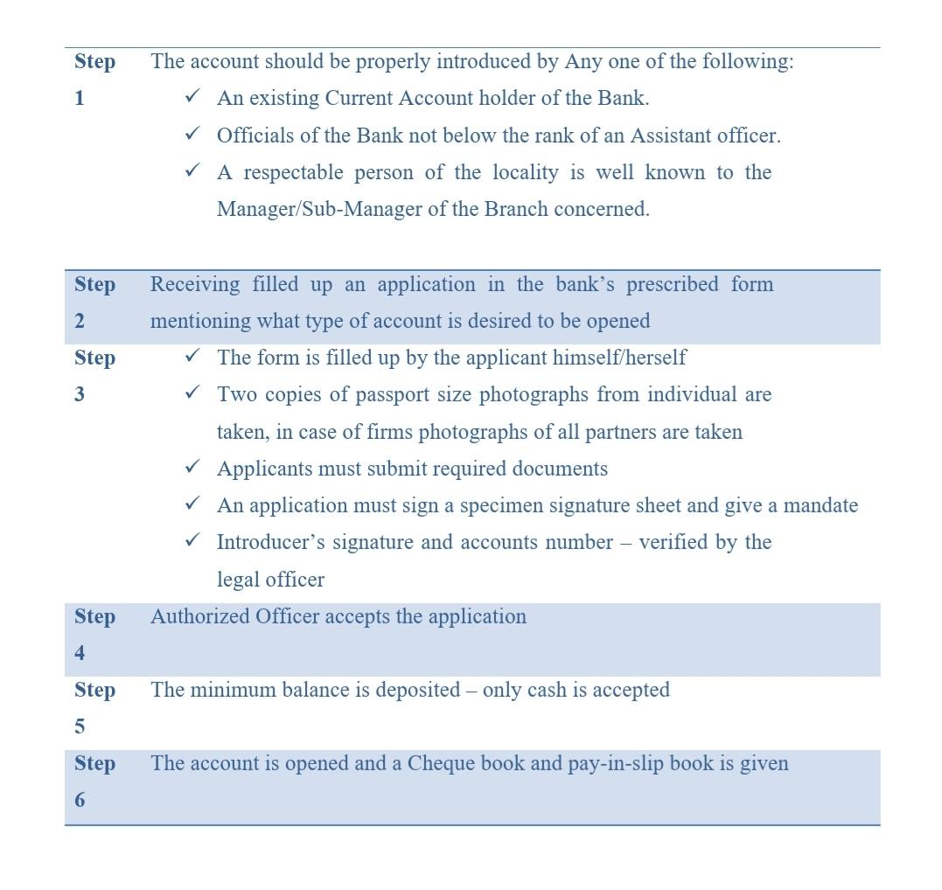

- Papers Prerequisite For Opening An Account
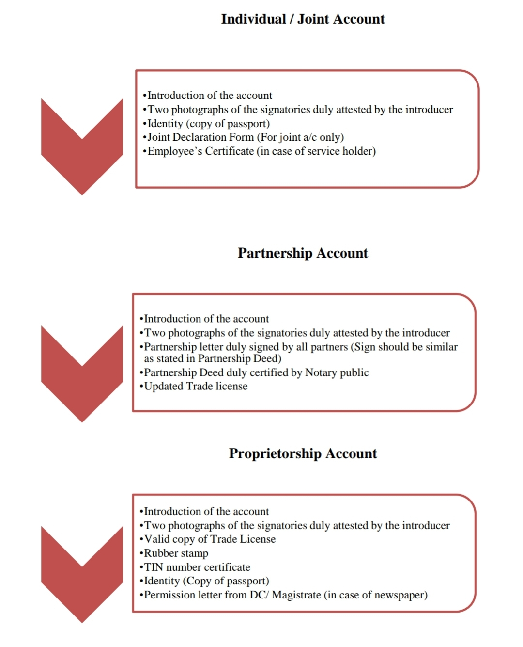
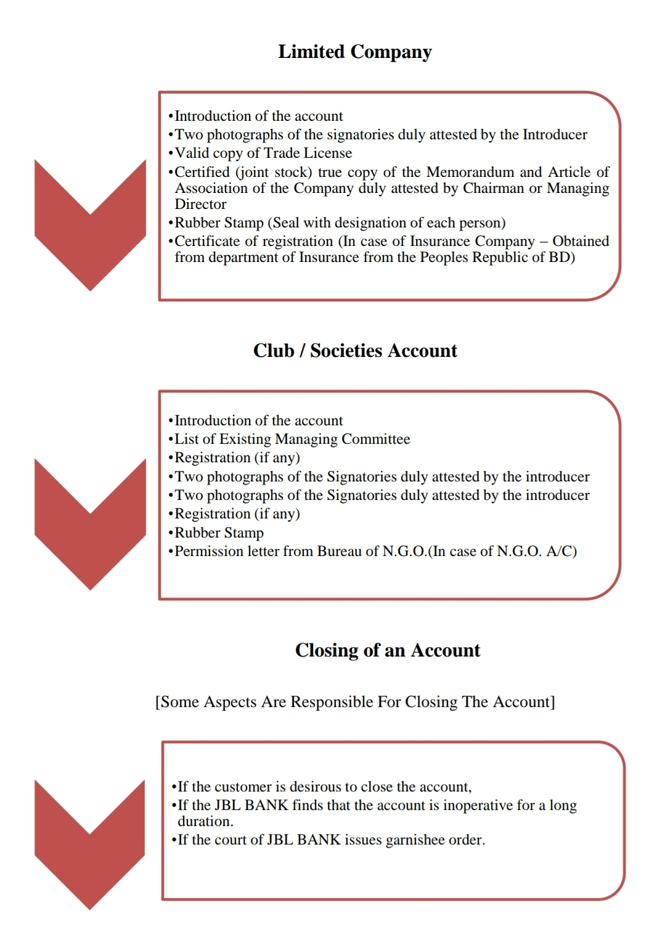

A client can disclose his/her record through a request to the bank. The client must be approached to pull the last check for the sum remaining to the credit of his/her record less the measure of shutting additional accidental charge as well as submission the fresh check leaves and the approved official of the bank ought to pulverize the unused check. For the mutual account, the request for shutting the record ought to be marked by every holder. The charge for the end of a record is Tk.50.

3.2.2 Local Remittance Segment

Conveying money is inconvenient and unsafe. That is the reason cash can be moved starting with one spot to another over the financial channel (Banks) and it is named as a remittance. It is the greatest significant parts of the Commercial Banks in delivering administrations to their clients.

The fundamental instruments utilized through the JBL remittance of assets are

So the fundamental three types of local remittances are talked like as:

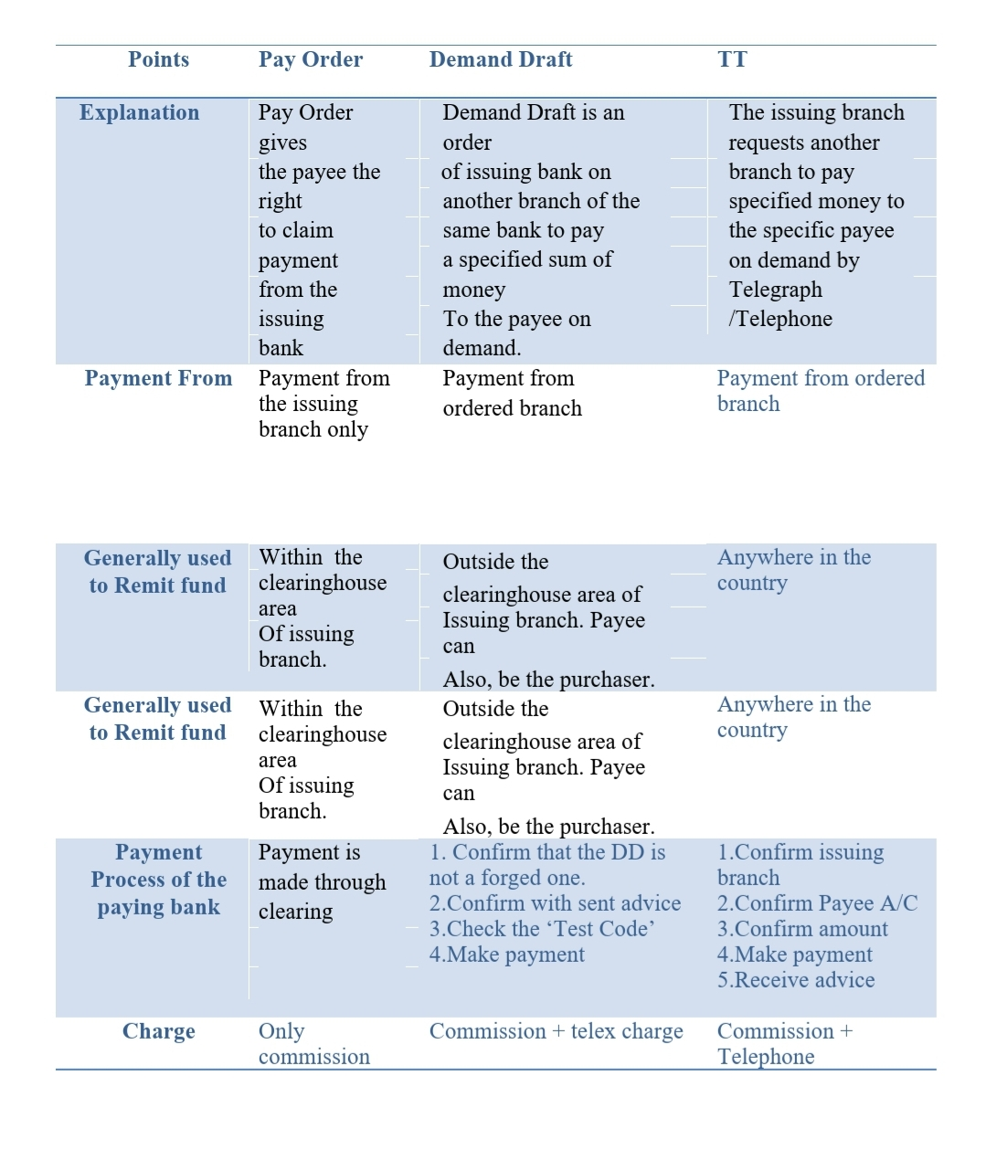
Three Types of Local Remittance

3.2.3 Accounts Segment

The Accounts Department is known as the operational hub of the bank. In the financial business, exchanges are completed each day and these exchanges are to be recorded appropriately and efficiently so that the banks manage the investors' cash. Inappropriate exchanges will misalliance to both sides. To keep away from the gaps, the bank offers different sections and the main purpose is to control the missteps in transient vouchers as well as incorrect passages/ misrepresentation and fake. This division is named as AD. Uncertainty any inconsistency emerges to every exchange this office report to the apprehensive office. On the other hand, the division needs to set up particular inward proclamations just as specific legal articulations, which are given into the Central Bank and the HO and this section arranges these announcements.
Activities of this Section Are like:

- Ready And Prepare Debit/Credit Vouchers Of This Branch
- Writing Different Dealings To The Registered Book
- Taking To The Utilities Bills
- Writing Pay Order
- Providing Bank Statements To The Clients
- Making The KPI And Sent It To The Branch Manager
- Read-Through To The Transaction And So On

3.2.4 Cash Segment and Other Similar Activities

The cash segment is a significant aspect of any branch. A large portion of the actions is communicated with the cash segment. The purpose of the cash segment is receipt and installment of money. I have done additional many Bank related exercises like register composing, Taking different bills, Sending e-mail, and call to clients for various causes. I go to the customers' apartment with my directing supervisor.

3.3 Contribution to Departmental Functions

I have done many activities during my internship period at JBL. I gather lots of experience by working different activities and try to contribute to our respected representatives like performing as an employee of general banking activities and conduct various tasks such as various types of account opening, remittance providing, to issue checkbooks, providing locker services, ready to the supplementary, thanks latter sending, preparing voucher, providing the bank statements to the clients, writing pay order on register book, maintaining & balancing of all security papers, cl accounts closing, calling to the customers for verities reasons, finding error in account opening form, get ready to checkbooks, files reorganized, LC writing, etc.
Additionally, I also worked on the other department like 1) loan department 2) letter of credit department 3) cash department, etc. And the activities are like- visiting the construction buildings with my supervisor, talking to the customers, NID and other documents verification, writing different dealings to the registered book, read-through to the transaction, making the KPI, and sent it to the branch manager, and so on. I try to give my best effort to contribute to this branch.

3.4 Evaluation

It was extremely fascinating to functioning at JBL. Every individual was so humble and cooperative with me. My evaluation of this organization is like:

- Tasks are never left forthcoming for the following day except if it is completely essential.
- The work cycle can be completed quicker with better-working frameworks and internal Interacting Arrangement.
- The branch manager evaluates each employee bias-free.
- The Head office and central bank regularly control and audit these bank activities.
- Great job execution is constantly applauded which inspires the representatives.

- Customers are satisfied with taking service from this bank and their complaint rate is very rare and when the complaint arises employees try hard to fix this problem in a short time.
- Every employee is more punctual and they maintain on-time activities.
- There is consistently a surge of clients on this division so the quantity of exchanges is high. Along these lines, the representatives stay occupied for the duration of the period.
- The work exercises remain constantly set and separated for every one of the representatives. Every single representative has a specific arrangement of accomplishments. They completed those duties for the duration of the time. It is simple to appoint responsibilities that way. Additionally, I frequently observed everybody help with each other.

3.5 Skills Applied and New Skills Developed

As an internee, it’s my pleasure to working for this organization. I have worked on an entry-level position in this branch and I try my best to do every works more effectively through using my general skills like Microsoft office skills (MS Word, PowerPoint, and Excel), social media knowledge skills, interpersonal skills, writing skills, good communication skills and other basic skills that I learned from my academic career.
For working of this organization, I have developed also many skills from here like I have learned real working experience underperforming this branch, to know about the corporate life, improve my communications skills, learned about the banking software systems, develop the basic idea of the banking sector, improve the ability to work under pressure, to know about how the customers handle at any situations, learn how the products or services offerings to the customers and Inside the period, I needed to manage diverse assigned workers and staff of the division and different varieties of customers. I handled a few sorts of circumstances; several fulfilled me, some dismal, some displeasure, and so forth. Through these good and bad times, I ought to realize what the atmosphere office is and how to manage it and other skills/ abilities that will be developed for working this branch and these skills assuredly made me ready for my next commercial time.

3.6 Application of Academic Knowledge

Temporary position (Internship) is also related to the corporate business through scholarly life. In the temporary job time, educational information gives more support to the person to perform his/her tasks easily. Therefore how I use my educational information’s is given beneath:

Section of General Banking: Every branch is part of the main bank. So Customers can know their banking information’s from different branches. At the position of my general banking, I utilized my scholastic information through doing DPS and FDR because it needs to find out the rate of interest for a particular individual at a particular rate for a particular period. It tends to be 3 months, a half year, 1 year, 5 years, and 10 years. I needed to compute the rate on the sum to their FDR. That implies the rate they will acquire and what they will acquire once the FDR will mature. Moreover the similar process, I needed to prepare in the event of DPS. So my academic knowledge has been applied in this following way to the JBA segment.

Section of Credit Division: Into the credit division the primary concern they do is giving loans. There are a few plans for this bank and for each plan the financing cost is unique. At this time I need to estimate the interest as per that specific pace of the plan. I followed a chart for this interest that the creditors need to remuneration to the bank and if any regularly scheduled payment they need to remuneration or not. I have additionally utilized my understanding of proportion examination into the credit office. I utilized the equations of current proportion, quick proportion, and so on. Thus, these things I can utilize though operating in the credit division.

Chapter Four

Conclusions and Key Facts



4.1 Conclusion

Each bank has its extraordinary procedure or tactics that prompts their destinations or goals. Specific banks wish to become quicker and accomplish some long-extend development. Then again, a few banks need to have a peaceful existence reducing hazards and continue better performance by following proper rules and regulations.

At this time new banks are accompanying various thoughts and dreams. Though Jamuna Bank Limited has just earned decent notoriety in the nation and it gets one of the top banks in our nation. Afterward, the foundation offered new items and administrations for its customers and developing their status based on great products and by providing the best services. The statistics indicate that the performance of JBL is expanding step by step and if they retain this advancement ongoing, then the bank will become a top bank among the private business banks in Bangladesh done their energetic performance and solid administration. Also, they have just made a smooth activity arrangement in export and import from the time when 2001.

4.2 Recommendations

Jamuna bank is one of the great and well-reputed banks in our banking sector. So it is quite difficult for me to give suggestions or recommendations to this organization. But from my internship experience, I am providing some recommendations which JBL can follow for their betterment and it will help to reach as a top performer to this bank that I believe.

- It has only 62 branches in Bangladesh. Since step by step, their interest is expanding so it is very difficult to meet all customer's demands in every place. So they have to put more consideration into the development of branches particularly in metropolitan regions where other banks are making the most of their business forlorn just as ATM Booths.
- JBL gain 68.87% benefit from Dhaka City. So JBL should also expand its activities all over the country so that they can earn more profit than before.
- JBL ought to work universally. Following this cycle, JBL has begun its activity in Malaysia to move smooth settlement into Bangladesh. So, the region ought to be expanded internationally.
- To compete with other banks JBL ought to acquire new thoughts and innovation dynamically.
- They ought to have their own Research and Development division.
- A marketing strategy ought to be stronger. They have to redesign their current promoting methodology for attracting more customers and they have no marketing division. So they should focus on this drawback.
- The authority should enlist more representatives to serve the clients so they ought to hire a more experienced and fresh graduate representative in their banking sector. JBL ought to redesign its Front Desk as it remains amazingly bustling the entire time and we all know GB is the base for any bank so for smooth activity in the GB section, JBL should enroll more energetic and talented HR.

- Various motivational activities should be taken in every branch because it motivates and satisfied their employees on their performance.
- The bank should fund purchaser products because numerous individuals in the nation need to purchase consumer goods from the bank advance.
- They ought to take an early activity to progress their ability in speculation dealings to be briefer.
- JBL can offer diverse store plans (Deposit Schemes) for school and college understudies.
- JBL ought to explain and embrace exposure about their position and their exercises in financial and socio-cultural improvement in the country.
- They need to extend the ATM card framework very fast to contend with the highest level banks so they ought to exposed additional ATM stalls to address client demand and for better opposition.
- For improving the quality of service performance and other activities, staff and departmental consultation in every branch should be enhanced.
- For establishing a good position and reputation the bank should take some aggressive marketing strategy.
- The management should take immediate decision to take the current opportunities.
- JBL should provide equivalent importance to female applicants regarding enrollment.
- The bank ought to be more worried about the benefit and also should involvement in the financial advancement of the nation.

I trust that these suggestions would be useful for Jamuna bank Limited.

REFERENCE

- Jamuna Bank Limited Annual Reports of the Last Five Years
- Jamuna Bank Ltd. (2020). Retrieved 26 September 2020, From Https://Jamunabankbd.Com/Front/Information/1/81
- Anik, A. F. (2019). Internship Report On The Banking Industry Of Bangladesh & ONE Bank Limited With The Internship Experience.
- Ahmed, J. (2018). General Banking Activities and Market Development Initiative” Of the Premier Bank Limited.
- Uddin, A. (2019). Foreign Exchange Operations of Jamuna Bank LTD (Mohakhali Brach).
- Rubel, M. (2014). Credit Department of Jamuna Bank Limited.
- Haque, S. (2011). A Working Report On General Banking Of Mutual Trust Bank Limited.
- Hossain, M. (2016). General Banking Activities of the City Bank.

APPENDIX: A
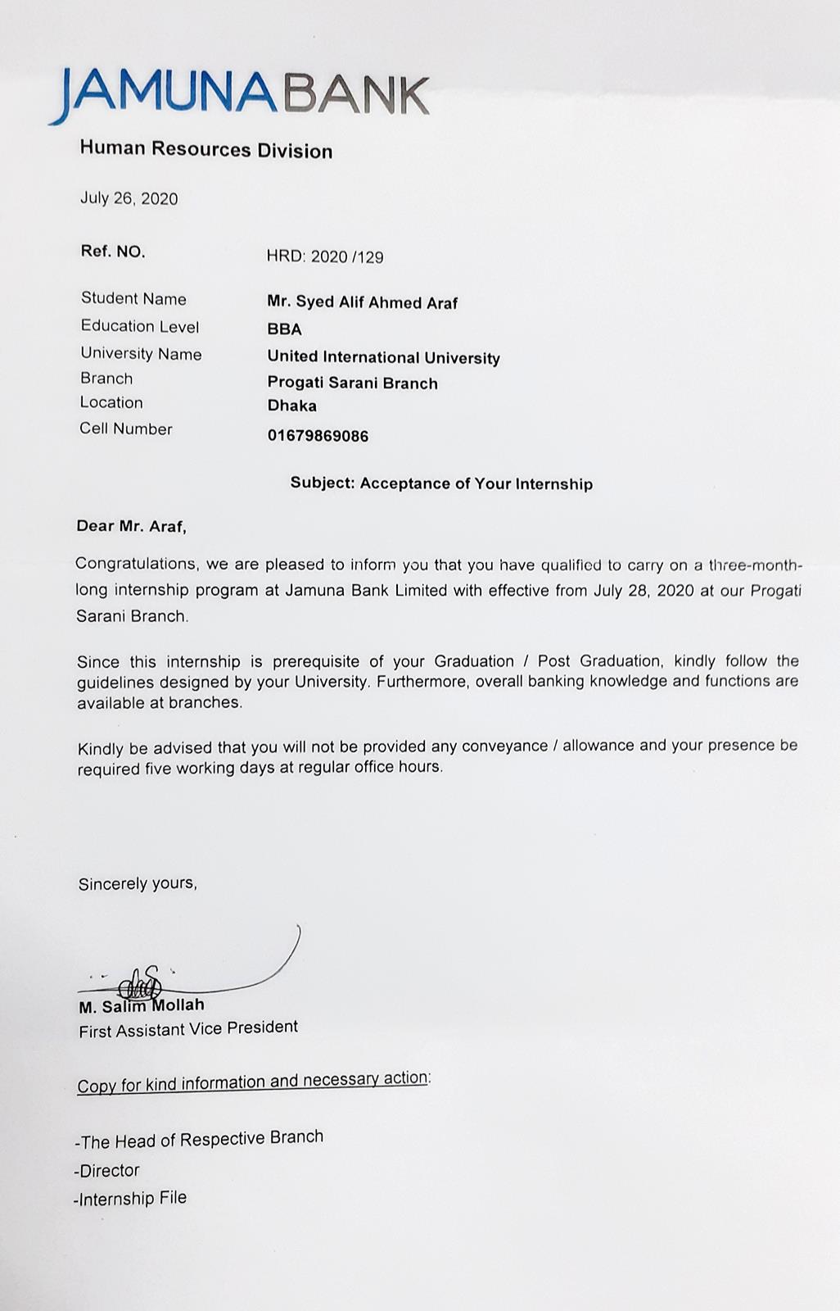
Attach to my internship appointment letter and visiting cards to my supervisors in the given below:


Thank you!!

