


Analysis of Marketing Strategies of Ispahani Tea Limited

Submitted To
Dr. Md. Shariful Alam
Associate Professor
School of Business & Economics
Submitted By
Amena Khatun Moon
ID:111 143 182

Acknowledgement

Firstly, by the grace of Almighty Allah I got a chance to finish my internship report precisely. I express my gratitude to my honorable supervisor Dr Md Shariful Alam, Associate Professor, Department of Marketing, United International University, for his guidance and cooperation, which helped me to make this report. I will never forget his contribution to finish my internship report in my entire life.
Then I express my thanks to Mr Harun, Sr. Manager, (Sales and distribution) for his kindness who actually gave me the opportunity to work in such a reputed business house at respectful department. I have learn lot of things about research and planning through my internship period. I express thanks to the Sir Sharfuddin Ahammed, Brand Executive, who has helped me a lot to conduct survey along with market visit as well as analyze the data and by providing much valuable information to this report. I have learnt things regarding data assortment from him and I do recognize his contribution. I will be glad to recall the contributions of all the officials of M. M. Ispahani Limited, Corporate Office 14-15 Motijheel C/A for their pleasant hospitality. Without their co-operation it would not be possible for me to work on such an important project.
I prepare this report based on my internship experience on M. M. Ispahani. I have provided proper citation for the information that I have collected from other sources.

Letter of Transmittal

July 24, 2019
Dr. Md. Shariful Alam
Associate Professor
School of Business & Economics
United International University

Subject: Submission of Internship report on completion of B.BA program.

Respected Sir,
It is a great pleasure for me to submit my internship report on “Analysis of Marketing Strategies of Ispahani Tea Limited”. The internship report is submitted as a part of the partial fulfillment of BBA program.
This report titled as “Analysis of Market Strategies of Ispahani Tea Limited” has been completed by the knowledge that I gathered from the major courses on marketing which I have completed during my BBA as well as from my internship in Ispahani.
In writing this report, I have followed your instructions to make this report a valid one. Hopefully, you will discover my well-researched and informative report as an outcome of my three months effort. I would like to thank you for the opportunity that you have given me to do the study at Ispahani Tea limited which has given me real-life experience. Any query regarding the report will be appreciated.

Sincerely yours,

………………………….
Amena Khatun Moon
ID: 111143182
Batch: 143
United International University

Student Declaration

I, Amena Khatun Moon, hereby declare that the presented report titled “Analysis of Marketing Strategies of Ispahani Tea Limited” is prepared by me. I also confirm that the report is prepared only for the requirement of completion of BBA Degree, not for any other purpose.

………………………….
Amena Khatun Moon
ID: 111143182
Batch: 143
United International University

Executive Summary
Ispahani Tea Limited is a well-known company in Bangladesh. Since 1820 they are doing business in Bangladesh. They are very well-known for some of their famous products. “Ispahani Mirzapore Tea” is a known brand across the country. Now they are facing a huge challenge in the market. A survey has been conducted to know the present market scenario of Ispahani Tea in Bangladesh and their marketing strategies and find out the causes behind Ispahani’s loss of market share.
From the survey, we have found different forms of information of Tea market scenario what need to be analyzed. It’s also been found how many Tea Stalls and hotels and number of families are using the branded Tea, what kind of tea they are using, amount of their daily consumption and also their sale, along with the source of buying Tea (Leaf) correspondingly. This study also helped to find out Tea Stalls, hotels and householders brand awareness and which Tea brand name comes first to their mind when they visit the market for buying tea leaf and Ispahani held Top position on this survey. Brand loyalty percentage of Ispahani Tea among competitive brands is high. Due to the higher price, Ispahani lost their sale in some tea stall and hotels even though Ispahani offered lower profit to the tea stall owner and hotels compared to competitors.
Ispahani has the biggest distribution network in Bangladesh with huge human resources, they have depot throughout the country along with the divisional office. They distribute their product on the market by their own salesperson. A very limited number of Tea Stalls and wholesalers claimed that they are unsatisfied with Ispahani because of unavailability and it forces them to use another brand. Most of the superstores charges to the branded company for shelf branding and display program. And Ispahani does not pay them, and that is why the superstores keep Ispahani product on the shelf unorganized. On the other hand, Seylon and Taaza (competitors of Ispahani tea) are kept in a convenient shelf precisely because they pay extra charges for the shelf.
This report suggests a few reasons for the unavailability of this brand as a recommendation to the company. In Bangladesh Tea Stall market and hotel business, use Seylon in Dhaka city and outside of Dhaka city they compete with Ispahani most ferociously. A competitively less price and more frequently TP offered than Ispahani makes Seylon famous to them. Besides Taaza (a product of Unilever Bangladesh) competes with Ispahani in the family consumers. Tea stall and hotels are concerned about the price rather than quality. They look for a low price product. But in household consumers prefer quality rather than price. For increasing Tea sales volume in the Tea market, Ispahani should offer some TP and CP offer according to the market demand though very recently it has given CP offer for consumer (4 tk discount for 200 gram and 10 tk discount for 400 gram in Ispahani best leaf and lucky coupon winner will get mug and Bali Indonesia tour. Besides, it has been found that their trade marketing department do some activations on special occasions on school or universities. They serve free tea to the people. They always try to capture the household consumer by their branding activities. According to Tea Stall and superstores and wholesale markets observation and findings, this report may be helpful to face the challenges of competitors by filling the gap what is needed by the Tea Stalls, hotels and tea lovers.
Table of Content

Acknowledgement ii
Letter of Transmittal iii
Student Declaration iv
Executive Summary v
Chapter
- Introduction 1
Objective of the Study 1

Board Objective 1

Specific Objectives 1
Rational of the study 2
Scope of the study 2
Limitation of the study 2
- Methodology 3

Data Design 3

Source of Primary Data 3

Source of Secondary Data 3

Analytic tool 4

- Organization History & Background 5-14
SWOT analysis 15

4 Analysis and Findings of the Study 17-32

- Conclusion and Recommendation 33

6 References 34
Appendix 35
Acronyms 38

Ispahani Tea Limited

1. Introduction
Ispahani Tea Limited since 1820 Certification of ISO: 9001 and one of the famous private conglomerate industries in South Asia. On 1900 its Head office was in Kolkata and later in 1947 they moved to Chittagong after that they build many corporate offices gradually in Dhaka, Khulna, Sylhet and Tea Estate and production zones etc. In Bangladesh M.M Ispahani Ltd is the biggest Tea trading company and captures a big market share of Tea industry. “Ispahani Mirzapore Tea” is the most popular Tea brand in Bangladesh which is considered as a category and generic name of Tea more than a brand. The company has strong distribution network where big organization like Unilever cannot go for head to head completion. The group has many supplementary companies in different sectors. They also serve the nation with Corporate Social Responsibility activities by founding EYE Hospital which is known as Ispahani Eye Hospital and many educational institutes as corporate philosophy. From the beginning they served good quality products and services to the national and worldwide.

1.2 Objective of the Study
Board Objective
The broad objective of the study is to make an idea about the daily routine as well as factors that influence to shape the daily activities and habit of media of a typical child

Specific Objectives
- To describe the company profile of Ispahani Tea limited
- To analyze the marketing activities of Ispahani Tea limited
- To describe SWOT analysis of Ispahani Tea Limited
- To find out problem of marketing activities of Ispahani tea Limited
- To give some recommendation of those identified problems.

1.3 Rational of the study
A large number of buyers are concerned about the brand Ispahani Mirzapore. Present market scenario is not up to the mark for Ispahani Tea Limited because of huge competitors. They need to improve this situation. This report is important to the concerned person of this company to know why they need to improve their strategies.

1.4 Scope of the study
This report covered overall sales strategies of Ispahani Tea Limited and the present market scenario of Ispahani Tea and how people specially the traders react towards this brand. Why they need this tea rather than other tea brand.

1.5 Limitation of the study:
I had to go through some limitation while making this report. I tried my level best to complete my report paper. I have faced some problems and limitations which are as follow:

Confidential information:
Every company has some confidential information. I faced difficulties to collect that.

Lack of experience:
As this is the first formal report which is prepared by me, lack of experience is also a limitation.

Shortage of time:
The duration of my work simplest three months. But this period of time is not sufficient for a complete and clean study. If I had enough time, I think it could be better.

Gender Issue:
As a girl it was difficult to visit market alone. I visited the market with an executive of the organization from brand department when he visited the market.

2 Methodology:
2.1 Data Design:
The sampling survey technique has been followed to make the report as given instruction. The whole study has been separated in parts quantitative and qualitative. In questionnaire only few parts are set in quantitative and most of the questionnaire has been set in qualitative approach.
The survey of the study includes both open-ended and close-ended questionnaire format to be asked for Tea Stall Owner directly. To collect data from Tea Stall author of the study went for surveying in Dhaka Metropolitan Area best possible. The surveyed locations are Azimpur, Lalbagh,New Market, Dhanmondi, Mohammadpur, Wari, and Mogbazar. Roadside and circle based (nearby) Tea Stalls were selected to survey. Most of markets area has been skipped during survey. Market area shopkeeper are too much busy to give interview. It suits best with interviewing of road side Tea Stalls and more over these are highly noticeable to the surveyor.
At first data collection method was started with an expected manner during the survey session exchanging greetings and giving a short description of survey reason by referencing the name of organization M. M. Ispahani Limited where the surveyor has come from. Later the session has continued through informal friendly conversation.

I have collected data from two relevant sources. These are:
2.2 Source of Primary Data: Sources of primary data collections are as following,
❖ Conversation with the senior employees.
❖ Communication with consumers that frequently purchase service from Ispahani Tea Limited.
2.3 Source of Secondary Data: Sources of secondary data collections are as following,
❖ Internet and company website (www.ispahanibd.com).
❖ Bangladesh tea board. (www.teaboard.gov.bd)
❖ Referred books.
❖ Annual report.

During the survey I got permission from my supervisor (Intern) and a Sr. Manager to set up the sample size. Based on my ability to visit a market I fixed to study on 150 sample size which is based on Dhaka metro city. I choose to use convenience sampling.
2.4 Analytic tool
I followed the same way what I learned during my internship period under the Business Development department of Ispahani Tea Limited. Both surveyed primary data and internet collected data have analyzed in Microsoft Office and Excel program. Raw data have been processed, transferred and examined carefully.

3. Organization History & Background:

Ispahani Tea Limited since 1820 Certification of ISO 9001: 2008 and one of the renowned private conglomerate industries in South Asia. Its head office was in Kolkata in 1900 and later in 1947, it moved head office in Chittagong with many corporate offices gradually in Dhaka, Khulna, Sylhet, and Tea Estate and production zones etc. The group is creating opportunities of employment in various sectors day by day. In our country. It is the biggest Tea trading company and occupies a giant amount of market share of Tea industry. “Ispahani Mirzapore Tea” is a popular Tea brand within the country which is considered as a category and generic name of Tea more than a brand. The group has many subsidiary companies in different sectors. It also serves the nation with (C.S.R) Corporate Social Responsibility activities founding EYE Hospital and many educational institutes as corporate philosophy. From the establishment it was committed to serving good quality products and services to the nation and worldwide. This philosophy has been created a good corporate image that influences the company among the community. It is beginning Ispahani as a group is conquering the community love, dependence and support. It is established to serve the nation with best quality products and services till the survival.
Ispahani is the largest tea company in Bangladesh. As a pioneer in Bangladesh's tea business, they have introduced the first laminated pouch, double chamber T-bag, stack-up pouch, food grade jar, three-layer wide pouch, 10 gram packs and bag-in-bag packets in Bangladesh market.
In Bangladeshi perspective, tea means Ispahani. They are concerned about providing restless satisfaction to our customers and enjoyable moments for a long time.

3.1 Organization Mission

Ispahani Tea Limited has a set of mission to see the business in Bangladesh and others countries. Some of them are given below,
- Increasing the profit size by enhancing total sales.
- To be the market leader in the serving industry.
- Balancing the price with product and service quality.
- To secure consumer rights providing best quality food and service.

3.2 Organization Values
Ispahani tea limited maintains a highly ethical standard. Their values indicate some set of criteria given here:
➢Respecting the competitors among industries.
➢Not to compromise with the quality issue.
➢Research and development.
➢Highest customer value.
➢Ensuring best utilization of the resources.
➢Appreciating the efforts.
➢Serving the society Corporate Social Responsibility.

3.3 Organization Strategy

Ispahani tea limited sets the business strategies for the well-being of company as well as for the industry. Some of them are given below:
➢Fixing a clear objective to achieve.
➢Working as a team.
➢Adapting with the changed environment.
➢Conversing through integrity.
➢Searching for the best potential.
➢Caring for mutual benefit.

3.4 Organizational Chain of Command (Hierarchy for Marketing)

Ispahani Tea Limited follows a horizontal chain of command as hierarchy. Each of department has individual structure for operation. Here the model marketing hierarchy is given below.

Top line Management

Chairman

Managing Directors

Senior Manager (Marketing)

General Manager

Manager

Middle line Management

Divisional Manager

Mid Line Management

Territory Manager

Territory Officer

Sales Officer

Assistant Sales officer

3.5. Company Businesses

The company has different kind of business sectors in more than 13 fields of industry. Those fields are Trading, Agro, Hospitality and Leisure, Packaging, Energy, ICT (Information and Communication Technology), Poultry, Foods, Real Estate, Shipping, Jute, Cotton and Textiles, Tea Garden and well established Tea Trade. A short description of these companies and competitions is given here gradually.

Trading

The company has a trading wing named south east trading limited. It was established in 1979 and contains bigger project works like supplying for ports and shipping, utility provider’s state owned organization road construction, water-sewerage in our country.

Agro
In agriculture sector the group established Ispahani agro limited in 2007 as having a philosophy behind nation’s food security including three different wings of seed, bio pesticide, and agro processing. It commits to meet country’s agro industry development as operating business in a mostly agro based economy.

Hospitality and Leisure

Ispahani has hospitality and Leisure business named The Avenue Hotel and Suites located in Chittagong. For catering it owns some stores named Pitstop Bakery and Sweets, Pitstop Store and Pitstop Restaurant in the same premise. These provide best quality food and refreshment to the consumers.

Packaging

To serve with poly products for many industries like garment and textile, consumer food packaging, see food preserving, tea packaging etc. Ispahani Marshal Limited is a pioneer poly manufacturer in Bangladesh. It serves both domestic and multi-national companies beyond border for many successful years.

Energy

Ispahani has a power (electricity) supplying company named pahartali power house for its factory including a project agreement with power development board of Bangladesh government and that plant is situated in chittagong nearby the one of company factories.

Information and Communication Technology (ICT)

Broad band telecom services limited provides I.C.T solution to country’s internet usage industry. It was founded in the year of 2002. It covers 7 divisions including 48 districts of the country in an outstanding network.

Poultry

In 1997 Zareen farms limited was established for serving eggs and chicken to meet up the country’s protein demand as initially a public limited company joint venture with m. M. Agha limited. It provides 5.5 million day-olds chicks and 7.76 million eggs per year to the market.

Foods

Ispahani foods limited is a subsidiary company of ispahani group and was founded in 1999 factory plant located at gazipur. It does agricultural and food businesses like manufacturing fast moving consumer goods (FMCG). The product category is rice, potato chips, energy cookie biscuit, chanachur, bakery and snacks item ISPI powder drink etc.

Real Estate

It has two companies named Free School Street Property Limited and Nasirabad Properties Limited as their real estate wing. These help to develop and design companies and for third party construction like road, building etc. Another company named Sikomi Properties Limited provides company’s tea state water plantation facilities.

Shipping

In Bangladesh, Ispahani limited has been acting as second oldest agent for many shipping lines for more than 50 years. It operates the business as a non-vessel operating common carriers for renowned agency like hoegh lines, Oslo etc.
Jute
Though jute industry is considered as one of the sunset industries in Bangladesh ispahani have glories progression in this sector. In early 1950, Chittagong jute manufacturing company limited was established to produce jute and supply. Later another company was also established named as victory jute products limited and because of losing demand it turned into a warehouse business.

Cotton and Textiles

Pahartali textile & hosiery mills is a unit of Ispahani’ thread yarn manufacturing business. It provides categorized high quality yarns to country’s export oriented knitting industry remarkably from the establishment year of 1954. It is termed as one of the biggest yarn suppliers among the suppliers and most revenue earning department for Ispahani group.

Tea Garden

Ispahani group owns four tea gardens across the country. Mirzapore, Gazipore, Zareen tea estates are located in Moulavi Bazar, Sylhet and Neptune tea estate is located in Chittagong. These estates supply tea for own company and for the market dealing at the Chittagong tea auction. Those gardens yield on average 1800 kilos the highest amount achieved nationally. In tea gardens ispahani produces a small volume raw rubber sheet and its 75 percent of total productions are being exported to the international market.

Tea sale

Ispahani mirzapore tea is the most famous and sole largest tea categorized brand in Bangladesh. It pioneers the tea market segment from the very beginning of country’s tea manufacturing history. Ispahani tea department is one of the most profitable revenue sections for the company considering since its operation. Its tea blending and packaging factory, located in Chittagong ensures the best quality of packed both for foreign and local market to be served. Tea .it is providing quality tea product and for that it has been achieved IOS 9001:2008 certification because of excellence management coordination. Being as market leader in branding arena it becomes a household consumer brand name too. Community recognizes the brand as a category wherever it is found appreciably.

Sales Volume of Ispahani Tea

Ispahani tea limited during my internship session i got opportunities to work in different department of the organization mainly under their business development. This development also does marketing, research and planning for tea department. According to last tea sales record (source: audit 2017-18), Ispahani tea department has been sold out to 20 million kg tea (approximately).

Size of Workforce

Ispahani limited as a group provides work for more than 10000 employees and this number of employment rate is enhancing continuously.

Ispahani’s Competition among Industry

Ispahani is a market leader still now in the Tea Market segment. Other brands like Seylon (from AbulKhayer Group of Companies), Taaza (from Unilever), Fresh, No. 1 (from Meghna Group of Industries), HRC (from HRC Products Limited), Tetley (marketed by ACI Limited in a Joint venture with Tata Group), Danish (from Partex-Star Group), Shaw-Wallace (from Shaw- Wallace Bangladesh Limited), Pusti (from T. K. Group of Companies), Muskan (from S. A. Group of Industries) and Finlay (from The Consolidated Tea and Lands Company Bangladesh Limited) are the most branded Tea competitors in the market. In recent years only Taaza is considered as strong competitor of Ispahani Tea Brand in city market. At the time of market visit, I have noticed that most of the wholesalers say that Taaza is the second best selling product after Ispahani. Seylon is being popular day by day and increasing its acceptance to the hot tea stall and hotel at an increased growth rate. In my survey it is also noticeable Seylon is capturing large amount of market share especially at Hot Tea Stall market in Dhaka city. Some competitors are performing well in cities or any particular locality but an intensive strong distribution channel strategy and strong brand value to the people of Bangladesh have made Ispahani Tea brands indomitable. In Textile section, Pahartali Textile & Hosiery Mills (PTHM) faces severe competitions in the relevant industry. In this industry other market players like Beximco, Square, Badsha, and Desh are the main competitive Textile manufacturers. Here PTHM’s position is well enough serving various range of cotton yarn supply and it is considered as one of the profitable unit for Ispahani. Ispahani Foods Limited is a growing food item manufacturer of the group. Here competitors like Square Food & Beverage Limited, Akij Food & Beverage Limited, Pran-RFL Group, Bombay Sweets etc. are good performers among food and beverage industry. In comparison of competitors’ success Ispahani Foods Limited can be regarded as question marked unit in order to Boston Consulting Group (BCG) matrix. In Agro division, Ispahani Agro Limited (IAL) faces huge competitions by well-established companies. Here IAL has to face competitors like Supreme Seeds, United Seeds, Petrocam, LalTeer etc. are the main market players. Being a new company in agro sector since 2007, IAL is considered as developing one for the group. As a group Ispahani competes with other mergers by diversification of many units of business. Large and established companies like Unilever, Beximco, ACI, AFBL, Square etc. have made the industry more competitive than earlier booming period. In only Tea sector Ispahani occupies the market as monopoly. To sustain in the industry M. M. Ispahani Limited would like to serve the market with best quality products and services as following set of corporate ethics.

3.6 Ispahani Tea Distribution Channel

Ispahani distributes their products 64 districts in Bangladesh. They have total 26 divisional warehouses and 528 Depots across the country. They transfer their products to sales centers from the divisional warehouse. After that, the Sales center employees are selling products to the retailer. Finally, consumers are buying from the retailer.
Consumer
Ispahani / Manufacturer Tea Blend and Packaging Factory.
Retailer Supper Shop Department al store Shopping mall
Sales Centers
517 Depots across the Country.
Division Warehouse

Distribution Channel & Place

3.7 Product Line in Ispahani Tea Limited

In Bangladesh the way of consuming tea differs place to place. For this reason the company launched different branded Teas throughout the country. Here some of their Tea brands are given below including the existing market area.

Brand Name | Served Area
Blender’s Choice | All Districts
Five Star | Bogra
Green Spot | Chittagong, Rangpur, Bogra
Hot Tea Stall | All Districts
Hotel Dust | Bogra
Lion Dust | Rangpur and Rajshahi Divisions
Lion Leaf | Rangpur and Rajshahi Divisions
Mayur | Dianjpur, Rangpur, Rajshahi and Khulna
Mirzapore BL | All Districts
Mirzapore BOP | All Districts
Mirzapore BRD | Dhaka
Mirzapore PD | All Districts
Mirzapore TB | All Districts
MTB Bag in Bag | All Districts
Superior Tiger | Dinajpur,Rangpur, Rajshahi and Cox’s Bazaar
Tea Stall Special | All Districts
Zareen | All Districts

3.8 Awards

Ispahani tea limited have achieved the following awards-
❖ 'Overall Best Brand' award across all categories in 'Best Brand Award 2018' and the 'Best Brand Award' in the hot beverage category for the fourth consecutive year amongst all local and multinational brands operating in Bangladesh.

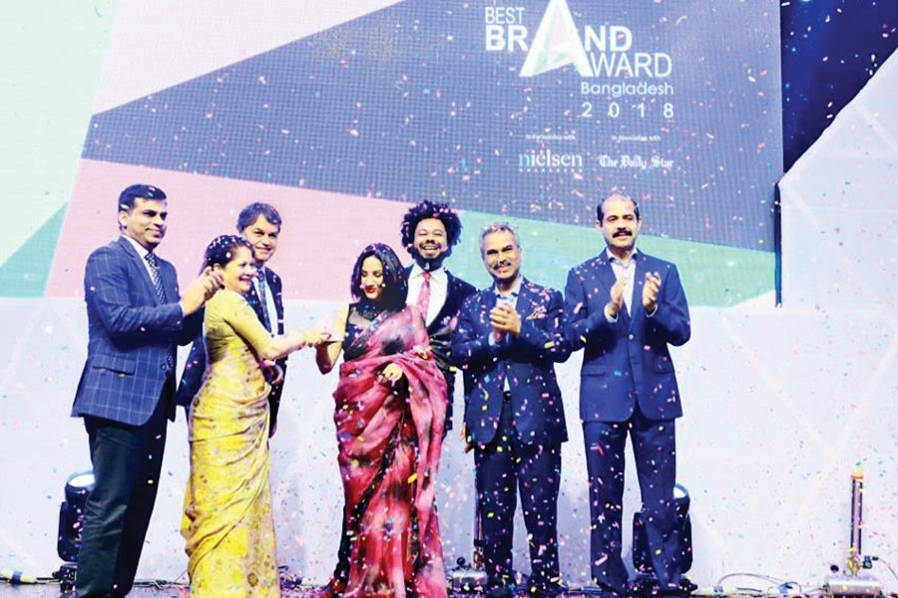
a city hotel
❖Ispahani Mirzapore Banglabid Silver Efficacy

❖Ispahani Mirzapore Banglabid Gold Native

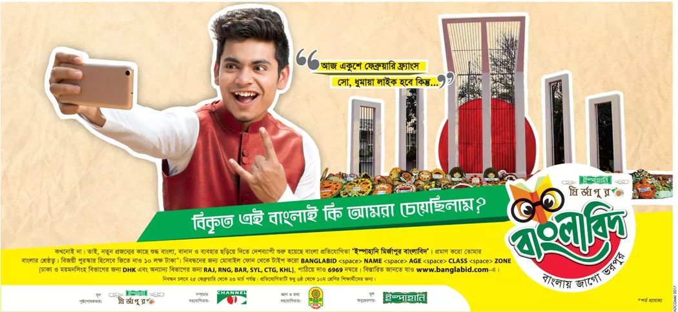

❖The most chosen beverage brand in Bangladesh (Kantar World panel Brand Footprint 2017)
❖The Most Attractive Packaging Award (Blender’s Choice Premium Bag-in-Bag Tea Bags)
❖ Ispahani Mirzapore Tea No. 1 Hot Beverage Brand 2017.

❖Ispahani Mirzapore Tea No. 4 Overall Brand 2017Amongst MNC & local brands across all categories.
❖IspahaniMirzapore Tea No. 1 Hot Beverage Brand 2016
❖IspahaniMirzapore Tea Best Local Brand 2016Amongst local brands across all categories
❖IspahaniMirzapore Tea No. 4 Overall Brand 2016 Amongst MNC & local brands across all categories
❖ IspahaniMirzapore tea Best Hot Beverage Brand 2015

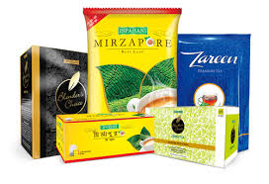

3.9 SWOT Analysis:

The overall evaluation of company’s Strength, Weakness, Opportunities, and Threats are called SWOT analysis helps to explore the areas of possible changes in marketing activities. Brief discussion Of Ispahani Tea Limited internal and external environment as follows.

S | W
O | T

Strength
• Number one tea brand in Bangladesh.
• Positive company image.
• Strong distribution channel.
• High quality products.
• Reliable with a long history.

Weakness
• Insufficient digital marketing activity.
• Inadequate print media and electronica media advertisement
• Not so focused on online shopping and services.
• Website is not updated and developed.

Opportunities
• Online based purchasing and delivery systems.
• The habit of taking tea is increasing day by day. It’s a great opportunity to expand the business.

Threats
• Strong competition among the competitors.
• Product price is high.

4. Analysis and Findings of the Study

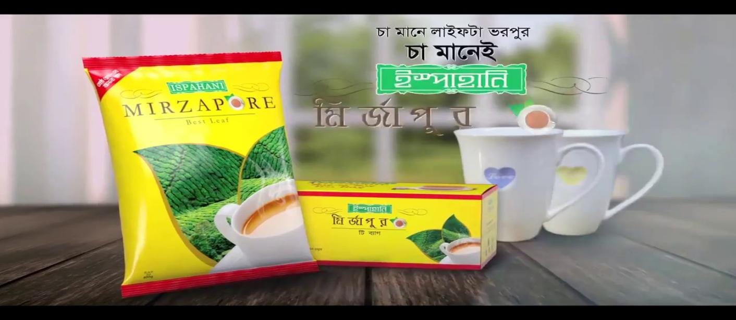

This paper has been made to identify the factors behind Ispahani’s market position in Bangladesh overall in Tea Stall market, hotel and to the householders of families. The result of this report which has been found is narrating below

According to questionnaires surveyed relating objectives.

4.1 Questionnaire Figure 1:
1. What type of TEA leaf do you usually use?
For Tea Stall:
Particular | Frequency
Branded Tea | 44
Local Tea | 5
Loose Tea | 1

For Family members:
Particular | Frequency
Brander tea | 66
Local Tea | 4
Loose tea | No one

For Hotel:
Particular | Frequency
Branded Tea | 24
Local Tea | 4
Loose Tea | 2

*For Wholesalers/ Salespeople of superstores
- How many Branded Tea do you keep in your store and name of them?
Frequency ( number of wholesalers and superstores) | Name of the company which tea leaf they keep in their stores
47 (wholesales) | Ispahani, Taaza and Seylon
43 (wholesalers) | Ispahani, Taaza, Danish, Fresh, seylon, Finley,Tetly,HRC and Number 1
8 ( Superstores) | Ispahani, Taaza, Fresh, Tata gold and Seylon
2 (Superstores) | Ispahani, Taaza and Seylon)

2. Which brand tea is best-selling in you store?

1st position | Ispahani
2nd position | Taaza
3rd position | Seylon

According to survey, Tea Stalls, hotels and family members are interviewed by 3 types of Tea gradually Branded, Local (area based) and Loose. From gathered data 134 out of 150 Tea Stalls, family member and hotels answered that they prefer branded Tea to serve and consume .The number of family members, tea stall and hotels using local tea is number in 13 and only 1 tea stall and 2 hotels has been found in using Loose Tea. In percentage, 89% using brand tea, Local 9% and Loose only 2% have been concluded. Besides all the wholesalers and superstores keep branded tea according to my surveys. Finally all the wholesalers agree that Ispahani Tea is best-selling in their stores and Taaza hold second position overall.
Outcome:
❖It means that maximum consumers and business people of Bangladesh much aware about branded Tea.
❖The little portion of hotels and tea stalls using Local and Loose Tea might be potential target for brands Tea.

4.2 Questionnaire Figure 3: Daily Consumption of Tea (on average)

For Hot Tea Stall and Hotel:

Particular | Frequency
Below 500gm | 25
500gm to 1 kg | 48
Over 1 kg | 7

For family members (Monthly basis):
Particular | Frequency
Below 500gm | 67
500gm to 1 kg | 3
Over 1 kg | No one

Tea Stall owners and hotel managers or owners are requested to tell the amount (in KG) of daily consumption of Tea (Except Tea Bag). 48 respondents are found using Tea 500gm to 1 kg. 25 respondents use tea leaf below 500gm and 7 respondents crossing over 1 kg are found using Tea. And it is very tough for family members to say daily consumption amount because some of them are not regular tea drinkers. That is why they are asked to say the amount of tea consumption on monthly basis. Here 67 respondents generally use tea leaf below 500gm and 3 respondents use tea leaf between 500gm to 1 kg and there is no respondent to use over 1 kg package.

Outcome:
❖Tea stalls and hotels generally using over 500gm Tea leaf daily is a common scenario of Tea Market.
❖ Tea Stall and hotels situated at overcrowded place need more than 1 kg Tea leaf daily.
❖200gm and 400gm package is best suitable for families.

4.3 Questionnaire Figure 4: Source of Tea Purchase

For Tea Stall and hotel:
Particular | Frequency
From Wholesalers | 30
From company ( cycle man ASO) | 34
From Near shop | 5
Others | 1

For family members:
Particular | Frequency
From Wholesalers | 10
From company ( cycle man ASO) | No one
From Near shop | 47
Superstore | 13

Most of the family members feel convenience to take Tea from near shop and most of the frequency of tea stall owners and hotels collect tea from Cycle man ASO.

Outcome:
❖It helps Tea manufacturer to improve distribution channel for different segment.

4.4 Questionnaire Figure 5-7: Brand Awareness, Preference and Loyalty

If you are asked to mention one TEA company name, then which company’s name come first on your mind?
For Tea stall owner and hotel manager or owner:

Particular | Frequency
Ispahani | 34
Taaza | 9
Seylon | 30
Finley | No one
Tetley | 2
Fresh | 4
Danish | 1

For family member:
Particulars | Frequency
Ispahani | 38
Taaza | 21
Seylon | 5
Fresh | 3
Finley | No one
Tetley | 1
HRC | 2

4.5 Which TEA brand(s) do you prefer most? (Multiple possible answer)
For Tea stall and Hotel Owners or managers:

Particular | Frequency
Ispahani | 32
Seylon | 31
Taaza | 8
Fresh | 3
Danish | 3
Tetley | 2
HRC | 1

For family members:
Particular | Frequency
Ispahani | 37
Taaza | 24
Seylon | 5
Fresh | 2
HRC | No one
Tetley | 1
Danish | 1

In questioning of brand, 41% tea stall owners and hotel managers or owners prefer Ispahani and 39% prefer seylon and the rest of them prefer other brands in case of trade package. In case of consumer package, 53% family members like the brand ‘Ispahani’ and 34% family members like and feel the brand ‘Taaza’.
What is then name of the company which tea leaf you use now is-
For Tea Stalls and hotels:
Particular | Frequency
Ispahani | 33
Seylon | 30
Taaza | 6
Fresh | 5
Tetley | 2
Danish | 4
HRC | No one

For family members:
Particular | Frequency
Ispahani | 41
Taaza | 21
Seylon | 3
Fresh | 1
Danish | 2
HRC | No one
Tetley | 2

We can conclude from the sample data that approximately 50% of the tea consumers are involved with Ispahani tea. So we can say tea means Ispahani tea because it is the market leader in tea business still now from the 1847.

Outcome
❖The market share of Seylon in hot tea stalls and hotels is enhancing day by day for serving purposes of branding
❖Ispahani belongs to highest brand awareness and loyalty but decreasing by the competitors
❖Family consumers prefer most Ispahani Tea compared to Tea Stall and Hotels.4.5 Are you satisfied purchasing current Brand or selling it?

For family members, hot tea stall owner and hotel

It has been found according to survey that 141 respondents feel that they are satisfied with current brand. Only 9 respondents feel that they are unsatisfied with what the present brand provides to them. But the satisfaction level of distribution channel is difficult to define

Particular | Frequency
Yes | 141
No | 9

4.6 Duration of using current Brand:
Particular | Frequency
0-4 months | 37
4-8 months | 8
8-12 months | 5
1-2 years | 15
2-5 years | 31
More than 5 years | 54

Here brand loyalty on duration represents 36% highest more than 5 years and then following 21% between 2-5 years. So we can conclude from the survey that maximum customers are loyal to the brand which they have used for long time.

4.7 Have you recently switch any tea brand? If yes then what is the reason to switch?
For Tea Stall Owners and hotels:
Yes | 36
No | 42

For Family members:
Yes | 11
No | 59

Generally Tea stalls and hotels frequently change their brand if they get discount from the competitors .From the Survey we see that 45% tea stall owners and hotels change their current brand because they are very price sensitive. Their demand are elastic in nature. So if any company follows everyday lower price, it will be able to occupy tea stall and hotel market. On the other hand family consumer rarely switch their tea brand. We can see that 11% family consumer recently switch brand. So they are more loyal to a brand compared to hot tea stalls and hotels. Family consumers are inelastic to price.

Reasons to Switch:
Maximum hot tea stall owners and hotels manager claim that they switch current brand because of higher price, quantity, availability, TP offer and credit facilities. On the other hand maximum family consumers claim that they switch their current brand because of unavailability of their preferred brand in the near shop from where they usually purchase their necessary and essential products.

4.8 Have you ever purchased Ispahani? If yes then what is the reason not to buy now?

YES | 142
NO | 8

Consumers of tea were asked about using Ispahani tea during their entire life. 95% businessmen and family consumer say ‘Yes’ and only 5% of them say ‘No’.
Reason not to purchase now:
Particular | Frequency
Price | 19
Quality | 13
Credit facility | 1
Availability | 10
Others | 6
No comment | 16

Though Ispahani is in good position in the tea market, it should focus on above mentioned facilities so that it can retain its growing position and easily meet the challenges created by its core competitors. It has to facilitate availability, increase quality and price discount on time according to market demand.

Learning from internship

Time management
M.M. Ispahani strictly follows and maintain time management. It is their corporate culture to be punished on being late.
Data Coding and Analysis
In internship program, I have worked in Ispahani under their Marketing department. This department is involved in doing research and analyzing market scenario for increasing sales and brand equity of their brand. It operate research and survey for analyzing market and taking competitive strategy for Ispahani Tea Trade Department in many places. Survey sampling has been enlarged in size because of strong analysis. I have learnt how to code the factors found through survey and input data on sheet precisely. I went for cross checking as needed to break down in the factors to be arranged.
Communication Skill
During internship period I have to visit market weekly two days on a weak and I have to communicate with various people. Besides I went to various events organized by M.M. Ispahani that helps me to increase my communication skill.
Relating Academic theory practically
I have worked under marketing department. So I worked with the dynamic team of M.M. Ispahani. So I have observed their marketing plan, branding process and promotional activities which help me to relate my academic knowledge with business practice.

Promotion

Promotion can be paid, owned and also earned through the help of media channels. Through promotion, customers can actually be aware of the product or service that is in the market. Ispahani uses a lot of promotional tools, such as;
❖ Print media and Electronica media: Ispahani has been doing advertising through print media and electronic media which is a paid promotion. Newspapers and TV Channel they are promoting their products and services. 30% advertising is given in print media and electronic media.
❖ Sales Promotions: When a company wants to increase the quantity of sales of their products, it uses sales promotion. Sales promotion provides extra value or incentives to the sales force, the distributor, or the ultimate consumer and can stimulate immediate sales. There are two types of Sales promotion:

Consumer oriented:
Consumer oriented promotional tools helps to increase the amount of sales to the current customers and attracting new ones.
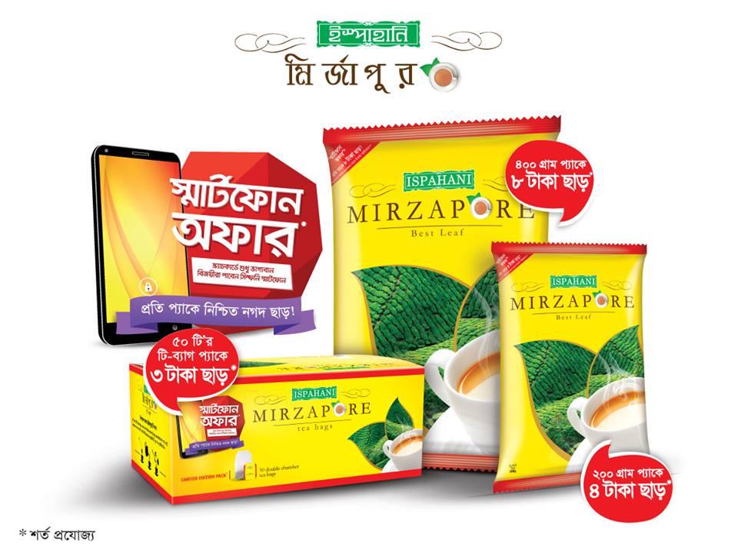

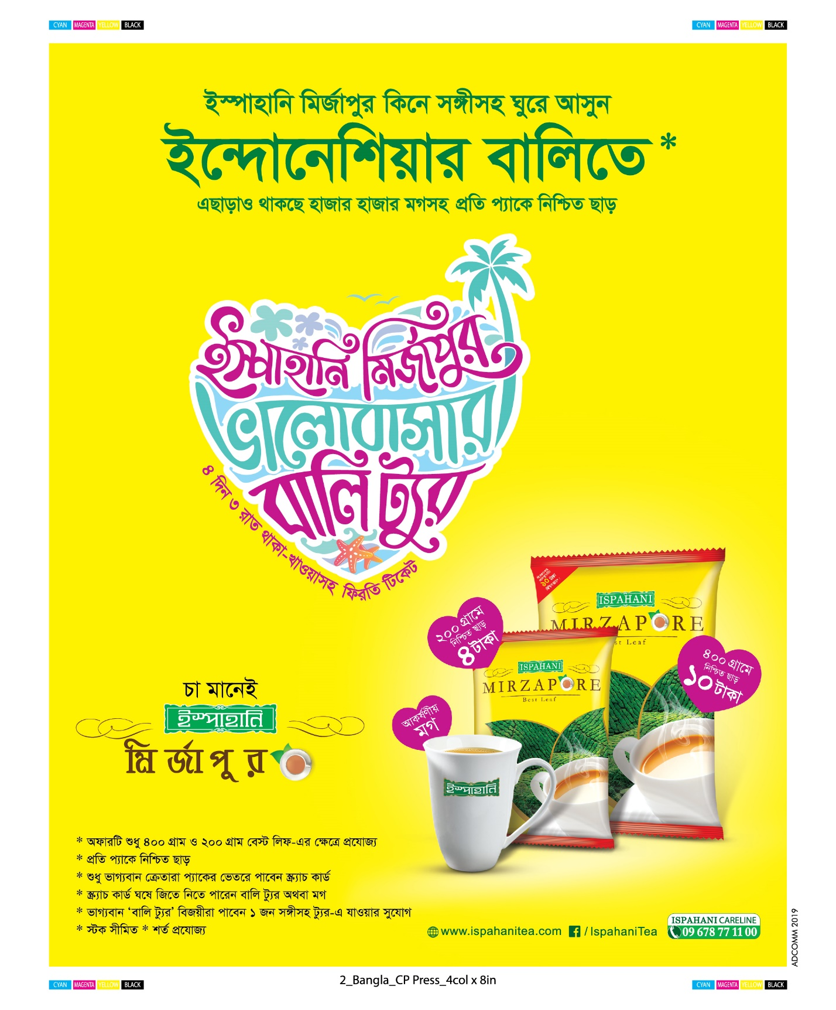

Trade oriented activities:
It is known as push strategy. It is generally given marketing channel so that they push company’s product to the consumers.
Ispahani uses sales promotion also which is about 20% of their advertising budget. It helps to increases sales in short times. For example, 10/20 take off per kg.

❖ Social media: Ispahani has been doing advertising through digital marketing which is also paid promotion. 40% advertising is given in social media and digital marketing platform. They often come to Facebook page, Instagram, and You Tube for promotional activity and for promoting their services.
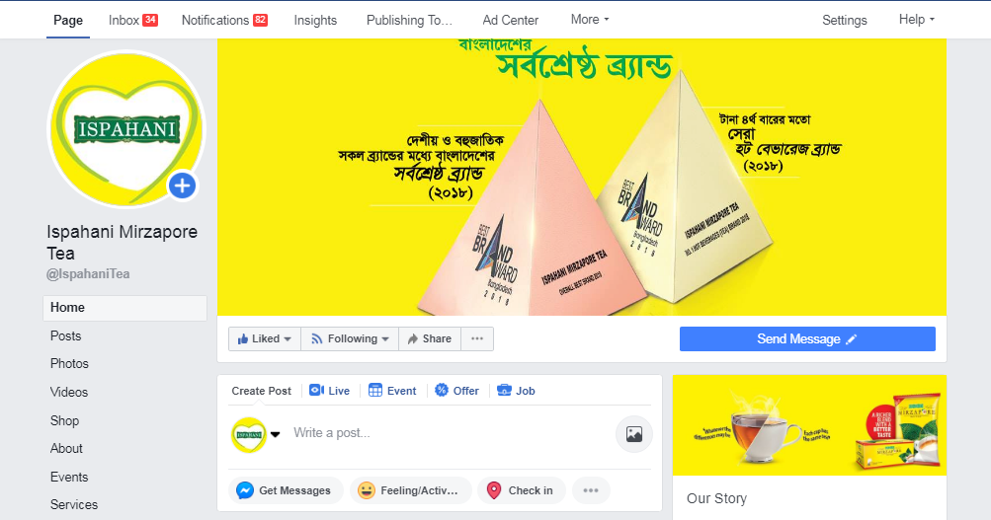

❖ Shop sign and Billboard: Ispahani has been doing promotion used shop sign and billboard also. Significant percent promoting gives in shop sign and billboard.
❖ Tour and Gift: Ispahani is offering to customer’s tour and gift. Ispahani already offered several places to customers. Like as: Bali, Malaysia, Nepal, Omar hajj e.tc

Out of home advertising:

It includes Billboards, kiosk transit advertising etc. Ispahni Mirzapore uses Billboard advertising for some certain reasons. To get maximum coverage on local market.
❖Regularity
❖Geographical advantage
❖ Innovation
❖To create mass awareness
❖Productivity
❖Usefulness
❖ Production abilities
❖ Suitability

Summary of Findings

Ispahani is operating Tea business for many years. Besides it has made an incomparable distribution network across the country. In Tea brand awareness, it is the market leader still now. Tea Stall owners, hotels and consumers of Bangladesh are much aware about the brand and the people of Bangladesh more than 80% are loyal to a strong brand compared to others. Besides consumers cite brand as top factor that influences their buying decisions. In the criteria of availability, preference, and purchasing Ispahani is still positioned in first. A constant growth of competitor is capturing the market wisely. In case of trade package, Seylon has been regarded here as a close competitive brand (threat) for Ispahani but in case of consumer package, Taaza is the strong competitive brand of Ispahani. Tea Stalls and hotels found satisfied but the inclusion of quality failure claims. Tea Stalls easily switch one brand to another frequently if they get promotion enough because they focus equally on profits and quality. If Ispahani wants to do well in tea stall and hotel market, it has to give discount very frequently because their demand is elastic (changing demand according to price increase or decrease). On the other the nature of demand of family consumers is inelastic (demand not changing according to price increase or decrease) and Ispahani is more popular to family consumers compared to hot tea stalls and hotels. So by using different strategies for different market, it can easily regain lost market. However Family members rarely switch one brand to another frequently which is good for the company to maintain constant sale. In losing criteria Ispahani has lost many of its customers mainly because of quality failure and proper promotional activities on time, their higher product price and also for the competitors.

5. Conclusion

Ispahani is a well-established tea brand in Bangladesh. It has been a long journey for Ispahani to reach the top level of success, but the company always had its priorities set to overcome all obstacles. Since the very beginning of its operation, the company has focused on providing the consumers the best possible experience in terms of quality and customer satisfaction and this has played a vital role in building and maintaining the brand image of its tea products. Ispahani now enjoys the status of the single largest tea company in the country as well as the topmost position in brand awareness among its consumers. Ispahani reputation will grow more and more and someday Ispahani tea will make its footprint beyond the borders of Bangladesh.

5.1 Recommendation:

❖ Ispahani can develop an online ordering system. It will create a digital platform for the company.
❖ Market penetration strategy should be applied to reduce the gap between the competitor’s success and Ispahani’s failure
❖It has been got complaints from marketing channel and hot tea stall owner that Cycle men are less active in distribution. As a result, they cannot provide Tea to their customers on time sometimes. Therefore other brands have got chance to capture market respectively. Maybe they want proper remuneration facility and other facilities (as Tea Stall Owner Saying) and it should redesign.
❖They can improve their R&D department to know about the customer needs, wants and demands.
❖Sufficient training and workshop can increase the process and behavior of the employees.
❖As Ispahani is a well-established and renowned brand, it should maintain a higher image than other brands. It is not wise for Ispahani to participate in price reduction competition with competitors because sometimes price support a good brand and it say something about a brand. Frequently price reduction may harm the brand image badly. Here company can add extra value for their target consumers (i.e. extra amount of Tea in the same price for different ranges of packages can be effective). This Trade promotion is not only effective for Ispahani branding but also increasing the sales in hot tea stall and hotel market. Overall Ispahani should follow here the wise saying by Steven Bradley “Don’t try to give your customers the best price, give them the best value for the price.”
❖ They need to be more technologically updated. They need to develop a strong website with all update information.

6. References
(2017). Retrieved from http://teaboard.portal.gov.bd/sites/default/files/files/teaboard.portal.gov.bd/monthly_report/63cf718c_b92f_42fe_958a_a679cb37c679/Bulletin-Noember%2717.pdf
Bangladesh Brand Forum | - Inspiring Brands in Bangladesh. (2019). Retrieved from http://bangladeshbrandforum.com/
Hanson, W., & Kalyanam, K. (2007). Internet marketing & e-commerce. Australia: Thomson/South-Western.
Internship Report by Umme Salma | Price Elasticity of Demand | Pricing. (2019). Retrieved from https://www.scribd.com/document/18275394/Internship-Report-by-Umme-Salma
Islam, S. (2019). Deputy Manager [In person].
Islam, S. (2019). Deputy Manager [In person]. Motijheel branch office.
Ispahani Mirzapore Tea | Ispahani Tea in Bangladesh. (2019). Retrieved from http://www.ispahanibd.com/
Kotler, P., & Armstrong, G. Principles of Marketing, Global Edition.
Peterson, R. (2007). Principles of marketing. Delhi: Global Media.
Team, D. (2019. Retrieved from http://www.banglabid.com/home(2019). Retrieved from http://www.teaboard.gov.bd/

6.1 Appendix
Questionnaire

Name of the Respondent:
Name of the shop:
Address:
Contact Number:

For Hot Tea Stall Owner/ family member/hotel manager or owner
*What type of TEA leaf do you usually use in your tea stall or hotel or for your family (Local TEA= Locally Branded & Area Based (√)

Branded Tea
Local Tea
Loose Tea

*. If you use branded tea then name of the brand is-
❖

For Wholesalers/ Salespeople of Superstore
1. How many Branded Tea do you keep in your store and name of them?

2. Which brand tea is best-selling in you store?
S.I. | Name of the brand

1st position
2nd position
3rd position

*. Daily consumption or use of TEA (gm)

*. By whom do you purchase TEA or by whom (√)

From wholesalers
From retailers
From distributors
Others

Answers of the questions no. 5 to 7 should be ranked on the box (Rank 1 to the highest) 5. If you are asked to mention one TEA company name, then which company’s name come first on your mind? (If there are more than one answer then spontaneously rank from the 1st)
* Which TEA brand(s) do you prefer most? (Multiple possible answer)
*. Which TEA brand(s) do you purchasing now? (Multiple possible answer)
Name:
Brand Name | Q.5 | Q.6 | Q.7
Ispahani
Taaza
Fresh
Seylon
Tetley
HRC
Danish

*. Are you satisfied purchasing current Brand or selling it? ( √)
Yes
No

*. Duration of using current Brand:

*. Have you recently switch any tea brand? ( √)If yes then what is the reason to switch?
Yes
No

Comment:
*. Have you ever purchased Ispahani? If yes then why you are not purchasing now?
YES
NO

Reason not to purchase:
Price
Quality
Credit facility
Availability
Others
No comment

6.7 Acronyms

ASO | Assistant Sales Officer
BL | Best Leaf
BOP | Broken Orange Pekoe
BRD | Broken Reddest
CS | Confectionary Shop
CSR | Corporate Social Responsibility
FFD | Farmer’s Field Day
IAL | Ispahani Agro Limited
MM | Mirza Mohammad
DS | Departmental Store
PB | Promotional Billing
PD | Premium Dust
TM | Territory Manager
TO | Territory Officer
VFM | Value for Money
ASO | Assistant Sales Officer
BL | Best Leaf
BOP | Broken Orange Pekoe
BRD | Broken Reddest
CSR | Corporate Social Responsibility
FFD | Farmer’s Field Day
IAL | Ispahani Agro Limited

