
UNITED INTERNATIONAL UNIVERSITY

Project on
EFFECTS OF WORK ENVIRONMENT ON EMPLOYEES’ PRODUCTIVITY IN GOVERNMENT ORGANIZATIONS. (CASE STUDY OF BONDHERE DISTRICT IN MOGADISHU- SOMALIA)
This report is submitted as part of the Master of International Human Resource Management degree requirements

Submitted To
Md. Kazimul Hoque
Assistant Professor
School of Business & Economics

Submitted By
Ifrah Hussein Mohamud
ID: 115203015

School of Business & Economics
United International University
Date of Submission
October- 2022
LETTER OF TRANSMITTAL
Date: October 4, 2022
Md. Kazimul Hoque
Assistant Professor
School of Business & Economics.
United International University.
Topic: Report on the effects of work environment on employee’s productivity in government organizations. (Case Study of Bondhere District in Mogadishu)"
Dear Madam,
This is my earnest effort to convince you that the paper you considered to be a useful
Structure on the subject was flawed. The effects of work environment on employee’s productivity in government organizations.
It is required for the completion of my MIHRM degree. Despite a few flaws, I feel the study has met its objectives to a large extent. Thank you for providing me with the opportunity to write a report on this topic. I gave it everything I had to deliver the report on time and at the good standard I have set for myself. It will be my pleasure to share extra details on this research. I am confident that my study will assist you in making informed decisions and will suit your needs.
Regards, Sincerely,

Ifrah Hussein Mohamud
Signature: 
ID: 115203015

ACKNOWLEDGMENT
First and foremost, I am grateful to Allah for giving me the strength to do this research. I'd want to convey my heartfelt gratitude to my parents, loving wife, and friends for their unwavering support and encouragement during my journey to success; without them, I wouldn't be who I am today.
I also owe a debt of gratitude to my supervisor, Md. Kazimul Hoque, as well as all others who helped me do this research.
I am grateful to my supervisor for providing me with the necessary guidance, advice, and assistance in order for me to do and complete my research in the most efficient manner possible.
My supervisors, who instilled professionalism in my job, are also to be thanked.

EXECUTIVE SUMMARY
The study was get the working environment can enhance employee productivity of government organization, Also the study was found the administrative and social environment can enhance employee productivity of government organization.
Most government organizations have unsafe working circumstances that are bad for one's health. A few of them include poor air circulation, inadequate, inappropriate furniture, inadequate fire safety measures, needless noise, bad lighting, and improperly built workplaces (Chandraseker, 2013). People working in these environments run the risk of developing a job-related disease, which lowers productivity.
The workplace atmosphere has both good and negative effects on employee morale, productivity, and engagement. When employees have a pleasant working environment, they are more motivated and produce greater results.
The office environment has a favorable or negative impact on employee morale, productivity, and engagement. When people work in a pleasant setting, they are more motivated and produce greater outcomes.
Federal agencies that are skilled at fostering a work climate that promotes parity between the employer and the employee are more productive and profitable. Working conditions: refers to an employee's working environment as well as their employment contract stipulations. Employee performance is influenced by their working environment. As a result, the federal and state governments must investigate measures to repair and modernize infrastructure in order to offer a more favorable work environment for higher employee productivity.

Table Content
LETTER OF TRANSMITTAL……………………………………………………….I
ACKNOWLEDGMENT…………………………………………………………..….II
EXECUTIVE SUMMARY………………………………………………….……..…III
CHAPTER ONE ….………………………………………………………………..…....1
1.1 BACKGROUND…………………………….………………….…………………….1
1.2 PRIOR TO THE RESEARCH…………………….…….……………….……….…...3
1.3 SCOPE OF THE STUDY……………………………………………………….…….4
1.3.1 Content Scope: ………………………………………………………………......4
1.3.2 Geographically Scope: ………………………………………………………..…4
1.3.3 Time Scope......................................................................................................…...4
1.4 OBJECTIVE OF THE STUDY: …………….………………………………………..4
1.4.1 General Objective………………………………………………………………..4
1.4.2 Specific Objective: ………………………………………………………………4
1.5 METHODOLOGY OF THE STUDY: …………………………………………..……5
1.5.0 Type of data: Primary and Secondary data…………………………………..5
1.5.1 Data Collection Method: …….……………………………………………...5
1.5.2 Sampling Techniques……………………………………………………......6
1.5.3 Area and Time of Research: …………………..……………………………….........6
1.6 LIMITATIONS OF THE STUDY: ……………..……………………………….........6
CHAPTER TWO: …………………………….…………………………………………7
LITERATURE REVIEW……………………………………………………………….7
2.0 INTRODUCTION: ……………………………………………..…………………….7
2.1 CONCEPT OF WORK ENCIORONMENT…………………………………………7
2.2 MEASUREMENT AND CHARACTERISTICS OF IV WORK ENVIROMENT....…8
2.2.1 Environment Factors………………………………………………….………….9
2.2.2 Physical Environment…………………………………………………………….10
2.2.3 Social Environment: ……………………………………………………………..10
2.2.4 Administrative Environment: ……………………………………………..…..10
2.3 CONCEPTS OF EMLPOYEE PRODUCTIVITY: ……………………………………..11
2.4 MEASUREMENT AND CHARACTERISTICS OF RMPLOYEE PRODUCTIVITY.13
2.4.0 Goal-setting…………………………………………………………………..…14
2.4.1 Performance feedback: ……………………………………………………..…14
2.4.2 Role congruity…………………………………………………………………….14
2.4.3 Incentives: ………….……………………………………………….....................14
2.4.4 Supervisor support: ………………………………………………........................14
2.4.5 Mentoring: ………………………………………………......................................15
2.5.7 RELATIONSHIP BETWEEN THE WORK ENVIRONMENT AND EMPLOYEE PRODUCTIVITY: ………………………………………………...............................................15
2.6 CONCLUTION: ……………………………………………….............................................15
CHAPTER THREE………………………………………………............................................20

ORGANIZATIONAL PROFILE…………………………………...........................................20

3.0 INTRODUCTION: ……………………………………................................................................................................20

3.1 HISTORY OF BONDHERE DISTRICTS: ………………................................................................................................................................20

3.2 Local government officers ………………................................................................................................................................20

3.3 VISION AND MISSION MINISTER OF EDUCATION OF SOMALIA: ..........................22
3.3.0 Vision: ……………….............................................................................................22
3.3.1 Mission: ………………...........................................................................................22
3.3 Structure of Bondhere District……….……………………………………………………....22
3.4 STRUCTURE OF BONDHERE DISTRICT:……………………………………………….22
3.5 HISTORY OF HUMAN RECOURSEDEPARTMENT………………………….................22
3.6 OPERATIONS OF THE ORGANIZATION:……………………………………………….24
3.7 TRAINING AND DEVELOPMENT FUNCTION OF HUMANRECOURSE.............…….24
3.7 Conclusion:………………......................................................................................................25
CHAPTER FOUR ………………...............................................................................................28
ANALYSIS AND INTERPRETRATION:................................................................................28
4.0 INTRODUCTION: .................................................................................................................28
Demographic Characteristics of Respondents .............................................................................28
LIST OF TABLE
TABLE 4.1.1 RESPONDENT OF GENDER: ............................................................................28
Table 4.1.2 Respondent Education ............................................................................................29
Table 4.1.3 Respondent Age………….........................................................................................31
Table 4.1.4 Respondent Marital Status:........................................................................................32
Table 4.1.5 Respondent Experience..............................................................................................33
Table 4.2.1 the employee performance appraisal system here....................................................34

Table 4.2.2 everyone that works here, including me, possesses all of the abilities necessary to fulfill our obligations………………………………..................................................................35

Table 4.2.3 we were Arranged sufficient authority to carry out our responsibilities..............36

Table 4.2.4 Employees of Municipality are involved in goal setting …...................................37
Table 4.2.5 Work processes are well-documented and strict, making it impossible to change them when necessary……………………………......................................................................38

Table: 4.2.6 the layout of the offices of Municipal and workspaces here are very

Well designed ……………………………………………………………………….…….…....39
Table: 4.2.7 the workers in the municipality are very hardworking…………………………..40

Table: 4.2.8 the workers in the municipality are very much committed to their employer……..41
Table 4.2.9 the health of the employee in the municipality is good and their morale is high………………………………………………………………………………………………42

Table: 4.2.10 Communication within the municipality is good……………………………...….43

Table: 4.2.11 the performance of workers in the municipality is high………………………….44

Table: 4.2.12 Employees enjoy what they do in the municipality……………………….……..45

Table 4.2.13 Workers are proud of what they do in the municipality………………….………..46

Table 4.2.14 There are no absenteeism in the Municipal municipality………………….……....47

Table 4.2.15 they have very good team culture in the municipality…………………………...48

LIST OF FIGURE
Figure: 4.1.1 Respondent Gender..................................................................................................29
Figure: 4.1.2 Respondent Education...........................................................................................30
Figure: 4.1.3 Respondent Age ....................................................................................................31
Figure: 4.1.4 Respondent marital status. ....................................................................................32

Figure 4.1.5 Respondent Experience..............................................................................................33
4.2. DATA ANALYSE AND INTERPRESENTATION ..............................................................34

Figure: 4.2.1 the employee performance appraisal system here...................................................34
Figure: 4.2.2 All people working here including My Self have All the Skills required to Perform our Responsibility………………………….................................................................................35
Figure 4.2.3 we were Arranged sufficient authority to carry out our responsibilities...............................................................................................................................36

Figure 4.2.4 Employees are involved in goal setting ...................................................................37

Figure: 4.2.5 Work processes are well-documented and strict, making it impossible to change them when necessary……………………………………………………………………………38

Figure 4.2.6 the layout of the offices Municipal and workspaces here are very well designed….39
Figure: 4.2.7 the workers in the municipality are very hardworking……………………………40

Figure: 4.2.8 the workers in the municipality are very much committed to their employer………41
Figure: 4.2.9 the health of the employees in the municipality is good and their morale is high...42
Figure 4.2.10 THE health of the employees in the municipality is good and their morale is high………………………………………………………………………………………………43

Figure 4.2.11 the performance of workers in the municipality is high…………………………....44
Figure 4.2.12 Employees enjoy what they do in the municipality…………………….……….45

Figure: 4.2.13 Workers are proud of what they do in the municipality…………………….…...46

Figure 4.2.14 there are no absenteeism in the Municipal municipality……………………....….47

Figure 4.2.15 they have very good team culture in the municipality……………………………48

CHAPTER FIVE……………………………………………………………………………….49
FINDINGS, RECOMMENDATIONS, REFFERENCE AND CONCLUTION……………49
5.1 FINDINGS…………………………………………………………………………………..49

5.2 RECOMMENDATIONS….……………………………………………………………….50

5.23 CONCLUSION…………………………………………………………………………..50
5.4 REFFERENCE:…………………………………………………………………………….52
QUESTIONNAIRE…………………………………………………………………………….54
APPENDIX I ………………………………………………………………………………….55
CHAPTER ONE
1.1 BACKGROUND:
Certain activities in the vicinity of people's homes or places of work have an effect on them. The work environment encompasses both the physical site and the surrounding surroundings.
It's the social and professional environment in which a person is expected to interact with a wide range of people. A friendly, well-designed, safe physical workplace, good equipment, and effective communication, according to Hay Group (2012), are all components of a productive work environment. Well-designed and organized offices and work environments have a big influence on how people feel about themselves.
their chosen professions Working circumstances might send negative signals about how much a firm values and expects from its employees (Armstrong &Murlis, 2014). A comfortable, happy, and productive employee is a company's most valuable asset. Effective work environments result in happier employees who are more happy with their occupations, which has an impact on both business and economic growth. According to Lambert et al., environmental variables are a crucial determinant of job satisfaction. Salary, promotion, evaluation system, climate management, and coworker relationships are all important factors to consider. Creating higher-quality goods Understanding how the environment effects behavior and how conduct influences job performance is essential for a thriving workplace.
People work both alone and in groups, necessitating a wide range of workplace options (Chandrasekar, 2013). The new goal of management is to foster an environment that draws, keeps, and motivates employees. Supervisors and managers are responsible and accountable at all organizational levels. People must be able to enjoy their work, feel that it has meaning, be confident of what they are doing, and be able to perform to their full capacity in this atmosphere. Employee participation, productivity, and morale are just a few of the factors that the workplace environment can affect positively or negatively. Businesses have implemented a number of measures to encourage employee motivation, including performance-based compensation, employee engagement, recruiting agreements, strategies to help balance work and family life, and other forms of information.
Today's workplaces are varied, both different and dynamic. The company today needs the workers more often than the employees need the company for a number of reasons. An employee's desire and subsequent performance are greatly impacted by the standard of their working environment. Businesses can nowadays never again continue to waste the potential of their staff due to the intense competition in the marketplace (Hughes, 2007). As both a response, most government organizations are making a lot of effort to create more fun, secure, and healthy working environments.
The workplace atmosphere has both good and negative effects on employee morale, productivity, and engagement. When employees have a pleasant working environment, they are more motivated and produce greater results.
Workplaces in today's world are varied, dynamic, and one-of-a-kind. Because of a multitude of factors, the firm today asks more of its employees than the employees demand of the organization. The workplace environment has a significant influence on an individual's motivation and subsequent performance. In today's competitive economic environment, companies can no longer afford to squander their employees' potential (Hughes, 2012). As a result, the majority of government agencies are concentrating their efforts on increasing workplace happiness, security, and health.
The office environment has a favorable or negative impact on employee morale, productivity, and engagement. When people work in a pleasant setting, they are more motivated and produce greater outcomes.
Federal agencies that are skilled at fostering a work climate that promotes parity between the employer and the employee are more productive and profitable. Working conditions: refers to an employee's working environment as well as their employment contract stipulations. Employee performance is influenced by their working environment. As a result, the federal and state governments must investigate measures to repair and modernize infrastructure in order to offer a more favorable work environment for higher employee productivity.
The majority of government entities have hazardous working conditions. Only a few examples include inadequate air circulation, insufficient personal protection equipment, improper furniture, insufficient fire safety procedures, incorrect lighting, and poorly constructed structures.

1.2 PRIOR TO THE RESEARCH:
The working conditions are unstable and harmful to one's health in the majority of government and public institutions (Perry & Porter, 2012). Poor air flow, insufficient PPE, incorrect furniture, inadequate fire safety precautions, excessive noise, wrong lighting, and improperly designed workplaces just are a few examples. Workers who are exposed to these environments are more likely to get sick from their jobs, which can reduce productivity. Meanwhile, the quality of an employee's motivation and productivity is significantly impacted by the value of their work environment (Hughes, 2014).
The problem is that it's challenging to inspire local employees with in face of a miserable workplace. One of the key issues in public administration is really how managers can inspire their staff.
The issue is that it's challenging to inspire local employees in a toxic workplace. The ability of local managers to motivate their staff is one of the major issues in public administration (Behn, 2014). The aforementioned scenario seems to have the potential to lower government output, necessitating immediate action. Today, as opposed to a few years ago, a completely different strategy is needed to motivate and retain people. Workplace productivity and employee satisfaction are closely related. There is compelling evidence that the rise of government productivity have lagging behind even the financial market (Killefer & Mendonca, 2010).
Most government organizations have unsafe working circumstances that are bad for one's health. A few of them include poor air circulation, inadequate PPE, inappropriate furniture, inadequate fire safety measures, needless noise, bad lighting, and improperly built workplaces (Chandraseker, 2013). People working in these environments run the risk of developing a job-related disease, which lowers productivity.
I recommend conducting a study on the impact of the work environment on employee productivity in public enterprises. In addition, I will investigate ways to reduce the risks to an employee's productivity. It will have the best sensitivity, according to academics, therefore I'll conduct interviews with educated Mogadishu inhabitants.
1.3 SCOPE OF THE STUDY:
This study will be supported out work environment on employee productivity In Mug. Somalia.
The scope of study will contain: Content Scope, geographically Scope, Time Scope and research instrument .
1.3.1 Content Scope: This research will focused on the effects of work environment on employees productivity in government organizations.
1.3.2 Geographically Scope: The study will be carried out work environment on employee productivity In Mug. Somalia.
1.3.3 Time Scope: 01 January 2022 up to 23 May 2022

1.4 OBJECTIVE OF THE STUDY:
There are both general and specific Objectives:

1.4.1 General Objective
The aim at this study was to assess the effects of work environment on employees productivity in government organizations.

1.4.2 Specific Objective:
1. To identify effect physical environment on employee productivity.
2. To have a better understanding of how the social environment affects employee productivity.
3. To see how administrative environment affects staff productivity.

1.5 METHODOLOGY OF THE STUDY:
1.5.0 Type of data: Primary and Secondary data
The core data was collected primarily through the administration of a survey questionnaire to Bondhere district workers.
Secondary data will also be utilized. Secondary data is information that has already been obtained for another purpose. Secondary data sources include, but are not limited to, published articles, books, reports on the topic area, and online sites. These sources were primarily used to create the ideas that served as the foundation for the empirical study in the literature review chapters. In addition, quantitative analysis will be used in this study, as well as studies using the Statistical Package for Social Sciences software (SPSS Version 16.0).

1.5.1 Data Collection Method:
Questionnaires will be the primary method used to gather data for this study. Because they are useful if a population is huge and time is limited, a questionnaire is a written list of questions. The main objective of a questionnaire is to collect a great amount of data in a short period of time.
The primary goal of this research is to explain the influence of the work environment on employee productivity in Mugadisho, Somalia. This research will primarily focus on opinions, perspectives, perceptions, feelings, and attitude. Questionnaires are the most effective way to collect this type of data. Because there will be a limited amount of time available. Questionnaires are widely used and used more often than other approaches.
Respondents are needed to read the questions, comprehend what is anticipated, then write down or enter their responses independently in the questionnaire.
The researcher created the questionnaires for this study by following the stages below: they based questionnaires on the research goals in order to get relevant information on the research issue, then they structured questionnaires into four sections (A): the first several paragraphs, Section (B): Concerns the respondent's personal characteristics, such as age, gender, marital status, and educational level. Which is calculated on a nominal scale. The questions are in section (C). the questions Section (D): The final section.
1.5.2 Sampling Techniques
persons with a great deal of knowledge and experience in the field in research.
66 participants from a non-probability sample were requested to complete the survey. Data was gathered in a number of places, on alternating schedules of the week and at different times of the day.in order to reduce location and timing biases. In Mugadhiso-somalia, the employed in this strategy to collect better informed replies about the influence of work environment on employee productivity,
1.5.3 Area and Time of Research:
This Study will be Start and End 01 January 2022 up to 23 May 2022

1.6 LIMITATIONS OF THE STUDY:
Part of the respondents refused to share with the researcher some of the information they considered confidential or did not complete the Questionnaire correctly for fear of being targeted and killed or kidnapped by individuals who caused the crisis, whether they are rebels or not. However, the researcher vowed to keep the information obtained as private as possible and to use it solely for scholarly purposes.
Security issue is a major factor that affects your study and makes it easier to attain your objective; if you don't have security, you won't be able to achieve your goal, and your research will be ambiguous.
Because respondents to the questionnaire had difficulty understanding the questions
in their Native Language, the researchers translated the questions into Somali.
There were instances when there was insufficient internet, library, and other facilities.

CHAPTER TWO:
LITERATURE REVIEW
2.0 INTRODUCTION:
The researcher discussed the literature on the effect of work environment on employee productivity in government organizations in this chapter.
The review discussed related concepts including work environment, measurement and characteristics of work environment, employee productivity, measurement and characteristics of employee productivity, work environment and employee productivity relationships, and conclusion.
2.1 CONCEPT OF WORK ENCIORONMENT
Workers/users are satisfied with various workspace components, according to numerous research. In terms of productivity and job satisfaction, people place a high value on lighting, ventilation rates, natural light, and the acoustic environment (Becker, 1981Humphries, 2005 Veitch, Charles). Employee health has been shown to be benefited by lighting and other components such as ergodic furnishings (Dilani, 2008). Milton, Glencross, and Walters (2000)) and, as a result, on production (Veitch & Newsham (2000); Milton, Glencross, and Walters (2000)). This is due to the fact that light has an impact on employees' physical, physiological, and psychological health, as well as their overall job performance. Lighting, temperature, the presence of windows, natural air flow, and other physical features of office spaces are thought to influence employee attitudes, behaviors, satisfaction, performance, and productivity (Larsen, Adams1996).
Whether each person would have their own workspace or if there are only these few people in each closed office, employees have greater protection in some kind of a tight office design than with an open plan layout. They have the option of working alone, which enables them to focus on the task at hand without getting sidetracked by the actions of their coworkers. Employees may think and act creatively without interruption (Mwbex, 2010). In an open workplace layout, noise is unpleasant and causes a lot of distraction, disturbance, and stress. a breach of one's privacy rights (Evans & Johnson, 2000). Employee attitudes, behaviors, contentment, performance, and productivity are thought to be influenced by lighting, temperature, the presence of windows, free air flow, and other physical aspects of office environments (Larsen, Adams1996).
Employees enjoy more privacy in a closed office layout than in an open office layout, whether they each have their own office or each closed office has only a few workers. They can work in peace and quiet without being distracted by the activities of their coworkers. Employees have the freedom to express themselves and produce without being disturbed (Mwbex, 2010). In an open workplace structure, noise is unpleasant and generates a lot of attention and distraction.

Additionally, interacting with someone who can see you is easier than communicating with someone who is beside you, far away, or separated from you by items. (Working with J'Istvan) (2010). By reducing employee distance and increasing communication flow, the open office promotes a more equal work atmosphere (Brennan, Chugh & Kline, 2002, Hedge, 1986, 2000). Employee distraction is one of the leading reasons of poor productivity, major errors, and increased job-related stress. Bruce claims that (2008). Numerous studies have connected a bad psychosocial environment to an increased risk of mental and physical issues, as well as absenteeism. Because a person is present at work despite suffering from a mental or physical ailment, presenteeism is more expensive than absence.

The psychological, economic, social, and medical aspects of absenteeism caused by bad working conditions have all been studied.
are the outcome of an employee's participation in the growth of their company, and involve both psychological and physical working conditions" (Gerber et al., 2008). Working circumstances relate to the working environment as well as any other factors that affect labor in the workplace, such as job hours, physical elements, legal rights and obligations, organizational climate, and workload, according to the business vocabulary. The Rolloos are an Australian rock band (2007). Wrongful manipulation poses specific issues, making working conditions hazardous and lowering productivity. As a result, the workplace is a place where employees go to accomplish their tasks (Chapins, 2005), but a productive workplace is one that allows management to achieve its objectives. the targeted objectives (Mike, 2010; Shikdar, 2012). Previous study has established a substantial There is a link among low job satisfaction and issues like employee turnover, absenteeism, and decreased productivity. Judge et al. (2011), Drago and Wooden (2008), Freeman (2009)8, Gordon and Denisi (1995); Judge et al. (2011), Drago and Wooden (2008), Freeman (2009)8, and Gordon and Denisi (1995). However, it's possible that the rising number of absence observations and poor work performance are relics of a worker's already made decision to leave (Griffeth et al., 2000). Workplace attitudes have been shown to be among the most accurate indicators of employee turnover (Griffeth et al., 2009). Workers who report low work satisfaction and are substantially more inclined to be exploring for alternative chances than those who are not involved. employment. If they were employed, those who said they were looking for new employment were likewise far more likely to leave their jobs.

Meyer and Allen (1997) look at employee attitudes on business loyalty, mobility, and desire to leave a current job for better pay in order to extend quit intentions. Coworking spaces came in a variety of sizes and shapes. The Holland Codes are one of the attempts to organize the various types, developed by John Holland (2015), a psychologist interested in pairing people with occupations that fit their personality. Holland's approach to various types of workplaces were determined by the nature of the work. He defined six different contexts: realistic, social, entrepreneurial, artistic, investigative, and traditional.
Work is more hands-on in more finished with a built. When it comes to investigative issues, logical analysis and theoretical discussions are highly valued. More self-initiative is required in enterprising situations to establish and innovate businesses. Traditional work environments, such as databasing client information, adhere to predetermined procedures and processes, whereas creative work environments promote innovation and the creation of art. Customer service and education are two examples of social professional situations that require a good deal of interaction (Dwyer et al, 2009).

2.2 MEASUREMENT AND CHARACTERISTICS OF IV WORK ENVIROMENT
2.2.1 Environment Factors:
Distinguish the change between both the physical, social, and administrative aspects of work.
2.2.2 Physical Environment
It's a workplace element that has had a direct impact on human perception, as well as altered interpersonal interactions and productivity in the environment. In an organization, the physical environment seems to have an impact on how employees interact, complete tasks, and are managed. This is attributed to the reason that the features of the room or venue where a group meets affect productivity and satisfaction.
Physical issues: Physical issues in the office, such as poor layout or congestion, can result in common workplace mishaps like tripping or colliding with furniture.
Technology/equipment, material supply availability, shift schedules, and working hours are almost all responsible for the physical environment.
2.2.3 Social Environment:
Discussions include interpersonal relationships, several teams, management support or style, work status, autonomy, decision-making, culture, and climate.
2.2.4 Administrative Environment:
The policies on promotion, leave, transfer, and performance review are all covered. Office furniture should be familiar to administrative office managers. Because it may be more difficult to remove utilized furniture that has been bought, not leased or rented, the consequences of poor office furniture choices can continue a long time.

workplaces such as offices, warehouses, retail stores, professional research facilities, fieldwork locations, and so forth. Are examples of work environments. Various personalities and professional goals can be found in these work environments.

Work adaptability can also be influenced by the physical surroundings; for example, some people dislike the strict, controlled environment of the a lab and rather working outside. Concerns regarding the working conditions in various types of work contexts, such as one's ability to succeed in physically taxing or boring situations, may cause some job searchers to hesitate. When contrasting various work environments, think about the social and emotional climate. While some companies are more democratic and flexible, others maintain strong command systems. Employees may be instructed to concentrate on particular tasks without criticizing their managers, or they may being encouraged to participate, offer ideas, and establish their own work environment. locations of employment Because of the acceptance of bullying or intense competitiveness, some climates may become hostile, while others maintain amicable and serene. Psyche and Woodward (2000).
2.3 CONCEPTS OF EMLPOYEE PRODUCTIVITY:
Is a statistic for evaluating the effectiveness of the economy and the resources needed to produce goods and services (Bernardin & Russell, 1998 Ross, 1999). Wasiams et al. claim that businesses that get a comparative advantages through firm-specific information may hope to change working conditions to reduce employee turnover and the chance that their productivity advantage will indeed be passed on to rivals (1999). Fosfuri, 2001; Glass, 2002).
If employees' non-monetary labors are linked with increased productivity, the organization should compensate them to avoid losing them. Employers may be obliged to bid up their pay if more than one employer offers fair pay, possibly to the marginal worth of the task "Productivity of workers. Employers may be obliged to bid up their wage if more than one employer provides fair pay - possibly as high as the marginal worth of the worker's product." There are four distinct occupational dangers. Yesufu (1999) claims that the physical environment in which individuals work has a significant impact on output. Offices and workplaces that are overheated and insufficiently ventilated are adverse to productivity. Clothing as a form of defense, as well as drinking water, rest rooms, bathrooms, and first-aid facilities, should all be provided. The essential conditions of the factory act must be met, and managers must always be risk averse. Productivity drops and service delivery deteriorates in organizations where workers are exposed to stressful work environments, according to Bornstein (2007).
Another issue to think about when it comes to enhancing employee productivity is selecting and employing appropriate furniture and equipment, which are key physical factors in the workplace (Keeling and Kallaus, 1996; Quible et al. 1996). Office managers must pay special attention to the selection of appropriate office furniture to ensure that the ergonomic atmosphere is maintained. Customizable office furniture, such as desks and chairs, is recommended to keep employees comfortable throughout the day, while an ergonomic workspace is essential for increasing employee productivity (Burke, 2000).

Because a business cannot run without people, all of its structures, machinery, procedures, and procedures are useless unless the individuals using them are skilled. It's considerably simpler than you might think to determine overall return on these assets, though.
The most challenging aspect of evaluation is measuring human output (The Insider, 2002). The link between an industrial or service system's input and output is referred to as productivity. The utilization of resources like labour, lands, investment, material, power, and information to create a range of commodities and services is therefore how productivity is defined (Prokopenko, 1987). Giving workers the resources they need and then anticipating higher output is typically ineffective.
Only if the employee who will complete the assigned task is given extra attention will employee productivity improve. Person productivity will only increase if the employee who will complete the task is the one who will accomplish it.

assigned Special care is paid to the work. Productivity is defined as the ability to accomplish more with the same amount of resources. Higher productivity is defined as accomplishing more with the same amount of resources. A combination of techniques focusing on employee satisfaction, health, and morale are utilized to overcome productivity difficulties and achieve high worker productivity (Corporate Leadership Council, 2003). On the other hand, productivity is defined as the relationship between the time it takes to accomplish a goal and the time it takes to do it. As a result, the more productive a system is, the more quickly it accomplishes its desired results. As a result, the more productive a system is, the more quickly it accomplishes its desired results (Prokopenko, 1987).

Employee productivity, on the other hand, is determined by a person's physical labor at a job according to how often and to what amount there operate "mentally present" or performing successfully during that time (Corporate Leadership Council, 2003). When employees in financial difficulties utilize work time to cope with personal issues, productivity suffers. According to the research of a renowned consumer credit counseling company, previous studies have not taken into account work time spent dealing with personal financial difficulties as a factor in determining productivity.
Almost everyone who calls their counselors does so from their place of employment, according to research done by the major consumer credit counseling group (Amsel, 1998). This counseling center offers support seven days a week, 24 hours a day, thus it is not constrained to doing so during regular business hours. Although Kim (2000) classified the average time spent at work worrying about personal finances as either good or bad, whatever total time spent worrying about personal finances, whether good or bad, might result in a decrease in productivity. Positive or bad feelings regarding one's personal money may contribute to a decline in productivity. After a night of work, the majority of participants experienced no negative effects, although problems can arise after several nights of work. Among them are things like exhaustion, decreased productivity, and psychological discomfort (Knauth & Hornberger, 2003). According to many writers (Hill et al, 1998; Igbaria et al, 1999: Kelliher & Anderson, 2010)
2.4 MEASUREMENT AND CHARACTERISTICS OF RMPLOYEE PRODUCTIVITY:
Employees' workstations are designed in a way that encourages them to work in a particular manner. As a result, the company can adjust to its strategy while also providing its citizens with all they required for success (Al-Anzi, 2009). Today, the majority of office buildings have air conditioning systems that enable the continuous control of a single room's temperature. However, certain factors should be taken into account while determining the proper temperature level; for example, obese people perform better at lower temperatures, whereas slender people work best at higher temperatures. Temperature, humidity, ventilation, and cleanliness really do have an impact on air quality.
A comfortable office environment is a clean facility or area with a bearable temperature range, sufficient ventilation, and adequate humidity in which workers can perform their work properly. The air in an office must still be circulated after the temperature has been set to a comfortable level within a comfortable humidity level. As a result, the temperature may rise, creating it uncomfortable to go out. Air flow is also important in order to prevent humans from inhaling too little oxygen.
Furthermore, smoking must be prohibited in the workplace. Electric fans are still used in certain small offices to ensuring that the air is effectively circulated (Quible, 1996, Keeling and Kallaus, 1996). Employees found to be less motivated and perceive their workload as more tough in both the coolest and warmest climates, resulting in lower performance.
2.4.0 Goal-setting:
Employees help in the creation of relevant job goals and performance metrics. This can be done formally as part of the organization's performance management process or informally between the person and their immediate supervisor.
2.4.1 Performance feedback:
Employees are given regular feedback. This covers both positive and critical feedback of the employee's work.
2.4.2 Role congruity:
The duties of the employee are consistent given employer expectations and any additional training. The company's immediate supervisor provides them tasks that are appropriate for their position within the company. Through documenting processes and communicating these expectations to individuals, the firm restricts the variability of how work is actually carried out.
2.4.3 Incentives:
The company assesses employees ’ motivation and develops official and informal processes to reward everyone who performs as expected
2.4.4 Supervisor support:
Employees' immediate supervisors work as its champions, The corporation evaluates employee motivation and creates formal and informal procedures to reward everybody who performs as expected.

2.4.5 Mentoring:
Organization members have access to knowledgeable and "superior" individuals who can encourage them advance in their particular jobs and take on new responsibilities. Potential for application: Employee development and use of current abilities are not impeded by their workloads or by organizational structures and procedures. By offering job aids, they may expedite their tasks, lower error rates, and improve customer satisfaction. Examples include models, checklists, templates, and instructions.
2.4.6 Working conditions:
refers to the workplace and all aspects that impact labor, including work schedules, physical challenges, constitutional obligations and rights organizational cultures, workloads, and training. Employee contact with their organizational climate influences working conditions.
2.5.7 RELATIONSHIP BETWEEN THE WORK ENVIRONMENT AND EMPLOYEE PRODUCTIVITY:
Workers/users are satisfied with a variety of workplace characteristics, according to multiple workplace studies. People consider lighting, ventilation rates, natural light availability, and the acoustic environment to be major factors in their productivity and enjoyment at work (Becker, 1981Humphries, 2005). Charles Veitch, Charles Newsham, Charles Marquardt, Charles Marquardt, Charles Marquardt, Charles Marquardt, Charles Marquardt, Charles Marquardt, Charles Marquardt, Charles Marquardt, Charles Marquardt, Charles Marquardt, Charles Marquardt Employee health and productivity have been found to be improved by lighting and other factors such as ergomic furniture (Dilani, 2004; Milton, Glencross & Walters, 2000; Veitch & Newsham, 2000). This is attributed to the reason that light has a considerable impact on the employees' physical, psychological, and psychological well-being, as well as overall job performance. Lighting, temperature, the availability of windows, open air movement, and other physical elements of office spaces are thought to influence employees ’ attitude, behaviors, satisfaction, performance, and productivity (Larsen, Adams 1999). Employees have whether each person occupies their own workspace or whether there is only a few individuals in each closed office, there is greater solitude in a private office design compared to an open floor plan layout. They may be able to function in peace and tranquility, which enables them to concentrate on their work without being disturbed by outside influences. It helps focus on their work without being distracted.
unforeseen (Mwbex, 2010). Noise is uncomfortable in an open office architecture, and it causes a lot of distraction and disruption, as well as a lack of privacy (Evans & Johnson, 2000).

As just a result of technical advancements, innovative communicative skills, virtual reality, the development of e-markets, and alternative employment patterns, workplaces are fast evolving (Challenger, 2000). Companies have historically used an environment to enable these quick changes while safeguarding or improving outcomes, such as open-plan office space (Terricone and Luca, 2002). This type of workplace, as contrast to entirely contained private offices, supports new approaches and flexible workplaces that allow for simple communication. Employee productivity has resulted in the growth of the move to an open plan office.

Furthermore, conversing with someone you can see is easier than conversing with someone who is next by, far away, or separated from you by items. (In the Workplace with J'Istvan) (2010). By reducing employee distance and boosting communication flow, the open office promotes a more equal job situation (Brennan, Chugh & Kline, 2002, Hedge, 1986, 2000). One of the primary causes of poorer productivity, serious errors, and increased job-related stress is employee distraction. Bruce believes that (2008). Various studies have connected a bad psychosocial environment to an increased risk of mental and physical problems, as well as absenteeism. Because a person is present at the workplace while suffering from a mental or physical condition, presenteeism is more expensive than absence.

There seems to be research on the emotional, economic, social, and medical aspects of absenteeism caused by a negative work environment. Employee productivity is often intangible, partly due to the unstructured and creative nature of knowledge labor. As a result, standard productivity measuring approaches based on physical output quantity are ineffective in knowledge work companies (Dogramaci & Adam, 1985). The fact that "knowledge worker productivity is not - at least not largely - a problem of amount of production" is one of Drucker's six primary components that govern knowledge worker productivity. Quality is equally important. The productivity of a knowledge worker necessitates that now the information workers be seen and appreciated. "Knowledge workers should bring the company ahead of all other possibilities" (Drucker, 1999).

Several production models, as well as quantitative methods like with the Return on Capital and Return on Assets, have had an impact on early office productivity. Unfortunately, the majority of them believe that what office professionals do is what industry workers produce are one and the same (Brand, 2009). Quality is recognized as the most significant factor for measuring Knowledge work productivity. This means that, just as with hard labor, quality must be gained in defining the amount of work completed; simply minimum quality, but ideal, though not optimum quality (Drucker, 1999).

2.6 CONCLUTION:
The nature of task was considered when classifying work environments. He defined six main contexts: realistic, political, economic, artistic, exploratory, and traditional.
Workplaces are more realistic and more hands-on. In investigative circumstances, thinking and theoretical disputes are highly important. To create and innovate companies in enterprising settings, more individualism is needed. Traditional working environments, including database schemas and client information, follow tight procedures and standards, whereas creative content environments foster creativity and the production of original works of art.
Two aspects of social work situations that demand a high level of commitment are customer support and training (Dwyer et al, 1991). Consider the actual surroundings, which include workplaces, warehouses, retail stores, professional research centers, fieldwork sites, etc., as another way to look at work environments. These workplaces could accommodate a wide range of personality types and career aspirations. Working appropriateness can be affected by the physical environment; for instance, many people prefer working outside since they don't enjoy the strict and regulated environment of a laboratory. Some job applicants may worry about their capability to function in physically demanding or monotonous situations because they are concerned about the environment in various sorts of work environments. (Salin, 2003).

Both psychological and social climate can be taken into account while comparing the various work environments. While some companies are more egalitarian and flexible, others have strict command hierarchies. Employees may be expected to focus on their work without criticizing their managers, or they may be encouraged to participate, offer feedback, and create the perfect work atmosphere. Certain working environments might become hostile due to an intolerance for mistreatment or intense competitiveness, whereas others are more welcoming and relaxed. Work environments are divided into three areas by Woodward and Psyche: environmental, psychological, and administrative (2000).

Heating exhaustion and heat stress, for example, can be caused by extremely hot temperatures. Temperature, humidity, and ventilation are all factors that might have a direct impact on one's health. Illness symptoms include: Physical difficulties in the workplace, such as poor layout or overpopulation, can lead to frequent workplace accidents, such as tripping or colliding with objects (De-Croon et al) (2005). Workload, advanced technologies, material supply availability, shift timings, and working hours are all part of the physical environment. The physical environment has had a direct impact on human perception, which has altered social communication and production in subtle ways. In an organization, the physical environment has an impact on how people interact, execute tasks, and are managed.

Warm air exhaustion and heat stress, for example, can be caused by extremely hot temperatures. Climate, lighting, and ventilation are all factors that might have a direct impact on one's health. Illness symptoms include: Physical difficulties in the workplace, including such poor layout or overcrowding, can lead to frequent workplace accidents, such as tripping or colliding with items (De-Croon et al) (2005). Workload, technology/equipment, supply chain . supply dependability, shift schedules, and working hours are all part of the physical environment. The physical environment has had a direct impact on human perception, which has altered interactions and efficiency in subtle ways. How employees communicate, complete jobs, and are controlled within a corporation is affected by their physical surroundings.
Because the work environment comprises interpersonal interactions, multiple organizations, management style or assistance, job status, independence, judgment, culture, and climate. The administrative environment includes organization culture, goals, advancement, sabbatical, and transfer policies, as well as performance evaluation. The notion that the end product is often intangible differentiates knowledge work productivity, indicating the unplanned and creative nature of knowledge labor. As a result, standard productivity measuring approaches based on the physical output quantities are ineffective in knowledge work companies (Dogramaci & Adam, 1985). The fact that understanding productivity levels is not - at least not largely - a problem of quantity of knowledge" is one of Drucker's six major variables that define knowledge worker productivity.
Knowledge productivity levels is not - at least not primarily - a quantity issue," says the author.
(ii) Seeing knowledge workers as just a resource rather than an expense improves their productivity. "Knowledge workers should choose working for a company over all other options" (Drucker, 1999). Various production models, as well as microeconomics such as the Return on The investment and Assets ratio, have influenced how early office productivity is evaluated. Regrettably, the majority of them assume that what office workers do and what industry workers produce are the same. When it comes to gauging knowledge work productivity, quality is regarded the most important factor.

CHAPTER THREE

ORGANIZATIONAL PROFILE

3.0 INTRODUCTION
The capital of the Republic of Somalia is Benaadir Regional Administration, often known as Mogadishu municipality. The city is divided into 17 districts and is led by a mayor. Bondhere, Hodan, How-wadaag, Xamar-Jajab, Hamar-weyne, Kaxda, Abdul-Aziz, Karan, Shangani, Waberi, Wadajir, Warta nabada, Yaqshid, Daynile, Dharkeynlay, Huruwa, Shibis are the names of the District.
Each of these districts is led by a district commissioner. The city has a population of 2.5 million people, out of a total population of 11.5 million in Somalia. This accounts for more than 20% of the world's largest country. Over half of the people in the region are under the age of 15.
Municipalities as well as regional districts employ a variety of officers and workers to carry out decisions made by regional government or regional district board and to carry out their directives. Local governments can utilize resources including job descriptions, employment contracts, collective bargaining agreements, bylaws, and ordinances to assist clarify their officers' and staff' responsibilities, pay, and benefits. Local governments must also follow all provincial and federal laws, such as the Employment Standards Act, Workers Compensation Act, and Income Tax Act. Local governments can contract with labor unions individually or collectively. A two-thirds vote is required for regional district boards to also include their regional districts in an employers' association as specified by the Labor Relations Code.
Local government workers may be delegated decision-making authority by municipal councils and regional district boards, subject to certain constraints. Local elected officials and local government employees play different functions. A member of the council or board cannot be a member of a local administration's staff, and a member of the council or board can become a member of the local government's staff. For example, a local public official who wishes to stand for political office in the municipalities where they work or in the region of which that municipal is a member should take a sabbatical and, if successful, resign form their position.

3.1 HISTORY OF BONDHERE DISTRICTS:
Zainab Moallim is the current Chairman of Bondhere District. The function of the office of the Chairman is to provide and execute a vision for the District. This is alongside Provision of District services, a conducive and safe working environment for the People to Live, work, play and Invest. To help the District achieve this, it’s also his role to appoint Deputies and Staff to support the delivery of his mandate.
the function of the office of the District is to provide and execute a vision for the city. This is alongside Provision of public services, a conducive and safe working environment for the People of District to Live, work, play and Invest. To help the mayor achieve this, it’s also his role to appoint Deputies and Staff to support the delivery of his mandate.

The employment circumstances of local government employees, including any specific benefits they may receive, are generally outlined in their employment contract or collective agreement. Bylaws, rules, and provincial legislation are usually used to supplement these contracts and agreements. While the local government may be held liable, officers and workers of the government are normally immune from personal legal culpability for actions, omissions, or defaults connected to their duties. They may also be covered by the local government in the event of legal action being filed against them Interfering with or obstructing the performance of duties by a local authority officer or employee, including regional government member regional district board members is illegal.

3.2 Local government officers
Municipal governments as well as regional district boards create bylaws to establish officer posts. At least two officer roles are required in all local governments: one is responsible for corporate administration and the other is responsible for finance administration. The minimum required duties for each post are defined by provincial legislation. These statutorily mandated responsibilities are part of the job and cannot be reduced, though a local council or regional district board can add responsibilities to any position. A same person can be assigned to numerous jobs, such as corporate officer and finance officer. A local government may also create any officer post and assign it tasks that it deems necessary, such as a chief administrative officer, through a bylaw. A local government may also create any officer position and assign it the duties that it deems essential, such as a chief administrative officer to oversee its overall operations, through a bylaw.
3.3 VISION AND MISSION MINISTER OF EDUCATION OF SOMALIA:
3.3.0 Vision:
A better services District society that supports human rights and performs better.
3.3.1 Mission:
To give high-quality services to qualified persons so that they can participate to development efforts and compete in the technological world.

3.4 STRUCTURE OF BONDHERE DISTRICT:
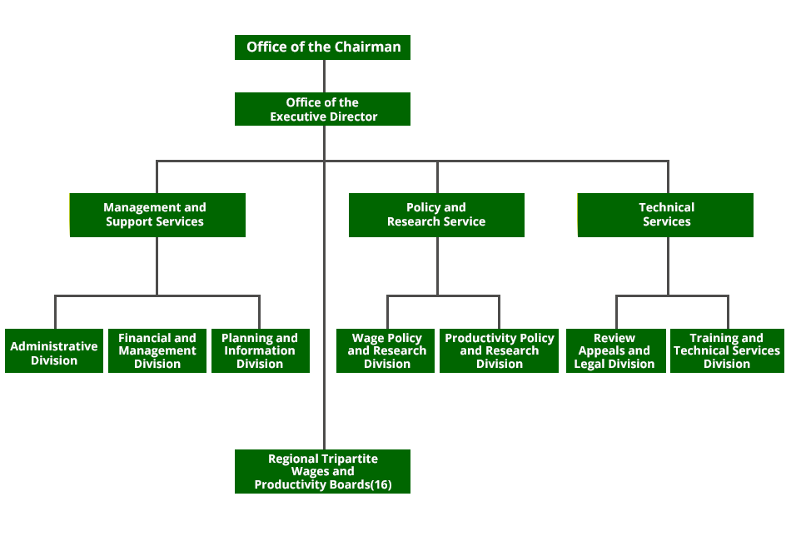
Local governments in Bondhere District may participate in individual or group labor relations bargaining. A two-thirds vote is required for regional district boards to also include their local district in an employees' association as specified by the Labor Relations Code.
Bondhere District workers may be delegated decision-making authority by municipal councils and regional district boards, subject to certain constraints. Local elected officials and local government employees play different functions. A member of the council or board cannot be a member of a local government's employees, and a member of the council or board can become a member of the local government's staff. For example, if a local government employee intends to run for elected office in the municipality where they work or the regional district of which that municipality is a member, they must take a leave of absence and, if elected, resign from their employment.

3.5 HISTORY OF HUMAN RECOURSE DEPARTMENT
The Planning and Policy department is in charge of implementing and coordinating the Municipal achievement management strategy, as well as providing a wonderful employee designated social and learning vehicles for employee communication. In addition, the Division plans and advises on management issues as they arise, as well as ensuring that the bank's human resources activities are carried out properly, successfully, and ethically. Policies help organizations achieve their objectives faster. Effective HRM practices are built on the foundation of HR rules. Furthermore, laws act as a standard by which a program's success can be assessed. Employee management policies are broad guidelines agreed upon by all members of a company in order to regulate the performance of individuals, directors, and administrators. Policies aid organizations in achieving their goals more quickly. HR regulations are the foundation of effective HRM procedures. Furthermore, laws serve as a benchmark against which the success of a program can be measured. Employee management policies are broad standards agreed upon by all corporate members to govern the performance of individuals, directors, and administrators.
Bondhere Municipal Of Somalia has released a statement underlining the need of acquiring and keeping exceptional individuals. The HRM director is important because he or she oversees the recruitment and hiring process, which is critical to the institution's long-term performance. To begin, HR may speak with an executive officer or supervisor to learn more about the job criteria and the qualities of a potential candidate. The human resources department can then devise a recruitment plan. This includes posting job openings both internally and externally, reviewing prospective applicants' résumés and other materials, and conducting preliminary interviews. HR may also be in charge of recognizing and conducting background checks. HR is responsible for recruiting people and selecting the finest ones to work for the company. Because employees are the lifeblood of every company, finding the proper fit is critical. A desire for gainful employment is frequently raised when a new post is formed or an existing job becomes accessible.

3.6 OPERATIONS OF THE ORGANIZATION:
An HR department's other responsibilities include increasing employee productivity and protecting a Municipal from workplace problems. HR is responsible for compensation and bonuses, recruitment, dismissal, and remaining current on any rules that may influence the firm and its employees. Organizational planning and management, as well as Board resource management, fall within the purview of the Human Resources department. It sets and maintains policies in the areas of basic administrative support, human resources, and financial management in this capacity.

3.7 TRAINING AND DEVELOPMENT FUNCTION OF HUMAN RECOURSE:
Employee productivity of Bondhere District is the duty of the unit in charge of training and development. It develops, coordinates, and implements successful training programs for all workers; analyzes bank-wide training needs to guide training operations; and finds and organizes relevant training solutions for employees. This area is always on the lookout for new instructional, outcomes, and performance-recognition initiatives to create and deploy. One component of an HR agency's job is to hire qualified staff. Top management may be in charge of implementing staff development initiatives in order to retain talent and remain competitive. Additional on-the-job retraining, skills training, or training programs that assist employees learn and progress in their current positions or prepare them for advancement within the organization could be included in this area. Both firms and employees benefit from investing in learning and development, according to human resources departments. Employers may profit from increased staff productivity and lower turnover rates. When employees see their employer invest in their development, they become more motivated. People are a product of their upbringing, the country and generation in which they grew up, and a wide range of cultural influences. HRM learning and development, employees will be able to respond to new operations, technological, sociological, or policy action.

3.7 Conclusion:
Bondhere Municipal Of Somalia has released a statement underlining the need of acquiring and keeping exceptional individuals. The HRM director is important because he or she oversees the recruitment and hiring process, which is critical to the institution's long-term performance. To begin, HR may speak with an executive officer or supervisor to learn more about the job criteria and the qualities of a potential candidate. The human resources department can then devise a recruitment plan. This includes posting job openings both internally and externally, reviewing prospective applicants' résumés and other materials, and conducting preliminary interviews. HR may also be in charge of recognizing and conducting background checks. HR is responsible for recruiting people and selecting the finest ones to work for the company. Because employees are the lifeblood of every company, finding the proper fit is critical.
HR is responsible for compensation and bonuses, recruitment, dismissal, and remaining current on any rules that may influence the firm and its employees. Organizational planning and management, as well as Board resource management, fall within the purview of the Human Resources department. It sets and maintains policies in the areas of basic administrative support, human resources, and financial management in this capacity.
Employee productivity of Bondhere District is the duty of the unit in charge of training and development. It develops, coordinates, and implements successful training programs for all workers; analyzes bank-wide training needs to guide training operations; and finds and organizes relevant training solutions for employees. This area is always on the lookout for new instructional, outcomes, and performance-recognition initiatives to create and deploy. One component of an HR agency's job is to hire qualified staff.
It is impossible to overestimate the importance of rewarding workers for their achievements at Somalia's central bank. Compensation and perks play a critical role in attracting the best candidates for the job and for the organization. One of the most important elements to consider is salary, but other important aspects include advancement and career opportunities, but also status, reputation, a favorable business culture, and a decent work-life balance.
A SWOT analysis evaluates the positive points, weakness, opportunities, and threats that a community faces. Similar exercise can also be used to help identify necessary actions and priorities, as well as to create a legislative "to do" list for elected authorities in the area. Decisionmakers can use the action items in each area to: build on community strengths, correct community weaknesses, seize opportunities, and prepare for risks. The themes uncovered in a previous survey conducted and public meeting again for Freshwater drum Area Planning effort inspired the items in this SWOT analysis.
Strengths
Existing assets, amenities, and traits that contribute to a community's success are known as strengths. Both intangible and tangible assets are included in this category. have been created to support this SWOT Analysis and to highlight the Rockfish Valley's remarkable physical features in particular. All of the strengths of a successful community are reinforced, protected, and built upon.

Weaknesses
Existing traits, conditions, or challenges that prevent a community from achieving its objectives are known as weaknesses. A community should think about how to deal with or overcome these challenges. Growth management that isn't up to par: Residents expressed their dissatisfaction with the County's lack of an unified or current (up-to-date) strategy for regulating development in the Freshwater drum Valley area, particularly along Route 151, throughout the strategic planning. The community has often stated that the nature and location of popular promotional development initiatives are endangering the rural character of the area. Improved growth management measures are also recommended in the County's Comprehensive Plan from 2002.

Opportunities
Opportunities, in contrast to strengths and weaknesses, generally more forward-looking and include larger forces. These are future possibilities that could assist a community in achieving its objectives. A community should think about how to take use of these opportunities strategically.
Threats
Threats, like opportunities, look ahead more so than advantages and disadvantages. These potential challenges may obstruct the community's ability to achieve its objectives. Threats should be avoided or mitigated by a community. Many residents confirm that the new Dominion Pipeline will affect the area's spectacular landscape, surface waterways, groundwater resources, and other natural resources, all of which are significant assets to the area. Despite the fact that the Line is not included of both the Freshwater drum Valley planning effort, survey participants and meeting attendees expressed concern about it.

CHAPTER FOUR
ANALYSIS AND INTERPRETRATION:
4.0 INTRODUCTION:
This chapter presents the data analyzed and the interpretation. My data analysis and interpretation are based on my research objectives and the Analysis Statistical Package for Social Science (SPSS). The presentation is divided into two parts.
This part presents the respondent's demographic information, while the second part questions my objective.

4.1 DEMOGRAPHIC CHARACTERISTICS OF RESPONDENTS
Table 4.1.1 Respondent of Gender:
DESCRIPTION | FREQUENCY | PERCENTAGE | CUMULATIVE PERCENTAGE
Male | 42 | 63 | 63.6
Female | 24 | 63.6 | 100.0
Total | 66 | 100.0
Source: Primary Data
Table 4.1.1 asks respondents to confirm their gender by checking the box next to the appropriate option (male or female). Males made up 42 (63.6 percent) of the 66 responders, while females made up 24 percent (36.4 percent ). As a result of the fact that men control The few females who work in this field may feel more motivated and proud of themselves for being able to achieve what the men do.

Figure: 4.1.1 Respondent Gender
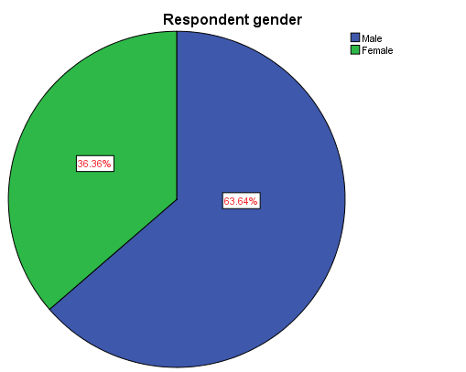

Table 4.1.2 Respondent Education
Valid | Frequency | Percentage | Valid Percentage | Cumulative
Diploma | 14 | 21.2 | 21.2 | 21.2
Bachelor | 33 | 50.0 | 50.0 | 71.2
Master | 17 | 25.8 | 25.8 | 97.0
PHD | 2 | 3.0 | 3.0 | 100.0
Total | 66 | 100.0 | 100.0
Source of Primary data
4.1.2 Table The researcher categorized participants' education level into four groups in the table above: diploma (14.2%), Bachelor Degree (33.3), Master Degree (22.7) and BHD 2 (3.0%), implying that bachelor's degrees were possessed by the majority of respondents. This indicates that the participants who responded towards the research tools were well-educated and capable of comprehending and analyzing the information.

Figure: 4.1.2 Respondent Education

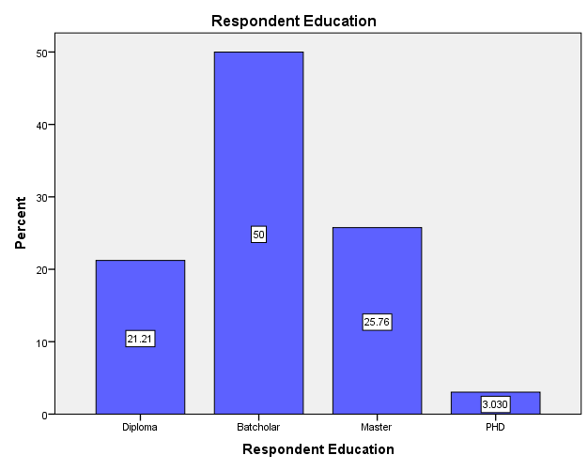

Table 4.1.3 Respondent Age
Valid | Frequency | Percentage | Valid Percentage | Cumulative
21-30 | 32 | 48.5 | 48.5 | 48.5
31-40 | 15 | 22.7 | 22.7 | 71.2
41-50 | 10 | 15.2 | 15.2 | 86.4
51-Abve | 9 | 13.6 | 13.6 | 100.0
Total | 66 | 100.0 | 100.0
Source of data primary data

4.1.3 Table The age range 21-30 years old is represented by 32 (48.5%) in this table, whereas the age range 31-40 years old is covered by 15 (22.7%), overall number of respondents aged 41-50 years old is provided by 10 (15.2%), and indeed the age group 51 and above is covered by 9 (9.5%). (13.6 percent ).
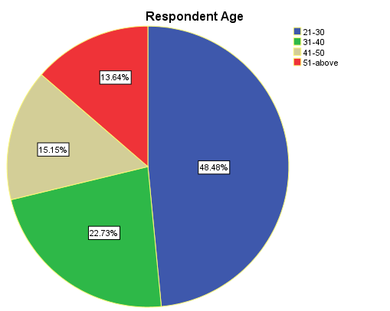
Figure: 4.1.3 Respondent Age

Table 4.1.4 Respondent Marital Status:
Valid | Frequency | Percentage | Valid Percentage | Cumulative
Married | 37 | 56.1 | 56.1 | 56.1
Singular | 29 | 43.9 | 43.9 | 100.0
Total | 66 | 100.0 | 100.0
Source of data primary data
4.1.4 Table The majority of respondents were married, with 37 (56.1%), and single, with 29 (43.9%), indicating that the majority of participants were married.

Figure: 4.1.4 Respondent marital status.
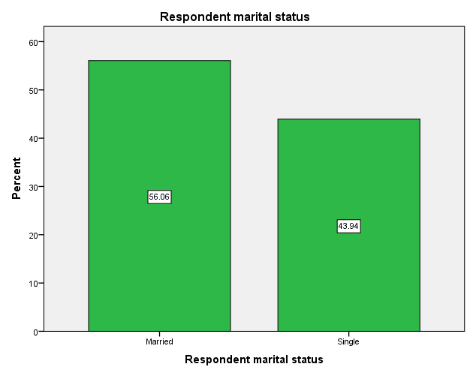

Table 4.1.5 Respondent Experience
Valid | Frequency | Percentage | Valid Percentage | Cumulative
Less Than 1 Year | 8 | 12.1 | 12.1 | 12.1
1-2 Years | 40 | 60.6 | 60.6 | 72.7
2-4 Years | 10 | 15.2 | 15.2 | 87.9
4- Years Above | 8 | 12.1 | 12.1 | 100.0
Total | 66 | 100.0 | 100.0

Source of data primary data
Table 4.1.5 The graph above illustrates how the respondents have worked for the municipality for Less Than 1 Year (8.1%), 1-2 Years (40.6)%, 2-4 Years (10.2), 4- Years Above (12.12%).

Table 4.1.5 Respondent Experience
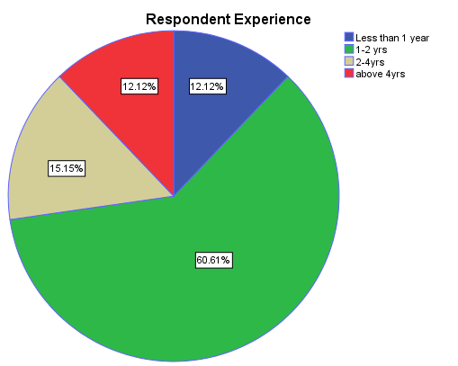

4.2. DATA ANALYSE AND INTERPRESENTATION

4.2.1 The employee performance appraisal system here.
Valid | Frequency | Percentage | Valid Percentage | Cumulative
Strongly Agree | 30 | 45.5 | 45.5 | 45.5
Agree | 15 | 22.7 | 22.7 | 68.2
Neutral | 5 | 7.6 | 7.6 | 75.8
Disagree | 9 | 13.6 | 13.6 | 89.4
Strongly Disagree | 7 | 10.6 | 10.6 | 100.0
Total | 66 | 100.0 | 100.0
Source of data primary data
4.2.1 Table In the chart above, the majority of respondents answered strongly agreed (30 (45.5%), agree 15 (22.7%), neutral (5.6%), disagree (9.6%), and strongly disagree (7.6%). (10.6% ). Because the majority of respondents agreed that this item is Respondents agree, 30 (45.5 percent ),

4.2.1 Figure: The employee performance appraisal system here.
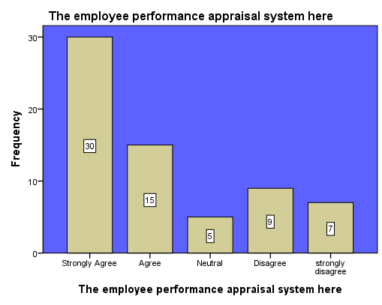

Table 4.2.2 Everyone that works here, including me, possesses all of the abilities necessary to fulfill our obligations.
Valid | Frequency | Percentage | Valid Percentage | Cumulative
Strongly Agree | 30 | 45.5 | 45.5 | 45.5
Agree | 25 | 37.9 | 37.9 | 83.3
Neutral | 2 | 3.0 | 3.0 | 86.4
Disagree | 5 | 7.6 | 7.6 | 93.9
Strongly Disagree | 4 | 6.1 | 6.1 | 100.0
Total | 66 | 100.0 | 100.0

Source of data primary data
4. 2.2 The table and the finger were responded Strongly agreed 30 (45.5%), agree 25(37.9%), Neutral 2(3.0%), Disagree (7.6), And Strong disagree 4 by the majority of respondents (6.1 percent ). Because the majority of respondents agreed that this.
Figure: 4.2.2 all people working here including My Self have All the Skills required to Perform our Responsibility.
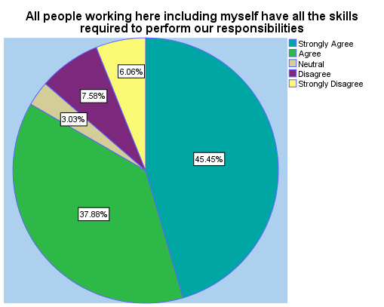
Table 4.2.3 We were Arranged sufficient authority to carry out our responsibilities.
Valid | Frequency | Percentage | Valid Percentage | Cumulative
Strongly Agree | 33 | 45.5 | 45.5 | 50.0
Agree | 10 | 37.9 | 37.9 | 65.2
Neutral | 7 | 3.0 | 3.0 | 75.8
Disagree | 9 | 7.6 | 7.6 | 89.4
Strongly Disagree | 7 | 6.1 | 6.1 | 100.0
Total | 66 | 100.0 | 100.0
Source of Data Primary Data
4.2.3 In the table above, the majority of respondents said strongly agreed, 33 percent (50.0 percent), agree, 10 percent (15.2%), neutral, 7 percent (10.6%), disagree, 9 percent (13.6 percent), and strongly disagree, 7 percent (10.6 percent ). Strongly agreed is the most common response, with 33 percent of respondents agreeing (50.0 percent).

4.2.3 We were Arranged sufficient authority to carry out our responsibilities.
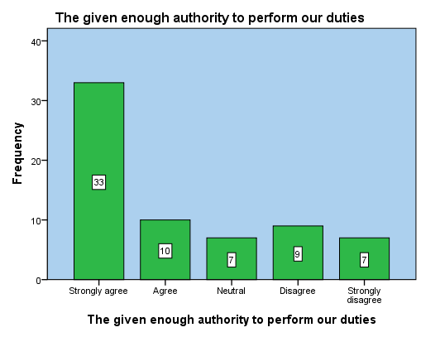

4.2.4 Employees of Municipality are involved in goal setting
Valid | Frequency | Percentage | Valid Percentage | Cumulative
Strongly Agree | 30 | 45.5 | 45.5 | 45.5
Agree | 12 | 18.2 | 18.2 | 18.2
Neutral | 6 | 9.1 | 9.1 | 9.1
Disagree | 10 | 15.2 | 15.2 | 15.2
Strongly Disagree | 8 | 12.1 | 12.1 | 12.1
Total | 66 | 100.0 | 100.0
Source of data Primary
4.2.4 In the above table and figure, the majority of the respondents said highly agreed 30 (45.5%), agree 12 (18.2%), neutral 6 (9.1%), disagree 10 (15.2%), and strongly disagree 8 (8.5%). (12.1 percent ). Strongly agreed is the most common response, with 30 percent of respondents agreeing (45.5 percent ).

4.2.4 Employees are involved in goal setting
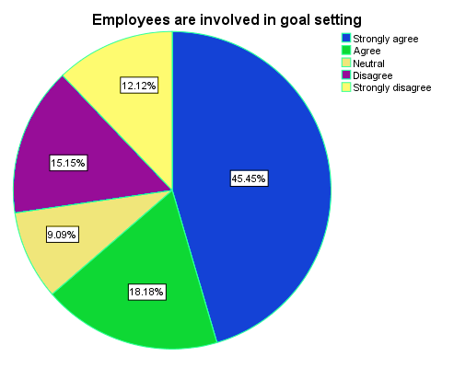

4.2.5 Work processes are well-documented and strict, making it impossible to change them when necessary.
Valid | Frequency | Percentage | Valid Percentage | Cumulative
Strongly Agree | 15 | 22.7 | 22.7 | 22.7
Agree | 16 | 24.2 | 24.2 | 47.0
Neutral | 4 | 6.1 | 6.1 | 53.0
Disagree | 17 | 25.8 | 25.8 | 78.8
Strongly Disagree | 14 | 21.2 | 21.2 | 100.0
Total | 66 | 100.0 | 100.0
Source Of Data Primary
4.2.5 In the above table and figure the majority of the respondents was answered Strongly agreed, 15(22.7%), while agree are 16(24.2%),while Neutral 6(9.1%), while Disagree are 4 (6.1%), and strongly Disagree are 17 (25.8%). The majority indicates of the respondents answered in agreement to this item is disagreed 17 (25.8%),

Figure: 4.2.5 Work processes are well-documented and strict, making it impossible to change them when necessary.
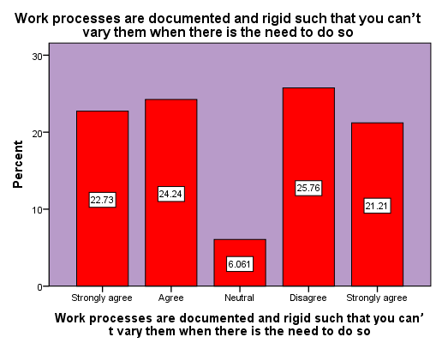

Table: 4.2.6 the layout of the offices of Municipal and workspaces here are very well designed
Valid | Frequency | Percentage | Valid Percentage | Cumulative
Strongly Agree | 8 | 12.1 | 12.1 | 12.1
Agree | 7 | 10.6 | 10.6 | 22.7
Neutral | 3 | 4.5 | 4.5 | 27.3
Disagree | 22 | 33.3 | 33.3 | 60.6
Strongly Disagree | 26 | 39.4 | 39.4 | 100.0
Total | 66 | 100.0 | 100.0
Source Of Date Primary
4.2.6 In the above Table And Figure the majority of The Respond was Answer Strongly agreed, 8(12.1%), while agree are 7(10.6%),while Neutral 3(4.5%), while Disagree are 22 (33.3%), and strongly Disagree are 26 (39.4%). The majority indicates of the respondents answered in agreement to this item is disagreed 17 (25.8%).

4.2.6 The layout of the offices Municipal and workspaces here are very well designed

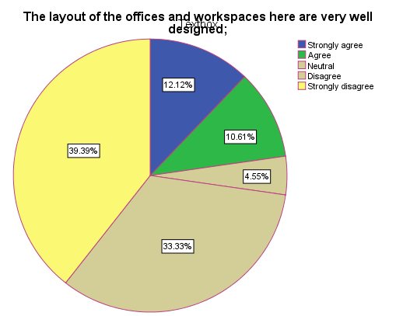

Table: 4.2.7 the workers in the municipality are very hardworking
Valid | Frequency | Percentage | Valid Percentage | Cumulative
Strongly Agree | 20 | 30.3 | 30.3 | 30.3
Agree | 14 | 21.2 | 21.2 | 51.5
Neutral | 5 | 7.6 | 7.6 | 59.1
Disagree | 22 | 25.8 | 25.8 | 84.8
Strongly Disagree | 10 | 15.2 | 15.2 | 100.0
Total | 66 | 100.0 | 100.0
Source of data primary data
4.2.7 In the above Table and Figure the Majority of the Respond was Answered Strongly agreed, 20(30.3%), while agree are 14(21.2%),while Neutral 5 (7.6%), while Disagree are 17(25.8%), and strongly Disagree are 26 (39.4%). The majority indicates of the respondents answered in agreement to this item is disagreed 10 (15.2%)
Figure: 4.2.7 The workers in the municipality are very hardworking

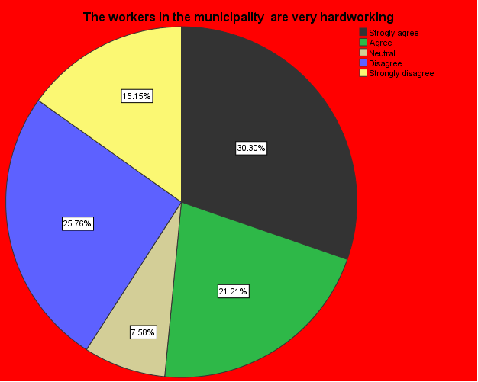

Table: 4.2.8 The workers in the municipality are very much committed to their employer
Valid | Frequency | Percentage | Valid Percentage | Cumulative
Strongly Agree | 31 | 47.0 | 47.0 | 47.0
Agree | 23 | 34.8 | 34.8 | 81.8
Neutral | 2 | 3.0 | 3.0 | 84.8
Disagree | 3 | 4.5 | 4.5 | 89.4
Strongly Disagree | 7 | 10.6 | 10.6 | 100.0
Total | 66 | 100.0 | 100.0
Source of data primary data
4.2.8 in the above table and figure the majority of the respondents was answered strongly agreed, 31(47.0%), while agree are 23(34.8%), while Neutral 2 (3.0%), while Disagree are 3(4.5%), and strongly disagree are 7 (10.6%). The majority indicates of the respondents answered in agreement to this item is strongly agreed, 31(47.0%).

Figure: 4.2.7 the workers in the municipality are very hardworking
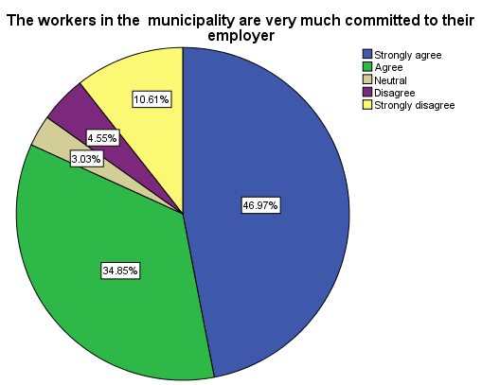

Table 4.2.9 the health of the employee in the municipality is good and their morale is high
Valid | Frequency | Percentage | Valid Percentage | Cumulative
Strongly Agree | 12 | 18.2 | 18.2 | 18.2
Agree | 13 | 19.7 | 19.7 | 37.9
Neutral | 4 | 6.1 | 6.1 | 43.9
Disagree | 7 | 10.6 | 10.6 | 54.5
Strongly Disagree | 30 | 45.5 | 45.5 | 100.0
Total | 66 | 100.0 | 100.0
Source of data primary data
4.2.9 In the above Table And Figure the majority of the Respond was Answered Strongly agreed, 12(18.2%), while agree are 13(19.7%),while Neutral 4 (6.1%), while Disagree are 7(10.6%), and strongly Disagree are 30 (45.5%). The majority indicates of the respondents answered in agreement to this item is strongly Disagree are 30 (45.5%).
Figure: 4.2.9 the health of the employees in the municipality is good and their morale is high
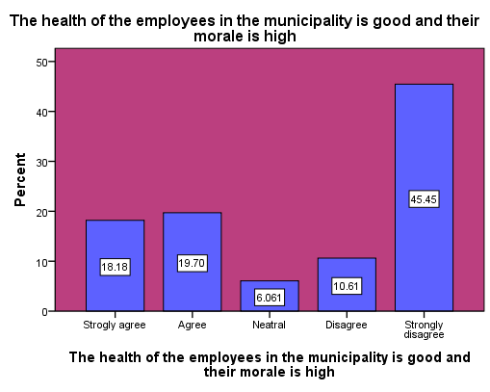

Table: 4.2.10 Communication within the municipality is good
Valid | Frequency | Percentage | Valid Percentage | Cumulative
Strongly Agree | 29 | 43.9 | 43.9 | 43.9
Agree | 26 | 39.4 | 39.4 | 83.3
Neutral | 1 | 1.5 | 1.5 | 84.8
Disagree | 4 | 6.1 | 6.1 | 90.9
Strongly Disagree | 6 | 9.1 | 9.1 | 100.0
Total | 66 | 100.0 | 100.0
Source of data primary data
4.2.10 In the above Table And Figure the majority of the Respond was Answer Strongly agreed, 29(43.9%), while agree are 26(39.4%),while Neutral 1 (1.5%), while Disagree are 4(6.1%), and strongly Disagree are 6 (9.1%). The majority indicates of the respondents answered in agreement to this item is Strongly agreed, 29(43.9%).
Figure 4.2.10 THE health of the employees in the municipality is good and their morale is high
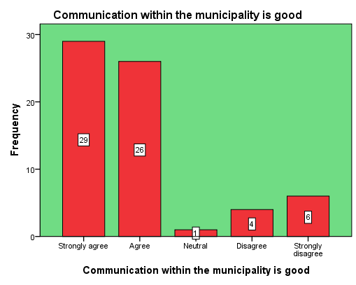

Table: 4.2.11 the performance of workers in the municipality is high
Valid | Frequency | Percentage | Valid Percentage | Cumulative
Strongly Agree | 30 | 45.5 | 45.5 | 45.5
Agree | 20 | 30.3 | 30.3 | 75.8
Neutral | 2 | 3.0 | 3.0 | 78.8
Disagree | 10 | 15.2 | 15.2 | 93.9
Strongly Disagree | 4 | 6.1 | 6.1 | 100.0
Total | 66 | 100.0 | 100.0

Source of data primary data
4.2.11 In the above Table And Figure the Majority of the Respond was answered Strongly agreed, 30(45.5%), while agree are 20(30.3%),while Neutral 2(3.0%), while Disagree are 4(6.1%), and strongly Disagree are 10 (15.2%). The majority indicates of the respondents answered in agreement to this item is Strongly agreed, 30(45.5%).

Figure 4.2.11 the performance of workers in the municipality is high.
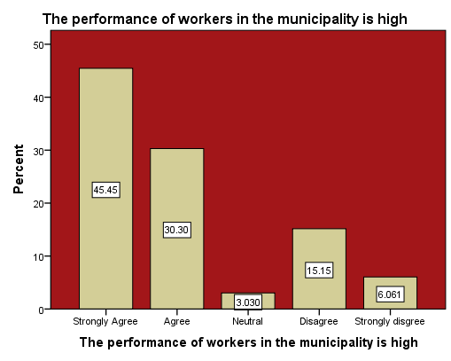

Table: 4.2.12 Employees enjoy what they do in the municipality
Valid | Frequency | Percentage | Valid Percentage | Cumulative
Strongly Agree | 25 | 37.9 | 37.9 | 37.9
Agree | 15 | 22.7 | 22.7 | 60.6
Neutral | 3 | 4.5 | 4.5 | 65.2
Disagree | 17 | 25.8 | 25.8 | 90.9
Strongly Disagree | 6 | 9.1 | 9.1 | 100.0
Total | 66 | 100.0 | 100.0

Source of data primary data 2018
4.2.12 In the above Table and figure the majority of the Respond was answered Strongly agreed, 25(37.9), while agree are 15(22.7%),while Neutral 3(4.5%), while Disagree are 17(25.8%), and strongly Disagree are 6 (9.1%). The majority indicates of the respondents answered in agreement to this item is Strongly agreed, 25(37.9),
Figure 4.2.12 Employees enjoy what they do in the municipality

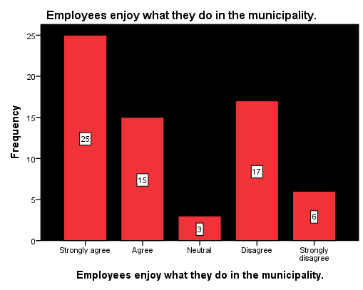

4.2.13 Workers are proud of what they do in the municipality
Valid | Frequency | Percentage | Valid Percentage | Cumulative
Strongly Agree | 18 | 27.3 | 27.3 | 27.3
Agree | 16 | 24.2 | 24.2 | 51.5
Neutral | 4 | 6.1 | 6.1 | 57.6
Disagree | 12 | 18.2 | 18.2 | 75.8
Strongly Disagree | 16 | 24.2 | 24.2 | 100.0
Total | 66 | 100.0 | 100.0

Source of data Primary
4.2.13 In the above Table And Figure the Majority of the Respond was Answered Strongly agreed, 18(27.3), while agree are 16(24.2%),while Neutral 4(6.1%), while Disagree are 12(18.2%), and strongly Disagree are 16 (24.2%). The majority indicates of the respondents answered in agreement to this item is Strongly agreed, 18(27.3%),

Figure: 4.2.13 Workers are proud of what they do in the municipality
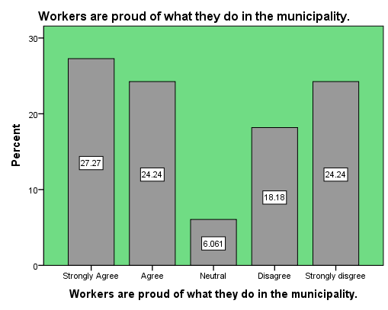

4.2.14 There are no absenteeism in the Municipal municipality.
Valid | Frequency | Percentage | Valid Percentage | Cumulative
Strongly Agree | 10 | 15.2 | 15.2 | 15.2
Agree | 11 | 16.7 | 16.7 | 31.8
Neutral | 5 | 7.6 | 7.6 | 39.4
Disagree | 20 | 30.3 | 30.3 | 69.7
Strongly Disagree | 20 | 30.3 | 30.3 | 100.0
Total | 66 | 100.0 | 100.0

Source of data primary data
4.2.14 In the above Table And Figure the Majority of the Respond was Answered Strongly agreed, 10(15.2%), while agree are 11(16.7%),while Neutral 5(7.6%), while Disagree are 20(30.3%), and strongly Disagree are 20 (30.3%). The majority indicates of the respondents answered in agreement to this item is Strongly agreed, 20 (30.3%) and Disagree 20 (30.3%).

Figure 4.2.14 There are no absenteeism in the Municipal municipality.
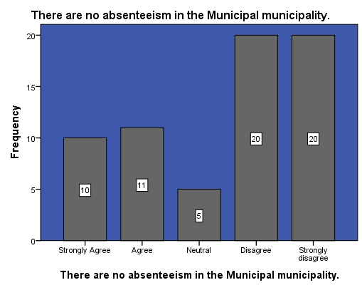

Table 4.2.15 they have very good team culture in the municipality.
Valid | Frequency | Percentage | Valid Percentage | Cumulative
Strongly Agree | 29 | 43.9 | 43.9 | 43.9
Agree | 26 | 39.4 | 39.4 | 83.3
Neutral | 2 | 3.0 | 3.0 | 86.4
Disagree | 3 | 4.5 | 4.5 | 90.9
Strongly Disagree | 6 | 9.1 | 9.1 | 100.0
Total | 66 | 100.0 | 100.0

Source of data primary data
4.3.15 In the above table and figure the majority of the respondents was answered Strongly agreed, 29(43.9%), while agree are 26(39.4%),while Neutral 2(3.0%), while Disagree are 3(4.5%), and strongly Disagree are 6 (9.1%). The majority indicates of the respondents answered in agreement to this item is Strongly agreed, 29(43.9%).

Figure 4.2.15 they have very good team culture in the municipality.
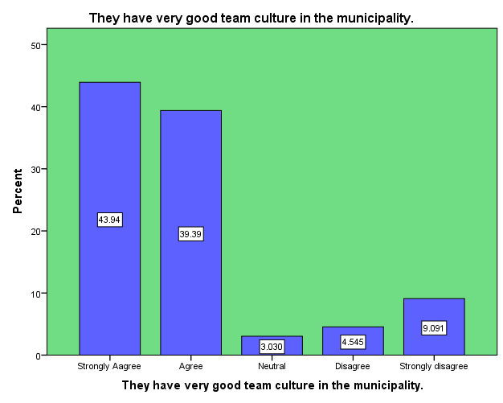

CHAPTER FIVE

FINDINGS, RECOMMENDATIONS, REFFERENCE AND CONCLUTION:

5.1 FINDINGS:
The study focused the effect of working employee productivity in government organization in capital university. This study looks into consideration of 66 respondents as sample size determines finding about topic under the study Demographic characteristics of the respondents were studies and found out the objective of the study.
From the table 4.1 shows that the findings of the study indicated the majority of the respondents were males represented by 42% while female were minority. The findings of the study from table 4.2, revealed that the first, respondents while the 15% of were diploma level, second respondents were 33% they were bachelor degree, The third were master 17% and the fourth PHD 2%. Findings in table 4.3 indicate that 32% of respondents were 21-30 years, 15% were between the Ages of 31-40, 10% respondents between the Ages 41-50 and 9% were above-51 years. This shows that the most respondents were at the age between 18-25 years. The findings of the study from table 4.4 indicate that the respondents were married are 37% and while singles are 29%.
The findings of the study from table 4.5 indicate that the respondents of working people were less than -1 year are 8%, while 1-2 years are 40%, while 2-4 years are 10%, and above 4 years are 8%. The following summary showed as a result of the research work carried out in the area of the effect of employee productivity in government organization.
Objective one: Administrative Work Environment. 4.2.1 In the table, the researcher found the majority of the employee performance appraisal system here the respondents was answered strongly agreed, 30 (45.5%).
Objective two: Physical Work Environment. 4.2.6 In the table and figure the majority of the respondents the layout of the offices and workspaces here are very well designed
Was answered strongly Disagree are 26 (39.4%).
Objective three: Social Work Environment. The performance of workers in the municipality is high. 4.2.11 in the above table and figure the majority of the respondents was answered strongly agreed, 30(45.5%), while agree are 20(30.3%), while Neutral 2(3.0%), while Disagree are 4(6.1%), and strongly disagree are 10 (15.2%). The majority indicates of the respondents answered in agreement to this item is strongly agreed, 30(45.5%).

5.2 RECOMMENDATIONS:

- The effect of employee productivity in Municipal.
- The impact of employee productivity in performances government organization.
- The effect of employee productivity in motivation.

5.23 CONCLUSION:

The following Conclusion presented as an outcome of the research work carried out in the area of the effect of employee productivity in government organization. The study set out to assess the effects of work environment on employee’s productivity in government organizations in Mogadishu Som. In an attempt to do this, 80 questionnaires were administered to the employees of Bondhere Municipal. A response rate of 66% was achieved. The data collected was analyzed using descriptive design and SPSS. However, the social work environment of employees of Bondhere Municipal was the most helpful. The Work Environment of Bondhere Municipal. Since the social environment of the Municipal was noted to be favorable, the municipal must keep an eagle eye on it so that the working life of the employees could be better to enhance productivity.
The psychological environment of the municipal was less conducive so the management of the municipal must improve the sub-environment that define psychological environment to improve the situation.
To further solve this problem the level of salary must be improved to impact positively on their psychological wellbeing since their level of salary was one of the reasons for poor psychological environment. Employees must be made to have a hand in how much they are paid to help improvement their administrative environment. The Productivity of Workers at Bondhere Municipal. In view of the fact that there was evidence of absenteeism in the Bondhere brought about by low motivational level of the employees and the stressful nature of their work, the Bondhere Municipal is advised to introduce reward systems to enable the employees feel that they are being valued by the organization they work for. In addition, all the components that define work environment were statistically significant to productivity of the Municipal.
Similarly, the work environment of the Municipal has positive impact on the productivity of its workers so the current must be maintained for the employees to be continued to be productive for the Municipal.

5.4 REFFERENCE:
CHRISTIAN ADDAI MANU. 2015. “the effects of work environment on employees
productivity in government organizations. A CASE STUDY OF OBUASI
(Adekola 2012; CHRISTIAN ADDAI MANU 2015; Chughta and Lateef 2015; Imran
and Tanveer 2015; Muhammad and Maqbool 2015; Sarboland 2012; Suci 2015
J Sun, Buys, and Wang 2013; Jing Sun, Buys, and Wang 2013; Zafar et al. 2015)
Abdul, Prof, and Ghafoor Awan. 2015. “Impact of Working Environment on Employee ’ Productivity : A Case Study of Banks and Insurance Companies in Pakistan.
Adekola, Bola. 2012. “The Impact of Organizational Commitment on Job Satisfaction:
A Study of Employees at Nigerian Universities.” International Journal of Human Resource Studies 2(2): pdf.
Chughta, Muhammad Waqas, and Khadeejah Lateef. 2015. “Role of Emotional Intelligence on
Employees productivity in in government: International Journal of Advance Research in Computer Science and Management Studies 3(2): 101–8.
Dalton, Amy H. 1982. “A Theory of the Organization of State and Local Government
Employees productivity.” Journal of Labor Research 3(2): 163–77.
Imran, Muhammad, and Aiman Tanveer. 2015. “Impact of Training and Development on
Employees Performance in Banks of Pakistan.” European Journal of Training
and Development Studies 3(1): 22–44.
Massoudi, Dr. Aram Hanna, and Dr. Samir Salah Aldin Hamdi. 2017. “The Consequence
of Work Environment on Employees Productivity.” IOSR Journal of Business and Management 19(01): 35–42. http://www.iosrjournals.org/iosr-jbm/papers/Vol19-issue1/Version-3/E1901033542.pdf.
Muhammad, Noreen, and Faiza Maqbool. 2015. “Impact of Extrinsic Rewards on Job
Satisfaction of Banking Sector Employees of Karachi Pakistan.” IOSR Journal of Business and ManagementVer. II 17(11): 2319–7668.
Oludeyi, Olukunle S. 2015. “A Review of Literature on Work Environment and
Workgovernment organization. Implication for Future Research in Citadels of Learning.pdf (2012): 32–46.
Arathya, and Mobinraj T. 2017. “Effect of Work Environment on Productivity in Construction
Management.” International Journal of Science and Research 6(3): 2015–18. ppt.
Sarboland, Kheyrollah. 2012. “Assessment of the Relationship between Emotional Intelligence and Organizational Commitment of Employees productivity: pdf.. 2(5): 5164–68.
Suci, Rahayu Puji. 2015. “The effect of work environment {ppt." in Mediates Leadership Style and Work Environment to the Employees’ P productivity: PPT POS Indonesia (Persero) Malang.” International Journal of Applied science and Economic Research 13(9): 7081–98.

Sun, J, N Buys, and X Wang. 2013. “Effectiveness of a Workplace-Based Intervention Program to Promote Mental Health among Employees in Privately Owned Enterprises in China.” Population Health Management 16(6): 406–14.
Sun, Jing, Nicholas Buys, and Xinchao Wang. 2013. “Effectiveness of a Workplace-Based Intervention Program to Promote Mental Health among Employees productivity in
Privately Owned Enterprises in China.” Population Health Management 16(6): 406–14.
Zafar, Qadoos et al. 2015.
(Abdul and Awan 2015; Dalton 1982; Massoudi and Hamdi 2017; Oludeyi 2015; S and Mobinraj T 2017; Stubbs, Forest, and State 2015). Employee productivity. Pdf. American journal of social sciences research 1(6).

QUESTIONNAIRE:

APPENDIX I

Dear Sir/Madam my name is: Ifrah Hussein Mohamud, I am a Somali student at United International University (UIU) in Bangladesh, where I’m pursuing a master's in international human resource management. I'm conducting research on the effect of work environment in employee productivity in government organization in Mogadishu-Somalia.
The finding of the research is important for me to understand the level of work environment in employee productivity in government organization. Responses to this survey will be kept strictly confidential and anonymous your participation on this survey is greatly appreciated.
Thank you very much in development.

SECTION ONE: Demographic profile. Please tick the appropriate answer.
Direction: Please tick ( √ ) only the right answers in full where applicable.
Gender
Male Female
Educational level:
Diploma Bachelor Master PHD
Age:
21-30 31-40 41-50 51-above
Marital status
- Maried 2) Single
How long have you been working with government?

Less than 1 year 1-2yrs 2-4yrs above 4yrs
SECTION B: INSTRUCTIONS

Please, read carefully and choose appropriate boxes by ticking the below:

1. ----------------------------2. -----------------------3. -----------------------4. ------------------------5.-------------
Strongly agree
Agree
Strongly Disagree
Disagree
Neutral

SECTION B: Objective one: Administrative Work Environment
NO | The effect of work environment on employee productivity in government organization | Strongly Agree | Agree | Neutral | Disagree | Strongly Disagree
1 | The employee performance appraisal system here
2 | All people working here including myself have all the skills required to perform our responsibilities
3 | The given enough authority to perform our duties
4 | Employees are involved in goal setting
5 | Work processes are documented and rigid such that you can’t vary them when there is the need to do so

SECTION C: Objective two: Physical Work Environment
Strongly agree
Agree
Strongly Disagree
Disagree
Neutral

NO | The effect of work environment on employee productivity in government organization | Strongly Agree | Agree | Neutral | Disagree | Strongly Disagree
1 | The layout of the offices and workspaces here are very well designed;
2 | The workers in the municipality are very hardworking
3 | The workers in the municipality are very much committed to their employer
4 | The health of the employees in the municipality is good and their morale is high
5 | Communication within the municipality is good

SECTION D: Objective three: Social Work Environment
Strongly agree
Agree
Strongly Disagree
Disagree
Neutral

NO | The effect of work environment on employee productivity in government organization | Strongly Agree | Agree | Neutral | Disagree | Strongly Disagree
1 | The performance of workers in the municipality is high
2 | Employees enjoy what they do in the municipality.
3 | Workers are proud of what they do in the municipality.
4 | There are no absenteeism in the Municipal municipality.
5 | They have very good team culture in the municipality.

