

UNITED INTERNATIONAL UNIVERSITY
Internship report on “Employee Job Satisfaction Level of ONE Bank Limited”
Course Name: Internship
Course Code: INT- 4399
SUBMITTED TO:
Md. Kazimul Hoque
Assistant Professor, School of Business and Economics
United International University

SUBMITTED BY:
MD. Maruf Hasan
Id.NO: 111-171-068

DATE OF SUBMISSION: 7th March, 2022

Letter of transmittal

7th March, 2022
Md. Kazimul Hoque
Assistant Professor, School of Business and Economics
United International University
Subject: Submission of Internship Report on “Employee Job Satisfaction Level of ONE Bank Limited.”
Honorable Sir,
It is certainly a great pleasure for me to be able to submit my Internship report to you. It is an honor to submit my internship report entitled “Employee Job Satisfaction Level of ONE Bank Limited.” I would like to thank you for your guidance, without it I might not be able to complete this report. To prepare this report I have mainly use the primary data and secondary data.
I have tried my level best to fulfill all your requirements you asked me to include in this report. Whatever the experience I have earned during this Internship period I have tried to put the reflection of that learning in my Internship report. I might have come short preparing this report. I apologize for the mistakes I have done. For this I appreciate your help and moral support in this regard. It was an honor to work under your guidance. I would request you to review the report and give feedback on if anything is wrongly present in this report.

Yours Sincerely
MD. Maruf Hasan
Id. No: 111-171-068

Acknowledgement

At the very beginning I would like to be grateful and all my gratitude to the almighty as I have successfully finished my Internship Report. And I would like to thank ONE Bank Limited for giving the opportunity to work in their workplace and earn some practical corporate knowledge.
Besides that I would like to thank my honorable faculty Md. Kazimul Hoque for his utmost support and the opportunity he provided me to earn a deep knowledge on a sensitive corporate issue like employee job satisfaction. Without his support I would not have been able to prepare this report. I have also got the help from my supervisors A.M.M Julfikar Ali khan (Principal Officer) to know deeply about the SME Loan, Ali Hasan (Officer) who has shared deep knowledge about the Retail Loan. And from Shafkat-E-Rabbi (Officer) and Kamrul Hasan (Officer) I have learned a lot about General Banking. And almost all the other employees have taught me at least something about banking. And they have openly talked to me and shared their experiences and thoughts on about their job satisfaction. That helped me to establish a structure of this report. And most importantly Mohammad Jahangir Alam sir (First Assistant Vice President) Manager of ONE Bank Limited Lalbagh Branch for the opportunity he gave me to work in every department of the branch to gain as much knowledge on banking as I could in this short tenure.
Lastly, I would like say that without hard-work and sacrifices I wouldn’t be able to prepare this report successfully. I owe a gratitude to all the people who helped me throughout the process.

Executive Summary
The Banking sector is one of those sectors which contribute the most to an economy. The banking sector plays a vital role in strengthening an economy. It is quite impossible to think of a stable economy without banks. But in order to run the banks successfully, they need potential and talented employees who will work with zero negligence to achieve the goals and objectives of the bank.
This report contains the knowledge and experiences that I have gained while doing my internship at ONE Bank Limited, Lalbagh Branch Dhaka. I have been assigned by my supervisor to prepare a report on the “Employee job satisfaction level of ONE Bank Limited.” I have worked in three different departments of ONE Bank Limited in these three months. This is a quite different experience for me. Though there were so many restrictions for me in the case of collecting data. But I have made a good bonding with the employees. So, I could easily talk to them about my project and I have collected a lot of information about their satisfaction level in the job. They have helped me a lot by sharing their experiences, problems, and major demands from the job. That I have tried to explain their authentic opinions in the report and tried my level best to know about how satisfied they are with their job. I have also given a short introduction and explained briefly the activities of ONE Bank Limited. I have conducted a survey to do the main part of my report. And at the end of the report, I have tried to recommend a few things by working upon those points ONE Bank Limited can increase the job satisfaction level of its employees.

Contents
Letter of transmittal ii
Acknowledgement iii
Executive Summary iv
Chapter: 1 7
1.1 (Introduction) 7
1.2 Origin of the report 7
1.3 Objective of the report 7
1.4 Methodology of the report 8
1.5 Scope of the report 8
1.6 Limitations of the report 9
Chapter-2 11
2.1 Literature Review 11
Chapter-3 14
3.1 Profile of ONE Bank Limited 14
3.2 Vision statement of ONE Bank Limited 14
3.3 Mission statement of ONE Bank Limited 14
3.4 Core values of One Bank Limited 15
3.5 Products and services of OBL 15
Chapter-4 18
4.1 Analysis of the “Employee job Satisfaction Level”- 18
4.2 Analysis of the survey: 18
Chapter-5 35
5.1 Findings 35
5.2 Recommendations 36
Chapter-6 39
6.1 Conclusion 39
References 41
Appendix 42

Chapter-1
Introduction

Chapter: 1

1.1 (Introduction)
Employees are the most valuable asset to any business organization. And it is necessary to keep the employees satisfied and contented with the necessary facilities. If employees are satisfied and their job satisfaction level is higher it would reflect positive results for that particular organization. If a particular organization has more efficient and talented employees working within, its sustainability and business growth in that particular industry would be much higher than usual. Employee job satisfaction level is so important that a company’s best and potential employee retention depends on that matter. The more satisfied the employees would be the more they would put their best performance in the job. Employee job satisfaction is something which brings a realization in the mind of an employee that he is getting all the necessary facilities which he deserves. As well as his expectations are getting fulfilled by the organization.

1.2 Origin of the report
In order to complete the graduation degree a student must work physically in a business institution or office for a very short time of 3-4 months to get the practical experiences and acquire knowledge about the corporate culture and get familiar with it. And at the end of the internship period he/she need to share his/her gathered experiences as an internship report. I have successfully finished my internship in ONE Bank Limited (Lalbagh Branch). And I have been assigned by my honorable supervisor to submit a report on the ‘Employee job satisfaction level’ at ONE Bank Limited.

1.3 Objective of the report
I am doing this report for the acknowledgement of “Employee job satisfaction level” at workplace (ONE Bank Limited). Employee plays the vital role for an organization to achieve its goals and objectives. If a particular organization does have a potential and extra ordinary team of employees, they might perform extra ordinary in the industry they belongs to. But all that depends on the job satisfaction level of employees. Because the matter of fact is that an employee might not perform up to level of his capability, if he is not satisfied with his job. And there can be various reasons for that. It can be the compensation, recognition, working environment or may be the people

1.4 Methodology of the report
In order to prepare this report all I need was to collect data. The report is prepared based on the context of ‘Employee job satisfaction level.’ I have worked at ONE Bank Limited Lalbagh Branch as an Interne for three months. I got the opportunity to talk in details on that matter with the employees. They have shared their opinions, thoughts and talked about their job satisfaction quite openly. So, it helped me to get the legit information and get to know whether they are really satisfied with their job or not.
For preparing this report I have used two types of data sources and those are primary data source and secondary data source. Most of the information in this report is from the ‘primary source’. As I have got opportunity to talk directly with the employees. I got the access to ask them questions on their job satisfaction level and some of them were quite open to that and they shared their genuine opinions and experiences. In case of collecting the primary data I have taken interviews and after taking interviews I have conducted a survey by preparing some questions and tried to know thoughts of the employees about their job satisfaction.
For the data collection I have used sampling data. Here the sample size is 39. And my target population were the employees of ONE Bank Limited (Lalbagh Branch & Kawran Bazar).
In this report I have tried to use primary data mostly. But I have put some information that has been collected from secondary data sources. I had to take help from a few and of ONE Bank Limited. And there is a very few amount of information that is collected from the secondary sources like journals, articles, websites annual report and the official website of ONE Bank Limited. And after collecting all the data I have analyzed those data and portrayed them with graphs and explanation.

1.5 Scope of the report
This report is totally prepared as a part of the completion of my under graduation degree. But this report has some scope though. In this report I have tried my level best to portray the condition of employee job satisfaction of ONE Bank Limited. And the current position of the bank in the banking industry. And I also tried to provide some recommendations in that report which I think ONE Bank Limited should implement to boost up the employees satisfaction about the job engagement and keep them motivated.

1.6 Limitations of the report
There are a few limitations of this report. And those are the time constraint, privacy and confidentiality. And most importantly the sensitivity of the report subject matter. Because they found my report contents a bit sensitive. So, it was a bit tough for me to talk to them on that matter and collect information.

Chapter- 2
Literature Review

Chapter-2

2.1 Literature Review
Employee satisfaction towards their job is a very important for a business organization. A company’s bright or dark both condition depends on what kind or quality employee an organization recruits. If employees are highly satisfied the employee turnover rate gets reduced. Employees become more engaged with their job. And they become more committed to their job rather than pursuing absenteeism. There are a lot of reasons behind the employee dissatisfaction and a lot of facts work behind the job satisfaction. A lot of authors and HR specialists have defined the employee job satisfaction very differently.
A famous philosopher Confucius once told that choose a job you love and you will never have to work a day in your life. (AZIRI, 2011).
Hoppock defined job satisfaction as any combination psychological, physiological and environmental circumstances that cause a person truthfully to say I am satisfied with my job. This approach explains that it is influenced by various external factors. That is job satisfaction presents a set of factors that cause a feeling of satisfaction.
Vroom in his definition on job satisfaction on the role of the employee in the workplace. Thus he defines job satisfaction as affective orientations on the part of individuals towards work roles which they are presently occupying.
Job satisfaction is a worker’s sense of achievement and success on the job. It is generally perceived to be directly linked to productivity as well as to personal well-being. Job satisfaction implies doing a job one enjoys, doing it well and being rewarded for one’s efforts. Job satisfaction further implies enthusiasm, and happiness with ones work. Job satisfaction is the key ingredient that leads to recognition, income, promotion and the achievement of other goals that lead to feeling of fulfillment.
The term job satisfaction refers to the attitude and feelings people have about their work. Positive and favorable attitudes towards the job indicate job dissatisfaction.

We consider that the job satisfaction represents a feeling that appears as result of the perception that the job enables the material and psychological needs.
Maslow arreanged human needs along a fiver hierarchy from physiological needs, safety and security, belonging, esteem to self- actualization, In, Maslow’s pyramid theory the lower needs should be fulfilled those rise to higher level.
A research conducted by Vanderberg and Lance in (1992)during which they surveyed 100 professionals in the information services for five months showed a strong relations between job satisfaction and employee loyalty Their research proved that the higher the degree of job satisfaction the higher is the level of employee loyalty.
Except all these there are so many theories established by so many researchers and authors. But all tried to focus on the fact that if the employees are happy and pacified with their job. They will be more engaged to their job and work even more passionately for their organization.

Chapter- 3
Company Profile

Chapter-3

3.1 Profile of ONE Bank Limited
ONE Bank Limited is a 3rd generation private bank of Bangladesh. It was established back in 1999 with a vision of to be a role model in the banking sector by fulfilling customers need and as well as stand up to the expectation of customers. One bank limited has 107 branches all over Bangladesh. They are working for the socio-economic growth of the nation since there entrance in the banking sector of Bangladesh. It is a dynamic bank with goals and objectives to serve the community. ONE Bank limited promises to serve the clients and community with undoubted and utmost devotion. Their main focus is on the effectiveness, straightforwardness, accuracy and inspiration with the soul and conviction to dominate as ONE Bank Limited in terms of worth and legacy. ONE Bank Limited basically focuses on taking deposits from the general public through various saving portfolios and loaning the assets in different areas at a higher edge. OBL has significant centralization of financing in medium and large ventures. As, the short term financing has comparatively low risk than long-term financing in that case OBL tries to keep the risk as minimal as possible. ONE Bank Limited is playing and a pivotal role in the growth of our economy. And in near future they would be one of the most well positioned and established bank in the banking industry of Bangladesh.

3.2 Vision statement of ONE Bank Limited
- To establish ONE Bank Limited as a Role Model in the banking Sector of Bangladesh. (ONE Bank).
- To meet the needs of our customers, provide fulfillment for our People and create Shareholder value. (ONE Bank)

3.3 Mission statement of ONE Bank Limited
- To constantly seek ways to serve better our customers. (ONE Bank)
- Be proactive in fulfilling our social responsibilities.
- To review all business lines regularly and develop the Best practices in the industry.
- Working environment to be supportive of teamwork, enabling the employees to perform the very best of their abilities. (ONE Bank)

3.4 Core values of One Bank Limited
- Oneness: One team one goal. Serving our clients, stakeholders, and the community at large in spirit of oneness. (ONE Bank, 2021).
- Take pride: In what we do and where we work: with the highest standard of fairness, ethics, integrity, and openness in everything we say and do.
- Client centricity: we earn our clients and customers’ trust by placing at the core of our organization and continuously strive to pursue mutually beneficial relationships in which the value created and is shared fairly.
- Respect & appreciate: the people we work with and the contribution they make.
- Excellence: We achieve excellence by “Doing Right Things Right, First Time Right.” (ONE Bank, 2021)

3.5 Products and services of OBL
ONE Bank Limited offers various types of products and services. (ONE Bank, 2021). It offers almost all the necessary products and services that a commercial bank must provide. OBL provide a few major type of banking services and those are corporate banking, retail banking and SME banking and trade services. Some of the services provided by OBL are as following:
- Current Deposit
- SND (Short Notice Deposit)
- Fixed Deposit
- Monthly Scheme Deposit
- OBL (Shubidha, Romoni, Trinomul)
- Working Capital Finance
- Term & Lease Finance
- OBL ( Imarot, Unnoyon, Notun Uddyog)
- OBL Earnest money/ Bid Bond
- Letter of Credit (Sight, Deferred, Usane & UPAS)
- Back to back LC
- Import documents handling
- Shipping Guarantee
- Export LC
- Export Bill Negotiation
- Letter of Guarantee (BG/PG)
- Remittance
- Debit and Credit Card
- Customer Service
- SME help desk
All these above products and services are provided by ONE Bank limited to their clients and so more.

Chapter- 4
Analysis

Chapter-4

4.1 Analysis of the “Employee job Satisfaction Level”-
In this report I have tried my level best to evaluate as well as portray the level of job satisfaction among the employees of ONE Bank Limited. I have conducted an online survey through Google form. I provided the employees with the link to respond the questions that I have prepared for collecting data.

4.2 Analysis of the survey:
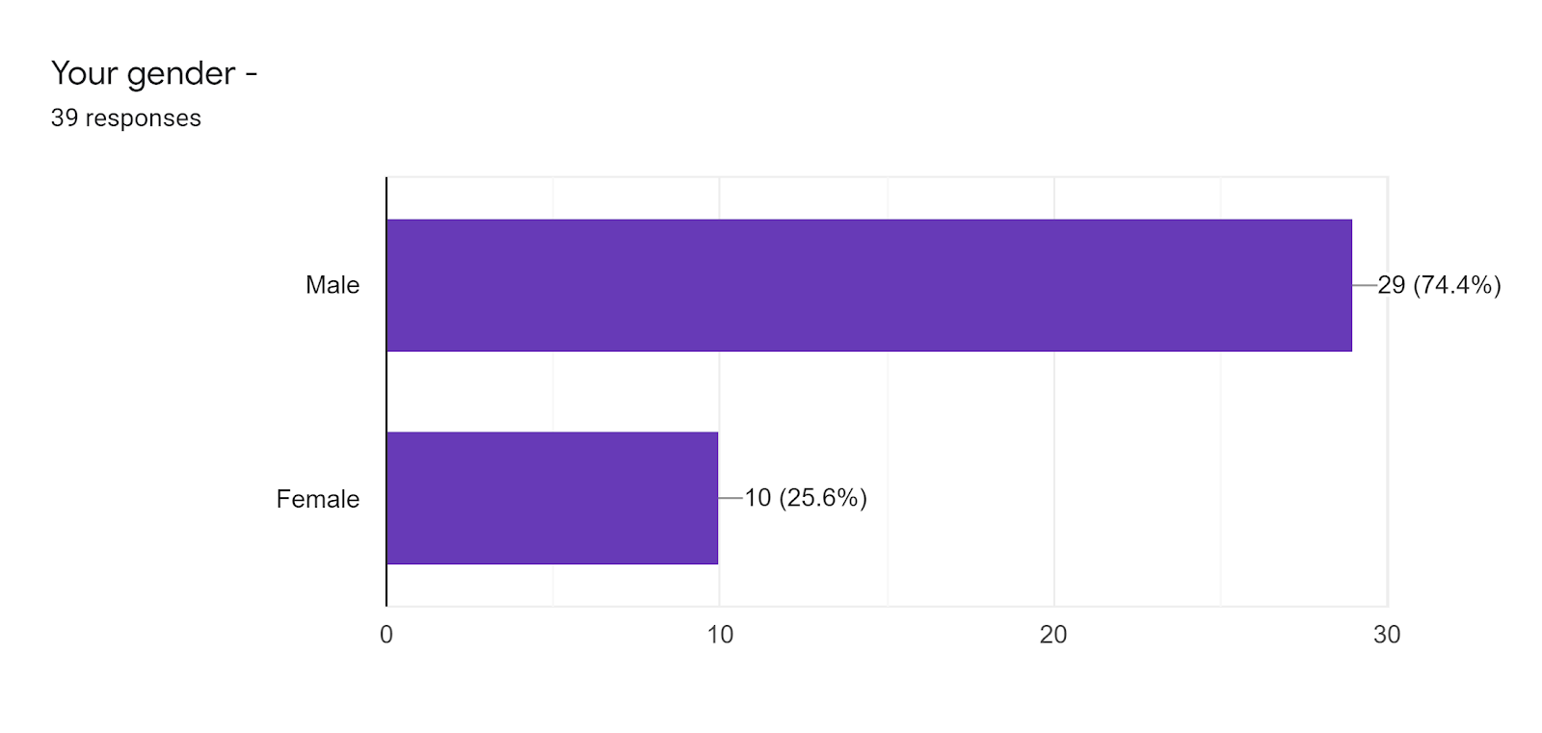
In this chart we can see that 39 people have responded to this survey. Among these 39 people the majority are male 74.4% and rest of the responses are from female employees. The link was provided to more than 50 employees but a few did not respond to the survey. Some employees showed their reluctance to fill the survey because of their work pressure.
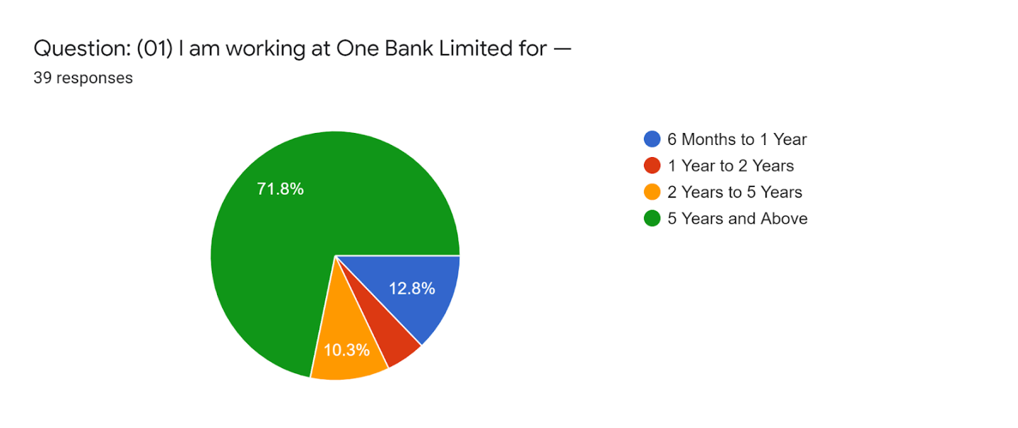
In this chart we can see 71.8% people that means majority of the employees are working at ONE Bank Limited more than 5 years or above. 12.8% employees are newly recruited, where 10.3% are working more than 2 years and 5.1% people are those who have just completed their probationary period. Majority employees who have responded to the survey are working since a long time period at ONE Bank Limited. As the workplace and the working culture over here is suitable to work so they are less tend to switch their job.

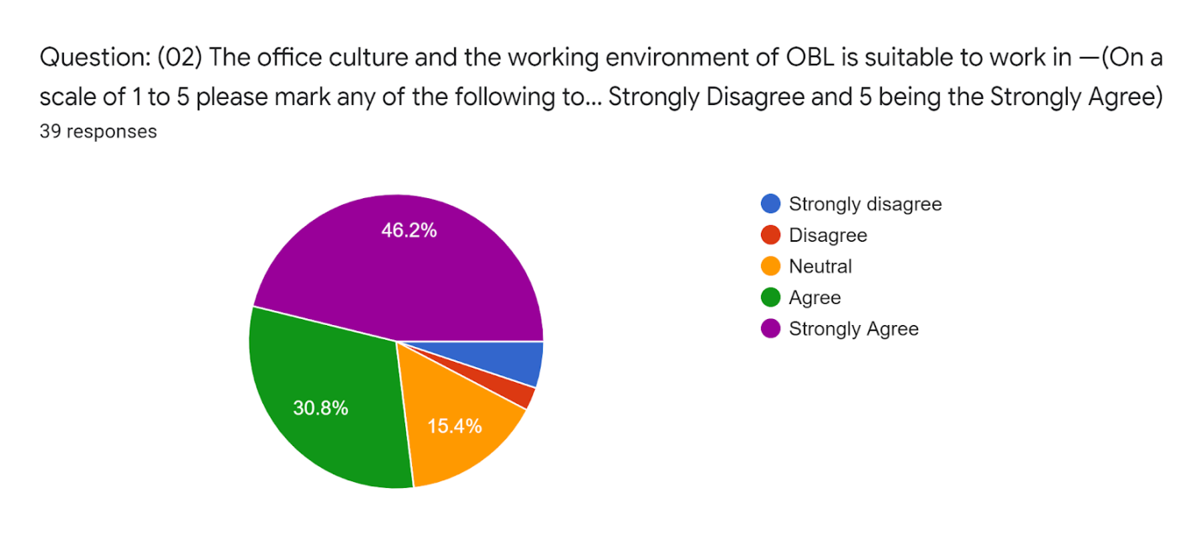

The working environment and office culture have positive relation with the job satisfaction of employees. Because employees’ job satisfaction level is higher it will increase their productivity at work. In the analysis part I have found that the Weighted Mean of that question is 4.13 that refer to that the employees are highly agreeing with the statement. It means that employees are satisfied with the workplace and the working environment. They found their workplace very suitable to work in and for that reason they are more likely to work with more sincere and efficiency.
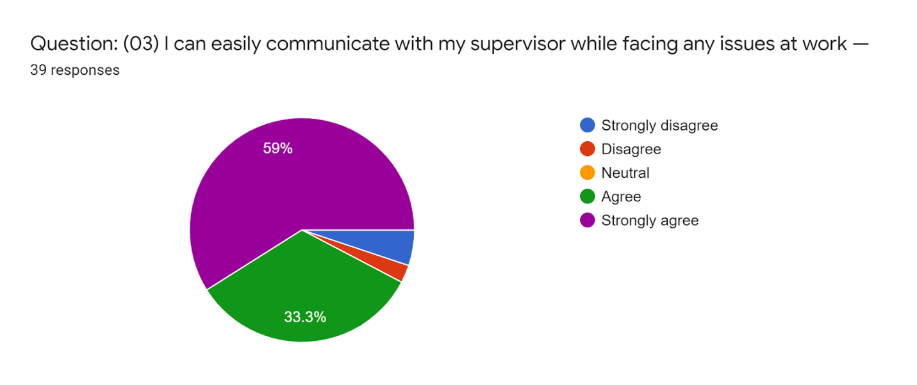
An employee’s ease of communication and flexibility with his/her supervisor has a positive impact on their job satisfaction. It is important for an employee to have the facility to communicate with their supervisors while they face any sorts of issue at work. If they cannot communicate properly with their supervisors their work would be on hold. In the analysis I have found that the weighted mean of the statement is 4.39 that refers to that the employee are highly agreeing with the statement. And that agreeableness refers to that the employees are satisfied as they have less communication gap with their supervisor.
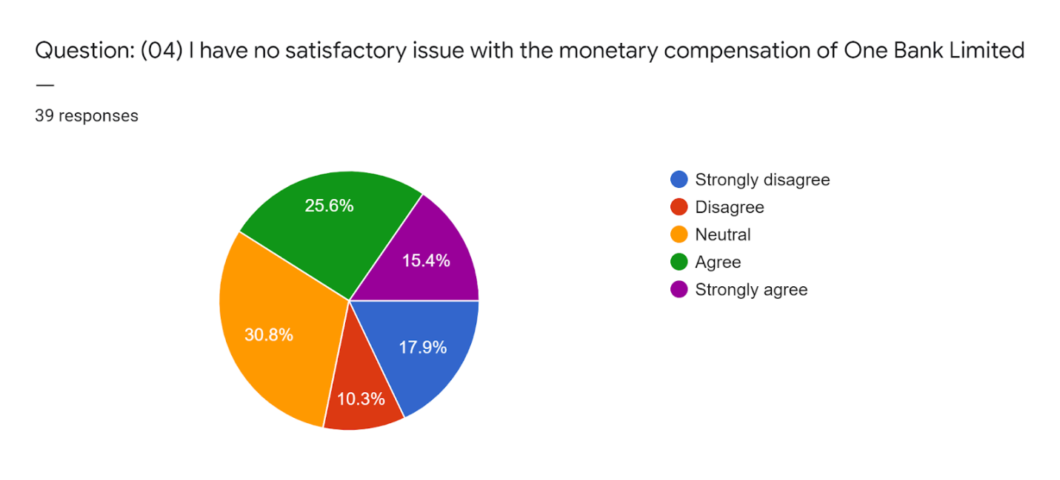

Monetary compensation has a direct positive relation with the job satisfaction level of employees. If the employees are not satisfied with their salary and other monetary compensation provided by the organization they would definitely not be happy and satisfied in the job. As I have found in the analysis that the weighted mean of that question is 3.1. This defines in case of that question the employees were found neutral. In other words the employees are moderately agreed with the statement. If the salary benefits matches with the employees’ satisfaction it would put positive impact on the employees’ job performance. And the employees would be more eager to work hard and efficiently.

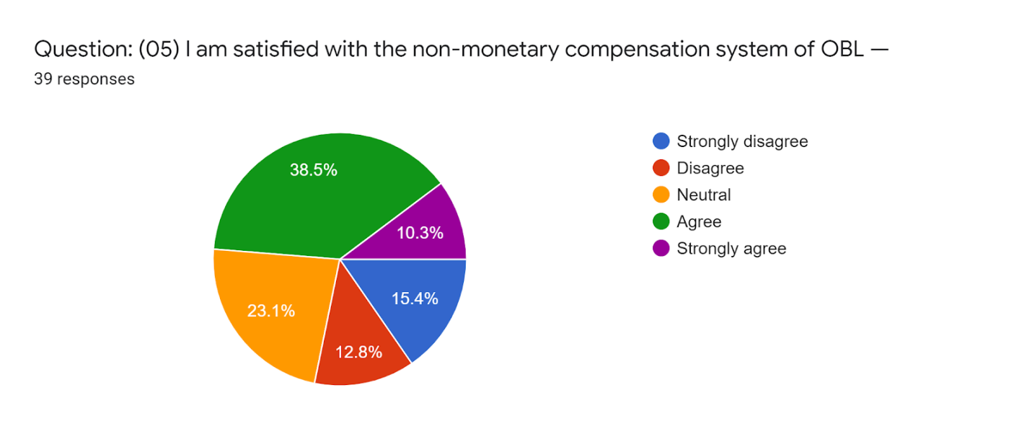
Non-monetary compensation has a positive correlation with the job satisfaction level of employees. If the employees are not satisfied with their promotion and other non-monetary compensation like annual leave, sick leave, mandatory leave and other different types of leaves provided by the organization they would definitely not be happy and satisfied in the job. As I have found in the analysis that the weighted mean of that statement is 3.15. This defines in case of that question the employees were found neutral. In other words the employees are moderately agreed with the statement. If the salary benefits matches with the employees’ satisfaction it would put positive impact on the employees’ job performance. And the employees would be more eager to work hard and efficiently.
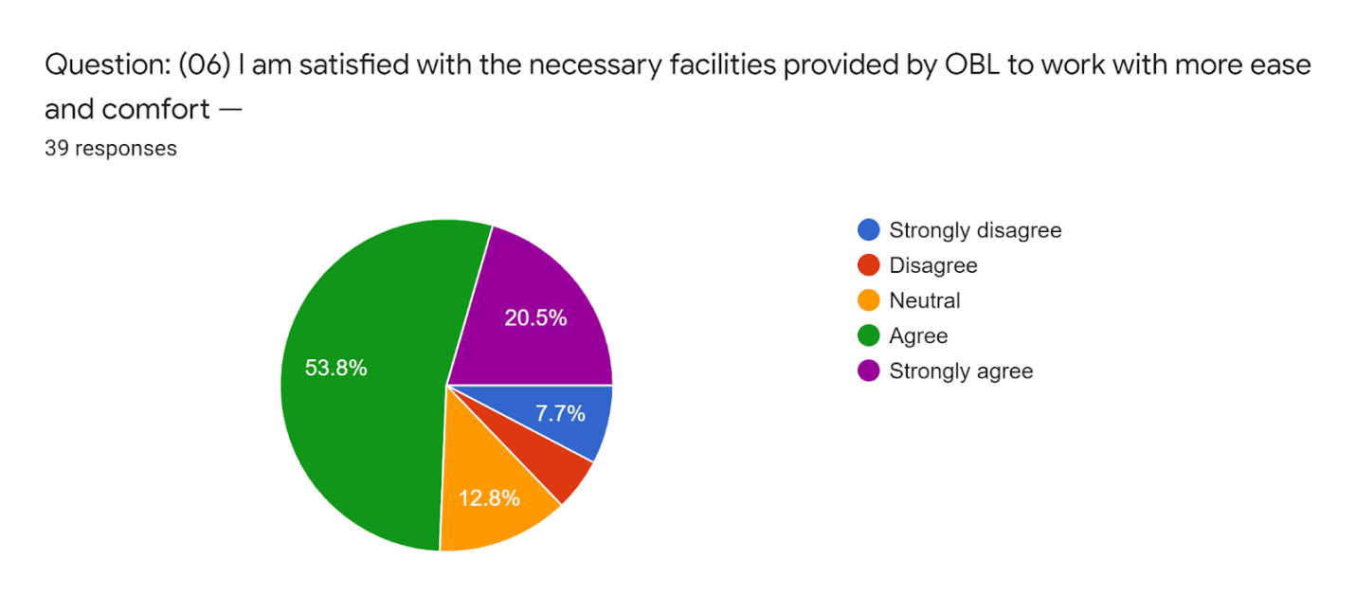

Employees need necessary facilities to work with more efficiency and comfort. If the organization does not provide the materials, equipment and other facilities which are very much needed to do work. It will definitely dissatisfy the employees of that particular organization. In the analysis I have figured out that the weighted mean of that statement is 3.74. This shows that the satisfaction of employees in that particular statement is a bit high. So, I can say that majority people are satisfied on that point except a few.

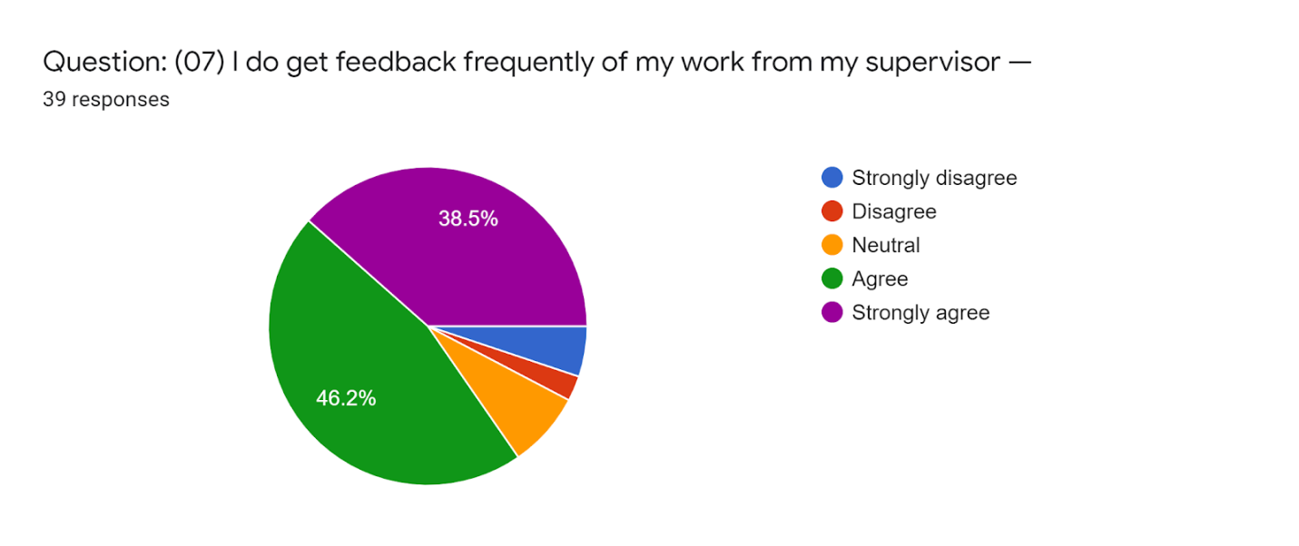
The potential and dedicated employees always appreciate to get feedback of their work by their supervisor. If the employees get feedback of so often they will work with more dedication and try to work on the feedback provided by their supervisor and correct themselves if they are doing anything wrong. If there is a gap of feedback then the employees won’t understand the value of their work and they might get upset to that and be dissatisfied. In the analysis I have found that the weighted mean of responses on that statement was 4.10. This means that majority employees are found satisfied because they highly agreed with the statement. And it defines that they are satisfied on that point.

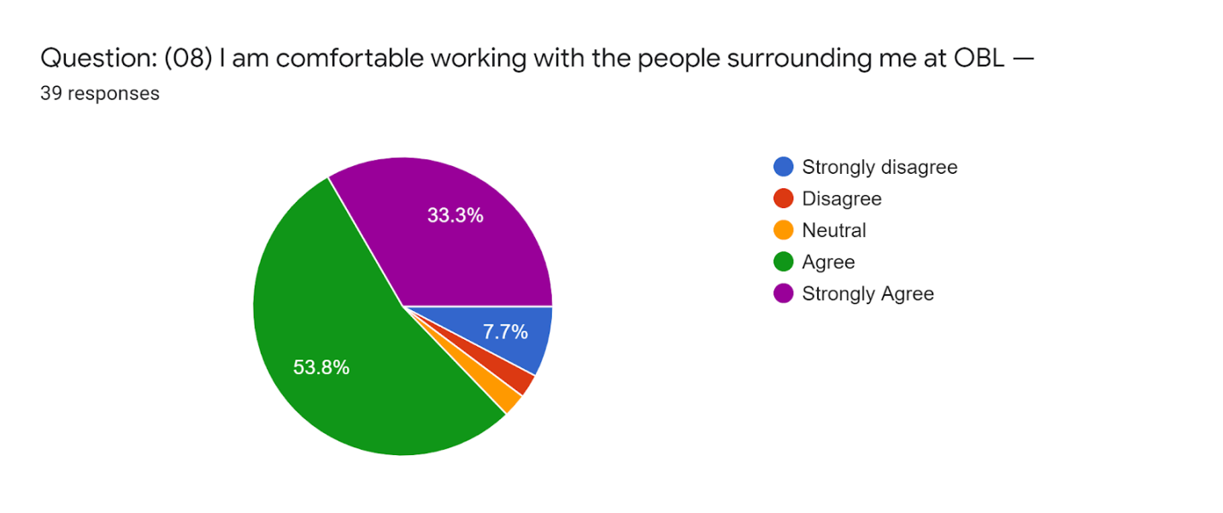
The surrounding people have a positive relation with the employee job satisfaction level. If an employee has a good surrounding of colleagues at his workplace it will be easier for him to work in office comfortably. There is a lot of work done in teams in a business organization. And for these employees need a good surrounding of people who would make them feel comfortable during work. If an employee feels uncomfortable to work with his colleagues it will put negative impact on his job performance. He/she would not be able to work with one hundred percent concentration. In the analysis I have figured out that the weighted mean of that particular statement is 4.10. This defines employees OBL are highly agreeing with that statement and they are content working with the people they work with.
.
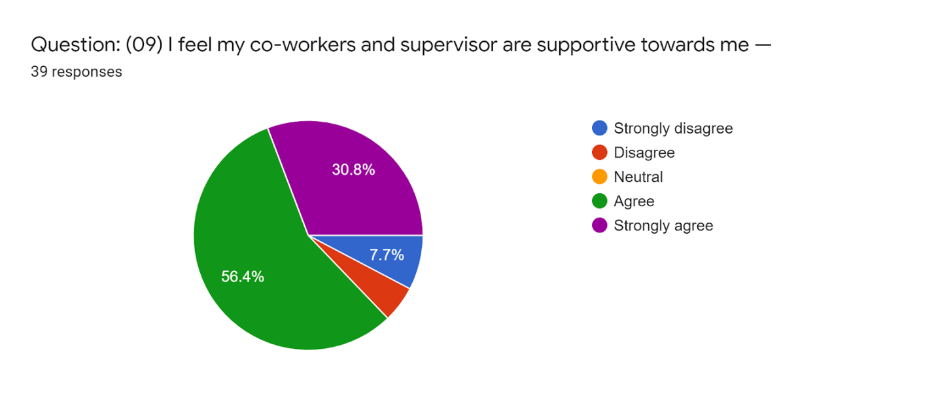
The support of colleagues and supervisor is a mandatory need of an employee to work with satisfaction at workplace. It has a positive relation with the job satisfaction. It is very natural that people cannot be satisfied where the people are not supportive to him. In the analysis I have figured out that the weighted mean of that statement is 3.97. Which means that the employees are highly agree with that their con workers and supervisor are supportive and they are happy with that. And the work becomes easy when there is full of supportive people at workplace. So, in that particular point I can say that the employees of OBL are found satisfied.
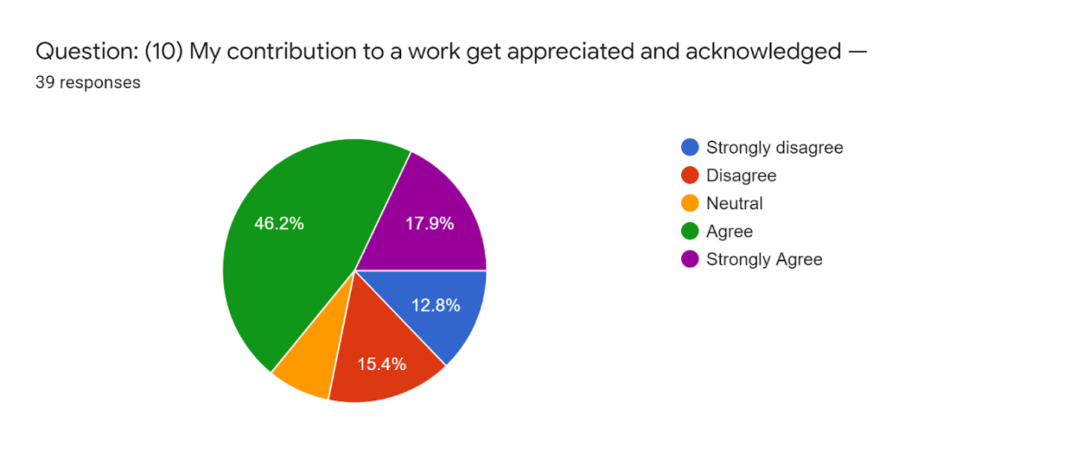
For an employee it matters a lot that he or she is getting appreciation for his/her work. If employees get appreciated they feel more satisfied. On the other hand if the organization does not appreciate employees for their contribution at work they would be more likely to be dissatisfied and may think to switch job. In the analysis I have seen that the weighted mean of that particular statement is 3.41. In this case I can say majority people are satisfied that their work and contribution gets appreciated. And it keeps them to work with more eagerness and proficiency.
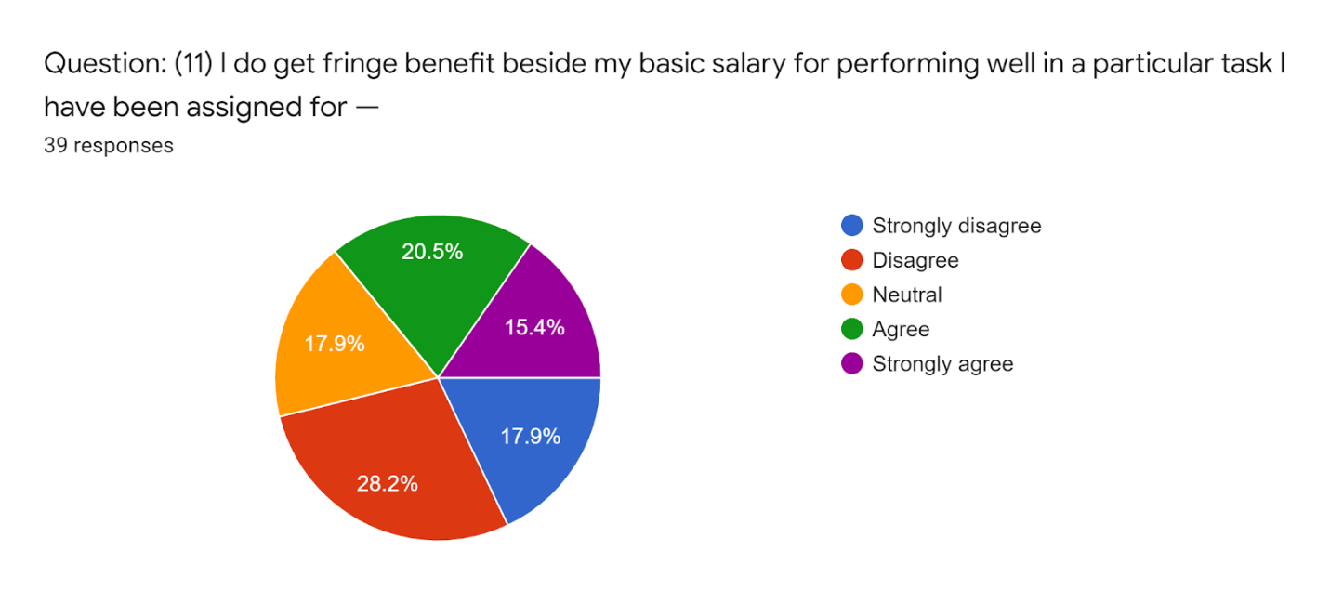
Extra benefits like performance bonus, recognition or credit of successfully completing a project or promotion on the basis of job performance has a positive relation and impact on job performance of an employee. These are the factor which keeps an employee motivated to work better in the workplace. Employees become dissatisfied they work hard but does not get their proper benefits or return for those works. While doing the analysis I have found that the weighted mean of that statement is 2.87. This shows overall majority employees are found dissatisfied in that point.

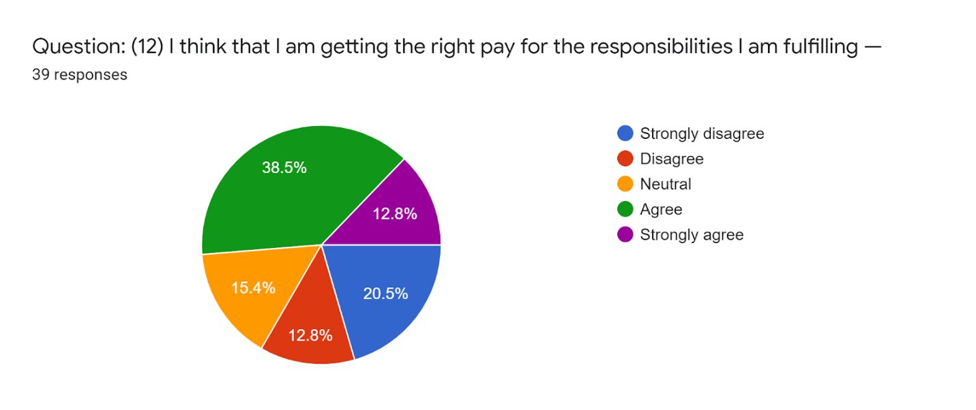
Satisfaction of getting the right pay has a great impact on the employee job satisfaction level. If an employee is satisfied with the pay he gets from his job he will be satisfied enough to work with satisfaction. But if it is not then an employee loses his willingness to work with spark and dedication. Dissatisfaction imposes negative impact on the job satisfaction level of an employee. In the analysis part I have figured it out that the mean of that statement is 3.10. This is showing that the employees are feeling that they are getting the right pay for what they are doing in the job. Somehow some of them have disagreed too. But overall they are satisfied with their salary benefits and they think they are getting the proper pay for their work.
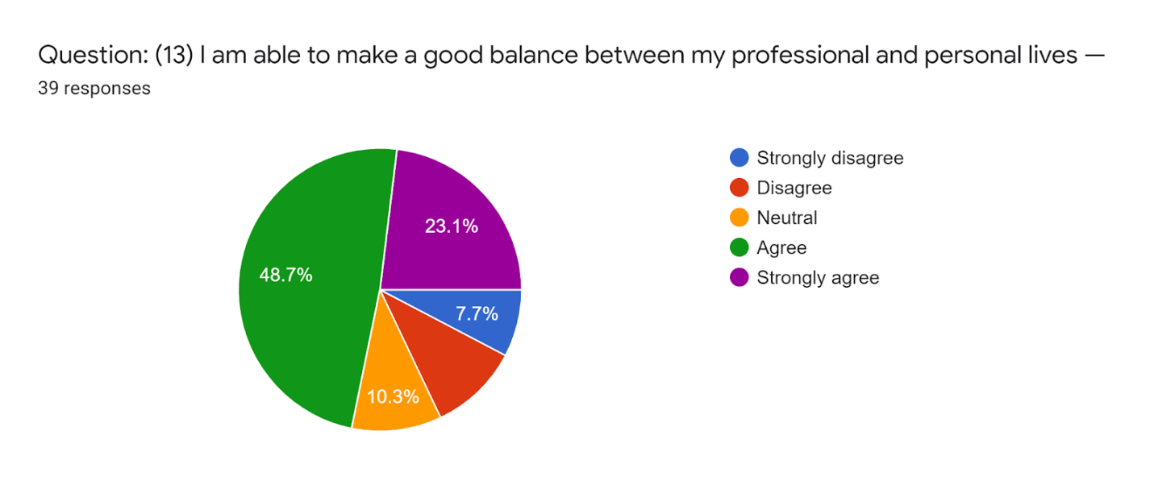

Balancing the both personal and professional life is an impactful factor in case of job satisfaction level of employees. As I have done the analysis and found that the weighted mean of that particular question is 3.69. That means employees are highly agreeing with that they are maintaining a balance between personal and professional life. That refers to the satisfaction of employees. And it has a positive impact with their job performance. If the employees are doing well in their personal and professional life definitely their outcome at workplace would be better. But if it is not then it turns into a drawback.

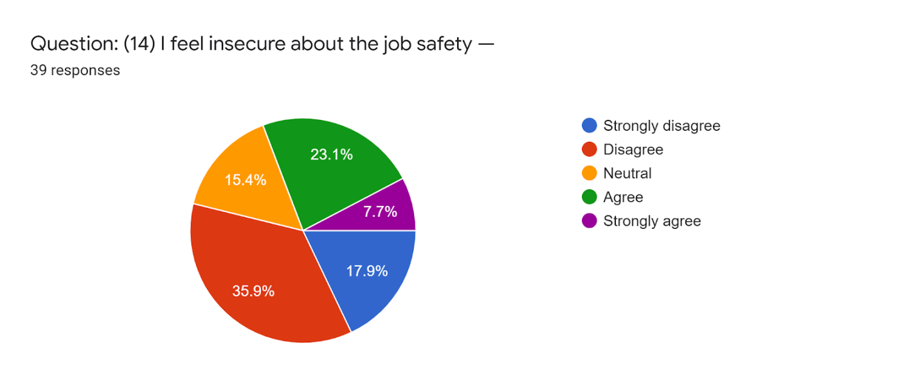Job safety has a direct correlation with the employee job satisfaction at workplace. Employees always wants ensure of their job sustainability certainty of job. Job safety has a positive relation with the job satisfaction level of employees. If employees are all time in an uncertain position and afraid of losing their job it is very obvious that a dissatisfaction will work in their mind. In the analysis I have figured out the weighted mean on that statement from the respondents is 2.67. In that case I can say that majority people are not feeling insecure and they are found dissatisfied with the job security provided by ONE Bank Limited. And if this job insecurity goes on it would put negative impact on the job performance of the employees.
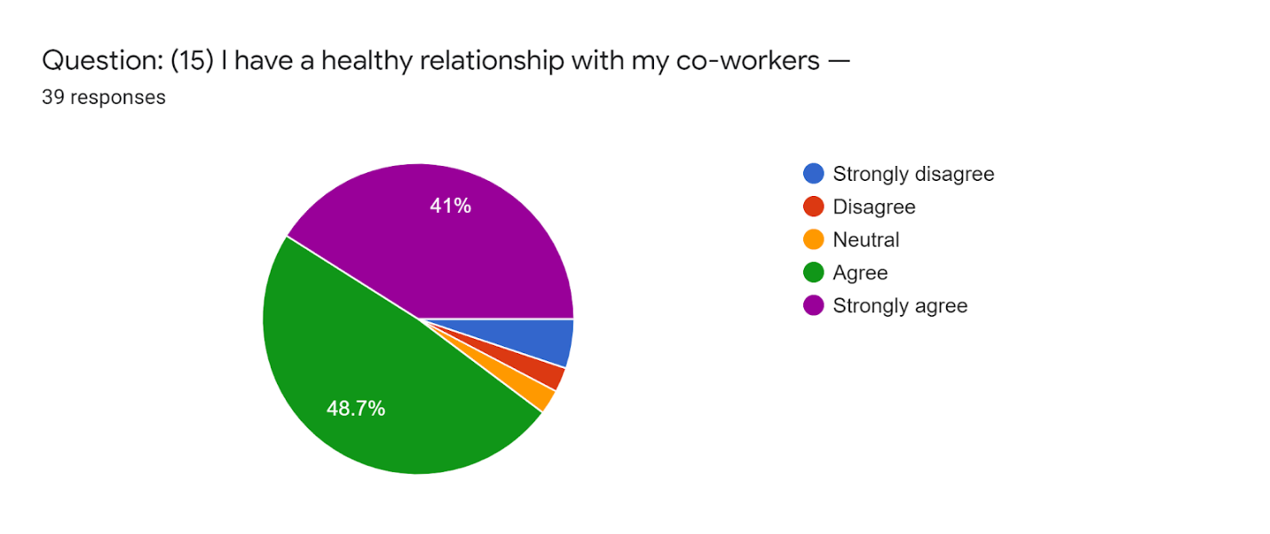
Having a good relationship with the co-workers is one of the important factors of employee job satisfaction level. Employees spend the most of their time with their co-workers at office. And it is expected that employees will pursue a healthy relationship among them. An employee’s job satisfaction level is high when he/she is having supportive colleagues and they are sharing a good bonding among them. In the analysis part I have observed that the weighted mean of that statement is 4.18. That means the employees of OBL are highly agreed with the matter that they are having good relationship with their co-workers. 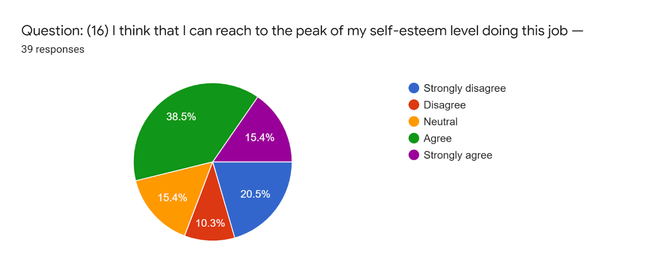
An employee’s level of job satisfaction defines his self-esteem level. If an employee’s job satisfaction level is high his self-esteem would be higher too. A highly satisfied employee would like to see himself at a position of higher self-esteem. And he/she is likely to expect proper respect and recognition of people. In the analysis I have observed that in that statement the weighted mean in is 3.17. Which is moderately high and explaining that the employees agreed on that statement that they can reach to their expected level of self-esteem and their self-actualization may get broaden.

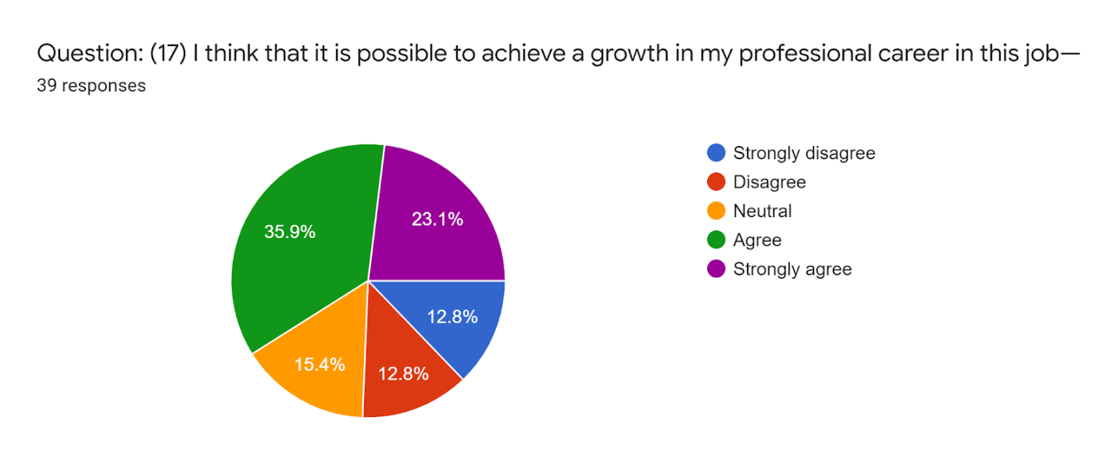
Undoubtedly job satisfaction level of employees is related to their growth in professional career. If an employee is highly satisfied with his job then he/she will definitely feel that he is achieving growth in his professional career. In the analysis I have found that the weighted mean of that particular question is 3.44. As the majority employees have a thought that they can attain professional growth by doing this job; So, I can say that the employees are satisfied here and would be more productive.

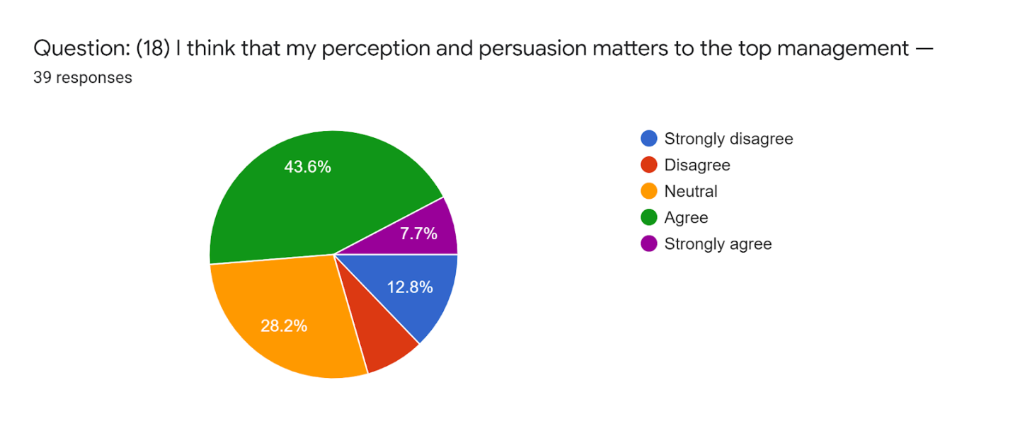
An employee becomes more satisfied with his job when he sees that his perception is valued by the top management. If an employee’s opinion does not matter to the authority then he would feel inferior. And dissatisfaction will be there as a result. In the analysis the weighted mean of that question is 3.26 that refers to that they are agreed with the statement. As we can see that majority people have expressed that their perceptions and thoughts matter. So, I can say that the employees are satisfied on that point.
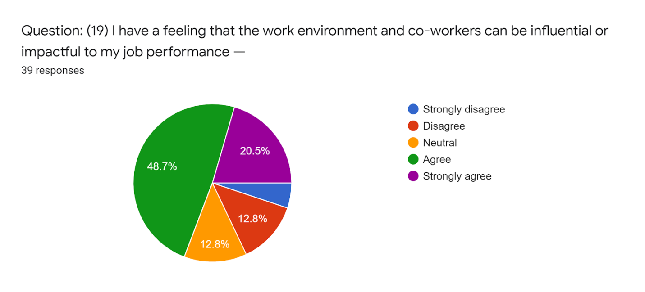
Employees need better workplace and colleagues to perform well in their job. And job performance is positively related to that. If the workplace is not suitable to work then employees cannot properly concentrate on their work and becomes dissatisfied. In the analysis I have found the weighted mean of that statement is 3.67. this means employees of OBL are agreeing with that statement. So, I can say that the employees are found satisfied on that point. As we saw that the employees are satisfied with the people they work with, so it is pretty obvious that the positive working environment would put positive impact to an employee’s job performance.

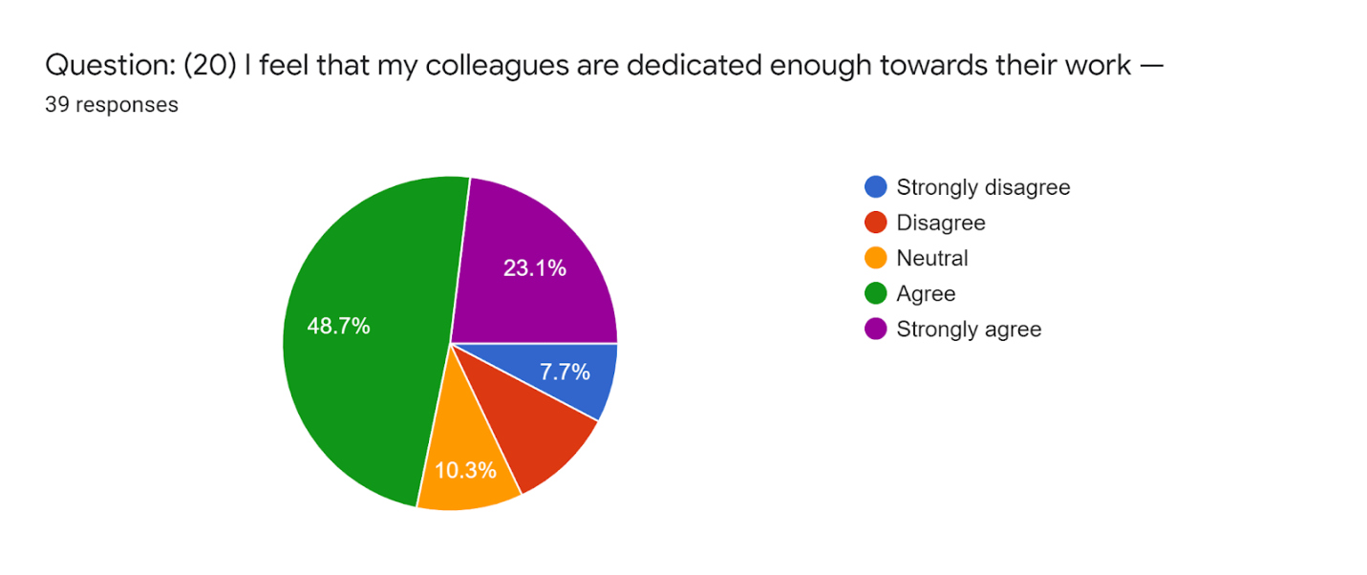
Employee’s dedication for his job is an indicator of job satisfaction level. The people who are engaged with their job they would be always dedicated and do hard work. In my analysis the weighted mean of that question is 3.69. That means employees of OBL found their colleagues dedicated and involved in their job. And definitely it is a fact of motivation if the surrounding people are dedicated to their job it will influence others to be dedicated those who are not. According to my analysis I have found majority of the employees are agreed with that statement and they are satisfied in that point.

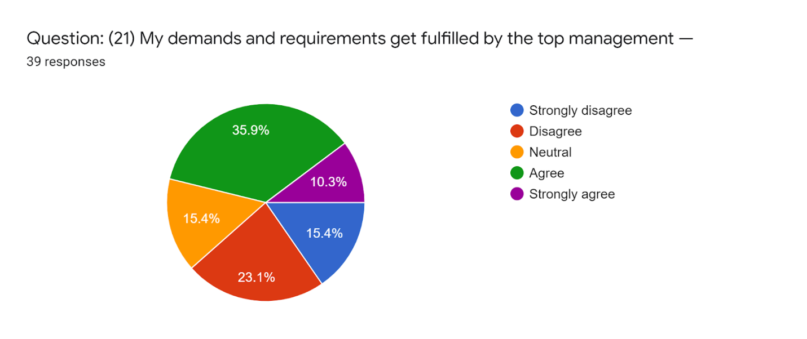
Generally employees are found satisfied when their demands get fulfilled. This is closely related with the employee job satisfaction level. If employee’s demands get fulfilled the turnover gets reduced and they become more motivated towards their work. While doing the analysis I have figured out the weighted mean of that statement is 3.03. This defines that employees are moderately agreed with the statement and they are satisfied that their requirements get fulfilled. This will impose positive impact on their job performance.
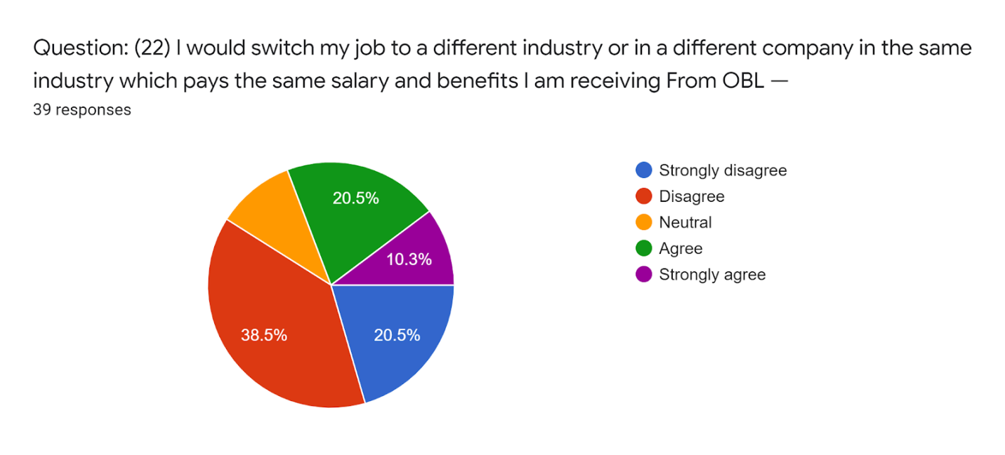
The employee turnover is seen when the employees are not happy with their job. And dissatisfied employees always tend to switch their job to go to a better place to work and get the right pay what they deserve. In the analysis part I have found the weighted mean (2.62) of that statement where majority people disagreed. They are satisfied with the job and not willing to switch job. On the other hand some people are interested to switch when they would get some better offers.
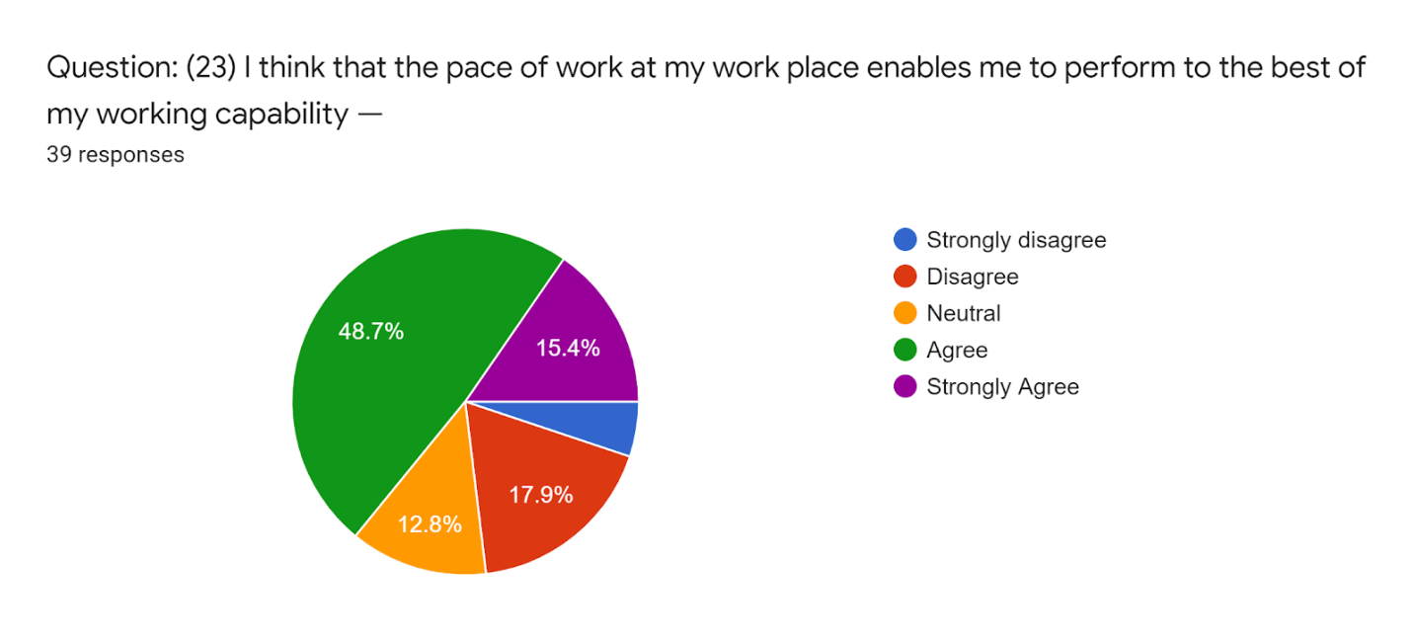
Employees’ performance sometimes depends on the pace of workplace and it may utilize the working capacity of an employee to the fullest. Sometimes pressure or pace of work can bring the best out of an employee. In the analysis the weighted mean of that statement is 3.51. It defines that the employees are moderately agreed to that statement. I have found most of the people agreed that they are satisfied and they can use their working capability to the maximum. And they can productively do their work.
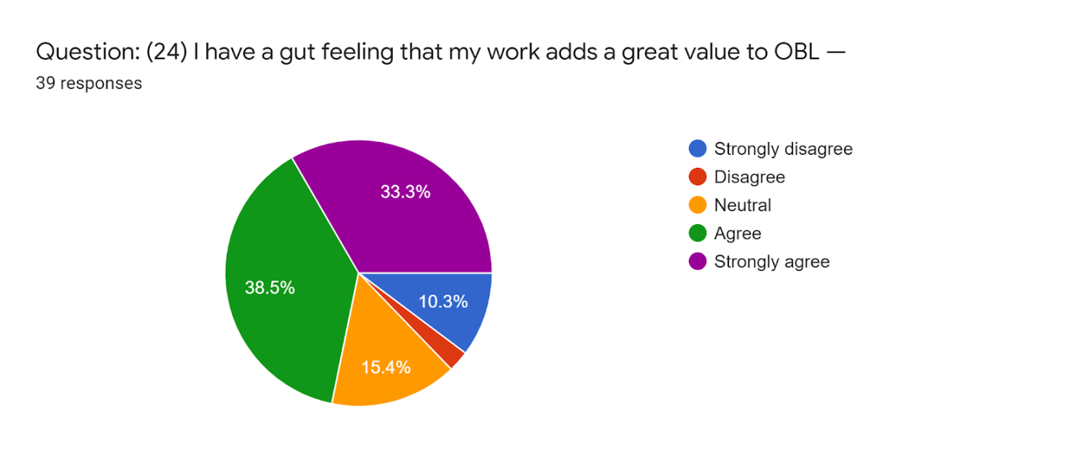
The job satisfaction level of an employee becomes high when he feels that his work is full of worth. If an employee feels that his contribution adds great value to the organization is also adds satisfaction to his job. Employee feels satisfied when they are recognized in their job for their job performance. In the analysis portion I have figured out that the weighted mean of that statement is 3.82. This is showing that employees have highly agreed with that statement. And they think that their work adds value to the organization. Their productivity, efforts and success has a value and it’s meaningful.
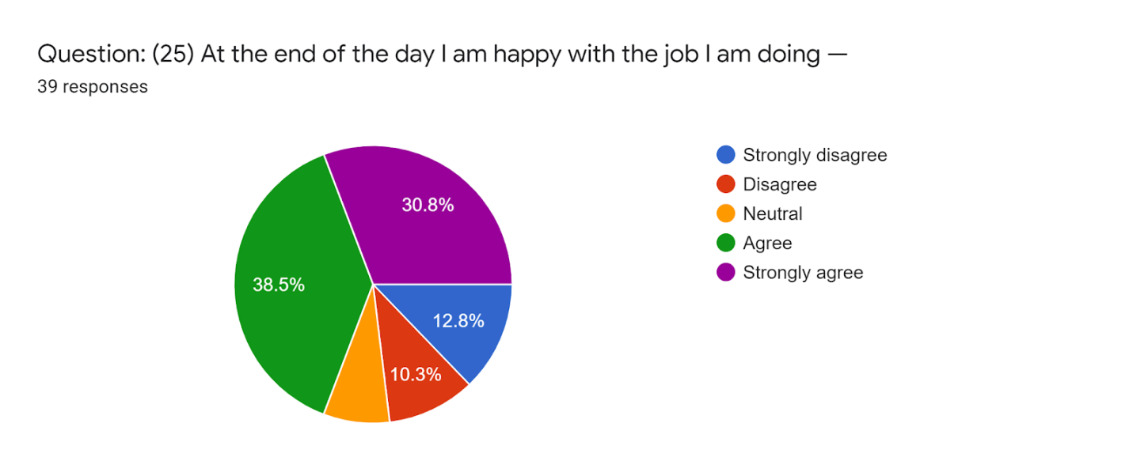
Employees’ happiness defines how much satisfied they are with their job. In the analysis I have found the weighted mean of that statement is 3.64. And this is defining that employees are moderately agreed to the statement. Majority of the employees have agreed upon that they are happy and satisfied with the job they are doing. As we have seen that on the previous statements employees have expressed their satisfaction. By doing the overall analysis I would say the employees at ONE Bank Limited are satisfied with their job. And obviously it is a fact that not everyone’s job satisfaction level is same and everyone would be satisfied. It is quite difficult to keep every employee happy and content in their job.

Chapter- 5
Findings and Recommendations

Chapter-5

5.1 Findings
As I have worked in ONE Bank Limited and got the opportunity to observe and explore so many facts about that employee job satisfaction and so many things related to banking. (Bourne, 2022).I would like to share some of my experiences, thoughts which can also be called as the findings. I have found some good along-side with bad. Those findings are as following:
- At very first I would like to mention about the working environment of ONE Bank Limited. It is so comfortable and cordial place to work in. I felt so because they treat me as if I was one of them not an outsider who just came here for a while.
- The ease of communication and the eagerness of helping each other and they carry a very strong professional bond among them. In my point of view their bond justifies the organizations name.
- The top level management trains the employees, if there is any new addition or change is made. And they do it thus the employee doesn’t face trouble in coping with that change.
- The marketing and advertising is not up to the mark which may attract a client just at a glance.
- The server they use to work has often some technical issues. Sometimes in the emergency moments the server was crashed and as a result the employees had to face clients blame and all that aggression.
- The schemes are pretty attractive but I have observed that the clients has to wait plenty amount of time to get the disbursement of loans. That’s why employees have to face some problems from the clients’ side.
- I have observed dissatisfaction among the employees from their speech and actions. And the reason behind is the salary and promotion criterion. The salary doesn’t get revised frequently.
- The employees who are newly recruited or who are on their probationary period, an insecurity of losing the job always works in their mind.
- And sometimes the performance of the employees is not valued properly. This breaks the will of employees to work more enthusiastically. And because of that their performance drops. (Bourne, 2022).

5.2 Recommendations
ONE Bank Limited is a big name in the banking industry of Bangladesh. It’s a large institution so many banking experts within it. So, I can barely give any suggestions or recommendations to them. But as I have worked there for a very short time, I would like to express some of my thoughts. ONE Bank Limited is one of those private banks in Bangladesh which is working continuously to provide the best facilities to its clients. They follow their motto to do the right thing in the most effective way. The bank would do much better if they can add some more unique services that other banks are not offering but clients are feeling need of those services. If the can provide the best deal to a client or to convince that particular client that the bank would backing him up whatever the business situation is. If these kinds of offers are proposed in front of the clients they would be definitely attracted. Clients always wants the best and unique services so there should be a R&D team who would always try to put something on the table of clients. What nobody else may offer. As, in the banking sector of Bangladesh in every second day new bank is getting established and the banking industry is getting so competitive day by day. So, ONE Bank has to operate their business keeping the customers and the market needs in mind. The main focus should be providing more loans and attaining plenty of deposits and generate revenue as much as they can. I personally think that ONE Bank should work upon those points.
- They need to work on their marketing and advertising of their products and services.
- They need to promote their Ok wallet more. If this becomes more scalable in the online money transaction market it would be a big success for them.
- The ONE app should add more features for clients’ convenience. For this they need to do a research on what kind of facilities does they would like to avail.
- They should do more affiliations with more fashion brands, restaurants and should add almost all type of bill payment system that their customers and clients want.
- The server has some bugs and it gets slow down on the peak hour. This bug should be fixed.
- The network issue should be fixed. As I have seen that many clients are upset with the bill payment when they have to return without paying because of the network issue from the banks side not from the side of the Government server.
- The loan approval and disbursement process should be a bit quicker, because of that long process bank would lose its potential clients.
- Bank should look upon to the employees’ job satisfaction. They should be paid at least close to their expectations.
- As far as my concern, I think that there is a fact of dissatisfaction going on through the employees mind about their job. Their demand of promotion should get fulfill. And the salary should be revised.
If ONE Bank Limited works upon these few things, I believe that the employees would be more than satisfied. If employees are satisfied, it will definitely influence them to perform better in the job. So, it’s important to keep your employees satisfied. And ONE Bank Limited should work upon that.

Chapter- 6
Conclusion

Chapter-6

6.1 Conclusion
Job satisfaction is something that defines an employee’s mental peace and contentment of mind about their job. Job satisfaction is so important that it is related with other multiple things related to job. Job satisfaction keeps the employee motivated and encourages them to out their best on the job. But job satisfaction is not the same for all the employees. Every individual’s satisfaction component is different from each other. In order to get success in the business an organization must keep its employees satisfied and keep them convinced. Employee is the key which brings success for its organization. An organizations success depends on the satisfaction level of its employees. If the employees are motivated they would work more sincerely. Satisfied employees would never show negligence to his work. He would consider the organization of his own. And he would try out his soul to perform better for the organization. But it is hard to keep all your employees happy. As the level of job satisfaction varies employee to employee. For this the engagement among the organization and employee is very important. Top management should try to build the employee and job engagement. If the employees can relate what they are doing and know the purpose of doing that then they would be more sincere. Employee turnover is a big issue for the business organizations now-a-days. Employees higher job satisfaction level will reduce the employee turnover rate. Business organizations must have open conversation with the employees on that matter. It’s a matter of fact that if the employees’ satisfaction is neglected probably he would just switch his job and find a better place to work.
My, study was concentrated on measuring the job satisfaction level of employees. As, I have worked in multiple departments of the bank I have gain different kind of knowledge from that. I have tried my level best to understand and collect as much information as I could to complete the report. And from the perspective of my study, I think the “Job satisfaction level of employees” will help ONE Bank Limited to sustain in this competitive banking industry. All they have to do the best things to keep the employees satisfied. If they are satisfied they would generate new ideas to gain potential clients. And the banks financial condition would be more sustainable and strong. ONE Bank Limited carries the potential to be in the leading position of banking sector as it has some brilliant minds working as the head of the institution. So, I think by improving continuously they would be in that position in the near competitive future of the banking industry of Bangladesh. So, in conclusion I would say if ONE Bank Limited wants better results from their employees they need to keep their employees satisfied.

References
AZIRI, B. (2011). JOB SATISFACTION: A LITERATURE REVIEW. MANAGEMENT RESEARCH AND PRACTICE, 77-86.
Bourne, J. (2022, February 4). What Is Job Satisfaction and Why Is It Important? Retrieved from PositivePsychology: https://positivepsychology.com/job-satisfaction/#:~:text=Lower%20turnover,staying%20power%20as%20added%20value.
Martocchio, J. J. (2017). Strategic Compensation. Hoboken, New Jersey: PEARSON .
ONE Bank. (2021). ONE Bank Annual Report 2020. Retrieved from https://www.onebank.com.bd/annual_report/AnnualReport-2020.pdf
ONE Bank. (n.d.). OBL Profile. Retrieved February 11, 2022, from onebank.com: https://www.onebank.com.bd/home/about-obl/obl-profile/
United International University. (n.d.). UIU DSpace Home. Retrieved from DSpace UIU: http://dspace.uiu.ac.bd/

Appendix
Questionnaire On
Employee Job Satisfaction of One Bank Limited
Dear Respondent,
I am Md. Maruf Hasan a student of United International University (B.B.A Department). This survey is being conducted only for my Internship Report Purpose. This is an integral work to do for the completion of my Graduation. It would be so kind of you if you manage a few minutes from your busy schedule and respond to this survey. I assure you that your name and information would not be disclosed.
Question: 01
I am working at One Bank Limited for —
6 Months to 1 Year | 1 Year to 2 Years | 2 Years to 5 Years | 5 Years and Above

Question: 02
The office culture and the working environment of OBL is suitable to work in —
(On a scale of 1 to 5 please mark any of the following to express: 1 being the Strongly Disagree and 5 being the Strongly Agree)
1 | 2 | 3 | 4 | 5
Strongly Disagree | Somewhat Disagree | Neither Agree nor Disagree | Somewhat Agree | Strongly Agree

Question: 03
I can easily communicate with my supervisor while facing any issues at work —
(On a scale of 1 to 5 please mark any of the following to express: 1 being the Strongly Disagree and 5 being the Strongly Agree)
1 | 2 | 3 | 4 | 5
Strongly Disagree | Somewhat Disagree | Neither agree nor Disagree | Somewhat Agree | Strongly Agree

Question: 04
I have no satisfactory issue with the monetary compensation of ONE Bank Limited —
(On a scale of 1 to 5 please mark any of the following to express: 1 being the Strongly Disagree and 5 being the Strongly Agree)
1 | 2 | 3 | 4 | 5
Strongly Disagree | Somewhat Disagree | Neither agree nor Disagree | Somewhat Agree | Strongly Agree

Question: 05
I am satisfied with the non-monetary compensation system of OBL —
(On a scale of 1 to 5 please mark any of the following to express: 1 being the Strongly Disagree and 5 being the Strongly Agree)

1 | 2 | 3 | 4 | 5
Strongly Disagree | Somewhat Disagree | Neither agree nor Disagree | Somewhat Agree | Strongly Agree

Question: 06
I am satisfied with the necessary facilities provided by OBL to work with more ease and comfort —
(On a scale of 1 to 5 please mark any of the following to express: 1 being the Strongly Disagree and 5 being the Strongly Agree)
1 | 2 | 3 | 4 | 5
Strongly Disagree | Somewhat Disagree | Neither agree nor Disagree | Somewhat Agree | Strongly Agree

Question: 07
I do get feedback frequently of my work from my supervisor —
(On a scale of 1 to 5 please mark any of the following to express: 1 being the Strongly Disagree and 5 being the Strongly Agree)
1 | 2 | 3 | 4 | 5
Strongly Disagree | Somewhat Disagree | Neither agree nor Disagree | Somewhat Agree | Strongly Agree

Question: 08
I am comfortable working with the people surrounding me at OBL —
(On a scale of 1 to 5 please mark any of the following to express: 1 being the Strongly Disagree and 5 being the Strongly Agree)
1 | 2 | 3 | 4 | 5
Strongly Disagree | Somewhat Disagree | Neither agree nor Disagree | Somewhat Agree | Strongly Agree

Question: 09
I feel my co-workers and supervisor are supportive towards me —
(On a scale of 1 to 5 please mark any of the following to express: 1 being the Strongly Disagree and 5 being the Strongly Agree)
1 | 2 | 3 | 4 | 5
Strongly Disagree | Somewhat Disagree | Neither agree nor Disagree | Somewhat Agree | Strongly Agree

Question: 10
My contribution to a work get appreciated and acknowledged —
(On a scale of 1 to 5 please mark any of the following to express: 1 being the Strongly Disagree and 5 being the Strongly Agree)
1 | 2 | 3 | 4 | 5
Strongly Disagree | Somewhat Disagree | Neither agree nor Disagree | Somewhat Agree | Strongly Agree

Question: 11
I do get fringe benefit beside my basic salary for performing well in a particular task I have been assigned for —
(On a scale of 1 to 5 please mark any of the following to express: 1 being the Strongly Disagree and 5 being the Strongly Agree)
1 | 2 | 3 | 4 | 5
Strongly Disagree | Somewhat Disagree | Neither agree nor Disagree | Somewhat Agree | Strongly Agree

Question: 12
I think that I am getting the right pay for the responsibilities I am fulfilling —
(On a scale of 1 to 5 please mark any of the following to express: 1 being the Strongly Disagree and 5 being the Strongly Agree)
1 | 2 | 3 | 4 | 5
Strongly Disagree | Somewhat Disagree | Neither agree nor Disagree | Somewhat Agree | Strongly Agree

Question: 13
I am able to make a good balance between my professional and personal lives —
(On a scale of 1 to 5 please mark any of the following to express: 1 being the Strongly Disagree and 5 being the Strongly Agree)

1 | 2 | 3 | 4 | 5
Strongly Disagree | Somewhat Disagree | Neither agree nor Disagree | Somewhat Agree | Strongly Agree

Question: 14
I feel insecure about the job safety —
(On a scale of 1 to 5 please mark any of the following to express: 1 being the Strongly Disagree and 5 being the Strongly Agree)
1 | 2 | 3 | 4 | 5
Strongly Disagree | Somewhat Disagree | Neither agree nor Disagree | Somewhat Agree | Strongly Agree

Question: 15
I have a healthy relationship with my co-workers —
(On a scale of 1 to 5 please mark any of the following to express: 1 being the Strongly Disagree and 5 being the Strongly Agree)
1 | 2 | 3 | 4 | 5
Strongly Disagree | Somewhat Disagree | Neither agree nor Disagree | Somewhat Agree | Strongly Agree

Question: 16
I think that I can reach to the peak of my self-esteem level doing this job —
(On a scale of 1 to 5 please mark any of the following to express: 1 being the Strongly Disagree and 5 being the Strongly Agree)
1 | 2 | 3 | 4 | 5
Strongly Disagree | Somewhat Disagree | Neither agree nor Disagree | Somewhat Agree | Strongly Agree

Question: 17
I think that it is possible to achieve a growth in my professional career in this job—
(On a scale of 1 to 5 please mark any of the following to express: 1 being the Strongly Disagree and 5 being the Strongly Agree)
1 | 2 | 3 | 4 | 5
Strongly Disagree | Somewhat Disagree | Neither agree nor Disagree | Somewhat Agree | Strongly Agree

Question: 18
I think that my perception and persuasion matters to the top management —
(On a scale of 1 to 5 please mark any of the following to express: 1 being the Strongly Disagree and 5 being the Strongly Agree)
1 | 2 | 3 | 4 | 5
Strongly Disagree | Somewhat Disagree | Neither agree nor Disagree | Somewhat Agree | Strongly Agree

Question: 19
I have a feeling that the work environment and co-workers can be influential or impactful to my job performance —
(On a scale of 1 to 5 please mark any of the following to express: 1 being the Strongly Disagree and 5 being the Strongly Agree)
1 | 2 | 3 | 4 | 5
Strongly Disagree | Somewhat Disagree | Neither agree nor Disagree | Somewhat Agree | Strongly Agree

Question: 20
I feel that my colleagues are dedicated enough towards their work —
(On a scale of 1 to 5 please mark any of the following to express: 1 being the Strongly Disagree and 5 being the Strongly Agree)
1 | 2 | 3 | 4 | 5
Strongly Disagree | Somewhat Disagree | Neither agree nor Disagree | Somewhat Agree | Strongly Agree

Question: 21
My demands and requirements get fulfilled by the top management —
(On a scale of 1 to 5 please mark any of the following to express: 1 being the Strongly Disagree and 5 being the Strongly Agree)

1 | 2 | 3 | 4 | 5
Strongly Disagree | Somewhat Disagree | Neither agree nor Disagree | Somewhat Agree | Strongly Agree

Question: 22
I would switch my job to a different industry or in a different company in the same industry which pays the same salary and benefits I am getting in OBL —
(On a scale of 1 to 5 please mark any of the following to express: 1 being the Strongly Disagree and 5 being the Strongly Agree)
1 | 2 | 3 | 4 | 5
Strongly Disagree | Somewhat Disagree | Neither agree nor Disagree | Somewhat Agree | Strongly Agree

Question: 23
I think that the pace of work at my work place enables me to perform to the best of my working capability —
(On a scale of 1 to 5 please mark any of the following to express: 1 being the Strongly Disagree and 5 being the Strongly Agree)
1 | 2 | 3 | 4 | 5
Strongly Disagree | Somewhat Disagree | Neither agree nor Disagree | Somewhat Agree | Strongly Agree

Question: 24
I have a gut feeling that my work adds a great value to OBL —
(On a scale of 1 to 5 please mark any of the following to express: 1 being the Strongly Disagree and 5 being the Strongly Agree)
1 | 2 | 3 | 4 | 5
Strongly Disagree | Somewhat Disagree | Neither agree nor Disagree | Somewhat Agree | Strongly Agree

Question: 25
At the end of the day I am happy with the job I am doing —
(On a scale of 1 to 5 please mark any of the following to express: 1 being the Strongly Disagree and 5 being the Strongly Agree)
1 | 2 | 3 | 4 | 5
Strongly Disagree | Somewhat Disagree | Neither agree nor Disagree | Somewhat Agree | Strongly Agree

