A Comprehensive Study on Work Life Balance Practices in Banking Sector of Bangladesh



Submitted To-
Shayla Khanam
Assistant Professor
School of Business & Economics
United International University

Submitted By-
Kashfia Arshay Noor
ID- 111 151 350
Program- BBA

Date of submission- 22nd May, 2021

Letter of Transmittal
22nd May, 2021
Shayla Khanam
Assistant Professor
School of Business & Economics
United International University
Subject- Submitting project report on, “A Comprehensive Study on Work Life Balance Practices in Banking Sector of Bangladesh.”

Dear Ma’am,
I have prepared a project report “A Comprehensive Study on Work Life Balance Practices in Banking Sector of Bangladesh.” This report has qualified me to obtain much important grasp about “Work Life Balance Practices”. And it evolves into a very engaging and interesting experience. Thank you for taking the time to consider my idea. This study would have been incomplete without your inspirations.
Finally, I'd love it if you could give me some prudent advice about how to proceed.

Sincerely,
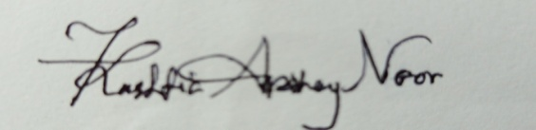

Kashfia Arshay Noor
ID- 111 151 350
Program- BBA

Acknowledgement

I'd like to express my heartfelt thanks to those who supported me in finishing my study. First and utmost, I would like to express my gratitude to Allah for allowing me to complete this report successfully, as well as for giving me the patience and strength to work. In addition, I'd like to express my gratitude to the staff and employees of United Commercial Bank & Trust Bank Limited for their valuable support in gathering details.
Finally, I'd like to express my gratitude to my supervisor, Shayla Khanam, Assistant Professor, School of Business & Economics, United International University, for assisting us in completing this study successfully. She supported me during the project, from start to finish. I was able to finish this project due to her unwavering encouragement and advice.

Table of Contents
Abstract v
CHAPTER: 1 Introduction 1
1.1 Introduction 2
1.2 Background of the study 3
1.2 The concept of work life balance in organization 3
1.3 Problem statement 4
CHAPTER:2 Organizational overview 5
2.1 Historical Background of United Commercial Bank 6
2.2 Industrial Scenario of United Commercial Bank 7
2.3 Practices of work life balance in United Commercial Bank 8
2.4 Historical Background of Trust Bank Limited 9
2.5 Industrial Scenario of Trust Bank Limited 9
2.6 Practices of work life balance in Trust Bank Limited 10
CHAPTER: 3 The study objectives 12
3.1 Objective of the study 13
3.2 Main objectives of study 13
3.3 Scope 13
3.4 Limitations 13
CHAPTER: 4 Methodology of the research 14
4.1 Types of data 15
4.2 Data collection & Data analysis 15
4.3 Scope of data collection 16
4.4 Limitations in data collection 16
CHAPTER: 5Literature review 17
5.1 A brief history of work life balance 18
5.2 How work life balance is defined? 19
5.3 Importance of work life balance practice in every organization 20
5.4 Factors that help to create work life balance policies 21
5.5 Global scenario of work life balance practice 22
CHAPTER: 6 Data findings & Data analysis 24
6.1 Inception 25
6.2 The survey results findings & analysis of United Commercial Bank 46
6.3 The survey results findings & analysis of Trust Bank Limited 68
CHAPTER: 7 Conclusion 69
7.1 Conclusion 70
References 71
Appendix 73

Abstract

The main focus of the analysis is to get the knowledge of work life balance practices in banking organizations. As we know balancing the work is all about maintaining a equivalent on professional works & other non-professional works activities just as life and family. Work life balance programs that are well implemented improve performance and as a result employee satisfaction. It increases employee loyalty with both their work and personal lives. The aim of this study was to know more about banking organizations’ work life balance policies. There are seven parts in this report which has been categorized. The main part depends on the presentation of the report, which includes topics such as the background of the study, the concept of work life balance and problem statement. In the second part, historical background and industry scenario of both bank (Trust Bank Limited and United Commercial Bank) included. The study's objective, scope and limitations has described on chapter three. Chapter four included types of data, data collection process and analysis and also included their scope and limitations. In chapter five basically literature review part where broadly describe the concept of work life balance. Chapter six and seven indicates the data analysis and findings and also summarize of the study with a conclusion.

CHAPTER: 1
INTRODUCTION

1.1 Introduction


Work-life balance mainly refers to the level of prioritization between personal and professional activities in an individual’s life. Work-life balance is an important aspect of a healthy work environment for employees. Work life balance has become major issues in the workplace. Many organizations' human resource department are trying to minimize the negative aspects of work family issues on working individuals. Family friendly organizational culture and human resources applications have recently been in agenda of executives in every organization. Organizations are trying to make policies that will create a healthy balance between job life and individual life.

1.2 Background of the study

Work-life balance is mainly focus to initiate employers by providing the better working place, flexible working hours and related policies in the organization. Through this organizational support employees can have better time for their personal well being and family. Currently organizations are getting competitive and they want very qualified employees for their companies. For this reason, the work responsibilities among employees are getting bigger. Due to this employees cannot manage their work life and personal life which is hampering their overall life. For employee well-being, it is necessary to balance the work life & family time. As we know work over time is increasing and organizations are failed to give pliable work environment. This situation is majorly affecting in banking organization. This research is examined on a sample of forty employees of two banks (United Commercial Bank & Trust Bank Limited) to get the information about work-life balance or whether it changed employees' personal life. This study will provide a cause why the organizations need to be concern on employees/workers and manage equilibrium of their work life and individual life.

1.2 The concept of work life balance in organization

Work life balance is maintaining balance between work and personal activities. It actually shows, how a individual work person dedicated to work and maintained personal life perfectly. To learn more about work-life balance, we must first recognize various demands and personal resources such as time and energy that can be used to point them. Managing the balance in work life, it is highly necessary to private & public organizations. It is not only about the prioritizing work role but also individual's personal life. If employees cannot make balance between their work and personal life then it will affect the social, psychological, economical and mental well being. It will also reflect in the output of employees' performance and organizational growth in the long run. Organizational effectiveness is measured by how employees managing their attitudes, behaviors, wellbeing to balance their work life. Work life balance is becoming an important issue as people deals with shrinking workplace and time pressure. There are lots of studies have showed that work life balance offer a win-win condition for both employees and employers and it also affect the overall business growth and performance. By improving work life balance practices in the organization, it will boost productivity, employee wellness, minimization of costs; improve employee retention, recruitment and better motivated work place for employees. The work life balance policies are made in organizations for reducing the work stress from the workers and give a healthier and safe work place for each employee. Work life balance has been associated with greater employee commitment, job satisfaction and organizational citizenship behavior and its policies are beneficial for individuals, their families, physical health, mental health, relationships, creativity, organizations, and society.

1.3 Problem statement

Now-a-days creating balance between work and life has become problematic for both employers and workers. Though it is completely related to employees work and lifestyle but still it impacts on work environment. It is highly important to identify the employees’ problems in work place and create policies according to their well-being so that they can engage themselves properly in the organization. Many organization does not know how what is work life balance and how does it effect in the organization. This study will guide them how they can identify the problem and what types of policies and practices can include in their work place.

CHAPTER:2
ORGANIZATIONAL OVERVIEW

2.1 Historical Background of United Commercial Bank

One of the largest banks in Bangladesh is United Commercial Bank. They are getting bigger within the banking division. United Commercial Bank began its journey in 1983 with a commitment to the financial and social development of Bangladesh, and has since achieved tremendous success in the banking industry. United Commercial Bank has 195 locations across the country to provide customized service, creative practices, a specific vision, and professional management to provide the best banking services.UCB made a name for itself in a variety of banking industries, including retail banking, small business banking, corporate banking, off-shore banking, and remittance, among others. Through personalized service, creative practices, a diverse strategy, and efficient management, the UCB has already made a name for itself in the sector of private banking, with a huge network of branches. UCB actively contributed to the economic and social developments of Bangladesh through its highly skilled management team and dedicated employee base. Moreover, UCB is vitally contributing to various sectors of social responsibilities.

2.2 Industrial Scenario of United Commercial Bank

UCB has played a key role in the development, management, and foundation of the country's leading banking industries. UCB is listed on the DSE30 Index, which is formulated by S&P and includes the DSE (Dhaka Stock Exchange Limited) and CSE (Chittagong Stock Exchange Limited). The bank is one of Bangladesh's top 30 listed firms. Via a number of distribution networks and subsidiary firms, UCB provides a broad range of banking products and financial services to business, SME, and retail customers. With a large network of 195 branches, an Off-shore banking unit, mobile financial services (UCash), Upay, Agent Banking, priority banking (UCB Imperial), remittance services, credit card industry, and 4,988 dedicated human capital, the bank has already made a name for itself in the sector of private banking through customized operation, innovative activities, and dynamic problem-solving approaches. With a view to leading nationwide economic development and green banking initiatives, the bank has a special emphasis on RMG, import-export, agriculture, SME industry, and retail market. The bank owns three wholly owned subsidiaries. UCB Capital Management Limited (provides capital market trading platform), UCB Investment Limited (aims to conduct full-fledged merchant banking operations in Bangladesh), and UCB Asset Management Limited (provides asset management services) (incorporated for both institutional and individual fund management).
Vision: To be the bank of first choice for our customers, shareholders, and employees by optimizing value for them and contributing to the national economy by social commitments.
Mission: To provide financial solutions that help our customers achieve, maintain, and develop their investments while also enhancing the quality of life in the communities we service.
Core Values:
-We prioritize our customers.
-We place a strong emphasis on professional ethics.
-We maintain a high level of quality.
-We believe in corporate social responsibility.
-We speak on what we believe in.
-We encourage participation in management.

2.3 Practices of work life balance in United Commercial Bank

Organizations are trying to implement more and more facilities to the employees so that they do not get de-motivation from the work. The main focuses are given in flexible working hours, good compensation program, and stress management in work place, leave availability etc. United Commercial Bank gives utmost facilities to the employees so that they can manage their work life and personal life in well mannered. Some of the policies and practices are discussed below;
1. In terms of recruiting and selection procedures, incentives, and salaries, United Commercial Bank gives equal opportunity to the employer. They do not accept discrimination in recruitment, hiring, selection, promotion, or any other aspect of employment based on ethnicity, faith, colour, gender, age, citizenship, or any other factor.
2. The aim of the Whistle Blowing Policy is to create an atmosphere at UCB where honest, committed, and loyal employees are empowered and confident to expose and disclose any fraudulent, immoral, unethical, or malicious behavior or actions of employees, which may cause harm but they can speak about without fear of retribution, subsequent discrimination, or being disadvantaged in any way.
3. United Commercial Bank aims for equitable human resource management through the implementation of a performance-based system.
4. The Banks Service Rule, as well as directions and guidelines from the board from time to time in accordance with standards, guide remuneration and other related matters.
5. Employees at the Bank receive incentive compensation in the form of deferred cash rewards, which are contingent on results based on Key Performance Indicators (KPI).
6. United Commercial Bank Limited have sufficient strength for reduce employee turnover.
7. A great learning culture provided to the employees so that they can develop themselves.
8. United Commercial Bank Limited followed all the leave policies such as, casual leave, sick leave, earned leave, maternity leave, study leave, hajj performing leave, special leave.
9. Training and development programs are also available for employee health management, stress management counseling programs etc.
10. Following The Labor Act, 2006: as per section 100 United Commercial Bank working hours is 8-hour and it does not exceed 10-hour day subject to the satisfaction of section 108.

2.4 Historical Background of Trust Bank Limited


The Trust Bank Limited is a commercial bank under the rules and directions of Bangladesh Bank. The Army Welfare Trust (AWT) running the banking operations. In 29th November, 1999 the bank began their journey. Currently they have 12 branches over the nation. Soon they are trying to convert it public limited company by distributing shares in the capital market. Under the Bank Companies Act 1991 they provide all types of personal, commercial and corporate banking services to the customers. In addition to ensuring quality customer services related to general banking the bank also deals in Foreign Exchange transactions. They are also focusing to plan and promote in agro based industry and agricultural banking facilities.

2.5 Industrial Scenario of Trust Bank Limited

Trust Bank Limited is serving the best expertise through technological excellence to satisfy their customers. They are investing in the country's industrial and agricultural sectors. Trust Bank Limited promoting agro based industries. They participated in syndicated loan agreement with other banks to promote textile sectors of the country. The client’s financial and banking needs the bank is constantly improving its services. For the clients, they are launching new and innovative products to provide better services towards fulfillment of growing demands of its customers. The Trust Bank Ltd offers full range of banking services that include: Deposit banking, Loans & advances, Export, Import, Financing in land, International remittance facilities, Foreign Exchange transactions, Personal, Credit, Consumer & Corporate Banking.
Vision: Build a long term sustainable financial institution through financial inclusion and deliver optimum value to all stakeholders with the highest level of compliance.
Mission:
-Long Term sustainable growth-diversified business with robust risk management.
-Financial inclusion-bring unbanked population into banking network through low cost and technology based service delivery.
-Accountable to all stakeholders - customers, shareholders, employees and regulators.
-Highest level of compliance and transparency at all levels of operation.

2.6 Practices of work life balance in Trust Bank Limited

Human resource department tries to give better facilities to the employees so that they always motivated in their work place. Every organization tries to give flexible working hours, good compensation program, and stress management in work place, leave availability so that employee can maintain their work life with their personal life. Trust Bank Limited's hr policies and practices are discussed below;
1. Following the Labor Act, 2006: as per section 100 Trust Bank Limited bank working hours is 8-hour and it does not exceed 10-hour day subject to the satisfaction of section 108.
2. Trust Bank Limited HR division gives much flexibility to employees where they are liberty to express their opinion/suggestion for improvement.
3. There is a service called "Payroll Banking Services" which are targeted towards facilitating employee payroll accounts for companies.
4. The compensation programs are flexible too. Salary is disbursed on a monthly basis with a combination of basic salary and other fringe benefits such as, Employees’ Hospitalization Benefit, Travelling/ Travelling Allowance Benefit, Residential Furniture and Appliances Benefit, Loan against Provident Fund, Staff House Building Loan, Executive Car Scheme, Provident fund, Gratuity, Superannuation, Leave encashment.
5. Trust Bank Limited's human resource department give the top priorities to the employee engagement. They made programs in way that spread a positive vibe among the employees and lead to employee satisfaction. It ensures better work environment, stress management and overall Employee-Management relationship.
6. A program named "Suddhachar" is a stage for promoting Shuddhachar activities of TBL in compliance with Bangladesh Bank guidelines which make awareness in the form of rhymes to practice integrity in every aspect of professional environment.
7. HRBL (Human Resource Business Lyrics) is a stage where every employees to project fresh business concept and process improvement, risk mitigation, value addition in existing products, customer service and cost efficiency. They also get reward from it.
8. HR department made "Speak Up Policy" to encourage employees for raising their voice against any dysfunction and misconduct, break of laws or regulation within or outside the organization related to the bank.
9. Trust Bank has an academy named "Trust Bank Training Academy (TBTA)" which provides in-house training courses for the employees.
10. Employees are empowered to obtain professional certifications with diverse honorarium packages, as remunerate, on completion of certification courses. The bank moreover repays cost caused by an employee to acquire professional certifications like CDCS, CSA etc.

CHAPTER: 3
THE STUDY OBJECTIVES

3.1 Objective of The study
Major objective of this research study is to find the core policies and practices are made to balance the work life of employees in the banking sector and get a complete concept of work life balance practices.

3.2 Main objectives of study

This project report is based on five main objectives which are given below:
1. To know the concept of work life balance.
2. How banking organizations are managing work life balance
3. What procedures are followed to ensure that workers are maintaining a healthy balance between their work and personal life?
4. Survey conducted among the employees of the banking organization to know how they get benefited from the policies.
5. The project focused on flexible working arrangements, employee wellbeing, career improvement, leave arrangements.

3.3 Scope

The scope for this study is to accrue knowledge about the policy practices to create balance between work life and personal life among employees. Researcher has taken two private commercial banks for the study one is United Commercial Bank and another one is Trust Bank Limited. The overall report study took an estimated four months.

3.4 Limitations
There were few limitations which were faced by the researcher during analysis of the topic. Those who were respondent through survey and the interview session would be hesitant and scared of sharing the information. HR personal from the organizations are restricted to share any inside information such as employee condition, employee productivity, employee s issues and upcoming programs and policies.

CHAPTER: 4
METHODOLOGY OF THE RESEARCH

4.1 Types of data

For preparing this research paper, there are two types of data type have used.
(1) Primary Data.
(2) Secondary Data.
Primary Data: Researcher has collected all the information from employees which has done physically. There was no meeting session with the employees due to covid-19 restrictions, researcher has to use online platform to connect with employees and collect data. Researcher has created question survey format on website and provided it to the individual respondent. It was difficult to reach multiple individuals of different categories. After completing the collection of survey data researcher made graph chart out of the survey results.
Secondary Data: Secondary data sources were different articles, journal, book based information, site, video link. Those sources were helped to create the literature survey.

4.2 Data collection & Data analysis

The survey method was online survey which was done under a website. Questionnaires were created to obtain relevant information from respondents on employee performance, organizational engagement, and work-life balances, as well as employee health programs, leave arrangements, career development opportunities, and other views. For sampling, researcher took two commercial banking organizations. 40 employees have participated from their 20 was male participants and 20 female participant.
The survey is an open ended question which has five nominal scales to measure the results. The researcher made twenty survey questions for both bank. The online survey procedure was convenient. The number of sample size is 40. For analyzing the content results researcher used content analysis method which is the analysis of text, photographs, and often tech devices were used to record information. Computer analysis program (sprees sheet) has used for analyzing data. Numerical data and interpretations of the results are displayed in this report on Chapter-6.

4.3 Scope of data collection

The researcher had many opportunities to expand the knowledge and establish good relationships with corporate executives. Worked with real life data and people, it will help the researcher in the future. And this will also create opportunity for the further research in relatable topics.
Corporate office area:
Head office of ‘United Commercial Bank Limited’
iPlot-CWS-(A)-1, iRoad Number 34, iGulshan Avenue, iDhaka-1212, Bangladesh.
Head office of ‘Trust Bank Limited’
iShadhinata Tower, iBir ishrestho ishaheed ijahangir igate, no-546 ‘Dhaka Cantonment’, Dhaka-1206, Bangladesh.
Period of time:
This research project report took almost four months to prepare.

4.4 Limitations in data collection

Covid-19 pandemic made difficulties to prepare research on time. The whole nation was lockdown and the organizations were closed. Researcher had to use the online platforms to collect data and make communication with respondents. The procedure of survey took bit time because employees were not available. There were some restrictions in collecting data from the organization because the outsider has no permission to access. The information are based on survey and open conversations with employees and HR personnel of the organization.

CHAPTER: 5
LITERATURE REVIEW

5.1 A brief history of work life balance

During the stage of industrial revolution people used to work foe longer period of time and most of the worker were over worked. The worker used to work for 14 to 16 hours a day and 6 days in a week in the United Kingdom. The working hour system was harming the workers' personal life. They did not get enough time for their family, children. It was also affecting their social life. The most dangerously was affecting in their mental health and over all physical health. The health costs of workers were increasing. After all of this, labor reformer made concern on it until U.K. proposed to give fewer hours for women and children. In the U.S.A, they started monitoring the work time. Surprisingly they found that workers were working more than hundred hours in a week. Employees mental and physical health problems came as a result of extended working hours, and safety risks posed to the whole country as a result of work overload. The United States of America government declared 40 hours of work per week after a long period of worker labor movement. This was happened in 24th of November, 1940 under the Fair Labor Standards Act. In 1930, the first movement made for work life balance programs but people did not recognize it. Before the Second World War, there was only one company named W.K. Kellogg practiced work life balance by creating flexible working shifts. This change brought massive efficiency among the employees. The traditional working hours and the new designed shift of work resulted in increased employee efficiency and morale. During 1980's, on the Women's Liberation Movement, "Work life balance" was first used to address the problem. Lack of facilities in work place, no maternity leave, and strong working hours was lead women in trouble on their family life. Many female employees and worker had to quit job because they could not balance their time between work and family. Many women were faced broken marriage, physical abuse by partner. In the 1980's "Women Liberation Movement" advocated for flexible working schedule and maternity leave facilities to the working women. Gradually many organizations are started following work family and friendly environment. Organization were started to make policies and promote work life balance programs. Primarily these programs were designed for woman or woman with children. But now the work life balance policies and programs have been introduced which are less gender specific and get benefited by every employees.

5.2 How work life balance is defined?

The aim work-life balance is to create supportive and healthy work place so that employees can manage to balance between work and individual life and that will improve the employee performance. The definition of work-life balance is the management of work and life responsibilities without negatively affecting either work or life responsibilities.

According to Clark, Koch and Hill, The work-life balance is equilibrium or maintaining overall sense of harmony in life and it promotes job satisfaction and good performance at home and at work, with minimal role conflict.(Clarke, 2004)

According to Grady, McCarthy, Darcy and Kirrane, Work-life balance is vital for individuals’ wellbeing, organizations’ performance and a functioning society. (Grady. G, 2008)

According to Grzywacz and Carlson, Work-life balance is an accomplishment of role-related expectations that are negotiated and shared between an individual and his/her role-related partner in the work and family domains. (Grwzywacz J.G. & Carlson, 2007)

Currently the concept of work life balance is widely use in every organizations by hr department. The work life balance is conceptualized as an individual's orientation among different life roles and inter role phenomenon. Different scholars have different views on the work life balance concept but still they all defined on the basis of employee satisfaction, healthy and productive life that includes work, play and love that integrates a range of life activities with attention to self and to personal and spiritual development, and that expresses a person’s unique wishes, interests, and values.

5.3 Importance of work life balance practice in every organization

Flexible work environment is one of the ways to satisfy the work life balance needs of most individuals. Work-life balance is associated with greater jobs, job satisfaction, organizational behavior, persons' and family policies, physical and mental wellbeing, relationships, innovation, organizations, and community. It is important to managers for making healthy organizational policies to reduce the work life balance conflicts. Importance of work life balance practices are given below;
- Balance work life creates employee involvement and devotion to the organization.
- Implementing balanced work life will reduce the employee turn-over.
- Work life balance practices promote better productivity which contributes to growth of economy.
- Implementing work life balance policies can result in less loss of knowledge workers to competitors.
- Work life balance policy practice may reduce unethical business practices among employees.
- Work life balance practices reduce work stress from employees.
- Implementing work life balance will also reduce absenteeism in work place.
- Work life balances create organizational effectiveness and positive behavior.
- Work life balances create job satisfaction among employees.
- Work life promotes happiness and better relations among employees and employers.

5.4 Factors that help to create work life balance policies

Work life balance practice can only be done if the organization's management willingly to make policies for the employees betterment. There are so many factors available to create policies in the organization to balance the work life. There are many organizations who are implementing better benefits to the employees so that they can happily engage themselves in the workplace. Descriptive factors can be applied to the organizations those who are not practicing the work life balance policies. Organizations should offer wide range of work family facilities and policies towards their employees. Those are given below;
1. Organizations have to give job sharing facilities to every employee.
2. Organizations should include staggered hours and compressed working hours.
3. Also include job protected parental leave for both male and female employee.
4. Provide dependent care assistance.
5. Provide work from home facilities.
6. Day-care facilities for working mothers.
7. Create support groups for working parents.
8. Provide chances to improve job conditions.


5.5 Global scenario of work life balance practice

Companies are also attempting to incorporate work-life balance strategies and activities in order to cope with competitors. Global competition and economic challenges are becoming more difficult to handle. Employees are concerned and want their company to recognize and resolve their work-life issues. Employee engagement is being harmed by work-life issues. Many businesses are taking the requisite steps to improve employee welfare and services. The work life balance should be strategically implied which employees and the organization can minimize work life conflict issues. Abby Shepiro and Karen Noble, top work-life experts, discovered three key reasons why employees all over the world struggle to reconcile their work and personal lives:
1. Workplace policies and practices are less adaptable.
2. Dependent care is becoming less accessible and affordable.
3. Workplace stress and long hours of job have a negative impact on their family life and well-being.
Many foreign organizations have found ways to effectively manage work-life balance problems. The following are two examples of best practices from two well-known multinational companies:
Unilever:
Unilever is a British-Dutch multinational corporation with a global reach. The Unilever Company is well-known in the personal care industry all over the world. Unilever's offices are in London and Rotterdam, as well as in the Netherlands. Unilever employs 160,000 people worldwide. Unilever has a wide range of consumer labels in the food, beverage, cleaning, and personal care categories. Unilever is a member of the “Diversity Best Practices” initiative. Employees at Unilever have access to the best working conditions and environments. Unilever suggests that “people who are also satisfied individuals are more likely to be inspired in their careers.” Employees at Unilever can work part-time hours and, if necessary, they can work from home. They have well sharing of employment arrangements and sabbaticals and extended maternity leave. Unilever started use video conferencing, virtual meetings, videophones and online collaboration so that employee can engage themselves on work from. During 2005, Unilever launched “Personal Vitality” campaign. This campaign includes a variety of services and events that support and assist employees in taking physical and mental care of themselves. Health assessment, exercise, diet, hygiene, and self-care are also part of the curriculum. Employees are also involved in local neighborhoods as part of the campaign, which improves work-life balance. To promote various aspects of the campaign, personal vitality guides have been made.
IBM:
IBM is the largest multinational corporation in the world. The headquarters of IBM are located in Armonk, New York. IBM is a firm that focuses on technology and consulting. Almost 200 countries are served by them. IBM is a technological corporation based in the United States that holds more patents than any other company. Vice President of IBM's Integrated Health Care Division “Advancing the health, safety, and well-being of our global workers is an absolute priority and it's a responsibility that includes the environments in which employees work as well as the communities in which they live” said Martin J. Sapulveda. In all aspects of its global business strategic and business planning, procurement, construction, manufacturing equipment, real estate leases, product creation, acquisitions, and outsourcing arrangements, IBM has facilitated and created better placement in health and well-being. IBM is often concerned about its employees' fitness, safety, and well-being. IBM's "total health management" strategy emphasizes the importance of both physical and mental health in ensuring productive and well-balanced employees. Their strategies ensure the constancy all geographic, time zones and cultures. Their well-being management system demonstrates that planning, implementation, assessment, and progress are all effective. IBM's Integrated Health Services department, which is made up of occupational medicine, industrial hygiene, protection, health insurance, and fitness practitioners, is in support of the company's global employee well-being programs.

CHAPTER: 6
DATA FINDINGS & DATA ANALYSIS

6.1 Inception

In this chapter, the researcher presented the research findings and interpretations based on the data collected and analyzed. This chapter's presentation included numerical data valuation as well as pie charts of the analyzed data. The survey data analysis is based on the 20 questions which were generated on a online survey program. The survey results were altered and coded.
United Commercial Bank
for further researching about work life balance, researcher went to "UNITED COMMERCIAL BANK" to make research queries. 20 employees were randomly picked where 10 male and 10 female employees included. Descriptive details are given below;
Gender | Age of the respondent
Male | 20-25 years  (20.0%) | 26-30 years  (30.0%) |  | 31-35 years  (40.0%) |  | 35-40 years  (10.0%)
Female | 20-25 years  (20.0%) |  | 26-30 years  (70.0%) |  | 31-35 years  (10.0%)
Table: Gender based age respondent
Gender | The years of working in the organization
Male | 0-2 years  (80.0%) | 5 years and above  (20.0%)
Female | 0-2 years  (70.0%) | 2-4 years  (30.0%)
Table: Working years in the organization based on gender

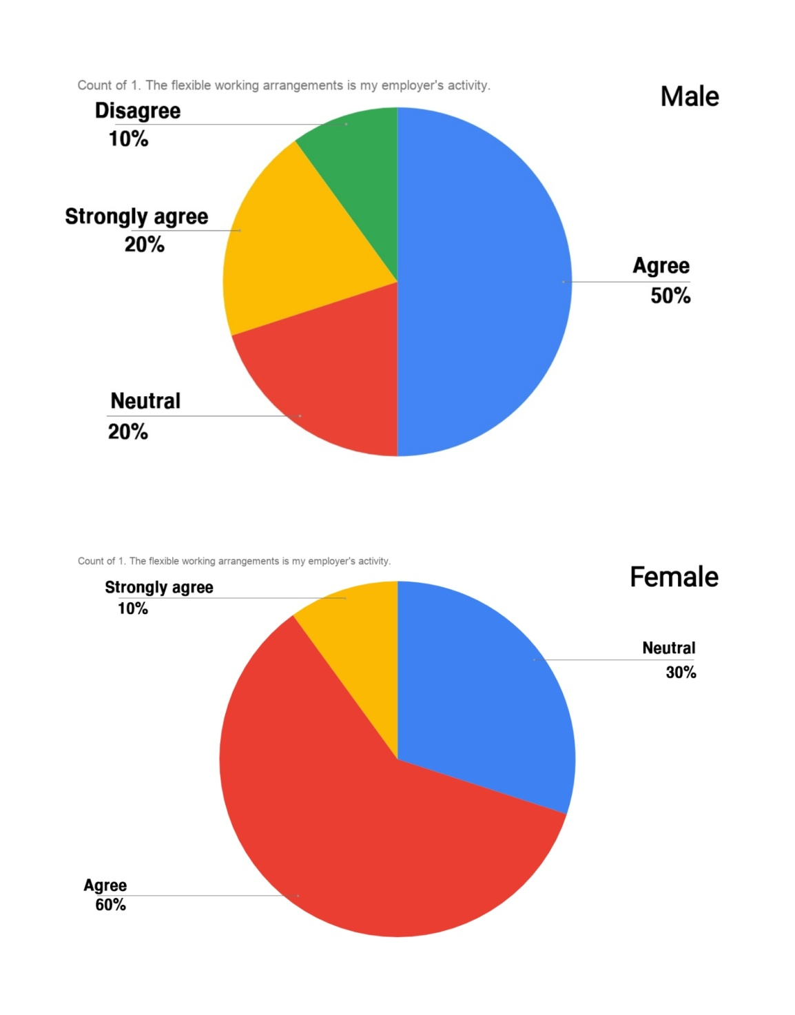
1. Interpretation: A researcher inquired as to whether or not their organization has flexible job arrangements. 20% of male employees firmly believe they have flexible job arrangements, and 20% have no comments, so they are considered neutral. 50% male employee agreed and 10% disagreed on that statement. In case of female employee 10% of them strongly believed that they have flexible work arrangements and 60 percentages agreed in it and also 30% were neutral.
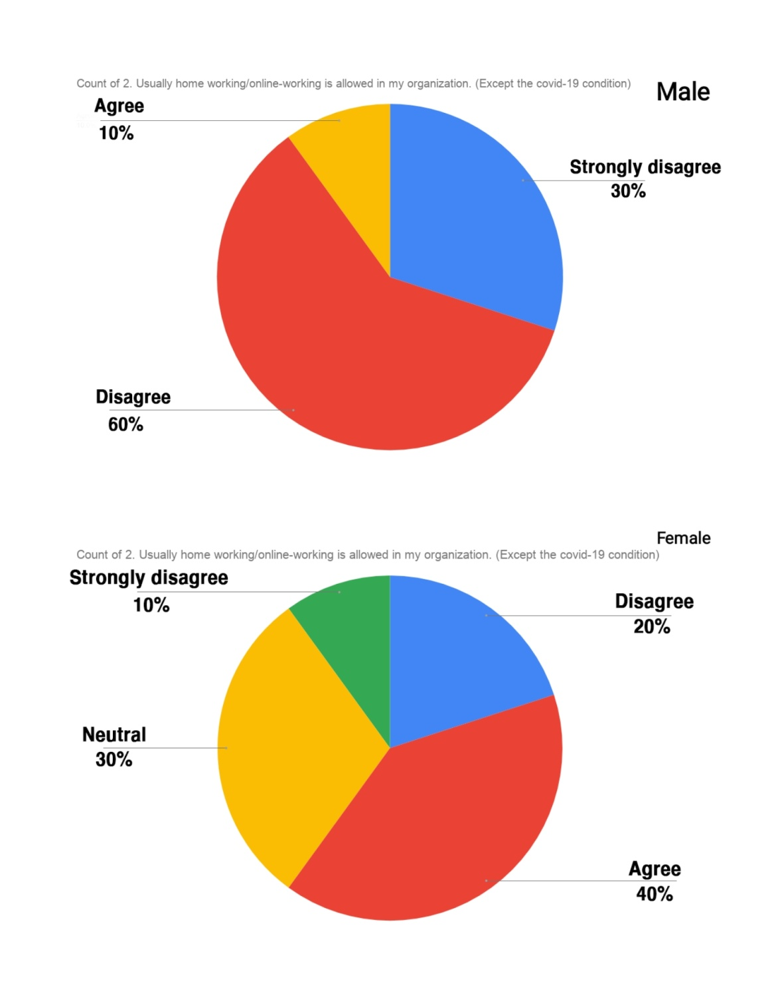

2. Interpretation: Employees were asked whether they were able to work from home or online by the researcher. Just 10% of male employees said they were able to work from home or online, while 60% said they were not. 30% male were disagreed. In the case of female employees, 40% agreed and 20% disagreed. 10% of female employees strongly disagreed, while 30% were undecided.
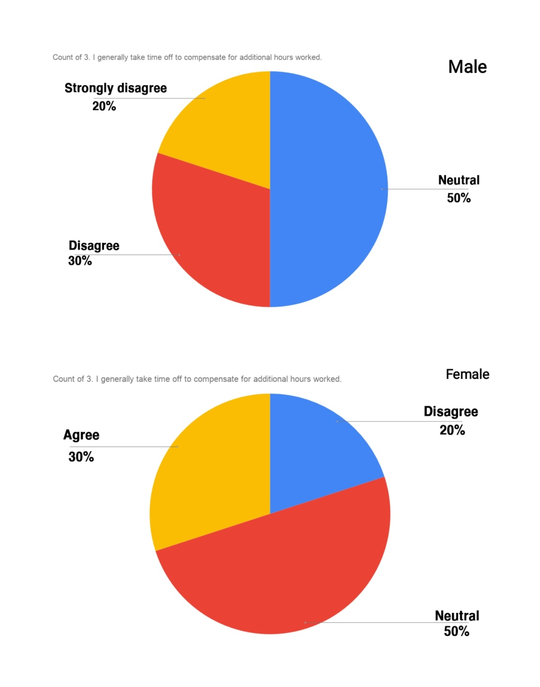
3. Interpretation: Do they get days off to compensate for the extra hours worked, according to the researcher? The statement was disputed by 30% of male employees, while the remaining 50% were neutral. A strong majority of male employees (20%) agreed with this statement. Female employees agreed 30 percent of the time and disagreed 20% of the time. Neutral workers made up 50% of the female employee.
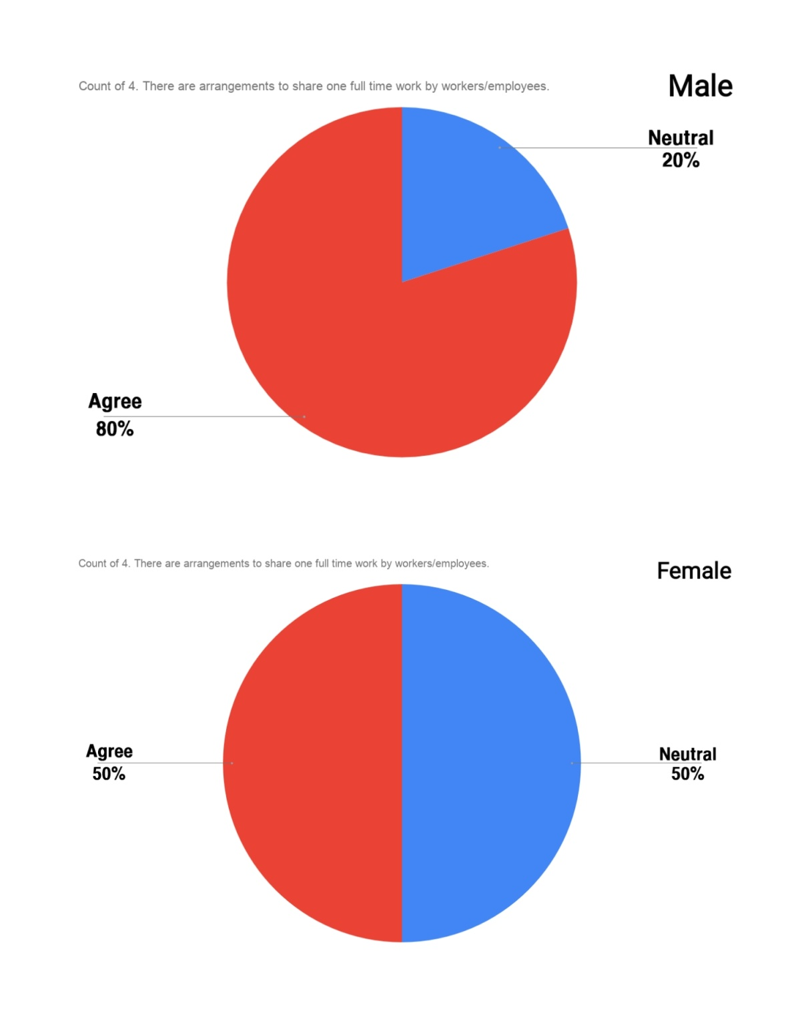
4. Interpretation: Employees were asked if they had got arrangements to share one full-time job with other employees. On that statement, 80% of male employees approved, while 20% were undecided. In terms of female employees, 50% agreed with the statement and 50% were undecided.

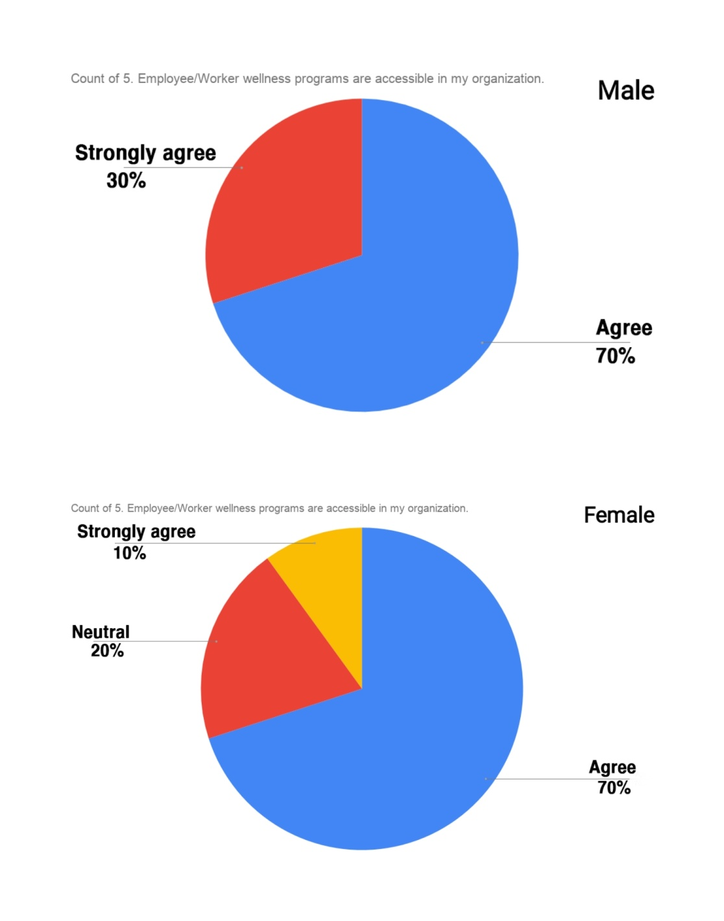
5. Interpretation: In this section, the researcher questioned about whether the employees had access to wellness programs in their offices. On that statement, 30% of male employees strongly disagreed, while 70% agreed. Seventy percent of female workers simply approved, and ten percent strongly believe they were aware of the wellness initiative. A total of 20% of female workers were neutral.

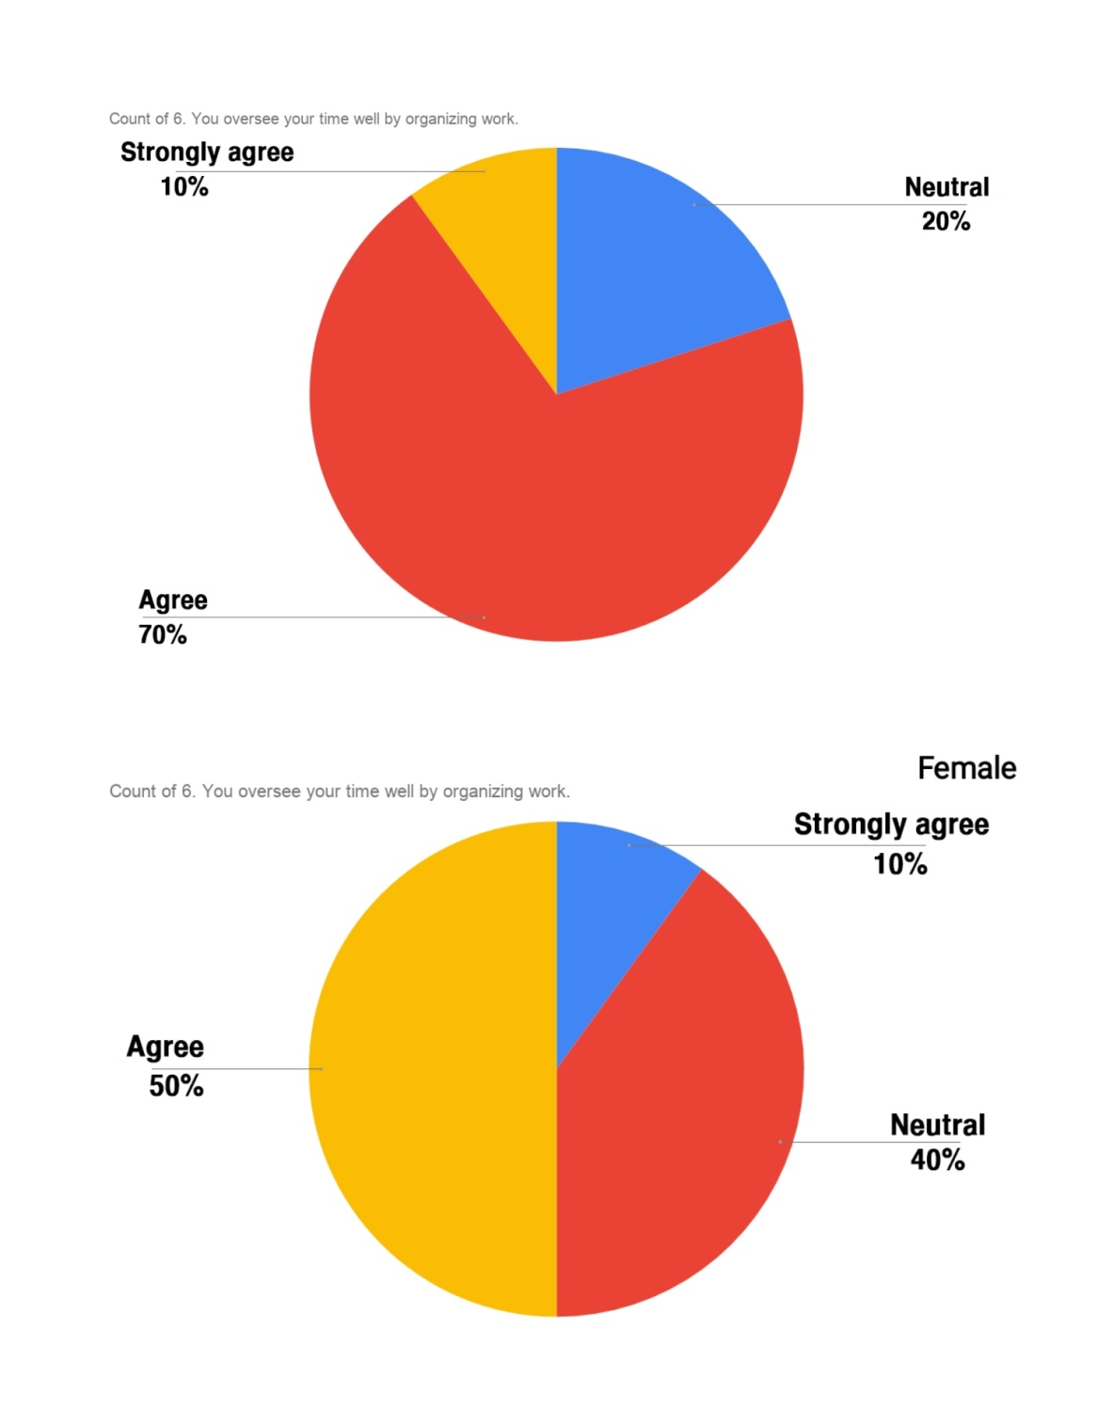
6. Interpretation: In this question, the researcher inquired about the employee's ability to manage their time effectively by coordinating their job. On that statement, 10% of male workers strongly agreed, while 70% only agreed. Just 20% of male employees were neutral. Female employees agreed 50% of the time, were neutral 40% of the time, and agreed 10% of the time.

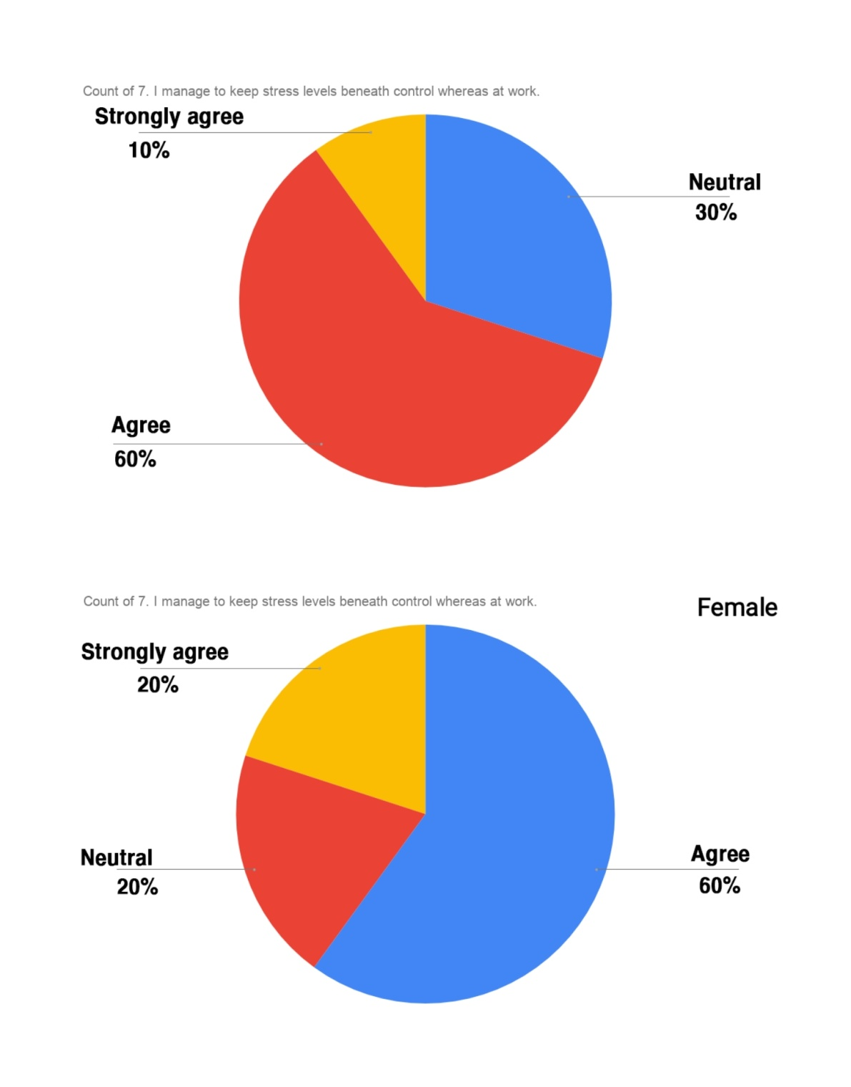
7. Interpretation: The employee was asked how they manage to keep their stress levels under control when at work. 10% of male workers strongly agree, and 60% only agreed with that statement. Neutral workers made up 30% of the male employees. In case of female employee 60 percent of them agreed and 20 percent strongly agreed on that statement. Neutrality was found in 20% of females.
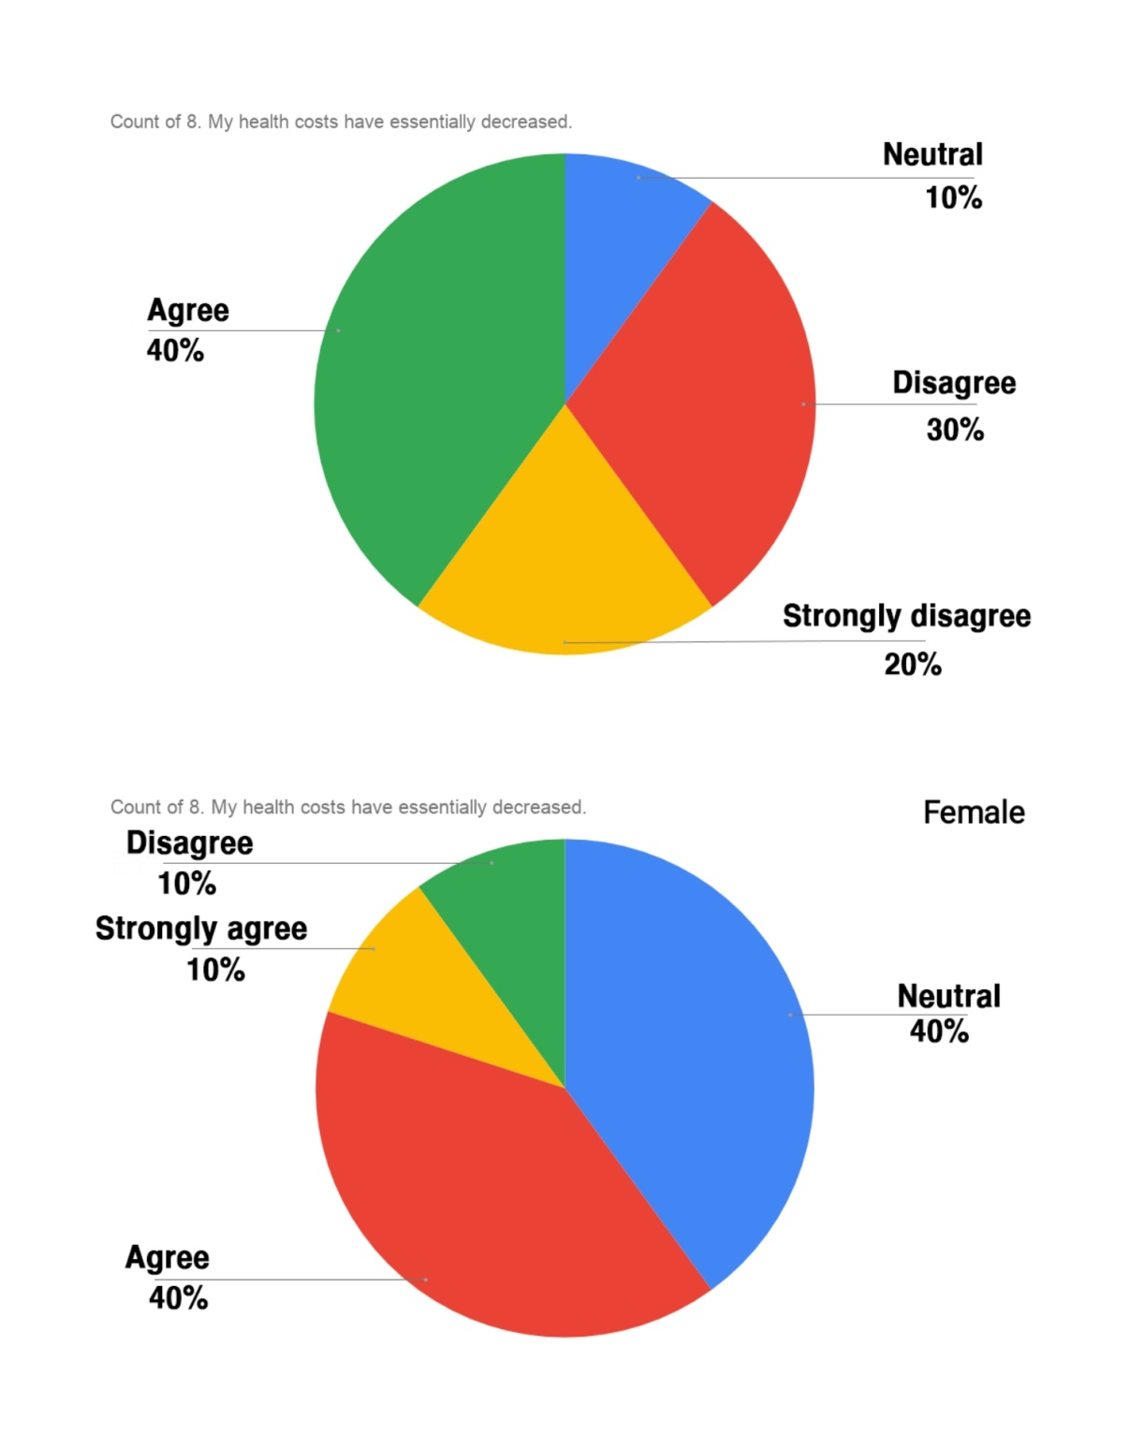
8. Interpretation: Employees were asked if their health-care costs had essentially reduced. In response to that statement, 40% of male employees agreed and 30% disagreed. 20% of male employees strongly disagreed, while 10% were undecided. Female employees, on the other hand, agreed 40% of the time and disagreed 10% of the time. 10 percent of those polled strongly disagreed, while 40 percentages were undecided.
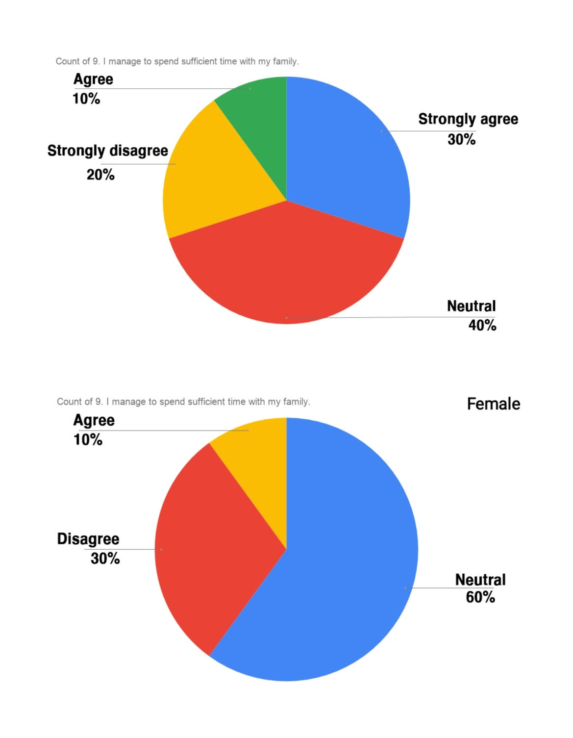
9. Interpretation: The employee was asked if they spend enough time with their families by the researcher. Just ten percent of male employees agreed, while twenty percent strongly disagreed. 40% of respondents were undecided, while 30% strongly agreed. In the case of female employees, ten percent strongly agree, thirty percent agree, and sixty percent are neutral.

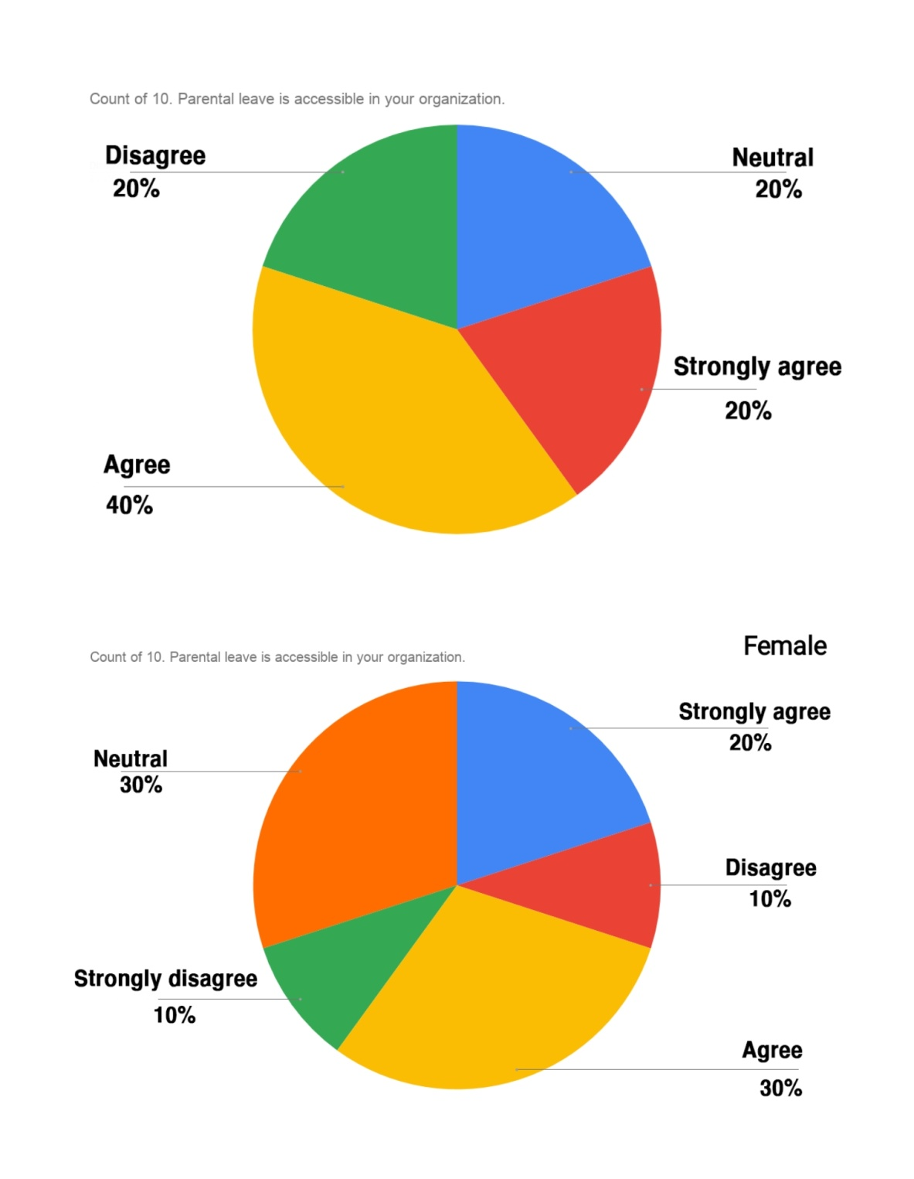
10. Interpretation: The question was posed to determine whether or not the employee had access to parental leave in their workplace. 20% of male employees strongly agreed, while 30% were undecided. 40% of male employees agreed, while 20% of male employees disagreed. On the other side, 30% of female employees agreed with the statement, while 10percent disagreed. A total of 20% of female employees strongly agreed, 10percent strongly disagreed, and 30percent were neutral.
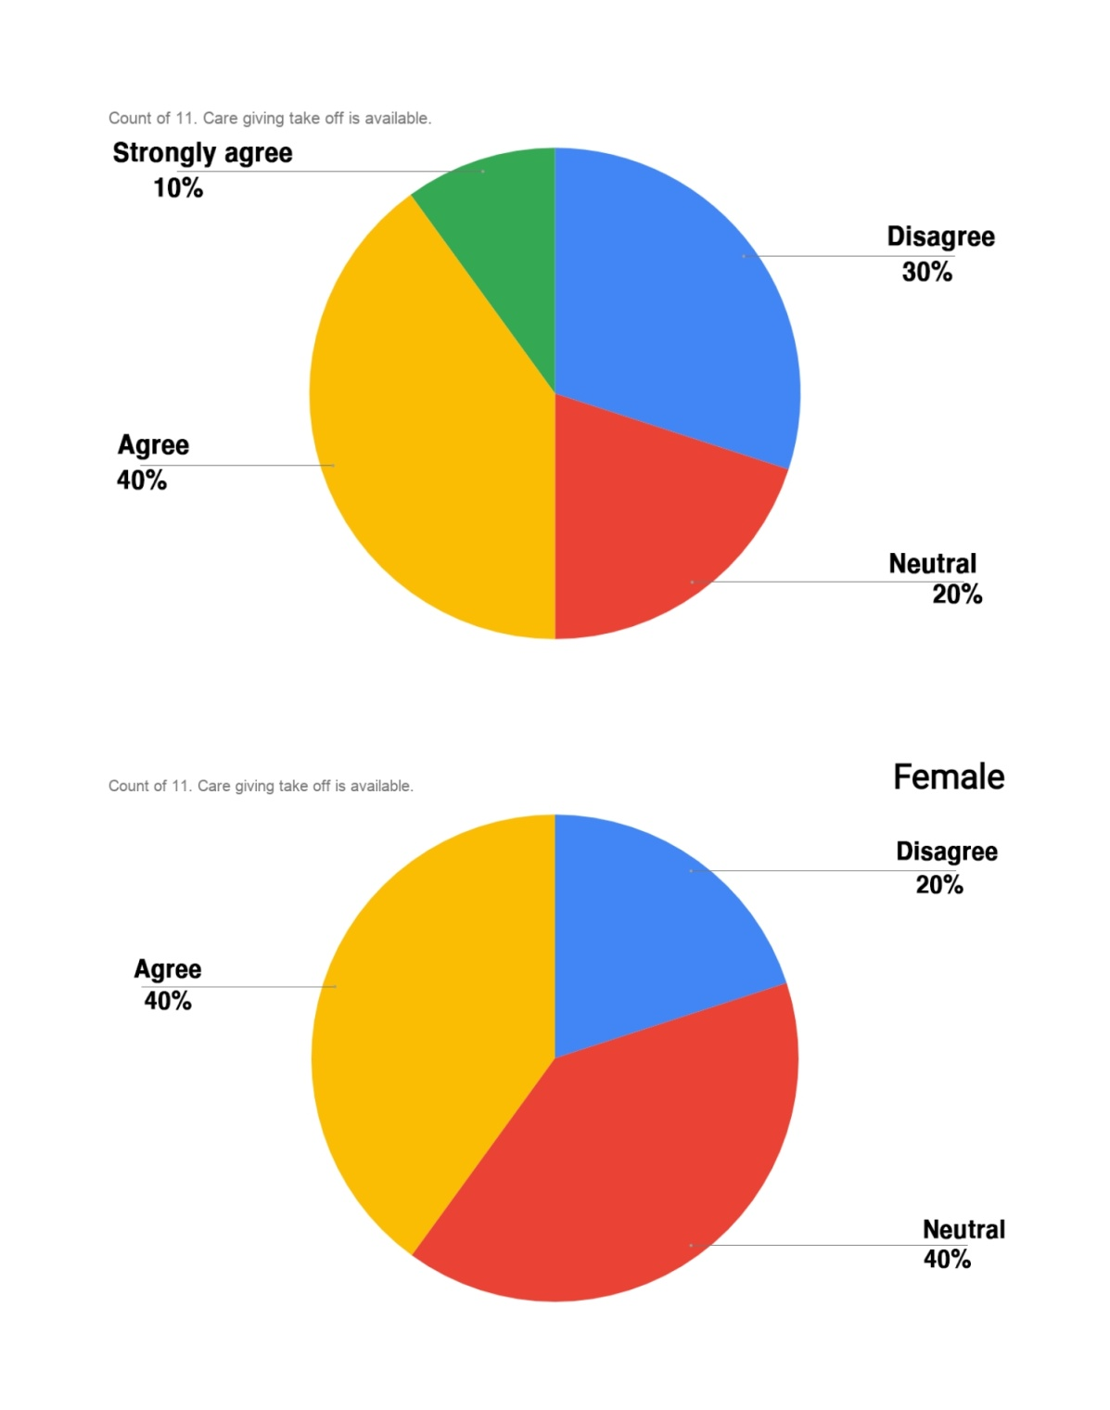
11. Interpretation: The researcher wanted to know if the employees could take care of themselves before taking off. 10percent of male employees strongly agreed, while 40percent only agreed. 30percent of male employees disagreed, while 20percent were neutral. In the case of female employees, 40percent agreed with the statement and 20percentage disagreed. The remaining 40percent of females is neutral.
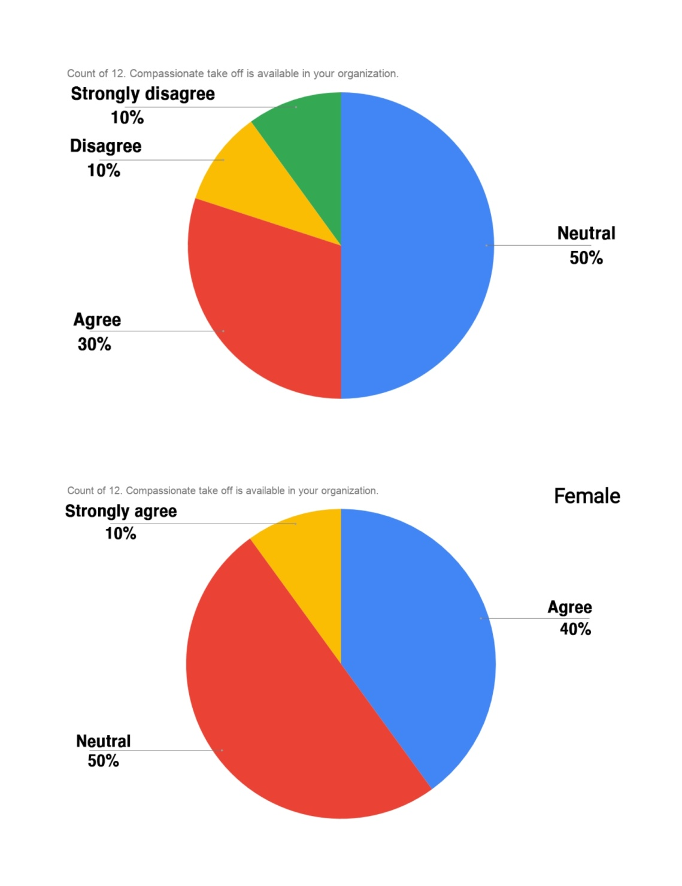
12. Interpretation: The researcher inquired if the employee was eligible for compassionate leave. Ten percent of male employees strongly disagreed, while thirty percent agreed. On that statement, 10percent disagreed, while 50percent were undecided. In the case of female employees, 40percent simply agreed. Only 10percent strongly agreed, while 50percent were undecided.

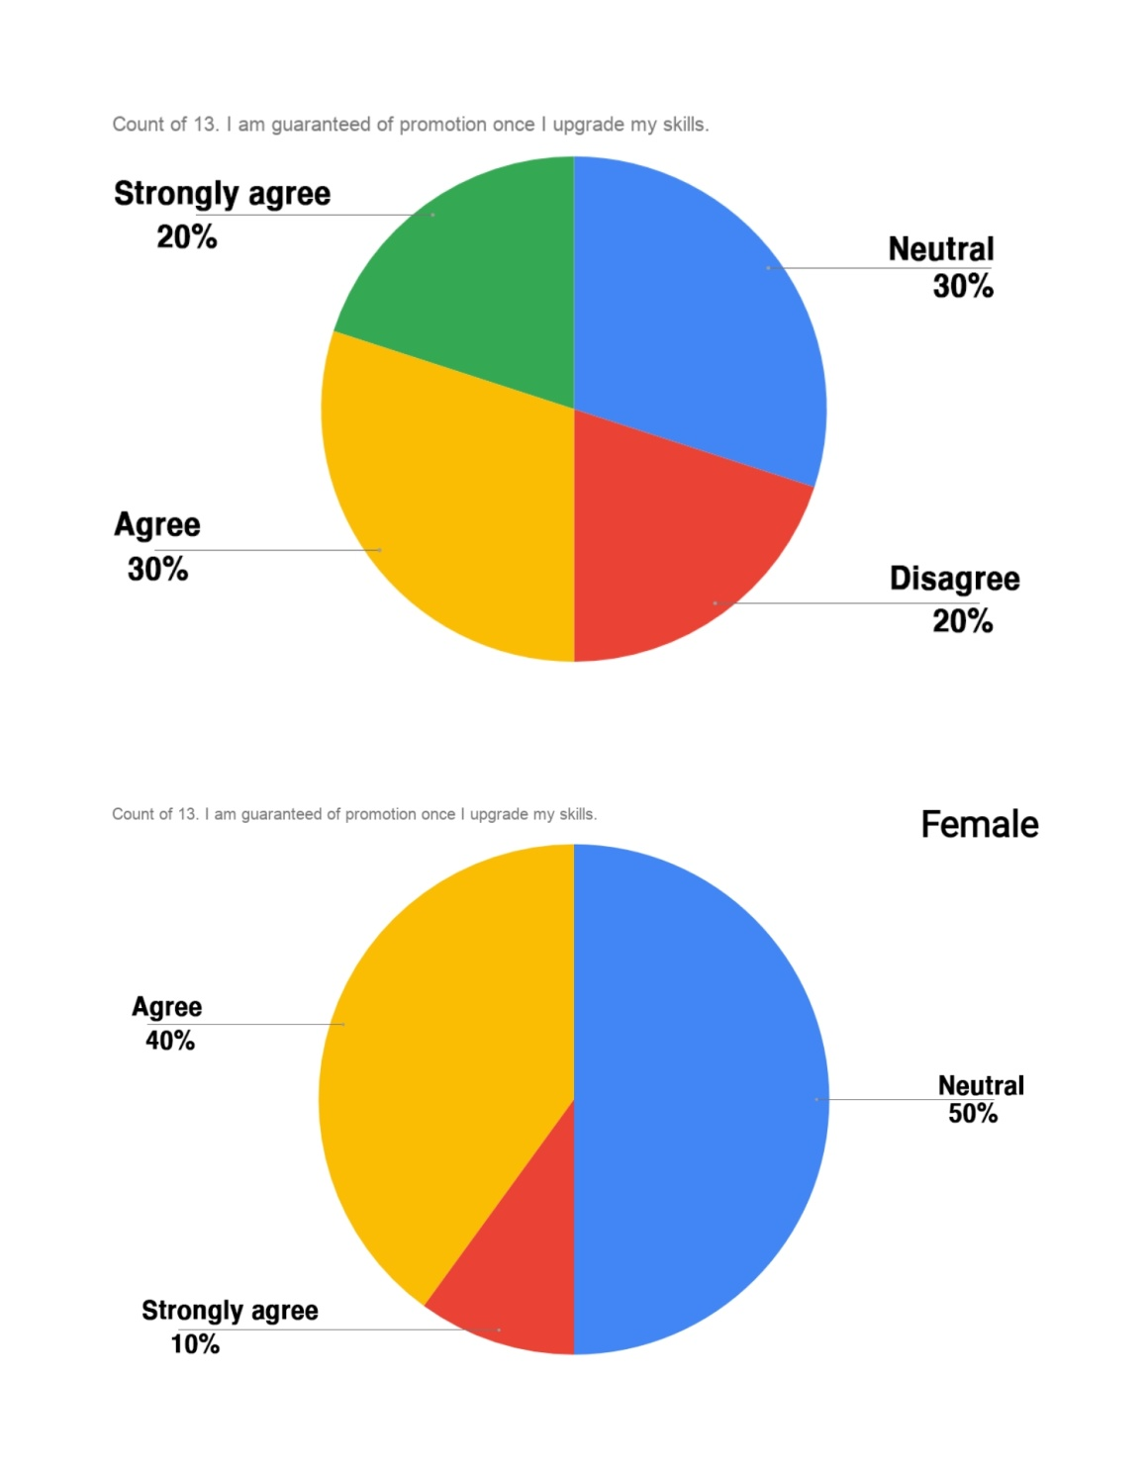
13. Interpretation: Employees who improve their talents are more likely to be promoted, according to the researcher. Males agreed in 30percent of cases and disagreed in 20percent. 20percent were strongly opposed, while 30percent were undecided. Female employees, on the other hand, agreed 40percent of the time, strongly agreed 10percent of the time, and neutral 50percent of the time.

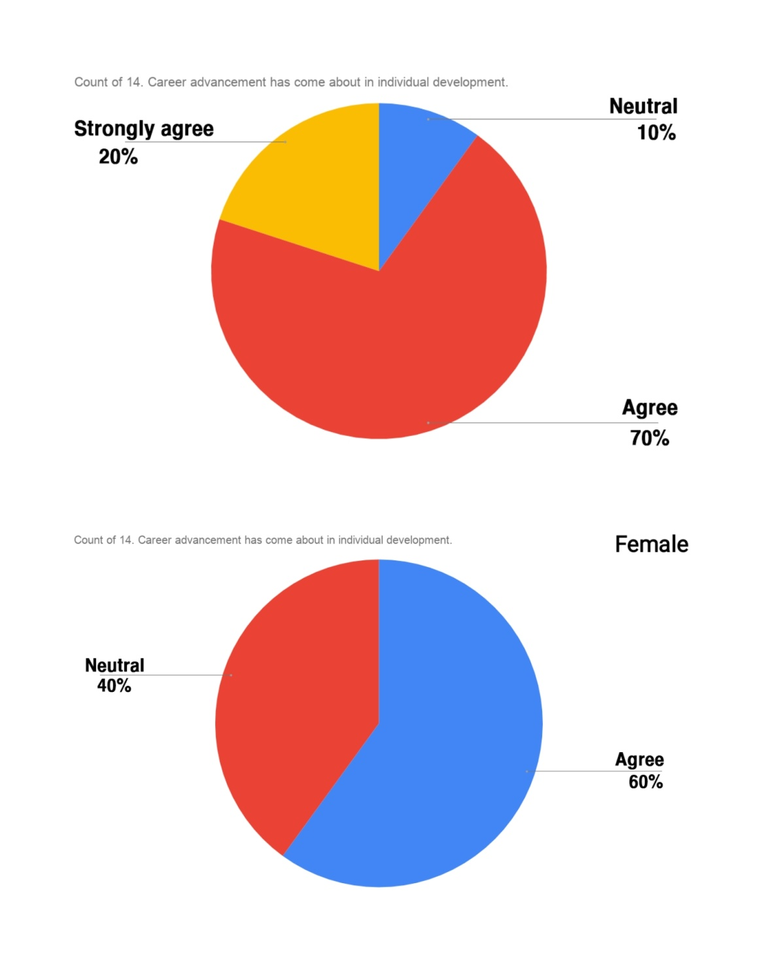
14. Interpretation: The researcher asked whether the employee had experienced some career growth as a result of their personal progress. Only 20percent of male employees strongly agreed, while 70percent only agreed. 10percent of the respondents were undecided. In the case of female employees, 60percent were in agreement and 40percent were neutral.
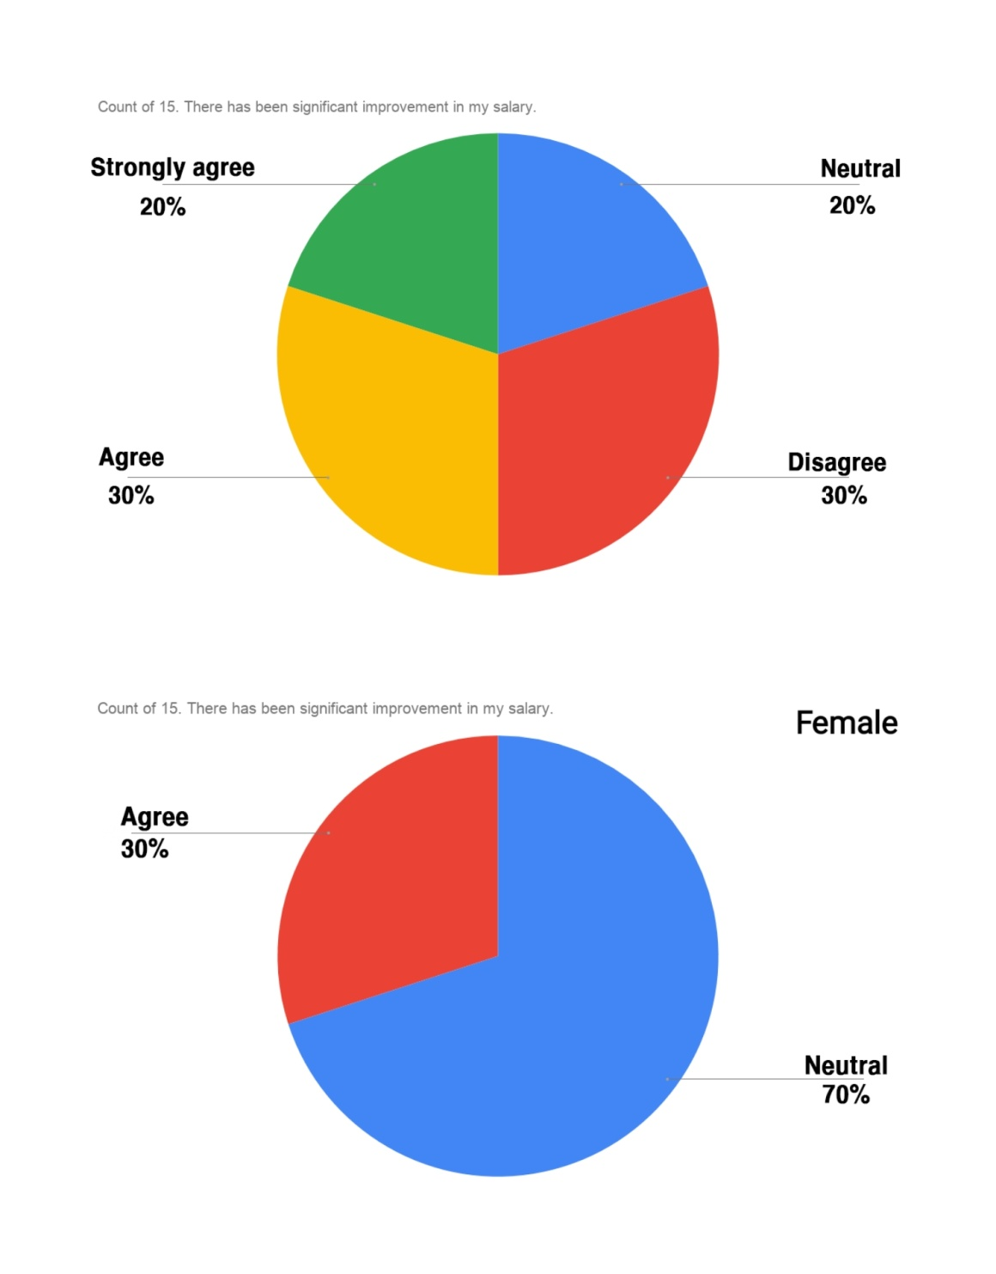
15. Interpretation: The employee was asked whether they had seen a significant increase in their salary. Thirty percent of male employees agreed, while thirty percent disagreed. Twenty percent strongly disagreed, while the other twenty percent were undecided. On the other hand, 30percent of female employees agreed with the assertion, while 70percent were undecided.

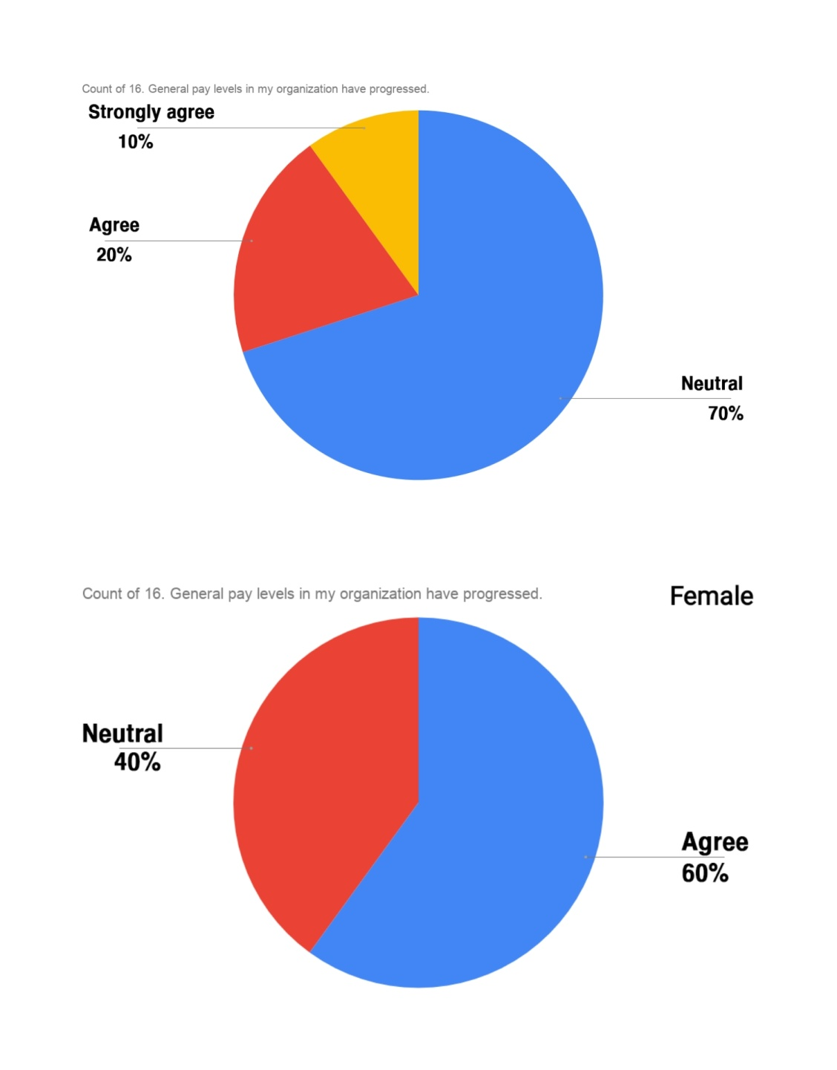
16. Interpretation: The researcher asked whether the employee's salary has progressed in their organization overall. Just 10percent of males strongly agreed, while 20percent only agreed. Seventy percent were undecided. In the case of female employees, 60percent were in agreed and 40% were neutral.
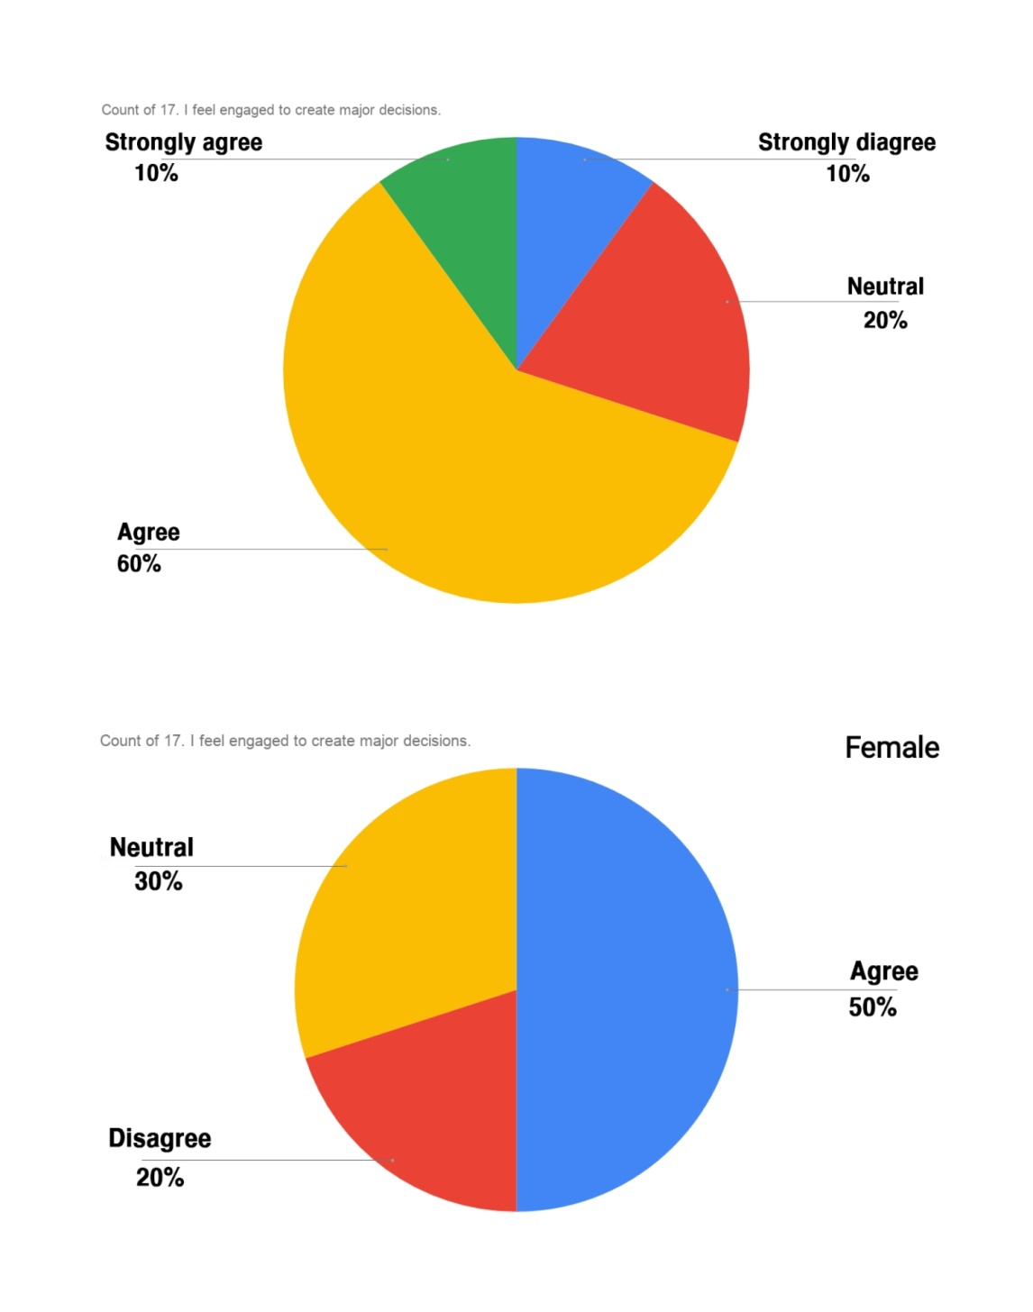
17. Interpretation: The employee was asked whether they feel involvement major decisions. Sixty percent of men agreed, while ten percent strongly disagreed. Just 10percent strongly agreed with that statement, while 20percent were undecided. Female employees, on the other hand, agreed 50percent of the time and disagreed 20percent of the time. Neutrality accounted for 30% of the total.

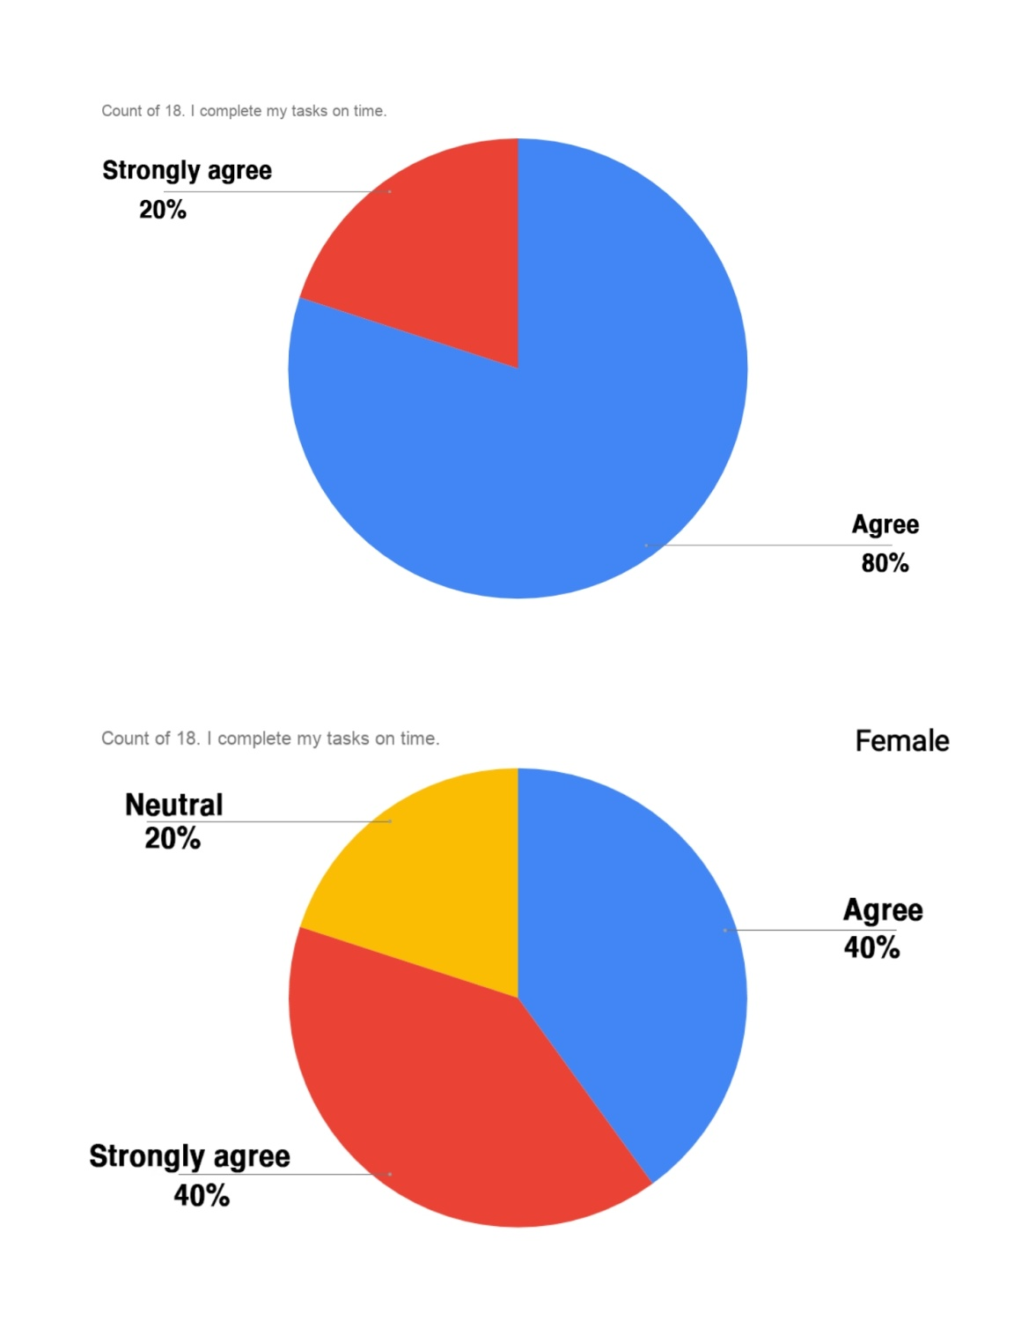
18. Interpretation: The researcher questioned about the employee's ability to complete their work on time. Eighty percent of male employees agreed, with twenty percent strongly agreed. Females, on the other hand, agreed 40percent and strongly agreed 40percent of the time. The remaining 20percent is undecided.

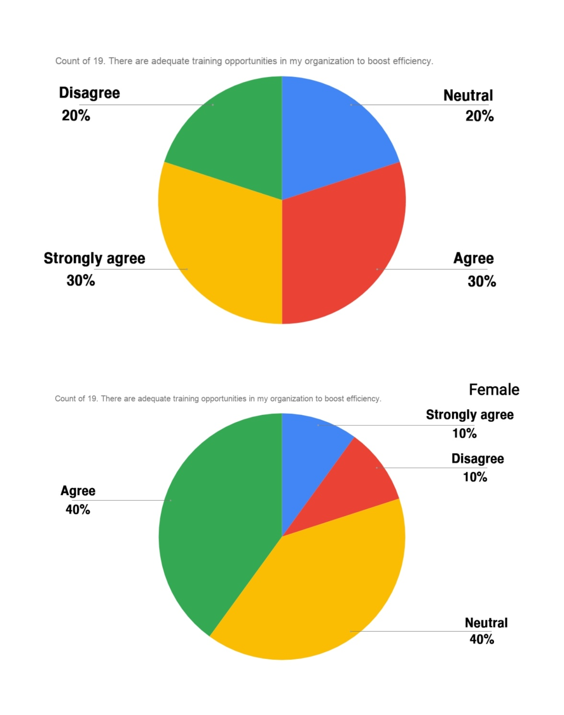
19. Interpretation: The researcher asked the employee whether their organization had sufficient training opportunities to improve quality. Thirty percent of males and twenty percent of males disagreed. Thirty percent strongly approved, while twenty percent were undecided. Forty percent of female employees agreed, ten percent strongly agreed, forty percent were neutral, and ten percent disagreed.

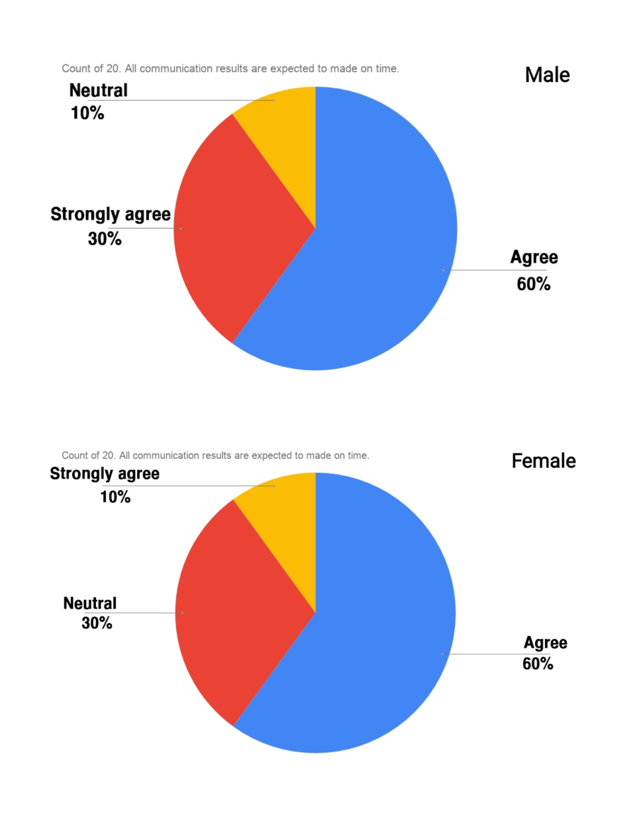
20. Interpretation: The employees were asked whether they acquire all types of communication results on time. Sixty percent of men agreed. 30percent of men strongly agreed, while 10percent were undecided. Sixty percent of female employees agreed, ten percent strongly agreed, and thirty percent were neutral.

6.2 The survey results findings & analysis of United Commercial Bank

In order to conduct the survey, the researcher created questionnaires focused on work-life balance factors. Employees from United Commercial Bank, both male and female, took part. Flexible working arrangements, job sharing, health services, family involvement, stress control, leave availability, and compensation are all factors that took to build the survey query.After survey results analysis, it shows that United Commercial Bank has flexible work arrangements. Employees are happy that they can share their work with other colleagues. Even they know about the wellness programs of their organization. Their work environment is friendly and they have fewer issues in stress level management. In terms of family management, they have moderate views. They have moderate view on salary and compensation improvement. They have less issues in leave flexibility.

Trust Bank Limited
For further researching about work life balance, researcher went to "TRUST BANK LIMITED" to make research queries. 20 employees were randomly picked where 10 male and 10 female employees included. Descriptive details are given below;

Gender | Age of the respondent
Male | 20-25 years  (20.0%) | 26-30 years  (10.0%) | 31-35 years  (40.0%) | 35-40 years  (30.0%)
Female | 20-25 years  (30.0%) |  | 26-30 years  (70.0%)
Table: Age of respondent on gender base

Gender | The years of working in the organization
Male | 0-2 years  (50.0%) | 2-4 years  (20.0%) |  | 5 years and above  (30.0%)
Female | 0-2 years  (70.0%) |  | 2-4 years  (30.0%)
Table: Working years in the organization based on gender

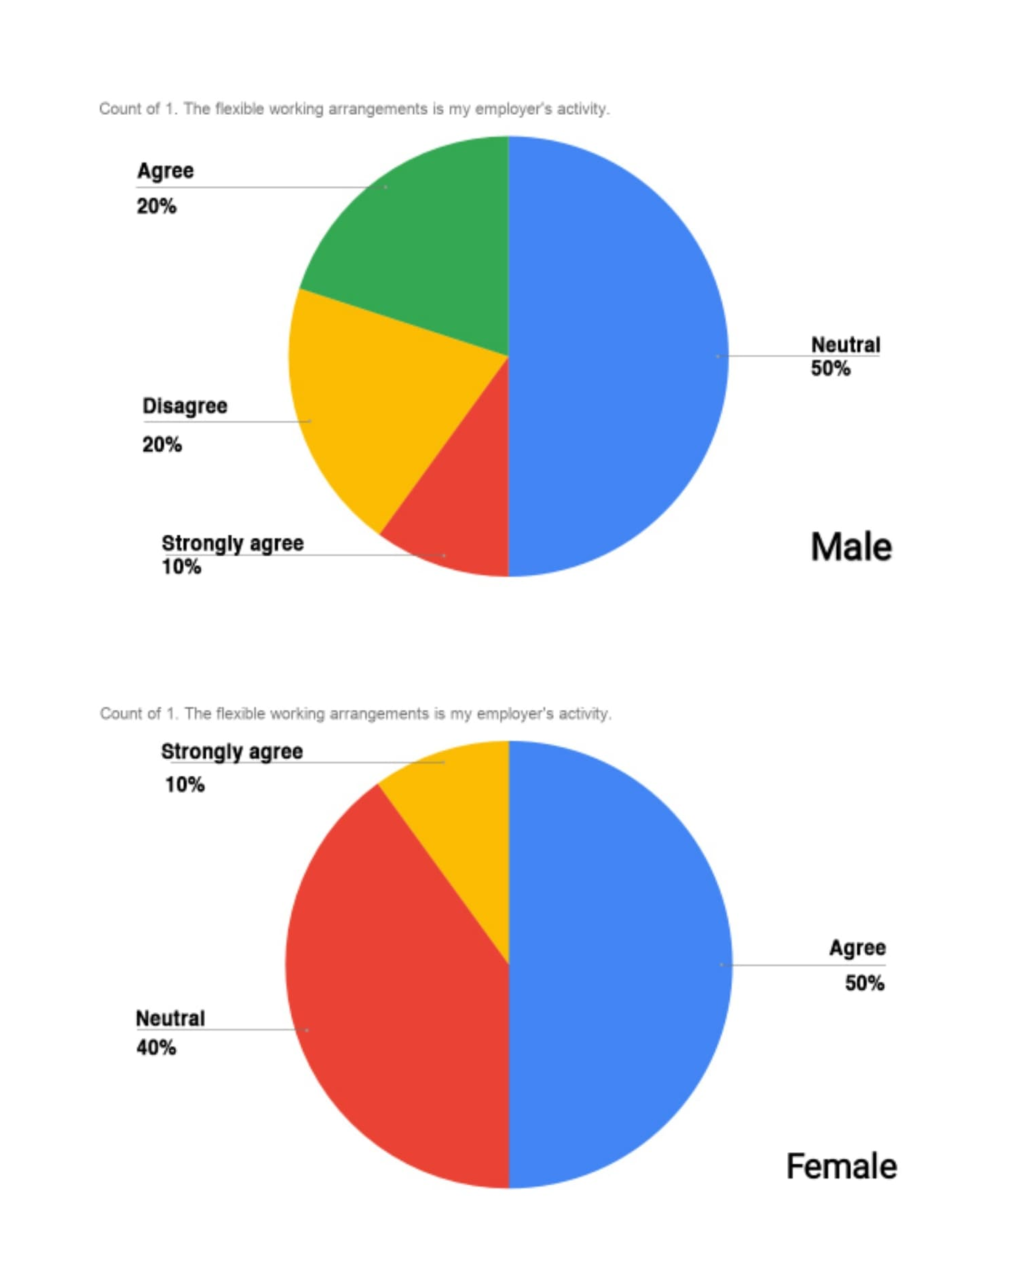
1. Interpretation: The employee was asked if they had any job arrangement that were flexible. Males agreed in 20percent of cases and strongly agreed in 10percent 20percent of those polled agreed, while 50percent were undecided. In the case of female employees, 50percent agreed, 10percent strongly agreed, and 40percent were undecided.

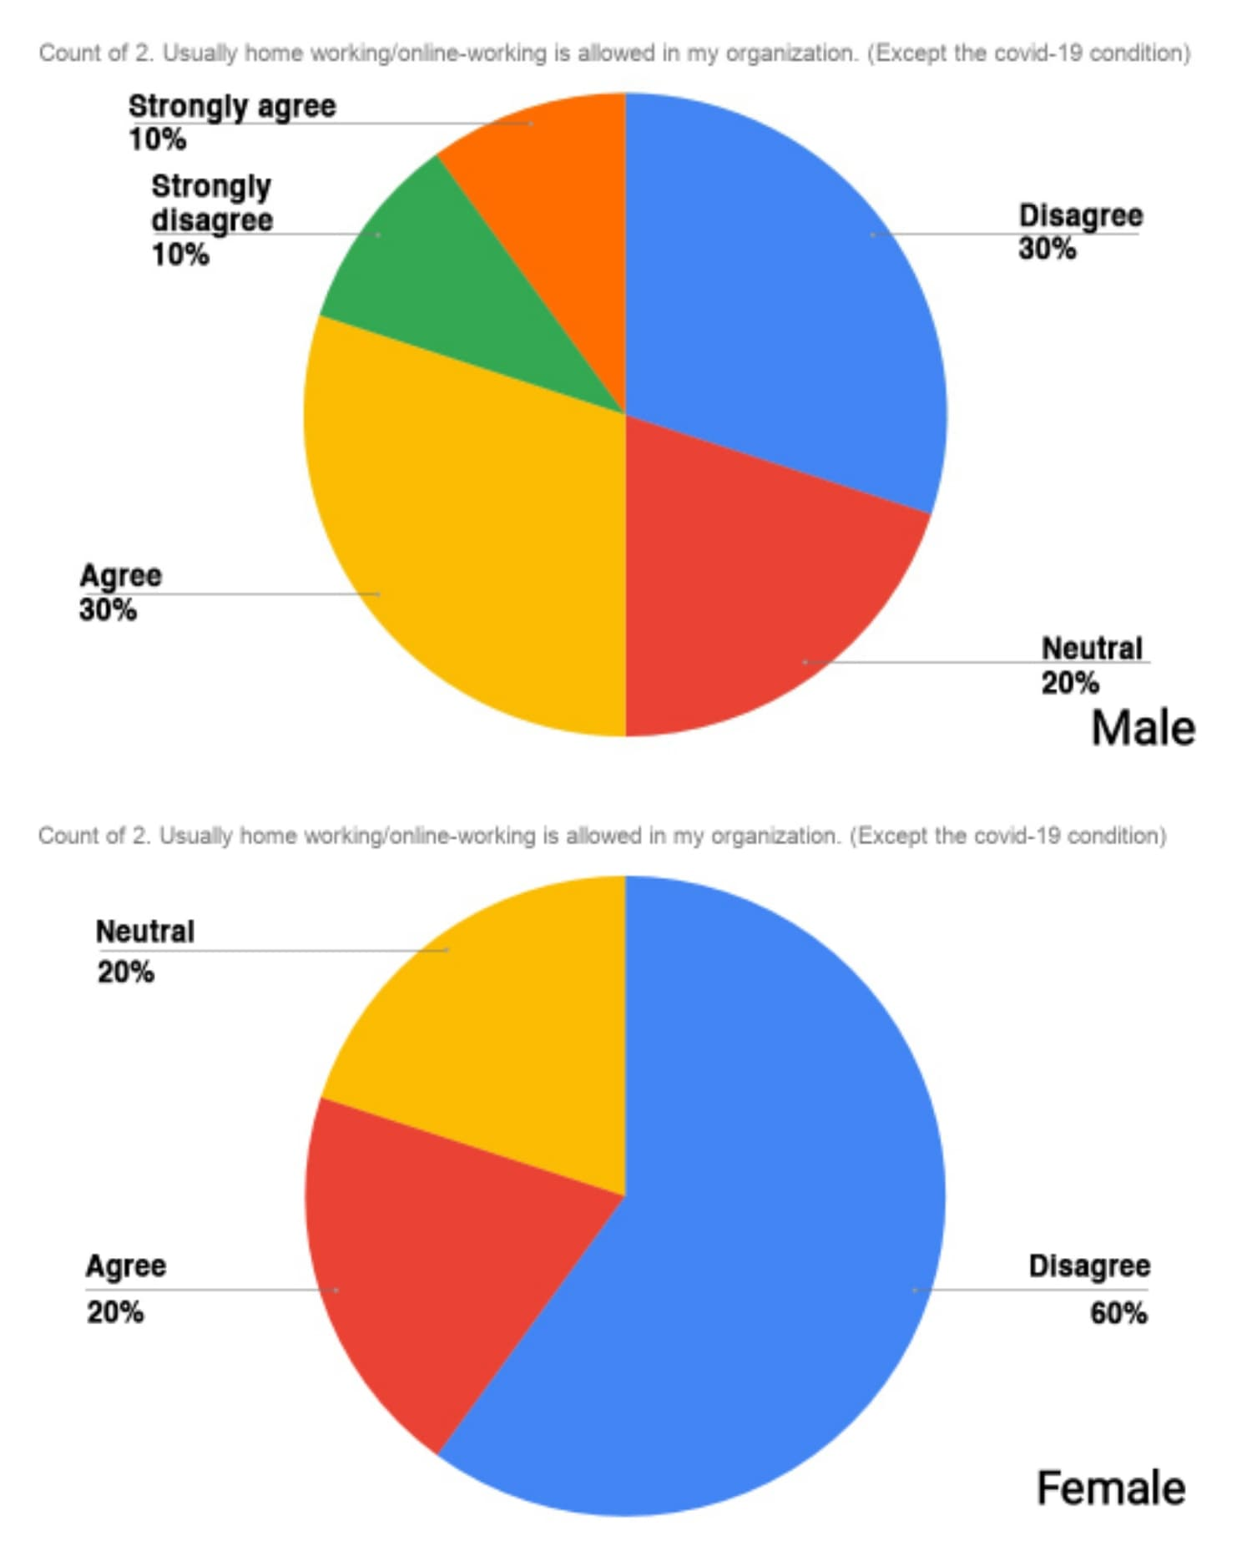
2. Interpretation: The employees were asked if they were usually allowed to work from home or online by the researcher. 10percent of males strongly agreed, while 10percent strongly disagreed. Just 30percent of males agreed, while the other 30percent disagreed. Neutrality was found in 20% of males. Females were disagreed 60percent, agreed 20% of the time, and were neutral 20percent.

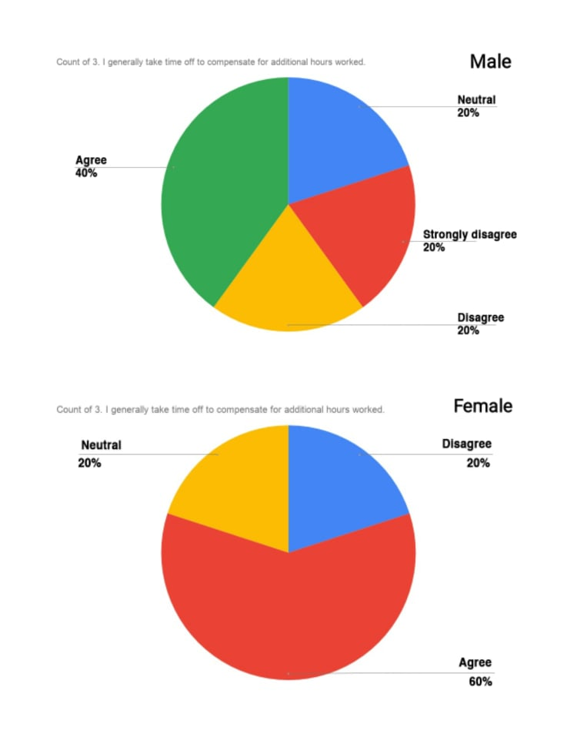
3. Interpretation: The researcher asked whether the employee took time off to compensate for the extra hours work. 40percent of males agreed, while 20percent were undecided. Twenty percent strongly agreed, while the other twenty percent disagreed. Female employees agreed 60percent of the time, disagreed 20percent and were neutral 20percent.

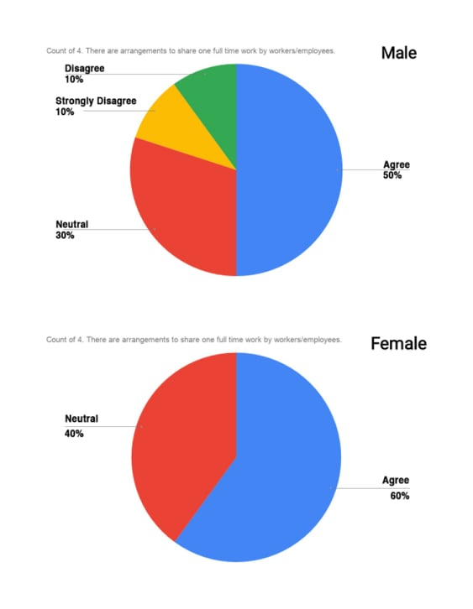
4. Interpretation: The researcher asked whether the employee also made arrangements for other employees to share one full-time job. On that statement, 10percent of employees strongly agreed and 50percent simply agreed. Neutrality was found in 30percent of males. In the case of female employees, 60percent of those polled agreed, although 40percent were undecided.

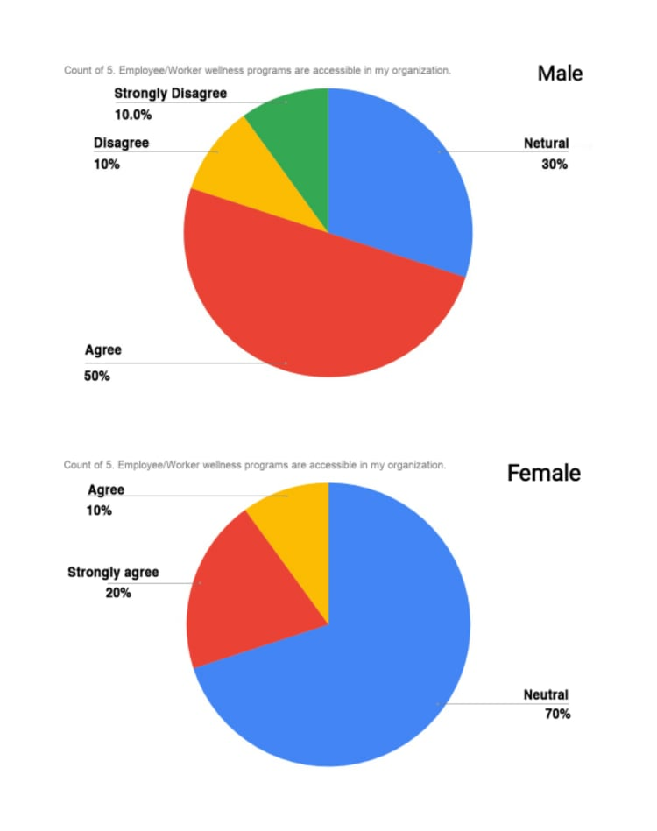
5. Interpretation: The researcher asked as to whether the workers had access to health programs at their workplace. 10percent of employees strongly disagreed, while 10percent were simply in agreed. 50percent of male employees strongly agreed, while 30percent were undecided. In the case of female employees, 10percent agreed and 20percent strongly agreed. On that statement, 70percent of people were undecided.

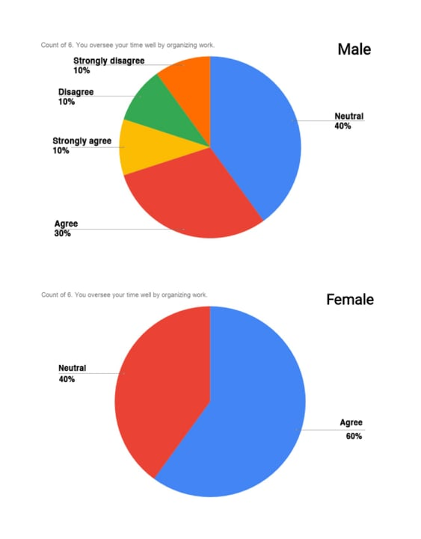
6. Interpretation: The employee was asked if they manage their time well by arranging their job. 10percent of male employees strongly agreed, while 10percent strongly disagreed. Thirty percent just agreed, ten percent just disagreed, and forty percent were neutral. Female employees approved 60percent of the time and were neutral 40percent.

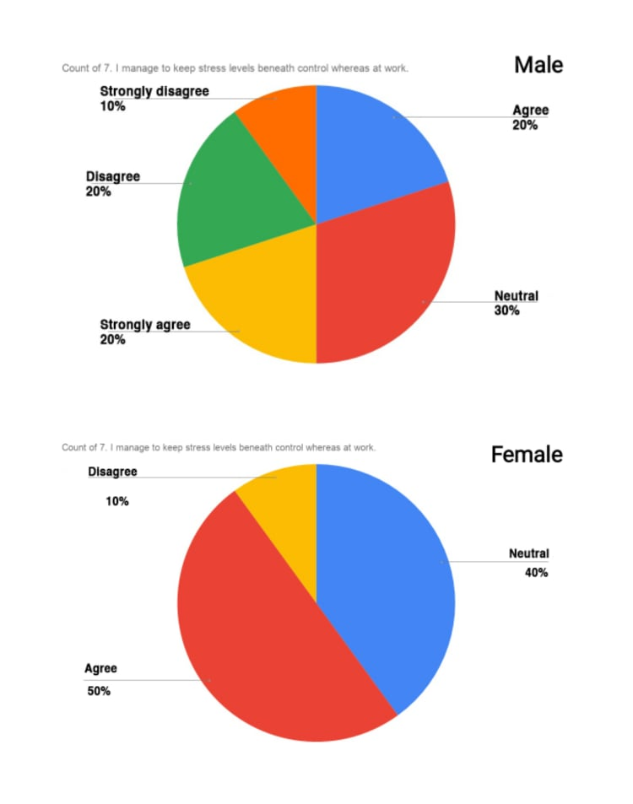
7. Interpretation: The researcher wanted to know whether the employee was able to keep their stress levels under control while at work. Ten percent of men strongly agreed, while ten percent strongly disagreed. Twenty percent simply agreed, while the other twenty percent simply disagreed. Neutrality accounted for 30percent of the total. In the case of female employees, 50percent agreed and 10percent disagreed. 40percent of the respondents were undecided.

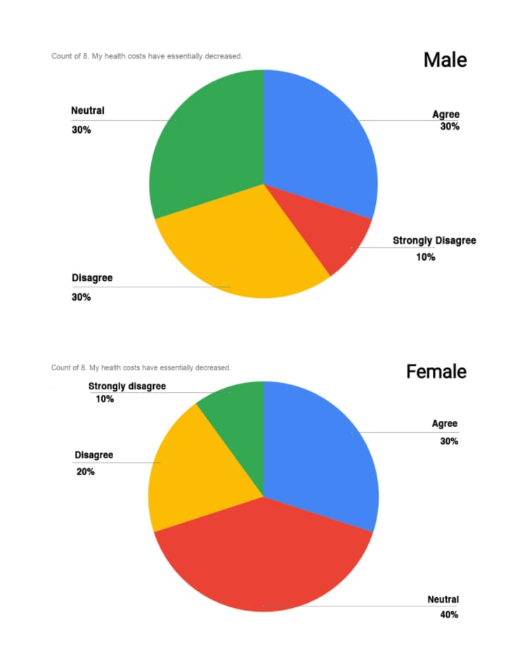
8. Interpretation: The researcher asked whether the employee's costs had reduced significantly. Thirty percent of male workers agreed, while thirty percent disagreed. 10percent were strongly opposed, while 30percent were undecided. Female employees, on the other hand, agreed 30percent, were disagreed 20percent, and strongly disagreed 10percent. 40percent of the respondents were undecided.

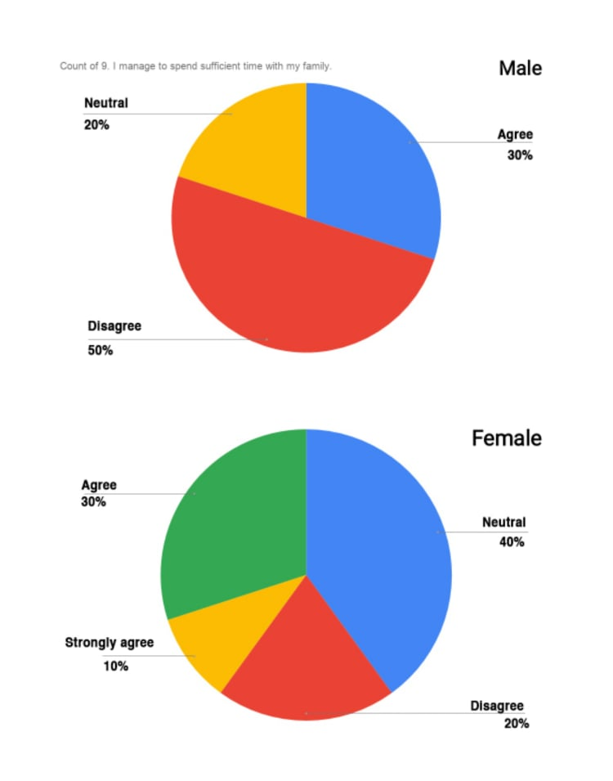
9. Interpretation: The employees were asked if they spend enough time with their families. Male employees agreed 30percent and were disagreed 50percent. The remaining 20percent were undecided. On the other hand, 10percent of female employees strongly agreed and 30percent simply agreed. In response to that comment, 40percent were neutral and 20percent disagreed.

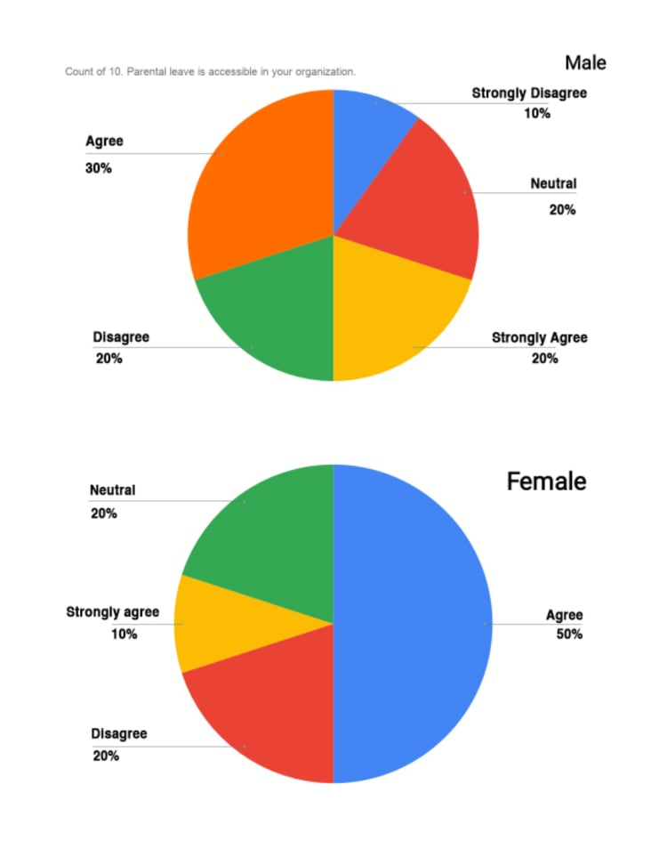
10. Interpretation: The researcher asked whether the employee had access to parental leave at their workplace. A total of 20percent of male employees strongly agreed, while 10percent strongly disagreed. There were 20percent people who were neutral. Just 30percent of those polled agreed, while 20percent disagreed. Female employees, on the other hand, agreed 50percent, 10percent strongly agreed, and 20percent disagreed. The remaining 20percent is undecided.

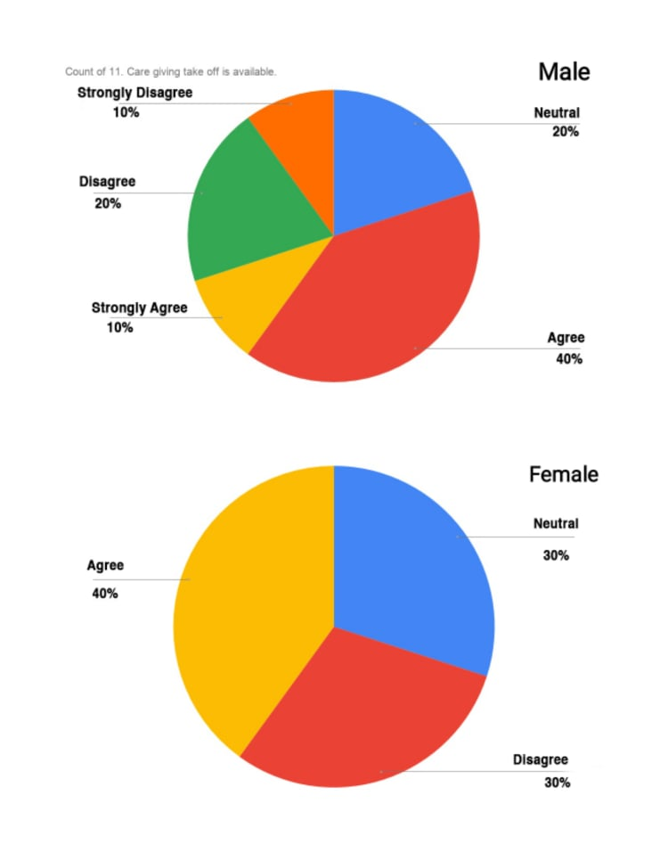
11. Interpretation: The researcher questioned as to whether the employee can take a giving take off leave. Ten percent of male employees strongly agreed, while ten percent strongly disagreed. Only 20percent of men disagreed, while 40percent of men agreed. The remaining 20percent is undecided. Female employees, on the other hand, agreed 40percent of the time and disagreed 30percent of the time. Neutrality accounted for 30percent of the total.

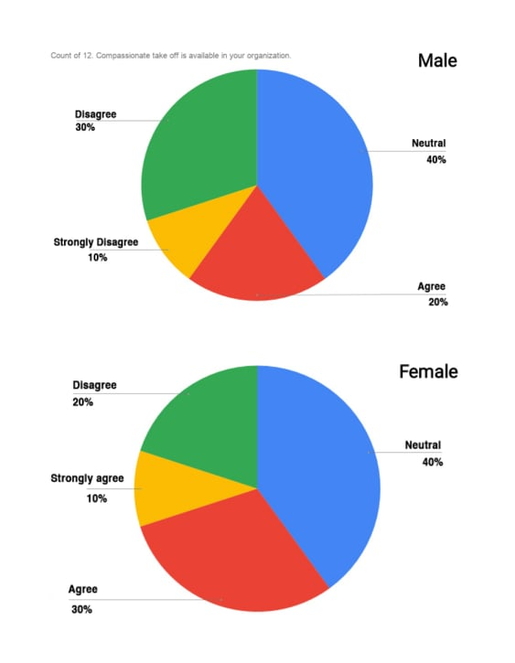
12. Interpretation: The researcher questioned on whether the employee could take compassionate leave. Ten percent of male employees strongly disagreed, while twenty percent agreed and ten percent only disagreed. 40percent of the respondents were undecided. In the case of female employees, 30percent of them agreed and 20percent simply disagreed. Only 10percent strongly agreed, while 40percent were undecided.

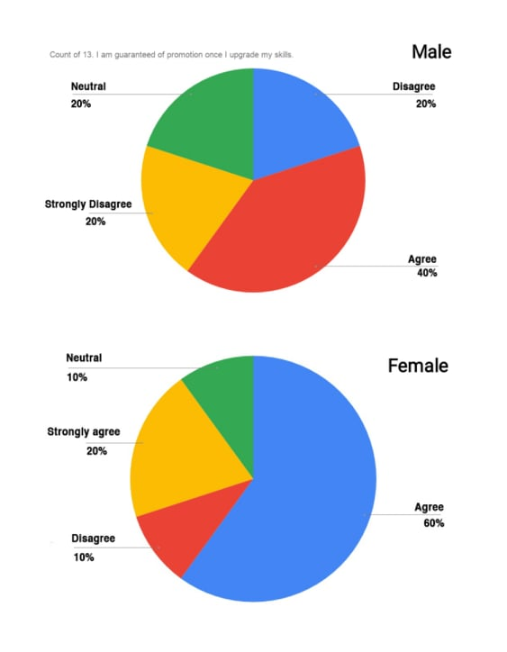
13. Interpretation: Do they get promoted if they improve their skills, the researcher asked the employee. Male employees agreed 40percent and disagreed 20percent. 20percent strongly disagreed, while the remaining 20percent were undecided. Female employees, on the other hand, agreed 60percent, strongly agreed 20percent, and were disagreed 10percent. On that statement, 10percent of people were simply undecided.

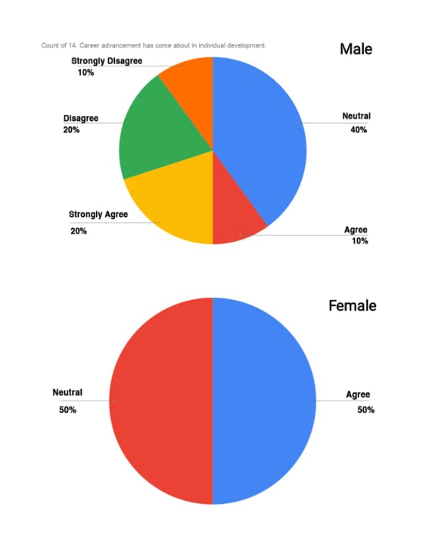
14. Interpretation: The researcher asked whether the employee had experienced some career advancement as a result of their career growth. 20percent of male employees strongly agreed, while 10percent strongly disagreed. Just 10percent of those polled agreed, while 20percent disagreed. Neutrality was found in 40percent of males. In the case of female employees, 50percent were in agreed and 50percent were neutral.

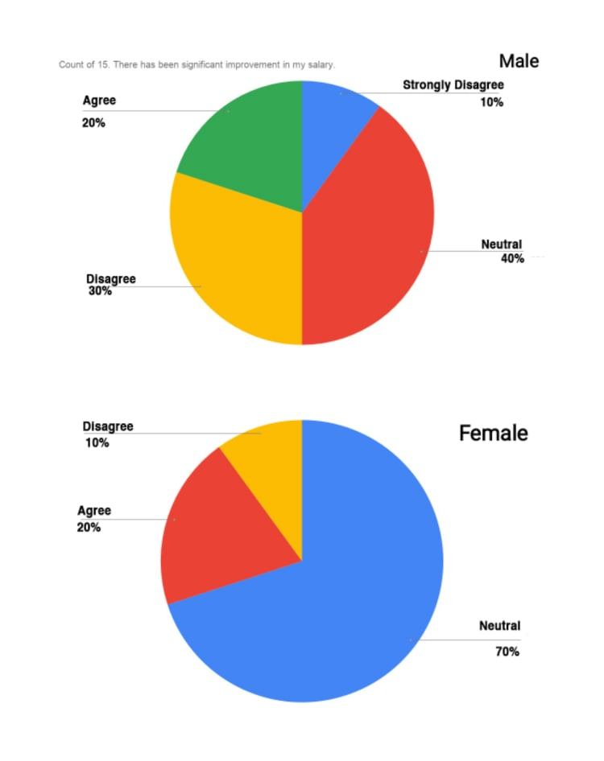
15. Interpretation: The employees were asked whether they have seen a substantial increase in their salary. Twenty percent of male employees agreed, while thirty percent disagreed. 10percent of those polled strongly disagreed, while 40percent were undecided. In the case of female workers, 20percent agreed, 10percent disagreed, and 70percent were undecided about the statement.

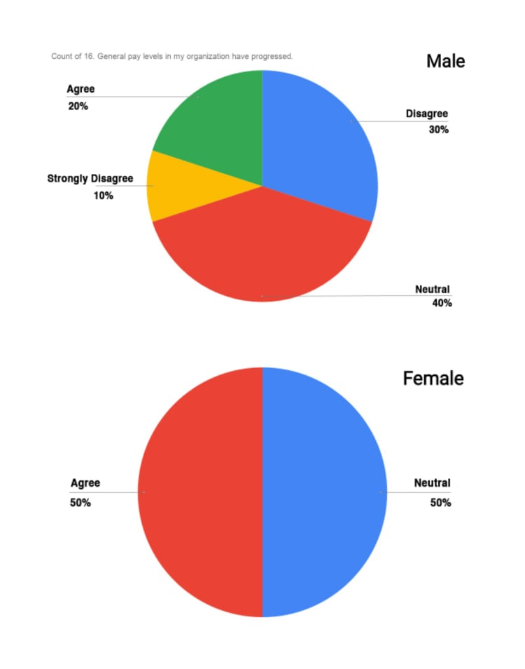
16. Interpretation: The researcher asked of the employee if their company's overall pay levels had increased. Twenty percent of male employees agreed, and thirty percent only agreed. 10percent of men strongly disagreed, while 40percent were undecided. In the case of female employees, half of them agreed and the other half were neutral.

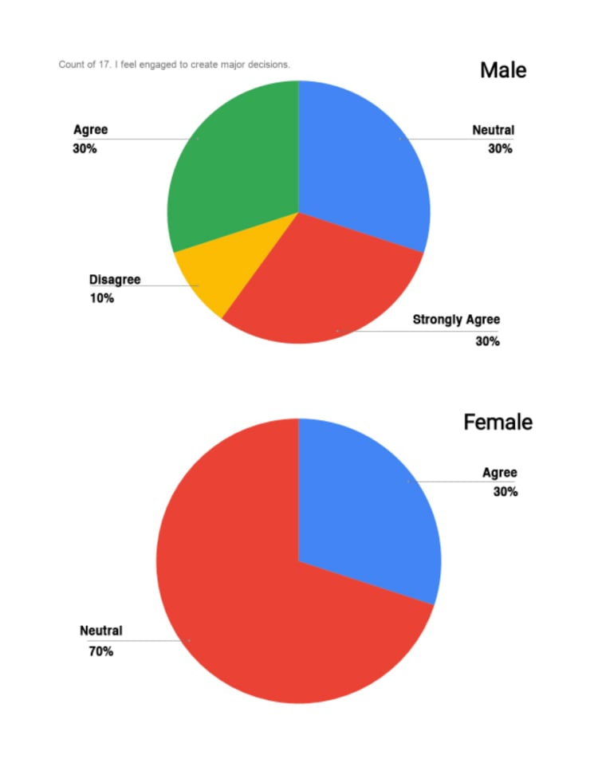
17. Interpretation: The employees were asked whether they feel involvement to create in major decisions. 30percent of the male employees agreed, while 10percent disagreed. 30percent strongly agreed, while the remaining 30percent were undecided. Female employees, on the other hand, agreed 30percent of and were neutral 70percent.

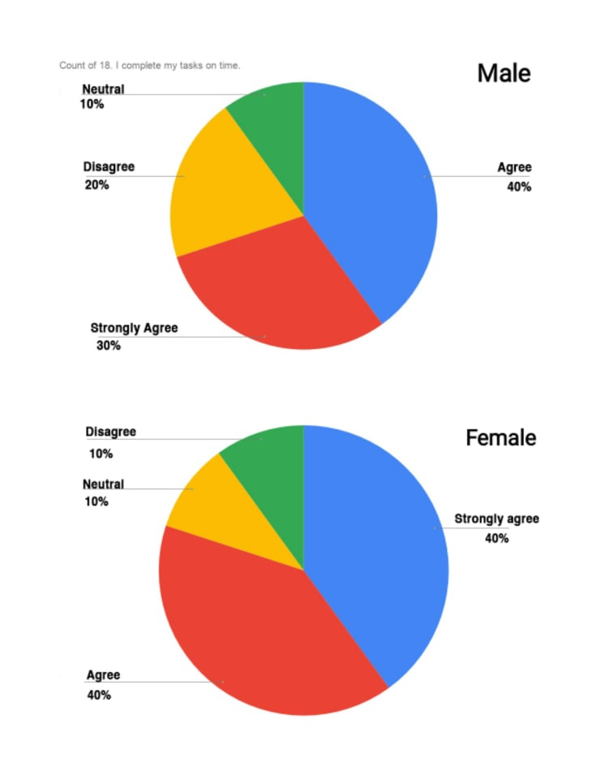
18. Interpretation: The researcher asked about the employee's ability to complete their task on time. Males agreed 40percent and were disagreed 20percent. Thirty percent strongly agreed, while ten percent were undecided. On the other hand, 40percent of female employees agreed with this statement, while 10percent disagreed. 40percent of females strongly agreed, while 10percent were undecided.

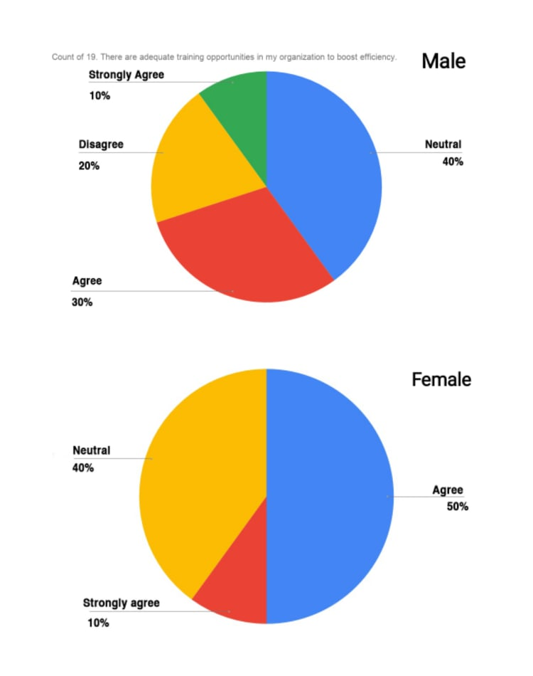
19. Interpretation: The researcher asked of the employee whether their company had sufficient training opportunities to improve efficiency. Males agreed 30percent of and disagreed 20percent. Only 10percent strongly agreed, while 40percent were undecided. In the case of female employees, 50percent agreed and 10percent strongly agreed. 40percent of the respondents were undecided.

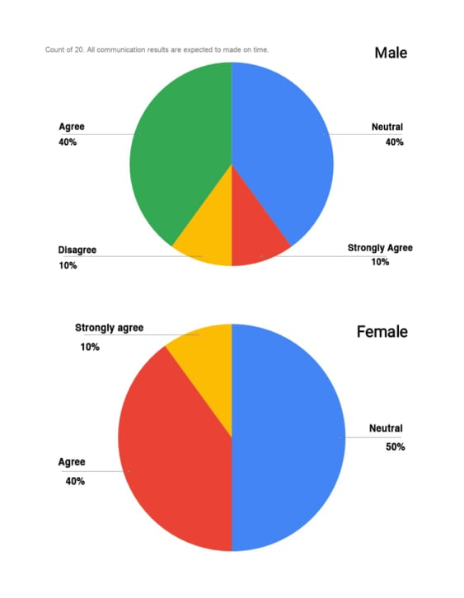
20. Interpretation: The employees were asked whether they receives all types of contact results that are completed on time. 40percent of those polled agreed, while 10percent disagreed. Only 10percent of men strongly agreed, while 40percent were undecided. In the case of female employees, 40percent were agreed, with 10percent strongly agreed. Neutral workers made up half of the female employee.

6.3 The survey results findings & analysis of Trust Bank Limited

In order to conduct the survey, the researcher created questionnaires focused on work-life balance factors. Both male and female employees worked at Trust Bank Limited. Flexible working arrangements, job sharing, health services, family involvement, stress control, leave availability, and compensation are all factors that went into creating the survey query. In TBL employees are moderately get flexible work arrangements in the office. They have good work environment and all employees get opportunities to share their work with their colleagues. The employee of Trust Bank Limited may not get access to the wellness programs. Gender wise their views are different. Gender wise their stress level management differ. Only females are better to handle their work life stress properly. Employees have issues that they do not get enough time to spent with their family. Leave availability and compensation facilities are well in the organization which all employees have agreed.

CHAPTER: 7
CONCLUSIONS

7.1 Conclusion

A well balanced work life balance practice in work place is highly needed in competitive market. Work-life balance is directly related to employee satisfaction and employee productivity. Flexible working hours, employee wellness and wellbeing plans, vacation schedules, and career development all benefit from a comprehensive work-life balance program. In this research report, importance and factors of work life balance practices are discussed. Work-life balance programs, such as flexible work structures and employee well-being, should be a priority for any organization's human resource department. The suggestion for human resource department is to increase the fund for employee well-being and flexible work programs for employee in the work place. This report will enlighten the factors which are not practiced earlier in the organization.

References
1. The following web site was accessed on November 05, 2020: https://www.ucb.com.bd/know-ucb/about-us/
2. The following web site was accessed on November 03, 2020: https://www.tblbd.com/
3. Sussannaa Shagvaliyevai, Rashad IYazdanifard "Impact of Flexible Working Hours on Work-Life Balance"hhttps://www.scirp.org/html/44-2120312_i42311.html
4. "American Journal of Industrial and Business Management" Vol.4 No.1(2014), Article ID:42311,4 pages DOI:10.4236/ajibm.2014.41004
5. iClark, S.C. (2000) “Work/iFamily Border Theory: iA New Theory iof iWork/Life iBalance”, iHuman iRelations i53(6): 747-770.
6. Mohammad Rahim Uddin1 Abdullah Mohammad Ahshanul Mamun2 Nazamul Hoque 3* Mohammad Shahab Uddin4 "Work-Life Balance: A Study on Female Teachers of Private Education Institutions of Bangladesh" "tEuropean aJournal of iBusiness iand iManagement" www.iiste.org iISSN 2222-1905 (Paper) ISSN 2222-2839 i(Online) Vol.5, No.13, 2013 iiteseerx.ist.psu.edu/iviewdoc/download?doi=10.1.1.735.9053&rep=irep1&itype=pdf.
7. Nancy R. Lockwood HR Content Expert "Work/Life Balance Challenges and Solutions" https:// 11_Lockwood_WorkLifeBalance.pdf.
8. iHelen Russell Philip J. O’Connell Frances McGinnity, "iThe iImpact of iFlexible iWorking Arrangements on Work–life Conflict and Work Pressure in Ireland" First published: 28 December 2008 https://doi.org/10.1111/j.1468-0432.2008.00431.
9. Lewis, S. Gambles, R. & Rapoport, R. (2007). The Constraints of a ‘Work-life Balance’ Approach: An International Perspective. International Journal of Human Resource Management, 18(3), 360-373
10. Tressa Danam and Manisha C.K. (2016). Work Life Balance: Study of Female Teachers of Kendriya Vidyalaya in Uppal, Hyderabad. Anveshana’s International Journal of Research in Regional Studies, Law, Social Sciences, Journalism and Management Practices, Vol.1, Issue 8.
11. A Mohanty, LK Jena - (2016) "Work-life balance challenges for Indian employees: socio-cultural implications and strategies" Journal of human resource and sustainability.
12. A Global Review of Work Life Balance Issues, Practices, and Initiatives November 2011
https://www.diversitybestpractices.com/sites/diversitybestpractices.com/files/import/embedded/anchors/files/_attachments_articles/rr-globalflexnovember2011.pdf
13. Clarke, M. C., Koch, L. C. & Hill, E. J. (2004) ‘The work and family interface: Differentiating balance and fit’. Family and Consumer Sciences Research Journal, 33 (2): 121-140.
14. Grady, G., McCarthy, A., Darcy, C. & Kirrane. M. (2008) Work Life Balance Policies and Initiatives in Irish Organisations: A Best Practice Management. Cork: Oak Tree Press.
15. Grzywacz, J.G. & Carlson, D.S. (2007) ‘Conceptualizing work–family balance: Implications for practice and research’. Advances in Developing Human Resources. 9:455–71.

Appendix
Survey questionnaires
